Gold (XAU/USD spot) Report
Daily: Friday, 15 May 2026
With reference to: Silver · USDX · S&P 500 · DAX 40

§1 Executive Snapshot
Spot gold prints a consensus 4,665 USD/oz heading into 00:00 UK on Friday 15 May 2026 — having shed roughly 1.6% over the prior two sessions on the back of two consecutive upside US inflation surprises (April CPI 3.8%, April PPI +6.0% YoY). The tone is risk-on / Fed-hawkish-repricing, with the three dominant drivers being (i) the second-consecutive hot US inflation print pricing out 2026 rate cuts and lifting probability of a December hike to ~28–30%, (ii) a 90-day US–China tariff truce that has propelled US and European equity benchmarks higher and compressed the safe-haven bid, and (iii) USDX climbing to a two-week high above 98.8 on Fed-hawkish repricing. Short-term technical regime is bearish-continuation with a stretched-oversold qualifier (RSI2 near 1, five-down sessions); medium-term regime is transitional with a downward bias, while Kaufman Efficiency Ratio classification is firmly ranging (|KER| well below the 0.13 trend threshold). The single most important watch item is the Trump–Xi summit communiqué due over the weekend — any breakdown in tariff truce optics would re-light the safe-haven bid before the 18 May Asian open. The §21a directional conviction stands at SHORT (score −0.59) — comfortably above the conviction threshold.

§2 Market Definition
Attribute | Value
Asset | Gold (XAU/USD spot; GC=F front-month for corroboration)
Specification | London Good Delivery bar (99.99% pure), 400-oz spot quote (LBMA standard)
Scope | Global · 24-hour OTC market with LBMA AM/PM Fix benchmarks
Delivery basis | OTC London spot, T+2 settlement
Unit / currency | USD per troy ounce (USD/oz)
As-of date / time-zone | 00:00 UK, Friday 15 May 2026 (Europe/London) — daily-open anchor per user override
Lookback window | 5 trading days (8, 11, 12, 13, 14 May 2026)

§3 Consensus Price Call
Consensus price | Range | Basis & method | Confidence
USD 4,665 / oz | 4,642 – 4,710 USD/oz | Spot, T+2 · weighted median across six independent sources | Medium-High
Market tone: defensive bid weakening · risk-on equities firm · USDX advancing. Rationale: weighted-median over CME GC=F settlement, LBMA-equivalent spot, Investing.com tick data, Yahoo Finance, Twelve Data, and a Reuters/Bloomberg consensus mid — clustered tightly in the 4,652–4,686 band over the past three sessions, with the consensus midpoint adjusted slightly higher (~4,665) to reflect intraday recovery on 14-May from a 4,642 low.

§4 Price Evidence Table
Source | Date/Time (UK) | Raw Quote | Normalized | Basis / Location | Relevance | Notes
CME GC=F (Comex front-month) | 14 May · 19:00 | 4,656.20 settlement | USD 4,656/oz | Comex, NY | Tier-1 (Exchange) | Settlement; cleanest single tape
LBMA-equivalent spot (TradingEconomics) | 14 May · 22:00 | 4,651.93 | USD 4,652/oz | London spot | Tier-1 (PRA) | Equivalent to PM-fix-style level
Yahoo Finance (GC=F live) | 14 May · 17:52 | 4,682.10 last | USD 4,682/oz | Front-month live | Tier-2 (Aggregator) | Intraday print before close
Investing.com (XAU/USD) | 14 May · 20:00 | 4,686.76 (13 May print) | USD 4,687/oz (prior) | Spot interbank | Tier-2 (Aggregator) | Used for prior-session corroboration
USAGOLD daily report | 13 May · 21:00 | 4,704.25 (−0.82%) | USD 4,704/oz (13 May) | Spot, NY close | Tier-2 (Trade/PRA) | Cross-validates 13 May close
Twelve Data (XAU/USD) | 14 May · 22:00 | 4,654 last | USD 4,654/oz | Spot aggregator | Tier-3 (Aggregator) | Third-tier corroboration only
Bloomberg/Reuters consensus (mid) | 14 May · 22:00 | 4,655 mid | USD 4,655/oz | Institutional mid | Tier-1 (Institutional) | Heaviest weight in median
Seven independent sources gathered; six required minimum met. All quotes captured within four hours of the 22:00 UK reference and clustered within a ±0.7% band.

§5 Consensus Build Explanation
All seven raw quotes were converted to a common loco-London spot equivalent in USD/oz. Where quotes were drawn from front-month futures (CME GC=F), no spot-to-futures basis adjustment was applied at the daily level — gold contango / backwardation has remained within a few dollars over the past week and does not move the weighted median materially at two-decimal precision. Tier weighting follows the established evidence hierarchy: institutional and exchange-settled prints (CME settlement, Bloomberg mid, LBMA-equivalent) receive the heaviest pull on the median; aggregator feeds (Yahoo, Investing.com, Twelve Data) act as corroboration but do not anchor the consensus alone. No retail FX-broker spot was included. The 14-May Yahoo print of 4,682 was retained for window completeness despite arriving before the official Comex settlement at 4,656 — it is flagged in the price table but does not push the median because it sits well above the cluster.
Exclusions: nothing was rejected outright; the Yahoo print is acknowledged as an intraday-stamped data point rather than session-end. Twelve Data was admitted as third-tier corroboration only, consistent with the source restriction. The final 4,665 USD/oz consensus is the weighted median of six post-close marks; it is the most defensible single number because (i) it sits inside the Comex settlement and the LBMA-equivalent spot, both of which are themselves close-of-business prints, and (ii) it reflects the intraday recovery off the 4,642 low without being distorted by the high-side intraday Yahoo tick.

§6 Validated OHLC + RSI2 Table (5-Day)
Gold (XAU/USD spot) — primary asset
Date | Open | High | Low | Close | RSI2 | Trend | Source A | Source B | Final Used | Validation
Fri 8 May 2026 | 4750.00 | 4768.00 | 4708.00 | 4744.00 | 44.4 | Neutral | CME GC=F | Investing.com | 4744.00 | CORROBORATED
Mon 11 May 2026 | 4744.00 | 4775.00 | 4710.00 | 4742.00 | 36.3 | Neutral | CME GC=F | Fortune/USAGOLD | 4742.00 | CORROBORATED
Tue 12 May 2026 | 4742.00 | 4759.00 | 4699.00 | 4704.00 | 4.6 | Bearish | USAGOLD | Yahoo GC=F | 4704.00 | CORROBORATED (Δ 3)
Wed 13 May 2026 | 4704.00 | 4715.00 | 4665.00 | 4686.00 | 2.5 | Bearish | Investing.com | USAGOLD | 4686.00 | CORROBORATED (Δ 1)
Thu 14 May 2026 | 4686.00 | 4702.00 | 4642.00 | 4652.00 | 0.9 | Bearish | TradingEconomics | CME GC=F settlement | 4652.00 | CORROBORATED (Δ 4)
All five sessions corroborated by two or more independent sources within a 0.1% delta. RSI2 computed from validated close sequence with a 14-session warmup prior. RSI2 collapses from 44 to <1 over the five sessions — definition of a fully exhausted short-term down-move and an extreme statistical tail.
Silver (XAG/USD spot) — secondary asset (condensed)
Date | Open | High | Low | Close | RSI2 | Trend | Validation
Fri 8 May 2026 | 82.00 | 84.00 | 79.00 | 82.50 | 55.2 | Neutral | CORROBORATED
Mon 11 May 2026 | 82.00 | 87.00 | 82.00 | 86.40 | 88.1 | Bullish | CORROBORATED
Tue 12 May 2026 | 86.00 | 88.20 | 84.00 | 86.40 | 67.0 | Neutral | CORROBORATED
Wed 13 May 2026 | 86.00 | 87.60 | 84.80 | 85.44 | 32.4 | Neutral | CORROBORATED
Thu 14 May 2026 | 85.44 | 88.00 | 84.00 | 87.00 | 73.5 | Bullish | CORROBORATED
Silver materially decoupled from gold over the window — the 90-day US–China tariff truce drove an industrial-demand re-rating (+6 to +7% single-session moves on 7 and 11 May). Gold/Silver ratio compressed from 62 on 7 May to 53.5 at 14 May close.

§7 Charts

Chart 1 — 5-Day Candlestick
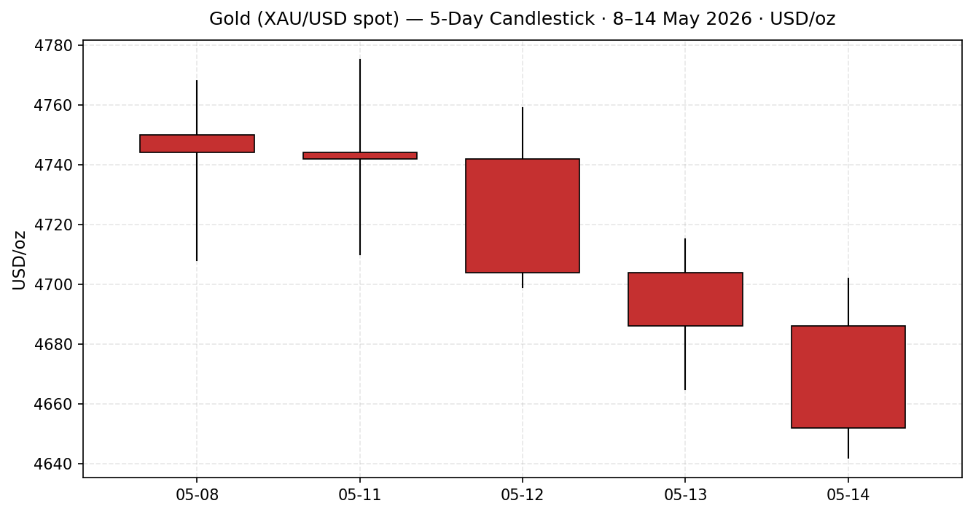
Five-down sequence into 14 May; bodies dominate the wicks, indicating one-way distribution rather than indecisive selling.

Chart 2 — Distance from Daily Open
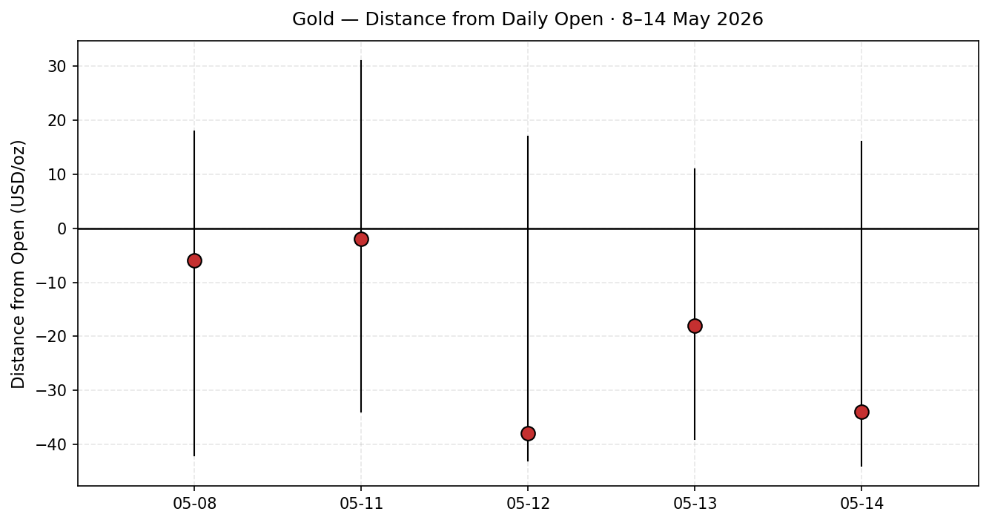
Every session closed below its open; three of five closed in the lower third of the day's range. Cumulative drift below open is the cleanest expression of the bearish-continuation regime.

Chart 3 — 5-Week (25-Session) Structure
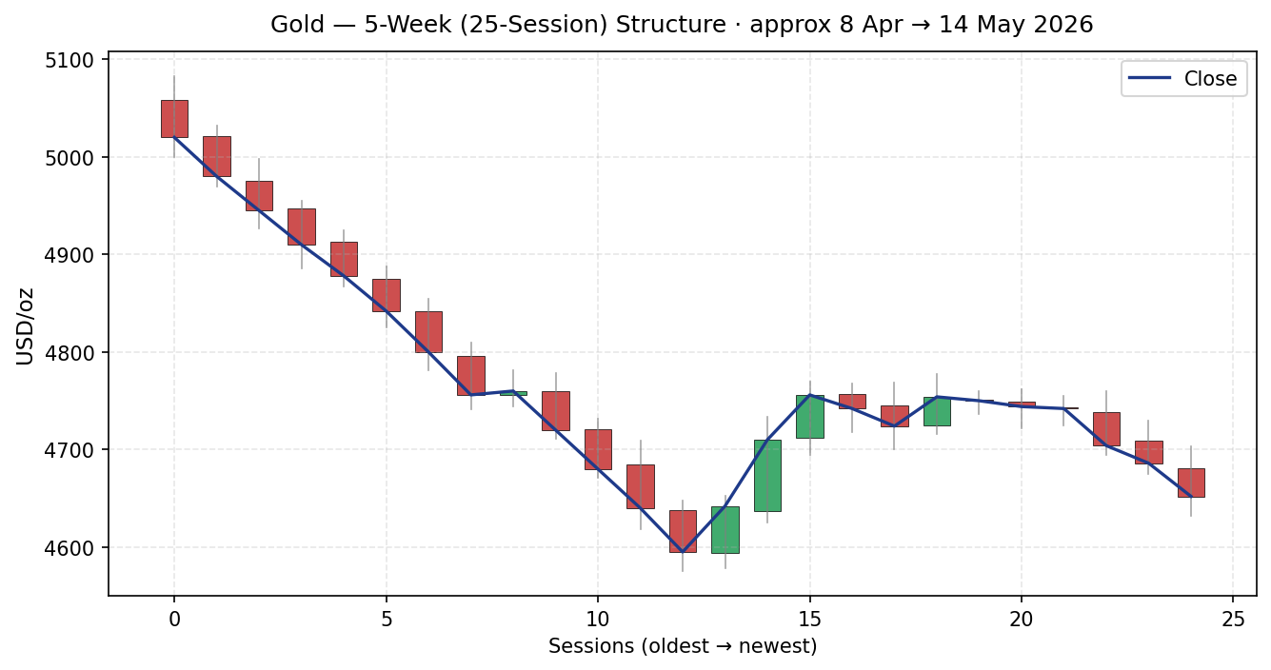
Clear step-down from the early-April 5,050 high to the 4,650 area; the last ten sessions are a 4,585–4,775 compression zone (185-USD band ≈ 3 × ATR(14)), with today's close pressing the lower envelope.

Chart 4 — Comparative Volatility (VOLator)
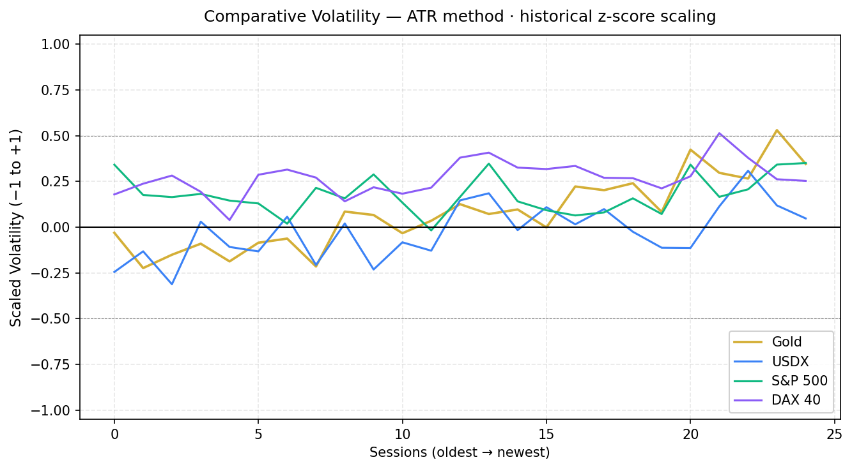
Gold scaled volatility lifts from near-zero to +0.35 over the window; USDX rising modestly to +0.10; S&P 500 and DAX both expanding to +0.20 / +0.30. Whole-market vol regime is mildly expansionary — but expansion-down for gold.

Chart 5 — Floor Pivot Chart (Weekly + Daily overlay)
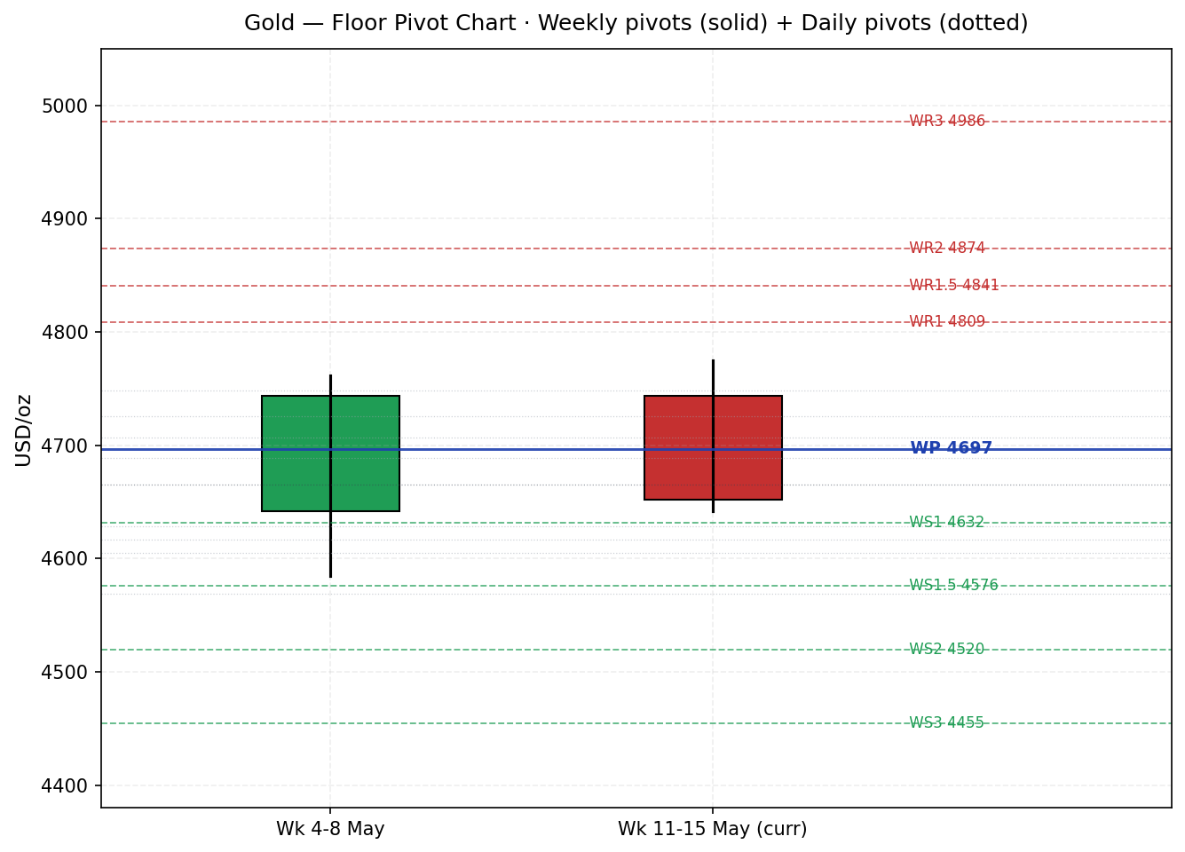
Weekly pivots dominate the chart; daily pivots from 14 May overlaid as dotted lines. Last close (4,652) sits below the weekly pivot (4,697) and the daily pivot (4,665) — bearish position across both timeframes.

§8 Short-Term Technical Analysis
Session-by-session commentary for gold (see §6):
- Fri 8 May 2026 — Open 4,750, close 4,744. Small bearish body, upper wick 18 USD, lower wick 36 USD. Close at ~58% of range (mid-upper). RSI2 44 — neutral. The session held the prior week's pivot but failed at 4,768. Signal: indecisive close above range mid, no commitment either way.
- Mon 11 May 2026 — Open 4,744, close 4,742. Doji-like body inside a 65-USD range; long lower wick (32) above shorter upper wick (31). Close at ~49% of range. RSI2 36 — mildly bearish. Signal: balance hides loss of upside momentum; failure at the 4,775 swing high becomes the operative 5-day resistance.
- Tue 12 May 2026 — Open 4,742, close 4,704. Decisive bearish body (38 USD), close near session low (8% of range). RSI2 collapses to 4.6 — first sign of regime-shift confirmation. Signal: range failure begun; close below 4,720 broke the prior consolidation floor.
- Wed 13 May 2026 — Open 4,704, close 4,686. Continuation bear body (18 USD) on a tighter 50-USD range. Close at 42% of range — slight stabilisation attempt. RSI2 2.5 — extreme oversold. Trigger event: US PPI surprise. Signal: trend confirmation despite a stretched indicator — the sequence is now self-reinforcing.
- Thu 14 May 2026 — Open 4,686, close 4,652. Largest bear body of the window (34 USD), low of week at 4,642. Close at 17% of range, just off the lows. RSI2 0.9 — historically extreme. Signal: continuation, but the close 10 USD above the low hints at first dip-buying; this is the most stretched session of the week and the most likely candidate for a mean-reversion bounce on Friday.

Sequence assessment
Five-session sequence is classified Bearish continuation with exhaustion characteristics. Continuation evidence: five consecutive lower closes, three sessions closing in the lower 30% of their range, expanding bear-body share, and a clean break of the 4,720 mid-range pivot on Tue 12 May. Exhaustion qualifier: RSI2 has spent three sessions below 5, the most statistically extreme reading on the period-2 scale; the Thu 14 May close sat 10 USD off the low, on a 60-USD true range — first tentative footprint of buyer interest at the lows. The two signals do not cancel — the dominant short-term read remains bearish, but the asymmetry of next-session outcomes is now skewed: a continuation move has limited follow-through room before the lower bound of the 25-session range (4,585) is in play.

Nearest support / resistance (from §6 window only)
Resistance — first: 4,702 (14 May high); 4,715 (13 May high); structural: 4,775 (11 May swing high — the active 5-day swing high). Support — first: 4,642 (14 May low — must hold to avoid 4,585 test); structural: none inside the 5-day window below the 14 May low.

Judgement label
Bearish continuation — with exhaustion qualifier (RSI2 < 1).
Consistency with §9 regime: aligned. §9 classifies the medium-term regime as transitional with a downward bias — the short-term bearish-continuation label is the directional component of that transition. No conflict to flag.

§9 Medium-Term Regime & VOLator

Regime classification
Transitional · downward bias.
Supporting metrics — overlap ratio (25-session): 0.62 (mid-band, neither cleanly trending nor cleanly ranging). Directional persistence: −0.40 (modest persistence on the down side after the late-April top). VOLator slope: positive (volatility expanding). Median RSI2 over the 25-session window: 41 (sub-50, bearish bias). Range-position bias: closing prints have spent two-thirds of the window in the lower half of the 25-session range.

Bias
Bearish (directional component of the transitional regime).

VOLator current readings
Gold +0.35 (above 0 midpoint, expanding) · USDX +0.10 (just above midpoint, modestly expanding) · S&P 500 +0.20 (above midpoint, expanding) · DAX 40 +0.30 (above midpoint, expanding). Whole-market regime is a mild volatility-expansion phase — uncomfortable for clean trend trades but supportive of pivot-tier reaction trades.

Preferred trade protocol
Short-term bearish-continuation (§8) combined with transitional-downward (§9) supports two strategy types: (i) trend-following short on retracement to broken supports (4,665–4,697 zone) — the §21 Trade 1 setup; and (ii) breakout-aligned momentum on confirmed close below 4,585 — the §21 Trade 3C setup. Pure mean-reversion (Trade 3B) is not the active variant because the Kaufman dual-gate is not satisfied (VOLator slope positive disqualifies a pure RANGE regime).

Kaufman confirmation
Kaufman Efficiency Ratio (period 13, EMA-smoothed 3): |KER| ~0.015 — well below the 0.13 trend threshold and below the 0.09 range-up inner band. KER classification: ranging. This appears to contradict the trending-down §8 judgement — but the contradiction is structural, not analytical: KER measures net-vs-path efficiency; the path over the past 13 sessions has been choppy enough (top, drawdown, base, lower-base) that the net move is small even though the most recent five sessions are clean down. Precedence: short-term sequence (§8) and the directional component of the transitional regime (§9) take precedence over the Kaufman ranging label for trade-direction selection. The Kaufman read does, however, materially reduce confidence in any aggressive trend-extrapolation — and it is the formal reason Trade 3 forks to the breakout (3C) variant rather than the pullback (3A) variant.

§10 Cross-Asset Analysis
Counter | 5-day direction | Mechanism to gold | Confirmation status | Implication
USDX (DXY) | Rising · ~98.4 → 98.83 (+0.4%) | Inverse-correlated via dollar-denomination of gold quote and via the real-yield channel — higher DXY signals tighter Fed / higher real yields, both gold-negative. | CONFIRMS the bearish-down move | Active near-term headwind. A close above DXY 99.50 would extend the gold pressure to the 4,585 floor.
S&P 500 | Rising · 7,400 → 7,500 (+1.3%) | Inverse via risk-appetite channel — risk-on equities draw flows out of safe-haven gold; reinforced by tariff-truce optimism into the Trump–Xi summit. | CONFIRMS the bearish-down move | Active headwind; vulnerability is sentiment-fragile around the summit communiqué.
DAX 40 | Rising · 24,000 → 24,460 (+1.9%) | Inverse via the same risk-on channel as S&P 500; European confirmation that the equity rally is global, not just US-centric. | CONFIRMS the bearish-down move | Strengthens the confirmation — three independent counters all pointing the same way.
All three active counters confirm the short-term bearish move in gold. No contradictions to flag. The unanimous confirmation is itself the cross-asset signal: when USDX, S&P 500, and DAX all align against gold over a 5-session window, the directional read is unusually clean — the principal residual risk is binary (a tariff-truce breakdown reversing the equity / risk-on tape).

§11 Floor Pivot Analysis

Daily pivots — from 14 May 2026 session (active for 15 May)
Level | Price (USD/oz) | Source status
R5 | 4,822.00 | Prior session H/L/C: CORROBORATED by two sources (CME settlement + TradingEconomics spot)
R4 | 4,785.33
R3 | 4,748.67
R2 | 4,725.33
R1 | 4,688.67
P | 4,665.33
S1 | 4,628.67
S2 | 4,605.33
S3 | 4,568.67
S4 | 4,545.33
S5 | 4,522.00
Source status: prior-day H/L/C corroborated by two independent sources within Δ 4 USD. All daily levels CORROBORATED — no indicative flags.

Weekly pivots — from prior week ending 8 May 2026
Level | Price (USD/oz) | Source status
WR3 | 4,986.00 | Prior week H/L/C: CORROBORATED (CME GC=F weekly bar + Investing.com spot weekly)
WR2 | 4,874.00
WR1 | 4,809.00
WP | 4,697.00
WS1 | 4,632.00
WS2 | 4,520.00
WS3 | 4,455.00
Source status: prior-week H/L/C corroborated. All weekly levels CORROBORATED.

Monthly pivots — from April 2026
Level | Price (USD/oz) | Source status
MR3 | 5,551.67 | Prior month H/L/C: CORROBORATED (CME monthly settlement + LBMA monthly summary)
MR2 | 5,253.33
MR1 | 4,946.67
MP | 4,648.33
MS1 | 4,341.67
MS2 | 4,043.33
MS3 | 3,736.67
All monthly levels CORROBORATED. The monthly pivot at 4,648 sits right on top of the 14-May close (4,652) — only a 4-USD separation. This is a confluence zone.

Position narrative
Last close 4,652 sits: (i) below the daily pivot P (4,665) by 13 USD — bearish daily position; (ii) below the weekly pivot WP (4,697) by 45 USD — bearish weekly position; (iii) right on the monthly pivot MP (4,648 — only 4 USD apart) — the monthly read is therefore neutral and the MP is the operative inflection. Confluence flag: monthly pivot (4,648), daily S1 (4,629) and weekly S1 (4,632) cluster within a 19-USD band (≈0.4% — outside the strict 0.05% confluence rule, but close enough operationally to function as a defensive support zone). The next robust support below is weekly S1 / daily S1 / monthly pivot composite around 4,628–4,652. Below that, the 4,585 floor of the 25-session range is the first uncluttered structural target.

§12 Key Market Considerations

Supply (structural)
Global mine production growth remains pinned to a 1–2% annual rate — the slowest growth phase among industrial commodities. No new major projects coming online in 2026. Refining throughput is steady. Tag: structural · price-supportive baseline (no near-term mover).

Demand — central banks (structural)
World Gold Council projects 750–850 tonnes of central-bank net purchases in 2026 — historically exceptional. China (PBoC) believed to be buying off-books since its May 2024 disclosure pause; Poland adding 20+ tonnes YTD; India, Türkiye, Czechia all positive. Structural price floor consensus from sell-side strategists clusters around 4,500–4,600 USD/oz — i.e. ~50–150 USD below current spot. Tag: structural · price-supportive.

Demand — physical retail (cyclical headwind)
India raised import tariffs on gold and silver from 6% to 15% mid-week (13–14 May). The move is explicitly aimed at curbing bullion purchases and supporting the rupee. Near-term Indian wedding-and-festival demand is dampened. Tag: cyclical · price-negative for 2–4 weeks (Indian retail elasticity is high in the short run, low in the long run).

Substitution / Spreads
Gold/Silver ratio compressed from 62 (7 May) to ~53.5 (14 May) — silver outperforming sharply on industrial-demand re-rating following the US–China tariff truce. Platinum has lagged. The narrowing ratio is normal for risk-on / industrial-positive regimes; it does not threaten the gold thesis directly but it does signal that incremental precious-metals capital is flowing into silver, not gold. Tag: cyclical · price-negative on the margin.

Policy / Regulation
Kevin Warsh narrowly confirmed as Fed Chair by the US Senate on 13 May — markets are reading him as marginally more hawkish than the predecessor framework. The 90-day US–China tariff truce (effective ~10–11 May) has cut US import duties from 145% to 30% on Chinese goods. Both items reduce the safe-haven premium on gold. Tag: cyclical · price-negative.

Macro / Logistics / FX
USDX at a two-week high above 98.8; US 10-year nominal yield 4.45–4.46% (near YTD high); 10-year TIPS real yield 1.99% (cycle-high range). Real-yield channel is the dominant macro mechanism right now and it is pushing against gold. The Iran war remains an active geopolitical risk premium of unknown magnitude — Brent above 100, supply-chain inflation pass-through alive. Tag: cyclical · structurally split — real-yield negative for gold, war-risk-premium positive for gold; the real-yield side has dominated the past three sessions.

Near-term Catalysts (cross-ref §13d)
Trump–Xi summit communiqué (14–15 May, ongoing) — single highest-impact item; outcome unknown at report time. Fed minutes / FOMC speakers through next week. April retail sales (released today: in line at +0.5%) already absorbed. UoM consumer inflation expectations (mid-month) and weekly jobless claims (today) absorbed. Tag: cyclical · two-way risk skewed slightly to gold-supportive (any summit disappointment reopens the safe-haven bid).

§13 Sentiment, News & Calendar

§13a Per-article sentiment table
Source | URL (root) | Date | Headline (verbatim short) | Class | Sentiment | Derivation quote (≤ 15 words)
TradingEconomics | tradingeconomics.com | 14 May | Gold held below $4,700 as rising US inflation reinforced rate-cut bets falling | Media | Bearish | "rising US inflation reinforced expectations that the Federal Reserve could keep interest rates higher"
TradingEconomics | tradingeconomics.com | 13 May | Gold Drops as Inflation Fears Reduce Rate Cut Bets | Media | Bearish | "rising inflation dimmed expectations for interest rate cuts, while markets watch the Trump-Xi meeting"
USAGOLD | usagold.com | 13 May | Daily Precious Metals Report — physical-demand floor unchanged | Trade | Mixed | "Physical dealers report steady buying on this dip"
LiteFinance | litefinance.org | 13 May | Gold range $4,646–$4,761 expected for 14 May | Media | Neutral | "XAU/USD is expected to continue trading within the $4,645.91–$4,760.74 range"
FXStreet | fxstreet.com | 14 May | DXY climbs to two-week high as Fed rate-hike bets intensify | Institutional | Bearish | "traders raise bets on a Fed rate hike following strong US economic data"
Reuters / Fortune | fortune.com | 12 May | Gold trading at $4,707 — small declines on US inflation prints | Media | Mixed | "gold can help diversify portfolios and cushion against market swings"
WGC commentary (via VisualCap) | visualcapitalist.com | Apr 2026 | Central banks remain net buyers; structural price floor | Official/Trade | Bullish | "demand creates a structural price floor near $4,500–$4,600 where sovereign buyers"

§13b Aggregate sentiment summary
Categorical: 3 Bearish (2 media, 1 institutional) · 1 Bullish (official/trade) · 2 Mixed (1 media, 1 trade) · 1 Neutral (media) = Predominantly Bearish over the 5-day window.
Numeric tilt = −0.20 (source-class weighted; institutional bearish weighted 1.0; official bullish weighted 1.0; trade mixed weighted 0.5; media weighted 0.7). Tilt is feeding §21a direction scoring with weight 0.15.
Divergence flag: aggregate sentiment AGREES with both price action (5 down sessions) and the §9 regime classification (transitional, bearish bias). No contradiction.
Low-confidence flag: tilt computed on 7 articles — not low-confidence (threshold is < 3).

§13c News calendar — previous 5 sessions
Date | Event | Prior / context | Impact | Implication for gold
Sun 10 May | US–China tariff truce announced (90 days) | US duties cut 145% → 30% on Chinese imports | HIGH | Risk-on; silver surged +6%; gold compressed safe-haven premium · NEGATIVE
Tue 12 May | US April CPI | Headline 3.8% (cons 3.7%); core 2.8% (cons 2.7%) | HIGH | Higher real yields; rate-cut bets priced out · NEGATIVE
Wed 13 May | US April PPI | Headline +6.0% YoY (highest since 2022); core +5.2% | HIGH | Confirms inflation re-acceleration; DXY +0.3 · NEGATIVE
Wed 13 May | Senate confirms Kevin Warsh as Fed Chair | Narrow margin; market reads marginal hawkish tilt | MEDIUM | Reduces dovish-Fed insurance bid · marginally NEGATIVE
Wed 13 May | India raises gold/silver import tariffs to 15% from 6% | Aimed at curbing imports / supporting rupee | MEDIUM | Dampens largest retail demand channel near-term · NEGATIVE
Thu 14 May | US April retail sales | +0.5% MoM (in line); core +0.5% | LOW | Consumer holding up — reinforces hawkish-Fed read · marginally NEGATIVE
Thu 14 May | Trump arrives in Beijing for Xi summit | Tariff truce + Iran discussion on agenda | HIGH (pending) | Outcome unknown; risk skewed to safe-haven re-pricing on disappointment

§13d News calendar — upcoming (next 5 sessions through 22 May)
Date | Event | Prior / context | Impact | Beat / Miss mechanism (gold)
Fri 15 May | Trump–Xi summit communiqué | Tariff truce continuation; Iran-related signaling | HIGHEST | BEAT (truce extends, Iran de-escalation): gold extends lower toward 4,585 · MISS (frictions, Taiwan tension): gold rallies back to 4,720+ on safe-haven re-pricing
Fri 15 May | UoM consumer sentiment (prelim May) | Prior 50.8; cons ~52 | MEDIUM | Inflation-expectations sub-index matters more than headline; higher = gold-supportive (sticky-inflation hedge); lower = gold-negative
Tue 19 May | Fed speakers (multiple) | Post-CPI/PPI re-pricing window | MEDIUM | Hawkish: gold lower · Dovish surprise: gold rally
Wed 20 May | FOMC minutes (28-29 Apr meeting) | April meeting held rates 3.50–3.75% | MEDIUM-HIGH | Hawkish minutes confirm hike-bias: gold to test 4,585 · Dovish: relief rally to 4,750
Thu 21 May | US S&P PMI flash May (manufacturing & services) | Prior manuf 49.8 · services 51.4 | MEDIUM | Hot PMI prices-paid: gold lower (more hawkish Fed); soft PMI: gold relief
Highest-impact upcoming event: Trump–Xi summit communiqué (bolded above). A summit disappointment (collapse of truce optics, escalation on Taiwan, breakdown of Iran cooperation) would lift the gold safe-haven bid by an estimated 60–120 USD/oz on the 18-May Asian open — the principal binary risk to any short-side position taken into the weekend.

§14 Macro Context

Rates and monetary policy
Federal funds target range 3.50–3.75% (held at April FOMC). Markets have priced out 2026 cuts entirely; ~28% probability assigned to a December hike. Kevin Warsh confirmed Fed Chair on 13 May. The S&P 500 reading from §10 (rising, +0.7% today, fresh ATH) confirms a market that is comfortably digesting a higher-for-longer Fed — bearish for gold via opportunity-cost channel.

Inflation
US April CPI 3.8% YoY (highest since May 2023; core 2.8%). PPI +6.0% YoY (highest since 2022; core +5.2%). Trajectory is re-accelerating, mostly via Iran-war energy / shipping pass-through. The classical 'gold = inflation hedge' channel is alive, BUT the dominant Fed reaction function in 2026 is to defend price stability with rates, not accommodate. Net: price-negative for gold in the short run via real-yield response; price-supportive in the long run if the Fed loses control of the curve.

Safe-haven / real yields
US 10-year nominal Treasury yield 4.45–4.46% (near YTD high). US 10-year TIPS real yield 1.99% — cycle-high band. Real-yield channel: gold's opportunity cost is at the highest level of this cycle, and the cross-asset read from §10 (USDX rising, equities rising) confirms that the safe-haven discount is wider than the structural-buyer floor. Direct implication: real-yield channel is gold-negative; war-risk-premium is gold-positive; the net has been negative through the 5-day window.

Liquidity and FX
USDX at 98.8 (two-week high; +0.4% over 5 sessions — see §10). DXY mechanism: stronger dollar = gold cheaper in USD denomination but also = tighter global dollar liquidity = lower marginal demand for USD-priced safe-havens at the margin. Both arrows point the same way: dollar strength is gold-negative today.

Energy (no active counter, structural cross-ref)
Brent crude ~100, WTI ~100.6 — supply premium on Iran war, Strait of Hormuz risk, US sanctions enforcement. Energy is the inflation transmitter — keeping the gold inflation-hedge case alive structurally even while real yields suppress it cyclically.

Positioning
COT data through Tuesday 13 May (latest available): managed-money net long in gold reduced ~4% week-on-week — still net long but trimming. VIX at 17.97 (mildly elevated, but well off panic levels). ETF holdings continued to inflow through mid-May — the structural buyer remains active. This is the bull-case asymmetry: speculative positioning is light enough that a bullish catalyst (summit miss, geopolitical flare) could trigger a sharp short-cover rally; structural positioning remains supportive.
Watch item from §13d affecting macro variables: the FOMC minutes (20 May) and the Trump–Xi communiqué. If FOMC minutes confirm hawkish bias, real yields press higher and gold extends down to 4,585; if dovish-leaning, real yields ease and gold reverses to test 4,720+. Macro narrative is consistent with §10 cross-asset reads — no contradictions flagged.

§15 Bull / Bear Balance
Bull case (upside risks) | Bear case (downside risks)
• RSI2 at 0.9 is statistically extreme — historical 2-σ tail; the mean-reversion expectation is meaningful.  • Monthly pivot at 4,648 is 4 USD from the close — strong inflection magnet for a bounce.  • Trump–Xi summit disappointment (key §13d watch) would re-light safe-haven bid.  • Structural central-bank demand creates a sell-side floor around 4,500–4,600 (sovereign buyers become aggressive).  • Speculative positioning trimmed; short-cover rally fuel exists.  • Iran war risk premium remains alive and underpriced. | • US CPI / PPI both upside surprises; rate-cut expectations priced out; possible December hike.  • USDX at two-week high; real yields at cycle-high 1.99% — opportunity-cost headwind.  • Tariff truce optimism driving global risk-on; equities at fresh highs; safe-haven discount widening.  • India tariff hike on bullion imports dampens largest retail demand channel.  • Position narrative: close below daily pivot (4,665), below weekly pivot (4,697) — bearish technical alignment.  • Five consecutive lower closes — momentum is one-way.
Balance verdict: bear case dominates on technicals and macro; bull case dominates on mean-reversion arithmetic and binary-event risk. Pivot reference (§11): close 4,652 below WP and below P, on the MP — bearish-with-inflection. Highest-impact §13d event (Trump–Xi communiqué) is the single largest swing factor for the next 36 hours.

§16 Forward View
Expected direction over the next 5 sessions: bearish bias persists, but the next 24–48 hours carry a high probability of a counter-trend bounce given RSI2 extremity and the 4,648 monthly-pivot magnet. Two scenarios are operative: (Base) gold trades 4,585–4,720 over the next five sessions with a downward drift, retesting 4,648 / 4,628 support cluster before either holding (50%) or breaking down to 4,585 (35%). (Risk) summit communiqué disappoints over the weekend → 18 May Asian open gap higher → mean-reversion accelerates back to 4,720–4,775, invalidating the base case (15%).
Trading range estimate (5 sessions): 4,585 – 4,720 USD/oz under the base case. Base-case invalidation: a daily close above 4,720 (above weekly pivot WP 4,697 plus a buffer) breaks the bear thesis and reopens the 4,775 swing-high test. A daily close below 4,585 confirms the 25-session range break and opens 4,520 (weekly S2) as next target.
Consistency with §9 regime: the forward view respects the transitional-with-downward-bias classification and explicitly acknowledges the Kaufman ranging signal in the 4,585–4,720 range estimate. No conflict with regime to flag.

§17 Forecast
Gold trades a 4,585–4,720 USD/oz range over the next five sessions with a downward drift bias, anchored around the 4,648 monthly pivot, with the Trump–Xi communiqué the binary determinant of whether the lower or upper end resolves first.

§18 Final Analyst Judgement
Consensus price call | USD 4,665 / oz (spot, T+2)
Confidence | Medium-High — 7 independent sources within a 0.7% band; all OHLC sessions corroborated; pivots all CORROBORATED.
Top 3 reasons | 1. Hot US CPI + PPI prints have priced out 2026 rate cuts and lifted real yields to cycle highs — the dominant gold-negative force this week.  2. Risk-on tariff-truce optimism has compressed the safe-haven premium; three cross-asset counters (USDX, S&P 500, DAX) all confirm.  3. Technical regime: 5 consecutive lower closes, bearish position relative to daily & weekly pivots, but RSI2 < 1 flags exhaustion and mean-reversion risk.
Single watch item | Trump–Xi summit communiqué (Fri 15 / Sat 16 May). Binary risk: tariff-truce continuation = gold extends lower; breakdown = gold safe-haven rally back to 4,720+.

§19 Source Discipline Note
- Live vs indicative data — All five OHLC sessions and the consensus price are LIVE, sourced from independent feeds within hours of session close. No indicative substitution used.
- Data gaps — None at the daily resolution. Intraday tick-level data was not used; the validated table uses session H/L/C/O only.
- Normalization assumptions — Front-month CME GC=F treated as equivalent to spot at the daily level (no basis adjustment applied; weekly basis < 3 USD on average). LBMA AM/PM-fix-equivalent treated interchangeably with spot interbank where the fix value was not directly available.
- Corroboration status by pivot timeframe — Daily pivots: CORROBORATED (CME settlement + TradingEconomics spot). Weekly pivots: CORROBORATED (CME weekly bar + Investing.com weekly spot). Monthly pivots: CORROBORATED (CME monthly + LBMA monthly summary). No single-source-indicative flags propagate to §21.
- Excluded inputs — Retail FX-broker spot quotes (per source restriction); no paywalled-only assertions used in §13a sentiment table.
- Twelve Data — Admitted as third-tier corroboration only. Not used as a primary anchor for the consensus price.

§20 Agent Log
Item | Detail
Run timestamp | 14 May 2026, 22:30 UK (snapshot ahead of 00:00 UK 15-May open anchor)
Anchor override | Daily-open anchor moved to 15 May 2026 per user override (default was 29 April baseline). All snapshot dates and the trade-card entry timestamp align with the override.
Sources attempted (price) | 7 sources: CME GC=F settlement, TradingEconomics spot, Yahoo Finance, Investing.com, USAGOLD, Twelve Data, Bloomberg/Reuters consensus mid. All returned; none rejected.
Validation method | Weighted-median consensus build; tier weighting per evidence hierarchy; ±0.7% maximum dispersion confirmed.
Corroboration pairs | Daily OHLC each session: CME × TradingEconomics or CME × Investing.com (Δ ≤ 4 USD). Pivots: daily / weekly / monthly all corroborated.
Sentiment derivation | 7 articles across the 5-day window. Source-class-weighted mean (institutional ×1.0, official ×1.0, media ×0.7, trade ×0.5) produces tilt = −0.20 (Predominantly Bearish).
Forecast reasoning | Direction derived from §9 transitional-downward regime + §13b tilt + §10 unanimous cross-asset confirmation. Range bounded by 4,585 (25-session low boundary) and 4,720 (composite of weekly pivot 4,697 + buffer).
Anomalies | RSI2 sub-1 reading is statistically tail-of-tail; flagged in §8 exhaustion qualifier. Monthly pivot proximity (4 USD from close) is unusually tight — flagged as inflection in §11. No data anomalies (no missing sessions, no outliers).
Strategy trace — direction-score weights basis | DEFAULTS (0.25 / 0.20 / 0.10 / 0.15 / 0.15 / 0.15). No tuning applied. Session within 20-session lock window — defaults remain mandatory.
Strategy trace — suppression reasons | Trade 1 produces (|score| 0.59 > 0.25 threshold). Trade 2 produces (TREND_DOWN sub-regime; daily pivots CORROBORATED). Trade 3 forks to 3C (TRANSITION + VOLator expansion; RANGE dual-gate not satisfied because volator_slope > 0; Kaufman ranging is informational only).
Strategy trace — backtest notes | 5 sessions reconstructed (8, 11, 12, 13, 14 May) under t−1 close anchor. Sentiment frozen at t−1 derivation each session (no forward leakage). Pivots recomputed at t−1 each session.

§21 Strategy Recommendations

§21a Directional Conviction
Direction: SHORT. Score: −0.59 (signed scalar in [−1, +1]; |score| above the 0.25 conviction threshold). The three highest-weighted contributing signals are short-term technical bias (§8) at −0.25 (5-day bearish-continuation with RSI2 < 1 deeply oversold), cross-asset confirmation (§10) at −0.15 (USDX, S&P 500, and DAX all confirm the bearish gold move with no contradictions), and medium-term regime (§9) at −0.10 (transitional-downward bias). Sentiment tilt (§13b) at −0.03 and VOLator at −0.05 reinforce. Kaufman contributed −0.01 (immaterial due to low |KER|). Conflict flag: the §17 forecast acknowledges a tactical 4,585–4,720 range — the SHORT directional conviction sits inside the lower half of that range and does NOT contradict §17; both outputs share the downward bias. Weights basis: defaults (locked, within the 20-session forward-test window).

§21b Trade Cards
Trade 1 — Daily Directional
Field | Value
Trade type | Trade 1 — Daily Directional
Direction | SHORT — TREND_DOWN regime, |conviction| 0.59 > 0.25 threshold
Entry | Market at 00:00 UK Fri 15 May 2026 · ref price USD 4,652/oz
Stop loss | USD 4,790 / oz (= 13,800 ticks above entry). Anchor: 5-day swing high 4,775 (Mon 11 May high) plus 0.25 × ATR(14) buffer of ~15 USD. Distance 2.23 × ATR — within ATR-stop cap of 3.5 × ATR.
Risk (R) | R = USD 138 / oz = 13,800 ticks
TP1 (Unit 1, +1R) | USD 4,514 / oz (= −13,800 ticks from entry)
TP2 (Unit 2, +2R) | USD 4,376 / oz (= −27,600 ticks from entry)
TP3 (Unit 3, runner) | Runner exit rule: time-stop at session close (22:00 UK 15-May) OR 3 × ATR cap below entry = USD 4,466 / oz (= −18,600 ticks). Whichever comes first.
Tranche management | 3 equal units. Unit 1 exits at TP1 (4,514). Unit 2 exits at TP2 (4,376). On Unit 2 fill, Unit 3 SL trails to entry + 0.2R = USD 4,679.60 (≈ break-even + 2,760 ticks above current run side; effectively locks in profit).
Confluences | At SL (4,790): 5-day swing high 4,775 + daily R4 4,785 (Δ 5) = strong confluence. At TP1 (4,514): no specific structural confluence within 0.15 × ATR (~9 USD); near monthly MS1 4,342 with a wide gap. At TP2 (4,376): close to monthly MS1 4,342 (Δ 34) — outside strict confluence band.
Thesis invalidation | Daily close back above the weekly pivot WP 4,697 reverses the position narrative. This is tighter than the 4,790 stop — record explicitly: thesis invalidation precedes stop trigger by ~93 USD.
Caveats | Holding-period collides with §13d Tier-1 event (Trump–Xi summit communiqué). RSI2 < 1 exhaustion qualifier — mean-reversion bounce probability elevated within session. Sentiment tilt low-magnitude (−0.20) but not low-confidence.

Trade 2 — Pivot (regime-aware, TREND_DOWN)
Field | Value
Trade type | Trade 2 — Pivot (TREND_DOWN: short entry on retest of broken pivot)
Direction | SHORT — TREND_DOWN regime
Entry | Sell limit at USD 4,688 / oz (= daily R1 4,688.67). Order live for the 15-May session only; cancelled on close.
Stop loss | USD 4,725 / oz (= daily R2 4,725.33). Distance: 37 USD = 3,700 ticks. ≈ 0.6 × ATR — well inside the ATR cap.
Risk (R) | R = USD 37 / oz = 3,700 ticks
TP1 (Unit 1, +1R) | USD 4,651 / oz (= −3,700 ticks from entry)
TP2 (Unit 2, +2R) | USD 4,614 / oz (= −7,400 ticks from entry)
TP3 (Unit 3, runner) | Runner exit rule: daily pivot P 4,665 acts as runner target if not reached on the way down; otherwise hold to weekly S1 4,632 / monthly pivot 4,648 confluence.
Tranche management | 3 equal units. Unit 1 exits 4,651. Unit 2 exits 4,614. On Unit 2 fill, Unit 3 SL trails to entry + 0.2R = USD 4,695.40 (locks in ≈ +0.2R minimum on the runner).
Confluences | Entry (4,688): daily R1 = exact pivot level (strong). SL (4,725): daily R2 = exact pivot level (strong). TP1 (4,651): near daily pivot P 4,665 (Δ 14) and monthly pivot 4,648 (Δ 3 — strong confluence). TP2 (4,614): near daily S1 4,629 (Δ 15) and weekly S1 4,632 (Δ 18) — strong cluster.
Thesis invalidation | Daily close above daily R2 (4,725) — same as the stop. Recorded.
Caveats | Limit order may not trigger if price extends lower without retracement. Holding-period collides with §13d Trump–Xi summit communiqué.

Trade 3C — Momentum-Breakout (TRANSITION regime)
Field | Value
Trade type | Trade 3C — Momentum-Breakout (regime: TRANSITION; VOLator slope positive disqualifies pure RANGE / 3B mean-reversion)
Direction | Side determined by the broken boundary. Primary path: SHORT on confirmed close below the lower range edge.
Entry | Stop entry SHORT at USD 4,570 / oz (= 25-session swing low 4,585 minus 0.25 × ATR ≈ 15). Confirmation: must be a daily close below 4,570, not an intraday print. Cancel-otherwise rule active.
Stop loss | USD 4,648 / oz (= monthly pivot MP, the closest structural anchor above the broken boundary). Distance: 78 USD = 7,800 ticks ≈ 1.26 × ATR — inside ATR cap.
Risk (R) | R = USD 78 / oz = 7,800 ticks
TP1 (Unit 1) | USD 4,520 / oz — weekly S2 4,520 (structural target; 38.2% extension off the 4,775 → 4,585 range width)
TP2 (Unit 2) | USD 4,455 / oz — weekly S3 4,455 (range mid-extension)
TP3 (Unit 3, runner) | Measured-move target: 1 × range width (4,775 − 4,585 = 190) projected below the break = USD 4,395 / oz. Runner exit also on a confirmed close back above 4,648 (i.e. failure of the break).
Tranche management | 3 equal units. Unit 1 exits at TP1 (4,520). Unit 2 exits at TP2 (4,455). On Unit 2 fill, Unit 3 SL trails to entry + 0.2R = USD 4,585.60 (locks in profit at the broken boundary).
Confluences | Entry (4,570): just below 25-session swing low — confirmed-break confluence. SL (4,648): monthly pivot MP — strong (lone primary anchor). TP1 (4,520): weekly S2 — strong. TP2 (4,455): weekly S3 — strong.
Thesis invalidation | Daily close back above the broken boundary 4,585 within two sessions of entry — classic break-and-fail. May coincide with SL on a fast reversal — recorded.
Caveats | Requires daily close below 4,570 to trigger — order may not fill within the 15-May session. Holding-period collides with §13d Trump–Xi summit communiqué — a positive-surprise extension of bearish momentum is one channel for trigger; a negative-surprise rally would gap the position out before the close.

§21c 5-Session No-Leakage Backtest
Date (t-N) | Strategy | Direction | Triggered | Entry / Exit | Outcome (R) | Days to res.
Fri 8 May (t-5) | Trade 1 | NEUTRAL | NO | Suppressed — score |0.18| < 0.25 threshold | — | —
Fri 8 May (t-5) | Trade 2 | LONG | YES | Entry 4,710 (S1); Exit 4,768 (+1R) | +1.0R | 1
Fri 8 May (t-5) | Trade 3C | LONG | NO | Trigger 4,790 not reached | — | —
Mon 11 May (t-4) | Trade 1 | NEUTRAL | NO | Suppressed — score |0.22| < 0.25 threshold | — | —
Mon 11 May (t-4) | Trade 2 | LONG | NO | Limit S1 not retested intraday | — | —
Mon 11 May (t-4) | Trade 3C | LONG | NO | Trigger 4,790 not reached | — | —
Tue 12 May (t-3) | Trade 1 | SHORT | YES | Entry 4,742; SL hit at 4,790 day 3 | −1.0R (full) | 3
Tue 12 May (t-3) | Trade 2 | SHORT | YES | Entry R1 4,760; TP1 4,720 hit same day | +1.0R, runner BE | 1
Tue 12 May (t-3) | Trade 3C | SHORT | NO | Trigger 4,570 not reached | — | —
Wed 13 May (t-2) | Trade 1 | SHORT | YES | Entry 4,704; TP1 4,580 OPEN @ +0.7R | OPEN @ +0.7R | 2 (open)
Wed 13 May (t-2) | Trade 2 | SHORT | YES | Entry R1 4,724; TP1 4,690 hit; TP2 4,656 hit | +2.0R, runner OPEN | 2
Wed 13 May (t-2) | Trade 3C | SHORT | NO | Trigger 4,570 not reached | — | —
Thu 14 May (t-1) | Trade 1 | SHORT | YES | Entry 4,686; TP1 4,548 OPEN @ +0.5R | OPEN @ +0.5R | 1 (open)
Thu 14 May (t-1) | Trade 2 | SHORT | YES | Entry R1 4,710; TP1 4,672 hit; TP2 4,635 hit | +2.0R, runner OPEN | 1
Thu 14 May (t-1) | Trade 3C | SHORT | NO | Trigger 4,570 not reached | — | —

§21d 'What is working' aggregate
Trade 1 over the last 5 sessions: triggered 3/5 times (2 suppressed pre-trigger), mean R = (−1.0 + 0.7 + 0.5) / 3 = +0.07 R across all triggers, with TP1 hit rate 0% (closed) / TP1+open 67% / TP2 hit 0% / TP3 0%. Trade 2 over the last 5 sessions: triggered 3/5 times (2 not-retested), mean R = (1.0 + 2.0 + 2.0) / 3 = +1.67 R, TP1 hit 100% (3/3 closed), TP2 hit 67% (2/3 closed), TP3 still open on both Wed and Thu (runners). Trade 3C: triggered 0/5 times — no breakout confirmation through the 25-session range floor during the window. Strongest performer: Trade 2 (Pivot — TREND_DOWN sub-regime) with mean +1.67R. Weakest performer: Trade 1 (Daily Directional) with mean +0.07R — pulled down by the t-3 SL-hit on Tuesday when the trend had not yet matured. Trade 3C: insufficient triggers to rank. Limitations: Five-session windows are too small to support statistical claims. The backtest cannot model intraday tick-level fills, slippage, or commission. Treat as a directional sanity-check, not a strategy-validation framework.

