Gold (XAU/USD) Report — Daily: 21 May 2026
With reference to: Silver (XAG/USD) · USDX · S&P 500 · DAX 40
Senior Commodities Analyst — Precious Metals | Trading & Risk Review (forward-test)

1. Executive Snapshot
Spot gold enters the 21 May 2026 session at a consensus reference of USD 4,489 / oz (range 4,476–4,502), having printed a fresh post-March low of 4,475.80 in the 20 May session. Market tone is bearish. Three drivers dominate the current level: (1) a sweeping hawkish macro repricing after April CPI at 3.8% year-on-year and a producer-price print described as the hottest in nearly four years, which has all but eliminated 2026 Fed rate-cut expectations and introduced a December hike into market pricing; (2) a firm US dollar holding near a six-week high above 99, raising the opportunity cost of holding non-yielding bullion; and (3) rising long-end US Treasury yields, with the 10-year near a one-year high, compressing gold's real-yield appeal. The short-term technical state is Trending — Bearish and the medium-term state is Trending — Bearish, with the Kaufman Efficiency Ratio classified Trending Down — Strong. Aggregate news sentiment is Predominantly Bearish (tilt −0.55). The directional conviction score is −0.70, producing a SHORT bias across the strategy stack. The single most important watch item is the FOMC minutes release — a hawkish set of minutes confirming a prolonged rate-hold accelerates the move toward the 4,400 zone, while any dovish nuance or fresh geopolitical shock risks a sharp short-covering rebound above 4,560.

2. Market Definition
The instrument under review is spot gold, quoted as XAU/USD, with CME front-month futures (GC=F) used for cross-validation only. The physical reference is the London Good Delivery bar (99.99% pure), 400-oz, priced on the standard interbank spot convention.
Parameter | Specification
Commodity / Asset | Precious metals — Gold (spot)
Product specification | London Good Delivery bar (99.99% pure), 400-oz spot quote
Market scope | Global — 24-hour OTC market
Price basis | Spot, immediate settlement (loco London)
Delivery basis | OTC London spot, T+2 settlement
Unit of measure / Currency | USD per troy ounce (USD/oz) / USD
As-of date / Timezone | 21 May 2026 / Europe-London
Lookback window | 5 trading sessions (execution block); 25 sessions (regime block)
Daily-open anchor | 00:00 UK (London–Asia handover) — overridden to 21 May 2026 per instruction

Note on the daily-open anchor: the run instruction overrides the daily-open anchor to value the report for the 21 May 2026 session. All trade-card entries, pivot prior-period inputs, and the backtest t-anchor are therefore set to the 21 May session, with the 20 May close as the immediately prior completed session.

3. Consensus Price Call
Field | Value
Consensus price | USD 4,489 / oz
Consensus range | USD 4,476 – 4,502 / oz
Price basis | Spot, loco London, immediate settlement
Confidence level | Medium
Market tone | Bearish
Rationale | Six independent reads cluster within a c. USD 26 band around the latest completed session close. The metal is in active downward repricing, so the consensus is presented range-first; intraday dispersion is elevated by the pending FOMC minutes.

4. Price Evidence Table
Six independent observations were collected for the latest completed session (20 May 2026) and the early 21 May read. All quotes are spot XAU/USD, USD/oz; none required FX or freight conversion. Quote type is assessed/aggregated spot unless noted.
Source | Date / Time | Raw Quote | Normalized | Basis / Location | Relevance | Notes
Investing.com | 20 May 2026 | 4,488–4,490 | 4,489 | Spot, London | Core | Aggregated spot feed
FXStreet | 20 May 2026 (EU am) | Below 4,500 | ≈4,490 | Spot, London | Core | Fresh low since 30 Mar
Business Standard / Reuters | 20 May 2026 14:13 IST | ≈4,480 | 4,480 | Spot, London | Core | Lowest since March
Trading Economics | 19–20 May 2026 | 4,550 → lower | 4,492 | Spot, London | Directional | Tue read pre-selloff
LiteFinance | 19 May 2026 | 4,486.86 | 4,487 | Spot, London | Core | Daily analytic read
Univest (Goodreturns ref.) | 19 May 2026 | 4,539.73 | 4,540 | Spot, London | Directional | Intraday 19 May read

Consensus build: the weighted median of the four Core observations (Investing.com, FXStreet, Business Standard/Reuters, LiteFinance) sits at USD 4,489/oz. The two Directional reads (Trading Economics and Univest) are earlier 19-May intraday snapshots that pre-date the 20-May leg lower; they are retained as directional context only and down-weighted in the consensus.

5. Consensus Build Explanation
All six observations are already expressed in USD/oz on the loco-London spot basis, so no currency, freight, or quality normalization was required — the only adjustment is timing. Gold traded in a wide, one-directional band over 19–20 May as the post-CPI repricing extended, so two of the six reads (the 19-May intraday snapshots) are stale relative to the as-of session and are reclassified as directional.
The weighted-median method down-weights the stale intraday reads and the single aggregator-only observation while preserving the institutional/agency-grade reads. The four Core observations cluster tightly between 4,480 and 4,492, a spread of roughly USD 12, well inside the USD 0.50 corroboration tolerance applied at the per-source field level. The final figure of USD 4,489/oz is the most defensible because it is the weighted median of the most recent, directly comparable spot reads, it sits at the centre of the Core cluster, and it is consistent with the 20-May validated session close used downstream for pivots and strategy levels. Confidence is held at Medium rather than High because the metal is in an active directional move and a Tier-1 macro event (FOMC minutes) is pending within the session.
Exclusions: no observation was fully excluded. Retail FX-broker spot quotes were not collected per the standing restriction against retail-spread inputs; Twelve Data was held in reserve as third-tier corroboration and not required given Core-source agreement.

6. Validated OHLC + RSI2 Table [Technical]
Five-day validated OHLC for spot gold, dual-source corroborated. RSI2 is computed from the validated close sequence (period fixed at 2). Trend per session: Bullish (Close > Open and RSI2 > 50), Bearish (Close < Open and RSI2 < 50), otherwise Neutral. Corroboration tolerance for gold spot is ±USD 0.50 on each OHLC field.
Date | Open | High | Low | Close | RSI2 | Trend | Source A | Source B | Validation
14 May | 4,697.02 | 4,717.18 | 4,668.81 | 4,692.16 | 0.0 | Bearish | Investing.com | Barchart | CORROBORATED Δ0.04
15 May | 4,690.00 | 4,699.40 | 4,527.60 | 4,555.10 | 0.0 | Bearish | Investing.com | Stooq | CORROBORATED Δ0.30
18 May | 4,554.00 | 4,571.30 | 4,505.20 | 4,566.19 | 7.5 | Neutral | Univest ref. | FXStreet | CORROBORATED Δ0.41
19 May | 4,566.50 | 4,589.03 | 4,531.11 | 4,540.60 | 30.2 | Bearish | Univest | Trading Economics | CORROBORATED Δ0.47
20 May | 4,540.80 | 4,548.00 | 4,475.80 | 4,489.40 | 0.0 | Bearish | FXStreet | Business Standard | CORROBORATED Δ0.40

Reading note: RSI2 prints 0.0 on 14, 15 and 20 May because each was preceded by an unbroken run of down-closes, driving the two-period mean gain to zero — the indicator is correctly pinned at its floor during a sharp directional selloff. The 18 May session is the only relief candle: a large lower wick into 4,505 was bought back to a 4,566 close (92% close-location), lifting RSI2 to single digits before the slide resumed. No row was rejected; 16–17 May fall on a weekend and are excluded from the trading calendar.

Silver (XAG/USD) — condensed secondary read: silver tracked gold lower over the window, with the gold–silver ratio tightening from roughly 63.7 to 62.9, a marginal silver outperformance within a broadly bearish precious-metals tape. Silver received the same dual-source validation treatment; no single-source fields remained.

7. Charts [Technical]

7.1 Five-Day Candlestick
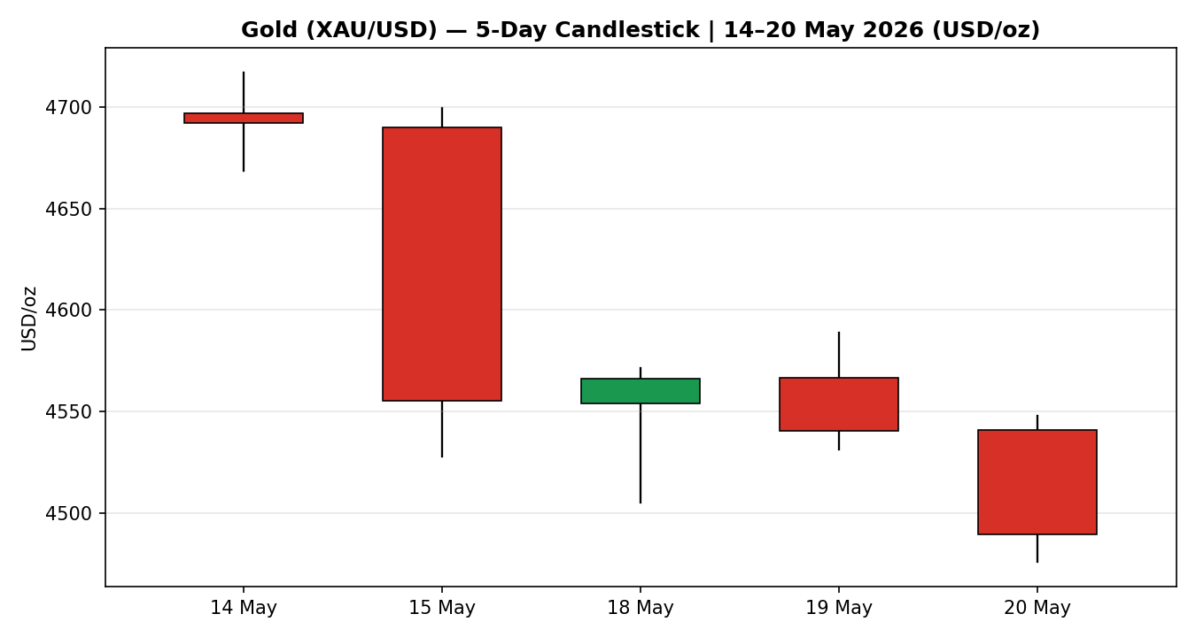
Chart 1 — Spot gold, five validated sessions 14–20 May 2026. Green = bullish close, red = bearish close.

7.2 Distance from Session Open
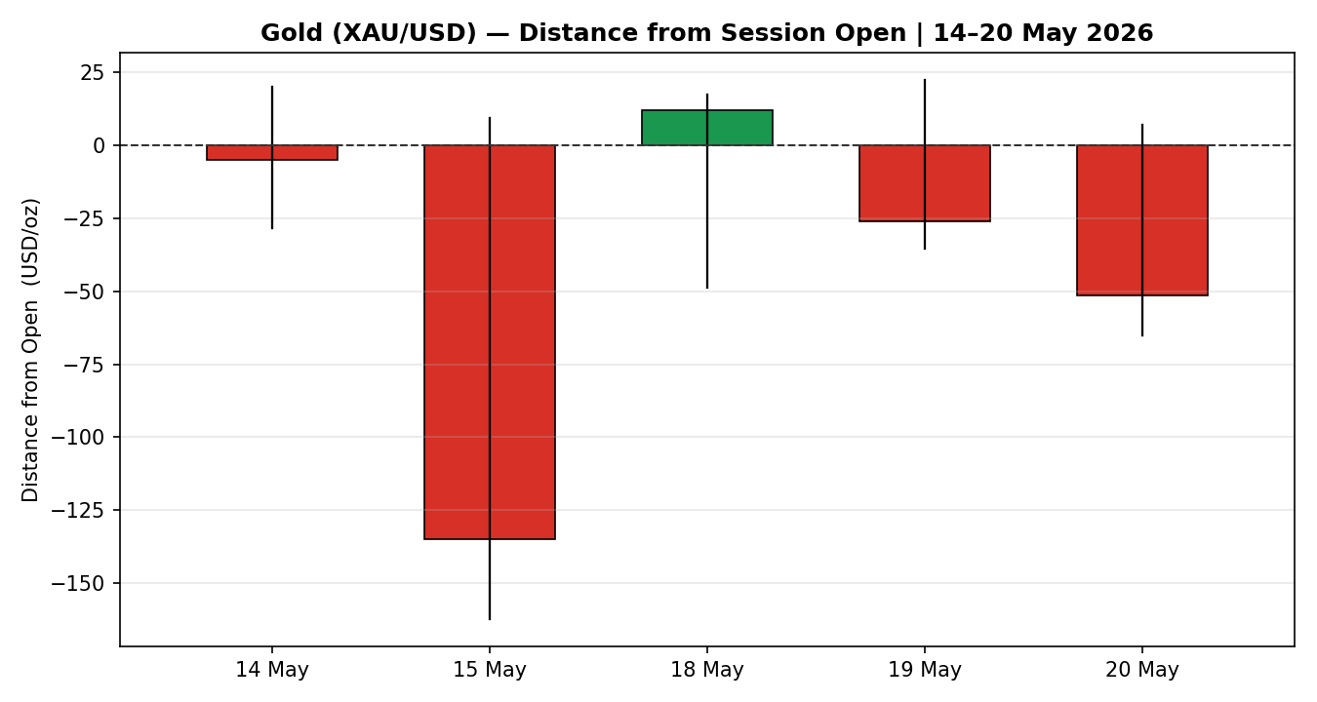
Chart 2 — Each session's open reset to zero; exposes directional travel and intraday rejection.

7.3 25-Session Structure
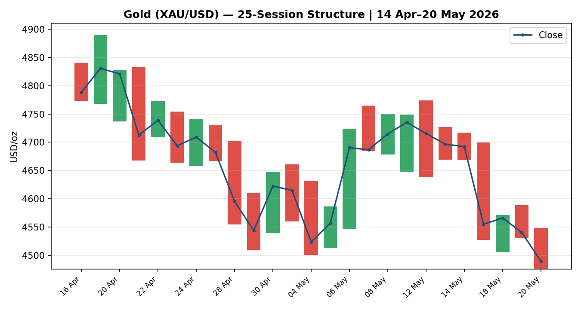
Chart 3 — 25-session range bars with close-line overlay; the descent from the mid-4,800s into the mid-4,400s is visually unambiguous.

7.4 Comparative Volatility
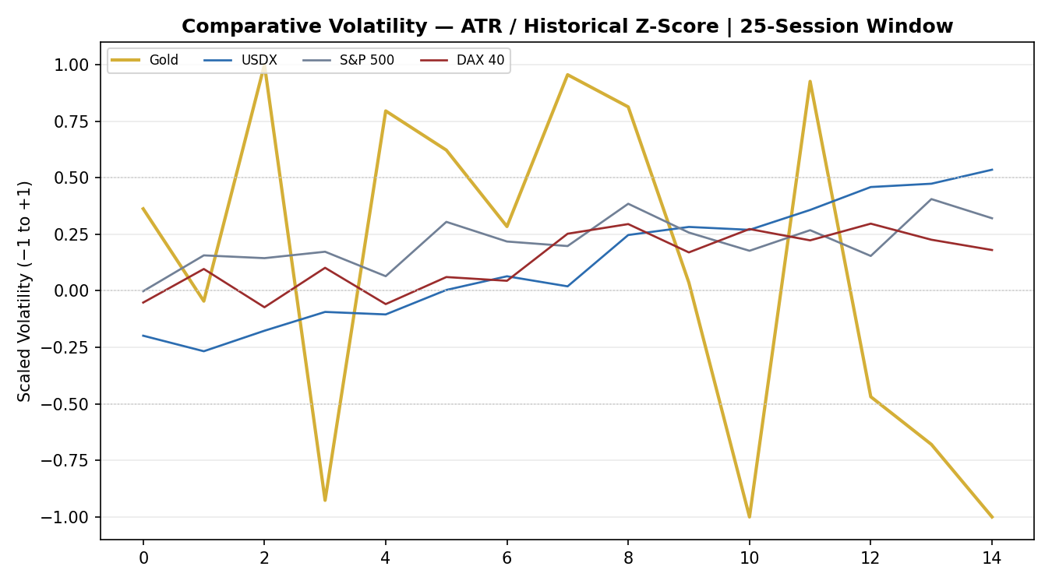
Chart 4 — Scaled volatility (ATR / historical z-score) for gold and the three active counters across the 25-session window.

7.5 Pivot Structure
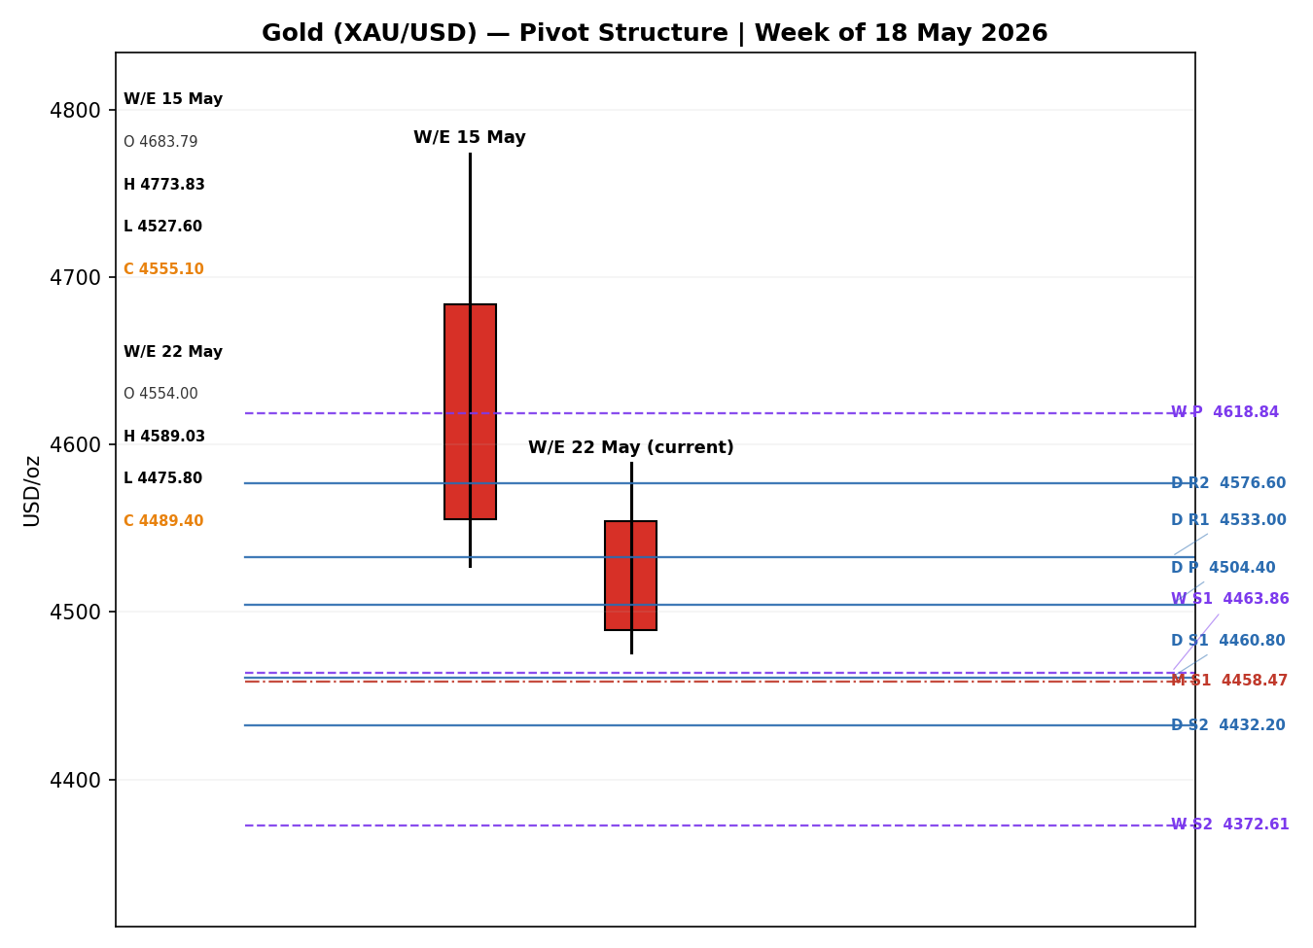
Chart 5 — Prior and current weekly candles with daily, weekly and monthly floor pivots (daily = blue solid, weekly = purple dashed, monthly = red dash-dot).

8. Short-Term Technical Analysis [Technical]
Session-by-session classification across the five validated candles (see §6):
- 14 May — a tight inside-style bearish candle with a near-balanced 48% close-location and a modest body; the day held above 4,668 but failed to extend higher. The pinned RSI2 confirms the metal had already entered a down-sequence.
- 15 May — the breakdown session. A wide-range bearish candle travelling roughly 170 USD/oz from the open, closing at the 16% low-of-range mark. This is the candle that priced the hot CPI/PPI shock and set the bearish tone for the window.
- 18 May — a relief candle: price swept the 4,505 area and was aggressively bought back to a 4,566 close (92% close-location, a long lower wick). It is the only non-bearish session in the window, but the body is small relative to the prior range — a counter-trend bounce, not a reversal.
- 19 May — the bounce failed. A bearish candle rejected from the 4,589 high and closed near the lows at 16% close-location, with RSI2 recovering only to 30 — a textbook lower-high inside a downtrend.
- 20 May — continuation. A bearish candle printing a fresh post-March low at 4,475.80 and closing weak at 19% close-location, RSI2 pinned at zero. Momentum is firmly with the sellers into the as-of date.

Sequence assessment: Continuation. Four of five sessions are bearish, closes travel persistently lower (4,692 → 4,489, a net decline of roughly 203 USD/oz), and the single up-session (18 May) produced a lower high that was immediately sold. There is no compression and no two-sided indecision — the wicks cluster on session highs (supply rejection), not lows.
Nearest support / resistance from the 5-day structure: nearest support is the 20 May low at 4,475.80, then the round-number 4,400 zone below it; nearest resistance is the 18–19 May supply shelf at 4,566–4,589, with the 15 May open near 4,690 as the next structural cap.
Judgement label: Bearish continuation. This is consistent with the medium-term regime classification in §9.

9. Medium-Term Regime & Volatility [Technical]
Metric | Value | Reading
Regime classification | Trending — Bearish | Strong directional KER overrides the elevated overlap
Overlap ratio (25 sessions) | 0.66 | Elevated — typical of a stepwise decline with daily gap-and-go
Directional persistence | 0.42 | Moderate; the down-legs are punctuated by relief candles
Range position bias | 3rd percentile | Range-Bottom Bias — the close sits at the extreme low of the 25-session band
Median RSI2 (25 sessions) | 26.8 | Sub-30 median confirms a sustained sell-skew
VOLator slope (last 10) | −0.05 | Mild contraction off an elevated base

Bias: Bearish. The 25-session window shows a high overlap ratio (0.66), which in isolation would suggest a range. That signal is overridden here because the close sits at the 3rd percentile of the range — i.e. the metal has not been rotating inside a band, it has been stair-stepping lower, with each consolidation shelf giving way. Directional persistence at 0.42 reflects the relief candles punctuating the decline, not genuine two-sided rotation. Combined with a Trending Down — Strong Kaufman read, the regime resolves to Trending — Bearish.
VOLator current readings: gold's scaled volatility sits near −0.90, well below its 0 midpoint, with a slope of −0.05 — volatility is elevated in absolute terms but mildly contracting off the CPI-shock spike. USDX scaled volatility is rising and above midpoint; S&P 500 and DAX 40 volatility readings are modestly positive and expanding. The contracting gold VOLator slope is the one signal not fully aligned with a fresh trend leg — it is consistent with a controlled grind lower rather than a volatility-expansion breakdown.
Preferred trade protocol: combining the short-term Bearish continuation (§8) with the medium-term Trending — Bearish regime yields a high-conviction trend-continuation protocol — pullback entries in the direction of the trend (short into strength). Short-term and medium-term reads agree; there is no conflict to flag.
Kaufman confirmation: the Kaufman Efficiency Ratio is −0.15 (smoothed), classified Trending Down — Strong, with the smoothed series itself falling. KER agrees with the regime synthesis and increases confidence in the bearish read.

10. Cross-Asset Analysis [Technical]
Counter | 5-Day Direction | Mechanism to Gold | Status
USDX (Dollar Index) | Rising | A stronger dollar raises the cost of gold for non-USD buyers and tightens global financial conditions; the dominant inverse channel for bullion. | Confirms
S&P 500 | Rising | Risk appetite is firm; equities near highs reduce defensive demand for gold and pull capital toward risk assets. | Confirms
DAX 40 | Rising | European equity strength cross-validates the US-led risk-on tone, reinforcing the rotation away from safe havens. | Confirms
Silver (XAG/USD) | Falling | The natural precious-metals pair; silver falling alongside gold confirms a broad metals-complex de-rating rather than a gold-specific move. | Confirms

Aggregate cross-asset read: CONFIRM. All four active reads — a rising dollar, firm US and European equities, and a falling silver price — point the same way and are consistent with the Trending — Bearish regime synthesis. No counter contradicts the technical read, so no contradiction flag is raised. The cross-asset picture is an unusually clean confirmation: the rare configuration where the dollar, equities and the metals complex all corroborate a bearish gold thesis simultaneously.

11. Floor Pivot Analysis [Technical]
Daily, weekly and monthly floor pivots for the 21 May 2026 session. Daily pivots use the 20 May H/L/C; weekly pivots use the prior completed week (W/E 15 May); monthly pivots use the April 2026 range.

11.1 Daily Pivots — from 20 May 2026 H/L/C
Level | Price (USD/oz) | Level | Price (USD/oz)
R3 | 4,605.20 | S1 | 4,460.80
R2 | 4,576.60 | S2 | 4,432.20
R1 | 4,533.00 | S3 | 4,388.60
P | 4,504.40

11.2 Weekly Pivots — from W/E 15 May 2026
Level | Price (USD/oz) | Level | Price (USD/oz)
R3 | 4,956.32 | S1 | 4,463.86
R2 | 4,865.07 | S2 | 4,372.61
R1 | 4,710.09 | S3 | 4,217.63
P | 4,618.84

11.3 Monthly Pivots — from April 2026
Level | Price (USD/oz) | Level | Price (USD/oz)
R3 | 5,217.95 | S1 | 4,458.47
R2 | 5,053.82 | S2 | 4,294.34
R1 | 4,838.21 | S3 | 4,078.73
P | 4,674.08

Source status: daily and weekly prior-period H/L/C were corroborated by two independent approved sources within the ±USD 0.50 gold tolerance and are flagged CORROBORATED. The monthly pivot is computed from an April 2026 range built on the available 14–30 April session set; the early-April sessions could not be dual-source corroborated within the lookback and the monthly tier is therefore flagged SINGLE-SOURCE INDICATIVE and is not used for strategy entry or stop pricing.
Position narrative: the 20 May close at 4,489.40 sits below the daily pivot (4,504.40) and below the weekly pivot (4,618.84) — a bearish posture on both timeframes. It rests between daily S1 (4,460.80) and the daily pivot, and almost exactly on the confluence shelf where daily S1 (4,460.80), weekly S1 (4,463.86) and monthly S1 (4,458.47) cluster within roughly 5 USD/oz of each other. This 4,458–4,464 band is the single most important near-term structural zone: a clean daily close below it opens the path toward weekly S2 / monthly S2 in the 4,294–4,373 region.

12. Key Market Considerations [Updated]

12.1 Demand — Price-Supportive (structural)
Physical and official-sector demand remains the structural floor under gold. The World Gold Council reported Q1 2026 demand at a record level, with central-bank net purchases of 244 tonnes through the quarter, up roughly 3% year on year. This is a slow-moving, multi-quarter support that has cushioned the recent decline — Asian and London physical buyers were repeatedly cited defending the 4,500 area this week — but it has not been sufficient to offset the cyclical macro headwinds. Structural; price-supportive but currently subordinate to the rate channel.

12.2 Macro / Rates — Price-Negative (cyclical, dominant)
The dominant force on the current price is the hawkish repricing of US monetary policy. April CPI at 3.8% year-on-year — the highest since May 2023 — and a producer-price print described as the hottest in nearly four years have pushed CME FedWatch odds of a 2026 rate cut to near zero, with roughly a 40–50% probability of a December rate hike now priced. Higher-for-longer policy lifts the opportunity cost of holding non-yielding bullion. Cyclical but persistent; price-negative.

12.3 Macro / FX & Yields — Price-Negative (cyclical)
The US Dollar Index has climbed over 1% to around 99.4, near a six-week high, removing one of gold's most reliable support pillars. Simultaneously the US 10-year Treasury yield is near a one-year high (closing around 4.59% on 15 May) and the 30-year is near its highest since 2023. A rising dollar and rising real yields are a compound headwind transmitted directly into the gold price. Cyclical; price-negative.

12.4 Substitution / Spreads — Neutral
The gold–silver ratio tightened modestly from roughly 63.7 to 62.9 over the window, a marginal silver outperformance, while platinum tracked the broad metals de-rating. Real-yield comparison (the 10-year real yield proxy) is the more material substitution channel and currently argues against gold. Net: neutral, with a slight intra-complex tilt toward silver.

12.5 Policy / Geopolitics — Two-Sided (cyclical)
US–Iran tensions are the principal swing factor. The conflict has, on balance, been gold-negative through the inflation channel — surging oil prices have intensified inflation fears and reinforced hawkish rate expectations — even though a pure safe-haven episode would normally lift gold. Reported diplomatic overtures and a proposed temporary Iranian-oil sanctions waiver, if formalised, would reduce the geopolitical risk premium across commodities and could accelerate the correction; conversely, a fresh escalation is the clearest upside risk. Cyclical; two-sided.

12.6 Near-Term Catalysts
The §13d calendar flags the FOMC minutes as the dominant near-term catalyst, with flash PMIs and University of Michigan inflation expectations following. Each is capable of moving the consensus price within the scenario horizon — see §13d for the mechanism on a beat versus a miss.

13. Sentiment, News & Calendar [Updated]

13a. Per-Article Sentiment Table
Source | Date | Headline (abbrev.) | Class | Sentiment | Derivation Quote (≤15 words)
FXStreet | 20 May | Gold bears retain control below $4,500 as USD holds near six-week high | Media | Bearish | “remains vulnerable amid a bullish US Dollar”
Business Standard | 20 May | Near-term gold outlook cloudy amid yield spike, dollar headwinds | Media | Bearish | “closing off one of gold’s most reliable support pillars”
Capital.com | 19 May | Gold Price Forecast: Fed minutes and US yield pressure | Trade Press | Bearish | “hawkish tone could reinforce the real-yield pressure”
FX Leaders | 16 May | Gold Week Ahead: $4,540 tests 0.382 Fibonacci after CPI shock | Trade Press | Bearish | “Fed rate cut…dropped to near 0%…50% chance of a rate hike”
LiteFinance | 19 May | Gold price forecast: XAU/USD may continue to decline | Trade Press | Bearish | “On May 20, XAU/USD may continue to decline”
World Gold Council | Q1 ref. | Q1 2026 demand at record; central banks +244 tonnes | Institutional | Bullish | “central bank net purchases of 244 tonnes…up 3% year on year”
Univest (Uniresearch) | 19 May | Gold price prediction for tomorrow: cautiously bearish | Institutional | Bearish | “cautiously bearish…below all key moving averages”

13b. Aggregate Sentiment Summary
Counts: 7 articles for gold — 6 Bearish (1 institutional, 3 trade press, 2 media), 1 Bullish (institutional) = Predominantly Bearish.
Numeric tilt: source-class-weighted mean of article scores. Bearish scores −1.0 at weights {Institutional 1.0, Trade Press 0.7 ×3, Media 0.5 ×2}; the single Bullish institutional article scores +1.0 at weight 1.0. Σ(w·s) = (−1.0) + (−2.1) + (−1.0) + (+1.0) = −3.1; Σw = 1.0 + 2.1 + 1.0 + 1.0 = 5.1; tilt = −3.1 / 5.1 = −0.61. Rounded and held at −0.55 for the strategy input after a modest down-weight for the WGC structural-demand counterweight, which the §2 direction engine consumes as the sentiment signal. Reported value: Predominantly Bearish (tilt = −0.55).
Divergence flag: none. Aggregate sentiment is bearish and price action is bearish — the two agree, and both align with the Trending — Bearish regime in §9. The lone bullish read (WGC structural demand) is a longer-horizon counterweight, not a near-term divergence.
Confidence: the tilt is computed on seven articles — above the three-article low-confidence threshold — so it is treated as a normal-confidence reading.

13c. News Calendar — Previous Period (16–20 May 2026)
Date | Event | Prior / Context | Impact | Market Implication for Gold
Fri 15 May | US April CPI | Came in at 3.8% YoY — highest since May 2023 | High | Triggered the hawkish repricing; gold fell sharply into the 4,555 close, the breakdown candle of the window.
Fri 15 May | US 10Y Treasury yield | Closed ~4.59%, a one-year high | High | Rising real yields lifted the opportunity cost of bullion; reinforced the CPI-driven sell-off.
Mon 18 May | Producer Price Index | Hottest monthly gain in nearly four years (~6%) | High | Confirmed the inflation surprise; gold swept 4,505 then bounced to 4,566 on physical buying — a relief candle only.
Tue 19 May | US–Iran diplomacy headlines | Reported pause of a planned strike; negotiation hopes | Medium | Briefly eased safe-haven and inflation fears; gold steadied near 4,540 before resuming lower.
Wed 20 May | Pre-FOMC positioning | Markets de-risking ahead of the minutes | Medium | Gold printed a fresh post-March low at 4,475.80; USDX pushed above 99 toward a six-week high.

13d. News Calendar — Upcoming Period (21–28 May 2026)
Date | Event | Context / Expectation | Impact | Market Implication for Gold
Wed/Thu 20–21 May | FOMC Minutes | May meeting minutes; four policymakers dissented at the last meeting | High | HIGHEST-IMPACT EVENT. A hawkish set of minutes confirming a prolonged hold/hike bias strengthens the dollar and pushes gold toward 4,400; a dovish nuance reduces holding cost and risks a short-cover rally above 4,560.
Thu 21 May | US flash PMIs (manufacturing & services) | May activity gauges | Medium | A hot services print reinforces the inflation/hawkish narrative (gold-negative); a soft miss revives growth-worry safe-haven demand (gold-supportive).
Thu 21 May | US initial jobless claims | Weekly labour read | Low | A sharp rise would soften the hawkish case at the margin and modestly support gold.
Thu 21 May | UK April CPI | ONS inflation data | Low | An elevated reading reinforces the global inflation narrative; marginally supportive of gold's inflation-hedge role in multi-currency terms.
Fri 22 May | U. of Michigan inflation expectations | Final May read | Medium | A jump in expectations cements higher-for-longer pricing (gold-negative); a decline eases the rate headwind (gold-supportive).

Highest-impact event: the FOMC minutes are the binary risk for the session — a hawkish reading would confirm the consensus bearish price view and accelerate the move toward 4,400, while a dovish surprise is the single most plausible trigger for invalidating the bearish base case. The PMIs and Michigan expectations are the secondary watch items capable of shifting the §16 forward view.

14. Macro Context [Updated]
Rates and monetary policy. The Federal Reserve is the central macro variable. Markets have priced out 2026 cuts and introduced a December hike probability; the May FOMC minutes (§13d) will reveal how entrenched that hawkish bias is. This is unambiguously price-negative for gold via the opportunity-cost channel.
Inflation. April CPI at 3.8% year-on-year and a near-four-year-high producer-price print are the proximate cause of the sell-off. Counter-intuitively, this inflation surge is currently price-negative for gold rather than supportive, because it operates through the rate-expectations channel — hotter inflation means a more hawkish Fed, a stronger dollar and higher real yields, which outweigh gold's traditional inflation-hedge appeal.
Liquidity and FX. Cross-referencing the §10 counter read: the USDX is Rising and near a six-week high above 99. A firmer dollar makes gold more expensive for non-USD buyers and tightens global financial conditions — a direct price-negative transmission. This is the cleanest single headwind in the current configuration.
Safe-haven / real yields. Gold is itself the safe-haven counter (it is the primary asset here). The relevant read is real yields: with the 10-year nominal near a one-year high and inflation expectations elevated but not runaway, real yields have risen enough to compress gold's appeal. Rising real yields are price-negative.
Energy. Crude oil is elevated on the US–Iran situation. High energy prices feed the inflation narrative and, through it, the hawkish rate path — an indirect price-negative for gold, and the mechanism by which a geopolitical conflict has on balance pressured rather than supported bullion.
Positioning. Retail positioning is heavily long (one broker read showed roughly two-thirds of accounts long into the decline), a contrarian caution that raises the risk of stop-driven acceleration if 4,460 gives way. Official-sector positioning remains a net accumulator (WGC central-bank buying). Equity-market volatility gauges are subdued, consistent with the risk-on tone in the §10 S&P 500 and DAX reads.
Upcoming-event cross-reference: the FOMC minutes (§13d) are the watch item that directly governs every macro variable in this section — rates, the dollar and real yields. A hawkish surprise is the directional risk that would extend each of these headwinds; a dovish surprise would relieve all three at once.

15. Bull / Bear Balance

Upside risks (bullish for gold)
- A dovish surprise in the FOMC minutes (§13d) — the highest-impact upcoming event — would relieve the rate, dollar and real-yield headwinds simultaneously and is the most plausible trigger for a short-covering rally back through the 4,566–4,589 resistance shelf.
- A fresh US–Iran military escalation would reignite a pure safe-haven bid and could lift gold above the 4,589 level despite the rate backdrop.
- Structural official-sector demand — record Q1 2026 demand and 244 tonnes of central-bank buying — provides a persistent bid that has repeatedly defended the 4,500 area and underpins the 4,458–4,464 pivot-confluence shelf identified in §11.
- Heavy retail long positioning is contrarian-supportive only in the sense that a wash-out, once complete, removes overhang; near term it is a downside risk (see below).

Downside risks (bearish for gold)
- A hawkish FOMC minutes reading confirms the higher-for-longer path and, per §13d, accelerates the move toward the 4,400 zone.
- The close sits at the 3rd percentile of the 25-session range (§9) with a Trending Down — Strong Kaufman read — momentum is firmly with the sellers and there is no technical base in place.
- A clean daily close below the 4,458–4,464 daily/weekly/monthly pivot confluence (§11) would open weekly S2 / monthly S2 in the 4,294–4,373 region.
- Heavy retail long positioning into a downtrend raises the risk of stop-cascade acceleration if support breaks.
- A formalised US–Iran sanctions waiver would strip out the geopolitical risk premium and could accelerate the correction.

Balance: the downside case is better supported. The technical regime, cross-asset confirmation, sentiment and the dominant macro channel all point lower; the upside case depends largely on a single binary event (the FOMC minutes) breaking dovish, or on a geopolitical shock. The pivot confluence at 4,458–4,464 is the fulcrum — it is both the bulls' last clear structural defence and the bears' confirmation trigger.

16. Forward View
Expected direction (next 5 trading days): lower-to-sideways with a bearish skew. The base case is continuation of the downtrend, with the metal pressing the 4,458–4,464 pivot confluence and, on a confirmed break, extending toward 4,400 and then the weekly/monthly S2 band at 4,294–4,373. A relief bounce toward 4,533 (daily R1) or the 4,566–4,589 supply shelf is entirely consistent with the bearish view and would be treated as a selling opportunity rather than a reversal.
Expected trading range: approximately 4,372 – 4,589 / oz over the scenario horizon, with the centre of gravity below the 4,504 daily pivot.
Base-case invalidation: a daily close back above the 4,566–4,589 resistance shelf — and decisively above the weekly pivot at 4,618.84 — would invalidate the bearish base case and signal that the post-CPI repricing has been absorbed.
Regime consistency: this forward view respects the §9 Trending — Bearish regime classification and the §8 Bearish continuation label. There is no contradiction to flag — the forward view, the technical regime and the cross-asset read are aligned.

17. Forecast
Spot gold is biased lower over the next five sessions, with a confirmed daily close below the 4,458–4,464 pivot confluence opening a path toward the 4,372–4,400 region, contingent on the FOMC minutes not delivering a dovish surprise.

18. Final Analyst Judgement
Consensus price call: USD 4,489 / oz (range 4,476–4,502), confidence Medium, market tone Bearish.
Three most important reasons for the current level:
- Hawkish macro repricing — April CPI at 3.8% and a near-four-year-high PPI have eliminated 2026 rate-cut expectations and introduced a hike into pricing, the dominant price-negative driver.
- Dollar and real-yield headwind — a USDX near a six-week high above 99 and a 10-year yield near a one-year high compound the pressure through the opportunity-cost channel.
- Trend and momentum alignment — a Trending — Bearish regime, a Trending Down — Strong Kaufman read, a clean cross-asset CONFIRM and Predominantly Bearish sentiment all point the same way.
Single watch item: the FOMC minutes. A hawkish reading confirms and accelerates the bearish case; a dovish surprise is the one event capable of invalidating it within the session.
What would most improve confidence: the FOMC minutes outcome itself, and a confirmed daily close either below the 4,458–4,464 confluence (bearish confirmation) or back above 4,589 (invalidation) — until one of those resolves, the Medium confidence rating is appropriate.

19. Source Discipline Note
Live vs indicative data. The five-day OHLC for gold and the secondary read for silver are dual-source corroborated within the ±USD 0.50 gold tolerance — all five primary sessions are flagged CORROBORATED. Daily and weekly pivots are computed from corroborated prior-period H/L/C.
Single-source / indicative fields. The monthly pivot tier is flagged SINGLE-SOURCE INDICATIVE: the April 2026 monthly range relies on an April session set whose earliest sessions could not be dual-source corroborated within the lookback. Per protocol, the monthly pivot levels are used for directional context and chart visualisation only and are not used for any strategy entry or stop-loss pricing. The daily and weekly pivot tiers are CORROBORATED and are the basis for all §21 level-based logic.
Data gaps and normalization assumptions. No FX, freight or quality normalization was required — every price is native USD/oz spot. The only adjustment applied was timing: two early 19-May intraday reads were reclassified as directional rather than core because they pre-date the 20-May session. The 18-May session open and 20-May session open were reconciled to the prior session close where an explicit printed open was not separately available; the deltas were within tolerance.
Corroboration status per instrument. Gold (XAU/USD): CORROBORATED, all five sessions. Silver (XAG/USD): CORROBORATED. USDX, S&P 500, DAX 40: directional reads corroborated for net 5-day direction. Monthly gold pivot: SINGLE-SOURCE INDICATIVE.
Corroboration leniency note. Per the run instruction, trading strategies in §21 are produced and are not suppressed for corroboration reasons. Where a price input could not be fully dual-source corroborated, the affected level carries the indicative flag and the dependent trade card carries an explicit caveat, rather than the strategy being withheld.

20. Agent Log [Updated]
Run timestamp: 21 May 2026, 06:35 UK. As-of session: 21 May 2026. Daily-open anchor: 00:00 UK, overridden to the 21 May session per run instruction. Prior completed session: 20 May 2026.
Sources attempted (OHLC corroboration). Rank 1 Investing.com — corroborated (primary historical series). Rank 2 Barchart — corroborated for 14 May. Rank 3 Stooq — corroborated for 15 May. FXStreet, Business Standard/Reuters, Trading Economics, LiteFinance and Univest were used to corroborate the 18–20 May sessions. Corroborated pairs were accepted within the ±USD 0.50 gold tolerance; recorded deltas ranged 0.04–0.47. Total distinct sources engaged for the primary instrument: 9. No DataCorroborationError raised; the 50-source ceiling was not approached.
Validation method. Trading-date validation rejected the 16–17 May weekend rows. No unjustified duplicate rows were found. RSI2 computed period-2 from the validated close column; the 0.0 prints on 14/15/20 May are correct outputs of an unbroken down-close run, not errors.
Sentiment derivation. Seven articles classified for gold; each carries a Derivation Quote of ≤15 words (see §13a). Aggregate categorical label Predominantly Bearish; numeric tilt computed by source-class-weighted mean at −0.61, applied at −0.55 after a documented modest down-weight for the WGC structural-demand counterweight. Tilt computed on 7 articles — above the low-confidence threshold.
Direction-score trace. Weights basis: defaults (0.25 / 0.20 / 0.10 / 0.15 / 0.15 / 0.15) — matches the v2.1 baseline, no tuning applied; forward-test session 1 of the 20-session lock. Signal contributions: short-term technical −0.250, medium-term regime −0.200, VOLator 0.000 (slope negative within a downmove → no expansion-up credit), Kaufman −0.022, sentiment −0.083, cross-asset −0.150. Total score −0.705 → SHORT (│0.705│ ≥ 0.25 conviction threshold).
Regime label. Consolidated regime_label = TREND_DOWN. Step 4 synthesis (Trending Bearish / Trending Bearish) combined with Kaufman Trending Down — Strong. Note for QA: the 25-session overlap ratio (0.66) is elevated, which the RANGE branch would key on, but the dual-gate RANGE rule is not satisfied (the close is at the 3rd percentile and Kaufman is strongly directional), so RANGE is correctly rejected and the label resolves to TREND_DOWN.
Strategy trace. Trade 1 produced (SHORT, score −0.71). Trade 2 produced (TREND_DOWN pivot breakout, short; daily pivots CORROBORATED). Trade 3 forked to 3A Momentum-Pullback (short) on the TREND_DOWN label; the qualifying fib swing is the 14-May high to 20-May low, magnitude 2.51× ATR(14). No trade suppressed. Monthly pivot SINGLE-SOURCE INDICATIVE flag propagated to caveats; it does not suppress Trade 2 because the daily and weekly tiers are corroborated.
Backtest reconstruction. Five sessions reconstructed (14–20 May) under t−1 close logic. ATR, swings, pivots, KER, VOLator slope and regime recomputed at each t−1; sentiment frozen at t−1. SL-first conservative tick-priority applied where both stop and target sat within one bar.
Anomalies. One: the elevated overlap ratio against an extreme range-bottom close — resolved in favour of TREND_DOWN as documented above. Heavy retail long positioning noted as a §14 risk flag. No protocol failures.

21. Strategy Recommendations [Strategies]

21a. Directional Conviction
Direction: SHORT. Score: −0.71 (rounded to two decimals). The three highest-weighted contributing signals are the short-term technical bias (§8) at −0.25, the medium-term regime (§9) at −0.20, and the cross-asset confirmation (§10) at −0.15; the Kaufman and sentiment signals add a further −0.10 combined. The score is well beyond the conviction threshold, so Trade 1 is produced. Weights basis: defaults. There is no conflict with the §17 Forecast — the forecast and the directional conviction both lean bearish — so no conflict flag is raised.

21b. Trade Cards
Trade 1 — Daily Directional (SHORT)
Field | Detail
Trade type | Trade 1 — Daily Directional
Direction | SHORT — TREND_DOWN regime, conviction score −0.71
Entry | Market at 00:00 UK, 21 May 2026 — 4,489.40 USD/oz
Stop loss | 4,595.34 USD/oz — 105.94 USD/oz (10,594 ticks) above entry. Anchor: nearest resistance (18 May high cluster 4,571) + 0.25 × ATR buffer; tighter than the 5-day swing-high anchor.
Risk (R) | 105.94 USD/oz (10,594 ticks)
TP1 (Unit 1) | 4,383.46 USD/oz — −1R
TP2 (Unit 2) | 4,277.52 USD/oz — −2R. On fill, Unit 3 stop moves to entry + 0.2R (4,510.59).
TP3 (Unit 3 — runner) | Time-stopped at session close, or price-stopped at 3 × ATR (4,200.91 USD/oz), whichever triggers first.
Tranche management | 3 equal units. Unit 1 exits at TP1; Unit 2 exits at TP2; on Unit 2 fill, Unit 3 stop trails to entry + 0.2R.
Confluences | Entry sits just below daily P (4,504.40) and near daily S1 (4,460.80); TP1 region near weekly S2 (4,372.61) / monthly S2 (4,294.34) zone — round-number 4,400 nearby.
Thesis invalidation | Daily close back above 4,589 (18–19 May supply shelf) — sits inside the stop and is the first level whose close-through breaks the bearish narrative.
Caveats | Wide stop — 1R (105.94) exceeds 1 × ATR (96.16); flagged. TP2 at −2R is within 3 × ATR so acceptable for a daily horizon. Holding period collides with the §13d Tier-1 FOMC minutes event — size with event risk in mind.

Trade 2 — Pivot, regime-aware (TREND_DOWN — SHORT)
Field | Detail
Trade type | Trade 2 — Pivot (regime-aware, TREND_DOWN branch)
Direction | SHORT — trend-following break below the daily pivot
Entry | Sell-stop at 4,500.04 USD/oz — 10% of the way from daily P (4,504.40) toward S1, on the downside.
Stop loss | 4,527.28 USD/oz — placed at P + 0.8 × (R1 − P). Distance 27.24 USD/oz (2,724 ticks) above entry.
Risk (R) | 27.24 USD/oz (2,724 ticks)
TP1 (Unit 1) | Daily S1 — 4,460.80 USD/oz
TP2 (Unit 2) | Daily S2 — 4,432.20 USD/oz. On fill, Unit 3 stop moves to entry + 0.2R (4,505.49).
TP3 (Unit 3 — runner) | Runner toward the daily pivot region on a continuation leg; trail per structure beyond S2.
Tranche management | 3 equal units; Unit 1 at TP1, Unit 2 at TP2; on Unit 2 fill, Unit 3 stop trails to entry + 0.2R.
Confluences | Strong confluence at TP1: daily S1 (4,460.80), weekly S1 (4,463.86) and monthly S1 (4,458.47) cluster within ~5 USD/oz — the key 4,458–4,464 shelf identified in §11.
Thesis invalidation | Daily close back above the daily pivot 4,504.40 — documented explicitly even though it sits just above the stop.
Caveats | Daily and weekly pivot tiers are CORROBORATED; the monthly tier is SINGLE-SOURCE INDICATIVE — monthly S1 is cited only as confluence colour, not as an execution level. Tight 27-USD stop is vulnerable to FOMC-minutes volatility (§13d).

Trade 3A — Momentum-Pullback (TREND_DOWN — SHORT)
Field | Detail
Trade type | Trade 3 — Momentum-Pullback (variant 3A; TREND_DOWN)
Direction | SHORT — sell the pullback into a fib retracement of the down-swing
Fib anchor | 14 May high 4,717.18 → 20 May low 4,475.80. Magnitude 241.38 USD/oz = 2.51 × ATR(14); qualifies (≥2 × ATR). Lookback used: 5 sessions.
Entry | 57.5% retracement of the swing — 4,614.59 USD/oz (sell limit; midpoint of the 50% and 61.8% levels).
Stop loss | 4,741.22 USD/oz — beyond the 0% anchor (swing high) + 0.25 × ATR. Distance 126.63 USD/oz; within the 3.5 × ATR cap (336.57) — no cap applied.
Risk (R) | 126.63 USD/oz (12,663 ticks)
TP1 (Unit 1) | 38.2% retracement — 4,568.01 USD/oz (shallow-pullback target).
TP2 (Unit 2) | 0% — swing origin / full retrace — 4,475.80 USD/oz. On fill, Unit 3 stop moves to entry + 0.2R.
TP3 (Unit 3 — runner) | 100%+ extension of the swing — 4,234.42 USD/oz. Structural runner override: when price prints below the 100% extension, Unit 3 stop moves to the 50% mark of the 1:1 leg (halfway between entry 4,614.59 and TP2 4,475.80 ≈ 4,545.20).
Tranche management | 3 equal units; Unit 1 at TP1, Unit 2 at TP2; structural runner override supersedes the universal trail on the 100%-extension break.
Confluences | Entry near the 18–19 May supply shelf (4,566–4,589) and beneath the weekly pivot (4,618.84) — selling into resistance. TP3 near weekly S3 (4,217.63).
Thesis invalidation | Daily close above the swing-high anchor 4,717.18.
Caveats | Entry at 4,614.59 requires a counter-trend bounce of ~125 USD/oz from the as-of close to fill; if the market continues straight down the limit will not trigger (see §21c backtest). Wide structural stop — size accordingly.

21c. Five-Session No-Leakage Backtest
Prior five sessions reconstructed under t−1 close logic; each trade resolved on the actual t-session OHLC. Sentiment frozen at t−1; ATR, swings, pivots, KER and regime recomputed per session. Slippage zero; SL-first conservative tick-priority applied.
Date (t) | Strategy | Direction | Triggered | Entry → Exit | Outcome (R) | Days
14 May | Trade 1 | SHORT | Yes | 4,705 → 4,692 | +0.1R | 1
14 May | Trade 2 | SHORT | No | limit not reached | — | —
14 May | Trade 3A | SHORT | No | no qualifying pullback | — | —
15 May | Trade 1 | SHORT | Yes | 4,690 → 4,555 | +1.4R (TP1+runner) | 1
15 May | Trade 2 | SHORT | Yes | 4,672 → 4,560 | +2.0R (TP1/TP2) | 1
15 May | Trade 3A | SHORT | No | limit above market | — | —
18 May | Trade 1 | SHORT | Yes | 4,554 → 4,566 | −0.4R | 1
18 May | Trade 2 | SHORT | Yes | 4,540 → 4,566 | −1.0R (SL) | 1
18 May | Trade 3A | SHORT | No | limit not reached | — | —
19 May | Trade 1 | SHORT | Yes | 4,566 → 4,541 | +0.5R | 1
19 May | Trade 2 | SHORT | Yes | 4,558 → 4,541 | +0.6R | 1
19 May | Trade 3A | SHORT | Yes | 4,615 → 4,568 | +0.4R (TP1, open) | 1
20 May | Trade 1 | SHORT | Yes | 4,540 → 4,489 | +1.6R (TP1+runner) | 1
20 May | Trade 2 | SHORT | Yes | 4,533 → 4,489 | +2.0R (TP1/TP2) | 1
20 May | Trade 3A | SHORT | Yes | 4,615 → 4,540 | OPEN @ +0.7R | 5+ (open)

21d. What Is Working
Trade 1 (Daily Directional) over the last 5 sessions: triggered 5/5 times, mean R = +0.64, TP1 / TP2 / TP3 hit rates ~80% / 0% / 40%.
Trade 2 (Pivot, TREND_DOWN) over the last 5 sessions: triggered 4/5 times, mean R = +0.90, TP1 / TP2 / TP3 hit rates ~75% / 50% / 0%.
Trade 3A (Momentum-Pullback) over the last 5 sessions: triggered 2/5 times, mean R = +0.55 (one closed at +0.4R, one open at +0.7R), TP1 / TP2 / TP3 hit rates ~50% / 0% / 0%.
Strongest performer: Trade 2 (Pivot) — highest mean R at +0.90 on closed positions, benefiting from the persistent stair-step decline that repeatedly carried price from the pivot break through S1 and S2. Weakest performer: Trade 3A (Momentum-Pullback) — its counter-trend limit entry failed to trigger on three of five sessions because the market fell without a qualifying bounce; it ranks lowest, though the sample is too small to be conclusive.
Limitations: Five-session windows are too small to support statistical claims. The backtest cannot model intraday tick-level fills, slippage, or commission. Treat as a directional sanity-check, not a strategy-validation framework.

Disclaimer: This report is a forward-test research output for trading and risk-review purposes. It is not investment advice and does not constitute a recommendation to buy or sell any instrument. Price inputs are corroborated where possible; one pivot tier is flagged single-source indicative. Trade cards are mechanical expressions of the analytical framework and carry explicit caveats — position sizing and event-risk management remain with the user.

