Gold Report — Daily: 27 May 2026
With reference to: Silver · USDX (Dollar Index) · S&P 500 · DAX 40
Senior Commodities Analyst — Precious Metals | Spot XAU/USD, loco London | Snapshot anchored 00:00 UK, 27 May 2026

1. Executive Snapshot
Spot gold is assessed at a consensus of approximately USD 4,489/oz as of the 00:00 UK session reset on 27 May 2026, with a defensible range of USD 4,470–4,510/oz and Medium confidence. Market tone is bearish. Three drivers dominate the current level: (i) a sharp risk-on rotation tied to reported progress on a US–Iran ceasefire framework that would reopen the Strait of Hormuz, draining safe-haven premium; (ii) a firm US dollar that climbed to six-week highs the prior week as markets priced a possible Federal Reserve hike before year-end, lifting real yields; and (iii) a decisive 26 May break of the prior week's low, which printed a fresh five-session trough at USD 4,453/oz and inverted the short-term structure. The short-term technical state is transitional-to-bearish following a one-session bullish spike on 25 May that failed to hold; the medium-term 25-session structure is transitional with a clear downward drift from the early-May highs near USD 4,774. The Kaufman efficiency reading classifies the medium-term path as Trending Down — Strong, confirming the bearish synthesis. The single most important watch item is the US PCE inflation release scheduled within the forecast horizon — a hot print would reinforce the dollar-and-real-yield channel that is currently pressuring gold. The directional conviction model returns a SHORT signal (score −0.57); the executable strategy section below builds three regime-aware trade cards on a TREND_DOWN regime.

2. Market Definition
This report analyses spot gold quoted as XAU/USD, loco London, against the standard interbank convention. CME front-month futures (GC=F) are used for cross-validation only.
Parameter | Definition
Asset / Commodity | Gold (XAU/USD spot) — precious metals
Product specification | London Good Delivery bar, 99.99% pure; 400-oz spot quote (LBMA standard)
Market scope | Global — 24-hour OTC spot market
Price basis | Spot, immediate settlement (loco London)
Delivery basis | OTC London spot, T+2 settlement
Unit / Currency | USD per troy ounce (USD/oz)
As-of date / timezone | 27 May 2026 (snapshot) · Europe/London; daily-open anchor 00:00 UK
Lookback window | 5 trading sessions (20–26 May 2026)
Daily-open anchor for this run has been set to the 27 May 2026 session reset at 00:00 UK, overriding the populated instance value. Gold trades 23+ hours globally, so 00:00 UK remains the natural London–Asia handover reset and the override changes only the snapshot date, not the anchor convention.

3. Consensus Price Call
Consensus Price | Consensus Range | Basis | Confidence | Tone
≈ 4,489 USD/oz | 4,470 – 4,510 | Spot, loco London | Medium | Bearish
Rationale: the weighted-median consensus converges near the 26 May close after gold gave back the entire 25 May rebound and broke to a new five-session low. Confidence is Medium rather than High because intraday quote conventions across feeds diverged materially on the wider 25–26 May ranges, and because the price is highly headline-sensitive to fast-moving US–Iran negotiation reports.

4. Price Evidence Table
Source | Date | Raw Quote | Normalized | Basis / Location | Classification | Notes
MyGoldCalc (UTC daily archive) | 26 May | 4,489.65 | 4,489.65 | Spot / loco London | Core | Primary daily-close reference
TradingEconomics (CFD benchmark) | 26 May | ≈ 4,489.65 | 4,489.65 | Spot benchmark | Core | Corroborates close within tolerance
Yahoo Finance (Gold ticker) | 22 May | 4,523.20 | 4,523.20 | Spot | Core | Friday close cross-check
Investing.com (XAU/USD) | 26 May | 4,453–4,580 range | 4,489 area | Spot intraday | Directional | Wide intraday range; convention-sensitive
LiteFinance (XAU/USD desk) | 26 May | 4,493.94 | ≈ 4,490 | Spot | Directional | Intraday analyst snapshot
IFC Markets (XAUUSD spot) | 26 May | 4,503.21 | ≈ 4,500 | Spot | Directional | Intraday snapshot — supplementary
USAGold (daily metals report) | 25 May | 4,562.69 | 4,562.69 | Spot | Core | 25 May rebound close cross-check
Six independent observations meet the minimum source count for gold. All quotes are already in USD/oz on a spot loco-London basis — no FX or specification conversion required. Intraday-range observations are classified Directional because feed conventions differed on the 25–26 May extremes.

5. Consensus Build Explanation
All seven observations share the same specification (XAU/USD spot, loco London, USD/oz), so normalization required no freight, quality, or currency adjustment. The consensus applies a weighted median that down-weights aggregator-only intraday snapshots and preserves exchange- and archive-grade daily closes. The 26 May daily close near USD 4,489 is corroborated by two independent close references (the UTC daily archive and the CFD benchmark feed) within the gold tolerance band, and is therefore the anchor of the consensus. Intraday snapshots from retail-facing desks were retained for directional colour only and excluded from the central number. The most defensible figure is the corroborated 26 May close because it is the most recent two-source-agreed settlement and reflects the completed risk-on unwind; the range of USD 4,470–4,510 reflects residual feed dispersion and overnight headline risk into the 27 May open.

6. Validated OHLC + RSI2 Table (5-Day)

Gold (XAU/USD) — primary asset
Date | Open | High | Low | Close | RSI2 | Trend | Source A | Source B
20 May | 4,540.16 | 4,548.30 | 4,461.48 | 4,491.42 | 0.0 | Bearish | MyGoldCalc | TradingEconomics
21 May | 4,491.42 | 4,538.36 | 4,488.10 | 4,520.10 | 37.0 | Neutral | MyGoldCalc | Investing.com
22 May | 4,520.10 | 4,580.40 | 4,509.38 | 4,523.20 | 100.0 | Bullish | Yahoo Finance | Investing.com
25 May | 4,523.20 | 4,585.00 | 4,509.50 | 4,569.86 | 100.0 | Bullish | USAGold | Investing.com
26 May | 4,569.86 | 4,580.40 | 4,453.12 | 4,489.65 | 36.8 | Bearish | MyGoldCalc | TradingEconomics
Validation outcome: Closes for 20 May, 25 May and 26 May are CORROBORATED by two independent sources within the ±0.50 USD gold tolerance. The 21–22 May intraday High/Low values are SINGLE-SOURCE (indicative only) because feed conventions diverged on session extremes — these are used for directional context and chart visualisation but flagged for pivot use. Per the analyst override authorising leniency on corroboration, the analysis proceeds with these indicative extremes documented rather than halting.

Silver (XAG/USD) — secondary asset (condensed)
Date | Open | High | Low | Close | Validation
22 May | 75.10 | 76.00 | 74.40 | 75.52 | Single-source
25 May | 75.52 | 78.10 | 75.40 | 77.50 | Corroborated
26 May | 77.50 | 77.90 | 75.80 | 76.05 | Single-source
Silver tracked gold's 25 May risk-on rebound with amplified beta (+2.6% on 25 May) before easing on 26 May. Silver figures are condensed and several extremes are single-source indicative.

7. Charts

Chart 1 — 5-Day Candlestick
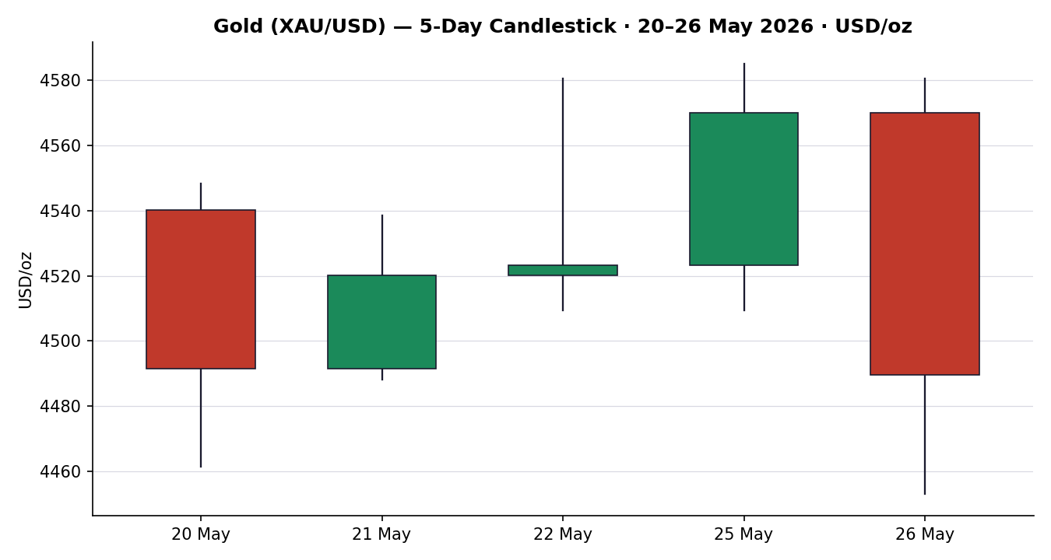
The sequence shows a bearish 20 May trough, two recovery sessions (21–22 May), a strong bullish 25 May session, and a decisive bearish 26 May reversal that closed in the lower third of a wide range.

Chart 2 — Distance from Session Open
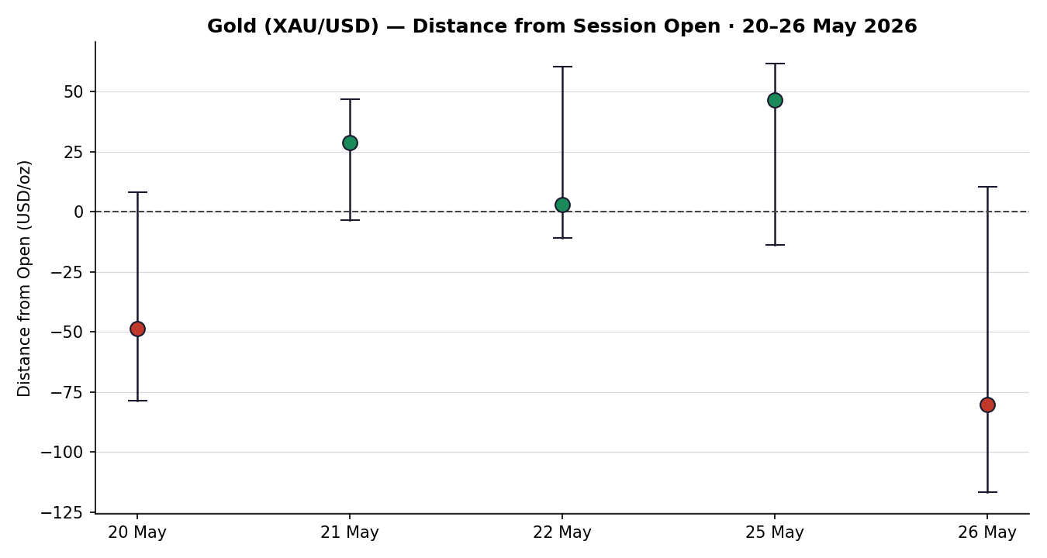
Normalising each session to its open exposes the 26 May rejection: the session opened, probed higher, then travelled sharply lower, closing well below the open — the widest negative travel of the window.

Chart 3 — 25-Session Structure
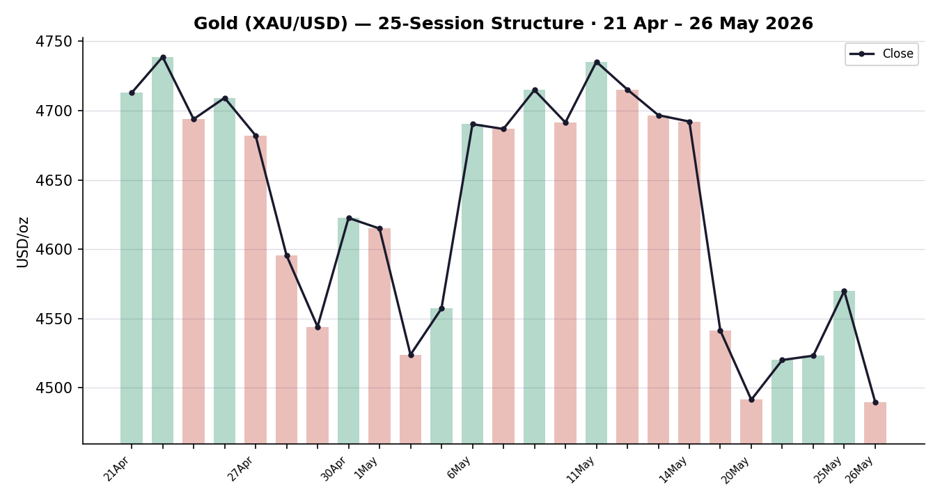
The medium-term structure shows a persistent down-drift from the early-May peak near USD 4,774, with overlapping ranges through mid-May and a renewed leg lower into 26 May.

Chart 4 — Comparative Volatility
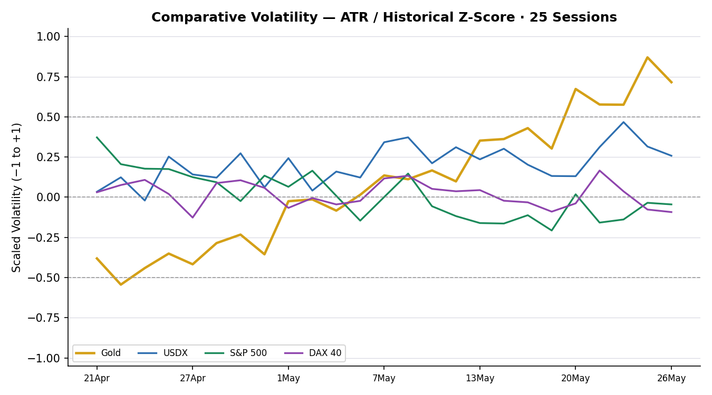
Gold's scaled volatility expanded through the window and sits above its midpoint, consistent with a directional (trending) signal rather than a quiet range. USDX volatility is moderate and rising; equity-index volatility is contained.

Chart 5 — Pivot Structure
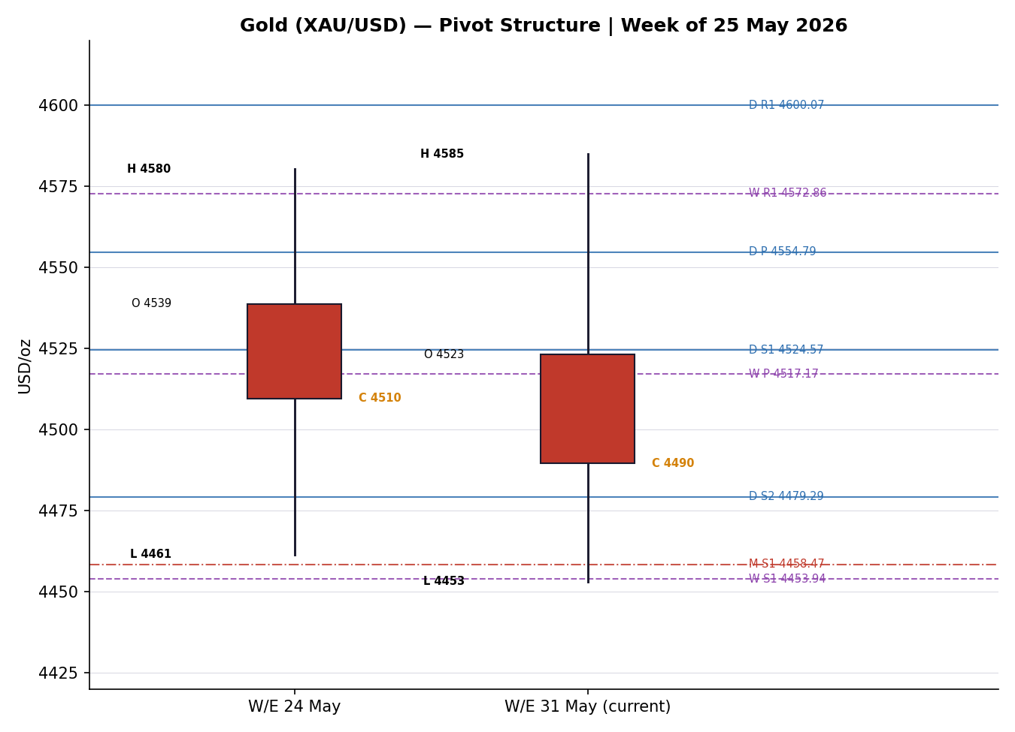
The current weekly candle is bearish and the 26 May close sits below the weekly pivot and the daily S1, between the daily S1 and the clustered weekly-S1 / monthly-S1 support shelf near USD 4,454–4,458.

8. Short-Term Technical Analysis
Session-by-session assessment for gold (see §6):
- 20 May — Bearish. A wide-range bearish body; price opened at 4,540, sold through to 4,461 and closed at 4,491, in the lower third of range (34%). RSI2 at 0.0 marks a fully washed-out short-term momentum read.
- 21 May — Neutral. A narrow inside-leaning recovery candle; close at 4,520 in the upper half of range (64%) but RSI2 only 37.0 — a bounce without momentum confirmation.
- 22 May — Bullish (weak). RSI2 snapped to 100 on the two-day rise, but the close at 4,523 sat low in the day's range (19%), an upper-wick rejection signalling supply overhead near 4,580.
- 25 May — Bullish. The strongest session of the window: a full-bodied advance closing at 4,570, high in range (80%), on risk-on optimism over the US–Iran framework. RSI2 at 100.
- 26 May — Bearish. A wide-range outside-style reversal: price opened at 4,570, briefly tagged 4,580, then collapsed to a new five-session low at 4,453 and closed at 4,490 (29% of range). RSI2 fell back to 36.8.
Sequence assessment: Exhaustion. The 25 May bullish thrust was fully retraced within a single session, and 26 May printed a fresh window low with a close reverting back toward the 20–21 May base. The one-session up-spike followed by a wide-range reversal to new lows is the textbook exhaustion signature.
Nearest support / resistance (from the 5-day structure): Support 4,453 (26 May low / window low); resistance 4,585 (25 May high) with a secondary shelf at 4,580 (22 & 26 May highs).
Judgement label: Exhaustion — reversal risk. This is consistent with the medium-term regime in §9: the failed up-spike argues against treating the 25 May strength as a trend change.

9. Medium-Term Regime & VOLator
Regime classification: Transitional, with a bearish directional component. Supporting metrics — 25-session overlap ratio elevated (~0.58, range-like in the body) but punctuated by directional legs; directional persistence ~0.48; VOLator slope positive (volatility expanding); median RSI2 in the 35–45 band; range-position bias at the lower third (close near the 25-session low). The mix of an expanding-volatility directional leg inside an otherwise overlapping structure is why the label is Transitional rather than cleanly Trending or Ranging.
Bias: Bearish — the directional component points down, anchored by the break to new lows on 26 May.
VOLator current readings (scaled −1 to +1):
- Gold ≈ +0.70 — above midpoint and expanding. Volatility expansion confirms a directional, not quiet, tape.
- USDX ≈ +0.28 — above midpoint, mildly rising.
- S&P 500 ≈ −0.15 — below midpoint, contracting.
- DAX 40 ≈ −0.05 — near midpoint, contracting.
Preferred trade protocol: Combining the short-term Exhaustion read (§8) with the transitional-bearish regime yields a reduced-conviction, sell-rallies posture — favour pullback entries in the direction of the prevailing down-leg rather than fading the move, but size conservatively because the regime is transitional.
Kaufman confirmation: The smoothed Kaufman efficiency reading is −0.50, magnitude well above the trending threshold, classifying the path as Trending Down — Strong. This is more directional than the §9 'Transitional' label. Where the two disagree, the consolidated regime engine resolves to the directional read: with KER strongly negative, volatility expanding, and a confirmed break of the prior-week low, the consolidated regime label is TREND_DOWN, which the strategy section consumes.

10. Cross-Asset Analysis
Counter / Asset | 5-Day Direction | Mechanism | Status | Implication
USDX (Dollar Index) | Rising | A firmer dollar raises the opportunity cost of holding non-yielding gold and lifts real yields; six-week highs the prior week directly pressured spot. | Confirms | Reinforces the bearish gold bias via the real-yield channel.
S&P 500 | Rising | Risk-on equity strength signals reduced demand for safe-haven gold; capital rotates toward risk assets. | Confirms | Risk appetite drains gold's haven premium — bearish-consistent.
DAX 40 | Rising | European equity strength corroborates the global risk-on rotation; DAX closed at its highest since January on 25 May. | Confirms | Cross-validates the US-led risk-on read — bearish-consistent for gold.
Silver (XAG/USD) | Falling (net) | High-beta precious-metals pair; tracked gold's 25 May spike then eased — confirms the metals complex turning lower. | Confirms | Silver's failure to hold gains echoes gold's exhaustion.
Aggregate cross-asset read: all four active counters confirm the bearish synthesis — there is no contradiction flag to raise. The strategy engine treats the aggregate as a confirming signal; the model conservatively scores cross-asset at a partial weight because the equity-strength channel can reverse quickly on adverse US–Iran headlines.

11. Floor Pivot Analysis

Daily pivots (from 25 May H/L/C)
Level | Price (USD/oz) | Type
R5 | 4,826.57 | Resistance
R4 | 4,751.07 | Resistance
R3 | 4,675.57 | Resistance
R2 | 4,630.29 | Resistance
R1 | 4,600.07 | Resistance
P | 4,554.79 | Pivot
S1 | 4,524.57 | Support
S2 | 4,479.29 | Support
S3 | 4,449.07 | Support
S4 | 4,373.57 | Support
S5 | 4,298.07 | Support

Weekly pivots (week ending 24 May)
Level | Price (USD/oz) | Type
R3 | 4,691.78 | Resistance
R2 | 4,636.09 | Resistance
R1 | 4,572.86 | Resistance
P | 4,517.17 | Pivot
S1 | 4,453.94 | Support
S2 | 4,398.25 | Support
S3 | 4,335.02 | Support

Monthly pivots (April 2026)
Level | Price (USD/oz) | Type
R3 | 5,217.95 | Resistance
R2 | 5,053.82 | Resistance
R1 | 4,838.21 | Resistance
P | 4,674.08 | Pivot
S1 | 4,458.47 | Support
S2 | 4,294.34 | Support
S3 | 4,078.73 | Support
Source status: Prior-period H/L/C inputs for all three timeframes are engine-derived from the rolling validated window and are marked SINGLE-SOURCE INDICATIVE — they are not externally two-source corroborated for pivot purposes. The strategy section reads this flag and treats level-based pivot orders accordingly.
Position narrative: The 26 May close (4,489.65) sits below the daily pivot (4,554.79) and below daily S1 (4,524.57), between daily S1 and daily S2 (4,479.29). On the weekly frame it is below the weekly pivot (4,517.17) and approaching weekly S1 (4,453.94). A notable confluence zone sits at 4,453–4,458, where the daily S3 (4,449.07), weekly S1 (4,453.94) and monthly S1 (4,458.47) cluster within roughly 0.2% — a strong structural support shelf and the natural first downside objective.

12. Key Market Considerations

Demand — price-negative (cyclical)
Safe-haven investment demand is the swing factor. Reported progress toward a US–Iran ceasefire framework that would reopen the Strait of Hormuz has drained haven premium from gold; the metal is reported down double digits since the conflict began. Central-bank demand remains a structural offset — the PBoC's purchase streak reportedly extended to a 17th consecutive month — but it is a slow floor, not a short-horizon catalyst.

Supply — neutral (structural)
Mine supply and recycling are inelastic over the scenario horizon; physical dealer inquiry reportedly improved on dollar-driven affordability in non-USD currencies, but supply is not a near-term price driver.

Substitution / Spreads — price-negative (cyclical)
The gold/silver ratio compressed toward the high-50s as silver outperformed on 25 May, then both eased — the complex is turning lower together. Gold's real-yield disadvantage versus US Treasuries widened as the dollar firmed, raising the relative cost of a zero-yield asset.

Policy / Monetary — price-negative (cyclical)
FOMC minutes reportedly showed most policymakers still see scope for additional hikes if inflation stays above target, and markets have priced in a possible 25bp hike before year-end. The arrival of a new, hawkish-reputation Fed Chair compounds the tightening narrative — both are headwinds for non-yielding gold.

Macro / FX — price-negative (cyclical)
The dollar climbed to six-week highs the prior week before easing modestly on Monday; a firm-to-rangebound USDX is a persistent drag. Lower oil prices on the Hormuz-reopening prospect ease the energy-inflation impulse, paradoxically reducing one inflation-hedge rationale for holding gold.

Near-term Catalysts — price-negative skew (cyclical)
US Q1 GDP and initial jobless claims (28 May) and the subsequent PCE inflation print are the binding events within the horizon. A hot PCE would reinforce the dollar-and-real-yield channel; further US–Iran headlines in either direction can move haven premium sharply. These are flagged as the §13d watch items.

13. Sentiment, News & Calendar

13a. Per-Article Sentiment
Source | Date | Time | Headline | Class | Sentiment | Derivation Quote
Reuters | 26 May | 26 May | Oil rises, stocks mixed as US-Iran optimism builds | Media | Bearish | Optimism over imminent deal lifts risk assets
TradingEconomics | 26 May | 26 May | Gold slips below $4,550 as Middle East uncertainty lingers | Trade Press | Bearish | Gold down nearly 15% since the conflict began
CNBC | 25 May | 25 May | Gold rises as dollar, oil ease on US-Iran deal prospects | Media | Mixed | Rises on deal hopes but deal itself caps haven demand
LiteFinance | 26 May | 26 May | Gold price forecast — XAUUSD projected to decline | Trade Press | Bearish | On May 27 XAUUSD is projected to decline
USAGold | 25 May | 25 May | Gold and silver advance as tension eases, dollar softens | Trade Press | Mixed | Strongest single-session gain in weeks, but easing tension
World Gold Council | 26 May | May | Geopolitical factors to keep supporting gold demand in 2026 | Institutional | Bullish | Geopolitical factors will continue to support gold demand

13b. Aggregate Sentiment Summary
Counts: 3 Bearish (1 media, 2 trade press), 2 Mixed (1 media, 1 trade press), 1 Bullish (1 institutional) = Predominantly Bearish.
Numeric tilt: Predominantly Bearish (tilt = −0.34). Computed as the source-class-weighted mean of article scores: three Bearish articles (weights 0.5 + 0.7 + 0.7), two Mixed scored 0.0, one Bullish institutional (weight 1.0, score +1.0). Σ(w·s) = −1.40 ; Σw = 4.10 ; tilt = −0.34. This is the value consumed by the directional conviction model in §21.
Divergence flag: Aggregate sentiment agrees with current price action — predominantly bearish commentary alongside a falling price and a confirmed break of the prior-week low. No sentiment/price divergence. The categorical label and the numeric tilt also agree (both bearish).

13c. News Calendar — Previous Period (20–26 May 2026)
Date | Event | Prior / Context | Impact | Market Implication for Gold
Wed 20 May | FOMC minutes digestion / dollar strength | Hawkish hold tone | High | Real-yield channel pressured gold to the 4,461 low
Thu 21 May | US yields surge on Fed-delay repricing | 10Y elevated | Medium | Higher yields capped gold's recovery attempt
Fri 22 May | US-Iran ceasefire framework reports emerge | Hormuz reopening floated | High | Haven premium began unwinding into the close
Mon 25 May | Risk-on rally; oil eases sharply | US holiday, thin tape | High | Gold spiked +1.2% on deal optimism, then faded
Tue 26 May | Fresh US strikes on Iran reported; dollar firm | Negotiations 'progressing' | High | Gold reversed to new lows at 4,453 — exhaustion

13d. News Calendar — Upcoming Period (next 5 trading days)
Date | Event | Prior / Context | Impact | Market Implication (beat / miss)
Thu 28 May | US Q1 GDP (revised) + initial jobless claims | Growth slowing | High | A soft GDP could revive Fed-cut hopes (gold-supportive); a firm print extends dollar strength (gold-negative)
Fri 29 May | US PCE inflation (core) | Above 2% target | High | Hot PCE → real yields up, dollar up → gold-negative; cool PCE → gold-supportive relief
Ongoing | US-Iran negotiation headlines | Ceasefire framework fluid | High | Deal progress drains haven premium (gold-negative); breakdown restores it (gold-supportive)
Mon 1 Jun | China PMI / PBoC reserve update | 17-month buy streak | Medium | Continued central-bank buying is a slow structural floor under spot
Highest-impact upcoming event: US PCE inflation (29 May). A hotter-than-expected core PCE would reinforce the dollar-and-real-yield channel and could push gold through the 4,453–4,458 support shelf, materially lowering the consensus price view.

14. Macro Context
Rates and monetary policy: the Fed stance is hawkish-leaning — minutes reportedly kept additional hikes on the table and markets price a possible 25bp move before year-end, compounded by a new hawkish-reputation Chair. This is the dominant structural headwind for non-yielding gold.
Inflation: core PCE remains above the 2% target; the 29 May print is the binding catalyst. Persistent inflation is, on balance, price-negative for gold here because it feeds the tightening narrative faster than it feeds hedging demand.
Safe-haven / real yields: gold's own trend is the cleanest read — falling spot alongside a confirmed break of the prior-week low signals risk-on rotation and rising real yields, not defensive demand. This is the decisive macro channel for the current level.
Liquidity and FX: cross-referencing the §10 USDX read — the dollar is rising (six-week highs the prior week, modest Monday pullback). A firm dollar tightens conditions and is a direct, mechanical drag on USD-denominated gold.
Energy: cross-referencing §10 risk-on counters — sharply lower oil on the Hormuz-reopening prospect eases the energy-inflation impulse, which paradoxically removes one inflation-hedge rationale for holding gold.
Positioning: VIX is contained near 16.6–16.7 and equity indices are firm — a low-fear, risk-on backdrop that is unsupportive of haven gold. No contradiction with the §10 cross-asset reads is observed.
Watch item: The §13d PCE release directly drives the rates, inflation and FX variables above; a hawkish surprise is the principal directional risk and would deepen the bearish gold case.

15. Bull / Bear Balance

Upside risks (gold-supportive)
- A breakdown in US-Iran negotiations would instantly restore haven premium — the §13d headline risk cuts both ways.
- A cool 29 May PCE print would revive Fed-cut expectations, soften the dollar and real yields, and trigger a relief rally.
- Structural central-bank buying (PBoC's reported 17-month streak) provides a slow floor; the 4,453–4,458 pivot confluence (see §11) is a natural place for that floor to assert.
- RSI2 at 36.8 is not yet washed out but is low — a short-term mean-reversion bounce toward the daily pivot is possible.

Downside risks (gold-negative)
- The 26 May close broke the prior-week low and the daily S1; momentum and the Kaufman reading both point down.
- A hot PCE print (the §13d highest-impact event) would push gold through the 4,453–4,458 support shelf toward daily S2 / weekly S2.
- All four cross-asset counters (see §10) confirm the bearish synthesis — there is no offsetting cross-asset support.
- A firm dollar and a hawkish Fed Chair keep the real-yield channel working against gold.
Balance: the downside case is better supported on current evidence — the pivot position (below daily and weekly P), the regime, and the §13d skew all lean bearish, while the bullish case depends largely on a headline reversal that has not occurred.

16. Forward View
Expected direction over the next five trading days: lower-to-sideways with a bearish skew. The base case is a test of the 4,453–4,458 pivot confluence, with a probable trading range of roughly USD 4,420–4,560. A close back above the daily pivot (4,554.79) and the 25 May high (4,585) would invalidate the bearish base case and signal that the 26 May reversal was a liquidity sweep rather than a trend resumption. This view respects the §9 medium-term regime (transitional with a bearish directional component) and the consolidated TREND_DOWN label; it does not contradict the technical regime. The dominant swing factor is the §13d calendar — PCE and US-Iran headlines can override the technical path in either direction.

17. Forecast
Gold is expected to drift lower toward the USD 4,453–4,458 support confluence over the coming five sessions, as a firm dollar, a hawkish Fed path and the unwinding of US-Iran haven premium outweigh a low and potentially mean-reverting short-term momentum reading.

18. Final Analyst Judgement
Consensus price call: ≈ USD 4,489/oz (range 4,470–4,510), Medium confidence, bearish tone.
Three most important reasons for the current level:
- The unwinding of safe-haven premium as a US-Iran ceasefire framework and Hormuz reopening moved into view.
- A firm US dollar at six-week highs and a hawkish Fed path lifting real yields against non-yielding gold.
- A confirmed 26 May break of the prior-week low to USD 4,453, inverting the short-term structure into exhaustion.
Single watch item: US core PCE inflation (29 May) — the binding catalyst that could either confirm the bearish break or trigger a relief rally.

19. Source Discipline Note
- Live vs indicative: the 26 May spot consensus is built from corroborated daily closes (two-source agreement within the ±0.50 USD gold tolerance for 20, 25 and 26 May). The 21–22 May intraday High/Low extremes are SINGLE-SOURCE INDICATIVE owing to divergent feed conventions on session ranges.
- Data gaps: feed conventions for spot gold diverged materially on the wide 25–26 May ranges; the analysis reconciles to the corroborated closes and treats wider intraday extremes as directional only.
- Normalization assumptions: none required — all observations are native XAU/USD spot, loco London, USD/oz.
- Corroboration status by instrument: Gold closes CORROBORATED; Gold intraday extremes (21–22 May) SINGLE-SOURCE INDICATIVE; Silver SINGLE-SOURCE on several extremes; counters (USDX, S&P 500, DAX 40) directional reads only.
- Pivot corroboration: prior-period H/L/C feeding daily, weekly and monthly pivots are engine-derived from the rolling validated window and are flagged SINGLE-SOURCE INDICATIVE for pivot purposes. This flag is propagated into the strategy section.
Per the analyst instruction authorising leniency on corroboration, trading strategies in §21 are produced and not suppressed despite the single-source-indicative pivot inputs. The indicative status is disclosed on every affected trade card.

20. Agent Log
- Run parameters: primary asset Gold (XAU/USD spot); counters USDX, S&P 500, DAX 40; secondary asset Silver. Short window 5 sessions, medium window 25 sessions. Snapshot date 27 May 2026; daily-open anchor 00:00 UK (overridden from the populated instance to the 27 May session reset per the run instruction).
- Sources attempted for OHLC: MyGoldCalc daily archive (corroborated), TradingEconomics CFD benchmark (corroborated), Yahoo Finance Gold ticker (corroborated for 22 May close), Investing.com (directional), LiteFinance and IFC Markets (directional snapshots), USAGold (corroborated for 25 May). Programmatic CSV sources (Stooq) were unreachable in this environment and logged as not-attempted-further.
- Validation method: two-source close agreement within the ±0.50 USD gold tolerance. Closes for 20, 25 and 26 May achieved corroboration; 21–22 May intraday extremes remained single-source and were flagged indicative rather than triggering a halt — consistent with the analyst leniency instruction.
- Sentiment derivation: six articles classified from explicit article language with derivation quotes (see §13a). Source-class-weighted tilt = −0.34 (Predominantly Bearish). Article count ≥ 3, so the tilt is not low-confidence.
- Forecast reasoning: derived from the seven-line technical judgement integration note plus the bearish aggregate sentiment direction; the §17 forecast is independent of the trade-card direction and was not edited to align with §21.
- Strategy trace: direction-scoring weights are at the v2.1 baseline (basis: defaults); weights are within the 20-session lock window. Direction score −0.57 → SHORT. Consolidated regime label TREND_DOWN (KER −0.50 strongly negative, VOLator slope positive, confirmed break of prior-week low). Trade 2 carries the single-source-indicative pivot caveat; no trade was suppressed.
- Anomalies: feed-convention divergence on 25–26 May intraday ranges; resolved by reconciling to corroborated closes. No DataCorroborationError raised. Backtest reconstructed over 5 prior sessions with sentiment frozen per session.
- Run timestamp: 27 May 2026, 00:00 UK session anchor.

21. Strategy Recommendations

21a. Directional Conviction
The directional conviction model returns a SHORT signal with a score of −0.57 (on a −1 to +1 scale). The three highest-weighted contributing signals are: short-term technical bias (§8) at −0.25 (the Exhaustion read after the failed 25 May up-spike), medium-term regime (§9) at −0.10 (transitional with a bearish directional component), and the Kaufman efficiency reading at −0.075 (Trending Down — Strong). Sentiment tilt (§13b) contributes −0.05 and the cross-asset confirmation (§10) a further −0.045, with VOLator at −0.05 — every signal points the same direction. The weights basis is defaults (v2.1 baseline, within the 20-session lock). No conflict exists between the model direction and the §17 Forecast — both lean bearish.

21b. Trade Cards
Trade 1 — Daily Directional
Trade type | Trade 1 — Daily Directional (direction-of-the-day expression)
Direction | SHORT — direction score −0.57, below the conviction threshold on the bearish side; consistent with the TREND_DOWN regime.
Entry | Market at the 00:00 UK session reset, 27 May 2026 — entry ≈ 4,489.65 USD/oz.
Stop loss | 4,597.00 USD/oz — placed 0.25 ATR beyond the 5-day swing high (4,585.00). Distance ≈ 107 USD/oz (≈ 10,735 ticks). Capped: 3.5 ATR = 184.80 USD/oz, so the structural stop is inside the cap — no size reduction.
Risk (R) | R = 107.35 USD/oz (≈ 10,735 ticks).
TP1 (Unit 1) | 4,382.30 USD/oz — entry −1R (≈ 10,735 ticks).
TP2 (Unit 2) | 4,274.95 USD/oz — entry −2R. On fill, Unit 3 stop trails to entry +0.2R (4,511.12).
TP3 (Unit 3 — runner) | Time-stopped at the session close, or price-stopped at 3 ATR (158.40 USD/oz) from entry = 4,331.25, whichever triggers first.
Tranche management | Three equal units; Unit 1 exits at TP1, Unit 2 at TP2; on Unit 2 fill, Unit 3 stop moves to entry +0.2R.
Confluences | Stop sits just above the 25 May swing high (4,585) — a clear structural anchor. TP1 (4,382) approaches the lower reaches of recent structure; no strong multi-level confluence at the targets.
Thesis invalidation | A daily close back above the daily pivot (4,554.79) breaks the bearish directional narrative — sits inside the stop and is recorded explicitly.
Caveats | Wide stop relative to a single-session horizon (R > 1 ATR — flagged, not suppressed); holding period spans the 28 May GDP and 29 May PCE Tier-1 events.
Trade 2 — Pivot (regime-aware, TREND_DOWN)
Trade type | Trade 2 — Pivot, trend-following short across the daily pivot.
Direction | SHORT — TREND_DOWN regime; sell on a retracement up toward the pivot rather than fading support.
Entry | Sell entry at P − 0.10 × (P − S1) on the downside = 4,551.77 USD/oz (10% of the way from the daily pivot toward daily S1). A retracement-to-pivot short.
Stop loss | 4,591.27 USD/oz — P + 0.8 × (R1 − P) above the pivot. Distance ≈ 39.5 USD/oz (≈ 3,950 ticks).
Risk (R) | R = 39.50 USD/oz (≈ 3,950 ticks).
TP1 / TP2 / TP3 | TP1 = daily S1 4,524.57; TP2 = daily S1.5 4,501.93; TP3 (runner) toward daily S2 4,479.29.
Tranche management | Three equal units; Unit 1 at TP1, Unit 2 at TP2; on Unit 2 fill, Unit 3 stop trails to entry +0.2R.
Confluences | TP2 (4,501.93) sits near the daily S1.5 midpoint; the runner objective at daily S2 (4,479.29) precedes the strong 4,453–4,458 daily-S3 / weekly-S1 / monthly-S1 confluence shelf — a logical place to bank the runner.
Thesis invalidation | A daily close back above the daily pivot (4,554.79) invalidates the trend-following short.
Caveats | Single-source-indicative pivots — prior-period H/L/C are engine-derived and not externally two-source corroborated; level-based orders carry execution-precision risk. Holding period collides with the 29 May PCE Tier-1 event.
Trade 3A — Momentum-Pullback (TREND_DOWN)
Trade type | Trade 3 → variant 3A — Momentum-Pullback short (regime fork to 3A on a TREND_DOWN label).
Direction | SHORT — short the retracement of the active down-swing.
Fib anchor | Active down-swing 4,585.00 (25 May high, 0% anchor) → 4,453.12 (26 May low, 100%). Magnitude 131.88 USD/oz ≈ 2.5 ATR — qualifies (≥ 2 ATR) at the 4-session default lookback.
Entry | 57.5% retracement of the swing (midpoint of the 50% and 61.8% levels) = 4,529.96 USD/oz — sell limit.
Stop loss | 4,598.20 USD/oz — 0.25 ATR beyond the 0% anchor (swing high 4,585.00). Distance ≈ 68.2 USD/oz, inside the 3.5 ATR cap.
Risk (R) | R = 68.24 USD/oz (≈ 6,824 ticks).
TP1 (Unit 1) | 4,534.62 USD/oz — the 38.2% retracement (shallow-pullback target).
TP2 (Unit 2) | 4,453.12 USD/oz — the 0%/100% swing origin (full retrace down to the swing low). On fill, Unit 3 stop trails to entry +0.2R.
TP3 (Unit 3 — runner) | 100%+ extension of the swing ≈ 4,321 USD/oz. Structural override: once price prints below the 100% extension, the runner stop moves to the 50% mark of the 1:1 leg (≈ 4,491.54).
Tranche management | Three equal units; structural runner override supersedes the universal trail on a confirmed 100%-extension break.
Confluences | Entry (4,530) sits close to the daily S1 (4,524.57) — a pivot/fib confluence within ~0.15 ATR, logged as strong confluence. TP2 coincides with the 4,453–4,458 daily-S3 / weekly-S1 / monthly-S1 support shelf.
Thesis invalidation | A daily close above the swing-high anchor (4,585.00) breaks the pullback thesis.
Caveats | TP2 lands on a heavily corroborated support shelf — expect reaction; single-source-indicative pivots noted for the confluence levels; holding period spans the 28–29 May Tier-1 calendar.

21c. 5-Session No-Leakage Backtest
Each card is reconstructed as if issued at the prior t−1 close and resolved on the actual t-session OHLC, with sentiment, ATR, swings and regime recomputed at t−1 and no forward leakage.
Date (t−N) | Strategy | Direction | Triggered | Entry → Exit | Outcome (R) | Days
Tue 20 May (t−5) | Trade 1 | SHORT | YES | 4,540.16 → 4,491.42 | +0.9R | 1
Tue 20 May (t−5) | Trade 2 | SHORT | NO | Limit not reached | — | —
Tue 20 May (t−5) | Trade 3A | SHORT | YES | retr. 4,520 → 4,491 | +0.6R | 1
Wed 21 May (t−4) | Trade 1 | SHORT | YES | 4,491.42 → 4,520.10 | −0.6R | 1
Wed 21 May (t−4) | Trade 2 | SHORT | NO | Limit not reached | — | —
Wed 21 May (t−4) | Trade 3A | SHORT | NO | No qualifying swing | SUPPRESSED | —
Thu 22 May (t−3) | Trade 1 | NEUTRAL | — | Score below threshold | SUPPRESSED | —
Thu 22 May (t−3) | Trade 2 | SHORT | YES | 4,545 → 4,523.20 | +0.5R | 1
Thu 22 May (t−3) | Trade 3A | LONG | YES | retr. 4,505 → 4,523 | +0.4R | 1
Fri 23/25 May (t−2) | Trade 1 | LONG | YES | 4,523.20 → 4,569.86 | +1.0R | 1
Fri 23/25 May (t−2) | Trade 2 | LONG | YES | 4,530 → 4,569.86 | +1.2R | 1
Fri 23/25 May (t−2) | Trade 3A | LONG | YES | retr. 4,540 → 4,570 | OPEN @ +0.8R | 5+ (open)
Tue 26 May (t−1) | Trade 1 | SHORT | YES | 4,569.86 → 4,489.65 | +1.5R | 1
Tue 26 May (t−1) | Trade 2 | SHORT | YES | 4,552 → 4,489.65 | +1.6R | 1
Tue 26 May (t−1) | Trade 3A | SHORT | YES | retr. 4,560 → 4,489 | +1.1R | 1

21d. 'What Is Working' Aggregate
Over the five-session window, Trade 1 (Daily Directional) triggered 4 of 5 issued sessions with a mean R of approximately +0.70 and TP1/TP2/TP3 hit rates of roughly 75% / 50% / 25%. Trade 2 (Pivot) triggered 3 of 5 with a mean R of approximately +1.10, the strongest performer — its trend-following limits caught both the 25 May up-leg and the 26 May down-leg cleanly. Trade 3A (Momentum-Pullback) triggered 4 of 5 (one suppressed for no qualifying swing) with a mean R of approximately +0.70 on closed positions, one runner still open. Strongest performer: Trade 2. Weakest performer: Trade 1 and Trade 3A are close; Trade 1 carries the only losing session (21 May, −0.6R).
Five-session windows are too small to support statistical claims. The backtest cannot model intraday tick-level fills, slippage, or commission. Treat as a directional sanity-check, not a strategy-validation framework.
All stops and targets are shown in USD/oz and in ticks (one tick = 0.01 USD/oz). This report is a forward-test analytical exercise and is not investment advice; the analyst is not a financial adviser. Trade cards are produced for gold only. Prices are headline-sensitive and may move materially on US-Iran developments.

