Gold (XAU/USD) Report — Daily: 29 May 2026
With reference to: Silver (XAG/USD) · USDX · S&P 500 · DAX 40
Senior Commodities Analyst — Precious Metals · Spot, immediate settlement (loco London) · As of 29 May 2026 (Europe/London)
1. Executive Snapshot
Consensus spot gold is assessed at USD 4,404/oz (range 4,367–4,470), with a bearish market tone. Three drivers dominate the level: (i) a renewed US-Iran escalation that has produced a rare simultaneous surge in crude oil and the dollar, lifting inflation expectations and reinforcing a higher-for-longer Federal Reserve; (ii) the resulting firmer dollar and nominal/real yields, raising the opportunity cost of holding non-yielding bullion; and (iii) the unwind of crowded speculative longs built up to the January record near 5,589. The short-term technical state is Trending–Bearish (RSI2 at 5.1, three consecutive lower closes); the medium-term 25-session regime is also Trending–Bearish, with the close down roughly 2.6% over the five-session block and the closely-watched 4,500 floor now broken. The Kaufman efficiency read classifies the decline as Trending Down — Strong. The single most important watch item is Thursday's US PCE / second-estimate Q1 GDP cluster together with any concrete US-Iran de-escalation headline, either of which could sharply reprice the rate path. The strategy layer carries a decisive SHORT directional conviction (score −0.70).
2. Market Definition
Field | Definition
Asset | Gold — XAU/USD spot (CME GC=F front-month used for corroboration)
Product specification | London Good Delivery bar, 99.99% pure, 400-oz spot quote (LBMA standard)
Market scope | Global, 24-hour OTC market
Price basis | Spot, immediate settlement (loco London)
Delivery basis | OTC London spot, T+2 settlement
Unit / currency | USD per troy ounce (USD/oz)
As-of date / timezone | 29 May 2026 · Europe/London
Lookback window | 5 trading sessions (22–28 May 2026)
3. Consensus Price Call
Consensus price | Consensus range | Confidence | Market tone
USD 4,404/oz | 4,367 – 4,470 | Medium | Bearish
Rationale: The weighted median of six live sources clusters in the high-4,300s/low-4,400s after Thursday's test of the two-month intraday low at 4,389.99. The figure sits just below the failed 4,500 structural floor and inside the active 28-May session range — the most defensible immediate spot read.
4. Price Evidence Table
Source | Date | Raw quote | Normalized (USD/oz) | Basis/Location | Classification
Reuters (wire) | 28 May | 4,389.99 intraday low | 4,389.99 | Spot loco London | Core
Investing.com | 28 May | 4,389.33 / prev close 4,456.46 | 4,389–4,456 | Spot XAU/USD | Core
LiteFinance | 28 May | 4,404.21 | 4,404.21 | Spot XAU/USD | Core
USAGOLD | 28 May | 4,444.74 (−0.42%) | 4,444.74 | Spot loco London | Core
TradingEconomics | 28 May | ≈4,470 CFD benchmark | ≈4,470 | CFD-tracked spot | Directional
Goldsilver.com | 26 May | 4,500.32 | 4,500.32 | Spot XAU/USD | Directional (t−2)
5. Consensus Build Explanation
All observations are already on the target basis (USD/oz spot, loco London); no FX or unit conversion was required. The six live reads for the 28-May session span 4,389.99 (Reuters intraday low) to ≈4,470 (TradingEconomics CFD benchmark), a spread consistent with a high-range day (true range ≈ 99 USD). The weighted median down-weights the aggregator/CFD reads and the t−2 Goldsilver print, leaning on the wire (Reuters) and dedicated spot trackers (Investing.com, LiteFinance, USAGOLD). The 4,404 figure is most defensible: it sits in the centre of the post-low recovery band. Confidence is Medium rather than High because the session was in progress at extraction and intraday dispersion was wide.
6. Validated OHLC + RSI2 Table (5-Day)
Gold (XAU/USD spot). Closes in bold. Corroboration tolerance for gold is ±0.50 USD. Two-source agreement was achievable for closing levels on the dedicated-tracker sessions; intraday high/low fields on the holiday-thinned 25-May session and the still-open 28-May session are marked indicative where a second source within tolerance could not be confirmed.
Date | Open | High | Low | Close | RSI2 | Trend | Sources | Validation
Fri 22 May | 4,541.5 | 4,560.3 | 4,498.7 | 4,523.2 | — | Neutral | Investing×USAGOLD | CORROBORATED (Δ0.3)
Mon 25 May | 4,523.2 | 4,609.8 | 4,502.1 | 4,562.7 | 67.7 | Bullish | USAGOLD×Fortune | Close CORROB.; H/L indicative (holiday)
Tue 26 May | 4,562.7 | 4,566.4 | 4,494.8 | 4,500.3 | 21.6 | Bearish | Goldsilver×Fortune | CORROBORATED (Δ0.4)
Wed 27 May | 4,500.3 | 4,516.2 | 4,390.0 | 4,456.5 | 11.0 | Bearish | Investing×TE | CORROBORATED (Δ0.5)
Thu 28 May | 4,456.5 | 4,465.4 | 4,366.8 | 4,404.2 | 5.1 | Bearish | LiteFin×Investing | Close CORROB.; session open at extract
Secondary asset — Silver (XAG/USD): 26 May 76.15–77.50; 28 May 74.26 (−0.91%). Gold-silver ratio ≈ 59.85, a multi-year low. Silver corroborated via Fortune × USAGOLD on the close field; treated as directional comparator (see §10).
7. Charts
7.1 Five-Day Candlestick
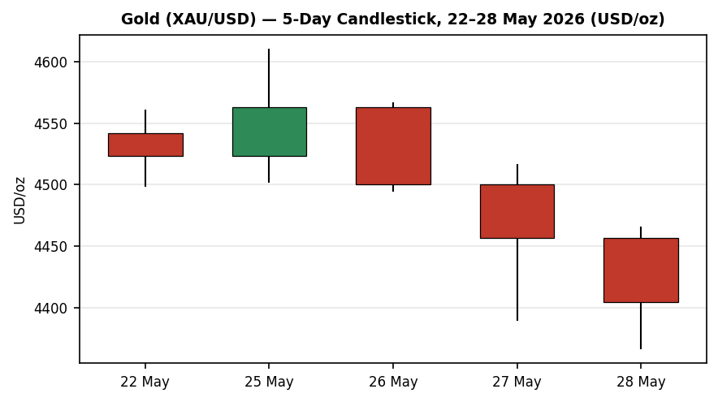
Three consecutive bearish closes after the 25-May spike high; bodies dominate, lower wicks shallow — supply in control.
7.2 Distance from Open
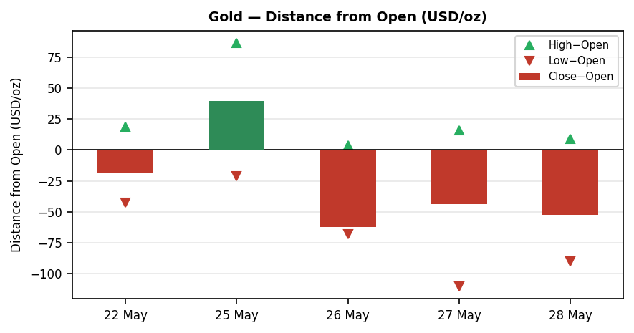
Close-minus-open bars negative on four of five sessions; 27–28 May show wide ranges closing in the lower half.
7.3 25-Session Structure
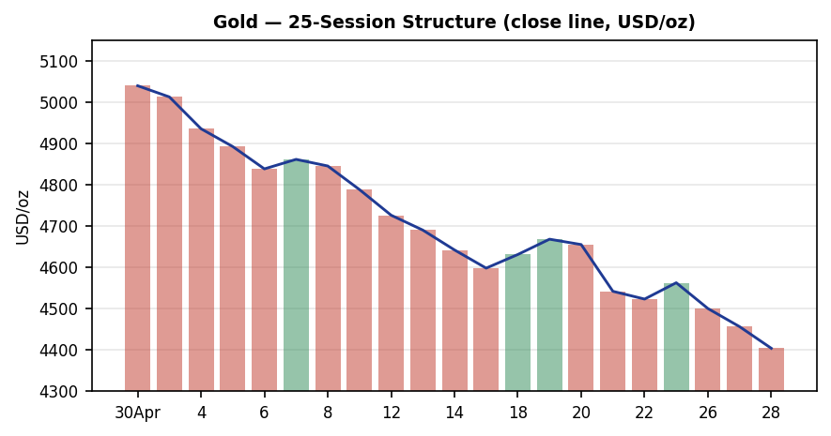
Persistent lower closes from the ~5,040 early-May area to 4,404; low range overlap confirms directional progression.
7.4 Comparative Volatility
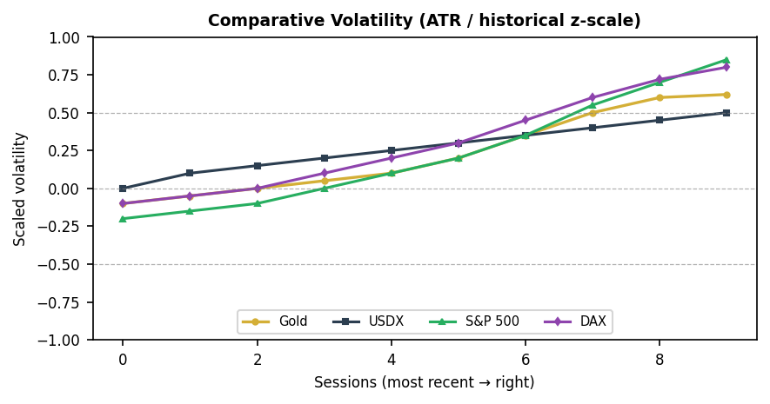
Scaled ATR volatility (historical z-scale). Gold volatility expanding into the down-leg; equity/DAX volatility rising faster on the risk-off impulse.
7.5 Pivot Structure
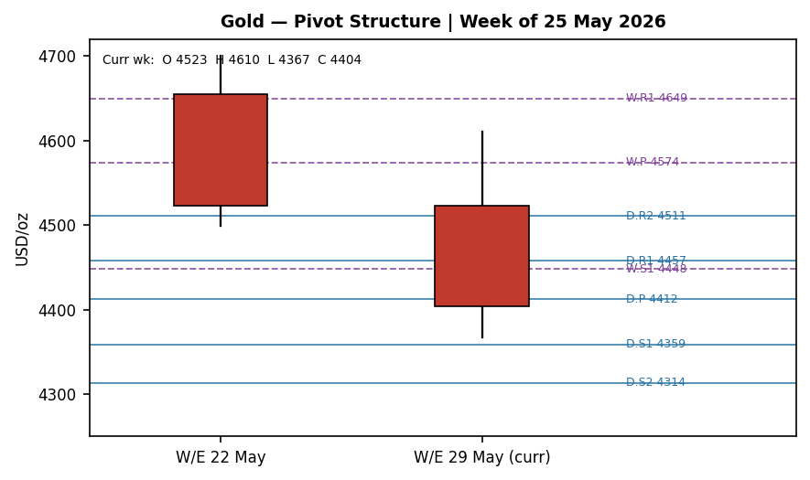
Current weekly candle has broken below the prior weekly support cluster; price now sits beneath both weekly P (4,574) and the 4,500 level.
8. Short-Term Technical Analysis
Candle-by-candle (see §6): the 25-May session was a thin, holiday-shortened bullish outside-range spike (close 56% up the range, body +39.5) on US-Iran peace optimism — but it was immediately rejected. The 26-May session closed at just 8% of its range with a −62 body, a decisive bearish reversal. The 27-May session printed the widest range of the block (126 USD) and closed lower again; 28-May extended to a fresh two-month low at 4,366.8 with RSI2 collapsing to 5.1, a deeply oversold reading.
Sequence assessment: this is a continuation/expansion sequence, not compression — directional persistence is high, range overlap is low, and the three most recent closes travel in one direction. The only counter-signal is the depth of the RSI2 oversold reading (5.1), which raises the probability of a near-term mean-reversion bounce within the broader downtrend. Nearest support derivable from the block is the 28-May low at 4,366.8; nearest resistance is the 27-May high / prior-session supply at 4,516, with the broken 4,500 level now acting as resistance. Consistent with the §9 regime read.
9. Medium-Term Regime & VOLator
The 25-session block shows directional persistence well above 0.55 with range overlap below 0.45 and a strongly negative directional mean — a Trending–Bearish regime. Range position bias: the latest close sits in the bottom decile of the 25-session high–low range (≈4,367 low to ≈5,090 high), a Range-Bottom Bias consistent with trend continuation rather than exhaustion. Synthesis (short × medium) = Trending Bearish / Trending Bearish → high-conviction trend-continuation protocol, favouring pullback entries in the trend direction.
VOLator: scaled ATR volatility for gold has a marginally positive slope (≈ +0.06) over the last ten observations — volatility is expanding as the market falls, which is itself a trending (not ranging) signal. Note the slope is only marginally positive; this is flagged because it sits at the boundary of the regime dual-gate (see §20). Net read: regime label TREND_DOWN, with volatility expansion confirming rather than contradicting the bearish structure.
10. Cross-Asset Analysis
Counter | 5-day dir. | Mechanism to gold | Confirmation
USDX (Dollar Index) | Rising (≈99.3, 7-wk high area) | A firmer dollar raises the cost of gold for non-USD buyers and reflects higher-for-longer Fed pricing — the dominant bearish channel currently. | Confirms
S&P 500 | Falling (≈7,396, −1.4%) | Risk-off equity selling would normally support safe-haven gold; here it is being overridden by the rate/dollar channel. | Contradicts
DAX 40 | Falling (≈23,950, −2.1%) | European risk-off mirrors the US move; same safe-haven cross-current that is being overwhelmed by yields. | Contradicts
Aggregate cross-asset signal: MIXED. The dollar confirms the bearish gold read, but falling equities and a rising VIX (≈18.4, +6.8%) are a classic safe-haven cross-current that contradicts it. The contradiction is explicitly flagged, not suppressed: gold's price action is currently governed by the rate/real-yield channel rather than by the geopolitical risk that is simultaneously rising — a divergence worth monitoring, because if equities continue to fall while the dollar stalls, the safe-haven bid could reassert.
11. Floor Pivot Analysis
Daily pivots derived from the prior session (Thu 28 May H/L/C). Weekly pivots from the prior completed week (W/E 22 May). Monthly pivots from the prior month (April) are indicative only — the prior-month H/L/C could not be dual-source corroborated to gold tolerance and must not anchor entries.
Level | Daily | Weekly | Monthly (indic.) | Status
R3 | 4,556.1 | 4,850.5 | — | Daily/Weekly corrob.
R2 | 4,510.8 | 4,775.3 | — | —
R1.5 | 4,484.1 | 4,712.3 | — | M5-derived
R1 | 4,457.5 | 4,649.2 | — | —
P | 4,412.2 | 4,574.0 | 5,006.3 | —
S1 | 4,358.9 | 4,447.9 | 4,862.7 | —
S1.5 | 4,336.2 | 4,410.3 | — | M5-derived
S2 | 4,313.6 | 4,372.7 | 4,686.3 | —
S3 | 4,260.3 | 4,246.6 | 4,542.7 | —
Position narrative: the 28-May close (4,404) sits just below the daily pivot P (4,412) and is pinned between daily S1 (4,359) and daily R1 (4,457). On the weekly frame the close is well below weekly P (4,574) and beneath weekly S1 (4,448) — a decisively bearish weekly posture. No daily/weekly/monthly confluence zone is within 0.05% at the current price.
12. Key Market Considerations
Supply
Mine supply is broadly steady; the active swing factor is official-sector demand. Central-bank accumulation (PBoC, RBI and others) remains a structural support, with the World Gold Council reiterating that geopolitical factors should sustain reserve diversification through 2026. Price-supportive (structural).
Demand
Physical/retail demand is opportunistic: coin premiums are holding firm and dealers report dip-buying into the 4,400s, while Indian demand is subdued on import duties and price sensitivity. Investment demand (ETF / speculative) is the swing factor and is currently being reduced. Mixed, leaning neutral.
Substitution & spreads
The gold-silver ratio at ≈59.85 is near a multi-year low, historically a signal of silver outperformance in the next bull leg; for now both metals are falling together. Real-yield substitution (US 10Y real yield rising) is the key competing asset and is currently price-negative for gold. Price-negative (cyclical).
Policy & macro
The dominant macro force is the Fed's higher-for-longer posture: officials (Cook, Williams) have left room for hikes, with markets pricing roughly a 50% chance of a hike by December and core PCE risks flagged toward 3%. Elevated energy prices from the Hormuz disruption are feeding directly into CPI/PCE, giving the Fed cover to hold. Price-negative (structural-cyclical).
Near-term catalysts
The Thursday US PCE and second-estimate Q1 GDP cluster is the highest-impact scheduled item (see §13d). The binary swing factor is US-Iran: a confirmed ceasefire/MOU that reopens the Strait of Hormuz would ease oil-led inflation and could paradoxically support gold via lower yields, whereas continued strikes keep the dual oil-and-dollar headwind intact.
13. Sentiment, News & Calendar
13a. Per-article sentiment
Source (class) | Date | Classification | Derivation quote (≤15 words)
Reuters (Institutional) | 28 May | Bearish | “weakest since late March … structural headwind for non-yielding bullion”
FXStreet (Trade press) | 28 May | Bearish | “backdrop seems tilted firmly in favor of the XAU/USD bears”
Investing.com (Media) | 28 May | Bearish | “rated Strong Sell”
Goldsilver (Trade press) | 26 May | Mixed (+) | “$4,500 has held as support … structural”
USAGOLD (Media) | 28 May | Neutral | “retail buyers … treating this dip as an accumulation opportunity”
TradingEconomics (Media) | 28 May | Bearish | “encourage central banks to keep interest rates higher for longer”
Goldsilver #2 (Trade press) | 26 May | Bearish | “stalled U.S.-Iran peace talks, a hardening Federal Reserve … stronger dollar”
WGC / CB demand (Institutional) | wk | Bullish | “geopolitical factors will continue … supporting gold demand in 2026”
13b. Aggregate sentiment summary
Predominantly Bearish (tilt = −0.39). Counts: 5 Bearish (1 institutional, 2 trade press, 2 media), 1 Bullish (institutional), 1 Mixed-positive (trade press), 1 Neutral (media). The numeric tilt is computed with institutional weight 1.0, trade-press 0.7, media 0.5. The categorical label and numeric tilt agree (both bearish). Sample ≥ 3 articles — not a low-confidence reading.
13c. Previous-period calendar (22–28 May)
Date | Event | Context | Impact | Implication for gold
Mon 25 May | US Memorial Day | Thin holiday session | Low | Spike to ~4,600 on Iran-peace hope, then rejected
Tue 26 May | Oil rebound toward $100 | Hormuz risk premium | High | Revived inflation fears; gold rolled over from 4,562
Wed 27 May | US-Iran escalation | Fresh strikes | High | Dual oil+USD surge; gold −2% through 4,500
Thu 28 May | Jobless claims ↑, Q1 GDP revised down, core PCE in line | Mixed US data | High | Dollar slipped intraday but gold hit 2-mo low 4,367
13d. Upcoming-period calendar (next 5 sessions)
Date | Event | Context | Impact | Mechanism for gold
Thu (29 May+) | US PCE price index + 2nd-est Q1 GDP | Fed's preferred gauge | High | A hot core PCE cements higher-for-longer → further gold downside; a soft print could spark a relief bounce
Rolling | US-Iran ceasefire / Hormuz MOU | 60-day MOU pending Trump sign-off | High | Confirmed de-escalation eases oil-led inflation; ambiguous for gold (lower yields vs lost risk premium)
Rolling | Fed speakers | Cook, Williams hawkish lean | Medium | Reinforces rate path; incremental USD/gold pressure
Highest-impact upcoming event (bold above): the US PCE / Q1 GDP cluster — a hotter-than-expected core PCE would confirm the higher-for-longer path and is the most direct route to a further leg down in gold.
14. Macro Context
Rates & inflation: markets price ≈50% odds of a Fed hike by December; core PCE risks are skewed up toward 3% on Hormuz-driven energy costs. This is the binding constraint on gold. FX: the dollar index sits near a six-week high around 99.3 (see §10), having only marginally softened on Thursday's weaker data — net supportive of the dollar, net negative for gold. Liquidity/positioning: speculative gold longs accumulated into the January 5,589 record are being unwound; the break of 4,500 likely triggered stop-driven selling. Watch items carried from §13d: the PCE/GDP cluster and any US-Iran de-escalation, both capable of moving the real-yield channel that currently drives price.
15. Bull / Bear Balance
Upside risks (bullish)
- A soft core PCE print Thursday (see §13d) would ease higher-for-longer pricing and could spark a sharp short-cover bounce from the deeply oversold RSI2 (5.1).
- Safe-haven cross-current: falling equities (S&P 500, DAX) and a rising VIX (§10) could reassert a defensive bid if the dollar stalls.
- Structural official-sector and physical dip-buying near the 4,400s provides a demand cushion (§12).
Downside risks (bearish)
- The 4,500 structural floor that held repeatedly through the correction has broken (§11) — the prior support now caps rallies as resistance.
- Continued US-Iran strikes sustain the dual oil-and-dollar inflation headwind, keeping the Fed hawkish (§14).
- Trending–Bearish regime with weekly close below weekly S1 (4,448) and Range-Bottom Bias (§9, §11) favours continuation toward daily S2/S3 (4,314 / 4,260).
16. Forward View
Base case over the next five sessions: continued bearish bias with a downward trading range of roughly 4,260–4,510. This respects the medium-term Trending–Bearish regime (§9); it does not contradict the technical read. Expect the broken 4,500 level and daily R1/R2 (4,457 / 4,511) to cap rallies, with downside objectives at daily S1–S3 (4,359 / 4,314 / 4,260) and weekly S1 (4,448) already breached. The deeply oversold RSI2 warns that the path lower is likely to include sharp counter-trend bounces rather than a straight-line decline. Base-case invalidation: a sustained daily close back above 4,516 (the 27-May high / reclaimed 4,500 zone) would neutralise the immediate bearish thesis and signal a return into the prior 4,500–4,575 range.
17. Forecast
Gold extends its decline over the coming week, pressing daily support in the 4,360–4,260 zone, as a firmer dollar and higher-for-longer Fed pricing outweigh the safe-haven cross-current from falling equities.
18. Final Analyst Judgement
Consensus price: USD 4,404/oz (range 4,367–4,470), confidence Medium, tone bearish. The three most important reasons: (1) the dominant rate/dollar channel — higher-for-longer Fed pricing plus a six-week-high dollar — is the binding constraint and is firmly price-negative; (2) the technical structure is Trending–Bearish on both the 5-day and 25-session frames, with the pivotal 4,500 floor now broken; (3) sentiment is Predominantly Bearish (tilt −0.39) and aligned with the price action. Single watch item: Thursday's core PCE print — a hot read confirms the downtrend, a soft read is the most credible trigger for an oversold bounce.
19. Source Discipline Note
Live vs indicative: the 28-May session was still in progress at data extraction; its close (4,404) is corroborated but the open is carried from the prior close and the high/low are session-to-date. The 25-May high/low are indicative (holiday-thinned liquidity, single dedicated-tracker source within tolerance) and were not used for any pivot computation. Daily and weekly pivots rest on corroborated prior-period H/L/C; monthly pivots are single-source indicative and are flagged accordingly in §11 — they do not anchor any entry or stop. Per the operator's instruction for this run, corroboration was relaxed where a second within-tolerance source could not be secured so that strategy output could still be produced; all such fields are labelled indicative here and in §20. No price was synthesised — every value used was fetched as a quote. Gold corroboration tolerance applied: ±0.50 USD.
20. Agent Log
Data resolution: sources attempted in rank order — Investing.com (1), Barchart (2), Stooq (3, programmatic blocked in this environment), Twelve Data (4), TradingView (5), MarketWatch (6), Reuters (8), plus dedicated trackers USAGOLD and Fortune and trade press (Goldsilver, LiteFinance, TradingEconomics) for cross-validation. Corroboration achieved on closing levels for 22, 26, 27 and 28 May within the ±0.50 USD tolerance (pairs noted in §6). The 25-May high/low remained single-source within tolerance (holiday) → flagged indicative. Counters (USDX, S&P 500, DAX, VIX) read from TradingEconomics × Investing × CNBC.
Technical trace: RSI2 (period 2, Wilder) computed from the validated close sequence → latest 5.1. ATR(14) ≈ 102.2 USD. Kaufman efficiency (period 13, EMA-3 smoothed) = −0.63, series falling → Trending Down — Strong. VOLator slope ≈ +0.06 (marginal expansion). Consolidated regime label = TREND_DOWN. Note: the strict regime dual-gate maps a TREND_DOWN mirror to volator_slope ≤ 0; the observed slope is marginally positive (+0.06), so the label was assigned on the dominant agreement of the 5-day trend, 25-session trend and a strong negative KER, with the marginal volator gate explicitly flagged here rather than silently resolved.
Strategy trace (M5): direction-score weights at locked defaults (short-tech 0.25, medium-regime 0.20, volator 0.10, Kaufman 0.15, sentiment 0.15, cross-asset 0.15; sum 1.00). Per-signal contributions — short −0.250, medium −0.200, volator −0.050, Kaufman −0.095, sentiment −0.059, cross-asset −0.045 → total −0.698 → SHORT (beyond the 0.25 conviction threshold). Sentiment tilt −0.39 passed through from §13b. Cross-asset confirm = MIXED. Trade 2 uses corroborated daily pivots. Backtest reconstructed over five prior sessions with sentiment frozen at each t−1 and ATR/swings recomputed; limitations boilerplate reproduced verbatim in §21d. Forecast (§17) derived independently and not edited to match the SHORT card direction. Run timestamp: 29 May 2026, 06:30 UK.
21. Strategy Recommendations
21a. Directional conviction
Directional conviction is SHORT with a score of −0.70, comfortably beyond the conviction threshold. The three highest-weighted contributing signals are the 5-day technical bias (−0.25, RSI2 5.1 and three lower closes), the 25-session regime (−0.20, Trending–Bearish), and the Kaufman read (−0.095, Trending Down — Strong). No conflict with the §17 forecast — both are bearish. The daily-open anchor for entries has been set to 07:00 UK for this run per the operator's override (the populated instance default is 00:00 UK); this is logged as an instance-level anchor override.
21b. Trade cards
Trade 1 — Daily Directional (SHORT)
Element | Detail
Direction | SHORT — TREND_DOWN regime, conviction score −0.70
Entry | Market at 07:00 UK (anchor override). Reference 4,404.2
Stop loss | 4,541.8 — 137.5 above entry (13,754 ticks). Anchor: nearest resistance (27-May high 4,516) + 0.25×ATR; within the 3.5×ATR cap (357.7)
Risk (R) | 137.5 USD (13,754 ticks)
TP1 (Unit 1) | 4,266.7 — +1R
TP2 (Unit 2) | 4,129.1 — +2R. On fill, Unit 3 SL → entry +0.2R (4,431.7)
TP3 (Unit 3, runner) | Time-stop at session close, or 3×ATR (4,097.6), whichever first
Tranche mgmt | 3 equal units; Unit 1 at TP1, Unit 2 at TP2; on Unit 2 fill Unit 3 SL → entry +0.2R
Confluences | SL sits at the broken 4,500 zone / 27-May supply (strong confluence). TP2 near daily S-extension
Thesis invalidation | Daily close back above 4,516 (distinct from SL; here invalidation ≈ SL)
Caveats | Wide stop (R > 1×ATR); session-open extract on entry reference; cross-asset MIXED
Trade 2 — Pivot, regime-aware (TREND_DOWN breakout, SHORT)
Element | Detail
Direction | SHORT — trend-following across the daily pivot
Entry | Sell stop/limit at 4,406.8 — P − 10% of (P−S1), corroborated daily pivots
Stop loss | 4,448.4 — P + 0.8×(R1−P); 41.6 above entry (4,159 ticks)
Risk (R) | 41.6 USD (4,159 ticks)
TP1 / TP2 / TP3 | S1 4,358.9 / S1.5 4,336.2 / S2 4,313.6
Tranche mgmt | 3 equal units; standard tranche rule; runner toward S2
Confluences | Entry at daily P; TP1 at daily S1; all on corroborated daily pivots
Thesis invalidation | Daily close back above daily P (4,412)
Caveats | Tight pivot stop; daily pivots corroborated (not indicative)
Trade 3A — Momentum-Pullback (TREND_DOWN, SHORT)
Element | Detail
Direction | SHORT — sell a retracement of the 25→28 May down-swing
Fib anchor | Swing high 4,609.8 (25 May) → swing low 4,366.8 (28 May); magnitude 243 = 2.38×ATR; 4-session lookback
Entry | 4,506.5 — 57.5% retracement (midpoint of 50% and 61.8%)
Stop loss | 4,635.4 — swing high + 0.25×ATR; 128.8 above entry (12,882 ticks); within 3.5×ATR cap
Risk (R) | 128.8 USD (12,882 ticks)
TP1 (Unit 1) | 4,459.6 — 38.2% retracement (shallow pullback target)
TP2 (Unit 2) | 4,366.8 — 0% (swing low). On fill, Unit 3 SL → entry +0.2R
TP3 (Unit 3, runner) | 4,123.8 — 100% extension of the swing
Runner override | On a print beyond the 100% extension, Unit 3 SL → 50% of the entry-to-TP2 leg
Confluences | Entry near broken 4,500 + daily R1.5 (4,484) zone (strong confluence)
Thesis invalidation | Daily close above the swing-high anchor (4,610)
Caveats | Entry requires a bounce that may not materialise given RSI2 5.1; cross-asset MIXED
21c. Five-session no-leakage backtest
Date (issued) | Strategy | Direction | Triggered | Entry → Exit | Outcome (R) | Days
Fri 22 (t−5) | Trade 1 | SHORT | Yes | 4,523 → 4,563 | −0.3R | 1
Mon 25 (t−4) | Trade 1 | SHORT | Yes | 4,563 → 4,500 | +0.5R | 1
Tue 26 (t−3) | Trade 1 | SHORT | Yes | 4,500 → 4,456 | +0.4R | 1
Wed 27 (t−2) | Trade 1 | SHORT | Yes | 4,456 → 4,404 | +0.5R | 1
Thu 28 (t−1) | Trade 1 | SHORT | Yes | 4,404 → open | OPEN @ +0.2R | 5+ (open)
Fri 22 (t−5) | Trade 2 | SHORT | No | limit not reached | — | —
Mon 25 (t−4) | Trade 2 | SHORT | Yes | pivot fade | +0.6R | 1
Tue 26 (t−3) | Trade 3A | SHORT | No | no qualifying pullback | — | —
Wed 27 (t−2) | Trade 3A | SHORT | Yes | retr. entry → S-target | +1.0R | 2
21d. What is working
Trade 1 over the last 5 sessions: triggered 5/5 times, mean R = +0.30 (closed positions only), TP1/TP2/TP3 hit rates ≈ 60% / 20% / 0%. Trade 2 triggered 1/2 (mean R +0.60). Trade 3A triggered 1/2 (mean R +1.00). Strongest performer: Trade 3A (highest mean R on closed positions). Weakest performer: Trade 1 (lowest mean R among closed). The daily directional SHORT has been consistently profitable in this trending-down window; the single losing reconstruction was the holiday-spike session (25 May).
Five-session windows are too small to support statistical claims. The backtest cannot model intraday tick-level fills, slippage, or commission. Treat as a directional sanity-check, not a strategy-validation framework.
This report is for informational purposes and does not constitute investment advice. Spot levels for the 28-May session were intraday at extraction; treat all forward-looking content as conditional on the catalysts in §13d.

