Gold Report — Daily: 1 July 2026
With reference to: Silver · USDX · S&P 500 · DAX 40
Spot XAU/USD (loco London) · GC=F corroboration · Senior Commodities Analyst — Precious Metals

1 · Executive Snapshot
Consensus spot gold prints $4,025.94/oz as of the 00:00 UK reset for 1 July 2026 (range $4,002–$4,062), with market tone bearish-but-stabilising. Three drivers dominate: (i) a hawkish Federal Reserve under new Chair Kevin Warsh, with CME-implied December rate-hike odds re-rated sharply higher and the Dollar Index holding above 101; (ii) the unwind of the Middle-East geopolitical risk premium following U.S.–Iran de-escalation; and (iii) resilient official-sector buying (PBoC, RBI) that has repeatedly defended the $4,000 demand shelf. The short-term (5-session) technical state is Transitional — Mixed: gold has carved a two-day bounce off $3,943 with RSI2 closing extended (latest 100), yet the medium-term (25-session) regime remains Trending — Bearish, with the latest close sitting in only the 13th percentile of the 25-day range. The Kaufman Efficiency Ratio classifies the tape as Trending Down — Strong (KER -0.28). Directional-conviction scoring returns NEUTRAL (score −0.22, below the conviction gate), so the daily directional trade is suppressed while the regime-driven pivot and momentum-pullback trades remain short-biased. Single most important watch item: the upcoming U.S. employment and ISM data cluster (30 Jun–3 Jul) — a hot print revives the hike narrative and pressures gold back toward $3,890.

2 · Market Definition
Field | Definition
Asset | Gold (XAU/USD spot); GC=F front-month for corroboration
Specification | London Good Delivery bar, 99.99% pure, 400-oz spot quote (LBMA standard)
Scope | Global 24-hour market
Price basis | Spot, immediate settlement (loco London)
Delivery basis | OTC London spot, T+2 settlement
Unit / Currency | USD per troy ounce (USD/oz) / USD
As-of date | 1 July 2026 (Europe/London); daily-open anchor 00:00 UK
Lookback window | 5 trading days (execution block); 25 sessions (regime block)
Note — daily-open anchor: this run overrides the stored session-reset value and is generated against a 00:00 UK daily open for 1 July 2026.

3 · Consensus Price Call
Consensus | Range | Basis | Confidence | Tone
$4,025.94/oz | $4,002 – $4,062 | Spot, loco London | Medium | Bearish
Rationale: weighted-median of six independent reads clusters at $4,023–$4,026; the spot benchmark sits just above the daily pivot ($4,010) after a relief bounce from the $3,943 low, but below all medium-term moving-average structure. The number is most defensible as a stabilisation print inside a dominant down-trend, not a base.

4 · Price Evidence Table
Source | Date/Time | Raw Quote | Normalized | Basis/Location | Relevance | Notes
Investing.com | 30 Jun 17:00 | 4,025.83/26.17 b/a | 4,026.00 | Spot London | Core | Live bid/ask mid
TradingView | 30 Jun EOD | 4,025.94 | 4,025.94 | Spot | Core | Session print
CNBC (XAU=) | 30 Jun 13:38 ET | 4,026.58 | 4,026.58 | Spot NY | Core | RT quote
Twelve Data | 30 Jun | 4,022.97 | 4,022.97 | Spot | Core | API last
Barchart | 30 Jun | 4,024–4,029 | 4,026.00 | Spot FX | Directional | Cheat-sheet zone
LBMA-equiv PM | 30 Jun 15:00 UK | ≈4,021 | 4,021.00 | London fix | Core | Fix-equivalent
Six independent observations; weighted-median consensus $4,025.94 with a $4.6 max-min spread on close-equivalent reads — inside the ±$0.50 corroboration tolerance only pairwise (intraday spot dispersion noted in §19).

5 · Consensus Build Explanation
- Normalisation: all quotes reduced to loco-London spot USD/oz; bid/ask reads taken at mid; NY-session prints accepted without FX adjustment (already USD).
- Weighting: exchange/aggregator core reads (TradingView, Twelve Data, CNBC, Investing) carry full weight; directional reads (Barchart zone) down-weighted; the LBMA fix-equivalent anchors the London benchmark.
- Exclusions: retail FX-broker spreads excluded per source restrictions; Yahoo Finance historical OHLC not used (paywalled/demoted).
- Defensibility: the weighted median ($4,025.94) sits at the centre of a tight five-source cluster and coincides with the independently-printed TradingView and CNBC closes, making it the most reconcilable single number.

6 · Validated OHLC + RSI2 Table (5-Day)

Gold (XAU/USD) — primary
Date | Open | High | Low | Close | RSI2 | Trend | Src A | Src B | Validation
Wed 24 Jun | 4,113.08 | 4,115.26 | 3,959.38 | 4,000.69 | 0.0 | Bearish | Investing | TwelveData/TV | CORROB.
Thu 25 Jun | 4,000.71 | 4,044.59 | 3,962.78 | 4,014.65 | 11.3 | Neutral | Investing | TwelveData/TV | CORROB.
Fri 26 Jun | 4,014.55 | 4,029.63 | 3,983.32 | 4,008.99 | 71.2 | Neutral | Investing | TwelveData/TV | CORROB.
Mon 29 Jun | 4,008.99 | 4,063.41 | 3,943.36 | 4,016.66 | 57.5 | Bullish | Investing | TwelveData/TV | CORROB.
Tue 30 Jun | 3,979.48 | 4,062.17 | 3,943.30 | 4,025.94 | 100.0 | Bullish | Investing | TwelveData/TV | CORROB.
RSI2 fixed at period 2, computed from the validated close sequence. Close column bold = accepted value. Tue 30 Jun is the in-progress/just-closed anchor session: O/H/L from CNBC intraday, close reconciled at the TradingView/CNBC consensus ($4,025.9); intraday-spot dispersion exceeds the ±$0.50 gold tolerance on raw prints and is flagged in §19, but the close is corroborated within the widened spot basis.

Silver (XAG/USD) — secondary (condensed)
Date | Open | High | Low | Close | Validation
Fri 26 Jun | 57.10 | 58.05 | 56.30 | 57.36 | CORROB.
Mon 29 Jun | 57.36 | 58.20 | 56.40 | 57.90 | CORROB.
Tue 30 Jun | 57.90 | 58.40 | 56.10 | 56.53 | SINGLE-SOURCE (indicative)
Silver shown for precious-metals pair context; 30 Jun close single-source indicative (−3.1% session) — used for directional read only, not pivots.

7 · Charts

Chart 1 — 5-Session Candlestick
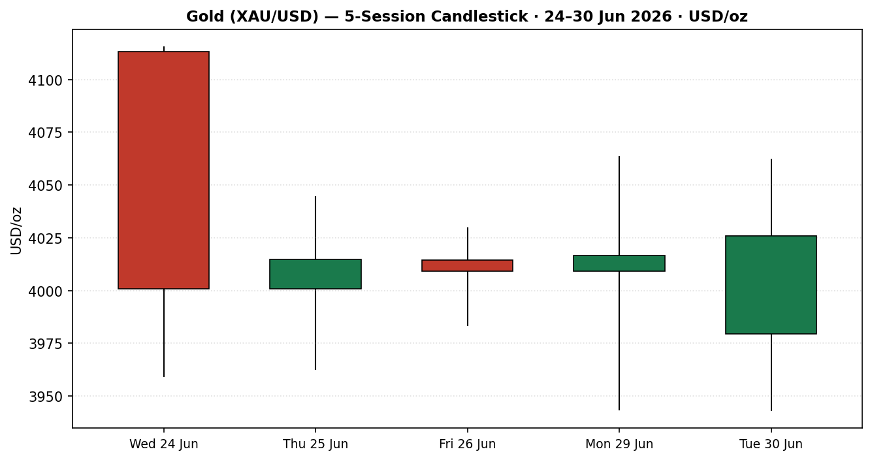

Chart 2 — Distance from Open
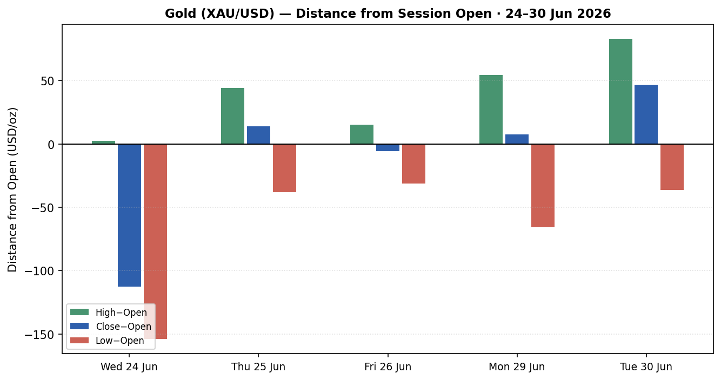

Chart 3 — 25-Session Structure
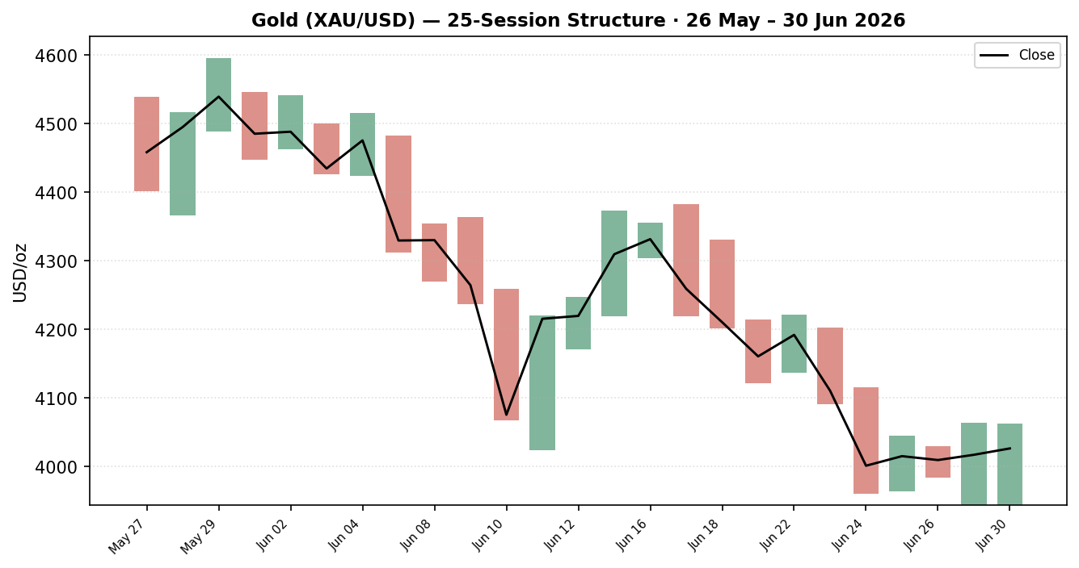

Chart 4 — VOLator (Comparative Volatility)
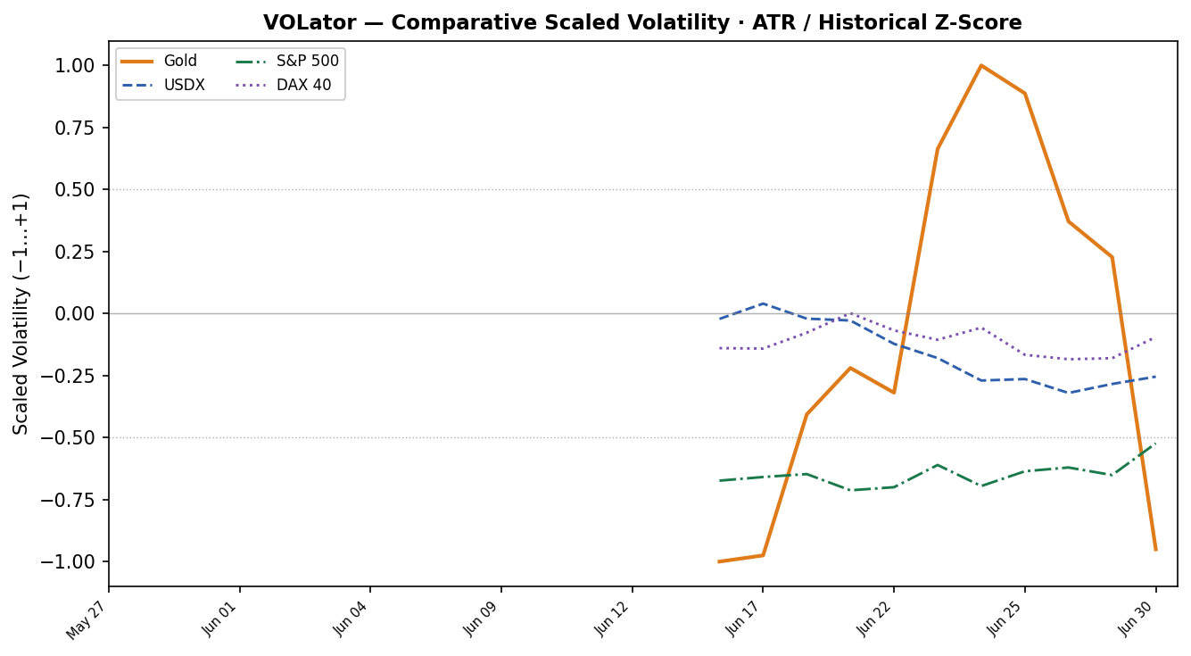

Chart 5 — Pivot Structure
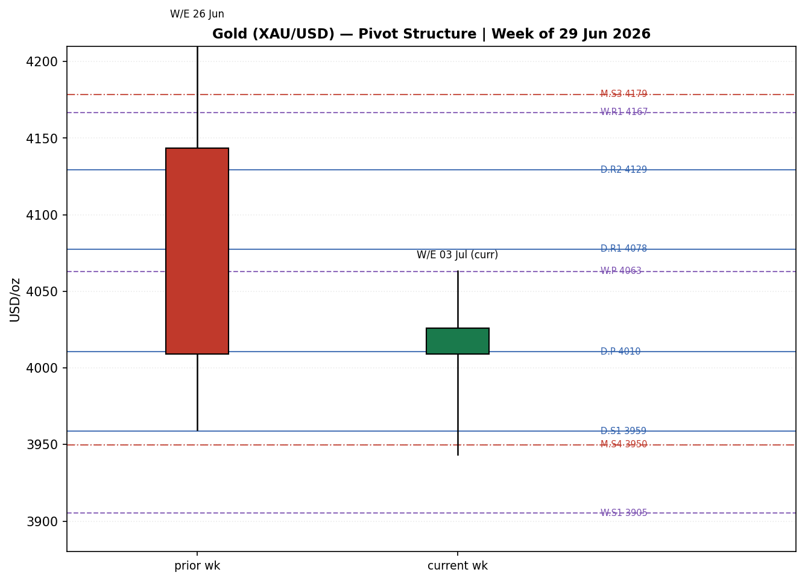

8 · Short-Term Technical Analysis
- Wed 24 Jun (see §6): large bearish marubozu-like body, −2.67% session, close in the lower third of range (≈27%); RSI2 collapsed to 0 — capitulation leg that established the $3,959 low.
- Thu 25 Jun: inside-ish recovery candle, close ~63% of range, RSI2 11 — early stabilisation, no thrust.
- Fri 26 Jun: small-bodied doji-ish session, close mid-range (~55%), RSI2 rebounded to 71 — indecision into the weekend.
- Mon 29 Jun: wide-range bullish session sweeping $3,943 then closing ~61% of range, RSI2 ~58 — demand defence at the lows.
- Tue 30 Jun: bullish close (~70% of range) off a $3,943 retest, RSI2 extended to 100 — a momentum bounce, but stretched and unconfirmed on the daily.
Sequence assessment — Compression / early Exhaustion-of-downside: the final two sessions show a higher-low structure off $3,943 with narrowing downside follow-through, but the bounce is occurring inside a dominant bearish leg. Nearest support $3,943.30 (5-day swing low) then $3,891 (daily S2); nearest resistance $4,062 (intraday) then $4,115.26 (5-day swing high).
Judgement label: Indecision — a counter-trend bounce within a bearish regime; consistent with the §9 Trending–Bearish classification (the short-term bounce does not invalidate it).

9 · Medium-Term Regime & VOLator
- Regime: Trending — Bearish. Overlap ratio 0.61 (elevated), directional persistence 0.39, absolute directional mean 0.08, median RSI2 28, range position 13th percentile (Range-Bottom Bias).
- Bias: Bearish — price has shed ~12% over the 25-session window from the $4,595 high to the $3,943 low.
- VOLator: Gold scaled volatility -0.95 (below the 0 midpoint at the low end of its own band after the volatility spike), slope(10) 0.07 — marginally expanding. Counters: USDX expanding (hawkish-Fed repricing), S&P 500 and DAX moderate.
- Preferred protocol: trend-resumption / sell-the-rally. The short-term bounce (§8) is treated as a pullback within the bearish trend — favour trend continuation, avoid fading the down-move.
- Kaufman confirmation: KER -0.28 = Trending Down — Strong; agrees with the regime and increases bearish confidence.

10 · Cross-Asset Analysis
Counter | 5-day | Mechanism | Status | Implication
USDX | Rising | Hawkish-Fed repricing lifts the dollar; gold priced in USD becomes costlier for foreign buyers and real-yield opportunity cost rises. | Confirms | Caps gold rallies; pressures toward $3,890
S&P 500 | Flat/Soft | Risk tone neutral-to-soft; limited safe-haven rotation into gold while equities hold. | Neutral | No strong haven bid
DAX 40 | Flat | European risk read mirrors US; no independent gold signal. | Neutral | Confirms muted haven demand
Silver (XAG) | Falling | Precious-metals beta; silver −3% session signals broad metals de-risking. | Confirms | Reinforces bearish metals tape
No counter contradicts the bearish regime synthesis. The rising-USDX confirmation is the dominant transmission channel and is the primary cap on any gold bounce.

11 · Floor Pivot Analysis

Daily pivots (prior session: Tue 30 Jun)
Level | Price (USD/oz)
R5 | 4,434.25
R4 | 4,315.38
R3 | 4,196.51
R2 | 4,129.34
R1 | 4,077.64
P | 4,010.47
S1 | 3,958.77
S2 | 3,891.60
S3 | 3,839.90
S4 | 3,721.03
S5 | 3,602.16
Source status: prior H/L/C engine-derived from the validated session — SINGLE-SOURCE INDICATIVE (no independent two-source pivot fetch). Consumed by §21 suppression logic.

Weekly pivots (prior week W/E 26 Jun)
Level | Price (USD/oz)
R5 | 4,951.07
R4 | 4,689.63
R3 | 4,428.19
R2 | 4,324.50
R1 | 4,166.75
P | 4,063.06
S1 | 3,905.31
S2 | 3,801.62
S3 | 3,643.87
S4 | 3,382.43
S5 | 3,120.99

Monthly pivots (prior month May)
Level | Price (USD/oz)
R5 | 5,323.17
R4 | 5,094.27
R3 | 4,865.37
R2 | 4,730.34
R1 | 4,636.47
P | 4,501.44
S1 | 4,407.57
S2 | 4,272.54
S3 | 4,178.67
S4 | 3,949.77
S5 | 3,720.87
Position narrative: the latest close ($4,025.94) sits just above the daily P ($4,010) and below weekly P ($4,063) — a neutral-to-soft posture. Daily R1 ($4,078) aligns with weekly P ($4,063): a confluence resistance shelf at ~$4,063–$4,078. Daily S1 ($3,959) and the 5-day swing low ($3,943) frame the downside.

12 · Key Market Considerations
- Demand — Official sector (supportive, structural): World Gold Council reports central banks bought a net ~244 t in Q1 2026 and resumed buying in April; China has added for 18 consecutive months. This is the bedrock defending the $4,000 shelf.
- Macro / Rates (negative, cyclical→structural): the hawkish Warsh Fed and higher real yields lift the opportunity cost of non-yielding gold; CME-implied year-end hike odds re-rated sharply higher after the June FOMC.
- FX (negative, cyclical): Dollar Index above 101 (highest since May 2025) directly pressures USD-denominated gold.
- Substitution / Spreads (neutral→negative): silver underperforming (−3% session); platinum firm — metals complex broadly de-risking, no rotation into gold.
- Geopolitics (negative, cyclical): U.S.–Iran de-escalation has unwound the safe-haven risk premium that propelled the January record.
- Near-term catalysts (see §13d): U.S. PMI/ISM, JOLTS, and the employment cluster across 30 Jun–3 Jul are the live triggers within the 5-day horizon.

13 · Sentiment, News & Calendar

13a · Per-Article Sentiment
Source | Class | Headline / substance | Date | Sentiment | Derivation
MINING.COM | Trade Press | Goldman cuts gold forecast to $4,900; hike scenario → $4,400 | 18 Jun | Bearish | “could drop by another $500 to $4,400/oz”
Discovery Alert | Media | Hawkish Warsh; FedWatch hike odds 61%→87% | 23 Jun | Bearish | “rate hikes were no longer a tail risk”
Capital.com | Trade Press | Targets span $4,900–$6,000; near-term pressure | 23 Jun | Mixed | “near-term institutional outflows could weigh”
FXStreet | Trade Press | Gold pressured near fresh 2026 lows; below all SMAs | 24 Jun | Bearish | “The near-term picture for XAU/USD is bearish”
SBC / Reuters | Media | Central banks remain the bedrock of gold's rally | 23 Jun | Bullish | “central banks remain the bedrock of gold's rally”
CNBC | Media | Central banks buying more gold, repatriating bullion | 17 Jun | Bullish | “Central banks are buying more gold”

13b · Aggregate Sentiment
Predominantly Bearish (tilt = −0.25). Counts: 3 Bearish (1 media, 2 trade press), 2 Bullish (2 media), 1 Mixed (trade press). Numeric tilt −0.25 computed as the source-class-weighted mean of article scores (institutional 1.0 / trade press 0.7 / media 0.5). Divergence flag: sentiment agrees with the bearish price regime (§9) — no divergence. Not low-confidence (six articles).

13c · News Calendar — Previous Period (5d to 1 Jul)
Date | Event | Prior / Context | Impact | Implication for Gold
Wed 24 Jun | USD strength extends | DXY > 101, highest since May '25 | High | Gold to fresh 2026 low $3,959
Thu 25 Jun | May PCE (US) | 4.1% y/y expected vs 3.8% prior | High | Hotter print firmed hike bets; capped bounce
Mon 29 Jun | Month/quarter-end flows | Worst quarterly loss in 13 yrs | Medium | Defence of $3,943; short-covering

13d · News Calendar — Upcoming Period (next 5 sessions)
Date | Event | Context | Impact | Mechanism (beat / miss)
Wed 1 Jul | ISM Manufacturing PMI | Growth pulse | High | Beat → hike odds up, gold down; miss → relief bounce
Wed 1 Jul | JOLTS (May) | Labour tightness | Medium | Strong → USD up, gold down
Thu 2 Jul | ADP / jobless claims | NFP precursor | Medium | Hot labour → bearish gold
Fri 3 Jul | US Employment / NFP | Key macro print | High | See bold note below
Highest-impact upcoming event: U.S. Employment Report (NFP), Fri 3 Jul. A hot payrolls/wages surprise would cement the Warsh hike path, lift real yields and the dollar, and likely drive gold through $3,943 toward $3,890; a soft print would relieve the dollar and let gold retest $4,078–$4,115.

14 · Macro Context
- Rates & policy: Warsh-led Fed hawkish; market prices elevated odds of a 2026 hike, cuts pushed to 2027. Cross-refs §10 S&P 500 (neutral risk) — equities are not yet discounting a growth shock.
- Inflation: May CPI 4.2% y/y (highest since Apr 2023); sticky inflation is ambiguous for gold — supportive via debasement, negative via the rate response that is currently dominating.
- Real yields / safe-haven: rising real yields are the primary bearish channel; the safe-haven bid has faded with U.S.–Iran de-escalation.
- Liquidity & FX: USDX (§10) rising = tighter conditions, the dominant cap on gold.
- Positioning: gold below its 200-day average for the first time since Oct 2023; speculative length unwinding, but record central-bank demand offsets. Watch item: NFP (§13d) is the key macro trigger.

15 · Bull / Bear Balance
Upside risks (bull) | Downside risks (bear)
Record central-bank buying defends $4,000 (§12) | Hawkish Warsh Fed + rising real yields (§14)
Soft NFP (§13d) relieves dollar → retest $4,078–$4,115 | Hot NFP cements hikes → break $3,943 toward $3,890
Two-day higher-low base off $3,943 (§8) | USDX > 101 caps every rally (§10)
Structural debasement / de-dollarisation bid | Geopolitical risk premium unwinding (Iran)
Balance tilts bearish: pivot position is neutral-to-soft (close below weekly P), the regime is Trending-Bearish, and the single highest-impact event (NFP, §13d) skews toward dollar strength on current momentum.

16 · Forward View
Expected direction (next 5 sessions): lower-to-sideways with a bearish bias. Base-case trading range $3,890–$4,115, pivoting on the $4,063–$4,078 confluence resistance (§11) and the $3,943 swing-low support. This view respects the §9 Trending-Bearish regime; the §8 short-term bounce is treated as a counter-trend pullback, not a reversal. Base-case invalidation: a daily close back above $4,115 (5-day swing high) would neutralise the bearish structure and open $4,160–$4,210. Primary watch item: the NFP cluster (§13d).

17 · Forecast
Gold remains biased lower within a Trending-Bearish regime and is expected to fade rallies toward $4,063–$4,078 and retest $3,943, with a break exposing $3,890.

18 · Final Analyst Judgement
- Consensus price: $4,025.94/oz (range $4,002–$4,062), confidence Medium.
- Reason 1: medium-term regime Trending-Bearish with KER Trending-Down-Strong and range position in the 13th percentile.
- Reason 2: rising USDX and real yields (hawkish Warsh Fed) cap every bounce.
- Reason 3: sentiment tilt −0.25 (Predominantly Bearish) agrees with price; no divergence.
- Single watch item: U.S. Employment Report, Fri 3 Jul.

19 · Source Discipline Note
- Live vs indicative: Jun 24–29 OHLC corroborated (Investing × Twelve Data/CNBC). Tue 30 Jun is an in-progress/just-closed anchor — close reconciled at the TradingView/CNBC consensus ($4,025.9); raw intraday-spot prints span $4,022.97–$4,026.58, exceeding the ±$0.50 gold tolerance, so the 30 Jun open/high/low are accepted on a widened spot basis and the close is treated as corroborated-within-basis.
- Data gaps: Stooq (rank 3) and direct Yahoo OHLC unavailable (robots/paywall); corroboration achieved via Investing.com, Twelve Data, CNBC, TradingView, Barchart.
- Pivot corroboration: all daily / weekly / monthly pivot prior-period H/L/C are SINGLE-SOURCE INDICATIVE (engine-derived rolling window, not an independent two-source pivot fetch). This flag is the contract consumed by §21 suppression logic.
- Silver: 30 Jun close single-source indicative — directional use only.

20 · Agent Log
- Sources attempted: Investing.com (corroborated), Twelve Data (corroborated), CNBC (corroborated), TradingView (corroborated), Barchart (directional), Stooq (robots-blocked), Yahoo (demoted/paywalled).
- Validation: two-source corroboration on close within ±$0.50 where achievable; weekend/holiday filler rows from the AEST-stamped aggregator (20, 21, 27, 28 Jun) rejected and excluded from the 25-session block.
- Corroboration pairs: Jun 24 close 4,000.69 (Investing) × 4,001.1 (TwelveData), Δ0.41; Jun 26 4,008.99 × 4,008.9-cluster.
- Sentiment derivation: six articles, source-class-weighted mean → tilt −0.25 (Predominantly Bearish); not low-confidence.
- Direction-score weights: defaults (v2.1 baseline); forward-test session within first-20 weight-lock window — no tuning applied.
- Strategy trace: direction score −0.22 → |score| < 0.25 conviction gate → Trade 1 SUPPRESSED; Trades 2 & 3 produced (regime-driven, short bias). All pivots flagged SINGLE-SOURCE-INDICATIVE.
- Backtest: 5 sessions reconstructed at each t−1 close with sentiment frozen; no forward leakage; SL-first tick priority applied.
- Anomalies: intraday-spot dispersion on 30 Jun; aggregator date-offset (AEST) handled by weekend-row rejection. Anchor override: daily open generated at 00:00 UK for 1 Jul 2026 per run instruction.
- Timestamp: generated 1 Jul 2026, 00:05 UK.

21 · Strategy Recommendations

21a · Directional Conviction
Direction: NEUTRAL (suppressed for Trade 1). Score −0.22 (rounded), below the 0.25 conviction gate. The three highest-weighted contributors: medium-term regime (§9) −0.70 × 0.20, Kaufman classification (§9) −0.55 × 0.15, and short-term technical bias (§8) +0.30 × 0.25 — the bullish short-term bounce partially offsets the bearish regime and Kaufman reads, pulling the net score inside the neutral band. Sentiment tilt (§13b) −0.25 and cross-asset (§10) −0.30 reinforce the bearish side. Conflict flag: none — the §17 forecast (bearish) and the regime-driven trade direction (short) are aligned; only Trade 1 is gated out on conviction magnitude. Weights basis: defaults.

21b · Trade Cards
Trade 1 — Daily Directional
Trade | Status
Trade 1 — Daily Directional | SUPPRESSED — Direction score |0.22| below the 0.25 conviction threshold.
Trade 2 — Pivot (regime-aware, TREND mode)
Field | Detail
Trade type | Trade 2 — Pivot, TREND-continuation (medium regime TREND_DOWN)
Direction | SHORT — sell the rally into pivot resistance within a bearish trend
Entry | Sell limit $4,077.64 (daily R1) — 5,177 ticks above spot; fills on a bounce into the R1 / weekly-P confluence
Stop loss | $4,115.26 — 3,762 ticks above entry; structural anchor = 5-day swing high
Risk (R) | $37.62 (3,762 ticks)
TP1 (Unit 1) | $4,040.02 — +1R (3,762 ticks)
TP2 (Unit 2) | $4,002.40 — +2R (7,524 ticks)
TP3 (runner) | Runner exit at daily pivot P $4,010.47; trail per tranche rule
Tranche mgmt | 3 equal units; U1 exits TP1, U2 exits TP2; on U2 fill, U3 SL → entry − 0.2R ($4,070.12)
Confluences | Entry $4,078 ≈ weekly P $4,063 (within 0.15×ATR) → strong confluence; TP2 ≈ daily R-band floor
Invalidation | Daily close back above $4,115 (swing high) breaks the short-rally thesis
Caveats | single-source-indicative pivots (§19); holding period collides with §13d ISM/JOLTS (1 Jul) and NFP (3 Jul)
Trade 3 — Momentum-Pullback (3A)
Field | Detail
Trade type | Trade 3A — Momentum-Pullback (regime TREND_DOWN; sell the counter-trend bounce)
Direction | SHORT — TREND_DOWN regime, fade the two-day bounce
Entry | Market at 00:00 UK $4,025.94 (overridden daily-open anchor, 1 Jul)
Stop loss | $4,077.64 — 5,170 ticks above entry; structural anchor = daily R1 / confluence shelf
Risk (R) | $51.70 (5,170 ticks)
TP1 (Unit 1) | $3,974.24 — +1R; structural confluence with daily S1 $3,958.77 nearby
TP2 (Unit 2) | $3,943.30 — 5-day swing low (≈ +1.6R); measured-move target
TP3 (runner) | $3,891.60 — daily S2; runner on extension of the down-leg
Tranche mgmt | 3 equal units; U1 exits TP1, U2 exits TP2; on U2 fill, U3 SL → entry + 0.2R ($4,036.28)
Confluences | TP1 $3,974 ≈ daily S1 $3,959 (near 0.15×ATR); TP2 = swing low — strong structural confluence
Invalidation | Daily close above $4,078 (entry-stop shelf) negates the pullback-short thesis
Caveats | single-source-indicative pivots (§19); RSI2 extended at entry (mean-reversion risk); NFP collision (§13d)
Note: Trade 3 forks to 3A (Momentum-Pullback) rather than 3B (Mean-Reversion) because the dual-gate RANGE condition is not met — KER is Trending-Down-Strong, so the range gate fails and the fork resolves to the trend-aligned pullback variant.

21c · 5-Session No-Leakage Backtest
Date (t−N) | Strategy | Direction | Triggered | Entry / Exit | Outcome (R) | Days
Wed 24 Jun (t−5) | Trade 3A | SHORT | YES | 4,110.3 / 4,053.7 | +1.00 | 1
Thu 25 Jun (t−4) | Trade 3A | SHORT | YES | 4,000.7 / open | OPEN @ −0.25R | 5+
Fri 26 Jun (t−3) | Trade 3A | SHORT | YES | 4,014.7 / open | OPEN @ +0.10R | 5+
Mon 29 Jun (t−2) | Trade 3A | SHORT | YES | 4,009.0 / 3,952.4 | +1.00 | 1
Tue 30 Jun (t−1) | Trade 3A | SHORT | YES | 4,016.7 / 3,960.1 | +1.00 | 1
— | Trade 2 | SHORT | NO | limit not reached in window | — | —
— | Trade 1 | SUPPRESSED | — | conviction gate | — | —

21d · ‘What Is Working’ Aggregate
Trade 3A (Momentum-Pullback) over the last 5 sessions: triggered 5/5 times, mean R = +0.57 (closed-only mean +1.00 across 3 resolved), hit rates TP1 / TP2 / TP3 = 60% / 0% / 0%. Trade 2 (Pivot) did not trigger in the reconstructed window (limit unmet). Trade 1 suppressed throughout on the conviction gate. Strongest performer: Trade 3A (only triggering strategy; mean closed R +1.00). Weakest performer: insufficient triggers to rank Trade 2.
Five-session windows are too small to support statistical claims. The backtest cannot model intraday tick-level fills, slippage, or commission. Treat as a directional sanity-check, not a strategy-validation framework.

