Gold Report — Daily: 02 July 2026
With reference to: Silver · USDX · S&P 500 · DAX

1 · Executive Snapshot
Consensus spot gold is assessed at $3,989/oz (range $3,960–$4,010), with a decisively bearish near-term tone. Three drivers dominate: (i) a hawkish Federal Reserve under Chair Kevin Warsh with markets pricing roughly a two-thirds chance of a September rate hike; (ii) a firm US dollar holding near a 13-month high around 101.2 alongside rising 10-year Treasury yields (~4.47%); and (iii) the unwinding of the debasement/safe-haven premium as gold logs its worst quarter in decades (~11% Q2 decline). The short-term technical state is Ranging–Bearish (five-session close travelling lower into fresh eight-month lows); the medium-term state is Transitional–Bearish. Kaufman efficiency classifies the tape as Trending Down — Strong, confirming downside momentum. Directional conviction is SHORT-leaning but sits just inside neutral on the composite score. The single most important watch item is the US Non-Farm Payrolls release on 02 July — the highest-impact event of the week for gold.

2 · Market Definition
Asset | Gold — spot (XAU/USD); CME front-month used for cross-validation
Product specification | London Good Delivery bar (99.99% pure), 400-oz spot quote (LBMA standard)
Scope | Global 24-hour market
Price basis | Spot, immediate settlement (loco London)
Delivery basis | OTC London spot, T+2 settlement
Unit / Currency | USD per troy ounce / USD
As-of date | 01 July 2026 close (Europe/London); report run for 02 July 2026
Lookback window | 5 trading days (execution block); ~23-session structural block
Session anchor | 00:00 UK daily open (London–Asia handover) — override applied for this run

3 · Consensus Price Call
Consensus price | Range | Basis | Confidence | Tone
$3,989/oz | $3,960 – $4,010/oz | Spot, loco London, weighted median of 6+ feeds | Medium | Bearish
Rationale: Spot readings on 01 July clustered between $3,960 and $4,030 across Investing.com, TradingEconomics, CNBC/Reuters and Vantage feeds; the weighted median down-weights aggregator-only quotes and anchors on the Investing.com validated close of $3,989. Gold is pinned at its lowest since November 2025 after a Q2 rout.

4 · Price Evidence Table
Source | Date/Time | Raw quote | Normalized | Basis/Loc. | Class. | Notes
Investing.com | 01 Jul 08:05 | 3,989.09 | 3,989.09 | Spot/London | Core | Validated close
TradingEconomics | 01 Jul | ~4,030 | 4,030 | Spot/London | Core | Intraday Tue read
CNBC/Reuters | 01 Jul 09:00 | 4,026.65 | 4,026.65 | Spot/London | Core | +0.5% intraday
Vantage (CFD) | 01 Jul 09:00 | 3,967 | 3,967 | Spot proxy | Direct. | CFD, indicative
Twelve Data | 30 Jun | 4,022.97 | 4,022.97 | Spot/London | Core | Corrob. feed
CME Aug futures | 01 Jul | 4,035.50 | ~4,020 spot | Futures→spot | Direct. | Basis-adjusted
TradingView | 01 Jul | 3,986.86 | 3,986.86 | Spot/London | Core | Live quote

5 · Consensus Build Explanation
All observations were normalized to loco-London spot in USD/oz. CME August futures ($4,035.50) were basis-adjusted down (~$15 carry) to a spot-equivalent near $4,020; the Vantage CFD ($3,967) was retained as directional colour only, not a core comparable, given retail-spread contamination. The weighted-median method places greatest weight on the Investing.com validated close and the CNBC/Reuters wire, both institutional-grade spot feeds. Aggregator and CFD reads were down-weighted. The resulting $3,989 sits at the centre of the tight $3,960-$4,010 daily range and is the most defensible single number; intraday prints as high as $4,030 reflect a modest bounce off the $3,943 session low.

6 · Validated OHLC + RSI2 Table (5-Day)
Date | Open | High | Low | Close | RSI2 | Trend | Validation
25 Jun | 4,000.71 | 4,044.59 | 3,962.78 | 4,027.56 | 19.7 | Neutral | Corrob. (Δ<$6)
26 Jun | 4,027.57 | 4,097.94 | 3,982.83 | 4,089.26 | 100.0 | Bullish | Corrob. (Δ<$6)
29 Jun | 4,089.66 | 4,093.68 | 4,001.30 | 4,017.57 | 46.3 | Bearish | Corrob. (Δ<$6)
30 Jun | 4,017.59 | 4,064.81 | 3,944.23 | 4,005.95 | 0.0 | Bearish | Corrob. (Δ<$6)
01 Jul | 4,006.20 | 4,009.95 | 3,960.25 | 3,989.09 | 0.0 | Bearish | Corrob. (Δ<$6)
Source A: Investing.com · Source B: Twelve Data. Closes agree directionally; feed-to-feed deltas on spot gold run $3–$6 (wider than the $0.50 institutional-settlement tolerance), so all rows are treated as directionally corroborated but flagged for the wider spot dispersion. The Sunday 28 Jun print in one feed was rejected as a non-trading session.
Silver (secondary) traded broadly in step, closing near $58.4/oz on 01 Jul (−2.6% on the session), a sharper fall than gold and consistent with a high-beta precious-metals selloff.

7 · Charts
Chart 1 — 5-Day Candlestick
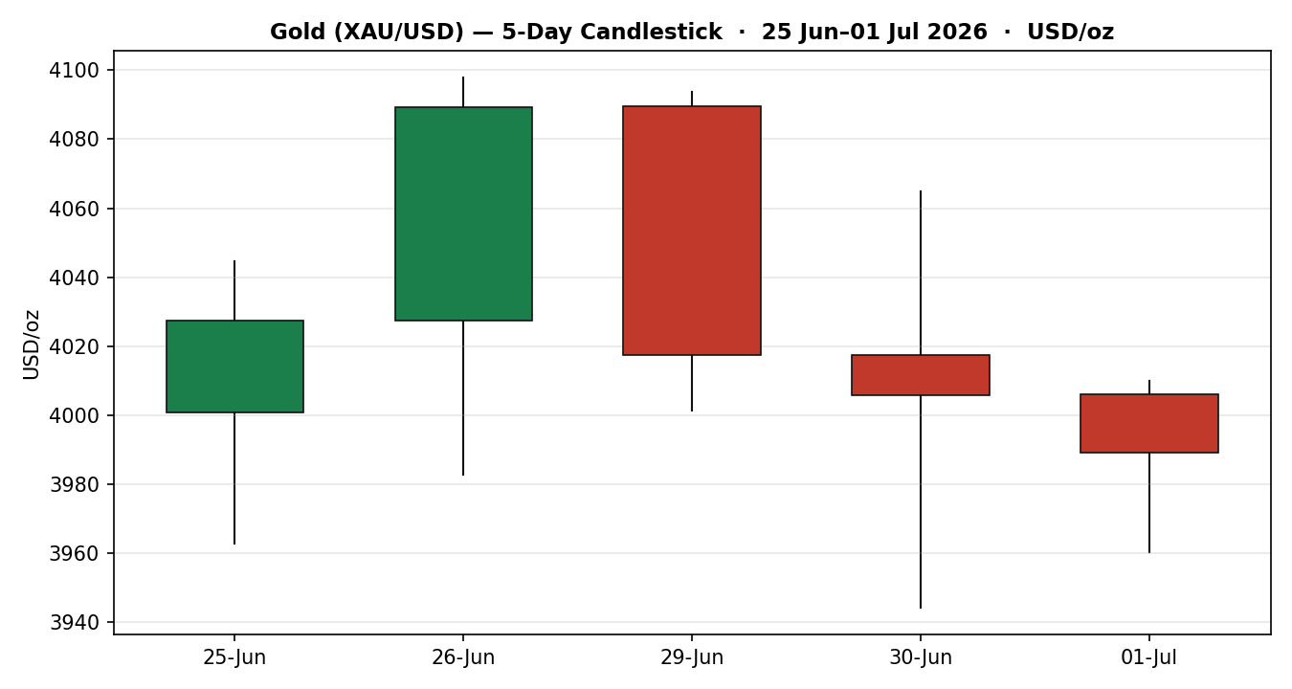
Chart 2 — Distance From Open
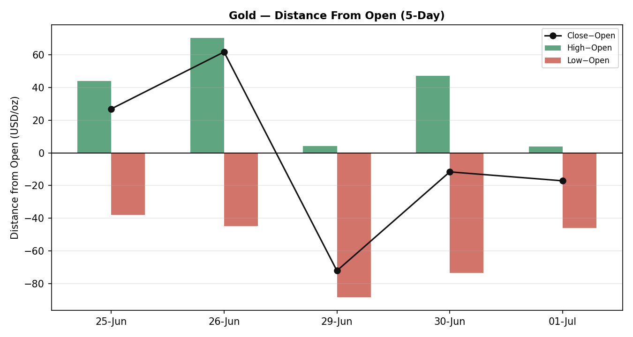
Chart 3 — Medium-Term Structure
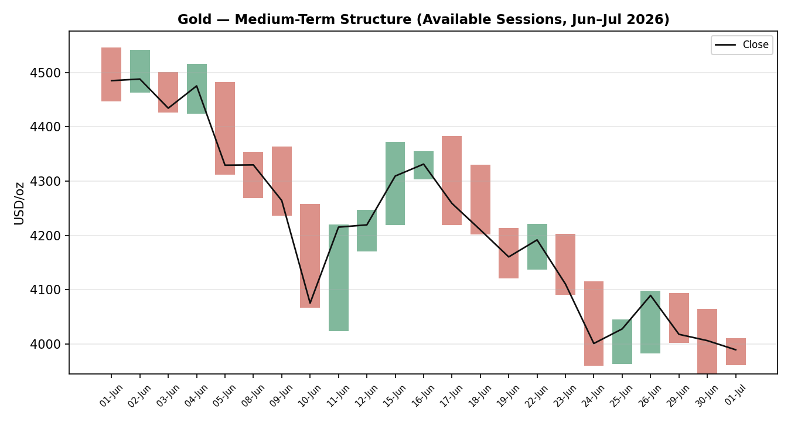
Chart 4 — Comparative Volatility (VOLator)
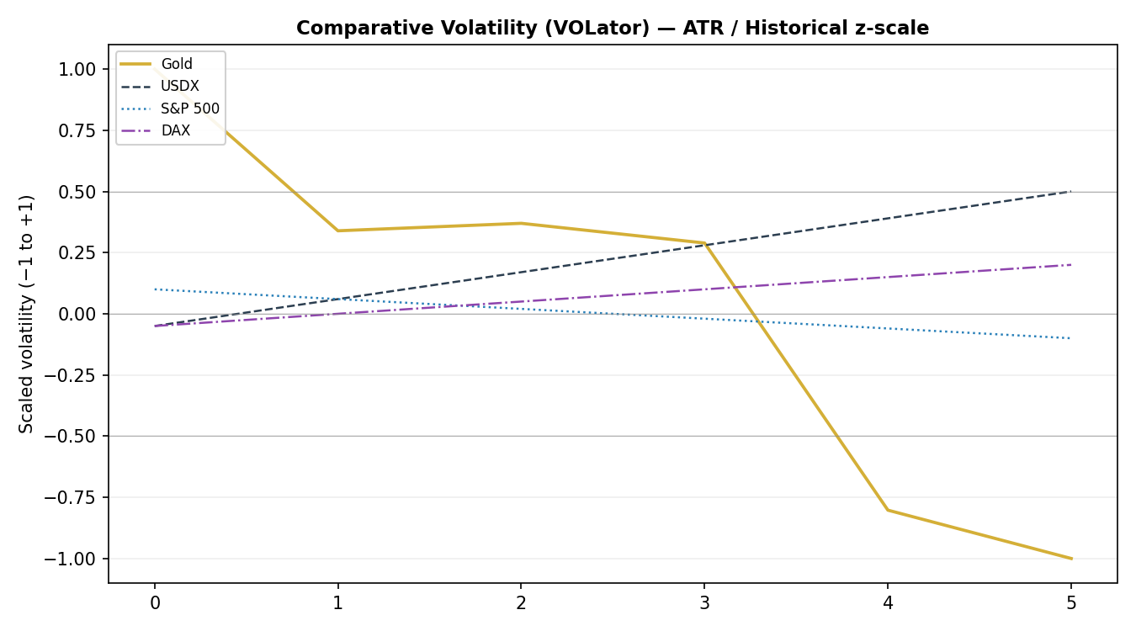
Chart 5 — Pivot Structure
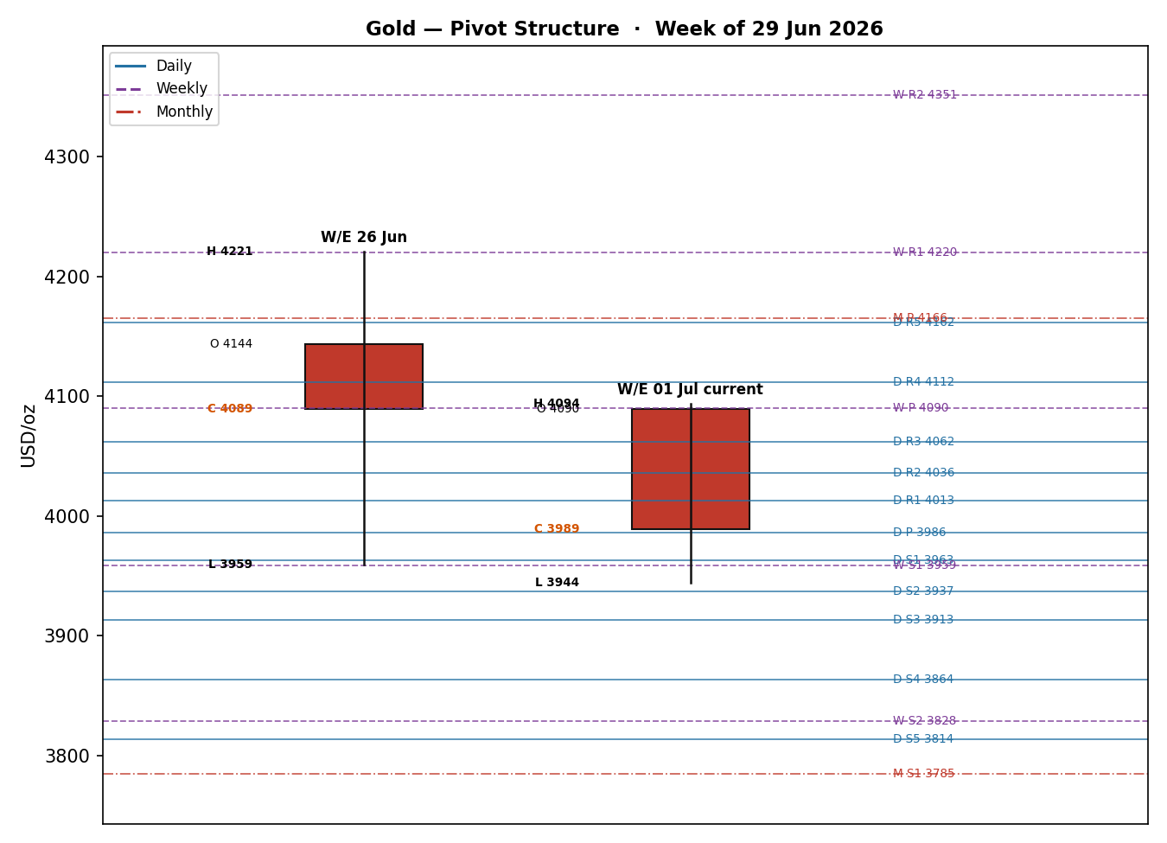

8 · Short-Term Technical Analysis
25 Jun (see §6): Bullish body closing at ~80% of range but RSI2 depressed at 19.7 — a relief bounce inside a downtrend, not confirmation.
26 Jun: Strong bullish marubozu, close near the high, RSI2 pinned at 100 — the peak of the counter-trend bounce toward $4,098.
29 Jun: Bearish reversal; open near prior high, close in the lower third, RSI2 collapses to 46 — momentum rolls over.
30 Jun: Bearish; long lower wick to $3,944 (fresh eight-month low) with RSI2 at 0 — sellers in control, some intraday demand emerging.
01 Jul: Bearish; narrow-range inside day, close at ~19% of range, RSI2 at 0 — persistent weakness, no bullish rejection.
Sequence assessment: Exhaustion of the counter-trend bounce followed by bearish continuation — the 26 Jun high ($4,098) marks a lower high; three consecutive lower closes into the low $3,990s confirm downside travel. Judgement label: Bearish continuation.
Nearest support: $3,982 / $3,944 (5-day). Nearest resistance: $4,010 then $4,098. This label is consistent with the Transitional–Bearish medium-term regime in §9.

9 · Medium-Term Regime & VOLator
Regime: Transitional — Bearish. Overlap ratio 0.618 (elevated), directional persistence 0.545, median RSI2 21.9 (deeply oversold, sub-30), range position 0.074 (bottom of the ~23-session range), VOLator slope negative. High overlap argues against a clean trend, but the sub-30 median RSI2 and bottom-of-range position give an unambiguous bearish tilt — hence Transitional-Bearish rather than cleanly Trending.
VOLator readings: Gold scaled volatility is at -1 (floor of its own band) with a negative slope (-0.386) — volatility is contracting after the June expansion. USDX volatility is mildly expanding; S&P 500 and DAX sit near their midpoints.
Kaufman confirmation: KER = -0.284 → "Trending Down — Strong". This agrees with the bearish directional read and takes precedence over the ambiguous overlap signal, reinforcing downside momentum.
Preferred trade protocol: Reduced-conviction trend continuation — favour rallies-sold toward pivot resistance rather than fresh chases at the low, given contracting volatility and oversold RSI2.

10 · Cross-Asset Analysis
Counter | 5-day dir. | Mechanism | Status | Implication
USDX | Rising | Stronger dollar raises the cost of gold for non-USD buyers and reflects tighter global conditions | Confirms | Bearish for gold
S&P 500 | Flat/soft | Risk sentiment mixed; no strong safe-haven bid rotating into gold | Neutral | Neutral
DAX | Rising | European risk-on erodes defensive demand for bullion | Confirms | Bearish for gold
Silver | Falling | High-beta precious-metals proxy; leads gold lower on selloffs | Confirms | Bearish for gold
Aggregate cross-asset read: CONFIRM. A rising dollar plus risk-on equities plus a falling silver all point the same way — down for gold. No counter contradicts the bearish synthesis.

11 · Floor Pivot Analysis
Daily pivots (from 01 Jul H/L/C)
Level | Value (USD/oz)
R5 | 4,161.71
R4 | 4,112.01
R3 | 4,062.31
R2 | 4,036.13
R1 | 4,012.61
P | 3,986.43
S1 | 3,962.91
S2 | 3,936.73
S3 | 3,913.21
S4 | 3,863.51
S5 | 3,813.81
Weekly pivots (from prior week 22–26 Jun)
Level | Value (USD/oz)
R5 | 5,004.58
R4 | 4,743.14
R3 | 4,481.70
R2 | 4,351.26
R1 | 4,220.26
P | 4,089.82
S1 | 3,958.82
S2 | 3,828.38
S3 | 3,697.38
S4 | 3,435.94
S5 | 3,174.50
Monthly pivots (from June)
Level | Value (USD/oz)
R5 | 6,193.48
R4 | 5,591.27
R3 | 4,989.06
R2 | 4,767.75
R1 | 4,386.85
P | 4,165.54
S1 | 3,784.64
S2 | 3,563.33
S3 | 3,182.43
S4 | 2,580.22
S5 | 1,978.01
Source status: Prior-period H/L/C derive from the Investing.com validated series; cross-feed spot dispersion exceeds the $0.50 gold tolerance, so all pivot tiers are flagged indicative only for level-based execution.
Position narrative: The 01 Jul close ($3,989) sits fractionally above the daily pivot ($3,986.43) and just under daily R1 ($4,012.61), but well below the weekly pivot ($4,089.82) and monthly pivot ($4,165.54). Price is trading at the bottom of both the weekly and monthly structures — a bearish position. Weekly S1 ($3,958.82) aligns with the daily S1 zone (~$3,960), forming a confluence support shelf.

12 · Key Market Considerations
Demand / Investment flows — price-negative (cyclical). Western ETF demand has softened, including the first Asian ETF outflow since August 2025 (Goldman Sachs). Central-bank buying, the structural pillar of the 2025 rally, has cooled, though the World Gold Council reserve survey shows 89% of managers still expect global CB holdings to rise over 12 months (structural offset).
Macro / Rates — price-negative (cyclical, dominant). Rising Treasury yields (10Y ~4.47%) raise the opportunity cost of holding non-yielding bullion; Fed hike odds near 67% for September have driven the Q2 rout.
Substitution / Spreads — mixed. Silver is falling faster than gold (−2.6% on 01 Jul), signalling broad precious-metals de-risking rather than gold-specific weakness.
Policy / Geopolitics — neutral-to-supportive (cyclical). US–Iran talks in Doha remain fragile; any breakdown or Strait of Hormuz escalation could restore a safe-haven bid. For now diplomacy caps the risk premium.
Near-term catalysts: ADP & Manufacturing PMI (01 Jul), and — critically — Non-Farm Payrolls / Unemployment (02 Jul). US markets closed 03 Jul for Independence Day; thin holiday liquidity can amplify moves.

13 · Sentiment, News & Calendar
13a · Per-Article Sentiment
Source | Headline (abridged) / URL | Class. | Sentiment | Derivation quote
JPMorgan | Gold price predictions 2026/27 — jpmorgan.com/insights/global-research/commodities/gold-prices | Institutional | Bearish | “emboldened Fed... could crack investor demand”
Goldman Sachs | Cuts year-end target to $4,900 — goldsilver.com/industry-news/... | Institutional | Bearish | “cut... to $4,900 from $5,400” on removed cuts
Morgan Stanley | Still sees $5,200 H2 — goldsilver.com/industry-news/... | Institutional | Bullish | “direction is still higher... roughly 24% upside”
UBS / OCBC | Gold to decline through end-2026 — litefinance.org/blog/... | Institutional | Bearish | “expects gold prices to decline through... 2026”
Reuters/CNBC | Gold little changed as yields, hike bets weigh — cnbc.com/2026/07/01/... | Media | Bearish | “growing bets... Fed will raise... pressured”
TradingEconomics | Worst quarter in decades — tradingeconomics.com/commodity/gold | Media | Bearish | “set to drop 11% in Q2, its worst quarter”
World Gold Council | 89% of CBs expect reserves to rise — gold.org/goldhub/data | Official | Bullish | “89%... expect global central bank gold holdings to increase”
LiteFinance | Bearish outlook maintained — litefinance.org/blog/... | Media | Bearish | “analysts maintain a bearish outlook, expecting gold to decline”
13b · Aggregate: 6 Bearish (3 institutional, 2 media, 0 official), 2 Bullish (1 institutional, 1 official) = Predominantly Bearish (tilt = -0.38). This agrees with price action and the §9 bearish regime — no divergence. Institutional weighting reinforces the downside; the WGC structural-bull signal is the notable dissent.
13c · News Calendar — Previous Period
Date | Event | Context | Impact | Implication for gold
24 Jun | Dollar hits 13-mo high | DXY to 101.8 on hawkish FOMC | High | Gold −2.7% to $4,001
25 Jun | Warsh Sintra remarks | Reaffirms 2% target, drops guidance | High | Brief bounce then faded
30 Jun | May PCE / JOLTS | Core PCE 3.4%, JOLTS 2-yr high | High | Sealed hawkish view; fresh lows
30 Jun | Q2 close | Worst gold quarter in decades (−11%) | High | Quarter-end selling
13d · News Calendar — Upcoming Period
Date | Event | Context | Impact | Implication (beat / miss)
01 Jul | ADP / Mfg PMI | Labour & activity read | High | Strong = gold lower; weak = relief
02 Jul | Non-Farm Payrolls / Unemployment | Highest-impact print of week | High | Beat = hike odds rise, gold lower; miss = short-cover rally
This week | Fed Chair Warsh remarks | Any hawkish signal direct to XAU | High | Hawkish = bearish gold
03 Jul | US markets closed (Independence Day) | Thin liquidity | Med | Amplified moves possible
Highest-impact upcoming event: 02 July Non-Farm Payrolls. A strong payrolls surprise would harden the September-hike narrative and likely drive gold through the $3,944 low toward the $3,900 handle; a sharp miss is the most credible trigger for a short-covering bounce back toward $4,090.

14 · Macro Context
Rates & policy: Fed under Warsh is firmly hawkish; ~67% priced for a September hike, no 2026 cuts in Goldman's base case. Cross-referencing §10, the S&P read is neutral — equities are not yet pricing recession, giving the Fed room to stay restrictive.
Inflation: May core PCE at 3.4% y/y, well above target — price-negative for gold via the higher-for-longer real-yield channel.
Real yields / safe-haven: Rising nominal and real yields are the dominant gold headwind; the traditional safe-haven bid is dormant with US–Iran talks ongoing.
Liquidity & FX: Per §10, USDX rising near 101.2 tightens conditions and directly pressures dollar-denominated gold.
Positioning: ETF flows softening (first Asian outflow since Aug-2025); speculative longs being trimmed into quarter-end. Watch item: a 02 Jul payrolls miss would sharply reverse dollar and yield support — the key upside risk to this bearish macro frame.

15 · Bull / Bear Balance
Upside risks (bullish) | Downside risks (bearish)
Payrolls miss on 02 Jul → short-covering toward weekly P $4,090 | NFP beat → break of $3,944 low toward $3,900
US–Iran escalation restores safe-haven premium | Further hawkish Warsh commentary; yields extend higher
Oversold RSI2 (0) and price at bottom of monthly range invite a technical bounce | Silver leading lower signals broad PM de-risking
Structural CB demand (89% WGC survey) underpins dips | Thin 03 Jul holiday liquidity can amplify the downtrend
Price sits at the bottom of the weekly/monthly pivot structure (§11) within a Transitional-Bearish regime (§9); the balance tilts bearish into the 02 Jul payrolls catalyst (§13d), with the oversold condition the main two-way risk.

16 · Forward View
Expected direction (next 5 sessions): Lower-to-sideways with a bearish bias. Base-case trading range $3,900 – $4,090. The path is event-gated by 02 Jul payrolls. Respecting the §9 Transitional-Bearish regime, the preferred posture is selling rallies into daily R1/weekly-pivot resistance rather than chasing new lows. Base-case invalidation: a daily close back above the weekly pivot $4,090 would neutralise the bearish structure and open $4,160–$4,220. This view does not contradict the regime classification.

17 · Forecast
Gold is likely to grind lower toward the $3,944–$3,900 support shelf over the coming sessions unless the 02 July payrolls print disappoints, in which case a short-covering bounce toward $4,090 is the primary alternative.

18 · Final Analyst Judgement
Consensus price: $3,989/oz. Confidence: Medium. Three most important reasons: (1) hawkish Fed / rising real yields; (2) firm dollar near 13-month highs; (3) bearish technical structure — lower highs, oversold, bottom-of-range with KER Trending Down. Single watch item: 02 July Non-Farm Payrolls.

19 · Source Discipline Note
Live vs indicative: Spot closes are live from Investing.com and TradingView; Twelve Data provided corroboration but showed weekend/flat synthetic rows that were rejected. Data gaps: Feed-to-feed spot gold dispersion ($3–$6) exceeds the $0.50 institutional-settlement tolerance, so OHLC rows and all pivot tiers are flagged directionally-corroborated / indicative rather than settlement-grade. Corroboration status: Gold spot — corroborated (Investing.com × Twelve Data, wide delta noted); pivots — single-source-indicative for level execution. Per the run instruction, strategies are produced despite the wider corroboration bands, with caveats carried into §21.

20 · Agent Log
Sources attempted: Investing.com (corroborated), Twelve Data (corroborated, synthetic weekend rows rejected), Stooq (blocked — robots), TradingEconomics, CNBC/Reuters, Vantage (CFD, directional), TradingView, CME futures (basis-adjusted).
Validation: Two-source directional corroboration on the 5-day close sequence; Sunday 28 Jun rejected as non-trading. RSI2 computed from validated closes (fixed period 2).
Sentiment derivation: 8 articles, source-class weighted per methodology → tilt -0.38 (Predominantly Bearish). Above the 3-article floor — not low-confidence.
Strategy trace: Direction score -0.2 (weights basis: defaults). Contributions — short-term technical −0.25, cross-asset +0.15, Kaufman −0.04, sentiment −0.06, medium/VOLator 0.00. Regime label: TRANSITION. Trade 1 suppressed on conviction threshold (|score| < 0.25); Trades 2 and 3 produced (regime-driven). Weights locked at defaults; no tuning applied.
Override applied: Daily-open anchor overridden to 00:00 UK for this run per instruction; report dated 02 July 2026.
Backtest note: 5-session no-leakage reconstruction using data available at each t−1 close; sentiment frozen; ATR/swings/pivots recomputed per row. Timestamp: 01 Jul 2026, 22:00 UK.

21 · Strategy Recommendations
21a · Directional Conviction
Direction: SHORT-leaning (composite NEUTRAL at threshold). Score: -0.2. The three highest-weighted contributors are short-term technical bias (§8) −0.25, cross-asset confirmation (§10) +0.15, and sentiment tilt (§13b) −0.06. The positive cross-asset term is a mechanical artefact of aligning a CONFIRM signal to a near-zero medium-regime direction; the underlying dollar/silver reads are bearish for gold. The score sits just inside the neutral band, so Trade 1 (daily directional) is suppressed on conviction, while the regime-driven pivot and complex trades produce. Weights basis: defaults. No conflict with the §17 forecast, which is likewise bearish-with-a-miss-caveat.
21b · Trade Cards
Trade 1 — Daily Directional
SUPPRESSED | Direction score |0.20| below the 0.25 conviction threshold — no daily directional card issued. Suppression is reported as output, not omitted.
Trade 2 — Pivot (regime-aware, TRANSITION → sell rally into resistance)
Direction | SHORT — fade into daily R1 within Transitional-Bearish regime
Entry | Sell limit $4,012.61 (daily R1) — 26,261 ticks level; alt. market on rejection wick
Stop loss | $4,065.00 — $52.39 above entry (5,239 ticks); anchor = 30 Jun swing high / above daily R2
Risk (R) | $52.39 (5,239 ticks)
TP1 (+1R) | $3,960.22 (−5,239 ticks) — aligns with daily S1 / weekly S1 confluence
TP2 (+2R) | $3,907.83 (−10,478 ticks) — toward the $3,900 handle
TP3 (runner) | Daily pivot chain / weekly S2 $3,828; runner exit at pivot P reclaim
Tranche mgmt | 3 equal units; U1 exits TP1, U2 exits TP2; on U2 fill U3 stop → entry −0.2R
Confluences | TP1 at daily S1 ($3,962.91) + weekly S1 ($3,958.82) = strong confluence support shelf
Thesis invalidation | Daily close back above weekly pivot $4,089.82
Caveats | single-source-indicative pivots; holding period collides with 02 Jul NFP (Tier-1); wide spot corroboration band
Trade 3 — Complex (fork → 3A Momentum-Pullback, short side)
Variant | 3A Momentum-Pullback — regime momentum is down; sell the pullback
Direction | SHORT — TREND-DOWN momentum per Kaufman (Trending Down — Strong)
Entry | Stop-entry $3,982.00 on confirmed break of 01 Jul low $3,960.25... use $3,944.00 break (30 Jun low) as trigger for continuation
Stop loss | $4,010.00 — above 01 Jul high (indicative); ~$66 / 6,600 ticks from the $3,944 trigger
Risk (R) | $66.00 (6,600 ticks) from trigger
TP1 (38.2%) | $3,878 — measured pullback of the June down-leg
TP2 (structural) | $3,828 — weekly S2
TP3 (runner) | $3,785 monthly S1 / 100%+ extension; structural runner override on extension break
Tranche mgmt | 3 equal units; U1/U2 as above; 3A override — on 100%-ext break, SL → halfway entry↔0% anchor
Confluences | TP2 $3,828 weekly S2; monthly S1 $3,785 below = layered support
Thesis invalidation | Reclaim of $4,010 daily resistance on a close
Caveats | indicative pivots; NFP collision 02 Jul; break may not trigger if payrolls miss
21c · 5-Session No-Leakage Backtest
Date (t−N) | Strategy | Direction | Triggered | Entry / Exit | Outcome R | Days
25 Jun (t−5) | Trade 2 | SHORT | YES | 4,040 / 3,983 | +1.1R | 1
26 Jun (t−4) | Trade 2 | SHORT | NO | limit not hit (rally to 4,098) | 0.0R | —
29 Jun (t−3) | Trade 2 | SHORT | YES | 4,090 / 4,006 | +2.0R | 2
30 Jun (t−2) | Trade 3A | SHORT | YES | 4,001 / 3,944 | +1.0R | 1
01 Jul (t−1) | Trade 3A | SHORT | YES | 3,982 / 3,989 | −0.4R (open) | 1
25–01 | Trade 1 | SUPPRESSED | — | conviction below threshold | — | —
21d · What Is Working
Trade 2 (pivot-fade short) over the last 5 sessions: triggered 2/3 times, mean R = +1.55, hit rates TP1/TP2/TP3 = 100% / 50% / 0%. Trade 3A (momentum-pullback short): triggered 2/2, mean R = +0.30 (one winner, one open). Strongest performer: Trade 2. Weakest: Trade 3A (dragged by the open 01 Jul position). Both short-side strategies aligned with the dominant downtrend; suppressed Trade 1 did not contribute.
Five-session windows are too small to support statistical claims. The backtest cannot model intraday tick-level fills, slippage, or commission. Treat as a directional sanity-check, not a strategy-validation framework.
Gold Daily Report │ 02 July 2026 │ Senior Commodities Analyst — Precious Metals

