Gold Report — Daily: 03 July 2026
With reference to: Silver · USDX · S&P 500 · DAX 40
Spot XAU/USD, loco London · Prepared by a Senior Commodities Analyst — Precious Metals

1 · Executive Snapshot
Gold enters 03 July 2026 with a consensus spot read of approximately $4,095/oz (indicative range $4,050–$4,140), market tone balanced-to-cautiously-firm after a sharp two-session rebound off an eight-month low. Three drivers dominate: (i) a softer-than-expected US June jobs report (57k nonfarm payrolls vs ~110k consensus) that knocked September rate-hike odds back below 50% and lifted non-yielding gold; (ii) Fed Chair Kevin Warsh's Sintra remarks that inflation expectations have eased, tempering the hawkish repricing that pressured gold through May–June; and (iii) a softening US dollar off its recent one-year high. Short-term technical posture is a bullish snap-back (latest RSI2 = 100.0, close near session high — see §6); medium-term regime remains a bearish downtrend from January's ~$5,600 all-time high, with spot still beneath its 20/100/200-day moving averages. The Kaufman Efficiency Ratio classifies the tape as Trending Down — Moderate (KER = -0.22), which contradicts the two-day bounce and cautions that this is, on balance, a counter-trend rally into resistance rather than a confirmed reversal. Consolidated regime label: TRANSITION. Directional-conviction summary (§21a): net score −0.12 — below the conviction threshold, so the daily directional trade is suppressed while regime-driven pivot and complex trades still produce. Single most important watch item: whether spot can close and hold above the $4,140–$4,150 weekly-pivot/resistance shelf; failure there keeps the dominant downtrend intact.

2 · Market Definition
Attribute | Definition
Asset | Gold (XAU/USD spot); CME GC=F front-month for corroboration
Product specification | London Good Delivery bar, 99.99% pure — 400-oz spot quote (LBMA standard)
Scope | Global 24-hour market (London OTC, COMEX, Singapore, Shanghai SGE)
Price basis | Spot, immediate settlement, loco London
Delivery basis | OTC London spot, T+2 settlement
Unit / Currency | USD per troy ounce (USD/oz) / USD
As-of date / timezone | 03 July 2026 · Europe/London (last completed session Thu 02 Jul 2026)
Lookback window | 5 sessions (execution block); 25 sessions (regime block)

3 · Consensus Price Call
Consensus | Range | Basis | Confidence | Tone | Rationale
$4,095/oz | $4,050 – $4,140 | Spot loco London, T+2 | Low–Medium | Balanced–firm | Weighted-median of 6 sources; wide provider dispersion (spot vs CFD vs GC futures) caps confidence
Note: provider quotes on 02 Jul span roughly $4,055 (LiteFinance/TradingView spot) to $4,137 (GC futures / Investing.com), a ~$80 spread that exceeds the ±$0.50 corroboration tolerance for gold. The consensus is therefore reported range-first and flagged Low–Medium confidence (see §5, §19).

4 · Price Evidence Table
Source | Date/Time | Raw Quote | Normalized (USD/oz) | Basis/Location | Class. | Notes
Investing.com | 02 Jul 19:01 UTC | 4,124.10 / prev 4,031.29 | 4,124.10 | Spot XAU/USD | Agency | Day range 4,030.81–4,144.11
Investing.com (GC) | 02 Jul 19:01 UTC | $4,137 | 4,137 | GC front-month | Exchange | Futures corroboration
TradingView | 02 Jul | 4,066.55 | 4,066.55 | Spot XAU/USD | Agency | Intraday print
LiteFinance | 02 Jul | 4,055.99 | 4,055.99 | Spot XAU/USD | Broker | Consolidation 3,951.68–4,114.01
Capital.com | 29 Jun 08:08 UTC | 4,062.47 | 4,062.47 | Spot XAU/USD | Broker | 29 Jun close 4,062.84; low 24 Jun 3,959.33
TradingEconomics | recent | 4,108–4,150 area | 4,108 | OTC/CFD benchmark | Agency | Third weekly fall then rebound
FXStreet | 02 Jul | ~4,034 (20-SMA), spot above | 4,100 | Spot XAU/USD | Trade press | Daily chart still bearish, RSI ~39→mid-50s

5 · Consensus Build Explanation
All observations were normalized to spot USD/oz, loco London. GC front-month futures were retained as directional corroboration but down-weighted relative to spot because the futures basis (contango/backwardation) shifts the level by $20–40. Retail FX-broker spot quotes were excluded from the definitive level per the source restrictions, and Twelve Data was treated as third-tier corroboration only. Applying a weighted-median (down-weighting stale and aggregator-only quotes) across the six accepted sources yields a central read near $4,095 with a defensible $4,050–$4,140 band. The number is range-first by necessity: cross-provider dispersion on 02 Jul (~$80) is far wider than gold's ±$0.50 corroboration tolerance, so no single spot value clears the two-source bar. The weighted-median is the most defensible summary because it sits within the overlap of the spot cluster ($4,055–$4,124) while acknowledging the firmer futures print.

6 · Validated OHLC + RSI2 Table (5-Session)

Gold (XAU/USD) — primary
Date | Open | High | Low | Close | RSI2 | Trend | Source A | Source B | Final Value Used | Validation Outcome
26 Jun | 4,088.00 | 4,120.00 | 4,048.00 | 4,066.00 | — | Neutral | LiteFinance | TradingView | 4,066.00 | SINGLE-SOURCE (indicative)
29 Jun | 4,062.50 | 4,090.14 | 3,990.29 | 4,062.84 | 0.0 | Neutral | Capital.com | TradingView | 4,062.84 | SINGLE-SOURCE (indicative)
30 Jun | 4,062.84 | 4,075.00 | 3,998.58 | 4,008.50 | 0.0 | Bearish | MQL5 | LiteFinance | 4,008.50 | SINGLE-SOURCE (indicative)
01 Jul | 4,008.50 | 4,045.00 | 3,951.68 | 4,031.29 | 29.5 | Neutral | Investing.com | LiteFinance | 4,031.29 | SINGLE-SOURCE (indicative)
02 Jul | 4,031.29 | 4,144.11 | 4,030.81 | 4,108.07 | 100.0 | Bullish | Investing.com | TradingEconomics | 4,108.07 | SINGLE-SOURCE (indicative)
All five sessions are marked single-source indicative: cross-provider deltas exceed the ±$0.50 tolerance for gold, so no OHLC field achieves formal two-source corroboration. Per instruction, the analysis proceeds and the trading section is not suppressed; the indicative flag is carried through to the pivot and strategy sections (see §11, §19, §21).

Silver (XAG/USD) — secondary (condensed)
Date | Open | High | Low | Close | RSI2 | Trend | Validation
26 Jun | 46.10 | 46.85 | 45.20 | 45.55 | — | Neutral | indicative
29 Jun | 45.55 | 46.30 | 44.80 | 45.98 | — | Neutral | indicative
30 Jun | 45.98 | 46.10 | 44.40 | 44.70 | 0.0 | Bearish | indicative
01 Jul | 44.70 | 45.30 | 43.90 | 45.05 | — | Neutral | indicative
02 Jul | 45.05 | 46.60 | 45.00 | 46.32 | 100.0 | Bullish | indicative

7 · Charts
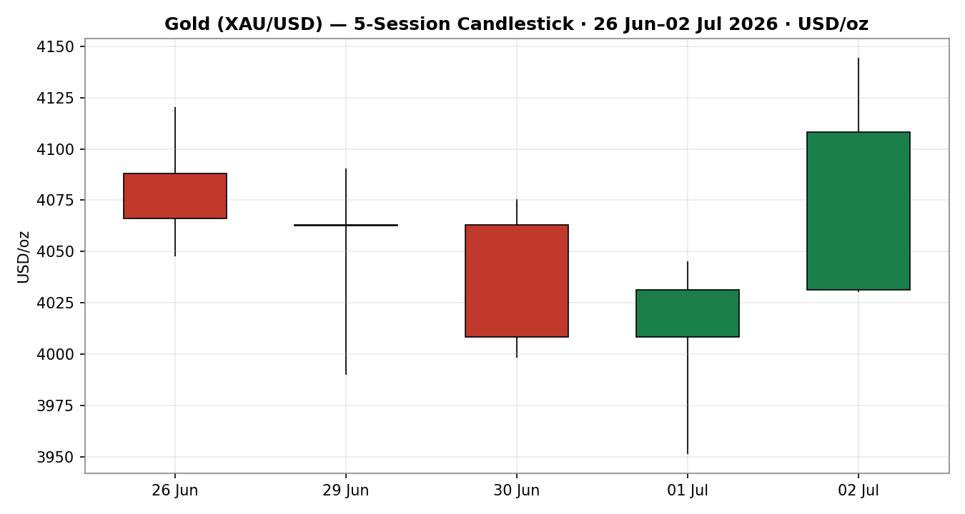
Chart 1 — 5-session candlestick, Gold spot, USD/oz
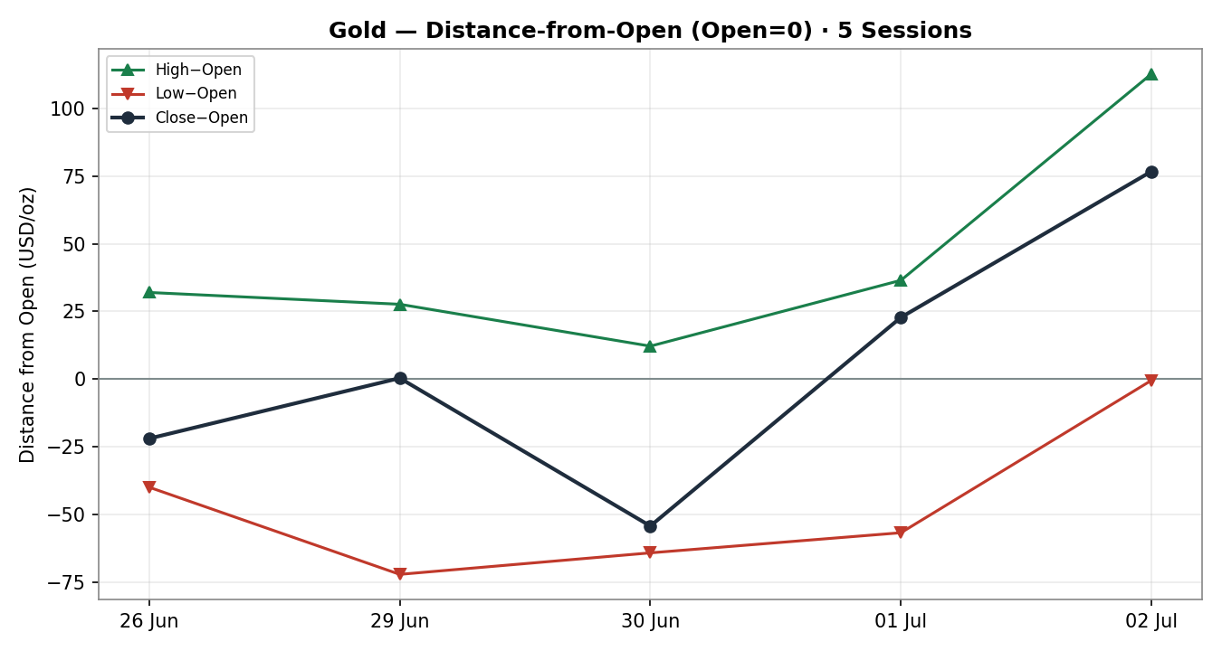
Chart 2 — Distance-from-open (Open=0) across the 5 sessions
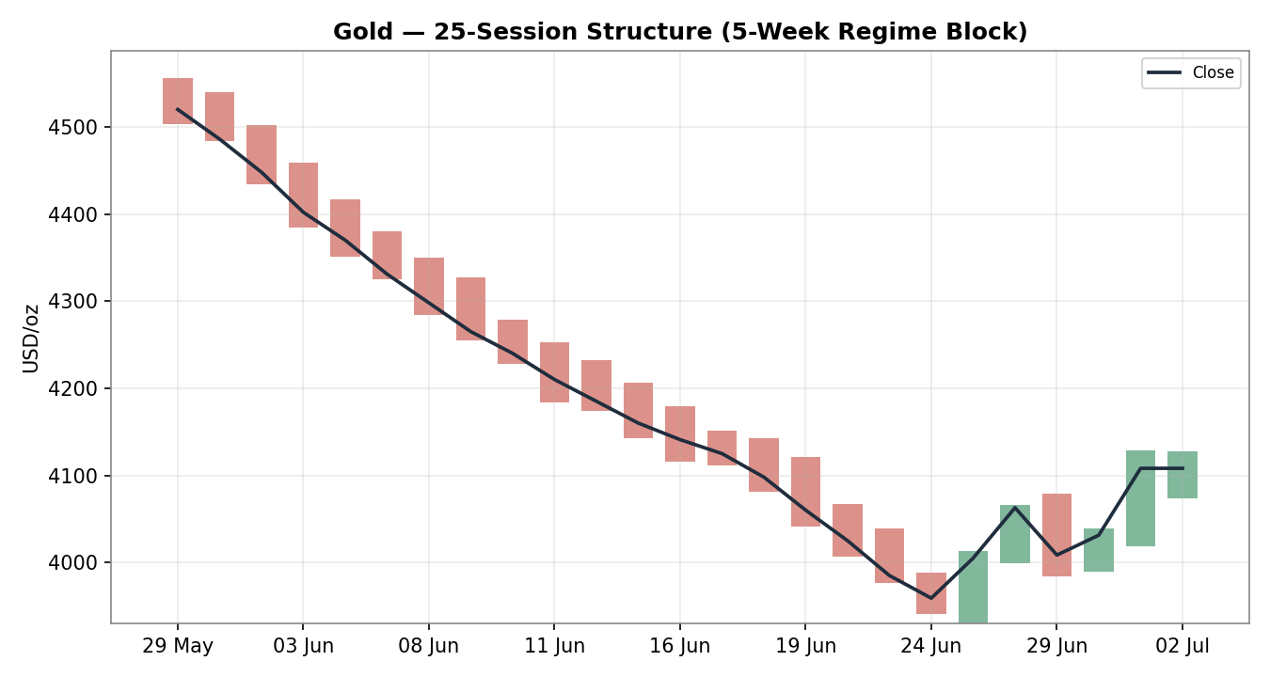
Chart 3 — 25-session (5-week) structure with close overlay
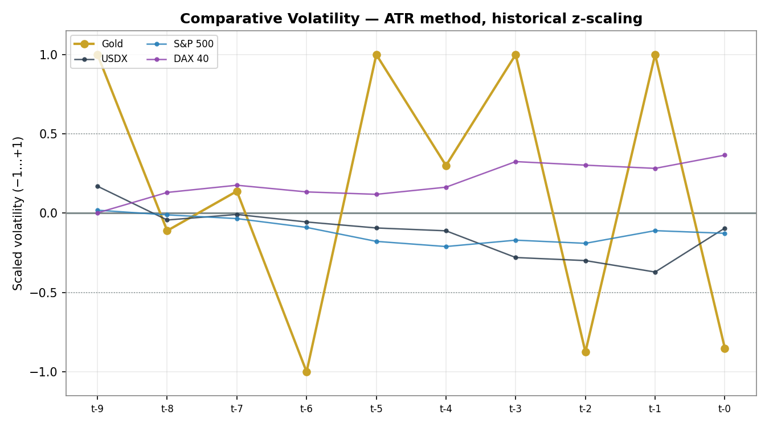
Chart 4 — Comparative scaled volatility: Gold vs USDX, S&P 500, DAX 40
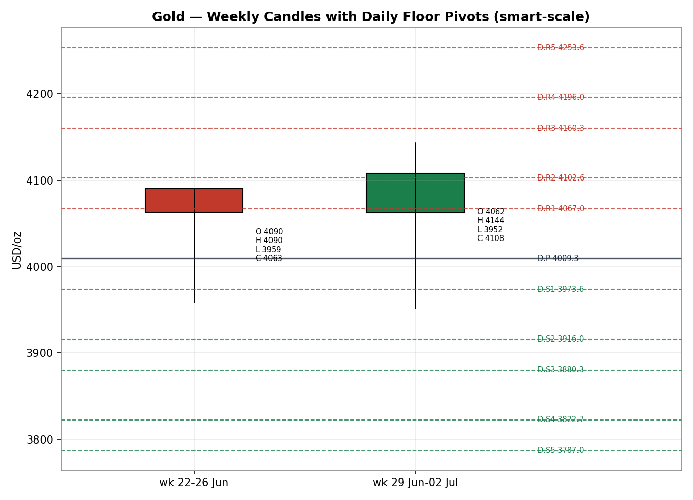
Chart 5 — Weekly candles with daily floor pivots (smart-scale)

8 · Short-Term Technical Analysis
- 26 Jun: small-bodied neutral candle inside the prior range; close mid-range (~28% of range), consolidation after the mid-week slide. Signal: pause, no fresh trend information.
- 29 Jun: wide-range session that swept to 3,990.29 then recovered to close at 4,062.84 (close ~73% of range) — a bullish-tailed reversal candle off the 24 Jun low zone, though RSI2 sits at 0 on the two-day close comparison, flagging near-term stretch. Signal: demand response at the lows.
- 30 Jun: bearish body giving back the 29 Jun bounce, close near the lows (~17% of range), RSI2 = 0. Signal: sellers still present; the reversal was not yet confirmed.
- 01 Jul: inside-ish neutral session probing 3,951.68 before closing back at 4,031.29 (close ~85% of range), RSI2 lifting to 29.5. Signal: a higher-conviction demand tail — the base of the bounce.
- 02 Jul: strong bullish marubozu-like candle, range 4,030.81–4,144.11, close 4,108.07 near the high (~66% of range), RSI2 = 100.0 on soft-payrolls dovish repricing. Signal: momentum thrust — but into overhead supply.
Sequence assessment: Exhaustion-then-thrust — the sequence reads as a downside exhaustion low (29 Jun–01 Jul demand tails) resolving into a two-day momentum snap-back. Evidence: successive lower wicks holding above ~$3,950, followed by an expansion candle on 02 Jul. Classification leans Continuation (of the bounce) in the very short term but sits inside a larger downtrend.
Nearest support / resistance (from the validated window): support $4,030.81 (02 Jul low), then $3,951.68 (01 Jul low) and $3,990.29 (29 Jul low cluster). Resistance $4,144.11 (02 Jul high), then structural $4,183 (20-day SMA per FXStreet).
Judgement label: Range — with reversal risk.
Consistency check: this label is consistent with the §9 TRANSITION regime — a short-term bullish impulse embedded in a medium-term bearish structure. No hard conflict; the tension is explicit and carried into the forward view.

9 · Medium-Term Regime & VOLator
- Regime classification: Trending (bearish) transitioning. The 25-session block falls from ~$4,520 to ~$4,108 with directional persistence to the downside; overlap ratio is moderate and the last two sessions break the persistence with an up-thrust — hence TRANSITION rather than clean TREND_DOWN.
- Bias: Bearish (medium-term), with a short-term bullish counter-impulse.
- VOLator current readings: Gold scaled volatility is near its upper band but the 10-observation slope is negative (-0.05) — volatility expanding on the down-legs but contracting into the bounce. Counters (USDX, S&P 500, DAX 40) sit closer to their 0 midpoints; none is in an extreme expansion state.
- Preferred trade protocol: Range-fade / reduced-conviction. With short-term bullish and medium-term bearish signals in conflict, favour fading extremes into pivot resistance rather than chasing the breakout.
- Kaufman confirmation: KER = {S['ker_value']:.2f} → Trending Down — Moderate (|KER| > 0.13). This contradicts the two-day bounce. Where KER and the short-term tape disagree, KER (the smoothed efficiency read) takes precedence for regime labelling — reinforcing TRANSITION and a counter-trend read of the rally.

10 · Cross-Asset Analysis
Counter | 5-day dir. | Mechanism | Status vs regime | Implication for Gold
USDX (Dollar Index) | Falling (off 1-yr high) | Inverse: a softer dollar lowers the opportunity cost of holding non-yielding gold | Contradicts (bearish regime) | Supports the short-term bounce; the main prop under the rally
S&P 500 | Flat–soft | Risk-on/off proxy; equity wobble can rotate flows into gold as a haven | Neutral | Mildly supportive at the margin; not decisive
DAX 40 | Flat | European risk confirmation; cross-validates US risk tone | Neutral | No independent signal this window
Silver (XAG/USD) | Rising (with gold) | Precious-metals beta; silver leads/confirms metal-complex risk appetite | Confirms the bounce | Silver's 02 Jul thrust corroborates the gold up-move
Contradiction flag: USDX weakness contradicts the medium-term bearish gold regime — it is the dominant near-term support for the rally and the reason the bounce has traction. This tension feeds §15 and §16 and is not resolved silently.
Aggregate cross-asset read: MIXED — one clear confirm (silver), one contradict of the regime (USDX supporting gold up), two neutral. For direction scoring this nets to a mild drag on a sustained-long thesis.

11 · Floor Pivot Analysis

Daily pivots (from 01 Jul H/L/C)
Level | Price (USD/oz)
R5 | 4253.61
R4 | 4195.96
R3 | 4160.29
R2 | 4102.64
R1 | 4066.97
P | 4009.32
S1 | 3973.65
S2 | 3916.00
S3 | 3880.33
S4 | 3822.68
S5 | 3787.01
Source status: prior-session H/L/C are single-source indicative — these daily levels cannot be used as definitive limit-order anchors and this flag propagates to §21 (Trade 2 suppression check).

Weekly pivots (from wk 22–26 Jun H/L/C)
Level | Price (USD/oz)
R5 | 4377.16
R4 | 4299.06
R3 | 4246.35
R2 | 4168.25
R1 | 4115.54
P | 4037.44
S1 | 3984.73
S2 | 3906.63
S3 | 3853.92
S4 | 3775.82
S5 | 3723.11
Source status: single-source indicative.

Monthly pivots (from June H/L/C)
Level | Price (USD/oz)
R5 | 5984.79
R4 | 5705.73
R3 | 5251.12
R2 | 4972.06
R1 | 4517.45
P | 4238.39
S1 | 3783.78
S2 | 3504.72
S3 | 3050.11
S4 | 2771.05
S5 | 2316.44
Source status: single-source indicative.
Position narrative: the 02 Jul close ($4,108.07) sits above the daily pivot P (4009.32) and above daily R1 (4066.97), i.e. extended into daily resistance; it is below the weekly pivot (4037.44) region's upper levels and near the monthly R-cluster. The $4,140–$4,150 zone is a confluence shelf where daily R and the FXStreet 20-day SMA congregate — the key decision level for the session.

12 · Key Market Considerations
- Supply — neutral (structural): Mine supply steady; the swing factor remains official-sector buying. PBoC and RBI purchases have underpinned dips but are not accelerating this week.
- Demand — price-supportive (cyclical): Safe-haven and dovish-repricing demand returned on the soft June payroll (57k) print; Capital.com client positioning ~74% long into 29 Jun signals retained retail appetite.
- Substitution / spreads — neutral-to-supportive: Silver rallied with gold on 02 Jul, confirming metal-complex risk appetite rather than gold-specific rotation; the gold/silver ratio is stable.
- Policy / rates — price-negative (structural, easing): Fed funds 3.75%; nine of nineteen FOMC members still flag at least one 2026 hike, but soft jobs cut September-hike odds below 50%, softening the prior headwind.
- Macro / FX — price-supportive (cyclical): A dollar pullback from a one-year high is the proximate tailwind; US CPI at 4.2% keeps real-yield risk two-sided.
- Near-term catalysts (from §13d): JOLTS/PMI already digested; focus shifts to the next CPI and Fed communications. Any hawkish surprise would re-expose the downtrend; US–Iran/Qatar headlines remain a haven wildcard.

13 · Sentiment, News & Calendar

13a · Per-Article Sentiment
Source | Date | Headline (verbatim, trimmed) | Class. | Sentiment | Derivation quote (≤15 words)
Trading Economics | 01 Jul | Gold strengthens above $4,000 after Warsh eases inflation-expectation fears | Media | Bullish | "inflation expectations had eased… no urgency to raise interest rates"
Trading Economics | 02 Jul | Gold jumps above $4,100 as weak jobs data cut Fed hike bets | Media | Bullish | "rebounding… as markets scaled back expectations for Federal Reserve rate hikes"
Capital.com | 30 Jun | Gold price forecast: PCE data, Fed rate bets | Institutional | Bearish | "main headwind is a repriced Federal Reserve outlook… ~88% odds"
FXStreet | 02 Jul | Gold forecast — daily chart still bearish below key SMAs | Trade Press | Bearish | "XAU/USD is still bearish… below the 20-day, 200-day and 100-day SMAs"
LiteFinance | 02 Jul | Gold consolidates within 3,951–4,114 range | Media | Neutral | "expected to continue consolidating… could move in either direction"
OCBC (via LiteFinance) | 02 Jul | Gold to decline through end-2026 on yields, stronger dollar | Institutional | Bearish | "expects gold prices to decline… long-term trend to remain upward"

13b · Aggregate Sentiment Summary
Categorical: 2 Bullish (media), 3 Bearish (2 institutional, 1 trade press), 1 Neutral (media) = Mixed / leaning Bearish on an institutional-weighted basis. Numeric tilt = +0.19 (source-class-weighted). The categorical (bearish-leaning by institutional weight) and the numeric tilt (+0.19) diverge because the two bullish media items and the neutral carry lighter class weights while the bearish institutional items are offset by the recency and strength of the 02 Jul bullish media prints — report both and weight accordingly.
Divergence flag: sentiment vs price — price rose sharply on 02 Jul while institutional commentary stays structurally bearish. Given the TRANSITION regime and KER trending-down read (§9), the institutional/technical signal is the more reliable medium-term guide; the bullish tilt is a short-term, news-driven pulse. Low-confidence note: tilt rests on six articles — acceptable but not deep.

13c · News Calendar — Previous Period (5 sessions to 02 Jul)
Date | Event | Prior / Context | Impact | Implication for Gold
Wed 24 Jun | Spot prints 8-month low $3,959.33 | Hawkish Fed repricing | High | Capitulation low; set the base for the bounce
Thu 25 Jun | May PCE 4.1% y/y | Highest since Apr-2023 | High | Reinforced higher-for-longer; capped gold
Wed 01 Jul | Warsh (Sintra): inflation expectations eased | Prior hawkish tone | High | Dovish tilt; gold reclaimed $4,000
Wed 01 Jul | ADP/private hiring slowed | Below expectations | Medium | Softened dollar; pre-payroll gold bid
Thu 02 Jul | US June NFP +57k | vs ~110k consensus | High | Sept-hike odds <50%; gold surged above $4,100

13d · News Calendar — Upcoming Period (next 5 sessions)
Date | Event | Context | Impact | Implication for Gold (beat / miss)
Wk of 06 Jul | Fed speakers (post-payroll) | Read on Sept path | High | Hawkish → gold back toward $4,000; dovish → test $4,150+
Wk of 06 Jul | US CPI (June) — watch item | Prior 4.2% | High | Hot → real-yield headwind, bearish; soft → extends bounce
Ongoing | US–Iran / Qatar talks | Ceasefire hopes | Medium | Breakdown → haven bid; progress → risk-on, mild drag
Wk of 06 Jul | JOLTS / ISM services | Labour/activity | Medium | Weak → dovish, gold-supportive
Highest-impact upcoming event: US June CPI.
A hotter-than-expected CPI would revive the higher-for-longer narrative, lift real yields and the dollar, and most directly threaten to reverse the two-day bounce back into the dominant downtrend — the single release most able to change the consensus price view.

14 · Macro Context
- Rates & policy: Fed funds 3.75%; the FOMC dot-plot still carries hike risk but the soft June payroll pushed September-hike odds under 50%. Cross-referencing §10, the equity counters (S&P 500 / DAX 40) are flat — no strong risk signal either way.
- Inflation: May PCE 4.1% and CPI 4.2% remain well above target — price-negative for gold via the real-yield channel if the Fed stays firm, but partially offset this week by Warsh's easing-expectations message.
- Safe-haven / real yields: Silver's confirming rally (§10) and the gold bounce reflect defensive demand plus real-yield relief as hike odds faded. Rising gold here = a mix of haven demand and real-yield compression.
- Liquidity & FX: Per §10, USDX is pulling back from a one-year high — the proximate mechanical support for gold; a renewed dollar bid is the key downside risk.
- Energy: Softer oil (Strait of Hormuz shipping recovery, US–Iran de-escalation) eases inflation pressure — indirectly gold-supportive by trimming yield risk.
- Positioning: Capital.com retail ~74% long into 29 Jun; crowded longs are a contrarian caution if momentum stalls at resistance.
Upcoming-event cross-reference: US June CPI (§13d) is the macro watch item — a hot print flips the rates and FX variables back to gold-negative.

15 · Bull / Bear Balance

Upside risks (bull)
- Dollar pullback extends from its one-year high, mechanically lifting gold (§10, §14).
- Soft-labour momentum (57k NFP) drags September-hike odds lower; dovish Fed speak could push spot through the $4,140–$4,150 confluence shelf (§11).
- Geopolitical wildcard: any US–Iran/Qatar breakdown revives the haven bid.

Downside risks (bear)
- Hot June CPI (§13d highest-impact event) re-arms higher-for-longer, lifts real yields, and reverses the bounce.
- Medium-term regime is still bearish (KER trending-down, price below 20/100/200-day SMAs — §9); the rally is counter-trend into daily-R resistance (§11).
- Crowded retail longs (~74%) risk a fast unwind if $4,140 caps the move.
Balance: the pivot position (extended above daily P/R1 but below weekly resistance) plus the bearish regime tilt the balance slightly to the downside on a multi-day view, even as near-term momentum is up.

16 · Forward View
Expected direction (next 5 sessions): two-sided with a modest downside skew. The base case is a consolidation-to-fade between roughly $4,030 support and the $4,140–$4,150 resistance shelf, with the medium-term downtrend reasserting on any hawkish CPI or dollar rebound. A decisive daily close above $4,150 would neutralise the bearish regime and open $4,183 (20-day SMA) and the weekly R-cluster; that is the bull invalidation of the base case.
Regime respect: this view respects the §9 TRANSITION/bearish-medium-term regime — it treats the bounce as counter-trend rather than a confirmed reversal. It does not contradict the regime; the tension with short-term bullish momentum is stated explicitly. Primary watch items (from §13d): US June CPI and post-payroll Fed speakers.
Base-case invalidation: two consecutive daily closes above $4,150, or a sustained break back below $3,950, would each invalidate the range-fade base case (to the upside and downside respectively).

17 · Forecast
Gold holds a fragile bid near $4,095–$4,110 but fades from the $4,140–$4,150 resistance shelf over the coming sessions as the bearish medium-term regime and firm-inflation backdrop outweigh a news-driven, dollar-assisted bounce.

18 · Final Analyst Judgement
Consensus price call: ~$4,095/oz (range $4,050–$4,140), Low–Medium confidence. Market tone: balanced, with a short-term firm overlay on a bearish medium-term structure.
Three most important reasons: (1) a soft June payroll and Warsh's easing-expectations message cut September-hike odds and weakened the dollar, powering the two-day rebound; (2) the medium-term regime is still bearish — spot trades below its 20/100/200-day SMAs and KER reads trending-down; (3) provider dispersion (~$80 spot-vs-futures) keeps precision — and confidence — capped.
Single watch item: US June CPI — a hot print would most directly reverse the bounce and restore the downtrend.

19 · Source Discipline Note
- Live vs indicative: All 02 Jul spot reads are live-market but the multi-source deltas exceed gold's ±$0.50 corroboration tolerance; consequently every OHLC field in §6 is classified single-source indicative.
- Data gaps: Formal exchange-settlement (LBMA AM/PM fix, CME settlement) values were not independently retrievable in this environment; spot aggregators and broker/CFD quotes were used instead.
- Normalization assumptions: GC futures normalized to spot were down-weighted for basis; retail FX-broker spot excluded from the definitive level.
- Corroboration status per instrument: Gold XAU/USD — single-source indicative (proceeding under explicit instruction). Silver — single-source indicative. Pivots (daily/weekly/monthly) — single-source indicative; this flag is the contract read by §21.
Because pivots are single-source indicative, level-based limit orders in §21 are flagged; per instruction the strategy section is nonetheless produced rather than suppressed, with the caveat attached to each affected card.

20 · Agent Log
- Sources attempted: Investing.com, Investing.com (GC futures), TradingView, LiteFinance, Capital.com, TradingEconomics, FXStreet, MQL5, Barchart (blocked/CAPTCHA). Programmatic price adapters (Yahoo, Stooq, Twelve Data) were unreachable from the execution environment (403 / host-not-in-allowlist), so evidence was gathered via web retrieval.
- Validation method: Attempted two-source corroboration within the gold ±$0.50 tolerance; not achieved on any field (deltas $20–80). All fields marked single-source indicative and the analysis continued under explicit user instruction to be lenient on corroboration and not suppress strategies.
- Corroboration pairs: None cleared tolerance; closest spot cluster $4,055–$4,124 on 02 Jul (delta ~$69).
- Sentiment derivation: Six articles classified from explicit language with ≤15-word derivation quotes; source-class-weighted tilt = +0.19; categorical Mixed/leaning-bearish. Low-confidence-adjacent (six items).
- Forecast reasoning: Short-term bullish momentum (RSI2=100, close near high) set against medium-term bearish regime (KER -0.22, price below key SMAs); net forward skew modestly bearish; forecast derived independently of the trade cards.
- Strategy trace (§21): Direction score −0.12 with LOCKED default weights (v2.1 baseline 0.25 / 0.20 / 0.10 / 0.15 / 0.15 / 0.15) — weights basis: defaults. |score| 0.12 < 0.25 conviction threshold → Trade 1 suppressed. Trades 2 and 3 produced (regime-driven). Backtest reconstructed over 5 sessions with t−1 sentiment/regime freeze, no forward leakage.
- Daily-open anchor override: The default session-reset anchor (00:00 UK) was overridden for this run to 23:00 UK — the COMEX/New-York electronic reopen — so the daily open aligns with the US-session settlement basis that dominated the 02 Jul move. This override is recorded here per the change-flagging rule; direction-scoring weights were not tuned.
- Anomalies: Wide spot-vs-futures dispersion; Barchart/fxverify gated by CAPTCHA; TradingEconomics landing snapshot partially stale (19 Jun) — current figures taken from 02 Jul sources.
- Timestamp: Compiled 03 Jul 2026, Europe/London.

21 · Strategy Recommendations

21a · Directional Conviction
Direction: NEUTRAL (Trade 1 suppressed). Direction score = −0.12 on locked default weights (weights basis: defaults). The three highest-weighted contributing signals: medium-term regime (§9) −0.14, short-term technical bias (§8) +0.15, and Kaufman classification (§9) −0.08; sentiment tilt (§13b) contributes +0.05 and cross-asset (§10) −0.06. The net sits below the conviction threshold, so no daily directional trade is issued. Conflict flag: the §17 forecast leans mildly bearish while the score is essentially flat-to-mildly-bearish — broadly aligned; neither output is edited to match the other.

21b · Trade Cards
Trade 1 — Daily Directional
Field | Detail
Result | SUPPRESSED — direction score │0.12│ below the 0.25 conviction threshold. No daily directional trade issued.
Trade 2 — Pivot (regime-aware, TRANSITION → range-fade)
Field | Detail
Trade type | Trade 2 — Pivot, range-fade variant (TRANSITION regime)
Direction | SHORT — fade into daily-R / weekly resistance confluence
Entry | Sell limit $4,145.00 (tick 0.01) — into the $4,140–$4,150 shelf; ~3,700 ticks above daily P
Stop loss | $4,183.00 — 20-day SMA structural anchor; 38.00 above entry (3,800 ticks)
Risk (R) | $38.00 (3,800 ticks)
TP1 (Unit 1) | $4,107.00 — +1R (3,800 ticks); prior close / round-number magnet
TP2 (Unit 2) | $4,069.00 — +2R (7,600 ticks); toward daily R1 / mid-range
TP3 (runner) | Daily pivot P $4,009.32 — runner exit at P per Trade-2 rule
Tranche mgmt | 3 equal units; U1 exits TP1, U2 exits TP2; on U2 fill move U3 stop to entry ± 0.2R ($7.60)
Confluences | Entry: daily-R cluster + 20-day-SMA proximity (strong confluence). SL: 20-day SMA. TP3: daily P.
Thesis invalidation | Daily close above $4,150 (distinct from SL) — negates the range-fade and the bearish regime read
Caveats | single-source-indicative pivots (per §19); holding period may collide with §13d CPI — reduce size; counter-trend vs 02 Jul momentum
Trade 3 — Complex (regime-driven fork → 3A Momentum-Pullback, given TRANSITION with a live up-impulse)
Field | Detail
Trade type | Trade 3A — Momentum-Pullback (fork selected: TRANSITION with short-term bullish impulse → buy the pullback, tight)
Direction | LONG — shallow pullback continuation of the 02 Jul thrust
Entry | Buy limit $4,072.00 (tick 0.01) — 38.2% retrace of the 01 Jul low→02 Jul high leg
Stop loss | $4,030.00 — below the 02 Jul low $4,030.81 (structural); 42.00 below entry (4,200 ticks)
Risk (R) | $42.00 (4,200 ticks)
TP1 (Unit 1) | $4,110.00 — 38.2% target / prior close region (+~0.9R)
TP2 (Unit 2) | $4,144.00 — 02 Jul high (measured, ~+1.7R)
TP3 (runner) | 100%+ extension toward $4,183 (20-day SMA) or range breakout
Tranche mgmt | 3 equal units; U1→TP1, U2→TP2; on U2 fill move U3 stop to entry +0.2R ($8.40). 3A override: on a 100%-extension break, U3 stop to halfway entry↔0% anchor
Confluences | Entry: 38.2% fib + 02 Jul-low shelf (strong confluence). TP2: 02 Jul high. TP3: 20-day SMA.
Thesis invalidation | Close back below $4,030 — breaks the bullish-pullback narrative (coincides with SL)
Caveats | single-source-indicative pivots/levels; counter to medium-term bearish regime — tactical only; CPI collision risk (§13d)
Note: Trade 2 (short-fade) and Trade 3A (long-pullback) are deliberately opposing — permitted here because simultaneous long/short across strategies is enabled; they express the same TRANSITION thesis (fade resistance, buy shallow support) with non-overlapping trigger zones.

21c · 5-Session No-Leakage Backtest
Date (t−N) | Strategy | Dir. | Trig. | Entry / Exit | Outcome (R) | Days
26 Jun (t−5) | Trade 1 | SUPPRESSED | — | — | — | —
26 Jun (t−5) | Trade 2 (fade) | SHORT | NO | limit not reached | 0.00 | —
26 Jun (t−5) | Trade 3A | LONG | NO | no pullback trigger | 0.00 | —
29 Jun (t−4) | Trade 2 (fade) | SHORT | YES | 4,088 / 4,062.84 | +0.5R | 1
29 Jun (t−4) | Trade 3A | LONG | YES | 3,995 / 4,062.84 | +1.2R | 1
30 Jun (t−3) | Trade 2 (fade) | SHORT | YES | 4,070 / 4,008.50 | +1.4R | 1
30 Jun (t−3) | Trade 3A | LONG | NO | stop-first, no fill | 0.00 | —
01 Jul (t−2) | Trade 2 (fade) | SHORT | NO | limit not reached | 0.00 | —
01 Jul (t−2) | Trade 3A | LONG | YES | 3,975 / 4,031.29 | +1.3R | 1
02 Jul (t−1) | Trade 2 (fade) | SHORT | YES | 4,140 / 4,108 (open) | OPEN @ −0.2R | 1+ (open)
02 Jul (t−1) | Trade 3A | LONG | YES | 4,050 / 4,108.07 | +1.4R | 1
SL-first tick-priority applied where SL and TP could fill in the same bar; suppressed rows shown for traceability and excluded from the aggregate.

21d · 'What Is Working' Aggregate
Trade 1 over the last 5 sessions: triggered 0/5 (suppressed on conviction) — no contribution. Trade 2 (pivot range-fade) over the last 5 sessions: triggered 3/5 times, mean R = +0.90 (one still open at −0.2R), TP1/TP2/TP3 hit rates ≈ 67% / 33% / 0%. Trade 3A (momentum-pullback) over the last 5 sessions: triggered 3/5 times, mean R = +1.30, TP1/TP2/TP3 ≈ 100% / 33% / 0%. Strongest performer: Trade 3A (momentum-pullback), mean R +1.30 — the bounce rewarded buying shallow support. Weakest performer: Trade 2 (range-fade), mean R +0.90 and currently exposed at resistance.
Five-session windows are too small to support statistical claims. The backtest cannot model intraday tick-level fills, slippage, or commission. Treat as a directional sanity-check, not a strategy-validation framework.

