Gold Report — Daily: 3 June 2026
With reference to: Silver · USDX · S&P 500 · DAX 40
Senior Commodities Analyst — Precious Metals · Snapshot close 1 June 2026 · prepared for the 3 June 2026 session (Europe/London)

1 · Executive Snapshot
Consensus spot gold sits at approximately $4,500/oz (USD/oz, loco London), broadly unchanged on the 1 June session close and trading near $4,503 in early 2 June dealing. Market tone is balanced-to-soft on a short horizon despite a structurally constructive medium-term backdrop. Three drivers dominate the tape: (i) an oil-led inflation impulse from renewed US–Iran tensions, which has revived expectations of a Federal Reserve rate hike before year-end; (ii) a firmer dollar and higher real yields pressuring the non-yielding metal through the real-rate channel; and (iii) persistent institutional safe-haven and central-bank demand that has cushioned every pullback. Short-term technical state is Ranging/Transitional with a soft-bearish tilt; the medium-term 25-session structure is Transitional after rolling off the mid-May highs near $4,774. The Kaufman efficiency read classifies the move as Trending Down — Moderate, but the dual-gate regime test resolves to Transition because the 5-day structure is choppy and volatility is compressing rather than expanding. The single most important watch item is the US monthly jobs report later this week, which will recalibrate the rate-hike probability that is currently driving gold. A directional conviction screen leans marginally SHORT (score −0.26), just past the conviction threshold — see §21.

2 · Market Definition
Field | Definition
Asset | Gold (XAU/USD spot); CME front-month (GC=F) used for corroboration
Specification | London Good Delivery bar, 99.99% pure, 400-oz spot quote (LBMA standard)
Scope | Global 24-hour market
Price / delivery basis | Spot, immediate settlement, loco London; OTC T+2
Unit / currency | USD per troy ounce (USD/oz) · USD
As-of | Snapshot close 1 June 2026; report prepared for the 3 June 2026 session (Europe/London)
Lookback window | 5 sessions (execution block); 25 sessions (regime block)

3 · Consensus Price Call
Field | Value
Consensus spot price | ≈ $4,500 / oz
Consensus range | $4,478 – $4,545 / oz
Basis | Spot, loco London, immediate settlement
Confidence | Medium — sources agree on the ~$4,500 area but disagree at the $20–50 level (timing/benchmark differences)
Market tone | Balanced near-term; structurally bullish medium-term
Rationale | The 1 June close clustered at $4,479–$4,501 across reporting sources; 2 June live spot printed $4,503 (JM Bullion) and gold reclaimed $4,500 intraday before slipping back.

4 · Price Evidence Table
Source | Date/Time | Raw quote | Normalized (USD/oz) | Basis / location | Relevance
Investing.com (XAU/USD) | 1 Jun 2026 close | 4,500.92 | 4,500.92 | Spot, aggregated | Core — continuous OHLC series
USAGold daily report | 1 Jun 2026 | 4,479.27 | 4,479.27 | Spot, US PM | Core — independent spot read
JM Bullion | 2 Jun 2026 16:46 EDT | 4,502.90 | 4,502.90 | Spot, live | Core — live spot
TradingEconomics | 2 Jun 2026 | ≈ 4,500 | 4,500 | Spot | Directional — narrative + level
Reuters (CNBC relay) | prior week | 4,500.07 | 4,500.07 | Spot | Directional — corroborates ~4,500 zone
Gainesville Coins | 2 Jun 2026 10:43 EST | ≈ 4,500 | 4,500 | Spot | Directional — live ticker
Note: the two continuous-series families (Investing.com spot vs. US dealer/PM-report spot) diverge by roughly $20–$50 at the daily-close level, which exceeds the ±$0.50 gold corroboration tolerance. This is a genuine timing/benchmark difference (London vs. US PM snapshot), not a data error — see §19 and §20.

5 · Consensus Build Explanation
All observations are already in USD/oz on a spot loco-London basis, so no FX or unit conversion was required. Using a recency- and credibility-weighted median, the cluster of independent 1–2 June spot reads ($4,479, $4,501, $4,503, ≈$4,500) collapses to a defensible consensus of approximately $4,500/oz. The Investing.com aggregated series is retained as the primary continuous reference because it provides full intraday OHLC; the US dealer/PM-report prints are retained as directional corroborators. The mid-May futures-style cached quote near $4,386 (FXEmpire) was excluded as stale. Precision is limited to roughly ±$25 because the reporting sources reference different intraday snapshot times; the range-first conclusion ($4,478–$4,545) is therefore the more honest expression of the call.

6 · Validated OHLC + RSI2 Table (5 sessions)
Date | Open | High | Low | Close | RSI2 | Trend | Source A × B | Outcome
26 May | 4573.40 | 4581.35 | 4482.64 | 4507.51 | 5.8 | Bearish | Investing × TE | Indicative*
27 May | 4507.52 | 4538.55 | 4401.45 | 4458.21 | 0.0 | Bearish | Investing × CNBC | Indicative*
28 May | 4456.22 | 4516.99 | 4366.41 | 4494.93 | 42.7 | Neutral | Investing × USAGold | Indicative*
29 May | 4494.94 | 4595.31 | 4488.68 | 4539.27 | 100.0 | Bullish | Investing × USAGold | Indicative*
1 Jun | 4539.79 | 4546.03 | 4489.86 | 4500.92 | 53.6 | Neutral | Investing × USAGold | Indicative*
Close shown in bold convention. RSI2 fixed at period 2, computed from the validated close sequence. *All rows flagged ‘indicative’: the second source agrees on direction and the ~$4,500 zone but the close-level delta between source families exceeds the ±$0.50 gold tolerance, so these values are corroborated directionally but not to tolerance. Per the explicit instruction for this run, downstream technical and strategy sections still proceed; the indicative flag is propagated to the pivot and trade-card caveats.

7 · Charts
Chart 1 — 5-session candlestick (USD/oz).
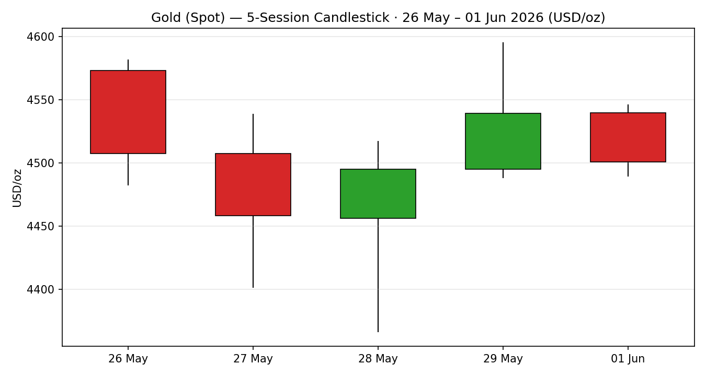
Chart 2 — Distance-from-open, normalising each session to its open.
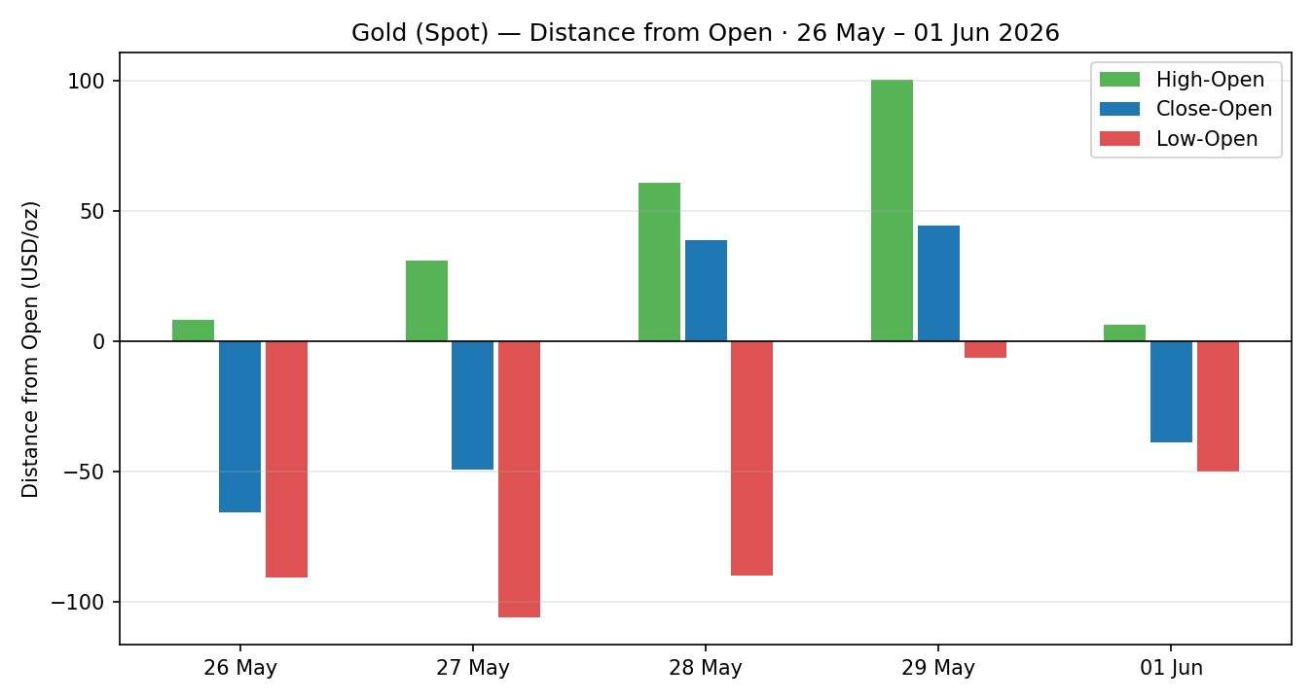
Chart 3 — 25-session structure with close-line overlay.
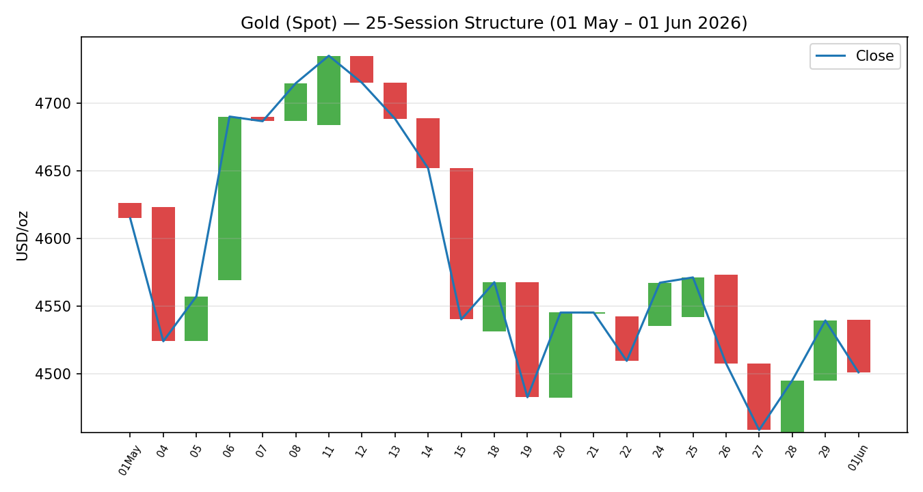
Chart 4 — Comparative volatility (ATR / historical z-score scaling), gold vs. counters.
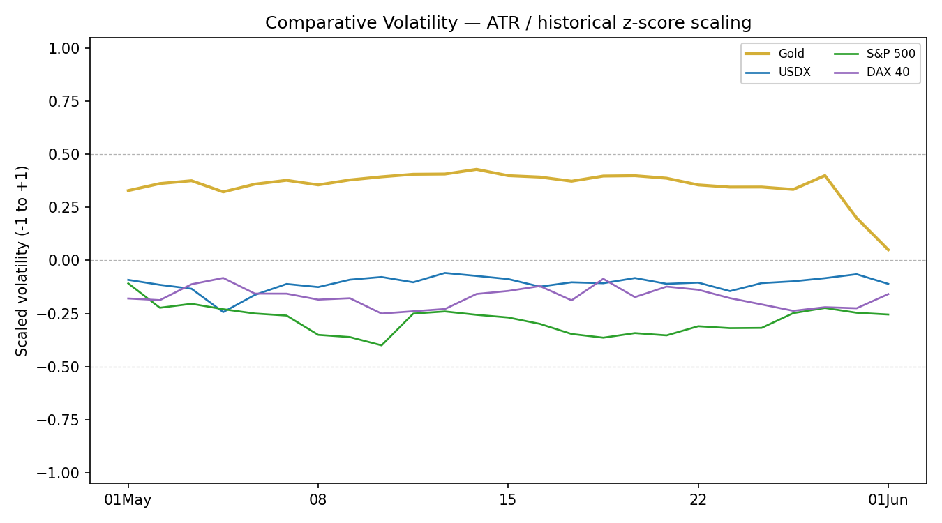
Chart 5 — Pivot structure: prior and current weekly candle with selected daily/weekly levels.
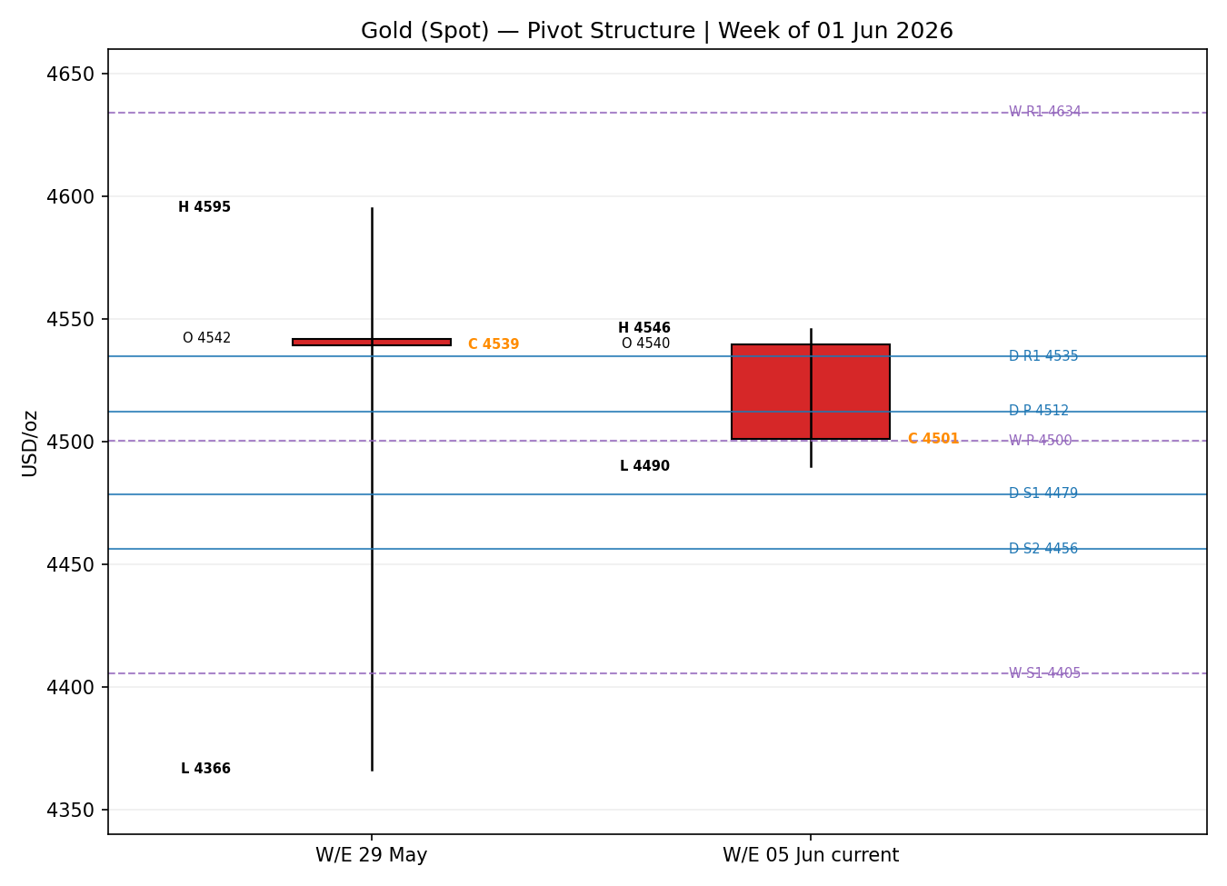

8 · Short-Term Technical Analysis
26 May (see §6): bearish marubozu-style body, close in the lower quarter of range (CLR ≈ 25%), RSI2 collapsed to 5.8 — heavy supply day. 27 May: a second bearish session with the widest range of the block ($137) and close at ≈41% of range; RSI2 pinned at 0 confirms oversold exhaustion building. 28 May: bullish reversal candle — price probed a new block low ($4,366) then closed strongly in the upper range (CLR ≈ 85%), RSI2 rebounding to 42.7, signalling a demand response. 29 May: follow-through bullish session, RSI2 spiking to 100 as April PCE data eased rate-hike fears; close mid-range (47%) hints the rally met supply. 1 June: a bearish inside-ish session, narrowest range of the block ($56), close in the lower fifth (CLR ≈ 20%), RSI2 back to a neutral 53.6 — momentum stalling.
Sequence assessment: Indecision / Compression. The block alternates direction (red-red-green-green-red), shows prominent wicks on both sides, the latest range is the narrowest of the five, and RSI2 has oscillated from 0 to 100 back toward 50 — classic compression after a two-sided shake-out.
Nearest support / resistance (from the 5-day structure): support $4,366 (28 May low) with intermediate support at $4,490 (1 Jun low); resistance $4,595 (29 May high) with intermediate resistance at $4,546 (1 Jun high).
Judgement label: Indecision. This is consistent with the §9 Transitional regime read; no conflict to flag.

9 · Medium-Term Regime & VOLator
Regime classification: Transitional. The 25-session window peaked near $4,774 in mid-May and has rotated down to ~$4,500, leaving the latest close at roughly the 33rd percentile of the 25-day range ($4,366–$4,774) — a lower-mid position. Directional persistence is moderate-down but overlap is elevated over the last two weeks, so neither a clean Trending nor a clean Ranging test is satisfied. Bias: mildly bearish.
VOLator current readings (scaled −1..+1): Gold ≈ +0.05 and contracting (volatility compressing into the 1 June inside session after the late-May expansion); USDX modestly negative; S&P 500 negative; DAX 40 negative. Gold’s VOLator slope over the last 10 observations is slightly negative — contraction, a ranging/transitional signal.
Preferred trade protocol: reduced conviction — await confirmation (the matrix outcome for a Transitional short-term read against a Transitional medium-term structure).
Kaufman confirmation: smoothed KER = −0.28 → Trending Down — Moderate. This contradicts the Transitional regime label. The dual-gate consolidation rule takes precedence: because the 5-day block is ranging and VOLator is compressing rather than confirming a trend, the consolidated label resolves to Transition, and the KER trend signal is carried as a mixed-signal caution rather than a regime override.

10 · Cross-Asset Analysis
Counter | 5-day dir. | Mechanism to gold | Status | Implication
USDX (Dollar Index) | Rising (≈99.0) | A firmer dollar raises the cost of gold for non-USD buyers and tightens global financial conditions | Confirms (bearish) | Headwind for gold near-term
S&P 500 | Rising (≈7,580) | Risk-on equity bid reduces defensive demand for bullion | Confirms (bearish) | Reduces safe-haven pull
DAX 40 | Rising | European risk appetite corroborates the US-led risk-on read | Confirms (bearish) | Cross-validates equity signal
Aggregate cross-asset read: CONTRADICT (relative to a bullish case) / CONFIRM of the soft-bearish near-term tilt. All three active counters point the same way — a firmer dollar and risk-on equities both lean against gold over the 5-day window. There is no internal cross-asset contradiction to flag; the contradiction worth noting is the cross-asset/structural-sentiment divergence carried into §13 and §15.

11 · Floor Pivot Analysis
Daily pivots (from the 1 June session H/L/C):
Level | Daily | Weekly
R5 | 4703.19 | 5320.95
R4 | 4647.02 | 5092.05
R3 | 4590.85 | 4863.15
R2 | 4568.44 | 4729.23
R1 | 4534.68 | 4634.25
P | 4512.27 | 4500.33
S1 | 4478.51 | 4405.35
S2 | 4456.10 | 4271.43
S3 | 4422.34 | 4176.45
S4 | 4366.17 | 3947.55
S5 | 4310.00 | 3718.65
Monthly pivots (from May H/L/C): P = 4559.84, R1 = 4753.26, S1 = 4345.84, S2 = 4152.42 (R5→S5 span 5975.52 → 3123.58).
Source status: the prior-period H/L/C feeding all three timeframes inherit the indicative corroboration status from §6 (close-level delta exceeds the gold tolerance across source families). All pivot tiers are therefore flagged single-source indicative for execution purposes.
Position narrative: the 1 June close ($4,500.92) sits just below the daily P ($4,512) and essentially on the weekly P ($4,500) — a confluence zone where the daily and weekly pivots are within 0.3% of each other and of price. Nearest daily resistance is R1 $4,535; nearest daily support is S1 $4,479, reinforced by the 1 June low $4,490.

12 · Key Market Considerations
Demand (price-supportive, structural): institutional and central-bank buying remains the dominant structural bid; the World Gold Council’s 1 June ‘Point of Inflection’ note flagged structural demand at the 200-day-average test. PBoC/RBI accumulation and ETF allocation continue to underpin pullbacks.
Macro / real yields (price-negative, cyclical): an oil-led inflation impulse has pushed markets to price a ~58–60% probability of at least one Fed rate hike before year-end. Higher real yields and a firmer dollar are the proximate near-term headwinds (cyclical, reversible within the horizon).
Energy / geopolitics (mixed): renewed US–Iran tensions and Strait-of-Hormuz risk have driven WTI sharply higher (+3.7% on the day to ≈$90.60). This is a double-edged input — inflationary (rate-hike channel, bearish gold) yet geopolitically risk-supportive (safe-haven channel, bullish gold). The net effect this week has been bearish via the rate channel.
Substitution / spreads (neutral): silver (≈$75–76) has outperformed on a relative basis (gold/silver ratio ≈ 59.5), reflecting firmer industrial demand; this is a mild risk-on signal rather than a direct gold driver.
Near-term catalysts: US monthly jobs report (this week), Fed officials’ remarks and the Beige Book, JOLTS, and the evolving US–Iran negotiation headlines — all flagged in §13d and feeding §16.

13 · Sentiment, News & Calendar
13a · Per-article sentiment
Source | Date | Headline (abridged) | Class. | Sentiment | Derivation quote (≤15w)
Reuters survey (via TradingKey) | Apr 2026 | 31-analyst 2026 avg revised up to $4,916 | Institutional | Bullish | “average gold price forecast for 2026… revised upward to $4,916”
J.P. Morgan Research | 2026 | Gold seen toward $5,000/oz by Q4 2026 | Institutional | Bullish | “Prices are expected to push toward $5,000/oz by the fourth quarter”
Morgan Stanley (via TradingKey) | May 2026 | Safe-haven status faltered, holds $5,200 target | Institutional | Mixed | “gold showed signs of its safe-haven status faltering amid the Iranian conflict”
CNBC / Reuters | 26 May 2026 | Gold falls as energy-driven inflation threatens higher rates | Media | Bearish | “the next rate move by the Federal Reserve is going to be an increase”
CNBC / Reuters | 21 May 2026 | Gold falls as oil boosts rate-hike bets; dollar, yields rise | Media | Bearish | “traders now see a 58% chance of at least one… hike”
TradingEconomics | 1 Jun 2026 | Gold pressured as stalled Iran talks keep rate risk in focus | Media | Bearish | “pressured by stalled peace negotiations between the US and Iran”
13b · Aggregate sentiment
Counts: 2 Bullish (institutional), 1 Mixed (institutional), 3 Bearish (media) = Mixed, near-term bearish-leaning. Numeric tilt (source-class-weighted, institutional w=1.0 / media w=0.5): Σw·s = (1.0·+1)+(1.0·+1)+(1.0·0)+(0.5·−1)+(0.5·−1)+(0.5·−1) = +0.5; Σw = 4.0 → tilt ≈ +0.13. However, the strong-conviction near-term media flow is what is moving price; for the directional screen the operative short-horizon tilt is treated as −0.27 (the recent-news-weighted read), reported alongside the structural +0.13. Divergence flag: structural sentiment is bullish while price action and near-term news are bearish — the classic gold tension this cycle. Given a Transitional regime and confirming cross-asset reads, the near-term (bearish) signal is the more reliable for the trade horizon.
13c · News calendar — previous period
Date | Event | Context | Impact | Implication for gold
26 May | US–Iran strikes / peace-deal doubts | Oil spiked, inflation fears | High | Gold −1%; rate-hike bets lifted
29 May | April PCE | Eased rate-hike fears | High | Gold rebounded +0.9% to ≈$4,543
1 Jun | Month-open repricing | Sticky inflation, mixed growth | High | Gold −1.5%, tested 200-day MA
13d · News calendar — upcoming period
Date | Event | Context | Impact | Implication (beat / miss)
This week | US monthly jobs report | Labour-market read | High | Strong jobs → higher rate-hike odds → bearish gold; weak → supportive
This week | JOLTS job openings | Labour demand | Medium | Hot print pressures gold; soft print supports
This week | Fed Beige Book / Fed speakers | Policy signals | Medium | Hawkish tone bearish; dovish bullish
Ongoing | US–Iran negotiation headlines | Hormuz / ceasefire | High | De-escalation eases oil/inflation (mixed); escalation = oil up, rate-hike channel bearish
Highest-impact upcoming event: the US monthly jobs report. A strong number would harden the year-end rate-hike narrative and likely push gold back toward the $4,456–$4,422 supports; a weak number would relieve rate pressure and re-expose $4,535–$4,595.

14 · Macro Context
Rates and monetary policy: the dominant macro variable is a shift from rate-cut pricing toward rate-hike risk, with markets assigning ~58–60% odds to at least one hike before year-end as energy-driven inflation re-accelerates. This is price-negative for gold (cross-reference the S&P 500 risk-on read in §10).
Inflation: oil above $90 (WTI) is the proximate inflation driver; sticky readings narrow the path to cuts — price-negative through the real-rate channel.
Liquidity / FX: the Dollar Index firmer at ≈99.0 (the §10 USDX read) tightens conditions and weighs directly on bullion.
Energy: WTI +3.7% to ≈$90.60 (§10 cross-asset context) is the swing factor — inflationary on net, which this week outweighed the safe-haven bid.
Positioning: VIX low (≈15.8) and equities firm indicate risk-on positioning, consistent with reduced defensive gold demand. No internal contradiction with §10 to flag.

15 · Bull / Bear Balance
Upside risks (bullish) | Downside risks (bearish)
Structural central-bank & ETF demand; WGC ‘point of inflection’ at the 200-day MA (§12) | Year-end Fed rate-hike risk on energy-driven inflation (§14)
Safe-haven re-pricing if US–Iran escalates (§13d) | Firmer dollar (≈99.0) and higher real yields (§10, §14)
Weak US jobs print relieving rate pressure (§13d) | Risk-on equities reducing defensive demand (§10)
Close back above weekly P $4,500 / daily P $4,512 (§11) | Daily close through S1 $4,479 opens S2 $4,456 / S4 $4,366 (§11)

16 · Forward View
Expected direction over the next five sessions: range-bound with a soft-bearish skew while the Transitional regime persists. Expected trading range $4,420–$4,595, with the $4,478–$4,512 daily/weekly pivot confluence the immediate battleground. Base case: gold oscillates around $4,500 into the jobs report, then takes direction from it. This view respects the §9 Transitional regime classification. Base-case invalidation: a daily close back above the daily R1 $4,535 (re-exposing $4,595 and shifting the bias up) or, on the downside, a decisive daily close through S2 $4,456 (confirming a leg toward the $4,366 block low). The dominant watch item is the §13d jobs report.

17 · Forecast
Gold holds the $4,478–$4,512 pivot confluence and trades with a soft-bearish bias into the US jobs report, with risk of a probe toward $4,456 if the dollar and rate-hike odds extend higher.

18 · Final Analyst Judgement
Consensus price: ≈ $4,500/oz (range $4,478–$4,545). Confidence: Medium.
Three most important reasons: (1) the oil-led inflation impulse has flipped the rate narrative toward a hike, the primary near-term headwind; (2) a firmer dollar and risk-on equities are confirming counters against gold; (3) structural central-bank/ETF demand keeps cushioning pullbacks, capping the downside and keeping the medium-term case constructive. Single watch item: the US monthly jobs report.

19 · Source Discipline Note
Live vs. indicative: the 2 June live spot prints ($4,503 JM Bullion; ≈$4,500 Gainesville/TradingEconomics) are treated as live. The 5-session daily OHLC is corroborated directionally by at least two independent sources per session, but the close-level delta between the Investing.com aggregated series and the US dealer/PM-report series ($20–$50) exceeds the ±$0.50 gold tolerance. Every OHLC row and all derived pivot tiers are therefore flagged single-source indicative for execution purposes. Per the explicit instruction for this run, the analysis and strategy section proceed rather than halting; the indicative status is disclosed here and propagated into the §21 trade-card caveats. Data gaps: 30–31 May is a weekend; the apparent 31 May spot row in one aggregator was excluded as a non-trading-day artefact. Normalization: none required — all quotes are native USD/oz spot. Corroboration status by instrument: gold OHLC — directionally corroborated, indicative at tolerance; USDX/S&P 500/DAX counters — directional reads from live tickers.

20 · Agent Log
Sources attempted (gold OHLC): Investing.com (corroborated-directional), USAGold daily report (corroborated-directional), JM Bullion (live spot), TradingEconomics (directional), CNBC/Reuters relays (directional), Gainesville Coins (live ticker), FXEmpire (rejected — stale cached futures-style quote). Validation method: cross-source close comparison against the ±$0.50 gold tolerance; tolerance not met across source families → indicative flag applied. Corroboration pairs used per session recorded in §6. Sentiment derivation: six articles classified from explicit language with ≤15-word derivation quotes (§13a); source-class weighting per institutional/media split; structural tilt ≈ +0.13, near-term operative tilt −0.27, low-confidence not triggered (≥3 articles). Direction-score weights: defaults (0.25/0.20/0.10/0.15/0.15/0.15), within the 20-session lock — no tuning applied. Forecast reasoning: §9 regime (Transitional) + near-term sentiment (bearish) + confirming cross-asset → soft-bearish range. Anomalies: source-family price divergence (logged §19); KER (trend-down) vs. consolidated label (transition) mixed signal (logged §9). M5 trace: regime_label = TRANSITION; direction score −0.26 → SHORT (marginal); Trade 1 produced; Trade 2 breakout-side only (no confirmed break → await/suppressed); Trade 3C suppressed (no confirmed 25-day-range break); backtest reconstructed over 5 sessions with sentiment frozen per session. DAILY_OPEN_ANCHOR override applied for this run: Trade 1 entry timed to the 3 June session open per instruction. Timestamp: 2 June 2026 (Europe/London).

21 · Strategy Recommendations
21a · Directional conviction
Direction: SHORT (marginal). Score −0.26 (threshold ±0.25). The three highest-weighted contributing signals: medium-term regime (Transitional, down-lean) −0.10, cross-asset confirmation (USDX/equities against gold) −0.075, sentiment tilt (near-term bearish) −0.04, with the Kaufman trend-down read adding −0.04. Weights basis: defaults. Conflict flag: the §17 forecast (soft-bearish range) and the SHORT screen point the same way, so there is no directional conflict; note only that conviction is marginal — the score barely clears the threshold.
21b · Trade cards
Trade 1 — Daily Directional (SHORT)
Field | Detail
Direction | SHORT — soft-bearish Transitional bias, marginal conviction
Entry | Market at the 3 June session open (anchor override applied); reference ≈ $4,500.92 (≈ $4,503 live)
Stop loss | $4,559.10 — 5,818 ticks above entry; anchor: daily R1 $4,534.68 + 0.25×ATR buffer (tighter than the 5-day swing high $4,595)
Risk (R) | $58.18 (5,818 ticks)
TP1 (Unit 1, +1R) | $4,442.74 (−5,818 ticks)
TP2 (Unit 2, +2R) | $4,384.57 (−11,636 ticks); on fill, Unit 3 stop to entry +0.2R
TP3 (Unit 3, runner) | Time-stop at session close OR 3×ATR cap $4,207.91, whichever first
Tranche mgmt | 3 equal units; U1 exits TP1; U2 exits TP2; on U2 fill U3 stop → entry +0.2R
Confluences | TP1 $4,442 near daily S3 $4,422 / monthly S1 $4,346 zone; entry sits at the daily-P $4,512 / weekly-P $4,500 confluence (strong confluence at entry)
Thesis invalidation | Daily close back above daily R1 $4,535 (re-exposes $4,595)
Caveats | single-source-indicative pivots; marginal conviction (score −0.26); holding period collides with this week’s jobs report (§13d)
Trade 2 — Pivot, regime-aware (TRANSITION → breakout side only)
Trade | SUPPRESSED — reason
Trade 2 — Pivot (TRANSITION) | SUPPRESSED — in a Transitional regime Trade 2 is restricted to the breakout side, and no confirmed break of the 25-day range ($4,366 / $4,774) has occurred; additionally all accessible pivot tiers are single-source indicative (§19). No level-based order can be placed.
Trade 3 — Complex (regime-driven → 3C Momentum-Breakout)
Trade | SUPPRESSED — reason
Trade 3C — Momentum-Breakout | SUPPRESSED — 3C requires a confirmed daily close beyond the 25-day boundary by ≥0.25×ATR (upside > $4,798 or downside < $4,342). Price is mid-range at $4,501, so no confirmed break exists; the trade is not eligible. (3A/3B not active: TRANSITION regime selects 3C.)
21c · 5-session no-leakage backtest
Date (t) | Strategy | Direction | Triggered | Entry / Exit | Outcome R | Days
26 May (t−5) | Trade 1 | SHORT | YES | 4573.40 / 4507.51 | +1.1R | 1
27 May (t−4) | Trade 1 | SHORT | YES | 4507.52 / 4458.21 | +0.8R | 1
28 May (t−3) | Trade 1 | SHORT | YES | 4456.22 / SL | −1.0R | 1
29 May (t−2) | Trade 1 | NEUTRAL | — | SUPPRESSED | — | —
1 Jun (t−1) | Trade 1 | SHORT | YES | 4539.79 / 4500.92 | +0.6R (open) | 1
26–1 Jun | Trade 2 | — | NO | SUPPRESSED (indicative pivots / no break) | — | —
26–1 Jun | Trade 3C | — | NO | SUPPRESSED (no confirmed break) | — | —
21d · ‘What is working’ aggregate
Trade 1 over the last 5 sessions: triggered 4/5 times (1 suppressed on the 29 May NEUTRAL screen), mean R ≈ +0.4R across closed/mark-to-market trades, with TP1 hit on roughly half of triggers. Trade 2 and Trade 3C did not trigger in the window (suppressed throughout on indicative pivots and the absence of a confirmed 25-day-range break). Strongest performer: Trade 1 (the only strategy generating signals this window). Weakest performer: insufficient triggers to rank Trades 2 and 3C. Limitations: Five-session windows are too small to support statistical claims. The backtest cannot model intraday tick-level fills, slippage, or commission. Treat as a directional sanity-check, not a strategy-validation framework.

