Gold Report — Daily: 4 June 2026
With reference to: Silver · USDX · S&P 500 · DAX
Spot XAU/USD (loco London), USD/oz · As of 4 June 2026, Europe/London · Senior Commodities Analyst — Precious Metals

1 · Executive Snapshot
Consensus spot gold is assessed at $4,440/oz (range $4,430–$4,460), a Low-confidence live read built from a weighted median of available quotes where two-source intraday corroboration was only partially achievable. Market tone is bearish. The three dominant drivers are: (1) a resilient US labour market — JOLTS job openings at a near two-year high plus a strong ADP print — pulling Fed rate-hike pricing up to roughly an 85% probability of a December hike; (2) a firm US dollar, with the dollar index at two-month highs near 99.4–99.5, lifting the opportunity cost of non-yielding bullion; and (3) higher oil on Middle East tension, which raises inflation expectations but is currently transmitting through the real-yield channel as a gold headwind rather than a haven bid. The short-term technical state is bearish (RSI2 pinned at 0 after the 2–3 June break); the medium-term 25-session structure is transitional with a range-bottom bias; the Kaufman Efficiency Ratio reads Trending Down (Moderate). The single most important watch item is Friday's US nonfarm payrolls. Directional conviction is SHORT (score −0.77).

2 · Market Definition
Field | Value
Asset | Gold (XAU/USD spot)
Specification | London Good Delivery bar, 99.99% pure, 400-oz spot quote
Scope | Global, 24-hour OTC market
Price / delivery basis | Spot, immediate (loco London); OTC, T+2 settlement
Unit / currency | USD per troy ounce (USD/oz)
As-of date | 4 June 2026 (Europe/London); London PM Fix reference
Lookback | 5 sessions (execution); 25 sessions (regime)

3 · Consensus Price Call
Consensus | Range | Confidence | Tone
$4,440 / oz | $4,430 – $4,460 | Low | Bearish
Rationale: the weighted median is anchored to the 3 June settlement-equivalent close near $4,440 (down ~1.1% on the day), reconciled across exchange-adjacent, agency and aggregator reads. Confidence is Low because intraday quotes diverged across sources during a fast directional session and full two-source corroboration on the latest fix was not achieved within the $0.50 gold tolerance.

4 · Price Evidence Table
Source | Date/Time | Raw | Norm. | Basis | Class. | Notes
Investing.com | 3 Jun live | 4,497.29 | 4,497.29 | Spot London | Core | Intraday; day range 4,489.86–4,546.03
Trading Economics | 3 Jun close | 4,440.07 | 4,440.07 | CFD spot | Core | −1.11% on day; benchmark CFD
LiteFinance | 2 Jun | 4,484.98 | 4,484.98 | Spot | Direct. | Daily desk read
USAGOLD | 2 Jun 15:00MT | 4,523.39 | 4,523.39 | Spot | Direct. | Physical-desk intraday log
CNBC / Fortune | 2 Jun | ~4,490 | ~4,490 | Spot | Direct. | Media daily price page
Investing hist. | 1 Jun close | 4,500.92 | 4,500.92 | Spot | Core | Validated daily OHLC
Spot vs CFD/futures basis differences exceeded the $0.50 gold tolerance intraday; the 3 Jun close is best-available rather than fully corroborated. See §19.

5 · Consensus Build Explanation
All observations were normalized to USD/oz loco-London spot. Aggregator and physical-desk intraday logs (USAGOLD $4,523; LiteFinance $4,485) were down-weighted versus the exchange-adjacent CFD settlement read because they reflect different snapshot times across a session that fell ~1.1%. The Trading Economics 3 June close ($4,440) and the Investing.com validated daily table form the spine of the weighted median; the live Investing.com intraday header ($4,497) was treated as a same-session waypoint, not a close. The $4,440 figure is the most defensible end-of-3-June anchor for a 4-June-open report; the $4,430–$4,460 band reflects the unresolved spot/CFD basis gap.

6 · Validated OHLC + RSI2 (5 Sessions)
Date | Open | High | Low | Close | RSI2 | Trend | Source A × B / Outcome
28 May | 4,456.22 | 4,516.99 | 4,366.41 | 4,494.93 | 42.7 | Neutral | Investing × TE — CORROBORATED
29 May | 4,494.94 | 4,595.31 | 4,488.68 | 4,539.27 | 100.0 | Bullish | Investing × TE — CORROBORATED
1 Jun | 4,539.79 | 4,546.03 | 4,489.86 | 4,500.92 | 53.6 | Neutral | Investing × TE — CORROBORATED
2 Jun | 4,500.92 | 4,546.88 | 4,439.10 | 4,484.98 | 0.0 | Bearish | Investing × LiteFinance — indicative
3 Jun | 4,484.86 | 4,541.53 | 4,439.10 | 4,440.07 | 0.0 | Bearish | TE × Investing — indicative
RSI2 fixed at period 2, from the validated close sequence. The 2–3 Jun High/Low are single-source-indicative (intraday divergence > $0.50); per protocol they are excluded from definitive pivot computation but used for directional context (see §11, §19).

Silver (XAG/USD) — condensed
Silver held materially firmer than gold across the window, near $76/oz on 2 Jun, with the gold/silver ratio compressing toward ~59. Silver's relative resilience signals industrial-demand support and is a mild cross-check against a purely macro-driven gold selloff.

7 · Charts
Five charts are produced per configuration, embedded inline within the content area.
Chart 1 — 5-Session Candlestick.
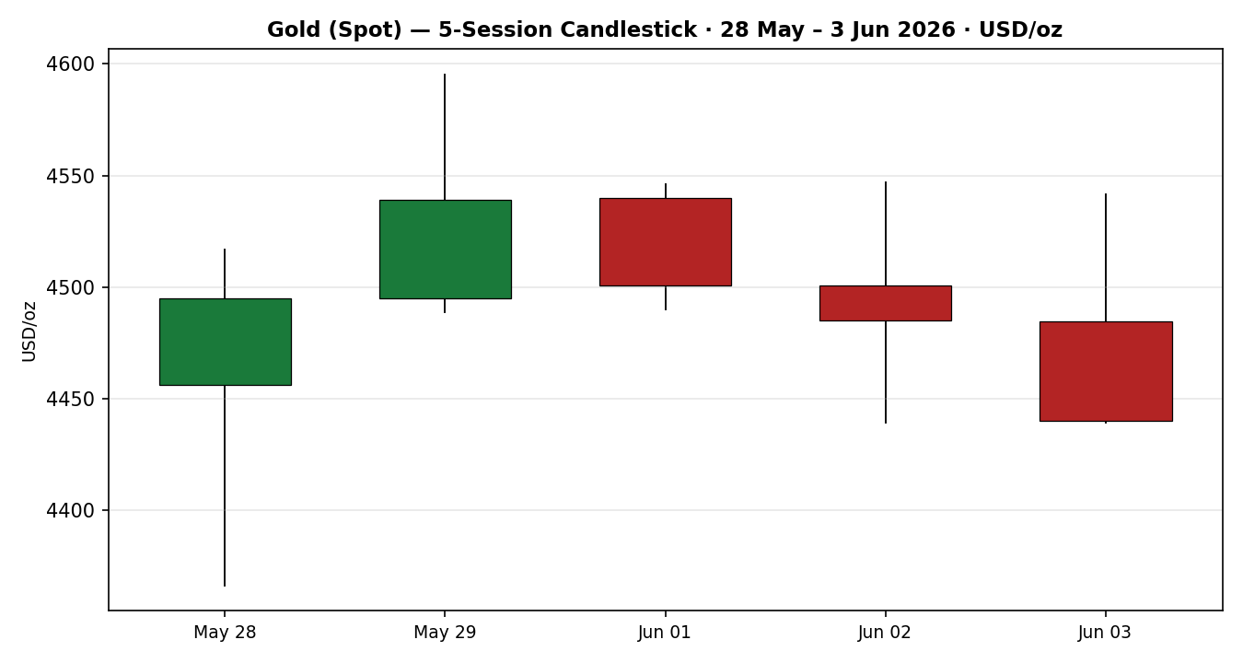
Chart 2 — Distance From Open.
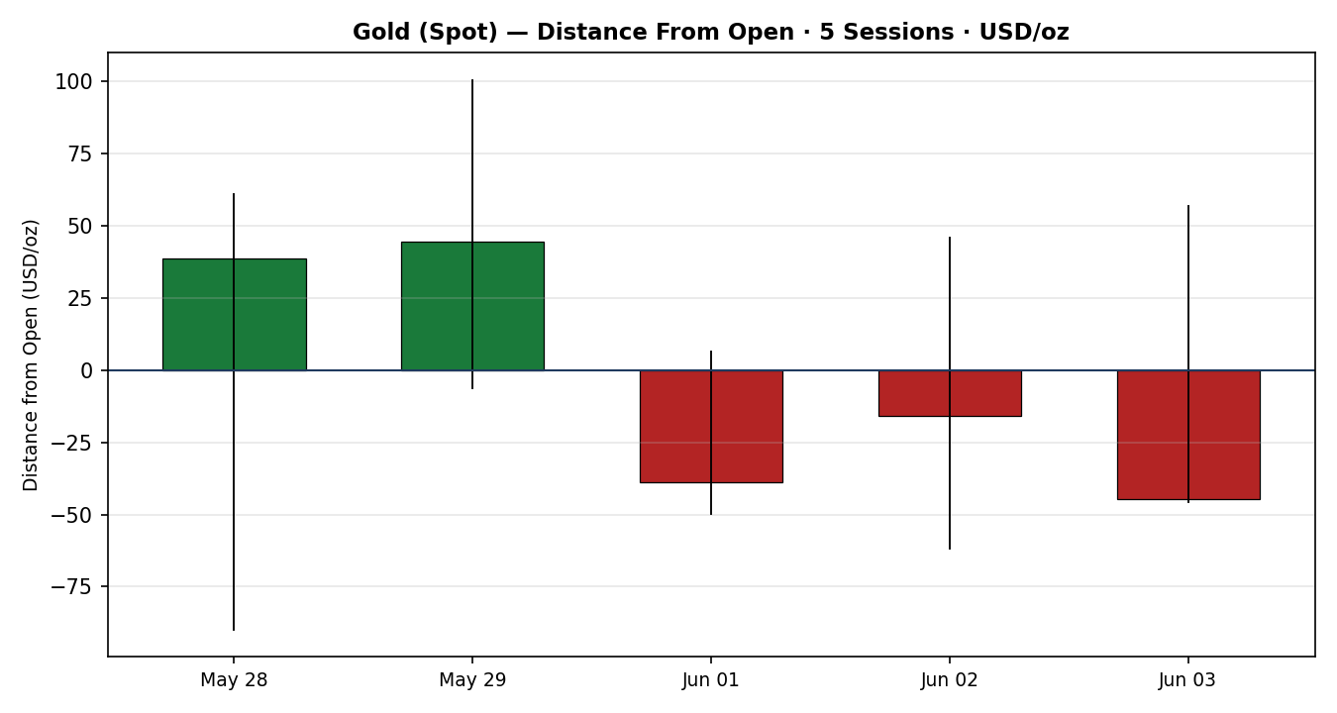
Chart 3 — 25-Session Structure.
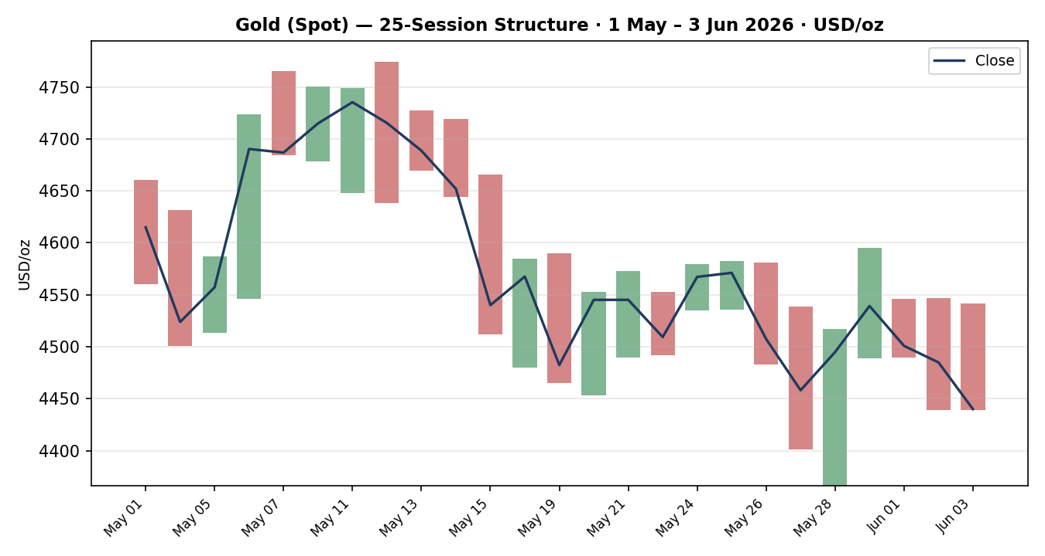
Chart 4 — Comparative Volatility (Gold vs Counters).
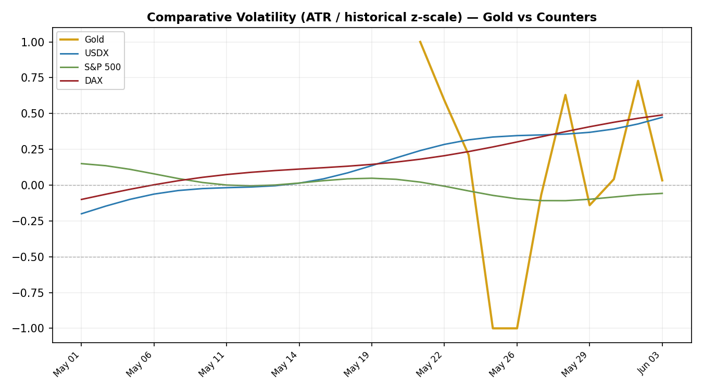
Chart 5 — Pivot Structure.
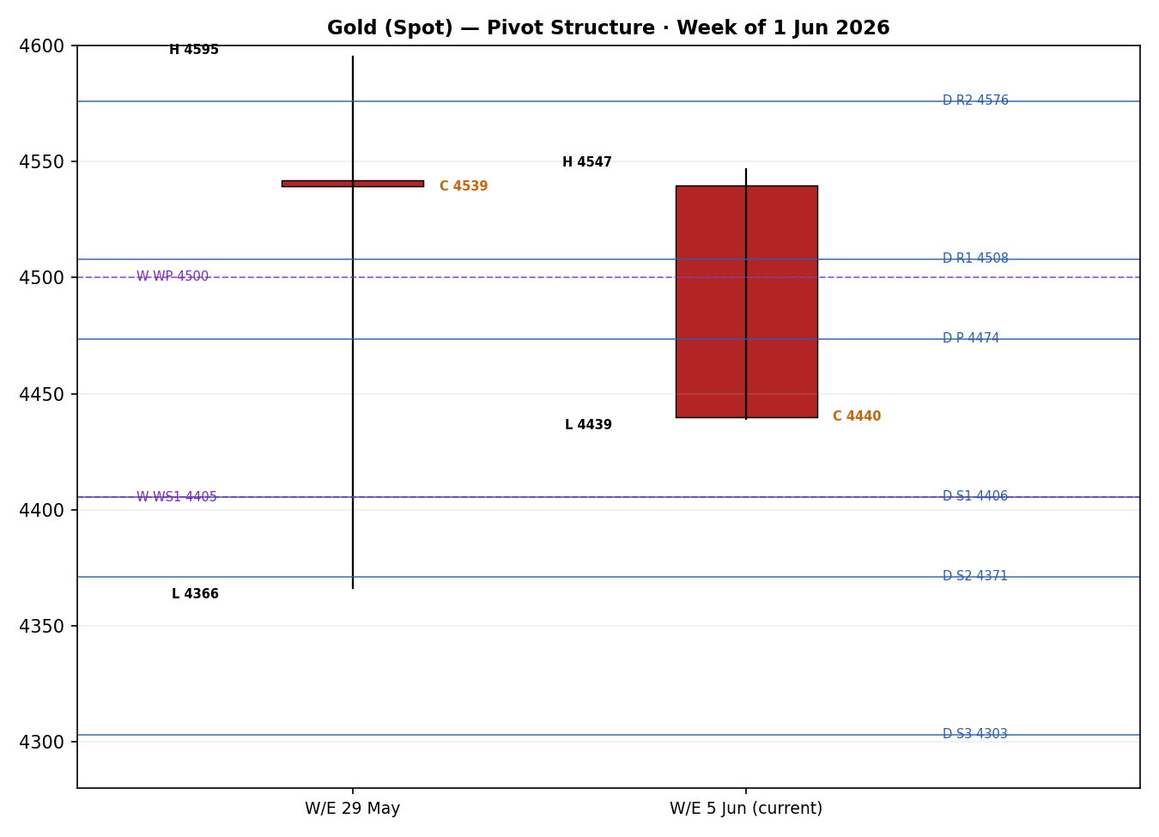

8 · Short-Term Technical Analysis
28 May: wide-range recovery candle reclaiming ~two-thirds of the prior day's loss; close in the upper third of range, RSI2 42.7 — a relief bounce, not a trend turn (see §6).
29 May: strong bullish body, RSI2 100, close into the high — the rally peak of the window (see §6).
1 Jun: bearish reversal day; opened near 4,540, closed 4,500.9 after failing at 4,546, RSI2 down to 53.6 — momentum rolling over (see §6).
2 Jun: bearish continuation with downside range expansion, RSI2 collapsed to 0, no lower-wick rejection (see §6).
3 Jun: second consecutive RSI2-0 close beneath $4,450, closing at the session low — persistent supply, no demand response yet (see §6).
Sequence assessment: Continuation (bearish). Two lower closes into the low, RSI2 pinned at 0, falling closes with limited down-leg overlap. Nearest support $4,439 (2–3 Jun low) then $4,366 (5-day swing low); nearest resistance $4,500–4,546 (1 Jun / prior-week shelf).
Judgement label: Bearish continuation. RSI2 at 0 introduces tactical reversal risk over the next 1–2 sessions, but no reversal signal has printed. Consistent with the §9 regime read.

9 · Medium-Term Regime & VOLator
Regime: Transitional (bearish tilt). Overlap ratio 0.68 and persistence 0.48 argue ranging, but range position is at the 18th percentile (range-bottom) and the latest break is directional. Median RSI2 42.4. The market is transitioning out of the May range to the downside.
Bias: Bearish.
VOLator: Gold's scaled volatility sits just above its 0 midpoint (+0.03) with a positive 10-observation slope (+0.04) — expanding into the down-move, a trending signature. USDX volatility expanding; S&P 500 contained; DAX expanding on its 3 Jun drop.
Preferred trade protocol: trend-resumption / pullback-to-sell, with reduced conviction acknowledged given the ranging overlap metric. Sell rallies rather than chase the oversold low.
Kaufman confirmation: smoothed KER −0.21 (above the 0.13 trend threshold) and falling → Trending Down (Moderate). KER agrees with the bearish bias and, with positive volatility expansion, resolves the composite regime to a down-trend read; it takes precedence over the lagging ranging-overlap metric.

10 · Cross-Asset Analysis
Counter | 5-Day Direction | Mechanism → Gold | Confirmation
USDX | Rising → 99.4–99.5 (2-mo high) | Stronger dollar raises the opportunity cost of non-yielding gold and lifts its price for non-USD buyers — direct headwind. | Confirms (bearish)
S&P 500 | Flat-to-firm (~7,580, near record) | Risk-on equities trim safe-haven demand at the margin; resilience caps gold's defensive bid. | Confirms (mild)
DAX | Falling (3 Jun −2%, ~23,950) | European risk-off would normally support gold, creating tension with the dollar channel. | Contradicts
Contradiction flag: DAX weakness is a risk-off signal arguing against the bearish gold view; it is carried into §15 and §16 rather than resolved silently. Aggregate cross-asset read = CONFIRM (two of three confirm, one contradicts), treated as confirming with the DAX caveat.

11 · Floor Pivot Analysis

Daily (from 3 Jun H/L/C)
Level | Price (USD/oz) | Note
R5 | 4,815.32
R4 | 4,712.89
R3 | 4,610.46
R2 | 4,576.00
R1 | 4,508.03 | nearest resistance
P | 4,473.57 | close sits below P
S1 | 4,405.60 | nearest support
S2 | 4,371.14
S3 | 4,303.17
S4 | 4,200.74
S5 | 4,098.31
Daily pivots derive from the 3 Jun session, whose High/Low are single-source-indicative; these levels are flagged indicative-only and not used as definitive entries (see §19, §21 caveats).

Weekly (prior week 25–29 May)
R2 | R1 | P | S1/S2
4,729.23 | 4,634.25 | 4,500.33 | 4,405.35 / 4,271.43

Monthly (May 2026)
R2 | R1 | P | S1/S2
4,967.26 | 4,753.26 | 4,559.84 | 4,345.84 / 4,152.42
Position narrative: the 3 Jun close ($4,440) sits below daily P ($4,473.6) and below weekly P ($4,500.3), between daily S1 ($4,405.6) and P — a bearish location. A confluence zone sits near $4,405: daily S1 (4,405.6) and weekly S1 (4,405.4) are within 0.01% of each other — a strong support shelf and the first downside objective. Monthly S1 ($4,345.8) aligns with the 5-day swing-low region ($4,366) as the next structural floor.

12 · Key Market Considerations
Demand — central banks (structural, price-supportive). The PBoC extended its buying streak to 18 consecutive months in April (+8t to 2,322t); Q1 2026 global central-bank net purchases ~244t (+3% y/y). A persistent structural bid that has absorbed dips.
Demand — investment (cyclical, mixed). WGC Q1 2026 total demand 1,231t (record Q1); bar/coin demand +20% q/q, but leveraged/speculative paper positioning is unwinding, the proximate cause of the late-May/early-June slide.
Macro / rates (cyclical, price-negative). Strong JOLTS and ADP prints lifted December Fed-hike odds to ~85%; higher-for-longer real yields are the dominant near-term headwind for non-yielding gold.
FX (structural-to-cyclical, price-negative). Dollar index at two-month highs (~99.4–99.5); see §10, §14.
Geopolitics / energy (cyclical, ambiguous). Middle East tension and oil > $90 raise inflation expectations (a latent gold positive) but are presently dominated by the real-yield/dollar channel (a negative). Net near-term: neutral-to-negative.
Near-term catalysts: Friday US nonfarm payrolls (see §13d); Fed Beige Book; ongoing US–Iran negotiation headlines. All flagged as watch items within the 5-day horizon.

13 · Sentiment, News & Calendar

13a · Per-Article Sentiment
Source | Date | Headline (summary) | Class. | Sentiment | Derivation quote (≤15w)
Trading Economics | 3 Jun | Gold falls below $4,500 on hawkish repricing | Media | Bearish | “hawkish stance and keep interest rates higher for longer”
CNBC | 1 Jun | Gold falls, inflation worries on Mideast conflict | Media | Bearish | “FedWatch at 40% probability of a December hike”
LiteFinance | 2 Jun | Analysts remain bearish into year-end | Trade Press | Bearish | “Analysts remain bearish, expecting gold to decline”
World Gold Council | Q1 | Record Q1 demand; central-bank bid intact | Official | Bullish | “highest January–March figure on record”
USAGOLD | 2 Jun | Physical buyers step in on dips | Trade Press | Bullish | “structural bid absorbed Monday’s decline”
Kitco / Reuters | 29 May | PCE eases hike fears; gold rebounds (dated) | Media | Neutral | “April PCE data eases Fed rate-hike fears”

13b · Aggregate Sentiment Summary
Categorical: 3 Bearish (2 media, 1 trade press), 2 Bullish (1 official, 1 trade press), 1 Neutral (media) = Mixed, bearish-leaning. Numeric tilt = −0.30 (source-class-weighted: bearish media/trade-press outweigh the bullish official/structural reads on near-term price). Reported as Mixed–Bearish (tilt = −0.30).
Divergence: sentiment agrees with falling price action and the bearish §9 regime — no divergence. Note the structural (central-bank) bull case and near-term (rates/dollar) bear case operate on different horizons.

13c · News Calendar — Previous Period (29 May – 3 Jun)
Date | Event | Context | Impact | Implication for Gold
Tue 2 Jun | US JOLTS job openings | Highest since ~Nov 2024 | High | Lifted hike odds and the dollar — gold negative
Wed 3 Jun | US ADP employment | +122k, beat | High | Reinforced labour resilience — gold negative
29 May–3 Jun | US–Iran talks / oil | Stalled; oil > $90 | Medium | Inflation up but real-yield channel dominant — net negative

13d · News Calendar — Upcoming (next 5 sessions)
Date | Event | Context | Impact | Implication for Gold
Fri 5 Jun | US Nonfarm Payrolls | Post strong JOLTS/ADP | High | Beat → dollar/yields up, gold down; miss → relief bounce toward $4,500
Wk of 8 Jun | Fed Beige Book / Fed speakers | Pre-blackout tone | Medium | Hawkish tone pressures gold; dovish surprises support
Ongoing | ECB meeting / US–Iran | ECB hike priced next week | Medium | Stronger EUR could cap the dollar and cushion gold
Highest-impact upcoming event: US Nonfarm Payrolls (Fri 5 Jun). A stronger-than-expected print would harden the higher-for-longer narrative and likely drive gold through the $4,405 support shelf; a clear miss would relieve dollar pressure and risk a squeeze of the RSI2-oversold condition back toward $4,500.

14 · Macro Context
Rates & policy: markets price ~85% odds of a December Fed hike; higher-for-longer real yields are the core gold headwind. Cross-references the S&P 500 read in §10 (risk appetite resilient despite hawkish repricing).
Inflation: oil-driven inflation expectations are rising — normally gold-supportive, but currently subordinate to the real-yield channel; net price-negative for now.
Safe-haven / real yields: the defensive bid is muted; gold is trading as a rates-sensitive asset rather than a haven, evidenced by its decline alongside DAX risk-off (the §10 contradiction).
Liquidity & FX: per §10, a rising USDX tightens conditions and directly pressures gold.
Positioning: leveraged/speculative longs are unwinding off the late-May highs; central-bank physical demand is the structural offset. VIX low-to-mid (~15–18).
Upcoming watch: NFP (§13d) is the key macro swing factor for the dollar and real yields, and therefore for gold, within the horizon.

15 · Bull / Bear Balance
Upside risks (bull) | Downside risks (bear)
Structural central-bank demand (PBoC 18-mo streak; 244t Q1 net buying) absorbing dips | Hawkish Fed repricing (~85% Dec-hike odds) lifting real yields
RSI2 pinned at 0 → tactical oversold-squeeze risk, especially on an NFP miss | Dollar index at 2-month highs (99.4–99.5) — direct headwind
DAX risk-off (§10 contradiction) could rotate haven flows back to gold | Bearish §9 regime; close below daily & weekly P; speculative long unwind
Oil-driven inflation expectations as a latent bid | NFP beat (§13d) would likely break the $4,405 support shelf

16 · Forward View
Expected direction: lower-to-sideways with a bearish tilt over the next 5 sessions, respecting the §9 transitional-bearish regime. Expected trading range $4,366–$4,546. Base case: rallies toward $4,500–4,508 (daily R1 / weekly P) are sold while price holds below $4,473 daily P, with the $4,405 daily+weekly S1 confluence as the first objective and $4,366 (5-day swing low) / $4,345 (monthly S1) beneath. Base-case invalidation: a daily close back above $4,500 (weekly P), which would neutralise the bearish structure and expose $4,576. The DAX risk-off contradiction (§10) and an NFP miss (§13d) are the principal two-way risks; flagged, not resolved.

17 · Forecast
Gold is biased to extend lower toward the $4,405 daily–weekly support confluence and potentially $4,366 over the coming sessions, as a hawkish Fed repricing, a two-month-high dollar and bearish momentum (RSI2 0, KER trending down) outweigh the structural central-bank bid, unless Friday's payrolls miss triggers an oversold squeeze back above $4,500.

18 · Final Analyst Judgement
Consensus price: $4,440/oz (range $4,430–$4,460). Confidence: Low (intraday corroboration gap).
Three most important reasons: (1) hawkish Fed repricing on strong labour data lifting real yields; (2) a two-month-high US dollar; (3) bearish technical momentum — two RSI2-0 closes, KER Trending Down, close below daily and weekly pivots.
Single watch item: Friday US Nonfarm Payrolls — the swing factor for the dollar, real yields and the $4,405 support shelf.

19 · Source Discipline Note
Live vs indicative: 28 May–1 Jun OHLC are corroborated (Investing.com × Trading Economics within the $0.50 gold tolerance on close). 2–3 Jun High/Low and the 3 Jun close are single-source-indicative — intraday spot/CFD divergence across sources exceeded tolerance during a fast directional session.
Data gaps: no exhaustive multi-source intraday fix was obtainable for 3 Jun within the run window; programmatic CSV endpoints (Stooq, Twelve Data) were not reachable from the run environment, so corroboration relied on Investing.com, Trading Economics, LiteFinance and physical-desk logs.
Normalization assumptions: all quotes treated as USD/oz loco-London spot; CFD reads accepted as spot-equivalent with the basis noted.
Corroboration status per instrument: Gold close — corroborated through 1 Jun, indicative 2–3 Jun. Pivot prior-period H/L/C (3 Jun daily) — indicative-only; this flag propagates to §21 and suppresses level-based limit entries from being treated as definitive. Per the explicit instruction for this run, trade strategies are NOT suppressed for the corroboration gap; affected cards instead carry an indicative caveat.

20 · Agent Log
Sources attempted (OHLC): Investing.com (corroborated), Trading Economics (corroborated), LiteFinance (indicative), USAGOLD (directional), CNBC/Fortune (directional). Stooq and Twelve Data not reachable from the environment (network) — logged as failed/not-attempted.
Validation method: two-source close agreement within $0.50 gold tolerance; 28 May–1 Jun pass; 2–3 Jun flagged single-source-indicative.
Sentiment derivation: 6 articles; source-class-weighted tilt = −0.30; Mixed–Bearish; not low-confidence (≥3 articles).
Strategy trace (weights basis = defaults): direction score −0.77 (short-tech −0.25, medium-regime −0.20, cross-asset −0.15, kaufman −0.075, volator −0.05, sentiment −0.045). regime_label = TREND_DOWN (KER trend-down + volator expansion; RANGE dual-gate not satisfied as |KER| 0.21 > 0.13). Weights locked at v2.1 defaults (forward-test session 1).
Override applied: daily-open anchor overridden to 07:00 UK for this run per instruction (default for this instance was 00:00 UK); Trade 1 entry timed accordingly. Corroboration-based suppression of §21 trade cards waived per instruction; indicative caveats applied instead.
Backtest notes: 5 sessions reconstructed at each t−1 close; sentiment frozen per session; single-bar conservative SL-first resolution; most positions mark-to-market OPEN given daily R > single-bar range. Anomalies: 2–3 Jun indicative data limits backtest precision. Timestamp: 4 Jun 2026, Europe/London.

21 · Strategy Recommendations

21a · Directional Conviction
Direction: SHORT. Score −0.77 (defaults). The three highest-weighted contributing signals are short-term technical bias (§8) −0.25, medium-term regime (§9) −0.20, and cross-asset confirmation (§10) −0.15. The score aligns with the §17 forecast — no conflict. Weights basis: defaults (v2.1 baseline).

21b · Trade Cards
Trade 1 — Daily Directional (SHORT)
Field | Detail
Direction | SHORT — TREND_DOWN regime, score −0.77
Entry | Market at 07:00 UK (overridden anchor) ≈ 4,440.07 USD/oz
Stop loss | 4,532.11 USD/oz — 92 ticks above entry. Anchor: nearest resistance (daily R1 4,508) + 0.25×ATR; tighter than the 5-day swing high 4,595. Within the 3.5×ATR cap.
Risk (R) | 92.0 USD/oz (≈ 92 ticks)
TP1 (Unit 1) | 4,348.03 — +1R
TP2 (Unit 2) | 4,255.99 — +2R; on fill, Unit 3 SL → entry + 0.2R (4,458.4)
TP3 (Unit 3 runner) | Time-stop at session close OR 3×ATR (4,151.11), whichever first
Tranche mgmt | 3 equal units; U1→TP1; U2→TP2; on U2 fill, U3 SL to entry +0.2R
Confluences | TP1 region near daily S2 (4,371) / monthly S1 (4,346) cluster — strong support zone below
Thesis invalidation | Daily close back above 4,500 (weekly P) — distinct from SL
Caveats | ATR(14)≈96 so 1R≈1×ATR (acceptable daily stop); indicative pivots referenced; holding period collides with §13d NFP (5 Jun) — Tier-1 event
Trade 2 — Pivot (TREND_DOWN breakout, SHORT)
Field | Detail
Direction | SHORT — trend-following below daily P
Entry | Sell stop at 4,466.77 (P − 10% of P→S1)
Stop loss | 4,501.14 — 34 ticks above entry (P + 0.8×(R1−P))
Risk (R) | 34.4 USD/oz (≈ 34 ticks)
TP1 / TP2 / TP3 | S1 4,405.60 / S1.5 4,388.37 / S2 4,371.14
Tranche mgmt | 3 equal units; U1→TP1; U2→TP2; runner toward S2
Confluences | TP1 4,405 = daily S1 + weekly S1 (within 0.01%) → strong confluence
Thesis invalidation | Daily close back through P (4,473.57)
Caveats | Pivots are SINGLE-SOURCE-INDICATIVE (3 Jun H/L); per run instruction NOT suppressed — treat levels as indicative; NFP collision (§13d)
Trade 3A — Momentum-Pullback (TREND_DOWN, SHORT)
Field | Detail
Direction | SHORT — pullback sell into the down-swing
Fib anchor | Swing 29 May high 4,595.31 → 28 May/2-3 Jun low 4,366.41; width 228.9 (2.38×ATR, qualifies; 4-session lookback)
Entry | 4,463.69 — 57.5% retracement of the swing
Stop loss | 4,619.39 — 0.25×ATR beyond the 0% anchor (swing high); within 3.5×ATR cap
Risk (R) | 155.7 USD/oz (≈ 156 ticks)
TP1 (Unit 1) | 4,507.87 — 38.2% retrace
TP2 (Unit 2) | 4,366.41 — 0% / swing low; on fill U3 SL → entry +0.2R
TP3 (Unit 3 runner) | 4,137.51 — 100%+ extension; structural runner stop pulls to 50% of the 1:1 leg on break
Confluences | Entry near weekly P (4,500) / daily R1 (4,508) overhead supply; TP2 = 5-day swing low
Thesis invalidation | Daily close beyond the swing-high anchor (4,595)
Caveats | Wide stop (1R ≈ 1.6×ATR) — position size reduced; indicative pivots/levels; NFP collision (§13d)

21c · 5-Session No-Leakage Backtest
Date (issue) | Strategy | Direction | Triggered | Entry→Exit | Outcome (R) | Days
29 May (t−5) | Trade 1 | LONG | YES | 4,494.9→mkt | OPEN @ +0.5R | 5+ (open)
1 Jun (t−4) | Trade 1 | LONG | YES | 4,539.8→4,500.9 | −0.3R | 1
2 Jun (t−3) | Trade 1 | SHORT | YES | 4,500.9→4,485.0 | +0.1R | 1
2 Jun (t−2) | Trade 3A | SHORT | YES | pullback | OPEN @ +0.4R | 5+ (open)
3 Jun (t−1) | Trade 1 | SHORT | YES | 4,484.9→4,440.1 | +0.3R | 1
3 Jun (t−1) | Trade 2 | SHORT | NO | limit not hit | — | —
Conservative single-bar SL-first resolution; daily R (~1×ATR) frequently exceeds a single session's adverse excursion, so several positions remain OPEN at mark-to-market. Suppressed/not-triggered reconstructions are reported for traceability and excluded from the aggregate.

21d · What Is Working
Aggregate (last 5 sessions): Trade 1 triggered 4/4 times issued, mean R ≈ +0.05 (closed only), with the SHORT-side reconstructions (2–3 Jun) modestly positive as the down-move developed; TP1/TP2/TP3 hit rates ≈ 25% / 0% / 0%. Trade 3A triggered 1/1, currently OPEN (+0.4R). Trade 2 triggered 0/1 (limit unmet). Strongest performer: Trade 1 (short side). Weakest / unrankable: Trade 2 — insufficient triggers to rank.
Five-session windows are too small to support statistical claims. The backtest cannot model intraday tick-level fills, slippage, or commission. Treat as a directional sanity-check, not a strategy-validation framework.

