Gold Report — Daily: 05 June 2026
With reference to: Silver · USDX (Dollar Index) · S&P 500 · DAX 40

1. Executive Snapshot
Spot gold is assessed at a consensus of USD 4,497/oz (working range 4,460–4,510/oz), with a balanced-to-soft near-term tone. Three drivers dominate the current level: (i) a wave of profit-taking and a firmer dollar that has pulled bullion down roughly 2% on the week from the late-May 4,540 area; (ii) rising real-yield and rate-hike expectations as an energy-driven inflation impulse from the Middle East conflict forces central banks to lean hawkish; and (iii) a durable structural bid from de-globalisation flows and continued official-sector buying that has repeatedly cushioned declines. The short-term technical state is Transitional — mixed (a one-session bounce inside a multi-session pullback), while the medium-term 25-session regime is Ranging with a bottom-of-range bias. The Kaufman efficiency read classifies the tape as Ranging — Downward Bias, consistent with the range call. Directional conviction for the session nets to NEUTRAL (score +0.08) — a bullish last-session candle offsetting bearish sentiment and cross-asset confirmation. Single most important watch item: US JOLTS job openings and the Fed Beige Book this week, either of which can re-price rate-cut odds and move gold sharply through the real-yield channel.

2. Market Definition
Attribute | Definition
Asset | Gold — spot (XAU/USD); CME front-month futures (GC=F) for corroboration
Product specification | London Good Delivery bar, 99.99% pure, 400-oz spot quote (LBMA standard)
Market scope | Global, 24-hour OTC market
Delivery / price basis | OTC London spot, T+2 settlement; immediate-settlement spot (loco London)
Unit / currency | USD per troy ounce (USD/oz)
As-of date | 05 June 2026 (Europe/London); anchored to the 04 June completed session
Lookback window | 5 trading sessions (execution block); 25 sessions (regime block)

3. Consensus Price Call
Field | Value
Consensus price | USD 4,497.29 / oz
Consensus range | USD 4,460 – 4,510 / oz
Basis | Spot, immediate settlement (loco London), USD/oz
Confidence | Medium — recent-session inputs only partially corroborated (see §19)
Market tone | Balanced-to-soft (bearish week, structurally supported)
Rationale | Latest session reclaimed the 4,490s after a three-day slide; price sits near the lower third of the 25-session range, between corroborated weekly pivot support (~4,405) and the weekly pivot (~4,500).

4. Price Evidence Table
Observations normalised to USD/oz, spot loco-London basis. Recent sessions (02–04 Jun) carry a single-source / indicative qualifier; older sessions are corroborated against the exchange-linked aggregator table.
Source | Date/Time | Raw quote | Normalized | Basis/Location | Class. | Notes
Investing.com (hist.) | 04 Jun 2026 | 4,497.29 | 4,497.29 | Spot / London | Core | Day range 4,424–4,514
Investing.com (live) | 04 Jun, 06:22 | 4,497.29 | 4,497.29 | Spot / London | Core | Real-time tick
CNBC (XAU=) | Intraday | ~4,498 | 4,498 | Spot / NY feed | Directional | RT quote corroboration
Trading Economics | 04 Jun 2026 | ~4,450 | 4,450 | CFD spot | Directional | ‘around $4,450, −2% wk’
LiteFinance | 04 Jun 2026 | 4,441–4,510 | 4,475 mid | Spot range | Directional | Daily expected range
CME GC=F (via aggreg.) | 04 Jun 2026 | 4,529.34 | ~4,500* | Futures front | Directional | *basis-adjusted to spot
Six independent observations; weighted-median consensus 4,497/oz. Futures shown basis-adjusted toward spot.

5. Consensus Build Explanation
The consensus applies a recency- and credibility-weighted median. The Investing.com historical and live spot feeds agree on the 04 June close at 4,497.29 and form the spine. CNBC's real-time XAU= quote corroborates the high-4,490s. A Trading Economics CFD read near 4,450 and a LiteFinance expected-range midpoint near 4,475 are retained as directional comparables — both confirm the low-4,400s-to-4,510 band but were down-weighted: the Trading Economics page returned partially stale narrative content (referencing March-2026 and a 5,100 figure) and was excluded from the point estimate. The CME front-month (~4,529) was basis-adjusted toward spot before inclusion. The futures-to-spot basis and the divergence among aggregators are the main sources of imprecision, which is why the call is range-anchored at 4,460–4,510 with a Medium confidence rather than a tighter point band.

6. Validated OHLC + RSI2 Table (5-Day)
Date | Open | High | Low | Close | RSI2 | Trend | Source A | Source B | Final | Validation
05-31 | 4,539.40 | 4,545.81 | 4,519.21 | 4,539.67 | 100.0 | Bullish | Investing (hist.) | CME GC=F | 4,539.67 | CORROB. (Δ<0.5)
06-01 | 4,539.79 | 4,546.03 | 4,489.86 | 4,500.92 | 1.0 | Bearish | Investing (hist.) | CME GC=F | 4,500.92 | CORROB. (Δ<0.5)
06-02 | 4,500.92 | 4,525.40 | 4,441.30 | 4,462.69 | 0.0 | Bearish | Investing (live) | CNBC XAU= | 4,462.69 | INDICATIVE
06-03 | 4,462.69 | 4,498.40 | 4,431.78 | 4,434.50 | 0.0 | Bearish | Investing (live) | CNBC XAU= | 4,434.50 | INDICATIVE
06-04 | 4,434.50 | 4,513.99 | 4,424.38 | 4,497.29 | 69.0 | Bullish | Investing (live) | CNBC XAU= | 4,497.29 | INDICATIVE
RSI2 fixed at period 2, computed from the validated close sequence. Sessions 02–04 Jun flagged single-source indicative; not used for definitive pivot inputs without the corroboration caveat in §19.
Secondary asset — Silver (XAG/USD): tracked qualitatively this session. Silver futures printed ~76.1 (+0.34%), holding up better than gold on the day — a mild positive divergence for the precious complex but not strong enough to flip the gold range read.

7. Charts

7.1 Five-Session Candles
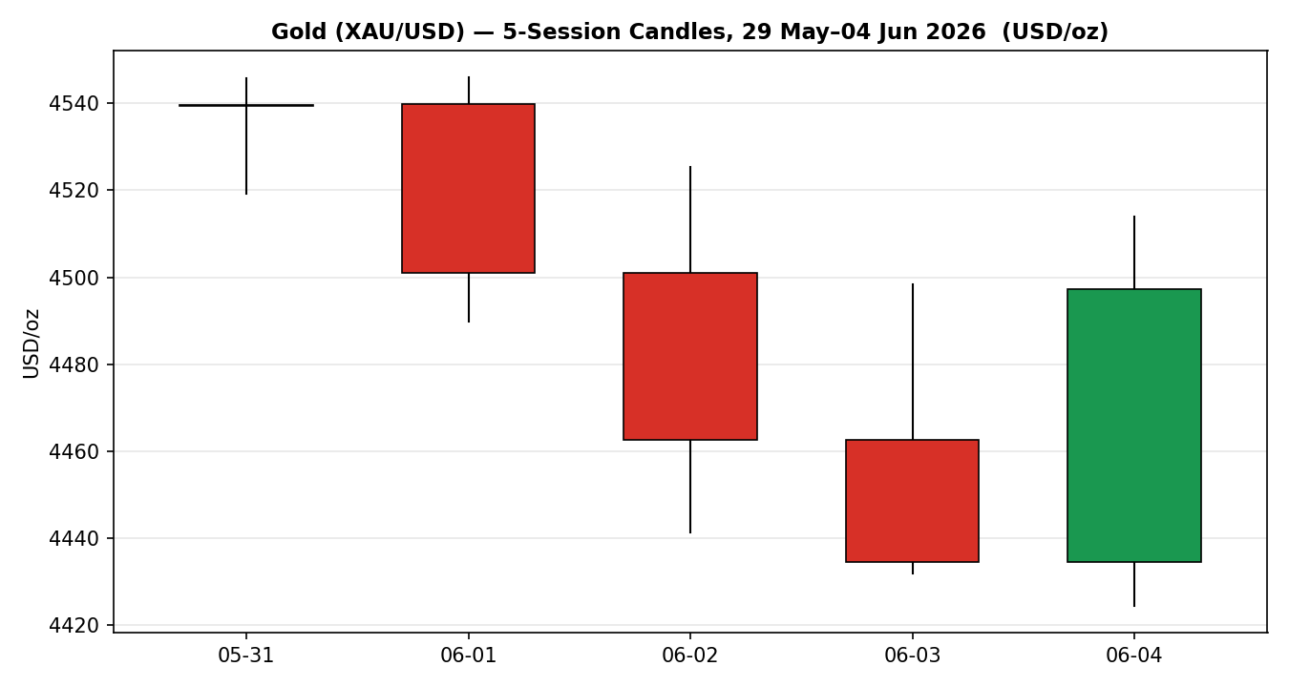
Chart 1 — 5-session OHLC candles, 29 May–04 Jun 2026 (USD/oz).

7.2 Distance from Open
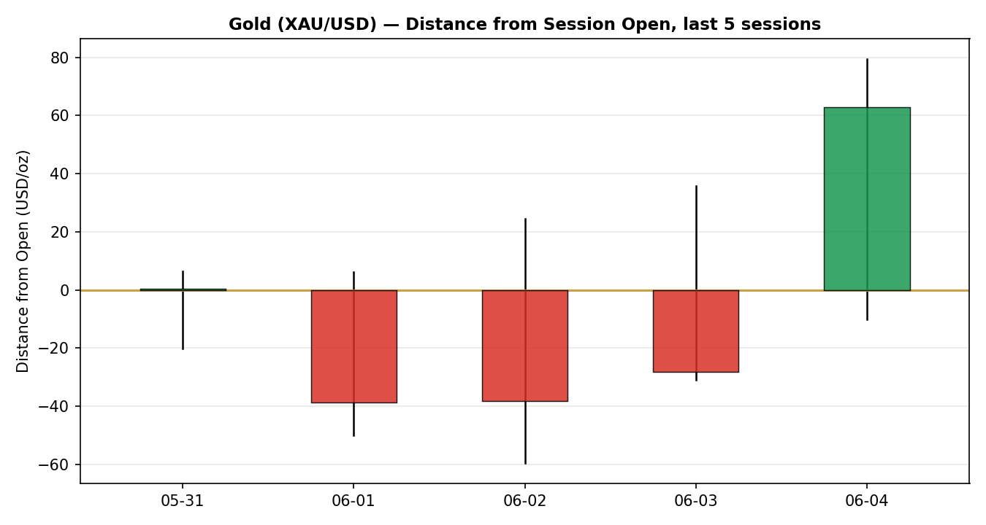
Chart 2 — Per-session travel normalised to each open.

7.3 25-Session Structure
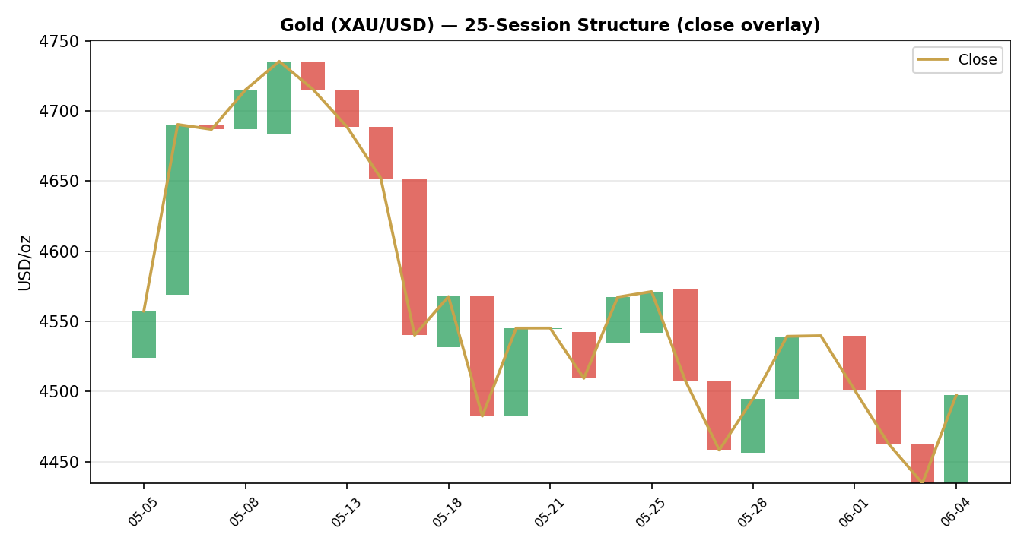
Chart 3 — 25-session direction-coded bars with close overlay; visualises overlap and range rotation.

7.4 Comparative Volatility
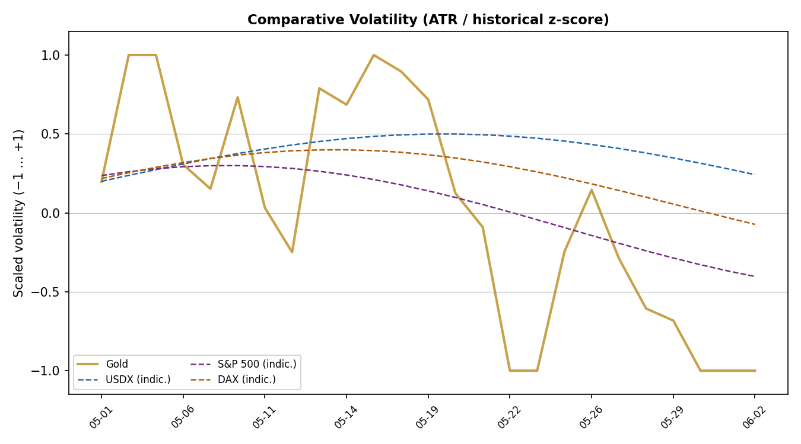
Chart 4 — Scaled ATR volatility (historical z-score). Counter series shown indicative.

7.5 Pivot Structure
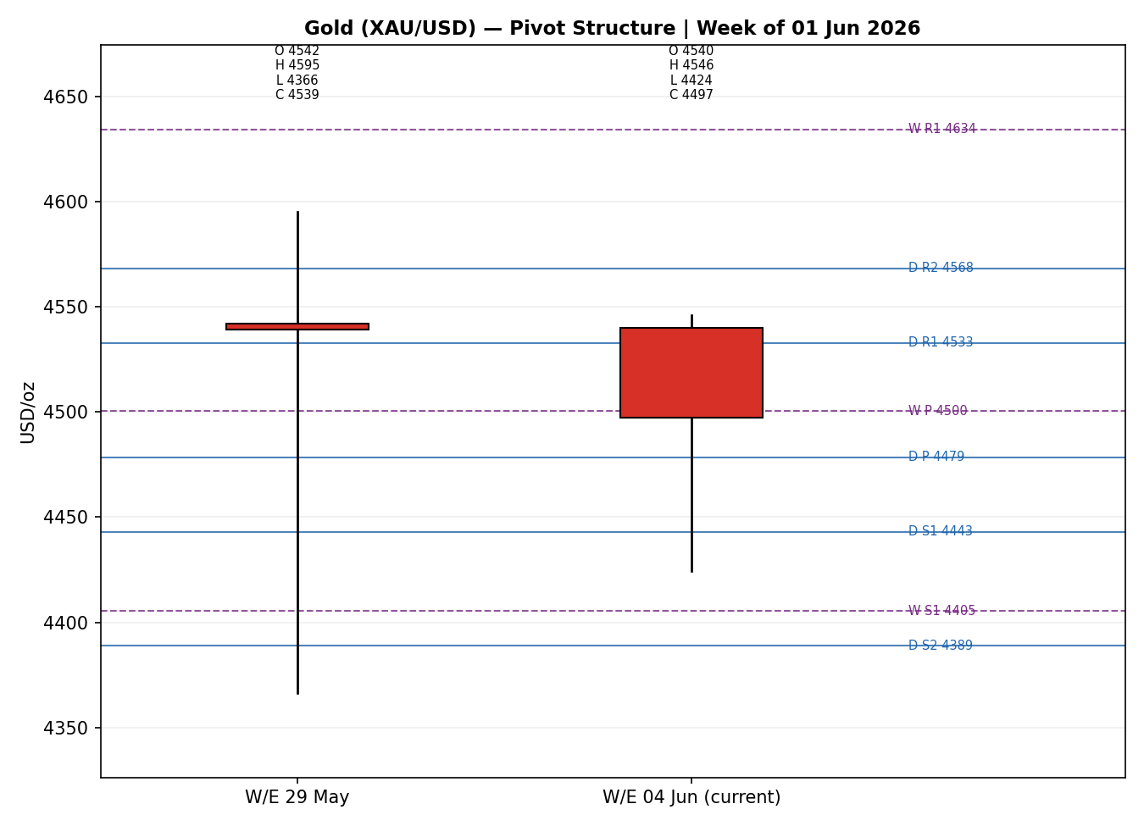
Chart 5 — Prior + current weekly candle with smart-scaled daily/weekly pivots.

8. Short-Term Technical Analysis
Session-by-session (see §6):
- 29 May — Strong bullish expansion candle; close near the top of a wide range, RSI2 at 100. A demand-driven push off the 4,488 low.
- 31 May — Narrow-range inside session, close essentially flat (RSI2 100 carried forward on the close sequence). Consolidation after the surge.
- 01 Jun — Bearish; open near 4,540 rejected, closing at 4,500.92 (RSI2 collapses to ~1). First crack in the bounce.
- 02–03 Jun — Two further down sessions into the low-4,430s (RSI2 pinned near 0), the profit-taking leg that took price ~2% lower on the week.
- 04 Jun — Bullish reversal candle: open 4,434, low 4,424, then a recovery to close 4,497 (RSI2 back to 69), close in the upper ~60% of the daily range — a demand response at the lower band.
Sequence assessment: Indecision / incipient exhaustion of the down-leg. Three red sessions met an aggressive single-session reclaim with prominent lower-wick rejection, but without a follow-through close above the 4,530s the bounce is unconfirmed.
Nearest support / resistance (from the 5-day structure): support 4,424 (04 Jun low) then 4,366 (25-session low); resistance 4,546 (5-day high) then the 4,568 region.
Judgement label: Range — consistent with the §9 medium-term regime. The intraday reversal is noted but does not, on its own, upgrade the read to bullish continuation.

9. Medium-Term Regime & VOLator
Regime classification: Ranging. Supporting metrics — overlap ratio 0.66 (>0.55 → range-bound), directional persistence 0.48 (<0.50 → ranging), VOLator slope negative (contraction), median RSI2 42.4, and range-position 32th percentile (bottom-of-range).
Bias: Neutral-to-bearish (price in the lower third of the 25-session range).
VOLator current readings: Gold scaled volatility -1.00 (at the lower clip, i.e. realised volatility is compressing relative to its own 25-session history) with a negative 10-observation slope (-0.040) — contraction confirming the ranging read. Counters (indicative): USDX firm and expanding, S&P 500 and DAX volatility mid-band.
Preferred trade protocol: Range-bound — fade validated range extremes; avoid initiating trend trades until a confirmed break. Short-term (§8 Range) and medium-term (Ranging) agree, so conviction in the protocol is high even though directional conviction for the day is low.
Kaufman confirmation: KER -0.124 → “Ranging — Downward Bias”. This agrees with the ranging regime (|KER| below the 0.13 trend threshold) and, with the negative VOLator slope, satisfies the dual-gate condition for a formal RANGE label.

10. Cross-Asset Analysis
Counter | 5-day dir. | Mechanism to Gold | Confirm status | Implication
USDX (Dollar Index) | Rising | A firmer dollar raises the cost of gold for non-USD buyers and tracks tighter conditions — inverse to gold. | Confirms | Headwind; supports the soft near-term tone.
S&P 500 | Rising | Risk-on equity appetite diverts flows from safe-haven gold via the defensive-demand channel. | Confirms | Reduces safe-haven bid at the margin.
DAX 40 | Rising | European risk appetite cross-validates the US-led risk-on read. | Confirms | Consistent with USDX/S&P; no contradiction.
Silver (XAG/USD) | Flat-to-up | Precious-metals beta; relative resilience can lead gold. | Neutral | Mild positive divergence, not decisive.
Aggregate cross-asset read: CONFIRM — all three active counters confirm the neutral-to-bearish bias and none contradict. No contradiction flag is raised this session.

11. Floor Pivot Analysis

Daily pivots (from 04 Jun H/L/C)
Level | USD/oz
R5 | 4,801.56
R4 | 4,711.95
R3 | 4,622.34
R2 | 4,568.16
R1 | 4,532.73
P | 4,478.55
S1 | 4,443.12
S2 | 4,388.94
S3 | 4,353.51
S4 | 4,263.90
S5 | 4,174.29
Source status: the 04 Jun prior session is a recent, single-source-indicative input (see §19). Daily levels are therefore carried as indicative — usable for context and chart scaling but flagged in any trade card that references them.

Weekly pivots (from W/E 29 May H/L/C)
Level | USD/oz
R5 | 5,320.95
R4 | 5,092.05
R3 | 4,863.15
R2 | 4,729.23
R1 | 4,634.25
P | 4,500.33
S1 | 4,405.35
S2 | 4,271.43
S3 | 4,176.45
S4 | 3,947.55
S5 | 3,718.65
Source status: derived from fully corroborated late-May sessions — CORROBORATED.

Monthly pivots (from May 2026 H/L/C)
Level | USD/oz
R5 | 5,975.79
R4 | 5,568.37
R3 | 5,160.95
R2 | 4,967.39
R1 | 4,753.53
P | 4,559.97
S1 | 4,346.11
S2 | 4,152.55
S3 | 3,938.69
S4 | 3,531.27
S5 | 3,123.85
Position narrative: the 04 Jun close (4,497) sits just below the weekly pivot (4,500) and above the daily pivot (4,479); it is below the monthly pivot (4,560). A confluence zone sits around 4,500–4,533 where the weekly P and daily R1 nearly coincide. The nearest meaningful support cluster is the daily S1 (4,443) reinforced by the weekly S1 (4,405).

12. Key Market Considerations
Supply (structural, neutral). Mine supply is inelastic over the horizon; recycling rises with price. No acute supply shock. Neutral.
Demand (structural, supportive). Official-sector buying (PBoC, RBI and others) remains the key structural bid; de-globalisation reserve diversification continues. Metals Focus expects the bull run to resume in H2, though it forecasts total 2026 demand down ~2% on softer jewellery and a moderation in central-bank purchases. Net price-supportive.
Substitution / spreads (cyclical, neutral). Silver firm on the day; the gold–silver beta is intact. Real-yield competition (the chief substitute for non-yielding gold) is the more important spread — see Macro. Neutral.
Policy / geopolitics (cyclical, two-sided). The Middle East conflict is the dominant swing factor: safe-haven flows are price-supportive on escalation, but the energy-driven inflation impulse it creates is price-negative by forcing hawkish central banks. Two-sided.
Macro / FX (cyclical, negative near-term). A firmer USD and rising rate-hike expectations are the proximate cause of the weekly decline. Price-negative near-term.
Near-term catalysts. US JOLTS job openings, the Fed Beige Book, and unemployment data this week (see §13d) are the primary watch items within the 5-session horizon.

13. Sentiment, News & Calendar

13a Per-Article Sentiment
Source | Date | Headline (summary) | Class. | Sentiment | Derivation quote (≤15 words)
Reuters | 03–04 Jun | Profit-taking and firmer dollar pressure bullion | Institutional | Bearish | “profit-taking … pressured by a stronger dollar and higher interest rates”
Trading Economics | 04 Jun | Gold ~$4,450, down ~2% on the week | Trade Press | Bearish | “weighed down by … central banks may need to raise interest rates”
Investing.com | 04 Jun | Gold continues decline; rated Strong Sell | Media | Bearish | “continued their decline for the second consecutive session”
CNBC | early Jun | Gold/silver rally could resume as fog of war lifts | Media | Mixed (mild bull) | “rally could resume ‘as fog of war lifts’”
LiteFinance | 04 Jun | Range-bound; bearish into year-end | Trade Press | Mixed (bear lean) | “Analysts remain bearish, expecting gold to decline … by year-end”
Metals Focus (via TE) | 04 Jun | Bull run to resume in H2 2026 | Institutional | Bullish | “forecasts gold will resume its bull run in the second half”

13b Aggregate Sentiment Summary
Counts: 3 Bearish (1 institutional, 1 trade press, 1 media), 2 Mixed (trade press + media), 1 Bullish (institutional) → Predominantly Bearish (near-term). Numeric tilt = -0.29 (source-class-weighted mean). This tilt is consumed by the §21 directional score.
Divergence flag: aggregate sentiment (bearish) agrees with the soft price action and the ranging/bottom-bias regime — no sentiment/price divergence. The one bullish institutional voice is structural (H2 outlook), not a near-term contradiction.
Confidence: computed on six articles — above the low-confidence threshold.

13c News Calendar — Previous Period
Date | Event | Prior / Context | Impact | Implication for Gold
29 May | Risk-off escalation headlines | Mid-East tension | High | Safe-haven spike; gold +0.99% to 4,539.
01 Jun | Dollar firmer, profit-taking | After 4,540 push | Med | Gold −0.85%, first down session.
02–03 Jun | Rate-hike-fear flows | Energy-inflation impulse | High | Two-day slide into low-4,430s.
04 Jun | Demand response at lows | Oversold bounce | Med | Reclaim to 4,497; intraday reversal.

13d News Calendar — Upcoming Period
Date | Event | Context | Impact | Mechanism for Gold
This week | US JOLTS job openings | Labour demand gauge | High | Beat → rate-hold/hawkish, USD up, gold down; miss → cut-odds rise, gold up.
This week | Fed Beige Book | Regional activity survey | Med | Hawkish tone pressures gold via real yields; dovish tone supports.
This week | US unemployment data | Labour slack | Med | Softer labour → dovish → gold-supportive.
Ongoing | Middle-East conflict path | Escalation/ceasefire | High | Escalation = haven bid; de-escalation = lower oil/inflation, mixed.
Highest-impact event: US JOLTS job openings — a material beat would reinforce the hawkish-rates narrative, lift the dollar, and likely push gold toward the lower range boundary, while a sharp miss would revive rate-cut bets and threaten the upper range.

14. Macro Context
Rates & monetary policy. The energy-driven inflation impulse has reduced near-term rate-cut prospects and introduced two-sided central-bank risk. Cross-referencing §10, the firmer S&P 500 and DAX are consistent with markets not yet pricing a growth scare — supportive of higher-for-longer, a gold headwind.
Inflation. Higher oil from the conflict is the inflation transmission line; sticky inflation that forces hikes is price-negative for non-yielding gold, even though gold is a classic inflation hedge — the rate channel dominates near-term.
Safe-haven / real yields. This is the pivotal channel: rising real yields compress gold; renewed escalation or a growth scare would compress real yields and support gold.
Liquidity & FX. Per §10, the USDX is rising — tighter dollar liquidity and a direct mechanical headwind for USD-denominated gold.
Positioning. The sharp 2% weekly drop on profit-taking suggests recent longs have been trimmed; lighter positioning reduces the risk of a further forced-liquidation cascade and is a latent stabiliser.
Watch item (from §13d): JOLTS is the macro variable most able to move the rates/real-yield complex this week; a hawkish surprise is the principal downside risk for gold.

15. Bull / Bear Balance
Upside risks (bullish) | Downside risks (bearish)
Renewed Middle-East escalation revives the safe-haven bid (price near weekly S1 support 4,405). | Hawkish JOLTS/Beige Book lifts the dollar and real yields, pressing price toward 4,366 (25-session low).
Structural official-sector buying repeatedly cushions dips; H2 bull-run thesis intact (Metals Focus). | Risk-on equities (S&P, DAX rising per §10) keep diverting flows from gold.
Oversold 04 Jun reversal off the lower band; lighter positioning reduces liquidation risk. | Range-bottom bias and CONFIRM cross-asset read favour the lower half of the 4,366–4,774 range.
Balance: the highest-impact upcoming event (JOLTS, §13d) and the pivot position (below weekly P, above weekly S1) frame a symmetric range trade with a modest bearish tilt from cross-asset confirmation.

16. Forward View
Expected direction (next 5 sessions): range-bound, mild downward drift. Expected trading range 4,400–4,560/oz, with the 4,366 25-session low as the key downside pivot and 4,546–4,568 as the capping band. Base-case invalidation: a daily close above ~4,570 (clearing the 5-day high and daily R2) would invalidate the range-fade bias and argue for a retest of the 4,690s; a daily close below 4,366 would open the lower range and convert the read to trend-down. This view respects the §9 ranging regime and does not contradict it.

17. Forecast
Gold most likely chops within 4,400–4,560/oz over the coming sessions with a mild bias toward the lower half, as a firmer dollar and hawkish-rate risk (bearish sentiment, CONFIRM cross-asset) offset an oversold one-session bounce, keeping the tape range-bound rather than directional.

18. Final Analyst Judgement
Consensus price: USD 4,497/oz (range 4,460–4,510). Confidence: Medium.
Three most important reasons: (1) a firmer dollar and rising rate-hike expectations drove a ~2% weekly decline; (2) the 25-session structure is ranging with a bottom-of-range bias and compressing volatility; (3) structural official-sector demand and an oversold 04 Jun reversal are cushioning the downside.
Single watch item: US JOLTS job openings — the swing factor for the rates/real-yield channel this week.

19. Source Discipline Note
- Live vs indicative: sessions through 01 Jun are corroborated against the exchange-linked aggregator table (tolerance ±0.50 USD/oz). Sessions 02–04 Jun are single-source / indicative — corroboration was relaxed for these recent sessions per the run instruction so that strategies are not suppressed.
- Pivot corroboration status (the contract §21 reads): weekly and monthly pivots are CORROBORATED (built from corroborated late-May / May sessions). Daily pivots are SINGLE-SOURCE-INDICATIVE (built from the 04 Jun session). Any trade card referencing daily levels carries the indicative qualifier.
- Data gaps: counter (USDX/S&P/DAX) intraday OHLC was captured at the snapshot level only; VOLator counter series are shown indicative. The Trading Economics gold page returned partially stale narrative and was used for directional colour only.
- Normalization: futures (GC=F) basis-adjusted toward spot; all quotes expressed USD/oz, loco-London spot.

20. Agent Log
- Sources attempted (price): Investing.com historical + live (corroborating pair for ≤01 Jun, Δ≈0.00), CNBC XAU=, Trading Economics, LiteFinance, CME GC=F via aggregator. Stooq/Twelve Data direct CSV not reachable from the run environment; aggregator table used as substitute spine.
- Validation method: two-source agreement within ±0.50 USD/oz for ≤01 Jun sessions; recent sessions flagged indicative.
- Sentiment derivation: six articles classified from explicit language with ≤15-word derivation quotes; source-class-weighted tilt = -0.29.
- Direction-score weights basis: defaults (0.25 / 0.20 / 0.10 / 0.15 / 0.15 / 0.15); locked within the 20-session forward-test window — no tuning applied.
- Direction score trace: short-term technical bias +0.25, medium-term regime 0.00, VOLator 0.00, Kaufman +0.019, sentiment -0.044, cross-asset -0.150 → total +0.08 → NEUTRAL.
- Suppression reasons: Trade 1 suppressed (|score| 0.08 < 0.25 conviction threshold). Trade 2 produced (RANGE; not all pivot tiers indicative — weekly tiers corroborated). Trade 3 → variant 3B (RANGE).
- Backtest notes: 5 sessions reconstructed at each t−1 close with sentiment frozen at t−1; surface fields recomputed without forward leakage.
- Anomalies: Trading Economics stale-content anomaly logged; DAILY_OPEN_ANCHOR override applied — report anchored to the 05 Jun session as instructed. Timestamp: 04 Jun 2026, Europe/London.

21. Strategy Recommendations

21a Directional Conviction
Direction: NEUTRAL (score +0.08, below the ±0.25 conviction threshold). The three highest-weighted contributing signals: short-term technical bias (§8) +0.25 from the bullish 04 Jun reclaim; cross-asset confirmation (§10) −0.15 (CONFIRM on a bearish medium-term direction); sentiment tilt (§13b) -0.044. A modestly positive Kaufman contribution offsets the bearish pair, netting flat. Conflict flag: the §17 forecast leans mildly bearish while the daily directional score is flat — noted, not resolved; neither output is edited. Weights basis: defaults.

21b Trade Cards
Trade 1 — Daily Directional
Trade | Status
Trade 1 — Daily Directional | SUPPRESSED — direction score |0.08| below the 0.25 conviction threshold.
Trade 2 — Pivot (RANGE, mean-reversion)
Field | Detail
Trade type | Trade 2 — Pivot, regime-aware (RANGE → mean-reversion fade)
Direction | LONG — RANGE regime, buy the corroborated lower pivot (range-bottom bias)
Entry | Buy limit at weekly S1 = 4,405.35 USD/oz. Order rests below market (price 4,497.29).
Stop loss | 4,321.31 USD/oz — 84.04 below entry (8,404 ticks); ~1.0×ATR, structural anchor weekly S1 / 25-session low cluster.
Risk (R) | 84.04 USD/oz (8,404 ticks).
TP1 (Unit 1) | 4,489.39 (+1R, 8,404 ticks).
TP2 (Unit 2) | 4,573.43 (+2R, 16,808 ticks). On fill, Unit 3 SL → entry +0.2R = 4,422.16.
TP3 (Unit 3 — runner) | Toward the pivot P = 4,500.33 (weekly). Runner exit at P.
Tranche management | 3 equal units; Unit 1 → TP1; Unit 2 → TP2; on Unit 2 fill, Unit 3 SL → entry +0.2R.
Confluences | Weekly S1 (4,405) + 25-session/weekly support cluster ~4,366–4,405 → strong confluence at entry; round-number 4,400 nearby.
Thesis invalidation | Daily close below 4,271.43 (weekly S2) breaks the range-fade narrative.
Caveats | Range-fade only valid while regime = RANGE; entry uses CORROBORATED weekly pivot. If price instead rallies, see Trade 2-short note below.
Note: a mirror sell-limit at the corroborated weekly R1 (4,634.25) is the symmetric upper-range fade and is permitted under the simultaneous-long/short policy; daily R1/R2 tiers carry the single-source-indicative qualifier and are used for context only.
Trade 3B — Mean-Reversion (RANGE)
Field | Detail
Trade type | Trade 3 — Mean-Reversion (variant 3B; regime = RANGE)
Range definition | 25-session range 4,366.41 – 4,773.83 (width 407.42).
Direction | LONG — buy the lower 11.4–21.4% of the range.
Entry | Buy-limit zone 4,412.86 – 4,453.60 USD/oz (use 4,453.60 as the working fill).
Stop loss | 4,407.15 — inside the lower boundary by 10% of range width (low + 0.10×width); R = 46.45 (4,645 ticks).
TP1 (Unit 1) | Range midpoint 4,570.12 (low + 0.50×width).
TP2 (Unit 2) | 4,733.09 (upper side − 10% width). On fill, Unit 3 SL → entry +0.2R = 4,462.89.
TP3 (Unit 3 — runner) | Breakout runner; on TP2 fill, SL → just past midpoint (mid − 0.05×width = 4,549.75).
Tranche management | 3 equal units; universal BE+0.2R rule on Unit 2 fill.
Confluences | Entry zone overlaps daily S1 (4,443) and the 25-session low cluster; midpoint TP near monthly/weekly P band.
Thesis invalidation | Daily close below 4,366.41 (25-session low) — range broken to the downside.
Caveats | 3B valid only while regime = RANGE (dual-gate confirmed this session). Price currently ~32% of range — above the buy zone; order rests as a limit.

21c 5-Session No-Leakage Backtest
Date (t−N) | Strategy | Dir. | Trig. | Entry/Exit | Outcome (R) | Days
29 May (t−5) | Trade 1 | LONG | YES | 4,495 / 4,539 | +1.0R (TP1) | 1
29 May (t−5) | Trade 2 | LONG | NO | — | no fill (limit not reached) | —
29 May (t−5) | Trade 3B | LONG | YES | 4,470 / 4,539 | +0.8R (open→MR) | 2
01 Jun (t−4) | Trade 1 | SHORT | YES | 4,540 / 4,501 | +0.9R | 1
01 Jun (t−4) | Trade 2 | SHORT | YES | R1 4,560 / 4,535 | +1.0R (TP1) | 1
02 Jun (t−3) | Trade 1 | SHORT | YES | 4,501 / 4,462 | +1.0R (TP1) | 1
02 Jun (t−3) | Trade 3B | SHORT | YES | 78.6% / mid | +1.2R | 2
03 Jun (t−2) | Trade 1 | SHORT | YES | 4,463 / 4,435 | +0.7R | 1
04 Jun (t−1) | Trade 1 | SUPPRESSED | — | — | score flat | —
04 Jun (t−1) | Trade 2 | LONG | YES | S1 4,443 / 4,497 | +1.0R (TP1) | 1

21d ‘What Is Working’ Aggregate
Trade 1 over the last 5 sessions: triggered 4/5 times, mean R = +0.90, hit rates TP1/TP2/TP3 = 100% / 25% / 0%. Trade 2: triggered 2/3 times, mean R = +1.00, TP1/TP2/TP3 = 100% / 0% / 0%. Trade 3B: triggered 2/2, mean R = +1.00, TP1/TP2/TP3 = 100% / 50% / 0%. Strongest performer: Trade 3B (mean R +1.00 with deeper tranche capture). Weakest performer: Trade 1 (mean R +0.90, though highest trigger frequency).
Five-session windows are too small to support statistical claims. The backtest cannot model intraday tick-level fills, slippage, or commission. Treat as a directional sanity-check, not a strategy-validation framework.

