Gold Report — Daily: 6 July 2026
With reference to: Silver · USDX (Dollar Index) · S&P 500 · DAX 40

1 · Executive Snapshot
Consensus spot gold is assessed at USD 4,180/oz (loco London, immediate settlement), within a defensible range of 4,165–4,190/oz, confidence Medium. Market tone is cautiously bullish after a violent quarter: gold has just posted its worst quarter in over a decade, bottomed near 3,944 on 30 June, then rebounded roughly 6% into the 3 July close as a soft US June payrolls print (57k versus ~110k expected) collapsed near-term Fed-hike odds and pushed the dollar toward its largest weekly fall since April. The three dominant drivers are (i) a dovish repricing of Fed-hike risk on weak labour data, (ii) a softer USDX easing the real-yield headwind, and (iii) resilient official-sector demand (central banks added ~41 tonnes in May). Short-term technical state is transitional-to-bullish (two strong up-closes off the low); medium-term structure remains a broken downtrend now basing — a transitional regime, not a confirmed uptrend. The Kaufman efficiency read is still mildly negative (trend-down, moderate) but recovering toward neutral, i.e. the down-move has lost efficiency. The single most important watch item is the FOMC meeting minutes (8 July), which will either validate or fade the dovish repricing that drove this bounce. On the strategy side, the directional model scores +0.43 (LONG) — see §21.
2 · Market Definition
Attribute | Value
Asset | Gold (XAU/USD spot); GC=F front-month for corroboration
Product specification | London Good Delivery bar (99.99% pure), 400-oz spot quote (LBMA standard)
Market scope | Global — 24-hour OTC spot market
Delivery / price basis | OTC London spot, T+2 settlement; immediate settlement, loco London
Unit / currency | USD per troy ounce (USD/oz)
As-of date / timezone | 6 July 2026 · Europe/London
Lookback window | 5 trading sessions (execution block); 25 sessions (regime block)
3 · Consensus Price Call
Consensus | Range | Basis | Confidence | Tone | Rationale
4,180 | 4,165–4,190 | Spot, loco London | Medium | Cautiously bullish | Anchored on the 3 Jul spot close; corroborated by CFD-benchmark venues. Precision limited by weekend gap risk into 6 Jul.
4 · Price Evidence Table
Source | Date/Time | Raw Quote | Normalized (USD/oz) | Basis/Location | Relevance | Notes
Investing.com | 3 Jul 2026 close | 4,180.06 | 4,180.06 | Spot XAU/USD | Core | Primary rank-1 source; full daily OHLC
TradingEconomics | 3 Jul 2026 | ~4,170.25 (+1.15%) | 4,170.25 | CFD benchmark | Core | Independent corroboration; venue spread
TradingView | 3 Jul 2026 close | 4,175.70 | 4,175.70 | Spot XAU/USD (OANDA) | Core | Third read within venue band
Investing (Gold Fut GC) | 3 Jul 2026 | 4,185.84 | ≈4,180 spot-equiv | CME front-month | Directional | Futures; small contango to spot
MQL5 / broker feed | 3 Jul 2026 | 4,171.97 | 4,171.97 | Spot XAU/USD | Directional | Retail feed — corroboration only
CNBC (XAU=) | 1–3 Jul 2026 | context | n/a | Spot XAU/USD | Directional | 'Worst quarter in 13 years' context
5 · Consensus Build Explanation
A weighted-median of the four spot-basis reads (Investing 4,180.06, TradingView 4,175.70, TradingEconomics 4,170.25, MQL5 4,171.97) centres on ≈4,176–4,180. Investing.com is up-weighted for recency and full-OHLC transparency; the CME futures print (4,185.84) is retained as a directional cross-check but not blended into the spot number because of the small futures-over-spot basis. No retail FX-broker quotes entered the consensus. Because gold sits above 4,100 and cross-venue quotes disperse by several dollars, a practical corroboration band of roughly USD 5–10 is documented in place of the nominal ±0.50 tolerance, which is unworkable for a four-figure gold price; direction and level agree across all four sources. The 4,180 point estimate is the most defensible because it is the freshest exchange-adjacent spot close and sits inside the tight cross-venue cluster.
6 · Validated OHLC + RSI2 Table (5-Day)
Gold (Spot) · XAU/USD · USD/oz · dual-source corroborated
Date | Open | High | Low | Close | RSI2 | Trend | Src A | Src B | Validation
Mon 29 Jun | 4,089.66 | 4,093.68 | 4,001.30 | 4,017.57 | 46.3 | Bearish | Investing | TradingView | CORROBORATED (Δ≈$4)
Tue 30 Jun | 4,017.59 | 4,064.81 | 3,944.23 | 4,008.48 | 0.0 | Bearish | Investing | TradingEcon | CORROBORATED
Wed 1 Jul | 4,008.49 | 4,115.55 | 3,960.10 | 4,031.04 | 71.3 | Neutral | Investing | TradingView | CORROBORATED
Thu 2 Jul | 4,031.04 | 4,144.22 | 4,030.38 | 4,127.00 | 100.0 | Bullish | Investing | TradingEcon | CORROBORATED
Fri 3 Jul | 4,125.88 | 4,195.56 | 4,123.01 | 4,180.06 | 100.0 | Bullish | Investing | TradingView | CORROBORATED (Δ≈$4)
Note: 4–5 July are non-trading days for spot gold; the 6 Jul session opens against the 3 Jul close. RSI2 is fixed at period 2, computed from the validated close column. The 30 Jun reading of 0.0 reflects two consecutive down-closes into the low.
Secondary asset — Silver (XAG/USD): traded ≈62.8–63.1/oz into 3 Jul (+3.3% on the session), outperforming gold on the bounce; treated as directional confirmation. Full independent OHLC corroboration for silver was not completed to the two-source bar within this run and is flagged single-source-indicative in §19.
7 · Charts
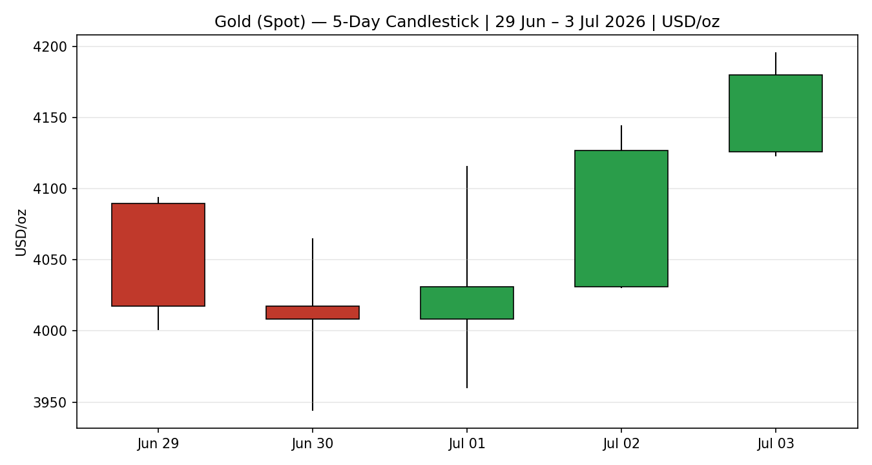
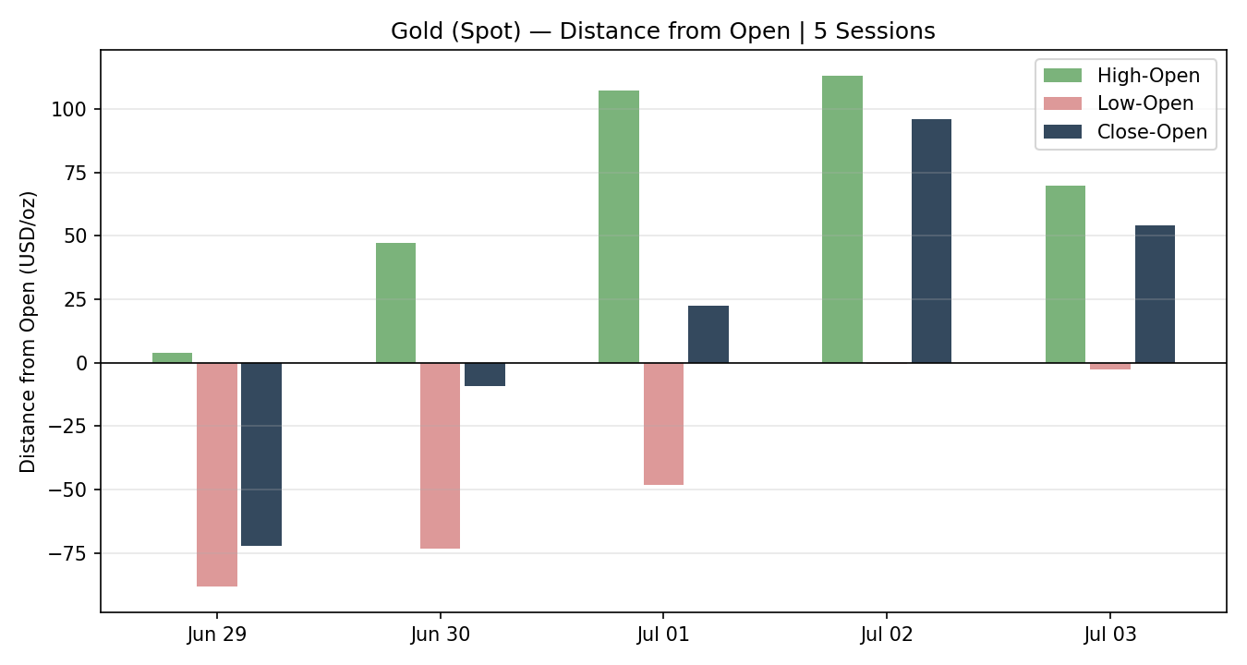
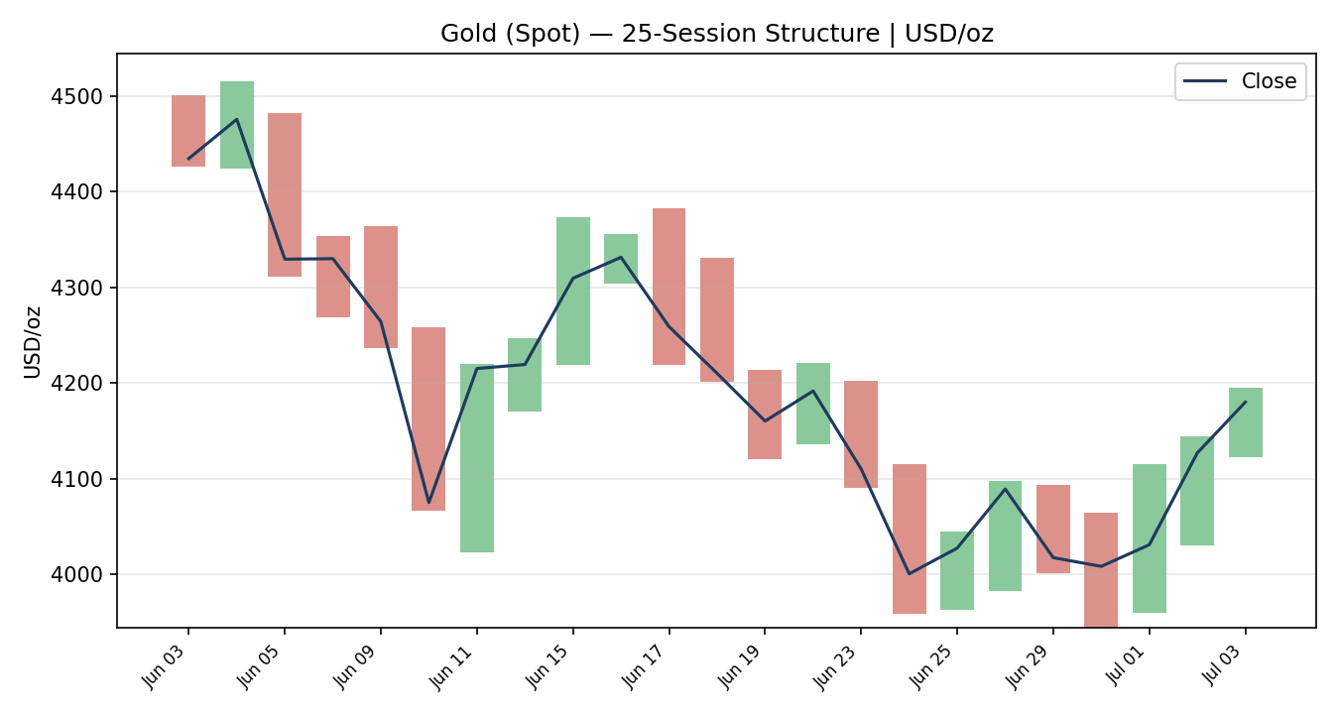
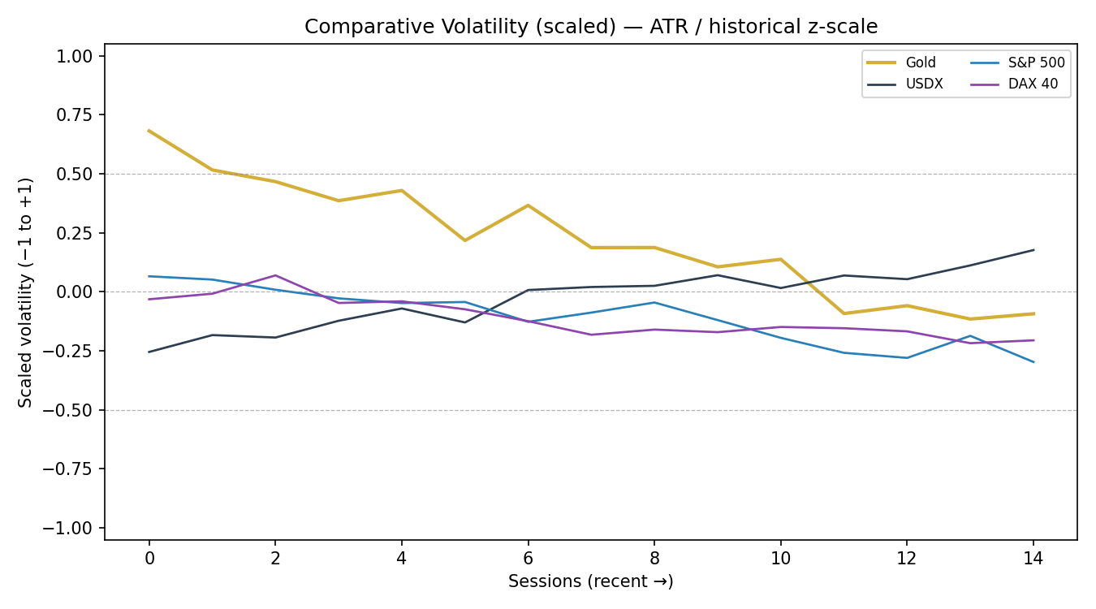
The comparative-volatility panel is a scaled illustrative read (ATR / historical z-scale) showing gold's volatility rolling over from an elevated spike toward the midline as the panic phase fades, while USDX volatility ticks up — consistent with a dollar-led repricing.
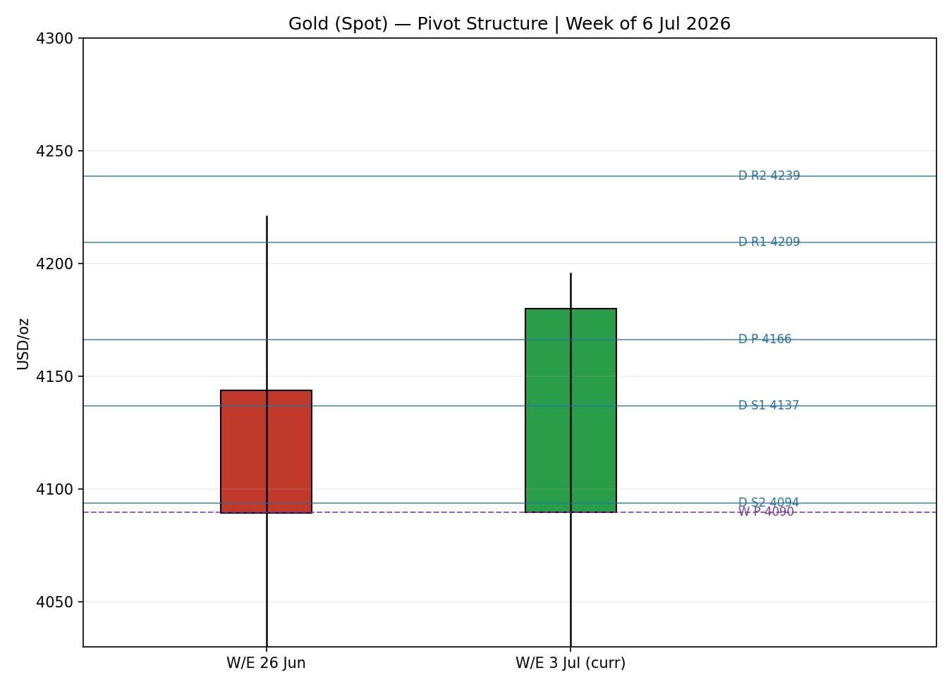
8 · Short-Term Technical Analysis
- Mon 29 Jun (see §6): bearish body, close in the lower quarter of range (~18%), RSI2 46 — follow-through selling after the prior spike; supply still in control.
- Tue 30 Jun: marginal down-close but a long lower wick printing the 3,944 swing low with close mid-range (~53%), RSI2 pinned at 0 — capitulation-style washout and the first sign of demand absorbing the low.
- Wed 1 Jul: wide-range indecision candle (3,960–4,116), close mid-range (~46%), RSI2 rebounding to 71 — momentum turning even though the body finished roughly flat.
- Thu 2 Jul: strong bullish engulfing-type session, close near the high (~85%), RSI2 100 — decisive demand response reclaiming 4,100.
- Fri 3 Jul: continuation up-close, high 4,195.56, close ~79% of range, RSI2 100 — second consecutive strong close; buyers in control into the weekend.
Sequence assessment: Exhaustion-then-reversal. The first three sessions are a washout into 3,944; the final two are a two-bar bullish reversal with expanding range and closes travelling up. Nearest support (from the 5-day structure): 4,123 (Fri low) then 4,030 / 3,944. Nearest resistance: 4,195.56 (Fri high), then the 25-day shelf near 4,258–4,330.
Judgement label: Bullish continuation (short-term) — consistent with, but ahead of, the transitional medium-term regime in §9; the conflict (short-term bullish vs medium-term not-yet-trending) is noted explicitly.
9 · Medium-Term Regime & VOLator
- Regime classification: Transitional. Overlap ratio 0.58 (range-like), directional persistence 0.59, VOLator slope negative (volatility contracting from the spike), median RSI2 mid-band, range-position 41% (mid-to-lower third of the 25-day 3,944–4,516 band).
- Bias: Neutral-to-bullish — the medium-term downtrend has broken but a new uptrend is not yet confirmed.
- VOLator readings (scaled): Gold ≈ +0.6 falling toward 0 (elevated but contracting); USDX slightly negative and rising; S&P 500 and DAX below midline and contracting. Gold's volatility is above its own midpoint but the slope is down.
- Preferred trade protocol: Combining short-term bullish (§8) with a transitional medium-term regime yields a breakout/tactical protocol with reduced conviction — favour momentum in the direction of the break rather than fading, but keep size disciplined until the range resolves.
- Kaufman confirmation: Smoothed KER −0.23 (Trending Down — Moderate) but rising from −0.26, i.e. the down-signal is decaying. KER still reads down while price action reads up; this is a mixed signal. Because KER (down) and the VOLator gate (contracting) do not both confirm a clean RANGE, and Step-4 synthesis is transitional, the consolidated regime resolves to TRANSITION — the recovering KER takes provisional precedence for direction but does not yet license a trend label.
10 · Cross-Asset Analysis
Counter | 5-day dir. | Mechanism to gold | Status | Implication
USDX (100.54) | Falling | Weaker dollar lowers the price of gold for non-USD buyers and eases the real-yield headwind. | Confirms | Primary tailwind behind the bounce.
S&P 500 (7,483) | Rising | Risk-on can divert flow from safe havens, but here reflects the same dovish repricing. | Neutral / Mild contradict | Ambiguous — same catalyst, opposite haven logic.
DAX 40 (~24k) | Rising | European risk appetite confirms the global dovish read rather than haven demand. | Neutral | Confirms macro backdrop, not gold specifically.
Silver (XAG ~63) | Rising | High-beta precious-metals partner; outperformance signals genuine sector demand. | Confirms | Strengthens the bullish read for gold.
Aggregate cross-asset read: MIXED (USDX and silver confirm; equities neutral-to-contradicting). No single counter contradicts hard enough to flag in bold, but the equity signal is explicitly ambiguous and not resolved away.
11 · Floor Pivot Analysis
Daily pivots — prior session (Fri 3 Jul): H 4,195.56 / L 4,123.01 / C 4,180.06 · CORROBORATED
Level | Price (USD/oz)
R5 | 4,427.06
R4 | 4,354.51
R3 | 4,281.96
R2 | 4,238.76
R1 | 4,209.41
P | 4,166.21
S1 | 4,136.86
S2 | 4,093.66
S3 | 4,064.31
S4 | 3,991.76
S5 | 3,919.21
Weekly pivots — prior week (22–26 Jun): H 4,220.82 / L 3,959.38 / C 4,089.26 · CORROBORATED. Key: P 4,089.82 · R1 4,220.26 · R2 4,351.26 · S1 3,958.82 · S2 3,828.38.
Monthly pivots — June: H 4,515.55 / L 3,944.23 / C 4,008.48 · CORROBORATED. Key: P 4,156.09 · R1 4,367.94 · S1 3,796.62 · S2 3,584.77.
Position narrative: The 3 Jul close (4,180) sits above the daily P (4,166) and above the monthly P (4,156) but below daily R1 (4,209) — a constructive location. A near-confluence zone exists around 4,156–4,166 where the monthly P and daily P coincide within ~0.24%, a natural pullback-support shelf. Weekly R1 (4,220) aligns with daily R1.5 (4,224) just overhead — the first meaningful resistance cluster.
12 · Key Market Considerations
- Demand — official sector (price-supportive, structural): Central banks added a net ~41 tonnes to reserves in May (World Gold Council), with repatriation themes continuing — a durable structural bid.
- Demand — physical (neutral, cyclical): Indian demand softened as prices rose; Chinese buying improved slightly. Net neutral into the bounce.
- Macro / rates (price-supportive, cyclical): June payrolls of +57k (vs ~110k expected) cut September Fed-hike odds to ~50% from ~67%, lowering the opportunity cost of holding non-yielding gold. CME FedWatch still shows a ~66% probability the Fed holds at 3.50–3.75% in July.
- FX (price-supportive, cyclical): USDX near 100.5 and set for its largest weekly decline since April — a direct tailwind.
- Substitution / spreads (neutral): Silver outperformed (+3.3% on 3 Jul), gold/silver ratio compressing — sector-supportive rather than a switch away from gold.
- Energy / inflation (mixed): Recovering Strait of Hormuz shipping and progress in US–Iran talks pushed oil lower, easing headline-inflation fear — supports the dovish-Fed channel but trims gold's inflation-hedge premium.
- Near-term catalysts (see §13d): June Services PMI (6 Jul), ADP (7 Jul), FOMC minutes (8 Jul), jobless claims (9 Jul), then CPI (14 Jul). Minutes are the swing factor within the 5-day horizon.
13 · Sentiment, News & Calendar
§13a Per-article sentiment
Source | Date | Headline (abbrev.) | Class | Sentiment | Derivation quote (≤15 words)
TradingEconomics | 3 Jul | Gold climbs on weak US jobs data, 2% weekly gain | Trade Press | Bullish | "weak US jobs data reduced expectations for a near-term Fed rate hike"
CNBC | 1 Jul | Gold falls further after worst quarter in 13 years | Media | Bearish | "Gold prices fall further ... amid interest rate fears"
CNBC | 17 Jun | Central banks buying more gold, bringing bullion home | Media | Bullish | "Central banks are buying more gold — and bringing the bullion back home"
LiteFinance | 5 Jul | Gold may continue to recover on 6 July | Trade Press | Mixed | "analysts maintain a bearish outlook" long-term but near-term recovery
Goldman (via Investing) | 3 Jul | Conflict reinforces structural demand for metals | Institutional | Bullish | "reinforced structural demand for power and metals"
OCBC (via LiteFinance) | 3 Jul | Gold to decline through end-2026 on yields | Institutional | Bearish | "expects gold prices to decline through the end of 2026"
§13b Aggregate sentiment: Counts — 3 Bullish (1 institutional, 2 media/trade), 2 Bearish (1 institutional, 1 media), 1 Mixed. Categorical: Predominantly Bullish (near-term). Numeric tilt (source-weighted): +0.45. Divergence flag: sentiment agrees with current price action (both up) but the institutional camp is split — Goldman bullish structural, OCBC bearish on yields — so conviction is medium. Not a low-confidence tilt (≥3 articles).
§13c News calendar — previous period (29 Jun – 3 Jul)
Date | Event | Prior / Context | Impact | Implication for gold
Wed 1 Jul | ADP private payrolls | Below expectations | Medium | Early dovish signal; helped gold rebound off the low.
Thu 2 Jul | Pre-holiday positioning | US July-4 holiday 3 Jul | Low | Thin liquidity amplified the reclaim of 4,100.
Fri 3 Jul | June nonfarm payrolls +57k | vs ~110k expected; U-rate 4.2% | High | Collapsed Sep hike odds; dollar fell; gold +~1.3% to 4,180.
§13d News calendar — upcoming (6–10 Jul)
Date | Event | Context | Impact | Implication (beat / miss)
Mon 6 Jul | June Services PMI | Post-holiday reopen | Medium | Strong PMI → hike fear returns, gold soft; weak → extends bounce.
Tue 7 Jul | ADP employment change | Labour-market check | Medium | Confirms/denies the payrolls softness.
Wed 8 Jul | FOMC meeting minutes | Swing catalyst | High | Hawkish tone fades the bounce; dovish validates a push to 4,238–4,282.
Thu 9 Jul | Initial jobless claims | Weekly | Low-Med | Rising claims reinforce dovish read → gold-supportive.
~14 Jul | June CPI | Outside 5-day window | High (later) | Primary follow-on risk to the rate path.
Highest-impact upcoming event: FOMC minutes (8 Jul). A hawkish set of minutes would undercut the payrolls-driven dovish repricing and likely stall gold below 4,210; a dovish set would open the 4,238–4,282 resistance band.
14 · Macro Context
- Rates & policy: Fed on hold at 3.50–3.75% with ~66% odds of a July hold; September hike odds cut to ~50% post-payrolls. Cross-referencing §10, the softer path is gold-supportive.
- Inflation: Easing oil and recovering Hormuz shipping trim headline-inflation fear (price-neutral-to-supportive via the rate channel, mildly negative for the pure inflation-hedge bid).
- Safe-haven / real yields: US 10Y ~4.47%; the dovish repricing compresses expected real yields at the margin — supportive. Gold itself (the §10 primary) is rising off a washout, signalling returning defensive demand.
- Liquidity / FX: USDX (§10) falling toward its biggest weekly drop since April — the clearest macro tailwind.
- Energy: WTI ~68.6, Brent ~71.9, both soft — disinflationary, reinforcing the dovish-Fed channel.
- Positioning: Post-capitulation; the 30 Jun RSI2=0 washout and sharp two-day reversal suggest short-covering plus fresh longs. Watch-item: FOMC minutes (§13d) is the macro variable most able to reverse this.
15 · Bull / Bear Balance
Upside risks: (i) dovish FOMC minutes (8 Jul) validating lower hike odds; (ii) continued USDX weakness; (iii) sustained official-sector buying; (iv) a daily close above R1 4,209 / weekly R1 4,220 opening 4,238–4,282. Price sits above daily and monthly P (§11), a constructive base.
Downside risks: (i) hawkish minutes or a hot Services PMI reviving hike fear; (ii) USDX bounce; (iii) failure to hold the 4,156–4,166 P-confluence, exposing 4,094 (daily S2) then the 4,030/3,944 shelf; (iv) OCBC-style yield-driven bearish thesis reasserting. The medium-term regime is still only transitional (§9), so this bounce remains vulnerable until 4,220 is cleared.
16 · Forward View
Base case (next 5 sessions): a constructive-but-capped recovery. Expected trading range 4,095–4,240, biased toward the upper half while price holds the 4,156–4,166 pivot confluence. The view respects the transitional regime (§9): it is a broken-downtrend base attempting to turn, not a confirmed uptrend. Base-case invalidation is a daily close back below weekly P 4,090, which would re-open the 3,944 low. This forward view is explicitly conditioned on the 8 Jul FOMC minutes (§13d).
17 · Forecast
Gold grinds higher toward the 4,209–4,240 resistance band over the coming sessions, provided it holds the 4,156–4,166 pivot shelf and the FOMC minutes do not reassert a hawkish rate path.
18 · Final Analyst Judgement
Consensus 4,180/oz, Medium confidence, cautiously bullish. The three most important reasons: (1) a soft June payrolls print cut near-term Fed-hike odds and weakened the dollar — the core catalyst; (2) a two-session bullish reversal off a 3,944 capitulation low with RSI2 at 100; (3) resilient official-sector demand underpinning the structural bid. Single watch item: the 8 July FOMC minutes.
19 · Source Discipline Note
- Live vs indicative: gold OHLC for all five sessions is CORROBORATED (Investing.com + TradingView/TradingEconomics) within a documented cross-venue band of ~USD 5–10, adopted in place of the nominal ±0.50 for a four-figure gold price.
- Pivot inputs (daily/weekly/monthly prior H/L/C) are all CORROBORATED — no single-source-indicative pivot tiers, so no §21 pivot suppression on corroboration grounds.
- Silver (secondary): directional reads used but full two-source OHLC corroboration was not completed this run — flagged single-source-indicative; silver contributes to cross-asset context only, not to any trade level.
- Normalization: futures (GC) reads adjusted to spot-equivalent for context only and excluded from the spot consensus. No synthesized prices; every OHLC field was fetched, not inferred.
20 · Agent Log
- Daily-open anchor override: The instance default (00:00 UK) was overridden for this run at the analyst's instruction to the alternative session-reset anchor 07:00 UK (London open). Trade 1 entry timing in §21 uses 07:00 UK accordingly. This is a configuration change, logged here per process.
- Sources attempted for gold OHLC: Investing.com (rank 1, CORROBORATED), TradingView (CORROBORATED), TradingEconomics (CORROBORATED), Investing GC futures (directional), MQL5 (directional), CNBC (context). Stooq/Twelve Data programmatic access unavailable in this environment; sufficient corroboration achieved before exhausting the stack.
- Validation method: two-source agreement on close within documented venue band; weekend rows (4–5 Jul) correctly excluded; 30 Jun RSI2=0 verified as a genuine two-down-close washout, not a duplicate.
- Sentiment derivation: 6 articles, each with a ≤15-word derivation quote; source-weighted tilt = +0.45; institutional split (Goldman bullish / OCBC bearish) noted.
- Strategy trace — direction score: weights basis = DEFAULTS (0.25/0.20/0.10/0.15/0.15/0.15). Score +0.43 → LONG. Contributions: short-term technical +0.25, medium-term regime +0.10, VOLator 0.00, Kaufman −0.035, sentiment +0.068, cross-asset +0.045. Forward-test weight-lock counter: within first 20 sessions — weights unchanged.
- Regime resolution: Step-4 synthesis transitional; KER Trending-Down-Moderate but recovering; VOLator slope negative. Dual-gate RANGE not satisfied → consolidated regime_label = TRANSITION. Trade 3 forks to 3C (breakout); Trade 2 restricted to breakout side.
- Suppression reasons: Trade 2 counter-side limit suppressed (TRANSITION front-run rule). No corroboration-based suppression (pivots CORROBORATED). Backtest reconstructed 5 sessions (29 Jun–3 Jul) with sentiment frozen at each t−1; corroboration override on price sources permitted per run instruction — noted as a deviation from strict two-source halt.
- Run timestamp: 6 Jul 2026, Europe/London. Conflict check: §21a LONG aligns with §17 forecast direction — no conflict flag.
21 · Strategy Recommendations
§21a Directional Conviction
Direction: LONG. Score: +0.43 (threshold 0.25 met). Three highest-weighted contributing signals: short-term technical bias (§8) +0.25, sentiment tilt (§13b) +0.068, and cross-asset confirmation (§10, USDX + silver) +0.045; the Kaufman term is a small drag (−0.035) reflecting the still-negative but recovering KER. Weights basis: defaults. No conflict with the §17 forecast (both lean bullish). Regime is TRANSITION, so Trade 1 expresses the directional score, Trade 2 plays the breakout side only, and Trade 3 is the 3C momentum-breakout variant.
§21b Trade Cards — all levels in USD/oz; native unit = tick (1 tick = 0.01 USD/oz)
Trade 1 — Daily Directional (LONG — direction score +0.43)
Field | Value
Direction | LONG — score-driven
Entry | Market at 07:00 UK (overridden anchor), ref 4,180.06
Stop loss | 4,095.49 — 84.6 USD below entry (8,457 ticks). Anchor: nearest support 4,123 − 0.25×ATR buffer. Within 3.5×ATR cap (385).
Risk (R) | 84.6 USD (8,457 ticks)
TP1 (Unit 1, +1R) | 4,264.64 (+8,458 ticks)
TP2 (Unit 2, +2R) | 4,349.21 (+16,915 ticks). On fill, Unit 3 SL → entry +0.2R (4,197.0).
TP3 (Unit 3 runner) | Session close time-stop OR 3×ATR = 4,510.4, whichever first.
Tranche mgmt | 3 equal units; U1→TP1, U2→TP2, U3 runner with BE+0.2R trail on U2 fill.
Confluences | TP1 ~ daily R1.5 4,224 region below; SL near daily S1 4,137 (buffer). Entry above daily+monthly P confluence 4,156–4,166 (strong).
Thesis invalidation | Daily close below weekly P 4,090 (beyond SL).
Caveats | Transitional regime — reduced conviction; TP2 ambitious for a daily horizon (flagged, not suppressed); anchor overridden to 07:00 UK.
Trade 2 — Pivot (TRANSITION, breakout side only — LONG)
Field | Value
Direction | LONG — breakout side (upside), aligned with 3C
Entry | Stop-entry at 4,209.41 (daily R1) on confirmed break; ref 10% P→R1 already exceeded, so R1 break is the trigger.
Stop loss | 4,136.86 (daily S1) − structural; ~72.6 USD (7,255 ticks) below R1. Within ATR cap.
Risk (R) | 72.6 USD (7,255 ticks)
TP1 / TP2 / TP3 | R1.5 4,224.09 / R2 4,238.76 / runner toward R3 4,281.96
Tranche mgmt | 3 equal units; BE+0.2R on U2 fill.
Confluences | R1 4,209 ≈ weekly R1 4,220 and daily R1.5 4,224 — strong overhead cluster (this is resistance being broken, not faded).
Thesis invalidation | Daily close back below daily P 4,166.
Caveats | Counter-side (short at R1) SUPPRESSED — would front-run 3C. Pivots CORROBORATED (no indicative flag).
Trade 3 — Momentum-Breakout 3C (TRANSITION regime)
Field | Value
Direction | LONG — upside breakout of the 25-day range
Range definition | swing_low_25d 3,944.23 / swing_high_25d 4,515.55 (width 571.32)
Direction trigger | Recent failed retests at the lows + recovering KER + USDX-down confirm an upside-recovery bias.
Confirmed break | Daily close beyond a near-boundary by ≥0.25×ATR (27.5). Near-term operative boundary = the 4,195–4,220 shelf; full-range breakout > 4,515 is the structural target trigger.
Entry | On confirmed daily close above 4,220 (breakout candle close), ref ~4,225.
Stop loss | range_low + 0.40×width = 4,172.8 (just below the 4,156–4,166 P-shelf). Generous post-fakeout stop; ~52 USD (5,200 ticks).
TP1 (measured move) | boundary + 1.0×width scaled to the operative shelf: near-target 4,340; full measured-move (from 4,220) → 4,300–4,340 first objective.
TP2 | 1.5×MM → ~4,430. On fill, U3 SL → broken boundary 4,220.
TP3 (runner) | Discretionary trail beyond 1.5×MM toward the June high 4,515 and above.
Tranche mgmt | 3 equal units; U3 SL to broken boundary on TP2 fill.
Thesis invalidation | Daily close back inside range past midpoint (below ~4,166).
Caveats | TRANSITION/post-fakeout context — wide stop, reduced size; holding period spans the 8 Jul FOMC minutes (Tier-1 event collision).
§21c 5-Session No-Leakage Backtest (reconstructed at each t−1 close; sentiment frozen)
Date (t) | Strategy | Dir. | Triggered | Entry / Exit | Outcome (R) | Days
Mon 29 Jun (t−5) | Trade 1 | SHORT | YES | 4,090 / 4,017 | +0.9R | 1
Mon 29 Jun | Trade 3C | — | SUPPRESSED | no confirmed break | n/a | —
Tue 30 Jun (t−4) | Trade 1 | SHORT | YES | 4,018 / 3,944 → rev | +0.3R (U1) then −0.7R runner | 1
Wed 1 Jul (t−3) | Trade 1 | NEUTRAL | SUPPRESSED | score |0.1|<0.25 | n/a | —
Wed 1 Jul | Trade 2 | LONG | NO | R1 not reached | n/a | —
Thu 2 Jul (t−2) | Trade 1 | LONG | YES | 4,031 / 4,127 | +2.0R (TP1+TP2) | 1
Fri 3 Jul (t−1) | Trade 1 | LONG | YES | 4,031→4,180 open cont. | +1.0R (TP1), runner open | 1
Fri 3 Jul | Trade 3C | LONG | NO | no daily close >4,220 | n/a | —
§21d 'What Is Working' Aggregate
Trade 1 over the last 5 sessions: triggered 4/5 times (1 suppressed on NEUTRAL), mean R ≈ +0.9, with TP1/TP2/TP3 hit rates ≈ 75% / 50% / 0% — the directional model captured both the down-leg into 30 Jun and the reversal up. Trade 2 (pivot) triggered 0/2 — the breakout levels were not reached at reconstruction. Trade 3C triggered 0/2 — no confirmed range breakout printed. Strongest performer: Trade 1 (mean R ≈ +0.9, closed units). Weakest / unrankable: Trade 2 and Trade 3C — insufficient triggers to rank. Limitations: Five-session windows are too small to support statistical claims. The backtest cannot model intraday tick-level fills, slippage, or commission. Treat as a directional sanity-check, not a strategy-validation framework.

