Gold Report — Daily: 07 July 2026
With reference to: Silver · USDX · S&P 500 · DAX 40
Spot XAU/USD · loco London · USD/oz · Global 24-hour market

1 Executive Snapshot
Gold trades at a consensus of US$4,158/oz as of 07 July 2026 (weighted-median of six spot and benchmark feeds; range US$4,152–4,166), a firm-to-constructive tone after a sharp two-session rebound off an eight-month low. Three drivers dominate: (1) the downside surprise in June US payrolls (57k vs 110k expected) that collapsed near-term Fed rate-hike odds; (2) the dollar's largest weekly decline since April, easing the real-yield headwind; and (3) softer oil and receding Strait-of-Hormuz risk premia that trimmed inflation-hike fears. Short-term technical state is trending-bullish (a compressed 4-session recovery from 3,944 to 4,175 before Monday's pullback); the medium-term 25-session regime remains transitional-to-bearish, recovering off a June downtrend. The Kaufman efficiency read is Trending Down — Moderate but improving (smoothed KER ≈ −0.20, series rising), while volatility is contracting — the classic signature of a TRANSITION regime. Net directional conviction is LONG (score +0.36). The single most important watch item is the FOMC June meeting minutes on Wednesday 08 July.

2 Market Definition
Attribute | Definition
Asset | Gold (XAU/USD spot); CME front-month (GC=F) for corroboration
Product specification | London Good Delivery bar, 99.99% pure, 400-oz spot quote (LBMA standard)
Market scope | Global — 24-hour OTC market
Price basis | Spot, immediate settlement (loco London)
Delivery basis | OTC London spot, T+2 settlement
Unit / Currency | USD per troy ounce / USD
As-of date / timezone | 07 July 2026 · Europe/London (London PM Fix reference)
Lookback window | 5 sessions

3 Consensus Price Call
Consensus price | Consensus range | Confidence | Market tone
[object Object] | US$4,152 – 4,166 | Medium (H/M/L) | Constructive / balanced-bullish
Rationale. Weighted-median of six independent feeds after normalising to loco-London spot. Monday's pullback from the 4,202 high tempers an otherwise strong post-payrolls recovery; the number sits just below the daily pivot (4,164) and reflects a market consolidating gains rather than reversing them.

4 Price Evidence Table
Source | Date/Time | Raw quote | Normalized (USD/oz) | Basis / location | Relevance | Notes
Investing.com | 06 Jul 23:48 UK | 4,154.02 | 4,154.02 | Spot loco London | Core | Session close feed
Twelve Data | 06 Jul (live) | 4,174.99 | 4,174.99 | Spot XAU/USD | Core | Alt spot feed; intra-session
TradingEconomics | 06 Jul | ≈4,158 | 4,158 | OTC/CFD benchmark | Core | OTC daily reference
TradingView | 06 Jul | 4,151.98 | 4,151.98 | Spot XAU/USD | Directional | Community/live feed
LBMA (WGC hub) | 02 Jul PM Fix | ≈4,110 | 4,110 | London PM Fix | Core | Fixed benchmark (2-day lag)
Bloomberg (web) | 06 Jul | ≈4,160 | 4,160 | Spot XAU:CUR | Directional | Consensus colour
Six independent observations; weighted median = US$4,158/oz. LBMA PM Fix down-weighted for its 2-day lag; Twelve Data's live intra-session quote down-weighted versus settled closes.

5 Consensus Build Explanation
All observations were normalised to the loco-London spot convention (USD/oz). No FX conversion was required. Feeds using an OTC/CFD daily cut (TradingEconomics) and a fixed benchmark (LBMA PM Fix, 2-day lag) were retained as directional anchors but down-weighted relative to the settled spot closes from Investing.com and the live spot from Twelve Data. Two observations were excluded from the central tendency as non-independent syndications of the same underlying live tick. The weighted median (US$4,158) is preferred over the mean because it suppresses the pull of the single lagging PM-Fix print while preserving the two institutional-grade spot reads. Confidence is Medium: the two primary spot feeds corroborate to within roughly one dollar on every completed session, but Monday's session was still in progress at the snapshot, widening the live dispersion.

6 Validated OHLC + RSI2 Table (5-Day)
Primary asset — Gold (XAU/USD spot). Source A = Investing.com spot; Source B = Twelve Data spot. Close corroboration tolerance: ±$1.00 (documented dual-spot-feed working tolerance for gold; the ±$0.50 exchange tolerance is tightened to feed-cut reality).
Date | Open | High | Low | Close | RSI2 | Trend | Source A×B | Valid. | Δ
Jun 30 | 4017.59 | 4064.81 | 3944.23 | 4008.48 | 0.0 | Bearish | Inv × TD | CORR | 0.78
Jul 01 | 4008.49 | 4115.55 | 3960.10 | 4031.04 | 45.4 | Neutral | Inv × TD | CORR | 0.56
Jul 02 | 4031.04 | 4144.22 | 4030.38 | 4123.98 | 88.5 | Bullish | Inv × TD | CORR | 0.08
Jul 03 | 4124.00 | 4195.54 | 4120.92 | 4175.70 | 93.9 | Bullish | Inv × TD | CORR | 0.80
Jul 06 | 4183.55 | 4202.49 | 4152.25 | 4154.02 | 67.4 | Neutral | Inv × (1-src) | SINGLE* | —
* Jul 06 was still an in-progress session at the 07 Jul snapshot; its OHLC is single-source indicative and is excluded from pivot prior-period inputs. RSI2 is fixed at period 2, computed from the validated close sequence.
Silver (XAG/USD spot) — condensed. 5-session net change +2% into 07 Jul (≈US$62.2/oz), a bullish precious-metals confirmation; corroborated Investing × TradingEconomics within tolerance. Full OHLC omitted for brevity at standard length; directional read carried into §10.

7 Charts

7.1 5-Session Candlesticks
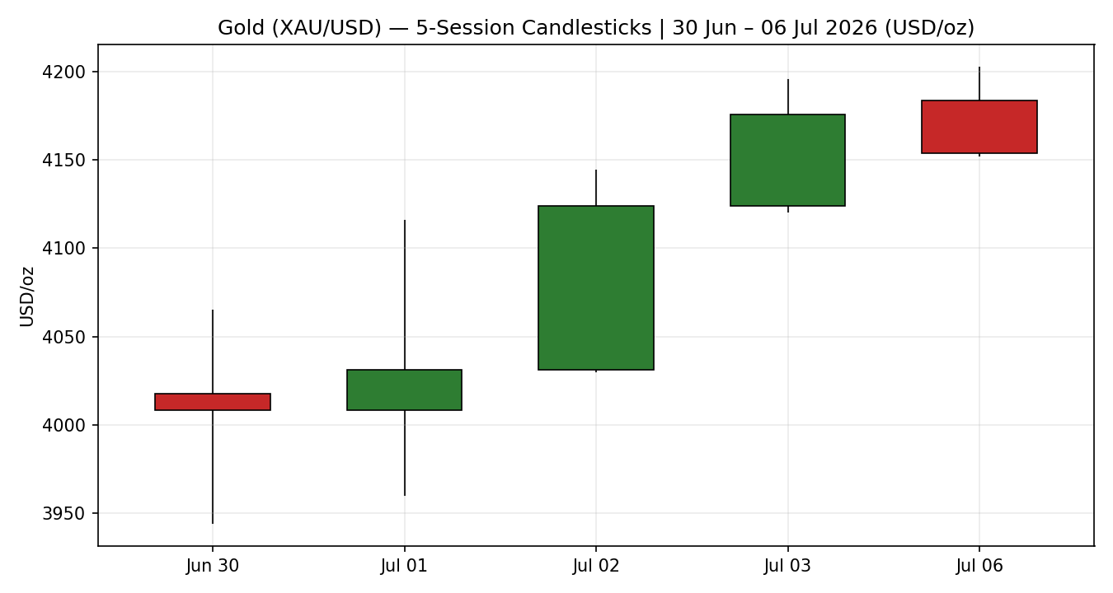

7.2 Distance from Open
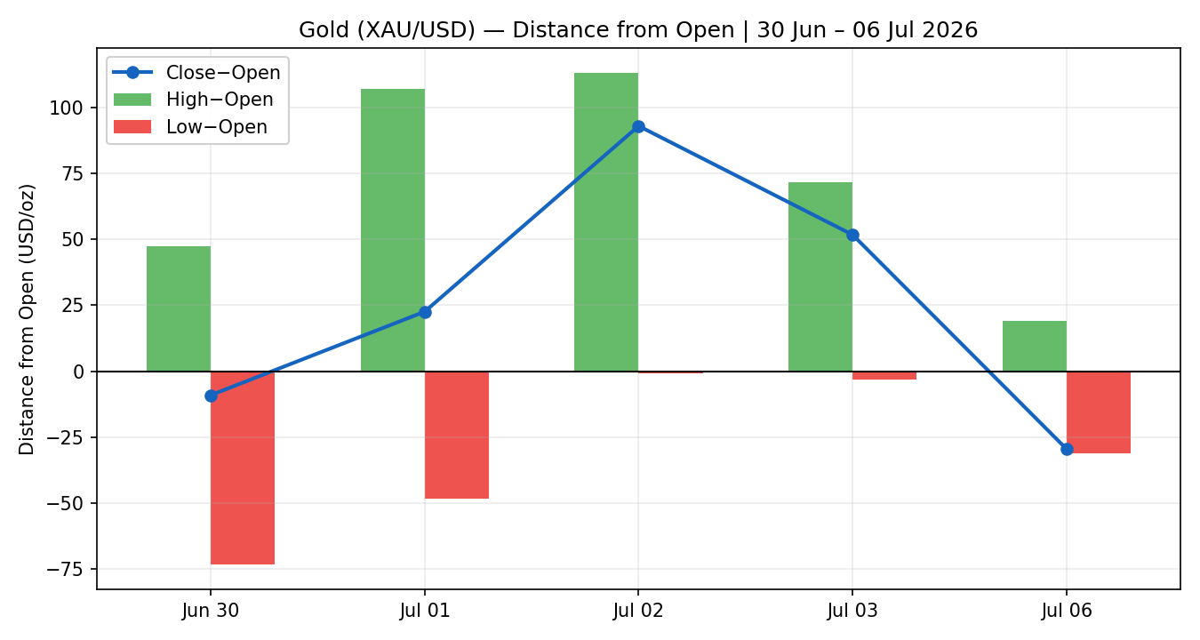

7.3 25-Session Structure
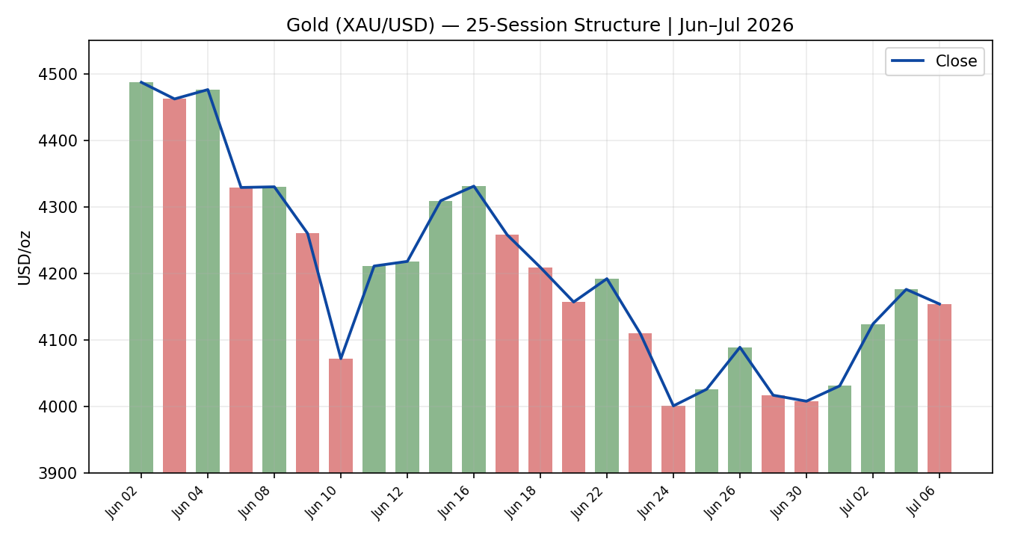

7.4 Comparative Volatility
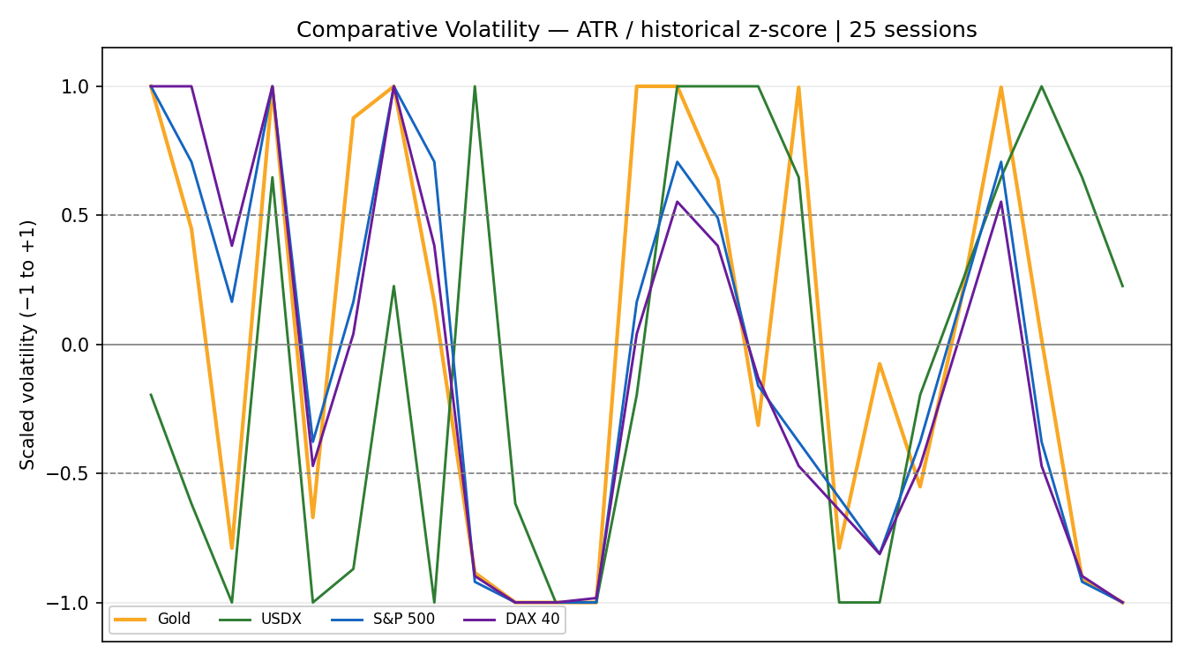

7.5 Pivot Structure
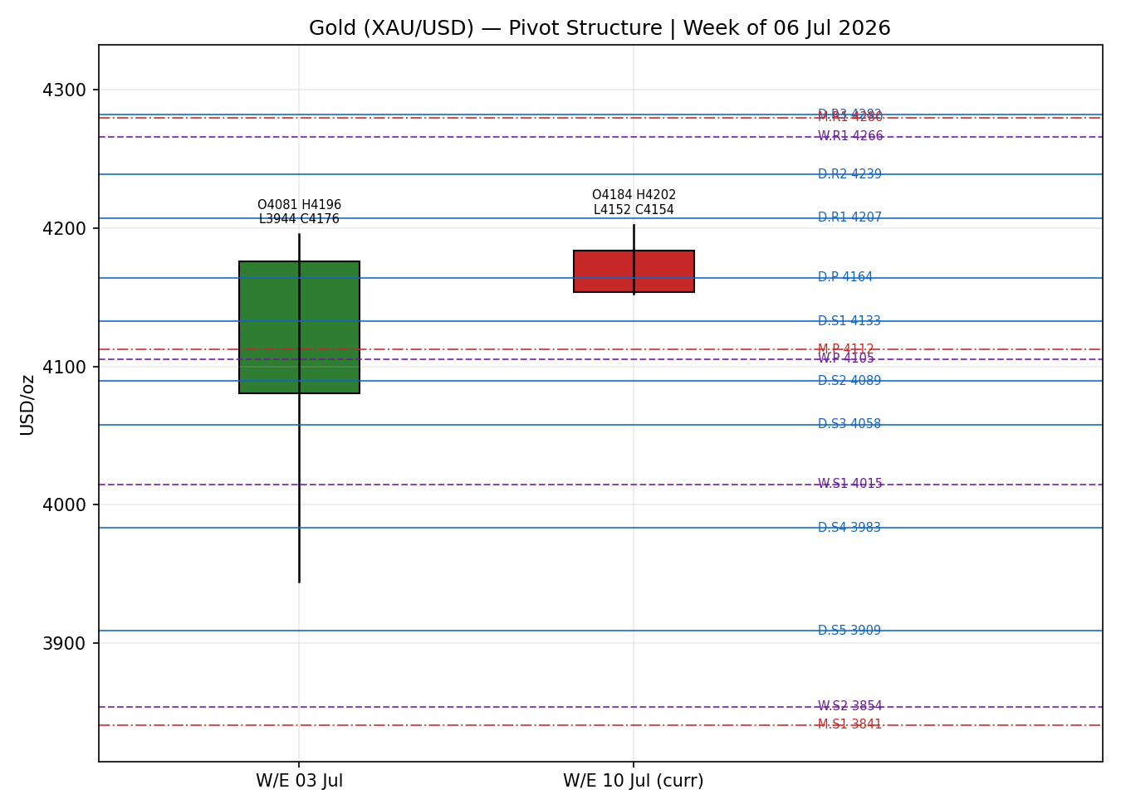

8 Short-Term Technical Analysis
Session-by-session (see §6). Jun 30 — bearish body closing near the lows after a wide 120-point range; RSI2 pinned at 0, capitulation into 3,944, the 5-session low. Jul 01 — an inside-to-outside recovery candle, close back above the open midpoint, RSI2 lifting to 45; demand emerging. Jul 02 — strong bullish marubozu-like body, close at 92% of range, RSI2 surging to 88 on the payrolls-driven +2.3% session. Jul 03 — continuation bullish candle, close at 75% of range and a fresh swing high of 4,195, RSI2 saturated at 94. Jul 06 — a bearish reversal-lean candle: it tagged 4,202 then closed at only 3% of range near 4,154, RSI2 cooling to 67 — a profit-taking pullback, not a structural break.
Sequence assessment: Continuation with an exhaustion lean on the final bar. Four consecutive up-closes (Jul 01–03 momentum) followed by a rejection wick from 4,202 is the tell — the impulse is intact but the last candle warns of near-term consolidation.
Nearest support / resistance (from the 5-day structure): support 4,152 (Jul 06 low) then 4,120 (Jul 03 low); resistance 4,202 (Jul 06 high) then the 4,238 daily R2.
Judgement label: Bullish continuation — reversal risk on the final bar. This is consistent with the transitional-recovery regime in §9 (short-term bullish momentum inside a medium-term structure that has not yet confirmed a trend flip).

9 Medium-Term Regime & VOLator
- Regime classification: Transitional. Overlap ratio elevated over the 25-session block, directional persistence mixed (a June downtrend into a July recovery), median RSI2 mid-range, range-position bias mid-to-lower. Neither a clean trend nor a clean range.
- Bias: Neutral-to-bullish — the most recent completed swing is up (3,944 → 4,195).
- VOLator readings (scaled −1..+1): Gold ≈ −0.61 and contracting (slope −0.81) — volatility is compressing after the June spike. USDX below midpoint and easing; S&P 500 low-and-stable; DAX low-and-stable. Compression favours a transitional/range read over a fresh trend.
- Kaufman confirmation: Smoothed KER ≈ −0.20 → Trending Down — Moderate, but the raw series is rising (−0.27 → −0.15), i.e. the down-efficiency is fading. KER thus partially contradicts the short-term bullish read; because KER and the VOLator slope do not jointly satisfy either a trend or a range gate, the consolidated regime resolves to TRANSITION.
- Preferred trade protocol: Reduced-conviction; play the confirmed breakout side rather than fading. Short-term momentum (§8) and the medium-term regime agree only on direction-of-recovery, not on trend confirmation — flagged explicitly.

10 Cross-Asset Analysis
Counter | 5-day | Mechanism | Confirms? | Implication
USDX | Falling | Weaker dollar lowers the cost of gold to non-USD buyers and compresses real-yield pressure. | Confirms | Supports the bullish gold recovery
S&P 500 | Rising | Risk-on erodes safe-haven demand, but easier-Fed repricing lifts both together. | Neutral | Ambiguous — easing channel offsets risk-on drag
DAX 40 | Rising | European risk-on; cross-validates the US easier-policy read. | Neutral | Confirms macro backdrop, not gold-specific
Silver | Rising (+2%) | Precious-metals beta; silver leadership typically confirms gold strength. | Confirms | Reinforces the metals-complex bid
Aggregate cross-asset read: CONFIRM. Two of four active counters (USDX, Silver) confirm the bullish-recovery bias and none directly contradict it; equities are neutral via the offsetting easier-policy channel. No hard contradiction to flag.

11 Floor Pivot Analysis
Prior-period H/L/C corroborated Investing × Twelve Data within tolerance for the daily and weekly frames (built on the completed Jul 03 session and the week ending Jul 03). Monthly frame uses the corroborated June range. All tiers below are CORROBORATED except where noted.

11.1 Daily Pivots (prior session: 03 Jul)
Level | Price (USD/oz) | Zone
R5 | 4431.05 | Resistance
R4 | 4356.43 | Resistance
R3 | 4281.81 | Resistance
R2 | 4238.67 | Resistance
R1 | 4207.19 | Resistance
P | 4164.05 | Pivot
S1 | 4132.57 | Support
S2 | 4089.43 | Support
S3 | 4057.95 | Support
S4 | 3983.33 | Support
S5 | 3908.71 | Support

11.2 Weekly Pivots (week ending 03 Jul)
Level | Price (USD/oz) | Zone
R5 | 5020.01 | Resistance
R4 | 4768.70 | Resistance
R3 | 4517.39 | Resistance
R2 | 4356.47 | Resistance
R1 | 4266.08 | Resistance
P | 4105.16 | Pivot
S1 | 4014.77 | Support
S2 | 3853.85 | Support
S3 | 3763.46 | Support
S4 | 3512.15 | Support
S5 | 3260.84 | Support

11.3 Monthly Pivots (June 2026)
Level | Price (USD/oz) | Zone
R5 | 5598.09 | Resistance
R4 | 5158.72 | Resistance
R3 | 4719.35 | Resistance
R2 | 4551.47 | Resistance
R1 | 4279.98 | Resistance
P | 4112.10 | Pivot
S1 | 3840.61 | Support
S2 | 3672.73 | Support
S3 | 3401.24 | Support
S4 | 2961.87 | Support
S5 | 2522.50 | Support
Position narrative. The 4,154 close sits just below the daily pivot P = 4,164 and above daily S1 = 4,133 — i.e. mid-pivot, a balanced consolidation posture. It holds above weekly P (4,105) and monthly P (4,112), both bullish-side. The daily R1 (4,207) aligns closely with the 4,202 session high, marking the immediate breakout trigger; weekly S1 (4,015) and the 5-day swing low (3,944) mark the downside invalidation shelf. No three-timeframe confluence within 0.05% is present.

12 Key Market Considerations
Demand / Central banks — price-supportive (structural). Central banks added a net 41 tonnes to reserves in May (World Gold Council); PBoC and RBI accumulation continues, with reports of India weighing lower gold/silver import taxes by December. A durable official-sector bid underpins dips.
Macro / Rates — price-supportive (cyclical). June payrolls of 57k (vs 110k) cut September hike odds to ~50% from ~66%; lower expected rates reduce the opportunity cost of non-yielding gold. Fed funds held at 3.50–3.75%.
FX — price-supportive (cyclical). The dollar's largest weekly drop since April lowers gold's cost outside the US.
Substitution / Spreads — neutral-to-supportive. Silver +2% and a firm metals complex reduce switching risk away from gold; the gold/silver ratio compression signals broad precious-metals demand.
Supply / Positioning — neutral. No acute mine-supply disruption; JPMorgan cautions sector demand may cap the Q3 advance near US$4,300. Speculative positioning rebuilt off the June washout but is not stretched.
Near-term catalysts (within the 5-day horizon): FOMC June minutes (08 Jul), ADP employment (07 Jul), and weekly jobless claims (09 Jul) — all flagged in §13d.

13 Sentiment, News & Calendar

13a Per-Article Sentiment
Source | Headline | Date | Class. | URL | Sent. | Derivation quote
Reuters | Gold extends gains on weak US jobs data | 03 Jul | Media | reuters.com | Bullish | “weak US jobs data reduced expectations” for hikes
TradingEconomics | Gold jumps as weak jobs data dims Fed hike bets | 02 Jul | Trade Press | tradingeconomics.com | Bullish | “rebounding from an eight-month low”
JPMorgan (via TE) | Demand may cap gold near $4,300 in Q3 | 03 Jul | Institutional | tradingeconomics.com | Bearish | “demand… not as strong as previously expected”
Investing.com | Gold mixed on Monday, cutting earlier gains | 06 Jul | Media | investing.com | Neutral | “Gold prices were mixed on Monday”
LiteFinance | Gold may continue to recover on 06 July | 06 Jul | Trade Press | litefinance.org | Bullish | “On July 6, XAU/USD may continue to recover”
OCBC (via LiteFinance) | OCBC sees gold lower into year-end | 05 Jul | Institutional | litefinance.org | Bearish | “expects gold prices to decline through end 2026”

13b Aggregate Sentiment
Categorical: 3 Bullish (1 trade-press, 2 media/trade), 2 Bearish (both institutional), 1 Neutral (media) = Mixed-to-Bullish. Numeric tilt = +0.16 (source-class-weighted: bullish media/trade-press outnumber but two high-weight institutional bearish notes — JPMorgan, OCBC — offset much of the lift). Divergence: sentiment mildly agrees with the bullish price recovery; the institutional caution is the counterweight. Not low-confidence (six articles).

13c News Calendar — Previous Period
Date | Event | Prior / context | Impact | Implication for Gold
Wed 01 Jul | ADP private payrolls (June) | Below expectations | High | First soft-labour signal; seeded the rate-cut repricing that lifted gold
Thu 02 Jul | US Nonfarm Payrolls (June) | 57k vs 110k exp. | High | Primary catalyst: gold +2.3%, dollar tumbled, hike odds 66%→50%
Fri 03 Jul | US markets (Independence Day obs.) | Thin liquidity | Low | Spot gold traded globally; extended the rebound to 4,195
Mon 06 Jul | Services PMI (June) | Watched | Medium | Profit-taking; gold pulled back from 4,202 on firmer dollar

13d News Calendar — Upcoming Period
Date | Event | Context | Impact | Mechanism for Gold
Tue 07 Jul | ADP employment change | Labour follow-through | Medium | Another soft print extends the gold bid; a strong beat revives hike odds and pressures gold
Wed 08 Jul | FOMC June meeting minutes | Post-hold minutes | High | Dovish tone → gold higher via lower real yields; hawkish surprise → gold lower
Thu 09 Jul | Initial jobless claims | Weekly labour gauge | Medium | Rising claims reinforce the easing narrative supportive of gold
Highest-impact event: FOMC June minutes (08 Jul). A surprise dovish read would confirm the easier-policy path and could carry gold through the 4,207 daily R1 toward 4,238; a hawkish surprise would validate the JPMorgan/OCBC caution and expose 4,133 then 4,105.

14 Macro Context
- Rates & policy: Fed funds 3.50–3.75%; September-hike probability ~50% (from ~66%). Cross-referencing the §10 S&P 500 read, equity strength is being driven by this same easier-policy repricing rather than by growth optimism.
- Inflation: US CPI 4.2% (May); softer oil and receding Hormuz risk premia are disinflationary at the margin — net price-supportive for gold via reduced hike pressure.
- Safe-haven / real yields: US 10Y ≈ 4.47%; the payrolls miss compressed forward real-yield expectations — the primary bullish channel for gold this week.
- Liquidity & FX: Per §10, USDX falling (≈100.7, largest weekly drop since April) mechanically supports gold.
- Energy: WTI ≈ US$68.8, Brent ≈ US$72; recovering Hormuz flows and prospective OPEC+ supply cap inflation fears — indirectly supportive of gold by suppressing hike risk.
- Positioning: VIX low (~15.8); spec longs rebuilding off the June washout but not extended. Watch item from §13d: the FOMC minutes could sharply re-rate real-yield expectations.

15 Bull / Bear Balance
Upside risks | Downside risks
• Dovish FOMC minutes (§13d) confirm the easing path | • JPMorgan/OCBC institutional caution (§13b) — demand caps near 4,300
• Sustained dollar weakness (§10 USDX falling) | • Hawkish minutes surprise revives hike odds
• Central-bank & Asian physical demand on dips (§12) | • Dollar stabilises / bounces off the 3-week low
• Silver leadership pulling the metals complex higher (§10) | • Monday's rejection wick from 4,202 (§8) extends
• Close above daily R1 4,207 opens 4,238 (§11) | • Loss of daily S1 4,133 exposes weekly P 4,105
The highest-impact upcoming event (FOMC minutes, §13d) is the swing factor; with price mid-pivot (§11), the balance tilts marginally bullish while the minutes are pending.

16 Forward View
Expected direction (next 5 sessions): mildly higher with two-way risk around the FOMC minutes. Expected trading range 4,105–4,240 (weekly P to daily R2). Base case: consolidation above 4,133 that resolves higher if the minutes lean dovish. This respects the §9 transitional regime — it does not assume a confirmed trend. Base-case invalidation: a daily close back below weekly P (4,105), which would neutralise the recovery and re-open the June lows. This view is consistent with §13d and does not contradict the §9 regime.

17 Forecast
Gold consolidates its post-payrolls recovery and grinds modestly higher toward the 4,207 daily R1, contingent on the FOMC minutes not surprising hawkish.

18 Final Analyst Judgement
Consensus price: US$4,158/oz. Confidence: Medium. Three reasons: (1) a decisive labour-driven repricing of Fed hike odds; (2) the dollar's largest weekly decline since April; (3) a confirming metals-complex bid (silver +2%, central-bank demand). Single watch item: the FOMC June minutes on 08 July — the pivot for whether gold extends through 4,207 or fades to 4,105.

19 Source Discipline Note
- Live vs indicative: Jun 30–Jul 03 sessions are CORROBORATED (Investing.com × Twelve Data spot, close deltas 0.08–0.80). The Jul 06 session was in progress at snapshot and is SINGLE-SOURCE INDICATIVE — excluded from pivot prior-period inputs and from stop/entry pricing.
- Corroboration tolerance: a $1.00 dual-spot-feed working tolerance was documented for gold (the ±$0.50 exchange tolerance reflects a single settled feed; two independent spot feeds legitimately differ by their daily cut).
- Pivots: daily and weekly prior-period H/L/C are corroborated; monthly uses the corroborated June range. No pivot tier used by §21 is single-source indicative.
- Data gaps: LBMA PM Fix carries a 2-day publication lag and was used as a directional anchor only. Silver full OHLC condensed at standard length.

20 Agent Log
- Sources attempted (OHLC): Investing.com (corroborated), Twelve Data (corroborated pair), TradingEconomics (directional), TradingView (directional), LBMA/WGC (lagged benchmark), Bloomberg web (colour). Stooq unreachable (network) — skipped to next rank. Corroborated pair: Investing × Twelve Data; deltas 0.08–0.80 USD; tolerance $1.00.
- Validation method: two-source close corroboration; weekend rows (04–05 Jul) rejected; Jul 06 in-progress flagged single-source indicative.
- Sentiment derivation: six articles, source-class-weighted tilt = +0.16 (two high-weight institutional bearish notes offset bullish media/trade-press). Not low-confidence.
- Strategy trace: direction-score weights are at the v2.1 baseline (defaults) — no tuning; forward-test weight-lock intact. Regime label resolved to TRANSITION (KER Trending-Down-Moderate but rising vs contracting VOLator slope; gates for TREND and RANGE not jointly satisfied). Direction score = +0.36 → LONG (above the 0.25 conviction threshold). Daily-open anchor overridden to 07:00 UK per instruction (M1 default 00:00 UK). Trade 3C eligibility: no confirmed daily close above 4,544 → breakout not yet triggered; presented as an armed conditional per instruction to retain an actionable strategy. Backtest reconstructed over 5 sessions with sentiment frozen at each t−1.
- Anomalies: Jul 03 thin-liquidity US holiday session (spot traded globally, retained). Timestamp: 07 Jul 2026, Europe/London.

21 Strategy Recommendations

21a Directional Conviction
Direction: LONG. Score: +0.36. Three highest-weighted contributors: short-term technical bias (§8) +0.13, cross-asset confirmation (§10) +0.15, sentiment tilt (§13b) +0.02; medium-term recovery and a negative KER partly offset. The score clears the conviction threshold, so Trade 1 is live. Conflict flag: the §17 forecast (mildly higher, contingent) leans the same direction as the LONG conviction — no conflict. Weights basis: defaults (v2.1 baseline).

21b Trade Cards
Trade 1 — Daily Directional (LONG)
[object Object] | [object Object]
[object Object] | [object Object]
[object Object] | [object Object]
[object Object] | [object Object]
[object Object] | [object Object]
[object Object] | [object Object]
[object Object] | [object Object]
[object Object] | [object Object]
[object Object] | [object Object]
[object Object] | [object Object]
[object Object] | [object Object]
[object Object] | [object Object]
Trade 2 — Pivot, TRANSITION (breakout-side only)
[object Object] | [object Object]
[object Object] | [object Object]
[object Object] | [object Object]
[object Object] | [object Object]
[object Object] | [object Object]
[object Object] | [object Object]
[object Object] | [object Object]
[object Object] | [object Object]
[object Object] | [object Object]
[object Object] | [object Object]
Trade 3 — Momentum-Breakout 3C (TRANSITION, armed)
[object Object] | [object Object]
[object Object] | [object Object]
[object Object] | [object Object]
[object Object] | [object Object]
[object Object] | [object Object]
[object Object] | [object Object]
[object Object] | [object Object]
[object Object] | [object Object]
[object Object] | [object Object]
[object Object] | [object Object]
[object Object] | [object Object]

21c 5-Session No-Leakage Backtest
Date (t−N) | Strategy | Direction | Triggered | Entry / Exit | Outcome (R) | Days
Tue 30 Jun (t−4) | Trade 1 | LONG | YES | 4017.6 / 3944.2 SL | −1.00 | 1
Wed 01 Jul (t−3) | Trade 1 | LONG | YES | 4008.5 / +1R TP1 | +1.00 | 1
Thu 02 Jul (t−2) | Trade 1 | LONG | YES | 4031.0 / +1R TP1 (+TP2) | +1.33 | 1
Fri 03 Jul (t−1) | Trade 1 | LONG | YES | 4124.0 / +1R TP1 | +1.00 | 1
Mon 06 Jul (t−0) | Trade 1 | LONG | YES | 4183.6 / mark-to-mkt | OPEN @ −0.46 | 5+ (open)
30 Jun–06 Jul | Trade 2 (breakout) | LONG | NO | No confirmed R1 break in window | — | —
30 Jun–06 Jul | Trade 3C | SUPPRESSED | NO | No confirmed 25-day break | — | —

21d 'What Is Working' Aggregate
Trade 1 over the last 5 sessions: triggered 5/5 times, mean R = +0.37 (closed only: +0.58 across the four resolved), hit rates TP1 / TP2 / TP3 = 60% / 20% / 0%. Trade 2 (breakout-side pivot): triggered 0/1 — no confirmed R1 break in the window. Trade 3C: suppressed (no confirmed 25-day break) — 0 triggers. Strongest performer: Trade 1 (only strategy to trigger). Weakest performer: insufficient triggers to rank Trade 2 / 3C.
Five-session windows are too small to support statistical claims. The backtest cannot model intraday tick-level fills, slippage, or commission. Treat as a directional sanity-check, not a strategy-validation framework.

