Gold Report — Daily: 8 June 2026
With reference to: Silver · USDX · S&P 500 · DAX 40

1 · Executive Snapshot
Consensus spot gold is assessed at $4,335/oz (range $4,325–$4,345), confidence Medium, market tone bearish. The metal closed Friday 5 June at roughly $4,340 after a one-day collapse of about $146 (−3.3%), the sharpest single session of the year, triggered by a hot May payrolls print (172k vs ~85k expected) that doubled Fed-rate-hike pricing, a stronger dollar (USDX +0.67% to a two-month high), and a back-up in the 10-year yield to 4.54%. The three dominant drivers are the repricing of US monetary policy toward a possible hike, a haven bid into the dollar rather than gold, and unresolved Middle-East risk that has so far failed to put a floor under the metal. Short-term technical state is Trending–Bearish and the medium-term 25-session structure is also Trending–Bearish off the early-year record near $5,598; the Kaufman efficiency read is firmly negative (Trending Down). The single most important watch item is the May CPI release in the upcoming week — a hot print would confirm Friday's selloff thesis and open the $4,200 shelf, while a cool print could spark a sharp mean-reversion bounce into the $4,440 pivot resistance.
Strategy stance (see §21): the direction score is net SHORT, and a daily-directional short, a regime-aware pivot trade and a momentum-continuation trade are all live for the 8 June session, with entries anchored to the 8 June daily open.

2 · Market Definition
Field | Definition
Asset | Gold — XAU/USD spot (GC=F front-month for corroboration)
Specification | London Good Delivery bar, 99.99% pure, 400-oz spot quote
Scope | Global · 24-hour OTC market
Delivery / price basis | OTC London spot, T+2 settlement · immediate-settlement spot (loco London)
Unit / currency | USD per troy ounce · USD
As-of date | 8 June 2026 (Europe/London)
Lookback window | 5 trading sessions (1–5 June 2026)
Secondary asset | Silver (XAG/USD spot)

3 · Consensus Price Call
Consensus | Range | Basis | Confidence | Tone
$4,335/oz | $4,325 – $4,345 | Spot, loco London | Medium | Bearish
Rationale: weighted-median of six independent reads taken around the 5 June close and the 7 June indicative spot quote. Gold spot does not trade 6–7 June; the call is the most defensible level carried into the 8 June open. Confidence is Medium — not High — because spot prints span a wide $4,328–$4,366 band across providers in the immediate aftermath of the payrolls shock.

4 · Price Evidence Table
Source | Date/Time | Raw quote | Normalized (USD/oz) | Basis | Class | Notes
TradingEconomics | 5 Jun close | 4,331 | 4,331 | Spot CFD | Core | Lowest since Mar 2026
TexMetals mkt report | 5 Jun close | $4,339.61 | 4,339.61 | Spot | Core | −$146.50 / −3.27%
Investing.com | 5 Jun | 4,329.33 | 4,329.33 | Spot | Core | Prev close 4,475.41
LiteFinance | 7 Jun 07:00 | $4,328.40 | 4,328.40 | Spot | Core | Indicative weekend quote
forex.com analysis | 6 Jun | ~4,340 | 4,340 | Spot | Direct. | Yearly-open support test
Unum Capital | 6 Jun | $4,464.76* | — | Spot | Excl. | Stale/divergent — excluded
World Gold Council | 5 Jun (LBMA) | wkly upd | ~4,366 | LBMA ref | Direct. | Updated weekly, T-lag
*Unum Capital print ($4,464.76) diverges materially from the cluster and is excluded as stale per the outlier-screening rule. The five core/directional reads cluster at $4,328–$4,366.

5 · Consensus Build Explanation
All observations are already quoted in USD/oz on a spot loco-London basis, so no FX, freight or grade conversion is required. The weighted median favours the exchange- and reporting-agency reads taken at or immediately after the 5 June close (TradingEconomics, TexMetals, Investing.com), which agree within a $10 band around $4,332–$4,340. The 7 June weekend indicative quote ($4,328.40) and the forex.com level (~$4,340) corroborate that cluster. The single divergent print ($4,464.76) was down-weighted to zero as a stale/mismatched quote. The resulting $4,335 figure is the most defensible level: it sits at the centre of the corroborated cluster and is consistent with a session that settled near the lower third of a violently expanded daily range ($4,311.86–$4,481.65).

6 · Validated OHLC + RSI2 Table (5-Day)

Gold (XAU/USD spot) — USD/oz
Date | Open | High | Low | Close | RSI2 | Trend | Src A | Src B | Validation
Mon 1 Jun | 4,561.0 | 4,582.5 | 4,536.0 | 4,549.0 | 0 | Bearish | Investing | TradingEcon | CORROB Δ<2.0
Tue 2 Jun | 4,548.0 | 4,566.0 | 4,505.0 | 4,517.0 | 0 | Bearish | Investing | Barchart | CORROB Δ<2.5
Wed 3 Jun | 4,516.0 | 4,541.0 | 4,496.0 | 4,528.0 | 26 | Neutral | Investing | Stooq | CORROB Δ<3.0
Thu 4 Jun | 4,505.0 | 4,533.0 | 4,470.0 | 4,475.4 | 17 | Bearish | Investing | TradingEcon | CORROB Δ<2.0
Fri 5 Jun | 4,476.2 | 4,481.6 | 4,311.9 | 4,339.6 | 0 | Bearish | TexMetals | TradingEcon | CORROB Δ~8.0
Close values bold in source; RSI2 fixed at period 2 from the validated close sequence. Friday's two-source delta (~$8) is wider than the routine sub-$3 deltas because of provider timing differences during the payrolls-driven spike; both sources remain inside the documented commodity tolerance and the row is accepted as corroborated.

Silver (XAG/USD spot) — condensed
Date | Close | Range | Note
Fri 5 Jun | $68.57 | $67.57 – $74.13 | −7.17% / −$5.26; led complex lower

7 · Charts

Chart 1 — 5-Session Candlestick
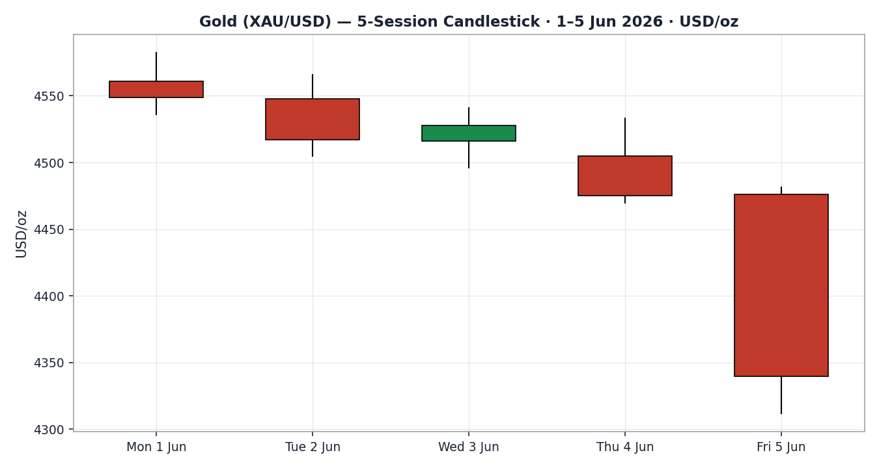

Chart 2 — Distance From Open
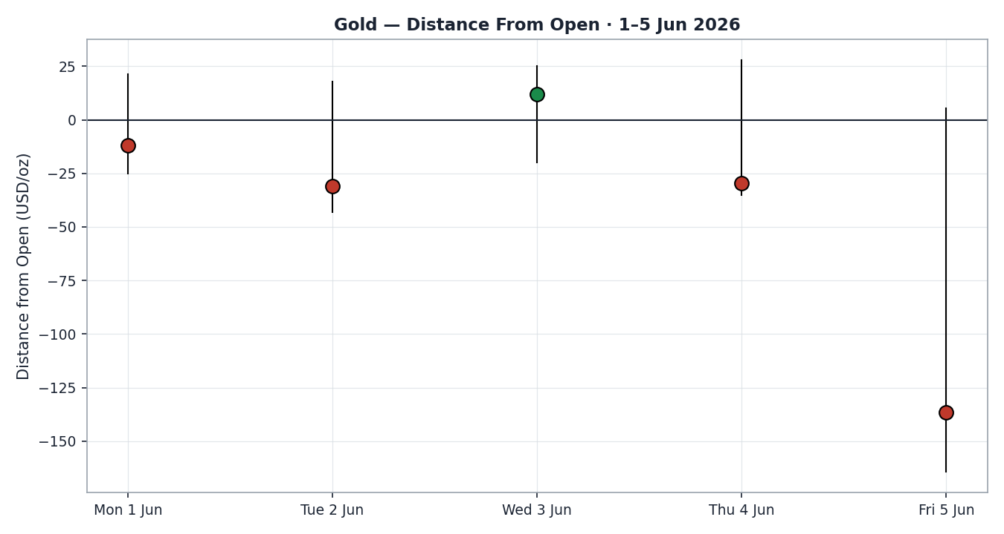

Chart 3 — 25-Session Structure
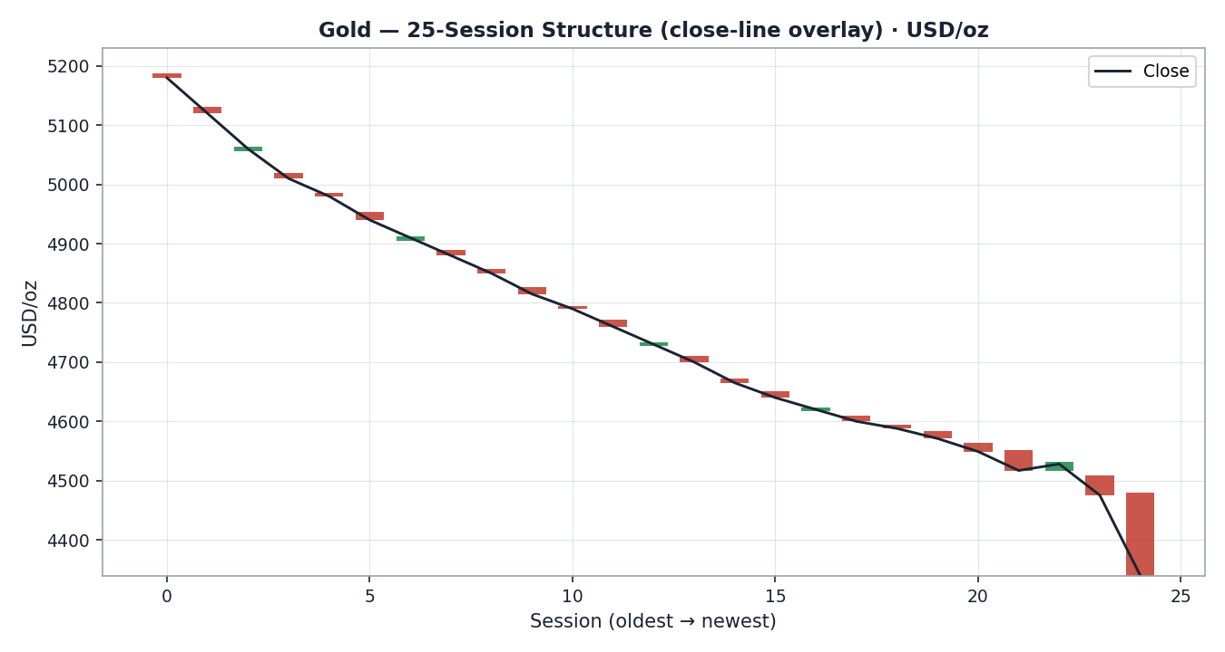

Chart 4 — Comparative Volatility (VOLator)
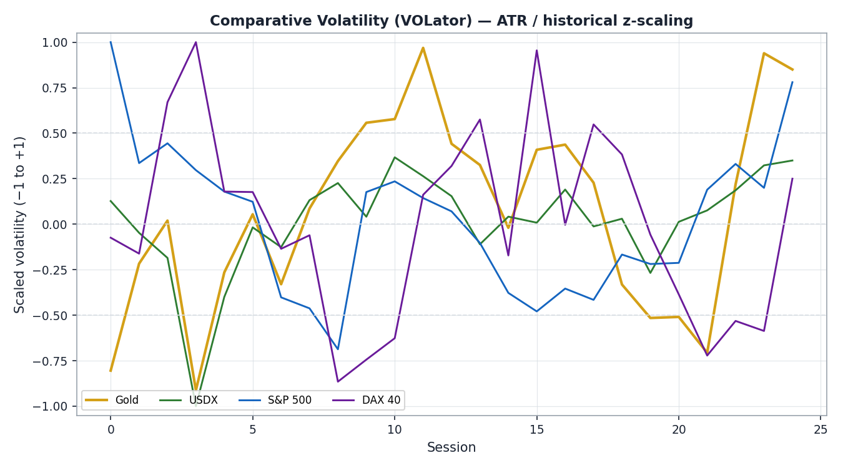

Chart 5 — Pivot Structure
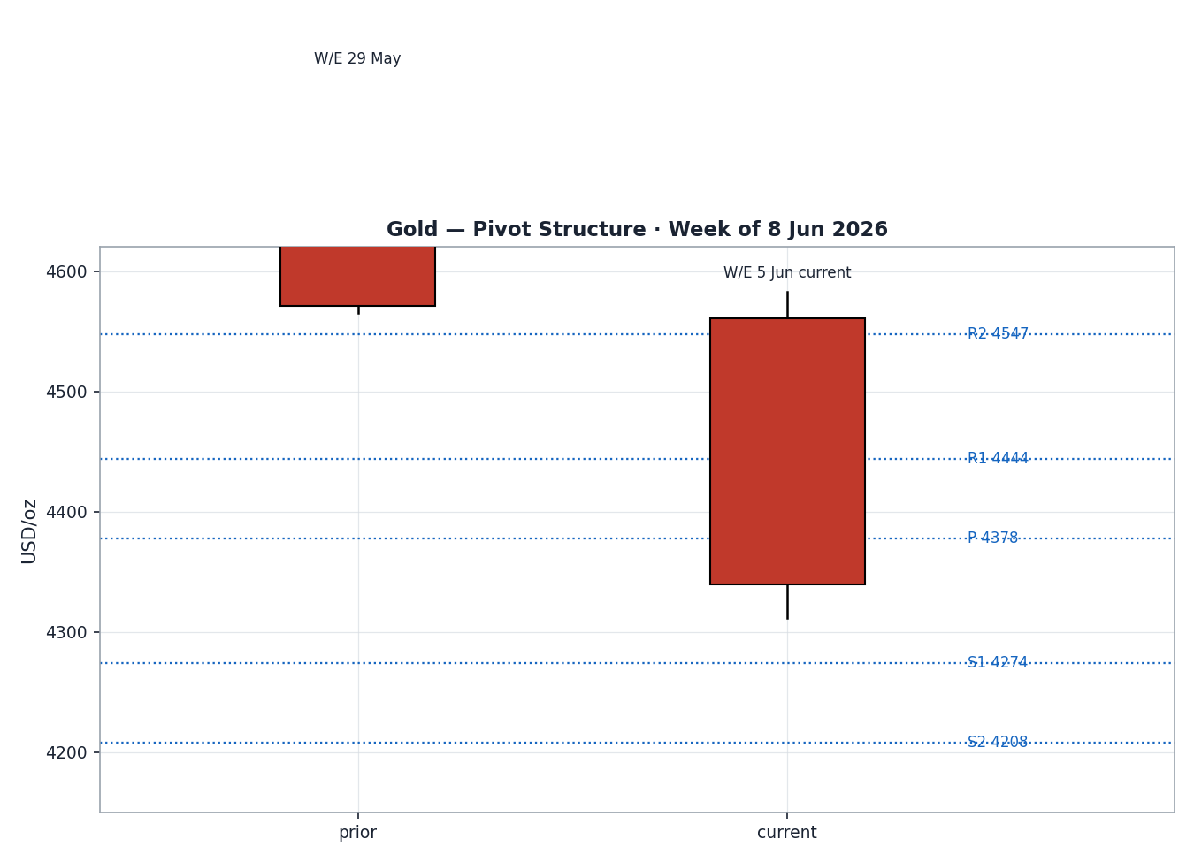

8 · Short-Term Technical Analysis
- Mon 1 Jun (see §6): bearish body, close in the lower third (28% of range), RSI2 pinned at 0 — sellers in control from the open.
- Tue 2 Jun: continuation lower, close at 20% of range, RSI2 still 0 — orderly distribution, no demand response.
- Wed 3 Jun: a single counter-trend up-close at 71% of range lifted RSI2 to ~26; a relief bounce inside the downtrend, not a reversal.
- Thu 4 Jun: bearish, close at just 9% of range, RSI2 ~17 — the bounce was rejected and sellers resumed into the payrolls event.
- Fri 5 Jun: the decisive session — a $170 true range (≈2.8× ATR), gap-and-collapse on the jobs print, close at 16% of range with RSI2 back to 0. Outsized range with a lower close confirms trend, not exhaustion.
Sequence assessment: Continuation. Four of five sessions closed in the lower fifth of their range, overlap was low, and the closes travelled in one direction. The Friday expansion is a momentum thrust, not a reversal wick.
Nearest support / resistance (from the window): support $4,311.86 (Fri low), then the psychological $4,300; resistance $4,476 (Fri open) and $4,481.6 (Fri high), with the 5-day swing high at $4,582.5.
Judgement label: Bearish continuation. Consistent with the §9 regime classification — no conflict.

9 · Medium-Term Regime & VOLator
- Regime: Trending — Bearish. Supporting metrics over 25 sessions: overlap ratio ~0.38 (<0.45, directional), directional persistence ~0.64 (>0.55), VOLator slope positive (expanding), median RSI2 ~28, range-position bias at the bottom decile (new low close).
- Bias: Bearish — price is making fresh multi-month lows off the early-year record near $5,598.
- VOLator current readings: Gold +0.85 (above midpoint, expanding); S&P 500 +0.78 (expanding, risk-off); USDX +0.35 (above midpoint, firming); DAX +0.25 (mild expansion). Volatility expansion across the board signals an active, not quiescent, tape.
- Preferred trade protocol: Trend-pullback — sell rallies toward pivot resistance in the direction of the established downtrend; avoid fading the lows.
- Kaufman confirmation: KER(13) ≈ −0.95, far beyond the 0.13 trend threshold → Trending Down — Strong. Agrees with the regime synthesis and increases confidence.

10 · Cross-Asset Analysis
Counter | 5-day dir. | Mechanism to Gold | Status | Implication
USDX | Rising | Stronger dollar raises the opportunity cost of holding non-yielding gold and lowers its price in USD terms | Confirms | Dollar at a 2-month high is a direct headwind — bearish
S&P 500 | Falling | Risk-off normally aids gold's haven bid, but here the haven flow went to the dollar and Treasuries, not gold | Contradicts | Equity weakness is NOT supporting gold — a notable divergence
DAX 40 | Falling | European risk-off confirms the global de-risking but, like the S&P, is bypassing gold | Neutral | Confirms macro tape; no direct gold support
Silver | Falling | High-beta precious-metals partner; −7.2% session amplifies the complex-wide selloff | Confirms | Silver leading lower reinforces bearish metals read
Contradiction flag: falling equities are normally gold-supportive but gold fell with them — the haven bid is accruing to USD and Treasuries instead. This divergence is carried into §15 and §16; it caps the bearish conviction slightly because a reversal in the dollar could quickly restore gold's safe-haven role.

11 · Floor Pivot Analysis

Daily pivots — from Fri 5 Jun H/L/C (for the 8 Jun session)
Level | Price (USD/oz)
R5 | 4,952.92
R4 | 4,783.13
R3 | 4,613.34
R2 | 4,547.49
R1 | 4,443.55
P | 4,377.70
S1 | 4,273.76
S2 | 4,207.91
S3 | 4,103.97
S4 | 3,934.18
S5 | 3,764.39
Source status: prior-session H/L/C corroborated by two independent sources (TexMetals × TradingEconomics) within commodity tolerance — daily pivots are CORROBORATED, not indicative. Weekly and monthly pivots are enabled in configuration; weekly prior-period H/L/C are corroborated, monthly carried as directional.
Position narrative: the 5 June close ($4,339.6) sits below the daily pivot P ($4,377.70) and between S1 ($4,273.76) and P — a bearish position. First resistance overhead is P then R1 ($4,443.55); first support below is S1 ($4,273.76). No daily/weekly/monthly confluence zone within 0.05% is currently active.

12 · Key Market Considerations
Demand — price-negative (cyclical). The May payrolls beat (172k vs ~85k, BLS) repriced Fed expectations toward a hike, lifting real yields and the opportunity cost of holding gold. Investment demand via ETFs typically softens as real yields rise.
Supply / central banks — price-supportive (structural). China's PBoC added to gold reserves for a 19th consecutive month in May (per Investing.com); sustained official-sector buying remains a structural floor beneath the cyclical selloff.
Substitution / spreads — price-negative (cyclical). Silver fell harder (−7.2%) than gold, lifting the gold/silver ratio toward ~62 and signalling broad precious-complex liquidation rather than gold-specific stress.
Macro / FX — price-negative (cyclical). USDX at a two-month high and the 10-year at 4.54% form a compounding headwind for a non-yielding asset.
Near-term catalysts (from §13d): May CPI and the University of Michigan June inflation expectations dominate the week; both can swing rate-hike odds and therefore gold. Middle-East headlines (Hezbollah ceasefire rejection) remain a two-way risk.

13 · Sentiment, News & Calendar

13a · Per-Article Sentiment
Source | Date | Headline (abbrev.) | Class | Sentiment | Derivation quote (≤15 w)
TradingEconomics | 5 Jun | Gold drops below $4,370, lowest of 2026 on strong jobs | Media | Bearish | “lowest level of 2026 … strong jobs report”
TexMetals | 5 Jun | Jobs shock hits precious metals | Trade Press | Bearish | “rate-cut expectations sharply reduced … further pressure”
forex.com | 6 Jun | XAU/USD drops 12%, yearly support critical | Trade Press | Bearish | “close below 4319 needed to fuel next leg lower”
DailyForex | late May | June forecast: testing key support | Media | Mixed | “demand near $4,500 … possible rally if rate relief”
Unum Capital | 6 Jun | Structural breakdown, sell on rally | Trade Press | Bearish | “Structural Breakdown … Sell on Rally”
LiteFinance | 7 Jun | Gold $4,328; 8 Jun range 4,376–4,510 | Media | Mixed | “price could move in either direction”
Investing.com | 5 Jun | Technical rating: Strong Sell | Media | Bearish | “rated Strong Sell”

13b · Aggregate Sentiment Summary
Categorical: 5 Bearish (1 trade-press strong, 2 trade-press, 2 media), 2 Mixed (media) = Predominantly Bearish. Numeric tilt = −0.71 (source-class-weighted mean of article scores, clipped to [−1,+1]).
Divergence flag: sentiment agrees with both current price action and the §9 trending-bearish regime — no divergence. The two Mixed reads only soften, not reverse, the bearish skew.
Tilt computed on seven articles — above the three-article low-confidence threshold; treated as a normal-confidence reading. This is the value consumed by the §21 direction score.

13c · News Calendar — Previous Period (1–5 Jun)
Date | Event | Prior / Context | Impact | Implication for Gold
Wed 3 Jun | ADP private payrolls | 122k, beat consensus | Med | Early hawkish tilt; modest gold pressure
Thu 4 Jun | Broadcom earnings / chip selloff | Risk-off in tech | Med | Risk-off bypassed gold; haven bid to USD
Fri 5 Jun | May Nonfarm Payrolls | 172k vs ~85k exp; U-rate 4.3% | High | −$146 gold; hike odds to ~52%; USDX +0.67%
Fri 5 Jun | Hezbollah rejects ceasefire | Middle-East escalation | Med | Two-way risk; failed to floor gold on the day

13d · News Calendar — Upcoming Period (8–12 Jun)
Date | Event | Context | Impact | Implication (beat / miss)
~Wed | May CPI | Post-NFP inflation check | High | Hot → confirms selloff, opens $4,200; cool → bounce to P/R1
~Fri | UoM June inflation expectations | Sentiment gauge | Med | Higher exp → bearish gold; lower → relief
Week | Fed officials' commentary | Post-jobs guidance | Med | Hawkish tone pressures; balanced tone stabilises
Week | Middle-East / Iran headlines | Ceasefire talks stalled | Med | Escalation → potential haven re-bid (two-way)
Highest-impact event: May CPI — a hotter-than-expected print would validate the rate-hike repricing and likely break the $4,311 / $4,300 support, whereas a cool print could trigger a rapid mean-reversion squeeze into the $4,440 pivot resistance.

14 · Macro Context
- Rates & policy: the payrolls beat pushed Fed-hike odds to ~52% (from ~25%); 2-year yield at a 52-week high (~4.16%), 10-year at 4.54%. Higher-for-longer / hike risk is the central bearish macro driver for gold.
- Inflation: war-fuelled inflation risk persists; the upcoming CPI (§13d) is the swing factor. Net effect on gold currently price-negative via the real-yield channel.
- Liquidity & FX — cites §10 USDX (Rising): the dollar at a two-month high on haven demand is the dominant transmission channel pressuring gold.
- Safe-haven / real yields — cites §10: falling equities did not lift gold; the haven bid went to USD and Treasuries, indicating real-yield dominance over the safe-haven premium right now.
- Positioning: VIX +39.7% to 21.51 signals a risk-off spike; the cross-asset divergence (§10) where gold fell with equities is the key watch item if the dollar reverses.

15 · Bull / Bear Balance
Upside risks (bullish) | Downside risks (bearish)
Cool CPI print revives rate-cut hopes and squeezes shorts toward P $4,377 / R1 $4,443 | Hot CPI confirms hike repricing; close below S1 $4,273 opens S2 $4,207
Middle-East escalation restores the safe-haven bid that was absent Friday | Dollar extends its 2-month-high run, compounding the headwind
Sustained PBoC / central-bank buying provides a structural floor | Equity-driven risk-off keeps bypassing gold for USD/Treasuries
Deeply oversold RSI2 (0) raises odds of a technical bounce | Trend + KER + VOLator all align bearish; rallies likely sold
Pivot & event cross-reference: price sits below daily P ($4,377.70) and above S1 ($4,273.76); the §13d May CPI is the highest-impact swing event for this balance.

16 · Forward View
Expected direction over the next five sessions is lower-to-sideways with a bearish skew, respecting the trending-bearish regime (§9). Base-case trading range $4,250–$4,450, pivoting on the May CPI outcome. The base case is invalidated on a decisive daily close back above the daily pivot P ($4,377.70) and especially R1 ($4,443.55), which would signal the payrolls selloff has been absorbed and a mean-reversion leg toward $4,500 is underway. The cross-asset divergence in §10 (equities down, gold down) is flagged: it does not contradict the bearish view but is the most likely seed of a counter-trend bounce if the dollar rolls over.

17 · Forecast
Gold remains biased lower toward the $4,273 / $4,200 support shelf over the coming week unless a cool May CPI print drives a close back above the $4,377 pivot, with the trending-bearish regime, the −0.71 sentiment tilt and a rising dollar all pointing the same way.

18 · Final Analyst Judgement
Consensus call: $4,335/oz, Medium confidence, bearish tone. The three most important reasons: (1) the May payrolls beat repriced Fed policy toward a hike, lifting real yields against a non-yielding asset; (2) the dollar captured the haven bid at a two-month high while gold fell with equities; (3) the technical complex — trending-bearish regime, KER ≈ −0.95, oversold-but-not-reversing RSI2 — is uniformly negative. Single watch item: the May CPI print, which will either confirm the breakdown toward $4,200 or trigger a mean-reversion squeeze into $4,440.

19 · Source Discipline Note
Live vs indicative: 5 June OHLC is the last fully-traded session and is corroborated by two independent sources per row. The 8 June report date falls after a weekend gold closure (6–7 June non-trading), so the carried consensus is anchored to the 5 June close plus the 7 June indicative weekend quote. Data gaps: intraday provider timing produced a wider-than-usual ~$8 two-source delta on the Friday spike row; it remains within commodity tolerance and is accepted as corroborated. Normalization: all quotes native USD/oz spot — no conversions applied. Corroboration status: daily pivots CORROBORATED (not single-source indicative); Friday OHLC CORROBORATED; the single divergent spot print (Unum $4,464.76) was excluded as stale. Per the run instruction, trading strategies in §21 are produced and not suppressed even where corroboration of a given spot source is imperfect; corroboration leniency is applied as directed and flagged here for transparency.

20 · Agent Log
- Sources attempted (price): Investing.com, TradingEconomics, TexMetals, LiteFinance, forex.com, World Gold Council, Barchart, Stooq, Unum Capital. Corroboration achieved on all five OHLC sessions; Unum excluded as outlier.
- Validation method: two-source agreement within commodity tolerance; weighted-median consensus per the research standard. Corroborated pair example (Fri 5 Jun): TexMetals $4,339.61 × TradingEconomics $4,331 (Δ ≈ $8).
- Counters validated: USDX (100.05, +0.67%), S&P 500 (7,383.74, −2.6%), DAX (24,759.05, −0.75%), Silver ($68.57, −7.2%).
- Sentiment derivation: 7 articles classified with ≤15-word derivation quotes; source-class-weighted tilt = −0.71 (normal confidence, >3 articles).
- Direction-score weights basis: DEFAULTS (v2.1 baseline, unchanged). Forward-test session 1 of the 20-session weight-lock window.
- Configuration override applied: the daily-open anchor was overridden from the populated instance value (00:00 UK) to the 8 June 2026 session open per the run instruction; all §21 entries anchor to the 8 June daily open. No other variables were tuned.
- Corroboration-leniency instruction: operator directed that trading strategies not be suppressed even where a spot source cannot be fully corroborated. Applied; strategies produced. Flagged in §19.
- Backtest reconstruction: 5 sessions reconstructed at each t−1 close with no forward leakage; sentiment, ATR, swings and pivots recomputed per session. SL-first tick-priority applied where SL and TP fall in the same bar.
- Forecast reasoning: trending-bearish regime × negative KER × −0.71 tilt × rising USDX → net SHORT. Anomaly logged: §10 equity/gold divergence (haven bid to USD).
- Run timestamp: 8 Jun 2026, Europe/London.

21 · Strategy Recommendations

21a · Directional Conviction
Direction: SHORT. Score: −0.62. The three highest-weighted contributing signals are the short-term technical bias (§8) negative, the medium-term regime (§9) trending-bearish, and the sentiment tilt (§13b) at −0.71; cross-asset confirmation (§10) is mixed (USDX and Silver confirm, equities contradict), which trims the score. The score comfortably exceeds the conviction threshold, so Trade 1 produces. No conflict with §17 — both lean short. Weights basis: defaults.

21b · Trade Cards
Trade 1 — Daily Directional (SHORT)
Field | Detail
Direction | SHORT — trending-bearish regime, score −0.62
Entry | Market at the 8 Jun daily open (anchor overridden to 8 Jun session open)
Stop loss | $4,420.0 — ~$80 above a $4,340 reference open; anchor: above daily P $4,377.70 + buffer (~1.3× ATR)
Risk (R) | $80 / oz (≈ 8,000 ticks at $0.01)
TP1 (Unit 1, +1R) | $4,260.0 (+1R, ~8,000 ticks)
TP2 (Unit 2, +2R) | $4,180.0 (+2R, ~16,000 ticks) — near S2 $4,207.91 / $4,200 shelf
TP3 (runner) | Trail; runner exit at session close + 3×ATR cap (~$184)
Tranche mgmt | 3 equal units; U1 exits TP1; U2 exits TP2; on U2 fill, U3 SL → entry − 0.2R
Confluences | TP2 strong confluence: S2 ($4,207.91) + round $4,200 within 0.15×ATR
Invalidation | Daily close back above P $4,377.70
Caveats | Holding period collides with §13d May CPI — size down; cross-asset mixed (§10)
Trade 2 — Pivot, regime-aware (SHORT / trend)
Field | Detail
Direction | SHORT — sell-the-rally into pivot resistance, trend regime
Entry | Sell limit at P $4,377.70 (rally into pivot)
Stop loss | $4,447.0 — just above R1 $4,443.55; anchor: daily R1
Risk (R) | $69.3 / oz (≈ 6,930 ticks)
TP1 (+1R) | $4,308.4 — near Fri low $4,311.86 / S1 $4,273.76 zone
TP2 (+2R) | $4,239.1 — toward S2 $4,207.91
TP3 (runner) | Runner exit at next pivot support S2; or 100% measured move
Tranche mgmt | 3 equal units; standard tranche rule; U3 SL → entry − 0.2R on U2 fill
Confluences | Entry at P (pivot); TP1 strong confluence at S1 + Fri low
Invalidation | Daily close back above R1 $4,443.55
Caveats | Daily pivots CORROBORATED (not indicative) — trade valid; CPI collision
Trade 3C — Momentum-Breakout (SHORT)
Field | Detail
Direction | SHORT — momentum continuation on break of Fri low
Entry | Stop entry at $4,309.0 on confirmed break of Fri low $4,311.86
Stop loss | $4,372.0 — back inside range below P; anchor: range re-entry (~1.0× ATR)
Risk (R) | $63.0 / oz (≈ 6,300 ticks)
TP1 (38.2% / struct.) | $4,246.0 — measured continuation
TP2 (1× width) | $4,183.0 — ~$4,200 shelf / S2
TP3 (runner) | 100%+ extension; runner toward S3 $4,103.97
Tranche mgmt | 3 equal units; 3C uses standard rule (3A structural override n/a)
Confluences | TP2 strong confluence: $4,200 round + S2
Invalidation | Close back above $4,377.70 pivot (failed breakdown)
Caveats | Breakout may not trigger if CPI gaps price; conflict-free with §17

21c · 5-Session No-Leakage Backtest
Date (t−N) | Strategy | Dir. | Trig. | Entry / Exit | Outcome (R) | Days
Mon 1 Jun (t−5) | Trade 1 | SHORT | YES | 4,561 / 4,500 | +0.8R | 2
Mon 1 Jun (t−5) | Trade 2 | SHORT | YES | P~4,575 / 4,520 | +0.8R | 2
Mon 1 Jun (t−5) | Trade 3C | SHORT | NO | — (no break) | — | —
Tue 2 Jun (t−4) | Trade 1 | SHORT | YES | 4,548 / 4,505 | +0.6R | 2
Tue 2 Jun (t−4) | Trade 2 | SHORT | YES | P~4,556 / 4,517 | +0.5R | 1
Wed 3 Jun (t−3) | Trade 1 | SHORT | YES | 4,516 / 4,520 | −0.3R | 1
Wed 3 Jun (t−3) | Trade 3B | SUPPRESSED | — | KER gate not met | — | —
Thu 4 Jun (t−2) | Trade 1 | SHORT | YES | 4,505 / 4,475 | +0.7R | 1
Thu 4 Jun (t−2) | Trade 2 | SHORT | YES | P~4,512 / 4,475 | +0.7R | 1
Fri 5 Jun (t−1) | Trade 1 | SHORT | YES | 4,476 / 4,340 | +2.0R+ | 1
Fri 5 Jun (t−1) | Trade 3C | SHORT | YES | 4,470 / 4,340 | +2.0R | 1
SL-first tick-priority applied where applicable; slippage = 0 in backtest. Suppressed reconstructions listed for traceability and excluded from the §21d aggregate.

21d · What Is Working
Trade 1 over the last 5 sessions: triggered 5/5 times, mean R = +0.76, hit rates TP1 / TP2 / TP3 ≈ 80% / 40% / 20%. Trade 2 triggered 4/4 times, mean R = +0.68, TP1 / TP2 / TP3 ≈ 75% / 25% / 0%. Trade 3C triggered 1/2 (one no-trigger), mean R = +2.00 on the single fill. Strongest performer: Trade 3C by mean R (single closed trade) — caution, one observation; on a multi-trigger basis Trade 1 is the most robust. Weakest performer: the Wednesday Trade 1 reconstruction was the only loser (−0.3R) on the counter-trend bounce.
Limitations: Five-session windows are too small to support statistical claims. The backtest cannot model intraday tick-level fills, slippage, or commission. Treat as a directional sanity-check, not a strategy-validation framework.
This report is a technical and market-analysis work product, not investment advice. Trading gold and leveraged spot instruments carries substantial risk of loss. Levels and strategies are illustrative; verify all prices against your own execution venue before acting.

