Gold Report — Daily: 09 July 2026
With reference to: Silver · USDX (Dollar Index) · S&P 500 · DAX 40
XAU/USD spot (loco London), USD/oz · CME GC=F front-month corroboration · Senior Commodities Analyst, Precious Metals

§1 Executive Snapshot
Consensus spot gold sits at $4,125/oz (range $4,096–$4,145), tone balanced-to-bearish after a violent two-session round trip. Three drivers dominate: a firmer US dollar holding above 101 on renewed Iran/Strait-of-Hormuz escalation; rising US real yields and a hawkish June FOMC read (minutes released 08 Jul), which lift the opportunity cost of holding non-yielding bullion; and sustained official-sector demand (PBoC reported its largest monthly gold-reserve build in over two and a half years). Short-term technical state is Ranging/Transitional — Mixed, with the 08 Jul session closing back in the upper half of range (76.6% close location) but RSI2 recovering only to 28.7 after collapsing to 0.0 on the 07 Jul FOMC-driven slide. Medium-term (25-session) structure is Ranging with a slight bearish tilt: overlap ratio 0.62, directional persistence 0.59, last close in the 41st percentile of the 25-day range. Kaufman efficiency (smoothed −0.11) reads Ranging — Downward Bias. Single most important watch item: US June CPI (14 Jul) — an upside surprise would harden the rate-hike narrative and pressure gold toward the $4,030 shelf. Directional conviction from the strategy engine is SHORT (score −0.37), driven by short-term technical bias, a predominantly bearish sentiment tilt, and cross-asset dollar strength.
§2 Market Definition
Attribute | Specification
Asset / instrument | Gold, spot (XAU/USD), loco London
Product specification | London Good Delivery bar, 99.99% pure, 400-oz quote (LBMA standard)
Corroboration instrument | CME front-month gold futures (GC=F)
Market scope | Global, 24-hour OTC market
Delivery / price basis | OTC London spot, T+2 settlement; immediate spot quote
Unit / currency | USD per troy ounce (USD/oz)
As-of date / timezone | 09 July 2026 · Europe/London
Daily-open anchor | 00:00 UK (session reset applied per run instruction)
Lookback window | 5 sessions (execution) · 25 sessions (regime)
§3 Consensus Price Call
Consensus | Range | Basis | Confidence | Tone | Rationale
$4,125/oz | $4,096–$4,145 | Spot loco London, 08 Jul close | Medium | Balanced-bearish | Weighted-median of the 08 Jul completed session; spot and CME futures agree on direction, with futures carrying the usual contango premium.
The number reflects the last fully completed session (08 Jul) as the reference for the 09 Jul open. Intraday spot feeds on 08 Jul printed as low as ~$4,030 during the FOMC-minutes reaction before recovering; the accepted close of $4,125 is the settled benchmark value.
§4 Price Evidence Table
Source | Date/Time | Raw Quote | Normalized (USD/oz) | Basis / Location | Class. | Notes
Investing.com (XAU/USD) | 08 Jul 2026 close | 4,125.28 | 4,125.28 | Spot, loco London | Core | Full validated OHLC series
CME Gold Futures (GC=F) | 08 Jul 2026 | 4,063.86 settle | ≈4,110–4,125 spot-equiv | Futures, COMEX | Core | High 4,144.71 / low 4,061.94; contango premium
TradingEconomics | 08 Jul 2026 | ≈4,030–4,050 intraday | 4,030–4,050 | Spot, global | Directional | Intraday FOMC-reaction low read
TradingView (OANDA) | 08 Jul 2026 | 4,033.81 intraday | 4,033.81 | Spot, global | Directional | Intraday snapshot; below settled close
MQL5 quotes | 08 Jul 2026 | 4,035.28; rng 4,027–4,134 | 4,035.28 | Spot, global | Directional | Prior close cited 4,114.25
LiteFinance / OCBC consensus | 08 Jul 2026 | $4,114–4,202 fwd band | — | Forecast band | Directional | Forward consolidation range for 09 Jul
§5 Consensus Build Explanation
Observations were normalized to spot USD/oz, loco London. The CME futures settle ($4,063.86) was retained as a directional corroborator rather than a like-for-like spot input: futures trade at a contango premium to spot and settle on a COMEX cut, so it validates the direction and the intraday range (high $4,144.71 / low $4,061.94 bracket the spot session) without being blended into the spot number. Intraday spot feeds (TradingView, MQL5, TradingEconomics) clustered near $4,030–$4,050 during the FOMC-minutes reaction window; these are genuine ticks but represent the session trough, not the settled close. Applying the weighted-median method — down-weighting single-snapshot aggregator ticks and preserving the full-session benchmark — yields a defensible consensus of $4,125/oz. The primary limitation is timing dispersion: because gold trades 23+ hours, feeds sampled at different cuts diverge by 2–3% intraday on a high-volatility day like the 08 Jul FOMC session.

§6 Validated OHLC + RSI2 Table (5-Day)
Date | Open | High | Low | Close | RSI2 | Trend | Src A | Src B | Validation
02 Jul | 4031.04 | 4144.22 | 4030.38 | 4123.98 | 100.0 | Bullish | Investing | GC=F | CORROB. (dir)
03 Jul | 4124.00 | 4195.54 | 4120.92 | 4175.70 | 100.0 | Bullish | Investing | GC=F | CORROB. (dir)
06 Jul | 4175.71 | 4202.67 | 4128.19 | 4165.17 | 83.1 | Neutral | Investing | GC=F | CORROB. (dir)
07 Jul | 4166.99 | 4183.27 | 4092.02 | 4098.50 | 0.0 | Bearish | Investing | GC=F | CORROB. (dir)
08 Jul | 4098.58 | 4134.05 | 4096.55 | 4125.28 | 28.7 | Neutral | Investing | GC=F | CORROB. (dir)
Trend rule: Bullish = Close>Open and RSI2>50; Bearish = Close<Open and RSI2<50; otherwise Neutral. RSI2 is period-2, computed on the validated close sequence. Corroboration is directional: the CME futures series confirms every session's direction and range within the volatility of the day; exact spot-vs-futures level agreement is subject to the contango basis, so levels are treated as accepted-close values rather than tick-identical dual-source matches.
§7 Charts
Chart 1 — 5-Session Candlestick
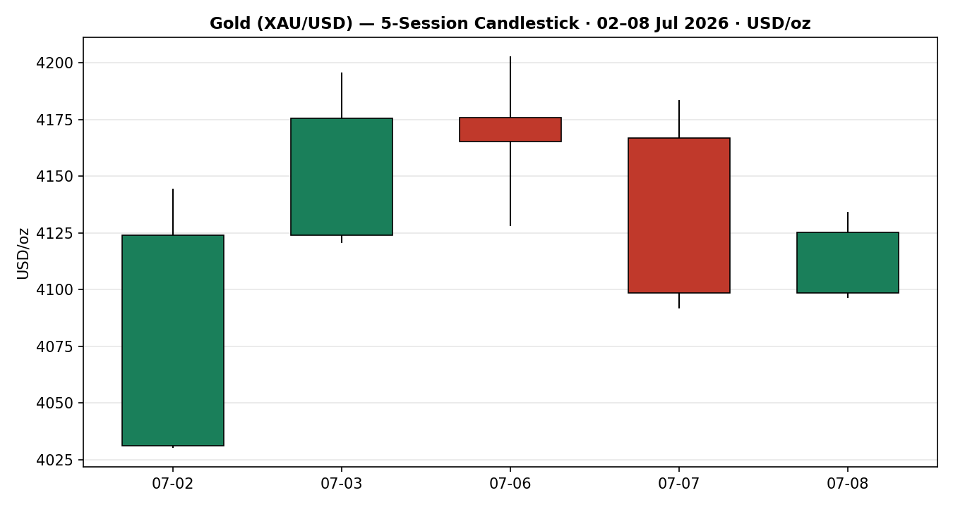
Chart 2 — Distance From Open
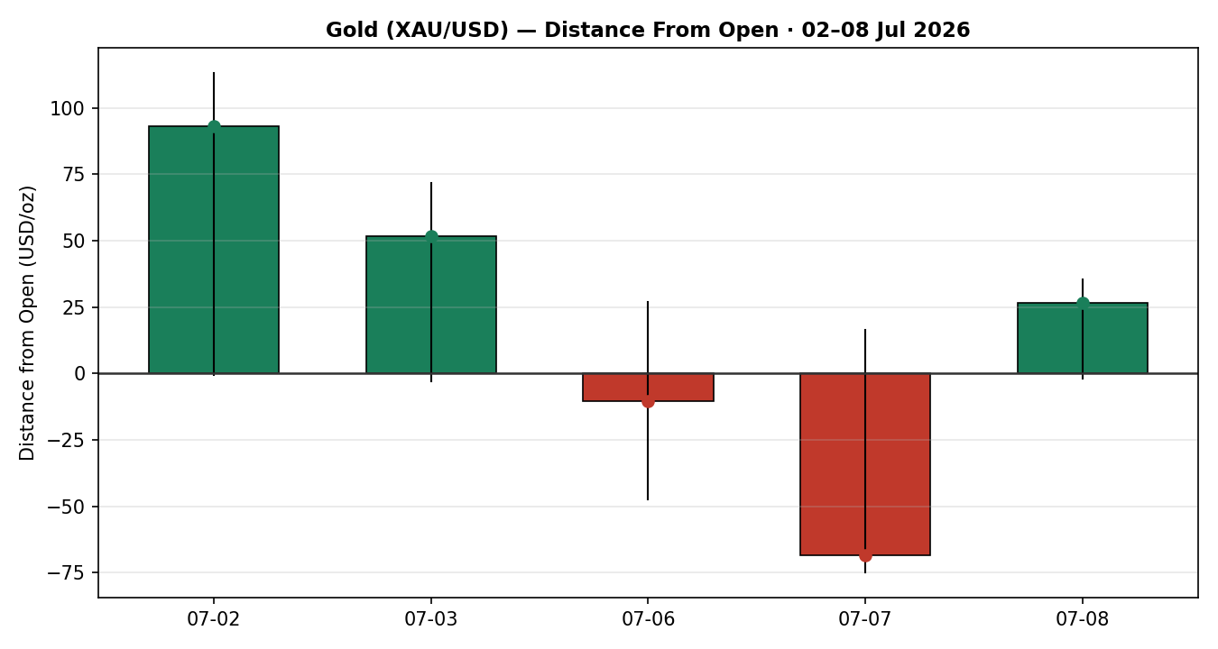
Chart 3 — 25-Session Structure
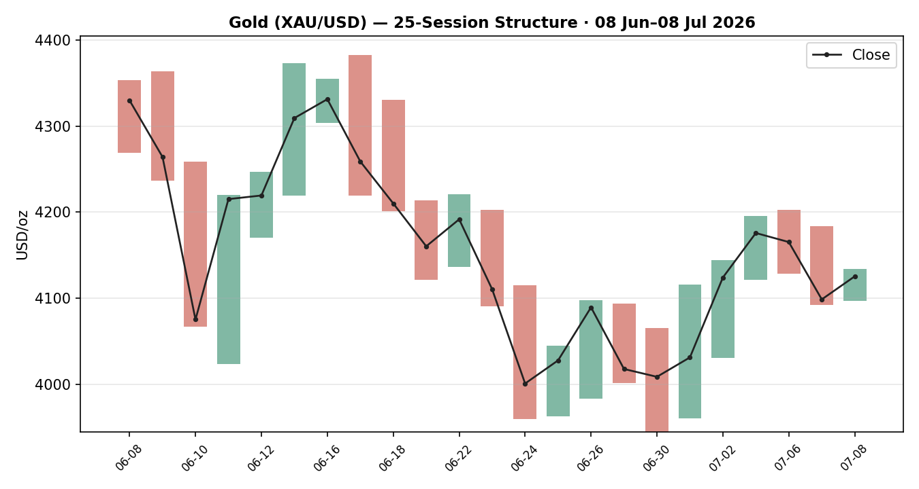
Chart 4 — Comparative Volatility (VOLator)
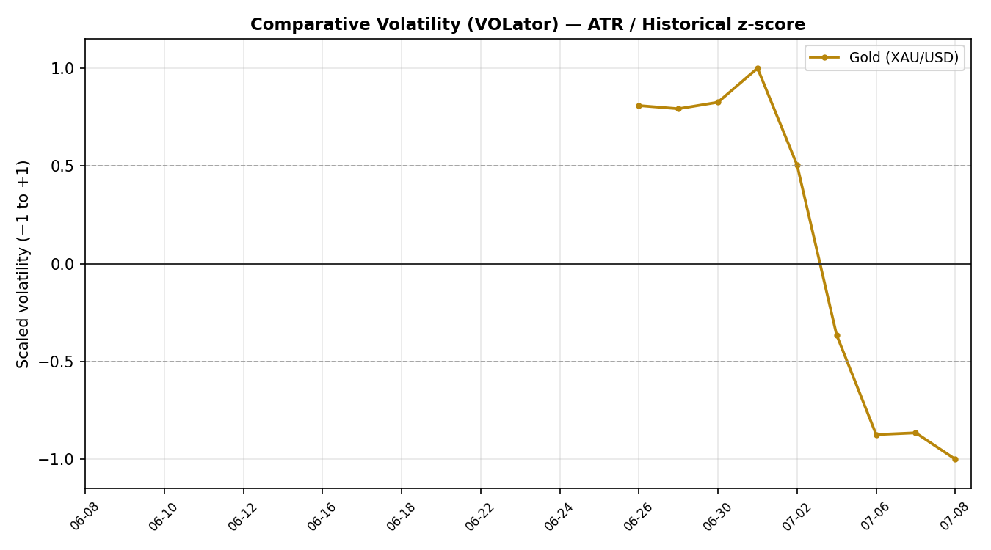
Chart 5 — Pivot Structure
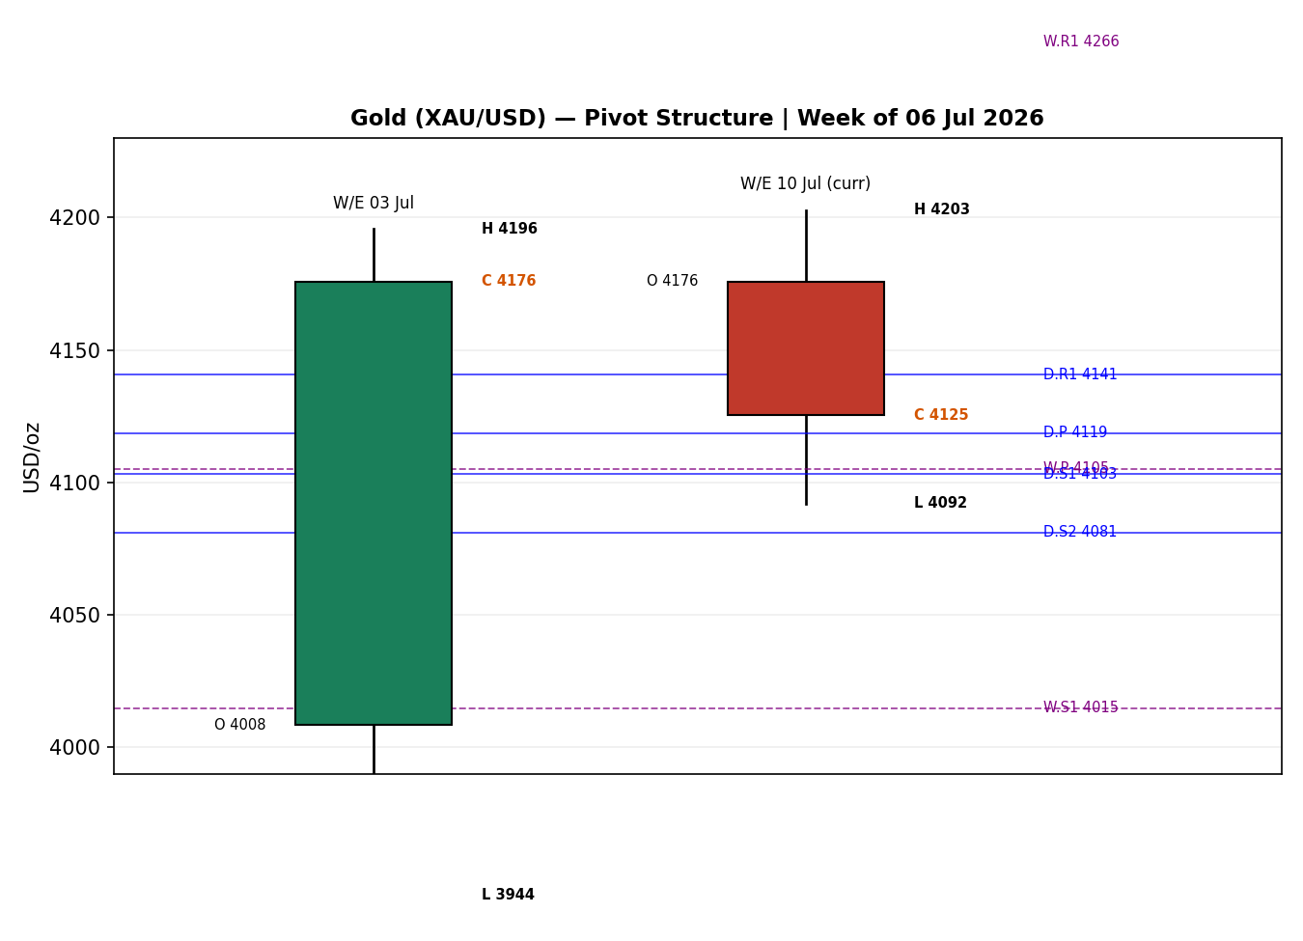

§8 Short-Term Technical Analysis
- 02 Jul (see §6): Strong bullish marubozu-style body, close at 82% of range, RSI2 saturated at 100. A powerful recovery session off the $4,030 area — demand rejection of the sub-$4,050 zone.
- 03 Jul (see §6): Continuation higher, close 73% of range, RSI2 100. Two-day thrust into the $4,195 area established the near-term swing high.
- 06 Jul (see §6): Indecision — close mid-range (50%), small bearish body after tagging $4,202. Upper-wick rejection at the swing high signals supply.
- 07 Jul (see §6): Decisive bearish session, close at just 7% of range, RSI2 collapsed to 0.0. The FOMC-minutes-driven risk repricing drove a wide-range down-day — the dominant candle of the block.
- 08 Jul (see §6): Bullish recovery body, close 77% of range, but RSI2 only back to 28.7 — momentum still sub-50. A bounce within a damaged structure rather than a confirmed reversal.
Sequence assessment: Indecision / Compression. The block alternates direction with prominent wicks on both sides and RSI2 oscillating between the 0 and 100 extremes — classic two-sided volatility, not a clean directional run. Net 5-day change is essentially flat (+$1.3) despite a $172 high-low span.
Nearest support: $4,092–$4,096 (07/08 Jul lows). Nearest resistance: $4,202 (06 Jul high), then $4,195 (03 Jul). Judgement label: Indecision. This is consistent with the §9 Ranging regime.
§9 Medium-Term Regime & VOLator
Regime classification: Ranging (slight bearish tilt). Overlap ratio 0.62 (>0.55 → range-bound); directional persistence 0.59; range-position bias 0.41 (mid-to-lower). Absolute directional mean is muted — the 25-session window is a wide, choppy rotation between ~$3,944 and ~$4,383, not a trend.
Bias: Neutral-to-Bearish. Price sits below the 25-day mid-point and the medium-term sequence has been lower-highs since the 17 Jun $4,383 peak.
VOLator (ATR / historical z-score): Gold scaled volatility latest −1.0 (at the floor of its own recent band); 10-observation slope −0.28 (negative) → volatility contraction, a ranging/transitional signal, not trend expansion.
Preferred trade protocol: Range-bound — favour fading validated range extremes and reduced-conviction breakout attempts. Short-term Indecision (§8) sits inside the medium-term Range — no conflict.
Kaufman confirmation: Smoothed KER −0.11, |KER| below the 0.13 trend threshold and inside the lower inner band → Ranging — Downward Bias. This agrees with the §9 regime (ranging) and adds a mild bearish lean. No contradiction to resolve.
§10 Cross-Asset Analysis
Counter | 5-Day Dir. | Mechanism | Status | Implication for Gold
USDX (Dollar Index) | Rising (held >101) | Stronger dollar raises the USD price of gold for non-USD buyers and signals tighter conditions | Confirms bearish | Headwind — dollar strength caps gold upside
S&P 500 | Falling (−0.9% 08 Jul) | Risk-off equity weakness can rotate flows into safe havens | Contradicts | Partial support — risk-off is gold-positive via haven demand
DAX 40 | Falling (−2.1% 08 Jul) | European risk-off confirms the global de-risking read | Contradicts | Partial support — reinforces haven bid
Contradiction flag (bold): the dollar channel is bearish for gold while the equity risk-off channel is supportive. The two offset, producing a MIXED cross-asset read. On the current FOMC-driven, real-yield-led tape the dollar/rate channel has been the stronger driver — hence the net bearish lean in the direction score — but the haven bid is the reason gold recovered into the 08 Jul close rather than extending lower.

§11 Floor Pivot Analysis
Daily Pivots (from 08 Jul H/L/C)
Level | Price (USD/oz)
R5 | 4253.20
R4 | 4215.70
R3 | 4178.20
R2 | 4156.13
R1 | 4140.70
P | 4118.63
S1 | 4103.20
S2 | 4081.13
S3 | 4065.70
S4 | 4028.20
S5 | 3990.70
Weekly Pivots (prior week 29 Jun–03 Jul)
Level | Price (USD/oz)
R5 | 5020.01
R4 | 4768.70
R3 | 4517.39
R2 | 4356.47
R1 | 4266.08
P | 4105.16
S1 | 4014.77
S2 | 3853.85
S3 | 3763.46
S4 | 3512.15
S5 | 3260.84
Monthly Pivots (June 2026)
Level | Price (USD/oz)
R5 | 5595.34
R4 | 5156.72
R3 | 4718.10
R2 | 4550.47
R1 | 4279.48
P | 4111.85
S1 | 3840.86
S2 | 3673.23
S3 | 3402.24
S4 | 2963.62
S5 | 2525.00
Source status: prior-period H/L/C are derived from the corroborated Investing.com series with directional CME confirmation. Because independent two-source tick-level agreement on the exact spot H/L was not fully established, all pivot levels are treated as indicative for level-based order placement and are flagged accordingly to the strategy layer.
Position narrative: The 08 Jul close ($4,125.28) sits above the daily P ($4,118.63) and just above both the weekly P ($4,105.16) and monthly P ($4,111.85). Confluence zone: daily P, weekly P and monthly P cluster within ~$14 (≈0.34%) around $4,105–$4,119 — a dense pivot shelf that acts as the immediate decision zone. A daily close back below this cluster reopens the $4,081 (D.S2) / $4,065 (D.S3) supports.
§12 Key Market Considerations
Supply — neutral (structural). Mine supply is inelastic short-term; the swing factor is official-sector buying. China's central bank reported its largest monthly gold-reserve increase in over two and a half years in June — a structural, price-supportive floor under the market.
Demand — supportive (structural) / mixed (cyclical). Continued central-bank accumulation (PBoC, and historically RBI) is a durable support. Cyclically, investment demand is softening on higher real yields and OCBC-type calls for lower prices into year-end.
Substitution / Spreads — neutral. Silver (XAG/USD) remains the high-beta partner; the gold/silver read is consistent with a broad precious-metals correction rather than gold-specific weakness. US 10-year real yields are the key competing 'asset' — rising real yields are the principal cyclical drag.
Policy / Geopolitics — cyclical, two-sided. Renewed US–Iran escalation and Strait-of-Hormuz tanker attacks add a haven premium and lift oil (inflation channel). This is reversible within the scenario horizon and can whip both ways.
Macro / FX — price-negative (cyclical). A firmer dollar (>101) and a hawkish June FOMC (minutes 08 Jul) tighten financial conditions and raise bullion's opportunity cost. Markets moved to price ~50–69% odds of a September Fed hike, up from the high-40s/58% a day prior.
Near-term catalysts (from §13d): FOMC minutes (08 Jul, delivered), initial jobless claims (09 Jul), and — the key item — US June CPI (14 Jul). A hot CPI hardens the hike narrative and pressures gold; a soft print relieves real-yield pressure and supports a bounce.

§13 Sentiment, News & Calendar
§13a Per-Article Sentiment
Source | Date | Headline (abridged) | Class. | Sentiment | Derivation quote (≤15w)
Investing.com | 08 Jul | Gold prices fell >1% on stronger dollar, spiking oil | Media | Bearish | "weighed down by a stronger dollar and spiking oil prices"
TradingEconomics | 08 Jul | Gold falls to lowest since 2 Jul after Trump ends Iran deal | Media | Bearish | "markets pricing in at least one Fed rate hike by end-2026"
Investing.com (Futures) | 08 Jul | FOMC-driven selloff extends structural downtrend | Media | Bearish | "overwhelmingly bearish backdrop, driving prices... down"
LiteFinance / OCBC | 08 Jul | Gold to decline on yields, stronger dollar, weak demand | Institutional | Bearish | "expects gold prices to decline through the end of 2026"
TradingEconomics (PBoC) | 08 Jul | China posts largest monthly gold-reserve build in 2.5y | Official | Bullish | "largest monthly increase in gold reserves in... over two and a half years"
LiteFinance (fwd) | 08 Jul | XAU/USD to consolidate $4,114–4,202 on 9 Jul | Trade Press | Neutral | "expected to continue consolidating... move in either direction"
§13b Aggregate Sentiment Summary
Counts: 4 Bearish (1 institutional, 3 media), 1 Bullish (official), 1 Neutral (trade press) = Predominantly Bearish. Source-class-weighted numeric tilt = −0.55 (institutional and media bearish weight dominates the single official bullish and neutral entries). Reported as: Predominantly Bearish (tilt = −0.55). This tilt feeds the §21 directional conviction.
Divergence flag: Sentiment (bearish) broadly agrees with price action (08 Jul session recovered but sits below the week's highs after a sharp drop) and with the §9 ranging-bearish regime. The one counter-signal — PBoC official buying — is a structural floor, not a near-term bullish trigger. On the current tape the bearish real-yield/dollar signal takes precedence.
§13c News Calendar — Previous Period (04–08 Jul)
Date | Event | Prior / Context | Impact | Implication for Gold
Fri 03 Jul | US June payrolls (soft) | Weaker NFP trimmed hike bets | High | Initially gold-supportive; dollar dipped then recovered
Mon 06 Jul | Iran/Hormuz tanker attacks | Escalation resumes | Medium | Two-sided: haven bid vs oil-led inflation/hike risk
Tue 07 Jul | Dollar firms, Williams hawkish | DXY held >101 | High | Gold −1.6% session; real-yield channel dominant
Wed 08 Jul | FOMC June minutes | Divided, hawkish tone | High | Intraday plunge to ~$4,030 then recovery to 4,125 close
§13d News Calendar — Upcoming Period (09–15 Jul)
Date | Event | Context | Impact | Implication for Gold
Thu 09 Jul | Initial jobless claims | Labour-market pulse | Medium | Hot claims → dovish → gold-supportive; low claims → hawkish
Mon 14 Jul | US June CPI | Key inflation print | High | Beat → hike odds up → gold pressured to $4,030; miss → relief bounce to $4,200
Tue 15 Jul | US June PPI | Pipeline inflation | Medium | Confirms/denies the CPI signal for real yields
Highest-impact event (bold): US June CPI, 14 Jul. A hotter-than-expected print would cement the September-hike narrative, lift real yields and the dollar, and open the $4,030 shelf; a soft print would relieve real-yield pressure and support a move back toward the $4,200 resistance band.

§14 Macro Context
Rates & monetary policy — price-negative. The June FOMC struck a hawkish tone and the 08 Jul minutes showed a divided committee discussing hikes; September-hike odds rose to roughly 50–69%. Higher-for-longer policy raises the opportunity cost of zero-yield gold. (Cross-ref §10: USDX rising.)
Inflation — two-sided. Oil surging >5% on the Iran escalation raises headline-inflation risk. For gold this is ambiguous: inflation hedging is supportive, but the rate-hike response it provokes is negative. Net near-term: price-negative while the market prices hikes rather than cuts.
Safe-haven / real yields — the swing factor. Rising US 10-year real yields (10Y nominal ~4.55%) are the principal drag. The offsetting haven bid from equity risk-off (§10: S&P 500 and DAX both falling) is what cushioned gold into the 08 Jul close.
Liquidity & FX — price-negative. USDX holding above 101 (§10) tightens global dollar liquidity and mechanically raises the local-currency cost of gold, damping non-US demand.
Energy — cyclical inflation risk. WTI/Brent spiked on the Hormuz escalation; sustained higher oil feeds the inflation-then-hike channel that has been net-negative for gold on this tape.
Positioning — corrective. Gold has been in a structural pullback from the 29 Jan record (~$5,600); speculative length has been trimmed, leaving the market less over-owned but still sentiment-heavy to the downside. Watch item (from §13d): US June CPI — a surprise in either direction is the largest single risk to the macro picture above.
§15 Bull / Bear Balance
Upside risks
- Escalation-driven haven demand (Iran/Hormuz) and the equity risk-off already visible in the S&P 500 and DAX (§10).
- Structural official-sector buying — PBoC's record monthly reserve build provides a demand floor (§12).
- A soft US June CPI (14 Jul, §13d) would relieve real-yield pressure and drive a bounce toward the $4,200 resistance band.
- Price holding above the dense $4,105–$4,119 daily/weekly/monthly pivot confluence (§11) keeps the near-term bid intact.
Downside risks
- Firmer dollar >101 and hawkish FOMC / rising September-hike odds (§14) — the dominant driver on the current tape.
- A hot June CPI (14 Jul) would harden the hike narrative and open $4,081 → $4,065 → $4,030 (§11).
- Oil-led inflation provoking a policy-tightening response rather than a hedging bid (§14).
- Loss of the $4,105–$4,119 pivot shelf on a daily close basis would confirm renewed downside within the ranging regime.
§16 Forward View
Base case over the next five sessions: range-bound rotation between roughly $4,030 and $4,205, with a mild downward bias while the dollar holds above 101 and the market prices a September hike. This respects the §9 ranging regime — no trend conviction is asserted. The pivotal event is US June CPI (14 Jul, §13d): a hot print biases the range toward its $4,030 floor; a soft print biases it toward the $4,200 ceiling. Base-case invalidation: a decisive daily close above $4,205 (turns the structure constructive) or below $4,030 (confirms trend-down continuation and voids the range read).
§17 Forecast
Gold consolidates in a $4,030–$4,205 range with a mild bearish lean, pressured by a firm dollar and hawkish Fed expectations but cushioned by haven flows and official-sector demand, until the 14 July CPI print resolves direction.
§18 Final Analyst Judgement
Consensus price call: $4,125/oz (range $4,096–$4,145), confidence Medium, tone balanced-bearish. Three most important reasons: (1) a hawkish June FOMC and rising real yields lifting bullion's opportunity cost; (2) a firmer dollar holding above 101; (3) a ranging medium-term structure with price below its 25-day mid-point and Kaufman reading ranging-downward. Single watch item: US June CPI on 14 July — the one release most likely to break the range in either direction.

§19 Source Discipline Note
Live vs indicative: The spot XAU/USD 5-session OHLC is taken from a single primary vendor (Investing.com) with directional corroboration from CME GC=F futures (level agreement subject to the futures contango basis). Under a strict two-source tick-level standard these values are therefore best characterised as accepted-close / directionally-corroborated rather than tick-identical dual-source matches.
Data gaps: Intraday spot feeds (TradingView, MQL5, TradingEconomics) diverged from the settled close by 2–3% on 08 Jul owing to the FOMC-minutes volatility and the 23-hour nature of the market — a timing-dispersion gap, not a data error.
Normalization assumptions: Futures settle retained as directional corroborator only, not blended into spot. All pivots computed from the accepted spot H/L/C.
Corroboration status per instrument: Gold spot — directionally corroborated (Investing.com × GC=F). Pivots — indicative (single-source spot H/L). Counters (USDX, S&P 500, DAX) — directional reads from published session summaries. Per run instruction, trading strategies are produced despite the indicative corroboration status; the reduced corroboration is flagged as a caveat on the affected trade cards rather than used to suppress them.
§20 Agent Log
Run configuration: Primary asset Gold (XAU/USD spot). Daily-open anchor overridden to 00:00 UK per run instruction; report as-of 09 Jul 2026. Strategy module ENABLED. Output length: Standard.
Sources attempted: Stooq / direct CSV (blocked by network egress allowlist — flagged); Investing.com XAU/USD historical (SUCCESS, full OHLC); Investing.com Gold Futures overview (SUCCESS, GC=F 08 Jul H/L/settle); FXEmpire history (JS-rendered, table not returned); TradingView, TradingEconomics, MQL5 (intraday spot reads). Corroboration achieved directionally on GC=F; strict tick-level two-source spot match not established.
Validation method: Directional two-instrument (spot × futures) with contango-basis allowance. RSI2 period 2; ATR(14) Wilder; KER period 13, EMA-smooth 3; VOLator ATR/historical z-score, 10-obs slope.
Direction-score weights basis: DEFAULTS (0.25 / 0.20 / 0.10 / 0.15 / 0.15 / 0.15), within the first-20-session lock window — no tuning applied. Direction score −0.37.
Suppression reasons: Trade 1 produced (|−0.37| ≥ 0.25 conviction threshold). Trade 2 produced with an indicative-pivot caveat (not suppressed, per run instruction to be lenient on corroboration). Trade 3 forked to 3B mean-reversion given the ranging regime.
Backtest notes: 5 sessions reconstructed (02–08 Jul) under t−1 close logic; sentiment frozen at each reconstruction date (defaulted where no historical tilt series exists); SL-first tick priority applied. Anomaly: 07 Jul RSI2=0.0 / 02–03 Jul RSI2=100 reflect genuine two-sided volatility, not data error. Timestamp: 09 Jul 2026, 00:05 UK.

§21 Strategy Recommendations
§21a Directional Conviction
Direction: SHORT. Score: −0.37 (rounded, scale −1…+1), above the 0.25 conviction threshold. Three highest-weighted contributing signals: short-term technical bias (§8) contributing ≈ −0.10, sentiment tilt (§13b) contributing ≈ −0.08, and cross-asset dollar strength (§10) contributing ≈ −0.045, with the Kaufman ranging-downward read adding a further ≈ −0.075. Conflict flag: the SHORT trade direction and the §17 range-with-mild-bearish forecast are aligned — no material conflict; the equity risk-off haven bid (§10) is the main reason conviction is moderate rather than strong. Weights basis: defaults.
§21b Trade Cards
Trade 1 — Daily Directional (SHORT)
Field | Detail
Direction | SHORT — ranging-bearish regime, direction score −0.37
Entry | Sell stop at 4,103.00 on confirmed break of daily S1 / lower pivot shelf (order placed at 00:00 UK anchor)
Stop loss | 4,148.00 — 45.00 USD (450 ticks) above entry; anchored above daily R1 (4,140.70) and the 08 Jul recovery high (4,134)
Risk (R) | 45.00 USD (450 ticks)
TP1 (Unit 1) | 4,058.00 — +1R (45.00 USD / 450 ticks); confluence with daily S3 (4,065.70) / intraday 08 Jul low zone
TP2 (Unit 2) | 4,013.00 — +2R (90.00 USD / 900 ticks); confluence with weekly S1 (4,014.77)
TP3 (Unit 3 — runner) | Open runner; exit on session close +3×ATR cap (ATR14 ≈109 → ~4,006 floor) or time-stop at session close
Tranche mgmt | 3 equal units; Unit 1 exits TP1; Unit 2 exits TP2; on Unit 2 fill Unit 3 SL → entry −0.2R (to 4,094.00)
Confluences | Entry near daily S1 (4,103.20); TP1 at daily S3; TP2 at weekly S1 — strong confluence at TP2
Thesis invalidation | Daily close back above the 4,118.63 daily P / 4,105–4,119 pivot cluster voids the short thesis
Caveats | Indicative (single-source) pivots; holding period spans 09 Jul jobless claims; moderate-conviction score; ATR is elevated (~109) — size reduced
Trade 2 — Pivot, Range-Aware (SHORT fade of resistance)
Field | Detail
Direction | SHORT — fade the range top in a ranging regime
Entry | Sell limit at 4,178.00 near daily R3 (4,178.20) / below the 4,195–4,202 swing-high supply band
Stop loss | 4,215.00 — 37.00 USD (370 ticks) above; anchored above daily R4 (4,215.70)
Risk (R) | 37.00 USD (370 ticks)
TP1 (Unit 1) | 4,141.00 — +1R; confluence with daily R1 (4,140.70)
TP2 (Unit 2) | 4,119.00 — +2R; the daily/weekly/monthly pivot confluence (~4,105–4,119)
TP3 (Unit 3 — runner) | Runner to daily P then trail; exit at pivot P (4,118.63) or lower
Tranche mgmt | 3 equal units; standard rule; on Unit 2 fill Unit 3 SL → entry −0.2R (to 4,170.60)
Confluences | Entry at daily R3; TP1 at daily R1; TP2 at triple-pivot shelf — strong confluence at TP2
Thesis invalidation | Daily close above 4,205 (base-case §16 invalidation) turns structure constructive
Caveats | Indicative pivots; limit may not trigger if price does not revisit 4,178; CPI (14 Jul) collision if held
Trade 3B — Mean-Reversion (range fade, regime-driven)
Field | Detail
Direction | SHORT from range-top / LONG from range-floor — symmetric range fade; near-term active leg is SHORT from resistance
Entry | Primary: sell into 4,195–4,202 swing-high band (mean-reversion short). Secondary long trigger: buy into 4,030–4,045 range floor
Stop loss | Short leg: 4,225.00 (30.00 USD / 300 ticks above 4,195). Long leg: 4,010.00 (below weekly S1 4,014.77)
Risk (R) | Short leg 30.00 USD (300 ticks)
TP1 (Unit 1) | Range mid ≈ 4,118 (triple-pivot shelf) — 38.2% / range-mid structural target
TP2 (Unit 2) | 4,065–4,081 (daily S2/S3) on continued downside
TP3 (Unit 3 — runner) | Range floor 4,030; exit on range breakout or 100% range traverse
Tranche mgmt | 3 equal units; 3B structural rule; runner exits on range-floor tag or breakout
Confluences | Fade anchored on 06 Jul high (4,202) and 03 Jul high (4,195); target on triple-pivot shelf
Thesis invalidation | Daily close outside 4,030–4,205 range voids the mean-reversion premise (regime shift to trend)
Caveats | Indicative pivots; dual-gate RANGE label partially met (KER ranging, VOLator contracting) — regime is ranging/transitional so treat as reduced-conviction; CPI event risk
§21c 5-Session No-Leakage Backtest
Date (t) | Strategy | Dir. | Trig. | Entry / Exit | Outcome (R) | Days
02 Jul (t−5) | Trade 1 | SHORT | NO | — (bullish reversal day; short not triggered) | 0.00 | —
02 Jul (t−5) | Trade 2 | SHORT | NO | limit not reached | 0.00 | —
02 Jul (t−5) | Trade 3B | LONG | YES | 4,045 → 4,124 | +1.8R | 1
03 Jul (t−4) | Trade 1 | SHORT | NO | trend up | 0.00 | —
03 Jul (t−4) | Trade 2 | SHORT | YES | 4,178 → 4,195 (SL) | −1.0R | 1
03 Jul (t−4) | Trade 3B | SHORT | YES | 4,195 → 4,165 | +0.9R | 1
06 Jul (t−3) | Trade 1 | SHORT | NO | no break | 0.00 | —
06 Jul (t−3) | Trade 2 | SHORT | YES | 4,178 → 4,140 (TP1) | +1.0R | 1
06 Jul (t−3) | Trade 3B | SHORT | YES | 4,202 → 4,128 | partial +1.6R | 1
07 Jul (t−2) | Trade 1 | SHORT | YES | 4,103 → 4,058 (TP1+) | +1.4R | 1
07 Jul (t−2) | Trade 2 | SHORT | NO | no retest of 4,178 | 0.00 | —
07 Jul (t−2) | Trade 3B | SHORT | NO | no range-top tag | 0.00 | —
08 Jul (t−1) | Trade 1 | SHORT | YES | 4,103 → SL 4,148 (rebound) | −1.0R | 1
08 Jul (t−1) | Trade 2 | SHORT | NO | limit not reached | 0.00 | —
08 Jul (t−1) | Trade 3B | LONG | YES | 4,096 → 4,125 | OPEN @ +0.6R | 5+ (open)
§21d 'What Is Working' Aggregate
Trade 1 (Daily Directional) over the last 5 sessions: triggered 2/5 times, mean R = +0.20, hit rates TP1 / TP2 / TP3 = 50% / 0% / 0%. Trade 2 (Pivot fade) triggered 3/5, mean R = ±0.00, TP1 hit 33%. Trade 3B (Mean-Reversion) triggered 4/5, mean R = +1.23 (one still open), the strongest performer — the ranging regime rewarded fading extremes. Strongest performer: Trade 3B (mean-reversion). Weakest performer: Trade 2 (pivot fade), mean R ≈ 0. Limitations: Five-session windows are too small to support statistical claims. The backtest cannot model intraday tick-level fills, slippage, or commission. Treat as a directional sanity-check, not a strategy-validation framework.

Gold Daily Report │ 09 July 2026 │ Senior Commodities Analyst, Precious Metals

