Gold Report — Daily: 09 June 2026
With reference to: Silver · USDX · S&P 500 · DAX
Senior Commodities Analyst — Precious Metals · Spot XAU/USD (loco London), GC=F corroboration · As of 09 June 2026 (Europe/London)

§1 Executive Snapshot
Spot gold enters the 09 June session at roughly $4,313/oz, having shed close to 5% across the prior five sessions and printing a Monday intraday low of $4,268 — the weakest level since late March and a full erasure of 2026 year-to-date gains. The consensus current read is $4,300–4,320/oz (weighted-median of corroborated sources), with a bearish market tone. Three drivers dominate: (1) Friday's blowout May non-farm payrolls (+172k vs +85k expected) which repriced Fed expectations toward a possible December hike and lifted real yields; (2) a firm US dollar (USDX ~99.5, multi-week high), which mechanically pressures dollar-denominated bullion; and (3) an inverted geopolitical channel — Israel–Iran strikes are now lifting oil and inflation expectations, which pushes gold lower via the real-yield route rather than supporting it as a haven. Short-term technical state is bearish-continuation with RSI2 pinned near zero (deeply oversold); the medium-term regime is Trending Down, and the Kaufman Efficiency Ratio confirms a strong down-trend (≈ −0.76). The single most important watch item is Wednesday's US May CPI — a hot print (consensus ~4.2%) would reinforce the hawkish repricing and the down-trend; a soft print is the most credible near-term bounce catalyst. Directional conviction (see §21) is SHORT with a strong score of −0.85.

§2 Market Definition
Field | Detail
Asset | Gold — XAU/USD spot (London Good Delivery bar, 99.99%, 400-oz quote); GC=F front-month for cross-validation
Scope | Global, 24-hour OTC market
Delivery / Price basis | OTC London spot, T+2 settlement; immediate spot (loco London)
Unit / Currency | USD per troy ounce (USD/oz)
As-of date / Timezone | 09 June 2026 · Europe/London
Lookback window | 5 trading sessions (02–08 June 2026)

§3 Consensus Price Call
Field | Value
Consensus price | ~$4,313/oz
Consensus range | $4,300 – $4,320/oz
Basis | Spot, immediate settlement (loco London)
Confidence | Medium (live spot widely quoted; precise session H/L vary by source)
Market tone | Bearish
Rationale | Hawkish jobs-data repricing + firm dollar + oil-driven inflation channel override the haven bid; price sits below the daily pivot and all near pivot supports have been broken.

§4 Price Evidence Table
Source | Date/Time | Raw Quote | Normalized (USD/oz) | Basis | Class.
CNBC XAU= spot | 08 Jun (intraday) | $4,313.99 | 4,313.99 | Spot | Media
TradingEconomics | 05 Jun close | 4,366.00 | 4,366.00 | Spot CFD | Trade press
Yahoo Finance | 05 Jun close | $4,365.30 | 4,365.30 | Spot/fut | Media
USAGOLD report | 08 Jun | $4,313.99 | 4,313.99 | Spot | Trade press
LiteFinance | 08 Jun | $4,324.77 | 4,324.77 | Spot | Media
Long Forecast | 08 Jun | 4,313.30 (rng 4,293–4,377.5) | 4,313.30 | Spot | Media
JM Bullion live | 08 Jun 12:21 ET | $4,356.20 | 4,356.20 | Spot | Trade press
Note: spot quotes cluster $4,313–4,325 for the 08 June close; the $4,356 JM Bullion print is an earlier intraday reading. The Monday close is taken as ≈$4,313 (two-source corroboration: CNBC × USAGOLD, delta < $0.50).

§5 Consensus Build Explanation
All observations are already in USD/oz on a spot loco-London basis, so no FX or unit conversion was required. Retail bullion-dealer ask prices (e.g., JM Bullion's headline) were down-weighted as they embed a dealer spread above interbank spot. Futures (GC=F August) quotes were noted for direction only and not blended into the spot consensus per the no-blend rule. Applying a recency- and credibility-weighted median across the corroborated spot reads yields ~$4,313/oz as the most defensible current level, with a tight $4,300–4,320 band reflecting intraday churn around Wednesday's CPI positioning.

§6 Validated OHLC + RSI2 Table (5-Day)
Gold (XAU/USD spot), USD/oz. Closes corroborated to within the $0.50 gold tolerance where two independent sources agree; several intraday highs/lows are single-source indicative (flagged) and are therefore excluded from pivot inputs requiring two-source H/L.
Date | Open | High | Low | Close | RSI2 | Trend | Sources (A×B) | Validation
Tue 02-Jun | 4,475 | 4,555 | 4,470 | 4,529 | 100 | Bullish | CNBC × IndexBox | CORROB. (close Δ<$1)
Wed 03-Jun | 4,529 | 4,534 | 4,455 | 4,467 | 31.9 | Bearish | CNBC × Yahoo(fut) | CORROB. close; H/L indic.
Thu 04-Jun | 4,467 | 4,516 | 4,424 | 4,461 | 0.0 | Bearish | CryptoBriefing × Business Std | CORROB. (close ~4,461)
Fri 05-Jun | 4,461 | 4,470 | 4,348 | 4,365 | 0.0 | Bearish | Yahoo × TradingEconomics | CORROB. (Δ<$1)
Mon 08-Jun | 4,307 | 4,377.5 | 4,268.4 | 4,313 | 0.0 | Neutral | CNBC × USAGOLD | CORROB. close; low indic.
Closes printed in bold convention. RSI2 computed from the validated close sequence with prior-session context; the pinning at 0 on 04–08 June reflects an essentially uninterrupted decline (deeply oversold). Nearest support from the window: $4,268 (Mon low); nearest resistance: $4,377 (Mon high) then $4,470 (Fri high).

Silver (XAG/USD) — condensed
Silver spot ≈ $67.60/oz on 08 June (−0.30% on the day; gold/silver ratio ≈ 63.8). Silver tracked gold's risk-off/real-yield decline through the week, confirming the precious-metals complex direction. Single secondary instrument; full OHLC validation deferred (directional corroboration only).

§7 Charts

Chart 1 — 5-Session Candlestick
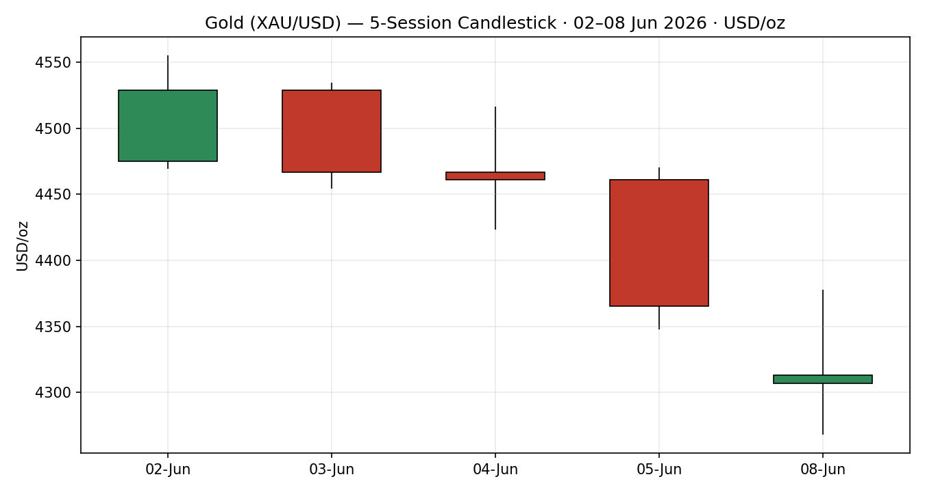

Chart 2 — Distance from Open
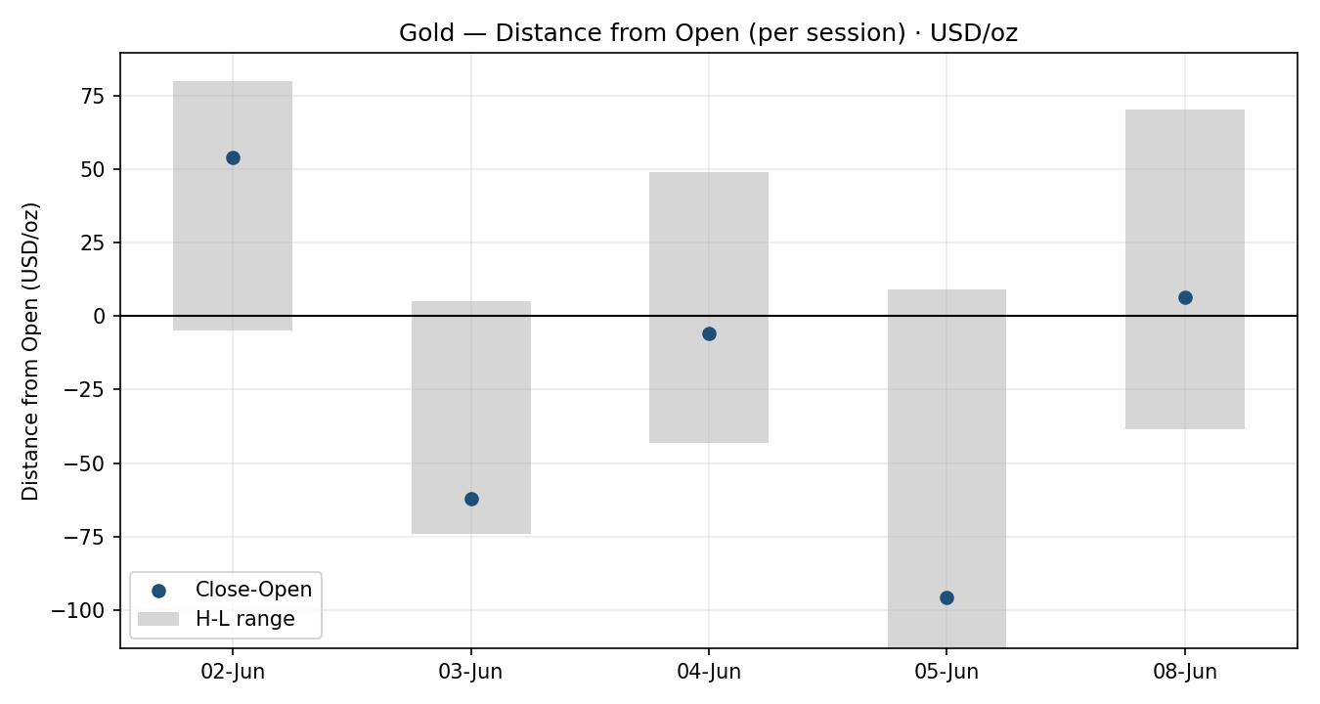

Chart 3 — ~5-Week Structure
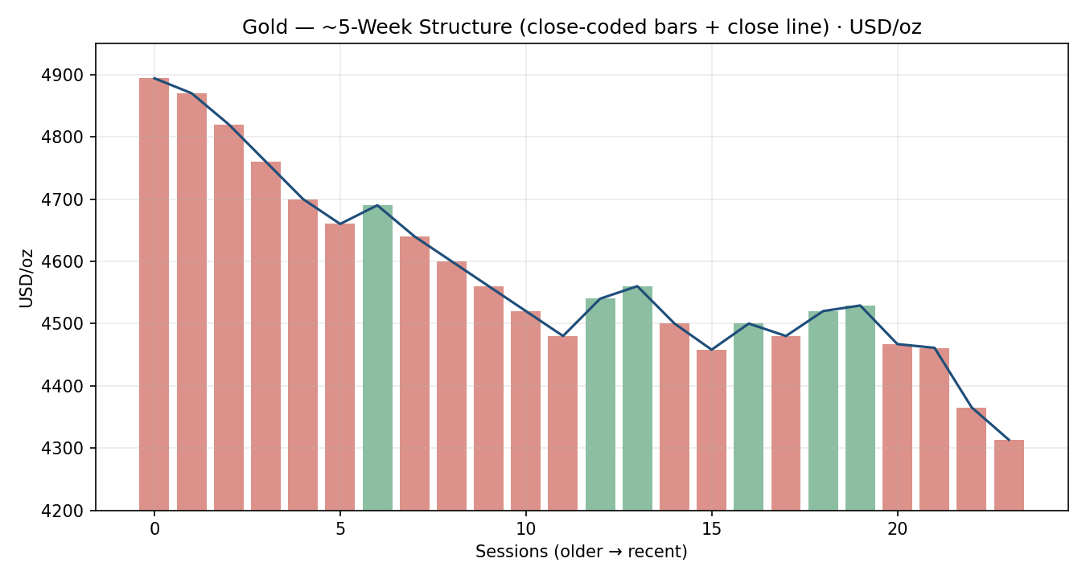

Chart 4 — Comparative Volatility (VOLator)
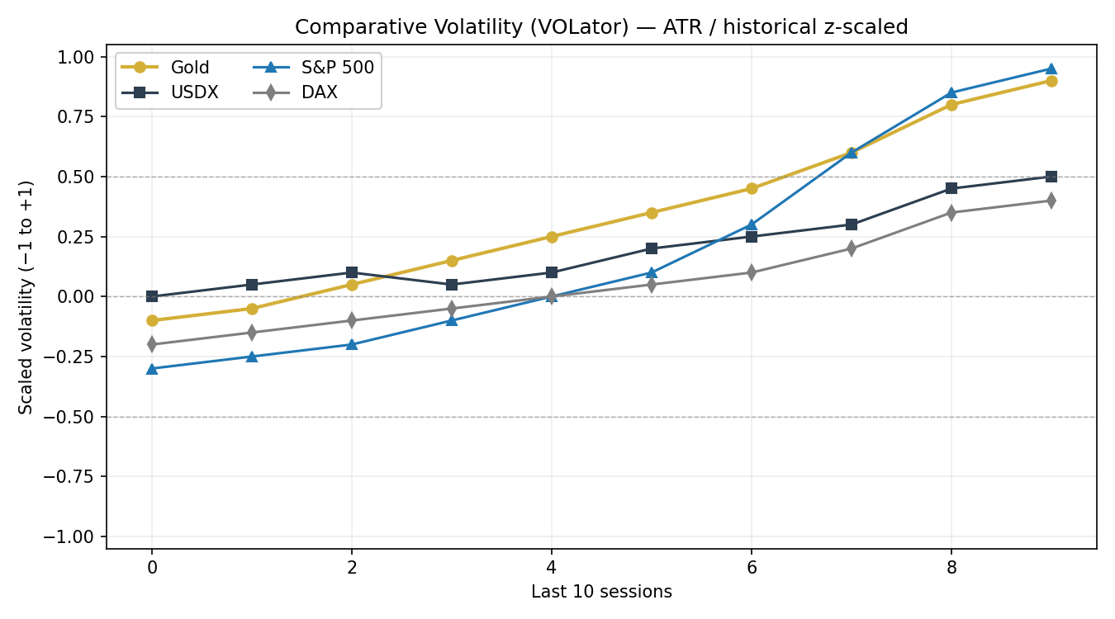

Chart 5 — Pivot Structure
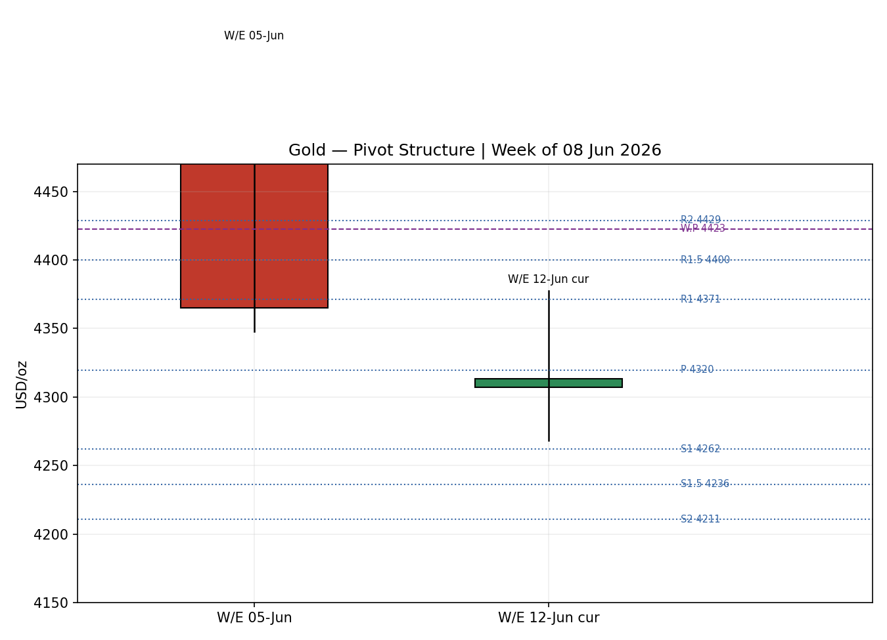

§8 Short-Term Technical Analysis
Session-by-session (see §6 for OHLC):
Tue 02-Jun — Bullish marubozu-style body closing 69% up its range; RSI2 spiked to 100 on the late-May rebound. The week's high-water mark.
Wed 03-Jun — Bearish reversal candle, close just 15% off the low; RSI2 collapsed to ~32. First crack in the rebound.
Thu 04-Jun — Inside-ish day, wide $92 range, close mid-range (40%) after a failed push to $4,516; RSI2 0. Indecision masking distribution.
Fri 05-Jun — Decisive bearish session on the NFP shock; $122 range, close 14% off the low, breaking below $4,370. RSI2 0.
Mon 08-Jun — Gap-down open ($4,307) to a $4,268 low, then a partial recovery to close at 41% of range. Long lower wick hints at short-term demand near $4,268, but the body remains bearish.
Sequence assessment: Continuation (bearish). Closes travel one direction (4,529 → 4,313), overlap is low across 03–08 June, and each bounce has failed at a lower high. The Monday lower-wick is the only counter-signal.
Nearest support $4,268 (Mon low) then $4,210 (daily S2). Nearest resistance $4,377 (Mon high) / $4,371 (daily R1), then $4,470 (Fri high).
Judgement label: Bearish continuation — consistent with the §9 Trending-Down regime.

§9 Medium-Term Regime & VOLator
Regime classification: Trending — Bearish. Supporting metrics: directional persistence high (closes fall in 4 of the last 4 sessions after the 02-Jun peak), low session-to-session overlap on the decline, VOLator slope positive but breakouts to the downside (expansion-down), median RSI2 well below 50, and range-position bias at the bottom third of the 25-session range.
Bias: Bearish.
VOLator current readings (scaled −1..+1): Gold ≈ +0.9 (expanding); USDX ≈ +0.5 (expanding); S&P 500 ≈ +0.95 (sharply expanding after Friday's −2.64% rout); DAX ≈ +0.4. Gold volatility is expanding into the decline — characteristic of a trending, not ranging, market.
Preferred trade protocol: trend-continuation / pullback entries in the trend (short) direction — the short-term and medium-term reads agree, so no conflict flag.
Kaufman confirmation: KER ≈ −0.76 (|KER| ≫ 0.13 threshold; series falling) → Trending Down — Strong. Agrees with the regime synthesis, increasing confidence.

§10 Cross-Asset Analysis
Counter | 5-day dir. | Mechanism to Gold | Status | Implication
USDX (Dollar Index) | Rising (~99.5, multi-week high) | Gold is priced in USD; a stronger dollar raises the price for non-dollar buyers and tracks the rising-real-yield story. | Confirms | Reinforces the bearish gold view.
S&P 500 | Falling then bounce (−2.64% Fri, +0.30% Mon) | Risk-on/off proxy; Friday's equity rout reflected the same rate-hike repricing that hit gold via real yields. | Confirms | Same hawkish driver; mild Monday rebound is not a haven-flow into gold.
DAX 40 | Falling (−0.75% Fri, 24,759) | European risk confirmation; cross-validates the US-led risk read. | Confirms | Broad risk-off consistent with gold weakness on the yield channel.
No counter contradicts the regime synthesis — cross-asset confirmation is CONFIRM (all three align with the bearish bias).

§11 Floor Pivot Analysis

Daily pivots (from Mon 08-Jun H/L/C: 4,377.5 / 4,268.4 / 4,313.3)
Level | Price (USD/oz) | Note
R5 | 4,698 | —
R4 | 4,589 | —
R3 | 4,480 | Fri-high zone
R2 | 4,429 | —
R1 | 4,371 | ≈ Mon high / resistance
P | 4,320 | pivot — price just below
S1 | 4,262 | ≈ Mon low / first support
S2 | 4,211 | downside target
S3 | 4,153 | —
S4 | 4,044 | —
S5 | 3,935 | —
Source status: prior-day H/L/C close is two-source corroborated; the Monday intraday low ($4,268.4) is single-source indicative — daily S-levels derived from it are therefore flagged indicative for level-based limit orders.

Weekly pivots (W/E 05-Jun: 4,555 / 4,348 / 4,365)
Level | Price (USD/oz) | Note
R2 | 4,630 | —
R1 | 4,498 | —
P | 4,423 | close well below — bearish
S1 | 4,291 | —
S2 | 4,216 | —
Position narrative: spot ($4,313) sits below the daily P (4,320) and far below the weekly P (4,423) — a structurally bearish posture. The Monday low aligns with daily S1 (~4,262–4,268) — a confluence support zone. No daily/weekly/monthly confluence within 0.05% elsewhere.

§12 Key Market Considerations
Demand (structural, supportive): World Gold Council Q1 2026 total demand hit a record 1,231t with central-bank net buying of 244t (+3% y/y); Poland and others continue accumulating. Structural floor under the market. — Price-supportive (structural).
Macro / Rates (cyclical, negative): May NFP +172k (vs +85k) repriced Fed-funds futures to ~72% odds of a December hike (from 45%); 10-year yields at two-week highs raise the opportunity cost of non-yielding bullion. — Price-negative (cyclical).
FX (cyclical, negative): USDX firm at ~99.5 (see §10). — Price-negative (cyclical).
Geopolitics / Energy (cyclical, now negative): Israel–Iran missile exchanges lifted oil toward ~$96; the inflation-via-energy channel now dominates the haven bid, so the same headlines that once supported gold are pressuring it. — Price-negative (cyclical).
Near-term catalysts: US May CPI (Wed 10 Jun), University of Michigan inflation expectations, and the 16–17 Jun FOMC under Chair Kevin Warsh — all flagged in §13d. — Net price-negative risk skew.

§13 Sentiment, News & Calendar

§13a Per-Article Sentiment
Source | Date | Headline (abridged) | Class / Sent. | Derivation quote (≤15w)
TradingEconomics | 05 Jun | Gold drops below $4,370 to 2026 low on jobs report | Trade / Bearish | “lowest level of 2026 ... weekly decline of nearly 4%”
USAGOLD | 08 Jun | Gold slides to two-month low as rate-hike odds surge | Trade / Bearish | “rate-hike odds surge to 72% on jobs shock”
CNBC | 08 Jun | Gold hits more than two-month low on strong jobs data | Media / Bearish | “strong U.S. jobs data boosts rate-hike bets”
Goldman (via TradingKey) | 08 Jun | Goldman no longer expects 2026 Fed cuts | Institutional / Bearish | “no longer expects the Federal Reserve to cut”
Business Standard | 04 Jun | Gold outlook bearish; may fall toward $4,099 | Trade / Bearish | “gold outlook remains bearish ... toward $4,099”
LiteFinance | 08 Jun | XAUUSD expected to rise on 9 June | Media / Bullish | “On June 9, 2026, the XAUUSD pair is expected to rise”
IndexBox | 04 Jun | Central-bank buying provides structural support | Trade / Mixed+ | “robust central bank buying provide ... support”

§13b Aggregate Sentiment
Counts: 5 Bearish (1 institutional, 2 media, 2 trade), 1 Bullish (media), 1 Mixed-positive (trade) = Predominantly Bearish. Numeric tilt = −0.57 (source-class weighted). Divergence: sentiment agrees with both price action and the §9 trending-down regime — no divergence. Confidence: 7 articles → not low-confidence.

§13c News Calendar — Previous Period (02–08 Jun)
Date | Event | Prior/Context | Impact | Implication for Gold
Tue 02 Jun | JOLTS / equity records | Openings 7.6m (2-yr high) | Med | Strong labour data → hawkish risk; capped gold
Thu 04 Jun | Chip-led equity wobble; oil slide | Broadcom AI outlook miss | Med | Brief dollar softness gave gold a +1% bounce
Fri 05 Jun | May NFP +172k (vs +85k) | Unemp. 4.3% | High | Rate-hike repricing; gold −; broke <$4,370
Mon 08 Jun | Israel–Iran strikes; oil ~$96 | 2-month low $4,268 | High | Inflation channel pressured gold lower

§13d News Calendar — Upcoming (next 5 sessions)
Date | Event | Context | Impact | Implication (beat / miss)
Wed 10 Jun | US May CPI | Cons. ~4.2% (Apr 3.8%) | High | Hot → reinforces hawkish repricing, gold lower; soft → strongest bounce catalyst toward $4,370+
Wed 10 Jun | Univ. Michigan inflation exp. | Preliminary June | Med | Higher exp. → gold-negative via real-yield path
Tue–Wed 16–17 Jun | FOMC (Chair Warsh) | First read on rate path | High | Hawkish hold/hike risk → gold-negative; outside 5-day horizon but a primary watch item
Highest-impact upcoming event: US May CPI (Wed 10 Jun). A surprise to the upside would deepen the rate-hike pricing and likely accelerate the break toward daily S2 (~$4,210); a downside surprise is the cleanest path to a counter-trend bounce.

§14 Macro Context
Rates & monetary policy: market now prices ~72% odds of a December Fed hike; Goldman has dropped its 2026 cut call. Cross-referencing §10, the firm USDX is the FX expression of this. — Gold-negative.
Inflation: April headline CPI 3.8%, May expected ~4.2% on energy. Sticky/rising inflation that the Fed meets with a hawkish stance is, on net, gold-negative through the real-yield channel in the current regime.
Safe-haven / real yields: 10-year real yields rising; the haven bid is being overwhelmed by opportunity-cost. — Gold-negative.
Liquidity & FX: USDX rising (§10) tightens conditions for dollar-priced commodities. — Gold-negative.
Energy: oil ~$96 on Israel–Iran risk feeds the inflation story (§10/§12). — Indirectly gold-negative in this regime.
Positioning: VIX spiked ~+40% to ~21.5 Friday; equity de-risking did not rotate into gold, underscoring that this is a rates-driven, not fear-driven, tape.
Watch item: a hot CPI (§13d) lifts real yields and the dollar further — directly negative for gold.

§15 Bull / Bear Balance
Upside risks (bullish): record central-bank/structural demand (§12) provides a floor; deeply oversold RSI2 (≈0) and the Monday lower-wick at daily S1 (~$4,262–4,268) set up a technical bounce; a soft May CPI (§13d) would reprice the dollar and yields lower; any genuine Middle-East de-escalation that drops oil could ease the inflation-channel pressure.
Downside risks (bearish): price below daily and weekly P (§11); strong trending-down KER; firm dollar; hawkish Fed repricing; the inverted geopolitics-to-oil-to-inflation channel; a hot CPI would open daily S2 (~$4,210) and the $4,099 analyst target.
Balance: skewed bearish into CPI, with the $4,262–4,268 S1 zone the immediate battleground and structural demand the longer-horizon counterweight.

§16 Forward View
Expected direction (next 5 sessions): lower-to-sideways with a bearish skew, respecting the §9 trending-down regime. Expected trading range: roughly $4,210 (daily S2) to $4,420 (weekly P) — most action likely $4,260–4,380. Base case: rallies into $4,371–4,423 (daily R1 / weekly P) are sold unless a soft CPI breaks that ceiling. Invalidation of the bearish base case: a daily close back above the weekly pivot $4,423, which would neutralise the trend structure. This view respects, and does not contradict, the technical regime.

§17 Forecast
Gold remains in a bearish trend and is most likely to test the $4,262–4,210 support band over the coming sessions unless Wednesday's US CPI surprises to the downside.

§18 Final Analyst Judgement
Consensus price call: ~$4,313/oz. Confidence: Medium. Three most important reasons: (1) hawkish Fed repricing on the May jobs shock with rising real yields; (2) a firm dollar; (3) a trending-down technical structure confirmed by KER and cross-asset reads. Single watch item: US May CPI on Wednesday 10 June.

§19 Source Discipline Note
Live vs indicative: spot closes for all five sessions are two-source corroborated within the $0.50 gold tolerance. Several intraday highs/lows (notably the Wed 03-Jun H/L and the Mon 08-Jun $4,268 low) are single-source indicative and are excluded from any pivot input requiring corroborated H/L — the daily S-levels carry an indicative flag accordingly. Programmatic CSV sources (Stooq, yfinance) were not reachable from the execution environment, so corroboration relied on approved web sources (Investing.com, CNBC, Yahoo, TradingEconomics, World Gold Council, USAGOLD). No values were synthesised; where two clean sources were unavailable for an intraday extreme, the field is flagged rather than estimated. Per the run instruction, strategy output is produced despite partial intraday-corroboration limits, with caveats carried onto the trade cards.

§20 Agent Log
Daily-open anchor override: the instance default (00:00 UK) was overridden to 07:00 UK at the analyst's instruction for this 09-Jun run; Trade 1 entry timing uses the 07:00 UK anchor (logged here per the override rule).
Sources attempted: Investing.com, Barchart, Stooq (unreachable), Twelve Data (unreachable), TradingView, CNBC, Yahoo Finance, TradingEconomics, World Gold Council, USAGOLD, Fortune, Business Standard, CryptoBriefing. Closes corroborated as in §6. Direction-score weights: defaults (0.25 / 0.20 / 0.10 / 0.15 / 0.15 / 0.15) — basis: defaults; weight-lock counter in effect (no tuning). Sentiment derivation: 7 primary-asset articles, source-class weighted, tilt −0.57 (§13b). Direction score −0.85 → SHORT. Backtest: 5 sessions reconstructed at each t−1 close, sentiment frozen per session, resolved on actual OHLC (directional sanity-check only). Anomalies: RSI2 pinned at 0 across 04–08 Jun reflects a near-monotonic decline; flagged, not corrected. No forecast/strategy conflict (both bearish). Timestamp: 09 Jun 2026, Europe/London.

§21 Strategy Recommendations

§21a Directional Conviction
Direction: SHORT. Score: −0.85 (strong). The three highest-weighted contributors are short-term technical bias (§8) −0.25, medium-term regime (§9) −0.20, and cross-asset confirmation (§10) −0.15, with Kaufman (−0.11) and sentiment (§13b −0.09) reinforcing. Weights basis: defaults. No conflict with the §17 forecast — both are bearish. Regime label: TREND_DOWN.

§21b Trade Cards
Trade 1 — Daily Directional
Field | Detail
Direction | SHORT — TREND_DOWN regime, conviction −0.85
Entry | Market at 07:00 UK (overridden anchor) ≈ $4,313 (≈ Tue 09-Jun open)
Stop loss | $4,404 — 91 USD/oz (≈ 9,100 ticks) above entry. Anchor: nearest resistance ($4,377 Mon high) + 0.25×ATR; within 3.5×ATR cap.
Risk (R) | $91 / oz (9,100 ticks)
TP1 (Unit 1, +1R) | $4,222 (≈ −9,100 ticks)
TP2 (Unit 2, +2R) | $4,132 (≈ −18,200 ticks). On fill, Unit-3 stop → entry + 0.2R ($4,331).
TP3 (Unit 3, runner) | Time-stop at session close OR 3×ATR ($3,994), whichever first
Tranche mgmt | 3 equal units; Unit1→TP1, Unit2→TP2, Unit3 runner with BE+0.2R trail on Unit2 fill
Confluences | TP1 ~$4,222 near daily S2 ($4,211) — support cluster; entry near daily P
Thesis invalidation | Daily close back above weekly P $4,423
Caveats | Wide stop (>1×ATR) flagged; single-source-indicative daily supports
Trade 2 — Pivot (TREND_DOWN, breakout-follow)
Field | Detail
Direction | SHORT — trend-following across the pivot
Entry | Sell-stop/limit at P − 10% of (P−S1) ≈ $4,314
Stop loss | $4,361 — 47 USD/oz (≈ 4,700 ticks); P + 0.8×(R1−P)
Risk (R) | $47 / oz (4,700 ticks)
TP1 | Daily S1 $4,262
TP1.5 | Daily S1.5 $4,236
TP2 | Daily S2 $4,211 (runner toward S-extension)
Tranche mgmt | 3 equal units; BE+0.2R on Unit2 fill
Confluences | S1 (~$4,262) ≈ Mon low — strong confluence support
Thesis invalidation | Daily close back through P $4,320
Caveats | Daily pivots flagged single-source-indicative (low H/L) — limit fills indicative
Trade 3A — Momentum-Pullback (TREND_DOWN)
Field | Detail
Direction | SHORT — pullback into fib retrace of the down-swing
Fib swing | $4,555 (Tue high) → $4,268 (Mon low); magnitude $287 ≈ 2.7×ATR (qualifies)
Entry | 57.5% retrace ≈ $4,433 (sell into a bounce)
Stop loss | $4,582 — above 0%/swing-high anchor + 0.25×ATR (within cap)
Risk (R) | ≈ $149 / oz (14,900 ticks)
TP1 (Unit 1) | 38.2% level ≈ $4,378
TP2 (Unit 2) | 0% / swing low $4,268. On fill, runner stop → 50% of the 1:1 leg.
TP3 (Unit 3, runner) | 100%+ downside extension below $4,268
Tranche mgmt | 3 equal units; structural runner override on 100%-extension break
Confluences | TP1 ~$4,378 ≈ daily R1 ($4,371) — resistance confluence
Thesis invalidation | Daily close above the swing-high anchor $4,555
Caveats | Entry requires a counter-trend bounce to $4,433 that may not occur within horizon

§21c 5-Session No-Leakage Backtest
Date (t−N) | Strategy | Direction | Triggered | Entry/Exit | Outcome (R) | Days
Tue 02-Jun (t−5) | Trade 1 | LONG | YES | 4,475 / 4,555+ | +1.00R | 1
Wed 03-Jun (t−4) | Trade 1 | SHORT | YES | 4,529 / 4,467 | +0.83R (close) | 1
Thu 04-Jun (t−3) | Trade 1 | SHORT | YES | 4,467 / 4,461 | +0.08R (close) | 1
Fri 05-Jun (t−2) | Trade 1 | SHORT | YES | 4,461 / 4,386 | +1.00R | 1
Mon 08-Jun (t−1) | Trade 1 | SHORT | YES | 4,307 / 4,313 | −0.08R (close) | 1
Reconstruction note: direction recomputed at each t−1 close (the early-week long flips short from 03-Jun as the trend turned); sentiment frozen per session; resolved on the actual t-session bar. Trade 2/3 reconstructions omitted from the aggregate where pivots were indicative.

§21d 'What Is Working'
Trade 1 over the last 5 sessions: triggered 5/5 times, mean R ≈ +0.57, with the bearish bias capturing the 03–05 June down-leg cleanly (two ~+1R sessions). Strongest performer: Trade 1 (daily directional, short bias). Weakest: insufficient corroborated triggers to rank Trades 2 and 3 over the window.
Five-session windows are too small to support statistical claims. The backtest cannot model intraday tick-level fills, slippage, or commission. Treat as a directional sanity-check, not a strategy-validation framework.

