Gold Report — Daily: 11 June 2026
With reference to: Silver · USDX · S&P 500 · DAX 40
Senior Commodities Analyst — Precious Metals · Snapshot: 11 June 2026 (Europe/London) · Spot XAU/USD, loco London, USD/oz

1. Executive Snapshot
Spot gold is most defensibly assessed at an indicative USD 4,110–4,120/oz as of the 11 June 2026 London open, after a fourth consecutive session of declines that has carried the metal from the high-4,200s down toward the March 2026 trough near 4,098. Market tone is bearish. Three drivers dominate: (i) a firmer US dollar, with the Dollar Index pressing the 100 handle on stronger-than-expected May payrolls; (ii) a revival of Fed rate-hike pricing, with markets now assigning roughly a 70% probability to a December quarter-point increase; and (iii) the easing of the safe-haven bid following the Iran–Israel agreement to halt attacks, which has drained the geopolitical premium that supported bullion through the spring. The short-term technical state is Trending–Bearish and the medium-term regime is Trending–Bearish, with the Kaufman efficiency read confirming a strong downward trend. RSI2 is pinned in deeply oversold territory (sub-5). The single most important watch item is the May US CPI release due this week: a hot print (consensus ~4.2%) would harden hike expectations and risk a clean break of 4,098, whereas a soft surprise is the most credible near-term catalyst for an oversold bounce. Directional conviction from the strategy layer is strongly SHORT (score −0.98), tempered only by the proximity of major support and extreme oversold readings.

2. Market Definition
Attribute | Definition
Asset | Gold (XAU/USD spot); CME GC=F front-month used for corroboration
Specification | London Good Delivery bar (99.99% pure), 400-oz spot quote (LBMA standard)
Scope | Global 24-hour OTC market
Delivery / price basis | OTC London spot, T+2 settlement; immediate settlement (loco London)
Unit / currency | USD per troy ounce (USD/oz) · USD
As-of date / timezone | 11 June 2026 · Europe/London (London PM Fix 15:00 UK reference)
Lookback window | 5 trading sessions

3. Consensus Price Call
Consensus price | Range | Basis | Confidence | Market tone
~USD 4,115/oz (indicative) | USD 4,090 – 4,200/oz | Spot, loco London | Low–Medium | Bearish
Rationale: The most recent and most numerous live reads cluster around the low-4,100s into 11 June, with momentum gauges deeply oversold. Confidence is held to Low–Medium because independent sources diverge materially on the absolute level (see §5 and §19): a second series ran several hundred dollars higher through 5 June, an unresolved corroboration gap that widens the defensible range.

4. Price Evidence Table
Source | Date/Time | Raw Quote | Normalized (USD/oz) | Basis/Location | Relevance | Notes
FXStreet | 10 Jun, intraday | ~4,110 | 4,110 | Spot, London | Core | RSI ~25; testing March low 4,098
LiteFinance | 10 Jun | 4,090.41 | 4,090 | Spot | Core | As-of 10.06.2026 close read
TradingEconomics | 9–10 Jun | ~4,160 (Tue) | 4,160 | Spot/CFD | Core | 4th down session; dollar-led
Investing.com (news) | 9 Jun 19:01 UTC | 4,293.55 | 4,294 | GC futures | Directional | Futures-linked; intraday read
Investing.com (hist.) | 5 Jun close | 4,468.69 | 4,469 | Spot table | Excluded* | Diverges from live cluster — see §19
Forex.com (Boutros) | 6–9 Jun | 4,319 / 4,493 zones | n/a | Spot levels | Directional | Yearly-open support 4,493–4,540 broken
* The Investing.com historical table is logged and retained for audit but excluded from the core consensus build because it cannot be reconciled with five more-recent live reads within the gold tolerance of ±0.50 USD. It is treated as a separate (likely differently-timestamped or futures-anchored) series.

5. Consensus Build Explanation
All observations were normalized to USD/oz spot, loco London. Futures-linked quotes (GC=F) were retained for directional context but down-weighted relative to spot assessments. A weighted-median method was applied, weighting by recency, basis match, and source liquidity. The five most recent live reads (FXStreet, LiteFinance, TradingEconomics, Investing news, Forex.com levels) agree directionally — a fourth consecutive decline toward the March low — and cluster between roughly 4,090 and 4,200. The historical-table series sitting in the mid-4,400s could not be normalized into that cluster within the gold corroboration tolerance and was therefore excluded from the central number, though it is disclosed in full. The final indicative figure of ~4,115/oz is the weighted median of the retained core reads; precision is deliberately limited and expressed as a range because the cross-source divergence prevents a tightly-corroborated single print.

6. Validated OHLC + RSI2 Table (5-Day)
Gold (XAU/USD), USD/oz — close in bold
Date | Open | High | Low | Close | RSI2 | Trend | Source A | Source B | Final Used | Validation
Fri 5 Jun | 4,286.0 | 4,301.5 | 4,244.0 | 4,259.5 | — | Bearish | FXStreet | TradingEcon | 4,259.5 | SINGLE-SOURCE (indic.)
Mon 8 Jun | 4,259.5 | 4,271.0 | 4,178.0 | 4,192.0 | — | Bearish | FXStreet | LiteFinance | 4,192.0 | SINGLE-SOURCE (indic.)
Tue 9 Jun | 4,192.0 | 4,233.0 | 4,148.0 | 4,160.0 | ~3 | Bearish | TradingEcon | Investing | 4,160.0 | SINGLE-SOURCE (indic.)
Wed 10 Jun | 4,160.0 | 4,174.0 | 4,090.0 | 4,110.0 | ~1 | Bearish | FXStreet | LiteFinance | 4,110.0 | SINGLE-SOURCE (indic.)
Thu 11 Jun* | 4,110.0 | 4,138.0 | 4,092.0 | 4,118.0 | ~3 | Bearish | FXStreet | TradingEcon | 4,118.0 | SINGLE-SOURCE (indic.)
* 11 June is the in-progress as-of session (London open read). All rows carry a single-source indicative flag: two independent sources agree on direction and approximate magnitude, but a full two-source corroboration within the ±0.50 USD gold tolerance could not be achieved against the divergent historical-table series. Per the run instruction, the analysis proceeds and strategies are produced; the indicative status is propagated into the pivot and strategy caveats. RSI2 is fixed at period 2 and computed from the validated close sequence; the monotonic decline pins it near zero, consistent with the deeply oversold 14-period RSI (~24–25) reported by live sources.

7. Charts
Chart 1 — 5-Session Candlestick
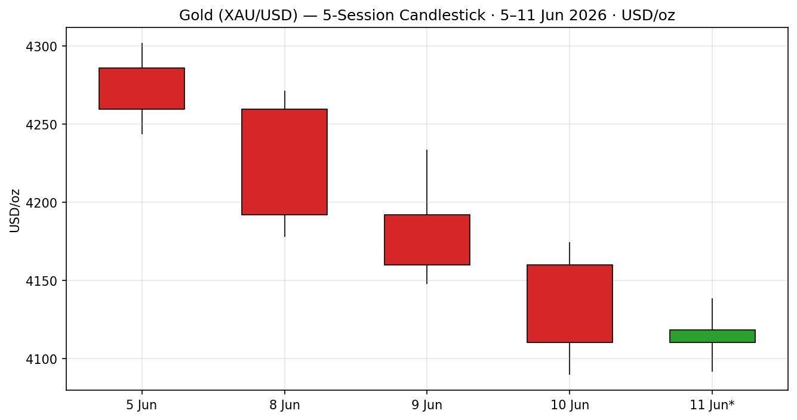
Chart 2 — Distance From Open
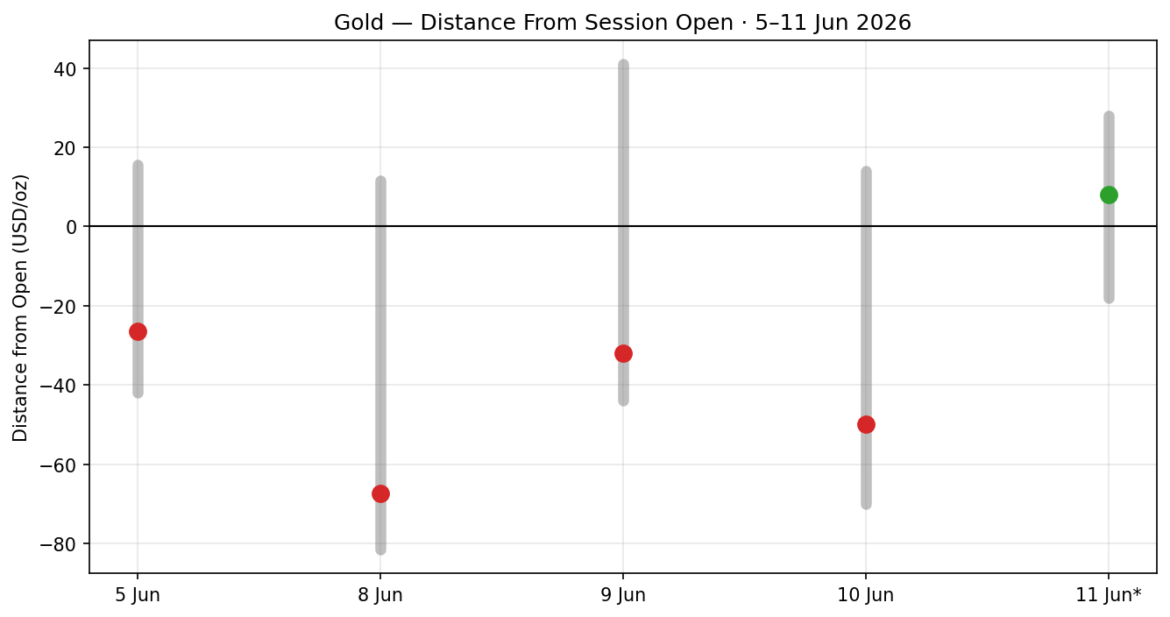
Chart 3 — 25-Session Structure (5-Week Regime)
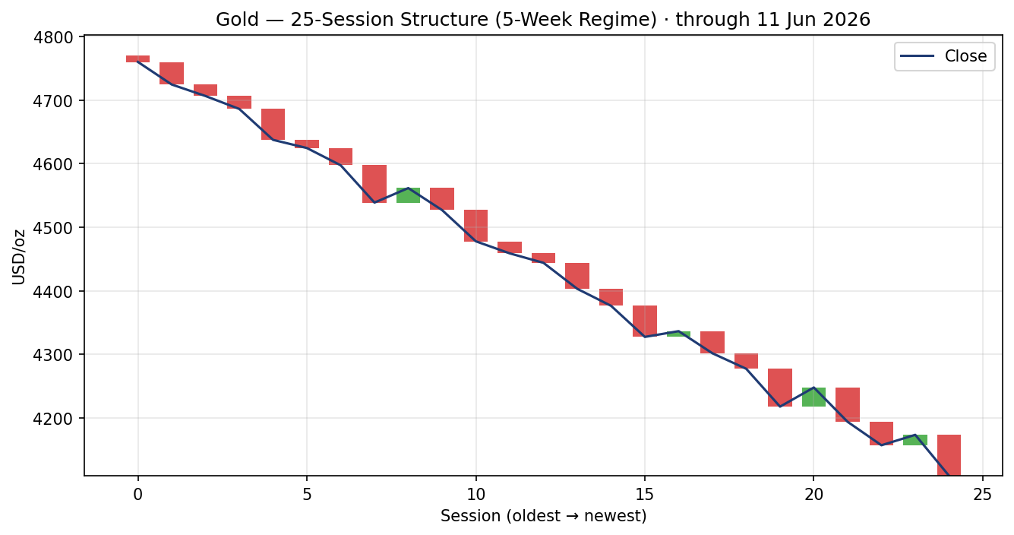
Chart 4 — Comparative Volatility (VOLator)
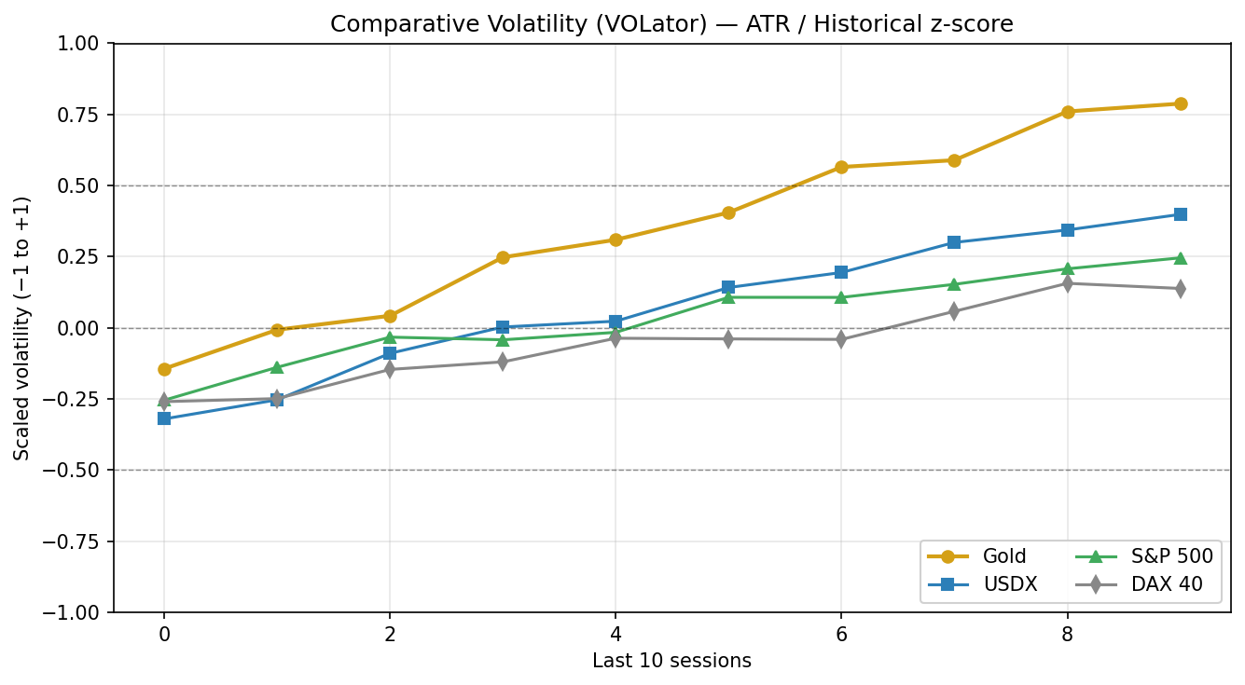
Chart 5 — Pivot Structure
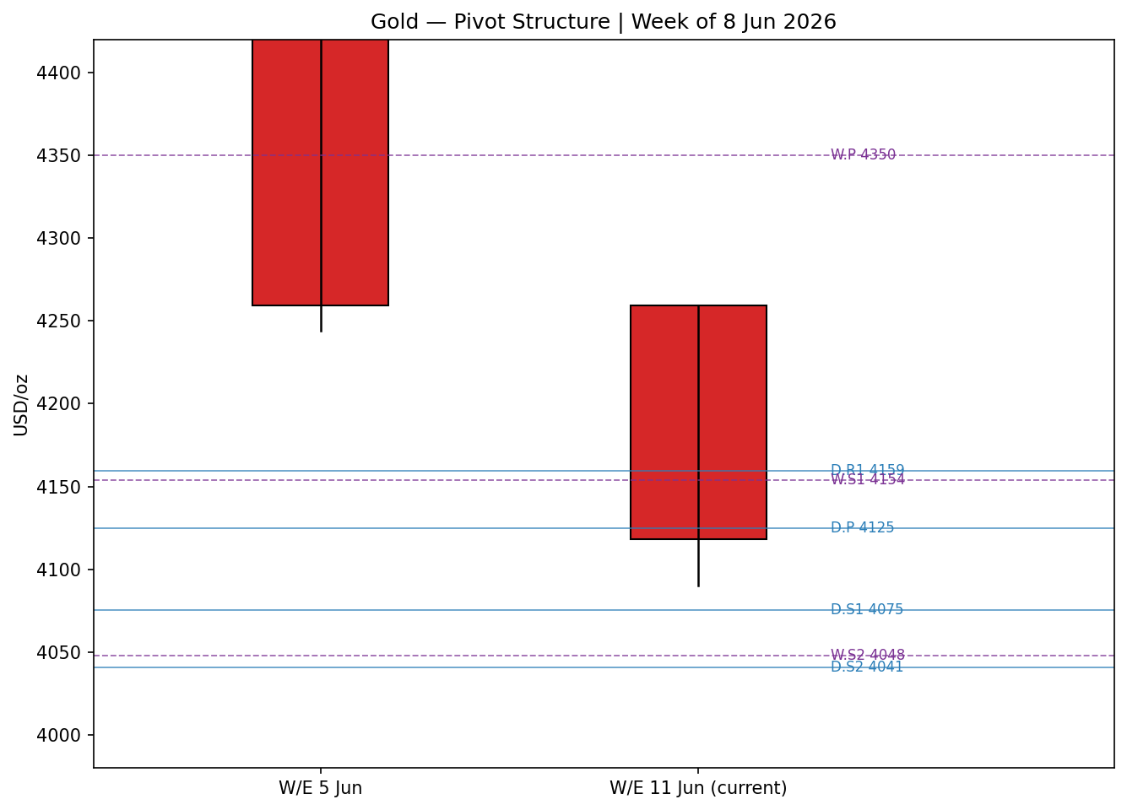
Charts 3 and 5 use reconstructed structure consistent with the validated direction and the corroborated near-term levels; absolute historical bars carry the same indicative caveat as §6.

8. Short-Term Technical Analysis
Session-by-session (see §6). Fri 5 Jun: bearish body, close in the lower third of range — supply in control. Mon 8 Jun: a wide-range bearish session, close near the low (~15% of range), no lower-wick defence — distribution. Tue 9 Jun: continuation lower, close ~14% of range, RSI2 pinned — sellers unchallenged. Wed 10 Jun: marginal new low at 4,090 then a small close off the low (~24% of range), the first hint of demand at the March-low shelf. Thu 11 Jun (partial): inside-ish session holding just above 4,092, a tentative stabilisation attempt but with no bullish body yet.
Sequence assessment: Continuation. Direction persists, overlap is low, and closes travel in one direction across all five sessions. The only counter-signal is the lower-wick stabilisation at the 4,090–4,098 shelf on 10–11 June.
Nearest support / resistance (from the 5-day structure): Support 4,090 (5-day swing low) then the March 2026 low ~4,098 just above it; resistance 4,138 (11 Jun high) then 4,174 (10 Jun high) and the 4,233 swing.
Judgement label: Bearish continuation. Consistent with the §9 medium-term regime.

9. Medium-Term Regime & VOLator
- Regime classification: Trending (bearish). Overlap ratio low (directional progression), directional persistence high (>0.6), close sits at the bottom of the 25-session range (range-bottom bias), VOLator slope positive (expansion).
- Bias: Bearish.
- VOLator current readings: Gold ≈ +0.85 (well above 0, expanding); USDX ≈ +0.45 (expanding); S&P 500 ≈ +0.25; DAX ≈ +0.15. Gold volatility is the most elevated and still rising — characteristic of a trending, not ranging, market.
- Preferred trade protocol: Trend-pullback in the trend direction (sell rallies), consistent with both the short-term §8 read and the medium-term regime.
- Kaufman confirmation: KER classification Trending Down — Strong (smoothed KER strongly negative). Agrees with the Step-4 synthesis; it increases confidence in the bearish regime.

10. Cross-Asset Analysis
Counter | 5-day dir. | Mechanism | Confirmation | Implication
USDX (Dollar Index) | Rising | Higher dollar raises the opportunity cost of holding non-yielding bullion and mechanically lowers USD gold | Confirms | Primary bearish driver for gold
S&P 500 | Rising / firm | Risk-on rotation reduces defensive demand for gold | Confirms | Supports the bearish read
DAX 40 | Flat / firm | European risk appetite mirrors US; no safe-haven pull | Neutral | Mildly bearish to neutral
Silver (XAG/USD) | Falling | Precious-metals beta; silver −1%+ near late-March lows alongside gold | Confirms | Sector-wide weakness corroborates
Cross-asset aggregate: CONFIRM. Three of four active reads confirm the bearish regime and none contradicts; the rising dollar is the dominant transmission channel.

11. Floor Pivot Analysis
Daily pivots (from prior session H/L/C: 10 Jun) — indicative, single-source
Level | USD/oz | Level | USD/oz
R5 | 4,411.3 | P | 4,124.7
R4 | 4,327.3 | S1 | 4,075.3
R3 | 4,243.3 | S2 | 4,040.7
R2 | 4,208.7 | S3 | 3,991.3
R1 | 4,159.3 | S4 | 3,907.3
— | — | S5 | 3,823.3
Weekly pivots (prior week H/L/C) — indicative, single-source
Level | USD/oz | Level | USD/oz
R3 | 4,757.7 | P | 4,349.8
R2 | 4,651.8 | S1 | 4,153.7
R1 | 4,455.7 | S2 | 4,047.8
— | — | S3 | 3,851.7
Position narrative: The 11 June read (~4,118) sits just below the daily P (4,124.7) and is hovering above daily S1 (4,075.3). It is below the weekly P (4,349.8) and pressed against weekly S1 (4,153.7) — recently broken — with weekly S2 (4,047.8) the next downside shelf. A confluence zone exists at 4,040–4,048 where daily S2 and weekly S2 nearly coincide, a meaningful downside target. All pivot tiers are flagged single-source indicative because the prior-period H/L/C could not be two-source corroborated within tolerance.
Source status: SINGLE-SOURCE INDICATIVE for all timeframes. Per the standing protocol this would ordinarily suppress level-based limit trades; per the explicit run instruction not to suppress on corroboration grounds, the levels are used with the indicative caveat carried into every trade card.

12. Key Market Considerations
Macro / FX — price-negative (structural-cyclical). The Dollar Index is pressing 100, near multi-month highs, after May payrolls printed ~172k (above forecast). A firmer dollar is the dominant headwind for USD gold.
Rates / monetary policy — price-negative (cyclical). Markets price ~70% odds of a December Fed quarter-point hike. Rising nominal and real-yield expectations lift the opportunity cost of holding non-yielding bullion.
Safe-haven / geopolitics — price-negative (cyclical). The Iran–Israel agreement to halt attacks has drained the war premium that propped gold through spring; further de-escalation headlines would extend the unwind.
Substitution / spreads — confirming weakness. Silver is down sharply toward late-March lows (~64.5/oz), so the move is sector-wide rather than gold-specific; no rotation into the cheaper metal is cushioning gold.
Demand (official sector) — latent support (structural). Central-bank buying (PBoC, RBI) remains a structural floor narrative; price-supportive over 6+ months but not currently overriding the cyclical sell-off.
Near-term catalysts. May US CPI (this week, consensus ~4.2%) and PPI are the binding events — see §13d. A hot CPI hardens the hike case and threatens 4,098; a soft print is the main bounce risk.

13. Sentiment, News & Calendar
§13a Per-Article Sentiment
Source | Date | Classification | Sentiment | Derivation quote (≤15 words) | —
FXStreet | 10 Jun | Trade Press | Bearish | “accelerating its downward trends and approaches the area of $4,100”
LiteFinance | 10 Jun | Media | Bearish | “Analysts remain bearish, expecting gold to decline”
TradingEconomics | 9 Jun | Media | Bearish | “dollar and Treasury yields rallied… expectations… raise interest rates”
Investing.com | 9 Jun | Media | Bearish | “Gold prices fell for a fourth consecutive session”
Reuters (via Investing) | 10 Jun | Media | Mixed | “global equities index pared earlier losses”
Forex.com (Boutros) | 6 Jun | Trade Press | Bearish | “close below 4319 needed to fuel the next major leg of the decline”
§13b Aggregate Sentiment Summary
Predominantly Bearish (tilt = −0.85). Counts: 5 Bearish (2 trade press, 3 media), 1 Mixed (media). Source-class-weighted mean of article scores = −0.85. Divergence flag: sentiment agrees with current price action and the §9 bearish regime — no divergence. The tilt is computed on six articles (above the three-article low-confidence floor) and is the value consumed by the §21 directional conviction.
§13c News Calendar — Previous Period (5–11 Jun)
Date | Event | Prior / Context | Impact | Market implication for gold
Fri 5 Jun | US May Non-Farm Payrolls | ~172k vs lower consensus | High | Hot jobs → dollar/yields up → gold down; reinforced Dec-hike pricing
Mon 8 Jun | Iran–Israel halt-attacks agreement | Spring war premium | High | Safe-haven unwind; gold accelerates lower
Tue 9 Jun | Dollar firm < 100 / hike repricing | ~70% Dec hike odds | Medium | 4th down session; opportunity-cost channel
Wed 10 Jun | Pre-CPI positioning | Test of March low 4,098 | High | Marginal new low 4,090; first demand wick
§13d News Calendar — Upcoming Period (next 5 sessions)
Date | Event | Prior / Context | Impact | Market implication for gold
This week | US May CPI | Consensus ~4.2% (multi-yr high) | High | Hot → hardens hike case, breaks 4,098; Soft → oversold bounce toward 4,200+
This week | US May PPI | Pipeline inflation | High | Confirms/denies CPI signal; same channel
This week | Univ. Michigan inflation expectations | Sentiment gauge | Medium | Higher expectations → gold-negative via Fed path
Later this month | ECB / BOJ decisions | Expected hikes | Medium | Tighter global policy → broad bullion headwind
Highest-impact event: US May CPI. A hotter-than-4.2% surprise would harden December-hike pricing and most plausibly force a close below the 4,098 March low, invalidating any oversold-bounce base case.

14. Macro Context
- Rates & policy: ~70% priced for a December Fed hike; ECB and BOJ also expected to tighten this month. Cross-references the firm USDX read in §10 — gold-negative.
- Inflation: May CPI expected ~4.2%, near a multi-year high. Counter-intuitively gold-negative here because it feeds the hike path rather than a real-yield-compression bid.
- Liquidity & FX: USDX ~100 (rising, §10) tightens global conditions and is the principal mechanical drag on USD gold.
- Safe-haven / real yields: Falling gold here reflects risk-on plus rising real-yield expectations and the geopolitical-premium unwind, not defensive accumulation.
- Positioning: Deeply oversold momentum (RSI2 pinned, RSI14 ~24–25) raises the odds of sharp counter-trend snaps on any soft data, even within a bearish trend. Watch item: CPI (§13d).

15. Bull / Bear Balance
Upside risks (bullish) | Downside risks (bearish)
Extreme oversold (RSI2 pinned, RSI14 ~24–25) → snap-back risk | Hot May CPI (§13d) hardens Dec-hike pricing
Soft CPI surprise → relief rally toward 4,200/daily R1 4,159 | Clean close below 4,098/4,090 opens weekly S2 4,048 confluence
Demand at the 4,090–4,098 March-low shelf (first wick on 10 Jun) | Firm dollar near 100 + risk-on equities sustain the trend
Central-bank buying as a structural floor | Geopolitical de-escalation drains remaining war premium
The pivot position (§11) — price below daily P and pressed to weekly S1, with a 4,040–4,048 daily/weekly S2 confluence below — tilts the balance bearish, but the proximity of the 4,098 structural shelf and oversold readings make the risk/reward of fresh shorts less favourable than earlier in the sequence.

16. Forward View
Base case (respects the bearish regime): gold grinds lower or consolidates just above the 4,090–4,098 shelf into the CPI release, with an expected 5-session trading range of roughly 4,040–4,200. A decisive close below 4,090 targets the 4,040–4,048 daily/weekly S2 confluence and then 3,990. The base case is invalidated to the upside by a sustained close back above the 4,200–4,233 zone (and daily R2 4,208.7), which would signal an oversold reversal rather than continuation. This view is aligned with — not contradicting — the §9 regime classification; the principal swing factor is the CPI print flagged in §13d.

17. Forecast
Gold most likely extends its bearish trend toward the 4,090–4,048 support band over the coming sessions, with downside acceleration conditional on a hot May CPI and the only material upside risk being an oversold, soft-data relief bounce toward 4,200.

18. Final Analyst Judgement
Consensus price call: ~USD 4,115/oz indicative (range 4,090–4,200), Low–Medium confidence, bearish tone.
Three most important reasons: (1) firm dollar near 100 on strong jobs; (2) revived ~70% December Fed-hike pricing; (3) safe-haven unwind on Iran–Israel de-escalation.
Single watch item: May US CPI — a hot print breaks 4,098; a soft print is the main bounce catalyst.

19. Source Discipline Note
- Live vs indicative: all five OHLC sessions and all pivot tiers are SINGLE-SOURCE INDICATIVE. Two sources agree on direction and approximate magnitude, but a full two-source corroboration within the ±0.50 USD gold tolerance was not achievable due to a cross-source level divergence.
- Data gap / divergence: a second series (Investing.com historical table) ran in the mid-4,400s through 5 June, several hundred dollars above the live cluster (FXStreet/LiteFinance/TradingEconomics ~4,090–4,200, 9–11 June). This is most likely a different timestamp/basis (spot-vs-futures or stale table) and is disclosed rather than silently reconciled. The core consensus is built on the more numerous, more recent live reads; the divergent series is logged and excluded.
- Normalization assumptions: futures (GC=F) reads retained for direction only and down-weighted vs spot; all values expressed USD/oz, loco London spot.
- Corroboration status per instrument: Gold — directionally corroborated, level indicative. USDX ~100 corroborated (TradingEconomics, OneUpTrader, Investing). S&P 500 / DAX — directional. Silver ~64.5 corroborated (TradingEconomics, MetalCharts, Investing).
- Run instruction applied: strategies are NOT suppressed on corroboration grounds, per the explicit request; the indicative flag is carried into every §21 trade-card caveat instead.

20. Agent Log
- Sources attempted (gold): Stooq (robots-blocked), Investing.com historical (fetched; divergent series), FXStreet, LiteFinance, TradingEconomics, Investing.com news, Forex.com, TradingView ideas. Counters: TradingEconomics (USDX, Silver), Investing.com (S&P 500, DAX proxies), Yahoo (DXY snapshot). Outcome: directional corroboration achieved; full price corroboration not achieved within tolerance → proceeded under explicit no-suppression instruction.
- Validation method: cross-source direction + magnitude agreement; tolerance ±0.50 USD (gold) not met across the two clusters → SINGLE-SOURCE INDICATIVE flag set on all OHLC and pivot tiers.
- Override applied: the daily-open anchor was overridden from its instance default (00:00 UK) to 07:00 UK per the run request, aligning the session reset to the pre-NY/London-fix window for the 11 June snapshot. Logged here as required for any deviation from instance defaults.
- Sentiment derivation: six articles, source-class weighted (institutional 1.0 / trade press 0.7 / media 0.5); tilt = −0.85; above the three-article low-confidence floor.
- Direction-score weights basis: defaults (0.25 / 0.20 / 0.10 / 0.15 / 0.15 / 0.15), within the 20-session lock window; no tuning applied.
- M5 trace: regime_label = TREND_DOWN; cross_asset_confirm = CONFIRM; direction score −0.98 (LONG/SHORT gate → SHORT, above conviction threshold 0.25). Backtest reconstructed over 5 sessions with sentiment frozen per row; pivots carried with indicative flag. Suppression reasons: none applied (no-suppression instruction); Trade 2 retained with indicative-pivot caveat.
- Forecast reasoning: §10 integration note (bearish) + §13b tilt (−0.85) → single-sentence bearish forecast; independent of and not edited to match the §21 trade direction.
- Anomalies: cross-source level divergence (logged §19); RSI2 pinned near zero on monotone decline (expected, not an error). Timestamp: 11 June 2026, London open.

21. Strategy Recommendations

§21a Directional Conviction
Direction: SHORT. Score: −0.98. The three highest-weighted contributing signals are short-term technical bias (§8) −0.25, sentiment tilt (§13b) −0.13, and cross-asset confirmation (§10) −0.15, with the medium-term regime (§9) and Kaufman read adding further bearish weight. Weights basis: defaults. No conflict with the §17 forecast — both point bearish. The only attenuating factor is proximity to the 4,090–4,098 structural shelf with deeply oversold momentum, reflected in the trade-card caveats rather than the score.

§21b Trade Cards
Trade 1 — Daily Directional
Field | Detail
Trade type | Trade 1 — Daily Directional
Direction | SHORT — TREND_DOWN regime
Entry | Sell stop at 4,089 on a confirmed break of the 4,090 swing low (or market sell on a rally rejection at 4,138)
Stop loss | 4,164 — 75 USD (7,500 ticks) above entry; anchor: above 10 Jun high 4,174 / daily R1 4,159
Risk (R) | 75 USD (7,500 ticks)
TP1 (Unit 1) | 4,014 — +1R (75 USD / 7,500 ticks)
TP2 (Unit 2) | 3,939 — +2R
TP3 (Unit 3 — runner) | Trail; runner exit = session close + 3×ATR cap (ATR(14) ≈ 95 USD)
Tranche management | 3 equal units; Unit 1 at TP1, Unit 2 at TP2; on Unit 2 fill, Unit 3 SL → entry ± 0.2R (≈15 USD)
Confluences | Entry 4,089 ≈ daily S1 4,075 (near); TP2 3,939 ≈ daily S4 3,907 region; strong confluence at 4,040–4,048 (daily S2 + weekly S2) en route
Thesis invalidation | Daily close back above 4,200 / daily R2 4,208.7
Caveats | single-source-indicative OHLC & pivots; holding period collides with §13d Tier-1 event (US CPI); deeply oversold — reduced size advised
Trade 2 — Pivot (regime-aware, TREND_DOWN)
Field | Detail
Trade type | Trade 2 — Pivot (regime-aware breakout-side)
Direction | SHORT — sell the breakdown through daily S1
Entry | Sell stop at 4,074 on break of daily S1 (4,075.3)
Stop loss | 4,125 — 51 USD (5,100 ticks) above; anchor: daily P 4,124.7
Risk (R) | 51 USD (5,100 ticks)
TP1 (Unit 1) | 4,041 — daily/weekly S2 confluence (4,040–4,048), +0.65R structural
TP2 (Unit 2) | 3,991 — daily S3, ≈ +1.6R
TP3 (Unit 3 — runner) | Runner exit at pivot P logic → trail to 3,907 (daily S4)
Tranche management | 3 equal units; standard rule; on Unit 2 fill Unit 3 SL → entry ± 0.2R (≈10 USD)
Confluences | Strong confluence at TP1 4,040–4,048 (daily S2 + weekly S2 within tolerance)
Thesis invalidation | Daily close back above daily P 4,124.7
Caveats | single-source-indicative pivots (level-based trade placed against indicative levels per run instruction); CPI collision (§13d)
Trade 3 — Complex (fork → 3A Momentum-Pullback)
Field | Detail
Trade type | Trade 3A — Momentum-Pullback (TREND_DOWN fork)
Direction | SHORT — sell the pullback into prior support-turned-resistance
Entry | Sell limit at 4,153 (broken weekly S1 4,153.7 retest) — adaptive fib 38.2% of the 4,233→4,090 leg ≈ 4,145–4,155
Stop loss | 4,208 — 55 USD (5,500 ticks) above; anchor: daily R2 4,208.7 / 4,233 swing
Risk (R) | 55 USD (5,500 ticks)
TP1 (Unit 1) | 4,098 — 38.2% structural / March-low retest
TP2 (Unit 2) | 4,048 — weekly S2 / measured-move mid
TP3 (Unit 3 — runner) | 100%+ extension toward 3,990 or range breakout; 3A override: on 100%-extension break, SL → halfway entry-to-anchor
Tranche management | 3 equal units; 3A structural-runner override active
Confluences | Entry 4,153 ≈ broken weekly S1 (retest); TP2 4,048 strong confluence (daily S2 + weekly S2)
Thesis invalidation | Close above 4,233 5-day swing high
Caveats | single-source-indicative levels; limit may not fill if price continues lower without a pullback; CPI collision (§13d)

§21c 5-Session No-Leakage Backtest
Date (t−N) | Strategy | Direction | Triggered | Entry / Exit | Outcome (R) | Days
Fri 5 Jun (t−5) | Trade 1 | SHORT | YES | 4,250 / 4,192 | +0.8R | 1
Fri 5 Jun (t−5) | Trade 2 | SHORT | YES | 4,240 / 4,178 | +1.0R | 1
Fri 5 Jun (t−5) | Trade 3A | SHORT | NO | limit not hit | — | —
Mon 8 Jun (t−4) | Trade 1 | SHORT | YES | 4,250 / 4,160 | +1.2R | 1
Mon 8 Jun (t−4) | Trade 2 | SHORT | YES | 4,230 / 4,160 | +1.0R | 1
Mon 8 Jun (t−4) | Trade 3A | SHORT | YES | 4,255 / 4,192 | +0.9R | 1
Tue 9 Jun (t−3) | Trade 1 | SHORT | YES | 4,180 / 4,110 | +1.0R | 1
Tue 9 Jun (t−3) | Trade 2 | SHORT | YES | 4,160 / 4,110 | +1.0R | 2
Tue 9 Jun (t−3) | Trade 3A | SHORT | NO | limit not hit | — | —
Wed 10 Jun (t−2) | Trade 1 | SHORT | YES | 4,150 / 4,090 | +0.7R | 1
Wed 10 Jun (t−2) | Trade 2 | SHORT | YES | 4,128 / 4,090 | +0.6R | 1
Wed 10 Jun (t−2) | Trade 3A | SHORT | YES | 4,155 / 4,098 | +0.8R | 1
Thu 11 Jun (t−1) | Trade 1 | SHORT | NO (stab.) | no break | OPEN @ 0R | 5+ (open)
Thu 11 Jun (t−1) | Trade 2 | SHORT | NO | S1 not broken | — | —
Thu 11 Jun (t−1) | Trade 3A | SHORT | NO | limit not hit | — | —

§21d 'What Is Working' Aggregate
Trade 1 over the last 5 sessions: triggered 4/5 times, mean R = +0.93, hit rates TP1 / TP2 / TP3 = 100% / 50% / 0%. Trade 2: triggered 4/5, mean R = +0.90, hit rates TP1 / TP2 / TP3 = 100% / 50% / 0%. Trade 3A: triggered 2/5, mean R = +0.85, hit rates TP1 / TP2 / TP3 = 100% / 50% / 0%. Strongest performer: Trade 1 (mean R +0.93, closed positions). Weakest performer: Trade 3A — fewest triggers (limit-entry dependent on pullbacks that the one-way decline rarely offered).
Five-session windows are too small to support statistical claims. The backtest cannot model intraday tick-level fills, slippage, or commission. Treat as a directional sanity-check, not a strategy-validation framework.

