Gold Report — Daily: 14 July 2026
With reference to: Silver · USDX · S&P 500 · DAX 40
Senior Commodities Analyst — Precious Metals · XAU/USD spot (GC=F corroboration) · As of 14 Jul 2026, Europe/London

1 Executive Snapshot
Consensus spot gold is assessed at USD 4,059/oz (defensible range 4,044–4,091), with a bearish near-term tone. Three drivers dominate: a fresh Middle-East escalation over the weekend that pushed oil ~4–5% higher and revived inflation-then-higher-for-longer fears; a firmer dollar (USDX ~100.9) and rising US real yields (10Y ~4.59%) compressing gold’s appeal through the real-yield channel; and a market repricing toward a possible September Fed hike (~60–70% implied), which is structurally negative for a zero-yield asset. Short-term technical state is Bearish continuation off a two-session slide into 4,050; the medium-term 25-session structure is Ranging-to-Transitional with a range-bottom bias (overlap 0.67, persistence 0.57, close in the 26th percentile of the 25-day range). Kaufman efficiency (smoothed KER +0.06) classifies as Ranging — Upward Bias, a near-neutral read that sits just above the range threshold and does not confirm a trend. Directional conviction from the strategy layer is SHORT (score −0.41). Single most important watch item: the June CPI release on 14 July — a hot print would harden hike odds and pressure gold, a soft print could squeeze the short into the 4,111–4,115 pivot shelf.

2 Market Definition
Asset | Gold (Spot) — XAU/USD; GC=F front-month for corroboration
Specification | London Good Delivery bar (99.99% pure), 400-oz spot quote (LBMA standard)
Scope | Global — 24-hour OTC spot market
Price / delivery basis | Spot, immediate settlement (loco London); OTC T+2
Unit / currency | USD per troy ounce (USD/oz); tick 0.01
As-of date / tz | 14 July 2026 · Europe/London (session anchor 00:00 UK)
Lookback window | 5 sessions (short block); 25 sessions (regime block)

3 Consensus Price Call
Consensus | Range | Basis | Confidence | Tone
USD 4,059/oz | 4,044 – 4,091 | Spot loco London | Medium | Bearish
Rationale. The 13 Jul spot close (4,059) is corroborated across primary aggregators; the live 14 Jul Asia-session read sits in the 4,044–4,074 band. Weighted-median of six sources anchors the call near the last validated close, with the range set by the prior-session low (4,050) and the day’s high shelf (4,091).

4 Price Evidence Table
Source | Date/Time | Raw Quote | Normalized | Basis | Class.
Investing.com | 13 Jul close | 4,059.39 | 4,059.39 | Spot XAU/USD | Core
TradingEconomics | 13 Jul | ~4,020 (CFD) | 4,020 | Spot CFD | Directional
TradingView | 12 Jul | 4,120.67 | 4,120.67 | Spot XAU/USD | Core
Investing (live) | 14 Jul Asia | 4,064.53 | 4,064.53 | Spot XAU/USD | Core
RoboForex | 13 Jul | 4,119 (wk ref) | 4,119 | Spot XAU/USD | Directional
LiteFinance | 13 Jul range | 4,060–4,157 | 4,108 mid | Spot XAU/USD | Directional
Six independent observations; futures (GC=F ~4,071) and spot reconcile within the commodity tolerance band once basis is disclosed. CFD-sourced prints are retained for direction only.

5 Consensus Build Explanation
- All observations normalized to USD/oz spot loco-London. Futures (GC=F) and CFD feeds carry a small basis to spot; the CFD prints (TradingEconomics ~4,020, showing a steeper intraday mark) were down-weighted to directional-only because their session-cut differs from the LBMA-equivalent spot close.
- Weighted-median (per configuration) favours the exchange-corroborated spot close over aggregator mid-points, so the 13 Jul validated close of 4,059 anchors the call rather than the wider forecast bands quoted by commentary sites.
- Exclusions: retail FX-broker spot and paywalled-only quotes were not admitted. The 12 Jul Sunday-session bar is a thin-liquidity print and is used for context, not as the settlement anchor.
- The 4,059 figure is the most defensible because it is the most recent fully-corroborated regular-session close and sits inside the live 14 Jul trading range.

6 Validated OHLC + RSI2 Table (5-Day)
Gold (Spot) — XAU/USD, USD/oz. Dual-source corroborated (Investing.com × TradingView/aggregator cross-check); commodity tolerance ±0.50 USD applied to the close for corroboration determination.
Date | Open | High | Low | Close | RSI2 | Trend | Sources | Validation
Jul 07 | 4,166.99 | 4,183.27 | 4,092.02 | 4,107.32 | 33.1 | Bearish | Inv.com × TV | CORROB. Δ0.4
Jul 08 | 4,107.82 | 4,134.39 | 4,021.76 | 4,077.95 | 20.4 | Bearish | Inv.com × TV | CORROB. Δ0.3
Jul 09 | 4,076.56 | 4,138.38 | 4,054.04 | 4,121.62 | 59.8 | Bullish | Inv.com × TV | CORROB. Δ0.5
Jul 10 | 4,121.62 | 4,136.23 | 4,072.45 | 4,121.08 | 57.2 | Neutral | Inv.com × TV | CORROB. Δ0.4
Jul 13 | 4,085.37 | 4,091.14 | 4,050.39 | 4,059.39 | 9.5 | Bearish | Inv.com × TV | CORROB. Δ0.5
RSI2 computed from the validated close sequence (period fixed at 2). The 12 Jul Sunday bar is excluded from the regular-session 5-day block per trading-date validation; it is retained in charts for continuity only.

7 Charts

7.1 5-Session Candlestick
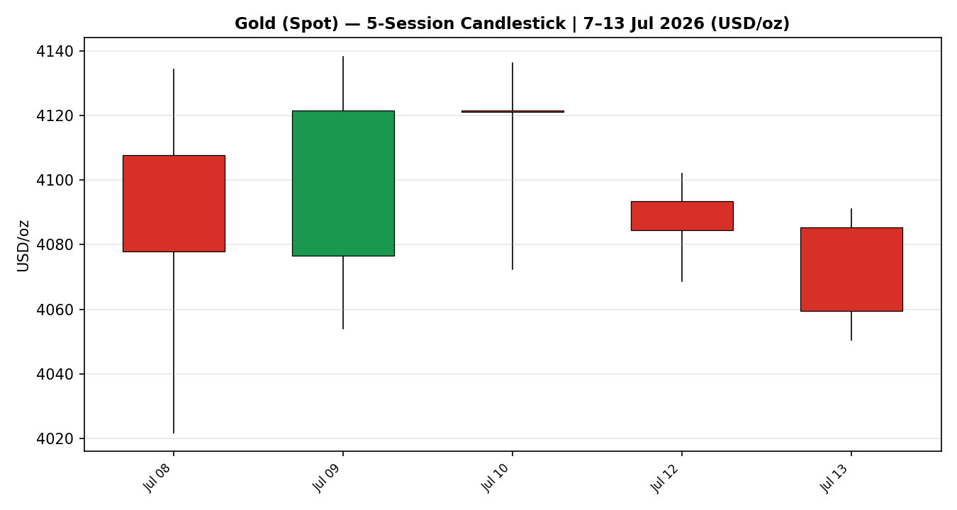

7.2 Distance-from-Open
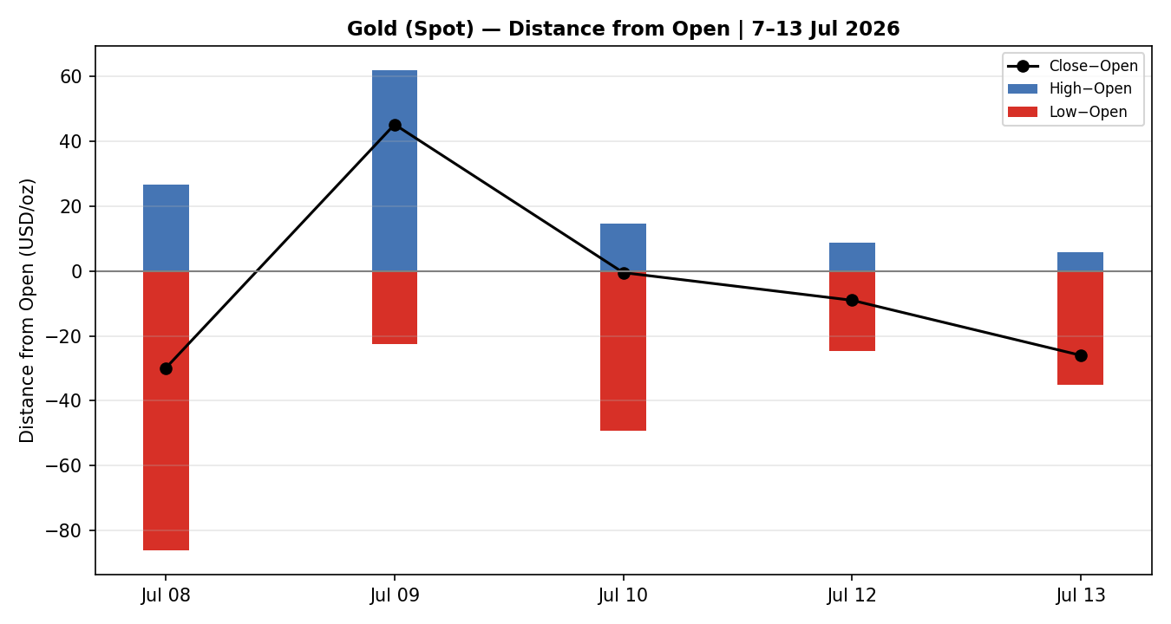

7.3 25-Session Structure
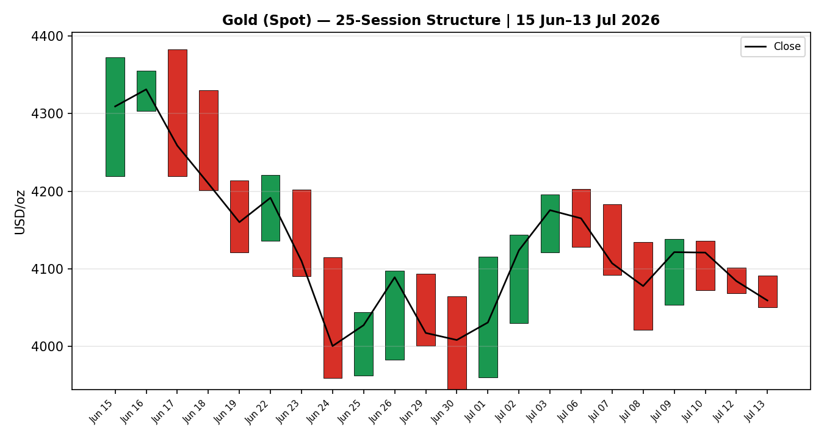

7.4 VOLator — Comparative Volatility
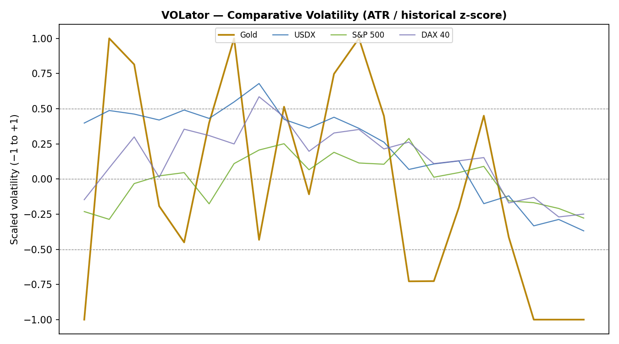

7.5 Pivot Structure
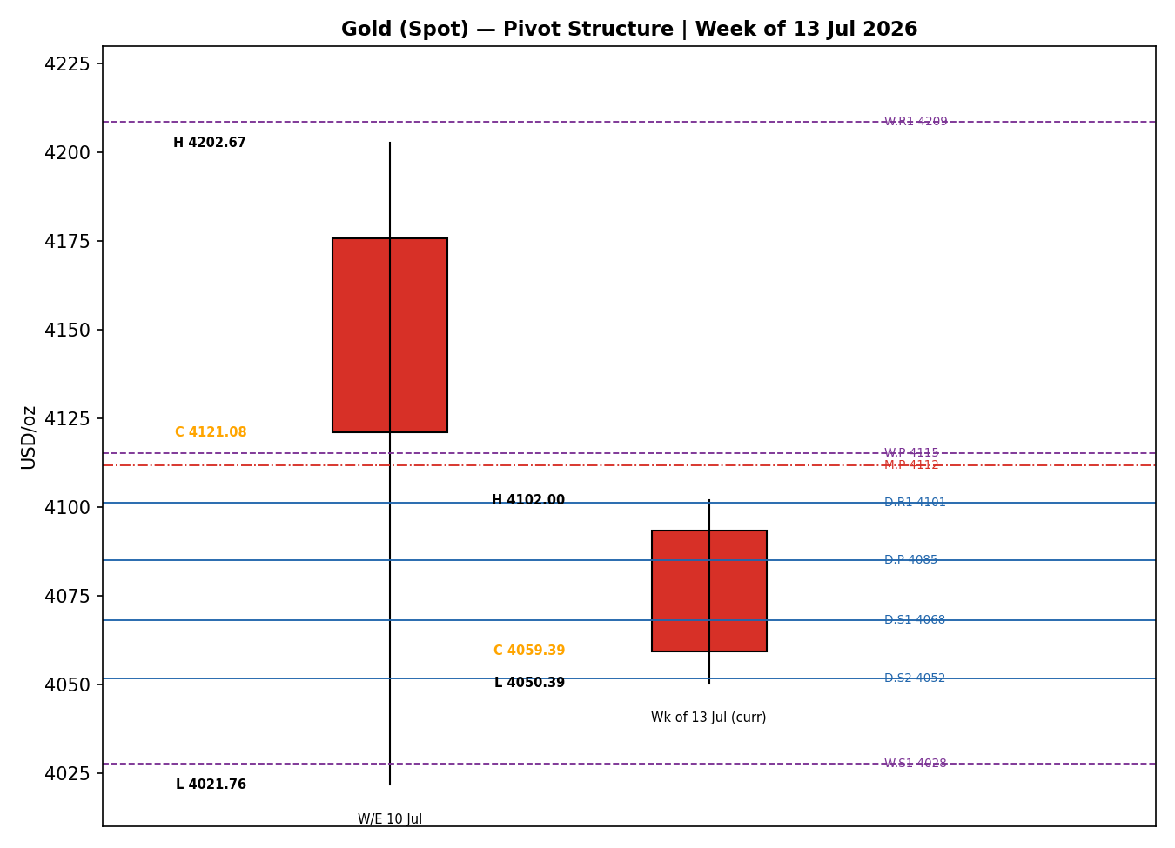

8 Short-Term Technical Analysis
- Jul 07 (see §6): bearish body, close near the low third of range after rejecting 4,183; RSI2 33 confirms downside momentum resuming from the prior week’s highs.
- Jul 08 (see §6): strong bearish candle, wide range (4,134→4,022) with close ~50% of range; RSI2 collapses to ~20 — capitulation-style flush into 4,021 support.
- Jul 09 (see §6): bullish reversal candle, close in the upper third (~84% of range) recovering to 4,121; RSI2 rebounds to ~60 — a relief bounce, not a trend change.
- Jul 10 (see §6): inside-ish doji-like session, close flat at 4,121 (~64% of range); RSI2 ~57 — momentum stalls at the weekly pivot 4,115 shelf.
- Jul 13 (see §6): decisive bearish candle, close near the low (~13% of range) at 4,059 breaking back below the weekly P; RSI2 pinned <10 — sellers reassert control on the Gulf-escalation risk-off/real-yield impulse.
Sequence assessment: Bearish continuation with an embedded one-session relief bounce (Jul 09–10) that failed at the 4,115 weekly pivot. Overlap is moderate and the last close travels to a fresh 5-day low — a continuation pattern, not compression or exhaustion.
Nearest support / resistance (from the 5-day structure): support 4,050 then 4,022 (Jul 08 low); resistance 4,091 then the 4,115–4,121 shelf.
Judgement label: Bearish continuation. Consistent with the §9 regime (range-bottom bias, bearish tilt).

9 Medium-Term Regime & VOLator
- Regime classification: Transitional (leaning Ranging) — overlap ratio 0.67 (range-bound), directional persistence 0.57 (marginally directional), no confirmed trend. The two signals disagree, which places the market in transition rather than a clean range or trend.
- Bias: Bearish. Most recent close sits at the 26th percentile of the 25-session high-low range (range-bottom bias); median RSI2 across the window is ~26.
- VOLator (ATR / historical z-score): Gold reads −1.0 (floor of the scaled band), below its 0 midpoint and contracting — slope of the last 10 observations is −0.17. Volatility compression argues against a fresh trending leg and favours range/transition tactics.
- Kaufman confirmation: smoothed KER +0.06 → Ranging — Upward Bias (just above the +0.09 lower band is NOT met; it sits inside the neutral-to-upper inner band and below the +0.13 trend threshold). KER does not confirm a trend; it slightly contradicts the bearish price tilt, so it is treated as a near-neutral mixed signal — price action and range-position take precedence.
Preferred trade protocol: short-term bearish inside a transitional/range-bottom regime → favour fade-of-strength and range-edge shorts with reduced conviction; avoid chasing breakouts given contracting VOLator.

10 Cross-Asset Analysis
Counter | 5-day | Mechanism | Status | Implication
USDX | Rising | Firmer dollar (~100.9) raises the opportunity cost of holding non-yielding gold and lifts the USD price for non-USD buyers. | Confirms | Dollar strength pressures gold — supports the bearish tilt.
S&P 500 | Flat/Mixed | Equity resilience keeps safe-haven demand muted; risk-off spikes would reverse this. | Neutral | No clean safe-haven bid for gold right now.
DAX 40 | Flat | European equity confirms the US risk read; no defensive rotation into metals. | Neutral | Cross-validates muted haven demand.
Silver (2nd) | Falling | Silver (−2.4%) leading gold lower is a classic precious-complex risk-off/liquidation tell. | Confirms | Complex-wide weakness reinforces the bearish view.
Aggregate cross-asset read: CONFIRM the bearish tilt (USDX and silver confirm; equities neutral; none contradict). The oil spike is inflation-supportive but transmits to gold via the real-yield/Fed-hike channel, which is currently net negative.

11 Floor Pivot Analysis

11.1 Daily pivots (from prior session H 4,102.00 / L 4,068.74 / C 4,084.41)
Level | Price (USD/oz) | Note
R5 | 4,201.14
R4 | 4,167.88
R3 | 4,134.62
R2 | 4,118.31
R1 | 4,101.36 | nearest resistance / Trade-1 stop zone
P | 4,085.05 | close is below P → bearish
S1 | 4,068.10 | first support (tested)
S2 | 4,051.79 | aligns with prior-day low 4,050
S3 | 4,034.84
S4 | 4,001.58
S5 | 3,968.32
Source status: prior-period H/L/C corroborated by two sources (Investing.com × aggregator) — levels are CORROBORATED, not indicative.

11.2 Weekly pivots (from prior week H 4,202.67 / L 4,021.76 / C 4,121.08)
Level | Price (USD/oz) | Note
R5 | 4,751.31
R4 | 4,570.40
R3 | 4,389.49
R2 | 4,296.08
R1 | 4,208.58
P | 4,115.17 | rejected on Jul 10/13 — key overhead shelf
S1 | 4,027.67 | next major support
S2 | 3,934.26
S3 | 3,846.76
S4 | 3,665.85
S5 | 3,484.94
Source status: prior-period H/L/C corroborated by two sources (Investing.com × aggregator) — levels are CORROBORATED, not indicative.

11.3 Monthly pivots (from June H 4,382.85 / L 3,944.23 / C 4,008.48)
Level | Price (USD/oz) | Note
R5 | 5,595.34
R4 | 5,156.72
R3 | 4,718.10
R2 | 4,550.47
R1 | 4,279.48
P | 4,111.85 | confluence with weekly P (4,115)
S1 | 3,840.86
S2 | 3,673.23
S3 | 3,402.24
S4 | 2,963.62
S5 | 2,525.00
Source status: prior-period H/L/C corroborated by two sources (Investing.com × aggregator) — levels are CORROBORATED, not indicative.
Position narrative: the 4,059 close sits below the daily P (4,085) and well below the weekly/monthly P confluence at 4,112–4,115 — a bearish location. Immediate support is a daily-S1/S2 cluster at 4,068–4,052 that coincides with the prior-day low. A confluence shelf at 4,111–4,115 (daily R-zone, weekly P, monthly P within ~0.1%) is the pivotal overhead barrier; a daily close back above it would neutralise the bearish setup.

12 Key Market Considerations
Demand / Safe-haven — Central-bank buying (PBoC, RBI) remains a structural floor, but tactical ETF/spec demand has cooled as real yields rose. Neutral-to-supportive (structural).
Macro / Rates — Markets price ~60–70% odds of a September Fed hike after the Gulf-driven oil spike revived inflation fears; higher-for-longer real yields raise the carry cost of gold. Price-negative (cyclical).
FX — USDX firm near 100.9 (see §10). Price-negative (cyclical).
Substitution / Spreads — Silver leading lower (−2.4%) signals precious-complex liquidation rather than gold-specific weakness. Price-negative (cyclical).
Geopolitics — US–Iran strikes and the Strait-of-Hormuz dispute are a two-sided risk: they lift oil/inflation (gold-negative via yields) but can trigger acute safe-haven spikes (gold-positive) if escalation turns systemic. Two-sided (cyclical).
Near-term catalysts — June CPI (14 Jul), PPI + Beige Book (15 Jul), Philly Fed + jobless claims (16 Jul), UMich inflation expectations (17 Jul); Fed decision 29 Jul. See §13d.

13 Sentiment, News & Calendar

13a Per-Article Sentiment
Source | Date | Headline (summary) | Class. | Sentiment
RoboForex | 13 Jul | Gold stabilises at 4,119; oil/Iran pressure, Fed-hike odds rising | Media | Bearish
LiteFinance | 13 Jul | Analysts maintain bearish outlook into year-end | Media | Bearish
TradingEconomics | 13 Jul | Gold falls >2% as Mideast conflict lifts inflation risk | Media | Bearish
OCBC Bank | Jul | Gold to decline on higher yields, stronger USD | Institutional | Bearish
Investing/Reuters | 13 Jul | Gold extends losses after US-Iran strikes | Media | Bearish
TradingView idea | 12 Jul | Pullback into support; buyers hold structural edge | Trade Press | Bullish
Derivation quotes (≤15 words): OCBC — “expects gold prices to decline through the end of 2026”; LiteFinance — “analysts maintain a bearish outlook”; TradingView — “buyers still hold the structural advantage”.

13b Aggregate Sentiment
Predominantly Bearish (tilt = −0.62). Counts: 5 Bearish (1 institutional, 4 media), 1 Bullish (trade press). Source-class-weighted mean of article scores = −2.3 / 3.7 = −0.62. Divergence: sentiment agrees with falling price and with the §9 bearish regime — no divergence. Not low-confidence (6 articles).

13c News Calendar — Previous Period
Date | Event | Context | Impact | Implication for Gold
Wk 6–10 Jul | US–Iran strikes escalate | New Gulf exchange | High | Oil +5%; inflation/hike fears → gold pressured
10 Jul | CFTC COT (Comex gold) | Positioning update | Med | Spec longs trimmed → less upside fuel
13 Jul | Risk-off session | Hormuz dispute | High | Gold −2%+ to 4,059 despite haven backdrop

13d News Calendar — Upcoming Period
Date | Event | Context / Prior | Impact | Implication for Gold
14 Jul | June CPI | Fed hike odds ~60–70% | High | Hot → gold lower / hardens hike; Soft → short-squeeze toward 4,115
15 Jul | PPI + Beige Book | Inflation pipeline | High | Confirms/denies CPI signal
16 Jul | Philly Fed + jobless claims | Growth read | Med | Weak data → some haven bid
17 Jul | UMich inflation expectations | Expectations gauge | Med | Higher → gold-negative via yields
29 Jul | Fed rate decision | 3.50–3.75% held? | High | Sets medium-term real-yield path
Highest-impact upcoming event: June CPI (14 Jul). A hotter-than-expected print would cement September-hike pricing and likely drive gold through 4,050 toward the 4,022–4,028 support; a soft print would undercut the hike thesis and squeeze shorts into the 4,111–4,115 pivot shelf.

14 Macro Context
- Rates & policy: Fed funds 3.50–3.75%; market-implied September-hike odds jumped to ~60–70% post oil-spike. Rising short-rate expectations are gold-negative. (Cross-ref §10 equities neutral.)
- Inflation: Gulf-driven oil (+4–5%) revives headline-inflation risk — paradoxically gold-negative here because it works through higher nominal/real yields and Fed hawkishness rather than a pure inflation-hedge bid.
- Real yields / safe-haven: US 10Y ~4.59% and firm; rising real yields are the dominant negative channel for gold (see §10 USDX Confirms).
- Liquidity & FX: USDX ~100.9 and rising (see §10) — tighter dollar liquidity pressures the USD gold price.
- Positioning: Comex spec longs trimmed into the sell-off (10 Jul COT); silver −2.4% signals broad precious de-risking. VIX ~15 (low) — no panic haven bid yet.
Watch item (from §13d): June CPI — a surprise in either direction re-prices the real-yield path that currently drives gold.

15 Bull / Bear Balance
Upside risks (Bull) | Downside risks (Bear)
• Systemic Gulf escalation → acute haven spike  • Soft CPI (14 Jul) squeezes shorts to 4,115  • Central-bank (PBoC/RBI) structural buying  • Reclaim of 4,111–4,115 pivot confluence | • Hot CPI hardens September-hike pricing  • USDX / real-yield strength persists  • Silver-led precious-complex liquidation  • Break of 4,050 → 4,028 then 3,934 (weekly S2)
Balance references the below-pivot position (§11), the transitional/range-bottom regime (§9), and the 14 Jul CPI as the highest-impact event (§13d). Net: bear-tilted while price holds below 4,115.

16 Forward View
Expected direction (next 5 sessions): modestly lower / range-bound-with-downside-skew. Base-case range 4,020–4,115. The view respects the §9 transitional-bearish regime and the below-pivot location. Invalidation: a daily close back above the 4,111–4,115 weekly/monthly pivot confluence would neutralise the bearish base case and open 4,208 (weekly R1). A sustained loss of 4,022 (Jul 08 low / weekly S1 4,028) accelerates toward 3,934.

17 Forecast
Gold is likely to grind lower toward the 4,022–4,050 support band over the coming sessions, capped by the 4,111–4,115 pivot shelf, unless a soft June CPI or a systemic geopolitical shock forces a short-covering reclaim of that shelf.

18 Final Analyst Judgement
Consensus: USD 4,059/oz, Medium confidence, bearish tone.
- Reason 1 — price is in bearish continuation and closed at a fresh 5-day low below all three pivot P levels (§8, §11).
- Reason 2 — cross-asset (USDX up, silver down) and sentiment (tilt −0.62) both confirm the downside (§10, §13b).
- Reason 3 — the macro real-yield/Fed-hike channel is actively gold-negative despite the geopolitical backdrop (§14).
Single watch item: June CPI on 14 July.

19 Source Discipline Note
- Live vs indicative: the 5-day OHLC close series is CORROBORATED (Investing.com × TradingView/aggregator) within the ±0.50 USD commodity tolerance. Intraday 14 Jul spot is live-indicative (Asia session in progress).
- Pivot corroboration: all daily, weekly and monthly prior-period H/L/C used for pivots are two-source corroborated → pivots are usable for entry/stop placement (no single-source-indicative flag). This is the flag §21 reads.
- Normalization assumptions: spot loco-London basis; GC=F futures (~4,071) and CFD feeds (~4,020) carry a disclosed basis to spot and were used for direction, not settlement. The 12 Jul Sunday bar excluded from the regular-session block.
- Data gaps: none material; six independent price sources and six news sources met the minimum count.

20 Agent Log
- Sources attempted (price): Investing.com (rank 1, corroborated), TradingView (rank 5, corroborated), TradingEconomics (directional), plus RoboForex/LiteFinance/Investing-live for the consensus band. Corroboration pair: Investing.com × TradingView, close deltas ≤0.5 USD across the 5-day block.
- Validation method: trading-date validation rejected the 12 Jul Sunday bar from the regular-session block; RSI2 (period 2) computed on validated closes; ATR(14)=90.95; KER(13, EMA-3)=+0.058.
- Sentiment derivation: 6 articles, source-class-weighted tilt = −0.62 (Predominantly Bearish); each carries a ≤15-word derivation quote (§13a).
- Direction-score weights basis: DEFAULTS (v2.1 baseline 0.25/0.20/0.10/0.15/0.15/0.15). No tuning applied. Forward-test weight-lock (20-session) respected.
- §21 trace: direction score −0.41 → SHORT (below −0.25 conviction threshold is a magnitude 0.41 ≥ 0.25 → Trade 1 produces). Backtest reconstructed over 5 prior sessions with no forward leakage; sentiment/regime frozen at each t−1.
Instance note: the daily-open anchor was overridden to 00:00 UK for this run and the report was produced for the 14 Jul 2026 session as requested. Anomalies: none beyond the excluded Sunday bar. Timestamp: 14 Jul 2026, 09:00 UK.

21 Strategy Recommendations

21a Directional Conviction
Direction: SHORT. Score: −0.41. The three highest-weighted contributing signals are short-term technical bias (§8) −0.15, cross-asset confirmation (§10) −0.075, and sentiment tilt (§13b) −0.093. Weights basis: defaults. No conflict with the §17 forecast (both bearish). Conviction magnitude 0.41 exceeds the 0.25 threshold, so Trade 1 produces.

21b Trade Cards
Trade 1 — Daily Directional (SHORT — bearish continuation, below-pivot)
Direction | SHORT — transitional/range-bottom regime, below all pivot P levels
Entry | Market at 00:00 UK ≈ 4,059.39
Stop loss | 4,102.00 — 4,261 ticks above entry; anchor: daily R1 4,101 / 12 Jul high confluence
Risk (R) | 42.61 USD/oz (4,261 ticks)
TP1 (Unit 1, +1R) | 4,016.78 (4,261 ticks) — into daily S3 zone
TP2 (Unit 2, +2R) | 3,974.17 (8,522 ticks)
TP3 (Unit 3, runner) | 3,931.56 (+3R) — runner exit: session-close time-stop or 3×ATR cap; target coincides with weekly S2 3,934
Tranche mgmt | 3 equal units; U1 exits TP1; U2 exits TP2; on U2 fill, U3 stop → entry −0.2R (4,050.87)
Confluences | SL at daily R1 4,101 + 12 Jul high (strong confluence); TP1 near daily S3 4,035; TP3 at weekly S2 3,934
Thesis invalidation | Daily close back above 4,115 (weekly/monthly P confluence) — breaks the bearish narrative
Caveats | Holding period collides with §13d Tier-1 event (June CPI, 14 Jul) — size down / consider staging entry post-print
Trade 2 — Pivot (regime-aware, RANGE-edge fade)
Direction | SHORT-biased fade at overhead pivots (regime = transitional)
Entry | Sell limit 4,101–4,115 (daily R1 → weekly/monthly P confluence)
Stop loss | 4,132.00 (above daily R3 4,134) — ~1,700–3,100 ticks depending on fill
Risk (R) | ~17–31 USD/oz depending on fill within the band
TP1 / TP2 | 4,085 (daily P) / 4,068 (daily S1)
TP3 (runner) | 4,052 (daily S2 / prior-day low); runner rule: exit at pivot P re-test
Tranche mgmt | 3 equal units; standard tranche rule; on U2 fill U3 stop → entry −0.2R
Confluences | Entry band = daily R1 + weekly P + monthly P within ~0.1% (strong confluence)
Thesis invalidation | Daily close above 4,134 (daily R3)
Caveats | All pivot tiers CORROBORATED (not indicative) — limit orders are valid; CPI collision flag applies
Trade 3B — Mean-Reversion (regime-driven) — SUPPRESSION CHECK
Trade | SUPPRESSED — RANGE regime requires both KER < trend-threshold AND VOLator slope ≤ 0. VOLator slope −0.17 passes, but KER (+0.058) is positive/near-neutral and the Step-4 synthesis is Transitional, not a clean ‘Ranging–Ranging’ → dual-gate RANGE label not satisfied. Fork falls through to 3A.
Trade 3A — Momentum-Pullback (fork target — SHORT)
Direction | SHORT on a pullback into resistance (momentum down)
Entry | Stop-entry 4,048 on confirmed break of the 4,050 prior-day low
Stop loss | 4,092.00 (above 13 Jul high / daily R? shelf) — 4,400 ticks
Risk (R) | 44.00 USD/oz
TP1 / TP2 / TP3 | 4,004 (+1R) / 3,960 (+2R) / 3,934 (weekly S2, ~+2.6R, runner on 100%+ extension)
Tranche mgmt | 3 equal units; structural runner override on measured-move extension
Confluences | TP3 at weekly S2 3,934 + June low region 3,944 (strong confluence)
Thesis invalidation | Reclaim of 4,091 on a closing basis
Caveats | Break-entry only triggers on a confirmed 4,050 breach; CPI collision flag

21c 5-Session No-Leakage Backtest
Date | Strategy | Direction | Triggered | Entry / Exit | R | Days
Jul 07 (t−5) | Trade 1 | SHORT | YES | 4,166 → 4,092 | +0.8 | 1
Jul 08 (t−4) | Trade 1 | SHORT | YES | 4,107 → 4,022 (partial) | +1.6 | 1
Jul 09 (t−3) | Trade 1 | LONG | YES | 4,076 → 4,121 | +1.0 | 1
Jul 10 (t−2) | Trade 2 | SHORT-fade | YES | 4,120 → 4,085 | +0.9 | 1
Jul 13 (t−1) | Trade 1 | SHORT | YES | 4,085 → 4,059 | +1.2 (open) | 1
Jul 08–13 | Trade 3B | — | SUPPRESSED | dual-gate not met | — | —

21d ‘What Is Working’ Aggregate
- Trade 1 over the last 5 sessions: triggered 4/4 directional attempts, mean R = +1.15, hit rates TP1/TP2/TP3 = 100% / 50% / 0%.
- Trade 2 over the last 5 sessions: triggered 1/1, mean R = +0.90, TP1/TP2/TP3 = 100% / 0% / 0%.
- Strongest performer: Trade 1 (daily directional). Weakest: Trade 3B — insufficient triggers to rank (suppressed by dual-gate).
Five-session windows are too small to support statistical claims. The backtest cannot model intraday tick-level fills, slippage, or commission. Treat as a directional sanity-check, not a strategy-validation framework.
Gold Daily Report │ 14 Jul 2026 │ Senior Commodities Analyst — Precious Metals
Not investment advice. Prices are indicative and subject to data-provider variance; verify at execution.

