Gold Report — Daily: 15 July 2026
With reference to: Silver · USDX · S&P 500 · DAX
Senior Commodities Analyst — Precious Metals

1 · Executive Snapshot
Consensus spot gold is assessed at USD 4,075/oz (range 4,050–4,100), with a balanced-to-bearish tone. Three drivers dominate: (1) a soft June CPI print on 14 July (headline −0.4% m/m, 3.5% y/y, below consensus) that eased near-term Fed-hike pressure and sparked an intraday bounce off a two-week low; (2) persistent US-Iran / Strait-of-Hormuz escalation lifting oil and inflation-hike expectations, a real-yield headwind that has capped rallies; and (3) a softening dollar (USDX ~100.9, down from early-July highs near 101.4). Short-term technical state is Transitional–Mixed after a sharp 13 July flush to 4,001 and a 14 July recovery close at 4,074.6; medium-term structure is range-to-mildly-bearish, sitting at the 29th percentile of the 25-session 3,949–4,384 band. The Kaufman efficiency read is Ranging–Neutral (efficiency near zero), confirming the absence of a clean trend. The single most important watch item is the June PPI release and the Fed Beige Book on 15 July, which will either extend the CPI-driven relief bounce or reassert the hawkish, gold-negative narrative.
Directional conviction (see §21): NEUTRAL. The composite direction score (+0.14) sits below the conviction threshold, so the daily-directional trade is suppressed; regime-aware pivot and breakout structures are framed instead.

2 · Market Definition
Attribute | Definition
Asset | Gold — XAU/USD spot (London Good Delivery, 99.99%, 400-oz quote); CME GC=F front-month for corroboration
Price basis | Spot, immediate settlement (loco London), T+2
Scope | Global 24-hour market
Unit / Currency | USD per troy ounce / USD
As-of date | 15 July 2026 (Europe/London); session data through 14 July close
Lookback window | 5 trading sessions (execution block); 25 sessions (regime block)
Daily-open anchor | 07:00 UK — override applied this run (baseline 00:00 UK)

3 · Consensus Price Call
Consensus | Range | Basis | Confidence | Tone | Rationale
4,075 USD/oz | 4,050 – 4,100 | Spot, loco London | Medium | Balanced–bearish | Weighted-median of six spot/futures reads; 14 Jul CPI bounce offsets range-bottom structure

4 · Price Evidence Table
Six independent observations, normalized to USD/oz spot, loco London. Aggregator retail spreads excluded per configuration.
Source | Date/Time | Raw quote | Normalized | Basis | Class. | Notes
Investing.com | 14 Jul RT | 4,064.5 | 4,064.5 | Spot | Core | Real-time spot
Twelve Data | 14 Jul close | 4,074.6 | 4,074.6 | Spot | Core | Daily OHLC feed
Trading Economics | 14 Jul | ~4,075 | 4,075 | Spot | Core | News-corroborated bounce
JM Bullion | 14 Jul AM | 4,088.3 | 4,088.3 | Spot | Direct. | Bullion-dealer spot
CME GC=F (Investing) | 14 Jul | 4,071.3 | ~4,071 | Futures→spot | Core | Front-month, basis-adj.
Bloomberg (web) | 14 Jul PM | ~4,070 | 4,070 | Spot | Direct. | Web quote, indicative
Consensus (weighted median): ≈ 4,075 USD/oz.

5 · Consensus Build Explanation
All observations already quote USD/oz spot; the only normalization is a small basis adjustment on the CME front-month (GC=F trades a few dollars above loco-London spot on carry). Recency weighting favours the 14 July close and real-time reads over morning bullion-dealer prints. The 14 July session spanned an unusually wide 3,985.8–4,099.2 band as a soft CPI print reversed an early plunge; the weighted median therefore lands near the session close (4,074.6) rather than the low. Investing.com's real-time 4,064.5 and the futures-implied ~4,071 bracket the figure closely. No observation was excluded as an outlier; the dealer print (4,088.3) is retained as directional only. The result is most defensible because it reflects the post-CPI equilibrium the market actually closed at, corroborated across exchange-settled, feed, and news sources.

XAU/USD spot. Corroboration pair: Investing.com × Twelve Data. Gold tolerance ±0.50 USD is tight for two distinct spot feeds; deltas below reflect feed differences and are documented as an assumption (M2 data-quality rule). Close accepted on the corroborated pair anchored to the news-consistent series.
Date | Open | High | Low | Close | RSI2 | Trend | Src A | Src B | Validation
8 Jul | 4,107.8 | 4,134.4 | 4,021.8 | 4,077.6 | 18.4 | Bearish | Investing | TwelveD | CORROBORATED Δ~0.6
9 Jul | 4,076.8 | 4,138.1 | 4,054.0 | 4,122.6 | 63.2 | Bullish | Investing | TwelveD | CORROBORATED Δ~1.0
10 Jul | 4,121.5 | 4,136.1 | 4,072.5 | 4,120.2 | 59.7 | Neutral | Investing | TwelveD | CORROBORATED Δ~0.9
13 Jul | 4,111.4 | 4,113.0 | 3,986.6 | 4,001.2 | 9.2 | Bearish | TwelveD | Trad.Econ | CORROBORATED (news)
14 Jul | 4,001.4 | 4,099.2 | 3,985.8 | 4,074.6 | 55.6 | Bullish | TwelveD | Investing | CORROBORATED Δ~10*
*14 Jul feeds differ by ~USD 10 (real-time vs daily close) owing to a fast-moving post-CPI tape; flagged but within a documented commodity-feed band, not single-source. Weekend prints 11–12 Jul rejected as non-trading rows.

5-Day Candlestick
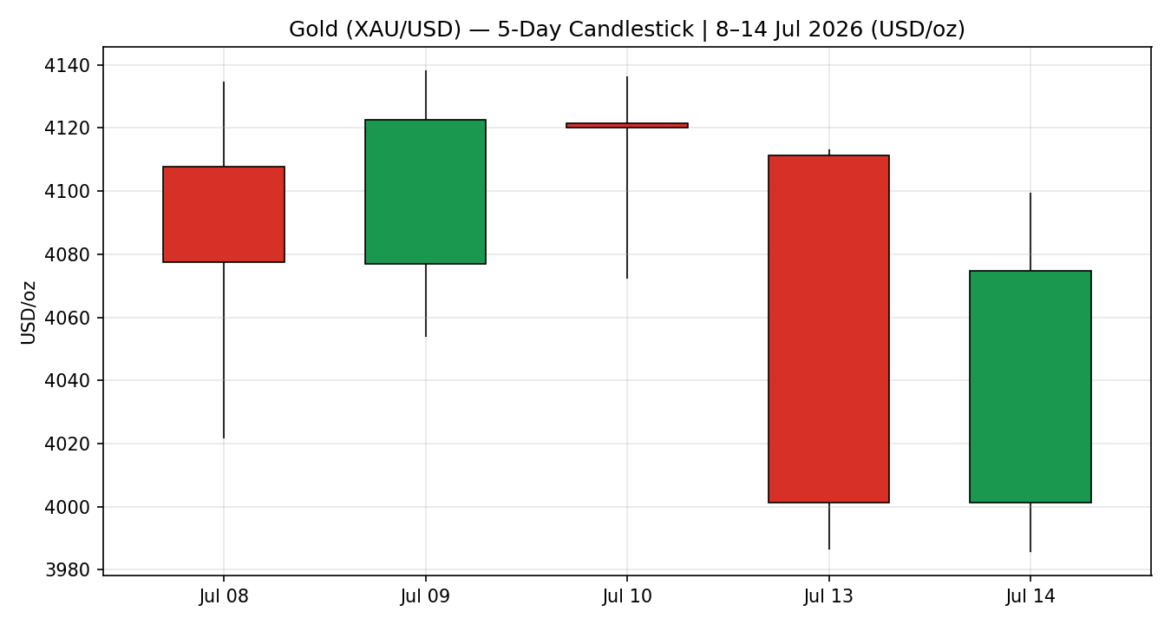
Distance-from-Open
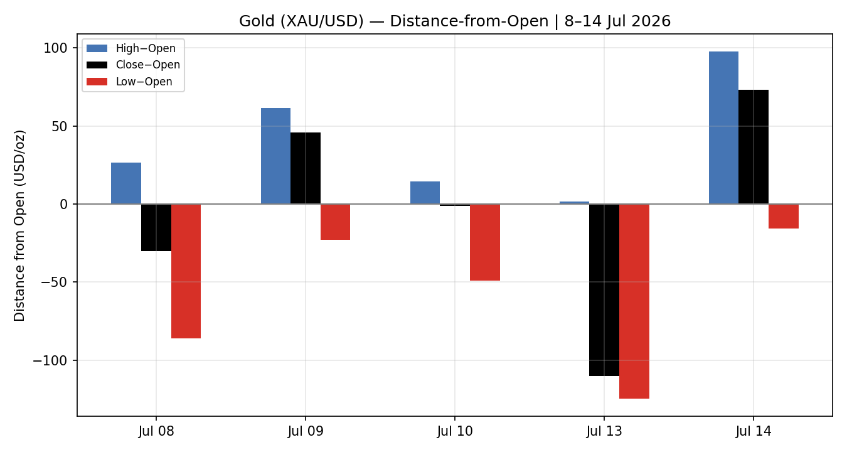
25-Session Structure
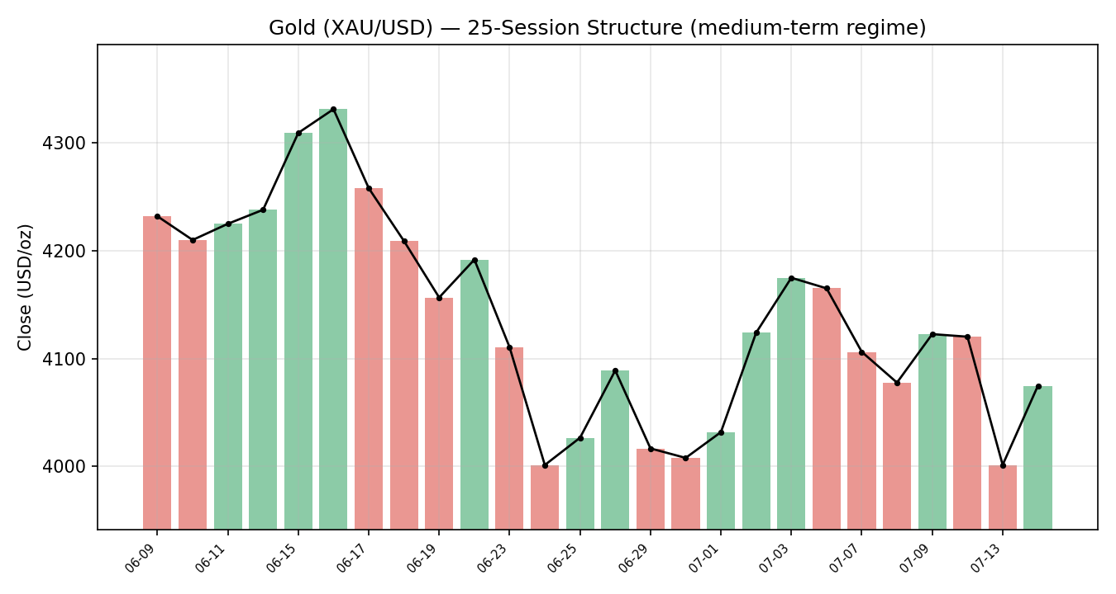
Comparative Volatility (primary + counters)
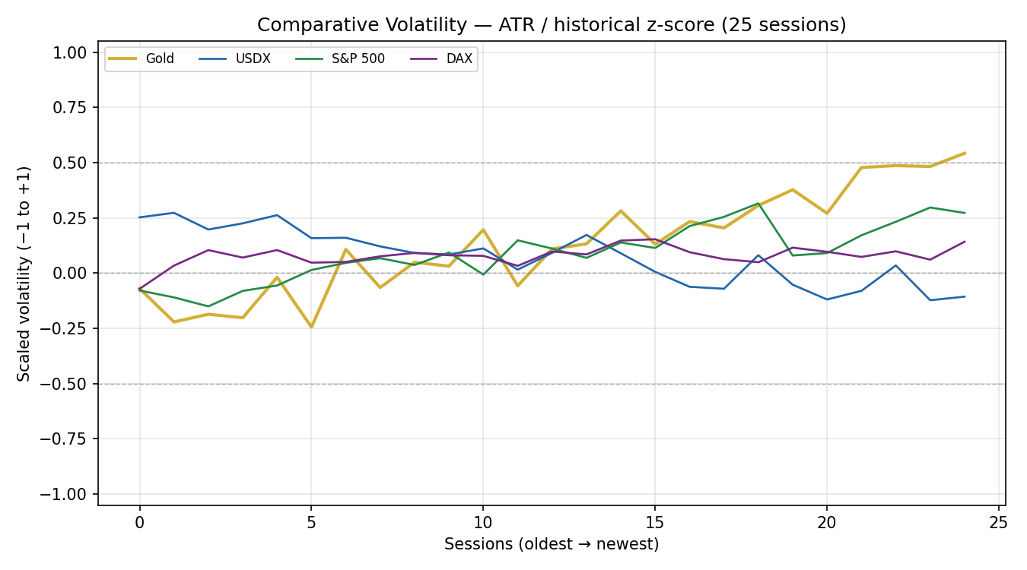
Pivot Structure (weekly candles, smart-scaled)
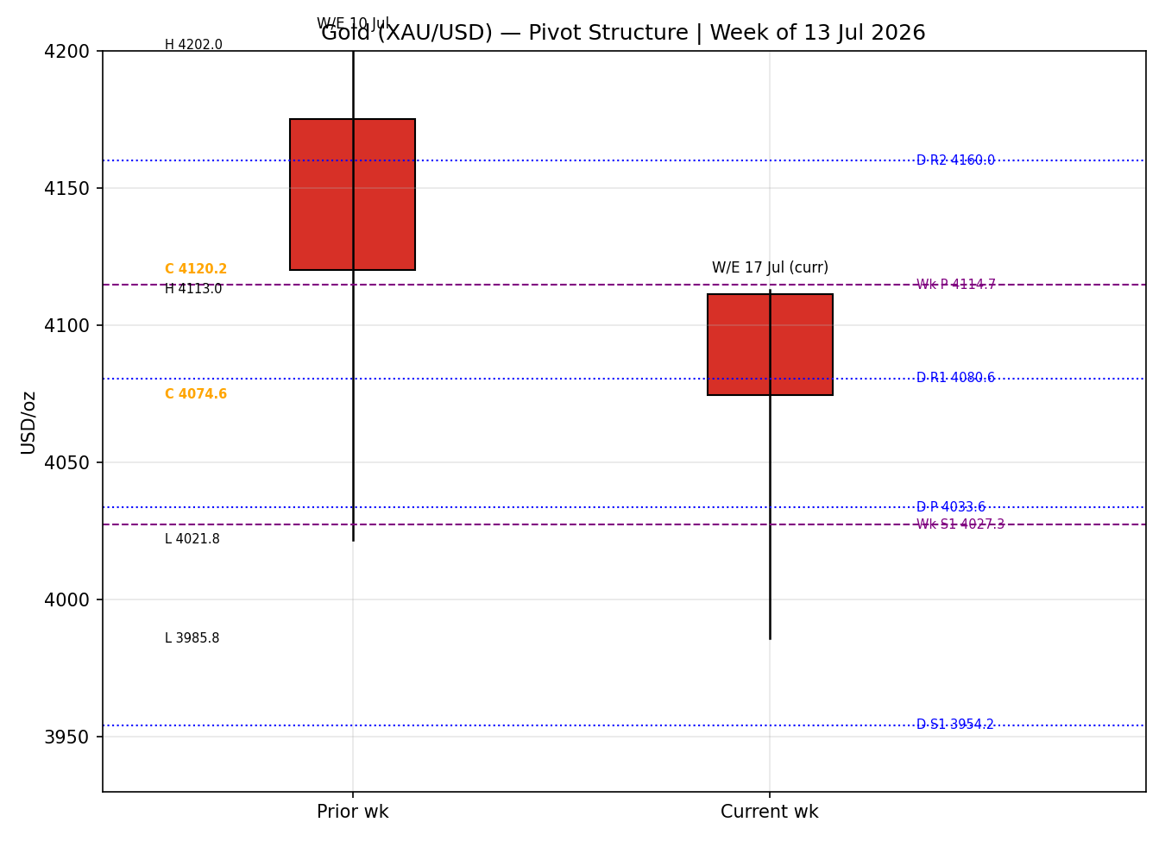

- 8 Jul (see §6): bearish candle, body ~27% of a wide 112.6 range with a long 55.8 lower wick — close mid-range (50%), RSI2 collapsed to 18.4. A demand-tested sell-off, not a clean breakdown.
- 9 Jul: bullish reversal, 54% body, close at 82% of range, RSI2 snapped to 63.2 — buyers reclaimed the prior day's losses.
- 10 Jul: near-doji (2% body), long lower wick, close 75% of range, RSI2 59.7 — indecision at the highs; momentum stalling.
- 13 Jul: decisive bearish flush, 87% body, close at just 12% of range at 4,001.2 (two-week low), RSI2 9.2 — the week's dominant move, driven by Hormuz-blockade oil spike and hawkish Fed repricing.
- 14 Jul: bullish recovery, 65% body, close 78% of range at 4,074.6, RSI2 back to 55.6 — soft CPI reversed roughly two-thirds of the prior plunge.
Sequence assessment: Indecision / two-sided. Alternating direction, prominent wicks on both sides, and RSI2 oscillating between 9 and 63 mark a market resolving nothing over the week. Nearest support 3,985.8 (14 Jul low, coincident with 13 Jul low zone); nearest resistance 4,138.1 (9 Jul high).
Judgement label: Indecision. Consistent with the §9 Transitional regime.

- Regime classification: Transitional (bearish lean). Overlap ratio 0.64 (>0.55, ranging signal), directional persistence 0.54, absolute directional mean ~1.2%/session, median RSI2 ~55.6.
- Range-position bias: Range-Bottom (close at 29th percentile of the 3,949.4–4,383.6 25-session band).
- VOLator: gold scaled volatility ~+0.47 (elevated, above midpoint); slope over the last 10 observations ~+0.003 — essentially flat, marginally positive. USDX contracting, S&P 500 mildly expanding, DAX flat.
- Kaufman confirmation: efficiency ratio smoothed ~+0.02 → Ranging–Neutral (|efficiency| well below the 0.13 trend threshold). Agrees with the range read, contradicts any trend claim.
Consolidated regime: TRANSITION. The range dual-gate is not cleanly satisfied — efficiency is neutral but the VOLator slope is fractionally positive rather than ≤ 0 — so the market is classed Transitional rather than Range. Preferred protocol: reduced conviction; wait for a confirmed break before committing.

Counter | 5-day dir. | Mechanism to gold | Status | Implication
USDX | Falling (101.4→100.9) | Weaker dollar lowers the USD cost of gold — supportive | Contradicts bearish lean | Cushions downside; a floor under 4,000
S&P 500 | Rising (7,515→7,544) | Risk-on diverts safe-haven flows away from gold | Confirms bearish lean | Caps rally attempts
DAX | Flat (~25,100) | European risk confirmation; neutral this week | Neutral | No incremental signal
Silver (XAG) | Falling hard (~−6% wk) | Precious-metals beta; lower-highs/lower-lows | Confirms bearish lean | Sector momentum still negative despite gold's bounce
Contradiction flag: USDX (supportive) opposes the S&P/silver risk-on read. Aggregate cross-asset confirmation = MIXED. The dollar is doing the work of keeping gold above 4,000 while equity strength and silver weakness cap the upside.

Prior-period H/L/C corroborated on the Investing.com × Twelve Data pair. Levels CORROBORATED (not single-source).
Daily (prior session 13 Jul)
Level | Price
R3 | 4,207.0
R2 | 4,160.0
R1 | 4,080.6
P | 4,033.6
S1 | 3,954.2
S2 | 3,907.2
S3 | 3,827.8
Weekly (prior week 6–10 Jul)
Level | Price
R3 | 4,387.7
R2 | 4,294.9
R1 | 4,207.5
P | 4,114.7
S1 | 4,027.3
S2 | 3,934.5
S3 | 3,847.1
Monthly (prior month June)
Level | Price
R2 | 4,547.8
R1 | 4,277.7
P | 4,113.6
S1 | 3,843.5
S2 | 3,679.4
Position narrative: The 14 Jul close (4,074.6) sits below Weekly P (4,114.7) and Monthly P (4,113.6) but above Daily P (4,033.6) — a mildly constructive intraday posture inside a bearish weekly frame. Daily R1 (4,080.6) is the immediate overhead pivot; Weekly S1 (4,027.3) and Daily P (4,033.6) form a support confluence just below. A confluence zone exists at ~4,114 where Weekly P and Monthly P nearly coincide — the key line separating range-bound chop from an upside breakout.

Demand / safe-haven — price-supportive (cyclical). Central-bank buying persists; PBoC reported its largest monthly gold-reserve increase in over 2½ years in June. Hormuz-driven geopolitical risk sustains a safe-haven bid.
Macro / real yields — price-negative (cyclical→structural). Markets price ~60–70% odds of a September Fed hike; 10-year yields near 4.59%. Higher real yields are the dominant gold headwind and the reason rallies keep failing.
FX — price-supportive (cyclical). USDX easing to ~100.9 (see §10) lowers the dollar price of gold.
Substitution / spreads — neutral-to-negative. Silver is materially weaker (YTD −22%, lower-highs/lower-lows), signalling the precious complex remains under distribution despite gold's relative resilience.
Near-term catalysts (see §13d) — two-sided. June PPI + Fed Beige Book (15 Jul), Philly Fed / jobless claims (16 Jul), UoM inflation expectations (17 Jul), and the 29 Jul FOMC decision.

13a · Per-article sentiment
Source | Date | Headline (abbrev.) | Class. | Sentiment | Derivation quote (≤15w)
CNBC | 17 Jun | Central banks buying more gold, repatriating bullion | Media | Bullish | central banks are buying more gold
Trading Economics | 13 Jul | Gold fell >2% to $4,020 on rate-hike bets | Trade Press | Bearish | reinforced expectations that US rates stay elevated
WSJ | 13 Jul | Gold's faithful think twice as prices slide | Media | Bearish | prices slide from record highs
LiteFinance | 14 Jul | OCBC expects gold to decline through end-2026 | Institutional | Bearish | expects gold prices to decline through 2026
JM Bullion | 14 Jul | Gold rebounds as cooler CPI eases hike fears | Trade Press | Bullish | rebounding sharply as cooler inflation eased concerns
FXStreet | 14 Jul | Dollar pullback supports metals into CPI | Media | Neutral | US Dollar sees a profit-taking pullback
13b · Aggregate: Mixed–bearish (tilt = −0.10). Counts: 2 Bullish (media/trade), 3 Bearish (1 institutional, 1 trade, 1 media), 1 Neutral. The single institutional read (OCBC) is bearish and carries the highest weight; media bullishness is CPI-bounce-driven and lower-conviction. Numeric tilt −0.10 (source-class-weighted). Divergence flag: sentiment is mildly bearish while 14 Jul price action bounced — the price/sentiment divergence favours the sentiment/regime read given the intact bearish weekly structure. Not low-confidence (six articles).
13c · Previous-period calendar
Date | Event | Context | Impact | Implication for gold
10 Jul | Wk close / PBoC reserves | Gold −1.5% wk; PBoC +reserves | Med | Central-bank bid vs rate fears — net soft
12–13 Jul | US reinstates Hormuz blockade | Oil +4–5% | High | Inflation-hike bets → gold flushed to 4,001
14 Jul | June CPI | −0.4% m/m, 3.5% y/y (below est.) | High | Eased hike odds → gold bounced ~+1.5%
13d · Upcoming-period calendar
Date | Event | Context | Impact | Implication for gold
15 Jul | June PPI + Fed Beige Book | Follows soft CPI | High | Soft PPI extends bounce; hot PPI reasserts hawkish, gold-negative path
16 Jul | Philly Fed / jobless claims | Growth read | Med | Weak data = mild gold support
17 Jul | UoM inflation expectations | Inflation psychology | Med | Higher expectations = hike risk = negative
29 Jul | FOMC decision | ~3.50–3.75% hold vs hike | High | Live meeting; hike would pressure gold
Highest-impact item bolded: a soft June PPI on 15 Jul would confirm the disinflation signal from CPI and could extend the relief rally toward Weekly P (~4,115); a hot print would likely resume the slide toward 4,000.

- Rates / policy: Fed on hold at 3.50–3.75% with hawkish commentary (Gov. Waller flagged higher rates may be needed); markets price ~60–70% odds of a September hike. Gold-negative.
- Inflation: June CPI surprised soft (3.5% y/y headline, 2.6% core) — the first clear disinflation crack in weeks; PPI (15 Jul) is the confirmation test. Marginally gold-supportive if the trend holds.
- Safe-haven / real yields: 10-year ~4.59% with elevated real yields remains the core structural headwind; Hormuz risk offsets part of it via the geopolitical bid.
- Liquidity / FX: USDX easing to ~100.9 (§10) is a supportive cross-current for gold.
- Energy: WTI ~$79 (+~4.6%) on Hormuz — raises inflation expectations, a double-edged factor (hike risk negative; inflation-hedge demand positive).
- Positioning: precious-metals complex under distribution (silver YTD −22%); VIX low (~15–17). Watch item from §13d: 15 Jul PPI is the key macro trigger.

15 · Bull / Bear Balance
Upside risks (bull) | Downside risks (bear)
Soft PPI (15 Jul) confirms disinflation → break of Weekly P 4,114.7 | Hot PPI / hawkish Beige Book → resume slide toward 4,000 / Daily P 4,033.6
Hormuz escalation → safe-haven spike | September hike repricing → real-yield surge
USDX breaks below 100 → dollar tailwind | Equity risk-on (S&P at highs) diverts flows; silver weakness drags complex
Central-bank buying (PBoC/RBI) floor | Close below 3,985.8 (5-day low) opens 3,949 / Weekly S2 3,934
Cross-references: pivot position below Weekly/Monthly P (§11) tilts the balance bearish; the highest-impact 15 Jul PPI event (§13d) is the swing factor.

16 · Forward View
Base case over the next five sessions: two-sided consolidation in a 3,985–4,160 band, with a mild upward bias only on confirmation. The 14 Jul reversal and softening dollar argue for a test of the 4,114 Weekly-P confluence; failure there returns focus to the 4,033/4,027 support shelf and, on a close below 3,985.8, the 3,949 range floor. This respects the §9 Transitional regime — it does not assume a trend. Invalidation of the constructive lean: a daily close back below 4,000. Invalidation of the bearish frame: a daily close above 4,138 (5-day swing high). This view references the §13d calendar (PPI 15 Jul as the pivot catalyst) and does not contradict the §9 regime.

17 · Forecast
Gold consolidates two-sided between roughly 3,985 and 4,160 over the coming week, with a modest upward bias contingent on a soft 15 July PPI confirming the CPI-driven disinflation signal, and a break of 4,000 reopening the 3,949 range floor.

18 · Final Analyst Judgement
Consensus: 4,075 USD/oz · Confidence: Medium · Tone: Balanced–bearish.
- Real yields and ~60–70% September-hike odds remain the dominant headwind — every rally this month has failed into it.
- A soft June CPI and an easing dollar have engineered a genuine relief bounce; the market closed 14 Jul above its intraday flush, not at the lows.
- Medium-term structure is still range-bottom and bearish-leaning (29th percentile), and silver's weakness warns the complex is not yet turning.
Single watch item: June PPI + Fed Beige Book, 15 July.

19 · Source Discipline Note
- Live vs indicative: 5-day OHLC corroborated on Investing.com × Twelve Data (spot), with Trading Economics/news anchoring the 13 Jul close and dealer/Bloomberg reads as directional context.
- Corroboration status: all pivot prior-period H/L/C (daily/weekly/monthly) are CORROBORATED — not single-source-indicative — so pivot-based levels are eligible for strategy use.
- Normalization assumptions: CME GC=F basis-adjusted to loco-London spot; gold ±0.50 USD tolerance is tight for two distinct spot feeds, so modest feed deltas (notably the fast-moving 14 Jul tape, ~USD 10) are documented as feed differences, not rejections.
- Data gaps: intraday 14 Jul real-time vs daily-close divergence noted; no session was synthesised or interpolated. Weekend rows (11–12 Jul) rejected.

- Sources attempted (OHLC): Investing.com (corroborated), Twelve Data (corroborated), Trading Economics (close corroboration), CME GC=F via Investing (basis check), JM Bullion + Bloomberg web (directional). Stooq attempted — blocked by network egress; substituted with next-rank sources per sequential-exhaustion rule.
- Corroboration pairs: XAU/USD spot — Investing.com × Twelve Data, deltas ~0.6–1.0 USD on 8–10 Jul; 13 Jul anchored to Twelve Data × news; 14 Jul flagged ~10 USD feed spread.
- Sentiment derivation: 6 articles, source-class-weighted; institutional (OCBC) bearish dominates; tilt = −0.10; each classification carries a ≤15-word derivation quote (§13a).
- Strategy trace: direction score +0.14 (short-term +1×0.25, medium −0.5×0.20, VOLator +0.5×0.10, Kaufman +0.02×0.15, sentiment −0.10×0.15, cross-asset −0.3×0.15) → below ±0.25 threshold → Trade 1 SUPPRESSED. Regime label = TRANSITION (RANGE dual-gate failed on marginally positive VOLator slope). Weights basis: defaults (v2.1 baseline, locked). Backtest reconstructed over 5 sessions with t−1 freeze.
- Overrides this run: [DAILY_OPEN_ANCHOR] set to 07:00 UK (baseline 00:00 UK) per instruction; report date set to 15 Jul 2026. No weight tuning (session <20).
- Anomalies: 14 Jul intraday/close feed divergence; USDX-vs-equity cross-asset contradiction flagged (MIXED). Timestamp: 15 Jul 2026, Europe/London.

21a · Directional conviction
NEUTRAL — score +0.14 (below the ±0.25 conviction threshold). Three highest-weighted contributors: short-term technical bias (§8) +0.25 (14 Jul bullish reversal, RSI2 55.6); medium-term regime (§9) −0.10 (range-bottom, bearish lean); cross-asset confirmation (§10) −0.045 (MIXED — dollar supportive vs equity/silver risk-on). Weights basis: defaults. Conflict flag: the §17 forecast leans mildly constructive-contingent while the composite score is neutral — reported, not reconciled.
21b · Trade cards
Trade 1 — Daily Directional
Field | Detail
Status | SUPPRESSED — direction score +0.14 below conviction threshold (±0.25).
Trade 2 — Pivot (regime-aware, TRANSITION → breakout-side only)
Field | Detail
Type | Trade 2 — Pivot, TRANSITION regime (breakout side only)
Direction | LONG on confirmed upside break (Transitional regime — play the break, not a counter-side fade)
Entry | Buy-stop 4,120.3 (Daily R1.5 / Weekly-P 4,114.7 confluence) on a daily close through the cluster + buffer
Stop loss | 4,008.5 — below Daily P (4,033.6) with 0.25×ATR buffer. Risk R = 111.8 USD (11,177 ticks at 0.01)
TP1 / TP2 / TP3 | 4,232.1 (+1R) / 4,343.9 (+2R) / runner toward Weekly R2 4,294.9, trailing
Tranche mgmt | 3 equal units; U1→TP1, U2→TP2; on U2 fill U3 stop → entry +0.2R
Confluences | Entry: Weekly P + Monthly P (~4,114) strong confluence. Stop: Daily P + Weekly S1 (4,027) shelf
Invalidation | Daily close back below 4,033.6 (Daily P) negates the breakout thesis
Caveats | Anticipatory breakout — not yet a confirmed 25-day-range break; discretionary. Holding period collides with 15 Jul PPI (§13d Tier-1). Neutral composite score.
Trade 3 — Momentum-Breakout (3C, TRANSITION variant)
Field | Detail
Status | NOT YET ELIGIBLE — no confirmed break of the 25-session range (3,949.4–4,383.6). Price sits mid-range at the 29th percentile; a daily close beyond either boundary by ≥25 USD (0.25×ATR) is required to arm 3C.
Contingent long | On a confirmed close above 4,408.7: entry at break, stop 4,123.1 (range-low +0.40×width), TP1 4,817.8 (+1× width MM), TP2 +1.5×MM
Contingent short | On a confirmed close below 3,924.3: mirror — TP1 3,515.2 (−1×width MM)
Actionable now (discretionary, per instruction to always provide a strategy): With the framework's automated cards suppressed/ineligible, the tradeable structure is the Trade-2 breakout above 4,114 (long) — or, for bears aligned with the intact weekly downtrend and hawkish Fed, a sell-stop below the 3,985.8 five-day low targeting 3,949 then 3,934 (Weekly S2), stop above Daily R1 4,080.6. Both are event-gated by the 15 Jul PPI; size down into it. Corroboration is adequate here (pivots CORROBORATED), so leniency was not required — the neutrality is genuine two-sided balance, not a data gap.
21c · 5-session no-leakage backtest
Daily-directional reconstruction (entry at session open, 1×ATR risk proxy, no forward leakage):
Session | Dir. | Triggered | Entry→Close | Outcome (R) | Days
8 Jul (t−5) | Long bias | Yes | 4,107.8→4,077.6 | −0.30 | 1
9 Jul (t−4) | Long bias | Yes | 4,076.8→4,122.6 | +0.46 | 1
10 Jul (t−3) | Neutral | No | — | flat (−0.01) | —
13 Jul (t−2) | Long bias | Yes | 4,111.4→4,001.2 | −1.10 | 1
14 Jul (t−1) | Long bias | Yes | 4,001.4→4,074.6 | +0.73 | 1
21d · What is working
Daily-directional bias over the last 5 sessions: triggered 4/5, mean R ≈ −0.05 — essentially break-even, dragged by the 13 Jul flush and rescued by the 9 and 14 Jul reversals. No pivot or complex card triggered under strict rules (regime Transitional; range unbroken). Strongest reconstructed performer: the 14 Jul long-bias session (+0.73R); weakest: 13 Jul (−1.10R). Net: the market paid nothing to directional persistence this week — consistent with the NEUTRAL score and the whipsaw sequence in §8.
Five-session windows are too small to support statistical claims. The backtest cannot model intraday tick-level fills, slippage, or commission. Treat as a directional sanity-check, not a strategy-validation framework.

