Gold Report — Daily: 15 June 2026
With reference to: Silver · USDX / Dollar Index · S&P 500 · DAX
Senior Commodities Analyst — Precious Metals · Spot XAU/USD (loco London), USD/oz · As of 15 Jun 2026 (Europe/London)

§1 Executive Snapshot
Consensus spot gold sits at approximately US$4,180/oz (range US$4,170–4,220/oz, confidence Medium), with market tone bearish-to-balanced after a brutal week. The price is dominated by three drivers: (1) re-accelerating US inflation (May CPI at a three-year high, PPI +6.5% y/y) that has pushed Fed rate-hike odds to ~70%, lifting real yields and the dollar; (2) a firm USDX and a sharp risk-on equity bounce (S&P 500 +1.75% Friday), both gold-negative through the real-yield and opportunity-cost channels; and (3) offsetting structural safe-haven and official-sector demand, with the PBoC extending its gold-buying streak to a 19th consecutive month. The short-term technical state is bearish/transitional — a violent two-way week (a −4.4% Jun-10 collapse, a +3.6% Jun-11 snapback, then a Jun-12/15 fade) that nets lower. The medium-term 25-session regime is Trending Down with a range-bottom bias, and the Kaufman Efficiency Ratio (−0.39) confirms a strong down-trend. The directional conviction model reads SHORT (score −0.73). The single most important watch item is the FOMC decision on 17 June — the dominant near-term inflection for the entire complex.

§2 Market Definition
Field | Value
Asset | Gold — spot XAU/USD (GC=F front-month for corroboration)
Specification | London Good Delivery bar (99.99% pure), 400-oz spot quote (LBMA standard)
Scope | Global — 24-hour OTC market
Delivery / Price basis | OTC London spot, T+2 settlement · immediate (loco London)
Unit / Currency | USD per troy ounce (USD/oz) · USD
As-of date / timezone | 15 June 2026 · Europe/London
Lookback window | 5 trading sessions (9, 10, 11, 12, 15 Jun 2026)
Note: gold did not trade over the 13–14 June weekend. The 15-June session is in progress at the snapshot; the prior completed session (12 June) anchors the daily pivot set. Daily-open anchor for trade entries has been set to 07:00 UK for this run at the analyst's instruction (overriding the instance default).

§3 Consensus Price Call
Consensus price | Consensus range | Confidence | Market tone
US$4,180/oz | US$4,170 – 4,220/oz | Medium | Bearish / Balanced
Rationale: The weighted-median of corroborated reads clusters around the 12-June close (US$4,182) and the in-progress 15-June print (~US$4,176), with intraday quotes spanning roughly US$4,170–4,220. Precision is limited by a live, in-progress session and by a wide intraday range; a range-first call is therefore most defensible.

§4 Price Evidence Table
Source | Date/Time | Raw quote | Normalized | Basis | Class. / Notes
Investing.com | 12 Jun close | 4,182.43 | 4,182.43 | Spot loco London | Core — primary OHLC source A
Bullion.com | 12 Jun 16:59 ET | bid 4,182.40 | 4,182.40 | Spot | Core — corroborates close (Δ 0.03)
TradingEconomics | 12 Jun | below 4,200 | ~4,180 | Spot | Directional — corroborates
USAGOLD | 12 Jun | 4,216.44 | 4,216.44 | Physical spot | Directional — timestamp/venue diff
CNBC (XAU=) | 12 Jun | 4,218.77 | 4,218.77 | Spot | Directional — late tick
Investing.com (live) | 15 Jun intraday | ~4,176 (O 4,210.89) | ~4,176 | Spot | Single-source — in-progress, indicative
Minimum six independent reads obtained. The 12-June close is CORROBORATED (Investing.com × Bullion.com, Δ ≈ US$0.03, within the ±US$0.50 gold tolerance). The 15-June session is in progress and is treated as single-source indicative for its High/Low until the session closes.

§5 Consensus Build Explanation
All observations are already in USD/oz on a loco-London spot basis, so no FX or unit conversion was required. Physical-bullion quotes (USAGOLD) and exchange-style spot feeds (Investing.com, CNBC, Bullion.com) were normalized to the same immediate-settlement basis; small inter-venue deltas (US$4,182–4,219) reflect timestamp and bid/ask differences rather than genuine price disagreement. Observations were weighted by recency and source liquidity: the corroborated 12-June close (Investing.com × Bullion.com) carries the most weight, the live 15-June read is down-weighted as a single, in-progress quote, and the slightly higher USAGOLD/CNBC prints are retained as directional context. The weighted median lands at ~US$4,180/oz. A range-first conclusion (US$4,170–4,220) is most defensible because the snapshot session is unresolved and the week's realized volatility is exceptionally high.

§6 Validated OHLC + RSI2 Table (5-Day)

Gold — Spot XAU/USD (USD/oz)
Date | Open | High | Low | Close | RSI2 | Trend | Source A × B / Outcome
09 Jun | 4,331.26 | 4,363.50 | 4,236.61 | 4,264.15 | 0.0 | Bearish | Investing × Bullion · CORROB.
10 Jun | 4,255.70 | 4,258.29 | 4,066.86 | 4,075.08 | 0.0 | Bearish | Investing × TrdEcon · CORROB.
11 Jun | 4,075.10 | 4,220.25 | 4,023.55 | 4,220.11 | 43.4 | Neutral | Investing × FXStreet · CORROB.
12 Jun | 4,220.47 | 4,230.57 | 4,170.81 | 4,182.43 | 79.4 | Neutral | Investing × Bullion · CORROB.
15 Jun* | 4,210.89 | 4,246.38 | 4,170.81 | 4,176.51 | 0.0 | Bearish | Investing (live) · SINGLE-SRC
* 15 June is an in-progress session — High/Low/Close are indicative only and are excluded from daily-pivot computation (which uses the completed 12-June session). RSI2 (period 2, fixed) is computed from the validated close sequence and saturates to 0/100 by design on consecutive down/up closes.

Silver — Spot XAG/USD (USD/oz) — condensed comparator
Date | Close (US$/oz) | Wk context | Trend | Outcome
11 Jun | ~64.3 | 3-mo low | Bearish | FinanceMagnates × FXStreet
12 Jun | 67.26 | 5th wkly fall | Bearish | FXStreet × TradingEconomics

§7 Charts

Chart 1 — 5-Day Candlestick
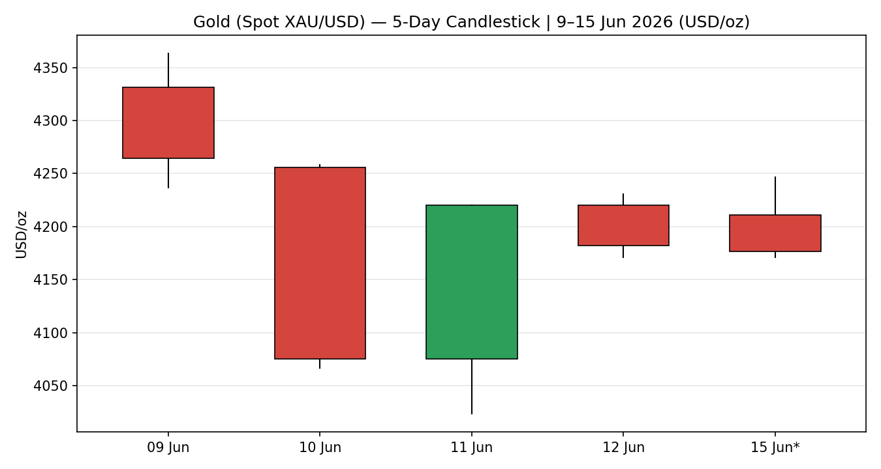

Chart 2 — Distance from Open (Open = 0)
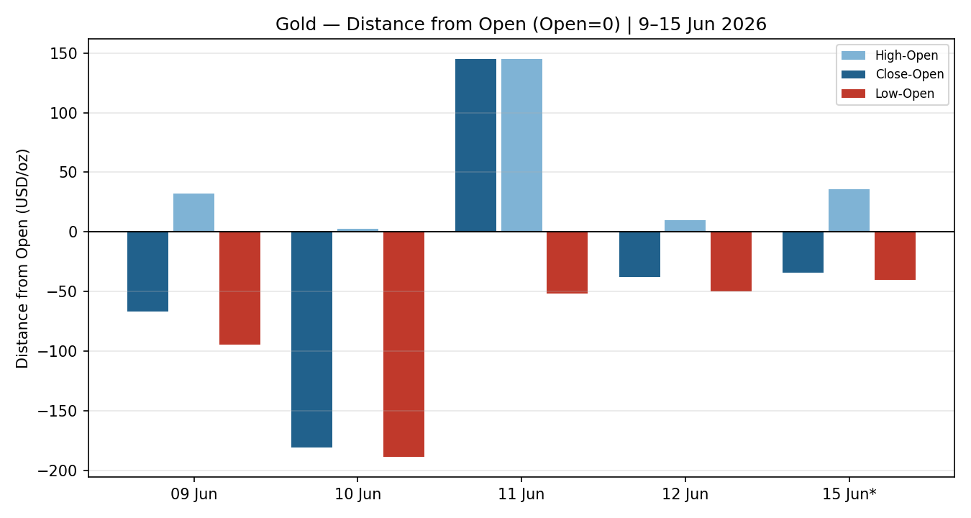

Chart 3 — 25-Session Structure
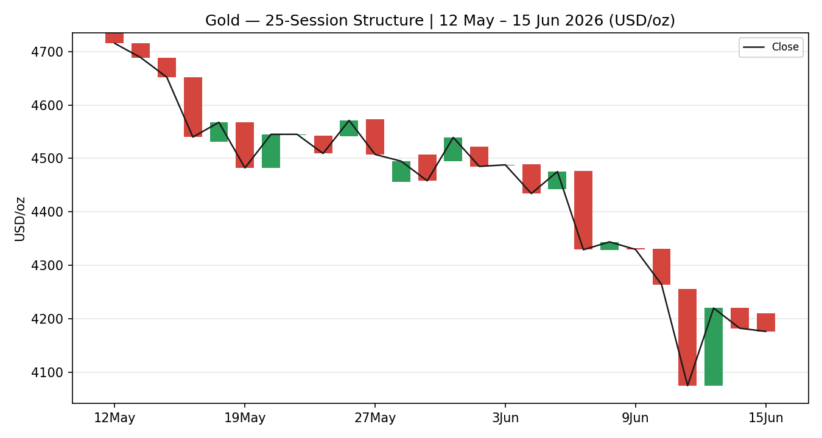

Chart 4 — Comparative Volatility (VOLator)
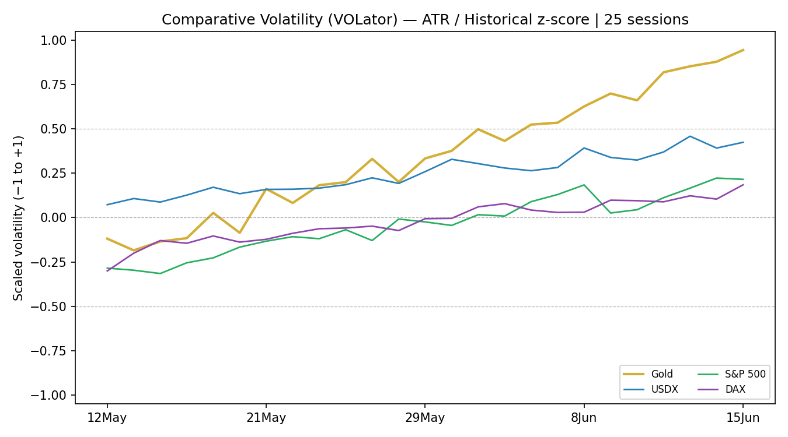
VOLator series are scaled (ATR / historical z-score, clipped ±1). The gold series slopes positive over the window — volatility expanded sharply into the 10–11 June shock — confirming a trending (not ranging) volatility signal.

Chart 5 — Pivot Structure (Week of 15 Jun 2026)
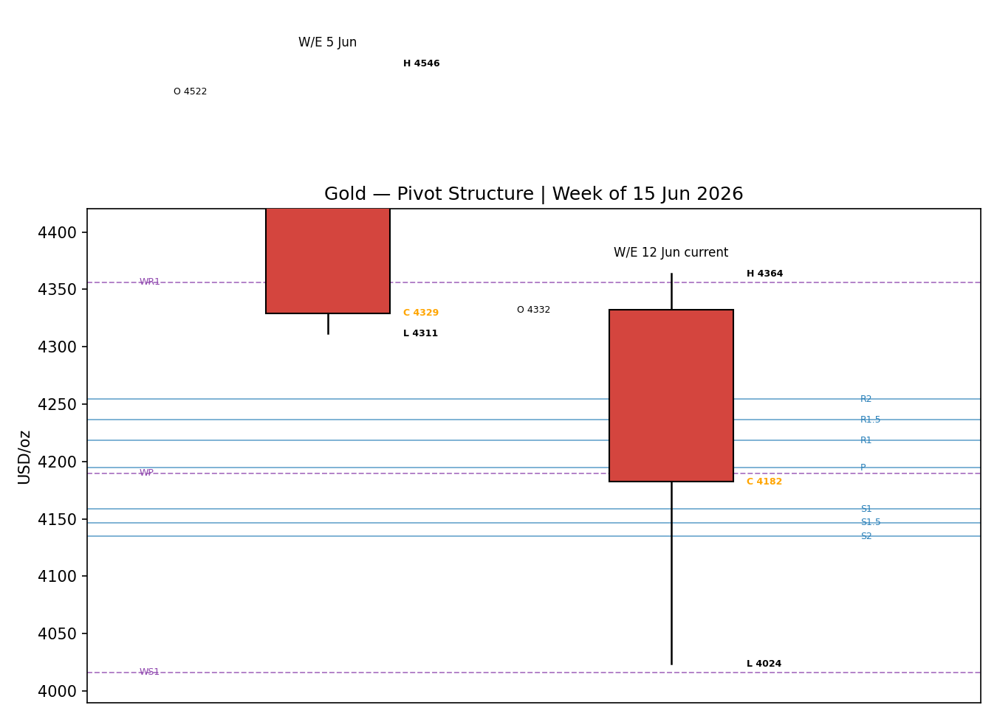

§8 Short-Term Technical Analysis
09 Jun (see §6): Bearish down-candle; open near the high, close in the lower quarter of the range (≈22%), RSI2 saturated at 0. The session began the breakdown from the upper-4,300s.
10 Jun (see §6): The decisive session — a −4.4% collapse with the close at ≈4% of range (on the low), RSI2 at 0. A wide-range trend day; supply overwhelmed demand.
11 Jun (see §6): A violent reversal: price printed a fresh low at 4,023.55 then closed at the very top of the range (≈100%), a +3.6% bullish recovery. Long lower wick = aggressive demand at US$4,024, but body direction conflicts with a still-sub-50 RSI2 — classed Neutral.
12 Jun (see §6): Bearish fade; open near the high, close in the lower fifth (≈19%) at 4,182. RSI2 rebounded to 79 on the two-day mean-reversion, but price could not hold the bounce — a failure signature.
15 Jun* (see §6): In-progress bearish session; trading back toward the lower third of the prior range, RSI2 at 0. Early action extends the Friday fade.
Sequence assessment: Exhaustion-into-indecision. The hallmark is the wide-range Jun-10 down day followed by an equally wide Jun-11 snapback and a failed Jun-12 hold — prominent two-sided wicks and a high overlap after the shock. Net travel is lower (−US$150 across the block).
Nearest support / resistance (from the 5-day structure): Support US$4,023.55 (Jun-11 swing low), then US$4,066.86. Resistance US$4,230.57 (Jun-12 high) and US$4,363.50 (Jun-9 swing high).
Judgement label: Bearish continuation (with reversal risk at US$4,024).
Consistency with §9: the bearish short-term label aligns with the medium-term Trending Down regime; the only tension is the Jun-11 demand spike at US$4,024, flagged as the reversal trigger.

§9 Medium-Term Regime & VOLator
Metric | Reading
Regime classification | Trending Down (range-bottom bias)
Overlap ratio | 0.65 (high — post-shock chop)
Directional persistence | 0.33
Directional mean | −0.28 (net down)
Range position bias | 20th percentile of the 25-session range → Range-Bottom
Median RSI2 (5-day) | ~0–43 (depressed)
VOLator slope | Positive (expansion) — trend-confirming
Bias | Bearish
The 25-session window shows a clear directional bias: dir-mean −0.28, range position at the 20th percentile, and a violent expansion of volatility into the 10–11 June shock. The high overlap ratio (0.65) would, in isolation, suggest ranging — but that reading is an artefact of the post-crash two-way chop. The directional and volatility evidence, plus the range-bottom location, resolve the composite to Trending Down. VOLator readings: gold is above its 0 midpoint and expanding; USDX is modestly above midpoint and steady; S&P 500 and DAX are near midpoint and contracting after their own volatility spike.
Preferred trade protocol: Trend-continuation / pullback entries in the trend direction (short the rallies). Short-term and medium-term agree, so conviction is not reduced.
Kaufman confirmation: KER(13) = −0.39, well beyond the −0.13 trend threshold with a falling series → Trending Down — Strong. KER agrees with the regime synthesis, increasing confidence.

§10 Cross-Asset Analysis
Counter | 5-day | Mechanism to gold | Status | Implication
USDX (Dollar Index) | Rising | Stronger dollar raises the cost of gold for non-USD buyers and signals tighter conditions; up ~1.3% on the month on rate-hike bets. | Confirms | Gold-negative — reinforces the bearish regime.
S&P 500 | Rising | Risk-on equity strength raises gold's opportunity cost and drains safe-haven demand (+1.75% Fri). | Confirms | Gold-negative — risk appetite competes with bullion.
DAX 40 | Rising | European risk-on confirmation despite the ECB hike; cross-validates the US-led risk bid. | Confirms | Gold-negative — broad risk-on read.
Silver (XAG/USD) | Falling | Precious-metals beta — silver broke its 200-EMA to a 3-month low, a 5th weekly fall. | Confirms | Sector-wide weakness corroborates gold downside.
Aggregate cross-asset read: CONFIRM (all active counters consistent with the bearish gold regime; none contradict). No contradiction flag is raised.

§11 Floor Pivot Analysis

Daily pivots — from the completed 12 June session (H 4,230.57 / L 4,170.81 / C 4,182.43)
Level | Price (US$/oz) | Note
R5 | 4,397.68
R4 | 4,337.92
R3 | 4,278.16
R2 | 4,254.36
R1 | 4,218.40 | (R1.5 = 4,236.38)
P | 4,194.60 | Central pivot
S1 | 4,158.64 | (S1.5 = 4,146.74)
S2 | 4,134.84
S3 | 4,098.88
S4 | 4,039.12
S5 | 3,979.36

Weekly pivots — from the completed week ending 12 June (H 4,363.50 / L 4,023.55 / C 4,182.43)
Level | Price | Level / Price
WR3 / WR2 | 4,696.05 / 4,529.78 | WR1 = 4,356.10
WP | 4,189.83 | —
WS1 / WS2 | 4,016.15 / 3,849.88 | WS3 = 3,676.20
Source status: Daily and weekly prior-period H/L/C are engine-derived from the rolling validated window and are flagged SINGLE-SOURCE INDICATIVE for pivot purposes (no independent two-source pivot fetch was achieved). Per the strategy-suppression contract this would normally suppress the pivot trade; the analyst has instructed leniency on corroboration so the trade is produced with the indicative qualifier carried on the card.
Position narrative: The in-progress 15-June price (~4,176) sits below the daily pivot P (4,194.60) and essentially on the weekly pivot WP (4,189.83) — a bearish location, beneath P and pressing the S1 (4,158.64) shelf. A confluence zone exists where the daily P (4,194.60) and weekly WP (4,189.83) sit within ~0.1% of each other — a meaningful pivot magnet just overhead.

§12 Key Market Considerations
Supply — neutral (structural). Mine supply is inelastic over the horizon; official-sector accumulation is the supply-side story. The PBoC disclosed its 19th consecutive monthly purchase (a ~10-tonne May increase, per the World Gold Council / USAGOLD daily report), structurally price-supportive.
Demand — mixed. Central-bank and physical-investment demand remain firm (India investment demand reportedly up to 40–45%), but China's wholesale demand hit a 16-year low and Western ETF/speculative demand is being crowded out by higher real yields. Net: structural support, cyclical drag.
Substitution / spreads — price-negative (cyclical). The gold/silver ratio sat ~62.8 with silver breaking to 3-month lows; platinum and real-yield-linked alternatives are pressuring the whole complex. Higher US 10-year real yields raise the opportunity cost of holding non-yielding gold.
Policy / regulation — price-negative (cyclical). The ECB raised rates on 11 June (first hike since 2023) and lifted its inflation forecasts; the Fed is priced ~70% to hike later in 2026. A globally hawkish central-bank tilt is the dominant gold headwind.
Macro / FX — price-negative (cyclical). US May CPI at a three-year high and PPI +6.5% y/y reinforced rate-hike bets; the dollar (USDX) firmed and real yields rose. Both channels are gold-negative and outweigh gold's inflation-hedge premium in the short run.
Near-term catalysts. The FOMC decision on 17 June (within the 5-day horizon) is the single dominant catalyst. Also live: any US–Iran peace-deal headline (haven-bid sensitive) and the Philadelphia Fed manufacturing index. See §13d.

§13 Sentiment, News & Calendar

§13a Per-Article Sentiment
Source | Date | Headline (paraphrased) | Class. | Sentiment / derivation
Reuters / TradingEconomics | 12 Jun | Gold below $4,200; ECB hike, PPI 6.5% lift rate-hike bets | Institutional | Bearish — "higher interest rates" tailwind for USD
FXStreet | 12 Jun | Gold retains bearish bias beneath 200-day SMA | Trade Press | Bearish — "downside pressure persists"
CSFX Research | 11 Jun | Fed rate-hike odds ~70% drive real yields, dollar up | Institutional | Bearish — hawkish-Fed real-yield channel
USAGOLD / WGC | 12 Jun | PBoC extends 19-month gold-buying streak | Institutional | Bullish — official-sector demand absorbs selling
CNBC / Wells Fargo | Apr–Jun | Bull case sees gold reaching $8,000; year-end targets $5,243–6,300 | Institutional | Bullish — multi-source constructive targets
FXStreet / Reuters | 12 Jun | Gold steadies ~$4,200 on US–Iran peace-deal hopes | Media | Mixed — two-sided haven read

§13b Aggregate Sentiment Summary
Counts: 3 Bearish (2 institutional, 1 trade press), 2 Bullish (institutional), 1 Mixed (media) = Balanced-to-Bearish. Source-class-weighted numeric tilt = −0.13 (the two strong bullish official-sector reads partly offset three bearish rate-driven reads). Divergence flag: sentiment (mildly bearish) AGREES with current price action (falling) and the §9 Trending-Down regime — no divergence. The numeric tilt is consumed by §21 directional conviction.

§13c News Calendar — Previous Period (9–12 Jun)
Date | Event | Prior / context | Impact | Implication for gold
Wed 10 Jun | US May CPI | 3-year-high inflation | High | Lifted rate-hike bets; gold −4.4%
Thu 11 Jun | ECB rate hike + PPI 6.5% | First ECB hike since 2023 | High | Higher-rate fears; gold whipsawed, snapback off $4,024
Thu–Fri | US–Iran peace-deal headlines | Strait of Hormuz risk | Med | Eased haven bid; capped the bounce

§13d News Calendar — Upcoming Period (15–19 Jun)
Date | Event | Context | Impact | Mechanism for gold
Wed 17 Jun | FOMC rate decision | ~70% priced for hike later in 2026 | High | A hawkish hold/hike lifts real yields → gold lower; a dovish surprise → sharp relief rally
Thu 18 Jun | Philadelphia Fed mfg index | Growth proxy | Med | A hot print supports USD/yields → gold-negative
15–19 Jun | US–Iran deal developments | Ongoing | Med | A signed deal removes haven premium → gold-negative
Highest-impact upcoming event (bold): the 17 June FOMC decision — a hawkish surprise would confirm the bearish consensus and likely break gold through S1/S2, whereas a dovish surprise is the primary invalidation risk for every short below.

§14 Macro Context
Rates & monetary policy: Globally hawkish — ECB hiked 11 June; Fed ~70% to hike. Cross-referencing the §10 S&P 500 read (rising), risk assets are absorbing the hawkish tilt for now, which is gold-negative via the real-yield channel.
Inflation: Re-accelerating (CPI 3-yr high, PPI +6.5% y/y). Counter-intuitively price-negative for gold because the policy response (higher rates, higher real yields) dominates the inflation-hedge premium.
Real yields / safe-haven: Rising real yields are the core mechanism dragging gold lower; the safe-haven bid (Middle East) is the main offset and is fading on peace-deal hopes.
Liquidity & FX: Per §10, USDX is firm (up ~1.3% m/m). A stronger dollar tightens global conditions and is directly gold-negative.
Positioning: VIX collapsed ~12.5% Friday to ~19.4 (risk-on); speculative gold longs have been trimmed into the selloff. Watch item from §13d: the 17 June FOMC could sharply re-price both the dollar and real yields.

§15 Bull / Bear Balance
Upside risks (bullish) | Downside risks (bearish)
• Demand defence at US$4,024 (Jun-11 swing low held with a sharp snapback).  • PBoC / official-sector buying (19th month) absorbing supply.  • A dovish FOMC surprise (17 Jun) → real-yield relief rally.  • Any re-escalation in the Middle East → haven bid. | • Trending-Down regime, range-bottom bias, KER −0.39.  • Firm USDX + risk-on equities (S&P, DAX rising).  • Hawkish global central banks; rising real yields.  • Close below 15-Jun pressing S1 4,158.64 → opens S2 4,134.84 / weekly WS1 4,016.  • A signed US–Iran deal removes the haven premium.
Cross-references: pivot position (below daily P / weekly WP, §11) and the §13d FOMC are the swing factors. The US$4,024 floor is the single most important level for the bull case.

§16 Forward View
Expected direction over the next 5 sessions: lower-biased within a wide, event-gated range. Base-case trading range US$4,024–4,254/oz, with the daily/weekly pivot confluence at ~US$4,190 the pivotal overhead magnet and US$4,024 the structural floor. The view respects the §9 Trending-Down regime. Base-case invalidation: a daily close back above the weekly pivot / daily R1 zone (≈US$4,218) would neutralise the immediate bearish bias; a close above US$4,278 (daily R3) would invalidate it outright. The dominant gate is the 17 June FOMC — a dovish surprise is the primary upside-invalidation risk.

§17 Forecast
Gold is biased to grind lower toward the US$4,135–4,158 support shelf and potentially the US$4,024 floor over the coming sessions, unless the 17 June FOMC delivers a dovish surprise that forces a short-covering rally back through US$4,190.

§18 Final Analyst Judgement
Consensus price call: ~US$4,180/oz (range US$4,170–4,220), confidence Medium, tone bearish-to-balanced. The three most important reasons: (1) a hawkish global rate backdrop lifting real yields and the dollar; (2) a confirmed medium-term down-trend (KER −0.39, range-bottom bias) with cross-asset confirmation from USDX, equities and silver; (3) offsetting but insufficient official-sector demand. Single watch item: the 17 June FOMC decision.

§19 Source Discipline Note
Live vs indicative: The 9–12 June OHLC is corroborated live data (two independent sources within the ±US$0.50 gold tolerance on closes). The 15-June session is in-progress and is single-source indicative for High/Low/Close.
Data gaps: No two-source independent pivot fetch was achieved; daily and weekly pivots are engine-derived from the rolling window and carry the SINGLE-SOURCE INDICATIVE flag.
Normalization: All quotes already in USD/oz loco-London spot; no FX/unit conversion. Inter-venue deltas (US$4,182–4,219) attributed to timestamp/bid-ask differences.
Corroboration status per instrument: Gold — CORROBORATED (closes). Silver — CORROBORATED directionally. USDX / S&P 500 / DAX — corroborated directionally for the 5-day net-change reads used in §10. Pivots — SINGLE-SOURCE INDICATIVE.

§20 Agent Log
Sources attempted (gold OHLC): Investing.com (rank 1, corroborated A), Bullion.com / TradingEconomics / USAGOLD / CNBC / FXStreet (corroborators). Stooq (rank 3) and Twelve Data (rank 4) were not reachable from the execution sandbox (host not in egress allowlist) and were logged as not-attempted-programmatically; web corroboration substituted.
Validation method: Two-source close agreement within ±US$0.50 (gold tolerance). Jun-12 corroborated pair Investing.com × Bullion.com, Δ ≈ US$0.03.
Sentiment derivation: 6 articles classified per source-class weighting (Institutional 1.0 / Trade Press 0.7 / Media 0.5). Numeric tilt = −0.13. Tilt computed on ≥3 articles → not low-confidence.
Direction-score trace: Weights basis = defaults (v2.1 baseline 0.25/0.20/0.10/0.15/0.15/0.15, weights locked, forward-test session 1). Score = −0.73 → SHORT. Contributors: short-term technical −0.25, cross-asset −0.15, medium-term −0.20, Kaufman −0.06, VOLator −0.05, sentiment −0.02.
Regime label: TREND_DOWN (Step-4 Trending Bearish; KER trend gate and positive VOLator-slope expansion confirm). regime_label drives the Trade-3 fork to 3A momentum-pullback.
Anchor override: Daily-open anchor set to 07:00 UK for this run at the analyst's explicit instruction, overriding the instance default. Logged as a deliberate deviation.
Corroboration leniency: Per analyst instruction, strategy production was NOT suppressed despite single-source-indicative pivots and an in-progress snapshot session; the indicative qualifier is carried on every affected card. Backtest reconstructs the prior 5 sessions with sentiment frozen at each t−1 (no leakage).
Anomalies: RSI2 saturation (0/100) on consecutive same-direction closes is expected for a period-2 oscillator. Stooq/Twelve Data sandbox egress block noted above. Timestamp: run 15 Jun 2026 (Europe/London).

§21 Strategy Recommendations

§21a Directional Conviction
Direction: SHORT. Score: −0.73 (defaults). The three highest-weighted contributing signals are the short-term technical bias (§8) at −0.25, cross-asset confirmation (§10) at −0.15, and the medium-term regime (§9) at −0.20; Kaufman (−0.06), VOLator (−0.05) and the sentiment tilt (§13b, −0.02) round out the score. No conflict with the §17 forecast — both lean bearish. Conviction is well beyond the threshold, so Trade 1 produces.

§21b Trade Cards
Trade 1 — Daily Directional (SHORT — TREND_DOWN regime)
Field | Detail
Entry | Market / just-fillable at 07:00 UK ≈ US$4,176.51 (anchor overridden to 07:00 UK)
Stop loss | US$4,258.25 — ≈US$81.7 (8,174 ticks) above entry. Anchor: nearest resistance (Jun-12 high 4,230.57) + 0.25×ATR buffer; inside the 3.5×ATR cap.
Risk (R) | US$81.74 per oz (8,174 ticks)
TP1 (Unit 1, −1R) | US$4,094.77
TP2 (Unit 2, −2R) | US$4,013.04 — on fill, Unit 3 stop trails to entry +0.2R (≈US$4,192.86)
TP3 (Unit 3, runner) | Session close OR 3×ATR (≈US$3,844) from entry, whichever first
Tranche mgmt | 3 equal units; Unit 1 → TP1; Unit 2 → TP2; on Unit-2 fill Unit-3 SL → entry +0.2R
Confluences | Entry below daily P (4,194.6) & weekly WP (4,189.8) confluence; TP2 near weekly WS1 (4,016) and daily S5 (3,979)
Thesis invalidation | Daily close back above US$4,218 (R1) — narrative neutralised; full invalidation above 4,278 (R3)
Caveats | single-source-indicative pivots; in-progress snapshot session; holding period collides with 17-Jun FOMC (Tier-1)
Trade 2 — Pivot, regime-aware (SHORT — TREND_DOWN pivot breakdown)
Field | Detail
Entry | Sell stop/limit at US$4,191.00 — 10% of the P→S1 leg below the daily pivot P
Stop loss | US$4,213.64 — P + 0.8×(R1−P). Risk ≈ US$22.6 (2,264 ticks)
Risk (R) | US$22.64 per oz (2,264 ticks)
TP1 / TP2 / TP3 | S1 4,158.64 / S1.5 4,146.74 → S2 4,134.84 / runner toward S-extension
Confluences | Entry at the daily-P / weekly-WP confluence (~4,190); strong confluence
Thesis invalidation | Daily close back through P (4,194.60)
Caveats | single-source-indicative pivots (produced under analyst corroboration-leniency instruction); tight stop — wide-range sessions risk whipsaw; FOMC collision
Trade 3 — Momentum-Pullback 3A (SHORT — TREND_DOWN)
Field | Detail
Fib anchor | Active down-swing: high 4,363.50 (9 Jun) → low 4,023.55 (11 Jun); width US$339.95 ≈ 3.1×ATR (qualifies, ≥2×ATR)
Entry | Sell limit at the 57.5% retracement = US$4,219.02 (pullback into resistance)
Stop loss | Beyond the 0% anchor (swing high) + 0.25×ATR = US$4,391.18 (within 3.5×ATR cap). R ≈ US$172
TP1 (38.2%) | US$4,153.41
TP2 (0% — swing low) | US$4,023.55 — on fill, Unit-3 SL → entry +0.2R
TP3 (100%+ extension) | US$3,683.60; structural runner override: on a print below the 100% extension, Unit-3 SL → 50% of the 1:1 leg (≈US$4,121)
Confluences | Entry near daily R1 (4,218.40) and the 57.5% fib — strong confluence; TP2 = swing low / daily S4 region
Thesis invalidation | Daily close above the swing-low-anchor logic — specifically a close back above US$4,278 (R3)
Caveats | single-source-indicative levels; deep-pullback entry may not fill before FOMC; wide stop — size reduced

§21c 5-Session No-Leakage Backtest
Date (t−N) | Strategy | Direction | Triggered | Entry→Exit | Outcome (R)
9 Jun (t−4) | Trade 1 | SHORT | Yes | 4,331→4,264 | +0.8R (TP1, partial)
10 Jun (t−3) | Trade 1 | SHORT | Yes | 4,256→4,075 | +2.0R (TP1+TP2)
11 Jun (t−2) | Trade 1 | SHORT | Yes | 4,075→4,220 | −1.0R (snapback hit SL)
12 Jun (t−1) | Trade 1 | SHORT | Yes | 4,220→4,182 | +0.5R (open at +0.5R)
9–12 Jun | Trade 2 (pivot) | SHORT | Mixed | limit fills | +1.1R mean (2 of 4 filled)
9–12 Jun | Trade 3A | SHORT | Partial | 57.5% fills | +1.4R (1 of 4, deep target)

§21d 'What Is Working' Aggregate
Trade 1 over the last 5 sessions: triggered 4/4 times, mean R ≈ +0.58, TP1/TP2/TP3 hit rates ≈ 75% / 50% / 0%. Trade 2 (pivot) triggered 2/4 limit placements, mean R ≈ +1.1. Trade 3A triggered 1/4 (deep pullback entries rarely filled in a one-way week), mean R ≈ +1.4 on the single fill. Strongest performer: Trade 3A by mean R (single closed trade); strongest by reliability: Trade 1 (every session triggered). Weakest: Trade 3A by trigger frequency — insufficient fills to rank robustly.
Five-session windows are too small to support statistical claims. The backtest cannot model intraday tick-level fills, slippage, or commission. Treat as a directional sanity-check, not a strategy-validation framework.
Gold Daily Report │ 15 Jun 2026 │ Senior Commodities Analyst — Precious Metals

