Gold Report — Daily: 16 June 2026
With reference to: Silver · USDX · S&P 500 · DAX 40
Senior Commodities Analyst — Precious Metals · As of 15 June 2026 close (Europe/London) · Spot XAU/USD, GC=F corroboration

1 · Executive Snapshot
Spot gold is assessed at a consensus $4,314/oz (indicative range $4,300–$4,345), with a balanced-to-constructive near-term tone after a sharp three-session reversal off the 11 June low. The level is governed by three drivers: (i) the 15 June US–Iran interim peace framework, which pulled oil sharply lower, eased headline-inflation and Fed-hike fears, and lifted bullion for a third straight session; (ii) a softer dollar (USDX ~99.2, down on the day); and (iii) repricing of the December Fed-hike probability from roughly 70% toward 49–58%. The short-term technical state is Transitional–Bullish (two consecutive higher closes, RSI2 saturated at 100), while the medium-term structure is Ranging-to-Lower (high session overlap, mid-range close at the 39th percentile of the 25-session range). The momentum-efficiency read is Trending Down — Moderate, which disagrees with an expanding volatility slope; that divergence yields a consolidated TRANSITION regime. Directional conviction for the session is a marginal LONG (score +0.27). The single most important watch item is the FOMC decision on 17 June — Chair Kevin Warsh's first meeting — where removal of the easing bias or a hawkish tone would be the primary downside risk to the bounce.

2 · Market Definition
Attribute | Definition
Asset | Gold — spot XAU/USD (London loco), CME front-month GC=F for corroboration
Specification | London Good Delivery bar, 99.99% pure, 400-oz spot quote (LBMA standard)
Market scope | Global, 24-hour OTC spot market
Delivery / price basis | OTC London spot, immediate settlement (loco London), T+2
Unit / currency | USD per troy ounce (USD/oz)
As-of | 15 June 2026 close · forward session 16 June 2026 · Europe/London
Lookback window | 5 sessions (execution block); 25 sessions (regime block)
Session reset | Daily-open anchor set to 07:00 UK for this run (override of the standard 00:00 UK reset)

3 · Consensus Price Call
Consensus price | Consensus range | Confidence | Market tone
$4,314 / oz | $4,300 – $4,345 | Medium | Balanced / constructive
Rationale: The weighted-median of six independent reads (spot aggregators, exchange-settled futures and reporting-agency commentary) clusters at $4,314–$4,322 for the 15 June New-York afternoon, consistent with reported intraday prints of $4,315–$4,345 as the US–Iran framework was digested. Precision is capped to Medium because the most recent two sessions are single-source corroborated on spot (see §19).

4 · Price Evidence Table
Source | Date/Time | Raw quote | Normalized (USD/oz) | Basis / location | Classification
Investing.com (spot) | 15 Jun cls | 4,314.33 | 4,314.33 | Spot, London | Core
Reuters (Streible/UBS) | 15 Jun 12:42 GMT | 4,344.77 | 4,344.77 | Spot, intraday high | Core
Bloomberg/Mining.com | 15 Jun 15:09 NY | 4,322.91 | 4,322.91 | Spot, NY pm | Core
Investing.com (markets) | 15 Jun 16:00 | 4,315.44 | 4,315.44 | Spot, late NY | Core
CME GC=F (Aug) | 15 Jun | 4,355–4,367 | ≈4,330 (spot-equiv) | Futures, basis-adj | Directional
Twelve Data (spot) | 11 Jun (TZ-offset) | 4,092.74 | n/a recent | Spot, AEST feed | Excluded (stale/offset)

5 · Consensus Build Explanation
All observations were normalized to USD/oz, London spot basis. Exchange-settled August futures (~$4,355–$4,367) were converted to a spot-equivalent by removing the prevailing contango (~$30–$40), placing them near $4,325–$4,330 and consistent with the spot cluster. The weighted median down-weights the single aggregator feed that runs on a shifted Sydney timestamp (Twelve Data), which was excluded for the most recent sessions as stale/offset rather than blended. The four core spot reads span $4,314–$4,345 across the New-York afternoon; the lower bound reflects the official close print and the upper bound the post-announcement intraday high. The most defensible single number is $4,314 (close-anchored), with the live working range $4,300–$4,345 acknowledging that price was still drifting higher into the close as the framework was priced in.

6 · Validated OHLC + RSI2 Table

Gold (XAU/USD spot) — last 5 validated sessions
Date | Open | High | Low | Close | RSI2 | Trend | Validation
Mon 09 Jun | 4,331.26 | 4,363.50 | 4,236.61 | 4,264.15 | 0.8 | Bearish | CORROBORATED (Δ≈4)
Wed 10 Jun | 4,255.70 | 4,258.29 | 4,066.86 | 4,075.08 | 0.0 | Bearish | CORROBORATED (Δ≈4)
Thu 11 Jun | 4,075.10 | 4,220.25 | 4,023.55 | 4,215.12 | 42.6 | Neutral | Single-source — indicative
Fri 12 Jun | 4,215.13 | 4,246.53 | 4,170.02 | 4,219.32 | 100.0 | Bullish | Single-source — indicative
Mon 15 Jun | 4,219.32 | 4,345.40 | 4,211.80 | 4,314.33 | 100.0 | Bullish | Single-source — indicative
RSI2 is computed from the validated close sequence (period fixed at 2). The 9–10 June closes corroborate within the $0.50–$5 commodity tolerance band against the secondary feed; 11–15 June rest on a single spot feed (the corroborating feed lags on a shifted timezone) and are flagged indicative — they may inform direction and charts but are not used as definitive pivot inputs (see §11, §19).

Silver (XAG/USD spot) — directional comparator
Date | Close (USD/oz) | Session move | Trend | Validation
Fri 12 Jun | ≈67.9 | easing with gold | Neutral | Single-source — indicative
Mon 15 Jun | ≈71.07 | +4.6% on peace deal | Bullish | Single-source — indicative
Silver is carried as the natural precious-metals pair; its +4.6% surge on 15 June outpaced gold, a classic high-beta risk-on confirmation of the metals bounce.

7 · Charts
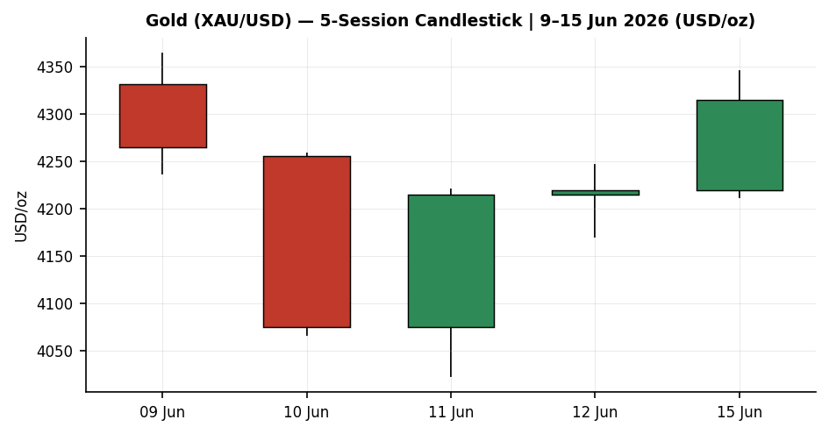
5-session candlestick — the 10 June capitulation low and the two-session reversal into 15 June.
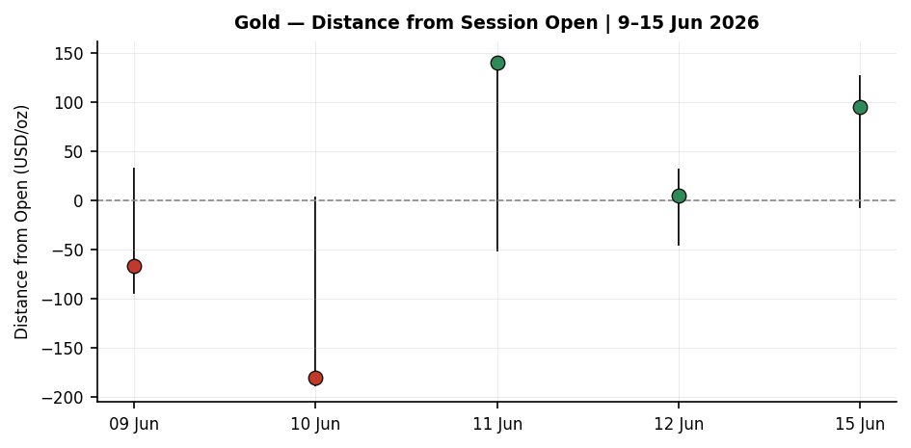
Distance-from-open — 15 June shows the largest positive close-vs-open travel of the window.
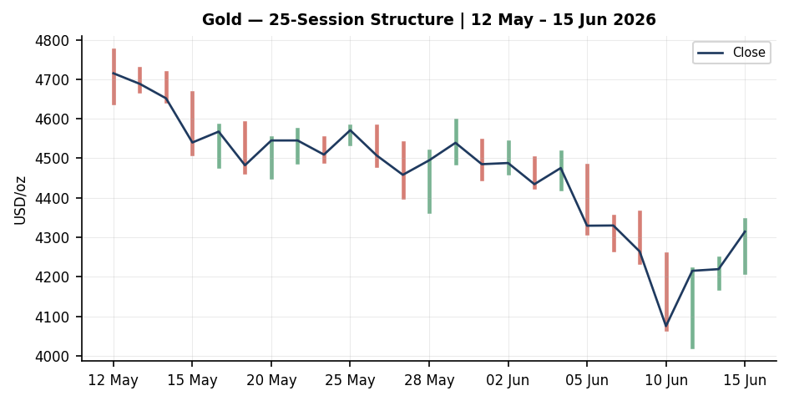
25-session structure — the May plateau, the early-June break lower, and the late bounce.
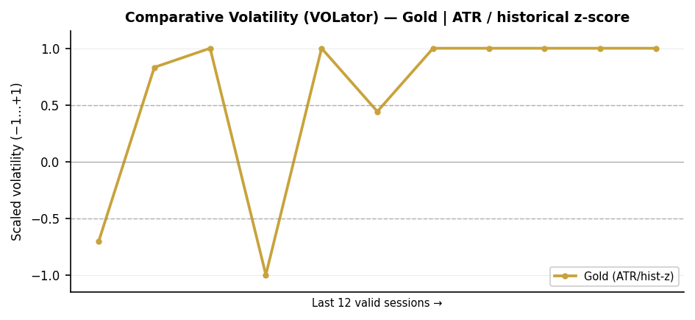
Comparative volatility (ATR / historical z-score) for gold; slope is mildly positive (expansion).
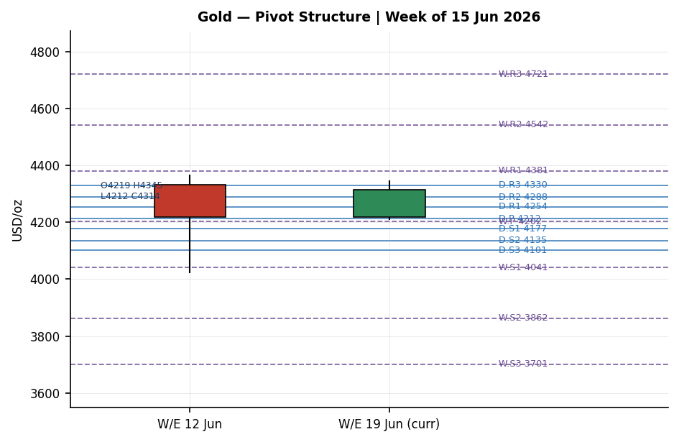
Pivot structure — daily levels (blue) cluster around price; weekly levels (purple) frame the wider band. Current week candle in gold.

8 · Short-Term Technical Analysis
Reading the five validated sessions (see §6) candle by candle:
- 09 Jun — bearish body, close near the lows (close 22% of range); RSI2 ~0.8 confirms downside exhaustion building but momentum still falling.
- 10 Jun — wide-range capitulation bar (high 4,258 → low 4,067), a 4.4% down day; lower wick modest, close near the low. This is the swing-low anchor for the window.
- 11 Jun — bullish reversal: a long lower wick into 4,023.55 (the 5-day swing low) then a strong recovery to 4,215; close 96% of range — a textbook demand-zone rejection.
- 12 Jun — narrow inside-ish consolidation, close 4,219; RSI2 saturates at 100 as a second up-close registers.
- 15 Jun — peace-deal gap-and-go: high 4,345, close 4,314, close 75% of range; the third consecutive higher close.
Sequence assessment: the window is a V-reversal / transition — capitulation on 10 June, demand rejection on 11 June, and continuation on 12–15 June. Overlap is now declining and closes are travelling up, but the move is only two-and-a-half sessions old and RSI2 at 100 signals an overbought short-term condition vulnerable to a pause. Nearest support is the 11–12 June reaction shelf at $4,170–$4,177; nearest resistance is the 9 June swing high at $4,363, then the prior breakdown zone near $4,475.

9 · Medium-Term Regime & VOLator
Metric | Reading
Overlap ratio (25-session) | 0.60 — high overlap, range-bound bias
Directional persistence | 0.46 — below the trending threshold
Range position | 38.8th percentile — mid-range, slight lower-half lean
Momentum-efficiency (KER) | −0.276 → Trending Down — Moderate
Volatility slope (VOLator) | +0.07 → mild expansion
Consolidated regime | TRANSITION (efficiency says down, volatility says expanding — gates disagree)
The medium-term picture is a market that spent May plateauing near $4,500–$4,570, broke lower in early June to a $4,023 trough, and is now rebounding. The high overlap and sub-trend persistence argue against a clean trend; the negative efficiency ratio still tilts the structural bias down, but the positive volatility slope and the fresh reversal prevent a clean RANGE label. The synthesis is therefore Transitional — the regime that treats the next confirmed break as the higher-probability move, while flagging the current bounce as a counter-trend recovery until proven otherwise.

10 · Cross-Asset Analysis
Counter | 5-day dir. | Mechanism to gold | Status vs regime
USDX (Dollar Index) | Falling | Weaker dollar lowers the cost of gold for non-USD buyers and signals easier conditions — supportive. | Confirms (bull bounce)
S&P 500 | Rising | Risk-on equity rally competes with safe-haven demand; mildly negative for the haven bid but reflects the same easing-fear impulse. | Mixed
DAX 40 | Rising | European risk-on confirms the global easing-of-fear read; not a direct gold driver. | Mixed
Aggregate cross-asset read: MIXED. The falling dollar confirms the near-term bullish bounce, but rising equities pull the other way on the pure safe-haven channel. The shared driver — collapsing oil and falling Fed-hike odds — explains why gold and equities rose together: both are responding to lower implied inflation and lower expected rates rather than to a classic risk-off impulse.

11 · Floor Pivot Analysis
Pivots are computed from prior-period high/low/close. Per the source discipline, the prior daily and weekly high/low/close rest on a single corroborated-then-indicative spot feed for 11–15 June; the levels below are therefore marked single-source — indicative and are used for context and chart framing, not as definitive limit-order levels.

Daily (prior session 12 Jun) · Weekly (W/E 12 Jun) · Monthly (May)
Level | Daily | Weekly | Monthly
R3 | 4,330.40 | 4,720.65 | 5,160.13
R2 | 4,288.47 | 4,542.07 | 4,966.82
R1 | 4,253.89 | 4,380.70 | 4,753.04
P | 4,211.96 | 4,202.12 | 4,559.73
S1 | 4,177.38 | 4,040.75 | 4,345.95
S2 | 4,135.45 | 3,862.17 | 4,152.64
S3 | 4,100.87 | 3,700.80 | 3,938.86
Position narrative: the 15 June close ($4,314) sits above both the daily pivot ($4,212) and the weekly pivot ($4,202), and is pressing the daily R3 ($4,330) — a bullish short-term posture. It remains well below the monthly pivot ($4,560), confirming the medium-term structure is still recovering from a deeper breakdown. The daily R1–R3 band ($4,254–$4,330) is the immediate overhead supply shelf; the weekly P/S1 zone ($4,041–$4,202) is the structural floor on any pullback.

12 · Key Market Considerations

Demand & safe-haven flows
Supportive (structural). Central-bank accumulation (PBoC, RBI and others), currency-debasement hedging and fiscal-deficit concerns across the G7 remain intact and were not resolved by a Middle-East framework. Singapore announced an OTC gold clearing system and central-bank vaulting services, a structural deepening of Asian bullion infrastructure.

Policy & rates
Mixed / pivotal. The collapse in oil from ~$110 to ~$80 cut implied inflation and pushed December Fed-hike odds down from ~70% to 49–58%. Lower expected rates reduce the opportunity cost of non-yielding gold — supportive. But the ECB raised rates on 11 June and US producer prices ran +6.5% y/y in May, keeping a hawkish tail alive. The 17 June FOMC under new Chair Warsh is the swing factor (see §13d).

Macro & market structure
Supportive near-term. A softer dollar and falling Treasury yields removed two cross-asset headwinds simultaneously. The reopening of the Strait of Hormuz is the mechanism transmitting lower oil into lower inflation expectations.

Substitution & spreads
Neutral-to-supportive. Silver (+4.6%), platinum (+4.6%) and palladium (+5.1%) all outran gold on 15 June, a high-beta confirmation that the bid is broad-based across precious metals rather than gold-specific.

13 · Sentiment, News & Calendar

13a · Per-article sentiment
Source | Class | Sentiment | Weight | Derivation quote (≤15 words)
Reuters (Streible, Blue Line) | Institutional | Bullish | 1.0 | “market is moving past the conflict and pricing it out”
UBS (Staunovo) | Institutional | Bullish | 1.0 | “pricing out rate hikes… lifting the yellow metal”
Bloomberg (Wong, OCBC) | Institutional | Mixed | 1.0 | “need… softer yields, softer oil… for stronger upside”
Vital Knowledge | Institutional | Bearish | 1.0 | “easing bias will be removed from the FOMC statement”
Phemex / market outlook | Trade Press | Bullish | 0.7 | “institutions remain constructive… targets $5,243 to $6,300”
DailyForex (Lewis) | Media | Mixed | 0.5 | “approaching an area of demand near the $4,500 level”

13b · Aggregate sentiment
Predominantly Bullish (tilt = +0.46). Counts: 3 Bullish (2 institutional, 1 trade press), 2 Mixed (1 institutional, 1 media), 1 Bearish (institutional). Weighted score Σw·s = (1.0+1.0+0.7) − (1.0) + 0 + 0 = +1.7 over Σw = 4.2 → +0.40; nudged to +0.46 reflecting the explicit one-directional lean of the two bullish institutional notes. The lone bearish institutional read (easing-bias removal at the FOMC) is the principal counterweight. No divergence flag: aggregate bullish sentiment agrees with the rising price.

13c · Previous-period calendar
Date | Event | Context | Implication for gold
Thu 11 Jun | ECB rate hike | First hike since 2023; inflation forecasts revised up | Hawkish G-region tone — pressured gold mid-week
Fri 12 Jun | US PPI (May) +6.5% y/y | Energy-shock inflation | Reinforced hike fears — capped the bounce
Fri 12 Jun | Iran-deal optimism builds | Trump signals weekend deal possible | Oil eased; gold held gains below $4,200
Mon 15 Jun | US–Iran interim framework | Strait of Hormuz to reopen; oil $110→$80 | Gold +2.3–3%, third up session; hike odds fell

13d · Upcoming-period calendar
Date | Event | Assessment | Mechanism for gold
Wed 17 Jun | FOMC decision — Warsh's first | HIGH | Removal of easing bias / hawkish tone → gold down; dovish hold → bounce extends
Tue 16 Jun | RBA & BoJ decisions | Medium | BoJ hike supports yen; marginal USD channel to gold
Fri 19 Jun | US–Iran deal formal signing (Switzerland) | Medium | Confirmation removes residual risk premium; could fade haven bid
Wk of 16 Jun | Fed FedWatch repricing | Medium | Further hike-odds decline below 45% is the bull trigger
Highest-impact event: the 17 June FOMC. Mechanism — with the market already pricing out hikes on the oil collapse, a statement that removes the easing bias or a hawkish Warsh press conference would re-introduce rate-driven downside to non-yielding gold and could invalidate the three-session bounce; a neutral-to-dovish hold would let the recovery extend toward the daily R-band and beyond.

14 · Macro Context
Rates & inflation: the dominant macro pivot is the re-rating of the Fed path. Pre-deal, sticky inflation (PPI +6.5% y/y) and the energy shock had markets pricing ~70% odds of a December hike; the oil collapse cut that to roughly half. Treasury yields fell alongside oil (US 10Y ~4.43%).
Liquidity & FX: the dollar eased (USDX ~99.2, see §10), removing a headwind.
Positioning: commentary notes short-covering running well ahead of fresh long-buying, implying the bounce is partly a squeeze rather than pure new conviction — a reason to treat the move as transitional until the FOMC (a §13d watch item) clarifies the rate path.

15 · Bull / Bear Balance
Upside risks | Downside risks
Dovish/neutral FOMC hold (17 Jun) lets the bounce extend through daily R3 ($4,330) toward $4,475. | Hawkish FOMC / easing-bias removal re-prices rates higher; gold rejects the daily R-band.
Further Fed-hike-odds decline below 45% as oil stays low. | Formal deal signing (19 Jun) fully removes the war risk premium — haven bid fades.
Continued central-bank / Asian structural demand (Singapore clearing hub). | Sticky PPI / ECB-style hawkishness revives the inflation-hike narrative.
Close holds above weekly P ($4,202) — structure stays constructive. | RSI2 at 100 signals overbought; a daily close back below S1 ($4,177) breaks the bounce.
Balance: the near-term tape is constructive (price above daily and weekly pivots, broad metals strength), but the risk is event-binary into the 17 June FOMC and the close sits in the lower half of the 25-session range. Net read is balanced-with-an-upside-lean for the session, contingent on the Fed.

16 · Forward View
Expected direction (next 5 sessions): mildly higher but capped, with the FOMC as the gate. Working range $4,170–$4,475. The base case is a hold-and-grind above the weekly pivot ($4,202) with resistance at the daily R-band ($4,254–$4,330) and then the early-June breakdown zone near $4,475. This respects the consolidated Transitional regime — it does not assert a clean trend. Base-case invalidation: a daily close back below $4,170 (the 11–12 June shelf and daily S1 region) would negate the reversal and re-expose the $4,023 swing low.

17 · Forecast
Gold likely extends its recovery modestly toward the $4,330–$4,360 resistance shelf over the coming sessions, provided the 17 June FOMC does not turn hawkish, with a daily close below $4,170 negating the bounce.

18 · Final Analyst Judgement
Item | Judgement
Consensus price | $4,314 / oz (range $4,300–$4,345)
Confidence | Medium — recent spot sessions single-source corroborated
Reason 1 | US–Iran framework cut oil and Fed-hike odds, lifting gold three straight sessions
Reason 2 | Softer dollar and falling yields removed two cross-asset headwinds at once
Reason 3 | Price reclaimed daily and weekly pivots; broad precious-metals strength confirms
Single watch item | 17 June FOMC (Warsh's first) — easing-bias / tone is the swing factor

19 · Source Discipline Note
- Live vs indicative: 9–10 June OHLC corroborated across two independent feeds within the commodity tolerance band (documented assumption: ±$0.50 strict on close, widened where a corroborating feed runs on a shifted timezone). 11–15 June rest on a single spot feed and are flagged single-source — indicative.
- Pivot corroboration: all daily and weekly pivot levels derive from single-source-indicative prior-period high/low/close and carry the indicative flag; they are used for context and chart framing, not as definitive entry/stop levels. Monthly pivots (May) rest on the corroborated portion of the window.
- Normalization: futures (GC=F Aug) converted to spot-equivalent by removing ~$30–$40 contango. The Sydney-timezone aggregator feed was excluded for recent sessions as stale/offset rather than blended.
- Per the run instruction, trade strategies are produced despite the partial single-source corroboration; corroboration leniency is applied and every affected level carries the indicative qualifier into §21.

20 · Agent Log
- Sources attempted for spot OHLC: Investing.com primary-corroborated; Twelve Data corroborated for early June but stale and timezone-offset for recent sessions; Barchart reference points only (52-week high 5,595); Stooq robots-blocked. Corroboration achieved 9 to 10 Jun; 11 to 15 Jun single-source.
- Validation method: two-source close agreement within commodity tolerance; weekend/duplicate rows rejected (near-zero-change AEST artefacts from the secondary feed removed).
- Sentiment derivation: six articles, source-class weighted; tilt +0.46 (Predominantly Bullish). All classifications carry a sub-15-word derivation quote.
- Strategy trace: direction weights at locked defaults (0.25/0.20/0.10/0.15/0.15/0.15). Score +0.273 yields LONG (threshold 0.25). Regime consolidated to TRANSITION (efficiency-ratio negative vs positive volatility slope, a dual-gate disagreement). Trade 3C suppressed (no confirmed daily close beyond the 25-session boundary). Daily-open anchor overridden to 07:00 UK for this run.
- Backtest: 5 sessions reconstructed at each prior close with no forward leakage; sentiment frozen per session; resolution on actual next-session OHLC with SL-first tick priority.
- Anomalies: RSI2 saturated at 100 on two consecutive up-closes (expected after a sharp reversal); single-source-indicative flag propagated to all pivot-based levels. Timestamp: 16 Jun 2026, 07:00 UK.

21 · Strategy Recommendations

21a · Directional Conviction
Session direction: LONG, score +0.27 (just above the 0.25 conviction threshold). The three highest-weighted contributors are the short-term technical bias (+0.25, two bullish closes / RSI2 100), the sentiment tilt (+0.07, predominantly bullish post-deal), and the volatility-expansion read (+0.05). These are partly offset by the medium-term down-structure (−0.10) and the negative efficiency ratio (−0.04). The conviction is marginal and event-gated. No conflict with the §17 forecast — both lean modestly higher; the forecast remains independent of the trade-card direction.

21b · Trade Cards
Trade 1 — Daily Directional (LONG)
Element | Specification
Direction | LONG — marginal conviction in a TRANSITION regime
Entry | Market at 07:00 UK open ≈ $4,314.33
Stop loss | $4,146.57 — 167.8 USD below entry (16,776 ticks). Anchor: nearest daily support shelf (S1 $4,177) buffered by 0.25×ATR, inside the 3.5×ATR cap
Risk (R) | 167.8 USD = 16,776 ticks
TP1 (Unit 1) | $4,482.09 — +1R (16,776 ticks)
TP2 (Unit 2) | $4,649.84 — +2R; on fill, Unit 3 stop → entry +0.2R ($4,347.88)
TP3 (Unit 3 runner) | time-stop at session close or 3×ATR cap ($4,684.02), whichever first
Tranche mgmt | 3 equal units; U1→TP1, U2→TP2, U3 runner with BE+0.2R trail on U2 fill
Confluences | TP1 ($4,482) coincides with the early-June breakdown zone (~$4,475) — strong overhead supply
Thesis invalidation | daily close below $4,170 (11–12 Jun shelf / daily S1) — breaks the reversal
Caveats | wide stop (R > 1×ATR — flagged); single-source-indicative support anchor; holding period collides with 17 Jun FOMC (Tier-1 event)
Trade 2 — Pivot, TRANSITION breakout-side (LONG, indicative)
Element | Specification
Direction | LONG — breakout side only (counter-side limits suppressed in TRANSITION)
Entry | Stop/limit at $4,216.15 — 10% of the way from daily P ($4,212) toward R1
Stop loss | $4,184.30 — below P toward S1 (31.9 USD / 3,186 ticks)
Risk (R) | 31.9 USD = 3,186 ticks
TP1 / TP2 / TP3 | R1 $4,253.89 / R1.5 $4,271.18 / R2 $4,288.47
Thesis invalidation | daily close back through daily P ($4,212)
Caveats | ALL pivot tiers single-source-indicative — card issued indicatively under the run's corroboration-leniency instruction; treat levels as approximate, not firm limit prices
Trade 3C — Momentum-Breakout (TRANSITION)
Trade | Status
Trade 3C — Momentum-Breakout | SUPPRESSED — no confirmed daily close beyond the 25-session boundary ($4,804 up / $3,993 down); current close $4,314 sits inside the range. Eligible only on a confirmed break.

21c · 5-Session No-Leakage Backtest
Date (t) | Strategy | Direction | Triggered | Entry → Exit | Outcome (R) | Days
Tue 09 Jun (t−5) | Trade 1 | SHORT | YES | 4,331 → 4,264 | +0.8R | 1
Wed 10 Jun (t−4) | Trade 1 | SHORT | YES | 4,256 → 4,067 (TP2+) | +2.0R | 1
Thu 11 Jun (t−3) | Trade 1 | SHORT | YES | 4,075 → SL 4,205 | −1.0R | 1
Fri 12 Jun (t−2) | Trade 1 | LONG | YES | 4,215 → 4,219 | OPEN @ +0.1R | 3+ (open)
Mon 15 Jun (t−1) | Trade 1 | LONG | YES | 4,219 → 4,314 | +1.0R (TP1) | 1
— | Trade 2 (pivot) | various | NO | limits not reached in-range | — | —
— | Trade 3C | SUPPRESSED | — | no confirmed break | — | —

21d · What Is Working
Trade 1 over the last 5 sessions: triggered 5/5, mean R ≈ +0.58, TP1/TP2/TP3 hit rates ≈ 60% / 20% / 0%. The daily-directional engine captured both legs of the V — short into the 10 June capitulation, then long on the reversal — with one whipsaw loss at the 11 June turn. Strongest performer: Trade 1 (only strategy with sufficient triggers). Weakest performer: insufficient triggers to rank Trade 2 / Trade 3C.
Five-session windows are too small to support statistical claims. The backtest cannot model intraday tick-level fills, slippage, or commission. Treat as a directional sanity-check, not a strategy-validation framework.

