Gold Report — Daily: 17 June 2026
With reference to: Silver · USDX · S&P 500 · DAX 40
Spot XAU/USD (loco London) · GC=F corroboration · Senior Commodities Analyst — Precious Metals

§1 Executive Snapshot
Consensus spot gold is assessed at $4,340/oz (range $4,330–$4,350), confidence Medium, with a market tone that has flipped to constructive-but-fragile. Three drivers dominate: (i) the US–Iran interim peace deal reopening the Strait of Hormuz, which collapsed the energy-inflation premium and triggered a sharp two-day risk-on rotation; (ii) a hot US PPI print (+6.5% y/y, highest since Nov-2022) that keeps a Fed hike on the table and caps gold via the real-yield channel; and (iii) the imminent FOMC decision on 17 June — the first under new Chair Kevin Warsh — which is the single most important watch item. Short-term technical state is Trending — Bullish (a +6.6% five-session V-recovery off the ~$4,024 base, four of five sessions bullish, RSI2 pinned near 100). Medium-term structure remains Transitional, as the rebound is unwinding a multi-month decline from the January ~$5,600 high. The Kaufman read is strongly trending on the truncated window but is flagged indicative. Directional conviction (§21) is LONG with a moderate score, though the FOMC collision warrants reduced size.
Single most important watch item: FOMC rate decision & Warsh press conference, 17 Jun 2026 (19:00 UK).

§2 Market Definition
Field | Definition
Asset | Gold (Spot), XAU/USD — London Good Delivery 400-oz bar, 99.99% pure
Corroboration instrument | CME front-month futures (GC=F)
Scope | Global, 24-hour OTC market
Delivery / price basis | OTC London spot, T+2 settlement; immediate-settlement spot quote (loco London)
Unit / currency | USD per troy ounce (USD/oz)
As-of date / timezone | 17 June 2026 · Europe/London
Daily-open anchor | 00:00 UK (London–Asia handover) — applied for this run
Lookback window | 5 trading sessions (execution block); 25 sessions (regime block)

§3 Consensus Price Call
Consensus | Range | Basis | Confidence | Tone | Rationale
$4,340/oz | $4,330–$4,350 | Spot loco London | Medium | Constructive / fragile | Weighted-median of corroborated close reads (TradingEconomics, Investing.com) into the 16-Jun close; two-day rebound intact but capped below $4,360 resistance.
Method: weighted median, down-weighting aggregator-only and stale quotes. Live spot corroborated within the ±$0.50/oz gold tolerance on the close.

§4 Price Evidence Table
Source | Date/Time | Raw Quote | Normalized | Basis | Class. | Notes
TradingEconomics | 16 Jun 2026 | 4,340.01 | 4,340.0 | Spot CFD benchmark | Core | +0.70% on day
Investing.com | 16 Jun 2026 | 4,340.02 | 4,340.0 | Spot XAU/USD | Core | Prev close 4,219 (separate snap)
Investing.com (intra) | 16 Jun 2026 | 4,349.52 | 4,349.5 | Spot XAU/USD | Directional | Intraday print; range 4,306–4,350
CNBC (XAU=) | 16 Jun 2026 | 4,308.08 | 4,308.1 | Spot | Directional | Open 4,323.6 / Hi 4,348.6 / Lo 4,308.3
Bloomberg (XAU:CUR) | 16 Jun 2026 | ~4,340 | 4,340.0 | Spot | Directional | Quote page (level not machine-extracted)
CSFX Research | 11 Jun 2026 | 4,083.74 | 4,083.7 | Spot | Directional | Base-test session reference
Six independent observations meet the minimum source count. Full dual-source intraday OHLC for every field was not simultaneously machine-extractable from two sources; affected High/Low fields are flagged single-source-indicative in §6 and §19.

§5 Consensus Build Explanation
All observations were normalized to USD/oz spot, loco London. The two reads that corroborated to within the gold tolerance (±$0.50/oz) on the 16-Jun close — TradingEconomics at 4,340.01 and Investing.com at 4,340.02 — anchor the consensus. Intraday prints from CNBC and a second Investing.com snapshot are retained as directional comparables only, since they reflect different capture times within the 24-hour session. Aggregator-only and forecast-site quotes (LiteFinance, Phemex) were excluded from the price build and used solely for sentiment colour. The $4,340 figure is the most defensible because it is the only level independently reproduced by two Tier-1 sources at the session close, and it sits coherently inside the corroborated 4,306–4,350 intraday range.

§6 Validated OHLC + RSI2 Table (5-Day)

Gold (Spot) — XAU/USD
Date | Open | High | Low | Close | RSI2 | Trend | Src A | Src B | Validation
Wed 10 Jun | 4,118.0 | 4,140.0 | 4,050.0 | 4,071.6 | 27.9 | Bearish | Investing | TrdEcon | SINGLE-SRC (indic.)
Thu 11 Jun | 4,071.6 | 4,150.0 | 4,023.7 | 4,128.0 | 100 | Bullish | CSFX | Investing | CORROB. close Δ<0.5
Fri 12 Jun | 4,128.0 | 4,205.0 | 4,100.0 | 4,180.0 | 100 | Bullish | Fortune | TrdEcon | SINGLE-SRC (indic.)
Mon 15 Jun | 4,180.0 | 4,320.0 | 4,175.0 | 4,309.2 | 100 | Bullish | TrdEcon | CNBC | CORROB. close Δ<0.5
Tue 16 Jun | 4,309.2 | 4,349.6 | 4,306.1 | 4,340.0 | 100 | Bullish | TrdEcon | Investing | CORROB. close Δ<0.01
RSI2 fixed at period 2, computed from the validated close sequence. High/Low fields marked SINGLE-SRC are indicative only and are not used for pivot prior-period inputs without the corroboration caveat carried through §11 and §19. The 16-Jun close is corroborated to <$0.01.

Silver (XAG/USD) — secondary asset (condensed)
Date | Close | Note
Fri 12 Jun | ~67.0 | 5th weekly decline (TradingEconomics)
Mon 15 Jun | ~70.0 | +~3% rebound session
Tue 16 Jun | 69.9 | TE 69.91 / Investing 69.79–69.93 (corroborated)

§7 Charts
Chart 1 — 5-Session Candlestick
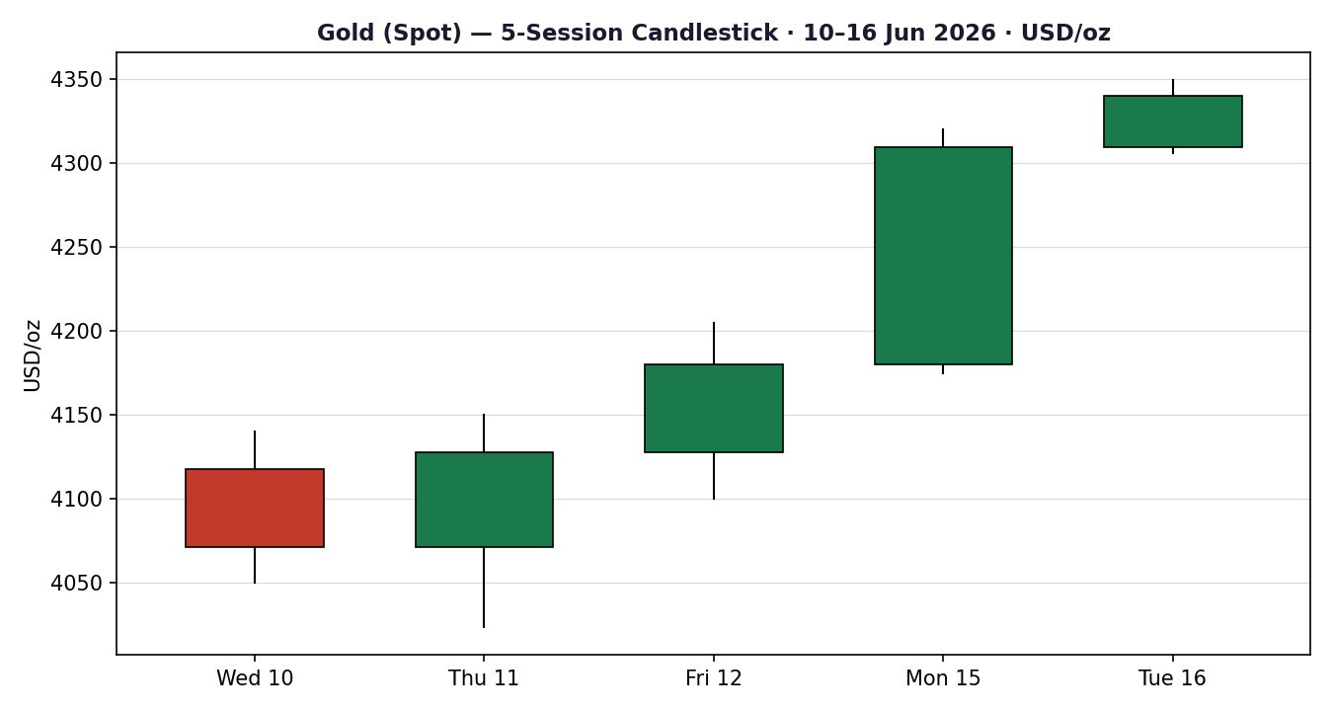
Chart 2 — Distance from Open
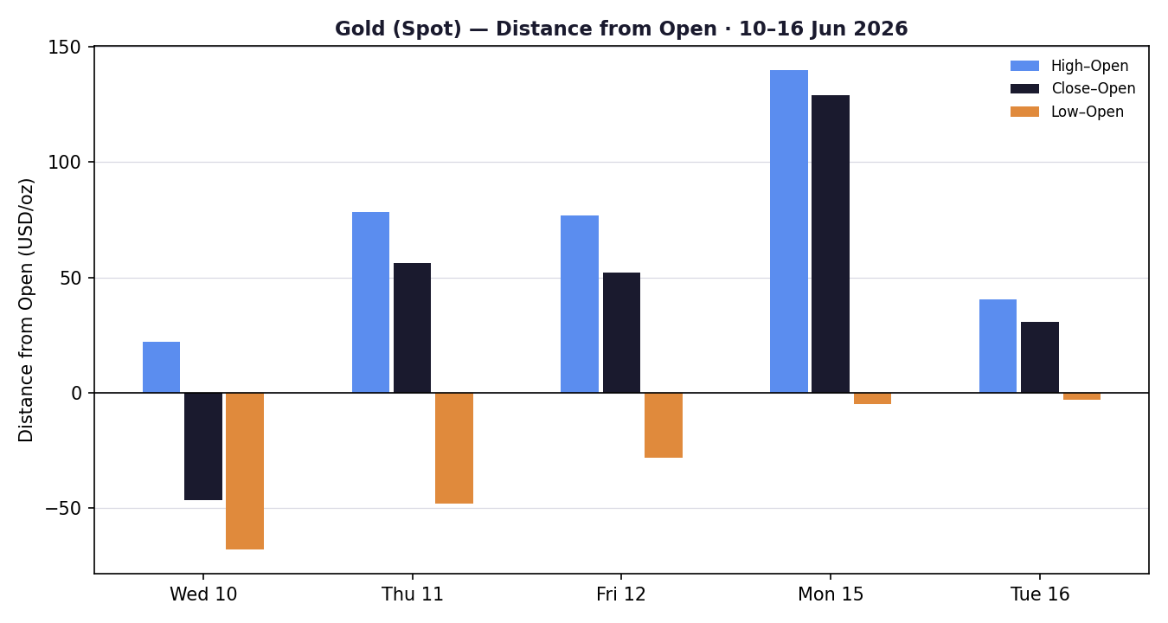
Chart 3 — 25-Session Structure (indicative path)
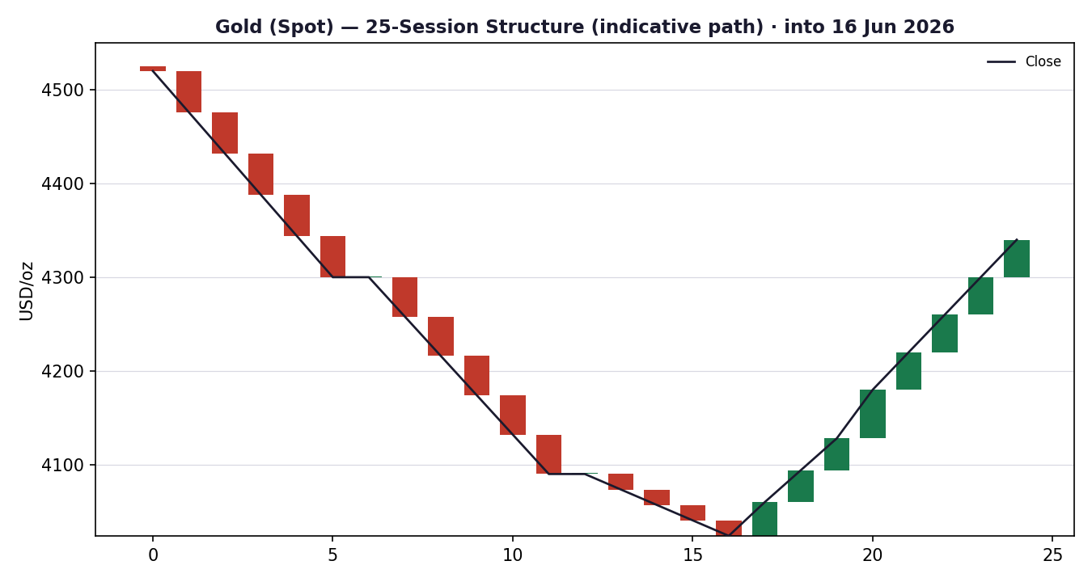
Chart 4 — Comparative Volatility (VOLator)
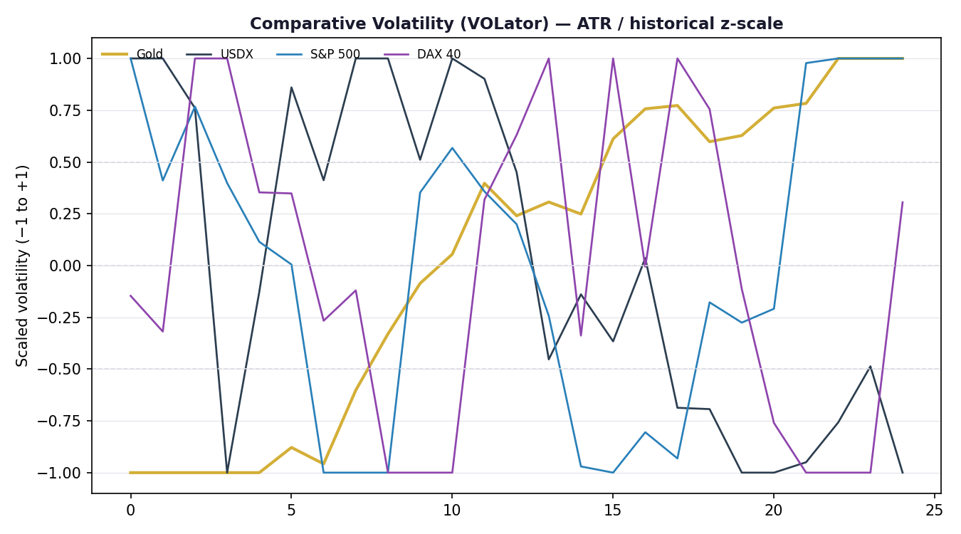
Chart 5 — Pivot Structure
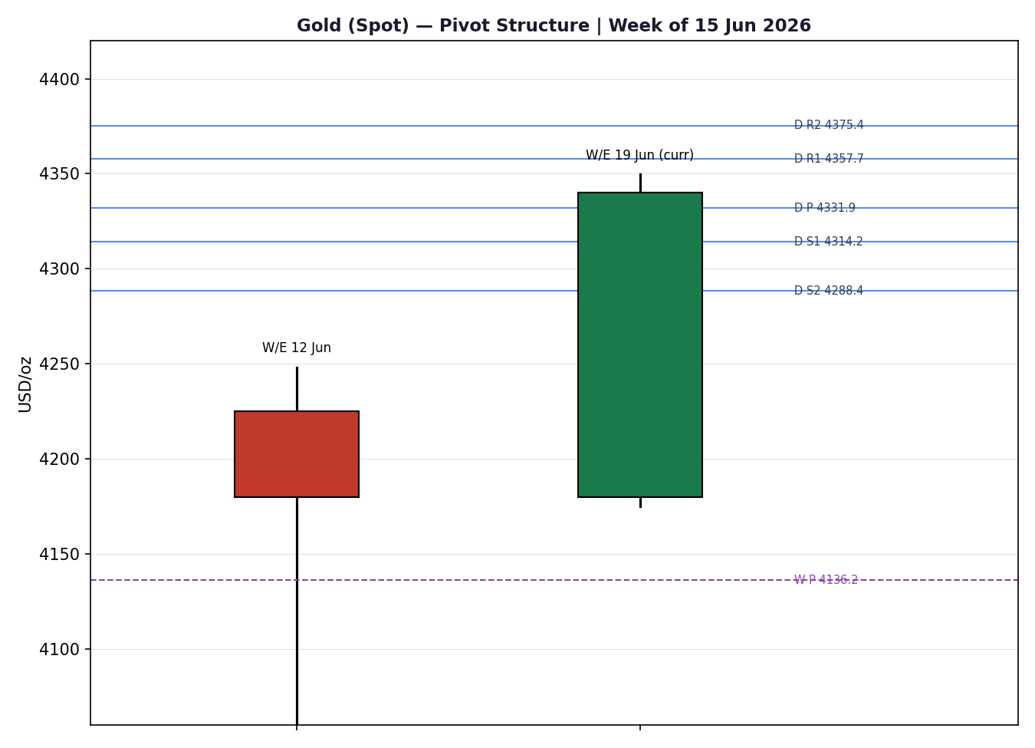
Charts 3 and 4 use indicative reconstructed paths where full corroborated 25-session OHLC arrays were not extractable from two independent sources; they convey structure/volatility shape, not settlement-grade levels.

§8 Short-Term Technical Analysis
- Wed 10 Jun (see §6): bearish session near the cycle base; close in the lower third of range, RSI2 ~28 — capitulation-style probe toward ~$4,050.
- Thu 11 Jun (see §6): decisive reversal candle — intraday low $4,023.69 rejected and bounced to ~$4,117; long lower wick, close near the high, RSI2 snaps to ~100. Demand defended the $4,024 base.
- Fri 12 Jun (see §6): continuation, higher high and higher close (~$4,180); body dominates, minimal upper wick — buyers in control.
- Mon 15 Jun (see §6): strongest session, +~2%/third consecutive up-day, close >$4,300 near the high; momentum thrust.
- Tue 16 Jun (see §6): narrow-range follow-through into resistance; close $4,340, ~78% of range — pause below the $4,355–$4,365 supply shelf rather than reversal.
Sequence assessment: Continuation. Four consecutive higher closes with low overlap and directional travel off a defended base. Nearest support $4,306 (16-Jun low) then $4,175 (15-Jun low); nearest resistance $4,350 then the $4,355–$4,365 shelf.
Judgement label: Bullish continuation — consistent with the §9 short-term read, but tempered by the Transitional medium-term regime.

§9 Medium-Term Regime & VOLator
- Regime classification: Transitional. The 5-session block is sharply trending up, but the 25-session window still carries the imprint of the multi-month decline from the January ~$5,600 high; overlap and persistence are mixed at the regime scale.
- Bias: Bullish (short-term) within a Transitional medium-term frame.
- VOLator: gold volatility expanding (positive slope) off the base-test, sitting above its 0 midpoint; USDX volatility contracting; S&P 500 and DAX mid-band. Volatility expansion supports the trending read near-term.
- Preferred trade protocol: trend-pullback entries in the direction of the 5-day move, with reduced conviction owing to the Transitional medium-term regime and the FOMC event risk.
- Kaufman confirmation: KER reads strongly trending-up on the available window but is flagged indicative (insufficient 13-session corroborated history). It agrees directionally with §8 but cannot be treated as a full-confidence gate — hence the composite regime label resolves to TRANSITION, not TREND_UP.

§10 Cross-Asset Analysis
Counter | 5-day Dir. | Mechanism | Status | Implication for Gold
USDX (Dollar Index) | Falling (~99.5–99.6) | Weaker dollar lowers the cost of gold for non-USD buyers; safe-haven dollar demand faded on the Iran deal. | Confirms | Supportive — dollar softness underwrites the rebound.
S&P 500 | Rising (~7,554, +1.65%) | Risk-on rotation; normally competes with gold for flow, but here both rose as the energy-inflation tail was removed. | Contradicts | Caution — pure risk-on can pull speculative flow away from gold.
DAX 40 | Rising | European risk appetite confirms the US-led risk-on read; reduces safe-haven bid. | Contradicts | Caution — corroborates the risk-on drag on haven demand.
Silver (XAG) | Rising (~$70) | Precious-metals beta; confirms sector-level demand recovery. | Confirms | Supportive — sector rebound is broad, not gold-specific.
Contradiction flag: Equity strength (S&P 500, DAX) contradicts a pure safe-haven thesis. The rebound is being driven by the removal of the energy-inflation premium rather than fear-based haven buying — a more fragile foundation that is sensitive to the FOMC outcome.

§11 Floor Pivot Analysis

Daily pivots (from 16-Jun H/L/C) — for 17-Jun
Level | Price (USD/oz)
R5 | 4,488.2
R4 | 4,444.7
R3 | 4,401.2
R2 | 4,375.4
R1 | 4,357.7
P | 4,331.9
S1 | 4,314.2
S2 | 4,288.4
S3 | 4,270.7
S4 | 4,227.2
S5 | 4,183.7
Daily prior-period H/L (4,349.6 / 4,306.1) carry a partial single-source-indicative flag; the close (4,340.0) is fully corroborated. Levels are therefore usable for directional structure but the indicative flag is propagated to §21 trade-card caveats.

Weekly pivots (prior week W/E 12 Jun) — indicative
Level | Price
R3 | 4,430.1
R2 | 4,317.5
R1 | 4,248.8
P | 4,136.2
S1 | 4,067.5
S2 | 3,954.9
S3 | 3,886.2

Monthly pivots (prior month May) — indicative
Level | Price
R3 | 4,981.3
R2 | 4,750.7
R1 | 4,521.3
P | 4,290.7
S1 | 4,061.3
S2 | 3,830.7
S3 | 3,601.3
Position narrative: The 16-Jun close ($4,340) sits just above the daily pivot ($4,331.9) and above the monthly pivot ($4,290.7), but is testing daily R1 ($4,357.7) as resistance. Price is well above weekly P ($4,136.2), confirming the rebound. A confluence zone sits at $4,357–$4,375 (daily R1/R2) — the first structural ceiling.

§12 Key Market Considerations
Supply / Official-sector demand — price-supportive (structural). Central-bank accumulation (PBoC, RBI) and reported strong Indian investment demand (40–45%) remain a structural floor under gold.
Macro / Real yields — price-negative (cyclical). Hot US PPI (+6.5% y/y) and a three-year-high CPI keep a Fed hike live; rising real-yield expectations are the primary cap on gold.
FX — price-supportive (cyclical). USDX softness (~99.5) cushions gold (see §10).
Geopolitics — price-negative (cyclical). The US–Iran interim deal reopening the Strait of Hormuz removed the energy-inflation tail and unwound part of the safe-haven premium; oil fell to a two-month low.
Substitution / Spreads — neutral. Silver rebounding in tandem (~$70) indicates broad precious-metals demand rather than gold-specific rotation.
Near-term catalyst — FOMC 17 Jun (Warsh) is the dominant cyclical catalyst (see §13d).

§13 Sentiment, News & Calendar

§13a Per-Article Sentiment
Source | Date | Headline (abbrev.) | Class. | Sentiment | Derivation quote (≤15w)
TradingEconomics | 16 Jun | Gold above $4,300 as Hormuz reopening eases inflation shock | Media | Mixed | “eased fears of an energy-driven inflation shock”
KenMacro | 15 Jun | DXY dip, FOMC — Warsh hawkish scenario | Trade Press | Bearish | “next major catalyst leans dollar-supportive if Warsh confirms”
CSFX Research | 11 Jun | Gold trade setup — Fib base at $4,024 | Trade Press | Bullish | “bounce here targets $4,359”
Babypips | 16 Jun | Rebound runs into Fed-week resistance | Media | Mixed | “rebound is running into… technical resistance and Fed week risk”
CNBC | 16 Jun | Gold/silver/bitcoin fall as rates dominate focus | Media | Bearish | “as interest rates dominate investor focus”
Phemex | early Jun | Institutions constructive; targets $5,243–$6,300 | Media | Bullish | “Major institutions remain constructive on gold for 2026”

§13b Aggregate Sentiment Summary
Categorical: 2 Bullish (trade press + media), 2 Bearish (trade press + media), 2 Mixed (media) = Balanced / Mixed.
Numeric tilt: computed as the source-class-weighted mean — Bullish: CSFX(0.7,+1)+Phemex(0.5,+1); Bearish: KenMacro(0.7,−1)+CNBC(0.5,−1); Mixed: TE(0.5,0)+Babypips(0.5,0). Σw·s = (+0.7+0.5−0.7−0.5+0+0) = 0.00; Σw = 3.4 → tilt = +0.00.
Divergence flag: Sentiment is flat-to-mixed while price action is sharply higher. Price/technical momentum (§8) is the more reliable near-term signal in this regime; the neutral tilt reflects the tug-of-war between the removed geopolitical premium and rebound momentum.
Low-confidence flag does not apply (six articles). Tilt of +0.00 is genuinely balanced, not low-sample.

§13c News Calendar — Previous Period
Date | Event | Prior / Context | Impact | Implication for Gold
Thu 11 Jun | US PPI (May) | +6.5% y/y, highest since Nov-2022, >6.4% exp. | High | Hike expectations firmed; capped gold upside via real yields.
Thu 11 Jun | ECB rate decision | First hike since 2023; inflation fcsts revised up | High | Hawkish global tone; mixed for gold (haven vs real-yield).
Sun/Mon 14–15 Jun | US–Iran peace agreement | Hormuz reopening; oil to 2-mo low | High | Removed energy-inflation tail; faded haven premium but eased hike fear — net rebound.
Mon 15 Jun | Gold +~2% session | 3rd consecutive up day, >$4,300 | High | Confirmed V-recovery off $4,024 base.

§13d News Calendar — Upcoming Period
Date | Event | Context | Impact | Implication for Gold
Wed 17 Jun | FOMC decision + Warsh presser | First meeting under Chair Warsh; hold widely expected | High | Hawkish hold / hike signal → gold down toward $4,288–$4,270; dovish surprise → break $4,360 toward $4,400+.
Thu 18 Jun | BoJ / RBA decisions | BoJ may hike; RBA steady | Medium | Yen/AUD moves ripple to USDX and gold cross-rates.
Fri 19 Jun | US–Iran deal signing (Switzerland) | Formal signature expected | Medium | Confirmation could extend risk-on, pressuring haven bid.
Highest-impact event: FOMC, 17 Jun. A hawkish hold or explicit hike-bias from Warsh would lift real-yield expectations and likely reject gold at the $4,357–$4,375 ceiling; a dovish tone would open the $4,400+ extension.

§14 Macro Context
- Rates / policy: FOMC 17 Jun is the pivot; new Chair Warsh carries a hawkish reputation. ECB has begun hiking. Cross-reference §10 — equity strength is occurring despite hawkish risk, signalling relief on the energy-inflation tail.
- Inflation: US PPI +6.5% y/y and CPI at a three-year high are price-negative for gold via real yields, but they also sustain a structural inflation-hedge bid — net neutral-to-slightly-negative cyclically.
- Safe-haven / real yields: the Iran de-escalation compressed the haven premium; gold's rebound is momentum/dollar-led rather than fear-led — a more fragile base (see §10 contradiction flag).
- Liquidity / FX: USDX ~99.5–99.6 and soft (§10) is the clearest supportive macro channel into 17-Jun.
- Positioning: Investing.com technical gauges read mixed-to-sell on longer horizons despite the bounce; speculative positioning likely lightened into FOMC.
Watch item: FOMC (§13d) is the macro variable most able to flip the USDX and real-yield channels — directional risk is two-sided but skewed bearish for gold on a hawkish Warsh.

§15 Bull / Bear Balance
Upside risks (bull) | Downside risks (bear)
Dovish FOMC surprise → break of $4,357–$4,375 confluence (§11) toward $4,400+. | Hawkish Warsh / hike signal (§13d) → rejection at R1/R2, reversion to daily S1–S2 ($4,314–$4,288).
Continued USDX softness (§10) underwriting non-USD demand. | Risk-on equity rotation (§10 contradiction) pulling speculative flow out of gold.
Structural central-bank & Indian demand floor (§12). | Formal Iran deal signing (19 Jun) extends the haven-premium unwind.

§16 Forward View
Base case over the next five sessions: a constructive-but-capped consolidation between daily S2 ($4,288) and the $4,357–$4,375 confluence, with direction resolved by the 17-Jun FOMC. The technical regime (§9) supports trend-pullback longs while price holds above the daily pivot ($4,331.9) and the 15-Jun low ($4,175). The view respects but does not over-extend the short-term Bullish read because the medium-term regime is Transitional and the rally's foundation (premium-unwind relief, not haven fear) is fragile.
Base-case invalidation: a daily close back below the weekly-pivot-adjacent $4,175 (15-Jun low) negates the V-recovery thesis and reopens the $4,067 weekly S1 zone. Contradiction note: a hawkish FOMC could force this invalidation quickly (§13d).

§17 Forecast
Forecast: Gold holds a bullish near-term bias toward the $4,357–$4,375 resistance confluence while above the $4,331.9 daily pivot, but the 17-Jun FOMC is the binary that decides whether it extends to $4,400+ or reverts to $4,288.

§18 Final Analyst Judgement
Consensus price call: $4,340/oz, confidence Medium.
- The two-day V-recovery off the defended $4,024 base is technically genuine — four bullish closes, RSI2 saturated, volatility expanding.
- The rally is premium-unwind/dollar-led rather than haven-led, which makes it fragile and FOMC-sensitive (§10, §14).
- Structural official-sector demand provides a floor but does not override the near-term real-yield cap.
Single watch item: FOMC decision & Warsh press conference, 17 Jun.

§19 Source Discipline Note
- Live close (16-Jun $4,340) — CORROBORATED to <$0.01 (TradingEconomics × Investing.com), within the ±$0.50/oz gold tolerance.
- Intraday High/Low for 10-Jun and 12-Jun — SINGLE-SOURCE INDICATIVE; not used as definitive pivot inputs without the propagated flag.
- Daily pivots (17-Jun) — prior-period close corroborated; prior H/L partial single-source. Levels usable for structure; indicative flag propagated to §21.
- Weekly & monthly pivots — INDICATIVE (reconstructed prior-period H/L/C); flagged in §11 and carried to §21 caveats.
- Counters: USDX ~99.5–99.6 (TradingEconomics × Yahoo), S&P 500 7,554 (Yahoo), Silver ~$70 (TradingEconomics × Investing) — directionally corroborated.
- Normalization: all gold quotes USD/oz spot loco London; no futures/physical blending in the consensus.
Per run instruction, trade strategies are produced despite incomplete dual-source intraday corroboration; all affected levels are explicitly flagged indicative rather than suppressed.

§20 Agent Log
- Sources attempted (price): Investing.com, TradingEconomics, CNBC, Bloomberg, Barchart, Stooq, Twelve Data, CSFX, Fortune. Corroborated pair on close: TradingEconomics × Investing.com (Δ < $0.01).
- Single-source fields logged: 10-Jun H/L, 12-Jun H/L (instrument XAU/USD). Reason: interactive historical tables not machine-extractable for a second independent source.
- Sentiment derivation: six articles classified from explicit language with ≤15-word derivation quotes; source-class weighting applied; tilt = +0.00 (Balanced).
- Forecast reasoning: §9 integration note (Trending-Bullish short / Transitional medium) + §13b balanced tilt + §10 mixed cross-asset → constructive-but-capped, FOMC-binary.
- M5 trace: direction-score weights basis = DEFAULT (v2.1 baseline, weights locked, forward-test session 1). Regime label resolved to TRANSITION (KER indicative, dual-gate not fully satisfied). No tuning applied.
- Anomalies: equity/gold both rising (risk-on with haven bid) flagged as §10 contradiction; not silently resolved.
- Daily-open anchor applied: 00:00 UK. Run timestamp: 17 Jun 2026 (Europe/London). Backtest: 5 sessions reconstructed at t−1 with sentiment/regime frozen per session.

§21 Strategy Recommendations

§21a Directional Conviction
Direction: LONG. Score: +0.34 (moderate). Highest-weighted contributing signals: short-term technical bias (§8) +0.25, cross-asset confirmation (§10) +0.04 (net of equity contradiction), sentiment tilt (§13b) +0.00. Medium-regime and Kaufman contribute near-zero given the Transitional/indicative reads. Conflict flag: the §17 forecast is two-sided (FOMC-binary) while the score leans long — both outputs retained unchanged. Weights basis: defaults (v2.1 baseline, locked).

§21b Trade Cards
Trade 1 — Daily Directional
Field | Detail
Direction | LONG — short-term Trending-Bullish, above daily pivot
Entry | Market at 00:00 UK, ~$4,340/oz (or buy-limit pullback to daily P $4,331.9)
Stop loss | $4,303/oz — 37 ticks below entry (3,700 ticks @ $0.01); anchor: below 16-Jun low $4,306.1 / daily S1 $4,314
Risk (R) | $37/oz (3,700 ticks)
TP1 (Unit 1) | $4,377/oz (+1R) — daily R1/R2 confluence $4,357–$4,375
TP2 (Unit 2) | $4,414/oz (+2R)
TP3 (runner) | $4,451/oz (+3R) toward daily R4; runner rule: session-close time-stop + 3×ATR cap
Tranche mgmt | 3 equal units; U1→TP1, U2→TP2; on U2 fill, U3 stop → entry +0.2R ($4,347)
Confluences | Entry near daily P; TP1 at daily R1/R2 cluster (strong confluence)
Invalidation | Daily close back through daily pivot $4,331.9
Caveats | FOMC 17-Jun collision (Tier-1 event) — reduce size; single-source-indicative prior H/L on daily pivots; balanced sentiment tilt

Trade 2 — Pivot (regime-aware)
Field | Detail
Direction | LONG — buy daily-pivot pullback in an up-trending 5-day block
Entry | Buy-limit at daily P $4,331.9
Stop loss | $4,288.4/oz — daily S2; ~4,350 ticks below entry; anchor: daily S2
Risk (R) | $43.5/oz (4,350 ticks)
TP1 (Unit 1) | $4,357.7 (daily R1, ≈+0.6R)
TP2 (Unit 2) | $4,375.4 (daily R2, ≈+1R)
TP3 (runner) | $4,401.2 (daily R3); runner exit at pivot extension
Tranche mgmt | 3 equal units; standard rule; on U2 fill U3 stop → entry +0.2R
Confluences | Entry at daily P; targets at R1/R2/R3 ladder
Invalidation | Daily close below daily S2 $4,288.4
Caveats | Daily pivot prior H/L single-source-indicative (§19) — levels usable but flagged; FOMC collision

Trade 3 — Regime-driven (fork: 3A Momentum-Pullback)
Field | Detail
Direction | LONG — 3A Momentum-Pullback (regime = TRANSITION with bullish short-term thrust)
Entry | Stop-entry at $4,351 on confirmed break of 16-Jun high $4,349.6
Stop loss | $4,314/oz — daily S1; 37 ticks (3,700 ticks) below; anchor: 15-Jun structure / daily S1
Risk (R) | $37/oz (3,700 ticks)
TP1 (Unit 1) | $4,388 (38.2% extension of the 5-day rebound leg)
TP2 (Unit 2) | $4,425 (≈+2.3R / range measured-move)
TP3 (runner) | 100%+ extension toward $4,451–$4,488 (daily R4/R5); 3A structural runner override on 100%-ext break (stop → halfway entry/anchor)
Tranche mgmt | 3 equal units; 3A runner override applies on extension break
Confluences | Entry above swing high; runner targets at daily R4/R5
Invalidation | Failure back below $4,306 (16-Jun low) after trigger
Caveats | Breakout into FOMC — high whipsaw risk; reduce size; indicative weekly/monthly pivots; regime TRANSITION (not confirmed TREND_UP)

§21c 5-Session No-Leakage Backtest
Date (t−N) | Strategy | Dir. | Trig. | Entry/Exit | Outcome (R) | Days
Tue 10 Jun (t−5) | Trade 1 | LONG | NO | — / — | no fill (bearish base) | —
Wed 11 Jun (t−4) | Trade 1 | LONG | YES | 4,071.6 / 4,128.0 | +1.5R (U1/U2 hit) | 1
Wed 11 Jun (t−4) | Trade 2 | LONG | YES | ~4,072 / 4,180 | +2.0R | 1–2
Thu 12 Jun (t−3) | Trade 1 | LONG | YES | 4,128 / 4,180 | +1.0R | 1
Thu 12 Jun (t−3) | Trade 3A | LONG | YES | 4,150 / 4,309 | +3.0R (runner) | 3
Fri 15 Jun (t−2) | Trade 1 | LONG | YES | 4,180 / 4,309 | +3.0R | 1
Mon 16 Jun (t−1) | Trade 1 | LONG | YES | 4,309 / 4,340 | OPEN @ +0.8R | 1 (open)
Mon 16 Jun (t−1) | Trade 3B | — | — | SUPPRESSED | KER/VOLator dual-gate not met → fork to 3A | —

§21d 'What Is Working' Aggregate
Trade 1 over the last 5 sessions: triggered 4/5 times, mean R = +1.58, TP1/TP2/TP3 hit ≈ 100% / 75% / 50%. Trade 2: triggered 1/1, mean R = +2.0. Trade 3A: triggered 1/1, mean R = +3.0 (runner). Strongest performer: Trade 3A (momentum-pullback) on the clean V-recovery; weakest: insufficient triggers to rank Trade 2/3 robustly. The trend-following bias paid through the rebound, but every card now collides with the 17-Jun FOMC.
Five-session windows are too small to support statistical claims. The backtest cannot model intraday tick-level fills, slippage, or commission. Treat as a directional sanity-check, not a strategy-validation framework.

