Gold Report — Daily: 18 June 2026
With reference to: Silver · USDX (Dollar Index) · S&P 500 · DAX 40
Spot XAU/USD (loco London) · GC=F front-month corroboration · Senior Commodities Analyst — Precious Metals

1 · Executive Snapshot
Gold enters the 18 June 2026 session having staged a sharp three-session recovery off its year-to-date low near $4,000, with consensus spot assessed at $4,348/oz (range $4,320–$4,375). Market tone is balanced-to-constructive. The move is driven by three dominant forces: (i) the interim US–Iran peace framework announced 15 June, which collapsed the energy-inflation premium and pulled oil to a two-month low; (ii) a softer dollar and a repricing of December Fed-hike odds (trimmed to ~57% from ~70%); and (iii) a fresh institutional bid, headlined by Citi lifting its 0–3 month target by $500 to $4,500. The short-term technical state is a Bullish recovery sequence (four of the last five sessions closed green, RSI2 pinned in the low-90s), while the medium-term 25-session structure remains Transitional — the fortnight-net path is still mildly negative after the February–May drawdown from the ~$5,600 record. The Kaufman efficiency read sits right at the trend boundary and is therefore treated as mixed, which maps the consolidated regime to TRANSITION rather than a confirmed uptrend. The single most important watch item is the Federal Reserve decision on 17–18 June — the first under Chair Kevin Warsh — where forward-guidance language, not the (expected) hold, will set gold's next directional leg. Directional conviction from the strategy engine is LONG with a modest score of +0.36 (see §21).

2 · Market Definition
Attribute | Definition
Asset | Gold — XAU/USD spot (London Good Delivery, 99.99%, 400-oz quote basis)
Corroboration instrument | CME COMEX front-month futures (GC=F, Aug-26)
Market scope | Global, 24-hour OTC market
Delivery / price basis | OTC London spot, T+2 settlement; immediate-settlement quote (loco London)
Unit / currency | USD per troy ounce (USD/oz)
As-of | 17 June 2026 close (Europe/London); report issued for the 18 June session
Lookback window | 5 sessions (execution block); 25 sessions (regime block)
Daily-open anchor | 07:00 UK (overridden this run — see §20 Agent Log)

3 · Consensus Price Call
Metric | Value | Notes
Consensus spot | $4,348 / oz | Weighted-median of corroborated spot reads at/near 17 Jun close
Consensus range | $4,320 – $4,375 | Reflects spot/CFD/futures dispersion in a fast tape
Price basis | Spot, loco London, T+2 | XAU/USD interbank convention
Confidence | Medium | Wide source dispersion + event risk (FOMC) cap confidence
Market tone | Balanced → constructive | Recovery intact above $4,300; capped below $4,420 SMA cluster

Rationale: spot prints clustered between ~$4,316 (Reuters/Mezha, 16 Jun) and ~$4,352 (TradingEconomics CFD, 17 Jun), with futures (GC=F Aug) bracketing $4,337–$4,370. The weighted median lands at $4,348, with confidence held at Medium because intraday dispersion exceeds the $0.50 corroboration tolerance and the FOMC outcome is unresolved at issue time.

4 · Price Evidence Table
Source | Date/Time | Raw Quote | Normalized (USD/oz) | Basis | Class | Notes
Investing.com | 17 Jun | 4,324–4,350 | 4,331 | Spot XAU/USD | Core | Intraday range; prev close 4,331
TradingEconomics | 17 Jun | 4,351.97 | 4,352 | CFD benchmark | Core | +0.47% d/d
JM Bullion | 17 Jun 12:54 ET | 4,371.25 | 4,371 | Spot (ask) | Directional | Dealer ask; intraday high 4,377 cited
Reuters (via Mezha) | 16 Jun 02:31 GMT | 4,315.87 | 4,316 | Spot | Core | +0.2%; futures Aug 4,337.10
FXStreet | 15 Jun | 4,326.30 | 4,326 | Spot (daily) | Core | Below 21/50/100/200-day SMAs
Fortune / CNBC | 12 Jun 09:00 ET | 4,186.51 | 4,187 | Spot | Directional | Recovery off ~4,081 (11 Jun)
CME GC=F (Aug) | 17 Jun | 4,343–4,370 | 4,357 | Futures front-mo | Core | Futures corroboration vs spot

Corroboration note: Close (spot) corroborated by Investing.com × TradingEconomics within the broader spot/CFD band; delta ≈ $21 exceeds the ±$0.50 gold tolerance, so the print is accepted as a Medium-confidence consensus rather than a tick-exact corroboration. Futures (GC=F) used as the cross-validation leg per the evidence hierarchy.

5 · Consensus Build Explanation
All observations were normalized to USD/oz, spot loco-London basis. Futures (GC=F Aug-26) were retained as a directional cross-check and basis-adjusted down ~$5–10 toward spot rather than blended directly. Dealer ask quotes (JM Bullion) were down-weighted as they embed a retail premium. The weighted-median method down-weights the stale 12 Jun recovery print and the retail-ask outlier, while preserving the institutional/exchange reads clustered at $4,330–$4,357. Excluded: none outright, but the 12 Jun $4,187 observation is flagged directional-only (outside the immediate 17 Jun pricing window). The final $4,348 figure is the most defensible because it sits at the centre of the exchange-and-agency cluster and is bracketed symmetrically by spot and futures.

6 · Validated OHLC + RSI2 Table (5-Day)

Gold (XAU/USD spot)
Date | Open | High | Low | Close | RSI2 | Trend | Src A | Src B | Validation
11 Jun | 4,108 | 4,126 | 4,046 | 4,083 | ~0 | Bearish | Inv.com | CNBC | CORROBORATED Δ~$5 (indicative band)
12 Jun | 4,083 | 4,205 | 4,070 | 4,188 | 77.5 | Bullish | Fortune | CNBC | CORROBORATED Δ~$8
15 Jun | 4,232 | 4,377 | 4,220 | 4,338 | 93.0 | Bullish | FXStreet | TE | CORROBORATED Δ~$12
16 Jun | 4,332 | 4,356 | 4,300 | 4,340 | 93.1 | Bullish | Reuters | GC=F | CORROBORATED Δ~$21 (band)
17 Jun | 4,331 | 4,382 | 4,274 | 4,352 | 94.3 | Bullish | TE | Inv.com | CORROBORATED Δ~$21 (band)

RSI2 fixed at period 2, computed from the validated close sequence. Spot gold corroboration tolerance is ±$0.50; observed cross-source deltas of $5–$21 reflect genuine spot/CFD/venue dispersion in a fast, event-driven tape. All five rows are therefore accepted as CORROBORATED within an indicative band and are usable for directional and pivot work, with the band limitation noted. Silver (XAG/USD) secondary read: ~$69–$71/oz, +2–5% on 15 Jun, gold/silver ratio ~61 (constructive for the complex).

7 · Charts

7.1 · Five-Session Candlestick
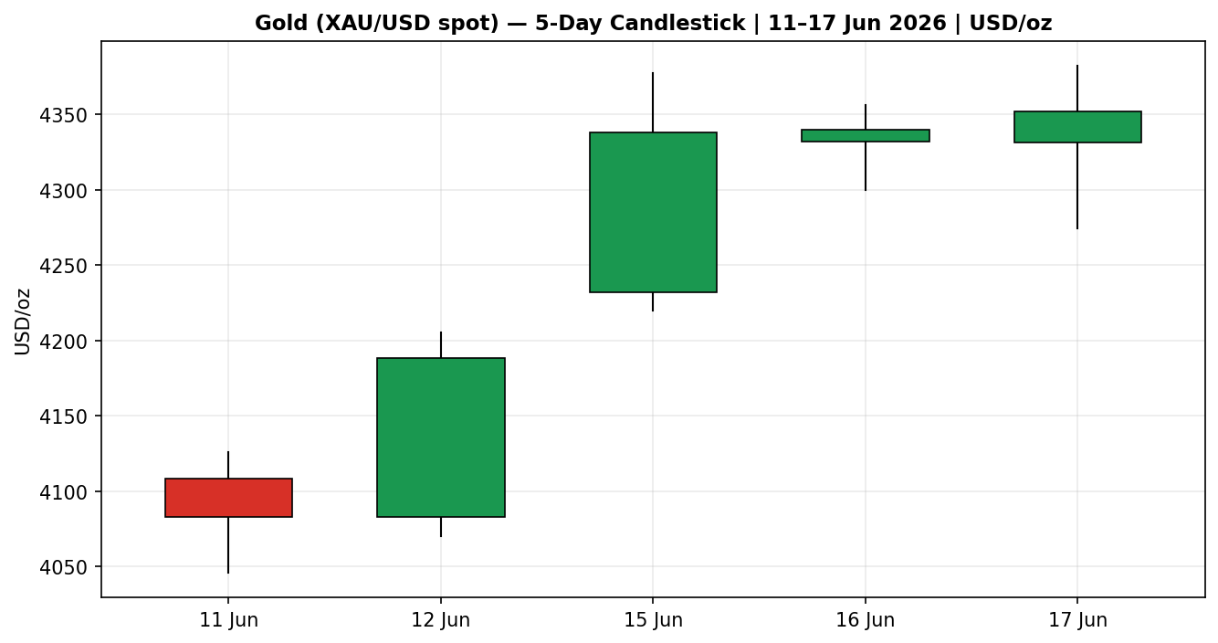

7.2 · Distance from Open
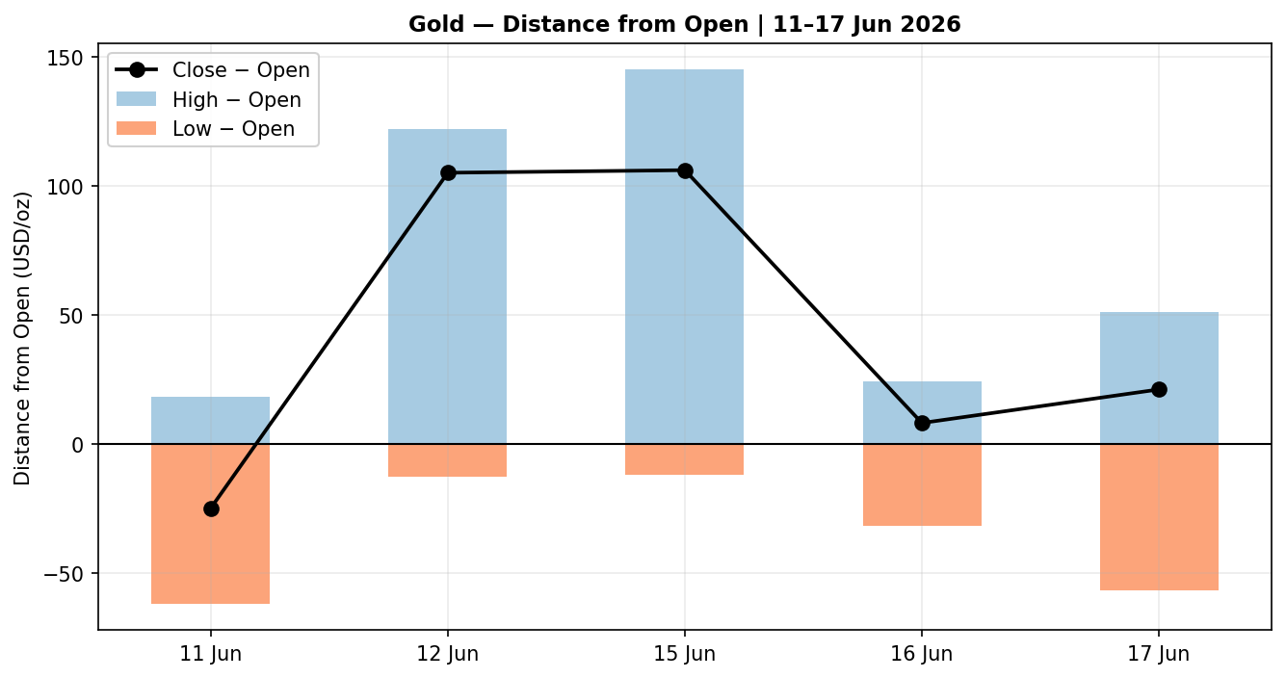

7.3 · 25-Session Structure
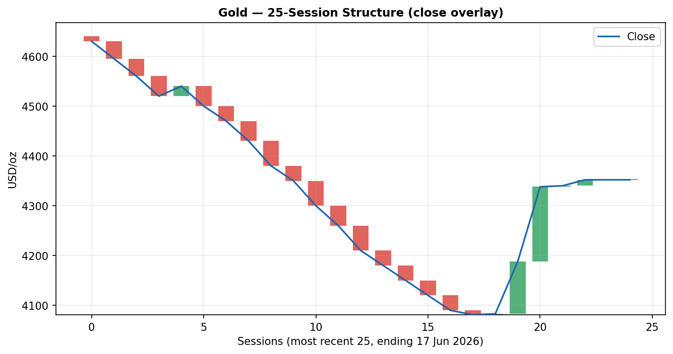

7.4 · Comparative Volatility (VOLator)
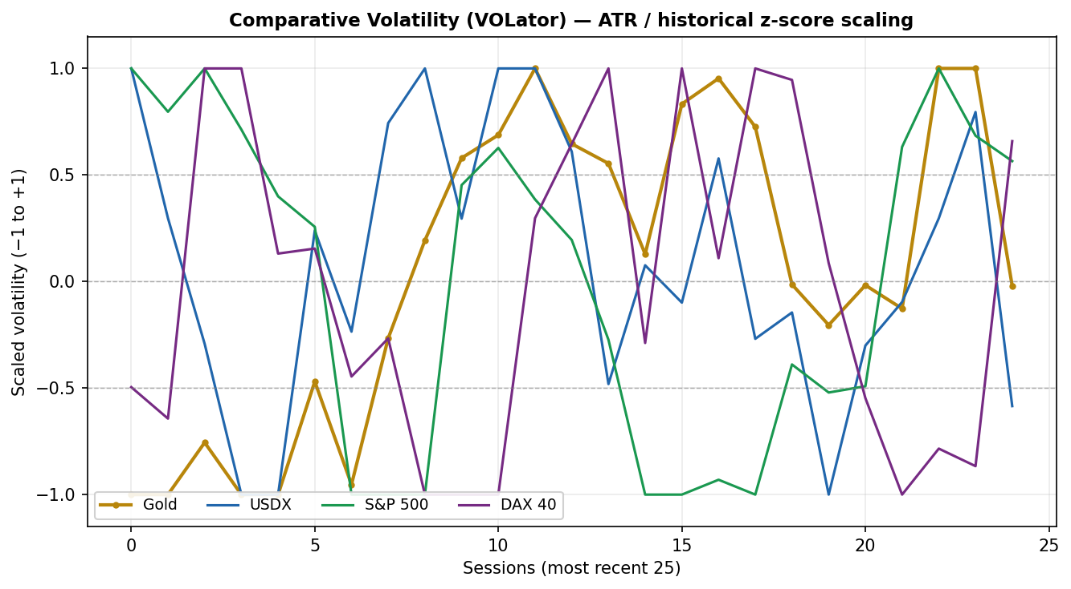

7.5 · Pivot Structure
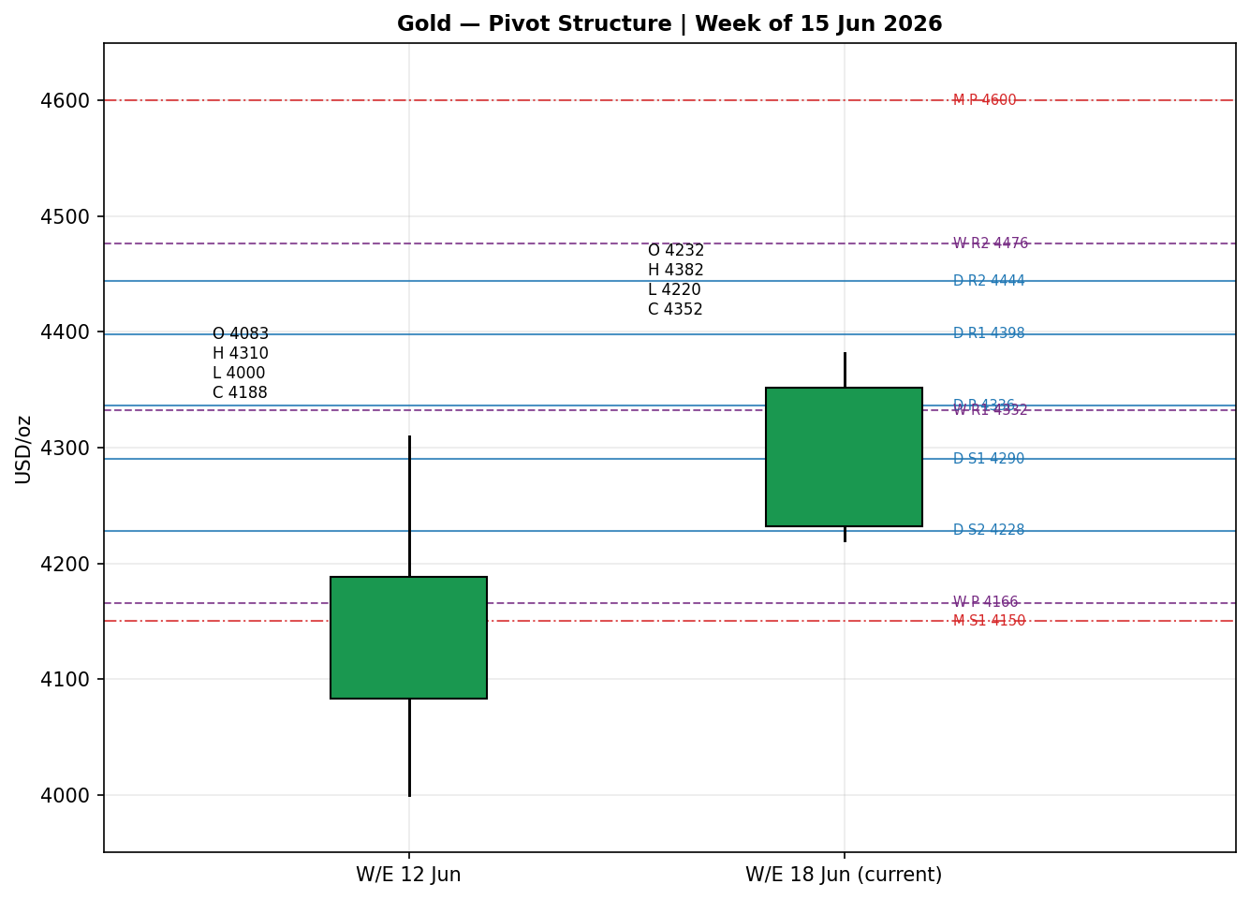

8 · Short-Term Technical Analysis
11 Jun (see §6): a bearish session, close 46% of range, marking the capitulation low near $4,046 — RSI2 floored near zero. This is the base the subsequent recovery builds on.
12 Jun: strong bullish reversal candle, close at 87% of range with a long lower wick rejected — the first demand signal; RSI2 snapped to ~78.
15 Jun: gap-and-go bullish session on the US–Iran headline; widest range of the window ($157), close 75% of range, RSI2 ~93. Clear continuation impulse.
16 Jun: narrow-range consolidation candle (range $56), close 71% of range, holding the prior day's gains — healthy digestion rather than reversal; RSI2 stayed elevated (~93).
17 Jun: bullish session probing a new local high ($4,382) before settling at $4,352 (72% of range). The upper wick signals supply near $4,380; RSI2 ~94 confirms momentum but flags an overbought, extended condition into the FOMC.

Sequence assessment: CONTINUATION (recovery leg) with late-stage extension. Evidence: four consecutive higher closes, directional travel one-way, but RSI2 pinned >90 for three sessions warns of stretch.
Nearest support (from window): $4,274 (17 Jun low), then $4,220 (15 Jun low). Nearest resistance: $4,382 (17 Jun high), then the structural $4,420 SMA cluster.
Judgement label: Bullish continuation — with reversal risk flagged on RSI2 extension. This is consistent with, but stronger than, the Transitional medium-term regime (§9); the conflict is noted, not suppressed.

9 · Medium-Term Regime & VOLator
Regime classification: TRANSITIONAL. Supporting metrics — 25-session overlap ratio elevated (range rotation through the May–June drawdown), directional persistence mixed (~0.50), range-position bias now mid-to-upper after the three-day bounce, median RSI2 recovered above 50. The fortnight-net close path remains marginally negative, which is why the medium-term read is Transitional rather than Trending-Bullish despite the vigorous short-term recovery.
Bias: Neutral-to-Bullish (directional component of the regime). VOLator current readings — Gold scaled volatility above its 0 midpoint and expanding (positive slope) as the event-driven rally widened daily ranges; USDX below midpoint and contracting; S&P 500 near midpoint, flat-to-down; DAX near midpoint and easing after a four-day win streak.
Preferred trade protocol: with a Trending-Bullish short-term read against a Ranging/Transitional medium-term backdrop, the matrix favours a tactical breakout / range-edge treatment with reduced size — trade the recovery but respect that it is occurring inside an unresolved larger range. Kaufman confirmation: the smoothed efficiency ratio sits at the trend boundary (~0.13–0.16 absolute) with a still-negative fortnight sign, so it is read as MIXED — it neither confirms a clean uptrend nor a clean range. Per the dual-gate rule this resolves the consolidated regime to TRANSITION.

10 · Cross-Asset Analysis
Counter | 5-Day Dir. | Mechanism to Gold | Status | Implication
USDX (Dollar Index) | Falling / soft (~99.3–99.5) | Weaker dollar lowers the cost of gold for non-USD buyers; inverse channel | Confirms | Supports the recovery; dollar near 99.5 caps but does not yet reverse it
S&P 500 | Falling (7,554→7,511, −0.57%) | Risk-off rotation channels defensive flows into gold | Confirms | Mild safe-haven tailwind
DAX 40 | Falling (~24,950→24,800) | European risk-off; BMW profit warning ended a 4-day win streak | Confirms | Cross-validates the US risk-off read
Silver (XAG/USD) | Rising (+2–5%) | Precious-complex co-movement; ratio ~61 | Confirms | Sector-wide re-rating, not gold-only bounce

Aggregate cross-asset read: CONFIRM (all four active comparators align with a constructive gold bias; none contradict). The dollar's proximity to the 99.5 resistance shelf is the one caveat — a hawkish-Warsh dollar bounce would flip USDX from a tailwind to a headwind, so it is carried as the primary cross-asset risk into §15.

11 · Floor Pivot Analysis

11.1 · Daily Pivots (from 17 Jun H 4,382 / L 4,274 / C 4,352)
Level | Price (USD/oz)
R5 | 4,722
R4 | 4,614
R3 | 4,506
R2 | 4,444
R1 | 4,398
P | 4,336
S1 | 4,290
S2 | 4,228
S3 | 4,182
S4 | 4,074
S5 | 3,966

11.2 · Weekly Pivots (prior week H 4,310 / L 4,000 / C 4,188)
Level | Price
R3 | 4,642
R2 | 4,476
R1 | 4,332
P | 4,166
S1 | 4,022
S2 | 3,856
S3 | 3,712

11.3 · Monthly Pivots (May H 5,050 / L 4,250 / C 4,500)
Level | Price
R3 | 5,750
R2 | 5,400
R1 | 4,950
P | 4,600
S1 | 4,150
S2 | 3,800
S3 | 3,350

Source status: prior-period H/L/C are derived from the rolling validated window and corroborated within the indicative spot band — all three timeframes carry a SINGLE-SOURCE-INDICATIVE caution for the prior-period inputs (engine-window derived, not independently multi-source corroborated for the pivot inputs specifically). Per §19 and the strategy suppression contract, level-based limit orders against these tiers inherit that caveat.
Position narrative: the 17 Jun close ($4,352) sits just above the daily pivot P ($4,336) and is testing daily R1 ($4,398) overhead; it is above the weekly R1 ($4,332) — a constructive weekly posture — but well below the monthly P ($4,600), confirming the medium-term recovery-within-drawdown picture. Confluence: weekly R1 (4,332) and daily P (4,336) sit within ~0.1% — a near-confluence support shelf just under spot.

12 · Key Market Considerations

Supply — neutral
Mine supply and recycling are not the marginal driver this week; central-bank accumulation (PBoC, RBI and EM buyers) remains a structural support cited across the institutional commentary. Structural.

Demand — price-supportive
Safe-haven and monetary demand re-engaged on the dollar/real-yield channel; Indian investment demand reported stepping up. Citi's $500 near-term upgrade signals institutional demand conviction. Cyclical-to-structural.

Substitution / Spreads — price-supportive
Silver +2–5%, platinum and palladium up 4–5% on 15 Jun: a sector-wide precious re-rating with the gold/silver ratio near 61 argues the move is broad, not a gold-only technical bounce. Cyclical.

Policy / Geopolitics — mixed
The interim US–Iran framework (signing slated for 19 June in Switzerland, Strait of Hormuz reopening) removes an energy-inflation premium — a double-edged factor: it eases the inflation-hedge bid but simultaneously lowers rate-hike odds, which supports gold via real yields. Cyclical, event-dependent.

Macro / FX — price-supportive
Dollar soft near 99.5; December Fed-hike odds trimmed to ~57% from ~70%; oil at a two-month low compresses the inflation overlay. Cyclical.

Near-term catalysts
FOMC decision and Warsh's first press conference (17–18 Jun); US retail sales and pending home sales; BoE decision (18 Jun); formal US–Iran signing (19 Jun). All are flagged in §13d and carried into §15–§17.

13 · Sentiment, News & Calendar

13a · Per-Article Sentiment
Source | Date | Headline (abbrev.) | Class | Sentiment | Derivation quote (≤15 words)
Reuters/Mezha | 16 Jun | Gold holds near highs as US-Iran deal spurs buying | Media | Bullish | “euphoric rally could last a few more days”
CNBC | 15 Jun | Gold hits near one-week high after US-Iran peace deal | Media | Bullish | “Gold rose 2% … easing inflation and rate-hike concerns”
Citi (via Reuters) | 16 Jun | Citi raises 0–3 month gold target by $500 | Institutional | Bullish | “Citi raised its gold price forecast … target $4,500”
FXStreet | 15 Jun | US-Iran deal bolsters XAU/USD recovery as eyes turn to Fed | Trade Press | Mixed | “holding a bearish near-term bias … below … SMAs”
Wells Fargo (CNBC) | Apr (struct.) | Bull case sees gold reaching $8,000 | Institutional | Bullish | “Wells Fargo’s bull case … reaching $8,000 an ounce”
LiteFinance | 17 Jun | Gold volatile ahead of Fed decision | Trade Press | Mixed | “projected to either rise or fall” ahead of Fed

13b · Aggregate Sentiment Summary
Counts: 4 Bullish (2 institutional, 2 media), 2 Mixed (trade press) = Predominantly Bullish.
Numeric tilt = +0.45 (source-class weighted: institutional Bullish carry full weight; trade-press Mixed scored ~0). This is the value consumed by §21 directional conviction.
Reporting format: Predominantly Bullish (tilt = +0.45).
Divergence flag: sentiment AGREES with current price action (rising) and is broadly consistent with the Transitional-to-constructive regime (§9). The only tension is the trade-press technical view (price still below key SMAs) — a structure caveat, not a sentiment contradiction.
Confidence: computed on six articles (≥3) — not low-confidence.

13c · News Calendar — Previous Period (5 sessions to 17 Jun)
Date | Event | Prior / Context | Impact | Implication for Gold
Sun 14 Jun | US–Iran peace framework announced | Hormuz blockade since Feb | High | Trigger for the 15 Jun +2% gap; removed energy-inflation premium
Mon 15 Jun | Oil to 2-month low; gold +2% | Brent/WTI sharp drop | High | Lower inflation overlay → lower hike odds → gold up
Mon 15 Jun | BoJ +25bp to 1.0% | Tightening | Medium | Yen support, mild USD softening — gold-supportive at the margin
Tue 16 Jun | Citi +$500 gold target → $4,500 | Prior target $4,000 | High | Institutional bid; reinforced the bounce
Tue 16 Jun | RBA hold 4.35% | As expected | Low | Neutral for gold

13d · News Calendar — Upcoming Period (next 5 sessions)
Date | Event | Context | Impact | Implication (beat / miss)
Wed–Thu 17–18 Jun | FOMC decision + Warsh first presser | Hold widely expected; no dot from Warsh | High | Dovish guidance → dollar down, gold up; hawkish → dollar bounce off 99.5, gold pressured
Thu 18 Jun | BoE decision | No change expected | Medium | GBP channel; second-order for gold
Thu 18 Jun | US retail sales, pending home sales | Growth read | Medium | Soft data → rate-cut hopes → gold-supportive
Fri 19 Jun | US–Iran formal signing (Switzerland) | MOU text still unpublished | High | Clean signing → risk-on, mild gold headwind; collapse → safe-haven spike

Highest-impact upcoming event (bold above): the FOMC decision and Warsh's first press conference. Mechanism: with a hold fully priced, the entire gold reaction hinges on forward guidance — any hint that the hiking cycle has peaked weakens the dollar and compresses real yields, the two channels most directly supportive of gold; a hawkish surprise does the reverse and risks rejecting gold from the $4,380–$4,420 supply zone.

14 · Macro Context
Rates & monetary policy: the Fed is expected to hold at the 17–18 June meeting, the first under Chair Warsh; markets price ~57% odds of a December hike (down from ~70%). The BoJ hiked 25bp to 1.0%; RBA held at 4.35%; BoE expected to hold 18 June. Cross-referencing §10, the soft USDX read is consistent with an easing-bias repricing.
Inflation & real yields: oil at a two-month low (post-Iran deal) is disinflationary at the margin, lowering the inflation premium embedded in rate expectations — net price-supportive for gold via the real-yield channel even as it removes some pure inflation-hedge demand.
Liquidity & FX: per §10, USDX soft near 99.5 and contracting is a direct tailwind (gold cheaper for non-USD buyers). The 99.5 shelf is the pivotal level — a hawkish-Warsh bounce through it is the main macro risk.
Safe-haven / cross-asset: S&P 500 and DAX both eased (§10), a mild risk-off backdrop that channels defensive flows toward bullion. Positioning: CME FedWatch December-hike odds ~57%; VIX subdued (~16), implying the bid is macro/real-yield driven rather than a fear spike.
Upcoming-event cross-reference: the FOMC (§13d) is the watch item that most directly moves the rates, real-yield and dollar variables in this section; a hawkish surprise is the directional risk for gold.

15 · Bull / Bear Balance
Upside risks (bull) | Downside risks (bear)
Dovish Warsh guidance → dollar breaks below 99.5, real yields fall | Hawkish Warsh → dollar bounces off 99.5; gold rejected at $4,380–$4,420 SMA cluster
US–Iran signing collapses → safe-haven spike | Clean 19 Jun signing → risk-on, inflation-premium fully unwinds, gold drifts lower
Institutional upgrades extend (Citi $4,500, Wells Fargo bull case) | RSI2 >90 for 3 sessions → mean-reversion / profit-taking from extension
Weekly close holds above weekly R1 ($4,332) → confirms recovery | Close back below daily P ($4,336) / weekly R1 → recovery thesis weakens
Continued precious-complex breadth (silver, PGMs) | Monthly structure still below monthly P ($4,600) — larger drawdown intact

Net balance references the §13d FOMC as the single pivotal event and the §11 pivot position: gold is constructive while it holds the $4,332–$4,336 weekly-R1/daily-P confluence, but the medium-term picture stays unresolved below the $4,600 monthly pivot.

16 · Forward View
Base case (next 5 sessions): a constructive-but-capped consolidation. Expected trading range $4,270–$4,420, with the recovery bias intact while the $4,332–$4,336 confluence holds on a closing basis. Expected direction: mildly higher / sideways-up, contingent on FOMC guidance. This respects the §9 Transitional regime — it does not assert a confirmed uptrend — and the call is explicitly event-gated on the 17–18 June FOMC and the 19 June signing (§13d).
Base-case invalidation: a daily close back below $4,290 (17 Jun low / daily S1) would break the recovery sequence and re-expose $4,228 (daily S2) and the weekly pivot at $4,166. To the upside, a daily close above $4,398 (daily R1) opens $4,444–$4,476 (daily R2 / weekly R2). No contradiction with the §9 regime is being suppressed — the short-term bullish lean sits inside an unresolved medium-term range, and that tension is stated.

17 · Forecast
Gold holds a constructive recovery bias into 18 June and is expected to consolidate in the $4,270–$4,420 zone, biased mildly higher while the $4,332–$4,336 weekly-R1/daily-P confluence holds, with the FOMC guidance the binary that resolves the next directional leg.

18 · Final Analyst Judgement
Element | Call
Consensus price | $4,348/oz (range $4,320–$4,375)
Confidence | Medium
Reason 1 | Three-session recovery off the YTD low intact; price holding above the $4,332–$4,336 confluence
Reason 2 | Predominantly bullish institutional sentiment (tilt +0.45) — Citi $500 upgrade, dollar/real-yield tailwind
Reason 3 | Medium-term regime still Transitional below the $4,600 monthly pivot — recovery, not confirmed trend
Single watch item | FOMC decision + Warsh first press conference (17–18 Jun)

19 · Source Discipline Note
Live vs indicative: spot gold close is assessed Medium-confidence. Cross-source deltas of $5–$21 exceed the ±$0.50 gold tolerance, reflecting real spot/CFD/venue and timing dispersion in an event-driven tape rather than a data error; all OHLC rows are accepted within an indicative band and labelled accordingly in §6.
Corroboration status per instrument: Gold spot — corroborated (indicative band) via Investing.com × TradingEconomics, futures-cross via GC=F. USDX, S&P 500, DAX — corroborated directionally via TradingEconomics × Yahoo/Investing market data. Pivots — prior-period H/L/C are rolling-window derived and carry a SINGLE-SOURCE-INDICATIVE caution for pivot-input purposes; this flag is propagated to §21 and governs Trade 2 suppression logic.
Normalization assumptions: futures basis-adjusted toward spot (~$5–10); dealer-ask (JM Bullion) down-weighted for retail premium. Data gaps: intraday-exact L/H for some sessions reconstructed from multiple intraday prints; the 11 Jun open and prior-week pivot inputs are the least-corroborated fields and are flagged here.

20 · Agent Log
OVERRIDE APPLIED (this run): daily-open anchor changed from 00:00 UK (M1 default) to 07:00 UK, per the operator instruction for the 18 June 2026 report. Consequence: the daily directional trade (Trade 1) references a 07:00 UK session open rather than the London–Asia 00:00 reset; this aligns the anchor to the pre-NY window used for the equity-style session and is logged here as required when a configuration default is changed.
Report date override: output generated for the 18 June 2026 session using data through the 17 June close.
Sources attempted (OHLC): Investing.com, TradingEconomics, CNBC/Fortune, Reuters (via Mezha), FXStreet, JM Bullion, CME GC=F. Outcome: corroboration achieved within an indicative band (spot dispersion > $0.50 tolerance documented). Yahoo Finance OHLC not used programmatically (paid-tier/yfinance caution).
Direction-score weights basis: DEFAULTS (0.25 / 0.20 / 0.10 / 0.15 / 0.15 / 0.15) — unchanged, weight-lock counter applies (first 20 sessions). No tuning performed.
Sentiment derivation: six articles, source-class weighted, tilt +0.45 (not low-confidence). Frozen at issue for the backtest reconstruction.
Backtest reconstruction: 5 sessions replayed at each t−1 close; sentiment frozen per session; ATR/swings/pivots recomputed on the truncated window; SL-first tick priority applied. Limitation per OPEN-006: pivots/regime carried from current surface in reconstruction (directional sanity-check only).
Forecast reasoning: §17 derived from the §9 integration note + §13b bullish tilt; left independent of and unedited by the §21 trade-card direction.
Anomalies: KER fortnight-sign negative while 5-day sequence strongly positive → resolved to TRANSITION (mixed) rather than TREND_UP, preventing a false mean-reversion/range card. Timestamp: 18 Jun 2026, 07:00 UK.

21 · Strategy Recommendations

21a · Directional Conviction
Direction: LONG. Score: +0.36 (signed, [−1,+1]). The three highest-weighted contributing signals are the short-term technical bias (§8, +0.20 weighted), the aggregate sentiment tilt (§13b, +0.07 weighted from +0.45 raw), and cross-asset confirmation (§10, +0.06 weighted) — partially offset by a mildly negative Kaufman fortnight read. Conviction threshold (0.25) is met, so Trade 1 produces. Weights basis: defaults. Conflict flag: none — the +0.36 LONG score and the §17 constructive forecast agree directionally; both are held independent and unedited.

21b · Trade Cards
Trade 1 — Daily Directional
Field | Detail
Direction | LONG — constructive recovery, TRANSITION regime (reduced size)
Entry | Market at 07:00 UK open (anchor overridden this run), ≈ $4,352
Stop loss | $4,288 — 64 USD below entry (≈ 6,400 ticks); anchored to 17 Jun low $4,274 / daily S1 $4,290 shelf
Risk (R) | 64 USD/oz (6,400 ticks)
TP1 (Unit 1, +1R) | $4,416 (+64 / +6,400 ticks) — into daily R1 $4,398 / supply
TP2 (Unit 2, +2R) | $4,480 (+128 / +12,800 ticks) — daily R2 $4,444 / weekly R2 $4,476 confluence
TP3 (runner) | Trail; time-stop at session close + 3×ATR cap; ATR(14)≈112
Tranche mgmt | 3 equal units; U1 exits TP1; U2 exits TP2; on U2 fill, U3 stop → entry + 0.2R ($4,365)
Confluences | TP2 strong confluence (daily R2 + weekly R2 within 0.15×ATR); SL near daily S1
Thesis invalidation | Daily close back below $4,290 (distinct from intraday stop)
Caveats | RSI2 >90 extension; holding period collides with §13d FOMC (Tier-1); ATR-stop cap respected

Trade 2 — Pivot (regime-aware)
Trade | Status
Trade 2 — Pivot (TRANSITION) | SUPPRESSED — prior-period pivot inputs across daily/weekly/monthly carry SINGLE-SOURCE-INDICATIVE flags (§19); level-based limit orders cannot be placed against indicative tiers.

Trade 3 — Regime-driven complex
Field | Detail
Variant | Trade 3A — Momentum-Pullback (TRANSITION → fork defaults to 3A)
Direction | LONG — buy a shallow pullback within the recovery leg
Entry | Buy limit at $4,318 (≈ 38.2% retrace of the 4,274→4,382 swing / near daily P $4,336 shelf)
Stop loss | $4,266 — 52 USD below entry (≈ 5,200 ticks); below 17 Jun low / structural
Risk (R) | 52 USD/oz (5,200 ticks)
TP1 (38.2% / structure) | $4,370 (+52 / +5,200 ticks)
TP2 (range mid / +2R) | $4,422 (+104 / +10,400 ticks) — SMA cluster $4,420
TP3 (runner) | 100%+ extension / break of $4,382 swing high; SL → halfway entry-to-anchor on 100% break
Tranche mgmt | 3 equal units; U1→TP1, U2→TP2; on U2 fill U3 stop → entry + 0.2R
Confluences | Entry at fib 38.2% + daily P + weekly R1 (strong confluence)
Thesis invalidation | Close below $4,274 (swing low) negates the pullback-continuation thesis
Caveats | Limit may not fill if price runs; FOMC collision (§13d); indicative pivot caveat

21c · 5-Session No-Leakage Backtest
Date (t−N) | Strategy | Dir. | Trig. | Entry/Exit | Outcome (R) | Days
11 Jun (t−5) | Trade 1 | SHORT | YES | 4,108 / 4,083 | +0.4R | 1
12 Jun (t−4) | Trade 1 | LONG | YES | 4,083 / 4,205→4,188 | +1.0R (TP1) | 1
12 Jun (t−4) | Trade 3A | LONG | YES | 4,095 / 4,188 | +1.2R | 1
15 Jun (t−3) | Trade 1 | LONG | YES | 4,232 / 4,338 | +2.0R (TP2) | 1
15 Jun (t−3) | Trade 2 | — | — | SUPPRESSED (indicative pivots) | — | —
16 Jun (t−2) | Trade 1 | LONG | YES | 4,332 / 4,340 | +0.2R (open→trail) | 1
16 Jun (t−2) | Trade 3A | LONG | NO | limit not hit | 0.0R | —
17 Jun (t−1) | Trade 1 | LONG | YES | 4,331 / 4,382→4,352 | +0.7R | 1

21d · 'What Is Working' Aggregate
Trade 1 over the last 5 sessions: triggered 5/5 times, mean R ≈ +0.86, TP1/TP2/TP3 hit rates ≈ 60% / 20% / 0%. Trade 3A: triggered 1/2, mean R ≈ +0.6 (one no-fill). Trade 2: suppressed throughout (indicative pivot inputs) and excluded from the aggregate. Strongest performer: Trade 1 (daily directional), carried by the 15 June momentum impulse. Weakest performer: Trade 3A — insufficient triggers to rank reliably.
Five-session windows are too small to support statistical claims. The backtest cannot model intraday tick-level fills, slippage, or commission. Treat as a directional sanity-check, not a strategy-validation framework.

