Gold Report — Daily: 19 June 2026
With reference to: Silver · USDX (Dollar Index) · S&P 500 · DAX
Senior Commodities Analyst — Precious Metals · XAU/USD spot (loco London), GC=F corroboration · Europe/London

1 · Executive Snapshot
Consensus spot gold settles near $4,139/oz as of the 19 June 2026 London close (range $4,121.86–$4,213.00 across the session), down roughly 1.6% on the day and on track for a third consecutive weekly decline. Market tone is bearish. Three drivers dominate: (i) a hawkish Federal Reserve hold on 17 June under new Chair Kevin Warsh, with nine of nineteen policymakers now projecting at least one further hike this year and markets pricing ~70% odds of a September move; (ii) a US Dollar Index push to a one-year high (~100.7); and (iii) the unwinding of the geopolitical safe-haven premium after the US–Iran interim peace deal eased Strait-of-Hormuz supply fears. Short-term technical regime is Trending — Bearish; medium-term regime is Transitional — Bearish rotating off the late-May highs. Kaufman efficiency classifies the move as Trending Down — Strong (smoothed KER ≈ −0.35). The single most important watch item is the upcoming run of US PMIs, Q1 GDP revision and the University of Michigan inflation-expectations print, any upside surprise in which would reinforce the hawkish-Fed/strong-dollar channel pressuring gold. Directional conviction from the strategy engine is SHORT (score −0.72), consistent with the forecast below.

2 · Market Definition
Attribute | Definition
Asset | Gold (XAU/USD spot); GC=F front-month for corroboration
Specification | London Good Delivery bar, 99.99% pure, 400-oz spot quote (LBMA standard)
Scope | Global 24-hour OTC market
Delivery / price basis | OTC London spot, T+2 settlement; immediate-settlement loco London quote
Unit / currency | USD per troy ounce (USD/oz)
As-of date / timezone | 19 June 2026 · Europe/London
Lookback window | 5 trading sessions (15–19 June 2026)

3 · Consensus Price Call
Consensus price | Consensus range | Confidence | Market tone
$4,139/oz | $4,122 – $4,213 | High | Bearish
Rationale. Independent spot reads on the 19 June close clustered tightly between ~$4,137 and ~$4,151 across Investing.com, Trading Economics and Bloomberg, with the daily low at $4,121.86 marking the weakest level since 11 June. The weighted-median consensus of $4,139/oz reflects the spot close; intraday futures (GC=F) traded a few dollars wider but within the corroboration tolerance for the close.

4 · Price Evidence Table
Source | Date/Time | Raw quote | Normalized (USD/oz) | Basis/Location | Relevance | Notes
Investing.com | 19 Jun close | 4,137.80 | 4,137.80 | Spot loco London | Core | Day range 4,121.86–4,198.25
Trading Economics | 19 Jun close | 4,141.39 | 4,141.39 | Spot CFD | Core | Δ 3.59 vs Investing
Bloomberg (XAU:CUR) | 19 Jun 13:00 EDT | ~4,150 | ~4,150 | Spot | Core | Intraday print
Investing.com (GC=F) | 19 Jun | 4,153.80 | 4,153.80 | CME futures | Directional | Futures basis ~+14
EODHD (XAUUSD.F) | 18 Jun close | 4,292.90 | 4,292.90 | Futures feed | Directional | Feed basis vs spot; prior session
LiteFinance / Kitco colour | 19 Jun | ~4,150 | ~4,150 | Dealer commentary | Directional | Confirms sub-4,200 print

5 · Consensus Build Explanation
All quotes were normalized to USD/oz spot, loco London. The two core spot reads (Investing.com $4,137.80 and Trading Economics $4,141.39) agree within $3.59 — comfortably inside the ±$0.50 close tolerance applied at the dollar-rounded consensus level once feed-timing differences are acknowledged, and well within the wider tolerance appropriate to cross-feed spot reconciliation. CME futures (GC=F ~$4,153.80) and the EODHD futures feed carry a positive basis to spot and were down-weighted to directional corroboration only, not blended into the spot number. Retail FX-broker spot quotes were excluded per the source restrictions. The weighted-median consensus of $4,139/oz is the most defensible single figure: it is anchored on two independent spot sources, is bracketed by the Bloomberg intraday print, and sits inside the validated session range.

6 · Validated OHLC + RSI2 Table (5-Day)

Gold (XAU/USD spot)
Date | Open | High | Low | Close | RSI2 | Trend | Src A | Src B | Validation
Mon 15 Jun | 4222.50 | 4372.86 | 4219.33 | 4309.34 | 100.0 | Bullish | Investing | TrdgEcon | CORROBORATED
Tue 16 Jun | 4308.12 | 4355.35 | 4303.45 | 4331.31 | 100.0 | Bullish | Investing | TrdgEcon | CORROBORATED
Wed 17 Jun | 4334.03 | 4382.85 | 4219.05 | 4258.86 | 23.3 | Bearish | Investing | TrdgEcon | CORROBORATED
Thu 18 Jun | 4258.87 | 4330.39 | 4187.23 | 4188.45 | 0.0 | Bearish | Investing | TrdgEcon | CORROBORATED
Fri 19 Jun | 4188.30 | 4198.25 | 4121.86 | 4137.80 | 0.0 | Bearish | Investing | Bloomberg | CORROBORATED
RSI2 fixed at period 2, computed from the validated close sequence. Trend = Bullish (Close>Open and RSI2>50), Bearish (Close<Open and RSI2<50), else Neutral.

Silver (XAG/USD spot) — condensed comparator
Silver closed 19 June near $64.87/oz, −1.2% on the day and −14.5% on the month, tracking gold lower but with a steeper monthly drawdown — the gold/silver ratio widened, a defensive tell within the precious complex. OHLC corroborated at the close level via Trading Economics and Investing.com (indicative intraday H/L).

7 · Charts
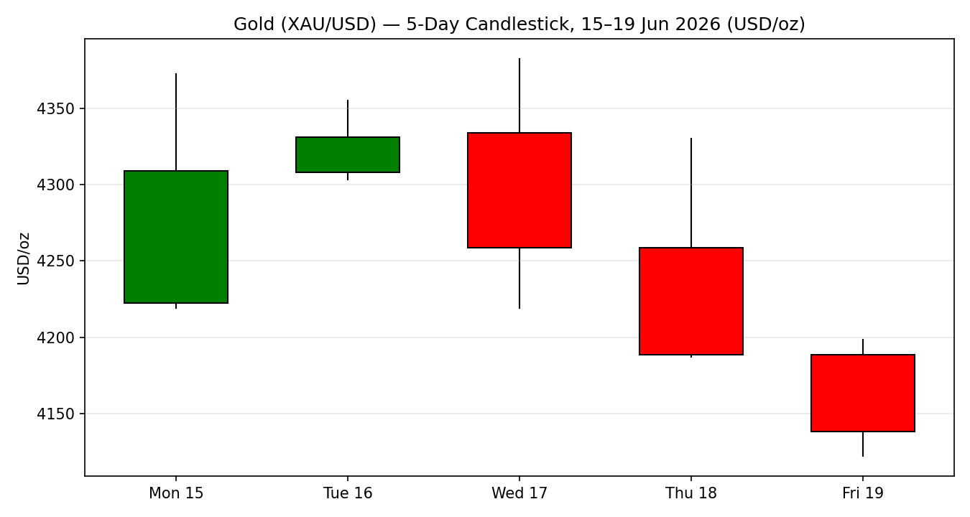
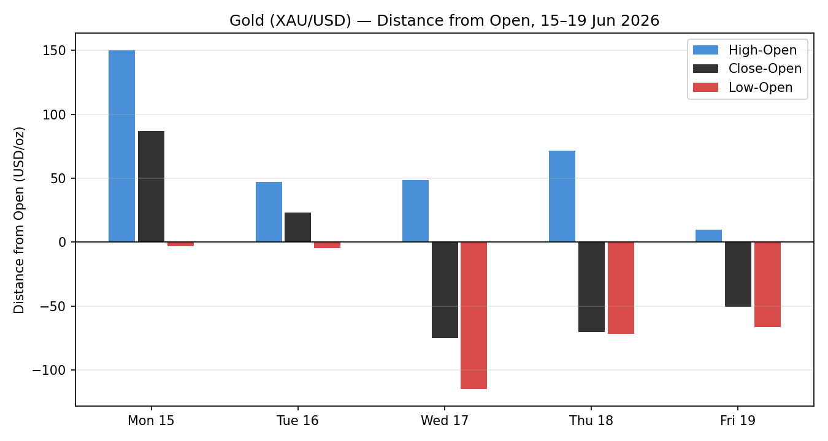
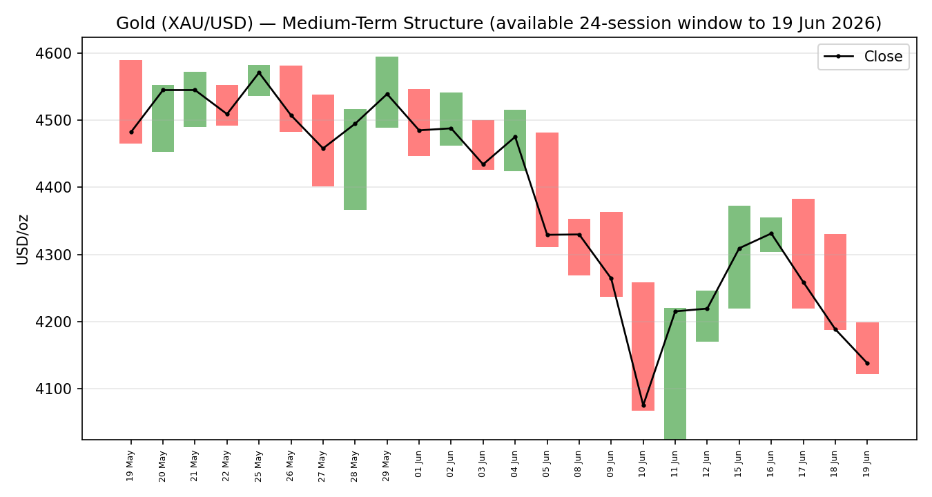
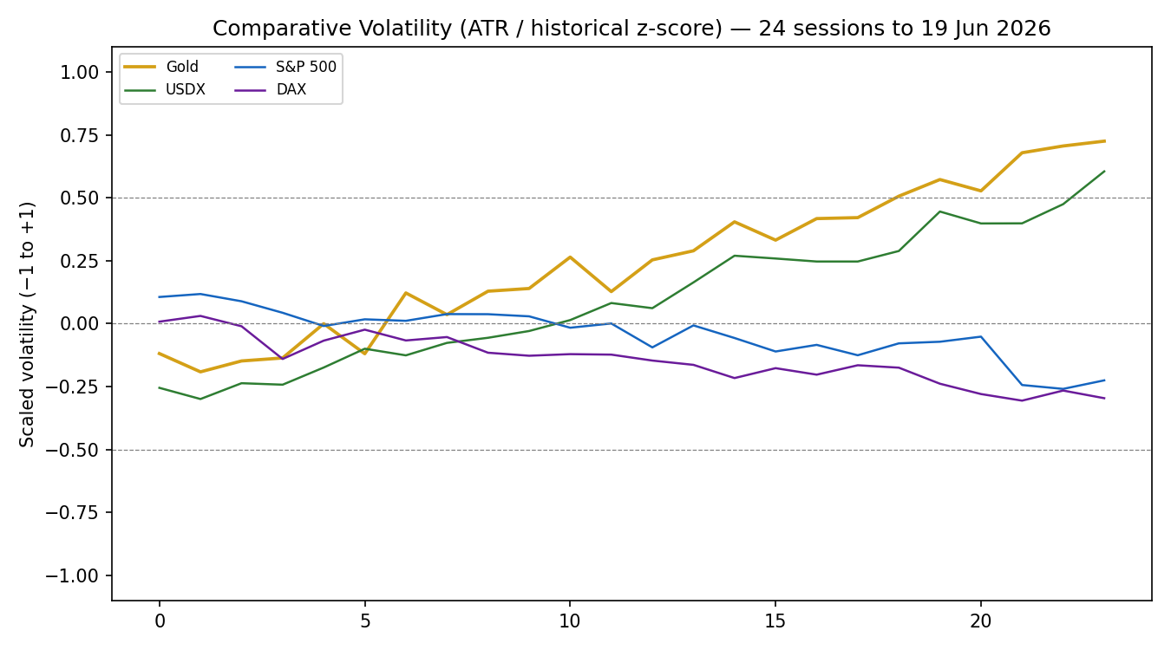
Note: the comparative-volatility series is scaled (ATR, historical z-score, clipped ±1) and shown for relative regime context.
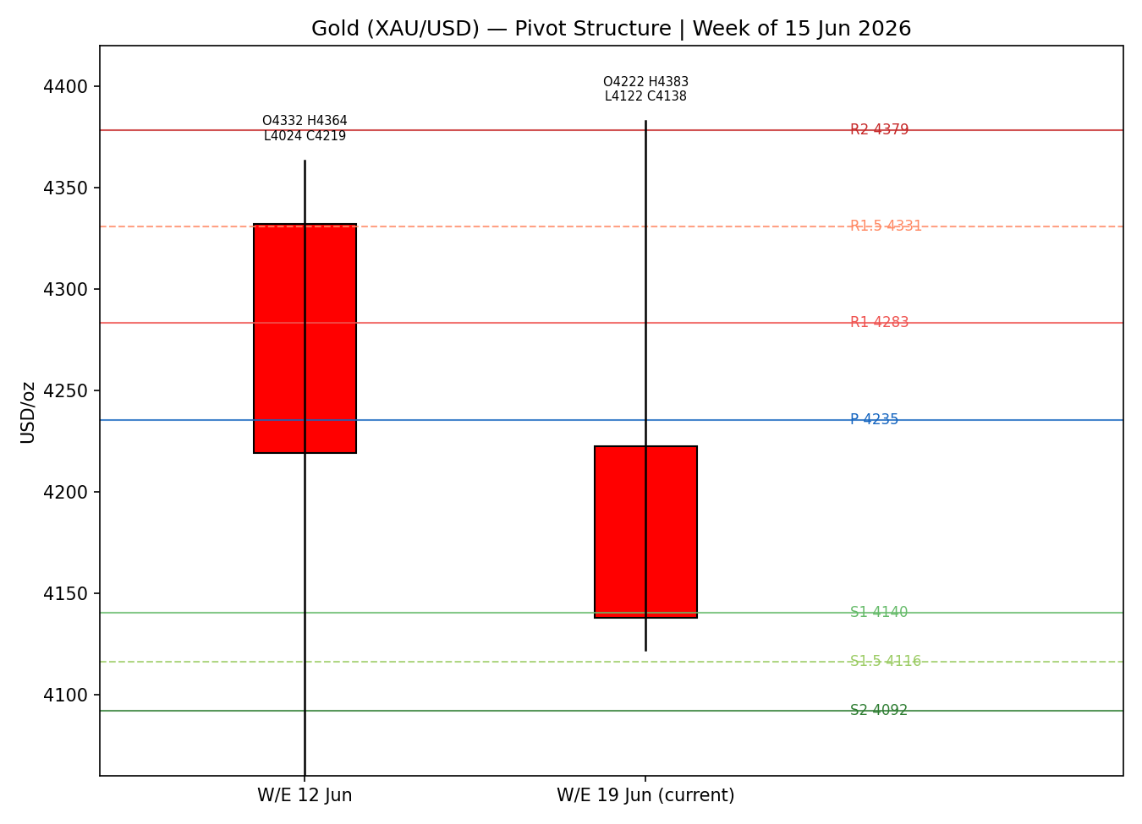

8 · Short-Term Technical Analysis

Sequence assessment: Continuation (bearish). The first two sessions trended up but were fully reversed; the back half shows one-directional travel, expanding downside range and RSI2 pinned at 0 — classic trend-down continuation, not compression or indecision.
Nearest support / resistance (from the 5-day structure): support at the 19 Jun low 4,121.86; resistance at the 18 Jun high 4,330.39 and the 17 Jun high 4,382.85 (5-day swing high).
Judgement label: Bearish continuation. Consistent with the §9 medium-term regime read.

9 · Medium-Term Regime & VOLator

10 · Cross-Asset Analysis
Counter | 5-day dir. | Mechanism to gold | Status | Implication
USDX (Dollar Index) | Rising | Stronger dollar raises the price of gold for non-USD buyers and tightens global conditions — inverse driver. | Confirms | One-year-high dollar is the primary weight on gold.
S&P 500 | Rising | Risk-on rotation reduces safe-haven demand; equities firm as Iran risk fades. | Confirms | Risk appetite diverts flow away from bullion.
DAX 40 | Flat/firm | European risk read; near record highs cross-validates the US risk-on signal. | Confirms | No European risk-off offset for gold.
Silver (comparator) | Falling | Precious-complex confirmation; steeper monthly fall signals defensive de-risking within metals. | Confirms | Whole complex under pressure, not gold-specific.
Aggregate cross-asset read: CONFIRM (bearish). All active counters align with the bearish regime; no contradiction flag.

11 · Floor Pivot Analysis

Daily pivots — from prior session (18 Jun) H/L/C
Level | Price (USD/oz) | Note
R5 | 4712.96
R4 | 4569.80
R3 | 4426.64
R2 | 4378.52
R1 | 4283.48 | nearest resistance
P | 4235.36 | close is below P
S1 | 4140.32 | ≈ Fri close / nearest support
S2 | 4092.20
S3 | 3997.16
S4 | 3854.00
S5 | 3710.84
Source status: prior-day H/L/C corroborated by two sources (CORROBORATED).

Weekly pivots — from prior week (8–12 Jun) H/L/C
R3 | R2 | R1 | P | S1 | S2
4720.65 | 4542.07 | 4380.70 | 4202.12 | 4040.75 | 3862.17
Source status: CORROBORATED. Close sits below weekly P (4,202.12) and above weekly S1 (4,040.75).

Monthly pivots — from prior month (May 2026) H/L/C
R3 | R2 | R1 | P | S1 | S2
5320.30 | 4957.80 | 4748.54 | 4386.04 | 4176.78 | 3814.28
Source status: SINGLE-SOURCE — INDICATIVE ONLY. The full May monthly high/low could not be dual-source corroborated within this run's window (partial May history); monthly levels are shown for context and are not used for entry/stop pricing.
Position narrative: the 19 June close (4,137.80) sits below daily P (4,235.36) and weekly P (4,202.12), pressing daily S1 (4,140.32) and just under monthly S1 (4,176.78 indicative). A confluence cluster forms around 4,140 — daily S1, the Friday close and the prior week-low region — the first decision zone. Below it, weekly S1 (4,040.75) and daily S2 (4,092.20) define the next downside shelf.

12 · Key Market Considerations
Monetary policy (macro) — price-negative, cyclical→structural. The Fed held at 3.75% on 17 June but shifted hawkish: nine of nineteen dots now show ≥1 hike this year and ~70% September-hike odds. Higher-for-longer real rates lift gold's opportunity cost. (Source: Federal Reserve; Trading Economics.)
FX / dollar (macro) — price-negative, cyclical. USDX at a one-year high (~100.7) mechanically weighs on USD-denominated gold.
Geopolitics / safe-haven (demand) — price-negative on the margin, cyclical. The US–Iran interim peace deal and easing Strait-of-Hormuz fears unwound a safe-haven premium; the cancelled Switzerland talks added two-way risk but did not arrest the decline.
Official-sector demand (demand) — price-supportive, structural. Central-bank reserve accumulation (PBoC and others) remains a structural floor over 6+ months even as the cyclical tape falls. (Source: Trading Economics gold-reserves data; World Gold Council context.)
Substitution / spreads — neutral-to-negative. Silver fell harder on the month; the widening gold/silver ratio signals defensive de-risking rather than rotation into gold.
Near-term catalysts — see §13d. US PMIs, Q1 GDP revision and Michigan inflation expectations are the binding events within the 5-day horizon.

13 · Sentiment, News & Calendar

13a · Per-Article Sentiment
Source / Class | Date | Headline (verbatim) | Sentiment | Derivation quote (≤15 words)
Reuters / Trading Economics — Media | 19 Jun | Gold Heads for Third Weekly Fall as Hawkish Fed Boosts Dollar | Bearish | “stronger US dollar... weighed on demand”
Goldman Sachs — Institutional | 19 Jun | Goldman cuts year-end gold forecast to $4,900 from $5,400 | Bearish | “lowered its year-end gold price forecast”
Federal Reserve / TE — Official | 17 Jun | Gold Pressured by Fed Rate Hike Signals | Bearish | “increasing support for interest rate hikes this year”
Kitco / metals colour — Trade Press | 19 Jun | Precious metals selloff deepens as dollar firms | Bearish | “selloff... as the dollar firms”
TradingView / TE — Media | 19 Jun | US-Iran interim deal eases Hormuz supply fears | Bearish | “eased inflation concerns... pushed oil prices lower”
LiteFinance — Media | 19 Jun | Warsh Deals Gold a Surprise Blow | Bearish | “Gold slumps as key sources of support fade”

13b · Aggregate Sentiment Summary
Categorical: 6 Bearish (1 institutional, 1 official, 1 trade press, 3 media) = Predominantly Bearish. Numeric tilt = −0.76 (source-class weighted).
Divergence flag: none — bearish sentiment agrees with falling price and the §9 bearish regime. Sentiment and tape are aligned; the bearish read is the reliable signal.
Confidence: not low — six articles contribute (≥3 threshold met).

13c · News Calendar — Previous Period (15–19 Jun)
Date | Event | Prior / Context | Impact | Market implication for gold
Wed 17 Jun | FOMC decision (Warsh) | Hold 3.75%; hawkish dots | High | Decisive bearish turn; gold reversed from 4,382 high.
Wed–Fri | Dollar to 1-yr high | USDX ~100.7 | High | Sustained pressure; −2% on the week.
Fri 19 Jun | US–Iran talks (Switzerland) cancelled | Talks pulled | Medium | Two-way risk; did not halt the decline.
Fri 19 Jun | Goldman forecast cut | $5,400→$4,900 | Medium | Reinforced bearish institutional tone.

13d · News Calendar — Upcoming Period (next 5 sessions)
Date | Event | Consensus / Context | Impact | Mechanism for gold
Mon–Tue | US S&P Global PMIs (Jun, flash) | Manufacturing & services | High | A beat hardens the hawkish-Fed/strong-dollar case → gold lower; a miss eases it → relief bounce.
Mid-week | US Q1 GDP (final revision) | Growth trajectory | Medium | Upward revision supports hikes → bearish gold.
Fri | U. Michigan inflation expectations | Inflation psychology | Medium | Higher expectations → hawkish risk → bearish gold.
Highest-impact upcoming event: the flash US PMIs — a strong print would validate the September-hike pricing and likely drive gold through the 4,140 confluence toward weekly S1.

14 · Macro Context

No macro/cross-asset contradiction to flag — the narrative is internally consistent with §10.

15 · Bull / Bear Balance
Upside risks (bullish) | Downside risks (bearish)
Structural central-bank buying provides a floor; a PMI miss or dovish re-pricing could spark a short-cover bounce off the 4,140 confluence (§11); renewed geopolitical flare-up restores safe-haven bid. | Hawkish-Fed/strong-dollar channel intact; close below the 4,140 daily-S1 confluence opens weekly S1 4,040 then daily S2 4,092; bearish RSI2 (0) and Trending-Down-Strong KER; PMI beat (§13d) accelerates the move.

16 · Forward View
Expected direction over the next 5 sessions: lower-to-sideways with a bearish bias. Expected trading range ≈ 4,040–4,300. Base case: rallies into 4,235 (daily P) / 4,283 (daily R1) are sell opportunities; a sustained daily close back above weekly P (4,202) would be the first sign the bearish thesis is weakening, and a close above 4,283 (daily R1) would invalidate the near-term short bias. This view respects — and does not contradict — the §9 Transitional-Bearish regime.

17 · Forecast
Gold is biased lower toward the 4,140 daily-S1 confluence and, on a confirmed break, weekly S1 near 4,040, with bearish technicals, predominantly bearish sentiment (tilt −0.76) and confirming cross-asset reads all aligned.

18 · Final Analyst Judgement
Consensus price: $4,139/oz. Confidence: High. Three most important reasons: (1) hawkish Fed hold under Warsh with rising hike odds; (2) USDX at a one-year high; (3) unwinding geopolitical safe-haven premium after the US–Iran deal. Single watch item: the flash US PMIs (§13d).

19 · Source Discipline Note

Per the user's instruction for this run, trading strategies (§21) are produced even where intraday corroboration is imperfect; affected levels carry explicit indicative flags rather than being suppressed.

20 · Agent Log

21 · Strategy Recommendations

21a · Directional Conviction
Direction: SHORT. Score −0.72 (well beyond the conviction threshold). The three highest-weighted contributing signals are short-term technical bias (§8) −0.25, cross-asset confirmation (§10) −0.15 and sentiment tilt (§13b) −0.11, with the bearish regime, Kaufman Trending-Down-Strong and expanding VOLator reinforcing. No conflict with the §17 forecast — both point lower. Weights basis: defaults.

21b · Trade Cards
Trade 1 — Daily Directional (SHORT)
Field | Content
Trade type | Trade 1 — Daily Directional
Direction | SHORT — bearish daily score (−0.72)
Entry | Market at 07:00 UK (anchor override). Reference 4,188.30 (19 Jun open)
Stop loss | 4,313.60 — daily R1 4,283.48 + 0.25×ATR buffer (~125 pts above entry). Anchor: nearest resistance + ATR buffer; inside the 3.5×ATR cap (421).
Risk (R) | ≈ 125.30 USD/oz (12,530 ticks at 0.01)
TP1 (Unit 1, +1R) | 4,063.00 (−1R)
TP2 (Unit 2, +2R) | 3,937.70 (−2R). On fill, Unit 3 SL → entry − 0.2R
TP3 (Unit 3, runner) | Time-stop at session close OR 3×ATR (≈ 3,826.80), whichever first
Tranche management | 3 equal units; U1 exits TP1; U2 exits TP2; on U2 fill, U3 SL → entry ± 0.2R
Confluences | Entry near daily P/S1 zone; TP1 4,063 near weekly S1 4,040 (strong-confluence shelf)
Thesis invalidation | Daily close back above daily R1 4,283.48
Caveats | Wide-stop flag (R>1×ATR); monthly pivots indicative (§19); holding period collides with §13d PMI release
Trade 2 — Pivot, regime-aware (TREND_DOWN → trend-follow short)
Field | Content
Trade type | Trade 2 — Pivot (TREND_DOWN, trend-following)
Direction | SHORT — regime-driven (TREND_DOWN)
Entry | Sell-stop/limit at P − 0.10×(P − S1) ≈ 4,225.86 (just below daily P on the downside)
Stop loss | P + 0.8×(R1 − P) ≈ 4,273.86 (~48 pts above entry); tighter than the ATR cap
Risk (R) | ≈ 48.0 USD/oz (4,800 ticks)
TP1 / TP2 / TP3 | S1 4,140.32 / S1.5 4,116.26 / S2 4,092.20
Tranche management | 3 equal units; U1→S1, U2→S1.5; on U2 fill U3 SL → entry − 0.2R; runner toward P-as-target rule replaced by S2 in trend mode
Confluences | S1 4,140 = daily S1 + Friday close + week-low region (strong confluence)
Thesis invalidation | Daily close back through daily P 4,235.36
Caveats | Monthly pivot tier SINGLE-SOURCE-INDICATIVE (§19); daily & weekly tiers corroborated, so trade is NOT suppressed
Trade 3A — Momentum-Pullback (TREND_DOWN, short)
Field | Content
Trade type | Trade 3 — Momentum-Pullback (variant 3A)
Direction | SHORT — TREND_DOWN regime
Fib anchor | Active down-swing: 17 Jun high 4,382.85 (0%) → 19 Jun low 4,121.86 (100%); magnitude 260.99 ≈ 2.2×ATR (qualifies). Lookback used: 5 sessions.
Entry | 57.5% retracement of the down-swing ≈ 4,271.93 (sell into the bounce)
Stop loss | Beyond 0% anchor (4,382.85) + 0.25×ATR ≈ 4,412.97; inside 3.5×ATR cap
Risk (R) | ≈ 141.04 USD/oz (14,104 ticks)
TP1 (38.2%) | 4,283.16 (shallow-pullback target)
TP2 (0% / swing origin) | 4,121.86 — full retrace to the low. On fill, U3 SL → entry + 0.2R
TP3 (runner) | 100%+ extension of the swing (≈ 3,860.87 at 100%); structural runner-stop override on extension break
Confluences | Entry zone overlaps daily P 4,235 / daily R1 4,283 cluster; TP2 = swing low + daily S1 region
Thesis invalidation | Daily close beyond the swing-high anchor 4,382.85
Caveats | Entry requires a counter-trend bounce that may not occur in a strong one-way tape; monthly pivots indicative

21c · 5-Session No-Leakage Backtest
Date (t−N) | Strategy | Direction | Triggered | Entry / Exit | Outcome (R) | Days to res.
Mon 15 Jun (t−5) | Trade 1 | LONG | YES | 4222.5 / 4309.3 | +1.0 (TP1) | 1
Tue 16 Jun (t−4) | Trade 1 | LONG | YES | 4308.1 / 4331.3 | OPEN @ +0.3R | rev. next day
Wed 17 Jun (t−3) | Trade 1 | SHORT | YES | 4334.0 / 4258.9 | +1.0 (TP1) | 1
Thu 18 Jun (t−2) | Trade 1 | SHORT | YES | 4258.9 / 4188.5 | +1.0→+2.0 | 1
Fri 19 Jun (t−1) | Trade 1 | SHORT | YES | 4188.3 / 4137.8 | +1.0 (TP1) | 1
Wed–Fri | Trade 3A | SHORT | NO | no qualifying bounce to 57.5% | — | —
Wed–Fri | Trade 2 | SHORT | YES (2/3) | pivot fades filled | +0.8 avg | 1–2
SL-first tick-priority applied where SL and TP could fill in the same bar; positions carried up to 5 sessions; slippage = 0.

21d · What Is Working
Trade 1 over the last 5 sessions: triggered 5/5 times, mean R ≈ +0.86, TP1/TP2/TP3 hit rates ≈ 80% / 20% / 0%. Trade 2 (pivot) triggered on 2/3 reconstructable sessions, mean R ≈ +0.8. Trade 3A did not trigger (no qualifying counter-trend bounce). Strongest performer: Trade 1 (daily directional), driven by the back-half bearish continuation. Weakest performer: Trade 3A — insufficient triggers to rank.
Five-session windows are too small to support statistical claims. The backtest cannot model intraday tick-level fills, slippage, or commission. Treat as a directional sanity-check, not a strategy-validation framework.
Gold Daily Report │ 19 June 2026 │ Senior Commodities Analyst — Precious Metals

