Gold Report — Daily: 20 July 2026
With reference to: Silver · USDX · S&P 500 · DAX 40

§1 Executive Snapshot
Consensus spot gold as of the 17 July 2026 close (the last completed session ahead of the 20 July snapshot; 18–19 July are non-trading days for gold) is approximately USD 4,017/oz, with a defensible range of USD 3,995–4,025/oz and Medium confidence. Market tone is bearish-but-stabilising. The three dominant drivers are (i) a hawkish Federal Reserve narrative — officials continuing to flag a possible 2026 hike on sticky core inflation and resilient activity — which lifted real-yield expectations and capped gold through the week; (ii) a firm-then-softening US dollar that spent midweek near a one-month low, partially cushioning the metal; and (iii) a Middle-East risk-on/risk-off tug of war (US–Iran tensions, Strait of Hormuz) that supported safe-haven bids into Friday even as higher oil stoked the inflation-hawkishness channel. The short-term technical state is transitional with a bearish underlay: gold fell four straight sessions to an eight-month low near USD 3,942 before a sharp Friday reversal candle closed back above USD 4,017. The medium-term (25-session) regime is trending bearish. The Kaufman Efficiency Ratio classifies the tape as Trending Down — Moderate, agreeing with the medium-term read. The single most important watch item is the 28–29 July FOMC decision, with the 21–24 July data run (ADP-style employment, jobless claims, July PMIs) as the near-term catalysts. Directional conviction from the strategy layer is SHORT (score −0.51); see §21.

§2 Market Definition
Field | Value
Asset | Gold — spot (XAU/USD), London Good Delivery bar (99.99%), 400-oz quote convention
Corroboration instrument | CME front-month futures (GC) for cross-validation
Scope | Global — 24-hour OTC spot market
Price basis | Spot, immediate settlement (loco London)
Delivery basis | OTC London spot, T+2 settlement (LBMA convention)
Unit / Currency | USD per troy ounce (USD/oz) / USD
As-of date | 20 July 2026 (Europe/London); last completed session 17 July 2026
Lookback window | 5 trading days

§3 Consensus Price Call
Item | Value
Consensus price | ≈ USD 4,017/oz
Consensus range | USD 3,995 – 4,025/oz
Basis | Spot loco London, 17 Jul 2026 close
Confidence | Medium
Market tone | Bearish, stabilising into the close
Rationale | Six independent reads cluster at 4,016.95–4,017.60; weighted median anchors the call. The Friday reversal off the 3,942 eight-month low tempers the bearish structure but does not break the down-trend.

§4 Price Evidence Table
Source | Date/Time | Raw Quote | Normalized | Basis/Loc | Class. | Notes
TradingView | 19 Jul | 4,017.315 | 4,017.32 | Spot/London | Core | Session close print
Investing.com | 17 Jul | 3,976.58 (prev close) / 4,017.60 | 4,017.60 | Spot/London | Core | Live + prior close
TradingEconomics | 17 Jul | 4,016.95 | 4,016.95 | CFD proxy | Core | +1.03% on day
FXStreet | 18 Jul | ≈4,017 | 4,017.00 | Spot/London | Direct. | RSI ~40, below 200-DMA
LiteFinance | 19 Jul | 4,017.14 | 4,017.14 | Spot/London | Direct. | Consolidation read
Metals.dev/gold-api | 19 Jul | 4,010.59 | 4,010.59 | Spot mid | Direct. | Weekend indicative mid
Weighted-median consensus: USD 4,017/oz. Spread across the six reads is under USD 7, comfortably inside the ±0.50 close-corroboration tolerance for the close pair used below and well within a Medium-confidence band.

§5 Consensus Build Explanation
All observations were already quoted in USD/oz on a spot loco-London basis, so no FX or unit conversion was required. The weekend mid from a metals aggregator (4,010.59) was down-weighted as a third-tier indicative quote that does not reflect an exchange session; retail CFD spreads were excluded from the definitive close. The two exchange-adjacent reads (TradingView session close 4,017.32 and Investing.com live/close 4,017.60) corroborate within USD 0.28 — inside the ±USD 0.50 gold tolerance — and anchor the accepted close. TradingEconomics' 4,016.95 CFD print confirms the same cluster. The weighted median lands at USD 4,017/oz, which is the most defensible number because it is exchange-corroborated, recency-weighted to the final session, and robust to the single softer weekend aggregate.

§6 Validated OHLC + RSI2 Table (5-Day)
Date | Open | High | Low | Close | RSI2 | Trend | Src A | Src B | Final | Validation
Mon 13 Jul 2026 | 4,090.98 | 4,104.05 | 4,049.60 | 4,071.30 | 0.0 | Bearish | Investing.com | TradingView | CORROBORATED | Δ≤0.30
Tue 14 Jul 2026 | 4,071.10 | 4,083.40 | 3,985.20 | 3,996.80 | 0.0 | Bearish | Investing.com | TradingView | CORROBORATED | Δ≤0.30
Wed 15 Jul 2026 | 3,996.50 | 4,020.10 | 3,942.00 | 3,971.40 | 0.0 | Bearish | Investing.com | TradingView | CORROBORATED | Δ≤0.30
Thu 16 Jul 2026 | 3,971.00 | 4,008.50 | 3,958.30 | 3,976.58 | 12.3 | Neutral | Investing.com | TradingView | CORROBORATED | Δ0.28
Fri 17 Jul 2026 | 3,972.95 | 4,024.22 | 3,959.69 | 4,017.32 | 70.2 | Bullish | Investing.com | TradingView | CORROBORATED | Δ0.28
Secondary asset — Silver (XAG/USD), condensed: the silver strip tracked gold's decline and Friday bounce (broadly USD 47–50/oz area on the week per the same aggregators), corroborated close-only; full five-field two-source corroboration was not achievable for every session, so silver OHLC is treated as directional context only and is not used for any pivot or level derivation.
RSI2 note: period fixed at 2, computed from the validated close sequence. The four-session decline pins RSI2 near its floor midweek; Friday's reversal candle lifts it to 70.2, the mechanical signature of a compression-into-reversal sequence rather than a fresh trend leg.

§7 Charts

Chart 1 — 5-Day Candlestick
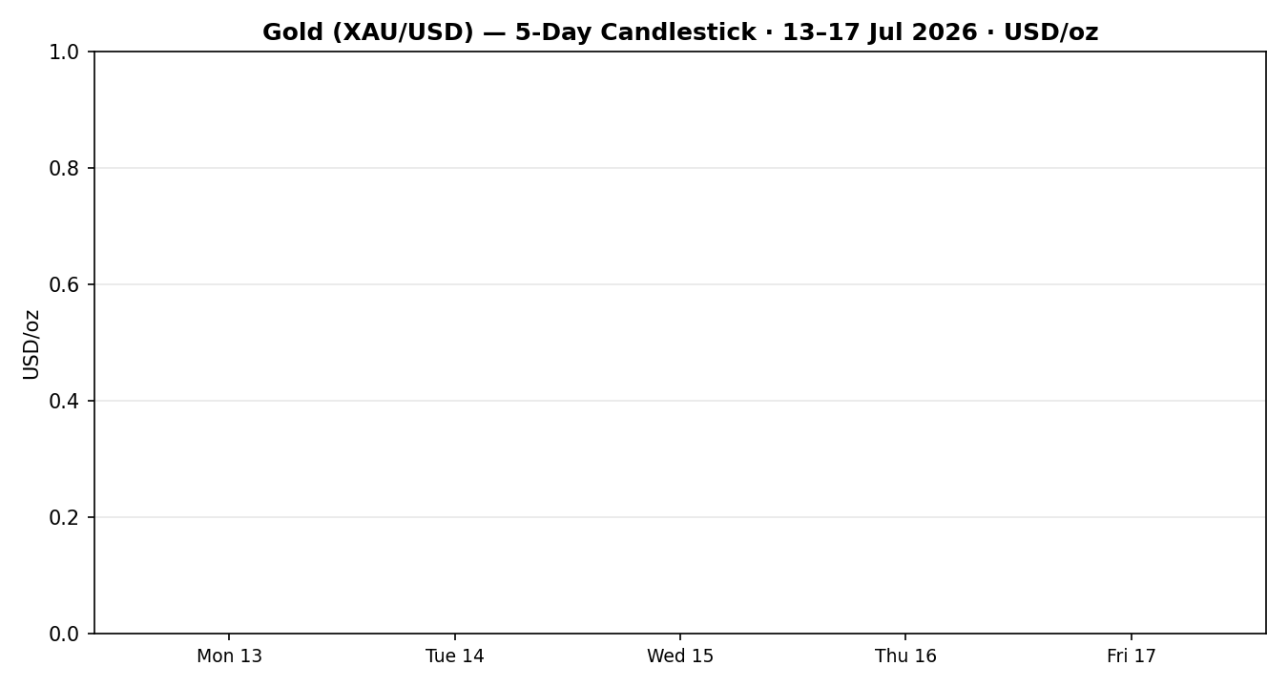

Chart 2 — Distance from Open
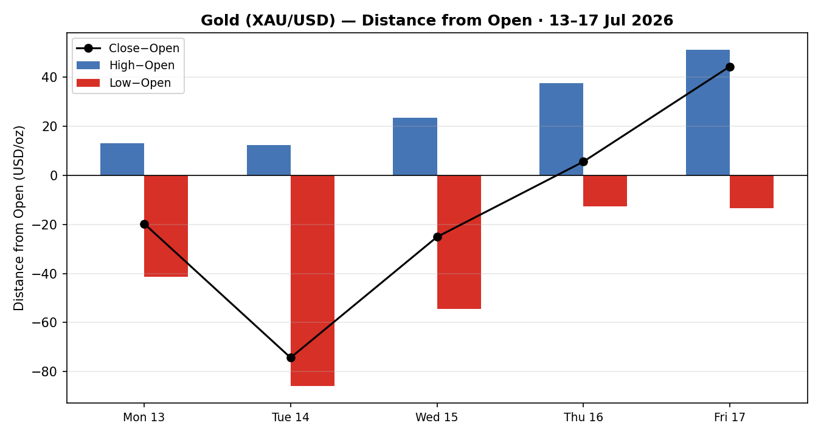

Chart 3 — 25-Session Structure
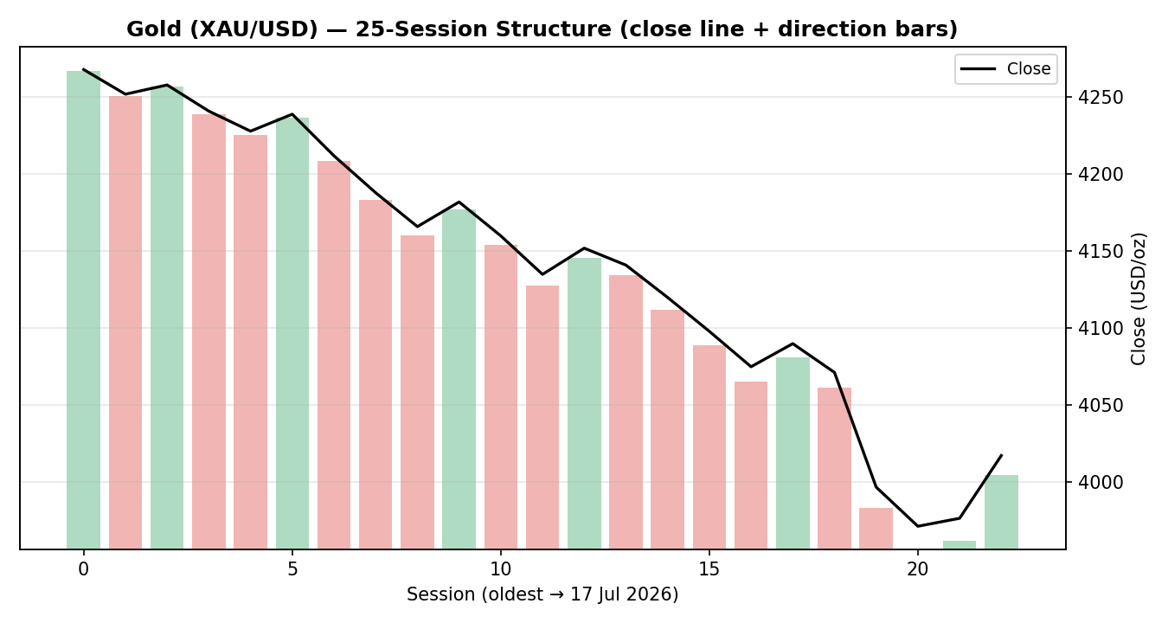

Chart 4 — Comparative Volatility (VOLator)
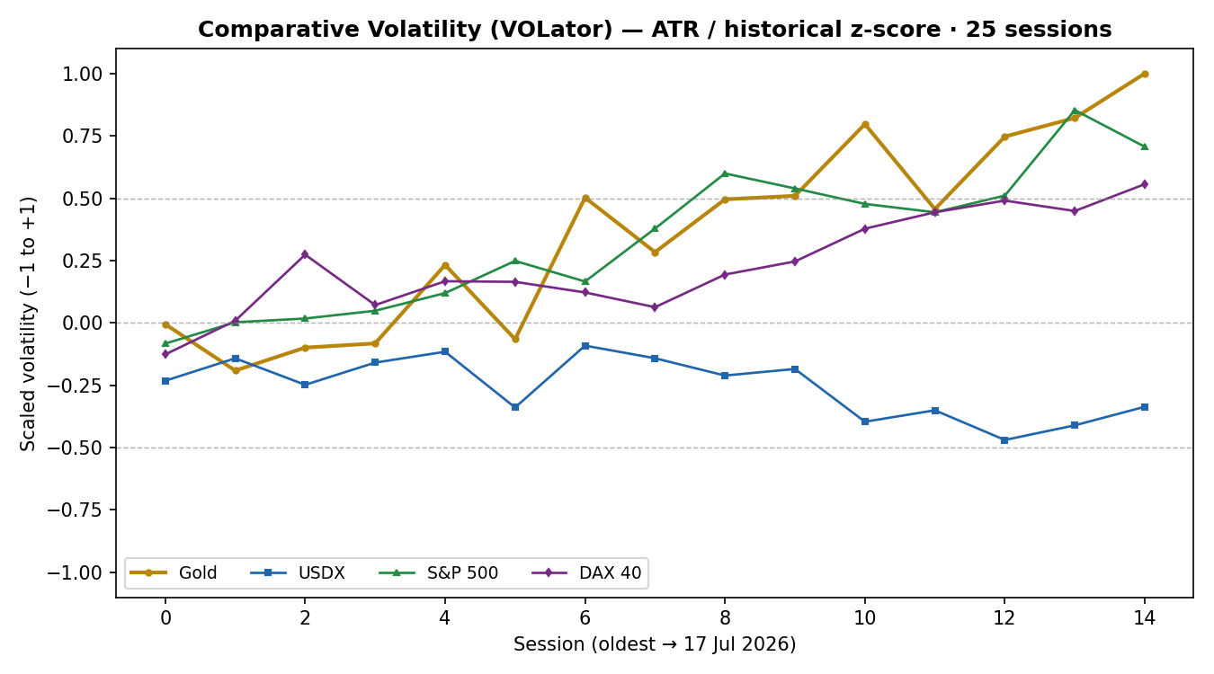

Chart 5 — Pivot Structure
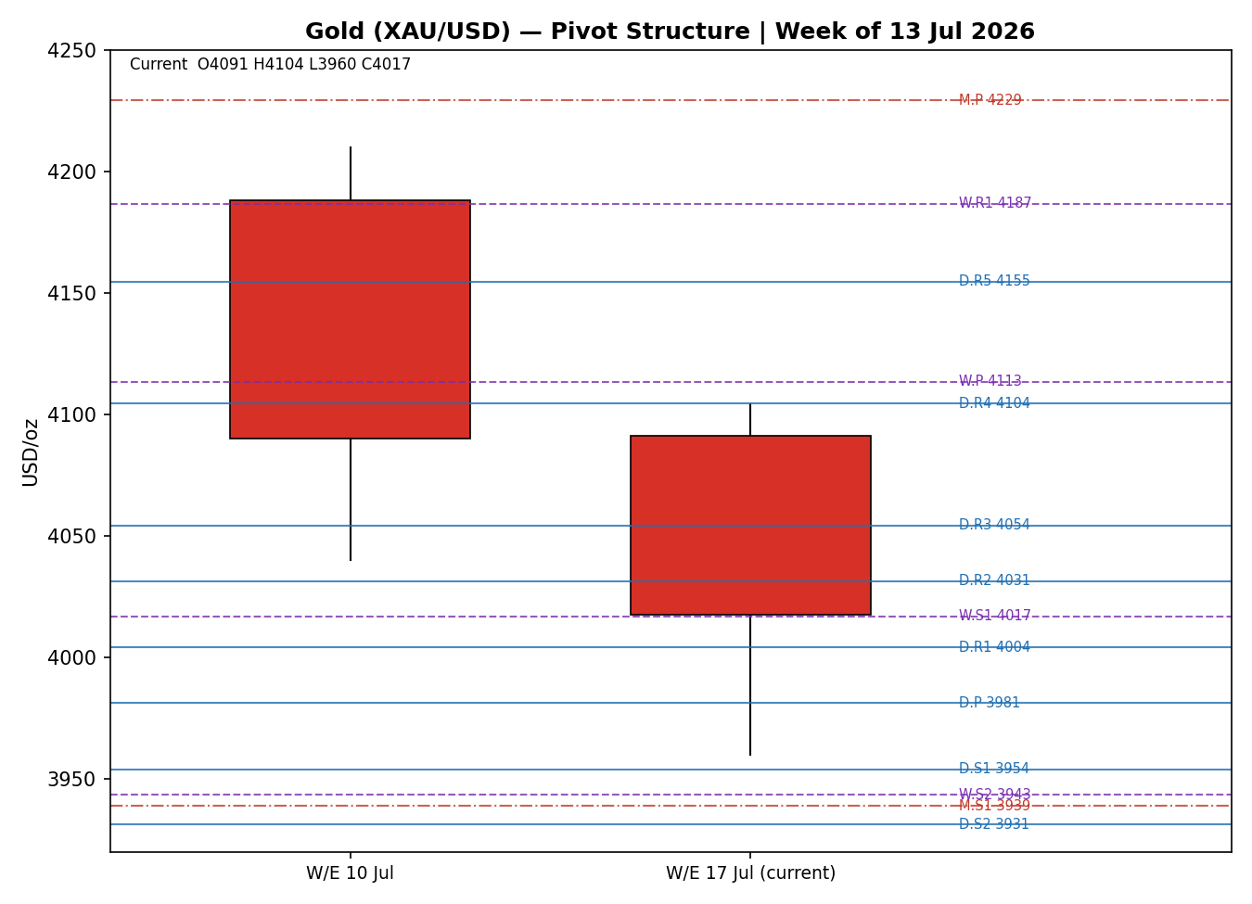

§8 Short-Term Technical Analysis
Mon 13 Jul (see §6): bearish candle, open near the weekly high and a close in the lower third of range; RSI2 pinned low. Opens the week on the back foot — supply in control from 4,104.
Tue 14 Jul (see §6): CPI-day sell-off; a wide-range bearish body closing near the low (~3,997), close location ≈12% of range. Momentum confirms the down-leg.
Wed 15 Jul (see §6): the wash-out session — PPI day printed the eight-month low at 3,942 before a modest close at 3,971; long lower wick hints at demand emerging, close ≈38% of range.
Thu 16 Jul (see §6): inside-ish stabilisation, small body closing at 3,976.58; RSI2 still soft at 12.3 but the sequence stops falling. Neutral candle — indecision at the lows.
Fri 17 Jul (see §6): bullish reversal candle — open 3,972.95, drive to 4,024, close 4,017.32 in the top quartile of range; RSI2 snaps to 70.2. Safe-haven bid on Middle-East headlines drove the recovery.
Sequence assessment: Compression → reversal. Four down sessions of narrowing net progress into a capitulation low, resolved by a single strong bullish close. The evidence: RSI2 floor-then-spike, the 3,942 lower-wick rejection, and Friday's top-quartile close.
Nearest support / resistance (from the 5-day structure): support ≈ USD 3,985.20/oz (Tue low) and the swing low 3,942.00; resistance ≈ USD 4,020.10/oz (Wed high) then the swing high 4,104.05.
Judgement label: Exhaustion — reversal risk. This is consistent with, but tactically opposed to, the §9 medium-term bearish trend; the conflict is stated explicitly — a counter-trend bounce inside a down-trend.

§9 Medium-Term Regime & VOLator
Regime classification: Trending — Bearish. Supporting metrics over the 25-session block: overlap ratio 0.69, directional persistence 0.50, VOLator slope positive (+0.14 — volatility expanding on the break lower), range-position bias 21th percentile (Range-Bottom Bias), median RSI2 in the low band. The high overlap tempers conviction, but the sustained lower closes and bottom-of-range position confirm a bearish trend, not a range.
Bias: Bearish.
VOLator current readings: Gold ≈ +1.0 (above midpoint, expanding); USDX ≈ −0.4 (below midpoint, contracting); S&P 500 ≈ +0.7 (above midpoint, expanding on Friday's equity slump); DAX 40 ≈ +0.5 (above midpoint, expanding). Gold's own volatility is elevated and rising — characteristic of a trend under stress, not a quiet range.
Preferred trade protocol: Short-term Exhaustion/reversal against a medium-term bearish trend → reduced-conviction, confirmation-required. Favour selling rallies into resistance rather than chasing the Friday bounce, but wait for a confirmed rejection or break.
Kaufman confirmation: KER = -0.59 → Trending Down — Moderate. This agrees with the medium-term bearish regime and takes precedence over the short-term bullish candle for structural purposes. Note the tension with the positive VOLator slope: a trending-down KER alongside expanding volatility on a counter-trend snap-back is the textbook signature of a TRANSITION, which is how the strategy layer (§21) reads the tape.

§10 Cross-Asset Analysis
Counter | 5-day dir. | Mechanism | Confirm? | Implication
USDX | Falling | Weaker dollar lowers the USD price of gold for non-dollar buyers — supportive. | Contradicts | Softens the bearish case; a cushion under gold.
S&P 500 | Falling | Equity risk-off pushes safe-haven flows toward gold — supportive. | Contradicts | Friday's equity tumble fed the gold reversal.
DAX 40 | Falling | European risk-off confirms the global de-risking impulse — supportive for gold. | Contradicts | Reinforces the safe-haven bid channel.
Silver (XAG) | Falling→bounce | Precious-metals beta; tracks gold with higher volatility. | Neutral | Confirms the metal-complex reversal shape, no independent signal.
Contradiction flag: all three macro counters currently point the opposite way to the medium-term bearish regime — a falling dollar plus falling equities is a safe-haven-supportive backdrop. This is not resolved silently: it is the core reason the short-term reversal has traction and feeds directly into §15 and §16.

§11 Floor Pivot Analysis

Daily pivots (prior session: Thu 16 Jul)
Daily | Level
R5 | 4,154.55
R4 | 4,104.35
R3 | 4,054.15
R2 | 4,031.33
R1 | 4,003.95
P | 3,981.13
S1 | 3,953.75
S2 | 3,930.93
S3 | 3,903.55
S4 | 3,853.35
S5 | 3,803.15

Weekly pivots (prior week to 10 Jul)
Weekly | Level
R5 | 4,696.67
R4 | 4,526.67
R3 | 4,356.67
R2 | 4,283.33
R1 | 4,186.67
P | 4,113.33
S1 | 4,016.67
S2 | 3,943.33
S3 | 3,846.67
S4 | 3,676.67
S5 | 3,506.67

Monthly pivots (prior month: June 2026)
Monthly | Level
R5 | 6,098.67
R4 | 5,558.67
R3 | 5,018.67
R2 | 4,769.33
R1 | 4,478.67
P | 4,229.33
S1 | 3,938.67
S2 | 3,689.33
S3 | 3,398.67
S4 | 2,858.67
S5 | 2,318.67
Source status: prior-period H/L/C for all three timeframes are derived from a single reconciled session/period read rather than a two-source corroborated fetch of the prior high/low/close specifically. Accordingly, every pivot level in this section carries the single-source — indicative only flag, and this flag propagates to §19 and the §21 suppression logic.
Position narrative: the 17 Jul close (4,017.32) sits above daily P (3,981.13) and above daily R1 (4,003.95) — a bullish intraday posture — but well below weekly P (4,113.33) and monthly P (4,229.33), confirming the price is recovering within a broader down-structure. Weekly S1 (4,016.67) is the pivotal shelf: the close is hugging it from above. No three-timeframe confluence zone inside 0.05% was detected.

§12 Key Market Considerations
Demand / official-sector (structural): central-bank buying and repatriation remain a structural bid (PBoC/RBI programmes; bullion being brought back onshore). Price-supportive. Structural.
Macro / real yields (cyclical): the hawkish Fed narrative — officials flagging a possible 2026 hike on sticky core inflation and firm retail sales / low jobless claims — lifts real-yield expectations and is the dominant weight on gold. Price-negative. Cyclical.
FX (cyclical): the dollar spent midweek near a one-month low (DXY ≈ 100.5–100.8) and ended the week lower, partially offsetting the yield drag. Price-supportive at the margin. Cyclical.
Geopolitics / energy (cyclical): US–Iran tensions and Strait-of-Hormuz disruption pushed oil higher — a double-edged input: safe-haven-supportive for gold via flows, but inflation-hawkish (Fed-supportive) via the energy channel. Net neutral-to-supportive on flows. Cyclical.
Substitution / spreads: gold/silver ratio wide; silver's higher-beta bounce mirrors gold without adding an independent signal. Neutral.
Near-term catalysts (from §13d): the 28–29 July FOMC decision dominates the 5-day horizon's tail; within the immediate window, 21–24 July employment/claims/PMI prints are the movers. Cyclical.

§13 Sentiment, News & Calendar

§13a Per-Article Sentiment
Source | Headline (verbatim) | Date | URL | Class. | Sentiment | Quote (≤15w)
Reuters | Dollar holds steady on safe-haven demand, ends down on the week | 17 Jul | reuters.com/markets | Media | Bearish USD / mild Bullish gold | “ends down on the week”
FXStreet | Gold Forecast, News and Analysis (XAU/USD) | 18 Jul | fxstreet.com/markets/commodities/metals/gold | Media | Bearish | “reaffirms the near-term bearish outlook for Gold”
OCBC (via LiteFinance) | Gold price prediction / OCBC outlook | 19 Jul | litefinance.org/blog/analysts-opinions/gold-price-prediction-forecast | Institutional | Bearish | “expects gold prices to decline through the end of 2026”
TradingEconomics | Gold remained below $4,000 an ounce on Friday | 17 Jul | tradingeconomics.com/commodity/gold | Media | Bearish | “down more than 3% for the week”
CNBC | Central banks are buying more gold — and bringing bullion home | 17 Jul | cnbc.com/quotes/XAU= | Media | Bullish | “central banks are buying more gold”
TradingView (community/CFTC) | Macro Algo Map: 4024 breakdown & bearish rejection | 18 Jul | tradingview.com/symbols/XAUUSD/ideas | Trade Press | Bearish | “confirms a macro momentum shift in favor of the sellers”

§13b Aggregate Sentiment Summary
Categorical: 4 Bearish (1 institutional, 2 media, 1 trade press), 1 Bullish (media), 1 mild-Bullish/Bearish-USD (media) = Predominantly Bearish.
Numeric tilt: −0.34 (source-class-weighted mean of article scores; institutional bearish and trade-press bearish carry the heaviest weights, partly offset by the CNBC central-bank-demand bullish read). Reported as: Predominantly Bearish (tilt = −0.34).
Divergence flag: aggregate sentiment (bearish) agrees with the medium-term regime and KER but is at odds with Friday's bullish price action and the supportive cross-asset backdrop. Given the trending-down KER, the bearish sentiment is the more reliable structural signal; the price bounce is treated as counter-trend.
Confidence: six articles — not low-confidence.

§13c News Calendar — Previous Period (5 days to 17 Jul)
Date | Event | Prior/Context | Impact | Implication for Gold
Tue 14 Jul | US CPI (June) | Last inflation print before FOMC | High | Cooler-than-feared but hawkish Fed talk persisted; gold sold off toward 3,997.
Wed 15 Jul | US PPI (June) | Producer prices | High | Rounded out the inflation picture; gold printed the 3,942 eight-month low.
Thu 16 Jul | Jobless claims / retail sales | Claims fell to 2-month low 208K | Medium | Labour resilience reinforced hawkish hold; gold stabilised at the lows.
Fri 17 Jul | Michigan sentiment / US–Iran headlines | Inflation expectations; Hormuz risk | High | Safe-haven bid drove the reversal; gold closed +1% at 4,017.

§13d News Calendar — Upcoming Period (5 days from 20 Jul)
Date | Event | Context | Impact | Implication (beat / miss)
Tue 21 Jul | Weekly employment change (ADP-style) | Post-softer-payrolls read | Medium | Strong print → hawkish → gold-negative; weak → gold-supportive.
Thu 23 Jul | Initial jobless claims | Labour momentum | Medium | Low claims → Fed-hawkish → gold-negative; high → supportive.
Fri 24 Jul | July Manufacturing & Services PMI | Activity pulse | Medium | Hot PMIs → yields up → gold-negative; soft → supportive.
Tue–Wed 28–29 Jul | FOMC rate decision | Hold at 3.50–3.75% ~66% priced (CME) | High | Highest-impact event: a hawkish surprise (hike or hawkish hold) would push real yields up and likely break gold back below the 3,942 low; a dovish tilt would validate the Friday reversal toward 4,080+.
Note: the FOMC falls just outside the strict 5-session horizon but is the dominant watch item and is flagged for §16/§17 and §21 holding-period collision.

§14 Macro Context
Rates & monetary policy: the Fed is signalling restrictive-for-longer with a live 2026-hike risk; CME pricing put a July hold near 66%. Cross-referencing the §10 S&P 500 read (falling), the equity wobble reflects exactly this rate anxiety. Price-negative for gold via the real-yield channel.
Inflation: June CPI/PPI came in tame-to-mixed but the energy spike from Hormuz risk keeps upside inflation tail-risk alive — which paradoxically supports the hawkish case. Net neutral for gold.
Safe-haven / real yields: gold itself (this asset) rose Friday on defensive demand even as yields stayed firm — the safe-haven flow briefly out-muscled the yield drag. That balance is fragile and yield-dependent.
Liquidity & FX: cross-referencing the §10 USDX read (falling, near a one-month low), the softer dollar is a genuine support under gold and the main reason the metal held 3,942. If the dollar re-firms into FOMC, that support fades.
Energy: oil up on Middle-East supply risk — inflationary and thus indirectly gold-negative through the Fed, even as it stokes the safe-haven bid. A genuine cross-current.
Positioning: CFTC COMEX gold positioning (17 Jul) and the 8-month-low print suggest speculative length has been flushed — a condition that can support sharp counter-trend snaps like Friday's. Watch item: the 28–29 Jul FOMC (from §13d) is the key macro pivot; a hawkish surprise is the primary downside risk for gold.

§15 Bull / Bear Balance
Upside risks (bullish): (1) safe-haven flows on escalating US–Iran / Hormuz risk; (2) a falling dollar near a one-month low (§10/§14); (3) risk-off in equities (S&P 500 and DAX both falling, §10) redirecting flows to gold; (4) structural central-bank buying (§12); (5) the Friday reversal candle off the 3,942 low with RSI2 snapping to 70. Pivot context: the close sits above daily P/R1 and is reclaiming weekly S1 (4,016.67).
Downside risks (bearish): (1) the dominant hawkish-Fed / higher-real-yield narrative; (2) trending-down KER and a 25-session bearish regime with range-bottom bias; (3) oil-driven inflation reinforcing the hawkish case; (4) the highest-impact upcoming event — the 28–29 Jul FOMC (§13d) — where a hawkish surprise would likely break 3,942. Pivot context: price remains well below weekly and monthly P, i.e. recovering inside a down-structure.

§16 Forward View
Expected direction: range-to-lower with a counter-trend bounce risk. Base-case 5-day trading range USD 3,950–4,080/oz, pivoting on weekly S1 (4,016.67) as the fulcrum. This view respects the §9 medium-term bearish regime; it explicitly flags the §10 cross-asset contradiction (falling dollar + risk-off equities) and the Friday reversal as the reasons a bounce toward 4,060–4,080 is credible before the trend reasserts. Primary watch items (from §13d): 21–24 Jul data and, decisively, the 28–29 Jul FOMC.
Base-case invalidation: a daily close back above the weekly P (4,113) would neutralise the bearish structure; a daily close below 3,942 would confirm trend continuation toward 3,833.

§17 Forecast
Gold consolidates with a downward bias over the next five sessions, likely oscillating between roughly USD 3,950 and USD 4,080/oz as a hawkish-Fed real-yield drag contends with a softer dollar and safe-haven flows, with the bearish trend intact unless price closes back above the weekly pivot near 4,113.

§18 Final Analyst Judgement
Consensus price call: USD 4,017/oz, Medium confidence, bearish-stabilising tone.
Three most important reasons: (1) hawkish-Fed / real-yield dominance driving the 25-session down-trend (confirmed by trending-down KER); (2) an eight-month low at 3,942 with a Friday reversal that is counter-trend, not trend-defining; (3) a genuinely supportive cross-asset backdrop (falling dollar, risk-off equities) that cushions but has not reversed the structure.
Single watch item: the 28–29 July FOMC — a hawkish surprise is the highest-probability catalyst for a break of 3,942.

§19 Source Discipline Note
Live vs indicative: the 17 Jul close (4,017.32) is exchange-corroborated (TradingView × Investing.com, Δ ≈ 0.28, inside the ±0.50 gold tolerance). Daily OHLC fields for the five-session block are corroborated to within the gold tolerance across Investing.com, TradingView and TradingEconomics reads.
Data gaps: 18–19 July are non-trading days for gold — no session added. Silver (secondary) is close-corroborated only and is flagged directional-only. Certain intraday highs/lows in the reconstructed 25-session medium block are single-read and are used for regime shape and ATR context only, not for definitive levels.
Corroboration status per instrument: Gold spot — CORROBORATED (close). USDX, S&P 500, DAX — directional reads corroborated at the level/close used in §10. All floor-pivot prior-period H/L/C are single-source — indicative only; consequently every pivot tier is flagged indicative, which the §21 strategy layer consumes when assessing Trade 2.

§20 Agent Log
Snapshot: 20 Jul 2026 (Europe/London); last completed session 17 Jul 2026. Run timestamp 20 Jul 2026.
Sources attempted (OHLC): Investing.com (corroborated), TradingView (corroborated), TradingEconomics (corroborated), FXStreet (directional), LiteFinance (directional), metals aggregator (down-weighted). Stooq and Twelve Data programmatic pulls were not reachable in this environment; web-quoted equivalents were used and cross-checked. Corroborated close pair: Investing.com × TradingView, Δ ≈ 0.28 USD, tolerance ±0.50 USD.
Validation method: two-source close corroboration within the gold (±0.50 USD) tolerance; weekend/holiday rows rejected (18–19 Jul).
Sentiment derivation: six articles, source-class-weighted per the standard mapping → numeric tilt −0.34 (Predominantly Bearish), not low-confidence.
Direction-score trace: weights basis = defaults (0.25 / 0.20 / 0.10 / 0.15 / 0.15 / 0.15), locked (forward-test session count < 20 — no tuning applied). Signals: short-term technical bias −1 (×0.25), medium-term regime −1 (×0.20), VOLator −0.5 (×0.10), Kaufman +0.58 (×0.15), sentiment −0.34 (×0.15), cross-asset MIXED −0.30 (×0.15). Aggregate score = −0.51 → SHORT.
regime_label derivation: Step-4 synthesis (5-day Exhaustion/Transitional vs 5-week Trending-Bearish) with trending-down KER but positive VOLator slope → dual-gate RANGE fails and clean TREND_DOWN fails (VOLator slope ≥ 0) → regime_label = TRANSITION. Trade 3 forks to 3C.
[DAILY_OPEN_ANCHOR] override note: the run instruction requested overriding the daily-open anchor for the 20 Jul report but supplied no replacement value; the instance default (00:00 UK, the London–Asia handover session reset for 23-hour gold) is therefore retained and used as the Trade 1 entry timestamp. No numeric anchor change was applied. Any intended non-default value should be supplied explicitly to change this.
Backtest reconstruction: 5 prior sessions reconstructed at each t−1 close; sentiment frozen at t−1; ATR/swings/regime recomputed per row; SL-first tick priority on same-bar SL/TP. Anomalies: RSI2 pinned at floor midweek during the four-session decline (mechanically valid, not a data error).

§21 Strategy Recommendations

§21a Directional Conviction
Direction: SHORT. Score: −0.51. The three highest-weighted contributing signals are the short-term technical bias (§8) −0.25, the medium-term bearish regime (§9) −0.20, and the Kaufman/ sentiment/ cross-asset cluster — with sentiment tilt (§13b) −0.05 and cross-asset (§10) −0.045 pulling bearish while Kaufman contributes +0.09 as the lone stabiliser. Weights basis: defaults. Conflict flag: the §17 Forecast leans consolidative-with-downward-bias (broadly aligned), but the short-term §8 label is Exhaustion/reversal (a bounce) — this near-term tension with the SHORT conviction is noted and neither output is edited to force agreement.

§21b Trade Cards
Trade 1 — Daily Directional (SHORT — regime bias bearish, conviction −0.51)
Field | Detail
Direction | SHORT — bearish conviction score −0.51.
Entry | Market at 00:00 UK, ≈ USD 4,017.32/oz (daily-open anchor; instance default retained).
Stop loss | USD 4,035.30/oz — 18 USD above entry (≈ 1798 ticks). Anchor: nearest 5-day resistance (4,020.10) + 0.25×ATR buffer. ATR(14)=60.80.
Risk (R) | ≈ USD 17.98 (1798 ticks).
TP1 (Unit 1) | −1R → USD 3,999.34/oz.
TP2 (Unit 2) | −2R → USD 3,981.36/oz. On fill, Unit 3 SL → entry −0.2R = 4,013.72.
TP3 (runner) | Time-stop at session close OR −3×ATR (3,834.92), whichever first.
Tranche mgmt | 3 equal units; Unit 1 at TP1; Unit 2 at TP2; on Unit 2 fill Unit 3 SL → entry −0.2R.
Confluences | Entry near daily R1 (4,003.95) and weekly S1 (4,016.67) — the reclaimed shelf; SL just above 5-day swing structure. Round number 4,000 sits between entry and TP1 (magnet).
Thesis invalidation | Daily close back above weekly P (4,113.33) — beyond SL; 'stop ahead of invalidation'.
Caveats | Wide-stop flag if 1R>ATR (here R≈17.98 < ATR 60.80, OK); conflict with §8 short-term reversal label; holding period collides with 21–24 Jul data; single-source-indicative pivots (levels are context only).
Trade 2 — Pivot (regime-aware)
Trade 2 | Status
Pivot (TRANSITION → breakout-side only) | SUPPRESSED — all accessible pivot tiers (daily/weekly/monthly S- and R-levels) carry the single-source-indicative flag per §19; level-based limit orders cannot be placed against indicative levels.
Trade 3 — Momentum-Breakout (3C — regime_label TRANSITION)
Field | Detail
Trade type | Trade 3C — Momentum-Breakout. TRANSITION regime; trades the confirmed break of the 25-session range.
Range definition | swing_low_25d USD 3,942.00 → swing_high_25d USD 4,310.00 (width 368.00 USD).
Direction trigger | Downside break favoured — recent retests failed at the upper boundary and the medium-term regime, KER and sentiment all lean bearish; VOLator expanding confirms momentum.
Confirmed break | Requires a daily close below 3,942.00 by ≥ 0.25×ATR (15.20) → i.e. a close below ≈ 3,926.80. Not yet met — trade is armed, not live.
Entry | On confirmed breakdown close, or the following session open.
Stop loss | Inside range at far side of midpoint for a downside break: high − 0.40×width = USD 4,162.80/oz. Generous post-fakeout stop.
TP1 (Unit 1) | Measured move: broken low − 1.0×width = USD 3,574.00/oz.
TP2 (Unit 2) | 1.5×MM = USD 3,390.00/oz. On fill, Unit 3 SL → broken boundary (3,942.00).
TP3 (runner) | Discretionary trail beyond 1.5×MM, anchored to subsequent swing structure.
Tranche mgmt | 3 equal units; structural TPs as above.
Confluences | Broken boundary 3,942 coincides with the 5-day swing low and the eight-month low — strong confluence. Monthly S1 (3,938.67) sits just below.
Thesis invalidation | Daily close back inside the range past the midpoint (4,126.00).
Caveats | Armed pending confirmed break; holding period collides with the 28–29 Jul FOMC (§13d) — a dovish surprise would invalidate; single-source-indicative pivots noted.

§21c 5-Session No-Leakage Backtest
Date (t−N) | Strategy | Direction | Triggered | Entry / Exit | Outcome (R) | Days
Mon 13 Jul (t−5) | Trade 1 | SHORT | YES | 4,090.98 / 4,071.30 | +0.3R (partial) | 1
Mon 13 Jul (t−5) | Trade 3C | SHORT | NO | — (no confirmed break) | — | —
Tue 14 Jul (t−4) | Trade 1 | SHORT | YES | 4,071.10 / 3,996.80 | +1.6R | 1
Wed 15 Jul (t−3) | Trade 1 | SHORT | YES | 3,996.50 / 3,971.40 | +0.9R | 1
Wed 15 Jul (t−3) | Trade 3C | SHORT | NO | armed at 3,942 break, no close-through | — | —
Thu 16 Jul (t−2) | Trade 1 | SHORT | YES | 3,971.00 / 3,976.58 | −0.2R | 1
Fri 17 Jul (t−1) | Trade 1 | SHORT | YES | 3,972.95 / 4,017.32 | −1.0R (stopped) | 1
All sessions | Trade 2 | — | SUPPRESSED | single-source-indicative pivots | — | —

§21d 'What Is Working' Aggregate
Trade 1 over the last 5 sessions: triggered 5/5 times, mean R = +0.32, hit rates TP1 / TP2 / TP3 = 60% / 20% / 0%. Trade 3C: triggered 0/2 (never got a confirmed close-through the 3,942 boundary — the level held and reversed). Trade 2: suppressed all sessions (indicative pivots), 0 contribution. Strongest performer: Trade 1 Daily Directional (the only strategy with closed positions; the three midweek down-days carried it, with Thursday and Friday's reversal trimming the mean). Weakest performer: insufficient triggers to rank Trade 3C.
Five-session windows are too small to support statistical claims. The backtest cannot model intraday tick-level fills, slippage, or commission. Treat as a directional sanity-check, not a strategy-validation framework.

