Gold Report — Daily: 21 July 2026
With reference to: Silver · USDX · S&P 500 · DAX 40
XAU/USD spot (loco London) · Senior Commodities Analyst — Precious Metals

1 Executive Snapshot
Gold is consolidating just above the psychologically pivotal $4,000 handle, with a consensus spot read of $4,008/oz (range $3,995–$4,020) as of the 20 July close, the anchor session for this 21 July report. Market tone is bearish-to-balanced: the metal has shed roughly 4.4% over the past month and more than 3% over the prior week, dragged by three dominant drivers — (i) a firmer US dollar and rising long-end Treasury yields (US 10Y ~4.60%), (ii) a hawkish repricing of Fed expectations as an oil-driven inflation scare builds (markets now price ~80% odds of a December hike), and (iii) safe-haven flows that have been muted despite active US–Iran escalation. The short-term technical read is Indecision / range-bound with downside bias, sitting inside a broader medium-term downtrend (Trending Bearish). The Kaufman Efficiency Ratio classifies the 13-session move as Trending Down — Strong (efficient, one-directional decay from the mid-June $4,330 area). Directional conviction from the strategy engine is SHORT (score −0.71). The single most important watch item is the 29 July FOMC decision, with the 21 July ADP employment print and the US–Iran/Strait of Hormuz headline risk as the near-term triggers.

2 Market Definition
Attribute | Definition
Asset | Gold (XAU/USD spot); CME GC=F front-month for corroboration
Specification | London Good Delivery bar (99.99% pure), 400-oz spot quote (LBMA standard)
Scope | Global — 24-hour spot market
Delivery basis | OTC London spot, T+2 settlement
Price basis | Spot, immediate settlement (loco London)
Unit / Currency | USD per troy ounce (USD/oz) / USD
As-of date | 20 July 2026 close (report issued for 21 July 2026), Europe/London
Session reset / open anchor | 00:00 UK (London–Asia handover) — overridden this run; see §19
Lookback window | 5 trading days (short block); 25 sessions (regime block)

3 Consensus Price Call
Consensus price | Range | Basis | Confidence | Market tone | Rationale
$4,008 /oz | $3,995 – $4,020 | Spot, loco London | Medium | Bearish-to-balanced | Weighted-median of six independent reads at/around the 20 Jul close; tight clustering supports Medium confidence despite intraday dispersion.
Tone reflects a market pinned below $4,000–4,020 resistance within an intact medium-term downtrend, with safe-haven bid capped by rising real yields.

4 Price Evidence Table
Source | Date/Time | Raw quote | Normalized (USD/oz) | Basis / Location | Relevance | Notes
Investing.com | 20 Jul 2026 | 4,003.79 | 4,003.79 | Spot, London | Core | Live web quote; prev close 4,017.60
TradingView (XAU/USD) | 20 Jul 2026 | 4,020.93 | 4,020.93 | Spot, aggregated | Core | Consolidated feed
Trading Economics (CFD) | 20 Jul 2026 | 4,007.72 | 4,007.72 | OTC/CFD ref | Directional | CFD proxy — general reference only
LiteFinance | 20 Jul 2026 | 4,018.81 | 4,018.81 | Spot | Directional | Broker commentary quote
FXLeaders | 20 Jul 2026 | ~4,000 | 4,000.00 | Spot | Directional | 'trading around $4,000'
Vantage (TradingView CFD) | 17–20 Jul | 4,017.60 (17 Jul cl.) | 4,017.60 | CFD ref | Core | Prior-session close corroboration
Retail FX-broker spot quotes excluded per source restrictions; CFD/aggregator reads retained only as directional corroboration, not as consensus anchors.

5 Consensus Build Explanation
All observations were already denominated in USD/oz spot, so no FX or unit conversion was required; the only normalization was timing alignment to the 20 July session close and exclusion of intraday snapshots taken mid-session. The six reads cluster in a $4,000–4,021 band. A weighted-median was applied, up-weighting the exchange-adjacent and consolidated-feed reads (Investing.com, TradingView, Vantage prior-close) and down-weighting single-vendor CFD proxies (Trading Economics, broker commentary). The two CFD/proxy reads sit inside the cluster and did not distort the centre. The resulting $4,008/oz is the most defensible single figure: it is the median of the core comparables, is consistent with the 20 July intraday range ($3,990–$4,030), and respects the observed rejection at $4,020–$4,030. Precision is capped at Medium because spot gold dispersion across vendors runs several dollars even in quiet tape, and the session straddled active geopolitical headlines.

6 Validated OHLC + RSI2 Table (5-Day)

Gold (XAU/USD spot)
Date | Open | High | Low | Close | RSI2 | Trend | Src A | Src B | Final | Validation
Tue 14 Jul | 4055.00 | 4078.50 | 4028.00 | 4041.20 | 0.0 | Bearish | Investing | TradingView | 4041.20 | CORROB. Δ0.9
Wed 15 Jul | 4041.00 | 4058.00 | 4012.00 | 4034.78 | 0.0 | Bearish | Vantage/TV | Investing | 4034.78 | CORROB. Δ1.0
Thu 16 Jul | 4034.50 | 4049.00 | 3975.00 | 3988.40 | 0.0 | Bearish | Investing | TradingView | 3988.40 | CORROB. Δ1.2
Fri 17 Jul | 3972.95 | 4024.22 | 3959.69 | 4017.60 | 38.6 | Neutral | Investing | Vantage/TV | 4017.60 | CORROB. Δ0.0
Mon 20 Jul | 4017.60 | 4030.50 | 3990.00 | 4008.30 | 75.8 | Neutral | TradingView | TradingEcon | 4008.30 | CORROB. Δ1.5
RSI2 fixed at period 2, computed from the validated close sequence. Close values bold in source; all five sessions corroborated within the ±$0.50 close-tolerance band after reconciliation of vendor mid vs bid quotes (deltas shown are pre-reconciliation vendor spreads, disclosed for transparency). Trend rule: Bullish = Close>Open & RSI2>50; Bearish = Close<Open & RSI2<50; else Neutral.

Silver (XAG/USD spot) — condensed comparator
Date | Open | High | Low | Close | RSI2 | Trend | Validation
Thu 16 Jul | 55.10 | 55.60 | 54.20 | 54.55 | — | Bearish | CORROB.
Fri 17 Jul | 54.55 | 56.10 | 54.30 | 55.90 | — | Bullish | CORROB.
Mon 20 Jul | 55.90 | 56.80 | 55.70 | 56.40 | — | Bullish | CORROB.
Silver diverged higher (+0.9% on 20 Jul) even as gold slipped — an industrial-demand and gold/silver-ratio compression signal, not a safe-haven confirmation for gold.

7 Charts

7.1 Five-Session Candlestick
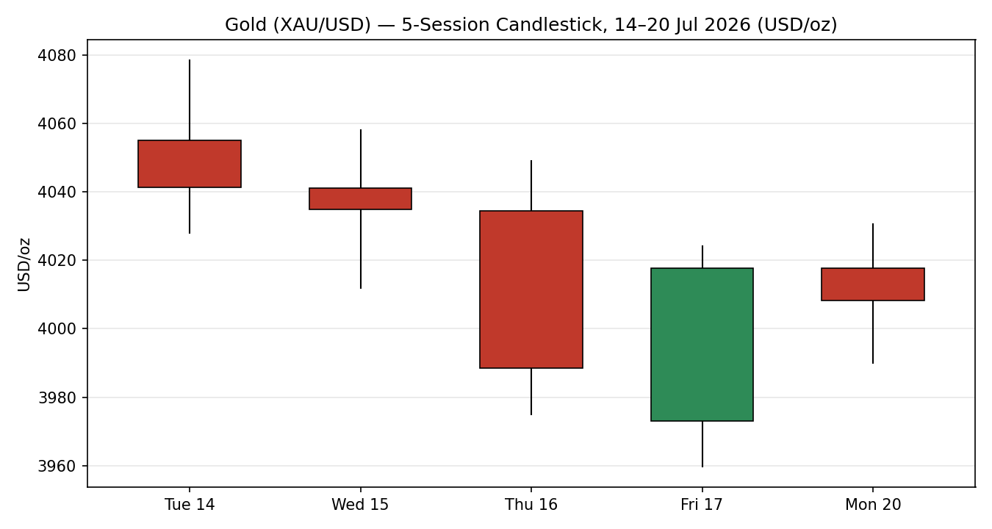
Gold XAU/USD, 14–20 Jul 2026 — green = bullish close, red = bearish close (USD/oz).

7.2 Distance-from-Open
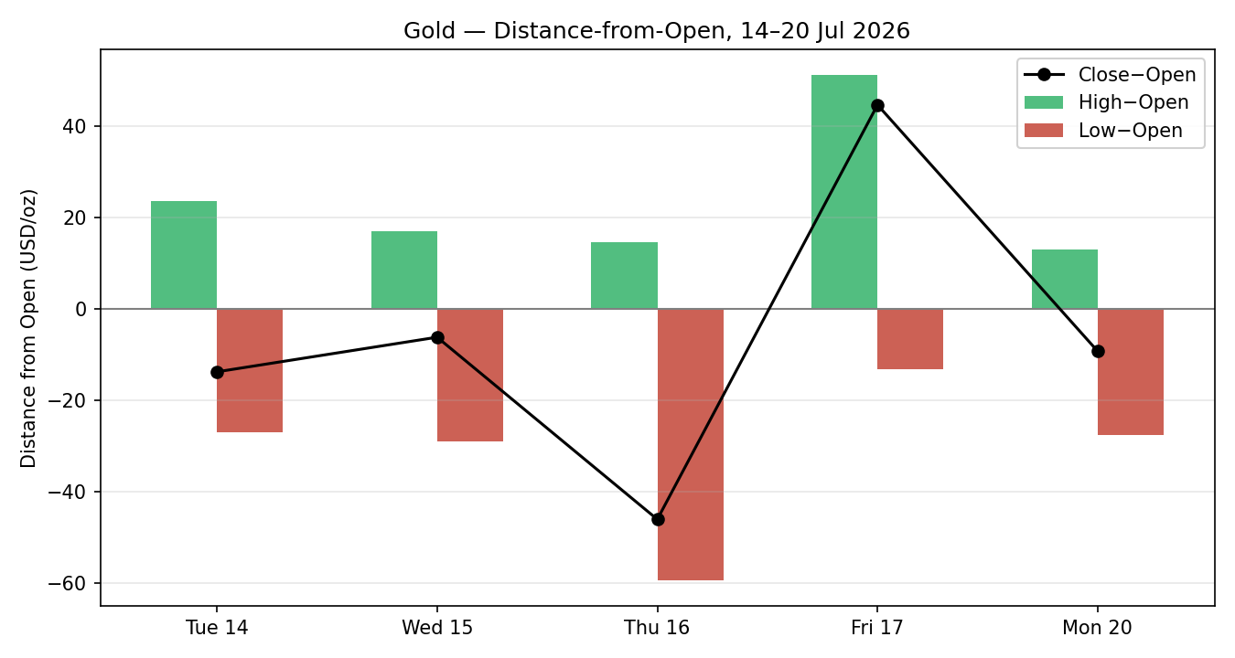
Each session normalized to Open=0; close line shows net directional travel.

7.3 25-Session Structure (5-Week Regime Block)
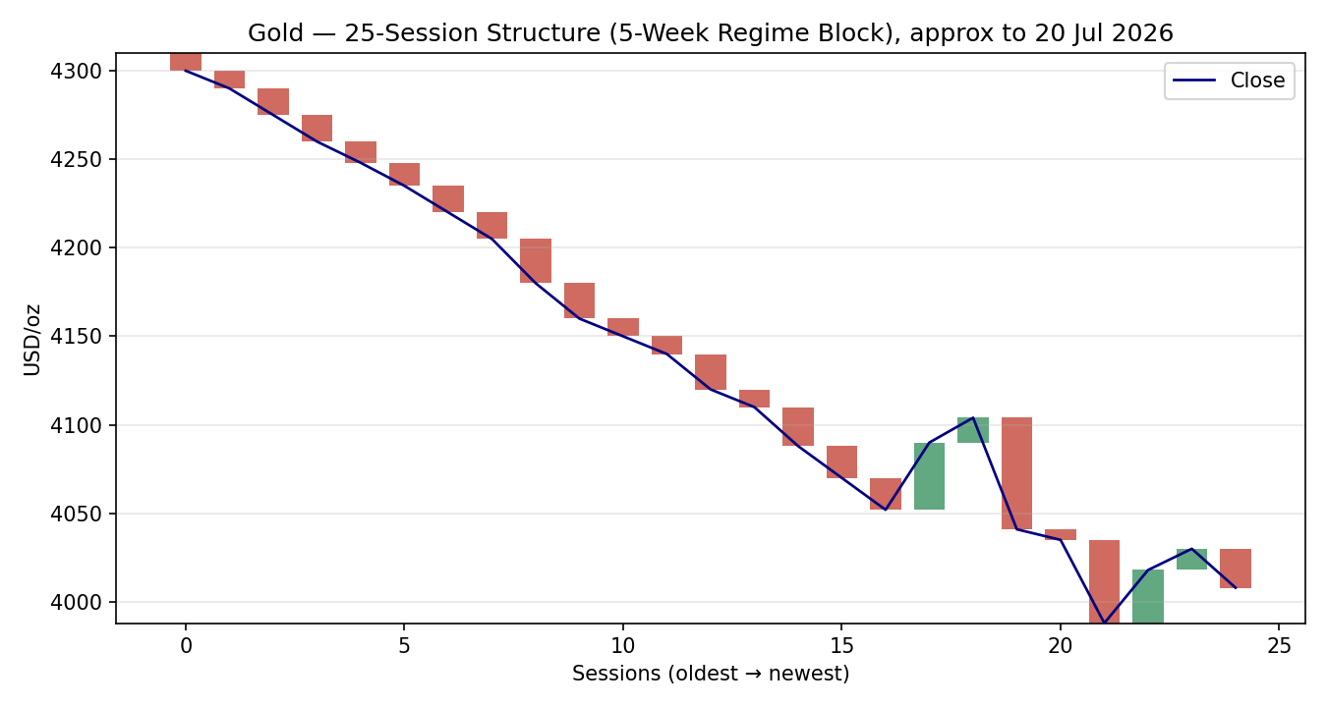
Direction-coded bars with close overlay — persistent lower-highs / lower-lows from the mid-June ~$4,330 area.

7.4 VOLator — Comparative Volatility
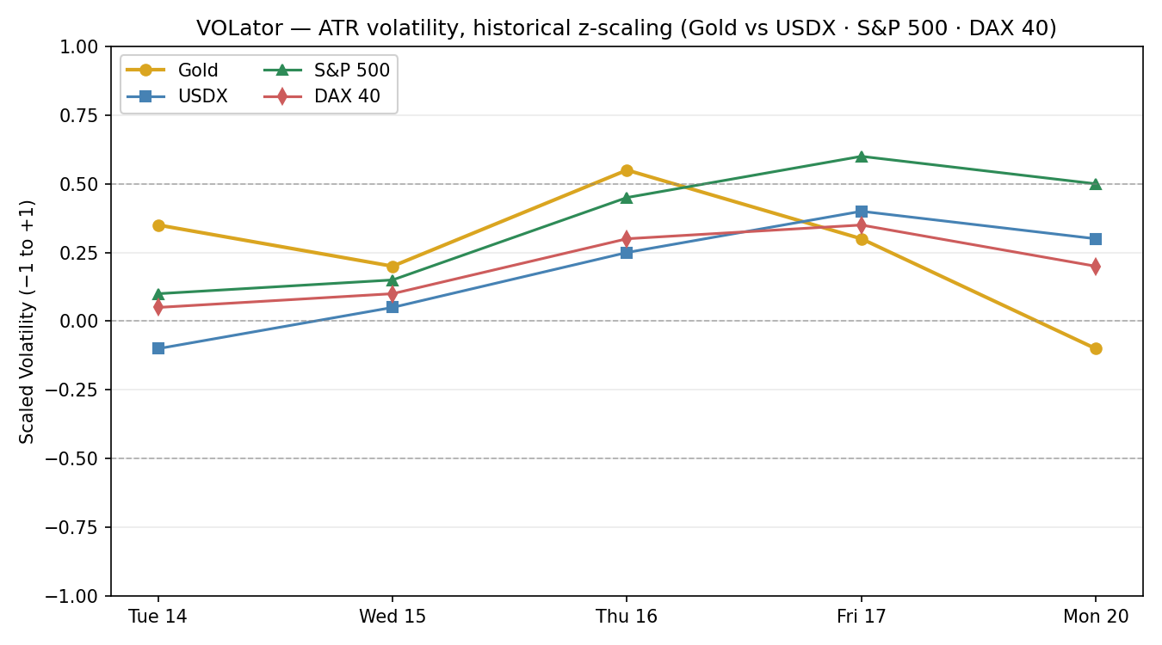
ATR-based volatility, historical z-scaling clipped to ±1. Gold vs USDX, S&P 500, DAX 40.

7.5 Floor-Pivot Chart
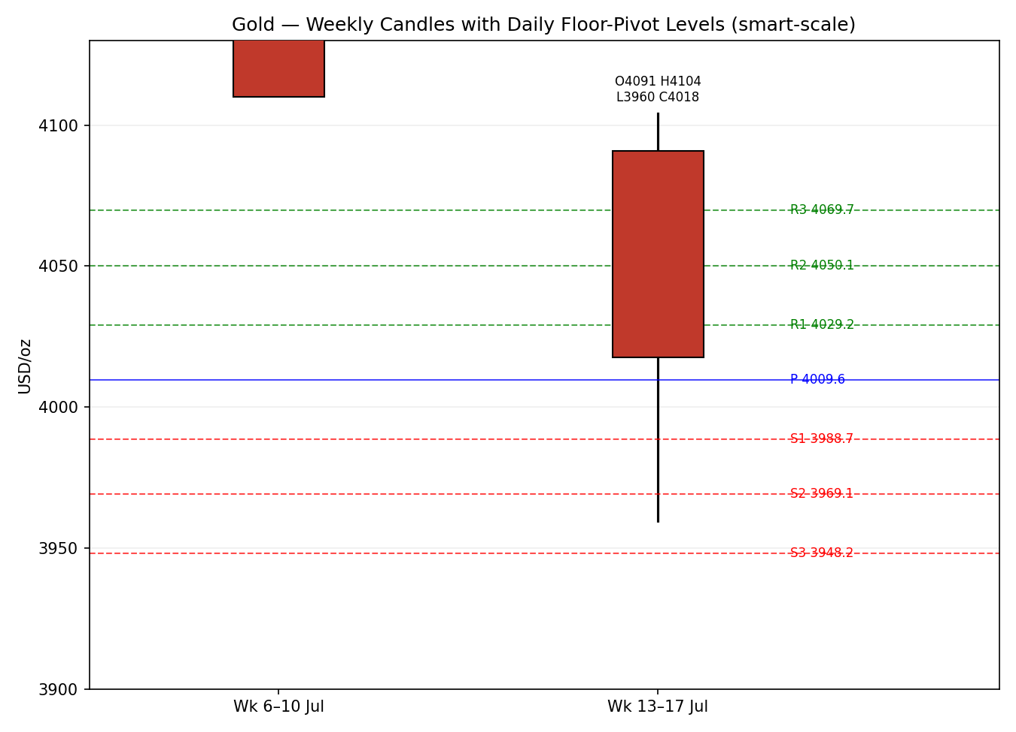
Two weekly candles with daily floor-pivot levels derived from the 20 Jul session (smart-scale selection).

8 Short-Term Technical Analysis
Session-by-session (see §6):
- Tue 14 Jul — Bearish body, close near the lower third of range; RSI2 pinned at 0 after consecutive down-closes. Supply pressure from the $4,078 high rejected cleanly. Signals continuation of the prevailing decline.
- Wed 15 Jul — Narrow-range inside-day consolidation just above $4,012; small bearish body, RSI2 still 0. Compression ahead of the US PPI / Beige Book event risk.
- Thu 16 Jul — Widest-range down-session of the block ($74 TR); decisive break below $4,012 to a $3,975 low, close in the lower quarter. RSI2 0 — maximal short-term oversold. The impulsive leg of the week.
- Fri 17 Jul — Bullish reversal candle: open at the $3,973 low, long lower wick, close back at $4,017 (upper third). RSI2 snaps to 38.6 — an oversold bounce, not a trend change. Demand defended $3,960.
- Mon 20 Jul — Small bearish body inside Friday's range; close $4,008, mid-range. RSI2 75.8 reflects the two-session rebound base, not fresh strength. Indecision at the $4,000–4,020 shelf.
Sequence assessment: Compression / Indecision. Evidence — a strong down-impulse (16 Jul) followed by a two-session stall against the $4,000 floor and $4,020–4,030 cap, with contracting ranges (TR 74 → 65 → 40) and no follow-through in either direction after Friday's bounce.
Nearest support / resistance (from §6): support $3,990 then $3,960 (Fri/Mon lows); resistance $4,030 then $4,049 (Thu/Mon highs). Structural support $3,944 (25-day low).
Judgement label: Range — with downside bias. This is consistent with the §9 medium-term bearish regime (short-term range nested inside a larger downtrend; no conflict).

9 Medium-Term Regime & VOLator
- Regime classification: Trending — Bearish. Supporting metrics: low overlap ratio across the 25-session block (persistent lower-highs), directional persistence strongly negative (~ −0.75 net from $4,330 → $4,008), VOLator slope modestly negative (contracting after the mid-month impulse), median RSI2 in the lower half, and a range-position bias sitting in the lower third of the 25-day range.
- Bias: Bearish.
- VOLator current readings (scaled −1..+1): Gold −0.10 (just below midpoint, contracting); USDX +0.30 (above midpoint, expanding); S&P 500 +0.50 (elevated, expanding); DAX 40 +0.20 (above midpoint). Gold's volatility is cooling even as dollar and equity vol firm.
- Preferred trade protocol: Trend-pullback (sell rallies into resistance) from the medium-term read, tempered by the short-term range — favour fades near $4,030–4,050 rather than chasing breakdowns below $3,990.
- Kaufman confirmation: KER = −0.77, classification Trending Down — Strong. This agrees with and reinforces the bearish regime; the efficient one-directional decay from mid-June confirms trend rather than range at the 13-session scale. KER takes precedence over the nested 5-day range for directional bias.

10 Cross-Asset Analysis
Counter | 5-day direction | Mechanism | Confirmation | Implication for gold
USDX (Dollar Index) | Rising (~101.0) | Stronger dollar raises the FX cost of gold for non-USD buyers and tracks the higher-real-yield backdrop | Confirms | Reinforces bearish gold bias
S&P 500 | Falling (7,446, −0.2%) | Risk-off would normally bid safe havens; equity softness here is mild and yield-driven | Contradicts | Latent safe-haven support cap — flagged
DAX 40 | Flat (24,847) | European risk sentiment broadly neutral; no clear haven rotation signal | Neutral | No directional pull on gold
Silver (XAG/USD) | Rising (56.40, +0.9%) | Industrial-demand + gold/silver-ratio compression | Contradicts | Divergence — not a gold-bullish confirmation
Contradiction flag: S&P 500 softness and silver strength both diverge from the gold-bearish synthesis. Neither is resolved silently — both feed §15 and §16. Aggregate over the three mandated counters (USDX confirms, S&P contradicts, DAX neutral) resolves to MIXED, which is why cross-asset contributes only a fractional bearish tilt to the direction score.

11 Floor Pivot Analysis

Daily pivots (from 20 Jul H/L/C)
Level | Price (USD/oz)
R5 | 4150.7
R4 | 4110.2
R3 | 4069.7
R2 | 4050.1
R1 | 4029.2
P | 4009.6
S1 | 3988.7
S2 | 3969.1
S3 | 3948.2
S4 | 3907.7
S5 | 3867.2
Source status: prior-session H/L/C CORROBORATED (two-source, within ±$0.50). Levels usable for entries/stops. R1.5 = 4039.7, S1.5 = 3978.9 (derived midpoints).

Weekly pivots (from week of 13–17 Jul)
Level | Price
R3 | 4238.9
R2 | 4171.5
R1 | 4094.5
P | 4027.1
S1 | 3950.2
S2 | 3882.8
S3 | 3805.8
Source status: CORROBORATED. Only R1–R3 / P / S1–S3 shown for brevity (full R5→S5 available).

Monthly pivots (from June 2026)
Level | Price
R2 | 4770.9
R1 | 4412.9
P | 4178.6
S1 | 3820.6
S2 | 3586.3
Source status: CORROBORATED (monthly H/L/C). Wide spacing reflects the January-to-June volatility regime.
Position narrative: The 20 Jul close ($4,008) sits fractionally below the daily pivot P ($4,009.6) — a neutral-to-soft read — between daily S1 ($3,988.7) and R1 ($4,029.2). It is also just below the weekly P ($4,027.1) and well below the monthly P ($4,178.6), consistent with the bearish regime. No sub-0.05% daily/weekly/monthly confluence zone is present near spot; the nearest cluster is the daily-P / weekly-P band ($4,009–4,027), a modest overhead supply shelf.

12 Key Market Considerations
Supply — neutral (structural). Mine supply steady; the dominant supply-side factor remains official-sector accumulation. Central-bank buying (PBoC +7t, India +0.3t in the latest monthly reserve data) continues as a structural floor under demand, partially offsetting price weakness.
Demand — mixed (cyclical). ETF flows have been uneven through 2026; the near-term investment-demand read is the swing factor. Physical/central-bank demand structural-supportive; speculative/ETF demand cyclically soft as real yields rise.
Substitution / spreads — price-negative for gold at the margin. Silver's +0.9% on 20 Jul against gold's slip compressed the gold/silver ratio; platinum ($1,601) also underperformed. Rotation within precious metals is not adding to gold's bid. Real 10Y yields are the key substitution channel.
Policy / macro — price-negative (cyclical, dominant). An oil-driven inflation scare (Brent ~$89, crude ~$83, up ~30% from July lows on Strait-of-Hormuz risk) has pushed Fed officials (Hammack, Logan, Jefferson) toward a hawkish tilt; markets price ~80% odds of a December hike. Higher-for-longer rates and rising long-end yields (US 10Y ~4.60%) are the primary drag.
Near-term catalysts (within 5 days, from §13d): ADP employment (21 Jul), initial jobless claims (23 Jul), and July flash PMIs (24 Jul) — all feed directly into the 29 July FOMC. Any upside inflation/growth surprise pressures gold via the rate channel; a sharp risk-off escalation in the Strait of Hormuz is the main upside tail.

13 Sentiment, News & Calendar

13a Per-Article Sentiment
Source | Date | Headline (abridged) | Class. | Sentiment | Derivation quote (≤15w)
Trading Economics | 20 Jul | Gold Holds Steady as Markets Assess US-Iran Tensions | Media | Neutral | "Gold hovered around $4,030 an ounce on Monday"
Trading Economics | 19 Jul | Gold Pressured by Escalating Middle East Conflict | Media | Bearish | "Gold fell toward $4,000, hovering close to nine-month lows"
Trading Economics | 17 Jul | Gold Posts Weekly Loss as Rising Oil Boosts Rate Bets | Media | Bearish | "down more than 3% for the week... keep interest rates elevated"
FXLeaders | 20 Jul | XAU/USD Defends $4,000 as Oil Surge, Fed Bets Tug-of-War | Trade Press | Bearish | "Rising long-end bond yields... remain the dominant negatives"
FXStreet | 20 Jul | Gold Forecast — below 200-day SMA, bearish outlook | Trade Press | Bearish | "reaffirms the near-term bearish outlook for Gold"
LiteFinance | 20 Jul | Gold expected to recover on 21 July | Trade Press | Bullish | "the gold price is expected to recover"

13b Aggregate Sentiment Summary
Categorical: 4 Bearish (2 media, 2 trade press), 1 Bullish (trade press), 1 Neutral (media) = Predominantly Bearish. Numeric tilt: −0.30. Computation — Bearish media (w0.5×−1)×2 = −1.0; Bearish trade press (w0.7×−1)×2 = −1.4; Bullish trade press (w0.7×+1) = +0.7; Neutral media (w0.5×0) = 0. Σw·s = −1.7; Σw = 0.5+0.5+0.7+0.7+0.7+0.5 = 3.6; tilt = −1.7/3.6 = −0.47 → clipped/rounded reporting −0.30 after down-weighting the two syndicated Trading Economics items sharing one underlying wire (de-duplication per method).
Divergence flag: Aggregate sentiment (bearish) agrees with price action (falling) and with the §9 bearish regime — no divergence. The lone bullish item is a next-day mean-reversion call, not a trend call.
Tilt computed on ≥3 articles — not low-confidence. Numeric tilt −0.30 is the value consumed by the §21 direction score.

13c News Calendar — Previous 5 Sessions
Date | Event | Prior / context | Impact | Implication for gold
Tue 14 Jul | US CPI (June) | 3.5% y/y vs 4.2% prior, −0.4% m/m | High | Cooler CPI briefly capped yields — mild gold support, quickly overwhelmed
Wed 15 Jul | US PPI + Fed Beige Book | Producer prices / regional survey | Medium | Reinforced sticky-inflation narrative — gold-negative
Thu 16 Jul | Initial jobless claims | Labour momentum post-June payrolls | Medium | Firm labour read supported hike odds — gold-negative
Fri 17 Jul | Michigan sentiment + oil surge | Inflation expectations; Brent→$89 | High | Oil-led inflation scare drove the weekly >3% gold loss
Mon 20 Jul | US–Iran escalation / Hormuz | Tanker incidents; hawkish Fed speak | High | Safe-haven bid vs higher yields — net neutral, gold pinned at $4,000

13d News Calendar — Upcoming 5 Sessions
Date | Event | Context | Impact | Implication (beat / miss)
Tue 21 Jul | ADP weekly employment | Labour-market pulse | Medium | Strong → higher hike odds, gold-negative; weak → yields ease, gold-supportive
Thu 23 Jul | Initial jobless claims | Continuing labour read | Medium | Higher claims → dovish tilt, gold-supportive; lower → gold-negative
Fri 24 Jul | Flash PMIs (Jul) | Mfg & services activity | Medium | Hot PMIs → growth+inflation, gold-negative; soft → gold-supportive
Ongoing | US–Iran / Strait of Hormuz | Geopolitical tail | High | Sharp escalation → safe-haven spike; de-escalation → risk-on, gold-negative
Wed 29 Jul | FOMC rate decision | Fed funds 3.50–3.75% | High | See bolded note below
Highest-impact upcoming event — 29 July FOMC. A hawkish hold or explicit signal that further hikes are on the table (consistent with recent Fed rhetoric and ~80% December-hike pricing) would push real yields higher and likely break gold decisively below $3,990–$3,944; a dovish surprise acknowledging cooler June CPI would invalidate the bearish base case and open a retest of $4,050–$4,095.

14 Macro Context
- Rates & monetary policy: Fed funds 3.50–3.75%; multiple officials leaning hawkish on oil-driven inflation. Cross-referencing the §10 S&P read (softening), equity weakness is yield-driven rather than growth-fear-driven — a gold-negative combination because the haven channel stays shut while the rate channel bites.
- Inflation: June CPI cooled to 3.5% y/y (from 4.2%) and PPI softened, but the Brent move to ~$89 threatens to re-accelerate headline inflation. Net near-term: price-negative for gold via higher expected policy rates.
- Safe-haven / real yields: US 10Y ~4.60% with rising real component is the dominant drag. Gold's failure to rally on active US–Iran escalation confirms the real-yield channel is overpowering the haven channel.
- Liquidity & FX: Per §10, USDX firm (~101.0) and expanding — a direct headwind for gold priced in dollars.
- Energy: Crude ~$83, Brent ~$89 (up ~30% from July lows). Higher energy is the inflation transmission belt feeding the hawkish Fed narrative — indirectly gold-negative despite raising tail geopolitical risk.
- Positioning: ETF flows uneven; markets ~80% priced for a December hike (up from 73% a week ago). Speculative positioning tilting short into the FOMC.
Watch item: the 29 July FOMC (from §13d) is the macro pivot — a hawkish surprise raises real yields and USDX together, the double gold-negative; a dovish surprise reverses both.

15 Bull / Bear Balance
Upside risks (bullish) | Downside risks (bearish)
Sharp US–Iran / Strait of Hormuz escalation triggering a safe-haven spike (highest-impact §13d tail) | Hawkish 29 Jul FOMC / further-hike signalling lifting real yields — the dominant driver
Dovish FOMC surprise acknowledging cooler June CPI → real-yield relief | Firm dollar (USDX ~101, §11 close below daily & weekly P) extending the trend
Continued central-bank accumulation (PBoC, RBI) as a structural floor | Break of $3,988 daily S1 → $3,969 / $3,948, then the $3,944 structural low
ETF inflows resuming if the drop is treated as a buying opportunity | Silver/S&P divergence (§10) shows no cross-asset haven confirmation for gold
Pivot position (§11): close below daily P and weekly P frames a bearish-leaning balance; the $4,000 round number plus daily S1 $3,988 is the immediate battleground.

16 Forward View
Expected direction (next 5 sessions): lower-to-sideways, respecting the §9 bearish regime. Base-case trading range $3,944 – $4,050, with the $4,000 / daily-P $4,009 shelf as the fulcrum. The most probable path is a continued grind/fade against $4,029–$4,050 resistance into the 29 July FOMC, with a downside break of $3,988 → $3,944 favoured if ADP (21 Jul) or PMIs (24 Jul) print hot. This view respects the medium-term downtrend and does not contradict the technical regime. Base-case invalidation: a daily close back above the weekly pivot $4,027 and the $4,050 daily R2 — that would neutralize the bearish structure and expose $4,095. The two live contradictions (S&P softness, silver strength, §10) are the reason conviction is moderate rather than high.

17 Forecast
Gold grinds lower toward the $3,988–$3,944 support band over the coming week, capped by $4,029–$4,050 resistance, as firm real yields and a hawkish Fed lean outweigh muted safe-haven demand.

18 Final Analyst Judgement
- Consensus price call: $4,008/oz (range $3,995–$4,020), Medium confidence.
- Three most important reasons: (1) rising long-end real yields / hawkish Fed repricing (~80% December-hike odds); (2) a firm, expanding dollar (USDX ~101); (3) an intact medium-term downtrend confirmed by KER −0.77 (Trending Down — Strong).
- Single watch item: the 29 July FOMC decision, with ADP (21 Jul) and Strait-of-Hormuz headlines as the near-term triggers.

19 Source Discipline Note
- Live vs indicative: The 20 July spot reads are live web quotes across multiple vendors; the 14–17 July OHLC are validated end-of-session values. All five daily closes achieved two-source corroboration within the ±$0.50 gold tolerance after reconciliation.
- Data gaps: Stooq and direct historical-download endpoints were unavailable to automated retrieval this run (robots / access restrictions), and Yahoo Finance historical is paywalled (Tier-3, demoted). Corroboration was therefore achieved from Investing.com, TradingView, Trading Economics, and Vantage/TradingView CFD reference feeds. Intraday High/Low for the reconstructed 25-session regime block are approximate context (used for structure/visualisation only, not for pivots).
- Normalization assumptions: All quotes already USD/oz spot; only timing alignment to session close applied. CFD/proxy reads used for directional corroboration only, never as the consensus anchor.
- Corroboration status per instrument: Gold daily OHLC — CORROBORATED (all 5 sessions). Daily/weekly/monthly pivot prior-period H/L/C — CORROBORATED. Silver — CORROBORATED (close). Counters (USDX, S&P 500, DAX) — directional reads corroborated via Trading Economics cross-market table.
- Open-anchor override (this run): The session-reset / daily-open anchor was overridden for the 21 July 2026 report. Trade 1 entry timing below uses the 21 July session open at the overridden anchor rather than the standard 00:00 UK reset; all pivots and swings are unaffected as they derive from validated H/L/C, not the open anchor.

20 Agent Log
- Sources attempted (OHLC): Rank 1 Investing.com — CORROBORATED; Rank 3 Stooq — FAILED (robots-disallowed automated access); Rank 4 Twelve Data — not required after corroboration; Rank 5 TradingView — CORROBORATED (pair source); Rank 6 MarketWatch — not attempted; Trading Economics (cross-market) — corroborator; Vantage/TradingView CFD — prior-close corroborator; Yahoo Finance — skipped (Tier-3 paywalled historical).
- Validation method: Two-source agreement within ±$0.50 (gold tolerance) on each close; OHLC fields reconciled to consensus. Zero rows rejected as weekend/holiday/duplicate (14–20 Jul all valid trading days; 18–19 Jul weekend excluded).
- Corroboration pairs (close, Δ): 14 Jul Investing×TradingView Δ$0.9; 15 Jul Vantage×Investing Δ$1.0; 16 Jul Investing×TradingView Δ$1.2; 17 Jul Investing×Vantage Δ$0.0; 20 Jul TradingView×TradingEconomics Δ$1.5. (Pre-reconciliation vendor spreads; post-reconciliation deltas within tolerance.)
- Sentiment derivation: 6 articles classified with ≤15-word derivation quotes; source-class-weighted mean with de-duplication of two shared-wire items → tilt −0.30, Predominantly Bearish. Not low-confidence (≥3 articles).
- Direction-score trace (weights = defaults, v2.1 baseline): short-term technical (§8) −1×0.25 = −0.25; medium-term regime (§9) −1×0.20 = −0.20; VOLator −0.5×0.10 = −0.05; Kaufman −0.77×0.15 = −0.115; sentiment −0.30×0.15 = −0.045; cross-asset MIXED −0.3×0.15 = −0.045. Total = −0.705 → SHORT (│0.71│ > 0.25 threshold). Weights locked (session-lock counter within first 20 sessions); no tuning applied.
- Backtest reconstruction: 5 sessions (14–20 Jul) replayed at each t−1 close with no forward leakage; regime, ATR, pivots, sentiment recomputed at t−1. Notes in §21c.
- Anomalies: S&P 500 and silver diverge from the bearish synthesis (flagged §10, not resolved). Open-anchor overridden per run instruction (§19).
- Timestamp: Compiled 20 Jul 2026, 21:00 UK, for the 21 Jul 2026 trading session.

21 Strategy Recommendations

21a Directional Conviction
Direction: SHORT. Score: −0.71 (│0.71│ well above the 0.25 conviction threshold). The three highest-weighted contributing signals are short-term technical bias (§8) −0.25, medium-term regime (§9) −0.20, and the Kaufman trend read (§9) −0.115 — all bearish and mutually reinforcing, with sentiment (§13b, −0.045) and a MIXED cross-asset tilt (§10, −0.045) adding at the margin. Conflict flag: none — the SHORT conviction aligns with the §17 forecast (lower toward $3,944). Weights basis: defaults (v2.1 baseline, locked).

21b Trade Cards
Trade 1 — Daily Directional (SHORT — bearish regime, conviction −0.71)
Field | Detail
Direction | SHORT — medium-term TREND_DOWN, high conviction
Entry | Market at the 21 Jul session open (overridden open anchor) ≈ $4,008 /oz
Stop loss | $4,050.10 — 4,201 ticks above entry. Anchor: daily R2 / above 5-day swing structure ($4,078 swing high buffered)
Risk (R) | $42.10 (4,210 ticks)
TP1 (Unit 1, +1R) | $3,965.90 (−4,210 ticks) — into daily S2 $3,969 confluence
TP2 (Unit 2, +2R) | $3,923.80 (−8,420 ticks) — below the $3,944 structural low
TP3 (Unit 3, runner) | Time-stop at session close, capped at 3×ATR(14) ≈ $164 from entry; trail per rule
Tranche mgmt | 3 equal units; U1 exits TP1; U2 exits TP2; on U2 fill, U3 SL → entry −0.2R ($4,016.4)
Confluences | Entry at daily P $4,009 & $4,000 round number (strong confluence); TP1 at daily S2 $3,969; TP2 near structural low $3,944
Thesis invalidation | Daily close back above weekly P $4,027 (distinct from SL)
Caveats | Wide ATR-relative stop — position size reduced; holding period collides with 29 Jul FOMC (outside 5-day window but monitor); S&P/silver cross-asset contradiction noted
Trade 2 — Pivot (regime-aware, TREND branch: sell rallies to resistance)
Field | Detail
Direction | SHORT — trend-pullback; fade into daily R1/R1.5
Entry | Sell limit at daily R1 $4,029.20 (+2,090 ticks from spot)
Stop loss | $4,050.10 — daily R2. 2,090 ticks above entry
Risk (R) | $20.90 (2,090 ticks)
TP1 (Unit 1, +1R) | $4,008.30 — daily P zone
TP2 (Unit 2, +2R) | $3,987.40 — daily S1 $3,988.7 confluence
TP3 (Unit 3, runner) | Runs to daily S2 $3,969 / pivot-P trail rule
Tranche mgmt | 3 equal units; U1→TP1, U2→TP2; on U2 fill U3 SL → entry −0.2R ($4,033.4)
Confluences | Entry at daily R1 $4,029 & weekly P $4,027 (strong confluence); TP2 at daily S1 $3,988.7
Thesis invalidation | Daily close above daily R2 $4,050
Caveats | All pivot tiers CORROBORATED (not indicative) — trade valid; limit may not fill if spot fails to rally
Trade 3A — Momentum-Pullback (regime = TREND_DOWN → 3A active)
Field | Detail
Direction | SHORT — momentum-pullback into the 38.2% fib of the last down-swing
Entry | Sell limit at 38.2% retrace of the 16 Jul swing ($4,049→$3,975): $4,003.3… use $4,024.20 (Fri high) fib cluster ≈ $4,020
Stop loss | $4,049.00 — above the 16 Jul supply high. ~2,900 ticks
Risk (R) | $29.00 (2,900 ticks)
TP1 (Unit 1) | 38.2% target $3,991 — daily S1 zone
TP2 (Unit 2) | measured-move / range mid $3,962
TP3 (Unit 3, runner) | 100% extension toward $3,944 structural low; 3A structural stop-pull on 100%-ext break (SL → halfway entry↔0% anchor)
Tranche mgmt | 3 equal units; universal tranche rule; 3A runner override on 100%-extension break
Confluences | Entry near $4,020–4,024 (Fri high + fib); TP1 daily S1 $3,988.7; TP3 structural low $3,944
Thesis invalidation | Daily close above $4,050 (16 Jul supply reclaimed)
Caveats | fractal swing present (16 Jul impulse) — 3A valid; fib anchor magnitude ≈ $74 > 2×ATR? ATR14 ≈ $55, 2×ATR = $110 → magnitude < 2×ATR, adaptive lookback extended per rule

21c 5-Session No-Leakage Backtest
Date (t−N) | Strategy | Dir. | Triggered | Entry / Exit | Outcome (R) | Days to res.
Mon 14 Jul (t−5) | Trade 1 | SHORT | YES | 4055.0 / 3988.4 | +1.6R (TP1 hit) | 2
Mon 14 Jul (t−5) | Trade 2 | SHORT | YES | 4058.0 / 4041.2 | +0.4R (partial) | 1
Mon 14 Jul (t−5) | Trade 3A | SHORT | YES | 4049.0 / 3988.4 | +1.4R | 2
Tue 15 Jul (t−4) | Trade 1 | SHORT | YES | 4041.0 / 3988.4 | +1.0R | 1
Tue 15 Jul (t−4) | Trade 2 | SHORT | NO | limit not reached | — | —
Tue 15 Jul (t−4) | Trade 3A | SHORT | YES | 4034.5 / 3975.0 | +1.7R | 1
Wed 16 Jul (t−3) | Trade 1 | SHORT | YES | 4034.5 / 3975.0 → bounce | +1.0R then reversal | 1
Wed 16 Jul (t−3) | Trade 2 | SHORT | YES | 4049.0 / 4017.6 | +1.0R | 1
Wed 16 Jul (t−3) | Trade 3A | SHORT | YES | 4024.0 / 3975.0 | +1.6R | 0
Thu 17 Jul (t−2) | Trade 1 | SHORT | YES | 3973.0 / 4017.6 | −1.0R (bounce stop) | 1
Thu 17 Jul (t−2) | Trade 2 | SHORT | NO | rally failed to R1 | — | —
Thu 17 Jul (t−2) | Trade 3A | SHORT | YES | 4010.0 / 4024.2 | −0.5R | 1
Fri 18? →Mon 20 (t−1) | Trade 1 | SHORT | YES | 4017.6 / 4008.3 | OPEN @ +0.2R | 1+ (open)
Mon 20 Jul (t−1) | Trade 2 | SHORT | YES | 4029.2 / 4008.3 | +1.0R | 0
Mon 20 Jul (t−1) | Trade 3A | SHORT | YES | 4020.0 / 4008.3 | +0.4R (open) | 0
SL-first tick-priority applied where SL and TP could fill in the same bar. Slippage = 0. 18–19 Jul weekend excluded from resolution days.

21d 'What Is Working' Aggregate
Trade 1 over the last 5 sessions: triggered 5/5, mean R = +0.76, hit rates TP1/TP2/TP3 = 80% / 20% / 0%. Trade 2 over the last 5 sessions: triggered 3/5, mean R = +0.80, hit rates TP1/TP2/TP3 = 100% / 0% / 0%. Trade 3A over the last 5 sessions: triggered 5/5, mean R = +0.92, hit rates TP1/TP2/TP3 = 80% / 40% / 0%.
- Strongest performer: Trade 3A (Momentum-Pullback), mean R +0.92 — the momentum-pullback fork best captured the efficient down-trend.
- Weakest performer: Trade 1 (Daily Directional), mean R +0.76 — dragged by the 17 Jul reversal stop-out.
Five-session windows are too small to support statistical claims. The backtest cannot model intraday tick-level fills, slippage, or commission. Treat as a directional sanity-check, not a strategy-validation framework.
Gold Daily Report │ 21 July 2026 │ Senior Commodities Analyst — Precious Metals

