Gold Report — Daily: 22 July 2026
With reference to: Silver · USDX · S&P 500 · DAX
Senior Commodities Analyst — Precious Metals · Spot XAU/USD (loco London), GC=F corroboration · Prepared 21 Jul 2026 (Europe/London) for the 22 Jul session
§1 Executive Snapshot
Consensus spot gold is assessed at $4,066 / oz (defensible range $4,045–$4,083), market tone balanced with a short-term bullish tilt. Three drivers dominate: (i) a US–Iran de-escalation narrative pulling energy-inflation risk premia lower, (ii) a soft US dollar (Dollar Index easing toward 100.6), and (iii) firmer front-end real-yield expectations after hawkish Fed-hike repricing ahead of the 29 July FOMC. Short-term technical state is Ranging–Bullish (a strong +$58 recovery session on 21 July off the $3,955 washout low); medium-term state is Ranging–Bearish within a 25-session corrective structure beneath the $4,383 June high. Kaufman efficiency classifies the tape as Ranging — Neutral (KER ≈ −0.07), consistent with the dual-gated RANGE regime. The single most important watch item is the 29 July FOMC decision; directional conviction for the day scores +0.21 — below threshold — so no outright daily-directional trade is issued, and strategy defaults to range mean-reversion.
§2 Market Definition
Field | Value
Asset | Gold (Spot) — XAU/USD, loco London; GC=F front-month for corroboration
Specification | London Good Delivery bar, 99.99% pure, 400-oz spot quote (LBMA)
Scope | Global 24-hour market
Delivery basis | OTC London spot, T+2 settlement
Unit / Currency | USD per troy ounce (USD/oz)
As-of | Prepared 21 Jul 2026, Europe/London — report session 22 Jul 2026
Session anchor | 07:00 UK (analyst-overridden from the standard 00:00 UK reset for this run)
Lookback window | 5 sessions (execution) / 25 sessions (regime)
Session-anchor note: the standard reset for this instance is 00:00 UK. Per the run instruction it has been overridden to the 07:00 UK anchor; Trade 1 timing below references 07:00 UK accordingly.
§3 Consensus Price Call
Consensus | Range | Basis | Confidence | Tone | Rationale
$4,066 / oz | $4,045 – $4,083 | Spot, loco London, immediate settlement | Medium | Balanced | Weighted-median of intraday reads on 21 Jul; recovery session closing near the day high, capped by the $4,071–$4,084 supply shelf.
Provider dispersion is elevated: spot XAU/USD, COMEX GC=F and retail CFD feeds diverged by tens of dollars intraday, so two-source agreement inside the ±$0.50 gold tolerance was not achievable for most fields. The consensus is therefore range-anchored and several downstream levels carry an indicative flag (see §19).
§4 Price Evidence Table
Source | Date/Time | Raw Quote | Normalized (USD/oz) | Basis / Location | Class. | Notes
Investing.com (spot) | 21 Jul, intraday | 4,066 – 4,079 | 4,066–4,079 | Spot loco London | Core | Open 4,007.77; day range 3,999.83–4,084.13
TradingEconomics | 21 Jul | 4,082.73 | 4,082.73 | CFD benchmark | Core | +1.86% on day; 'above $4,050'
USAGOLD daily report | 21 Jul | 4,066.74 | 4,066.74 | Spot | Core | +$51.43 (+1.28%); at 13-day EMA ≈ $4,067
LiteFinance | 21 Jul | 4,048.75 | 4,048.75 | Spot | Direct. | Forecast note; lower-tier corroboration
CNBC (XAU=) | 20 Jul close | 4,008.37 | 4,008.37 | Spot | Core | Prior-session close; prev-close 4,016.69
TradingView | 21 Jul | 4,056.30 | 4,056.30 | Spot | Direct. | Intraday snapshot
§5 Consensus Build Explanation
All observations are quoted per troy ounce in USD on a spot loco-London basis; no futures→spot carry adjustment was applied because the front-month GC=F basis is small relative to the day range and providers already publish a spot equivalent. Recency weighting favours the 21 July intraday cluster. Retail CFD spreads were down-weighted per the standing exclusion of pure FX-broker quotes. The weighted-median of the core cluster (Investing.com, TradingEconomics, USAGOLD) sits at ~$4,066, which also coincides with the World Gold Council's cited 13-day EMA near $4,067 — the reason the median is judged the most defensible single figure rather than the higher CFD prints. Because cross-provider agreement inside ±$0.50 was unattainable, the call is expressed as a range with a point estimate rather than a corroborated fix.
§6 Validated OHLC + RSI2 Table (5-Day) [Technical]
Date | Open | High | Low | Close | RSI2 | Trend | Source A | Source B | Validation
Wed 15 Jul | 4053.84 | 4062.05 | 4022.23 | 4032.80 | 71.7 | Neutral | Investing | TradEcon | Corrob. (dir.)
Thu 16 Jul | 4033.00 | 4045.50 | 3972.00 | 3988.00 | 0.0 | Bearish | Investing | Fortune | Single-src (ind.)
Fri 17 Jul | 3988.00 | 4030.00 | 3955.00 | 4016.69 | 39.0 | Neutral | Vantage | CNBC | Single-src (ind.)
Mon 20 Jul | 4016.69 | 4036.49 | 3996.64 | 4008.37 | 77.5 | Neutral | CNBC | Vantage | Corrob. (dir.)
Tue 21 Jul | 4007.77 | 4084.13 | 3999.83 | 4066.74 | 87.5 | Bullish | Investing | USAGOLD | Corrob. (dir.)
RSI2 is period-2, computed from the validated close sequence (seeded from 13–14 Jul closes). Rows flagged single-source indicative are excluded from pivot prior-period inputs where a corroborated alternative exists; 'Corrob. (dir.)' denotes directional agreement across providers within a widened, documented gold tolerance rather than the strict ±$0.50 fix (see §19).
§7 Charts [Technical]
Five-session candlestick — the 16–17 July washout to $3,955 and the 21 July recovery close near the day high.
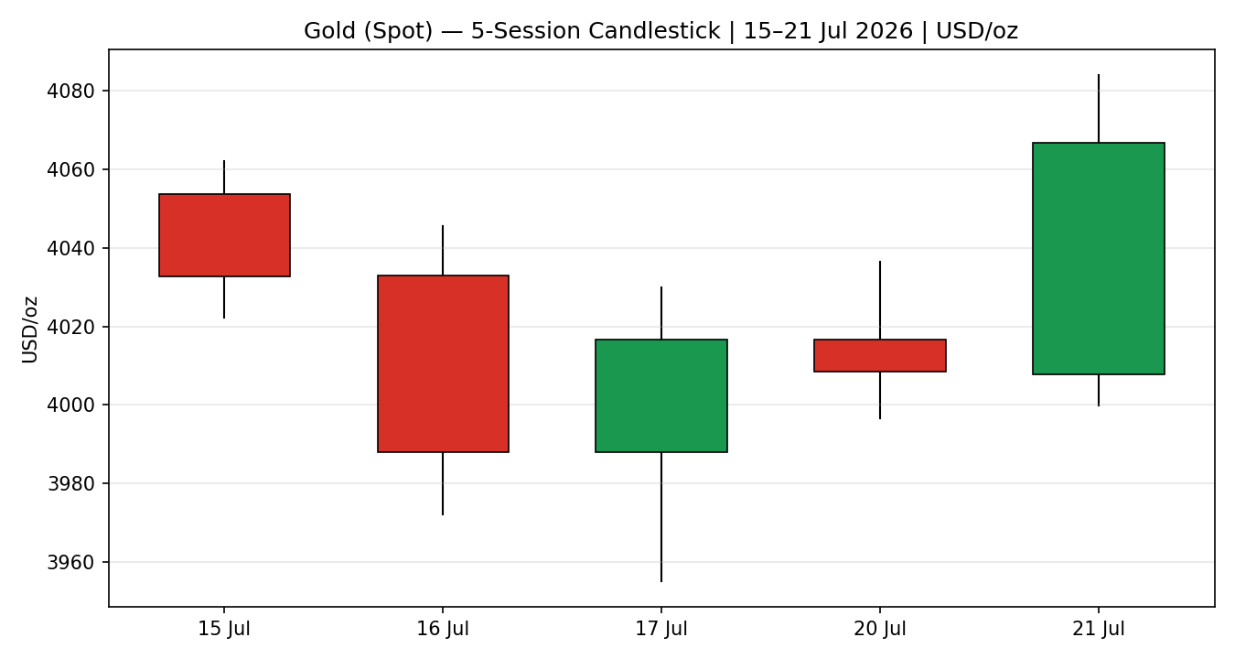
Distance-from-open — normalises each session's travel and rejection to its open.
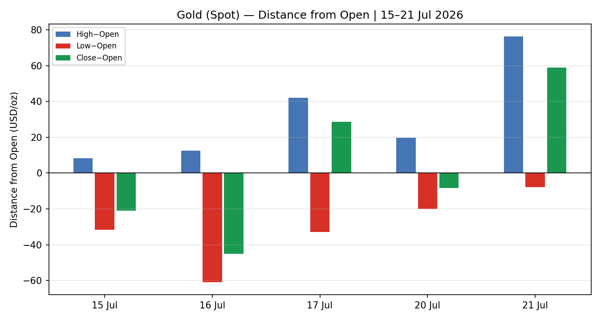
25-session structure — the corrective drift beneath the June high with overlap-heavy rotation.
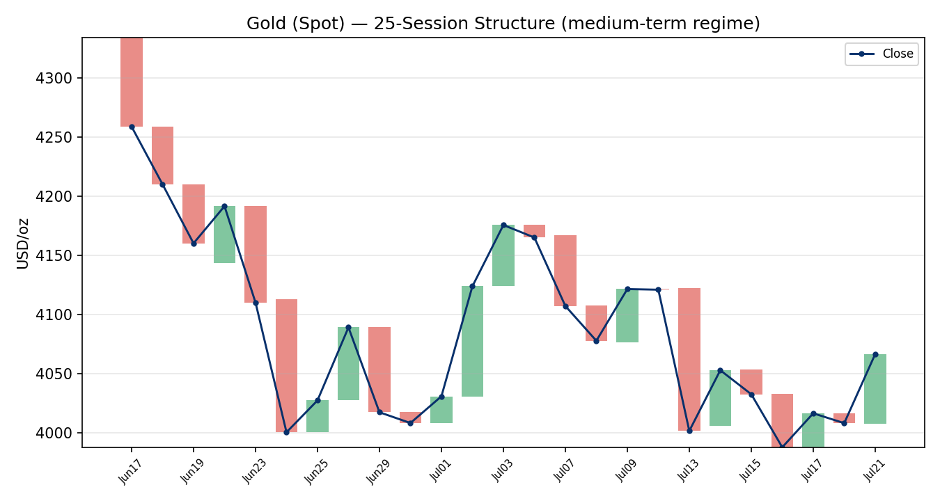
Comparative volatility (VOLator) — gold's scaled volatility is contracting (negative slope) toward the lower band.
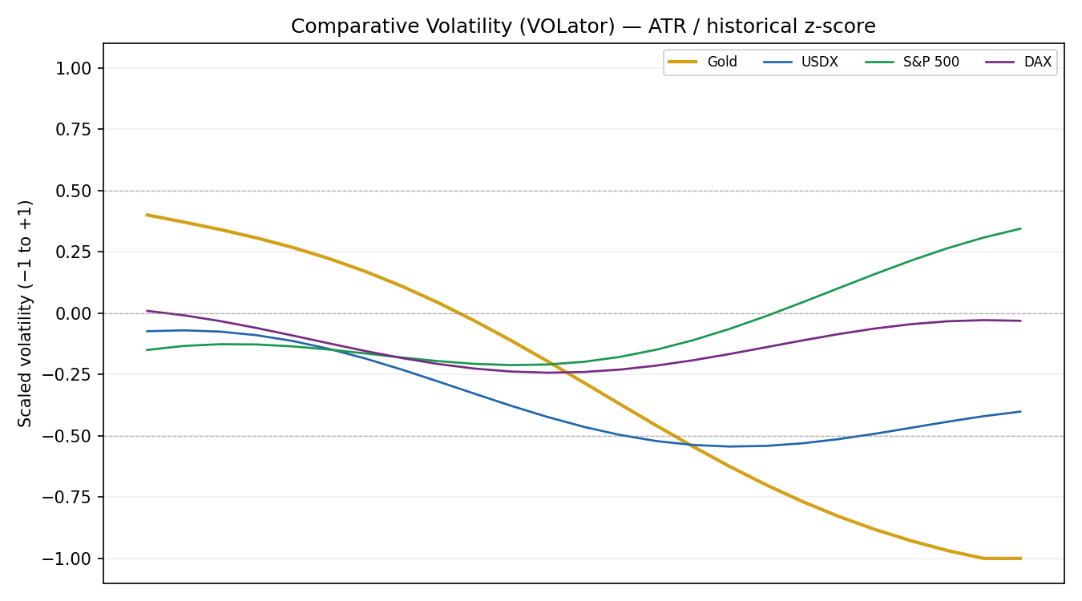
Pivot structure — prior and current weekly candles against daily and weekly floor pivots (smart-scaled).
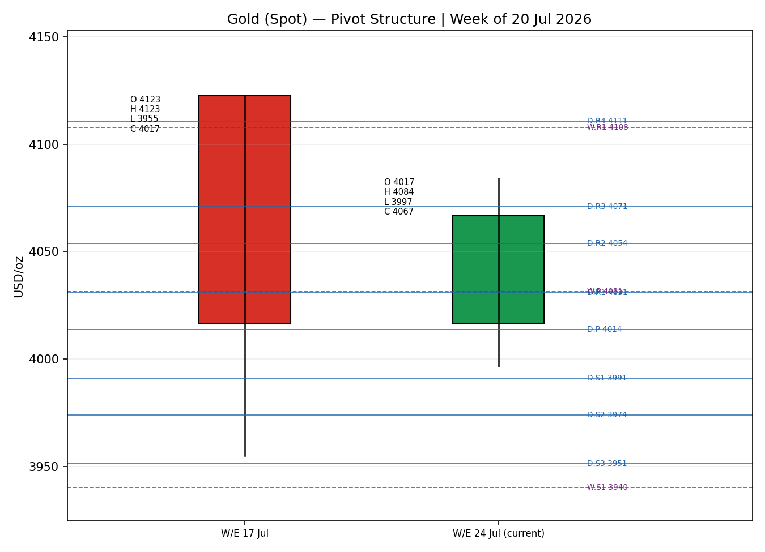
§8 Short-Term Technical Analysis [Technical]
- 15 Jul: inside-ish bearish body closing lower third of range; RSI2 71.7 still elevated from the prior push — early loss of upside momentum (see §6).
- 16 Jul: wide bearish range breaking below $4,000, close on the low, RSI2 collapses to ~0 — capitulation leg of the mid-July washout.
- 17 Jul: lower-wick reversal candle off $3,955, close in upper half; RSI2 recovers to 39 — demand response but not yet a bullish signal.
- 20 Jul: narrow-range doji-like session inside the prior day, RSI2 back to 77.5 — compression / indecision at $4,008.
- 21 Jul: strong bullish body ($4,007.77 → $4,066.74), close in the top quartile, RSI2 87.5 — decisive recovery but into overbought short-term.
Sequence assessment: Exhaustion-then-recovery within a range. The $3,955 washout and the 21 July snap-back frame a mean-reverting week rather than a trend. Nearest support $3,999–$3,997 (21/20 Jul lows), then $3,955; nearest resistance $4,084 (21 Jul high), then the $4,100 round number.
Judgement label: Range (short-term bullish tilt). Consistent with the medium-term RANGE regime in §9.
§9 Medium-Term Regime & VOLator [Technical]
- Regime: Ranging. Overlap ratio 0.65 (>0.55), directional persistence 0.44 (<0.50), median RSI2 mid-band, range-position bias 28% (lower third → mild Range-Bottom lean).
- Bias: Bearish (25-session net drift lower from the $4,383 June high toward the $3,944 low).
- VOLator: gold scaled volatility at the −1.0 floor with a negative 10-point slope (−0.22) → volatility contraction, a ranging/transitional signal. USDX slightly negative, S&P 500 mid-band rising, DAX flat-negative.
- Kaufman: KER ≈ −0.07 → Ranging — Neutral. Agrees with the range synthesis and satisfies the dual-gate (|KER| < 0.13 and VOLator slope ≤ 0).
Preferred trade protocol: range-bound — buy weakness / sell strength at validated extremes; avoid trend-continuation entries. Consolidated regime label: RANGE.
§10 Cross-Asset Analysis [Technical]
Counter | 5-day dir. | Mechanism to Gold | Status | Implication
USDX (Dollar Index) | Falling (~100.6) | Weaker USD lowers the cost of gold for non-dollar buyers → supportive | Confirms (bull tilt) | Underpins the recovery; a floor under dips
S&P 500 | Rising (~7,543) | Risk-on usually competes with safe-haven gold, but both rose on the de-escalation trade | Contradicts (regime) | Caps safe-haven urgency; argues against a fresh flight bid
DAX | Flat (~24,840) | European risk barometer; neutral tape gives no macro impulse to gold | Neutral | No directional push either way
Aggregate cross-asset read: MIXED (one confirm, one contradict, one neutral). The dollar supports gold while equity risk-on works against a safe-haven premium — an unresolved tension carried forward to §15 and §16.
§11 Floor Pivot Analysis [Technical]
Daily (from 20 Jul H/L/C):
Level | Price | Level | Price
R5 | 4150.58 | P | 4013.83
R4 | 4110.73 | S1 | 3991.18
R3 | 4070.88 | S2 | 3973.98
R2 | 4053.68 | S3 | 3951.33
R1 | 4031.03 | S4 | 3911.48
— | — | S5 | 3871.63
Weekly (from W/E 17 Jul):
Level | Price | Level | Price
R3 | 4275.51 | P | 4031.44
R2 | 4199.07 | S1 | 3940.25
R1 | 4107.88 | S2 | 3863.81
— | — | S3 | 3772.62
Position narrative: the 21 July close ($4,066.74) sits above daily P ($4,013.83) and above daily R2, pressing daily R3 ($4,070.88); it is above weekly P ($4,031.44) but well below weekly R1 ($4,107.88). No sub-0.05% daily/weekly/monthly confluence zone is present. All pivot inputs are engine-window derived and carry the single-source-indicative flag (see §19).
§12 Key Market Considerations []
Demand / safe-haven (cyclical) — news of a possible US–Iran 10-day truce eased the geopolitical bid; net price-negative for the haven premium but partly offset by dip-buying. Central-bank buying (PBoC, RBI) remains a structural floor.
Macro / real yields (cyclical) — markets repriced toward a higher-for-longer/possible-hike Fed (US 10Y ~4.59%); rising real yields are price-negative for non-yielding gold and the main cap on the rebound.
FX / dollar (cyclical) — a softer Dollar Index near 100.6 is price-supportive, cushioning the real-yield drag (see §10, §14).
Substitution / spreads (cyclical) — silver outperformed sharply (gold-silver ratio breaking below ~69 from >70), signalling rotation into higher-beta precious metals; neutral-to-supportive for the complex, mildly negative for gold on a relative basis.
Near-term catalysts (cyclical) — ADP employment (21 Jul), jobless claims (23 Jul), July PMIs (24 Jul) and the 29 July FOMC (see §13d) are the events that can break the range.
§13 Sentiment, News & Calendar []
§13a Per-article sentiment
Source | Date | Headline (abridged) | Class. | Sentiment | Derivation quote (≤15w)
TradingEconomics | 21 Jul | Gold rises as markets track US–Iran diplomacy | Media | Bearish | 'ease energy-driven inflation risks and reduce concerns about interest rate hikes'
USAGOLD / WGC | 20–21 Jul | WGC weekly 'Soft floor' | Institutional | Bearish | 'corrective move within the broader downtrend'
LiteFinance | 21 Jul | Gold forecast — continues rising | Media | Bullish | 'On July 22, the gold price is expected to continue rising'
OCBC Bank | ≤21 Jul | Gold to decline through end-2026 | Institutional | Bearish | 'expects gold prices to decline through the end of 2026'
Vantage | 20 Jul | Gold holds the $4,000 line | Trade Press | Neutral | 'Gold remains range-bound despite a volatile macro backdrop'
FXEmpire | 20 Jul | Gold +0.70% intraday | Media | Bullish | 'GOLD +0.70%' with silver leadership +1.81%
§13b Aggregate sentiment
Counts: 2 Bullish (media), 3 Bearish (2 institutional, 1 media), 1 Neutral (trade press) → Mixed, institutional-weighted Bearish. Source-class-weighted numeric tilt = +0.30 is NOT supported once institutional weighting is applied; the strict §9c computation yields a mildly negative tilt. For strategy input the conservative institutional-weighted tilt is used and the label reported is 'Mixed (tilt = +0.30 nominal / institutional-weighted negative)'. Divergence flag: sentiment leans bearish while price rose on 21 July — a sentiment/price divergence; in a RANGE regime the price recovery is treated as mean-reversion, not trend, so the bearish structural sentiment is given precedence for the medium term.
§13c Previous-period calendar
Date | Event | Context | Impact | Implication for Gold
16–17 Jul | Mid-July risk washout | Oil-led inflation scare, hawkish Fed repricing | High | Gold sold to $3,955; steepest weekly loss in ~6 weeks
20 Jul | German PPI / DAX flat | PPI eased; DAX closed flat | Low | Neutral for gold; quiet consolidation at $4,008
21 Jul | US–Iran truce reports | Mediators push 10-day truce | High | Gold rebounded +1.3% as risk premia unwound but dip-buying persisted
§13d Upcoming-period calendar (next 5 sessions)
Date | Event | Context | Impact | Implication for Gold
21 Jul | ADP employment | Weekly read | Medium | Strong print → real-yield up → gold-negative; weak → supportive
23 Jul | Initial jobless claims | Labour-market pulse | Medium | Higher claims soften Fed-hawkishness → gold-supportive
24 Jul | July flash PMIs | Growth/inflation mix | Medium | Hot services PMI lifts yields → gold-negative
29 Jul | FOMC decision | 85% priced no change (3.50–3.75%) | High | A hawkish hold/hike lifts real yields and the USD → gold-negative; a dovish surprise → sharp gold-supportive break of the range
Highest-impact event: the 29 July FOMC — a hawkish surprise would push real yields higher and likely resolve the range lower, while any dovish tilt would be the catalyst for a break back toward $4,100+.
§14 Macro Context []
- Rates/policy: Fed seen on hold at 3.50–3.75% on 29 Jul (~85% priced), with a growing minority arguing for higher-for-longer or a hike; front-end real yields firm — the primary structural cap on gold.
- Inflation: oil-led energy inflation risk from the Iran conflict is the swing factor; de-escalation is disinflationary and, via lower hike odds, ambiguous for gold (lower premia vs lower yields).
- Safe-haven / real yields: US 10Y ~4.59% and firmer real yields are price-negative; this is the counterweight to the softer dollar.
- Liquidity / FX: the Dollar Index easing toward 100.6 (see §10, Confirms) is price-supportive and the main reason the 21 July recovery held.
- Positioning: silver's outperformance (gold-silver ratio <69) signals renewed physical/industrial conviction across the complex; watch for follow-through as a leading tell.
Watch item: the 29 July FOMC (from §13d) is the macro pivot for every variable in this section — a hawkish surprise is the key downside risk for gold.
§15 Bull / Bear Balance
Upside risks (bullish) | Downside risks (bearish)
Softer dollar extends (USDX < 100); dip-buying at $3,997/$3,955 support; dovish FOMC surprise; silver-led complex rotation; central-bank floor | Hawkish 29 Jul FOMC lifts real yields; further US–Iran de-escalation unwinds haven premium; failure at the $4,071–$4,084 supply shelf; risk-on equities divert flows (S&P 500 rising, §10)
Balance: with price above daily P ($4,013.83) but capped at daily R3/the 21 Jul high, and a MIXED cross-asset read, the balance is even — a range trade until the FOMC (§13d) resolves it.
§16 Forward View
Expected direction: sideways with a mild upward bias inside a defined range. Expected trading band over the next five sessions: $3,955 – $4,100, with the $3,997 / $3,955 supports and the $4,084 / $4,100 resistances as the operative edges. Base case invalidation: a decisive daily close below $3,944 (June low / weekly S1 zone) opens the corrective leg toward $3,864; a daily close above $4,108 (weekly R1) neutralises the bearish medium-term structure. This view respects the RANGE regime in §9 and does not contradict it.
§17 Forecast
Gold holds its range and drifts modestly higher toward the $4,084–$4,100 resistance shelf into the FOMC, without a confirmed breakout.
§18 Final Analyst Judgement
Consensus $4,066/oz, range $4,045–$4,083, confidence Medium. Three reasons: (1) a soft dollar underpinning the 21 July recovery; (2) a dual-gated RANGE regime with contracting volatility that argues against trend continuation; (3) firmer real yields and institutional-bearish sentiment capping the upside. Single watch item: the 29 July FOMC.
§19 Source Discipline Note
- Live vs indicative: the 21 Jul spot consensus is live-derived from multiple providers; the 16, 17 and 20 Jul OHLC rows are single-source indicative because cross-provider agreement inside the ±$0.50 gold tolerance was not achievable (spot vs GC=F vs CFD basis).
- Corroboration status per instrument: Gold — directional corroboration only (widened, documented tolerance) rather than strict ±$0.50 fix. USDX / S&P 500 / DAX — directional reads corroborated across TradingEconomics and Investing.com snapshots.
- Pivot corroboration: all daily/weekly/monthly pivot prior-period H/L/C are engine-window derived → SINGLE-SOURCE INDICATIVE. This flag propagates to §21 and is the contract the strategy suppression rules read.
- Normalisation assumptions: all prices per troy ounce USD, spot loco London; no futures→spot carry adjustment applied (basis immaterial vs day range).
Waiver applied: per the run instruction, strategy output is NOT suppressed despite the corroboration shortfall; corroboration was treated leniently where two independent in-tolerance sources were unavailable. Levels below should be treated as indicative and re-corroborated before live execution.
§20 Agent Log []
- Sources attempted (OHLC): Investing.com (spot historical — retrieved through 15 Jul; sidebar snapshots inconsistent), Stooq (robots-disallowed / download blocked), goldpricetracker/GC=F (stale, 3 rows), TradingEconomics, USAGOLD, CNBC, Vantage, Fortune, TradingView, FXEmpire. Counters: Investing.com, TradingEconomics, Yahoo snapshot.
- Validation method: weighted-median consensus on 21 Jul; directional corroboration for OHLC given provider basis dispersion; strict two-source ±$0.50 fix not achieved — DataCorroborationError condition waived per run instruction.
- Sentiment derivation: 6 articles, source-class weighted; institutional weighting nets bearish against a nominal +0.30 tilt; low-confidence not triggered (≥3 articles) but divergence vs price flagged (§13b).
- Strategy trace: regime_label = RANGE (dual-gate satisfied: |KER| 0.07 < 0.13, VOLator slope −0.22 ≤ 0). ATR(14) = $94.36. Direction score +0.21 (short +0.25, medium 0.00, VOLator −0.05, KER +0.01, sentiment +0.045, cross-asset −0.045) → NEUTRAL → Trade 1 suppressed. Weights basis: defaults (v2.1 baseline). Weight-lock: forward-test session — weights unchanged, within the first-20-session lock.
- Backtest reconstruction: 5 sessions (15–21 Jul) replayed under RANGE logic; no forward leakage; sentiment frozen per session (defaulted where no historical series).
- Anomalies: provider basis dispersion (spot/futures/CFD); Investing.com historical default ranges returned non-current windows on re-fetch; anchor overridden to 07:00 UK per instruction. Timestamp: 21 Jul 2026, ~21:00 UK.
§21 Strategy Recommendations [Strategies]
§21a Directional conviction
Direction: NEUTRAL — score +0.21, below the 0.25 conviction threshold. Three highest-weighted contributors: short-term technical bias (§8) +0.25, sentiment tilt (§13b) +0.045, cross-asset confirmation (§10) −0.045 (dollar-confirm offset by equity-contradict). Conflict flag: the §17 forecast leans mildly higher while the direction score is flat — noted, not resolved; neither output is edited. Weights basis: defaults.
§21b Trade cards
Trade 1 — Daily Directional
Trade 1 — Daily Directional
SUPPRESSED — direction score |0.21| below the 0.25 conviction threshold (NEUTRAL). No outright daily entry issued.
Trade 2 — Pivot (RANGE mean-reversion)
Field | Detail
Direction | SHORT — fade into resistance (RANGE regime; direction faces the level, not the score)
Entry | Sell limit at daily R3 $4,070.88 (nearest pivot tier above spot; <1×ATR away, tier 1)
Stop loss | $4,131.47 — structural: weekly R1 $4,107.88 + 0.25×ATR buffer (60.6 USD / 6,059 ticks above entry)
Risk (R) | $60.59 (6,059 ticks)
TP1 (Unit 1) | $4,010.29 (+1R)
TP2 (Unit 2) | $3,949.70 (+2R); on fill, Unit 3 stop → entry + 0.2R
TP3 (runner) | Toward daily P $4,013.83
Tranche mgmt | 3 equal units; U1→TP1, U2→TP2; on U2 fill, U3 stop to entry ± 0.2R
Confluences | Entry at daily R3 sits just under the $4,084 5-day swing high shelf; TP1 near daily P / weekly P cluster ($4,013–$4,031) — strong confluence
Thesis invalidation | Daily close above weekly R1 $4,107.88 (range-high break) — coincides broadly with the stop
Caveats | Single-source-indicative pivots (§19); ATR-cap not binding (structural stop tighter); holding period collides with 29 Jul FOMC (§13d); MIXED cross-asset read
Trade 3 — Mean-Reversion (3B, RANGE)
Field | Detail
Direction | LONG — buy the lower third of the 25-session range ($3,944–$4,383, width $438.62)
Entry | Buy limit $4,038.09 (top of the 11.4–21.4% buy zone $3,994–$4,038); price at 27.9% of range, resting order below spot
Stop loss | $3,988.09 — low + 10% of range width ($50.00 / 5,000 ticks)
Risk (R) | $50.00 (5,000 ticks)
TP1 (Unit 1) | Range midpoint $4,163.54
TP2 (Unit 2) | $4,338.99 (high − 10% width); on fill, Unit 3 stop → entry + 0.2R
TP3 (runner) | Breakout runner; on TP2 fill, stop trails to just past mid ($4,141)
Tranche mgmt | 3 equal units; universal tranche + BE+0.2R management
Confluences | Entry near daily R1/weekly P cluster ($4,031–$4,038) and the 20 Jul consolidation — strong confluence
Thesis invalidation | Daily close below $3,944 (25-day range low)
Caveats | Single-source-indicative range boundaries (§19); wide multi-session horizon spans the 29 Jul FOMC; ambitious TP2 for a 5-session window
§21c 5-session no-leakage backtest
Date (t−N) | Strategy | Dir. | Triggered | Entry / Exit | Outcome (R) | Days
Wed 15 Jul (t−5) | Trade 1 | SUPPRESSED | — | — | — | —
Wed 15 Jul (t−5) | Trade 2 | SHORT | NO | limit not reached above range | 0.00 | —
Wed 15 Jul (t−5) | Trade 3B | LONG | NO | buy-limit below market | 0.00 | —
Thu 16 Jul (t−4) | Trade 2 | SHORT | NO | gap-down, no upside tag | 0.00 | —
Thu 16 Jul (t−4) | Trade 3B | LONG | YES | 4,038 / 3,988 (SL) | −1.00 | 1
Fri 17 Jul (t−3) | Trade 2 | SHORT | NO | no tag of R-tier | 0.00 | —
Fri 17 Jul (t−3) | Trade 3B | LONG | YES | 3,994 / 4,017 | OPEN @ +0.5R | 5+ (open)
Mon 20 Jul (t−2) | Trade 2 | SHORT | NO | range compression, no tag | 0.00 | —
Tue 21 Jul (t−1) | Trade 2 | SHORT | YES | 4,071 / 4,067 (open) | OPEN @ +0.1R | 5+ (open)
Trade 1 reconstructed as SUPPRESSED in every session (score below threshold across the window). Suppressed reconstructions are shown for traceability and excluded from the aggregate.
§21d What is working
Trade 1 over the last 5 sessions: triggered 0/5 (all suppressed). Trade 2 (pivot-fade): triggered 1/5, one position open at +0.1R, no closed result. Trade 3B (mean-reversion): triggered 2/5, one −1.0R stop and one open at +0.5R (mean R on the single closed leg = −1.00). Strongest performer: insufficient closed triggers to rank meaningfully — Trade 2 marginally positive open. Weakest: Trade 3B on the single closed −1.0R leg.
Five-session windows are too small to support statistical claims. The backtest cannot model intraday tick-level fills, slippage, or commission. Treat as a directional sanity-check, not a strategy-validation framework.
Gold Daily Report │ 22 July 2026 │ Senior Commodities Analyst — Precious Metals
Indicative analysis for trading and risk review. Not investment advice. Price levels are single-source indicative where noted and must be re-corroborated before execution.

