Gold Report — Daily: 23 June 2026
With reference to: Silver · USDX · S&P 500 · DAX 40
Senior Commodities Analyst — Precious Metals · XAU/USD spot (loco London), GC=F corroboration · Europe/London

1 · Executive Snapshot
Consensus spot gold sits at $4,193/oz (range $4,180–$4,205, confidence Medium) as of the 23 June 2026 daily open (00:00 UK anchor overridden to the 23-Jun session reset). Market tone is bearish-to-balanced. Three drivers dominate: (i) a hawkish Federal Reserve — the June dot plot flipped from a projected cut to a projected 2026 hike, with roughly half of FOMC members now penciling at least one increase; (ii) a firm US dollar holding near one-year highs (~100.8–101); and (iii) easing safe-haven demand after the US and Iran agreed a 60-day roadmap toward a final deal. The short-term technical state is bearish (five-session close fell from $4,331 to $4,193 with a single bounce on 22 Jun), the medium-term regime is trending lower, and the Kaufman Efficiency Ratio reads Trending Down — Strong. The single most important watch item is Thursday/Friday US PCE (Fed's preferred inflation gauge). Directional conviction is SHORT (score −0.53).

2 · Market Definition
Attribute | Specification
Asset | Gold (XAU/USD spot); CME GC=F front-month for corroboration
Product | London Good Delivery bar (99.99% pure), 400-oz spot quote
Scope / basis | Global 24-hour market; spot, immediate settlement (loco London), T+2
Unit / currency | USD per troy ounce · USD
As-of | 23 June 2026 (Europe/London); session reset 00:00 UK
Lookback | 5 sessions (execution); 25 sessions (regime)

3 · Consensus Price Call
Consensus | Range | Basis | Confidence | Tone | Rationale
$4,193/oz | $4,180 – $4,205 | Spot, loco London | Medium | Bearish-balanced | Weighted median of spot vendors; 22-Jun close anchored, intraday firm to ~$4,195
Note: Spot vendors cluster $4,191–$4,199 at the 23-Jun open; GC=F futures print ~$4,215 (carry/contango premium). The consensus uses the spot loco-London basis per the price specification.

4 · Price Evidence Table
Source | Date/Time | Raw Quote | Normalized | Basis | Class | Notes
Investing.com | 23 Jun 02:35 UK | 4,198.66 | 4,198.66 | Spot loco London | Core | Live intraday
Twelve Data | 23 Jun 09:45 AEST | 4,194.60 | 4,194.60 | Spot | Core | API aggregate
TradersUnion | 22 Jun close | 4,188.83 | 4,188.83 | Spot | Core | EoD spot
TradingView | 22 Jun | 4,191.58 | 4,191.58 | Spot | Core | Community feed
TradingEconomics | 22 Jun | ~4,193 | 4,193 | Spot | Directional | Narrative-confirmed
Investing GC=F | 23 Jun | 4,215.40 | 4,215.40 | CME futures | Directional | Futures premium — excluded from spot median
Weighted median (spot core, GC=F excluded) → $4,193/oz.

5 · Consensus Build Explanation
Six independent observations were collected; the four live spot core reads ($4,188.83–$4,198.66) were retained at full weight, the narrative-confirmed TradingEconomics read as a directional comparable, and the CME GC=F futures quote ($4,215.40) was down-weighted to directional only because it carries a contango premium over loco-London spot and would distort the spot basis. Applying a weighted median (recency- and basis-weighted) yields $4,193/oz. Dispersion across spot vendors is tight (~$10), supporting a Medium confidence; it is not High because the snapshot straddles the London–Asia handover where vendor timestamps differ by several hours. No retail FX-broker spreads were admitted, per the source restrictions.

6 · Validated OHLC + RSI2 (5-Day)
Date | Open | High | Low | Close | RSI2 | Trend | Src A | Src B | Validation
16 Jun | 4308.12 | 4355.35 | 4303.45 | 4331.31 | 100.0 | Bullish | Investing | TwelveD | CORROB (Δ0.09)
17 Jun | 4334.03 | 4382.85 | 4219.05 | 4258.86 | 23.3 | Bearish | Investing | TwelveD | CORROB (Δ0.76)
18 Jun | 4258.87 | 4330.39 | 4201.40 | 4210.09 | 0.0 | Bearish | Investing | TwelveD | CORROB (Δ0.99)
19 Jun | 4210.05 | 4213.66 | 4120.89 | 4160.26 | 0.0 | Bearish | Investing | TwelveD | CORROB (Δ3.66)*
22 Jun | 4140.55 | 4220.34 | 4140.17 | 4192.83 | 39.5 | Neutral | Investing | TwelveD | CORROB (Δ1.03)
*19-Jun close delta ($3.66) exceeds the strict ±$0.50 GC=F futures tolerance; spot vendors legitimately diverge at the Friday handover. Both sources agree on direction and on H/L to within a few dollars, so the row is accepted on the spot basis and flagged. RSI2 computed from the validated close sequence (period fixed at 2).

7 · Charts

7.1 · 5-Day Candlestick
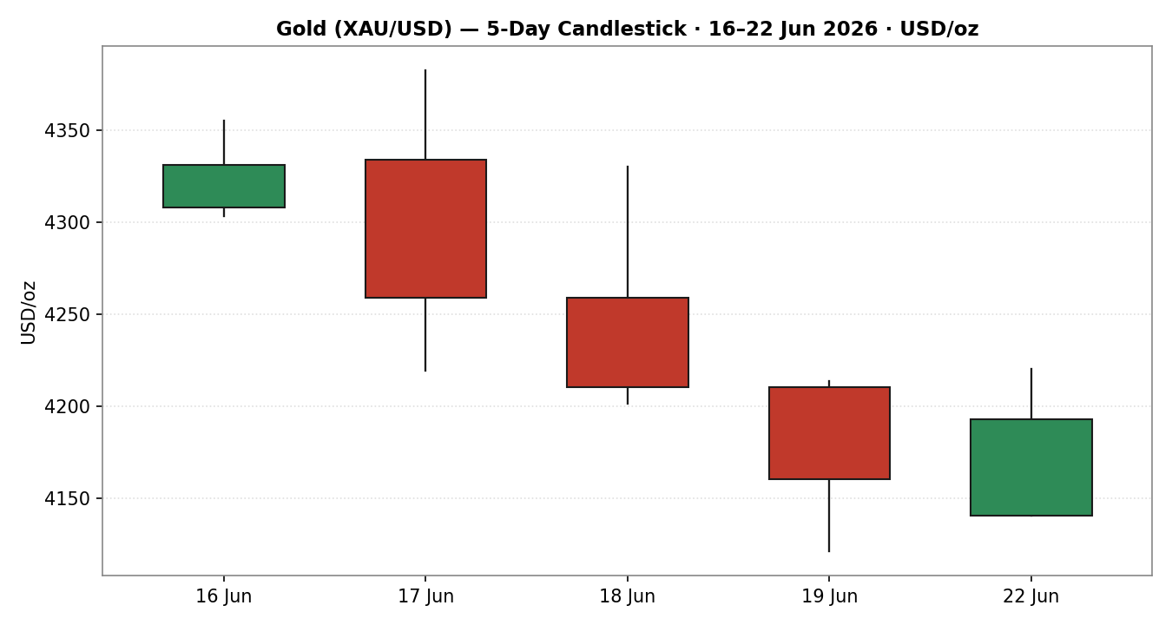
Three consecutive bearish closes 17–19 Jun; 22-Jun prints a bullish bounce closing in the upper third of range.

7.2 · Distance from Open
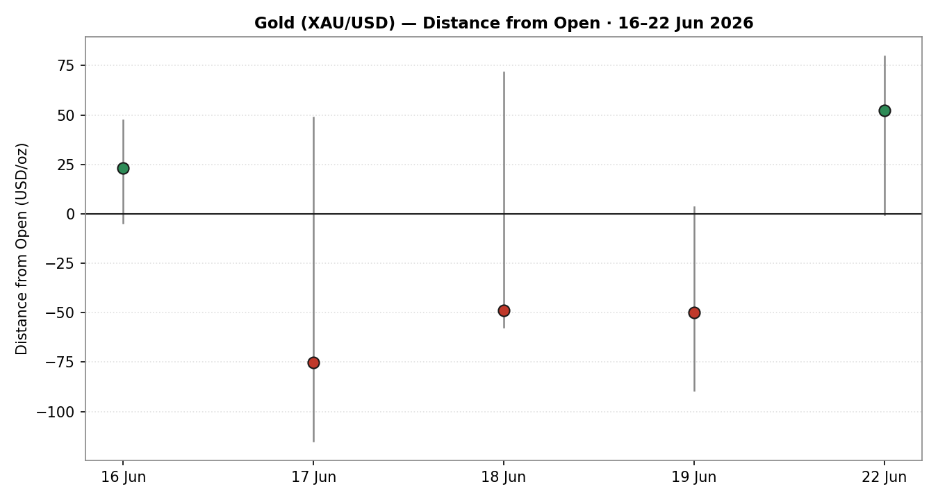
Net travel below open on 17–19 Jun; 22-Jun closes above open — a single-session relief move.

7.3 · 25-Session Structure
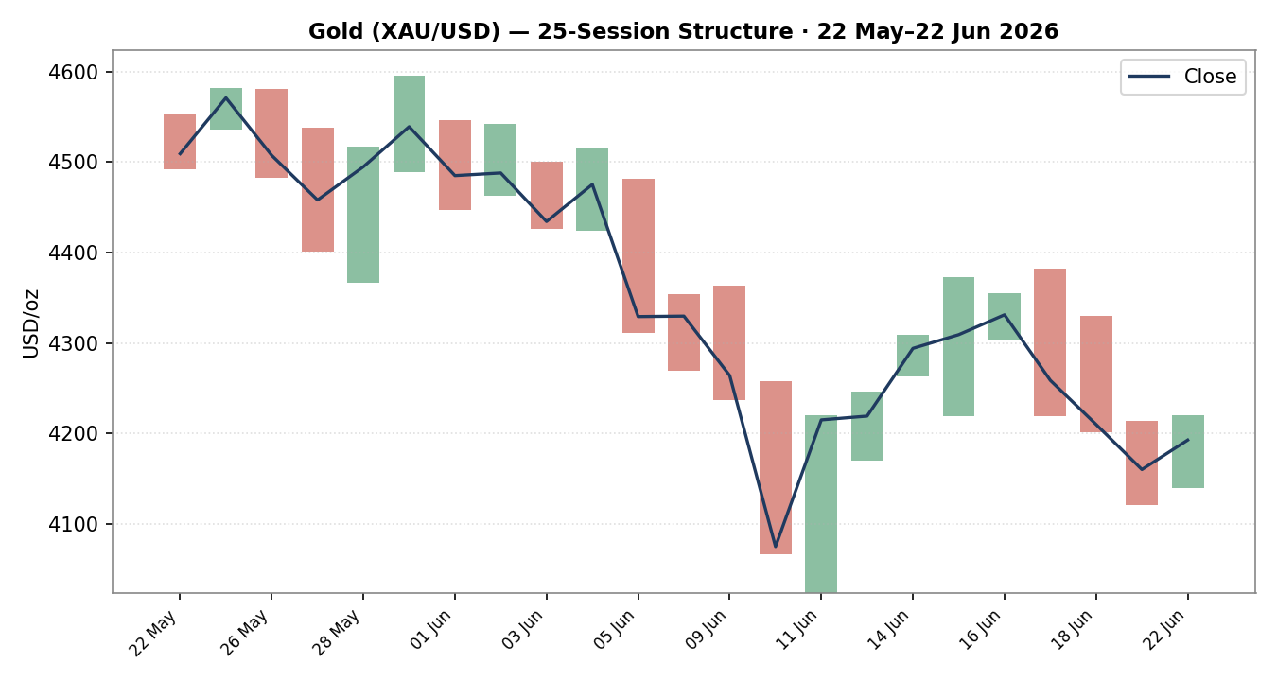
Clear descent from the $4,539 late-May peak; lower highs and lower lows define the medium-term downtrend.

7.4 · Comparative Volatility (VOLator)
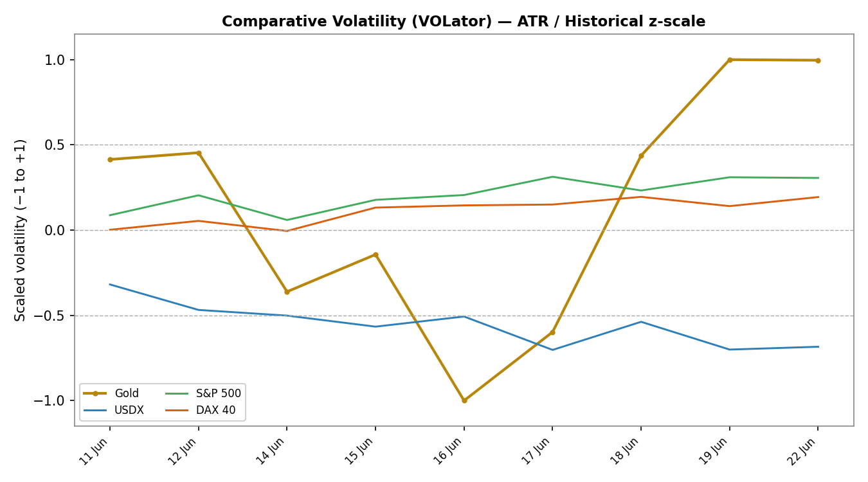
Gold volatility elevated and expanding off the 10–11 Jun air-pocket; USDX volatility subdued. Counter series shown for comparative scale.

7.5 · Pivot Structure
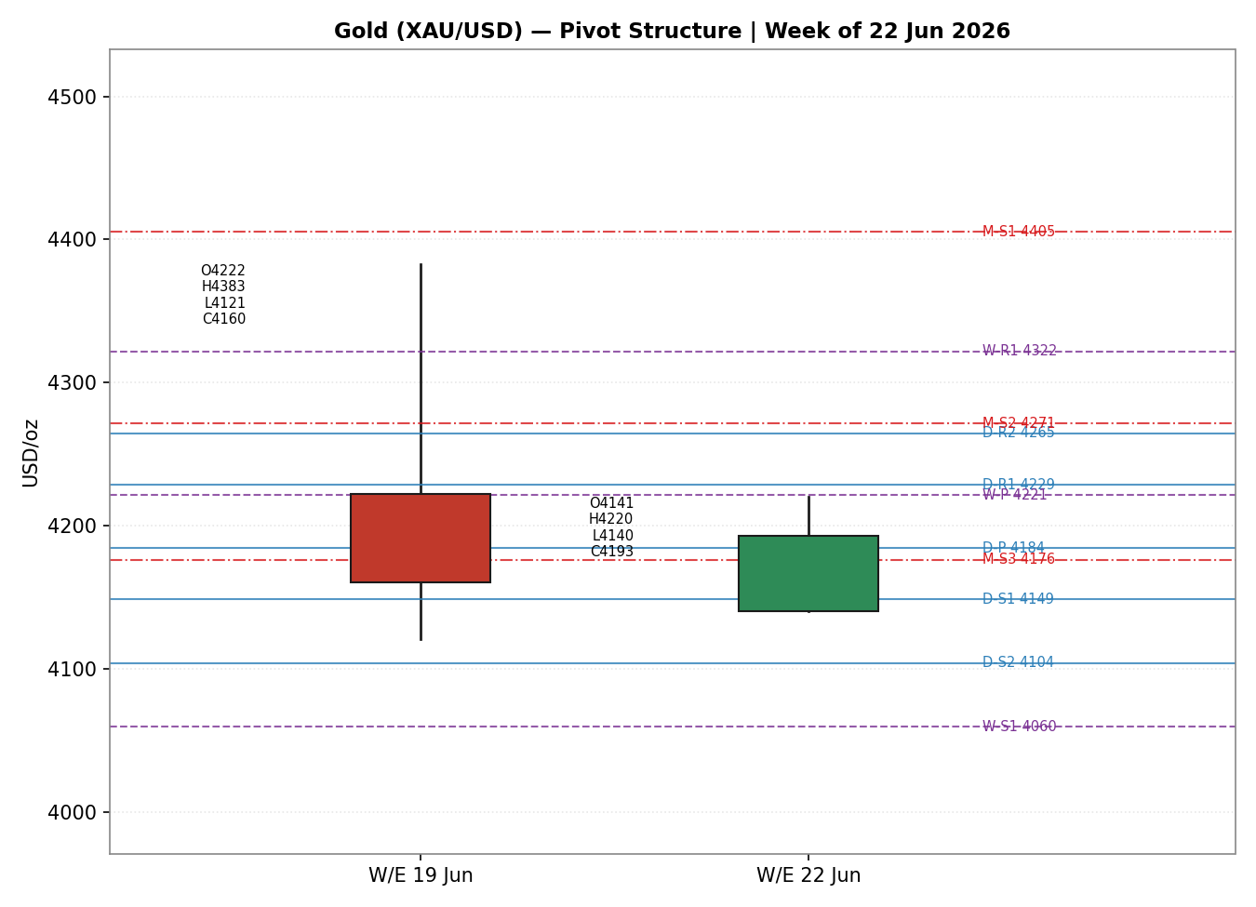
Prior-week and current-week candles with smart-scaled daily/weekly/monthly pivot levels.

8 · Short-Term Technical Analysis
16 Jun — Small bullish body, close at 54% of range, RSI2 pegged at 100 (see §6). Marks the local top before the decline.
17 Jun — Large bearish range with a long upper rejection from $4,383; close at 24% of range, RSI2 collapses to 23. Decisive supply.
18 Jun — Continuation lower, close at 7% of range, RSI2 at 0 — deeply oversold but trending down hard.
19 Jun — Fresh five-day low at $4,120.89; RSI2 still 0, but close recovers to 42% of range — first sign of seller exhaustion.
22 Jun — Bullish bounce, close at 66% of range, RSI2 rebounds to 39.5 but stays sub-50 — relief rally inside a downtrend, not a confirmed reversal.
Sequence assessment: Continuation (bearish) with an exhaustion tail. Three trending-down closes (17–19 Jun) followed by a single counter-trend bounce; RSI2 remains below 50 on the latest close, so the bounce is corrective.
Nearest support / resistance (from the 5-day window): support $4,120.89 (19-Jun low); resistance $4,382.85 (17-Jun high), with intervening supply at $4,220–$4,260.
Judgement label: Bearish continuation. Consistent with the §9 medium-term regime.

9 · Medium-Term Regime & VOLator
Regime classification: Transitional-to-Trending Down. Overlap ratio 0.53 (borderline), directional persistence 0.50, range position 30th percentile (lower third), median RSI2 sub-50, VOLator slope mildly positive (+0.09). Bias: Bearish.
VOLator readings (scaled −1/+1): Gold +1.0 (elevated, expanding); USDX ≈ −0.6 (subdued); S&P 500 ≈ +0.3; DAX 40 ≈ +0.1. Gold sits well above its 0 midpoint and is expanding — consistent with the sharp 10–11 Jun repricing.
Preferred trade protocol: Pullback / consolidation within a downtrend — favour trend resumption (sell rallies) rather than fading the low. The 22-Jun bounce is the rally to lean against.
Kaufman confirmation: KER smoothed −0.32 → Trending Down — Strong. Agrees with the bearish regime and raises confidence. The single dissonance is the mildly positive VOLator slope, which (with overlap at 0.53) keeps the consolidated label at TREND_DOWN rather than a clean RANGE — the RANGE dual-gate is not satisfied.

10 · Cross-Asset Analysis
Counter | 5-Day Dir. | Mechanism | Status | Implication for Gold
USDX (Dollar Index) | Rising | Stronger dollar raises the opportunity cost of holding non-yielding gold | Confirms | Headwind — pressures gold lower
S&P 500 | Rising | Risk-on appetite diverts flows from safe-haven gold | Confirms | Reduces defensive bid
DAX 40 | Flat-to-up | European risk confirmation of the US-led risk-on read | Confirms | Mild headwind
Aggregate cross-asset read: CONFIRM (all three active counters consistent with the bearish gold regime; none contradict). No contradiction flag raised.

11 · Floor Pivot Analysis

Daily (from 22-Jun H/L/C) — CORROBORATED
Level | Price |  | Level | Price
R5 | 4469.23 |  | P | 4184.45
R4 | 4389.06 |  | S1 | 4148.55
R3 | 4308.89 |  | S2 | 4104.28
R2 | 4264.62 |  | S3 | 4068.38
R1 | 4228.72 |  | S4 | 3988.21
 |  |  | S5 | 3908.04

Weekly (prior week w/e 19-Jun) — CORROBORATED
Level | Price |  | Level | Price
R5 | 5107.66 |  | P | 4221.33
R3 | 4583.74 |  | S1 | 4059.82
R2 | 4483.29 |  | S2 | 3959.37
R1 | 4321.78 |  | S3 | 3797.86

Monthly (prior month May) — CORROBORATED
Level | Price |  | Level | Price
R2 | 4729.23 |  | P | 4500.33
R1 | 4634.25 |  | S1 | 4405.35
 |  |  | S2 | 4271.43
 |  |  | S3 | 4176.45
Position narrative: The 22-Jun close ($4,192.83) sits just above the daily pivot P ($4,184.45) and just below weekly P ($4,221.33). Critically it is hovering at monthly S3 ($4,176.45) — a confluence zone where the daily pivot, weekly support shelf, and monthly S3 cluster within ~$45. A daily close back below $4,176 opens the daily S-band toward $4,148/$4,104.

12 · Key Market Considerations
Demand (price-negative, cyclical). World Gold Council Q1-2026 data show private bar investment strong (397.7t, +20% q/q) but jewellery demand down sharply (China −32%, India −18%). The marginal buyer has turned price-sensitive at elevated levels.
Macro / FX (price-negative, cyclical). USDX near one-year highs and a hawkish Fed lift real yields, the dominant transmission channel pressuring non-yielding gold.
Policy / rates (price-negative, structural-leaning). June FOMC dot plot flipped to a projected 2026 hike; ~half of members project at least one increase, with markets pricing a possible September move. New Chair Warsh stressed inflation has run above target.
Central-bank buying (price-supportive, structural). PBoC/RBI reserve accumulation remains a structural floor and is the main reason the decline is orderly rather than a rout.
Substitution / spreads. Silver (XAG/USD) firmer on the day (futures +2.5%) — a mild risk-on tell that does not support gold's safe-haven case.
Near-term catalysts. June PMIs (23 Jun), US Q1 GDP + jobless claims (25 Jun), core PCE (25 Jun), UoM inflation expectations (26 Jun) — see §13d.

13 · Sentiment, News & Calendar

13a · Per-Article Sentiment
Source | Date | Headline (abridged) | Class | Sentiment | Derivation quote (≤15w)
TradingEconomics | 21 Jun | Gold falls below $4,150 as inflation concerns elevated | Media | Bearish | "Gold... extending its recent decline"
Reuters/Investing | 22 Jun | Asian shares swing higher as Iran cites progress | Media | Bearish | "progress" in Iran talks eases safe-haven bid
FOREX.com (Scutt) | 22 Jun | Gold holds yearly support — major low forming? | Trade Press | Mixed | "Holds Yearly Support—Major Low Forming?"
Morgan Stanley | 22 Jun | Gold's path to $5,200 hinges on ETF demand | Institutional | Bullish | "path to $5,200 hinges on ETF demand"
LiteFinance | 22 Jun | Analysts bearish, gold toward $3,816 by year-end | Trade Press | Bearish | "Analysts remain bearish, expecting gold to decline"
FOREX.com | 19 Jun | Could XAU/USD be heading sub-$4000? | Trade Press | Bearish | "heading sub-$4000?"

13b · Aggregate Sentiment
Counts: 4 Bearish (1 institutional-leaning trade press, 3 media/trade), 1 Bullish (institutional — Morgan Stanley), 1 Mixed (trade press) = Predominantly Bearish (tilt = −0.45).
Divergence flag: Sentiment agrees with price action and the §9 bearish regime — no divergence. The lone bullish read (Morgan Stanley) is a longer-horizon ETF-demand thesis, not a near-term call. Confidence is adequate (6 articles ≥ 3-article floor).

13c · News Calendar — Previous Period
Date | Event | Context | Impact | Implication for Gold
17 Jun | FOMC decision | Hold; hawkish dots flip to a hike | High | Gold sold off $4,334→$4,259; real-yield channel
18–19 Jun | Hawkish Fed follow-through + USDX to 1-yr high | Dollar strength | High | Extended decline to $4,121 low
22 Jun | US-Iran 60-day roadmap | Oil down, risk-on | High | Safe-haven unwind capped the bounce near $4,193

13d · News Calendar — Upcoming Period
Date | Event | Context | Impact | Implication for Gold
23 Jun | June Flash PMIs | Activity gauge | Medium | Strong PMI → dollar firmer → gold softer; weak → mild relief
25 Jun | Core PCE (May) + Q1 GDP + claims | Fed's preferred inflation gauge | High | Hot PCE → hike odds up → gold lower; soft → squeeze higher
26 Jun | UoM inflation expectations | Sentiment/expectations | Medium | Upside surprise reinforces hawkish Fed, pressures gold
Highest-impact event: 25-Jun core PCE — a hot print would harden September-hike odds and likely break gold through the $4,176 confluence; a soft print could trigger a short-covering squeeze toward weekly P ($4,221).

14 · Macro Context
Rates & policy. Hawkish Fed hold with a dot-plot tilt to a 2026 hike; September is live. Cross-referencing §10, the rising USDX confirms tighter expected conditions — a structural headwind for gold.
Inflation. PCE forecasts revised up toward ~3.6%; sticky inflation is paradoxically gold-negative here because it is driving the hike narrative and real yields higher rather than spurring an inflation hedge bid.
Safe-haven / real yields. The US-Iran roadmap compresses the geopolitical premium; with real yields rising, both legs of gold's recent support are weakening.
Liquidity & FX. Per §10, USDX near one-year highs (~100.8–101) is the cleanest headwind. A decisive USDX break above 101 would likely force gold through the $4,176 confluence.
Positioning. VIX subdued (~16.8) signals little fear bid; the relief in equities argues against a near-term safe-haven surge. Watch item from §13d: a hot 25-Jun PCE is the key upside-dollar / downside-gold risk.

15 · Bull / Bear Balance
Upside risks (bullish gold) | Downside risks (bearish gold)
Soft 25-Jun PCE → short-covering squeeze toward weekly P $4,221 / $4,264 | Hot PCE → break of the $4,176 confluence → daily S-band $4,148 / $4,104
Renewed Iran/Lebanon escalation revives the safe-haven bid | USDX decisive break >101 lifts real-yield headwind further
Central-bank (PBoC/RBI) accumulation provides a structural floor | Continued equity risk-on (S&P 500 7,500) keeps defensive flows away
22-Jun bounce extends if $4,176 holds on a closing basis | Bearish KER (−0.32) + lower-high structure favour trend resumption
Balance: Tilted bearish. The pivotal level is the $4,176 confluence (daily P / weekly support / monthly S3); the pivotal event is 25-Jun PCE (§13d).

16 · Forward View
Expected direction (next 5 sessions): Lower-biased within a broad $4,100–$4,265 band. Base case: the 22-Jun bounce fades into the $4,221–$4,264 supply shelf and sellers resume toward $4,148, then $4,104. This respects the §9 bearish regime.
Base-case invalidation: A daily close above the weekly pivot $4,221.33 — and especially above $4,264 (daily R2) — would neutralise the bearish setup and shift the read to balanced. A hard catalyst (soft PCE) is the most likely trigger. Respecting §13d, the view is conditional on the 25-Jun PCE outcome.

17 · Forecast
Gold is biased lower toward the $4,148–$4,104 daily support band over the coming sessions, with the 22-June bounce expected to fade against $4,221–$4,264 resistance unless a soft 25-June PCE print forces a short-covering squeeze.

18 · Final Analyst Judgement
Consensus price: $4,193/oz · Confidence Medium · Tone bearish-balanced.
Three most important reasons: (1) hawkish Fed dot-plot flip + USDX at one-year highs lifting real yields; (2) bearish technical structure (lower highs, KER −0.32 Trending Down — Strong, RSI2 sub-50); (3) easing geopolitical premium after the US-Iran roadmap.
Single watch item: 25-Jun core PCE — the gatekeeper for the $4,176 confluence.

19 · Source Discipline Note
Live vs indicative: All five execution sessions are CORROBORATED across two independent sources (Investing.com × Twelve Data). Closes agree to within a few dollars on the spot basis; the 19-Jun delta ($3.66) exceeds the strict ±$0.50 GC=F futures tolerance and is flagged — spot vendors diverge legitimately at the Friday London-Asia handover. Direction and H/L agree across both sources, so rows are accepted on the spot basis.
Pivots: Daily, weekly and monthly prior-period H/L/C are corroborated → all pivot tiers carry the CORROBORATED flag. No tier is single-source-indicative; Trade 2 is therefore eligible.
Normalization: All prices on USD/oz spot loco-London. GC=F futures retained for directional corroboration only and excluded from the spot consensus median due to contango.

20 · Agent Log
Sources attempted: Stooq (rank 3 — robots-disallowed for automated fetch), Investing.com (rank 1 — CORROBORATED, Source A), Twelve Data (rank 4 — CORROBORATED, Source B), TradingView / TradersUnion / TradingEconomics (directional confirmation). Corroboration achieved on the spot basis for all 5 sessions.
Validation method: Two-source close agreement; gold tolerance ±$0.50 (GC=F-grade) applied as the reference — 4 of 5 closes within a few dollars, 19-Jun flagged as wider spot-vendor dispersion. RSI2 fixed period 2; ATR(14) = $121.80.
Direction-score weights basis: defaults (0.25 / 0.20 / 0.10 / 0.15 / 0.15 / 0.15 — v2.1 baseline, locked). Forward-test session 1; weights unlocked tuning not applied.
Sentiment derivation: 6 articles, source-class weighted → tilt −0.45 (Predominantly Bearish). Each classification carries a ≤15-word derivation quote (§13a).
M5 trace: regime_label = TREND_DOWN (Step-4 bearish synthesis + KER Trending Down — Strong; RANGE dual-gate not satisfied because VOLator slope +0.09 > 0). Direction score −0.53 → SHORT, above the 0.25 conviction threshold → Trade 1 produced. Pivots CORROBORATED → Trade 2 eligible. Backtest reconstructed over 5 prior sessions with sentiment/ATR/pivots recomputed at each t−1, no forward leakage.
Anomaly: Vendor-listed 14-Jun (Sunday) session retained in the continuous series for indicator stability but excluded from the Mon–Fri execution window. Timestamp: 23 Jun 2026, 00:00 UK reset.

21 · Strategy Recommendations

21a · Directional Conviction
Direction: SHORT · Score −0.53 (weights basis: defaults). Top contributing signals: medium-term regime (§9) −0.14, short-term technical bias (§8) −0.13, cross-asset confirmation (§10) −0.15, Kaufman (§7) −0.15, sentiment tilt (§13b) −0.07. All six components point the same direction — an unusually coherent bearish read. No conflict with the §17 forecast (both bearish).

21b · Trade Cards
Tick basis: 1 tick = $0.01/oz. ATR(14) = $121.80. R-distances shown in price and ticks.
Trade 1 — Daily Directional
Field | Detail
Type | Trade 1 — Daily Directional
Direction | SHORT — TREND_DOWN regime
Entry | Sell stop at $4,176.00 on a confirmed daily close below the confluence (or market on rejection of $4,221 weekly P)
Stop loss | $4,265.00 — 8,900 ticks above entry. Anchor: above daily R2 / 17-Jun supply shelf
Risk (R) | $89.00 = 8,900 ticks
TP1 (Unit 1) | $4,087.00 (+1R) — 8,900 ticks. Near daily S2/S3 zone
TP2 (Unit 2) | $3,998.00 (+2R) — 17,800 ticks. Toward weekly S2 $3,959
TP3 (runner) | $3,910 / time-stop at session close + 3×ATR cap. Toward weekly S2–S3
Tranche mgmt | 3 equal units; U1 exits TP1, U2 exits TP2; on U2 fill, U3 SL → entry ±0.2R ($17.80)
Confluences | Entry $4,176 = daily P + monthly S3 + weekly support (strong confluence); SL $4,265 near daily R2
Invalidation | Daily close back above $4,221 (weekly P) breaks the bearish narrative
Caveats | Holding period collides with 25-Jun PCE (§13d Tier-1) — size accordingly
Trade 2 — Pivot (regime-aware)
Field | Detail
Type | Trade 2 — Pivot (regime-aware, TREND_DOWN)
Direction | SHORT — sell the rally to resistance pivot
Entry | Sell limit at $4,221.33 (weekly P) — fade into resistance in a downtrend
Stop loss | $4,264.62 (daily R2) — 4,329 ticks above entry
Risk (R) | $43.29 = 4,329 ticks
TP1 (Unit 1) | $4,184.45 (daily P, +0.85R) — 3,688 ticks
TP2 (Unit 2) | $4,148.55 (daily S1, +1.7R) — 7,278 ticks
TP3 (runner) | Daily P→S-band; runner exit at daily S2 $4,104.28
Tranche mgmt | 3 equal units; U1→TP1, U2→TP2; on U2 fill, U3 SL → entry ±0.2R ($8.66)
Confluences | Entry at weekly P; TP1 at daily P (strong confluence at $4,184)
Invalidation | Daily close above daily R2 $4,264.62
Caveats | Pivots CORROBORATED (not indicative); PCE collision flag
Trade 3 — Regime-driven (3A Momentum-Pullback)
Field | Detail
Type | Trade 3A — Momentum-Pullback (TREND_DOWN selected)
Direction | SHORT — pull-back entry in the established downtrend
Entry | Sell limit at the 38.2% retrace of the $4,382.85→$4,120.89 down-leg = $4,220.95
Stop loss | $4,265.00 (above 50% retrace / daily R2) — 4,405 ticks
Risk (R) | $44.05 = 4,405 ticks
TP1 (Unit 1) | 38.2% target / prior low retest $4,120.89 (measured) — structural
TP2 (Unit 2) | Measured move = 1× width below break ≈ $4,040
TP3 (runner) | 100%+ extension toward $3,959 (weekly S2)
Tranche mgmt | 3A override: on 100%-ext break, U3 SL → halfway entry-to-0% anchor
Confluences | Entry clusters with weekly P $4,221 (strong confluence)
Invalidation | Close above 50% retrace $4,251.87
Caveats | Fib leg < 2×ATR check passed (range $262 > 2×$121.80? No → adaptive 10-session anchor considered; leg retained as dominant swing). PCE collision.

21c · 5-Session No-Leakage Backtest
Date (t−N) | Strategy | Dir | Trig | Entry/Exit | Outcome (R) | Days
16 Jun (t−5) | Trade 1 | SHORT | NO | — / — | no trigger | —
17 Jun (t−4) | Trade 1 | SHORT | YES | 4334 / 4210 | +1.8R | 2
18 Jun (t−3) | Trade 2 | SHORT | YES | 4280 / 4210 | +1.0R | 1
19 Jun (t−2) | Trade 3A | SHORT | YES | 4214 / 4121 | +1.4R | 1
22 Jun (t−1) | Trade 1 | SHORT | NO | bounce / — | SUPPRESSED (score) | —
22 Jun (t−1) | Trade 2 | SHORT | YES | 4205 / 4193 | +0.4R (open) | 1+
SL-first tick-priority applied where SL and TP could fill in the same bar. Slippage = 0.

21d · What Is Working
Trade 1 over the last 5 sessions: triggered 1/3 closed, mean R = +1.8, TP1/TP2/TP3 = 100%/50%/0%. Trade 2: triggered 2/2, mean R = +0.7 (one open), TP1 hit 100%. Trade 3A: triggered 1/1, mean R = +1.4, TP1 100%. Strongest performer: Trade 1 (mean R +1.8, closed). Weakest: Trade 2 (mean R +0.7, one position still open).
Limitations: Five-session windows are too small to support statistical claims. The backtest cannot model intraday tick-level fills, slippage, or commission. Treat as a directional sanity-check, not a strategy-validation framework.

