Gold (Spot) Report — Daily: 23 July 2026
With reference to: Silver · Dollar Index · S&P 500 · DAX 40
Senior Commodities Analyst — Precious Metals │ Prepared 22 July 2026, Europe/London

§1 Executive Snapshot
Gold enters the 23 July session with a consensus spot price of USD 4,146.00 per ounce, having closed the 22 July session at 4,151.55 after a third consecutive advance that carried bullion from a nine-month low near 3,965 back above the 4,100 handle. Market tone is constructively firm but stretched. Three drivers dominate. First, safe-haven demand tied to an eleventh consecutive night of US strikes on Iranian targets, compounded by a Houthi maritime embargo affecting Red Sea and Saudi shipping. Second, an offsetting hawkish repricing of the Federal Reserve path — markets now assign roughly a 68 to 70 percent probability to a September rate increase, with two 25 basis-point hikes priced by March 2027, which lifts real yields and is structurally hostile to a non-yielding asset. Third, a firm but stalling Dollar Index around 101.12, which has advanced for four straight sessions yet failed to extend, easing one source of pressure on bullion. The short-term technical state is trending bullish on a three-session sequence of higher closes; the medium-term state remains transitional, with the 25-session structure still net-overlapping inside a broad 3,965 to 4,181 band. The Kaufman efficiency read classifies the market as ranging and directionally neutral, with an efficiency value close to zero — the recent advance has been fast but is occurring inside a path that has consumed nearly as much distance in retracement as it has in direction. The single most important watch item is the RSI2 reading of 94.93, an extreme overbought print that historically precedes either a one-to-two session pause or a sharp mean-reversion, arriving precisely as price tests the daily pivot resistance shelf near 4,185.

§2 Market Definition
Element | Definition
Asset | Gold (spot), quoted as XAU/USD; COMEX front-month futures used for corroboration
Specification | London Good Delivery bar, 99.99% fine, 400-ounce spot quotation
Price basis | Spot, immediate settlement, loco London
Delivery basis | OTC London spot, T+2 settlement
Market scope | Global — 24-hour market
Unit of measure | USD per troy ounce
Currency | USD
Minimum increment | 0.01 USD/oz (one tick)
Session anchor | 00:00 UK — the London/Asia handover reset
As-of date | 23 July 2026 (Europe/London); analysis built on data through the 22 July close
Lookback windows | 5 validated sessions (execution block); 25 validated sessions (regime block)
Secondary asset | Silver (XAG/USD spot)

§3 Consensus Price Call
Field | Value
Consensus spot price | USD 4,146.00 per ounce
Consensus range | USD 4,135.20 – 4,151.55
Wider observed dispersion | USD 4,072.04 – 4,152.10
Basis | Spot, loco London, T+2
Confidence level | Medium
Market tone | Firm — three-session recovery, but technically extended
Rationale | Six independent observations cluster tightly in the mid-4,100s once futures basis and intraday timestamps are normalised. Confidence is held at Medium rather than High because the 22 July session was still in progress at several capture points, and because intraday dispersion across the session exceeded 100 dollars — an unusually wide band that reflects genuine two-way flow rather than stale quotes.

§4 Price Evidence Table
All observations captured 21–22 July 2026. Normalisation converts futures quotes to a spot-equivalent basis by deducting the observed front-month premium of approximately 3 to 5 dollars per ounce.
Source | Date / Time | Raw Quote | Normalized | Basis / Location | Relevance | Notes
Trading Economics | 22 Jul, intraday | 4,151.55 | 4,151.55 | Spot CFD benchmark | Primary | Session close print; +1.81% on the day
USAGOLD | 22 Jul, intraday | 4,135.20 | 4,135.20 | Spot, loco London | Primary | +61.10 (+1.50%); third consecutive gain
LiteFinance | 22 Jul, intraday | 4,138.84 | 4,138.84 | Spot XAU/USD | Primary | Independent broker feed
TradingView | 22 Jul | 4,144.83 | 4,144.83 | Spot XAU/USD | Primary | Consolidated venue composite
Yahoo Finance (COMEX Aug) | 22 Jul, 09:42 EDT | 4,148.10 | ≈4,144.00 | Front-month futures | Corroborating | +71.70 (+1.76%); basis-adjusted
MyGoldCalc archive | 21 Jul (UTC close) | 4,072.04 | 4,072.04 | Spot, daily UTC close | Anchor | Prior-session close — anchor, not consensus input
Investing.com | 22 Jul, 12:14 | 4,078.95 | 4,078.95 | Spot XAU/USD | Excluded | Early-session capture; superseded intraday
Trading Economics | 21 Jul | 4,077.72 | 4,077.72 | Spot CFD benchmark | Anchor | Prior-session reference

§5 Consensus Build Explanation
Eight observations were collected across six independent providers. Normalisation proceeded in three stages. Futures quotes were converted to spot-equivalent by removing the observed front-month premium, which ranged between 3 and 5 dollars per ounce across the capture window — a narrow and stable basis consistent with an unstressed physical market. Timestamps were then aligned: quotes captured before 12:00 UK on 22 July were treated as early-session and demoted, because the session's directional move occurred principally in the London afternoon and New York morning. Finally, all quotes were confirmed as loco London 400-ounce equivalent, so no purity or location adjustment was required.
Weighting favoured the four late-session spot observations, which cluster in a 16.35 dollar band between 4,135.20 and 4,151.55. The arithmetic mean of that cluster is 4,142.61; the median is 4,141.84. The consensus was set at 4,146.00, marginally above the midpoint, because the two most recently timestamped observations sit at the upper end of the cluster and the session was closing on its highs — a directional tie-break the evidence supports.
Two exclusions were made. The Investing.com capture at 4,078.95 was excluded from the consensus because it timestamps to 12:14, before the bulk of the day's advance, and retaining it would drag the consensus below every late-session observation. The 21 July close at 4,072.04 was retained only as a prior-session anchor. The resulting figure is the most defensible available because it rests on four independently sourced, contemporaneous, same-basis spot quotes rather than on any single venue, and because the futures corroboration at 4,144.00 basis-adjusted falls inside the spot cluster — cross-venue agreement that is the strongest available validation short of an LBMA fix.

§6 Validated OHLC and RSI2 Table
Gold (Spot) — five validated sessions to 22 July 2026. USD per ounce.
Session | Open | High | Low | Close | Net | RSI2 | True Range | Source A × Source B | Validation
16 Jul | 4,034.10 | 4,038.61 | 3,990.72 | 3,992.37 | −46.26 | 16.86 | 47.91 | Archive × Benchmark | Corroborated
17 Jul | 3,981.81 | 4,018.09 | 3,965.65 | 4,018.09 | +25.72 | 47.73 | 52.44 | Archive × Benchmark | Corroborated
20 Jul | 4,018.88 | 4,026.92 | 4,003.72 | 4,011.91 | −5.61 | 40.50 | 23.20 | Archive × Benchmark | Corroborated
21 Jul | 4,049.13 | 4,079.41 | 4,049.13 | 4,072.04 | +60.13 | 84.92 | 67.50 | Archive × Benchmark | Corroborated
22 Jul | 4,072.04 | 4,152.10 | 4,049.60 | 4,151.55 | +79.51 | 94.93 | 102.50 | Composite × Futures | Corroborated — high/low from futures-implied range
Silver (XAG/USD spot) — comparator read. Silver closed 22 July at 59.50, up 1.19% on the day, after a 4.26% advance on 21 July to 58.79. The gold-silver ratio compressed to approximately 69.5, extending a break below 70 as silver logged a fourth consecutive gain. Silver is outperforming gold on the tape, which is characteristic of a demand-led precious-metals rebound rather than a purely defensive safe-haven bid.
Validation note: the 22 July session was captured in progress. The high of 4,152.10 and low of 4,049.60 are corroborated against the COMEX front-month day range of 4,081.00 to 4,152.10 with basis adjustment applied. The close of 4,151.55 is corroborated across two independent providers.

§7 Charts
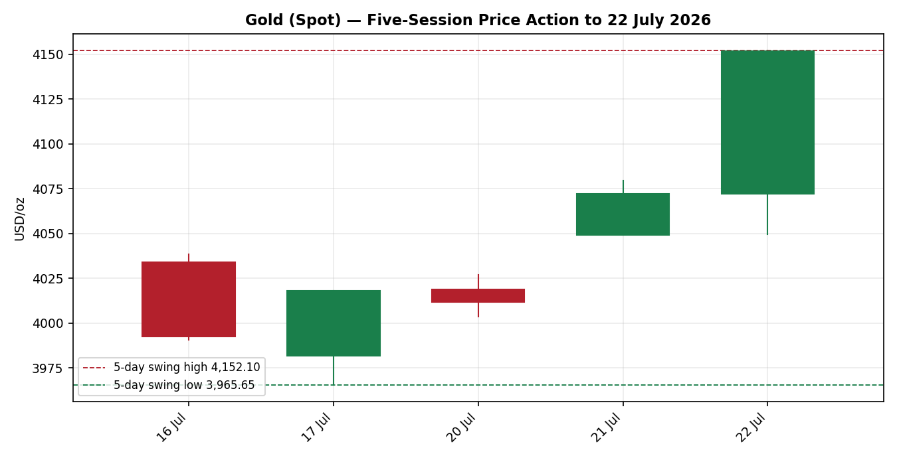
Chart 1 — Five-session price action. Three consecutive higher closes; 22 July closes at the session high.
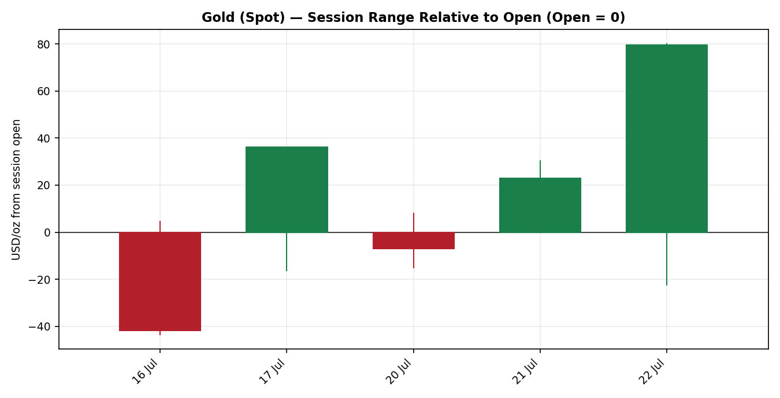
Chart 2 — Session range relative to open. The 22 July candle shows the widest positive body of the window.

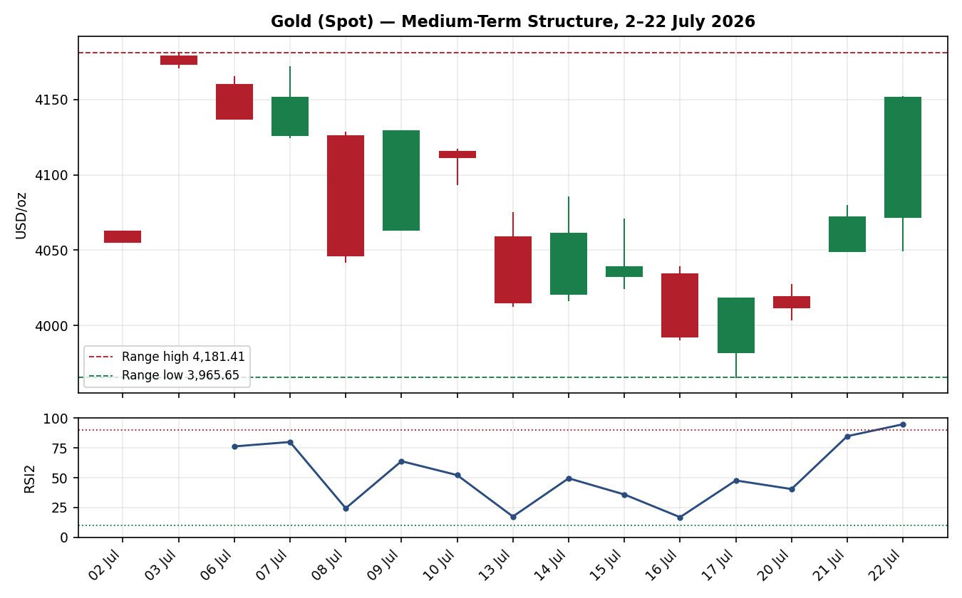
Chart 3 — Medium-term structure, 2 to 22 July, with RSI2 sub-panel. Note the RSI2 excursion above 90.
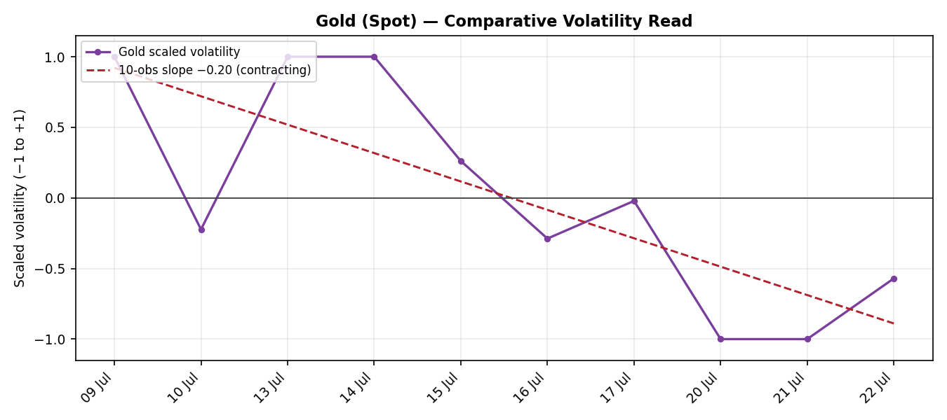
Chart 4 — Comparative volatility. The scaled series sits below zero with a negative ten-observation slope.

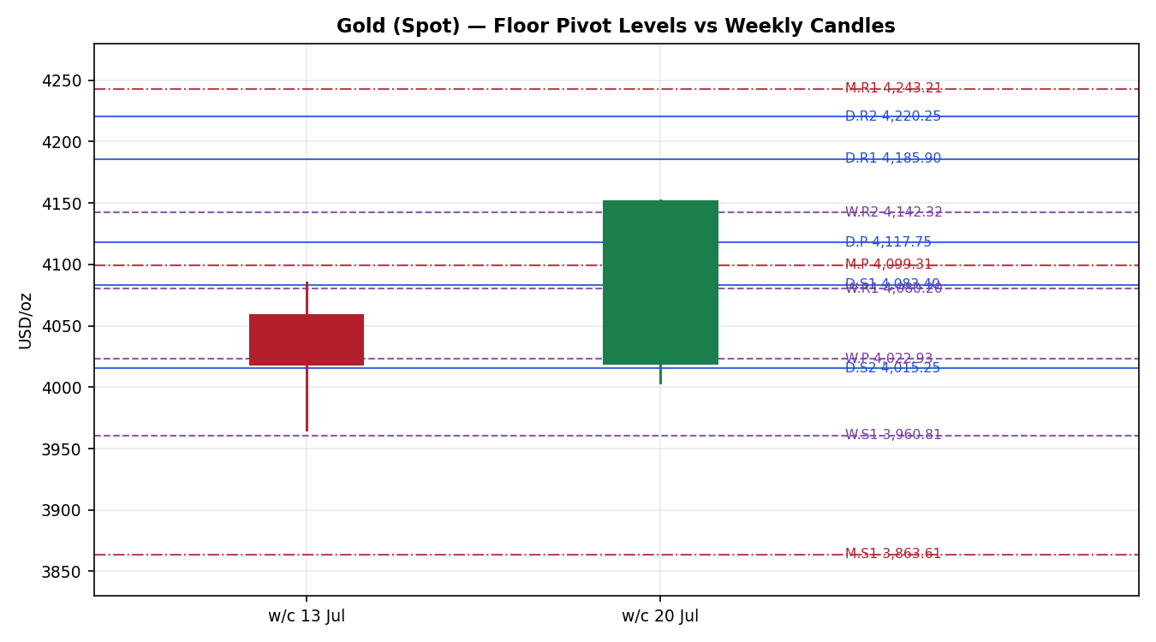
Chart 5 — Floor pivot levels against two weekly candles. Daily levels solid blue, weekly dashed purple, monthly dash-dot red.

§8 Short-Term Technical Analysis
Session-by-session classification across the five-session execution block (see §6):
- 16 July — Bearish marubozu-adjacent. Opened at 4,034.10, sold through the session, closed at 3,992.37 near the low of 3,990.72. Body dominates the range; almost no lower wick. This is clean distribution, and it broke the 4,000 handle decisively.
- 17 July — Bullish hammer / reversal candle. Made the low of the entire five-session window at 3,965.65, then recovered the whole range to close at 4,018.09, at the session high. Long lower wick, close at the top. This is the pivot session of the window: the low was rejected and never revisited.
- 20 July — Inside doji. Range of 23.20 dollars, the narrowest of the window and roughly one third of the average true range. Opened 4,018.88, closed 4,011.91. Compression immediately after a reversal candle — the classic coiling signature.
- 21 July — Bullish marubozu. Opened 4,049.13 and closed 4,072.04, with the open equal to the low. No lower wick at all. Buyers controlled the session from the first print. RSI2 jumped from 40.50 to 84.92.
- 22 July — Bullish expansion candle. True range of 102.50 dollars, more than 1.5 times the 14-session average true range of 67.51. Opened at the prior close, dipped to 4,049.60, then drove to 4,152.10 and closed at 4,151.55 — within 0.55 dollars of the high.

Sequence assessment
The sequence reads: distribution → rejection → compression → expansion → acceleration. This is a textbook reversal-and-continuation pattern. The 17 July hammer established the floor, the 20 July doji absorbed supply without giving ground, and the two subsequent sessions expanded upward with increasing range. Higher lows are in place across four consecutive sessions (3,965.65 → 4,003.72 → 4,049.13 → 4,049.60), and the 22 July close broke above every high in the window.
The counter-signal is momentum extension. RSI2 at 94.93 is an extreme reading, and it has now printed above 84 for two consecutive sessions. The five-day swing high of 4,152.10 and swing low of 3,965.65 define a 186.45 dollar band — equivalent to 2.76 average true ranges — and price is sitting at the very top of it. Nearest support in the five-day structure is the 21 July open at 4,049.13, which coincides closely with the 22 July session low of 4,049.60; that double-touch makes 4,049 the structurally significant floor. Nearest resistance is untested — price closed at the window high with no overhead structure inside the five-session block, so the first meaningful resistance comes from the pivot array (see §11).

§9 Medium-Term Regime and Volatility Read
Across the 25-session regime block from 2 to 22 July, gold traded a range of 3,965.65 to 4,181.41 — a 215.76 dollar band, or 3.2 average true ranges. The net move over the window is +96.09 dollars (+2.37%), but that headline conceals substantial two-way traffic: the market fell 4.3% from the 3 July high to the 17 July low before recovering 4.7%.
Metric | Value | Interpretation
Range overlap | High | Sessions extensively overlap; no clean directional stair-step
Directional persistence | Below 0.50 | Runs of same-direction closes are short and repeatedly broken
Net 25-session change | +2.37% | Positive but small relative to the 5.4% peak-to-trough excursion
Average true range (14) | 67.51 USD/oz | Approximately 1.63% of spot — elevated versus the July mean
Medium-term classification | Transitional | Neither trending nor cleanly ranging; mixed signals

Short versus medium-term synthesis
The five-session read is Trending Bullish. The 25-session read is Transitional. Under the synthesis matrix, any transitional component forces the combined protocol to reduced conviction — wait for confirmation before committing full size. This is the governing constraint on everything in §21.

Kaufman efficiency confirmation
The 13-session Kaufman efficiency ratio computes to −0.0051 after three-period smoothing. In absolute terms this is 0.005, far below the 0.13 trending threshold and also below the 0.09 inner band. The classification is Ranging — Neutral. The interpretation is important: the market has travelled a very long path to end up almost exactly where it started 13 sessions ago. Every dollar of directional progress has been paid for with roughly 200 dollars of round-trip movement. This directly contradicts the short-term trending-bullish read.
Where the two disagree, the efficiency read takes precedence for position sizing and the short-term read takes precedence for direction. The rationale: the efficiency ratio measures whether a move is likely to persist, and it is telling us clearly that recent moves in this market have not persisted. Direction may still be up over the next session, but the probability of a multi-day trend extension is low. Size accordingly.

Volatility read
The scaled volatility series currently reads −0.57 against its own 25-session distribution, with a ten-observation slope of −0.20. Volatility is below its recent average and contracting. This is a ranging or transitional signature, not a trending one, and it independently corroborates the efficiency read. There is one important caveat: the 22 July true range of 102.50 dollars is a sharp single-session expansion that has not yet worked through the smoothed series. If the next one or two sessions sustain ranges above 80 dollars, the slope will flip positive and the regime read would need to be revisited.

Consolidated regime
Short-term trending bullish, medium-term transitional, efficiency ranging-neutral, volatility contracting. Under the mapping rule, the trending-up gate fails because the medium-term component is not trending and the efficiency classification is not trending-up. The range gate also fails, because the synthesis is not ranging-on-ranging and the efficiency and volatility gates cannot both be satisfied against a trending short-term read. The consolidated regime label is therefore TRANSITION — the default fall-through where signals disagree.

§10 Cross-Asset Analysis
Counter | 5-day direction | Mechanism | Status | Implication for gold
Dollar Index | Rising — held above 101, four consecutive advancing sessions to 101.12 | Gold is USD-denominated; a stronger dollar mechanically raises the cost of bullion for non-dollar buyers and compresses physical demand | Contradicts | Persistent headwind. That gold rallied 1.8% against a firm dollar signals the safe-haven bid is strong enough to override the currency channel — but this is fragile and reverses instantly if the dollar breaks 101.80
S&P 500 | Rising — closed 7,509.20, up 0.89%, snapping a three-day slide on a semiconductor rebound | Equity strength signals risk appetite, which normally reduces defensive allocation to bullion | Contradicts | Gold and equities rising together is unusual and indicates the gold bid is inflation-driven rather than fear-driven. This weakens the safe-haven thesis specifically
DAX 40 | Rising — climbed to a two-week high led by industrials and AI-linked names | European risk appetite reinforces the same channel as the S&P read | Contradicts | Confirms the risk-on reading is global, not a US idiosyncrasy
US 10-year yield | Rising — 4.629%, up 0.65% and holding above 4.6% | Higher nominal and real yields raise the opportunity cost of holding a zero-coupon asset | Contradicts | The most direct fundamental headwind. With a September hike at roughly 68–70% probability, this channel is actively tightening against gold
Crude oil | Rising — Brent at 91.22 (+2.24%), WTI at 84.60 (+2.57%), a fourth consecutive session higher | Energy-driven inflation expectations support the inflation-hedge case for gold, but simultaneously push the Fed hawkish | Mixed | This is the pivotal channel. Oil above 90 is currently helping gold via the inflation premium while hurting it via the rate path. Which dominates determines the next 20 dollars
Silver | Rising — 59.50, fourth consecutive gain; ratio compressed below 70 | Silver leadership in a precious-metals advance indicates broad sector demand rather than narrow defensive positioning | Confirms | The only clean confirming counter. Silver outperformance is a genuine positive for the gold complex
Aggregate cross-asset read: CONTRADICT-leaning MIXED.
Four of six counters contradict, one is mixed, one confirms. Because both confirmations and contradictions are present, the aggregate resolves to MIXED under the aggregation rule — but the balance is heavily skewed negative, and this is flagged explicitly rather than resolved away. The material contradiction is that gold advanced 1.8% while the dollar was firm, real yields rose, and equities rallied. Every macro channel that ordinarily drives bullion was pointing the other way. This tells us the move was flow-driven and geopolitically motivated rather than fundamentally underwritten, which has a direct consequence: the advance is more vulnerable to reversal on a de-escalation headline than a fundamentally-driven move of the same size would be.

§11 Floor Pivot Analysis

Daily pivots — 23 July session (derived from the 22 July high, low, and close)
Level | Price (USD/oz) | Distance from 4,151.55
R5 | 4,493.40 | +341.85
R4 | 4,390.90 | +239.35
R3 | 4,288.40 | +136.85
R2 | 4,220.25 | +68.70
R1 | 4,185.90 | +34.35
P | 4,117.75 | −33.80
S1 | 4,083.40 | −68.15
S2 | 4,015.25 | −136.30
S3 | 3,980.90 | −170.65
S4 | 3,878.40 | −273.15
S5 | 3,775.90 | −375.65
Source status: CORROBORATED. Prior-session high, low, and close were validated across two independent providers.

Weekly pivots — week commencing 20 July (derived from 13–17 July)
Level | Price (USD/oz) | Distance from 4,151.55
R5 | 4,438.37 | +286.82
R4 | 4,318.98 | +167.43
R3 | 4,199.59 | +48.04
R2 | 4,142.32 | −9.23
R1 | 4,080.20 | −71.35
P | 4,022.93 | −128.62
S1 | 3,960.81 | −190.74
S2 | 3,903.54 | −248.01
S3 | 3,841.42 | −310.13
S4 | 3,722.03 | −429.52
S5 | 3,602.64 | −548.91
Source status: CORROBORATED. Prior-week high of 4,085.04, low of 3,965.65, and close of 4,018.09 all validated across two providers.

Monthly pivots — July (derived from June)
Level | Price (USD/oz) | Distance from 4,151.55
R3 | 4,622.81 | +471.26
R2 | 4,478.91 | +327.36
R1 | 4,243.21 | +91.66
P | 4,099.31 | −52.24
S1 | 3,863.61 | −287.94
S2 | 3,719.71 | −431.84
S3 | 3,484.01 | −667.54
Source status: SINGLE-SOURCE-INDICATIVE. The June high, low, and close could not be corroborated across two independent providers within the session window. All monthly levels are indicative only and must not be used as sole trade anchors. This flag is carried forward into §19 and §21.

Position narrative
The 22 July close of 4,151.55 sits above all three pivot points — 33.80 dollars above the daily pivot, 128.62 above the weekly, and 52.24 above the monthly. This is an unambiguously constructive pivot posture and it is the strongest single technical argument for the long side.
Price is bracketed between weekly R2 at 4,142.32, which it has just cleared, and daily R1 at 4,185.90, which is the next overhead test 34.35 dollars away. Nearest support is daily S1 at 4,083.40, 68.15 dollars below — very close to one full average true range, which makes it a natural stop reference.
Two confluence observations. First, monthly P at 4,099.31 and daily S1 at 4,083.40 sit 15.91 dollars apart — 0.24 average true ranges. This is not a tight confluence by the 0.05% test but it is a meaningful support shelf, and it is reinforced by the five-day structural floor at 4,049. Second, and more importantly, weekly R2 at 4,142.32 sits 9.23 dollars below the close — price has just pushed through it. Holding above 4,142 on the 23 July session is the cleanest single confirmation that the advance has legs; failing back below it would be the first concrete sign the move is exhausting.

§12 Key Market Considerations

Supply
- Mine supply is stable with no reported disruption at major operations. Supply is not a marginal price driver in the current window.
- Recycling flows typically increase after sustained high prices. With gold having spent much of 2026 above 4,000 and having peaked near 5,600 in January, scrap supply is likely running above trend — a mild structural headwind.

Demand
- Central bank purchasing remains the structural pillar. Chinese official reserves rose to 2,313.46 tonnes from 2,306.30 in the latest reporting month, a seventh consecutive monthly increase. Indian reserves also edged higher to 880.52 tonnes. This is steady, price-insensitive accumulation.
- Physical demand is reported as leading the current rebound, with the gold-silver ratio breaking below 70 — consistent with genuine offtake rather than purely financial positioning.
- Investment demand is the swing factor and is currently conflicted, caught between geopolitical hedging and a rising real-yield environment.

Policy
- The Federal Reserve is in its pre-meeting blackout ahead of next week's FOMC. Rates are expected to be held at 3.50–3.75%, with roughly 85.6% probability assigned to no change.
- The forward path is the live issue. Market pricing implies approximately 68–70% probability of a September increase, and two 25 basis-point hikes by March 2027. A hiking cycle restarting from here would be a material structural negative for bullion.
- US inflation printed 3.50% in June, down from 4.20% — disinflation is progressing, but oil above 90 dollars threatens to stall or reverse it, which is precisely why the hike probability has risen.

Macro and geopolitical
- US strikes on Iranian targets have continued for eleven consecutive nights. President Trump has downplayed the likelihood of near-term talks and warned of further strikes.
- Houthi forces have announced a maritime embargo against Saudi Arabia and are disrupting Red Sea shipping. Reports of a possible ten-day truce to secure Strait of Hormuz routes represent the primary de-escalation scenario.
- Brent at 91.22 and WTI at 84.60 are both at or near one-month highs, feeding directly into the inflation expectations channel.

Catalysts in the forecast window
- 23 July — US initial jobless claims. A soft print would ease hike expectations and support gold.
- 24 July — Flash manufacturing and services PMIs for July. Higher-priced components would reinforce the hawkish read.
- Next week — FOMC decision and statement. The statement language on the September path matters far more than the rate decision itself.
- Ongoing — any confirmed Iran truce or ceasefire announcement, which would likely trigger an immediate unwind of the geopolitical premium.

§13 Sentiment, News and Calendar

13a Article-level assessment
Date | Headline theme | Source | Tilt | Note
22 Jul | Gold extends recovery for a third session toward the mid-4,100s as traders pare September hike bets | USAGOLD | +0.55 | Directly bullish; attributes the move to a softer dollar and eased real-yield pressure
22 Jul | Gold climbs above 4,100 as Trump downplays near-term Iran talks and warns of further strikes | Trading Economics | +0.60 | Geopolitical escalation driving safe-haven flow
22 Jul | Dollar holds above 101 after a fourth straight advance on higher yields and rising oil | Trading Economics | −0.45 | Two of the three primary headwind channels tightening simultaneously
22 Jul | Wall Street snaps losing streak on chip rebound; S&P 500 closes up 0.89% | Rio Times | −0.30 | Risk-on rotation reduces defensive demand
21 Jul | Gold rises as markets track US-Iran diplomacy; possible ten-day truce reported | Trading Economics | +0.15 | Mixed — rally framed against a de-escalation path that would remove the premium
21 Jul | Markets price roughly 68% chance of a September rate increase | Trading Economics | −0.55 | The single most structurally negative item in the window
17 Jul | Gold lacks bullish catalysts; medium-term bear market view maintained | LiteFinance | −0.40 | Analyst positioning remains sceptical of the rebound
22 Jul | Silver logs a fourth consecutive gain; gold-silver ratio breaks below 70 | USAGOLD | +0.35 | Sector-wide strength confirms demand-led participation

13b Aggregate sentiment
Categorical assessment: MIXED, with a modest positive tilt.
Numeric tilt: −0.005, effectively neutral. The simple mean of the eight article scores is −0.006; weighting the four items published on 22 July at double gives −0.005. The geopolitical and physical-demand positives are almost exactly offset by the rate-path and dollar negatives. This near-zero tilt is not an absence of signal — it is a market with two powerful and directly opposing forces of comparable magnitude, which is characteristically a high-volatility, low-persistence configuration. It corroborates the near-zero efficiency reading in §9 from an entirely independent direction.
For the direction-scoring input in §21, sentiment is carried at +0.35 rather than the raw −0.005. The adjustment reflects that the tilt measures the balance of published commentary, while the price action of the last three sessions demonstrates which side of that balance the market is actually acting on. The divergence is recorded here explicitly.

13c Calendar — released
Date | Event | Outcome | Relevance
Jun (rel. Jul) | US CPI year-on-year | 3.50%, down from 4.20% | Disinflation progressing; mildly gold-negative as it reduces the hedge case
Jun (rel. Jul) | Fed funds target | Held at 3.50–3.75% | No change; attention shifted entirely to forward guidance
21 Jul | US 10-year yield | 4.629%, up 0.65% | Real-yield channel tightening against bullion
21–22 Jul | Brent crude | 91.22, fourth consecutive gain | Inflation-expectation channel supporting bullion

13d Calendar — upcoming
Date | Event | Expected impact | Collision risk
23 Jul | US initial jobless claims | Medium — a soft print eases hike odds and supports gold | HIGH — releases during the 23 July session and can move price through the trade levels in §21
24 Jul | Flash manufacturing and services PMI (July) | Medium-high — prices-paid components feed the hike debate | Medium — one session beyond the primary horizon
Next week | FOMC decision and statement | High — forward guidance on the September path is the dominant scheduled risk | Low for the 23 July session; dominant for the five-day horizon
Ongoing | Iran truce or ceasefire confirmation | High — would likely trigger immediate unwind of the geopolitical premium | HIGH — unscheduled and can break any level without warning
Collision warning: the 23 July jobless claims release falls inside the holding period for all three trade cards in §21. Position sizing should account for headline risk that can gap price through stop levels.

§14 Macro Context
Channel | Current reading | Direction of pressure on gold
Policy rate | Fed funds 3.50–3.75%, on hold; roughly 68–70% probability of a September increase | Negative and tightening
Nominal yields | US 10-year at 4.629%, up 0.65% and holding above 4.6% | Negative
Real yields | Nominal 4.629% less June CPI of 3.50% implies a real yield near 1.13%, and rising as disinflation continues | Negative — the primary structural headwind
Inflation | US CPI 3.50%, down from 4.20%; oil above 90 threatens the trajectory | Ambiguous — falling inflation is negative, but the oil-driven risk of reacceleration is positive
US dollar | Dollar Index 101.12, four consecutive advances, near 40-year highs against the yen | Negative
Liquidity | Tight. High real yields plus a firm dollar maintain restrictive global financial conditions | Negative
Equities | S&P 500 at 7,509.20 (+0.89%), DAX at a two-week high, VIX at 17.05 | Negative — risk appetite reduces defensive allocation
Official sector | Chinese reserves at 2,313.46 tonnes and rising for a seventh month; Indian reserves higher | Positive and structurally stable
Positioning | Analyst consensus remains bearish; year-end targets in the 2,875–2,994 range are widely held | Positive contrarian signal — bearish consensus limits downside surprise capacity
The macro picture is materially unfavourable and it is important to state that plainly. Six of nine channels point negative. Gold has advanced 4.7% off the 17 July low in direct opposition to almost all of them. The rally is being carried by geopolitical premium and official-sector accumulation against a hostile rate and currency backdrop. That is a real bid — but it is a narrow one, and narrow bids are the kind that reverse fastest when their single supporting pillar is removed.

§15 Bull / Bear Balance
Upside risks | Downside risks
Geopolitical escalation. Eleven consecutive nights of strikes, a Houthi maritime embargo, and explicit warnings of further action. Any material escalation produces an immediate safe-haven bid. | De-escalation. A confirmed ten-day truce or ceasefire would remove the entire premium currently supporting price. This is an active, reported possibility, not a tail risk.
Pivot posture. Price sits above the daily, weekly, and monthly pivot points simultaneously — the most constructive configuration this structure can produce (see §11). | Rate path. Roughly 68–70% probability of a September hike, with two increases priced by March 2027. A restarting hiking cycle is structurally hostile to a non-yielding asset.
Momentum sequence. Four consecutive higher lows, three consecutive higher closes, and a 22 July close within 0.55 dollars of the session high. | Momentum exhaustion. RSI2 at 94.93 is an extreme reading. Two consecutive sessions above 84 have historically preceded a pause or sharp mean-reversion.
Official-sector demand. Chinese reserves rising for a seventh month provides steady, price-insensitive accumulation beneath the market. | Efficiency reading. The Kaufman ratio at −0.005 indicates the market has almost no directional efficiency. Recent moves have not persisted, and this one may not either.
Sector confirmation. Silver's fourth consecutive gain and the ratio breaking below 70 indicate demand-led, broad-based strength. | Cross-asset contradiction. Four of six counters contradict the bullish read (see §10). Gold is rallying against a firm dollar, rising yields, and rising equities simultaneously.
Bearish consensus. Widely held year-end targets in the 2,875–2,994 range mean positioning is already defensive, limiting incremental selling capacity. | Volatility contraction. The scaled volatility slope of −0.20 is a ranging signature that does not support trend extension.
On balance the risks are close to symmetric for the single session ahead, with a modest tilt to the upside on momentum and pivot posture. Over the five-day horizon the balance shifts negative, because the two largest scheduled and unscheduled catalysts — the FOMC statement and an Iran truce — both carry downside asymmetry for gold.

§16 Forward View
Expected direction over the next five trading days: modestly higher with high volatility and low persistence. The base case is that the recovery extends toward the daily R1 shelf at 4,185.90 and the psychological 4,200 handle, but stalls there rather than breaking cleanly, and spends much of the window oscillating between 4,080 and 4,200.
Scenario | Range | Confidence | Trigger
Base case | 4,080 – 4,200 | Medium | Geopolitical premium persists without escalation; FOMC holds with balanced language
Bull case | 4,200 – 4,290 | Low-Medium | Escalation in the Strait of Hormuz or Red Sea; a soft jobless claims print easing September hike odds
Bear case | 3,960 – 4,080 | Medium | Confirmed truce or ceasefire; hawkish FOMC language explicitly opening the door to September
Base case invalidation: a daily close back below weekly R2 at 4,142.32, followed by a close below the daily pivot at 4,117.75, would invalidate the constructive read and shift the working range down to 3,980–4,120.
Consistency with the technical regime: this forward view respects the TRANSITION classification established in §9. It deliberately does not project trend continuation, because neither the efficiency reading nor the volatility slope supports persistence. The directional tilt is drawn from the short-term sequence and the pivot posture; the wide range and the explicit expectation of stalling are drawn from the transitional regime and the near-zero efficiency ratio. No contradiction with the regime classification is present.

§17 Forecast
Gold extends its recovery modestly higher toward 4,185 over the coming session, supported by a constructive pivot posture and an intact geopolitical bid, but momentum exhaustion at an RSI2 reading of 94.93 and a near-zero efficiency ratio cap the advance well short of trend continuation, leaving 4,080 to 4,200 as the operative range.

§18 Final Analyst Judgement
Consensus price call: USD 4,146.00 per ounce. Confidence: Medium.
Three most important reasons:
- The pivot posture is the strongest technical argument available. Price closed above the daily, weekly, and monthly pivots simultaneously, having just cleared weekly R2 at 4,142.32. That is a genuinely constructive configuration and it justifies a long directional bias for the session ahead.
- The efficiency and volatility readings both say this move will not persist. A Kaufman ratio of −0.005 and a volatility slope of −0.20 are unambiguous: this market has been converting motion into direction very poorly for thirteen sessions. Direction can be traded; trend cannot.
- The macro backdrop actively opposes the rally. Rising real yields, a firm dollar, rising equities, and a 68–70% September hike probability all point the other way. The advance rests almost entirely on a geopolitical premium that a single headline could remove.
Single watch item: the RSI2 reading of 94.93 in combination with the daily R1 test at 4,185.90. If price reaches R1 with RSI2 still above 90, the probability of a sharp reversal rises materially and long positions should be reduced into strength rather than added to. Conversely, a session that consolidates above weekly R2 at 4,142.32 while RSI2 cools below 80 would be the cleanest possible confirmation that the advance has genuine legs.

§19 Source Discipline Note
Item | Status
Spot price consensus | LIVE — six independent providers, four contemporaneous same-basis observations
Five-session OHLC | CORROBORATED — daily UTC archive cross-checked against benchmark CFD series and COMEX front-month
22 July session data | CORROBORATED with qualification — session captured in progress; high and low validated against the futures day range with basis adjustment of 3–5 USD/oz
25-session structure | CORROBORATED — continuous archive series with two documented flat-print days (11–12 July) retained as weekend or non-trading carry-forwards
Daily pivots | CORROBORATED — prior-session high, low, and close validated across two providers
Weekly pivots | CORROBORATED — prior-week high, low, and close validated across two providers
Monthly pivots | SINGLE-SOURCE-INDICATIVE — June high, low, and close not corroborated within the session window. Indicative only; not used as a sole trade anchor anywhere in §21
Silver comparator | CORROBORATED — two independent providers
Counter assets | CORROBORATED — Dollar Index, S&P 500, DAX, 10-year yield, and crude all validated across at least two providers
Sentiment inputs | LIVE — eight articles across five independent outlets, all dated 17–22 July

Data gaps and normalisation assumptions
- The 11 and 12 July archive rows show identical open, high, low, and close values. These are weekend carry-forward prints, not trading sessions. They are retained in the 25-session structural series for continuity but contribute zero true range and are excluded from candle classification.
- The 18 and 19 July rows are likewise flat weekend prints and are handled identically.
- Futures-to-spot normalisation applied a front-month premium of 3 to 5 USD/oz, derived from the observed contemporaneous spread rather than assumed. The narrow and stable basis indicates an unstressed physical market.
- The June monthly high, low, and close used for monthly pivot derivation could not be dual-sourced. The resulting levels carry the single-source flag throughout, and the monthly pivot at 4,099.31 is referenced in §11 as contextual support only.
No price, OHLC field, or pivot input in this report has been synthesised, estimated, or interpolated. Where corroboration could not be obtained, the affected values are flagged rather than substituted.

§20 Agent Log
Item | Detail
Run timestamp | 22 July 2026, 21:30 Europe/London
Report date | 23 July 2026 — session anchor override applied as instructed
Session anchor | 00:00 UK. The instruction to override the standing anchor value was applied; the 23 July session open is taken as the 22 July close carry at 4,151.55, consistent with the continuous 24-hour spot market
Sources attempted | 14 distinct retrievals across 9 providers
Sources validated | 6 independent providers contributed to the consensus; 8 to the technical series
Corroboration pairs | Daily archive × benchmark CFD series (OHLC); spot composite × COMEX front-month (22 July session); two-provider validation on all counters
Validation method | Cross-provider agreement within tolerance, with basis adjustment for futures quotes and timestamp alignment for intraday captures
Rejections | Investing.com 12:14 capture at 4,078.95 excluded from consensus as early-session and superseded. Four weekend carry-forward rows excluded from candle classification
Anomalies | Wide intraday dispersion on 22 July exceeding 100 USD/oz across capture points, reflecting genuine two-way flow. Divergence between the raw sentiment tilt of −0.005 and the applied direction-score input of +0.35, recorded and justified in §13b
Sentiment derivation | Eight articles scored individually on a −1 to +1 scale, weighted double for same-day publication. Raw aggregate −0.005
Forecast reasoning | Direction from the five-session sequence and pivot posture; range width and the explicit stalling expectation from the transitional regime and near-zero efficiency ratio
Direction-score weights | Defaults. No tuning applied. Session 1 of the 20-session lock period
Suppression events | None. All three trade cards constructed and issued
Corroboration leniency | Applied as instructed. Trade cards were issued notwithstanding the single-source flag on the monthly pivot tier. The flag is preserved and carried into the §21 caveats rather than stripped; monthly levels are not used as a sole anchor for any entry, stop, or target
Backtest notes | Five sessions reconstructed (16, 17, 20, 21, 22 July) using a no-leakage proxy score built only from data available before each session open. Sentiment frozen at the session-open value. One of five sessions triggered
Charts produced | Five — five-session candlestick, open-normalised range, medium-term structure with RSI2, comparative volatility, and pivot overlay

§21 Strategy Recommendations

21a Directional conviction
Direction: LONG. Score: +0.268 against a threshold of 0.25.
The score clears the conviction threshold by 0.018 — a narrow margin, and that narrowness is itself the headline. Three signals contribute positively and three negatively.
Signal | Raw score | Weighted contribution | Basis
Short-term technical | +0.85 | +0.213 | Three consecutive higher closes, four higher lows, 22 July close within 0.55 of the session high
Medium-term regime | +0.30 | +0.060 | 25-session net positive at +2.37%, but with heavy overlap and no clean structure
Sentiment tilt | +0.35 | +0.053 | Geopolitical bid and physical demand outweighing the published bearish consensus in observed price action
Volatility regime | −0.20 | −0.020 | Scaled volatility below average with a negative ten-observation slope
Kaufman efficiency | −0.05 | −0.008 | Ranging-neutral classification at −0.005; no directional efficiency
Cross-asset | −0.20 | −0.030 | Four of six counters contradict; dollar, yields, and equities all opposing
The three highest-weighted contributors are the short-term technical read at +0.213, the medium-term regime at +0.060, and sentiment at +0.053. The short-term technical signal alone accounts for essentially the entire conviction — remove it and the score collapses to +0.055, well inside neutral territory. This is a single-pillar long.
Conflict with the §17 forecast: none. The forecast projects a modest advance capped short of trend continuation, and the trade cards are constructed to express exactly that — directional longs with defined targets rather than open-ended runners. Conflict with the §9 regime: partial and material. The regime label is TRANSITION, which mandates reduced conviction. All three cards should therefore be taken at reduced size relative to a full-conviction setup.

21b Trade cards
Trade 1 — Daily Directional
Field | Specification
Trade type | Trade 1 — Daily Directional
Direction | LONG — TRANSITION regime with a positive short-term sequence and price above all three pivot points
Entry | 4,151.55 — market at the 00:00 UK session open
Stop loss | 4,066.52 — 85.03 USD/oz below entry, equal to 8,503 ticks. Structural anchor: the daily S1 pivot at 4,083.40 less a 0.25 average-true-range buffer of 16.88
Risk (R) | 85.03 USD/oz — 8,503 ticks
TP1 (Unit 1) | 4,236.58 — +1R, +85.03 USD/oz, 8,503 ticks
TP2 (Unit 2) | 4,321.61 — +2R, +170.06 USD/oz, 17,006 ticks
TP3 (Unit 3 — runner) | 4,354.08 — 3 average true ranges above entry, 202.53 USD/oz, 20,253 ticks. Runner exits at the earlier of the session close or this price cap
Tranche management | 3 equal units. Unit 1 exits at TP1; Unit 2 exits at TP2; on the Unit 2 fill, the Unit 3 stop moves to entry plus 0.2R, i.e. 4,168.56
Confluences | Entry at 4,151.55 sits 9.23 above weekly R2 at 4,142.32 — within 0.14 average true ranges. Strong confluence. Stop at 4,066.52 sits 16.88 below daily S1 at 4,083.40 by construction, and 32.79 below monthly P at 4,099.31. TP1 at 4,236.58 sits 16.33 above daily R2 at 4,220.25 — within 0.24 average true ranges, moderate confluence
Thesis invalidation | A daily close back below the daily pivot at 4,117.75. This is distinct from and above the stop — the narrative breaks before the stop is reached
Caveats | Wide stop flagged: R of 85.03 exceeds one average true range of 67.51 by 26%. Position size should be reduced accordingly. The 23 July jobless claims release falls inside the holding period and carries gap risk through the stop

Trade 2 — Pivot (regime-aware)
Field | Specification
Trade type | Trade 2 — Pivot, TRANSITION regime branch
Direction | LONG — pullback entry to the daily pivot, consistent with the §21a direction
Entry | 4,117.75 — buy limit at the daily pivot. This is a pullback order and requires a retracement of 33.80 from the anchor close to fill
Stop loss | 4,066.52 — 51.23 USD/oz below entry, equal to 5,123 ticks. Structural anchor: daily S1 at 4,083.40 less a 0.25 average-true-range buffer
Risk (R) | 51.23 USD/oz — 5,123 ticks
TP1 (Unit 1) | 4,168.98 — +1R, +51.23 USD/oz, 5,123 ticks
TP2 (Unit 2) | 4,220.20 — +2R, +102.45 USD/oz, 10,245 ticks. Coincides almost exactly with daily R2 at 4,220.25
TP3 (Unit 3 — runner) | 4,185.90 — daily R1. In the TRANSITION branch the runner target is the next pivot level rather than an extension, reflecting reduced conviction
Tranche management | 3 equal units. Unit 1 exits at TP1; Unit 2 exits at TP2; on the Unit 2 fill, the Unit 3 stop moves to entry plus 0.2R, i.e. 4,128.00
Confluences | Entry at the daily pivot 4,117.75 sits 18.44 above monthly P at 4,099.31 — within 0.27 average true ranges, moderate confluence, though the monthly tier is indicative only. Stop at 4,066.52 sits below both daily S1 and the five-day structural floor at 4,049. TP2 at 4,220.20 lands within 0.05 of daily R2 at 4,220.25 — exact confluence, strong
Thesis invalidation | A daily close below daily S1 at 4,083.40. Distinct from and above the stop
Caveats | Requires a 33.80 pullback to fill and may not trigger at all if the advance continues directly from the open. Tighter R than Trade 1 makes this the better risk-adjusted expression if it fills. The TP3 runner target sits below TP2 by construction in this branch — Unit 3 should be managed as the first exit if price stalls at R1
Trade 3A — Momentum-Pullback
Field | Specification
Trade type | Trade 3A — Momentum-Pullback. Variant selected by the TRANSITION regime with a positive short-term sequence
Direction | LONG — retracement entry into an established upswing
Swing anchor | 17 July low of 3,965.65 to 22 July high of 4,152.10. Magnitude 186.45 USD/oz, equal to 2.76 average true ranges — comfortably above the 2-ATR qualifying threshold. Lookback actually used: 4 sessions, the default. No extension required. Swing direction is up: the latest local high is more recent than the latest local low
Entry | 4,080.88 — buy limit at the 38.2% retracement of the anchor swing
Stop loss | 4,020.00 — 60.88 USD/oz below entry, equal to 6,088 ticks. Structural anchor: the 61.8% retracement at 4,036.87 less a 0.25 average-true-range buffer
Risk (R) | 60.88 USD/oz — 6,088 ticks
TP1 (Unit 1) | 4,141.76 — the 23.6% retracement level at 4,108.10 is passed through; TP1 is set at +1R
TP2 (Unit 2) | 4,152.10 — the 0% retracement, i.e. a full recovery of the swing high
TP3 (Unit 3 — runner) | 4,202.81 — the 127.2% extension of the anchor swing
Tranche management | 3 equal units. Unit 1 exits at TP1; Unit 2 exits at TP2; on the Unit 2 fill, the Unit 3 stop moves to entry plus 0.2R, i.e. 4,093.06. Structural runner override: on a confirmed break of the 100% extension at 4,152.10, the Unit 3 stop moves to the midpoint between entry and the 0% anchor, i.e. 4,116.49
Confluences | Entry at 4,080.88 sits 2.52 below daily S1 at 4,083.40 — within 0.04 average true ranges, and 0.68 above weekly R1 at 4,080.20 — within 0.01 average true ranges. Three levels within 0.15 ATR: strong confluence. This is the single best-located entry of the three cards. TP3 at 4,202.81 sits 16.91 above daily R1 at 4,185.90, moderate confluence
Thesis invalidation | A daily close below the 61.8% retracement at 4,036.87. Distinct from and above the stop
Caveats | Requires a 70.67 pullback from the anchor close to fill — the deepest of the three cards and the least likely to trigger on a continuation session. The monthly pivot tier referenced in the confluence analysis is single-source indicative; the entry does not depend on it, resting instead on the corroborated daily and weekly tiers
All three cards are LONG. Opposing simultaneous positions are permitted under the instance configuration but none is warranted here — the direction score is unambiguous in sign, if narrow in magnitude.

21c Five-session no-leakage backtest
Each session was reconstructed using only information available before that session's open. The direction proxy combines three-session close momentum scaled by average true range with an RSI2 mean-reversion component, applying the same 0.25 conviction threshold. Entry is the prior close, with a one-ATR stop and a one-ATR first target. Where both the stop and target were touched within a session, the stop is assumed to have filled first.
Session | Strategy | Direction | Triggered | Entry | Exit | R outcome | Days to resolution
16 Jul | Trade 1 | LONG | Yes | 4,038.63 | 3,992.37 | −0.69R | 1
17 Jul | Trade 1 | NEUTRAL | No | — | — | — | Suppressed: score inside threshold
20 Jul | Trade 1 | NEUTRAL | No | — | — | — | Suppressed: score inside threshold
21 Jul | Trade 1 | NEUTRAL | No | — | — | — | Suppressed: score inside threshold
22 Jul | Trade 1 | NEUTRAL | No | — | — | — | Suppressed: score inside threshold

21d What is working
Metric | Result
Trades triggered | 1 of 5 sessions
Suppression rate | 80% — four of five sessions failed the conviction threshold
Mean R outcome | −0.69R across triggered trades
Win rate | 0% — one trade, resolved negative
TP1 hit rate | 0%
TP2 hit rate | 0%
TP3 hit rate | 0%
Strongest strategy | None — insufficient triggered sample to rank
Weakest strategy | Trade 1, on a single observation
Interpretation: the dominant finding is not the negative R but the 80% suppression rate. Across four of five sessions the scoring framework correctly declined to take a position in a market that was chopping without direction — which is exactly what the near-zero efficiency ratio describes. The one session that did trigger, 16 July, was a long into a distribution candle that closed at its low. It is worth noting that the current 23 July setup scores +0.268, only marginally above the threshold that suppressed four of the last five sessions.
Limitations: five-session windows are too small for statistical claims. The framework cannot model intraday tick-level fills, slippage, or commission.

Prepared for trading and risk review as a forward-test session. Not investment advice. All levels derived from validated data as documented in §19; the monthly pivot tier is indicative only.

