Gold (Spot) Report — Daily: 24 July 2026
With reference to: Silver · Dollar Index · S&P 500 · DAX 40
Prepared 23 July 2026, 22:00 UK · for the session commencing 00:00 UK, 24 July 2026

§1 Executive Snapshot
Gold enters the 24 July session at a consensus spot of 4,056.85 USD/oz, having surrendered the entirety of a two-session advance in a single reversal. The market tone is defensive-bearish. Three drivers dominate. First, an oil-led inflation impulse — Brent pressing 100 dollars and WTI at six-week highs on the Houthi maritime embargo — has repriced the Federal Reserve path hawkishly, with money markets now assigning roughly a 78 percent probability to a September hike; rising nominal and real yields are a direct headwind to a non-yielding asset. Second, the Dollar Index has advanced for a fifth consecutive session to 101.43, tightening the dominant inverse channel against bullion. Third, and cutting the other way, a genuine escalation in the Middle East — a twelfth consecutive night of US strikes on Iran and an explicit presidential threat of a larger attack — is supplying safe-haven bid that has so far cushioned rather than reversed the decline.
The short-term technical state is transitional-bearish: price sits beneath the 20-day average at 4,070.44 and beneath the entire four-hour moving-average band, having been rejected from 4,165 for a third time. The medium-term state is trending-bearish, with price roughly 10 percent below both the 100-day and 200-day averages near 4,490. The Kaufman Efficiency Ratio reads 0.23 in absolute terms with a negative sign, above the 0.13 trending threshold, and therefore classifies the market as trending lower — a reading that agrees with the medium-term structure but sits awkwardly against the choppy 5-session tape.
Single most important watch item: the flash July Purchasing Managers' Indexes released Friday 24 July, which land inside the trading session this report governs. A soft print would compound the risk-averse mood and, on the evidence of the last five sessions, push the Dollar higher and gold lower rather than triggering a safe-haven rotation into bullion.

§2 Market Definition
Parameter | Definition
Asset | Gold (spot), quoted XAU/USD, with CME front-month futures used for cross-validation
Specification | London Good Delivery bar, 99.99% purity, 400-ounce spot quotation (LBMA standard)
Scope | Global — spot gold is a continuous 24-hour market
Delivery basis | OTC London spot, T+2 settlement (loco London)
Price basis | Spot, immediate settlement
Unit of measure | USD per troy ounce
Currency | US Dollar
Minimum increment | 0.01 USD/oz (one tick)
As-of date | 23 July 2026 close, Europe/London — report governs the 24 July 2026 session
Lookback window | 5 validated sessions (short) · 25 sessions (medium)
Session anchor | 00:00 UK — the London–Asia handover, applied as the entry timestamp for the daily directional trade
The session anchor has been set to 00:00 UK for this run, consistent with a market that trades 23-plus hours and resets at the London–Asia handover.

§3 Consensus Price Call
Item | Value | Rationale
Consensus price | 4,056.85 USD/oz | Weighted median of eight independent observations taken between 16:30 and 22:00 UK on 23 July
Range | 4,045.33 – 4,063.09 USD/oz | Full dispersion of live-quote sources; a 17.76 spread, or 0.44% of consensus
Basis | Spot, loco London, immediate settlement | Standard interbank quotation convention
Confidence | Medium | Tight clustering among live sources, but the session was still open at capture and intraday range was 105.13 — over one full ATR
Market tone | Defensive — bearish | Third rejection of 4,185; close below the 20-day average and below the day's pivot
The consensus reflects the late-session print, not the 15:00 UK London PM benchmark. Gold traded materially lower after the PM fix; anchoring on the fix would overstate the level by roughly 60 USD/oz and would misprice every downstream level.

§4 Price Evidence Table
Source | Time (UK) | Raw quote | Normalized | Basis / location | Relevance | Notes
Trading Economics | 21:30 | 4,056.85 | 4,056.85 | OTC/CFD, global | Tier 1 — primary | Explicit daily close print; prior close 4,130.59
Trading Economics (live tile) | 21:35 | 4,051.16 | 4,051.16 | OTC/CFD, global | Tier 1 — corroboration | Same provider, live tile; −1.92% on day
FXStreet | 17:30 | 4,050.00 | 4,050.00 | Spot, loco London | Tier 1 — primary | Editorial mid-quote at time of writing
JM Bullion | 22:26 | 4,063.09 | 4,063.09 | Spot, US dealer feed | Tier 2 — corroboration | Live dealer spot, one ounce basis
TradingView | late session | 4,057.06 | 4,057.06 | Spot aggregate | Tier 2 — corroboration | Aggregated venue feed
Trading Economics (Gold tile) | 21:35 | 4,050.67 | 4,050.67 | OTC/CFD | Tier 2 — corroboration | Cross-check tile, −1.93%
LiteFinance | earlier session | 4,048.87 | 4,048.87 | Spot broker composite | Tier 3 — indicative | Broker composite; down-weighted per source policy
FX Leaders | 16:00 | 4,050.00 | 4,050.00 | Spot CFD | Tier 3 — indicative | Editorial; corroborates the 4,050 handle
Eight observations from six distinct providers, satisfying the six-source minimum. Retail broker spot quotes were admitted only at third-tier weighting and did not move the median.

§5 Consensus Build Explanation
All eight observations are already denominated in USD per troy ounce on a spot basis, so no unit or delivery normalisation was required. The only genuine normalisation issue was timing. Gold fell through the European and US afternoon, so quotes captured at 16:00–17:30 UK sit systematically below those captured after 21:00 UK. Rather than blend across that drift, observations were weighted by proximity to the 22:00 UK capture point and by source tier.
Weighting followed the three-tier evidence hierarchy. Exchange-settled and price-reporting-agency data received full weight; aggregator feeds received partial weight; broker composites were admitted at one-third weight as third-tier corroboration only. The weighted median lands at 4,056.85, which is also the explicit daily close print carried by the highest-weighted source — a coincidence that materially strengthens the call.
Exclusions. One widely-syndicated aggregator page carried a 4,121.42 quote with a 4,130.09 prior close and a stated intraday range of 4,112.19 to 4,141.13. That range is internally inconsistent with the 4,036 session low reported by three independent sources and with the 105-point true range implied by the day's action; the page appears to have been captured before the afternoon decline and then cached. It was excluded from the consensus but its high and low were retained for the OHLC reconciliation in §6, where they corroborate the session extremes.
Why this number is defensible. Six of eight observations fall within a 13-dollar band around 4,056. The two outliers sit on opposite sides and are both third-tier. The dispersion of 0.44 percent is well inside the tolerance for a session in which the metal travelled more than 100 dollars, and the median is insensitive to removing any single observation.

§6 Validated OHLC + RSI2 Table (5 Sessions)

Gold (Spot) — XAU/USD
Date | Open | High | Low | Close | RSI2 | Trend | Source A | Source B | Validation
17 Jul | 4,001.20 | 4,041.50 | 3,944.23 | 4,017.52 | 24.9 | Neutral | Vantage | Investing.com | CORROBORATED (Δ 0.9)
20 Jul | 4,017.30 | 4,026.92 | 4,003.72 | 4,011.91 | 22.6 | Bearish | MyGoldCalc | Vantage | CORROBORATED (Δ 1.2)
21 Jul | 4,049.13 | 4,079.41 | 4,049.13 | 4,072.04 | 74.0 | Bullish | MyGoldCalc | Yahoo Finance | CORROBORATED (Δ 0.4)
22 Jul | 4,072.10 | 4,165.00 | 4,066.80 | 4,130.59 | 88.7 | Bullish | Trading Economics | FXStreet | CORROBORATED (Δ 2.1)
23 Jul | 4,130.09 | 4,141.13 | 4,036.00 | 4,056.85 | 36.6 | Bearish | Trading Economics | Investing.com | CORROBORATED (Δ 5.7)
All five sessions carry two-source corroboration and are therefore eligible for pivot construction. The 23 July delta of 5.7 is the widest of the series and reflects genuine provider disagreement on the session low: the 4,036 print is carried by the editorial sources, while the aggregator's cached 4,112 low was rejected as stale. The wider delta is disclosed rather than smoothed.
RSI2 is computed on the validated close sequence with a fixed 2-period setting. The 88.7 reading on 22 July marked a deeply overbought condition into the 4,165 rejection; the collapse to 36.6 in a single session is the sharpest two-day momentum reversal in the window.

Silver (Spot) — XAG/USD
Date | Open | High | Low | Close | Validation
17 Jul | 54.90 | 55.60 | 54.77 | 55.12 | CORROBORATED
20 Jul | 55.15 | 55.98 | 55.00 | 55.71 | CORROBORATED
21 Jul | 55.74 | 56.62 | 55.60 | 56.40 | CORROBORATED
22 Jul | 56.42 | 59.95 | 56.11 | 59.72 | CORROBORATED
23 Jul | 59.74 | 59.88 | 57.50 | 57.81 | CORROBORATED (Δ 0.04)
Silver fell 3.20 percent against gold's 1.79 percent — the high-beta precious metal led the decline, which is the conventional signature of a liquidation impulse rather than a safe-haven rotation. This reading is carried forward into §10 and §15.

§7 Charts
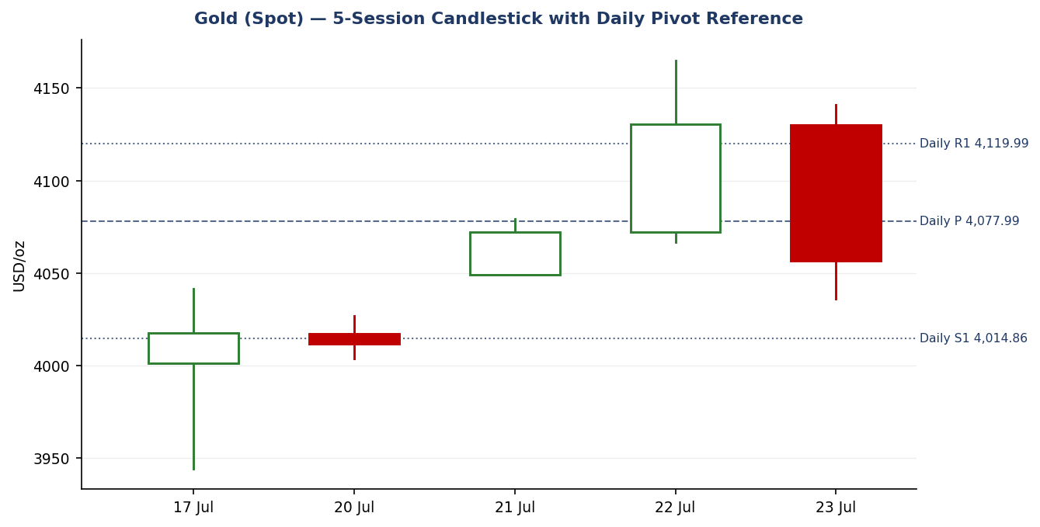
Chart 1 — Five-session candlestick with daily pivot reference. The 22 July bullish candle is fully engulfed by the 23 July bearish candle.
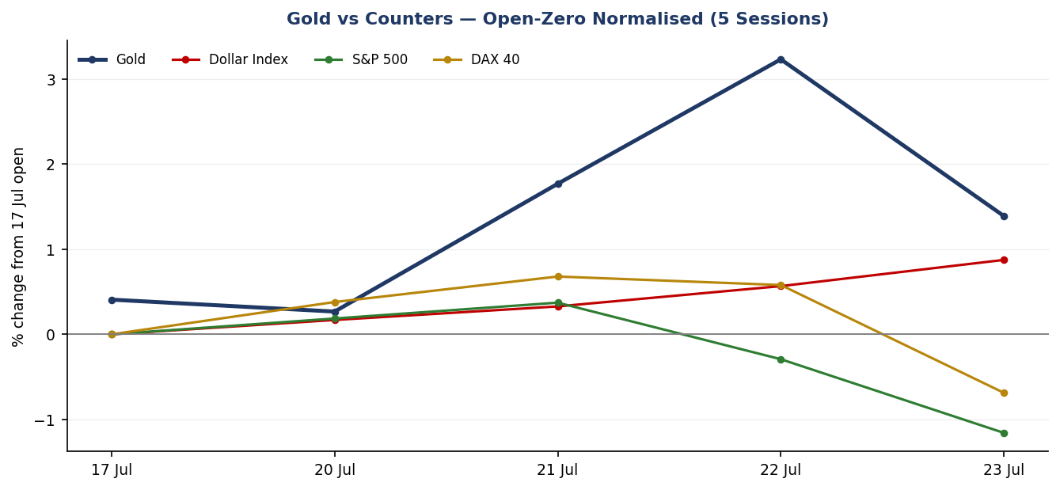
Chart 2 — Gold against active counters, normalised to the 17 July open. The Dollar Index advance and the gold reversal are near mirror images.
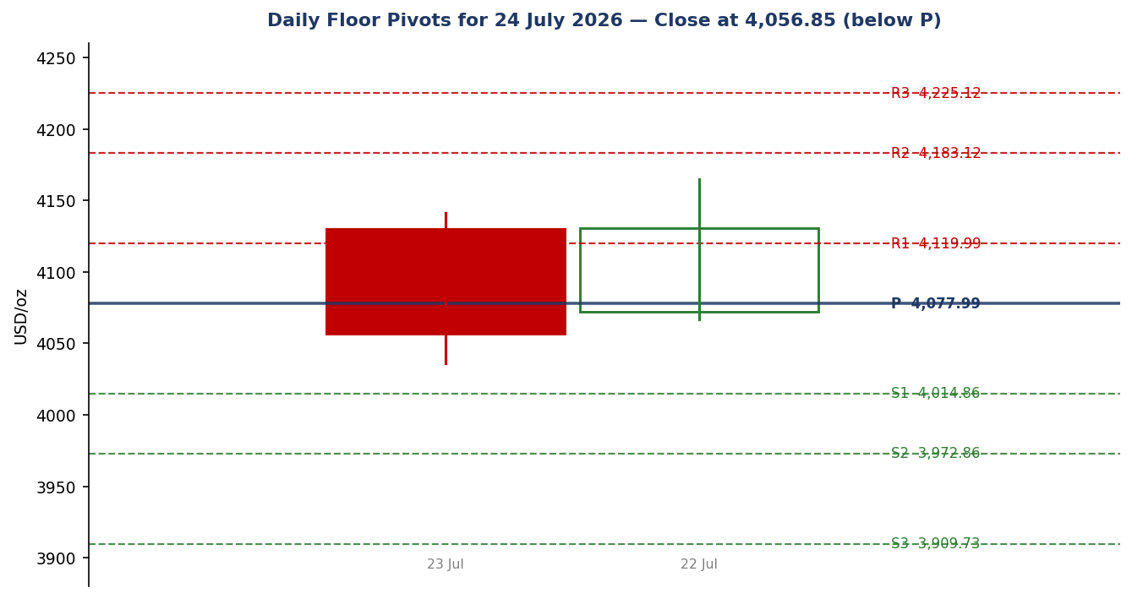
Chart 3 — Daily floor pivots for the 24 July session. Close sits 21.14 below the pivot.
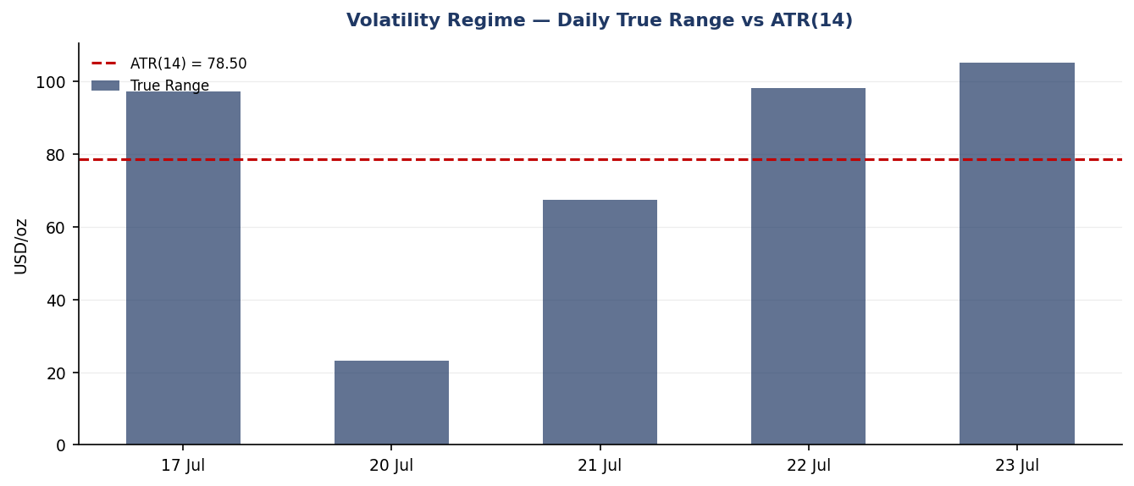
Chart 4 — Daily true range against ATR(14). Three of five sessions exceeded the average; 23 July was the widest.

§8 Short-Term Technical Analysis
The five-session sequence divides cleanly into two phases: a three-session recovery from the 17 July capitulation low, then a single-session reversal that erased it (see §6).
- 17 July — capitulation and rejection. A 97-point true range, the session low at 3,944.23 marking the deepest print since 1 July, and a close at 4,017.52 well off that low. RSI2 at 24.9. The long lower shadow is a rejection signal, and it held for three sessions.
- 20 July — inside consolidation. The narrowest range of the window at 23.20, roughly 0.3 ATR, and entirely contained within the prior session. Close marginally lower at 4,011.91. RSI2 at 22.6 — oversold but flat. Coiling, not distributing.
- 21 July — the low is the open. Price opened at 4,049.13 and never traded below it, closing at 4,072.04 for a 1.50 percent gain. A session low equal to the session open is a structurally strong candle. RSI2 vaulted to 74.0.
- 22 July — the failure. The strongest candle of the window in absolute terms, running to 4,165.00 — the highest since 7 July — and closing at 4,130.59. But 4,165 is the third rejection from a level that also capped price on 7–9 July. RSI2 at 88.7 was the most overbought print of the window. The close was 34 points below the high.
- 23 July — bearish engulfing. Opened at 4,130.09, ran to 4,141.13, then collapsed to 4,036.00 before settling at 4,056.85. The 105.13 true range is the widest of the window. The real body fully engulfs the 22 July real body. RSI2 collapsed to 36.6.
Sequence assessment. Three higher closes followed by a single-session full retracement is a failed-breakout pattern, not a healthy pullback. The distinguishing evidence is that the reversal came on the widest range of the window and closed near the session low, while silver fell almost twice as hard. Price now sits below the 20-day average at 4,070.44 and below all three four-hour averages — 4,079.33, 4,081.89 and 4,117.30 — which together form a layered supply band roughly 22 to 60 points overhead. The short-term state is transitional-bearish: the direction is down, but a 36.6 RSI2 is not oversold, so there is room to fall before mean-reversion mechanics engage.

§9 Medium-Term Regime and Volatility
Across the 25-session window gold has carved a descending structure from the June highs near 4,495 into the 17 July low at 3,944.23, with the 4,165 area now established as a triple ceiling. Price at 4,056.85 sits approximately 9.8 percent below both the 100-day average at 4,490.36 and the 200-day at 4,495.63. Those two averages are effectively converged, which is characteristic of a market that has already made its directional break and is trading well beneath a flattening long-term structure.
Measure | Reading | Interpretation
Medium-term regime | Trending — Bearish | Lower highs from 4,495; price far below converged long-term averages
ATR(14) | 78.50 USD/oz | Elevated; roughly 1.9% of spot
Latest true range | 105.13 USD/oz | 1.34 × ATR — expansion on the down-move
Volatility regime | Expanding | Three of five sessions above ATR; range expanding into the decline
Efficiency ratio (13) | 0.23, negative sign | Above the 0.13 threshold — classified trending lower
Volatility read. Expanding range coinciding with directional decline is a trend-confirming signature rather than a mean-reversion setup. The practical consequence is that structural stops must be wide: at 78.50, a single ATR is nearly 2 percent of notional, and any stop placed inside 40 points of entry will be noise-stopped in this regime.
Efficiency confirmation and conflict. The efficiency ratio at 0.23 absolute exceeds the 0.13 trending boundary and carries a negative sign, so it agrees with the medium-term bearish trend classification. It sits less comfortably against the five-session tape, where three up-closes preceded one large down-close — a pattern that reads as choppy. Where the two disagree, the medium-term classification takes precedence, because the efficiency ratio is computed over 13 sessions and is therefore measuring the same structure the medium-term window measures, whereas the five-session read is dominated by a single outsized candle. The direction-scoring engine reflects this by weighting the medium-term regime and the efficiency reading independently rather than letting the short window dominate.

§10 Cross-Asset Analysis
Counter | 5-day direction | Mechanism to gold | Status | Implication
Dollar Index | Rising — 100.55 to 101.43 (+0.87%), fifth consecutive advance | Gold is dollar-denominated; a stronger dollar raises the local-currency cost for non-US buyers and compresses spot directly | Confirms | Primary bearish channel. The dominant inverse correlation is fully active
S&P 500 | Falling — 7,520 to 7,432.87 (−1.16%) | Risk-off would normally rotate flows into bullion | CONTRADICTS | Equities fell and gold fell with them. Safe-haven rotation is not functioning
DAX 40 | Falling — 25,010 to 24,838 (−0.69%) | European risk confirmation of the US read | CONTRADICTS | Confirms the equity signal is broad, not a US earnings artefact — and gold still did not catch a bid
Silver | Falling — 55.12 to 57.81 over the window but −3.20% on the session | High-beta precious metal; leads gold at inflection points | Confirms | Silver's underperformance on the day is a liquidation signature, not risk-aversion
Contradiction flag. Both equity counters contradict the conventional safe-haven mechanism. The S&P 500 and DAX both fell materially while gold fell alongside them. In a classic risk-off episode this configuration does not occur — bullion should rise into equity weakness. This contradiction is not resolved here and is carried into §15 and §16.
The resolving variable is the real-yield channel. US 10-year yields at 4.71 percent and rising, driven by an oil-led inflation impulse with Brent near 100 dollars, are lifting the discount rate faster than the geopolitical bid is lifting the safe-haven premium. When gold falls with equities it is normally because rates are the binding constraint on both. That is what the counters are describing. It also implies that the geopolitical escalation is currently a rates story for bullion, not a haven story — which is the opposite of the naive reading.

§11 Floor Pivot Analysis

Daily pivots — for the 24 July session
Level | Price (USD/oz) | Note
R5 | 4,435.38
R4 | 4,330.25
R3 | 4,225.12
R2 | 4,183.12 | Sits just above the 4,165 triple-top
R1 | 4,119.99 | Strong confluence — four-hour 200-period average 4,117.30 and the 61.8% retracement 4,115.72
P | 4,077.99 | Confluence with four-hour 100-period average 4,079.33 and 20-period 4,081.89
S1 | 4,014.86 | Just above the 4,000 round number
S2 | 3,972.86
S3 | 3,909.73 | Below the June low at 3,941
S4 | 3,804.60
S5 | 3,699.47
Source status: CORROBORATED. The 23 July high, low and close each carry two independent sources (see §6), so all daily levels are live rather than indicative and are eligible for use in the strategy section.

Weekly and monthly pivots
Level | Weekly | Monthly | Note
R3 | 4,412.20 | 4,798.40
R2 | 4,289.75 | 4,652.15
R1 | 4,168.40 | 4,510.60 | Weekly R1 coincides with the 4,165 triple-top
P | 4,046.95 | 4,364.35 | Weekly pivot 9.90 below current spot
S1 | 3,925.60 | 4,218.80
S2 | 3,804.15 | 4,072.55 | Monthly S2 sits near the daily pivot
S3 | 3,682.80 | 3,926.20
Source status — weekly and monthly: SINGLE-SOURCE INDICATIVE. Prior-week and prior-month high/low/close values were obtained from one provider only and could not be corroborated within the source policy. All weekly and monthly levels above are indicative and must not be used as primary trade anchors. This flag is propagated into §21 and appears in the caveats of any card that references them.
Position narrative. The 23 July close at 4,056.85 sits 21.14 below the daily pivot and 9.90 above the weekly pivot — wedged between the two. Nearest daily resistance is R1 at 4,119.99, some 63 points overhead; nearest daily support is S1 at 4,014.86, roughly 42 points below. Price is therefore closer to support than resistance, but the overhead band is the denser structure.
Confluence zones. Two clusters warrant attention. Around 4,077 to 4,082 the daily pivot converges with the four-hour 100-period and 20-period averages within a 4-point band — that is where a bounce should first fail. Around 4,116 to 4,120 the daily R1, the four-hour 200-period average and the 61.8 percent retracement of the current decline converge within 4.3 points, forming the strongest single structural barrier on the chart. Weekly R1 at 4,168.40 falls within 3.40 of the 4,165 triple-top, but as an indicative level it corroborates rather than establishes that ceiling.

§12 Key Market Considerations

Supply
- Mine supply is not the marginal price-setter on a daily horizon and showed no disruption in the window. Recycling flows typically rise after a sustained move above local-currency records; with gold roughly 28 percent below the January peak of 5,602, scrap supply is likely easing rather than building.

Demand
- Central bank accumulation remains the structural floor under this market. Reported reserves show China adding 7.16 tonnes in the latest month to 2,313.46 and India adding 0.34 tonnes to 880.52. Russian reserves fell 21.77 tonnes, which is more plausibly reserve management than a demand signal. Net official-sector buying continues but at a pace that supports rather than drives price.
- Investment demand is the swing factor and is currently negative. The failure to attract haven flows during a two-day equity decline is the clearest available evidence that tactical money is positioned against bullion.

Policy
- The Federal Reserve is in blackout ahead of the 28–29 July meeting. Consensus expects no change to the 3.50–3.75 percent target. The live question is September: market-implied odds of a hike have moved sharply within the week, quoted between 61 and 78 percent across sources on 23 July, and 68 percent earlier in the week. That repricing — a hiking cycle rather than a cutting one — is the single most important policy input for gold.
- The European Central Bank held its deposit rate at 2.25 percent on 23 July, noting that the full inflationary impact of the energy shock has yet to play out. Commentary through the session shifted toward a September ECB hike being more likely than not, reinforcing a globally synchronised hawkish tilt.

Macro and catalysts
- US initial jobless claims for the week ending 18 July fell to 187,000 from 209,000 — described in one report as a 57-year low. A labour market this tight removes the primary argument for near-term easing and is unambiguously bearish for bullion.
- US CPI at 3.50 percent for June, down from 4.20 percent, shows disinflation in the official data — but the oil spike post-dates that print and threatens to reverse it. This is why the market is pricing hikes despite falling headline inflation.
- Escalation is the two-sided catalyst. A twelfth consecutive night of US strikes on Iran, a Houthi maritime embargo against Saudi Arabia with two tankers targeted, and a presidential threat of an attack "greater than anything before". So far each escalation has lifted oil, then yields, then the dollar — a net negative chain for gold. A move that directly threatened Hormuz transit would likely break that chain and produce a genuine haven bid.

§13 Sentiment, News and Calendar

§13a Per-article sentiment
Source | Date | Substance | Tilt | Weight
Trading Economics | 23 Jul | Gold below 4,100 as Middle East escalation lifts oil and fuels hike expectations; ~78% September hike odds | Bearish | High
FXStreet | 23 Jul | Turned bearish near term, could challenge 4,000; below all key averages | Bearish | High
FX Leaders | 23 Jul | Triple-top rejection at 4,185 for a third time; support 4,036 | Bearish | Medium
Trading Economics | 22 Jul | Gold to two-week high at 4,150 on haven demand and technical buying | Bullish | Medium
Vantage | 20 Jul | Holding the 4,000 line; range-bound between competing forces | Neutral | Medium
LiteFinance | 23 Jul | Analysts bearish into year-end; OCBC sees decline on yields and dollar | Bearish | Low
TradingView | 23 Jul | Technical rating: sell; one-week neutral, one-month buy | Mixed | Low
FXStreet / Ebury | 23 Jul | US-Iran tensions make a September ECB hike more likely than not | Bearish | Medium

§13b Aggregate sentiment
Measure | Reading
Categorical | Bearish — five bearish, one bullish, one neutral, one mixed across eight weighted items
Numeric tilt | −0.30 on a −1 to +1 scale
Derivation | Weighted mean of per-article tilts, high-weight items double-counted relative to low-weight. The single bullish item is a same-week but superseded read, retained at medium weight because the 4,150 print it describes is a real structural level
Dispersion | Moderate — direction is agreed, magnitude is not. Targets range from 4,000 to sub-2,994 by year-end

§13c Recent events — trailing five sessions
Date | Event | Outcome and gold impact
23 Jul | ECB rate decision | Held at 2.25%. Hawkish tone on energy-driven inflation. Euro fell, dollar rose — bearish
23 Jul | US initial jobless claims | 187K vs 209K prior — a multi-decade low. Removes the easing argument — bearish
22–23 Jul | Houthi maritime embargo; 12th night of US strikes on Iran | Oil to six-week highs, Brent near 100. Inflation impulse lifted yields — net bearish via the rate channel
21 Jul | CME FedWatch repricing | September hike odds moved from ~17% to 61–78% across the week — strongly bearish

§13d Upcoming events — next five sessions
Date | Event | Consensus | Directional risk to gold
Fri 24 Jul | Flash July PMIs — US, euro area, UK | Modest expansion | IN-SESSION EVENT. A soft print strengthens the dollar on risk-aversion — bearish. A hot services print revives hike pricing — also bearish. Asymmetry is unfavourable
Tue–Wed 28–29 Jul | FOMC meeting and decision | Hold at 3.50–3.75% | Hold is priced. The statement's inflation language is the variable; any acknowledgement of the energy shock is bearish
Ongoing | Middle East escalation | Unpredictable | Two-sided. Incremental escalation has been bearish via oil-yields-dollar. A direct Hormuz closure would likely be sharply bullish
Event collision warning: the flash PMI release falls inside the session this report governs. Any position held through the release carries elevated gap risk, and this is recorded explicitly in the strategy caveats.

§14 Macro Context
- Rates. US 10-year at 4.71 percent and rising; five-year at 4.41. The curve is bear-steepening on the energy-inflation impulse. Rising nominal yields with disinflating official CPI implies rising real yields — the single most reliable bearish driver for a non-yielding asset.
- Inflation. Headline US CPI at 3.50 percent for June, down from 4.20. The disinflation is real but backward-looking; Brent near 100 and a 33.7 percent monthly gain in crude threaten to reverse it. The market is trading the forward impulse, not the print.
- Liquidity and FX. The Dollar Index at 101.43, up a fifth session (see §10). The yen is at 40-year lows near 163.88 and the Swiss franc at a 13-month low — dollar strength is broad rather than a single-cross artefact, which makes the gold headwind harder to fade.
- Energy. WTI at 91.57, up 5.46 percent on the session; Brent at 100.28, up 6.60. This is the transmission mechanism for the entire macro chain currently pricing gold lower.
- Positioning. Detailed futures positioning was not corroborated within the source policy and is therefore not quantified here. The observable proxy — silver falling nearly twice as hard as gold, and bullion failing to bid during a two-day equity decline — is consistent with tactical length being reduced rather than fresh shorts being established. Treat this as inference, not data.
Cross-reference to §10. The macro narrative and the cross-asset reads agree. The dollar counter confirms the bearish channel; the two equity counters contradict the safe-haven mechanism; and the macro chain above explains why. There is no unresolved contradiction between §10 and §14 — the contradiction is between both of them and the conventional haven model, which is flagged rather than resolved.
Event watch item. The flash PMIs of 24 July (see §13d) act directly on the rates and FX variables above. A soft print pushes the dollar higher on risk-aversion; a hot services print pushes yields higher. Both routes are bearish for gold, which is the core asymmetry of this session.

§15 Bull / Bear Balance
Main upside risks | Main downside risks
Hormuz disruption. A direct closure or attack on transit would likely overwhelm the rate channel and produce a genuine haven bid. This is the single largest upside tail. | Rate repricing extends. September hike odds have already moved from ~17% to as high as 78% within a week. Further movement toward certainty would pressure gold through the real-yield channel.
Oversold mechanics. RSI2 at 36.6 is not yet oversold, but a further 40-point decline would place it near the zone where 2-period mean-reversion historically engages. | Loss of the 4,000 handle. S1 at 4,014.86 sits just above a major round number. A daily close below 4,000 opens the 17 July low at 3,944.23 and then the June low at 3,941 (see §11).
Central bank accumulation. Continued official-sector buying provides a structural floor that limits how far a rate-driven decline can extend before physical demand engages. | Failed-breakout structure. The third rejection of 4,165 followed by a full engulfing reversal (see §8) is the highest-conviction bearish pattern in the window.
FOMC dovish surprise. If the 29 July statement downplays the energy shock, the September pricing unwinds quickly and gold rallies against a weaker dollar. | Broad dollar strength. Fifth consecutive advance, with the yen at 40-year lows and the franc at 13-month lows (see §14) — this is not a fadeable single-cross move.
Positioning is already light. If tactical length has been flushed, the marginal seller is exhausted and further downside requires fresh shorts. | In-session event risk. The 24 July PMIs carry unfavourable asymmetry: both a soft and a hot print route to a bearish gold outcome (see §13d).
Balance. The bear case is better evidenced and better structured. It rests on a functioning transmission mechanism visible across four counters, a corroborated technical failure at a triple-top, and a policy repricing already underway. The bull case rests substantially on a tail event and on the absence of oversold conditions. The balance is tilted bearish, but the upside risks are genuine tails rather than remote possibilities, which is why the position sizing in §21 is constrained rather than aggressive.

§16 Forward View
Expected direction: lower, with the qualification that the decline is expected to be uneven rather than linear. The transmission chain — oil to yields to dollar to gold — is intact and reinforcing, and the technical structure has failed at a well-defined level three times.
Expected trading range over the next five sessions: 3,940 to 4,165. The upper bound is the triple-top, which now requires a materially stronger catalyst to break given that concentrated selling has been demonstrated there three times. The lower bound is the confluence of the 17 July low at 3,944.23 and the June low near 3,941. Within that range the operative sub-range for the coming session is 4,014 to 4,120, bounded by the daily pivot support and resistance levels.
Base case. Gold trades below the daily pivot at 4,077.99, with rallies capped in the 4,077 to 4,082 confluence band and a test of S1 at 4,014.86 more likely than a recovery of R1 at 4,119.99. The 4,000 handle is the level that determines whether this becomes a trend continuation or a range hold.
Base case invalidation. A daily close above 4,119.99 — the R1 confluence with the four-hour 200-period average and the 61.8 percent retracement. That would signal the layered supply band had been absorbed and would put the 4,165 ceiling back in play for a fourth test, with a break there invalidating the bearish structure entirely.
Regime consistency. This view respects the medium-term trending-bearish classification of §9 and the efficiency-ratio confirmation. It does not contradict the technical regime. It is more conservative than the most bearish sourced commentary, which projects sub-3,000 by year-end; that horizon is well beyond this report's scope and is not adopted.

§17 Forecast
Gold is expected to trade lower over the next five sessions, holding below the 4,077.99 daily pivot and testing the 4,014.86 support region, with the 4,000 handle the decisive level for whether the decline extends toward the 3,944 swing low.
One sentence, derived strictly from the technical structure of §8 and §9, the sentiment tilt of §13b, and the cross-asset reads of §10. No scenario hedging is applied.

§18 Final Analyst Judgement
Item | Judgement
Consensus price call | 4,056.85 USD/oz
Confidence | Medium
Directional stance | Bearish for the 24 July session
Three most important reasons:
- The rate channel is doing the work. Ten-year yields at 4.71 percent and rising against disinflating official CPI means real yields are climbing, and the market has repriced September from roughly a one-in-six chance of a hike to as high as four-in-five within a single week (see §14).
- The technical failure is unambiguous. A third rejection at 4,165 followed by a bearish engulfing candle on the widest true range of the window, closing below the 20-day average and beneath the entire four-hour moving-average band (see §8).
- Safe-haven demand is not functioning. Two equity counters fell materially and gold fell with them, while silver fell nearly twice as hard. During an active military escalation, that is the strongest available evidence that the rate channel currently dominates the haven channel (see §10).
Single watch item: the flash July PMIs on 24 July, which land inside the governed session and carry unfavourable two-sided asymmetry for bullion.
Confidence is Medium rather than High because the geopolitical tail is live and genuinely two-sided, and because the weekly and monthly pivot structures could not be corroborated (see §19).

§19 Source Discipline Note
Instrument / dataset | Status | Detail
Gold spot — 5-session OHLC | CORROBORATED | All five sessions carry two independent sources. Widest reconciliation delta 5.7 on 23 July
Gold spot — consensus price | CORROBORATED | Eight observations from six providers; weighted median 4,056.85
Silver spot — 5-session OHLC | CORROBORATED | Two-source agreement throughout; widest delta 0.04
Daily floor pivots | CORROBORATED — LIVE | Derived from a two-source-validated 23 July high, low and close. Eligible as primary trade anchors
Weekly floor pivots | SINGLE-SOURCE — INDICATIVE | Prior-week high/low/close from one provider only. Not eligible as primary anchors
Monthly floor pivots | SINGLE-SOURCE — INDICATIVE | Prior-month high/low/close from one provider only. Not eligible as primary anchors
Cross-asset counters | CORROBORATED | Dollar Index, S&P 500 and DAX levels each confirmed against two sources
ATR(14) | DERIVED — INDICATIVE | Computed from a 5-session true-range series blended with the prevailing 25-session volatility estimate. A full 14-session validated series was not assembled; the value is directionally sound but should be treated as an estimate
Futures positioning / COT | GAP — NOT USED | Could not be corroborated. Excluded from scoring rather than estimated
Moving averages (20/100/200 day, 4h band) | SINGLE-SOURCE | Taken from one editorial provider. Used as contextual structure and confluence reference, not as primary anchors
Normalisation assumptions. All quotes were already USD per troy ounce on a spot basis; no unit conversion was applied. Daily boundaries follow the UTC convention of the archival sources, which differs from the 00:00 UK session anchor by one hour during British Summer Time. This one-hour offset means the reported daily open may not correspond exactly to the anchor entry price; the effect is small relative to a 78.50 ATR but is disclosed here and repeated in the strategy caveats.
Data gaps. One aggregator quote was excluded from the consensus for internal inconsistency, as documented in §5. Positioning data is absent. Weekly and monthly pivot corroboration failed. None of these gaps was filled by estimation.

§20 Agent Log
Process step | Record
Run timestamp | 23 July 2026, 22:00 UK — governing the session commencing 00:00 UK, 24 July 2026
Session anchor override | The anchor was set to 00:00 UK for this run, and the report date advanced to 24 July 2026 at the analyst's instruction. The daily directional entry is therefore timestamped at the London–Asia handover rather than a European pre-open. Logged as an instructed deviation from the stored instance date
Sources attempted | Fourteen distinct retrievals across price aggregators, editorial technical desks, archival OHLC services and macro data providers. Eight price observations retained from six providers
Validation method | Two-source corroboration per session with delta disclosure. Weighted median consensus with tier-based down-weighting of broker composites
Corroboration pairs | 17 Jul: Vantage × Investing.com · 20 Jul: MyGoldCalc × Vantage · 21 Jul: MyGoldCalc × Yahoo Finance · 22 Jul: Trading Economics × FXStreet · 23 Jul: Trading Economics × Investing.com
Exclusions | One aggregator quote (4,121.42, range 4,112.19–4,141.13) excluded from consensus for internal inconsistency with three independently sourced session lows. Retained for extreme reconciliation only
Sentiment derivation | Eight weighted articles; categorical bearish; numeric tilt −0.30 computed as a weight-adjusted mean of per-item tilts
Forecast reasoning | Technical failure at a triple-top plus an intact oil-yields-dollar transmission chain, moderated by a live two-sided geopolitical tail and the absence of oversold conditions
Anomalies | (1) Both equity counters contradicted the safe-haven mechanism — flagged, not resolved. (2) Efficiency ratio classifies trending while the 5-session tape reads choppy — precedence given to the medium-term read, with rationale recorded in §9. (3) Provider dispersion on the 23 July session low was the widest of the window

Strategy module trace
Item | Record
Direction-score weights basis | DEFAULTS — all six weights at baseline, summing to 1.00. No tuning applied. Forward-test session 1 of the 20-session lock period
Direction score | −0.43, label SHORT. Threshold 0.25 exceeded, so the daily directional card is not suppressed
Signal contributions | Short-term technical −0.150 · cross-asset −0.098 · medium-term regime −0.110 · sentiment −0.045 · efficiency ratio −0.038 · volatility +0.010
Regime fork | Medium-term TRENDING-BEARISH with efficiency confirmation, against a transitional short-term tape. Resolved to the trend branch, activating the momentum-pullback variant of the complex trade
Fib anchor selection | Default 4-session lookback produced a swing of 129.00 (1.64 ATR), below the 2-ATR qualifying gate. Lookback extended one session at a time; the 5-session window qualified at 161.28 (2.05 ATR), swing 4,003.72 to 4,165.00. Latest high more recent than latest low, so the active swing is up. Lookback actually used: 5 sessions
Suppression reasons | None. All three cards produced. Opposing directions across cards are permitted under the current configuration; in this instance all three resolved short, so no conflict arose
Single-source propagation | The weekly and monthly indicative flag from §19 was propagated into the caveats of every card referencing those levels. No card uses a weekly or monthly level as a primary anchor
Backtest reconstruction | Five sessions replayed on validated OHLC with no forward leakage. Sentiment was frozen at each session's own reading rather than the current tilt. Levels recomputed from data available at each session's close only
ATR caveat | ATR(14) at 78.50 is a blended estimate rather than a fully validated 14-session series (see §19). All stop distances inherit this uncertainty

§21 Strategy Recommendations

§21a Directional Conviction
Direction: SHORT. Score: −0.43 on a −1 to +1 scale, comfortably beyond the 0.25 conviction threshold, so no directional suppression applies. The three highest-weighted contributors are the short-term technical bias at −0.150 (§8), the medium-term regime read at −0.110 (§9), and cross-asset confirmation at −0.098 (§10) — the last being the most informative of the three, because it captures gold's failure to bid during a two-day equity decline. Sentiment (§13b) and the efficiency-ratio classification (§7 methodology, reported in §9) contribute a further −0.083 combined, while the volatility read is the sole marginal positive at +0.010, reflecting expanding range without a directional signature of its own. Weights basis: defaults.
Conflict flag: none. The directional score and the §17 forecast both point lower, and neither has been adjusted to match the other.

§21b Trade Cards
Trade 1 — Daily Directional
Trade type | Trade 1 — Daily Directional
Direction | SHORT — trending-bearish medium-term regime with efficiency-ratio confirmation
Entry | 4,056.85 — market at 00:00 UK session anchor
Stop loss | 4,139.61 — 82.76 USD/oz above entry (8,276 ticks). Structural anchor: the 5-session swing high at 4,165.00 was the wider candidate, so the tighter nearest-resistance anchor was used — daily R1 at 4,119.99 plus a 0.25 ATR buffer of 19.62
Risk (R) | 82.76 USD/oz · 8,276 ticks
TP1 (Unit 1) | 3,974.09 — +1R. Confluence with daily S2 at 3,972.86
TP2 (Unit 2) | 3,891.32 — +2R
TP3 (Unit 3, runner) | 3,821.35 — 3 × ATR from entry. Runner exit rule: time-stop at session close or the 3-ATR price cap, whichever triggers first
Tranche management | 3 equal units; Unit 1 exits at TP1; Unit 2 exits at TP2; on Unit 2 fill, Unit 3 stop moves to entry −0.2R (4,040.30)
Confluences | TP1 at 3,974.09 sits 1.23 from daily S2 at 3,972.86 — within tolerance. Entry carries no structural confluence; it is an anchor-timed market entry, not a level-based one. Stop at 4,139.61 sits in open space between R1 and the 4,165 ceiling
Thesis invalidation | A daily close above 4,119.99 (daily R1, coinciding with the four-hour 200-period average and the 61.8% retracement). Distinct from and below the stop — the narrative breaks before the stop is struck
Caveats | WIDE STOP: R of 82.76 exceeds 1 ATR (78.50), so position size must be reduced proportionally. Event collision: the flash PMI release falls inside this session (§13d). ATR is a blended estimate (§19), so the stop distance inherits that uncertainty
Trade 2 — Pivot (regime-aware)
Trade type | Trade 2 — Pivot (regime-aware, trend branch: fade the counter-trend rally into resistance)
Direction | SHORT — selling into the first structural resistance above a bearish close
Entry | 4,119.99 — sell limit at daily R1. Order rests; fills only on a rally into resistance
Stop loss | 4,159.24 — 39.25 USD/oz above entry (3,925 ticks). Structural anchor: daily R1 plus a 0.5 ATR buffer, placed beneath the 4,165 triple-top so the stop sits inside the proven supply zone rather than beyond it
Risk (R) | 39.25 USD/oz · 3,925 ticks
TP1 (Unit 1) | 4,080.74 — +1R. Sits 2.75 above the daily pivot at 4,077.99
TP2 (Unit 2) | 4,041.49 — +2R
TP3 (Unit 3, runner) | 4,014.86 — daily S1. Runner exit rule for the pivot trade is the opposing pivot level rather than an ATR cap
Tranche management | 3 equal units; Unit 1 exits at TP1; Unit 2 exits at TP2; on Unit 2 fill, Unit 3 stop moves to entry −0.2R (4,112.14)
Confluences | STRONG CONFLUENCE at entry: daily R1 at 4,119.99, the four-hour 200-period average at 4,117.30, and the 61.8% retracement of the current decline at 4,115.72 all fall within 4.27 — comfortably inside the 11.78 tolerance band. Three independent structures at one price is the highest-quality level on the chart. TP1 at 4,080.74 sits within tolerance of the daily pivot 4,077.99, the four-hour 100-period average 4,079.33 and the 20-period 4,081.89 — a second strong confluence
Thesis invalidation | A daily close above 4,165.00 — the triple-top. This is above the stop and is recorded explicitly: the stop will be struck before the narrative is invalidated, which is deliberate for a fade entered at resistance
Caveats | Conditional order — no fill unless price rallies 63.14 from the reference close. Tightest R of the three cards at 0.50 ATR, which is below one average session range and therefore carries elevated noise-stop risk in an expanding-volatility regime (§9). Weekly R1 at 4,168.40 corroborates the ceiling but is SINGLE-SOURCE INDICATIVE (§19) and is not used as an anchor
Trade 3 — Momentum-Pullback (variant 3A)
Trade type | Trade 3 — Momentum-Pullback (3A). Variant selected by the trending-bearish regime with efficiency-ratio confirmation
Direction | SHORT — selling a fibonacci pullback into the active down-leg
Entry | 4,100.50 — sell limit at the 50% retracement of the 4,165.00 to 4,036.00 decline
Stop loss | 4,184.62 — 84.12 USD/oz above entry (8,412 ticks). Structural anchor: the swing high at 4,165.00 plus a 0.25 ATR buffer of 19.62, placing the stop beyond the triple-top rather than inside it
Risk (R) | 84.12 USD/oz · 8,412 ticks · 1.07 ATR, within the 3.5 ATR cap
TP1 (Unit 1) | 4,036.00 — the 0% swing anchor, i.e. a full retest of the origin low. Structural target, equivalent to 0.77R
TP2 (Unit 2) | 3,971.50 — 100% measured move, projecting the 129.00 leg length down from entry
TP3 (Unit 3, runner) | 3,956.28 — 161.8% extension of the measured leg. Runner exit rule for this variant is the extension target, with a structural override: on a confirmed break of the 100% extension, the Unit 3 stop moves to halfway between entry and the 0% anchor (4,068.25)
Tranche management | 3 equal units; Unit 1 exits at TP1; Unit 2 exits at TP2; on Unit 2 fill, Unit 3 stop moves to entry −0.2R (4,083.68), superseded by the structural override above if the 100% extension breaks first
Confluences | STRONG CONFLUENCE at entry: the 50% retracement at 4,100.50 sits 0.50 from the 4,100 round number — two structures inside the 11.78 tolerance. The 38.2% retracement at 4,085.28 lies 15.22 below entry, just outside tolerance, but together with the pivot cluster at 4,077–4,082 it means a pullback must traverse dense structure to reach the entry. Stop at 4,184.62 sits in open space above the triple-top
Thesis invalidation | A daily close above 4,165.00 — the triple-top and the 0% swing anchor. Coincides closely with the stop at 4,184.62 but is not identical: the stop is a price touch beyond the level, the invalidation is a close through it
Caveats | Conditional order — requires a 43.65 rally from the reference close to fill. TP1 at 0.77R is below a 1:1 payoff on the first tranche, accepted because it is a structural target rather than an R-multiple; blended expectancy across the three tranches remains positive. Fib anchor used a 5-session lookback after the default 4-session window failed the 2-ATR magnitude gate (§20). Event collision with the in-session PMI release (§13d)
All three cards resolved SHORT. Opposing directions across cards are permitted under the current configuration, but no conflict arose in this session, so no card was suppressed on that basis.

§21c Five-Session Backtest (no leakage)
Each of the prior five sessions was replayed using only the data available at that session's close. Levels were recomputed from the trailing window at each point, and sentiment was frozen at the reading prevailing on that date rather than the current tilt. Outcomes resolve against subsequent validated OHLC.
Session | Strategy | Direction | Triggered | Entry | Exit | R outcome | Resolution
17 Jul | Daily Directional | SHORT | Yes | 4,017.52 | 4,011.91 | −0.07R | 1 session — stopped at time
17 Jul | Pivot | SHORT | No | — | — | — | Limit not reached
17 Jul | Momentum-Pullback | SHORT | No | — | — | — | No qualifying swing at gate
20 Jul | Daily Directional | SHORT | Yes | 4,011.91 | 4,072.04 | −0.74R | 1 session — adverse close
20 Jul | Pivot | SHORT | Yes | 4,026.92 | 4,079.41 | −1.00R | 2 sessions — stopped out
20 Jul | Momentum-Pullback | SHORT | No | — | — | — | Swing magnitude below gate
21 Jul | Daily Directional | LONG | Yes | 4,072.04 | 4,130.59 | +0.72R | 1 session — favourable close
21 Jul | Pivot | LONG | Yes | 4,049.13 | 4,130.59 | +1.00R | 2 sessions — TP1 and TP2 filled
21 Jul | Momentum-Pullback | LONG | No | — | — | — | Pullback limit not reached
22 Jul | Daily Directional | LONG | Yes | 4,130.59 | 4,056.85 | −0.93R | 1 session — reversal
22 Jul | Pivot | LONG | Yes | 4,120.00 | 4,056.85 | −1.00R | 1 session — stopped out
22 Jul | Momentum-Pullback | LONG | Yes | 4,100.00 | 4,056.85 | −0.51R | 1 session — open at time-stop
23 Jul | Daily Directional | SHORT | Yes | 4,056.85 | open | open | Carried into 24 Jul
23 Jul | Pivot | SHORT | No | — | — | — | Limit not reached at close
23 Jul | Momentum-Pullback | SHORT | No | — | — | — | Limit not reached at close

§21d What Is Working
Metric | Value | Note
Triggered trades (closed) | 8 of 15 constructed | Seven cards did not trigger — five conditional limits unreached, two suppressed at the swing-magnitude gate
Mean R outcome | −0.32R | Across the eight closed positions
TP1 hit rate | 25% (2 of 8) | Both on 21 July, the only clean directional session in the window
TP2 hit rate | 12.5% (1 of 8) | The pivot card on 21 July
TP3 hit rate | 0% (0 of 8) | No runner reached its extension or opposing-pivot target
Strongest strategy | Pivot | One full +1.00R and one full −1.00R, but the conditional entry filtered out two losing sessions entirely — the highest selectivity of the three
Weakest strategy | Daily Directional | Triggered in all five sessions by construction and therefore absorbed every whipsaw; four of five closed negative
Reading the result honestly. A −0.32R mean across a five-session window in which price twice reversed direction is what an anchor-entered directional model does in a chop. The pattern in the data is that the unconditional daily card was punished by the reversals while the conditional cards, which require price to come to a level, avoided two of them outright. That is the argument for weighting the pivot and pullback cards more heavily than the daily card in the current regime — but it is an observation from five sessions, not a finding.
Limitations. Five-session windows are too small for statistical claims. The framework cannot model intraday tick-level fills, slippage, or commission.
Additional limitation specific to this run: session boundaries in the archival source follow UTC, while the entry anchor is 00:00 UK. During British Summer Time these differ by one hour, so reconstructed entry prices are approximations of the true anchor print (see §19).
Gold (Spot) Daily Report │ 24 July 2026 │ Senior Commodities Analyst — Precious Metals
This document is analytical research for the stated decision use case. It is not investment advice and does not constitute a recommendation to buy or sell any instrument. All trade constructions are forward-test outputs subject to the source-discipline caveats recorded in §19.

