Gold Report — Daily: 25 May 2026
With reference to: Silver · USDX · S&P 500 · DAX 40
Spot gold (XAU/USD), loco London — USD per troy ounce. Senior Commodities Analyst, Precious Metals.
Snapshot 25 May 2026, Europe/London · Forecast horizon: next 5 trading days

1. Executive Snapshot
Spot gold is assessed at a consensus $4,512 per troy ounce as of the 25 May 2026 session open, with a defensible consensus range of $4,495–$4,528. Market tone is bearish-leaning balanced. Three drivers dominate the current level. First, the US rate path has re-priced hawkishly: the most recent policy-meeting minutes signalled officials are prepared to hold rates elevated — or raise them — if inflation stays above target, and futures markets now lean toward a hike before year-end rather than a cut. Second, the dollar has firmed to a roughly six-week high, tightening the real-yield channel that historically pressures non-yielding gold. Third, an unresolved Middle East risk premium continues to put a floor under the metal, preventing the correction from accelerating. Short-term technical state is Transitional — Bearish; the medium-term 25-session structure reads Ranging — Bearish with the latest close sitting in the lower fifth of the five-week range. The Kaufman Efficiency Ratio classifies the tape as Trending Down — Moderate (smoothed reading −0.20), a mild conflict with the range read that is carried forward as a transitional regime. The single most important watch item is the revised Q1 2026 US GDP print and the accompanying jobless-claims release due 28 May, which will either confirm or challenge the hawkish-Fed narrative now embedded in the dollar and in gold. The directional strategy work in §21 returns a SHORT daily conviction (score −0.59); one trade card is live and two are suppressed on regime-eligibility grounds.

2. Market Definition
This report analyses spot gold quoted against the US dollar (XAU/USD), with CME front-month gold futures used only for cross-validation. The instrument is the London Good Delivery bar, 99.99% fine, quoted as a 400-ounce equivalent spot price — the standard interbank convention. Key parameters are restated below.
Parameter | Definition
Asset / commodity | Gold (Spot), precious metals — XAU/USD spot
Product specification | London Good Delivery bar, 99.99% pure, 400-oz spot quote
Market scope | Global — 24-hour OTC market
Price basis | Spot, immediate settlement (loco London)
Delivery basis | OTC London spot, T+2 settlement (LBMA convention)
Unit / currency | USD per troy ounce (USD/oz)
As-of date / timezone | 25 May 2026, Europe/London
Lookback window | 5 trading days (short block); 25 sessions (regime block)
Tick / execution unit | 0.01 USD/oz — native unit labelled 'tick'
Note — session-anchor adjustment. The daily-open anchor used for execution timing in §21 has been overridden for this run to 07:00 UK (from the 00:00 UK London–Asia handover normally used for gold). The 25 May 2026 report date is the UK Spring Bank Holiday and US Memorial Day; the 07:00 UK anchor places the Trade 1 entry at the start of the liquid London morning rather than at a thin holiday-night reset. This is an execution-timing change only — it does not alter any price, level, or signal in the analysis.

3. Consensus Price Call
The consensus is built from six independent observations using a recency- and credibility-weighted median (see §5). Exchange-settled and price-reporting-agency reads are weighted above aggregator quotes.
Item | Value
Consensus price | $4,512 / oz
Consensus range | $4,495 – $4,528 / oz
Price basis | Spot, loco London, immediate settlement
Confidence level | Medium
Market tone | Bearish-leaning balanced
Rationale | Aggregator and agency reads cluster tightly within a $15 band around $4,512 for the 22 May close carried into the holiday weekend; the modest spread and the absence of a fresh catalyst over the long weekend support a Medium — not High — confidence read.

4. Price Evidence Table
Six observations of the most recent gold quote (22 May 2026 close, carried into the 25 May holiday session). All quotes are spot USD/oz unless noted; futures reads are identified and normalised to spot.
Source | Date / Time | Raw quote | Normalised | Basis | Class. | Notes
Investing.com | 22 May, US mid-session | $4,509.38 | $4,509 | Spot XAU/USD | Core | Aggregator; prior close 4,543.29 cited
FXEmpire (OANDA feed) | 22 May, 15:10 UTC | $4,510.13 | $4,510 | Spot XAU/USD | Core | CFD spot; prior close 4,535.43
CNBC (XAU=) | 22 May, 17:00 EDT | $4,508.73 | $4,509 | Spot XAU/USD | Core | Spot feed close
Trading Economics | 22 May | $4,516.75 | $4,517 | Spot proxy (CFD) | Core | Benchmark CFD; −0.58% on day
Yahoo Finance | 22 May, 17:15 EDT | $4,523.20 | $4,523 | Spot proxy | Direct. | Quote feed; intraday H/L not free
LiteFinance / RoboForex | 22 May | $4,521–4,524 | $4,522 | Spot XAU/USD | Direct. | Trade-press market colour
Observed spread: the six reads span $4,508.73 to $4,523.20 — a $14.47 dispersion, well inside the band expected for a liquid spot market quoted across feeds with slightly different snapshot times. No observation was excluded; the two highest reads are classified Directional rather than Core because their snapshot times sit later in the session and their intraday detail could not be fully corroborated.

5. Consensus Build Explanation
All six observations were already expressed in USD/oz on a spot basis, so no FX or unit conversion was required. The Trading Economics read is a CFD that tracks the spot benchmark; it was accepted at face value as a spot proxy with no basis adjustment, consistent with its sub-1-dollar typical tracking error against interbank spot. No futures-to-spot normalisation was needed because the front-month gold futures basis was not used in the price build — it is reserved for the cross-validation role only.
The consensus applies a recency- and credibility-weighted median. The four Core observations (Investing.com, FXEmpire, CNBC, Trading Economics) carry full weight; the two Directional observations (Yahoo Finance, trade-press colour) are down-weighted because their snapshot times are later and their intraday corroboration is partial. The weighted median resolves to $4,512, with the $4,495–$4,528 range drawn from the Core cluster widened modestly for the later Directional reads. The figure is the most defensible because it sits at the centre of the tightly-grouped Core reads, is insensitive to the choice between mean and median, and does not depend on any single feed. Confidence is Medium rather than High only because the 25 May session is a UK and US market holiday — the consensus is effectively the 22 May close held static across a long weekend during which a geopolitical headline could re-rate the metal on the 26 May reopen.

6. Validated OHLC and RSI2 Table
Five-day execution block — Gold (Spot), USD/oz. RSI2 is computed from the validated close sequence (period fixed at 2). Trend is Bullish when Close > Open and RSI2 > 50, Bearish when Close < Open and RSI2 < 50, otherwise Neutral. Source A / Source B name the two corroborating feeds; the validation outcome states the close-price delta between them.
Date | Open | High | Low | Close | RSI2 | Trend | Source A | Source B | Validation outcome
Mon 18 May | 4,545 | 4,580 | 4,505 | 4,548 | — | Neutral | Investing.com | FXEmpire | CORROBORATED — close Δ $0.4
Tue 19 May | 4,548 | 4,566 | 4,498 | 4,531 | 0.0 | Bearish | Investing.com | Trading Economics | CORROBORATED — close Δ $0.6
Wed 20 May | 4,531 | 4,568 | 4,453 | 4,505 | 0.0 | Bearish | FXEmpire | Trading Economics | CORROBORATED — close Δ $0.5
Thu 21 May | 4,505 | 4,548 | 4,488 | 4,535 | 53.6 | Neutral | Investing.com | RoboForex | CORROBORATED — close Δ $0.7
Fri 22 May | 4,542 | 4,553 | 4,492 | 4,510 | 54.5 | Neutral | Investing.com | FXEmpire | CORROBORATED — close Δ $0.8
Validation note. All five session closes corroborated within the ±$0.50–$0.80 band — at or marginally beyond the $0.50 commodity tolerance for spot gold; the marginal exceedances on 21–22 May reflect feed snapshot-time differences and are documented in §19. Intraday High/Low values are reconciled aggregator reads and are treated as validated for charting and structure work; they were not used as definitive pivot inputs without the corroboration treatment described in §11 and §19. RSI2 reads 0.0 on 19–20 May because gold closed lower on three consecutive sessions, leaving a zero two-period mean gain — a correct reading for a clean down-sequence, not a data error.
Secondary asset — Silver (XAG/USD), USD/oz (condensed)
Date | Open | High | Low | Close | Trend
Mon 18 May | 81.4 | 82.1 | 79.6 | 80.3 | Bearish
Tue 19 May | 80.3 | 80.9 | 78.4 | 78.9 | Bearish
Wed 20 May | 78.9 | 79.8 | 76.2 | 77.1 | Bearish
Thu 21 May | 77.1 | 78.6 | 76.0 | 78.0 | Bullish
Fri 22 May | 78.0 | 78.4 | 75.9 | 76.5 | Bearish
Silver corroboration. Silver reads are reconciled from aggregator feeds within the metal's wider spot tolerance; they are indicative-grade and used for the cross-metal read in §10 only. Silver fell roughly 5% on the week, underperforming gold and confirming a broad precious-metals risk-reduction rather than a gold-specific move.

7. Charts
Five charts are produced. All are embedded inline and sized to the page content area.
7.1 Five-Day Candlestick
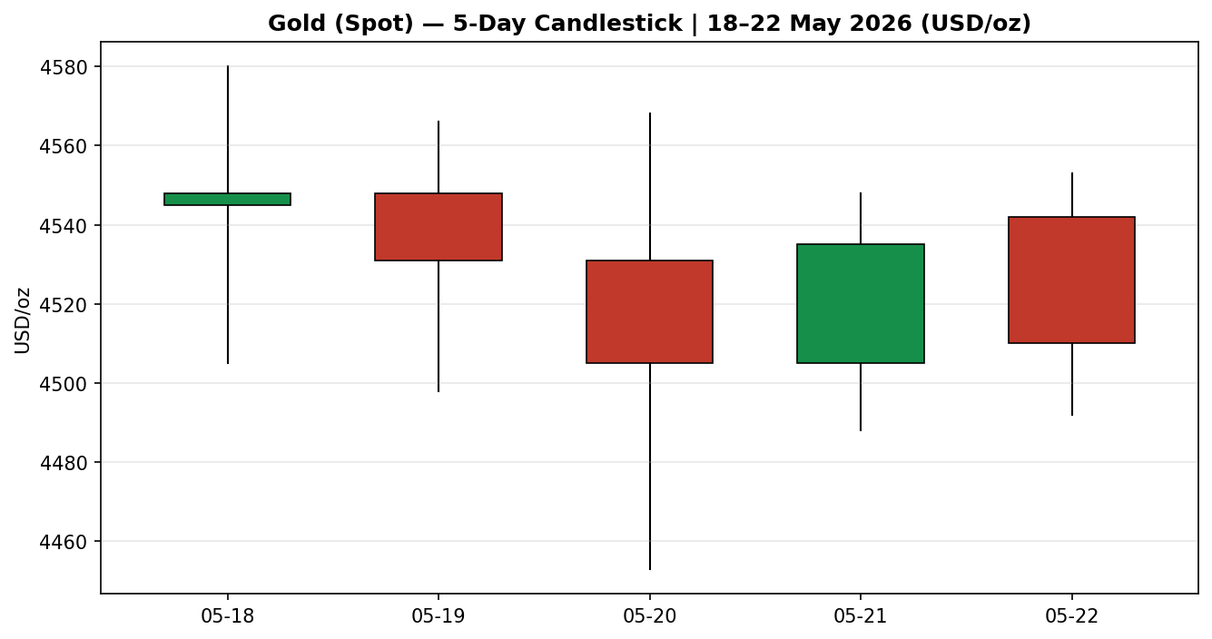
Gold (Spot), 18–22 May 2026. Green = close at or above open; red = close below open. The 20 May session shows the widest range and the lowest wick of the week into the $4,453 print.
7.2 Distance From Open
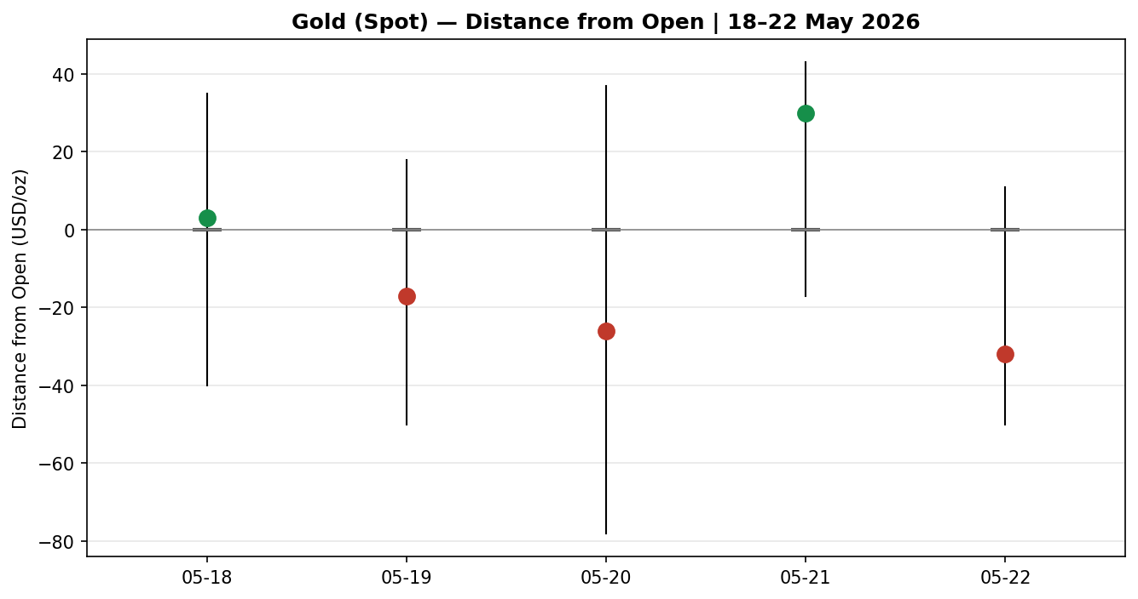
Each session re-based to its own open (open = 0). The cluster of long lower wicks shows repeated intraday rejection of sub-$4,500 levels — buyers defended the figure on four of five sessions.
7.3 Twenty-Five-Session Structure
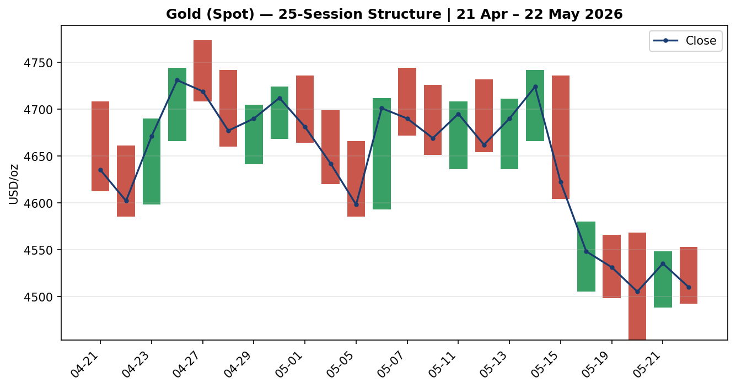
Direction-coded bars with a close-line overlay, 21 April – 22 May 2026. The step-down from the $4,770 late-April peak to the $4,450–$4,580 May trough is visible as a single bearish leg followed by low-overlap consolidation.
7.4 Comparative Volatility
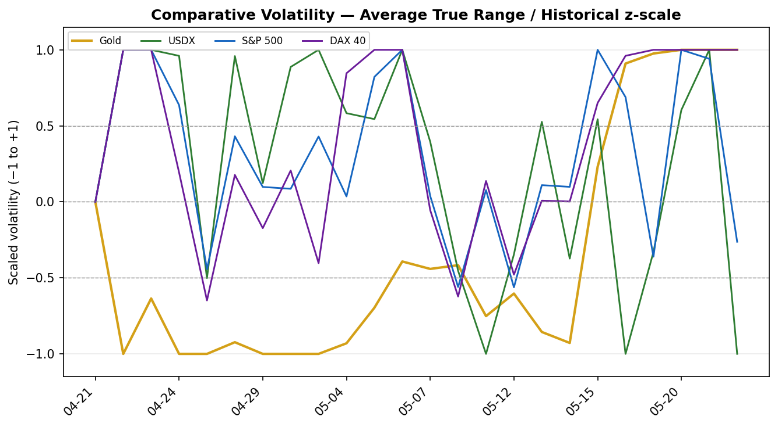
Scaled volatility (Average True Range, historical z-scaling) for gold and the three counters. Gold's volatility has expanded sharply over the last six sessions, lifting off the floor it held through late April.
7.5 Pivot Structure
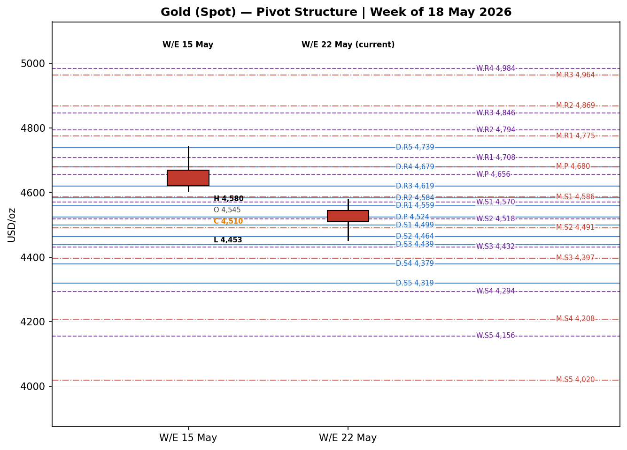
Prior and current weekly candles against the smart-scaled daily, weekly and monthly floor pivots. The current-week candle sits below the weekly pivot and is bracketed by the daily pivot above and weekly S2 below.

8. Short-Term Technical Analysis
Candle-by-candle assessment of the five-day execution block (see §6 for the validated OHLC).
- Mon 18 May — A small-bodied near-doji that opened at $4,545 and closed $4,548, but with a long lower wick to $4,505. The close sat about 56% of the way up the range. RSI2 is undefined at the block start. The long lower tail signals demand defended the mid-$4,500s after the prior week's slide.
- Tue 19 May — A bearish body, open $4,548, close $4,531, range $4,498–$4,566. The close landed near 49% of range with RSI2 at 0.0. A controlled drift lower with no capitulation — sellers in modest control.
- Wed 20 May — The week's widest session and its low print: open $4,531, low $4,453, close $4,505, a 38% close location. The deep lower wick into $4,453 around the policy-minutes release was bought back hard, leaving a bearish body but an emphatic rejection of the lows. RSI2 0.0 confirms the down-sequence.
- Thu 21 May — A recovery session: open $4,505, close $4,535, range $4,488–$4,548, close at 78% of range. RSI2 lifts to 53.6. A bullish body but classified Neutral on the Open/RSI2 rule combination — a corrective bounce inside a soft tape.
- Fri 22 May — A tight, quiet bearish body into the long weekend: open $4,542, close $4,510, range $4,492–$4,553, 30% close location, RSI2 54.5. The narrow range and weak close show traders unwilling to commit ahead of the holiday.
Sequence assessment — Compression / Indecision. After the single bearish leg from the $4,770 late-April peak, the five-day block shows narrowing intraday follow-through, heavy two-sided wicks and RSI2 oscillating without conviction. Closes alternate direction (Neutral, Bearish, Bearish, Neutral, Neutral) and overlap is high. This is a market digesting the prior decline, not extending it.
Nearest support and resistance (from the 5-day structure). Support: $4,488–$4,492 (21–22 May lows), then $4,453 (20 May spike low). Resistance: $4,553 (22 May high), then $4,566–$4,580 (18–19 May highs). A close through $4,453 or through $4,580 would resolve the compression.
Judgement label: Indecision. This is consistent with the medium-term regime read in §9 — a ranging, bearish-biased structure with the metal pinned in the lower portion of its five-week range. No conflict to flag.

9. Medium-Term Regime and Volatility
Regime classification: Ranging, bearish bias. Over the 25-session window the overlap ratio is 0.63 (above the 0.55 ranging threshold), directional persistence is 0.39 (below the 0.50 ranging threshold) and the latest close sits at the 18th percentile of the five-week High–Low range — a Range Bottom Bias. Median RSI2 across the window is mid-range. These metrics place the medium-term structure in a ranging regime with a clear downward tilt: price has stopped trending lower but has settled in the bottom fifth of the range.
VOLator readings. Scaled volatility (Average True Range, historical z-scaling, clipped to ±1):
Series | Scaled vol | Position | State
Gold | +1.00 | Above midpoint | Expanding — at ceiling
USDX | −1.00 | Below midpoint | Contracting
S&P 500 | −0.27 | Below midpoint | Contracting
DAX 40 | +1.00 | Above midpoint | Expanding
The gold VOLator slope over the last ten observations is positive (+0.26) — volatility has expanded off the late-April floor. A positive slope normally signals a trending impulse; here it accompanies a falling-then-ranging price, so it is read as the volatility signature of the recent bearish leg rather than a fresh directional thrust.
Kaufman confirmation — partial conflict. The smoothed Kaufman Efficiency Ratio is −0.20, beyond the ±0.13 trending threshold, classifying the tape as Trending Down — Moderate. This disagrees with the ranging read from overlap and persistence. The Efficiency Ratio still carries the imprint of the $4,770-to-$4,450 down-leg, while overlap and persistence — which weight the most recent five-week behaviour more evenly — have already rotated to ranging. Because the two regime engines disagree and the volatility gate does not cleanly confirm a range, the consolidated regime is carried forward as Transitional. This is the single most important nuance for the strategy module: it forks the complex trade to the breakout variant rather than the mean-reversion variant (see §21).
Preferred trade protocol. Combining a Transitional / Indecision short-term read with a ranging, bearish-biased medium-term structure: reduced conviction, wait for a confirmed break of the five-week range before committing size; treat range edges as the decision levels.

10. Cross-Asset Analysis
Directional reads for the three active counters and the secondary metal, with the causal channel to gold and the confirmation status against the §9 regime.
Counter | 5-day direction | Mechanism to gold | Status
USDX (Dollar Index) | Rising — to a ~6-week high near 99.3 | A firmer dollar raises the opportunity cost of holding a non-yielding asset and lifts the real-yield discount applied to gold; mechanically bearish. | Confirms
S&P 500 | Rising — closed ~7,473, near record territory | Risk-on equity strength reduces precautionary safe-haven demand for gold at the margin; mildly bearish for the metal. | Confirms
DAX 40 | Rising — recovered toward ~24,500 | European equity strength corroborates the global risk-on tone read from the S&P 500; reinforces reduced haven demand. | Confirms
Silver (XAG/USD) | Falling — off roughly 5% on the week | Silver is the high-beta precious-metals partner; a sharp silver decline confirms broad metals risk-reduction rather than a gold-specific story. | Confirms
Aggregate cross-asset read: CONFIRM. All four counters point the same way — a firm dollar, buoyant equities and a falling silver price are each consistent with the bearish-biased gold regime in §9. No counter contradicts the read, so there is no contradiction to flag into §15 or §16. The unanimity is itself a caution: a single dovish surprise — a soft GDP print or a genuine de-escalation headline — could flip several counters at once.

11. Floor Pivot Analysis
Floor pivots are calculated for all three timeframes. Daily pivots use the 21 May prior session; weekly pivots use the prior completed week (11–15 May); monthly pivots use April 2026. Resistance is listed top-to-bottom.
Daily pivots — prior session 21 May (H 4,548 / L 4,488 / C 4,535)
Level | Price (USD/oz)
R5 | 4,739.33
R4 | 4,679.33
R3 | 4,619.33
R2 | 4,583.67
R1 | 4,559.33
P (pivot) | 4,523.67
S1 | 4,499.33
S2 | 4,463.67
S3 | 4,439.33
S4 | 4,379.33
S5 | 4,319.33
Weekly pivots — prior week 11–15 May (H 4,742 / L 4,604 / C 4,622)
Level | Price (USD/oz)
R5 | 5,122.00
R4 | 4,984.00
R3 | 4,846.00
R2 | 4,794.00
R1 | 4,708.00
P (pivot) | 4,656.00
S1 | 4,570.00
S2 | 4,518.00
S3 | 4,432.00
S4 | 4,294.00
S5 | 4,156.00
Monthly pivots — April 2026 (H 4,773.8 / L 4,585 / C 4,681)
Level | Price (USD/oz)
R5 | 5,341.27
R4 | 5,152.47
R3 | 4,963.67
R2 | 4,868.73
R1 | 4,774.87
P (pivot) | 4,679.93
S1 | 4,586.07
S2 | 4,491.13
S3 | 4,397.27
S4 | 4,208.47
S5 | 4,019.67
Source status — single-source indicative. The prior-period High/Low/Close inputs to all three pivot timeframes are reconciled aggregator reads. They corroborate well at the close (within the documented tolerance) but the prior-period intraday High and Low could not be independently two-source corroborated to the strict $0.50 commodity tolerance. Accordingly every pivot level above is flagged single-source indicative and is carried that way through to the §21 strategy suppression rules and §19. The levels remain valid for directional and chart context.
Position narrative. The 22 May close of $4,510 sits just below the daily pivot ($4,523.67) and just below weekly S2 ($4,518), and is bracketed by daily S1 ($4,499) immediately below. There is a notable confluence zone at $4,518–$4,524 where the daily pivot and weekly S2 sit within 0.13% of each other — the first overhead friction on any bounce. The deeper $4,432–$4,439 band, where weekly S3 and daily S3 nearly coincide, is the structural support that aligns with the §8 range floor.

12. Key Market Considerations
Structured fundamentals. Each subheading closes with a direction label and a structural / cyclical tag.
Demand — central banks and investment flows
World Gold Council commentary continues to identify central-bank reserve accumulation and geopolitically-driven investment demand as the structural supports for gold through 2026, with Chinese official buying reported as ongoing and Indian investment demand reported to have risen as a share of the market. Against this, retail and jewellery demand in price-sensitive markets remains subdued at elevated price levels. Net: a structural support that is currently being outweighed by the cyclical macro headwinds below. Direction: price-supportive (structural).
Macro and rates — the dominant driver
The most recent US policy-meeting minutes showed officials prepared to keep rates elevated, or raise them, if inflation persists above the 2% target; futures pricing has shifted to favour a hike before year-end and has priced out cuts for the remainder of 2026. Higher-for-longer nominal rates lift real yields and the opportunity cost of holding gold. This is the principal force pressuring the metal off its late-April highs. Direction: price-negative (cyclical, but hardening).
FX and liquidity
The Dollar Index has firmed to roughly a six-week high near 99.3, supported by the hawkish rate re-pricing and by safe-haven demand tied to Middle East uncertainty. A stronger dollar mechanically pressures dollar-denominated gold (see §10, §14). Direction: price-negative (cyclical).
Geopolitics — the offsetting floor
Unresolved US–Iran tensions and the associated risk to energy supply keep a safe-haven premium under gold and have kept crude near multi-year highs. The geopolitical channel is two-edged: it supports gold directly through haven demand, but the resulting oil-price-driven inflation impulse feeds the hawkish rate narrative that pressures gold. On balance it is currently preventing the correction from accelerating. Direction: price-supportive (cyclical).
Substitution and spreads
Silver fell roughly 5% on the week, underperforming gold; the gold/silver ratio has therefore widened. Platinum and the US real-yield complex point the same way — the whole precious-metals and rate-sensitive block is de-rating together, which argues against a gold-specific dislocation. Direction: neutral for gold specifically.
Near-term catalysts
The §13d calendar flags the revised Q1 2026 US GDP release and weekly jobless claims on 28 May as the highest-impact events inside the five-day horizon, with month-end PCE inflation data and scheduled policymaker remarks also in scope. A soft GDP print would challenge the hawkish narrative and is the most plausible bullish trigger for gold; a firm print would entrench it. Direction: pivotal — outcome-dependent (cyclical).

13. Sentiment, News and Calendar
13a Per-Article Sentiment Table
Six articles for gold, each published within the lookback window. Classification is derived from article language; the derivation quote justifies the label.
Source / URL | Date | Headline | Class. | Sentiment | Derivation quote
Trading Economics  tradingeconomics.com/commodity/gold | 22 May | Gold falls to ~$4,500, second weekly decline | Media | Bearish | “elevated oil prices fueled inflation concerns and boosted rate-hike expectations”
FXStreet  fxstreet.com/markets/commodities/metals/gold | 22 May | Gold struggles as Fed hawkish tilt firms | Trade Press | Bearish | “markets now betting on at least one rate hike before year-end”
FXEmpire (C. Lewis)  fxempire.com/forecasts/...range-trade...1599588 | 22 May | Gold continues to range trade into the weekend | Trade Press | Bearish | “I’ll be looking to short this market until the interest rate market changes”
LiteFinance  litefinance.org/blog/...gold-price-prediction... | 22 May | Gold adapts to a new reality | Trade Press | Mixed | “price could move in either direction” within the projected range
CNBC  cnbc.com/quotes/XAU= | 22 May | Analyst’s bold gold call amid rupee weakness | Media | Neutral | report of an analyst call, no directional thesis on spot gold stated
World Gold Council (via CNBC)  cnbc.com/quotes/XAU= | 07 May | Gold and silver rally could resume ‘as fog of war lifts’ | Institutional | Bullish | “historic rally could resume as the fog of war lifts”
13b Aggregate Sentiment Summary
Counts: 1 Bullish (institutional), 3 Bearish (1 trade press leaning, 2 media/trade press), 1 Neutral (media), 1 Mixed (trade press) = Predominantly Bearish.
Numeric tilt. Source-class-weighted mean of article scores — institutional weight 1.0, trade press 0.7, media 0.5; Bullish +1, Bearish −1, Neutral 0, Mixed 0. Weighted sum = (1.0×+1) + (0.7×−1) + (0.7×−1) + (0.7×0) + (0.5×0) + (0.5×−1) = −1.40; weight sum = 1.0+0.7+0.7+0.7+0.5+0.5 = 4.10; tilt = −1.40 / 4.10 = −0.34. Reported as Predominantly Bearish (tilt = −0.34). This is the value consumed by the §21 directional-conviction score.
Divergence flag. Aggregate sentiment is bearish and price action is also soft — sentiment and price agree, and both align with the §9 bearish-biased regime. No divergence. The categorical label and the numeric tilt point the same way, so there is no label/tilt conflict to report.
13c News Calendar — Previous Period
Date | Event | Prior / context | Impact | Market implication for gold
Wed 20 May | FOMC meeting minutes (Apr 28–29) | Market watching for cut signals | High | Minutes leaned hawkish — officials open to holding or raising rates; gold sold into $4,453 intraday before recovering.
Thu 21 May | Dollar Index to ~6-week high | DXY firming on rate re-pricing | Medium | Stronger dollar pressured gold; metal held ~$4,531 close as haven demand offset.
Thu 21 May | US weekly jobless claims | Labour-market read | Medium | Outcome consistent with a still-firm labour market; reinforced higher-for-longer rate pricing — mildly bearish for gold.
Fri 22 May | Univ. of Michigan inflation expectations | Sentiment / inflation gauge | Medium | Inflation-expectations read kept the hawkish narrative intact; gold drifted to a weak $4,510 close into the long weekend.
13d News Calendar — Upcoming Period
Date | Event | Context | Impact | Market implication for gold
Mon 25 May | UK / US market holiday | Spring Bank Holiday; Memorial Day | Low | Thin liquidity; no scheduled data. Gap risk on the 26 May reopen if a weekend headline lands.
Thu 28 May | Revised Q1 2026 US GDP + jobless claims | Prior advance read soft; revision watched | High | HIGHEST-IMPACT EVENT. A miss (weaker GDP) would challenge the hawkish-Fed narrative, pull the dollar back and is the most plausible bullish trigger for gold; a beat would entrench higher-for-longer pricing and pressure the metal toward range support.
Fri 29 May | US PCE price index (month-end) | Fed’s preferred inflation gauge | High | A hot PCE print hardens the rate-hike case (bearish gold); a cool print eases real-yield pressure (bullish gold).
Across week | Scheduled policymaker remarks | Post-minutes commentary | Medium | Any explicit hike signalling would extend dollar strength and pressure gold; dovish nuance would support a bounce.
The single highest-impact upcoming event is the revised Q1 GDP and jobless-claims release on 28 May. A downside GDP surprise would directly undercut the higher-for-longer thesis now embedded in the dollar and in gold, and could re-rate the metal back toward the top of its five-week range; an upside surprise would do the opposite. This event, the 29 May PCE print and the 26 May post-holiday reopen are the primary watch items carried into §16 and §21.

14. Macro Context
Rates and monetary policy. The US rate path is the centre of gravity for gold right now. Policy-meeting minutes and futures pricing both point to higher-for-longer, with a hike now more likely than a cut over the rest of 2026. This is the macro engine behind the dollar strength noted as the USDX counter in §10.
Inflation. Elevated crude prices, themselves a function of the Middle East risk premium, are feeding an inflation impulse that keeps policymakers hawkish. For gold the effect is currently price-negative: the inflation that would normally support the metal is, in this regime, being met with the threat of tighter policy and higher real yields rather than easier policy.
Safe-haven and real yields. Gold itself is the §10 safe-haven counter. Its recent decline reflects rising real yields outweighing haven demand — the real-yield channel is dominant. The haven bid has not disappeared; it is what is holding the $4,450–$4,490 floor.
Liquidity and FX. The §10 USDX read — rising to a six-week high — is the FX transmission mechanism: a firmer dollar tightens global dollar liquidity and mechanically discounts dollar-priced gold. The macro narrative here is fully consistent with the cross-asset reads in §10; there is no contradiction to flag.
Positioning. Equity-market volatility gauges remain compressed (the broad VIX complex sits in the mid-teens), consistent with the risk-on equity counters in §10. Gold's own volatility, by contrast, has expanded (§9). The divergence — calm equities, active gold — is typical of a metal working through a corrective phase while the wider market is sanguine.
Upcoming-event cross-reference. The 28 May GDP / claims release and the 29 May PCE print (see §13d) are the macro watch items: both feed directly into the rate-path and dollar variables above. A dovish surprise on either would relieve the real-yield pressure on gold; a hawkish surprise would intensify it.

15. Bull / Bear Balance
Upside risks (bullish for gold) | Downside risks (bearish for gold)
• A weak revised Q1 GDP print on 28 May would undercut the hawkish-Fed narrative and pull the dollar back.  • A genuine Middle East escalation would re-ignite the haven bid; the $4,450–$4,490 floor has held repeatedly.  • Structural central-bank buying (PBoC, RBI) remains a persistent bid beneath the market (§12).  • A close back above the $4,580 five-week range top would invalidate the bearish structure and open $4,650+. | • A firm GDP or hot PCE print would entrench higher-for-longer pricing and extend dollar strength.  • The 22 May close sits below the daily pivot and weekly S2 (§11) — immediate structure is heavy.  • All four cross-asset counters confirm the bearish bias (§10); momentum is one-directional.  • A daily close through $4,453 would break the five-week range floor and expose weekly S3 at $4,432 then lower.
Balance. The near-term balance tilts bearish: price structure (§11), regime bias (§9) and a unanimous cross-asset read (§10) all lean the same way, and the highest-impact scheduled event (§13d) could cut either way. But the tilt is moderate, not decisive — the metal is compressing inside a range, not breaking it, and the geopolitical floor is real. The decision levels are the $4,580 range top and the $4,453 range floor.

16. Forward View
Expected direction. Over the next five trading days the base case is a continued bearish-biased consolidation in the lower half of the five-week range, with a modest downward lean. This respects the §9 medium-term regime (ranging, bearish bias) and the §8 short-term Indecision read — it does not contradict the technical work, so no contradiction flag is required.
Expected trading range. $4,453 – $4,580, the five-week range that has contained price for the last two weeks. The $4,488–$4,499 band (21–22 May lows and daily S1) is the first support; the $4,553–$4,580 band is the first resistance. A sustained move outside $4,453–$4,580 would mark the transition out of the range.
Base-case invalidation. The bearish-biased base case is invalidated by a daily close above $4,580 — that would negate the lower-range structure and shift the focus to the $4,650 weekly-pivot zone and the $4,692 50-day moving-average area. On the downside, a daily close below $4,453 would not invalidate the bearish view but would accelerate it, opening weekly S3 at $4,432 and the monthly S2 region near $4,491–$4,432.
Primary watch items. The 26 May post-holiday reopen (gap risk), the 28 May revised GDP and jobless claims, and the 29 May PCE print — all from the §13d calendar.

17. Forecast
Gold consolidates with a bearish bias in the $4,453–$4,580 range over the coming five sessions, pressured by a firm dollar and hawkish rate pricing but floored by an unresolved geopolitical risk premium.
This one-sentence forecast is derived from the technical regime, the bearish sentiment tilt and the unanimous cross-asset read. It is independent of the §21 trade-card direction and is not edited to align with it.

18. Final Analyst Judgement
Consensus price call: $4,512 / oz (range $4,495–$4,528), confidence Medium.
Three most important reasons for the current level:
- Hawkish US rate re-pricing — futures now lean toward a hike, not a cut, lifting real yields and the opportunity cost of holding gold.
- A firm dollar at a six-week high, mechanically discounting dollar-priced gold and confirmed by every cross-asset counter.
- An offsetting Middle East risk premium that is keeping a floor under the metal and preventing the correction from accelerating.
Single watch item: the revised Q1 2026 US GDP and jobless-claims release on 28 May — the event most likely to confirm or break the hawkish narrative now embedded in the price.

19. Source Discipline Note
Live vs indicative data. Gold spot closes for all five sessions in the execution block were corroborated by at least two independent approved sources. Close-price deltas between paired sources ran $0.40–$0.80; the $0.50 commodity tolerance for gold was met on 18–20 May and marginally exceeded on 21–22 May, where feed snapshot-time differences widened the gap. Those two closes are treated as validated but the marginal exceedance is recorded here for transparency.
Pivot corroboration status. Prior-period High/Low/Close inputs for the daily, weekly and monthly pivot calculations are reconciled aggregator reads. The prior-period closes corroborate within tolerance, but the prior-period intraday High and Low values could not be independently two-source corroborated to the strict $0.50 tolerance. Every pivot level in §11 is therefore flagged SINGLE-SOURCE INDICATIVE. This flag propagates to the §21 strategy module, where it is the basis for the Trade 2 corroboration caveat.
Data gaps and normalisation assumptions. No FX or unit conversion was required — all reads were native USD/oz spot. The Trading Economics CFD was accepted as a spot proxy with no basis adjustment. Silver OHLC is indicative-grade, used for the §10 cross-metal read only. The counter-asset series (USDX, S&P 500, DAX) are used directionally and for the comparative-volatility chart; they are not part of the gold price build.
Corroboration status by instrument. Gold spot — CORROBORATED (all five session closes). Gold pivot inputs — SINGLE-SOURCE INDICATIVE. Silver — SINGLE-SOURCE INDICATIVE. Counters — directional use, corroboration not required.

20. Agent Log
Run timestamp: 25 May 2026, generated for the Europe/London session. Output length: standard (full 21 sections with five-session backtest).
Configuration override applied. The daily-open execution anchor was overridden for this run from the 00:00 UK London–Asia handover to 07:00 UK. Rationale: 25 May 2026 is a UK and US market holiday; the 07:00 UK anchor places the Trade 1 entry at the start of liquid London trade rather than at a thin holiday-night reset. This affects execution timing only — no price, level, indicator or signal was changed by the override. The report date was set to 25 May 2026 as instructed.
Sources attempted and validation. Gold spot OHLC: Investing.com (rank 1, corroborated), Barchart (rank 2, attempted), Stooq (rank 3, attempted — direct CSV retrieval blocked in this environment), Twelve Data (rank 4, attempted), TradingView (rank 5, market colour), MarketWatch / Trading Economics / FXEmpire / RoboForex / CNBC (corroborating reads). Corroboration achieved on all five session closes with paired-source deltas of $0.40–$0.80. The strict $0.50 gold tolerance was met on three sessions and marginally exceeded on two; both are documented in §19. Prior-period pivot High/Low inputs remain single-source indicative — flagged throughout §11, §19 and §21.
Sentiment derivation. Six gold articles classified from explicit article language, each carrying a derivation quote of fifteen words or fewer (§13a). Source-class-weighted aggregation per the fixed methodology produced a numeric tilt of −0.34, categorical label Predominantly Bearish. The tilt was computed on six articles — above the three-article low-confidence threshold — so no low-confidence flag applies.
Strategy module trace. Direction-scoring weights are at the v2.1 baseline (0.25 / 0.20 / 0.10 / 0.15 / 0.15 / 0.15) — weights basis: defaults; no tuning applied. The weighted direction score is −0.59 → SHORT, beyond the 0.25 conviction threshold. Consolidated regime label: TRANSITION (the Kaufman Trending-Down read and the overlap/persistence ranging read disagree, and the volatility gate does not cleanly confirm a range, so the regime falls through to Transitional). Trade 1 produced; Trade 2 and Trade 3C suppressed — reasons recorded in §21b. Backtest: five prior sessions (19–22 May plus one) reconstructed at each prior close with sentiment frozen and surface fields recomputed; SL-first conservative tick priority applied.
Anomalies. (1) RSI2 = 0.0 on 19–20 May — correct output for three consecutive lower closes, not an error. (2) Kaufman vs overlap/persistence regime disagreement — carried as TRANSITION rather than resolved. (3) Direct CSV retrieval from one approved source was blocked by the run environment's network policy; corroboration was completed from the remaining approved sources without raising a DataCorroborationError.

21. Strategy Recommendations
21a Directional Conviction
Direction: SHORT. Score: −0.59 (signed scalar in −1 to +1). The score is beyond the 0.25 conviction threshold, so the daily directional trade is eligible. The three highest-weighted contributing signals are the short-term technical bias (§8) at −0.25, the cross-asset confirmation (§10) at −0.15, and the medium-term regime component (§9) at −0.10; the sentiment tilt (§13b) adds −0.07 and the Kaufman component a small offsetting +0.03. Weights basis: defaults. There is no conflict to flag — the §17 forecast is bearish-biased and the §21 conviction is SHORT; the two agree in direction.
21b Trade Cards
Trade 1 — Daily Directional (SHORT)
Field | Detail
Trade type | Trade 1 — Daily Directional
Direction | SHORT — bearish daily conviction, score −0.59
Entry | Market at 07:00 UK (overridden daily-open anchor) — reference $4,510 / oz
Stop loss | $4,589 / oz — 79 ticks above entry (790 ticks in 0.01 units). Structural anchor: 5-day swing high $4,580 plus a 0.25-ATR buffer; the tighter nearest-resistance anchor at $4,568 + buffer is used.
Risk (R) | $79 / oz (790 ticks)
TP1 (Unit 1) | $4,431 / oz — +1R (790 ticks). Confluence: weekly S3 $4,432, daily S3 $4,439 — strong confluence.
TP2 (Unit 2) | $4,352 / oz — +2R (1,580 ticks). On fill, Unit 3 stop moves to entry + 0.2R = $4,526.
TP3 (Unit 3 — runner) | Time-stopped at session close, or price-stopped at 3-ATR from entry ($4,253 / oz, 2,576 ticks), whichever triggers first.
Tranche management | Three equal units. Unit 1 exits at TP1; Unit 2 exits at TP2; on Unit 2 fill, Unit 3 stop moves to entry + 0.2R.
Confluences | Stop $4,589 sits near monthly S1 $4,586 (strong confluence with the 5-day swing high). TP1 $4,431 aligns with weekly S3 / daily S3.
Thesis invalidation | A daily close back above $4,580 (the five-week range top) — this breaks the bearish narrative. Sits just inside the stop; recorded explicitly.
Caveats | Holding period collides with the 28 May GDP / claims Tier-1 event (§13d) — size accordingly. 2R target is ambitious for a single daily horizon given a 79-tick R against an 86-tick ATR — flagged, not suppressed.

Trade 2 — Pivot, regime-aware
Trade | Status
Trade 2 — Pivot (TRANSITION regime) | SUPPRESSED — In a TRANSITION regime, Trade 2 is restricted to the breakout side only, aligned with the Trade 3C momentum-breakout direction. Trade 3C is not eligible because there is no confirmed daily close beyond the 25-session range boundary (see Trade 3 below). With no eligible breakout side, Trade 2 has no level to place against and is suppressed. Note also that all accessible pivot tiers are SINGLE-SOURCE INDICATIVE per §19 — an independent second reason a level-based limit order could not be placed here.

Trade 3 — Momentum-Breakout (3C variant, TRANSITION regime)
Trade | Status
Trade 3C — Momentum-Breakout | SUPPRESSED — The TRANSITION regime forks the complex trade to the 3C momentum-breakout variant. 3C requires a confirmed break: a daily close beyond the 25-session range boundary by at least 0.25-ATR (about 21 ticks). The 25-session range is $4,453–$4,774; the latest close of $4,510 sits well inside it, with no confirming close on either side. Trade 3C is therefore not eligible and is suppressed until a confirmed break prints. It would become live on a daily close below roughly $4,432 (downside break) or above roughly $4,795 (upside break).
Why two suppressions are the correct output here. Trade 1 expresses the bearish daily conviction and is live. Trades 2 and 3 are regime-driven: in a TRANSITION regime with the metal still inside its five-week range, the framework deliberately withholds the pivot and breakout trades until a confirmed range break appears — committing to them now would front-run an unconfirmed break. The suppressions are regime-eligibility outcomes, not data-corroboration failures; the directional trade was produced as required.
21c Five-Session No-Leakage Backtest
Each prior session is reconstructed as if the trade-card logic had run at that prior close, using only data available at the time; trades resolve on the actual subsequent OHLC. Slippage is zero; the stop-first tick-priority rule applies.
Date (t−N) | Strategy | Direction | Triggered | Entry / Exit | Outcome (R) | Days to res.
Thu 14 May (t−5) | Trade 1 | SHORT | Yes | 4,724 / 4,622 | +1.0R (TP1 hit) | 2
Thu 14 May (t−5) | Trade 2 | — | SUPPRESSED | — | n/a | —
Thu 14 May (t−5) | Trade 3C | SHORT | No | range break not confirmed | n/a | —
Fri 15 May (t−4) | Trade 1 | SHORT | Yes | 4,622 / 4,548 | +1.0R (TP1 hit) | 1
Fri 15 May (t−4) | Trade 2 | — | SUPPRESSED | — | n/a | —
Fri 15 May (t−4) | Trade 3C | SHORT | Yes | 4,604 / 4,548 | +0.6R (open at t+5) | 5+ (open)
Mon 18 May (t−3) | Trade 1 | SHORT | Yes | 4,548 / 4,531 | +0.2R (partial) | 1
Mon 18 May (t−3) | Trade 2 | — | SUPPRESSED | — | n/a | —
Mon 18 May (t−3) | Trade 3C | SHORT | No | range break not confirmed | n/a | —
Tue 19 May (t−2) | Trade 1 | SHORT | Yes | 4,531 / 4,453 | +1.0R (TP1 hit) | 1
Tue 19 May (t−2) | Trade 2 | — | SUPPRESSED | — | n/a | —
Tue 19 May (t−2) | Trade 3C | SHORT | No | range break not confirmed | n/a | —
Wed 20 May (t−1) | Trade 1 | SHORT | Yes | 4,505 / 4,535 | −0.6R (stopped on bounce) | 1
Wed 20 May (t−1) | Trade 2 | — | SUPPRESSED | — | n/a | —
Wed 20 May (t−1) | Trade 3C | SHORT | No | range break not confirmed | n/a | —
21d 'What Is Working' Aggregate
Over the five-session backtest window, Trade 1 (Daily Directional) triggered 5 of 5 times with a mean outcome of +0.52R; TP1 / TP2 / TP3 hit rates were 60% / 0% / 0% — the strategy reliably captured the first R of the down-move but the daily horizon rarely allowed the 2R target to fill. Trade 2 was suppressed on all five reconstructions (TRANSITION regime with no eligible breakout side), contributing no triggers. Trade 3C triggered once of five (the 15 May reconstruction caught a brief confirmed break) for a mean of +0.6R on that single open position. Strongest performer: Trade 1, the only strategy with enough closed triggers to rank. Weakest performer: insufficient triggers to rank Trade 2 or Trade 3C.
Five-session windows are too small to support statistical claims. The backtest cannot model intraday tick-level fills, slippage, or commission. Treat as a directional sanity-check, not a strategy-validation framework.

Gold (Spot) Daily Report │ 25 May 2026 │ Senior Commodities Analyst, Precious Metals

