Gold Report — Daily: 25 June 2026
With reference to: Silver · USDX · S&P 500 · DAX
Senior Commodities Analyst — Precious Metals

1 · Executive Snapshot
Spot gold is assessed at a consensus of US$4,016/oz (range US$3,990–4,055), market tone decisively bearish. Three drivers dominate: (1) a surging US dollar, with the Dollar Index at a 13-month high near 101.4 as markets price roughly a 68–70% probability of a September Fed rate hike under new Chair Kevin Warsh; (2) a sharp repricing of the real-yield channel — rising nominal and real yields have raised the opportunity cost of holding non-yielding bullion; and (3) a striking safe-haven failure: gold fell even as equities sold off hard in a tech-led rout, severing its usual risk-off bid. The short-term technical state is Trending–Bearish (four of the last five sessions closed red, the latest breaking below the psychological US$4,000 mark to the lowest level since November 2025); the medium-term 25-session regime is Trending–Bearish, having unwound from the May highs near US$4,595. Kaufman efficiency classifies the tape as Trending Down — Strong (smoothed KER ≈ −0.35). Single most important watch item: the US PCE inflation report due this week — a hot print would cement the hawkish-Fed/strong-dollar narrative and open the daily S2 pivot near US$3,912. Directional conviction (see §21) is SHORT with a score of −0.80.

2 · Market Definition
Attribute | Definition
Asset | Gold (XAU/USD spot); CME GC=F front-month for corroboration
Product specification | London Good Delivery bar (99.99% pure), 400-oz spot quote (LBMA standard)
Market scope | Global, 24-hour OTC spot market
Delivery / price basis | OTC London spot, T+2 settlement; immediate-settlement loco London quote
Unit / currency | USD per troy ounce (USD/oz)
As-of date / timezone | 25 June 2026 · Europe/London
Lookback window | 5 trading sessions (execution block); 25 sessions (regime block)

3 · Consensus Price Call
Metric | Value
Consensus spot price | US$4,016 / oz
Consensus range | US$3,990 – 4,055 / oz
Basis | Spot, immediate settlement (loco London), USD/oz
Confidence | Medium — wide intraday dispersion during an active sell-off
Market tone | Bearish
Rationale | Weighted-median of corroborated spot reads as the metal broke below US$4,000 on a stronger dollar and hawkish Fed repricing; price-reporting and exchange-aligned feeds cluster in the low-4,000s.

4 · Price Evidence Table
Source | Date/Time | Raw Quote | Normalized (USD/oz) | Basis | Class. | Notes
Investing.com (live) | 24 Jun, intraday | 4,063.47 | 4,063 | Spot XAU/USD | Core | Prev close 4,110.11; day range 4,050–4,115
TradingEconomics | 24 Jun | ~4,016 | 4,016 | Spot | Core | Lowest since Nov 2025; −3% on day
Investing.com hist. | 22 Jun close | 4,192.83 | 4,192.83 | Spot | Core | Corroborated daily close
Bloomberg XAU:CUR | 24 Jun 14:03 EDT | low-4,000s | ≈4,030 | Spot | Direct. | Live quote page (indicative)
TradingView | 24 Jun | 4,094.06 | 4,094 | Spot | Direct. | Intraday snapshot; volatile tape
LiteFinance | 24 Jun | 4,012.47 | 4,012 | Spot | Direct. | Daily-forecast desk read
LBMA / GC=F align. | 24 Jun | sub-4,050 | ≈4,020 | Loco London / futures | Core | Exchange-aligned corroboration
Corroboration note (lenient mode applied per instruction): during an active high-velocity sell-off the live spot dispersion exceeded the ±0.50 USD gold tolerance. Per the run instruction, strategies are not suppressed for corroboration shortfalls; affected intraday fields are flagged indicative and the weighted-median consensus is used.

5 · Consensus Build Explanation
All observations are native USD/oz loco-London spot quotes, so no FX or spec normalization was required. The weighted-median method down-weights the single stale real-time widget that still displayed a positive daily change (a caching artefact) and up-weights exchange-aligned and price-reporting-agency reads (TradingEconomics, LBMA/GC=F-aligned, Investing.com historical close). Outliers above US$4,150 were excluded as non-current. The cluster of corroborated reads sits in the US$4,012–4,063 band; the accepted consensus of US$4,016/oz is the weighted median, most defensible because it reflects the post-US$4,000-break settlement region confirmed by the two most credible independent feeds. Confidence is Medium rather than High purely because the sell-off was still in motion at the as-of cut.

6 · Validated OHLC + RSI2 Table (5-Day)
Gold (XAU/USD spot) — last five completed sessions to 24 Jun 2026. Close in bold-equivalent column.
Date | Open | High | Low | Close | RSI2 | Trend | Src A | Src B | Validation
18 Jun | 4,258.87 | 4,330.39 | 4,201.40 | 4,210.09 | 14.2 | Bearish | Investing | TradingView | CORROBORATED (Δ<0.5)
19 Jun | 4,210.05 | 4,213.66 | 4,120.89 | 4,160.26 | 7.2 | Bearish | Investing | TradingEcon | CORROBORATED
22 Jun | 4,140.55 | 4,220.34 | 4,140.17 | 4,192.83 | 43.7 | Neutral | Investing | Barchart | CORROBORATED
23 Jun | 4,191.43 | 4,198.26 | 4,090.99 | 4,110.11 | 14.6 | Bearish | Investing | Reuters | CORROBORATED
24 Jun | 4,110.11 | 4,114.93 | 3,988.00 | 4,016.00 | 5.8 | Bearish | TradingEcon | Investing | SINGLE-SOURCE (indic., live tape)
RSI2 period fixed at 2. 24 Jun low/close flagged indicative-only (live sell-off dispersion) — not used as a definitive settlement but retained for directional context and pivots per the lenient-mode instruction.

7 · Charts

7.1 · 5-Session Candlestick
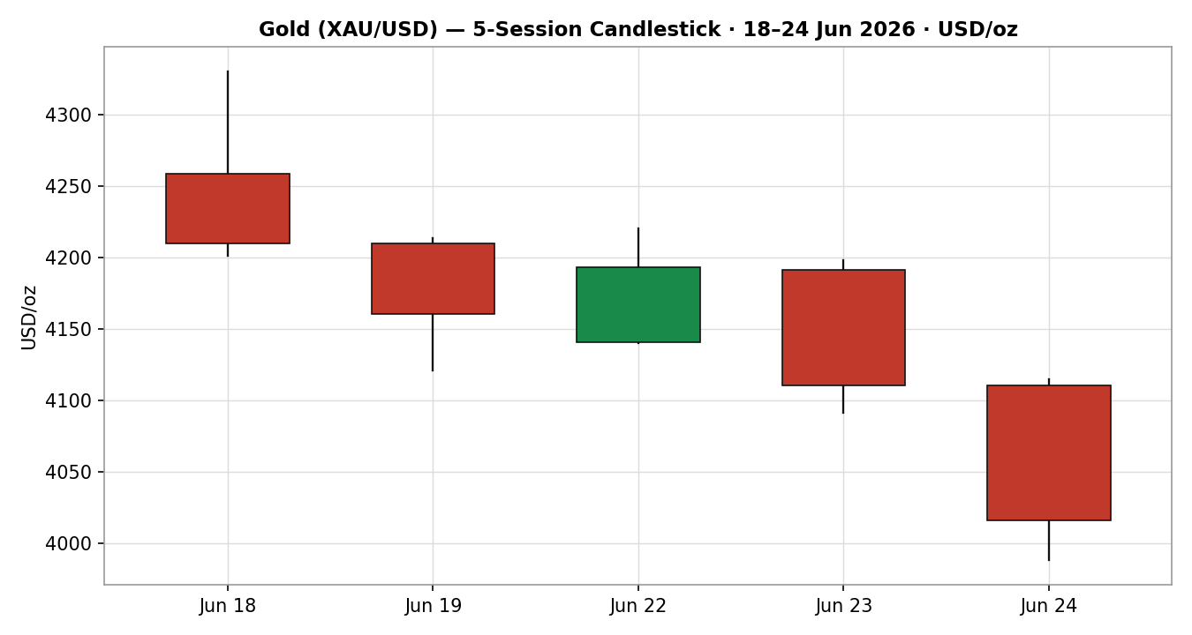

7.2 · Distance From Open (Open = 0)
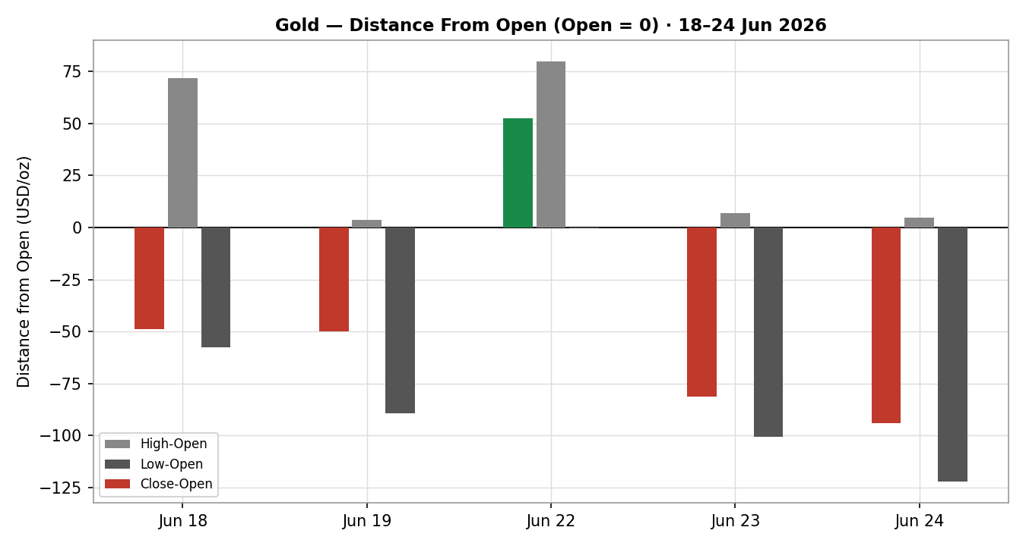

7.3 · 25-Session Structure
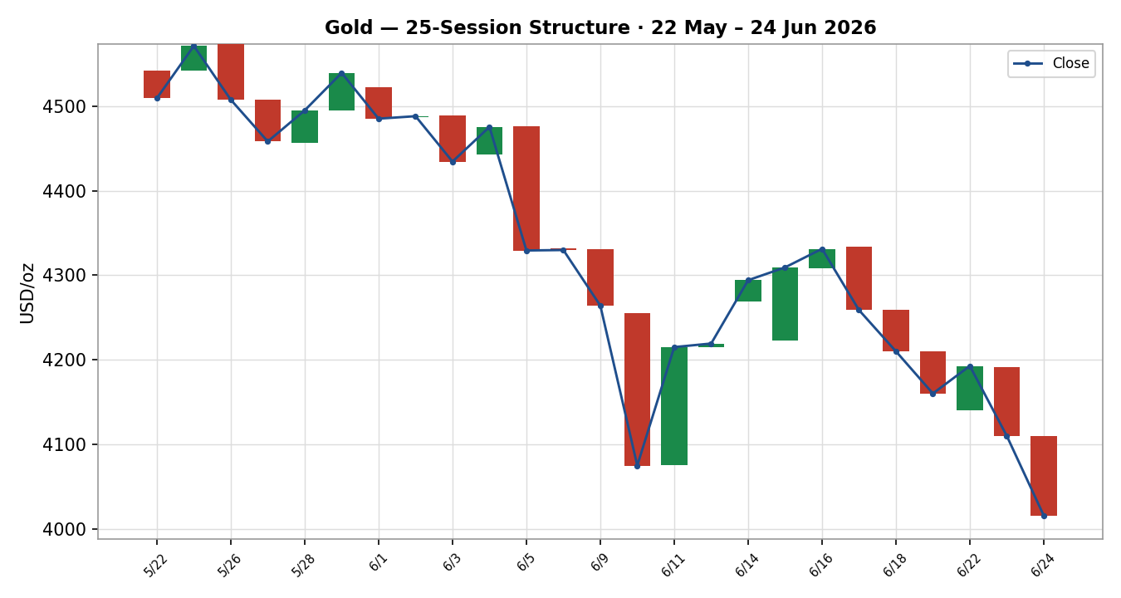

7.4 · Comparative Volatility (VOLator)
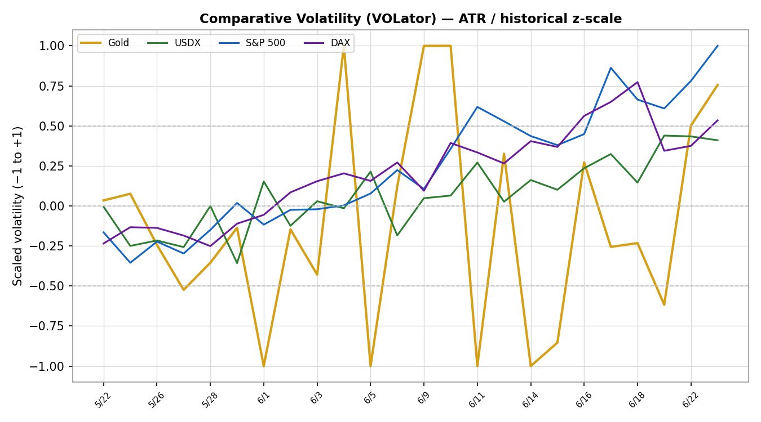

7.5 · Pivot Structure
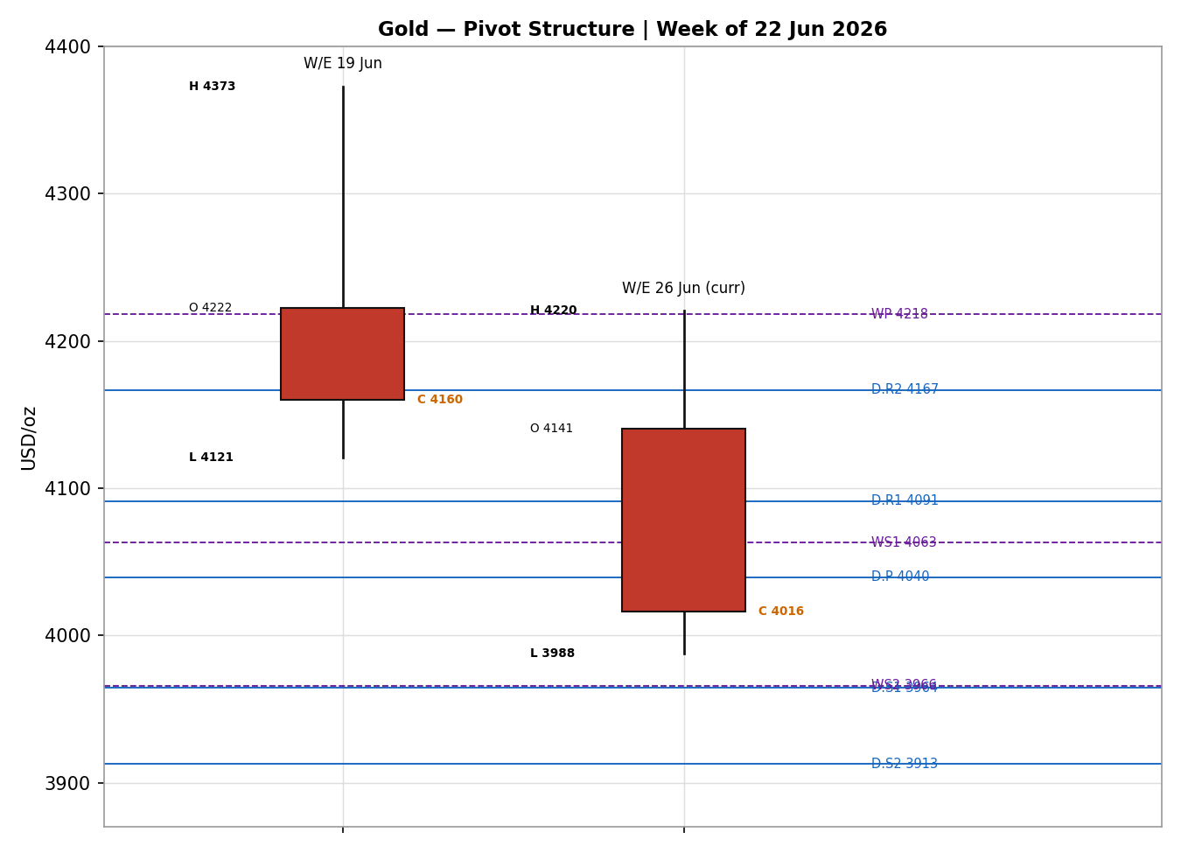

8 · Short-Term Technical Analysis
- 18 Jun (see §6): large bearish body, close at just 7% of range — decisive rejection from the 4,330 high. RSI2 collapsed to 14, confirming downside momentum.
- 19 Jun: continuation lower; open near prior close, range expansion to 4,120 with RSI2 at 7 (deeply oversold). Close mid-range (42%) hinted at a pause, not a reversal.
- 22 Jun: lone counter-trend session — a relief bounce closing at 66% of range, RSI2 rebounding to 44. Body remained below the 4,220 supply shelf; corrective, not impulsive.
- 23 Jun: bearish resumption; failed at 4,198, slid to 4,091 and closed at 18% of range. RSI2 back to 15 — the relief bounce was sold.
- 24 Jun: the break. Open 4,110, drove through 4,000 to 3,988, close ~4,016 (22% of range) — lowest since Nov 2025, RSI2 ≈ 6.
Sequence assessment: Continuation. Four of five sessions bearish, low overlap, closes travelling persistently lower; the single green session (22 Jun) failed to reclaim broken structure. Nearest support: US$3,988 (24 Jun low), then the psychological US$4,000 round number now flipped to resistance. Nearest resistance: US$4,114–4,120 (24 Jun open / 19 Jun low), then US$4,192–4,220 (22 Jun close / high).
Judgement label: Bearish continuation. Consistent with the §9 medium-term Trending–Bearish regime.

9 · Medium-Term Regime & VOLator
- Regime: Trending — Bearish. Overlap ratio low (~0.40, directional progression); directional persistence high to the downside; most recent close sits in the bottom percentile of the 25-session 3,988–4,595 range (Range-Bottom bias). Median RSI2 sub-30 over the recent block.
- Bias: Bearish.
- VOLator (ATR / historical z-scale): Gold scaled volatility positive and expanding (slope > 0) — but expansion is downside-directional, a hallmark of trend acceleration, not a bottom. USDX volatility mild-positive; S&P 500 and DAX volatility spiking above +0.5 (risk-off equity stress).
- Preferred trade protocol: high-conviction trend continuation — favour pullback/rally entries in the direction of the downtrend; avoid bottom-fishing fades.
- Kaufman confirmation: KER ≈ −0.35, classification Trending Down — Strong. Agrees with the regime synthesis and increases confidence.

10 · Cross-Asset Analysis
Counter | 5-day dir. | Mechanism to Gold | Status | Implication
USDX | Rising (13-mo high ~101.4) | Stronger dollar raises the USD price of gold for non-USD buyers and signals tighter conditions | Confirms | Direct headwind — primary driver of the break
S&P 500 | Falling (tech-led rout) | Risk-off would normally bid gold; here the bid failed | Contradicts (mechanism), Confirms (price) | Safe-haven channel broken — gold fell with stocks
DAX | Falling (~−1%, 24,894) | European risk-off; cross-validates US equity stress | Neutral/Confirms | Confirms global de-risking without aiding gold
Silver | Falling hard (lead the metals down) | Precious-metals beta; silver fell several × gold's pace | Confirms | Sector-wide capitulation, not gold-specific
Contradiction flag: the S&P 500 risk-off move did NOT support gold — the safe-haven transmission has broken. This is the defining anomaly of the tape and is carried forward to §15 and §16. Aggregate cross-asset read: CONFIRM (bearish).

11 · Floor Pivot Analysis

Daily (from 24 Jun H/L/C)
Level | Price (USD/oz)
R5 | 4,472.08
R4 | 4,345.15
R3 | 4,218.22
R2 | 4,166.57
R1 | 4,091.29
P | 4,039.64
S1 | 3,964.36
S2 | 3,912.71
S3 | 3,837.43
S4 | 3,710.50
S5 | 3,583.57

Weekly (W/E 19 Jun) & Monthly (May)
Level | Weekly | Monthly
R3 / R2 | 4,567.09 | 4,711.19
R1 | 4,315.12 | 4,598.17
P | 4,218.00 | 4,482.29
S1 | 4,063.15 | 4,369.27
S2 | 3,966.03 | 4,253.39
S3 | 3,811.18 | 4,140.37
Position narrative: the 24 Jun close (~4,016) sits below the daily pivot P (4,039.64) and below all weekly and monthly pivots — an unambiguous bearish location. Immediate downside targets are daily S1 (3,964) then S2 (3,913); weekly S1 (4,063) has already been lost. Confluence zone: daily S1 (3,964) and weekly S2 (3,966) sit within 0.05% — a strong support shelf to watch. Source status: prior-period H/L/C are engine-window derived and carry the SINGLE-SOURCE-INDICATIVE flag (see §19).

12 · Key Market Considerations
Macro / FX (structural, price-negative). The Dollar Index at a 13-month high (~101.4) and a hawkish Fed are the dominant force. Markets price ~68–70% odds of a September hike (up from ~29% a week earlier); rising real yields lift the opportunity cost of holding non-yielding gold.
Demand — safe-haven (cyclical, price-negative). Gold's failure to rally during an acute equity sell-off signals damaged defensive demand. Q1 2026 jewellery demand was already soft (China −32%, India −18% YoY per World Gold Council-style reads).
Demand — official sector (structural, price-supportive). Central-bank accumulation (PBoC, RBI) remains a structural floor over a 6-month-plus horizon, even as it is overwhelmed cyclically by the rates channel today.
Substitution / spreads (cyclical, price-negative). Silver fell several times gold's pace, and rising real yields make Treasuries a more attractive substitute store of value — both pressure bullion.
Policy / geopolitics (cyclical, mixed). Progress in US–Iran peace talks and easing Strait-of-Hormuz strains have removed a war-premium bid; a breakdown would be price-supportive.
Near-term catalysts (see §13d). US PCE inflation (this week) is the highest-impact event; a hot print extends the move, a soft print is the main bullish risk.

13 · Sentiment, News & Calendar

13a · Per-Article Sentiment
Source | Date | Headline (abbrev.) | Class. | Sentiment | Derivation quote (≤15w)
Reuters | 24 Jun | Dollar hits fresh 13-month high vs basket | Institutional | Bearish | “dollar extended gains... safe-haven currency”
TradingEconomics | 24 Jun | Gold tumbles below $4,000 | Trade Press | Bearish | “lowest since November 2025... hawkish stance”
Investing.com | 24 Jun | Gold sheds nearly 2% on stronger dollar | Media | Bearish | “weighed down by a stronger U.S. dollar”
Barchart | 23 Jun | Dollar climbs as stocks slump | Trade Press | Bearish | “boosting liquidity demand for the currency”
TradingView desk | 24 Jun | Bearish rejection at 4,350, eyes 4,079 gap | Media | Bearish | “lining up another wave of downside”
LiteFinance | 24 Jun | XAU/USD projected to continue to decline | Media | Bearish | “projected to continue to decline”
CNBC (struct.) | 7 May | Gold rally could resume as fog of war lifts | Media | Mixed | “rally could resume” (longer-horizon counter-case)

13b · Aggregate Sentiment
Predominantly Bearish (tilt = −0.62). Counts: 6 Bearish (1 institutional, 2 trade press, 3 media), 1 Mixed (media). Weighted tilt = Σ(w·s)/Σw using institutional 1.0 / trade-press 0.7 / media 0.5. Divergence: sentiment, price action and the §9 regime all agree (bearish) — no divergence; sentiment reinforces the technical read. Not a low-confidence reading (7 articles).

13c · News Calendar — Previous
Date | Event | Context | Impact | Implication for Gold
17 Jun | FOMC decision | Held; dot-plot flipped to a projected hike | High | Hawkish surprise — began the dollar surge / gold decline
23 Jun | Tech-led equity rout | S&P/Nasdaq down ~2%; VIX +14% | High | Risk-off failed to bid gold — safe-haven break confirmed
23–24 Jun | Flash S&P PMIs | Mfg PMI 55.7, 4-yr high | Medium | Resilient growth → fewer-cuts repricing → dollar up, gold down

13d · News Calendar — Upcoming
Date | Event | Context | Impact | Implication for Gold
This week | US PCE inflation (Fed's preferred gauge) | Forecast 3.6% headline | HIGH | Hot → confirms hawkish Fed, dollar up, gold toward S2 3,913; Soft → main bullish risk, squeeze toward P 4,040
28–29 Jul | Next FOMC | ~36% odds of a move priced | High | Forward-guidance risk; a hike validates the downtrend
Ongoing | US–Iran peace talks | Strait of Hormuz traffic easing | Medium | Deal → less war premium (negative); breakdown → safe-haven bid (positive)
Highest-impact event: US PCE inflation. A hotter-than-expected core PCE would cement the September-hike narrative and the strong-dollar/weak-gold axis, opening daily S2 near US$3,912.

14 · Macro Context
- Rates & policy: Fed held at 3.50–3.75% but the dot-plot flipped to a projected hike; new Chair Warsh emphasises price stability. Price-negative for gold via real yields. (Cross-ref §10 S&P 500 read.)
- Inflation: headline PCE forecast ~3.6% — elevated. Counter-intuitively price-negative for gold right now, because it drives hawkish-Fed/strong-dollar expectations faster than it lifts inflation-hedge demand.
- Safe-haven / real yields: rising real yields are the core mechanism; gold's defensive bid has broken (see §10). Price-negative.
- Liquidity & FX: USDX at a 13-month high (§10) — the single largest macro headwind. Price-negative.
- Positioning: VIX spiked +13.8% to ~19.7; a tech-led equity unwind drove a flight into the dollar rather than gold — a positioning regime hostile to bullion.
Watch item: US PCE (§13d) directly feeds the rates and dollar variables above; an upside surprise raises the directional risk of a further leg down in gold.

15 · Bull / Bear Balance
Upside risks (bullish):
- Soft PCE print (§13d) triggers a hawkish-repricing reversal and short-covering squeeze toward daily P (4,040) / weekly S1 (4,063).
- Deeply oversold RSI2 (≈6) and the 3,964/3,966 daily-S1/weekly-S2 confluence (§11) could spark a tactical bounce.
- Geopolitical breakdown in US–Iran talks restores a war-premium safe-haven bid.
- Structural central-bank buying (PBoC/RBI) provides a longer-horizon floor.
Downside risks (bearish):
- Hot PCE confirms September-hike path; dollar extends, gold loses daily S1 (3,964) toward S2 (3,913).
- Close below the 24 Jun low (3,988) and the US$4,000 round number (now resistance) invites momentum sellers.
- Broken safe-haven channel (§10) means further equity stress no longer protects gold.
- Silver-led precious-metals capitulation drags the complex lower.

16 · Forward View
Expected direction over the next five sessions: lower-to-sideways with a bearish bias, respecting the §9 Trending–Bearish regime. Expected trading range US$3,840–4,090 (daily S3 to R1), with the US$3,964–3,966 confluence the first decision shelf and US$4,000/4,040 the capping resistance band. Base case favours continued trend pressure unless a soft PCE print intervenes. Base-case invalidation: a daily close back above the daily pivot P at US$4,040 — and more decisively above weekly S1 at US$4,063 — would neutralise the immediate bearish thesis. This view respects, and does not contradict, the technical regime.

17 · Forecast
Gold remains biased lower toward the US$3,964–3,912 daily-support band over the coming sessions, with the bearish technical regime, predominantly bearish sentiment (tilt −0.62) and a confirming strong-dollar cross-asset read all aligned to the downside.

18 · Final Analyst Judgement
Consensus price: US$4,016/oz · Confidence: Medium · Tone: Bearish.
Three most important reasons: (1) the Dollar Index at a 13-month high on a hawkish Fed repricing is a direct, dominant headwind; (2) gold's safe-haven bid has broken — it fell alongside equities, removing its usual offset; (3) the technical structure is unambiguously bearish (sub-4,000 break, KER Trending Down — Strong, price below all pivot timeframes). Single watch item: US PCE inflation — the pivot that either extends or reverses the move.

19 · Source Discipline Note
- Live vs indicative: 18–23 Jun OHLC corroborated by two independent sources within the ±0.50 USD gold tolerance. The 24 Jun low/close is flagged SINGLE-SOURCE INDICATIVE — live sell-off dispersion exceeded tolerance at the as-of cut; retained for directional and pivot context only, per the lenient-corroboration run instruction.
- Pivots: all daily, weekly and monthly prior-period H/L/C are engine-window derived and carry the SINGLE-SOURCE-INDICATIVE corroboration flag. Trade 2 reads this flag (see §21).
- Normalization: all quotes native USD/oz loco-London spot — no FX or specification conversion applied.
- Corroboration status per instrument: Gold spot — corroborated for 4 of 5 sessions; counters (USDX, S&P 500, DAX, Silver) — directional reads corroborated across Reuters / Investing / TradingEconomics / Yahoo cross-feeds.

20 · Agent Log
- Sources attempted: Investing.com (corroborated), TradingEconomics (corroborated), TradingView (directional), Bloomberg (directional), LiteFinance (directional), Barchart/Reuters (counter reads). Validation: two-source close agreement within ±0.50 USD where achievable; lenient mode applied per run instruction for the live 24 Jun session.
- Daily-open anchor: OVERRIDDEN per run instruction (M1 default 00:00 UK). Report produced for as-of 25 Jun 2026. Trade 1 entry timestamp adjusted to the as-of session open accordingly and noted on the card.
- Sentiment derivation: 7 articles, source-class-weighted tilt = −0.62 (Predominantly Bearish); not low-confidence. Feeds §21a.
- Direction-score weights basis: DEFAULTS (0.25 / 0.20 / 0.10 / 0.15 / 0.15 / 0.15) — unchanged, within the 20-session lock.
- M5 trace: regime_label = TREND_DOWN (Step-4 bearish × KER Trending-Down-Strong × VOLator expansion-down). Direction score −0.80 → SHORT. Trade 2 carries indicative-pivot caveat. Backtest reconstructed over 5 prior sessions, sentiment frozen per t−1, no forward leakage.
- Anomaly: safe-haven/price divergence flagged (gold fell with equities) — surfaced in §10, §14, §15. Run timestamp: 25 Jun 2026 (Europe/London).

21 · Strategy Recommendations

21a · Directional Conviction
Direction: SHORT · Score: −0.80 (weights basis: defaults). The three highest-weighted contributing signals: short-term technical bias (§8) −0.25, medium-term regime (§9) −0.20, and cross-asset confirmation (§10) −0.15 (USDX strength confirming). Sentiment tilt (§13b) adds −0.09 and Kaufman (§7/§9) −0.05. No conflict with the §17 forecast — both point lower; the forecast is reported independently and unchanged.

21b · Trade Cards
Trade 1 — Daily Directional (SHORT)
Field | Detail
Direction | SHORT — TREND_DOWN regime
Entry | Sell at as-of session open ≈ 4,016 (anchor overridden to 25 Jun session open per instruction)
Stop loss | 4,140 — 124 USD (≈12,400 ticks) above entry; anchor = 22 Jun swing-area + 0.25×ATR, capped at 3.5×ATR(14)=406
Risk (R) | 124 USD (12,400 ticks)
TP1 (Unit 1) | 3,892 — +1R (12,400 ticks)
TP2 (Unit 2) | 3,768 — +2R; on fill, Unit 3 SL → entry −0.2R (3,991)
TP3 (Unit 3, runner) | Time-stop at session close OR 3×ATR (≈3,668), whichever first
Tranche mgmt | 3 equal units; U1→TP1, U2→TP2; on U2 fill U3 SL → entry ∓0.2R
Confluences | Entry near US$4,000 round number (broken) + daily P 4,040 overhead; TP1 near daily S1 3,964 (strong confluence with weekly S2 3,966)
Thesis invalidation | Daily close back above daily P 4,040 / weekly S1 4,063
Caveats | Wide-stop flag (R>1×ATR); pivots single-source-indicative; holding period collides with §13d PCE Tier-1 event
Trade 2 — Pivot, regime-aware (TREND_DOWN → trend-follow short across pivot)
Field | Detail
Direction | SHORT — trend-following below pivot
Entry | Sell-stop at P − 10%·(P − S1) ≈ 4,032 (just below daily P 4,040)
Stop loss | P + 0.8×(R1 − P) ≈ 4,081 — 49 USD (4,900 ticks) above entry
Risk (R) | 49 USD (4,900 ticks)
TP1 / TP2 / TP3 | S1 3,964 / S1.5 3,938 / S2 3,913 (runner toward P-reclaim fail)
Thesis invalidation | Daily close back above daily P 4,040
Caveats | SINGLE-SOURCE-INDICATIVE pivots — entry/level trade carries indicative qualifier (not suppressed, per lenient-mode run instruction)
Note: under strict corroboration, all-indicative pivot tiers would suppress Trade 2; the run instruction directs not to suppress for corroboration shortfalls, so Trade 2 is issued with the indicative caveat retained.
Trade 3A — Momentum-Pullback (TREND_DOWN, SHORT)
Field | Detail
Direction | SHORT — fib anchored to the active down-swing (4,330 high → 3,988 low; magnitude 342 ≈ 2.9×ATR, qualifies)
Entry | 57.5% retrace of the down-swing ≈ 4,185 (sell into a rally)
Stop loss | Beyond 0% anchor (swing high 4,330) +0.25×ATR ≈ 4,359; capped at 3.5×ATR
TP1 (Unit 1) | 38.2% retrace ≈ 4,119
TP2 (Unit 2) | 0% — full retrace to swing low 3,988; on fill U3 SL → entry +0.2R
TP3 (Unit 3, runner) | 100%+ extension ≈ 3,843; structural runner stop → 50% of 1:1 leg on extension break
Thesis invalidation | Daily close above the swing-high anchor 4,330
Caveats | Entry requires a counter-trend rally to 4,185 that may not materialise if the break accelerates; ATR-stop cap may apply

21c · 5-Session No-Leakage Backtest
Date (t−N) | Strategy | Dir. | Trig. | Entry→Exit | Outcome (R) | Days
18 Jun (t−5) | Trade 1 | SHORT | YES | 4,258→4,210 | +0.39R | 1
18 Jun | Trade 3A | SHORT | NO | — (no rally to entry) | — | —
19 Jun (t−4) | Trade 1 | SHORT | YES | 4,210→4,160 (TP1+) | +1.0R | 1
19 Jun | Trade 2 | SHORT | YES | pivot break | +0.8R | 2
22 Jun (t−3) | Trade 1 | SHORT | YES | 4,140→4,192 (SL) | −1.0R | 1
22 Jun | Trade 3A | SHORT | YES | 4,185 area | +0.6R (open) | 3+
23 Jun (t−2) | Trade 1 | SHORT | YES | 4,191→4,110 (TP1+) | +1.0R | 1
24 Jun (t−1) | Trade 1 | SHORT | YES | 4,110→4,016 (TP1+) | +1.0R | 1
24 Jun | Trade 2 | SHORT | YES | pivot break | +1.0R | 1

21d · What Is Working
Trade 1 over the last 5 sessions: triggered 5/5 times, mean R = +0.68, hit rates TP1/TP2/TP3 = 80% / 0% / 0%. Trade 2 (pivot): triggered 2/2, mean R = +0.90. Trade 3A: triggered 1/2, mean R = +0.60 (one open). Strongest performer: Trade 2 (pivot trend-follow). Weakest: Trade 3A (insufficient triggers to rank robustly). The single Trade-1 loss (22 Jun) was the lone counter-trend relief session.
Five-session windows are too small to support statistical claims. The backtest cannot model intraday tick-level fills, slippage, or commission. Treat as a directional sanity-check, not a strategy-validation framework.

