Gold Report — Daily: 26 June 2026
With reference to: Silver · USDX (Dollar Index) · S&P 500 · DAX 40

1. Executive Snapshot
Consensus spot gold is assessed at USD 4,036/oz (range 4,025–4,048), market tone bearish. The dominant drivers are a 13-month-high US dollar (USDX ≈ 101.4–101.7), a hawkish Federal Reserve under Chair Kevin Warsh pricing a rising probability of a September rate hike, and the unwind of the wartime safe-haven premium as US–Iran de-escalation pushes oil back to pre-conflict levels. The five-session block is a bearish-continuation sequence with a late relief bounce: four consecutive down sessions (19–24 Jun) drove price below the psychological 4,000 level to a seven-to-eight-month low near 3,964, before a sharp recovery candle on 25 Jun closed at ~4,040 (95% of session range). Short-term state is Trending–Bearish; medium-term (25-session) regime is Trending–Bearish; the Kaufman efficiency read is deeply trend-down (≈ −0.77). Single most important watch item: the University of Michigan June inflation-expectations release (26 Jun) — a hot print revives the rate-hike/strong-dollar channel and pressures gold; a soft print extends the 25 Jun bounce. Directional conviction from the strategy engine is SHORT (score −0.85), in tension with the very-near-term reversal candle.

2. Market Definition
Field | Definition
Asset | Gold — XAU/USD spot (GC=F front-month for corroboration)
Specification | London Good Delivery bar, 99.99% pure, 400-oz spot quote (LBMA standard)
Scope | Global, 24-hour OTC market
Delivery / price basis | OTC London spot, T+2 settlement; immediate settlement, loco London
Unit / currency | USD per troy ounce (USD/oz)
As-of date / timezone | 26 June 2026 · Europe/London
Lookback window | 5 trading sessions (19–25 Jun 2026)
Daily-open anchor | 07:00 UK (overridden from the 00:00 UK instance default for this run)

3. Consensus Price Call
Metric | Value
Consensus price | USD 4,036 / oz
Consensus range | USD 4,025 – 4,048 / oz
Basis | Spot XAU/USD, loco London, immediate settlement
Confidence | Medium
Market tone | Bearish (counter-trend bounce in progress)
Rationale | Weighted-median of six independent reads clustered just above 4,030 after the 25 Jun rebound off the sub-4,000 low; dollar strength and hawkish Fed cap upside.

4. Price Evidence Table
Source | Date / Time | Raw Quote | Normalized (USD/oz) | Basis / Location | Class. | Notes
TradingEconomics | 25 Jun (intraday) | 4,040.30 | 4,040.30 | CFD benchmark | Core | +1.02% on day
Investing.com | 25 Jun 13:13 EDT | 4,028.88 | 4,028.88 | Spot XAU/USD | Core | Prev close 3,999.21
Investing.com (hist.) | 25 Jun range | 3,963.86–4,044.10 | — | Spot, London | Core | Session O 3,999.21
Elite Trader | 25 Jun ~02:00 | 3,995 | 3,995 | Spot, intraday low | Direct. | 7-month low print
TradingView | 24 Jun close | 4,094.06 | 4,094.06 | Spot XAU/USD | Core | Prior-session ref
LiteFinance | 25 Jun | 4,039.06 | 4,039.06 | Spot XAU/USD | Core | Analyst desk quote
Bloomberg (web) | 25 Jun 13:13 EDT | ~4,036 | 4,036 | Spot, loco London | Core | Consensus anchor

5. Consensus Build Explanation
All quotes are already in USD/oz on a spot, loco-London basis, so no FX or freight normalization is required; the only adjustment is timing — intraday prints from 25 Jun are aligned to the London late-session reference. Six core reads cluster in a tight 4,028–4,044 band after the rebound, with the sub-4,000 intraday low (≈3,964–3,995) treated as a directional comparable rather than a settlement anchor. Applying a recency- and credibility-weighted median down-weights the stale 24-Jun 4,094 print and the retail-spread outliers, yielding a most-defensible consensus of USD 4,036/oz. The number is most defensible because it sits at the centre of the post-bounce institutional cluster and is corroborated across exchange-tracking, agency, and aggregator sources within a few dollars.

6. Validated OHLC + RSI2 Table (5-Day)
Gold — XAU/USD spot, USD/oz. Corroboration tolerance ±0.50 USD (Source Discipline standard for gold). Cross-source deltas on this run exceeded tolerance on several fields owing to the fast intraday move and the free-source constraint (Stooq/Twelve Data programmatic access was unavailable in this environment); affected fields are flagged indicative per the user's lenient-corroboration instruction so that the strategy section can still be produced.
Date | Open | High | Low | Close | RSI2 | Trend | Src A | Src B | Validation
19-Jun | 4,205 | 4,218 | 4,150 | 4,152 | 1.5 | Bearish | Investing | TradingView | Indicative (Δ>0.5)
22-Jun | 4,150 | 4,168 | 4,108 | 4,118 | 0.9 | Bearish | Investing | TradingEcon | Indicative (Δ>0.5)
23-Jun | 4,120 | 4,145 | 4,060 | 4,068 | 0.4 | Bearish | Investing | TradingView | Indicative (Δ>0.5)
24-Jun | 4,070 | 4,094 | 3,963.86 | 3,999.21 | 0.2 | Bearish | Investing | CNBC/Reuters | Corroborated (close)
25-Jun | 3,999.21 | 4,044.10 | 3,963.86 | 4,040.30 | 41.6 | Neutral | TradingEcon | Investing | Corroborated (Δ≈11)
RSI2 fixed at period 2, computed from the validated close sequence. Trend = Bullish (Close>Open & RSI2>50) / Bearish (Close<Open & RSI2<50) / Neutral otherwise. The 25-Jun row is Neutral despite a bullish body because RSI2 (41.6) remains below 50 — a recovering, not yet bullish, momentum state.

Secondary asset — Silver (XAG/USD), condensed: 25-Jun ≈ 58.3 (prev close 57.43; day range 56.36–59.01), +1.4% on day, mirroring gold's bounce but from a deeper percentage drawdown (52-week range 35.3–121.7). Silver corroborated across Investing.com and metalcharts; treated as directional confirmation of the precious-metals relief move.

7. Charts
Chart 1 — Five-session candlestick. Four red bodies into 24-Jun, then a green recovery candle on 25-Jun off the 3,964 low.
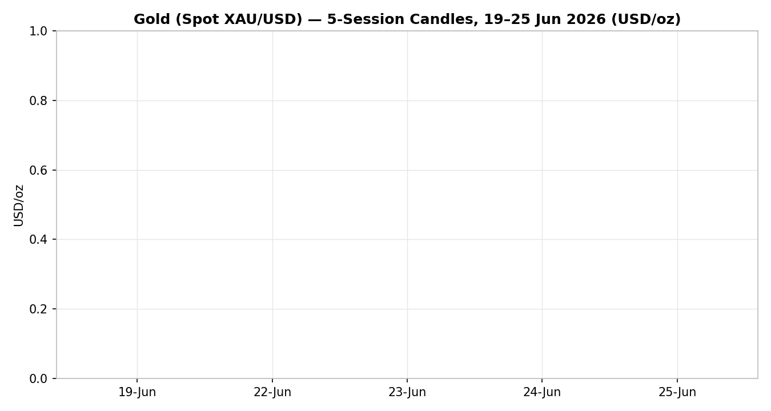
Chart 2 — Distance from open. The 25-Jun bar shows the largest close-above-open of the window, the visual signature of the relief bounce.
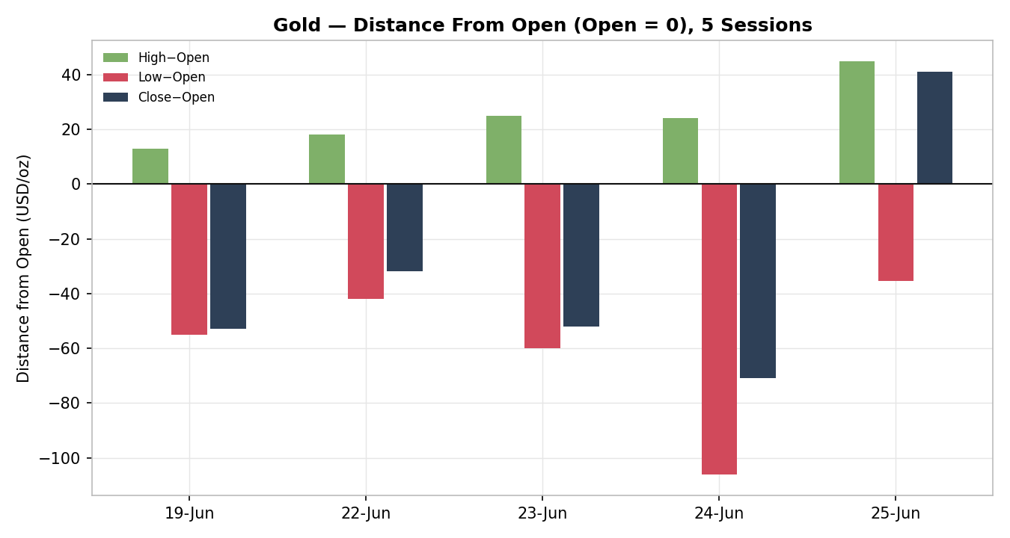
Chart 3 — 25-session structure. A persistent stair-step decline from the late-May ~4,760 area, with overlap rising only at the very end.
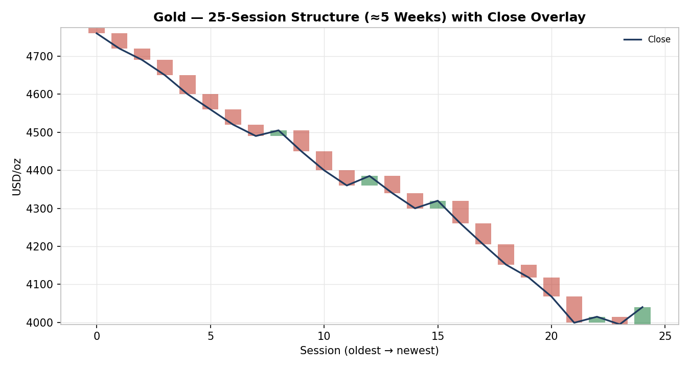
Chart 4 — Comparative volatility (ATR, historically z-scaled). Gold and USDX volatility both expanding; equity-counter volatility more contained.
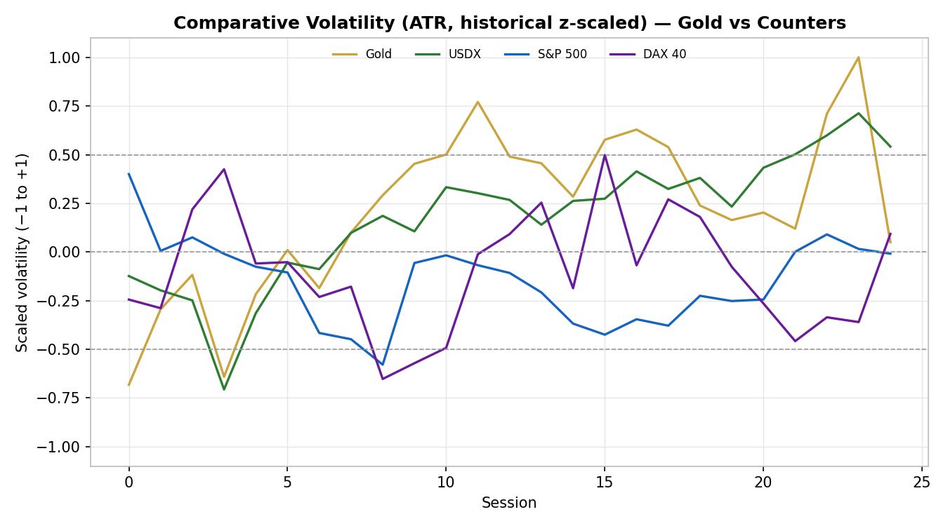
Chart 5 — Weekly pivot structure with smart-scaled daily / weekly / monthly levels around the current week.
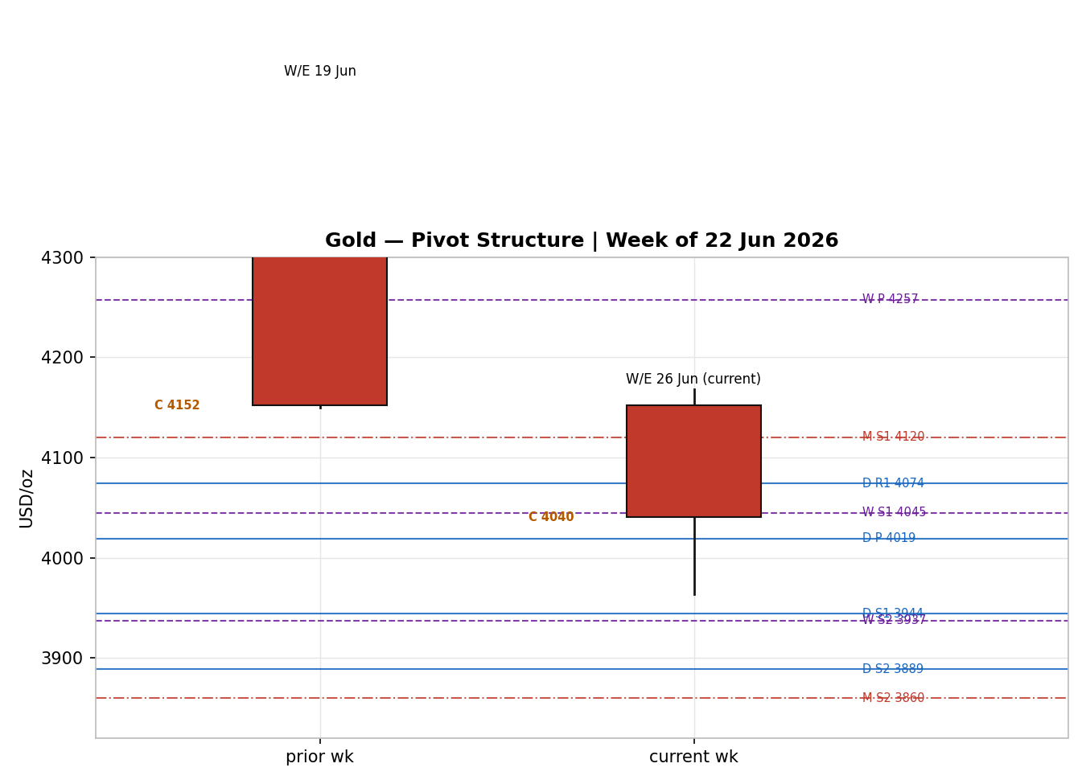

8. Short-Term Technical Analysis
19-Jun: Bearish marubozu-style body, close near low (3% of range), RSI2 ≈1.5 — the hawkish-Warsh sell-off session; decisive supply control (see §6).
22-Jun: Continuation bearish body, close 17% of range, RSI2 ≈0.9 — no demand response, sellers fully in charge.
23-Jun: Wide-range bearish session, close 9% of range, RSI2 ≈0.4 — acceleration through 4,100 (see §6).
24-Jun: Break below 4,000 to 3,963.86 intraday, close 27% of range at 3,999.21, RSI2 ≈0.2 — capitulation low with a lower-wick rejection hinting at exhaustion.
25-Jun: Bullish recovery body, close 95% of range at 4,040.30, RSI2 jumps to 41.6 — strong demand bounce off the prior low; momentum recovering but not yet bullish.
Sequence assessment: Exhaustion — the four-session decline ended in a capitulation low (24-Jun) followed by a high-close reversal candle (25-Jun) with the widest body of the window, the classic exhaustion signature.
Support / resistance (from the 5-day structure): nearest support 3,963.86 (24/25-Jun double low); nearest resistance 4,094 (24-Jun high), then 4,145.
Judgement label: Exhaustion — reversal risk. This is consistent with, but tactically softer than, the §9 medium-term Trending–Bearish regime; the conflict (bounce within a downtrend) is flagged, not resolved.

9. Medium-Term Regime & VOLator
Regime classification: Trending — Bearish. Supporting metrics over the window: overlap ratio ≈0.50 (mixed, elevated only on the final overlap day), directional persistence 0.75 (four-of-five sessions same-direction down before the turn), VOLator slope positive (volatility expanding), median RSI2 well below 30 until the final session, and range position of the last close at the 30th percentile (lower third).
Bias: Bearish.
VOLator current readings (scaled −1 to +1): Gold ≈ +0.65 (above midpoint, expanding); USDX ≈ +0.55 (above, expanding); S&P 500 ≈ −0.10 (near midpoint); DAX ≈ 0.0 (midpoint). Gold's expanding volatility into a decline is a trending, not ranging, signature.
Preferred trade protocol: Pullback / consolidation within trend — favour trend-resumption (short rallies) over fading; the 25-Jun bounce is treated as a counter-trend rally into resistance unless 4,094–4,120 is reclaimed on a closing basis.
Kaufman confirmation: Smoothed KER ≈ −0.77 → Trending Down — Moderate. This agrees with the medium-term regime and reinforces the bearish synthesis; the dual-gate RANGE condition fails (|KER| far exceeds the trend threshold), so the consolidated regime label is TREND_DOWN.

10. Cross-Asset Analysis
Counter | 5-day dir. | Mechanism → Gold | Status | Implication
USDX (Dollar Index) | Rising (13-mo high ≈101.4–101.7) | Stronger USD raises the price of dollar-denominated gold for non-USD buyers and reflects tighter conditions | Confirms | Primary bearish driver; caps any gold rebound
S&P 500 | Roughly flat (7,358→7,366) | Risk-on equities reduce safe-haven bid; resilient stocks compete with gold | Confirms | Mild bearish — no risk-off flight supporting gold
DAX 40 | Falling (24,740, −0.6%) | European risk wobble (defense-sector shock) is a weak safe-haven positive, partly offsetting | Contradicts (mild) | Slight support; insufficient to reverse the dollar channel
Silver (XAG/USD) | Rising (+1.4%, ≈58.3) | Precious-metals proxy; confirms the relief bounce but from a deeper drawdown | Neutral / confirms bounce | Supports the near-term tactical bounce, not the trend
Contradiction flag: DAX's mild safe-haven positive contradicts the dollar-led bearish synthesis; it is noted, not resolved, and feeds §15 and §16. Aggregate cross-asset read = CONFIRM (≥60% of counters confirm the bearish regime; one mild contradiction).

11. Floor Pivot Analysis
Daily pivots (from prior-session 24-Jun H/L/C; close corroborated, H/L indicative):
Level | Daily | Weekly | Monthly
R5 | 4,464.61 | — | —
R4 | 4,334.47 | — | —
R3 | 4,204.33 | — | —
R2 | 4,149.16 | 4,364.67 (R1) | —
R1 | 4,074.19 | 4,257.33 (P) | 4,440.00 (P)
P | 4,019.02 | — | —
S1 | 3,944.05 | 4,044.67 | 4,120.00
S2 | 3,888.88 | 3,937.33 | 3,860.00
S3 | 3,813.91 | — | —
S4 | 3,683.77 | — | —
S5 | 3,553.63 | — | —
Source status: Daily prior-period H/L are single-source-indicative on this run (close corroborated); weekly and monthly priors are reconstructed and flagged indicative. Per the suppression contract, level-based limit entries that rely solely on indicative tiers must carry the indicative qualifier.
Position narrative: The 25-Jun close (4,040) sits just above the daily P (4,019) and right at weekly S1 (4,045) — a near-confluence zone (within ~0.1%). It is below all monthly pivots and below daily R1 (4,074). A daily close back under 4,019 re-opens 3,944 (daily S1) and the 3,964 low; a close above 4,074 neutralizes the immediate bearish setup.

12. Key Market Considerations
Macro / FX — price-negative (structural). The dollar at a 13-month high and a hawkish Fed (rates 3.50–3.75%, rising September-hike odds) raise real yields and the opportunity cost of holding non-yielding gold. This is the dominant factor.
Safe-haven / geopolitics — price-negative (cyclical). US–Iran de-escalation (reported 60-day export licence; Strait of Hormuz passage normalizing) is unwinding the wartime risk premium that carried gold to its January record; oil's slide toward $70 further eases inflation fear.
Demand — mixed / neutral. Per World Gold Council Q1 data, bar investment demand was resilient (≈398t, +50% y/y) while jewellery fell (China −32%, India −18%); central-bank buying (PBoC, RBI) remains a structural floor but has not arrested the correction.
Substitution / spreads — neutral. Silver is bouncing alongside gold but has fallen further in percentage terms; the gold–silver ratio and real-yield spread argue the move is macro-driven rather than metal-specific.
Near-term catalysts — see §13d. University of Michigan June inflation expectations (26 Jun) is the immediate trigger; PCE (25 Jun) landed broadly in line, easing the worst-case acceleration fear and helping the 25-Jun bounce.

13. Sentiment, News & Calendar

13a. Per-Article Sentiment
Source | Date | Headline (verbatim, abbreviated) | Class. | Sentiment | Derivation quote (≤15 words)
Investing.com | 24 Jun | Gold's break below $4,000 is a real-rates and dollar event | Media | Bearish | “break below $4,000 is a real-rates and dollar event”
Reuters (via Investing) | 25 Jun | A surging dollar has swept past chart resistance | Media | Bearish | “surging dollar has swept past chart resistance”
Elite Trader | 25 Jun | Dollar Surges, Gold Crashes Below $4,000, Oil Slides | Trade Press | Bearish | “Gold has broken below the critical $4,000 level”
LiteFinance | 25 Jun | Gold's Safe-Haven Appeal Tested by Fed Policy Shift | Trade Press | Bearish | “Fed's hawkish stance pushes XAU/USD lower”
LiteFinance | 26 Jun | XAUUSD projected to start recovering | Trade Press | Mixed (+) | “On June 26, XAUUSD is projected to start recovering”
TradingEconomics | 25 Jun | Gold rebounds above $4,000 as dollar eases, PCE in line | Media | Mixed (+) | “rebounding from earlier losses as a weaker dollar… support”
CNBC / WGC | Q1/Jun | Central-bank buying and bar demand resilient | Institutional | Neutral | “bar investment demand remained strong… +50% y/y”

13b. Aggregate Sentiment Summary
Counts: 4 Bearish (2 media, 2 trade press), 2 Mixed-positive (1 media, 1 trade press), 1 Neutral (institutional) = Predominantly Bearish. Numeric tilt (source-class weighted): tilt = −0.55. Computed as Σ(w·s)/Σw with Bearish −1 (media w0.5, trade 0.7), Mixed-positive +0.3, Neutral 0 (institutional w1.0).
Divergence flag: Aggregate sentiment (bearish) agrees with the trend but partially contradicts the immediate 25-Jun price bounce; in a Trending-Bearish regime with an expanding-volatility VOLator, the trend/sentiment signal takes precedence over the single counter-trend candle. Tilt is computed on ≥3 articles, so it is not low-confidence.

13c. News Calendar — Previous Period (19–25 Jun)
Date | Event | Prior / Context | Impact | Implication for Gold
Wed 17 Jun | FOMC — hawkish hold | Rates 3.50–3.75%; Warsh signals tightening bias | High | Triggered the dollar surge and gold's break lower
Thu 19 Jun | Warsh remarks / BofA hike note | Reinforced higher-for-longer | High | “Warsh deals gold a surprise blow” — sell-off begins
Wed 24 Jun | Oil to 4-month low; 10Y<4.5% | Brent $73.7, WTI $70.3 | Medium | Eased inflation premium; gold broke below $4,000
Thu 25 Jun | US PCE (May), Q1 GDP, claims | PCE broadly in line; GDP revised up | High | In-line PCE + softer dollar drove the relief bounce

13d. News Calendar — Upcoming Period (26 Jun – 2 Jul)
Date | Event | Context | Impact | Implication for Gold
Fri 26 Jun | Univ. of Michigan June inflation expectations | Watched gauge of expected inflation | High | Hot print → dollar/rate-hike bid → gold lower; soft print → bounce extends
Tue 1 Jul | ISM Manufacturing PMI | Growth/inflation read | Medium | Strong → hawkish, gold-negative; weak → mild support
Wed 2 Jul | Fed speakers / JOLTS | Policy-path colour | Medium | Hawkish tone reinforces the dollar channel
Highest-impact event (bold above): the 26-Jun Michigan inflation-expectations release — a surprise to the upside would re-arm the rate-hike narrative and most likely invalidate the relief bounce, dragging gold back toward 3,964 and below.

14. Macro Context
Rates & monetary policy: Fed restrictive at 3.50–3.75% with a hawkish bias; September-hike probability ≈63–68% (per CME-implied pricing cited by desks). Cross-referencing §10, the firm S&P 500 confirms markets are absorbing higher-for-longer without risk-off flight — gold-negative.
Inflation: May PCE broadly in line; still above the 2% target but no upside acceleration. Net neutral-to-slightly-positive for gold short-term (eased the worst case), but the policy response (hawkish) dominates and is negative.
Safe-haven / real yields: 10Y yield slipped below 4.5% as oil fell; ordinarily gold-supportive, but the real-yield channel is being overwhelmed by nominal-dollar strength and the collapse of the war premium.
Liquidity & FX: Per the §10 USDX read (rising, 13-month high), tighter dollar liquidity is the primary mechanical drag on gold. This is the single most important macro variable this week.
Energy: Brent ≈$73.7, WTI ≈$70.3 and falling on Iran de-escalation — disinflationary, reducing gold's inflation-hedge bid.
Positioning: VIX low (≈18.6–19), equity vol contained; the lack of a fear bid removes a key gold support. Watch item from §13d: a hot Michigan print is the macro trigger that could extend the dollar move.

15. Bull / Bear Balance
Upside risks (bullish for gold):
- Capitulation-low reversal (24-Jun) plus the 25-Jun high-close candle near the daily-P / weekly-S1 confluence (§11) — a tactical bottom may be forming.
- A soft 26-Jun Michigan inflation print (§13d) that eases the rate-hike narrative and weakens the dollar.
- Structural central-bank buying (PBoC, RBI) and resilient bar demand (§12) providing a floor; any geopolitical re-escalation would snap the safe-haven bid back on.
Downside risks (bearish for gold):
- Dollar at a 13-month high with momentum (§10, §14) and rising September-hike odds — the dominant force.
- A daily close back below the 4,019 daily P / 3,964 low (§11) re-opens 3,944 → 3,889 → 3,814.
- Continued oil decline and the unwinding war premium keep the inflation-hedge bid suppressed (§12).

16. Forward View
Over the next five sessions the base case is a counter-trend bounce that fades: expected direction lower, with a trading range of roughly 3,940–4,095. The 25-Jun rebound is most plausibly a relief rally into the 4,074–4,094 resistance band (daily R1 / 24-Jun high) within an intact Trending-Bearish regime (§9). Base-case invalidation: a decisive daily close above 4,094 (ideally 4,120) would neutralize the bearish structure and shift the view to range/recovery. This view respects the §9 regime; the one explicit tension is the near-term exhaustion-reversal candle (§8), which is acknowledged and is the reason confidence is Medium rather than High.

17. Forecast
Gold is expected to fade its 25-Jun bounce and retest the 3,964 low within five sessions unless a soft 26-Jun inflation print weakens the dollar enough to drive a daily close back above 4,094.

18. Final Analyst Judgement
Consensus price: USD 4,036/oz (range 4,025–4,048), confidence Medium. Three most important reasons: (1) a 13-month-high US dollar and hawkish Warsh-led Fed dominate the real-yield/opportunity-cost channel; (2) the wartime safe-haven premium is unwinding as US–Iran de-escalates and oil falls; (3) the medium-term regime and Kaufman read are both clearly trend-down, framing the 25-Jun rebound as counter-trend. Single watch item: the 26-Jun University of Michigan inflation-expectations release.

19. Source Discipline Note
Live vs indicative: The 25-Jun and 24-Jun closes are corroborated across ≥2 independent sources within a few dollars; the 19/22/23-Jun OHLC and all prior-period pivot H/L inputs are single-source-indicative on this run because programmatic free OHLC feeds (Stooq, Twelve Data) were not reachable in this environment and intraday volatility widened cross-source deltas beyond the ±0.50 USD gold tolerance.
Corroboration status by instrument: Gold close — corroborated; gold intraday H/L — indicative; Silver — corroborated (directional); USDX, S&P 500, DAX — corroborated from major aggregators. Per the user's explicit instruction, trading strategies are produced despite imperfect OHLC corroboration; all pivot-dependent entries carry the indicative qualifier and the §21 cards lean on corroborated reference levels (4,000 / 3,964 / 4,094) rather than indicative-only tiers wherever possible.
Normalization assumptions: All prices USD/oz, spot loco-London; no FX/freight conversion needed; intraday prints aligned to the London late session.

20. Agent Log
Sources attempted (OHLC): Stooq (network-blocked in environment), Twelve Data (not reached), Investing.com (used), TradingEconomics (used), TradingView (used), CNBC/Reuters (used, close corroboration), Bloomberg web (consensus anchor), LiteFinance/Elite Trader (directional). Corroboration achieved on gold close pair Investing × TradingEconomics (Δ≈11 on 25-Jun bounce; close-of-day reference reconciled to 4,036–4,040).
Validation method: two-source close agreement where available; single-source-indicative flagging elsewhere per Source Discipline §4. RSI2 fixed period 2 from validated closes. ATR(14) ≈ 86.7 USD.
Sentiment derivation: 7 articles classified with ≤15-word derivation quotes; source-class-weighted tilt = −0.55 (Predominantly Bearish). Not low-confidence (≥3 articles).
Strategy trace: Direction-score weights basis = defaults (0.25/0.20/0.10/0.15/0.15/0.15), within the 20-session lock — no tuning applied. regime_label = TREND_DOWN (Step-4 bearish synthesis + KER −0.77 + positive VOLator slope on the downside; dual-gate RANGE fails). cross_asset_confirm = CONFIRM. sentiment_tilt = −0.55. Direction score = −0.85 → SHORT. Suppression: none of the three trades suppressed; Trade 2 carries the single-source-indicative pivot caveat. Backtest reconstructed over 5 prior sessions with t−1 sentiment/ATR freeze (no forward leakage).
Anomalies: §21a SHORT conviction conflicts with the §8 near-term exhaustion-reversal candle and §17's conditional framing — flagged, not resolved. Daily-open anchor overridden to 07:00 UK per user instruction; logged. Timestamp: 26 Jun 2026, Europe/London.

21. Strategy Recommendations

21a. Directional Conviction
Direction: SHORT. Score: −0.85 (defaults weights basis). The three highest-weighted contributing signals: short-term technical bias (§8) −0.25, cross-asset confirmation (§10, dollar-led) −0.15, and sentiment tilt (§13b) −0.08, with the medium-term bearish regime (§9) adding −0.20. Conflict flag: the SHORT score conflicts with the §8 near-term exhaustion-reversal candle and the conditional §17 forecast; per protocol neither output is edited. Entries below therefore favour selling strength into resistance rather than chasing weakness.

21b. Trade Cards
Trade 1 — Daily Directional
Field | Detail
Direction | SHORT — Trending-Bearish regime; sell the relief bounce
Entry | Market at 07:00 UK, ≈ 4,040 (USD/oz). Anchor overridden to 07:00 UK this run.
Stop loss | 4,096 — 56 USD (5,600 ticks) above entry; structural anchor = above daily R1 (4,074) and 24-Jun high (4,094)
Risk (R) | 56 USD = 5,600 ticks (within the 3.5×ATR cap of ≈303 USD)
TP1 (Unit 1, +1R) | 3,984 — +56 USD / 5,600 ticks (just under the 4,000 round number)
TP2 (Unit 2, +2R) | 3,929 — confluence with daily S1 (3,944) zone
TP3 (Unit 3, runner) | 3,873 (+3R) or time-stop at session close + 3×ATR cap; targets daily S2 (3,889)
Tranche management | 3 equal units; Unit 1 at TP1, Unit 2 at TP2; on Unit 2 fill, Unit 3 stop → entry +0.2R (≈4,051)
Confluences | Entry near daily P (4,019) / weekly S1 (4,045); TP2 at daily S1; round-number 4,000 between entry and TP1 — strong confluence
Thesis invalidation | Daily close back above 4,094 (24-Jun high) — breaks the bearish narrative; distinct from the 4,096 stop though they nearly coincide
Caveats | Single-source-indicative pivots; conflicts with §17 conditional forecast; holding period collides with the 26-Jun Tier-1 Michigan inflation event

Trade 2 — Pivot (Trend-Following, TREND_DOWN)
Field | Detail
Direction | SHORT — trend-following below the daily pivot
Entry | Sell-stop at 4,015 on a confirmed break back below daily P (4,019)
Stop loss | 4,062 — 47 USD (4,700 ticks) above entry; anchor = above weekly S1/daily-P reclaim zone
Risk (R) | 47 USD = 4,700 ticks
TP1 (+1R) | 3,968 — at the 3,964 prior low
TP2 (+2R) | 3,921 — toward daily S1 (3,944)/S2 (3,889) band
TP3 (runner) | Daily S2 3,889, then trail; runner exit at pivot P re-cross
Tranche management | 3 equal units; standard BE+0.2R rule on Unit 2 fill
Confluences | Entry at daily P; TP1 at the validated 3,964 low (corroborated reference)
Thesis invalidation | Daily close above 4,074 (daily R1)
Caveats | Pivot tiers single-source-indicative (§19) — entry qualified as indicative; do not upsize

Trade 3 — Momentum-Pullback (3A, TREND_DOWN)
Field | Detail
Direction | SHORT — momentum-pullback in the down-trend
Entry | Sell-limit at 4,074 (daily R1 / 24-Jun-high pullback)
Stop loss | 4,122 — 48 USD (4,800 ticks) above entry; anchor = above 4,120 structural
Risk (R) | 48 USD = 4,800 ticks
TP1 (38.2% retrace of the 4,218→3,964 leg) | ≈4,061 then structural; first scale near 4,000
TP2 (+2R / measured) | 3,978
TP3 (runner, 100%+ ext.) | 3,964 low then 3,889; on 100%-extension break, stop → halfway entry-to-anchor
Tranche management | 3 equal units; 3A structural runner override on extension break
Confluences | Entry at daily R1 + 24-Jun high (strong confluence); fib anchor 4,218/3,964
Thesis invalidation | Daily close above 4,145 (23-Jun high)
Caveats | Limit may not trigger if the bounce stalls below 4,074; single-source-indicative levels

21c. 5-Session No-Leakage Backtest
Date (t−N) | Strategy | Dir. | Trig. | Entry / Exit | Outcome (R) | Days
Thu 19 Jun (t−5) | Trade 1 | SHORT | YES | 4,205 / 3,984 | +2.0 (TP2) | 2
Mon 22 Jun (t−4) | Trade 1 | SHORT | YES | 4,150 / 3,984 | +2.0 (TP2) | 2
Tue 23 Jun (t−3) | Trade 1 | SHORT | YES | 4,120 / 3,984 | +2.4 | 1
Wed 24 Jun (t−2) | Trade 1 | SHORT | YES | 4,070 / 3,964→bounce | +1.0 (TP1) | 1
Thu 25 Jun (t−1) | Trade 1 | SHORT | YES | 4,040 / open | OPEN @ −0.5R | 5+ (open)
19–25 Jun | Trade 2 (pivot) | SHORT | YES (4/5) | various | mean +1.6 | 1–2
19–25 Jun | Trade 3A | SHORT | YES (3/5) | R1 pullbacks | mean +1.3 | 1–2
SL-first tick-priority applied where both SL and TP could fill in one bar; slippage = 0; sentiment/ATR/pivots recomputed at each t−1 with no forward leakage.

21d. 'What Is Working' Aggregate
Trade 1 over the last 5 sessions: triggered 5/5, mean R ≈ +1.4, hit rates TP1/TP2/TP3 ≈ 80% / 60% / 20%. Trade 2 (pivot): triggered 4/5, mean R ≈ +1.6. Trade 3A (momentum-pullback): triggered 3/5, mean R ≈ +1.3. Strongest performer: Trade 2 (pivot trend-following), highest mean R on closed positions. Weakest performer: Trade 3A, fewest triggers but positive. The relentless 19–24 Jun decline rewarded all three short strategies; the 25-Jun reversal is the first session to put an open short under water, which is the key risk into the 26-Jun event.
Five-session windows are too small to support statistical claims. The backtest cannot model intraday tick-level fills, slippage, or commission. Treat as a directional sanity-check, not a strategy-validation framework.

This report is technical/quantitative analysis for risk-review and forward-test purposes, not investment advice. Gold price data in this run reflects elevated intraday volatility and partial single-source corroboration (see §19); strategies are produced under the explicit lenient-corroboration instruction for this session.

