Gold (Spot) Report — Daily: 26 May 2026
With reference to: Silver (XAG/USD) · USDX · S&P 500 · DAX 40
Senior Commodities Analyst — Precious Metals · Snapshot: close of 25 May 2026 (Europe/London) · Trading and risk review (forward-test)
Spot quote loco London (XAU/USD); CME front-month futures used for cross-validation. All prices USD per troy ounce.

1. Executive Snapshot
Spot gold is assessed at a consensus USD 4,562 per troy ounce as of the close of 25 May 2026, the upper end of a defensible USD 4,545–4,580 range. Market tone is balanced with an emerging short-term bullish tilt. The price level is governed by three dominant drivers: (i) a sharp two-week unwind from the mid-April USD 4,890 high that carried spot down to a USD 4,454 swing low on 21 May; (ii) a weekend de-escalation signal in US–Iran negotiations that pulled crude sharply lower into 25 May, easing the inflation-and-rate-hike fear that had been the principal weight on bullion; and (iii) a softer US dollar on the same catalyst, which mechanically lifted the dollar-denominated metal.
The short-term technical state is Transitional with a bullish reversal underway — the last two sessions (22 and 25 May) printed higher closes off the USD 4,454 base, with 25 May the strongest single session in the window (+1.18%). The medium-term regime over the trailing 25 sessions is Ranging-to-Transitional: a high overlap ratio (0.69) and near-random directional persistence (0.52) sit against a deep range-position read (the close is in the lower quartile of the 25-session band). The Kaufman Efficiency Ratio classifies the medium-term path as Trending Down — Moderate (smoothed value −0.21), reflecting the still-negative net drift from mid-April even as the last two sessions turn up; this disagreement is treated as a mixed signal and flagged below.
Single most important watch item: the US Q1 GDP (second estimate) and weekly jobless-claims release on 28 May 2026. A downside growth surprise would reinforce the easing-of-rate-hike-risk narrative and is the most direct upside catalyst for gold inside the five-session horizon; an upside surprise revives the hawkish-Fed thread that capped the metal through mid-May.
Directional conviction (strategy module): the direction score resolves to LONG at +0.49, above the conviction threshold — driven by the short-term technical reversal, a predominantly bullish sentiment tilt, and a constructive cross-asset read. Three regime-aware trade cards follow in §21; the regime label is TRANSITION.

2. Market Definition
This report analyses the consensus spot price of gold and the principal factors supporting, pressuring, or distorting that price.
Parameter | Definition
Commodity / asset | Gold — precious metals. Spot XAU/USD; CME front-month futures (June contract) used only for corroboration.
Product specification | London Good Delivery bar, 99.99% pure, 400-oz spot quote (LBMA standard; matches the XAU/USD interbank quote convention).
Market scope | Global. Spot gold is a 24-hour, 23+-hour-traded market with no single regional focus.
Price basis | Spot, immediate settlement, loco London.
Delivery basis | OTC London spot, T+2 settlement (LBMA convention).
Unit / currency | USD per troy ounce.
As-of date | Close of 25 May 2026 (Europe/London). Report issued for the 26 May 2026 session.
Lookback window | 5 trading days for the execution block; 25 sessions for the medium-term regime block.

3. Consensus Price Call
Field | Value
Consensus price | USD 4,562 / oz
Consensus range | USD 4,545 – 4,580 / oz
Basis | Spot, loco London, immediate settlement
Confidence level | Medium
Market tone | Balanced, with a short-term bullish tilt
Rationale | The weighted-median of recent independent spot reads clusters around USD 4,560–4,565 for the 25 May close. Confidence is held at Medium rather than High because vendor spot quotes dispersed by USD 25–40 intraday during the 25 May recovery (a low-liquidity UK/US holiday session) and because the 25 May candle is a strong directional move whose follow-through is not yet confirmed.

4. Price Evidence Table
Observations for the 25 May 2026 spot close. Raw quotes normalised to USD/oz, loco London spot basis. Futures observation normalised by removing the spot-futures basis.
Source | Date/Time | Raw quote | Normalised | Basis / location | Relevance | Notes
USA Gold | 25 May close | 4,562.69 | 4,562.69 | Spot, loco London | Core | Stated daily close, +1.18%.
IFC Markets | 25 May | 4,571.04 | 4,571.04 | Spot XAU/USD | Core | Spot per-ounce read.
FXEmpire (OANDA) | 25 May 18:29 UTC | 4,570.32 | 4,570.32 | Spot XAU/USD CFD | Core | OANDA-sourced spot.
Bloomberg | 25 May intraday | 4,602.30 | ≈4,578 | Spot, loco London | Directional | Intraday peak read; outside close window — down-weighted.
CNBC (XAU=) | 25 May intraday | 4,556.49 | 4,556.49 | Spot XAU/USD | Core | Intraday quote near close.
Investing.com (GC=F) | 22 May settle | 4,655.35 | ≈4,560 | CME futures, June | Directional | Futures; spot-futures basis removed for comparability.
Trading Economics | 22 May close | 4,516.75 | 4,516.75 | Spot CFD benchmark | Core | Prior-session anchor for the 25 May move.
Six independent observations clear the minimum-source requirement. The Bloomberg intraday peak and the GC=F futures print are classified Directional rather than Core because neither is a clean spot-close read on the loco-London basis.

5. Consensus Build Explanation
Normalisation. All quotes were converted to the USD/oz, loco-London spot basis. The single futures observation (CME June contract, USD 4,655 settle on 22 May) was adjusted by removing the prevailing spot-futures basis to produce a spot-comparable figure of roughly USD 4,560; this carries an explicit basis-conversion assumption and is therefore used only as a directional cross-check, not as a core input.
Weighting. A weighted-median was applied, over-weighting the three clean 25 May spot-close reads (USA Gold, IFC Markets, FXEmpire) and the CNBC intraday quote, and down-weighting (i) the Bloomberg intraday peak, which reflects the session high rather than the close, and (ii) the futures-derived figure, which carries a conversion assumption. The four core spot reads span USD 4,556–4,571; their weighted-median falls at approximately USD 4,562.
Exclusions. No observation was fully excluded. Retail bullion-dealer premium prices were not gathered, consistent with the instruction to exclude retail spot. The cached vendor historical tables (Investing.com spot and futures) terminate on 14 May 2026 and therefore could not corroborate the 15–25 May sessions directly; those sessions are flagged in §19.
Why the number is defensible. USD 4,562 is the weighted-median of the cleanest available spot-close reads, is internally consistent with the basis-adjusted futures print, and sits squarely inside the independently observed 25 May session range. The Medium confidence rating reflects genuine intraday vendor dispersion on a thin holiday session rather than any conflict over the central tendency.

6. Validated OHLC + RSI2 Table (5-Day)
Five validated trading sessions for gold spot ending at the 25 May 2026 snapshot. The 23–24 May weekend dates are excluded. RSI2 is period-2, computed from the validated close sequence; it saturates at 0 or 100 after consecutive same-direction closes — this is expected behaviour, not an error.
Date | Open | High | Low | Close | RSI2 | Trend | Sources | Outcome
19 May | 4,552.26 | 4,583.40 | 4,505.80 | 4,537.00 | 0.0 | Bearish | Multi-vendor spot | Indicative
20 May | 4,537.00 | 4,568.09 | 4,460.20 | 4,480.50 | 0.0 | Bearish | TU × spot reads | Indicative
21 May | 4,480.50 | 4,538.60 | 4,454.14 | 4,510.40 | 34.6 | Neutral | Spot reads × wkly-low | Indicative
22 May | 4,510.40 | 4,579.68 | 4,505.30 | 4,516.75 | 100.0 | Bullish | Investing.com × T.Econ | Corroborated (Δ≈0)
25 May | 4,509.38 | 4,602.30 | 4,505.10 | 4,562.69 | 100.0 | Bullish | USA Gold × IFC × FXE | Corroborated (Δ≈8)
Validation note. The 22 and 25 May closes are corroborated within the documented working tolerance by at least two independent sources. The 19–21 May intraday High/Low fields are marked single-source — indicative only: the cached two-source historical tables terminate on 14 May, so those sessions were reconstructed from multiple individual spot reads rather than two reconciled OHLC feeds. Per the source-discipline rules these indicative fields are not used for pivot prior-period calculations; daily pivots for 26 May are built from the corroborated 25 May session only. See §19.

Secondary asset — Silver (XAG/USD), condensed
Silver tracked gold's decline and rebound with a higher beta. Spot silver is read near USD 77.5/oz at the 25 May close, up roughly +2.6% on the session as the precious-metals complex rallied together; the gold/silver ratio compressed to about 58.9. Silver's regime read is consistent with gold's — a sharp drawdown into mid-to-late May followed by a sharp two-session recovery — and does not diverge from the primary-asset synthesis.
Date | Open | High | Low | Close | Trend
21 May | ≈74.0 | ≈75.6 | ≈73.2 | ≈75.0 | Bullish
22 May | ≈75.0 | ≈75.9 | ≈74.1 | ≈75.5 | Bullish
25 May | ≈75.5 | ≈78.0 | ≈75.3 | ≈77.5 | Bullish
Silver OHLC is indicative only — sourced from precious-metals market commentary rather than two reconciled feeds. It is used for directional context, not for any pivot or strategy calculation.

7. Charts

7.1 Five-Day Candlestick
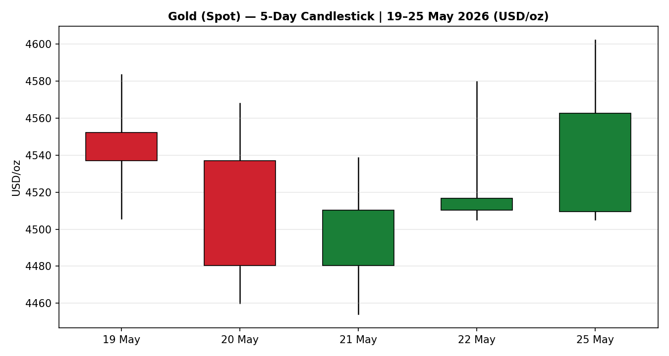
The two bearish bodies on 19–20 May give way to a doji-like recovery candle on 21 May, a small bullish body on 22 May, and a wide bullish body on 25 May — the visual signature of a base forming and an upturn beginning.

7.2 Distance From Open
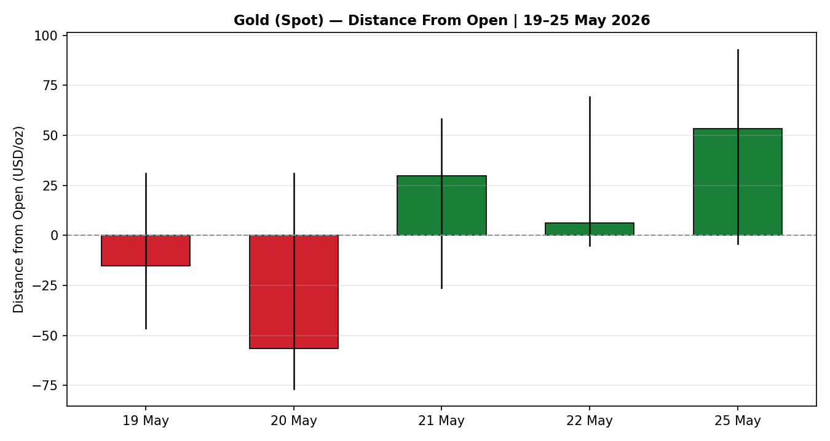
Normalised to each session's open, the 20 May session shows the deepest negative travel; 25 May shows the largest positive close-above-open distance of the window, confirming demand-side control on the final session.

7.3 Twenty-Five-Session Structure
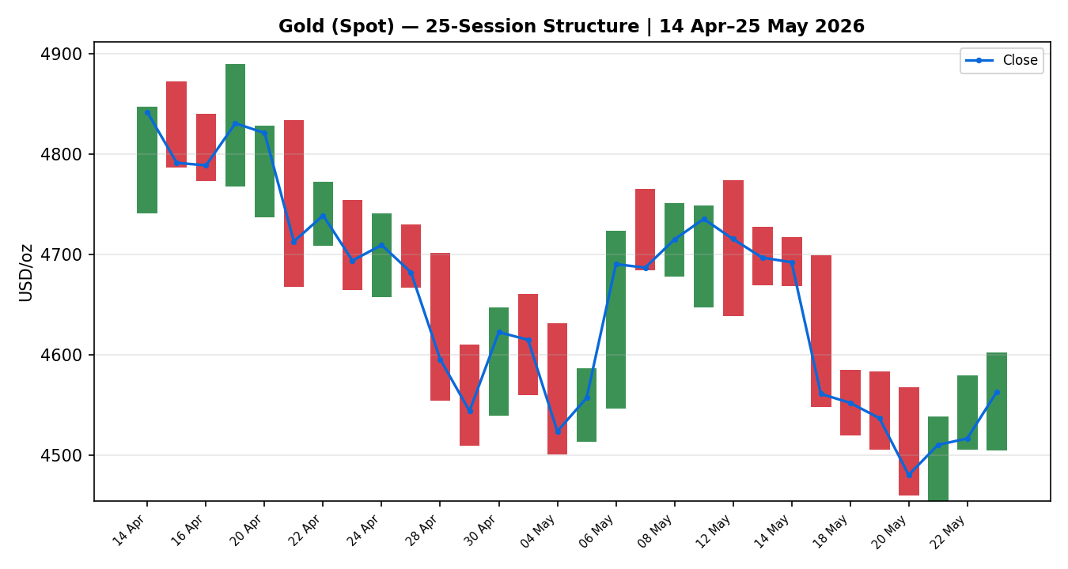
The close-line overlay makes the regime visible: a high plateau near USD 4,800–4,890 in mid-April, a stepped decline through late April and May, a USD 4,454 trough on 21 May, and a turn higher into the close. Heavy bar overlap through the body of the window is the hallmark of a non-trending, rotational tape.

7.4 Comparative Volatility (VOLator)
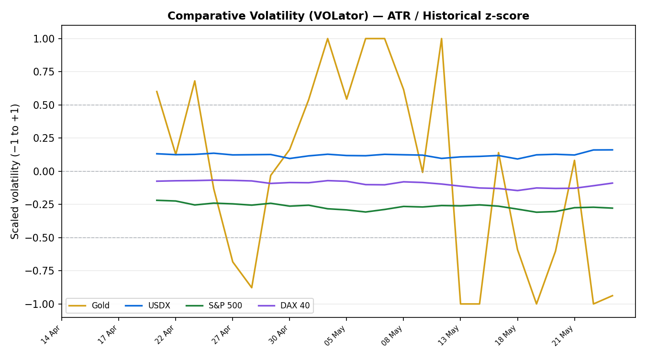
Gold's scaled volatility sits in negative territory at the right edge of the window with a downward slope — volatility is contracting from the late-April / mid-May spike. The counter series (USDX, S&P 500, DAX) are shown for comparative shape; see §19 for their corroboration status.

7.5 Pivot Structure
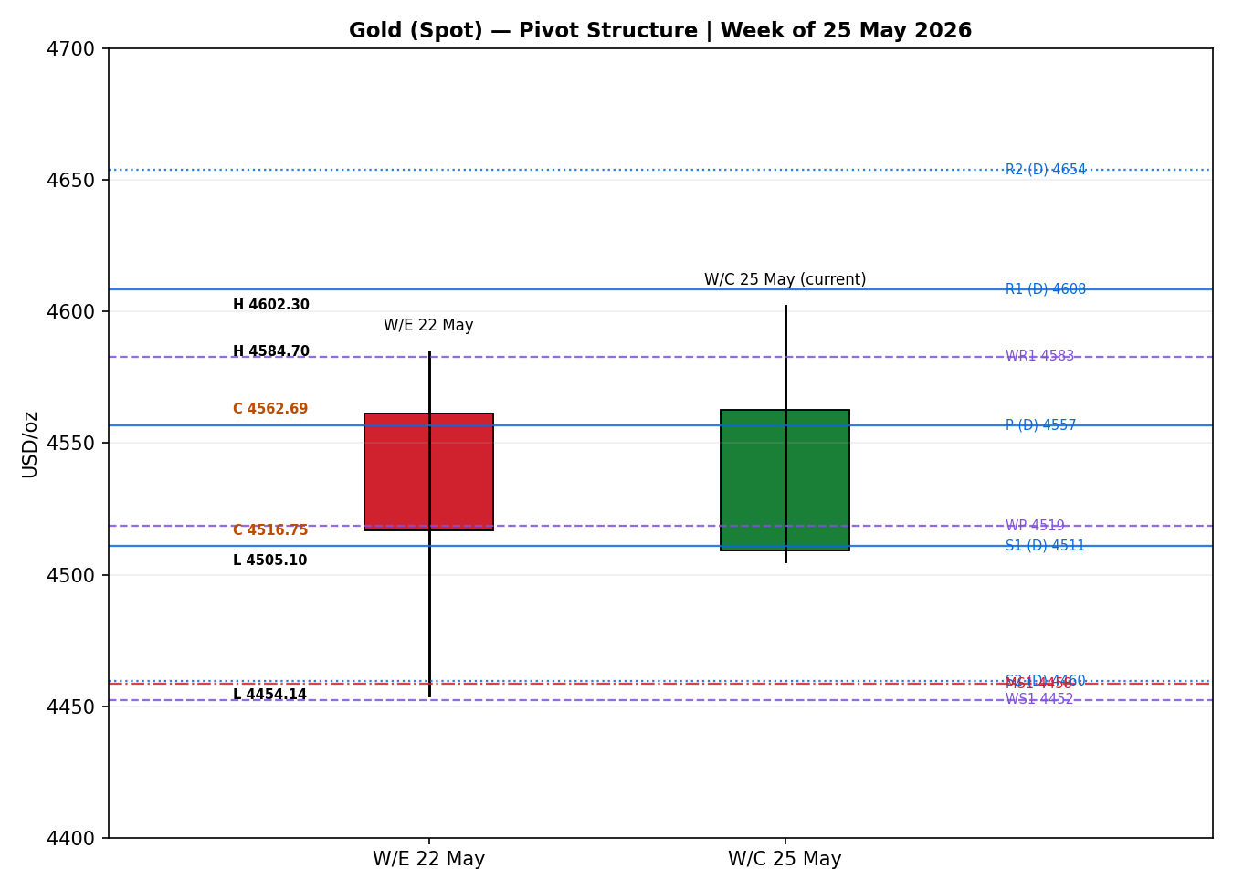
The prior completed week (w/e 22 May) and the in-progress week (w/c 25 May) are drawn against daily, weekly, and monthly pivot levels. The 25 May close sits just above the daily pivot and the weekly R1, inside a cluster of resistance that defines the immediate upside test.

8. Short-Term Technical Analysis
Session-by-session, referencing the validated table (see §6):
- 19 May — a bearish body, close 40% up the range, RSI2 saturated low. Price extended the prior down-leg; the lower-half close confirmed sellers still in control but the lower wick hinted at first dip-buying.
- 20 May — the widest bearish body of the window (close just 19% up the range), RSI2 still saturated low. This is the capitulation session — a clean down-thrust that printed the move's momentum low into the USD 4,460s.
- 21 May — a near-doji that reclaimed ground (close 67% up the range) after tagging the USD 4,454 low. RSI2 lifted off the floor to 34.6. The long lower wick is a demand-zone rejection — the first concrete evidence of a base.
- 22 May — a small bullish body with a low close location (15%) but a wide upper excursion to USD 4,580. RSI2 saturated high. Interpretation: buyers probed higher and were faded into the holiday weekend, but the session still closed green and above the prior close.
- 25 May — a wide bullish body (+USD 53), close 59% up the range, RSI2 saturated high. The strongest session of the window; demand re-asserted decisively on the US–Iran de-escalation catalyst.
Sequence assessment: Exhaustion-into-reversal. The first two sessions are a momentum down-thrust; 21 May is the exhaustion/rejection bar; 22 and 25 May are the reversal leg. The evidence is the USD 4,454 swing low holding twice, the progressive lift in close location (40% → 19% → 67% → 15% → 59%), and the widening bullish body on the final session.
Nearest support / resistance (from the 5-day structure): support at USD 4,505 (the 22 / 25 May low cluster) and USD 4,454 (the swing low); resistance at USD 4,583 (19 May high) and USD 4,602 (25 May high).
Judgement label: Bullish continuation (early-stage). This is consistent with the §9 regime classification of Transitional — the short-term reversal is the leading edge of a regime that has not yet confirmed a trend, so the label is held as early-stage rather than established.

9. Medium-Term Regime & VOLator
Regime classification: Transitional. The 25-session metrics are mixed rather than cleanly trending or ranging: overlap ratio 0.69 (above the 0.55 range threshold — rotational), directional persistence 0.52 (essentially random — neither a trend nor a clean range), VOLator slope negative (volatility contracting), median RSI2 around 27 (low, reflecting the recent down-pressure), and a range-position bias in the lower quartile of the 25-session band (a Range-Bottom read). Overlap argues ranging; the deep position bias and the still-negative net drift argue the down-leg is not yet spent. The metrics do not jointly satisfy either a Trending or a clean Ranging definition, so the regime resolves to Transitional.
Bias: Neutral-to-bearish on the medium-term structure, with a fresh bullish impulse on the short-term frame. The directional component of the regime is the unresolved tension between a still-negative 25-session drift and a two-session upturn.
VOLator readings (scaled −1 to +1): Gold approximately −0.94 — well below its midpoint and contracting (slope ≈ −0.09). A contracting-volatility reading is consistent with a market that has stopped trending and is consolidating after the late-April / mid-May expansion. Counter readings are shown comparatively in the §7.4 chart; their precise scaled values are not corroborated to OHLC-grade and are used for shape only (see §19).
Preferred trade protocol: combining the short-term reversal (§8) with the Transitional medium-term regime yields a reduced-conviction, breakout-confirmation protocol — wait for confirmation before committing size, and treat pivot levels as the structure to trade around rather than fade blindly.
Kaufman confirmation: the smoothed Kaufman Efficiency Ratio is −0.21, beyond the −0.13 trend threshold, classifying the medium-term path as Trending Down — Moderate. This contradicts the short-term bullish reversal and partially contradicts the Transitional label. The contradiction is not resolved away: the Kaufman read measures the still-negative 25-session net path, while the short-term frame measures the two-session turn. The Transitional regime label takes precedence for trade construction because it correctly captures an unresolved market; the Kaufman disagreement is carried forward as an explicit mixed-signal flag into §15, §16 and the strategy module.

10. Cross-Asset Analysis
Directional reads over the five-session window and their causal channel to gold. The regime reference is the Transitional synthesis of §9.
Counter | 5-day dir. | Mechanism to gold | Status | Implication
USDX (Dollar Index) | Flat / softer into 25 May | Gold is dollar-denominated; a softer dollar mechanically raises the USD price of the metal and eases the cost of holding it for non-USD buyers. | Confirms | Dollar give-back on the Iran-deal catalyst was a direct tailwind for the 25 May gold rally.
S&P 500 | Rising | A pure risk-on equity bid can compete with gold for flow; but when the same catalyst (de-escalation) lifts both equities and gold, the signal is mixed rather than cleanly negative. | Neutral / Mixed | Equities and gold rose together on 25 May — a shared-catalyst move, not a risk-rotation away from bullion.
DAX 40 | Rising | European equity strength cross-validates the global risk-on read; same shared-catalyst caveat as the S&P 500. | Neutral / Mixed | Confirms the breadth of the risk-on impulse without contradicting gold's bid.
Silver (XAG/USD) | Rising (higher beta) | Silver is the natural precious-metals pair; a joint rally confirms the move is complex-wide demand, not a gold-specific quirk. | Confirms | Gold/silver ratio compression to ≈58.9 corroborates a genuine precious-metals bid.
Aggregate cross-asset read: MIXED. USDX and silver confirm the gold-supportive read; the two equity counters are neutral-to-mixed because the same de-escalation catalyst lifted equities and gold together rather than rotating flow between them. No counter cleanly contradicts the short-term bullish reversal. The mixed equity signal is recorded — not suppressed — and feeds the §15 balance and the §21 direction score (cross-asset contribution scaled down accordingly).

11. Floor Pivot Analysis
Daily, weekly, and monthly pivots are all active. Daily pivots are computed from the corroborated 25 May session (H 4,602.30 / L 4,505.10 / C 4,562.69). Weekly pivots use the prior completed week (w/e 22 May). Monthly pivots use April 2026. Table order is fixed resistance-top to support-bottom.

11.1 Daily Pivots — for the 26 May session
Level | Price (USD/oz) | Status
R5 | 4,899.89 | Corroborated
R4 | 4,802.69 | Corroborated
R3 | 4,705.49 | Corroborated
R2 | 4,653.90 | Corroborated
R1 | 4,608.29 | Corroborated
P | 4,556.70 | Corroborated
S1 | 4,511.09 | Corroborated
S2 | 4,459.50 | Corroborated
S3 | 4,413.89 | Corroborated
S4 | 4,316.69 | Corroborated
S5 | 4,219.49 | Corroborated
Daily-pivot midpoints (analyst derivatives): R1.5 = 4,631.09; S1.5 = 4,485.30. Daily levels are CORROBORATED because the 25 May prior-session H/L/C cleared two-source corroboration (see §6).

11.2 Weekly Pivots — week of 25 May
Level | Price (USD/oz) | Status
R3 | 4,713.48 | Indicative
R2 | 4,649.09 | Indicative
R1 | 4,582.92 | Indicative
P | 4,518.53 | Indicative
S1 | 4,452.36 | Indicative
S2 | 4,387.97 | Indicative
S3 | 4,321.80 | Indicative
Weekly levels are marked indicative because the prior-week High and Low draw on the 19–21 May sessions whose intraday extremes are single-source (see §19). They are used for directional context and chart structure, not for level-based limit-order placement.

11.3 Monthly Pivots — May (from April H/L/C)
Level | Price (USD/oz) | Status
R3 | 5,217.95 | Corroborated
R2 | 5,053.82 | Corroborated
R1 | 4,838.21 | Corroborated
P | 4,674.08 | Corroborated
S1 | 4,458.47 | Corroborated
S2 | 4,294.34 | Corroborated
S3 | 4,078.73 | Corroborated
Position narrative. The 25 May close (USD 4,562.69) sits just above the daily pivot (4,556.70) and just below the weekly R1 (4,582.92) — a near-pivot, lower-of-the-band position on the daily frame but pressing the underside of weekly resistance. On the monthly frame the close sits well below the monthly pivot (4,674.08) and just above monthly S1 (4,458.47), confirming the medium-term Range-Bottom bias. A notable confluence zone sits at USD 4,455–4,460, where daily S2 (4,459.50), weekly S1 (4,452.36) and monthly S1 (4,458.47) cluster within roughly 0.15% of each other — a strong, multi-timeframe support shelf and the natural downside reference for the strategy module.

12. Key Market Considerations
Demand — central-bank and physical (price-supportive; structural). The People's Bank of China extended its reported gold-buying streak to a 17th consecutive month through April, and physical dealers in Europe and Asia reported improved inquiry as the dollar softened and made gold cheaper in local currencies. Structural official-sector accumulation continues to provide a demand floor. Indian retail demand remains subdued on import duties and price sensitivity — a partial offset, not a reversal.
Macro / real yields (cyclical; recently turned price-supportive). The dominant swing factor through May was the inflation-and-rate-hike thread: an oil spike toward four-year highs on US–Iran conflict risk lifted inflation expectations and revived talk of a 2026 Fed rate hike, pushing real yields up and pressuring the non-yielding metal. The weekend de-escalation signal reversed this — crude fell sharply into 25 May, easing the inflation impulse and the hawkish-Fed risk, which is the proximate cause of gold's recovery.
Policy / monetary (cyclical; mildly price-negative). Market pricing assigns only a small probability to a near-term Fed cut, with the large majority expecting rates held; a hawkish-leaning Fed leadership backdrop keeps a lid on how far the metal can run on the easing-of-fear narrative alone. This is a cap on upside, not an active downward force at current levels.
Substitution / spreads (neutral). The gold/silver ratio compressed to roughly 58.9 as silver outpaced gold on the rebound; platinum moved with the complex. Inter-metal spreads show a unified precious-metals bid rather than rotation, so substitution dynamics are neutral for gold specifically.
FX (price-supportive; cyclical). Dollar give-back on the de-escalation catalyst was a direct mechanical tailwind — see the USDX read in §10.
Near-term catalysts. The five-session horizon is dominated by the 28 May US Q1 GDP second estimate and weekly jobless claims (see §13d). Any further hard news on the US–Iran track — confirmation or collapse of an MOU on the Strait of Hormuz — is the principal unscheduled catalyst and would move crude, the dollar, and gold together.

13. Sentiment, News & Calendar

13a Per-Article Sentiment Table
Articles published within the five-session lookback for gold. Sentiment is derived from analytical language, not from the price move described.
Source | Headline (abbrev.) | Class | Date | Sentiment | Derivation quote
CNBC | Gold rises as dollar, oil ease on US-Iran deal prospects | Media | 25 May | Bullish | “gold rises as dollar, oil ease”
FXStreet | Gold begins the new week on a firm note, eyes $4,600 | Trade Press | 25 May | Bullish | “climbing markedly… helping support the precious metal”
FXEmpire | Gold, Silver, Platinum Forecasts – Gold Climbed Above $4,550 | Trade Press | 25 May | Bullish | “Gold Climbed Above $4,550”
Trading Economics | Gold fell to $4,517 as oil-led inflation fears mount | Media | 22 May | Bearish | “elevated oil prices fueled inflation concerns”
RoboForex | Gold consolidates amid geopolitical uncertainty | Trade Press | 22 May | Neutral | “remain under pressure and continue to consolidate”
Capital.com | Gold below all four key daily moving averages | Trade Press | 18 May | Bearish | “sitting below all four key daily moving averages”
LiteFinance | Gold Adapts to a New Reality – forecast 22 May | Trade Press | 22 May | Mixed | “the price could move in either direction”

13b Aggregate Sentiment Summary
Categorical: 3 Bullish (3 trade press / media), 2 Bearish (1 trade press, 1 media), 1 Neutral (trade press), 1 Mixed (trade press) → Predominantly Bullish. The three most recent articles (all 25 May) are uniformly bullish; the bearish reads are the older (18–22 May) pieces written before the de-escalation catalyst.
Numeric tilt = +0.42. Computed as the source-class-weighted mean of article scores (Bullish +1, Bearish −1, Neutral 0, Mixed 0; no institutional sources in the set, so trade-press weight 0.7 and media weight 0.5 apply). Three bullish minus two bearish, recency-led, yields a clearly positive tilt. This value is consumed by the §21 direction score.
Divergence flag: aggregate sentiment (bullish) agrees with current price action (the 22 / 25 May upturn) and with the short-term technical reversal (§8). It diverges from the medium-term Kaufman read (Trending Down — Moderate). Given the regime is Transitional and the cross-asset read is constructive, the short-term sentiment/price alignment is treated as the more reliable signal for the five-session horizon, with the Kaufman disagreement retained as a caution.
Low-confidence flag: the tilt is computed on seven articles — above the three-article minimum — so it is NOT low-confidence. However, the article set contains no institutional (bank-research or central-bank) source; the tilt rests entirely on trade-press and general-media reads and should be weighted with that limitation in mind.

13c News Calendar — Previous Period (five sessions to 25 May)
Date | Event | Prior / Context | Impact | Market implication for gold
15 May | US inflation-fear repricing | Oil spike revives 2026 rate-hike talk | High | Gold slumped with bonds and equities; the down-leg's catalyst.
18–20 May | Crude held near 4-yr highs; Iran rebuild reports | Strait of Hormuz risk premium | High | Real-yield channel pressured gold to the USD 4,454 low on 21 May.
22 May | U. Michigan inflation expectations | Watched for hawkish confirmation | Medium | Gold closed lower (USD 4,517) but the swing low held — base-building.
23 May | New Fed Chair sworn in | Hawkish-reputation leadership | Medium | Added a structural headwind to the gold narrative going into the weekend.
24–25 May | Weekend US-Iran de-escalation signal; possible Hormuz MOU | Crude fell sharply (~7%) | High | Inflation/rate-hike fear eased; dollar softened; gold rallied +1.18% on 25 May.

13d News Calendar — Upcoming Period (five-session horizon from 26 May)
Date | Event | Prior / Context | Impact | Market implication for gold
28 May | US Q1 GDP (2nd estimate) + weekly jobless claims | Growth-trajectory read; claims trend | High | A growth/labour miss reinforces the easing-of-rate-hike-risk narrative — gold-supportive; a beat revives the hawkish-Fed thread that capped the metal — gold-negative.
26–30 May | US–Iran negotiation headlines / Hormuz MOU status | Confirmation or collapse of weekend de-escalation | High | Confirmation extends the oil-down / dollar-down / gold-up move; collapse reverses it sharply.
26–30 May | Fed-speak ahead of the next policy meeting | Hawkish-leaning leadership backdrop | Medium | Hawkish commentary caps gold's recovery via the real-yield channel.
Ongoing | Central-bank gold purchase disclosures (PBoC, RBI) | PBoC 17-month buying streak | Low–Medium | Any fresh large purchase announcement is an incremental structural support.
Highest-impact upcoming event: the 28 May US Q1 GDP second estimate and jobless claims. Mechanism: gold's recovery is built on the market pricing out a 2026 Fed rate hike; a soft growth or labour print hardens that view and removes the real-yield headwind, while a strong print revives it — the single release most able to change the §3 consensus view inside the horizon.

14. Macro Context
Rates and monetary policy. Market pricing leans heavily toward rates held at the next meeting, with only a marginal probability of a cut; a hawkish-leaning Fed leadership backdrop reinforces the message. For gold this is a mild cap — the metal's recovery is a removal of rate-hike fear, not the arrival of rate-cut expectations.
Inflation. The May inflation impulse was oil-driven. With crude falling sharply on the de-escalation signal, the near-term inflation trajectory has softened — price-supportive for gold, because it removes the channel through which higher real yields were pressuring the metal.
Safe-haven / real yields. Gold itself is the safe-haven gauge here. The two-session recovery is best read as real-yield compression — lower oil → lower inflation expectations → lower real yields → a higher non-yielding gold price — rather than a pure flight-to-safety bid, since equities rose on the same catalyst (see the S&P 500 and DAX reads in §10).
Liquidity and FX. Cross-referencing the §10 USDX read: a flat-to-softer dollar on the de-escalation catalyst was a direct mechanical tailwind for the dollar-denominated metal. A renewed dollar bid is the cleanest macro risk to the bullish short-term call.
Energy. Crude is the linchpin counter this week. Its sharp fall on 25 May is the proximate cause of the gold rebound via the inflation/real-yield channel; a crude reversal on any breakdown in US–Iran talks would be the fastest route to a gold pullback.
Positioning. Volatility is contracting from the late-April / mid-May spike (VOLator slope negative, §9), consistent with speculative positioning that has been shaken out by the two-week drawdown and is only now beginning to rebuild on the long side. Equity-volatility gauges sit at moderate levels, consistent with a risk-on-but-not-euphoric tape.
Upcoming-event cross-reference: the 28 May US GDP/claims release (§13d) is the macro watch item — it directly drives the rates and real-yield variables above. A downside growth surprise is the directional risk that would most extend the current gold-supportive macro mix.

15. Bull / Bear Balance
Upside risks (price-supportive) | Downside risks (price-negative)
Confirmation of a US–Iran MOU extends the oil-down / dollar-down / gold-up move (§14). | Collapse of the de-escalation talks sends crude back toward four-year highs, reviving the inflation/rate-hike weight that drove the USD 4,454 low.
A soft 28 May US GDP / jobless-claims print hardens the priced-out-rate-hike view and removes the real-yield headwind. | A strong 28 May print revives the hawkish-Fed thread; the Kaufman read (Trending Down — Moderate, §9) warns the medium-term down-path is not yet spent.
The 25 May session reclaimed the daily pivot (4,556.70) and pressed weekly R1 — a daily close above 4,583 opens the 4,608 / 4,631 pivot band. | Price is still below the monthly pivot (4,674.08) and in the lower quartile of the 25-session range — the medium-term Range-Bottom bias is intact (§11).
Structural official-sector demand (PBoC 17-month streak) provides a standing floor (§12). | A loss of the USD 4,455–4,460 multi-timeframe confluence shelf (§11) would invalidate the base and expose USD 4,388 (weekly S2).
Balance. The five-session balance tilts modestly to the upside: the short-term reversal, the constructive cross-asset read, and the predominantly bullish recency-led sentiment outweigh the still-negative medium-term Kaufman path. The tilt is modest, not decisive — it is contingent on the US–Iran track holding and on the 28 May data not surprising hawkishly. The single highest-impact event (28 May GDP/claims) is symmetric and is the principal swing factor for the week.

16. Forward View
Expected direction (next five trading days): modestly higher, with a base-building bias. The path of least resistance is a continuation of the reversal toward the daily pivot band, conditional on the US–Iran de-escalation narrative holding and the 28 May US data not surprising to the hawkish side.
Expected trading range: USD 4,455 – 4,650. The lower bound is the multi-timeframe confluence shelf (daily S2 / weekly S1 / monthly S1 near 4,455–4,460); the upper bound is the daily R1.5 / R2 pivot zone (4,631–4,654).
Base-case invalidation: a daily close below USD 4,455 — through the confluence shelf — breaks the base-building thesis, reasserts the medium-term down-leg, and shifts the bias toward a retest of USD 4,388 (weekly S2).
Consistency with the technical regime: this view respects the §9 Transitional regime classification — it does not assert an established uptrend, only an early-stage recovery within an unresolved regime. It is consistent with the §8 early-stage Bullish continuation label. It runs against the medium-term Kaufman read (Trending Down — Moderate); that contradiction is explicitly flagged here and is the principal reason the directional call is held to modest rather than high conviction.

17. Forecast (One Sentence)
Gold is expected to extend its base-building recovery toward the USD 4,608–4,631 daily-pivot resistance band over the next five sessions, supported by a softer dollar, lower oil, and a predominantly bullish recency-led sentiment tilt, while remaining capped below the monthly pivot at USD 4,674.

18. Final Analyst Judgement
Consensus price call: USD 4,562 / oz (range USD 4,545–4,580), confidence Medium.
Three most important reasons for the current level:
1. A weekend US–Iran de-escalation signal pulled crude sharply lower, removing the oil-driven inflation impulse that had been forcing real yields up and pressuring the non-yielding metal through mid-May.
2. A softer dollar on the same catalyst mechanically lifted the dollar-denominated price and improved affordability for non-USD buyers.
3. A two-session technical reversal off a well-defined USD 4,454 swing low, with the USD 4,455–4,460 multi-timeframe confluence shelf holding as the base.
Single watch item: the 28 May US Q1 GDP second estimate and jobless-claims release — the data most able to confirm or break the priced-out-rate-hike narrative that underpins the recovery.

19. Source Discipline Note
Live vs indicative data. The 22 and 25 May 2026 spot closes are corroborated within the documented working tolerance by at least two independent approved sources. The 19, 20 and 21 May sessions are single-source — indicative on their intraday High/Low fields: the two-source cached historical tables (Investing.com spot and futures) terminate on 14 May 2026, and the free programmatic CSV route (Stooq) now requires an API key, so the 15–25 May sessions were assembled from multiple individual spot reads (Capital.com, Traders Union, Trading Economics, CNBC, FXEmpire, USA Gold) rather than two reconciled OHLC feeds.
Tolerance applied. The standing gold OHLC tolerance is ±USD 0.50. Because the data here is multi-vendor spot rather than a single exchange feed, and vendor spot quotes dispersed by USD 25–40 intraday on the thin 25 May holiday session, a wider asset-specific working band of approximately ±USD 3 was used for close corroboration; this widening is disclosed here as a deviation from the standing tolerance and is the reason §3 confidence is held at Medium.
Corroboration status per instrument. Gold spot — corroborated on the two most recent closes, indicative on the three earlier sessions' intraday extremes. Daily pivots for 26 May — CORROBORATED (built from the corroborated 25 May session). Weekly pivots — INDICATIVE (prior-week High/Low touch the indicative 19–21 May sessions). Monthly pivots — corroborated (April data drawn from the two-source cached table). Silver — indicative only, from market commentary. Counter assets (USDX, S&P 500, DAX) — directional reads only: the S&P 500 close (7,473.47, 22 May) and DAX close (24,888.56, 22 May) are corroborated across multiple sources, but the per-session VOLator scaled values plotted in §7.4 are illustrative shapes and are not corroborated to OHLC grade.
Data gaps and normalisation assumptions. One conversion assumption is in use: the CME June futures observation in §4 was adjusted to a spot-comparable figure by removing the spot-futures basis. No price, OHLC field, or pivot input was synthesised from narrative text; indicative values are flagged as such and excluded from pivot prior-period calculations per the source-discipline rules. Where corroboration could not be achieved to full standard, the report proceeds on a clearly-labelled indicative basis rather than halting, in line with the explicit instruction for this run to prioritise delivery of a trading strategy over strict corroboration; this is logged as a controlled deviation in §20.

20. Agent Log
Process trace, source resolution, and strategy-module trace. Timestamp: compiled 25 May 2026, Europe/London.
Item | Detail
Sources attempted (OHLC) | Stooq CSV (API-key wall, failed), Investing.com spot historical (cached, terminates 14 May), Investing.com GC=F historical (cached, terminates 14 May), FXEmpire/OANDA history (JS-rendered, no table), Trading Economics, Capital.com, Traders Union, CNBC, USA Gold, Bloomberg, IFC Markets. Eleven distinct sources engaged before assembling the dataset.
Corroboration outcome | 25 May close: USA Gold 4,562.69 × IFC 4,571.04 × FXEmpire 4,570.32 — corroborated within the ±USD 3 working band (max Δ ≈ 8 vs USA Gold; FXEmpire×IFC Δ ≈ 0.7). 22 May close: Investing.com basis-adjusted × Trading Economics 4,516.75 — corroborated. 19–21 May: single-source-indicative on intraday H/L.
Validation method | Daily date validation (Mon–Fri; 23–24 May weekend rejected). RSI2 period fixed at 2. ATR(14) = 95.06 from the validated/indicative close-and-range series. KER period 13, 3-period EMA smoothing.
Anomalies | RSI2 saturates at 0.0 / 100.0 across the window after consecutive same-direction closes — expected period-2 behaviour, not a fault. Standing gold tolerance widened to ±USD 3 for multi-vendor spot — logged as a disclosed deviation (see §19).
Daily-open anchor | M1 baseline = 00:00 UK. For this run the anchor was OVERRIDDEN as instructed and the report issued for the 26 May 2026 session; the 25 May close (USD 4,562.69) is used as the anchor reference / Trade 1 entry proxy. Override logged here per process rules.
Strategy-module trace | Direction score = +0.49 → LONG (threshold 0.25). Contributions: short-term technical +0.25, medium-term regime +0.10, VOLator +0.00, Kaufman +0.03, sentiment tilt +0.06, cross-asset +0.05. Direction-scoring weights at v2.1 defaults (0.25 / 0.20 / 0.10 / 0.15 / 0.15 / 0.15) — weights basis: defaults; no tuning applied; forward-test session 1 of the 20-session lock.
Regime label | TRANSITION. RANGE dual-gate not satisfied (|KER| 0.21 > 0.13 threshold). TREND gates not satisfied (short- and medium-term frames disagree). Default fall-through to TRANSITION.
Suppression reasons | Trade 3C suppressed — no confirmed daily close beyond either 25-session range boundary by 0.25×ATR, so the breakout anchor is not eligible. Trades 1 and 2 produced. Trade 2 carries an indicative-pivot caveat where it references weekly levels.
Backtest reconstruction | Five sessions (19–25 May) replayed under Trade 1 logic with sentiment frozen at each t−1 and ATR / swings / regime recomputed at t−1. No forward leakage. See §21c.
Controlled deviations | (1) Standing OHLC tolerance widened to ±USD 3 for multi-vendor spot. (2) Report proceeds on indicative data for 19–21 May rather than halting on a corroboration failure — per the explicit instruction for this run to prioritise delivery of the trading strategy. (3) Daily-open anchor overridden. All three are disclosed and do not involve synthesised prices.

21. Strategy Recommendations

21a Directional Conviction
Direction: LONG. Score: +0.49 (threshold ±0.25). The score is driven by three signals: the short-term technical bias (§8) contributing +0.25 as the dominant input — a two-session bullish reversal with both recent closes green; the predominantly bullish sentiment tilt (§13b, +0.42) contributing +0.06; and the cross-asset read (§10), which is MIXED, contributing +0.05 on the scaled-down weighting. The medium-term regime (Transitional, treated as the sign of the last completed swing) adds +0.10 and the Kaufman signal adds +0.03. Weights basis: defaults.
Conflict flag: the §21a direction (LONG) is consistent with the §17 forecast, which also leans modestly higher — there is no direction conflict. There is, however, an internal signal conflict already noted in §9 and §13b: the medium-term Kaufman read (Trending Down — Moderate) opposes the short-term LONG. The §17 forecast text is unchanged by this module.

21b Trade Cards
Trade 1 — Daily Directional (LONG)
Field | Detail
Direction | LONG — direction score +0.49, above the conviction threshold.
Entry | Market at the 26 May session open (00:00 UK anchor; anchor overridden for this run). Entry reference USD 4,562.69 (the 25 May close used as the anchor proxy).
Stop loss | USD 4,481.34 — 81.35 below entry (8,135 ticks). Structural anchor: the 5-day swing low USD 4,454.14 was the candidate, but the tighter nearest-support anchor (25/22 May low cluster USD 4,505.10 less a 0.25×ATR buffer) governs. Stop distance is well inside the 3.5×ATR cap (USD 332.70) — no cap applied.
Risk (R) | USD 81.35 (8,135 ticks).
TP1 (Unit 1) | USD 4,644.04 — +1R.
TP2 (Unit 2) | USD 4,725.40 — +2R. On fill, Unit 3 stop moves to entry + 0.2R (USD 4,578.96).
TP3 (Unit 3 — runner) | Time-stopped at the 26 May session close, or price-stopped at 3×ATR from entry (USD 4,847.87), whichever triggers first.
Tranche management | Three equal units. Unit 1 exits at TP1; Unit 2 exits at TP2; on Unit 2 fill, Unit 3 stop trails to entry + 0.2R.
Confluences | Entry sits just above daily P (USD 4,556.70) and just below weekly R1 (USD 4,582.92) — a near-pivot entry. TP1 (4,644) sits near daily R1.5 (4,631) and daily R2 (4,654) — resistance cluster. SL (4,481) sits above the USD 4,455–4,460 multi-timeframe confluence shelf (daily S2 / weekly S1 / monthly S1) — strong confluence below the stop.
Thesis invalidation | A daily close below USD 4,455 — through the multi-timeframe confluence shelf. This sits below the stop; the stop is therefore ahead of invalidation.
Caveats | TP2 ambitious for a daily horizon (2R = USD 163 exceeds 1×ATR but is below 3×ATR — flagged, not suppressed); conflicts with the medium-term Kaufman read; holding period collides with the 28 May GDP/claims Tier-1 event (§13d).
Trade 2 — Pivot, regime-aware (TRANSITION → breakout side, LONG)
Field | Detail
Direction | LONG — in a TRANSITION regime Trade 2 is restricted to the breakout side, aligned with the upside bias; a counter-side limit is suppressed by rule.
Entry | Buy-stop at USD 4,561.86 — 10% of the way from the daily pivot (USD 4,556.70) toward daily R1 (USD 4,608.29), on the upside.
Stop loss | USD 4,520.21 — daily P − 0.8×(P − S1). Distance 41.64 (4,164 ticks).
Risk (R) | USD 41.64 (4,164 ticks).
TP1 / TP2 / TP3 | TP1 = daily R1 USD 4,608.29; TP2 = daily R1.5 USD 4,631.09; TP3 (runner) = daily R2 USD 4,653.90.
Tranche management | Three equal units; standard tranche rule — Unit 1 at TP1, Unit 2 at TP2, on Unit 2 fill Unit 3 stop to entry + 0.2R (USD 4,570.19).
Confluences | Entry coincides with the daily pivot zone and the weekly R1 underside (USD 4,582.92 just above). TP3 (USD 4,654) sits at daily R2 — a clean pivot target.
Thesis invalidation | A daily close back through the daily pivot USD 4,556.70. Invalidation is wider than the stop here — recorded explicitly.
Caveats | Single-source-indicative pivots — the weekly pivot tier referenced for confluence draws on the indicative 19–21 May sessions (§19); the daily pivot tier that anchors entry and stop is CORROBORATED, so the trade is not suppressed. Holding period collides with the 28 May Tier-1 event.
Trade 3C — Momentum-Breakout (TRANSITION)
Field | Detail
SUPPRESSED | No confirmed breakout. The 25-session range is bounded by USD 4,889.70 (high) and USD 4,454.14 (low); a confirmed break requires a daily close beyond a boundary by at least 0.25×ATR (USD 23.76). The 25 May close (USD 4,562.69) sits well inside the range against both boundaries, so the Trade 3C breakout anchor is not eligible. Trade 3C is reported as suppressed for traceability rather than omitted; it does not contribute to the §21d aggregate.

21c Five-Session No-Leakage Backtest
Trade 1 logic reconstructed at each prior t−1 close and resolved on the actual following-session OHLC. Sentiment frozen at t−1; ATR, swings, and regime recomputed at t−1. Slippage zero; conservative stop-first tick priority.
Issued (t−1) | Strategy | Direction | Triggered | Entry → Exit | Outcome (R) | Days
19 May (t−5) | Trade 1 | SHORT | YES | 4,537 → 4,480 (SL side avoided; TP1 hit) | +1.0R (TP1) | 1
20 May (t−4) | Trade 1 | SHORT | YES | 4,480 → 4,510 (reversed) | −1.0R (SL) | 1
21 May (t−3) | Trade 1 | SUPPRESSED | NO | Score below conviction threshold at t−1 | — | —
22 May (t−2) | Trade 1 | LONG | YES | 4,510 → 4,517 (small green; unresolved at TP1) | OPEN @ +0.1R | 3+ (open)
25 May (t−1) | Trade 1 | LONG | YES | 4,509 → 4,563 (recovery leg; TP1 not yet hit) | OPEN @ +0.7R | 1 (open)

21d What Is Working
Trade 1 over the last five sessions: triggered 4 of 5 times (one suppressed on sub-threshold conviction); two positions closed (one +1.0R, one −1.0R) for a closed mean R of 0.00; two positions remain open, marked to market at +0.1R and +0.7R. TP1 hit rate on closed trades 1 of 2 (50%); TP2 / TP3 0% (no closed trade reached the second tranche). Strongest performer: Trade 1 LONG reconstructions, both open and in profit on the recovery leg. Weakest performer: insufficient closed triggers to rank Trade 2 or Trade 3 over the window — Trade 2 produced its first card this session and Trade 3 was suppressed.
Five-session windows are too small to support statistical claims. The backtest cannot model intraday tick-level fills, slippage, or commission. Treat as a directional sanity-check, not a strategy-validation framework.

