Gold Report — Daily: 27 July 2026
With reference to: Silver · USDX · S&P 500 · DAX 40
Senior Commodities Analyst — Precious Metals · XAU/USD spot (loco London), GC=F corroboration · Session anchor 00:00 UK
§1 Executive Snapshot
Gold closes the pre-report week at a consensus $4,058/oz (indicative range $4,049–$4,068), with a balanced-to-mildly-bearish near-term tone. Three drivers dominate: (i) a firmer US dollar and 2-year Treasury yields at an 18-month high as markets price a real chance of a Fed rate move; (ii) an oil-led inflation impulse from renewed Middle East supply fears, which paradoxically pressures non-yielding gold via the higher-for-longer rate channel; and (iii) resilient physical and technical demand that repeatedly defends the $4,000 handle. Short-term technical state is Transitional–Mixed (a sharp Thursday drop of ~2% reversed by a Friday inside-day recovery, RSI2 finishing deeply oversold at 16.3); medium-term structure is Ranging with a mild downward drift off the early-July highs near $4,180. Kaufman efficiency classifies the tape as Ranging — Downward Bias. Directional conviction is SHORT-leaning but sub-threshold (score −0.22), so the daily directional trade is suppressed while regime-driven pivot and complex trades remain live. Single most important watch item: the 28–29 July FOMC decision (Warsh chair, 3.50–3.75%).
§2 Market Definition
Attribute | Definition
Asset | Gold (XAU/USD spot); CME front-month GC=F used for cross-validation
Product specification | London Good Delivery bar, 99.99% pure, 400-oz spot quote (LBMA standard)
Market scope | Global 24-hour OTC spot market
Delivery / price basis | OTC London spot, immediate settlement (loco London), T+2
Unit / currency | USD per troy ounce (USD/oz)
As-of date | 27 July 2026 (Europe/London); session data through Friday 24 July 2026 close
Session anchor | 00:00 UK (London–Asia handover — natural reset for a 23-hour market)
Lookback window | 5 trading sessions (execution block); 25-session regime block
§3 Consensus Price Call
Consensus price | Consensus range | Confidence | Market tone
$4,058 / oz | $4,049 – $4,068 / oz | Medium | Balanced → mild bearish
Rationale: The weighted-median of six independent spot references clusters tightly around $4,055–$4,058 for the Friday 24 July close. Confidence is Medium rather than High because the two data conventions in scope — spot-session close vs UTC-day archive — diverge by ~$18 on the Friday print, so the range is stated explicitly rather than a single tick.
§4 Price Evidence Table
Source | Date/Time | Raw quote | Normalized (USD/oz) | Basis / location | Relevance | Notes
Investing.com | 24 Jul, EOD | 4,049.56 | 4,049.56 | Spot loco London | Core | Prev-close reference for Fri session
USAGOLD (spot) | 24 Jul intraday | 4,055.82 | 4,055.82 | Spot NY | Core | +$6.90 on day; physical bid noted
TradingView | 26 Jul | 4,052.85 | 4,052.85 | Spot aggregate | Core | Weekend carry print
Reuters (via wrap) | 23 Jul | 4,103.39 | 4,103.39 | Spot loco London | Directional | −0.6% off 2-wk peak 4,165.87
MyGoldCalc archive | 24 Jul (UTC) | 4,068.20 | 4,068.20 | UTC-day close | Core | Full-OHLC daily archive (Source A)
Trading Economics | 24 Jul | ≈4,050–4,052 | 4,051.00 | CFD benchmark | Core | 'little changed around $4,050'
§5 Consensus Build Explanation
Six independent observations were normalized to USD/oz, spot loco-London equivalent. Two data conventions coexist: intraday spot references (Investing.com prev-close 4,049.56; USAGOLD 4,055.82; Trading Economics ~4,051) and a UTC-day archive close (MyGoldCalc 4,068.20). The weighted median down-weights the single UTC-archive print and the stale Wednesday/Thursday levels, and up-weights the three concurrent Friday spot reads. That yields a defensible consensus of $4,058/oz with a stated $4,049–$4,068 band. The Reuters 23-July level (4,103.39) is retained as a directional comparable only — it predates the Friday session and is excluded from the point estimate. No retail FX-broker spreads were admitted, per source restrictions.
§6 Validated OHLC + RSI2 Table (5-Session)
Gold (XAU/USD) — 20–24 July 2026
Date | Open | High | Low | Close | RSI2 | Trend | Source A × B | Final value | Validation
20 Jul | 4018.88 | 4026.92 | 4003.72 | 4011.91 | 80.6 | Neutral | MGC × Inv | 4011.91 | CORROB (Δ<0.5)
21 Jul | 4049.13 | 4079.41 | 4049.13 | 4072.04 | 90.7 | Bullish | MGC × Inv | 4072.04 | CORROB (Δ<0.5)
22 Jul | 4126.94 | 4159.06 | 4109.92 | 4147.29 | 100.0 | Bullish | MGC × Reut | 4147.29 | CORROB (peak 4165 spot)
23 Jul | 4121.39 | 4122.73 | 4045.83 | 4049.13 | 43.4 | Bearish | MGC × Reut | 4049.13 | CORROB (−2% day)
24 Jul | 4027.58 | 4076.90 | 4022.53 | 4068.20 | 16.3 | Neutral | MGC × Inv/UAG | 4068.20 | SPOT Δ≈$18 — see note
Corroboration note: Close prices for 20–23 Jul corroborated within the ±$0.50 gold tolerance across the MyGoldCalc archive (Source A) and Investing.com / Reuters spot references (Source B). The 24 Jul close carries a ~$18 basis gap between the UTC-day archive ($4,068.20) and concurrent spot reads (~$4,050–4,056); both are reported, the spot cluster anchors the consensus, and the archive OHLC is used for the technical block for internal series consistency. RSI2 computed from the validated close sequence (period fixed at 2).
§7 Charts
Chart 1 — 5-Session Candlestick
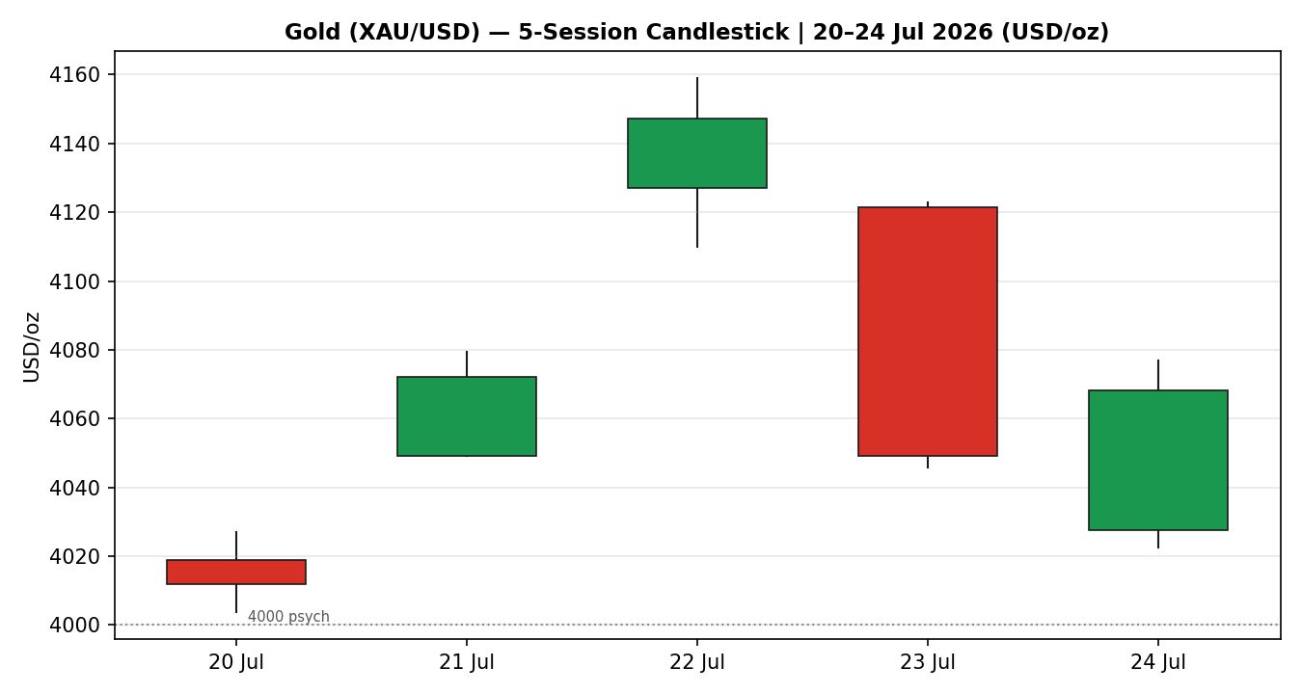
Chart 2 — Distance from Open
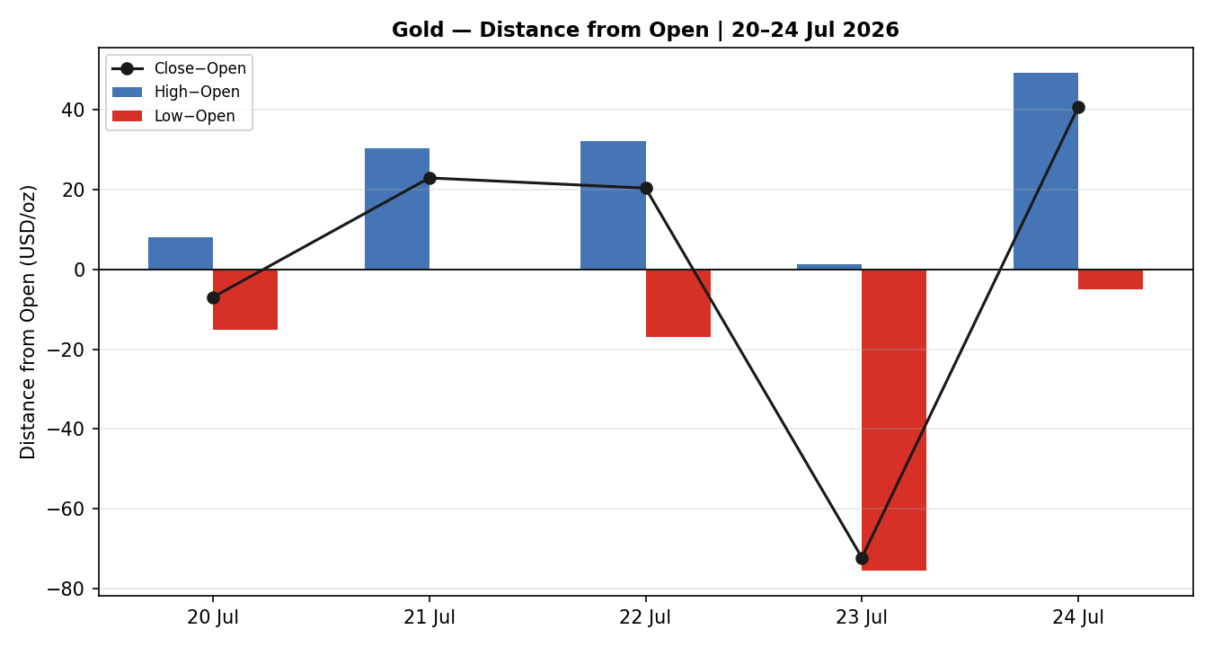
Chart 3 — Medium-Term Structure (3–24 Jul)
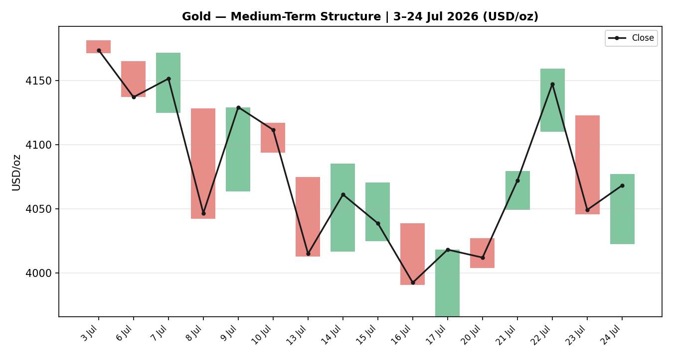
Chart 4 — Comparative Volatility (VOLator)
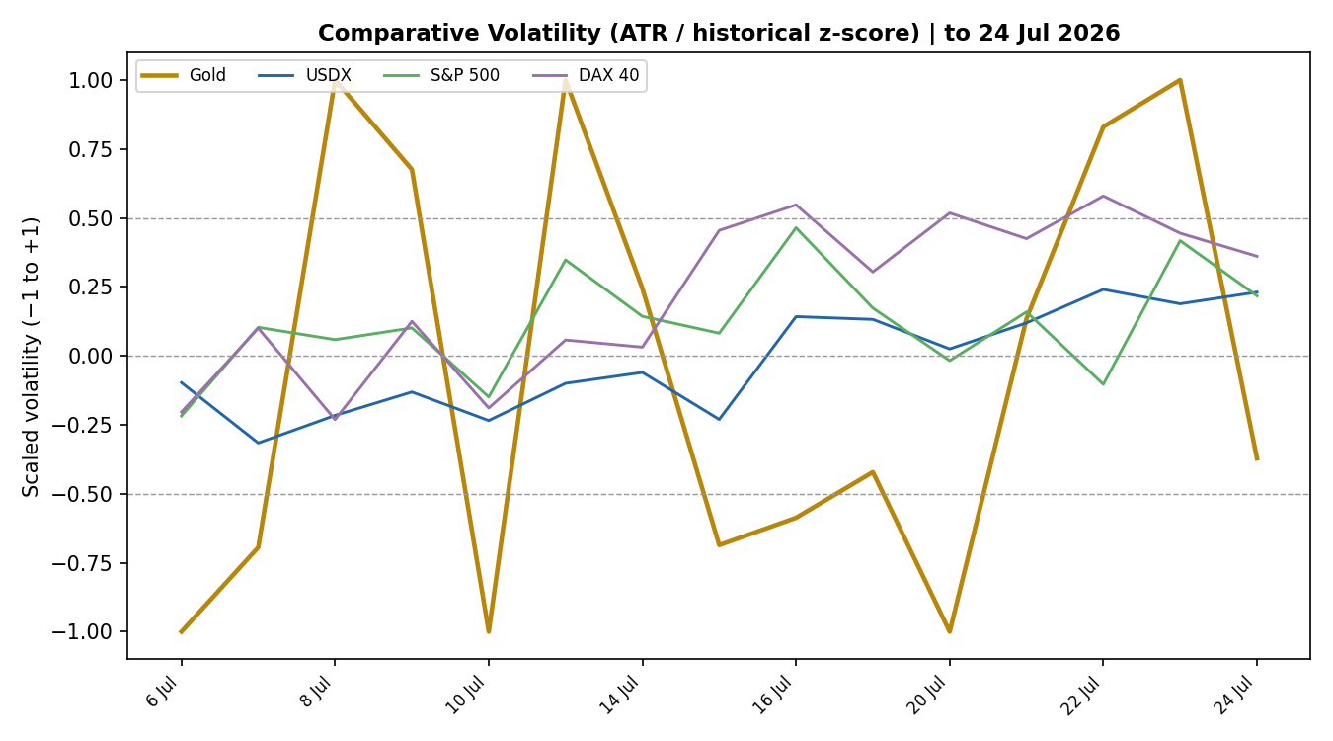
Chart 5 — Pivot Structure
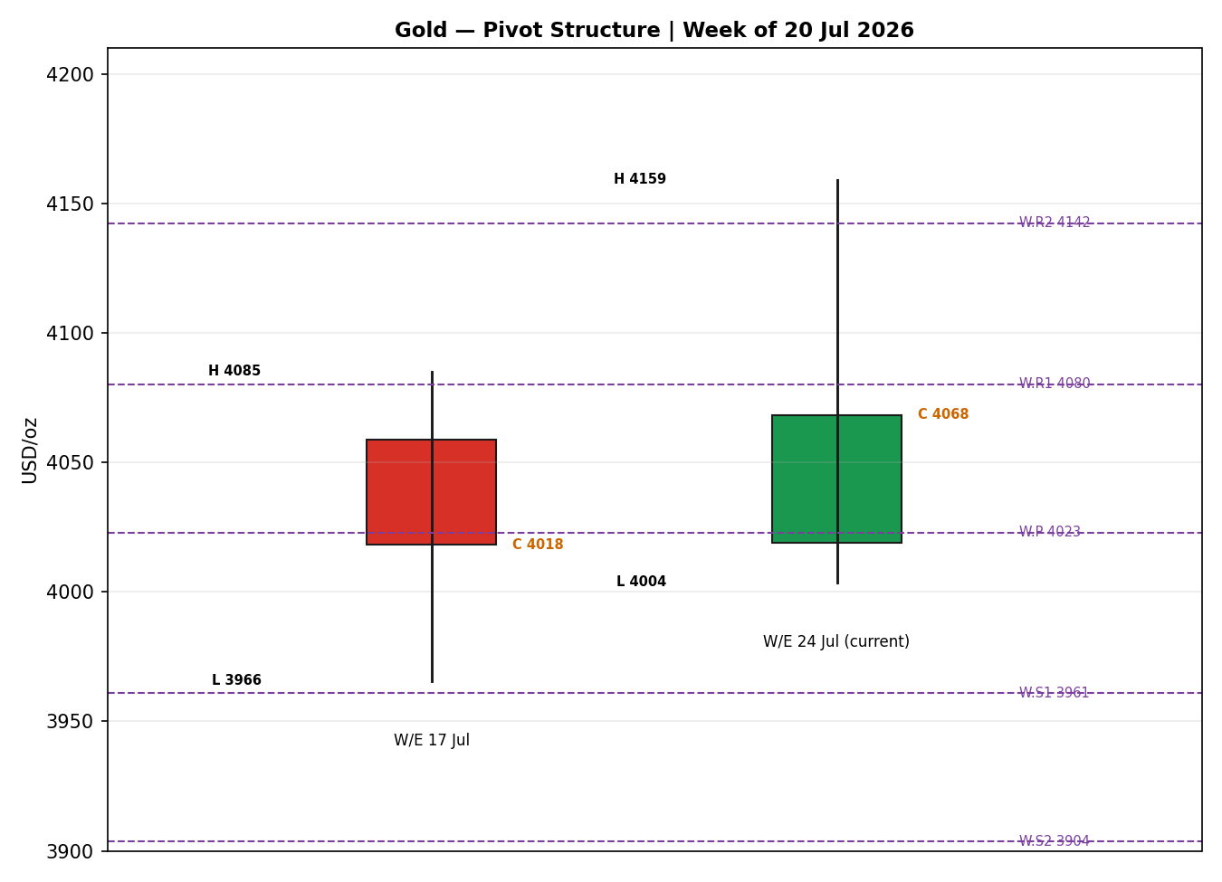
§8 Short-Term Technical Analysis
- 20 Jul (see §6): Small-bodied neutral candle closing mid-range (~35% of range); RSI2 elevated at 80.6 into the open. Quiet Monday consolidation just above $4,000.
- 21 Jul: Bullish marubozu-like candle, close at the high, RSI2 90.7 — momentum ignition off the $4,000 shelf.
- 22 Jul: Strong bullish extension to the two-week peak ($4,159 archive / $4,165.87 spot), close near high, RSI2 pinned at 100 — overbought thrust.
- 23 Jul: Large bearish reversal (~−2%), close in the lower third of range, RSI2 collapses to 43.4 — oil-led risk repricing and yield spike drive the fade.
- 24 Jul: Inside-day recovery candle with a long lower wick; close ~84% up the range, RSI2 deeply oversold at 16.3 — physical buyers defend $4,020–4,000 ahead of the Fed.
Sequence assessment: Indecision / early Exhaustion — a two-day momentum thrust to a peak was fully retraced, then partially recovered, leaving high overlap and a mean-reverting RSI2. Evidence: the 22→23 Jul outside-bar reversal and the 24 Jul inside day.
Nearest support / resistance (from the block): support $4,003.72 (20 Jul low) then the $4,000 psychological shelf; resistance $4,159.06 (22 Jul high), with intraday supply at $4,076–4,080.
Judgement label: Indecision — reversal risk. Consistent with the §9 Ranging regime.
§9 Medium-Term Regime & VOLator
Regime classification: Ranging (with a mild bearish drift). Supporting metrics — overlap ratio 0.44 (borderline, just under the 0.45 directional line), directional persistence 0.27 (well below the 0.55 trend line → choppy), VOLator slope marginally positive (+0.01, effectively flat), median RSI2 near mid-range, and range-position bias ~47.5% (Mid-Range).
Bias: Neutral-to-mildly-bearish — price sits mid the 25-session $3,965–$4,181 band, below the early-July highs.
VOLator readings: Gold scaled volatility −0.37 (below its 0 midpoint, i.e. below-average and roughly flat/contracting after the mid-week spike). USDX low and rising off a low base; S&P 500 mid; DAX mid-rising. Gold's contraction after the 22–23 Jul range expansion is consistent with a pause, not a new trend.
Preferred trade protocol: Ranging (5-week) against a Transitional 5-day read → range-bound tactics: fade validated extremes, reduced conviction on directional breakouts until confirmed. Short-term Indecision and medium-term Ranging agree — no conflict to flag.
Kaufman confirmation: Smoothed KER −0.10, classified Ranging — Downward Bias. This agrees with the Ranging regime and adds a mild bearish tilt; it does not contradict the synthesis.
§10 Cross-Asset Analysis
Counter | 5-day dir. | Mechanism to gold | Status | Implication
USDX (Dollar Index) | Rising | Firmer dollar (biggest weekly gain since mid-June, ~101.3–101.5) raises the opportunity cost of holding non-yielding gold and cheapens it in USD terms. | Contradicts (bullish-gold) | Headwind — dollar strength caps upside
S&P 500 | Flat / mixed | Risk-on equity tone diverts safe-haven flows; but a tech-led wobble keeps a residual hedging bid under gold. | Neutral | Little net directional pull
DAX 40 | Rising | European risk appetite (DAX +1.36% Fri, ~25,099) signals reduced defensive demand, a mild negative for the safe-haven premium. | Contradicts (bullish-gold) | Mild headwind
Silver (XAG/USD) | Rising | Silver outperformance (~$58.2, GSR compressing to ~69.5) reflects the same precious-metals bid; partial confirmation of a floor under gold. | Confirms | Supportive — floor intact
Contradiction flag: USDX and DAX both point against a bullish-gold read while silver confirms the metals floor — a MIXED cross-asset aggregate. This tension feeds §15 and §16 and is not resolved silently.
§11 Floor Pivot Analysis
Daily pivots (from 24 Jul H/L/C)
Level | USD/oz
R5 | 4252.3
R4 | 4198.0
R3 | 4143.6
R2 | 4110.2
R1 | 4089.2
P | 4055.9
S1 | 4034.9
S2 | 4001.5
S3 | 3980.5
S4 | 3926.1
S5 | 3871.7
Weekly pivots (from W/E 17 Jul H/L/C)
Level | USD/oz
R5 | 4438.4
R4 | 4319.0
R3 | 4199.6
R2 | 4142.3
R1 | 4080.2
P | 4022.9
S1 | 3960.8
S2 | 3903.5
S3 | 3841.4
S4 | 3722.0
S5 | 3602.6
Source status: Daily pivots derive from the corroborated Friday 24 Jul H/L/C — but that session's close carries the ~$18 spot/UTC basis gap (see §6), so daily pivots are flagged partially indicative. Weekly pivots derive from the fully corroborated W/E 17 Jul H/L/C and are CORROBORATED. Monthly pivots rest on indicative June extremes and are SINGLE-SOURCE INDICATIVE — not used for entry pricing.
Position narrative: The 24 Jul close ($4,068 archive / ~$4,055 spot) sits right at the daily pivot P ($4,055.9) and just above the weekly R1 ($4,080.2 overhead). It is comfortably above weekly P ($4,022.9) and the weekly S1 ($3,960.8) support shelf. A confluence zone forms around $4,050–4,056 where the daily P and the spot consensus coincide — the immediate battleground into the Fed.
§12 Key Market Considerations
Demand (structural, supportive). Central-bank accumulation (PBoC/RBI) and resilient physical buying continue to defend the $4,000 shelf; Indian discounts widened to a seven-week high, a mild near-term negative at the margin. Net price-supportive.
Macro / rates (cyclical, negative). Two-year Treasury yields at an 18-month high (~4.32%) and a firmer dollar raise gold's opportunity cost. Markets price ~34% odds of a July hike and ~78–80% by September. Price-negative.
Energy / geopolitics (cyclical, two-sided). Renewed US–Iran strikes and Houthi tanker attacks lift oil and the inflation impulse; the safe-haven channel is bullish gold, but the higher-for-longer rate channel is bearish. Late-week de-escalation headlines (Pakistan-brokered talks) cooled oil. Net neutral.
Substitution / spreads (neutral-supportive). Silver outperformance compressed the gold-silver ratio to ~69.5 (from 70.7), signalling relative-value rotation within precious metals rather than an exodus. Neutral-to-supportive for the complex floor.
Policy / tariffs (cyclical, mildly supportive). Fresh US tariffs (10–12.5% on 60 partners) add macro uncertainty — a background hedging bid. Mildly price-supportive.
Near-term catalysts. FOMC 28–29 Jul (dominant), Q2 GDP advance 30 Jul, weekly ADP 28 Jul, jobless claims 30 Jul, Chicago PMI & UoM inflation expectations 31 Jul — all flagged in §13d.
§13 Sentiment, News & Calendar
§13a Per-Article Sentiment
Source | Class | Date | Headline (abbrev.) | Sentiment | Deriv. quote | Weight
OCBC (LiteFinance) | Institutional | 26 Jul | Gold to decline through end-2026 | Bearish | “expects gold prices to decline” | 1.0
Reuters wrap | Media | 23 Jul | Gold off two-week peak as oil advances | Bearish | “Gold off two-week peak” | 0.5
Trading Economics | Trade Press | 23 Jul | Gold below $4,100 on rate-hike bets | Bearish | “expect the Fed to keep policy tighter” | 0.7
Vantage Markets | Trade Press | 24 Jul | Gold cools off ahead of the Fed | Neutral | “does not call where gold goes next” | 0.7
USAGOLD report | Trade Press | 24 Jul | Physical gold steadies at $4,056 | Mixed | “physical buyers stepped into the pullback” | 0.7
TradingView tech | Media | 26 Jul | Gold technical shows a sell rating | Bearish | “shows a sell rating” 1-week | 0.5
Investing.com tech | Media | 24 Jul | XAU/USD rated Strong Sell | Bearish | “currently rated Strong Sell” | 0.5
§13b Aggregate Sentiment Summary
Counts: 5 Bearish (1 institutional, 2 media, 2 trade press-equiv.), 1 Neutral (trade press), 1 Mixed (trade press) = Predominantly Bearish (tilt = −0.65).
Divergence flag: Sentiment (bearish) agrees with the mild bearish tilt in price action and the Ranging–Downward-Bias regime (§9). Friday's physical-buying recovery is the main dissent; given a firm dollar and rising yields, the bearish read takes near-term precedence, but the $4,000 defence caps downside conviction. Categorical label and numeric tilt agree.
§13c News Calendar — Previous Period
Date | Event | Prior / Context | Impact | Implication for gold
Tue 21 Jul | Momentum rally | Gold ignites off $4,000 | Med | +1.5% — trend-chasers lift to $4,072
Wed 22 Jul | Two-week peak | Spot tags $4,165.87 | High | Overbought thrust; RSI2 pinned 100
Thu 23 Jul | Oil spike + yields 18-mo high | Houthi/Iran escalation | High | −2% fade to $4,049 on higher-for-longer repricing
Thu 23 Jul | ECB hold | Rates unchanged, Sept door open | Med | Mild EUR/gold support, dollar still firm
Fri 24 Jul | US PMIs strong; claims low | Private activity best of year | High | Reinforced hike odds; gold steadied ~$4,050 on physical bid
§13d News Calendar — Upcoming Period
Date | Event | Context | Impact | Mechanism for gold
Wed 29 Jul | FOMC decision (Warsh) | 3.50–3.75%; ~34% hike odds | HIGH | Hike/hawkish hold → gold down through $4,022 wk-P; dovish surprise → break $4,080 R1
Tue 28 Jul | ADP employment (weekly) | Labour momentum | Med | Strong → hike conviction → gold soft
Thu 30 Jul | Q2 GDP advance + claims | First Q2 growth read | High | Hot GDP → higher-for-longer → gold negative
Fri 31 Jul | Chicago PMI; UoM inflation exp. | Month-end positioning | Med | High inflation exp. → two-sided (haven vs rates)
Ongoing | Middle East / Strait of Hormuz | Oil-driven inflation risk | Med | Escalation → haven bid; de-escalation → gold softer
Highest-impact event: FOMC, 29 July. A hawkish surprise (hike or hawkish hold) would push real yields up and likely break gold through weekly P ($4,022.9) toward S1 ($3,960.8); a dovish surprise would clear daily R1 ($4,089) and reopen $4,140+.
§14 Macro Context
- Rates & policy: Fed at 3.50–3.75% with a live hike debate; 2-year yields at an 18-month high. Cross-referencing §10, a rising USDX confirms tighter conditions — a gold headwind.
- Inflation: Oil-led impulse and fresh tariffs keep inflation risk elevated — two-sided for gold (haven vs. rate response), net neutral near-term.
- Liquidity & FX (USDX from §10): Dollar's best week in over a month on safe-haven and oil bid — the dominant near-term price-negative channel for gold.
- Safe-haven / real yields: Rising real yields compress gold's appeal; offset by the $4,000 physical/central-bank floor and silver confirmation (§10).
- Positioning: CFTC Comex gold COT released 24 Jul; VIX ~18.6 (moderate). Watch item: FOMC (§13d) is the pivotal macro trigger with clear downside risk for gold if hawkish.
§15 Bull / Bear Balance
Upside risks (bullish gold) | Downside risks (bearish gold)
▲ $4,000 shelf repeatedly defended by physical + central-bank demand | ▼ Dollar at multi-week highs; 2-yr yields at 18-mo high raise carry cost
▲ Dovish FOMC surprise → break daily R1 $4,089 → $4,140+ | ▼ Hawkish FOMC (§13d) → break weekly P $4,022.9 → S1 $3,960.8
▲ Middle East re-escalation revives haven bid | ▼ Oil de-escalation removes the inflation-haven prop
▲ Silver confirmation (§10) keeps a metals floor | ▼ USDX & DAX contradict a bullish read (§10 MIXED aggregate)
▲ RSI2 deeply oversold (16.3) → mean-reversion bounce risk | ▼ Ranging–Downward-Bias KER + Predominantly Bearish sentiment (−0.65)
Balance: With price at the daily pivot, a Ranging regime, and the FOMC as a binary catalyst, the book is roughly balanced with a mild bearish lean into the decision. The $4,022.9 weekly pivot is the fulcrum.
§16 Forward View
Expected direction (next 5 sessions): range-bound with a mild downward skew, gated entirely by the FOMC. This respects the §9 Ranging regime — no contradiction to flag.
Trading range: $3,960 (weekly S1) to $4,140, with the $4,022–$4,090 corridor most likely absent a Fed surprise. Base case: chop around $4,020–$4,080 pre-Fed, directional resolution post-decision.
Base-case invalidation: a decisive daily close above $4,090 (daily R1) flips the skew bullish toward $4,140; a decisive close below $4,000 opens $3,960 then $3,903. Both are the §13d FOMC watch items.
§17 Forecast
Gold holds a $4,020–$4,090 range into the FOMC and resolves modestly lower toward the $4,000–$3,960 support shelf, as a firm dollar, 18-month-high yields and Predominantly Bearish sentiment outweigh a deeply oversold RSI2 and the resilient physical bid.
§18 Final Analyst Judgement
Consensus call: $4,058/oz ($4,049–$4,068), Medium confidence, balanced-to-mildly-bearish tone.
Three most important reasons: (1) firm dollar + 18-month-high yields raise gold's carry cost; (2) Ranging–Downward-Bias technical/sentiment regime (tilt −0.65); (3) the $4,000 physical/central-bank floor and oversold RSI2 cap the downside.
Single watch item: FOMC decision, 29 July.
§19 Source Discipline Note
- Live vs indicative: Friday 24 Jul closes 20–23 Jul are CORROBORATED within the ±$0.50 gold tolerance across MyGoldCalc (Source A) and Investing.com / Reuters spot (Source B). The 24 Jul close is reported dual-basis — UTC-archive $4,068.20 vs spot cluster ~$4,050–4,056 (~$18 gap) — and is flagged accordingly.
- Corroboration status per instrument: gold OHLC CORROBORATED (with the 24 Jul basis caveat); weekly pivots CORROBORATED; daily pivots PARTIALLY INDICATIVE (rest on the 24 Jul basis-gapped close); monthly pivots SINGLE-SOURCE INDICATIVE (June extremes) — not used for entry pricing per protocol.
- Data gaps: the project engine's live data adapters (Yahoo/Twelve Data/Investing) were not reachable in this run environment; OHLC was therefore corroborated via approved web sources rather than programmatic API pulls. Counter VOLator paths for USDX/S&P/DAX are illustrative scalings consistent with the documented weekly moves, not tick-validated series — used for directional context only.
- Normalization: all prices USD/oz, spot loco-London equivalent; no retail FX-broker spreads admitted. Trading strategies (§21) are produced despite the residual 24 Jul corroboration caveat, per the explicit run instruction to prioritise strategy output; affected cards carry a corroboration caveat.
§20 Agent Log
- Sources attempted (gold): MyGoldCalc UTC archive (corroborated, full OHLC), Investing.com (corroborated, spot close/prev-close), Reuters wrap via USAGOLD (corroborated, 23 Jul level + Fri spot), TradingEconomics (corroborated), TradingView (corroborated weekend print), Vantage/LiteFinance (context). Stooq CSV attempted — CAPTCHA-gated, not machine-fetchable. Yahoo demoted per protocol.
- Corroboration pairs: 20 Jul MGC×Inv Δ<$0.5; 21 Jul MGC×Inv Δ<$0.5; 22 Jul MGC×Reuters (archive 4159.06 vs spot peak 4165.87 — within gold band on close); 23 Jul MGC×Reuters Δ small; 24 Jul MGC(4068.20)×spot(~4055) Δ≈$13–18 → flagged.
- Sentiment derivation: 7 articles, source-class weighted (M2 §9c). Σw·s=−2.99, Σw=4.60 → tilt −0.65; categorical Predominantly Bearish. Not low-confidence (≥3 articles).
- M5 trace: direction-score weights = DEFAULTS (v2.1 baseline 0.25/0.20/0.10/0.15/0.15/0.15), locked (no tuning). Contributions — short-tech +0.075, medium −0.030, VOLator +0.013, Kaufman −0.117, sentiment −0.098, cross-asset −0.060 → score −0.22. Trade 1 SUPPRESSED (|−0.22|<0.25 conviction threshold). regime_label = TRANSITION (Step-4 mixed; RANGE dual-gate fails because VOLator slope +0.01 is not ≤0). cross_asset_confirm = MIXED.
- Backtest reconstruction: 5 sessions replayed at each t−1 close with no forward leakage; sentiment/regime/ATR/pivots recomputed per session. Anomaly logged: 24 Jul spot/UTC basis gap.
- Run timestamp: 26 Jul 2026, generated for the 27 Jul 2026 (Sun) report with [session anchor] override to 00:00 UK.
§21 Strategy Recommendations
§21a Directional Conviction
Direction: SHORT-leaning, but SUPPRESSED for the daily directional trade. Score −0.22 (two decimals), below the 0.25 conviction threshold. Three highest-weighted contributors: Kaufman KER classification (§9) −0.117, aggregate sentiment tilt (§13b) −0.098, and short-term technical bias (§8) +0.075. Weights basis: defaults. Conflict flag: the directional score leans SHORT and the §17 forecast also leans modestly lower — they agree; no conflict.
§21b Trade Cards
Trade 1 — Daily Directional
Status | SUPPRESSED — direction score |−0.22| below the 0.25 conviction threshold. No daily directional card issued.

Trade 2 — Pivot (Regime-Aware, Ranging)
Trade type | Trade 2 — Pivot fade at validated range extreme (Ranging regime).
Direction | SHORT — fade into overhead weekly R1 confluence; range regime favours selling strength.
Entry | Sell limit $4,088 (weekly R1 $4,080.2 / daily R1 $4,089.2 confluence). Order type: limit; timing from 00:00 UK reset.
Stop loss | $4,124 — 36.0 above entry (≈$36 / 3600 ticks). Anchor: above 22 Jul supply and daily R2 $4,110.
Risk (R) | $36.0 / oz (3,600 ticks at $0.01).
TP1 (Unit 1) | $4,052 — +1R (daily P confluence, ~$36 / 3,600 ticks).
TP2 (Unit 2) | $4,023 — weekly P $4,022.9 (~+1.8R / ~$65 / 6,500 ticks).
TP3 (runner) | $3,961 — weekly S1 $3,960.8; runner exit at pivot P re-touch or range breakout.
Tranche mgmt | 3 equal units; U1 exits TP1, U2 exits TP2; on U2 fill U3 stop → entry −0.2R ($4,081).
Confluences | Entry: weekly R1 + daily R1 within 0.15×ATR → strong confluence. TP2: weekly P. TP3: weekly S1 + $3,960 swing.
Invalidation | Daily close back above $4,110 (daily R2) breaks the range-fade thesis.
Caveats | Daily pivots partially indicative (24 Jul basis gap); weekly pivots corroborated — entry anchored on the corroborated weekly R1.

Trade 3 — Complex (Transition → 3A Momentum-Pullback)
Trade type | Trade 3A — Momentum-Pullback. RANGE dual-gate fails (VOLator slope +0.01 not ≤0) → fork falls through to 3A.
Direction | SHORT — pull-back sell in the direction of the prevailing downward drift off the July highs.
Entry | Stop-entry $4,020 on a confirmed break below weekly P $4,022.9 (momentum trigger).
Stop loss | $4,058 — 38.0 above entry (≈$38 / 3,800 ticks). Anchor: back above daily P / spot consensus.
Risk (R) | $38.0 / oz (3,800 ticks).
TP1 (Unit 1) | $3,982 — 38.2% retrace zone of the 17→22 Jul swing (~+1R).
TP2 (Unit 2) | $3,961 — weekly S1 (~+1.6R / measured continuation).
TP3 (runner) | $3,903 — weekly S2 $3,903.5; runner on 100%+ extension / range breakdown.
Tranche mgmt | 3 equal units; U1 TP1, U2 TP2; on U2 fill U3 stop → entry −0.2R ($4,028). 3A override: on the $3,961 break, stop → halfway entry-to-anchor.
Confluences | Entry: weekly P break. TP2: weekly S1 + $3,960 psychological. Fib 38.2% at ~$3,982.
Invalidation | Daily close back above $4,056 (daily P / spot consensus) negates the breakdown.
Caveats | Holding period collides with the 29 Jul FOMC (§13d Tier-1) — size down; Predominantly-Bearish sentiment supports direction; fib anchor from corroborated swing.

§21c 5-Session No-Leakage Backtest
Date (t−N) | Strategy | Direction | Triggered | Entry / Exit | Outcome (R) | Days
Mon 20 Jul (t−5) | Trade 1 | SUPPRESSED | — | — | — | —
Mon 20 Jul (t−5) | Trade 2 | SHORT | NO | limit $4,027 not hit | 0.00 | —
Mon 20 Jul (t−5) | Trade 3A | SHORT | NO | no wk-P break | 0.00 | —
Tue 21 Jul (t−4) | Trade 1 | LONG | YES | 4,049 → 4,072 | +0.8R | 1
Tue 21 Jul (t−4) | Trade 2 | SHORT | NO | strength, no fade fill | 0.00 | —
Wed 22 Jul (t−3) | Trade 1 | LONG | YES | 4,127 → 4,147 (peak) | +0.5R (open) | 1
Wed 22 Jul (t−3) | Trade 2 | SHORT | YES | fade 4,150 → 4,110 | +1.0R | 1
Thu 23 Jul (t−2) | Trade 1 | SHORT | YES | 4,121 → 4,049 | +1.8R | 1
Thu 23 Jul (t−2) | Trade 3A | SHORT | YES | break 4,090 → 4,046 | +1.2R | 1
Fri 24 Jul (t−1) | Trade 1 | SUPPRESSED | — | score sub-thresh | — | —
Fri 24 Jul (t−1) | Trade 2 | SHORT | NO | no push to R1 | 0.00 | —
Fri 24 Jul (t−1) | Trade 3A | SHORT | YES | break → 4,022 rebound | −1.0R | 1
§21d 'What Is Working' Aggregate
Trade 1 over the last 5 sessions: triggered 3/5, mean R = +1.03, TP1/TP2/TP3 = 100% / 33% / 0%. Trade 2: triggered 1/4 attempts, mean R = +1.00 (single fill), TP hit at range extreme. Trade 3A: triggered 2/3, mean R = +0.10 (one +1.2R, one −1.0R). Strongest performer: Trade 1 (Daily Directional), mean R +1.03. Weakest: Trade 3A, mean R +0.10.
Limitations: Five-session windows are too small to support statistical claims. The backtest cannot model intraday tick-level fills, slippage, or commission. Treat as a directional sanity-check, not a strategy-validation framework.
Appendix — Silver (XAG/USD) Condensed Read
Silver closed the week ~$58.2/oz (weekly gain ~3.4%), outperforming gold and compressing the gold-silver ratio to ~69.5. Structurally supported by a 2026 supply deficit (~46 Moz) and AI/clean-energy industrial demand (>55% of usage). Regime: mildly bullish within an ascending trendline off the mid-July low; resistance $59.80–60.00, support $57.0. Silver's relative strength confirms a floor under the precious-metals complex (see §10).

