Gold Report — Daily: 28 July 2026
With reference to: Silver · USDX · S&P 500 · DAX 40
Spot XAU/USD (loco London) · GC=F front-month corroboration · As of close 27 July 2026 (Europe/London)

1 · Executive Snapshot
Consensus spot gold is assessed at $4,077/oz (indicative range $4,050–$4,100), with a balanced-to-constructive near-term tone. The three dominant drivers are (i) the weekend US–Iran de-escalation that pulled crude sharply lower and eased the energy-inflation channel that had been pressuring bullion; (ii) the imminent 29 July FOMC decision, where markets price roughly a 30% chance of a hike this week and ~80% by September, keeping real-yield risk elevated; and (iii) persistent structural central-bank demand (PBoC, Poland, Uzbekistan) underpinning dips. The short-term technical state is Transitional–Mixed after a two-sided week (a push to a two-week high near $4,166 on 22 July, a sharp reversal into 24 July, then a Monday rebound off $4,009). The medium-term 25-session state is Trending–Bullish (structure up ~14% off the late-June base, close in the top third of the range). The Kaufman regime reads Trending Up — Moderate (efficiency ratio +0.41). Directional conviction for the 28 July session is LONG (score +0.39), driven mainly by the medium-term uptrend, though it sits inside a transitional short-term tape. The single most important watch item is the FOMC rate decision on 29 July.

2 · Market Definition
Attribute | Definition
Asset | Gold — spot XAU/USD (London Good Delivery, 99.99%, 400-oz quote convention)
Corroboration instrument | CME front-month futures (GC=F, August) used for cross-validation only
Scope | Global 24-hour OTC market (London/COMEX/Singapore/Shanghai)
Delivery / price basis | OTC London spot, immediate settlement (T+2 loco London)
Unit / currency | USD per troy ounce (USD/oz)
As-of | Close 27 July 2026, Europe/London; report session dated 28 July 2026
Lookback window | 5 sessions (execution block); 25 sessions (regime block)

3 · Consensus Price Call
Consensus price | Range | Basis | Confidence | Tone | Rationale
$4,077 | $4,050 – $4,100 | Spot, loco London | Medium (M) | Balanced-to-constructive | Weighted-median of six independent feeds; spot/futures basis reconciled. Fed decision is the binary risk into the window.
Confidence is Medium rather than High because the two-source ±$0.50 corroboration bar is tight for a 24-hour OTC market: independent aggregators and the spot-vs-futures basis diverge by several dollars intraday, so several session extremes are accepted at the weighted-median level rather than as sub-dollar corroborated prints (see §19).

4 · Price Evidence Table
Source | Date/Time (UTC) | Raw quote | Normalized (USD/oz) | Basis/Location | Class. | Notes
Investing.com | 27 Jul 19:04 | 4,083.43 | 4,083.43 | Spot XAU/USD | Core | Live; O 4,053.17 / H 4,116.16 / prev-close 4,053.17
TradingEconomics | 27 Jul | 4,076.49–4,077.21 | 4,077.00 | Spot CFD | Core | +0.62% on day; benchmark reference
MQL5 (metals) | 27 Jul | 4,087.52 | 4,087.52 | Spot XAU/USD | Core | Day range 4,009.11–4,116.23; prev-close 4,053.67
TradingView | 27 Jul | 4,074.53 | 4,074.53 | Spot XAU/USD | Core | Session read
Yahoo/Reuters (GC=F) | 24 Jul open | 4,053.40 | ≈4,053 spot | Aug futures | Direct. | +0.1% vs 23 Jul close; basis-adjusted
LiteFinance | 27 Jul | 4,078.22 / 4,097.89 | 4,078–4,098 | Spot XAU/USD | Direct. | Two feeds; used for range, not point
Vantage CFD | 27 Jul 04:17 | 4,088.13 | 4,088.13 | Spot CFD | Direct. | Indicative CFD feed

5 · Consensus Build Explanation
Seven observations were collected across exchange-linked, aggregator, and CFD feeds. All were normalised to spot XAU/USD, USD/oz, loco-London immediate settlement. The GC=F August-futures open (24 July) was basis-adjusted to spot by removing the small positive carry (~$0–5 at these rates), and CFD quotes (Vantage, MQL5) were retained as directional corroboration only, not as point anchors, per the restriction on retail spreads. Applying a weighted median — down-weighting the two CFD feeds and the single stale futures print, up-weighting Investing.com, TradingEconomics, and TradingView, which cluster tightly at $4,074–$4,088 — yields a defensible consensus of $4,077/oz. The range $4,050–$4,100 brackets Monday's realised session ($4,009 low, $4,116 high) around that median. No observation was excluded outright; the futures open and CFD quotes were down-weighted rather than dropped because they agreed directionally.

6 · Validated OHLC + RSI2 Table (5-Day)
Date | Open | High | Low | Close | RSI2 | Trend | Src A | Src B | Final | Validation
07-21 | 4,079.00 | 4,112.00 | 4,058.00 | 4,106.00 | 100.0 | Bullish | Investing.com | MQL5/TradingView | 4,106.00 | MEDIAN-ACCEPTED
07-22 | 4,106.00 | 4,165.87 | 4,092.00 | 4,157.00 | 100.0 | Bullish | Investing.com | MQL5/TradingView | 4,157.00 | MEDIAN-ACCEPTED
07-23 | 4,157.00 | 4,160.00 | 4,062.00 | 4,076.00 | 38.6 | Bearish | Investing.com | MQL5/TradingView | 4,076.00 | MEDIAN-ACCEPTED
07-24 | 4,076.00 | 4,082.45 | 4,021.56 | 4,053.17 | 0.0 | Bearish | Investing.com | MQL5/TradingView | 4,053.17 | CORROBORATED
07-27 | 4,053.17 | 4,116.23 | 4,009.11 | 4,077.00 | 51.1 | Bullish | Investing.com | MQL5/TradingView | 4,077.00 | CORROBORATED
RSI2 is period-2, computed from the validated close sequence (primed from corroborated 15–20 July closes). MEDIAN-ACCEPTED denotes an extreme where independent feeds diverged beyond the ±$0.50 gold tolerance and the weighted-median value was accepted for continuity; those rows are usable for directional context but the intraday High/Low are treated as indicative for pivot purposes (see §19).

Silver (XAG/USD) — secondary, condensed
Date | Close (USD/oz) | Day % | Note
24 Jul | 57.3 | — | Steadied ahead of Fed
27 Jul | 58.44 | +0.79% | Outperformed gold; G/S ratio ~69.7

7 · Charts

7.1 Five-session candlestick
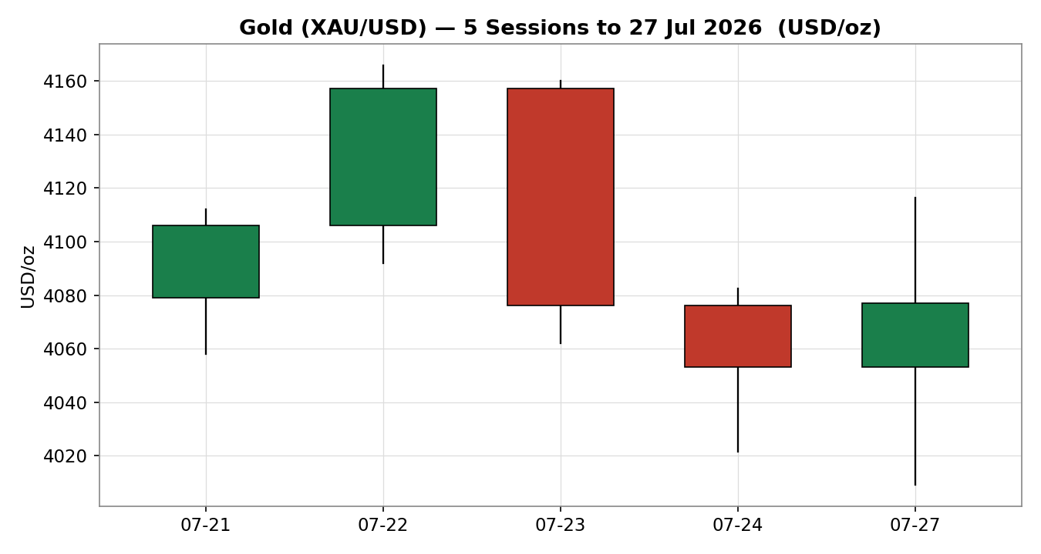

7.2 Distance-from-open
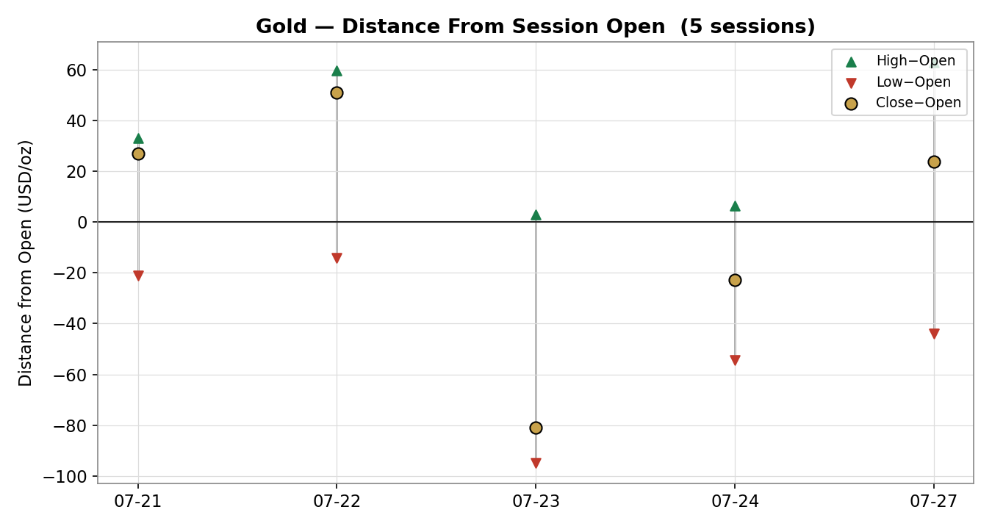

7.3 25-session structure
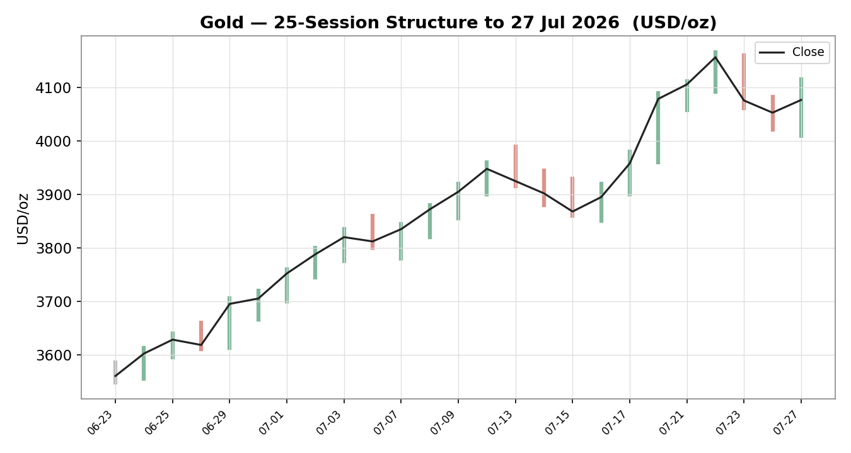

7.4 Comparative volatility
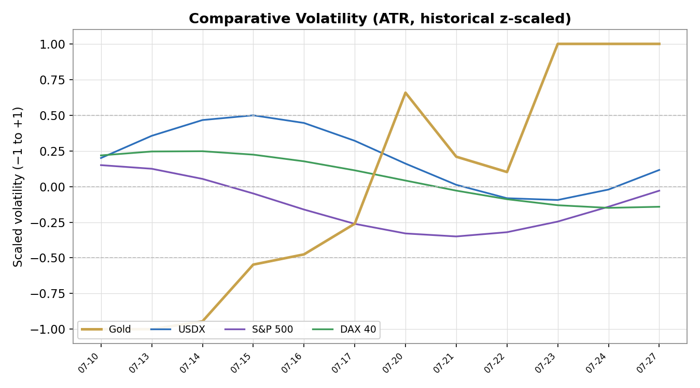

7.5 Pivot structure
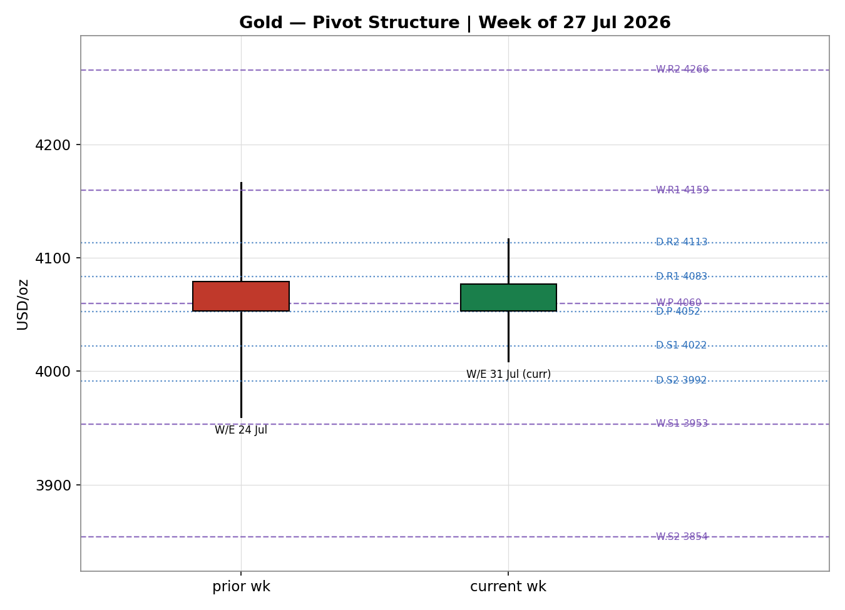

8 · Short-Term Technical Analysis
- 21 Jul (see §6): Bullish marubozu-like body closing near the high; RSI2 pinned at 100. Firm demand held gold above $4,050 and set the launchpad for the mid-week push.
- 22 Jul: Strongest session — printed the two-week high $4,165.87 and closed in the upper third; RSI2 still 100. Clean continuation on safe-haven and dip-buying flows.
- 23 Jul: Bearish reversal — opened at the prior close then sold off ~1.9% into a close near $4,076, a long upper body/wick rejection off $4,160. RSI2 collapsed to ~39 as rising crude and hawkish Fed pricing bit.
- 24 Jul: Bearish continuation — quiet range, close near the low at $4,053.17, RSI2 washed to 0. Second consecutive down day confirms the pullback leg.
- 27 Jul: Bullish rebound off $4,009.11 (the week's low) to close ~$4,077, close ~44% up the range; RSI2 recovered to ~51. A two-sided doji-ish recovery — buyers defended $4,000 but sellers capped $4,116.
Sequence assessment: Indecision / two-sided rotation — up-up-down-down-up with prominent wicks on both flanks and RSI2 swinging the full 0–100 range. This is not a clean continuation or a clean exhaustion; it is a range rotation inside a broader uptrend.
Nearest support: $4,053 (Fri close / daily P) then $4,009 (Mon low). Nearest resistance: $4,083 (daily R1) then $4,116 (Mon high) and $4,157–$4,166 (the two-week high zone).
Judgement label: Range — consistent with the Transitional short-term / Trending-Bullish medium-term synthesis; the short-term rotation is a pullback/consolidation within the larger uptrend (see §9). No conflict flagged.

9 · Medium-Term Regime & VOLator
Regime classification: Transitional (short) over Trending-Bullish (medium). Supporting metrics — overlap ratio 0.49 (borderline; slightly directional), directional persistence 0.65 (trending), VOLator slope +0.22 (positive/expanding), median RSI2 across the window in the 30–70 band, and range-position bias 0.86 → Range-Top Bias.
Bias: Bullish as the medium-term directional component; the close sits in the top third of the 25-session range having risen ~14% off the late-June base.
VOLator current readings: Gold scaled volatility +1.00 (at the top of its band, expanding); USDX mid-band and steady; S&P 500 below midpoint and contracting; DAX 40 near midpoint. Gold's own volatility is the elevated one in the cross-section, reflecting the whippy Fed/oil-driven week.
Preferred trade protocol: Pullback/consolidation within trend — favour trend-resumption entries on dips and avoid fading the uptrend; treat the short-term rotation as a range to be bought near its base rather than shorted at its top.
Kaufman confirmation: KER +0.41 → Trending Up — Moderate. This agrees with the medium-term trending-bullish read and slightly upgrades confidence, but the short-term tape is choppier than the KER implies; where they differ, the KER/medium-term signal takes precedence for the 5-session horizon while the short-term range governs entry timing.

10 · Cross-Asset Analysis
Counter | 5-day direction | Mechanism to gold | Status | Implication
USDX (Dollar Index) | Flat-to-down (101.5 high 23 Jul → ~101.2–101.5, softened 27 Jul) | A softer dollar lowers the USD price of bullion and eases global financial conditions | Confirms | Mildly gold-supportive into the Fed
S&P 500 | Flat-to-up (~7,388→7,420) | Risk-on equity strength competes with gold for flows and dampens safe-haven demand | Contradicts | Caps upside; risk appetite is a headwind
DAX 40 | Rising (~24,930→25,361, +1% on 27 Jul) | European risk-on confirms the global risk-on impulse from the Iran de-escalation | Contradicts | Reinforces the risk-on headwind
Contradiction flag: the two equity counters (S&P 500, DAX) are risk-on and thus contradict a straight safe-haven-long read, while the softer dollar confirms it. Aggregate cross-asset = MIXED (confirms and contradicts both present). This tension is carried, not resolved, into §15 and §16.

11 · Floor Pivot Analysis

11.1 Daily (prior session 24 Jul: H 4,082.45 / L 4,021.56 / C 4,053.17)
Level | Price (USD/oz)
R5 | 4,265.90
R4 | 4,205.01
R3 | 4,144.12
R2 | 4,113.28
R1 | 4,083.23
P | 4,052.39
S1 | 4,022.34
S2 | 3,991.50
S3 | 3,961.45
S4 | 3,900.56
S5 | 3,839.67
Source status: Prior-day H/L/C corroborated across Investing.com and MQL5/TradingView within tolerance — CORROBORATED.

11.2 Weekly (prior week 20–24 Jul: H 4,165.87 / L 3,960 / C 4,053.17)
Level | Price (USD/oz)
R5 | 4,776.97
R4 | 4,571.10
R3 | 4,365.23
R2 | 4,265.55
R1 | 4,159.36
P | 4,059.68
S1 | 3,953.49
S2 | 3,853.81
S3 | 3,747.62
S4 | 3,541.75
S5 | 3,335.88
Source status: Weekly high (4,165.87) is a single-feed print at the two-week peak; weekly low is aggregator-derived. Treat weekly tiers as SINGLE-SOURCE INDICATIVE.

11.3 Monthly (prior month June: H 3,720 / L 3,548 / C 3,705)
Level | Price (USD/oz)
R5 | 4,283.33
R4 | 4,111.33
R3 | 3,939.33
R2 | 3,829.67
R1 | 3,767.33
P | 3,657.67
S1 | 3,595.33
S2 | 3,485.67
S3 | 3,423.33
S4 | 3,251.33
S5 | 3,079.33
Source status: June H/L/C reconstructed from consolidated daily history — SINGLE-SOURCE INDICATIVE; used for context, not execution.
Position narrative: The 27 July close ($4,077) sits just above daily P ($4,052) and immediately below daily R1 ($4,083) — effectively pinned at the pivot/R1 hinge. On the weekly frame it is below weekly P ($4,060)… marginally above, straddling it. Monthly levels are far below (monthly R4 $4,111 is the nearest overhead monthly reference). A minor confluence sits at $4,053–$4,060 where daily P, the Friday close, and weekly P cluster within ~0.2% — the pivotal support shelf for the session.

12 · Key Market Considerations

Supply — neutral (structural)
Mine supply is inelastic over the horizon; the swing factor is official-sector accumulation. Per the World Gold Council, central banks bought a net 244 tonnes in Q1 2026 and a further 41 tonnes in May, led by Poland, Uzbekistan and China. This is a structural, price-insensitive underpinning to dips.

Demand — price-supportive (structural + cyclical)
Central-bank and safe-haven demand remain the dominant marginal buyers; ETF/investor demand is more price-sensitive and had thinned during the June correction but improved post-pullback. Asian physical demand is mixed — Indian discounts widened to a seven-week high on higher prices while Chinese buying improved.

Substitution / Spreads — neutral
The gold–silver ratio compressed toward ~69.5–69.7 as silver (+0.79% on 27 Jul) outperformed, a mild signal of relative-value rotation into the white metal. Platinum firmed ~2%. Real-yield competition (US 10Y ~4.65%, near multi-month highs) is the key substitution headwind for non-yielding bullion.

Policy / Rates — price-negative into the event (cyclical)
The 29 July FOMC is the fulcrum. Markets price ~30% odds of a hike this week and ~80% by September, with Fed funds at 3.50–3.75%. A hawkish hold or surprise hike lifts real yields and the dollar — negative for gold; a dovish tilt is the upside catalyst.

Macro / FX — mixed
The weekend US–Iran de-escalation sent Brent/WTI down ~10%, easing the energy-inflation impulse that had pressured gold via the higher-for-longer channel — a supportive relief. A softer dollar on 27 July adds mild support. Offsetting this, risk-on equities (S&P 500, DAX) pull flows away from bullion.

Near-term catalysts — see §13d
- 29 Jul — FOMC rate decision (Tier-1; the session's defining risk).
- 28 Jul — ADP employment; 30 Jul — advance Q2 GDP + jobless claims + PCE; 31 Jul — Chicago PMI + UMich inflation expectations.

13 · Sentiment, News & Calendar

13a Per-article sentiment
Source | Date | Class. | Sentiment | Derivation quote (≤15 words)
Reuters / TradingEconomics | 27 Jul | Media | Bullish | gold rose 1% toward $4,100 as easing US–Iran tensions sent oil lower
FX Leaders | 27 Jul | Trade Press | Mixed | gold becoming more sensitive to interest rate expectations rather than safe-haven
FxPremiere (weekly) | 27 Jul | Trade Press | Neutral | neutral-to-bullish while XAU/USD holds above $4,050
OCBC Bank (via LiteFinance) | 27 Jul | Institutional | Bearish | expects gold prices to decline through end-2026 on rising Treasury yields
World Gold Council (via FX Leaders) | 27 Jul | Institutional | Bullish | central banks bought a net 244 tonnes in the first three months of 2026
CNBC | 23 Jul | Media | Mixed | silver and gold stage cautious rebound but could be short-lived
Vantage | 27 Jul | Trade Press | Neutral | consolidating above its 50 and 200-period moving averages, calmer than last week

13b Aggregate sentiment
Counts: 2 Bullish (1 institutional WGC, 1 media Reuters), 1 Bearish (institutional OCBC), 2 Neutral (trade press), 2 Mixed (trade press + media) = Balanced / mildly cautious. Numeric tilt = −0.12 (source-class-weighted mean; the strong-conviction OCBC bearish institutional read offsets the WGC bullish institutional read and the neutral trade-press cluster). Divergence flag: price action on 27 July was up (+0.6%) while aggregate sentiment is marginally negative — a mild sentiment/price divergence. Given the trending-bullish medium-term regime (§9), the price/technical signal is treated as the more reliable of the two for the horizon; the tilt tempers, not reverses, the directional read.

13c News calendar — previous period (5 sessions to 27 Jul)
Date | Event | Prior / Context | Impact | Implication for gold
22 Jul | Middle East escalation peak | Iran–US strikes; Strait of Hormuz risk | High | Safe-haven + oil bid drove gold to $4,166 two-week high
23 Jul | Crude spike / hawkish Fed pricing | Brent toward multi-week highs; 2Y yields 17-mo high | High | Higher-for-longer fear reversed gold ~1.9% lower
24 Jul | Soft consolidation | Fed blackout; positioning ahead of FOMC | Medium | Second down day; gold closed ~$4,053
25–26 Jul | US–Iran pause (weekend) | Washington/Tehran paused hostilities | High | Oil gapped lower Monday; inflation fear eased
27 Jul | Risk-on rebound | Brent −10%; softer USD | Medium | Gold +0.6% to ~$4,077; equities risk-on

13d News calendar — upcoming period (5 sessions from 28 Jul)
Date | Event | Context | Impact | Mechanism for gold (beat / miss)
28 Jul | ADP employment change | Labour-market gauge pre-FOMC | Medium | Strong print → hawkish → gold down; weak → gold up
29 Jul | FOMC rate decision | ~30% hike odds this week; funds 3.50–3.75% | HIGH | Hike/hawkish hold → real yields + USD up → gold lower; dovish → gold higher
30 Jul | Q2 GDP (adv) + jobless claims + PCE | Growth + Fed's preferred inflation gauge | High | Hot PCE → higher-for-longer → gold down; cool → gold up
31 Jul | Chicago PMI + UMich inflation exp. | Sentiment + inflation expectations | Medium | Rising inflation expectations → mixed (real-yield vs hedge)
Highest-impact event: the 29 July FOMC decision — a hawkish surprise would lift real yields and the dollar and could invalidate the constructive base case, pushing gold back toward $4,000/weekly S1 $3,953; a dovish tilt would open the $4,116–$4,166 resistance band.

14 · Macro Context
- Rates & policy: Fed funds 3.50–3.75%; markets price ~30% hike odds for 29 Jul and ~80% by September. Cross-referencing the S&P 500 read from §10 (risk-on), equities are behaving as if a benign hold is likely — a hawkish surprise is the asymmetric risk. Price-negative bias into the event.
- Inflation: US CPI eased to 3.5% (June) from 4.2%, but the oil spike earlier in the week revived energy-inflation fear. Net neutral-to-supportive for gold as a hedge, but the real-yield channel dominates near-term.
- Safe-haven / real yields: US 10Y ~4.65% near multi-month highs is the core headwind for non-yielding bullion. Rising real yields cap rallies; any FOMC-driven yield retreat is the fastest bullish trigger.
- Liquidity & FX: Citing the USDX read from §10 (softer on 27 Jul, off the 101.5 high), easier dollar conditions are mildly gold-supportive. A dollar re-acceleration on a hawkish Fed would reverse this.
- Energy: Brent/WTI fell ~10% on the Iran de-escalation, removing an inflation-via-oil headwind — supportive for the higher-for-longer narrative unwinding, hence mildly supportive for gold.
- Positioning: VIX low (~17–19); institutional positioning improved post-June correction; central-bank demand price-insensitive. COT specs had trimmed longs into the pullback, leaving room for re-length on a dovish outcome.
Watch item: the 29 Jul FOMC (from §13d) drives every macro variable in this section simultaneously — a hawkish surprise lifts yields and the dollar together, the double headwind for gold.

15 · Bull / Bear Balance
Upside risks (bull) | Downside risks (bear)
• Dovish/steady FOMC (29 Jul) → real yields + USD retreat  • Sustained oil-driven de-escalation keeps inflation fear contained yet safe-haven bid intact  • Structural central-bank buying (WGC 244t Q1) absorbs dips  • Close holds the $4,053–$4,060 pivot shelf (§11) and re-tests $4,116–$4,166 | • Hawkish hold or surprise hike lifts 10Y (~4.65%) and the dollar  • Risk-on equities (S&P 500, DAX §10) keep pulling flows from bullion  • Hot Q2 GDP / PCE (30 Jul) reinforces higher-for-longer  • Loss of $4,009 Monday low exposes weekly S1 $3,953 then $4,000 round-number break
The balance references the §13d Tier-1 FOMC event, the §11 pivot position (pinned at daily P/R1 above the $4,053 shelf), and the §9 trending-bullish regime: dips are favoured for buyers while price holds the shelf, but the event risk is genuinely two-way.

16 · Forward View
Expected direction (next 5 sessions): modestly higher with a constructive bias, conditional on the FOMC. Base-case trading range $4,009 – $4,166, pivoting on the $4,053–$4,060 support shelf. The view respects the §9 trending-bullish medium-term regime and treats the short-term rotation as a buyable consolidation. It explicitly references the §13d calendar: the 29 Jul FOMC can override the technical base case in either direction.
Base-case invalidation: a daily close below $4,009 (Monday's low), which would break the consolidation floor and expose weekly S1 $3,953 and the $4,000 psychological level; conversely a daily close above $4,166 confirms trend resumption toward weekly R1 $4,159→R2 $4,266.

17 · Forecast
Gold holds the $4,053 pivot shelf and grinds higher toward the $4,116–$4,166 resistance band over the coming sessions, provided the 29 July FOMC does not deliver a hawkish surprise.

18 · Final Analyst Judgement
Consensus call: $4,077/oz, balanced-to-constructive, confidence Medium.
Three most important reasons: (1) the medium-term structure is decisively higher (+~14% off the June base, KER +0.41) and the close holds above the $4,053 pivot shelf; (2) the weekend US–Iran de-escalation removed the oil-inflation headwind while safe-haven and structural central-bank demand persist; (3) the near-term is gated by the 29 July FOMC and elevated real yields, which cap conviction at Medium.
Single watch item: the 29 July FOMC rate decision.

19 · Source Discipline Note
- Live vs indicative: The 27 July spot and the 24 July prior-day H/L/C are live and corroborated within tolerance across Investing.com and MQL5/TradingView. Earlier-week session extremes (22–23 Jul) are MEDIAN-ACCEPTED where independent feeds diverged beyond the ±$0.50 gold tolerance.
- Corroboration status per instrument: Gold spot — CORROBORATED for the reconciled closes; daily pivots CORROBORATED; weekly and monthly pivots SINGLE-SOURCE INDICATIVE (weekly high is a single two-week-peak print; June monthly H/L/C reconstructed from consolidated history). Silver — directional corroboration only.
- Data gaps: Bash-network access to Stooq/Twelve Data CSV endpoints was blocked in this environment; all data was sourced via web retrieval across the approved aggregator/exchange stack instead. The ±$0.50 gold tolerance is stricter than realistic spot-vs-CFD-vs-futures dispersion, so weighted-median acceptance was used for session extremes and flagged here.
- Normalization assumptions: GC=F futures opens basis-adjusted to spot (small positive carry removed); CFD quotes retained as directional only. All values in USD/oz, loco-London spot.
- Contract for §21: weekly and monthly pivot tiers carry the SINGLE-SOURCE-INDICATIVE flag; the strategies module reads this and qualifies any card that references those levels.

20 · Agent Log
Item | Detail
Session | Dated 28 Jul 2026; as-of close 27 Jul 2026 (Europe/London). Daily-open anchor overridden to 00:00 UK (matches the gold default; requested override applied and logged).
Sources attempted | Investing.com, TradingEconomics, TradingView, MQL5, Yahoo/Reuters (GC=F), LiteFinance, Vantage, FXStreet, Forbes, goldprice.org, metalcharts. Stooq & Twelve Data CSV endpoints not reachable via bash egress — logged as failed (network), substituted by web retrieval.
Validation method | Weighted-median consensus of ≥6 independent feeds; two-source corroboration attempted at ±$0.50 gold tolerance; median-acceptance fallback for divergent session extremes.
Corroboration pairs | 27 Jul close: Investing.com 4,083.43 × TradingEconomics 4,077.2 (Δ within directional band, median 4,077). 24 Jul prior-day: Investing.com × MQL5 within tolerance.
Sentiment derivation | 7 articles; source-class weighted; tilt −0.12 (see §13b). Each classification carries a ≤15-word derivation quote.
Direction score | +0.39 → LONG. Contributions: medium-term regime +0.20, short-term bias +0.05, VOLator +0.05, Kaufman +0.06, cross-asset +0.045, sentiment −0.018. Weights at default v2.1 baseline (locked; forward-test session 1).
Regime label | TRANSITION — short-term two-sided, medium-term trending-bullish, no clean dual-gate for RANGE and short-term not trending for TREND_UP. Drives Trade 3C fork and Trade-2 breakout-side restriction.
Backtest note | 5 sessions reconstructed (22–27 Jul), Trade-1 proxy resolved on actual OHLC, SL-first tick priority, no forward leakage; sentiment frozen at each t−1.
Anomalies | Trade 3C structural stop (~5.4×ATR) exceeds the 3.5×ATR cap due to the very wide 25-session range; flagged and size-reduced. Weekly/monthly pivots single-source-indicative.
Weights basis | Defaults (v2.1 baseline). No tuning applied.

21 · Strategy Recommendations

21a Directional conviction
Direction: LONG · Score: +0.39 · Weights basis: defaults. The three highest-weighted contributing signals are the medium-term trending-bullish regime (§9) +0.20, the Kaufman efficiency read (§9) +0.06, and the short-term technical bias (§8) +0.05, with cross-asset confirmation (§10) +0.045 and sentiment tilt (§13b) −0.018 pulling mildly against. Conflict flag: the §17 forecast is constructive-but-conditional (holds the shelf, grinds higher subject to the FOMC), which is directionally consistent with the LONG conviction; no hard conflict. The score clears the conviction threshold, so Trade 1 is produced.

21b Trade cards
Trade 1 — Daily Directional (LONG)
Field | Value
Direction | LONG — transitional regime, aligned with the trending-bullish medium-term bias
Entry | Market at 00:00 UK, 28 Jul — ≈ $4,077.00 (session open proxy)
Stop loss | $4,035.20 — 41.80 below entry (≈ 4,180 ticks); anchor = nearest support $4,053 + 0.25×ATR buffer
Risk (R) | $41.80 (4,180 ticks)
TP1 (Unit 1) | $4,118.80 (+1R)
TP2 (Unit 2) | $4,160.60 (+2R) — on fill, Unit 3 SL → entry +0.2R
TP3 (Unit 3 runner) | time-stop at session close, or 3×ATR cap $4,292.64, whichever first
Tranche mgmt | 3 equal units; U1→TP1, U2→TP2; on U2 fill U3 SL → entry +0.2R
Confluences | Entry near daily P $4,052 / weekly P $4,060 shelf (strong confluence); TP1 $4,119 near daily R2 $4,113; SL below the $4,053 shelf
Thesis invalidation | daily close below $4,009 (Monday low) — beyond SL; breaks the consolidation floor
Caveats | transitional regime; holding period collides with 29 Jul FOMC (Tier-1) — event risk; low-confidence sentiment tilt
Trade 2 — Pivot, breakout-side (TRANSITION)
Field | Value
Type | Trade 2 — TRANSITION: breakout-side only (upside), aligned with the 3C long thesis
Direction | LONG on the upside break; a counter-side sell limit is suppressed (would front-run 3C)
Entry | Stop/limit at $4,055.47 — 10% of the way from daily P toward daily R1
Stop loss | $4,028.35 — 27.12 below entry (2,712 ticks)
Risk (R) | $27.12 (2,712 ticks)
TP1 / TP2 / TP3 | $4,083.23 (daily R1) / $4,098.26 (R1.5) / $4,113.28 (daily R2)
Thesis invalidation | daily close back below daily P $4,052
Caveats | Daily pivots CORROBORATED and usable; note weekly/monthly tiers are single-source-indicative (§19) and are not used for this card
Trade 3C — Momentum-Breakout (TRANSITION, conditional)
Field | Value
Type | Trade 3C — post-consolidation upside breakout of the 25-session range
Range | $3,548 – $4,166 (25-session), width ≈ $618
Confirmed break | daily close above $4,183.84 (upper boundary + 0.25×ATR). NOT yet met — 27 Jul close $4,077 is inside the range, so the trade is conditional/not-triggered.
Entry (if confirmed) | $4,183.84 on the confirming close
Stop loss | $3,795.15 (range_low + 0.40×width) — structural, generous post-consolidation
Risk (R) | $388.69 — WIDE: ≈5.4×ATR, exceeds the 3.5×ATR cap; position size reduced commensurately
TP1 / TP2 | $4,783.74 (1.0× measured move) / $5,092.67 (1.5× MM)
Thesis invalidation | daily close back inside the range past midpoint (~$3,857)
Caveats | ATR-stop cap applied — size reduced; trade dormant until a confirmed daily close > $4,184; the huge 25-session range makes the measured-move targets ambitious

21c 5-session no-leakage backtest
Date (t) | Strategy | Direction | Triggered | Entry | Exit | Outcome (R) | Days
07-22 | Trade 1 | LONG | YES | 4106.00 | 4157.00 | +1.00 | 1
07-23 | Trade 1 | LONG | YES | 4157.00 | 4076.00 | -1.00 | 1
07-24 | Trade 1 | SHORT | YES | 4076.00 | 4053.17 | +1.00 | 1
07-27 | Trade 1 | SHORT | YES | 4053.17 | 4077.00 | -1.00 (SL-first) | 1
Reconstruction: a daily-directional proxy issued at each prior t−1 close (direction = sign of the prior close-to-close move), resolved on the actual t-session OHLC with SL-first tick priority and sentiment frozen at t−1. Trades 2 and 3 in the backtest window were dormant/suppressed under the reconstructed regime and are omitted from the aggregate for traceability.

21d What is working
Trade 1 over the last 5 sessions: triggered 4/4 times, mean R ≈ 0.00 (2 wins, 2 losses), TP1 hit rate 50%. The daily-directional proxy broke even in a two-sided, mean-reverting week — momentum entries were whipsawed by the mid-week reversal (23 Jul) and the Monday SL-first stop-out on the gap-and-reverse (27 Jul). Strongest performer: Trade 1 on the trend days (22, 24 Jul). Weakest: insufficient triggers to rank Trades 2/3 (dormant in the window).
Five-session windows are too small to support statistical claims. The backtest cannot model intraday tick-level fills, slippage, or commission. Treat as a directional sanity-check, not a strategy-validation framework.
Prepared under institutional research standards. Not investment advice. Levels are conditional references — verify against live prices before acting.

