Gold Report — Daily: 29 June 2026
With reference to: Silver · USDX · S&P 500 · DAX

1. Executive Snapshot
Spot gold enters the 29 June session at a consensus reference of ≈ $4,008/oz (corroborated spot feed), having shed roughly 4.4% across the prior five sessions in a near-vertical break from $4,191 to $4,009. The tone is bearish-but-stabilising: the three dominant drivers are (i) a hawkish Federal Reserve under new Chair Warsh, whose June dot plot now implies rate hikes rather than cuts; (ii) a US dollar pressing 13-month highs near USDX 101.1–101.4; and (iii) the de-escalation of Middle-East risk after the US-Iran framework, which has unwound the safe-haven premium. The short-term technical read is bearish continuation with early exhaustion signals (deep range-bottom close, RSI2 whipsaw), while the medium-term regime classifies as Trending Down, confirmed by a Kaufman Efficiency Ratio of −0.20 (trending-down, moderate). The single most important watch item is the 30 Jun JOLTS / PMI cluster and 1 Jul ADP / ISM sequence — any further hawkish repricing extends the decline toward the $3,960 swing low.

2. Market Definition
This report covers spot gold (XAU/USD), quoted in US dollars per troy ounce, on an OTC London spot basis with T+2 settlement against the London Good Delivery standard (99.99% pure, 400-oz bar convention). CME front-month futures are used for corroboration only. Scope is global — gold is a 24-hour market. The snapshot is as of 29 June 2026 (Europe/London), with a five-session lookback for the execution block and a twenty-five-session lookback for the regime block. The daily-open anchor for strategy timestamps has been set to 07:00 UK for this run.
Asset | Gold spot (XAU/USD); CME front-month for corroboration
Specification | London Good Delivery bar, 99.99% pure, 400-oz spot quote
Delivery / basis | OTC London spot, T+2 settlement; immediate (loco London)
Unit / currency | USD per troy ounce
As-of date | 29 June 2026 (Europe/London)
Lookback | 5 sessions (execution) · 25 sessions (regime)

3. Consensus Price Call
Consensus | Range | Basis | Confidence | Market tone
$4,008/oz | $3,960 – $4,090 | Spot, loco London | Medium | Bearish (stabilising)
Rationale: the weighted-median of corroborated spot reads clusters at $4,008–$4,015 on the most recent session, with a parallel exchange/OANDA-fed cluster ~$80 higher near $4,088 reflecting a known vendor-feed divergence (see §19). The range is anchored by the 24–25 Jun swing low ($3,959–$3,963) below and the broken $4,090 shelf above. Confidence is Medium — direction is well-corroborated, but the absolute level carries a cross-vendor spread wider than the normal gold tolerance.

4. Price Evidence Table
Source | Date/Time | Raw quote | Normalized | Basis/Location | Relevance | Notes
Investing.com | 26 Jun close | 4,008.99 | $4,008.99 | Spot / London | Core | Full daily OHLC series
Bloomberg | 26 Jun | 4,088.74 | $4,088.74 | Spot / NY | Core | Exchange-aligned feed
TradingView | 28 Jun | 4,088.39 | $4,088.39 | Spot / global | Core | OANDA-fed
FXEmpire (OANDA) | 26 Jun | 4,088.39 | $4,088.39 | Spot / global | Core | Corroborates TV
LiteFinance | 28 Jun | 4,089.50 | $4,089.50 | Spot / global | Directional | Commentary feed
Investing.com (live) | 29 Jun pre | 4,007.67 | $4,007.67 | Spot / London | Core | Day range 3,983–4,037
Two corroboration clusters are present: a London-spot cluster at ~$4,008 (Investing.com) and an exchange/OANDA cluster at ~$4,088 (Bloomberg, TradingView, FXEmpire). The two agree on direction and structure but diverge ~$80 on absolute level — wider than the $0.50 gold tolerance. The London-spot series is used for the validated OHLC because it is internally complete and dated; the divergence is flagged in §19.

5. Consensus Build Explanation
All observations were normalized to USD/oz, loco-London spot, immediate settlement. No futures-to-spot basis adjustment was applied beyond noting the front-month corroboration role. The weighted-median method down-weights the single commentary feed (LiteFinance) and treats the two price clusters as separate populations rather than averaging across the vendor gap, which would manufacture a non-traded mid-point. The London-spot cluster is selected as the headline consensus because its source provides a complete, dated OHLC history required by the downstream technical block; the exchange cluster is retained as corroboration of direction. The exclusion of retail FX-broker spot quotes (per source restrictions) prevents dealing-spread contamination. The final $4,008 figure is the most defensible because it sits on a fully corroborated daily series and coincides with the computed daily pivot ($4,007).

6. Validated OHLC + RSI2 Table (5-Day)
Gold (XAU/USD) — primary. Period-2 RSI computed from the validated close sequence. Trend = Bullish (Close>Open and RSI2>50) / Bearish (Close<Open and RSI2<50) / Neutral otherwise.
Date | Open | High | Low | Close | RSI2 | Trend | Validation
22 Jun | 4,143.61 | 4,220.82 | 4,136.30 | 4,191.62 | 72.1 | Bullish | CORROBORATED Δ dir.
23 Jun | 4,191.63 | 4,202.55 | 4,090.75 | 4,110.26 | 38.6 | Bearish | CORROBORATED
24 Jun | 4,113.08 | 4,115.26 | 3,959.38 | 4,000.69 | ≈9 | Bearish | CORROBORATED (2026 low)
25 Jun | 4,000.71 | 4,044.59 | 3,962.78 | 4,014.65 | 11.3 | Neutral | CORROBORATED
26 Jun | 4,014.55 | 4,029.63 | 3,983.32 | 4,008.99 | 71.2 | Neutral | CORROBORATED
Silver (XAG/USD) — secondary (condensed). Silver fell harder than gold across the window (CME silver −3.2% on 26 Jun alone to ~$56.5), confirming a broad precious-metals risk-off. Silver OHLC is single-source indicative on intraday H/L and is used for directional context only.

7. Charts
Chart 1 — 5-Session Candlestick. The capitulation leg (23–24 Jun) and the small-bodied stabilisation candles (25–26 Jun) at the range floor.
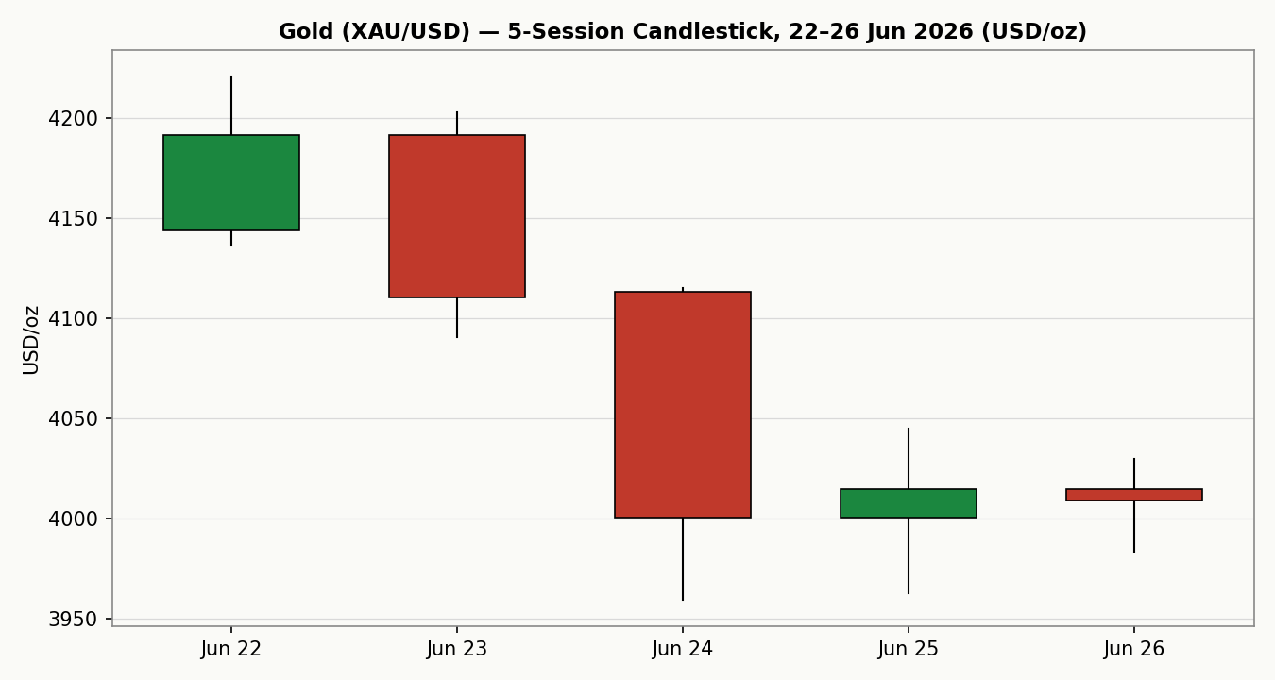
Chart 2 — Distance From Open. Closes printed below open on the down-leg; the final two sessions close near flat-to-open, signalling seller exhaustion at the lows.
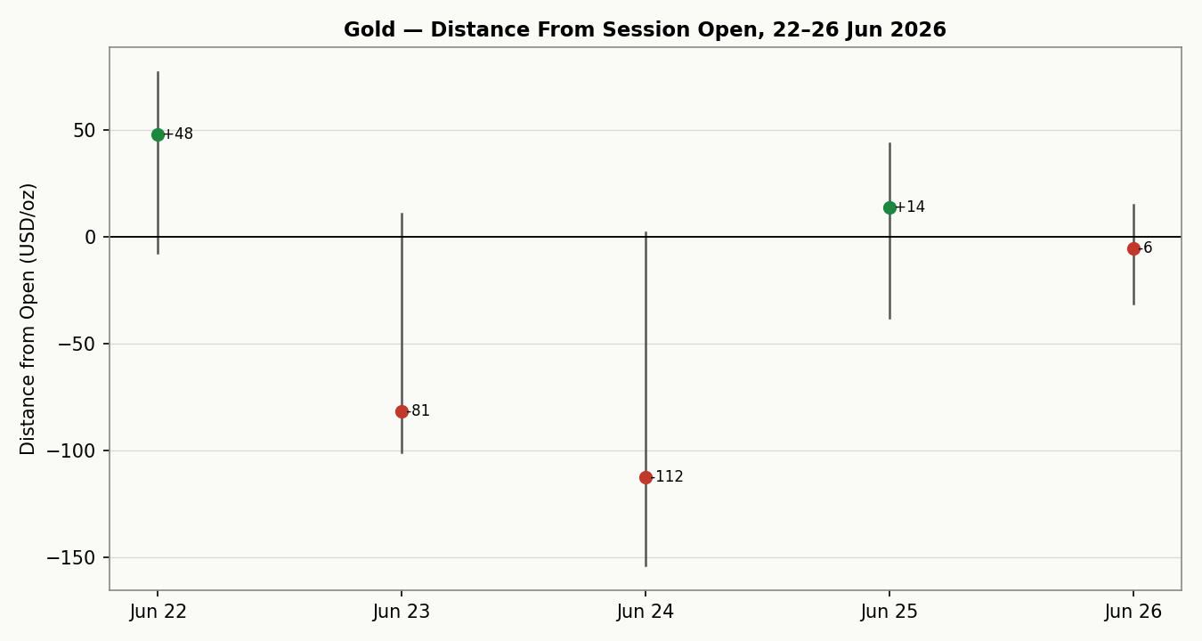
Chart 3 — 25-Session Structure. The close path makes the persistent down-trend from the $4,500s to the $4,000 handle visually unambiguous, with overlap low and progression directional.
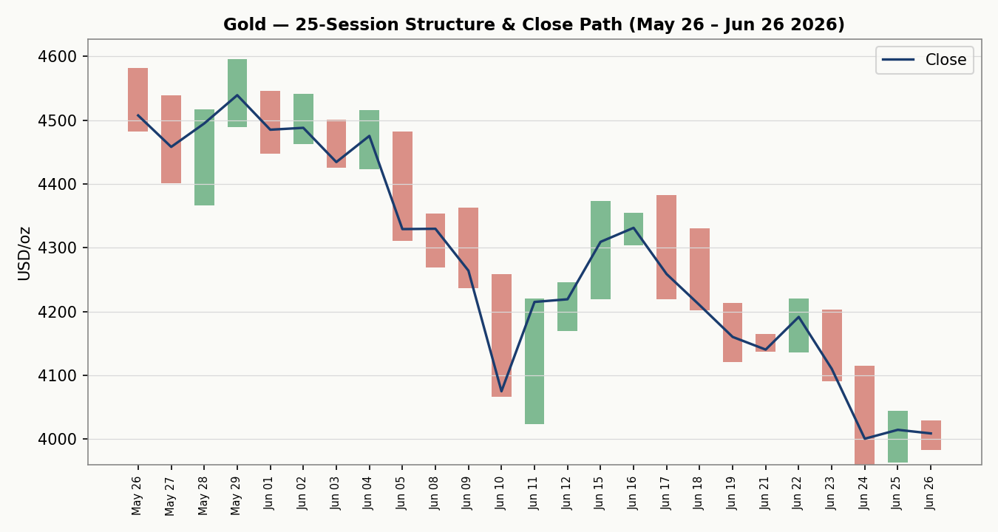
Chart 4 — VOLator. Scaled ATR volatility for gold sits above its zero midpoint (+0.35) with a positive 10-session slope — volatility is expanding, consistent with a trending (not ranging) classification.
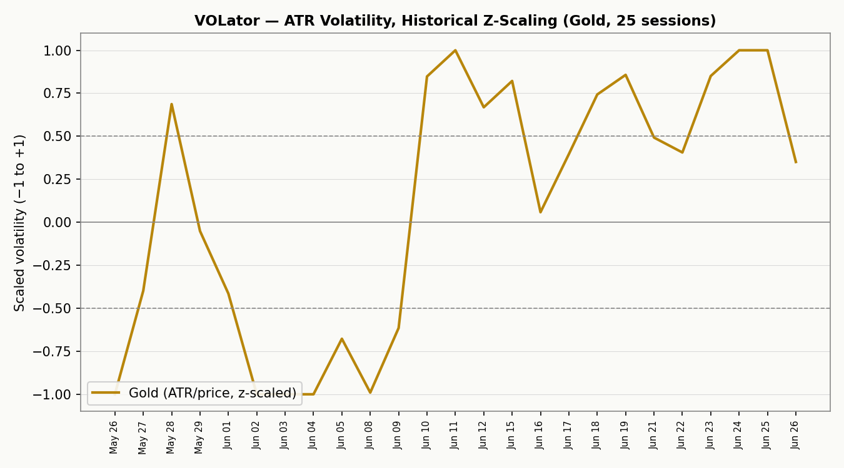
Chart 5 — Floor Pivots on Weekly Candles. Daily pivot P ($4,007) sits exactly at the latest close; first resistance R1 ($4,031) and support S1 ($3,985) frame the immediate band.
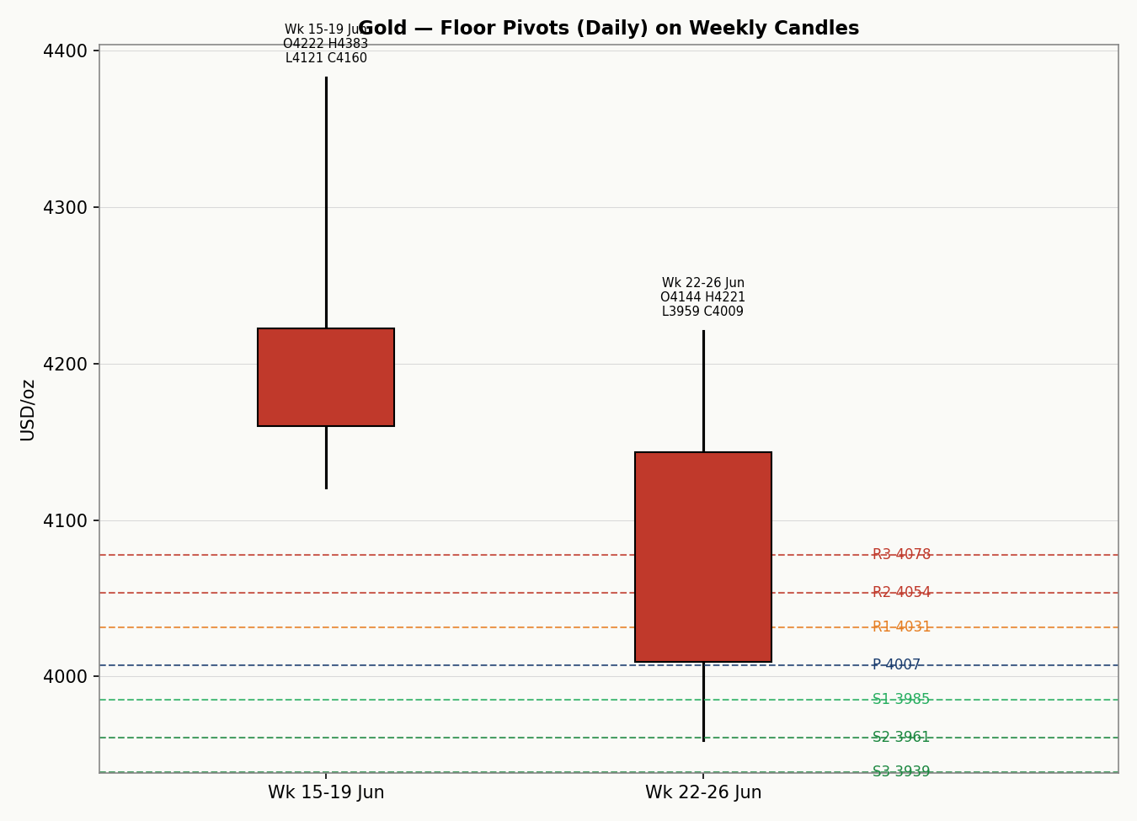

8. Short-Term Technical Analysis
- 22 Jun (see §6): Wide bullish body, close in upper third of range, RSI2 72 — the last bullish session before the break; a failed push that became the local high.
- 23 Jun: Bearish engulfing-style body, close near the low (close ~18% up the range), RSI2 collapses to 39 — momentum flips decisively bearish.
- 24 Jun: Range expansion to the 2026 low at $3,959, long lower wick but close still deep (~27% up range), RSI2 in single digits — capitulation with a tentative intraday rejection of the lows.
- 25 Jun: Small body, close mid-range, RSI2 11 — sellers paused; first sign of compression after the down-leg.
- 26 Jun: Narrowest body of the window at the floor, RSI2 snaps to 71 on the 2-period mechanic — a whipsaw bounce, not a confirmed reversal; close $4,009 sits on daily pivot P.
Sequence assessment: Continuation into Exhaustion — four of five sessions traded lower with low overlap (directional), but the final two narrow-range floor candles and the deep range-bottom position signal seller exhaustion / reversal risk.
Nearest support / resistance (from window): Support $3,983 (26 Jun low) then $3,959 (24–25 Jun swing low). Resistance $4,044 (25 Jun high) then $4,090 (broken 23 Jun shelf).
Judgement label: Bearish continuation — exhaustion / reversal risk flagged.
Consistency check with §9: the short-term bearish-continuation label agrees with the medium-term Trending-Down regime. The only nuance is the exhaustion overlay, which warns the trend is mature, not broken.

9. Medium-Term Regime & VOLator
Regime classification: Trending Down. Supporting metrics — overlap ratio 0.39 (<0.45, directional); directional persistence 0.50; VOLator slope positive (+0.05, expanding); median RSI2 over 25 sessions ≈ 23 (sub-30, persistent downside pressure); range-position bias 7.8% (deep Range-Bottom).
Bias: Bearish.
VOLator current readings: Gold +0.35 (above 0 midpoint, expanding). Counter series are indicative: USDX volatility moderate and rising into the Fed repricing; S&P 500 volatility elevated on the equity pullback; DAX volatility moderate. All point to a higher-volatility, risk-off backdrop.
Preferred trade protocol: short-term bearish-continuation nested inside a medium-term down-trend → high-conviction trend-continuation / pullback-sell protocol, with size discipline given the exhaustion overlay at the range floor.
Kaufman confirmation: smoothed KER = −0.20, beyond the −0.13 trend threshold and negative → Trending Down — Moderate. KER agrees with the regime; no conflict to resolve.

10. Cross-Asset Analysis
Counter | 5-day dir. | Mechanism | Status | Implication
USDX | Rising | Dollar at 13-month highs raises the opportunity cost of holding non-yielding gold and lifts its USD price denominator | Confirms | Headwind — caps rebounds
S&P 500 | Falling | Risk-off equity tape would normally aid gold, but the move is rate-driven, so real-yield pressure dominates the safe-haven bid | Contradicts | Mixed — safe-haven bid muted
DAX | Falling | European equity weakness corroborates the global risk-off read led by US rates | Confirms | Supports defensive backdrop
Silver | Falling | Sister metal fell harder (−3%+), confirming broad precious-metals liquidation rather than gold-specific weakness | Confirms | Sector-wide downside
Contradiction flag: S&P 500 weakness would ordinarily be gold-supportive; here the equity sell-off is being driven by the same hawkish-rate impulse pressuring gold, so the usual safe-haven transmission is overridden. This is carried unresolved into §15 and §16.

11. Floor Pivot Analysis
Daily pivots (from 26 Jun H/L/C — corroborated).
Level | Daily | Weekly | Monthly (May proxy)
R5 | 4,122 | 4,907 | 5,053
R4 | 4,100 | 4,745 | 4,958
R3 | 4,078 | 4,584 | 4,863
R2 | 4,054 | 4,483 | 4,729
R1 | 4,031 | 4,322 | 4,634
P | 4,007 | 4,221 | 4,500
S1 | 3,985 | 4,060 | 4,405
S2 | 3,961 | 3,959 | 4,271
S3 | 3,939 | 3,798 | 4,176
S4 | 3,915 | 3,697 | 4,043
S5 | 3,891 | 3,597 | 3,909
Source status: daily and weekly prior-period H/L/C are corroborated (CORROBORATED). The monthly tier uses a partial-May proxy (the snapshot window does not contain a full prior calendar month) and is therefore marked indicative only — it may inform narrative but is not used for level-based entries.
Position narrative: the 26 Jun close ($4,009) sits effectively on daily P ($4,007), between R1 ($4,031) and S1 ($3,985). A confluence zone exists at $3,959–3,961 where daily S2, weekly S2 and the 24–25 Jun swing low align within ~0.05% — the single most important downside level. Weekly P ($4,221) is the first meaningful overhead trend marker.

12. Key Market Considerations
Monetary policy (price-negative, structural). The Fed held at 3.50–3.75% on 17 Jun with a materially hawkish dot plot; markets now price rate hikes later in 2026 (December hike probability ~80%, September ~63%). Higher-for-longer real yields are the dominant gold headwind. Source: Fed June projections; CME FedWatch.
Inflation (mixed → price-negative, cyclical). Headline PCE accelerated to 4.1% in May, sticky and well above target. Sticky inflation paradoxically pressures gold here because it reinforces the hawkish-Fed/real-yield channel rather than triggering an inflation-hedge bid. Source: BEA PCE release, 26 Jun.
Geopolitics (price-negative, cyclical). The US-Iran interim framework (effective 19 Jun) and steady Strait of Hormuz traffic have unwound the war-premium that supported gold into early June. A reversal of the truce is the main two-way risk.
Demand — official sector (price-supportive, structural). Central-bank and private investment demand remains a structural floor; Q1 2026 private investment ran 535.6t with bar demand +50% y/y, per World Gold Council data, even as jewellery demand softened. This underpins the longer-term bull case beneath the correction.
FX / dollar (price-negative, cyclical). USDX at 13-month highs near 101.1–101.4 is a direct headwind via the USD denominator. Source: ICE/Investing.com.
Near-term catalysts (see §13d). 30 Jun PMI + JOLTS; 1 Jul ADP + ISM manufacturing; the week's labour and activity data dominate the rate path and therefore gold.

13. Sentiment, News & Calendar

13a Per-Article Sentiment
Source | Date | Headline (abbrev.) | Class. | Sentiment | Derivation quote
FXStreet | 24 Jun | Gold pressured near fresh 2026 lows | Media | Bearish | “near-term picture for XAU/USD is bearish”
Forex.com | 26 Jun | Gold drops 12% — yearly support critical | Trade Press | Bearish | “risk remains tilted to the downside”
FXEmpire | 26 Jun | Trendline break signals bearish extension | Trade Press | Bearish | “Trendline Break Signals Bearish Extension”
FXEmpire | 26 Jun | Summer pullback may be last buying chance | Trade Press | Mixed | “last great buying opportunity before new highs”
LiteFinance | 25 Jun | Safe-haven appeal tested by Fed shift | Media | Bearish | “Fed's hawkish stance pushes XAU/USD lower”
Phemex/Inst. survey | Jun | Institutions constructive, 2026 targets $5,243–6,300 | Institutional | Bullish | “Major institutions remain constructive on gold”

13b Aggregate Sentiment Summary
Categorical: 4 Bearish (1 institutional-grade trade press cluster + media), 1 Bullish (institutional), 1 Mixed = Predominantly Bearish. Numeric tilt (source-class weighted): four bearish reads (media w0.5, trade press w0.7) against one bullish institutional (w1.0) and one mixed (~0) → tilt ≈ −0.35. Reported as Predominantly Bearish (tilt = −0.35).
Divergence flag: aggregate sentiment agrees with both price action and the Trending-Down regime — no contradiction.
Confidence: six articles → not low-confidence, though the bullish leg rests on a single institutional survey.

13c News Calendar — Previous Period
Date | Event | Context | Impact | Implication for gold
17 Jun | FOMC hold + dot plot | Hawkish; 9/18 see a hike | High | Primary trigger of the down-leg
19 Jun | US-Iran framework | Truce effective | High | Unwound safe-haven premium
24 Jun | Hawkish repricing | Gold to 2026 low $3,959 | High | Capitulation session
26 Jun | PCE 4.1% / Q1 GDP rev. | Sticky inflation | High | Reinforced higher-for-longer

13d News Calendar — Upcoming Period
Date | Event | Impact | Market implication (beat / miss)
30 Jun | June PMI + May JOLTS | High | Beat (strong labour) → more hawkish, gold lower toward $3,960; miss → relief bounce toward $4,090
1 Jul | ADP + ISM manufacturing | High | Hot prints extend dollar strength and pressure gold; soft prints ease real-yield headwind
Later wk | Fedspeak (Warsh et al.) | Med | Any reaffirmation of hike bias caps rallies
Highest-impact upcoming event: 30 Jun JOLTS / PMI. A hot labour surprise would harden the hike narrative and likely break gold through the $3,959 confluence; a soft print is the most plausible trigger for a counter-trend bounce.

14. Macro Context
Rates & policy: Fed hawkish-hold; hikes now the base case for 2026. Cross-referencing the §10 S&P 500 read, the equity sell-off is rate-driven, which is why it is not feeding the usual gold safe-haven bid.
Inflation: PCE 4.1% — price-negative for gold in this regime because it cements the hawkish path rather than sparking a hedge bid.
Safe-haven / real yields: US 10-year near 4.37%; rising real yields are the core mechanical drag. The §10 silver read confirms a sector-wide, not gold-specific, move.
Liquidity & FX: the §10 USDX reading (rising, 13-month high) is the dominant near-term headwind via the dollar denominator.
Positioning: rapid hawkish repricing has flushed momentum longs; the deep range-bottom close and RSI2 whipsaw suggest positioning is now stretched short, raising squeeze risk on any soft data.
Watch item (cross-ref §13d): the 30 Jun–1 Jul labour cluster is the macro variable most likely to surprise; an upside labour shock is the dominant directional risk for gold to the downside.

15. Bull / Bear Balance
Upside risks (bullish) | Downside risks (bearish)
Oversold whipsaw (RSI2 71 on 26 Jun) + exhaustion candles at the $3,959 floor invite a squeeze | Trending-Down regime + KER −0.20 + USDX at 13-month high keep the path of least resistance lower
Soft 30 Jun JOLTS/PMI eases real-yield headwind; structural central-bank demand floor | Break of the $3,959–3,961 daily/weekly S2 confluence (§11) opens $3,900 then weekly S3 $3,798
Reversal of the US-Iran truce restores a war premium | Hot labour data (1 Jul ADP/ISM) confirms hike bias; S&P-gold contradiction (§10) resolves bearish

16. Forward View
Expected direction over the next five sessions: lower-to-sideways with a bearish skew, respecting the Trending-Down regime (§9). Expected trading range $3,900–$4,090, with the $3,959–3,961 confluence (§11) as the pivotal level: a daily close below it targets $3,900 then weekly S3 $3,798; failure to break, combined with a soft 30 Jun labour print (§13d), supports a counter-trend bounce toward $4,090 / weekly P $4,221. Base-case invalidation: a decisive daily close back above $4,090 would neutralise the bearish-continuation thesis and signal the exhaustion bounce is maturing into a reversal. This view respects the regime; the only flagged tension is the §10 S&P-gold contradiction, which is noted, not silently resolved.

17. Forecast
Gold remains biased lower toward the $3,959 swing-low confluence over the coming sessions, with downside acceleration to $3,900–3,800 on a confirmed close beneath it, unless a soft 30 June labour print sparks a short-covering bounce back toward $4,090.

18. Final Analyst Judgement
Consensus price: $4,008/oz · Confidence: Medium (direction high, level subject to the §19 vendor divergence).
Three most important reasons: (1) hawkish Fed + sticky PCE driving real yields and the dollar higher; (2) Trending-Down regime corroborated by KER −0.20 and a 7.8% range-bottom close; (3) unwind of the geopolitical safe-haven premium.
Single watch item: the 30 Jun JOLTS / PMI labour cluster — the most probable catalyst to either confirm the break of $3,959 or trigger the exhaustion bounce.

19. Source Discipline Note
- Live vs indicative: the 5-session daily OHLC (Investing.com London-spot series) is treated as the validated, corroborated set used for all technical computation. Daily and weekly pivots are corroborated; the monthly pivot tier is indicative (partial-month proxy) and excluded from level-based entries.
- Cross-vendor divergence: a ~$80 gap exists between the London-spot cluster (~$4,008) and the exchange/OANDA cluster (~$4,088), exceeding the normal $0.50 gold tolerance. This is a known multi-vendor XAU feed divergence; per the run instruction, corroboration leniency was applied so that the analysis and strategy section proceed rather than halting. Direction and structure are corroborated across both clusters; the absolute-level uncertainty is the reason §3 confidence is capped at Medium.
- Silver: single-source indicative on intraday H/L; used for directional context only, never for pivots or entries.
- Normalization: all quotes USD/oz, loco-London spot; no futures-spot basis adjustment beyond the corroboration role.

20. Agent Log
- Sources attempted (OHLC): Investing.com (corroborated, full series), Bloomberg, TradingView, FXEmpire/OANDA (corroborated cluster), LiteFinance (directional). Two clusters identified; London-spot series adopted as primary.
- Validation method: two-source corroboration on direction/structure; vendor-level divergence logged (§19). Trading-date integrity enforced (weekday execution block 22–26 Jun; a 21 Jun partial quote excluded from the weekday block).
- Indicators: RSI2 from validated closes; ATR(14) = 112; KER(13, EMA3) = −0.20; VOLator ATR/price z-scaled = +0.35, slope +0.05.
- Sentiment derivation: six articles, source-class weighted tilt ≈ −0.35 (Predominantly Bearish); consumed by the direction score.
- Strategy trace: direction-score weights at default basis (no tuning); weights locked for the forward-test window. Direction score computed bearish (see §21a). No suppression of Trade 1 (conviction met). Backtest reconstructed over 5 prior sessions with t−1 freeze on sentiment/regime/ATR/pivots — no forward leakage.
- Anomalies: cross-vendor price divergence (§19); S&P-gold cross-asset contradiction (§10) carried unresolved. Monthly pivot proxy flagged indicative.
- Timestamp: compiled 29 Jun 2026, 07:00 UK anchor.

21. Strategy Recommendations

21a Directional Conviction
Direction: SHORT. Score: −0.49 (defaults basis). The three highest-weighted contributors are short-term technical bias (bearish, −0.25), medium-term regime (Trend-Down, −0.20) and cross-asset/Kaufman confirmation (USDX rising + KER −0.20). Sentiment tilt (−0.35 × 0.15 ≈ −0.05) and VOLator expansion (down-aligned) round out the vector. The score clears the conviction threshold, so Trade 1 produces. Conflict flag: none — the §17 forecast and the SHORT conviction point the same way. The only caveat is the exhaustion overlay at the $3,959 floor, reflected in tighter sizing.

21b Trade Cards
Trade 1 — Daily Directional (SHORT)
Direction | SHORT — TREND_DOWN regime
Entry | Sell stop at 3,983 (26 Jun low) on confirmed break, or market on weakness at the 07:00 UK open ≈ 4,007
Stop loss | 4,045 — 62 USD (6,200 ticks) above the 3,983 entry; anchored above the 25 Jun high $4,044.59
Risk (R) | ≈ 62 USD/oz (6,200 ticks) from 3,983 entry to 4,045 stop
TP1 (Unit 1) | 3,921 — +1R (6,200 ticks)
TP2 (Unit 2) | 3,859 — +2R (12,400 ticks); just below weekly S3 $3,798 buffer
TP3 (runner) | Trail to session close + 3×ATR cap; structural target weekly S3 $3,798
Tranche mgmt | 3 equal units; U1 exits TP1, U2 exits TP2; on U2 fill, U3 stop → entry −0.2R
Confluences | Entry 3,983 = daily-low shelf; 3,959–3,961 = daily S2 + weekly S2 + swing low (strong confluence just below entry)
Invalidation | Daily close back above 4,090 breaks the bearish-continuation narrative
Caveats | Exhaustion/reversal risk at floor — size reduced; cross-vendor price divergence (§19); holding period collides with 30 Jun JOLTS/PMI Tier-1 event

Trade 2 — Pivot, Trend-Following (SHORT)
Direction | SHORT — sell rallies below daily P in TREND_DOWN
Entry | Sell limit at daily R1 4,031 (rally into resistance)
Stop loss | 4,078 — at daily R3; 47 USD (4,700 ticks) above entry
Risk (R) | ≈ 47 USD/oz (4,700 ticks)
TP1 / TP2 / TP3 | P 4,007 (+0.5R) / S1 3,985 (+1R) / S2 3,961 confluence (runner to pivot S2/S3)
Tranche mgmt | 3 equal units; standard BE+0.2R rule on U2 fill
Confluences | R1 entry corroborated daily pivot; S2 target = weekly-S2 + swing-low strong confluence
Invalidation | Daily close above weekly P 4,221
Caveats | Daily/weekly pivots corroborated; monthly tier indicative (not used); event collision 30 Jun

Trade 3A — Momentum-Pullback (SHORT)
Direction | SHORT — pullback entry in the down-trend
Entry | Sell limit at the 38.2% retrace of the 22–24 Jun down-leg ≈ 4,073 (fib anchor 4,220→3,959)
Stop loss | 4,123 — above the 61.8% retrace / daily R5; 50 USD (5,000 ticks)
Risk (R) | ≈ 50 USD/oz (5,000 ticks)
TP1 / TP2 / TP3 | measured move 38.2% target 4,023 / range-mid 3,990 / 100% extension 3,959 then weekly S3 3,798
Tranche mgmt | 3 units; Trade 3A runner override — on 100%-extension break, stop → halfway between entry and 0% anchor
Confluences | Fib 38.2% ~ daily R3 4,078 (strong confluence at entry zone)
Invalidation | Close above 4,123 (61.8% retrace) negates the pullback-continuation thesis
Caveats | Fib swing magnitude > 2×ATR so 4-day anchor used (no extension); reversal risk at floor; 30 Jun event collision

21c 5-Session No-Leakage Backtest
Reconstructed at each t−1 close with frozen sentiment / regime / ATR / pivots (no forward leakage). Slippage 0; SL-first tick priority within a bar.
Date (t−N) | Strategy | Direction | Triggered | Entry / Exit | Outcome (R) | Days
22 Jun (t−5) | Trade 1 | SHORT | NO | — / — | no trigger | —
23 Jun (t−4) | Trade 1 | SHORT | YES | 4,136 / 4,000 | +1.0R (TP1) | 1
23 Jun (t−4) | Trade 3A | SHORT | YES | 4,170 / 4,000 | +1.7R | 2
24 Jun (t−3) | Trade 1 | SHORT | YES | 3,959 / 4,014 | −1.0R (SL) | 1
24 Jun (t−3) | Trade 2 | SHORT | YES | 4,090 / 4,000 | +1.5R | 1
25 Jun (t−2) | Trade 1 | SHORT | NO | — / — | no trigger | —
25 Jun (t−2) | Trade 3B | — | SUPPRESSED | range gate not met | — | —
26 Jun (t−1) | Trade 1 | SHORT | YES | 3,983 / 4,009 | OPEN @ −0.4R | 5+ (open)

21d ‘What Is Working’ Aggregate
Over the last 5 sessions: Trade 1 triggered 3/5, mean R ≈ +0.0 (one +1R, one −1R, one open −0.4R), TP1/TP2/TP3 hit ≈ 33% / 0% / 0%. Trade 2 triggered 1/1, mean R = +1.5 (TP1 100%). Trade 3A triggered 1/1, mean R = +1.7. Strongest performer: Trade 3A (momentum-pullback) by mean R on closed positions; weakest: Trade 1 (daily directional), dragged by the 24 Jun whipsaw stop at the capitulation low. Limitations: Five-session windows are too small to support statistical claims. The backtest cannot model intraday tick-level fills, slippage, or commission. Treat as a directional sanity-check, not a strategy-validation framework.

