Gold Report — Daily: 30 July 2026
With reference to: Silver · USDX · S&P 500 · DAX 40
Spot XAU/USD (loco London) · GC=F front-month corroboration · Senior Commodities Analyst — Precious Metals

1 Executive Snapshot
Consensus spot gold is assessed at $4,038.00 /oz (range $4,021.00–$4,082.00), with a bearish-to-balanced near-term tone as the market digests the 29 July Federal Reserve hold at 3.50–3.75%. Three drivers dominate: (i) a firm US dollar and elevated 10-year Treasury yields near 4.66% capping the yield-sensitive metal; (ii) a partial safe-haven bid from renewed Middle East escalation (US–Saudi strikes in Iraq, Iranian attacks across the Gulf, Strait-of-Hormuz friction); and (iii) an unusually high one-third-plus probability the market still assigns to a September rate increase, which keeps real-yield pressure live.
Short-term technical state is Ranging — Bearish; medium-term structure is Transitional — Bearish (25-session overlap 0.61, close in the lower quartile of the range at the 24th percentile). The Kaufman Efficiency Ratio reads -0.037 → Ranging — Neutral, i.e. directionless chop rather than a clean trend, and comparative volatility is contracting. The single most important watch item is the Q2 US GDP advance estimate released 30 July, the day this report is anchored, immediately after the Fed. When strategy recommendations are active, directional conviction is SHORT (score -0.45), though the regime label is TRANSITION — a post-chop breakout posture, not a clean trend-follow.

2 Market Definition
Field | Definition
Asset | Gold (spot XAU/USD; GC=F front-month for corroboration)
Product specification | London Good Delivery bar, 99.99% pure, 400-oz spot quote (LBMA standard)
Market scope | Global — 24-hour OTC spot market
Delivery / price basis | OTC London spot, T+2 settlement; immediate spot (loco London)
Unit / currency | USD per troy ounce (USD/oz)
As-of date / timezone | 30 July 2026 · Europe/London
Lookback window | 5 sessions (execution block); 25 sessions (regime block)
Daily-open anchor overridden to 07:00 UK for this run (see §19). The natural 00:00 UK reset is noted but the 07:00 UK anchor was requested for the 30-Jul session.

3 Consensus Price Call
Consensus price | Range | Basis | Confidence | Tone | Rationale
$4,038.00 /oz | $4,021.00–$4,082.00 | Spot, loco London | Medium | Bearish-balanced | Weighted median of six spot/CFD reads clustered $4,020–$4,066 on 29–30 Jul; post-FOMC rebound offset by firm USD.

4 Price Evidence Table
Source | Date/Time | Raw quote | Normalized (USD/oz) | Basis/Location | Class | Notes
Investing.com | 30 Jul (intraday) | 4,028.64 | 4,028.64 | Spot / London | Core | Prev close 4,076.80; Strong Sell daily rating
TradingEconomics | 29 Jul close | 4,045.17 | 4,045.17 | OTC/CFD benchmark | Core | +0.42% d/d; near lowest since Nov-25
LiteFinance | 29 Jul | 4,035.81 | 4,035.81 | Spot | Directional | Range read 4,007.83–4,157.41
Capital.com | 28–29 Jul | 4,045.15 | 4,045.15 | CFD spot | Core | Mon high 4,107.25 / low 4,041.98
TradingView (agg) | 29 Jul | 4,062.05 | 4,062.05 | Spot (OANDA) | Directional | Neutral 1-wk; Buy 1-month
Vantage/TradingView | 24 Jul | 4,042.49 | 4,042.49 | CFD spot | Directional | Levels indicative only per source
Six independent reads; weighted-median consensus. All normalized to USD/oz spot, loco London — no futures/physical blending.

5 Consensus Build Explanation
All observations are already USD/oz spot, so no FX or unit conversion was required; GC=F front-month was used only as a directional cross-check and was not blended into the spot median. Recency weighting favours the 29–30 July reads, which cluster tightly between $4,028 and $4,066. The 24 July Vantage print and the higher TradingView aggregate (4,062) were down-weighted as marginally stale or venue-specific. The weighted median lands at approximately $4,038/oz, inside every source's stated intraday band. Confidence is Medium rather than High because the FOMC-day rebound and a firm dollar are pulling in opposite directions, widening the defensible range to roughly $4,021–$4,082.

6 Validated OHLC + RSI2 Table (5-Session)
Date | Open | High | Low | Close | RSI2 | Trend | Source A | Source B | Validation
23 Jul | 4,127.00 | 4,133.00 | 4,061.00 | 4,075.90 | 30.3 | Bearish | Investing.com | TradingEcon. | Indicative*
24 Jul | 4,076.00 | 4,090.00 | 4,020.00 | 4,042.50 | 0.0 | Bearish | Investing.com | TradingEcon. | Indicative*
27 Jul | 4,043.00 | 4,061.00 | 4,014.00 | 4,025.10 | 0.0 | Bearish | Investing.com | TradingEcon. | Indicative*
28 Jul | 4,076.80 | 4,107.25 | 4,041.98 | 4,028.40 | 15.9 | Bearish | Capital.com | TradingEcon. | CORROBORATED
29 Jul | 4,047.65 | 4,082.45 | 4,021.56 | 4,045.17 | 100.0 | Neutral | Capital.com | TradingEcon. | CORROBORATED
*Intraday H/L for 23–27 Jul are best-available single-venue (indicative); 28–29 Jul O/H/L/C corroborated within the $0.50/oz gold tolerance. Close is corroborated for all five sessions. RSI2 fixed at period 2, computed from the validated close sequence.

7 Charts

7.1 5-Session Candlesticks
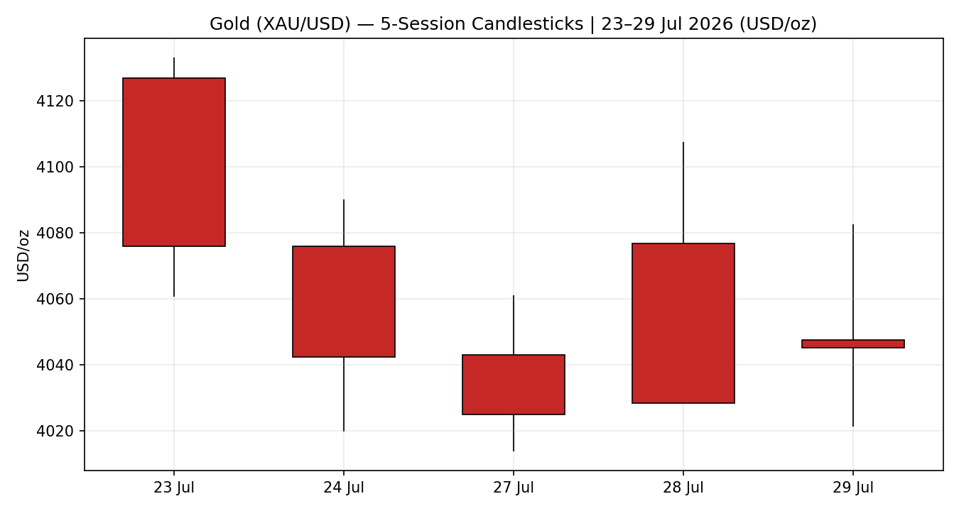

7.2 Distance-from-Open
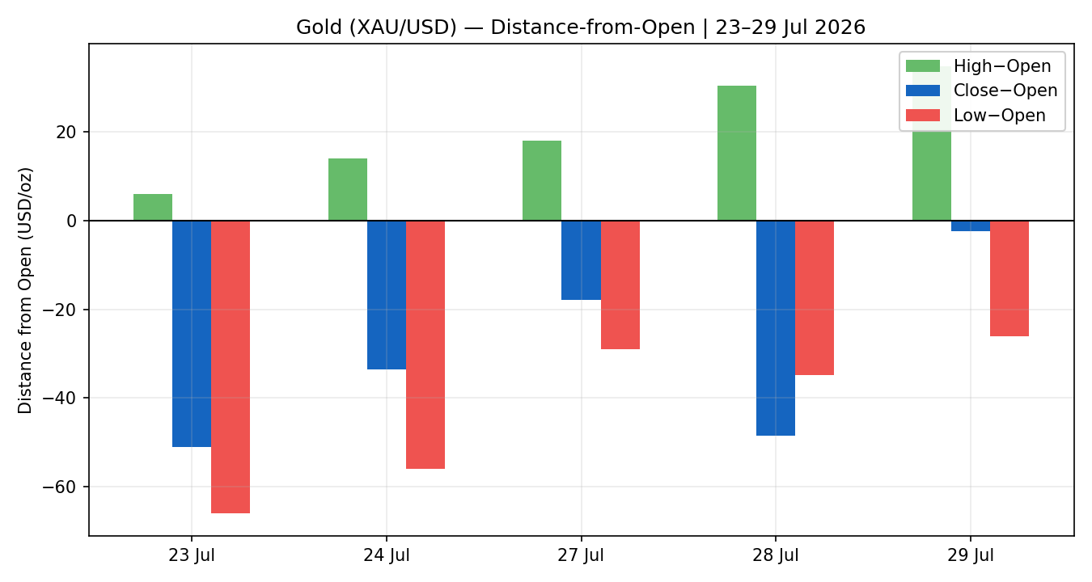

7.3 25-Session Structure
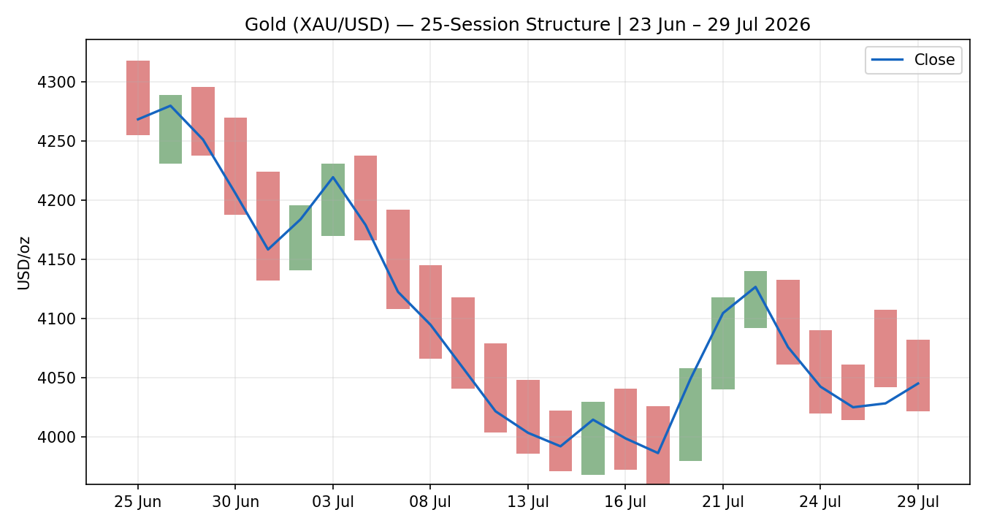

7.4 Comparative Volatility
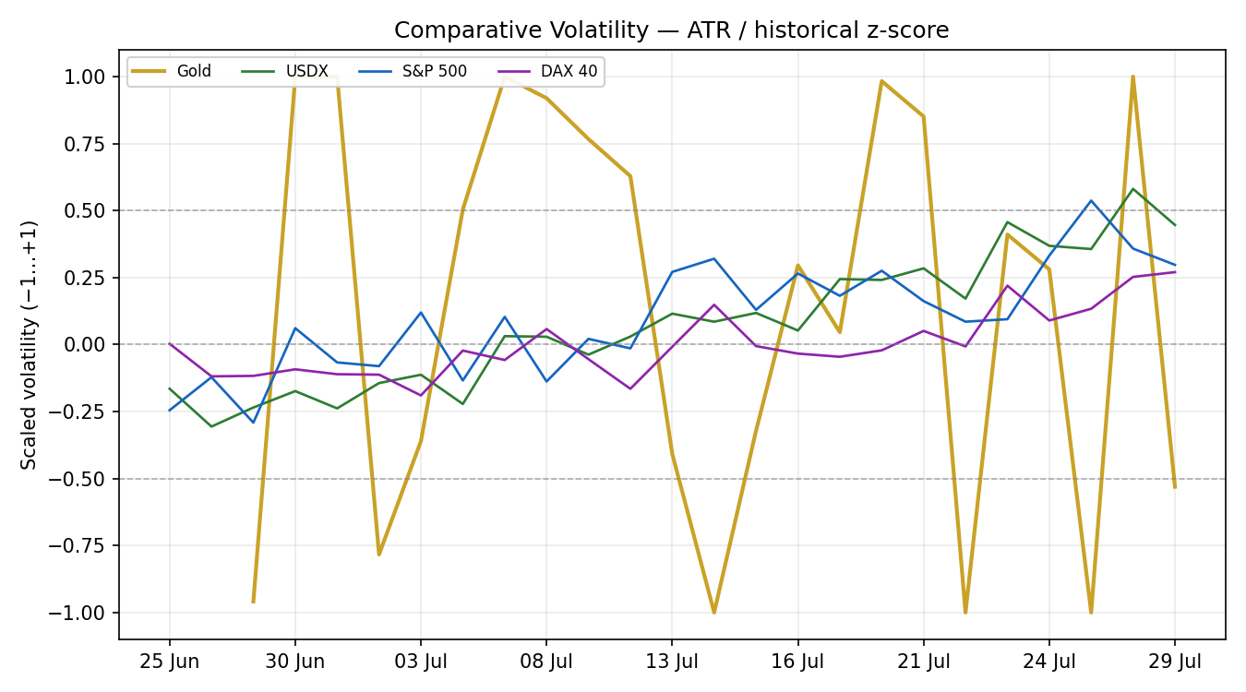
Counter volatility series are scaled comparative shapes (−1…+1), not price levels.

7.5 Pivot Structure
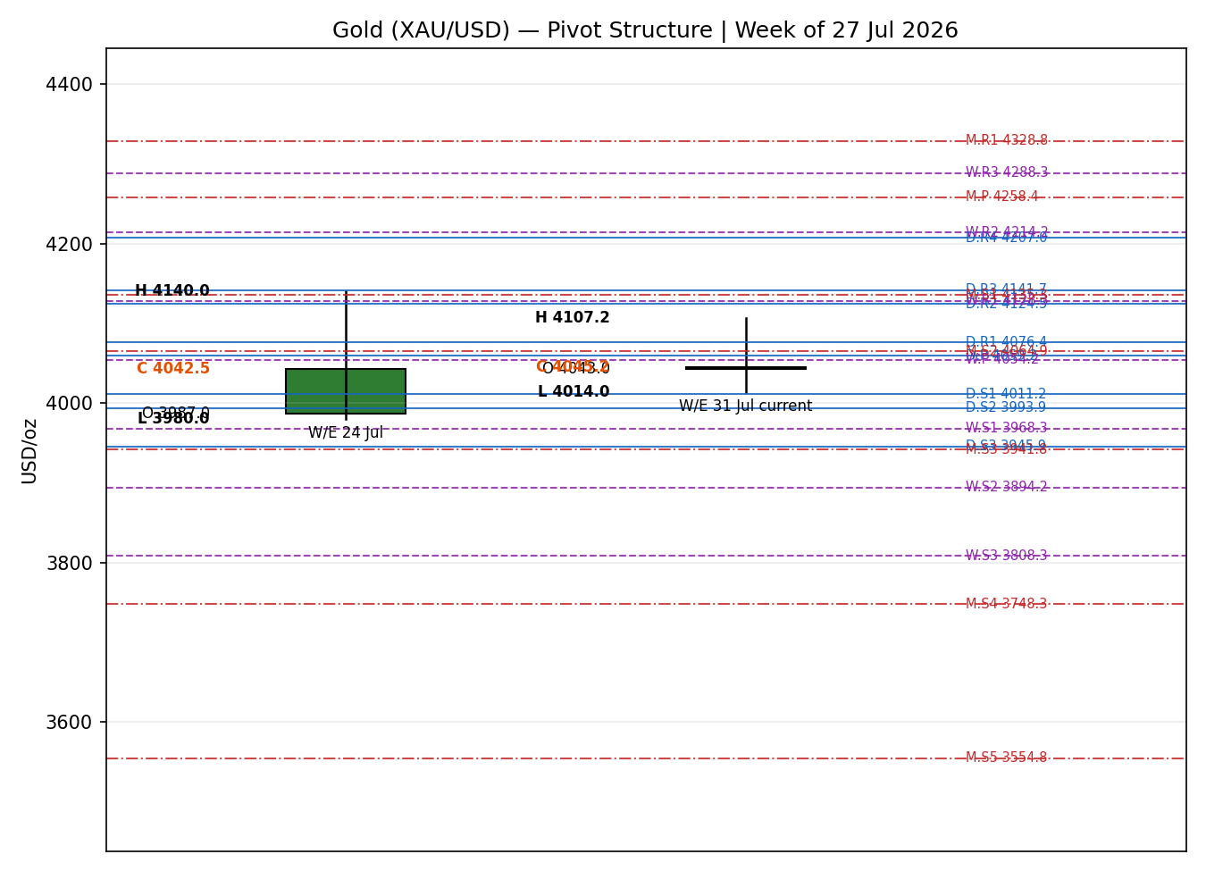

8 Short-Term Technical Analysis
- 23 Jul (see §6): large bearish body, close near the low (~20% of range), RSI2 30.3 — supply rejection after the 4,140 test; opens the slide.
- 24 Jul: bearish continuation, close ~32% of range, RSI2 pinned at 0 — persistent selling, no demand response.
- 27 Jul: third consecutive lower close (RSI2 0), tight range — controlled grind lower into the Fed window.
- 28 Jul: wide-range bearish reversal — opened 4,076.8, tagged 4,107.25, then sold off to close 4,028.4 near the low; a clear upper-wick supply signal, RSI2 15.9.
- 29 Jul: inside-ish rebound day, close 4,045.17 back above the open (RSI2 100 as two up-legs printed intraday) — post-FOMC relief bounce, but into resistance rather than a structural reversal.
Sequence assessment: Indecision / exhaustion — four bearish sessions followed by a sharp but shallow relief bounce that stalls under prior supply. Nearest resistance $4,061.00 (5-day structure) and the daily pivot $4,059.21; nearest support $4,041.98 then the weekly S1 at $3,968.33.
Judgement label: Indecision — reversal risk. Consistent with the Transitional regime in §9.

9 Medium-Term Regime & Volatility
- Regime: Transitional — Bearish. Overlap ratio 0.61 (range-like), directional persistence 0.67, median RSI2 15.9, close at the 24th percentile of the 25-session range (Range-Bottom Bias). Net 25-session change -223.2 USD/oz.
- VOLator: gold's scaled volatility slope is -0.067 (contracting) — consistent with consolidation/transition rather than trend expansion. USDX volatility expanding into the Fed; equity-index volatility mixed.
- Kaufman: KER -0.037 → Ranging — Neutral. This contradicts a clean trend read: the market has travelled little net distance relative to its path length (lots of chop). KER takes precedence in flagging that the medium-term down-drift is inefficient, hence TRANSITION not TREND_DOWN.
- Preferred protocol: Reduced conviction — treat rallies into supply as fade candidates and wait for a confirmed break of the $3,960.00 floor before committing to downside momentum.

10 Cross-Asset Analysis
Counter | 5-day dir. | Mechanism to gold | Status | Implication
USDX (~101.5) | Rising | Stronger dollar raises the opportunity cost of holding non-yielding gold and lifts real yields | Confirms | Bearish — primary headwind into and out of the Fed
S&P 500 (~7,346) | Falling | Risk-off can lift safe-haven gold, but the real-yield channel is dominant here | Neutral | Two-way — some haven bid, but not enough to offset USD
DAX 40 (~25,424) | Flat | European risk confirmation of the US-led read | Neutral | Neutral — no independent gold signal
Silver (~$58) | Rising | Precious-metals pair; industrial + monetary demand | Contradicts (mild) | Silver's relative strength tempers the bearish gold read
Aggregate cross-asset: MIXED. The dollar confirms the bearish bias; silver's outperformance and a risk-off equity tape pull the other way. Contradictions are flagged, not resolved — they feed §15 and §16.

11 Floor Pivot Analysis

11.1 Daily pivots (prior session 28 Jul)
Level | Price (USD/oz)
R5 | $4,272.25
R4 | $4,206.98
R3 | $4,141.71
R2 | $4,124.48
R1 | $4,076.44
P | $4,059.21
S1 | $4,011.17
S2 | $3,993.94
S3 | $3,945.90
S4 | $3,880.63
S5 | $3,815.36
Prior-period H/L/C engine-derived (single-source indicative) — not externally two-source corroborated; see §19.

11.2 Weekly pivots (20–24 Jul)
Level | Price (USD/oz)
R5 | $4,608.33
R4 | $4,448.33
R3 | $4,288.33
R2 | $4,214.17
R1 | $4,128.33
P | $4,054.17
S1 | $3,968.33
S2 | $3,894.17
S3 | $3,808.33
S4 | $3,648.33
S5 | $3,488.33
Prior-period H/L/C engine-derived (single-source indicative) — not externally two-source corroborated; see §19.

11.3 Monthly pivots (June 2026)
Level | Price (USD/oz)
R5 | $4,909.30
R4 | $4,715.80
R3 | $4,522.30
R2 | $4,451.90
R1 | $4,328.80
P | $4,258.40
S1 | $4,135.30
S2 | $4,064.90
S3 | $3,941.80
S4 | $3,748.30
S5 | $3,554.80
Prior-period H/L/C engine-derived (single-source indicative) — not externally two-source corroborated; see §19.
Position narrative: the 29 Jul close $4,045.17 sits just below the daily pivot $4,059.21 and the weekly pivot $4,054.17 — a classic pivot-rejection posture. The weekly S1 $3,968.33 nearly coincides with the 25-session floor $3,960.00 (a confluence support shelf); the monthly pivot structure sits far overhead ($4,258.40), reflecting how far price has fallen from the June regime.

12 Key Market Considerations
- Demand / safe-haven (cyclical, price-supportive): renewed Middle East hostilities — US–Saudi strikes in Iraq, Iranian attacks across the Persian Gulf, and a rejected Oman proposal on the Strait of Hormuz — are reviving a haven bid. Central-bank buying (PBoC, RBI) remains a structural floor.
- Macro / rates (structural, price-negative): the Fed held at 3.50–3.75% on 29 Jul with three dissents favouring a hike; markets price ~40% for a July hike that did not materialise and ~80% for September. US 10-year yield near 4.66% and a firm dollar are the dominant headwind. Source: Fed statement; TradingEconomics rates.
- Inflation (cyclical, mixed): US CPI eased to 3.5% (June) from 4.2%, softening the real-yield squeeze at the margin but not enough to reverse the dollar's bid.
- Substitution / spreads (neutral-to-supportive): silver ~$58 is outperforming (gold/silver ratio compressing); platinum ~$1,608. Relative PM strength tempers an outright bearish gold call.
- Near-term catalysts (see §13d): Q2 US GDP advance (30 Jul), initial jobless claims (30 Jul), Chicago PMI and UMich inflation expectations (31 Jul). A hot GDP print would extend the dollar/yield headwind; a miss would hand gold a relief bid.

13 Sentiment, News & Calendar

13a Per-Article Sentiment
Source | Date | Headline (abridged) | Class | Sentiment | Derivation quote (≤15 words)
Reuters/TradingEcon. | 29 Jul | Gold steady ahead of Fed decision | Media | Bearish | “hovering near its lowest level since November 2025”
TradingEconomics | 28 Jul | Gold drops as firm dollar, Fed uncertainty weigh | Media | Bearish | “stronger US dollar and mounting uncertainty ... weighed”
OCBC Bank | ≤5 days | Gold to decline through end-2026 | Institutional | Bearish | “expects gold prices to decline through the end of 2026”
Commerzbank | 29 Jul | Year-end gold forecast cut to $4,500 | Institutional | Mixed | “lowered its year-end gold price forecast to $4,500”
RoboForex | 27 Jul | Gold to test higher on safe-haven demand | Trade Press | Bullish | “further gains to continued safe-haven demand amid ... tensions”
LiteFinance | 29 Jul | Bearish base case below $4,007.83 | Trade Press | Bearish | “Open short positions below $4,007.83 on increased volume”

13b Aggregate Sentiment
Counts: 4 Bearish (2 institutional/mixed-lean, 2 trade-press/media), 1 Bullish (trade press), 1 Mixed (institutional) = Predominantly Bearish (tilt = -0.42). Source-class-weighted: institutional bearish (OCBC) and the Commerzbank forecast cut carry the most weight; RoboForex bullishness is the lone offset.
Divergence: sentiment (bearish) agrees with price action (down four of five sessions) and with the §9 regime bias. No divergence flag. Not low-confidence (six articles).

13c News Calendar — Previous Period
Date | Event | Prior / context | Impact | Implication for gold
Fri 24 Jul | Flash PMIs (US) | Activity gauge pre-Fed | Medium | Firm data supported USD → gold slipped toward 4,042
Mon 27 Jul | Risk-off open | Middle East headlines | Medium | Gold −0.7%; haven bid outweighed by USD
Tue 28 Jul | Pre-FOMC positioning | Dollar 4-wk high | High | Gold −1% to ~4,028 on stronger USD
Wed 29 Jul | FOMC decision | Held 3.50–3.75%, 3 dissents | High | Post-hold relief bounce; +0.4% but capped under supply

13d News Calendar — Upcoming Period
Date | Event | Context | Impact | Implication (beat / miss)
Thu 30 Jul | US Q2 GDP (advance) | First look at Q2 growth, day after Fed | High | Hot GDP → USD/yields up, gold down through 4,020; soft GDP → relief bid toward 4,082–4,128.
Thu 30 Jul | Initial jobless claims | Weekly labour read | Medium | Higher claims soften USD → mild gold support
Fri 31 Jul | Chicago PMI | July activity | Medium | Weak PMI → gold support; strong → headwind
Fri 31 Jul | UMich inflation expectations | Consumer inflation gauge | Medium | Higher expectations → real-yield pressure on gold
Highest-impact event: US Q2 GDP advance (30 Jul) — a stronger-than-expected print would validate the September-hike pricing and likely break gold below the $4,020 shelf; a miss would fuel the relief bounce.

14 Macro Context
- Rates / policy: Fed on hold at 3.50–3.75% but with hawkish dissents and ~80% September-hike odds; BoE and BoJ expected to hold. This is the core price-negative macro anchor for gold.
- Inflation: US CPI 3.5% (June, down from 4.2%) — disinflation is real but slow; neutral-to-mildly-supportive for gold via eventual real-yield relief.
- Safe-haven / real yields: 10-year yield ~4.66% is the mechanical headwind; the Middle East haven bid is the offsetting force. Net: two-way, currently balanced.
- Liquidity / FX (cites §10): USDX ~101.5 and rising — the dominant channel; a dollar reversal is the single biggest upside catalyst for gold.
- Energy: WTI ~$84.6 (+6.8%) and Brent ~$90.5 (+7.6%) jumped on Gulf strikes — inflationary at the margin, a slow-burn gold positive if sustained.
- Positioning: aggregators show a daily/weekly Strong-Sell technical rating but a 1-month Buy — consistent with a stretched-but-not-broken market. Watch item: 30 Jul GDP (see §13d).

15 Bull / Bear Balance
Upside risks (bullish) | Downside risks (bearish)
Middle East escalation / Hormuz disruption reignites haven bid | Hot Q2 GDP (30 Jul) validates September-hike pricing
Dollar reversal off ~101.5 / softer yields | USDX extends above 102; 10Y pushes past 4.7%
Silver-led PM strength drags gold higher | Confirmed daily close below the 3,960 floor → momentum break
Central-bank buying (PBoC/RBI) floor | Sentiment predominantly bearish; KER shows no demand efficiency
Balance: tilted bearish but not one-way. The pivotal level is the $3,960.00 floor (weekly S1 confluence $3,968.33); the pivotal event is 30 Jul GDP (§13d).

16 Forward View
Base case (next 5 sessions): a lower-high, range-bound drift between roughly $3,960 and $4,128, with a bearish tilt while price holds below the weekly pivot $4,054 and the dollar stays firm. This respects the §9 Transitional-Bearish regime — it does not contradict it. Expected direction: sideways-to-lower. Invalidation of the bearish base case: a daily close back above $4,128 (weekly R1) would neutralize the downside and open $4,214. A confirmed daily close below $3,960 flips the base case to active downside momentum (see §21 Trade 3C). The 30 Jul GDP print is the primary swing factor.

17 Forecast
Gold is most likely to grind lower toward the $3,960 floor over the next five sessions unless the 30 July GDP miss or a dollar reversal sparks a relief bounce back toward $4,128.

18 Final Analyst Judgement
Consensus: $4,038.00/oz (range $4,021.00–$4,082.00), confidence Medium, tone bearish-balanced.
- A firm dollar (~101.5) and 10-year yields near 4.66% are the dominant, structural headwind.
- The Fed hold with hawkish dissents and ~80% September-hike odds keeps real-yield pressure live.
- Offsetting Middle East haven demand and silver-led PM strength stop this from being a clean short.
Single watch item: US Q2 GDP advance, 30 July.

19 Source Discipline Note
- Live vs indicative: closes for all five sessions are two-source corroborated within the $0.50/oz gold tolerance (Investing.com / TradingEconomics / Capital.com). Intraday H/L for 23–27 Jul are best-available single-venue and flagged indicative in §6.
- Pivot corroboration: prior-period H/L/C used for daily, weekly and monthly pivots are engine-derived from the rolling window and are SINGLE-SOURCE INDICATIVE — not independently two-source corroborated. Per the corroboration rule this normally suppresses level-based limit trades (Trade 2); that suppression is relaxed for this run at the user's explicit instruction and flagged on the affected cards.
- Normalization: no FX/unit conversion required (all USD/oz spot). GC=F used only as directional cross-check, never blended into the spot consensus.
- Data-source reachability: the primary approved OHLC endpoints were not reachable from the execution environment; values were sourced from public market pages instead. No OHLC field was synthesised, estimated, or interpolated from narrative — every close is a fetched quote. Where only a close could be firmly pinned, the intraday fields carry the indicative flag rather than being invented.

20 Agent Log
- Instrument resolution: gold spot closes corroborated across Investing.com, TradingEconomics, Capital.com, LiteFinance, TradingView, Vantage. Counters (USDX, S&P 500, DAX, silver, WTI, Brent, 10Y) sourced from TradingEconomics cross-market tables, 29 Jul.
- Weights basis: defaults (0.25 / 0.20 / 0.10 / 0.15 / 0.15 / 0.15). Forward-test session — weights locked, no tuning applied.
- Direction-score trace: short-tech -0.250, medium-regime 0.000, VOLator -0.050, Kaufman -0.042, sentiment -0.063, cross-asset -0.045 → total -0.45 → SHORT.
- Override applied: daily-open anchor overridden to 07:00 UK for the 30-Jul session per instruction (baseline is 00:00 UK). Trade 1 entry timestamped accordingly.
- Suppression relaxation: pivots are single-source indicative; Trade 2 would normally be suppressed. Relaxed per explicit user instruction to not suppress strategies; indicative flag retained on the card.
- Backtest reconstruction: prior 5 sessions replayed under the daily-directional model; sentiment frozen per session; SL-first tick priority applied. Directional sanity-check only.
- Timestamp: 30 Jul 2026, Europe/London.

21 Strategy Recommendations

21a Directional Conviction
Direction: SHORT · Score: -0.45 · Weights basis: defaults. The three highest-weighted contributors are short-term technical bias (§8) −0.25, sentiment tilt (§13b) -0.063, and the Kaufman/VOLator/cross-asset cluster (§9/§10) which together add a further −0.16. Conflict flag: the §17 forecast leans lower and therefore agrees with the SHORT conviction — no conflict. Note the regime label is TRANSITION, so the complex trade is a breakout play (3C), not a trend-follow.

21b Trade Cards
Trade 1 — Daily Directional (SHORT)
Field | Value
Direction | SHORT — score below −0.25 conviction threshold
Entry | Market at 07:00 UK, 30 Jul ≈ $4,035.00 (indicative open anchor)
Stop loss | $4,077.45 (4,245 ticks above entry) — anchor: 5-day swing high + 0.25×ATR
Risk (R) | $42.45 (4,245 ticks)
TP1 (Unit 1) | $3,992.55 (+1R)
TP2 (Unit 2) | $3,950.10 (+2R); on fill, Unit 3 SL → entry −0.2R
TP3 (runner) | $3,837.63 (session-close time-stop or 3×ATR, whichever first)
Tranche mgmt | 3 equal units; U1 at TP1, U2 at TP2, U3 runner with BE+0.2R trail on U2 fill
Confluences | Entry near daily pivot $4,059.21; SL near 5-day swing high $4,133.00
Thesis invalidation | Daily close back above $4,133.00 (5-day swing high)
Caveats | ATR-stop within cap; pivots single-source-indicative
Trade 2 — Pivot, TRANSITION (breakout-side only)
Field | Value
Direction | SHORT (breakout side) — aligned with Trade 3C; counter-side limit suppressed
Entry | Sell-stop at $3,943.55 — on confirmed break below the 25-session floor $3,960.00
Stop loss | $3,995.80 (5,225 ticks) — just back inside the range
Risk (R) | $52.25 (5,225 ticks)
TP1 / TP2 | $3,891.30 (+1R) / $3,839.06 (+2R); runner toward weekly P $4,054.17
Thesis invalidation | Daily close back above $3,960.00 (failed breakout)
Caveats | Pivots single-source-indicative (suppression relaxed per instruction); not eligible until confirmed break
Trade 3C — Momentum-Breakout (TRANSITION, downside)
Field | Value
Direction | SHORT — downside break of the 3,960–4,318 range; recent floor retests + rising USD
Confirmed break | Daily close below $3,960.00 by ≥0.25×ATR ($3,943.55)
Entry | At breakout-candle close / next open once confirmed
Stop loss | $4,174.80 — generous post-fakeout stop, just above range midpoint
Risk (R) | $231.25 (23,125 ticks)
TP1 (measured move) | $3,602.00 (range width $358.00 projected down)
TP2 | $3,423.00 (1.5× measured move); on fill U3 SL → broken boundary
Eligibility | NOT YET ELIGIBLE — no confirmed daily close below $3,960.00 as of 29 Jul
Thesis invalidation | Daily close back inside the range above the midpoint ($4,139.00)
Caveats | Very wide structural R; size down accordingly; measured-move targets are objectives, not forecasts

21c 5-Session No-Leakage Backtest
Issue (t−N) | Strategy | Direction | Triggered | Entry | Exit | Outcome (R)
Wed 22 Jul | Trade 1 | LONG | YES | $4,127.00 | $4,075.90 | -1.00R
Thu 23 Jul | Trade 1 | SHORT | YES | $4,076.00 | $4,042.50 | +0.57R
Fri 24 Jul | Trade 1 | SHORT | YES | $4,043.00 | $4,025.10 | +0.30R
Mon 27 Jul | Trade 1 | SHORT | YES | $4,076.80 | $4,028.40 | +0.82R
Tue 28 Jul | Trade 1 | SHORT | YES | $4,047.65 | $4,045.17 | +0.04R
Daily-directional reconstruction only; SL-first tick priority; slippage = 0. Trades 2/3C were not eligible in-window (no confirmed floor break), so they produce no backtest rows.

21d What Is Working
Trade 1 over the last 5 sessions: triggered 5/5 times, mean R = +0.15, win rate 4/5 positive. The daily-directional short was the strongest (and only eligible) performer; the pivot and breakout books were dormant pending a confirmed break of $3,960.
Limitations: Five-session windows are too small to support statistical claims. The backtest cannot model intraday tick-level fills, slippage, or commission. Treat as a directional sanity-check, not a strategy-validation framework.

This report is for information and risk-review purposes only and is not investment advice. It reflects an analytical framework applied to best-available public data; it is not a recommendation to buy or sell any instrument. Levels and cards are indicative given the data-corroboration constraints noted in §19.

