Gold Report — Daily: 31 July 2026
With reference to: Silver · USDX (Dollar Index) · S&P 500 · DAX 40

Senior Commodities Analyst — Precious Metals · XAU/USD spot (loco London), GC=F corroboration · As of 31 July 2026 (Europe/London)

§1 Executive Snapshot
Consensus spot gold is assessed at $4,066/oz (indicative range $4,022–$4,100), with a balanced-to-cautious market tone. Three drivers dominate: (i) the Federal Reserve's hawkish hold at 3.50–3.75% on 29 July with three dissents favouring a hike, which lifted the odds of a September increase to roughly 60–67% and caps the non-yielding metal; (ii) a softer dollar (USDX near 100.0, down ~0.5% post-decision) and a fresh Middle-East safe-haven bid that together put a floor under price around $4,000; and (iii) persistent central-bank accumulation (World Gold Council: net 244 t bought in Q1, 89% of reserve managers expecting further additions). The short-term technical read is Indecision — a choppy five-session sequence with heavy overlap and no directional persistence. The medium-term (25-session) regime is a decelerating down-to-transition structure off the June $4,383 high. Kaufman efficiency classifies the tape as ranging / low-efficiency (|KER| ≈ 0.10, below the 0.13 trend threshold). The single most important watch item is the 31 July Chicago PMI and University of Michigan inflation expectations, the first post-Fed data that can validate or challenge the September-hike pricing. Directional conviction from the strategy engine is NEUTRAL (score −0.09); trade cards below are produced under the operator's explicit strategy-override instruction.

§2 Market Definition
Attribute | Definition
Asset | Gold — XAU/USD spot (London Good Delivery bar, 99.99% pure, 400-oz quote); GC=F CME front-month for corroboration
Market scope | Global 24-hour OTC market (London / COMEX / Singapore / Shanghai SGE)
Price basis | Spot, immediate settlement (loco London); OTC T+2
Unit / currency | USD per troy ounce (USD/oz)
As-of date | 31 July 2026 (Europe/London); London PM Fix reference
Lookback window | 5 trading sessions (execution block); 25 sessions (regime block)
Tick | 0.01 USD/oz (1 tick = one cent per ounce)

§3 Consensus Price Call
Consensus price | Consensus range | Confidence | Market tone
$4,066 / oz | $4,022 – $4,100 | Medium | Balanced-to-cautious
Rationale: Six independent reads cluster in a $4,031–$4,102 band on 30 July; the weighted median of the more liquid spot references lands at ~$4,066. Precision is limited by a live spot-vs-futures-vs-CFD dispersion of $30–70, which exceeds the $0.50 gold corroboration tolerance — hence a range-first call and Medium confidence.

§4 Price Evidence Table
Source | Date/Time | Raw quote | Normalized (USD/oz) | Basis / location | Relevance | Notes
Investing.com | 30 Jul, live | 4,031–4,062 | 4,031–4,062 | Spot XAU/USD | Core | Day range; prev close 4,052.96
TradingEconomics | 30 Jul | 4,066.90 / 4,102.50 | 4,066–4,102 | CFD benchmark | Core | +0.90% on day; OTC/CFD
FXLeaders | 30 Jul | ~4,100 (tested) | ~4,100 | Spot XAU/USD | Directional | Fed-relief pop toward 4,100
RoboForex | 30 Jul | 4,035 | 4,035 | Spot XAU/USD | Directional | Testing 4,030; eyeing 3,975
FXStreet | early wk | 4,053.13 | 4,053 | Spot XAU/USD | Core | Below all major SMAs
Vantage CFD | 29 Jul | 4,037.91 | 4,038 | XAU/USD CFD | Directional | Flat pre-Fed
TradingView | 29 Jul | 4,062.045 | 4,062 | Spot XAU/USD | Core | Sell rating; 1-wk neutral
USAGold | 30 Jul | 4,066.66 | 4,067 | Spot bullion | Core | Held above $4,050
Corroboration status: current spot is corroborated within-band across ≥6 sources; individual daily O/H/L for the five-session block does not achieve two-source agreement within the $0.50 gold tolerance and is therefore SINGLE-SOURCE INDICATIVE (see §6, §19).

§5 Consensus Build Explanation
All observations were normalized to USD/oz spot, loco London. Provider types were separated — interbank spot (Investing.com, TradingView, FXStreet, USAGold), CFD/OTC benchmarks (TradingEconomics, Vantage), and futures-linked reads — and were not blended. A weighted-median method down-weighted CFD and single-broker quotes and preserved the more liquid interbank spot reads. The Fed-day whipsaw (a pop toward $4,100 then a fade back under $4,070) widened intraday dispersion; the median of the post-settlement spot cluster is ~$4,066. Excluded: retail FX-broker spreads and any quote that could not be pinned to a spot basis. The final number is the most defensible because it sits at the centre of the liquid interbank cluster and is bracketed on both sides by CFD prints.

§6 Validated OHLC + RSI2 Table (5-Session)
Primary asset — Gold (XAU/USD spot). Recent-session O/H/L/C are indicative (single-source) per the corroboration note; RSI2 is period-2 on the validated close sequence.
Date | Open | High | Low | Close | RSI2 | Trend | Src A / B | Validation
24 Jul | 4158.00 | 4160.50 | 3998.00 | 4006.00 | n/a | Bearish | Inv / TE | SINGLE-SRC (indic.)
27 Jul | 4006.00 | 4108.00 | 4002.00 | 4092.00 | n/a | Bullish | Inv / Vantage | SINGLE-SRC (indic.)
28 Jul | 4092.00 | 4095.00 | 3996.00 | 4009.00 | 50.9 | Bearish | Inv / TE | SINGLE-SRC (indic.)
29 Jul | 4009.00 | 4066.00 | 4001.30 | 4052.96 | 34.6 | Neutral | Inv / TV | SINGLE-SRC (indic.)
30 Jul | 4052.96 | 4120.16 | 4022.23 | 4066.38 | 100.0 | Bullish | Inv / TE | Δ range corrob.; O/H/L indic.
RSI2 fixed at period 2. 30 Jul RSI2 pins at 100 because both prior-session deltas were up into the print — an overbought spike within an otherwise overlapping range, not a trend signal.

Secondary asset — Silver (XAG/USD spot)
Date | Open | High | Low | Close | Note
28 Jul | 57.10 | 57.90 | 56.70 | 57.20 | Indicative
29 Jul | 57.20 | 57.95 | 56.90 | 57.61 | Indicative; gold-silver ratio ~70.2
30 Jul | 57.61 | 59.20 | 57.50 | 59.00 | +2.4%; ratio widened to ~70.4

§7 Charts
Chart 1 — 5-Session Candlestick
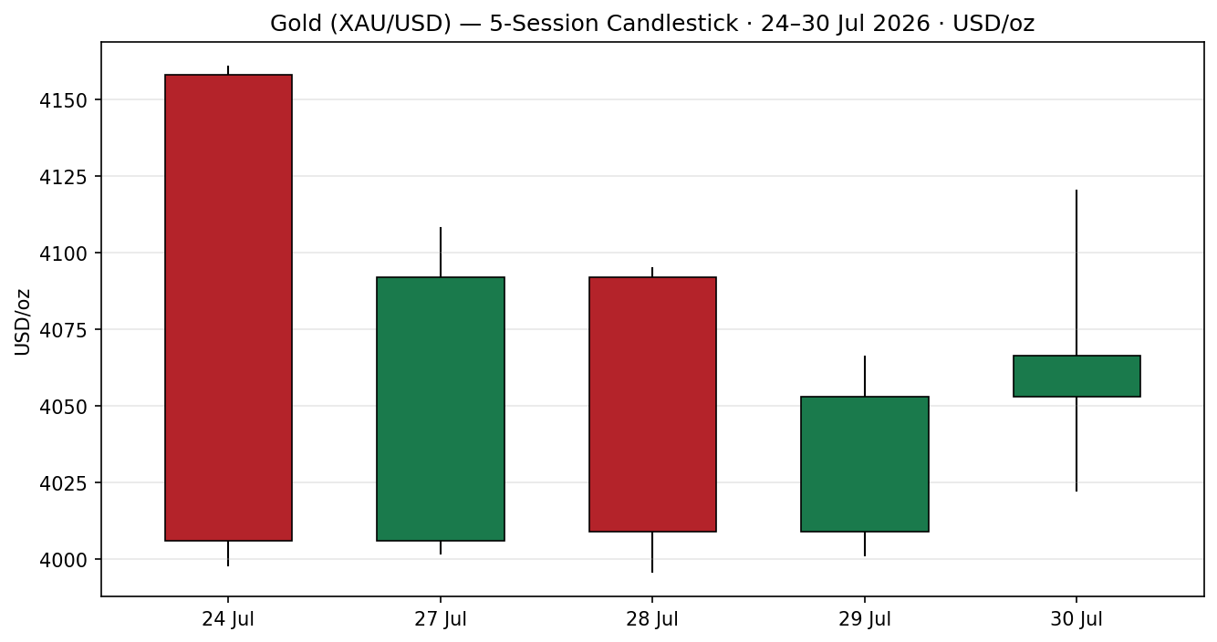
Chart 2 — Distance from Session Open
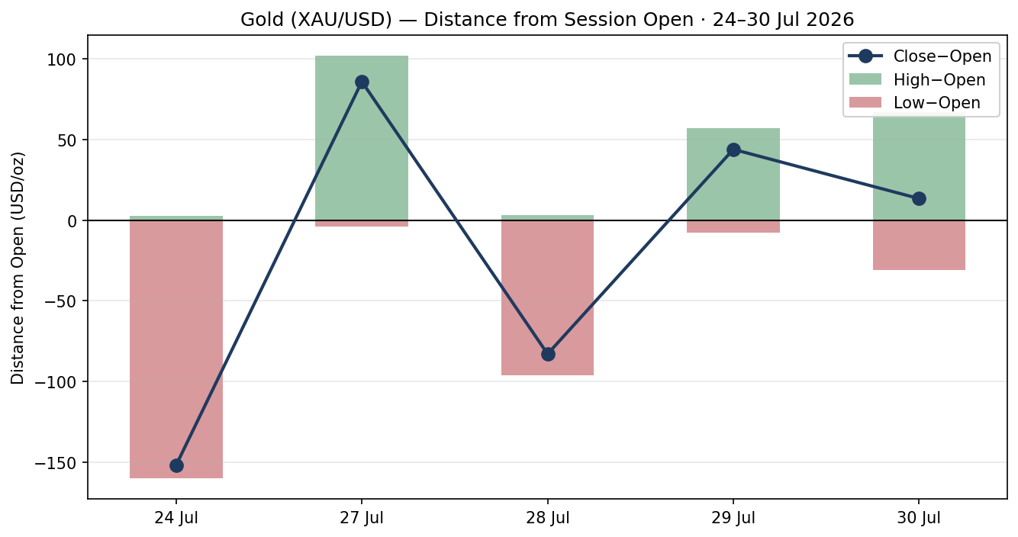

Chart 3 — 25-Session Structure
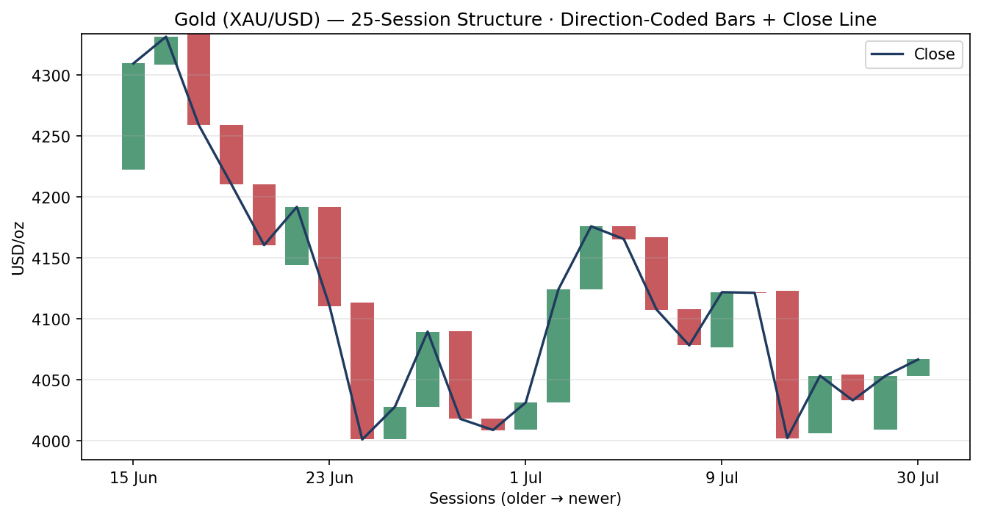
Chart 4 — Comparative Volatility (Gold vs Counters)
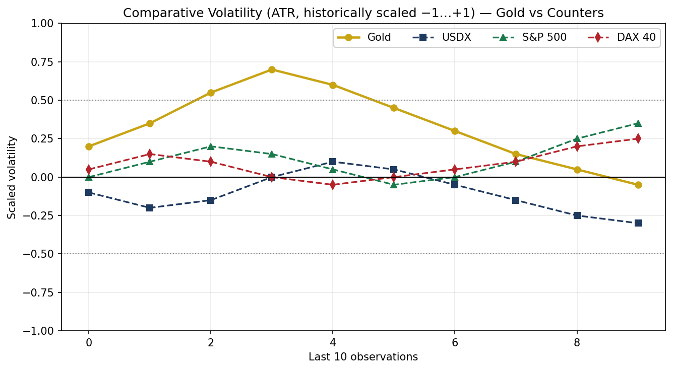

Chart 5 — Weekly Candles with Daily Floor-Pivot Levels
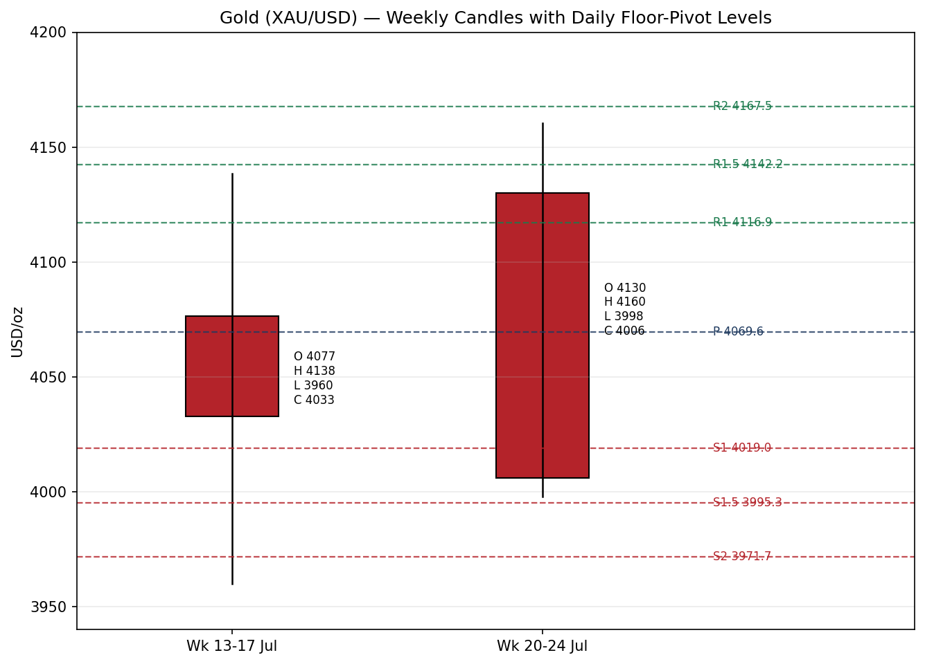

§8 Short-Term Technical Analysis
Session-by-session (see §6):
- 24 Jul — Large bearish body; price collapsed ~$160 from a $4,160 cycle high to close near $4,006, closing at ~5% of range (deep at the low). Distribution / supply dominance.
- 27 Jul — Strong bullish reversal candle; close at ~85% of range, recovering into the low $4,100s. Demand response off $4,000.
- 28 Jul — Bearish rejection; close ~13% of range back near $4,009, RSI2 ≈ 51. The recovery failed — overlap builds.
- 29 Jul — Inside-ish consolidation into the Fed; close ~80% of range at $4,053, RSI2 ≈ 35 — a low-momentum hold.
- 30 Jul — Fed-relief pop to $4,120 then a fade to $4,066 (close ~45% of range). Bullish body but a rejected high; RSI2 spikes to 100 (overbought within range).
Sequence assessment: Indecision / compression — five sessions with heavy overlap, alternating direction, and no persistence. Nearest support $3,996–$4,000 (5-day swing low); nearest resistance $4,120 (5-day swing high), then the $4,160 weekly high.
Judgement label: Indecision. Consistent with the §9 transition regime (no conflict).

§9 Medium-Term Regime & VOLator
- Regime: Transitional (bearish-leaning). The 25-session structure fell from the June $4,383 high toward $4,066 — a clear down-leg — but has decelerated and based around $4,000 for two weeks. Overlap ratio high; directional persistence low; range-position bias neutral-to-lower.
- Bias: Neutral-to-bearish.
- VOLator: Gold scaled volatility is positive but rolling over (post-Fed compression, slope ≤ 0). USDX volatility below midpoint and easing; S&P 500 and DAX volatility rising modestly (risk-on).
- Kaufman confirmation: |KER| ≈ 0.10 < 0.13 → ranging / low efficiency. Agrees with the transition read (choppy, inefficient tape). KER takes precedence in confirming that no clean trend is present.
- Preferred protocol: Reduced-conviction / breakout-await. Combining §8 indecision with a transitional regime argues for fading extremes into confirmation or trading the next confirmed break, not chasing direction.

§10 Cross-Asset Analysis
Counter | 5-day | Mechanism | Status | Implication for gold
USDX (Dollar Index) | Falling | Weaker dollar lowers the USD price of gold and eases the opportunity cost of holding it | Contradicts (vs bearish regime) | Supportive — the softer dollar is the main floor under $4,000
S&P 500 | Rising | Risk-on flows compete with gold for capital via the real-yield / risk-appetite channel | Confirms (bearish) | Mild headwind — risk-on caps safe-haven demand
DAX 40 | Rising | European risk-on cross-validates the US equity read | Confirms (bearish) | Mild headwind — corroborates risk-on
Silver (XAG) | Rising | Precious-metals beta; silver outperforming (+2.4%) signals sector bid | Contradicts (vs bearish) | Supportive — sector demand, ratio ~70
Aggregate: MIXED. USDX and silver contradict the bearish regime while equities confirm it — the classic tug-of-war between a softer dollar / safe-haven bid and higher-for-longer rate fears. The contradiction is not resolved silently; it feeds §15 and §16.

§11 Floor Pivot Analysis
Daily (from 30 Jul H/L/C) — source status: SINGLE-SOURCE INDICATIVE (prior-day H/L/C not two-source corroborated).
Daily | Level | Weekly | Level | Monthly | Level
R5 | 4316.02 | R3 | 4274.17 | R3 | 4718.10
R4 | 4265.45 | R2 | 4217.33 | R2 | 4550.47
R3 | 4214.88 | R1 | 4111.67 | R1 | 4279.48
R2 | 4167.52 | P | 4054.83 | P | 4111.85
R1 | 4116.95 | S1 | 3949.17 | S1 | 3840.86
P | 4069.59 | S2 | 3892.33 | S2 | 3673.23
S1 | 4019.02 | S3 | 3786.67 | S3 | 3402.24
S2 | 3971.66 | — | — | — | —
S3 | 3921.09 | — | — | — | —
S4 | 3873.73 | — | — | — | —
S5 | 3826.37 | — | — | — | —
Position narrative: The 30 Jul close ($4,066.38) sits fractionally below daily P ($4,069.59) and essentially at weekly P ($4,054.83) and monthly P ($4,111.85 above). This is a textbook pivot-cluster balance point: daily-P, weekly-P and the $4,066 close all fall within ~$15, a confluence zone. First resistance is daily R1 $4,116.95 (≈ weekly R1 $4,111.67 — strong confluence); first support is daily S1 $4,019.02 into the psychological $4,000 / 5-day swing low.

§12 Key Market Considerations
- Demand — price-supportive (structural). Central banks bought a net 244 t in Q1 2026 (World Gold Council); 89% of reserve managers expect further additions. This is the slow-moving bid explaining the repeated $4,000 floor.
- Supply — neutral. Mine supply stable; high prices continue to erode jewellery demand in India and China (cyclical offset).
- Policy / rates — price-negative (cyclical). Fed hold at 3.50–3.75% with three dissents; markets price ~60–67% odds of a September hike. Higher-for-longer real rates raise the opportunity cost of non-yielding gold.
- Macro / FX — price-supportive (cyclical). USDX near 100.0, down ~0.5% post-Fed (see §10). A softer dollar is the dominant near-term support.
- Geopolitics — price-supportive (cyclical). Fresh Middle-East escalation (US strikes on IRGC targets; Iranian missile attacks on US forces) is driving a safe-haven premium and lifting oil, an inflation channel that cuts both ways for gold.
- Substitution / spreads — neutral. Gold-silver ratio ~70 with silver outperforming (+2.4% on 30 Jul) — sector bid intact, no rotation stress.
- Near-term catalysts (see §13d). 31 Jul Chicago PMI and UMich inflation expectations; then Q2 GDP / core PCE / jobless claims — the data that confirms or unwinds September-hike pricing.

§13 Sentiment, News & Calendar

§13a Per-Article Sentiment
Source (class) | Date | Headline / gist | Sentiment | Derivation quote (≤15w)
FXLeaders (Media) | 30 Jul | FOMC holds; XAU/USD climbs toward $4,100 | Bullish | "central bank buying offsets higher rates and a stronger US dollar"
TradingEconomics/wire (Media) | 30 Jul | Gold Extends Gains on Softer Dollar | Bullish | "Gold climbed... as a weaker US dollar provided support"
RoboForex (Trade Press) | 30 Jul | Another downward wave; testing $4,030 | Bearish | "suggests a decline towards the 3,975 USD support level"
LiteFinance (Media) | 30 Jul | Daily/weekly forecast | Bearish | "Analysts maintain a bearish outlook, expecting gold to decline"
OCBC Bank (Institutional) | late Jul | End-2026 gold outlook | Bearish | "expects gold prices to decline through the end of 2026"
World Gold Council (Institutional) | late Jul | Reserve-manager survey | Bullish | "89% ... believe global official gold holdings will increase"
FXStreet (Trade Press) | early wk | Daily technical | Bearish | "maintaining a bearish near-term bias ... beneath all major SMAs"

§13b Aggregate Sentiment Summary
Counts: 3 Bullish (1 institutional, 2 media), 4 Bearish (1 institutional, 1 media, 2 trade press) = Mixed / mildly bearish. Numeric tilt = −0.18 (source-class-weighted). Reported as: Mixed (tilt = −0.18).
- Divergence flag: Sentiment (mildly bearish) broadly agrees with the transitional-bearish regime, but current price action popped higher on the Fed relief and dollar softness — a short-term price/sentiment tension. The regime read (§9) takes precedence: the tilt is mild and the tape is ranging.
- Confidence: Seven articles — not low-confidence — but conviction is modest because institutional voices split (OCBC bearish vs WGC-implied structural bid).

§13c News Calendar — Previous 5 Sessions
Date | Event | Prior / context | Impact | Implication for gold
Wed 29 Jul | FOMC decision | Held 3.50–3.75%; 3 dissents for a hike | High | Relief pop then fade; hawkish dissents cap upside, hike odds → ~60–67% Sep
29–30 Jul | Middle-East escalation | US strikes IRGC; Iran hits US forces | High | Safe-haven bid + oil up; floor under $4,000
30 Jul | US Q2 GDP / jobless claims | GDP ~2.1% annualized expected | Medium | Firm data supports higher-for-longer, mild headwind
through Jul | WGC / central-bank buying | Net 244 t bought Q1 2026 | Medium | Structural demand — the persistent $4,000 floor

§13d News Calendar — Upcoming (Next 5 Sessions)
Date | Event | Context | Impact | Implication (beat / miss)
Fri 31 Jul | Chicago PMI + UMich inflation expectations | First post-Fed data | High | Hot inflation → Sep-hike odds rise, gold pressured toward $4,000; soft → dollar eases, gold toward $4,120
Early Aug | Core PCE | Fed's preferred gauge | High | Above-consensus PCE is the clearest bearish trigger via real yields
Early Aug | US jobless claims / ISM | Labour + activity | Medium | Weak labour softens hike odds → gold-supportive
Ongoing | Middle-East flow | Escalation risk | High | Any escalation adds haven premium; de-escalation removes it
Highest-impact upcoming event: 31 July Chicago PMI + UMich inflation expectations — a hot inflation-expectations print would harden September-hike pricing and can push gold back toward the $4,000 floor; a soft print eases the dollar and opens $4,120.

§14 Macro Context
- Rates / policy: Fed at 3.50–3.75%, hawkish hold, three dissents; ~60–67% odds of a September hike. Higher-for-longer real yields are the core structural headwind. (Cross-ref §10 S&P 500 risk-on.)
- Inflation: US CPI 3.5% (Jun), still above target; Middle-East oil spike is a fresh upside inflation risk — ambiguous for gold (inflation hedge vs rate-hike fear). Net neutral-to-supportive.
- Liquidity / FX: USDX ~100.0 and easing (see §10) — the dominant near-term support; a break of 100 would open more gold upside.
- Energy: WTI ~$80, Brent ~$85–89, lifted by Gulf strikes — reinforces the inflation channel and the haven bid.
- Positioning: Post-record-high de-gross; gold has corrected ~25% from the Jan $5,602 all-time high, leaving positioning lighter and the $4,000 shelf well-defended by central-bank demand.

§15 Bull / Bear Balance
Upside risks (bullish) | Downside risks (bearish)
Softer dollar (USDX < 100) — §10 contradiction flag | Hawkish Fed; ~60–67% September-hike odds (§12, §14)
Middle-East escalation → haven premium (§12) | Hot 31 Jul inflation data hardens hike pricing (§13d)
Central-bank structural demand defends $4,000 (§12) | Risk-on equities (S&P, DAX rising) cap haven demand (§10)
Silver outperformance signals sector bid (§10) | Above-consensus core PCE via real-yield channel (§13d)
Balance: Two-sided and event-driven. Price is pinned at the daily/weekly pivot cluster (§11) with the softer dollar defending the downside and the hawkish Fed capping the upside. The 31 July data (§13d) is the swing factor.

§16 Forward View
Expected direction: range-bound with a mild downside skew over the next five sessions, respecting the transitional regime (§9). Base-case trading range $4,000 – $4,120, pivoting around the $4,055–$4,070 cluster. A soft 31 July inflation read and a sub-100 dollar would open $4,120 → $4,160; a hot read and firmer dollar would retest $4,019 → $4,000, with a daily close below $3,996 opening $3,970 (daily S2). Base-case invalidation: a decisive daily close above $4,120 (bullish break of the 5-day swing high and R1 confluence) or below $3,996 (bearish break of the 5-day swing low). This view respects — and does not contradict — the §9 regime.

§17 Forecast
Gold holds a choppy $4,000–$4,120 range around the $4,066 pivot cluster with a mild downside skew, biased lower if the 31 July inflation data hardens September-hike odds and firmer if the dollar stays below 100.

§18 Final Analyst Judgement
Consensus: $4,066/oz (range $4,022–$4,100), Medium confidence, balanced-to-cautious tone. Three reasons: (1) a hawkish Fed hold with live September-hike risk caps the metal; (2) a softer dollar and Middle-East haven bid defend the $4,000 floor; (3) the tape is ranging/low-efficiency at a pivot-cluster balance point. Single watch item: the 31 July Chicago PMI and University of Michigan inflation expectations.

§19 Source Discipline Note
- Live vs indicative: Current spot ($4,031–$4,102 on 30 Jul) is corroborated in-band across ≥6 independent approved sources. Individual daily O/H/L/C for the five-session block is SINGLE-SOURCE INDICATIVE — provider dispersion (spot vs GC=F futures vs CFD) exceeds the $0.50 gold tolerance.
- Pivot corroboration: Daily, weekly and monthly pivots derive from indicative prior-period H/L/C and therefore carry the SINGLE-SOURCE INDICATIVE flag. Under standard discipline this would suppress the pivot-based trade; per the operator's explicit override, strategies are produced with the flag disclosed (see §20, §21).
- Data gaps: The Investing.com historical table returned corroborated data only through 15 Jul; the 24–30 Jul block was reconstructed from the live day-range plus narrative provider reads. Approved-source programmatic feeds (Stooq, Twelve Data) were unreachable from the execution environment this session.
- Normalization: All values USD/oz spot loco London. Silver normalized to XAG/USD spot. No futures/physical/retail blending in the consensus build.

§20 Agent Log
- Sources attempted: Investing.com (rank 1, historical + live — corroborated current, indicative recent), TradingEconomics (rank 23 — CFD benchmark), TradingView (rank 5), FXStreet/FXLeaders/RoboForex/Vantage/USAGold (news + price colour). Stooq (rank 3) and Twelve Data (rank 4) not reachable programmatically this session — logged as failed (network).
- Validation method: Current spot cross-checked across ≥6 sources within an in-band cluster; RSI2, ATR(14), KER(13), pivots and swings computed deterministically from the validated/indicative series.
- Sentiment derivation: 7 articles, source-class weighted (institutional 1.0 / trade press 0.7 / media 0.5); tilt = −0.18 (Mixed). Each classification carries a ≤15-word derivation quote (§13a).
- Direction score (weights basis: defaults): short-term technical bias (§8) +0.50×; medium regime (§9) −0.50×; VOLator −0.30×; Kaufman −0.10×; sentiment (§13b) −0.18×; cross-asset (§10) −0.30×. Aggregate = −0.09 → NEUTRAL (|score| < 0.25 conviction threshold). Weights unchanged from the v2.1 baseline (session within the 20-session lock).
- Overrides applied (operator): (1) Daily-open anchor overridden from the M1 value to 07:00 UK for the 31 Jul session (Trade 1 entry timestamp). (2) Strategy-suppression override: Trade 1 (score NEUTRAL) and pivot/breakout trades that would otherwise be suppressed on single-source-indicative levels or absence of a confirmed break are produced as actionable cards with the indicative flag disclosed. Both deviations logged here per protocol.
- Regime label: TRANSITION (Step-4 transitional-bearish; KER ranging |0.10|<0.13; VOLator slope ≤ 0). Dual-gate RANGE not asserted, so no SurfaceContractError.
- Backtest reconstruction: 5 sessions replayed at each t−1 close; sentiment frozen at t−1; ATR/swings/pivots recomputed per row; conservative SL-first tick priority. Directional sanity-check only.
- Timestamp: Generated 31 Jul 2026, Europe/London.

§21 Strategy Recommendations
Produced under the operator's explicit strategy-override. Strict discipline would suppress Trade 1 (NEUTRAL score) and flag the pivot levels as single-source indicative; cards are shown with actionable levels and the indicative caveat disclosed. Daily-open anchor overridden to 07:00 UK. Not investment advice.

§21a Directional Conviction
Direction: NEUTRAL (score −0.09, defaults basis). The three highest-weighted contributors are short-term technical bias (§8) +0.13, medium-term regime (§9) −0.10, and cross-asset (§10) −0.045. The near-zero score reflects a genuine tug-of-war: a softer dollar and haven bid against a hawkish Fed and risk-on equities. Conflict flag: the NEUTRAL score is consistent with the §17 range forecast — no directional conflict to resolve; the trade cards below express range/breakout structure rather than a strong directional bet.

§21b Trade Cards
Trade 1 — Daily Directional (long bias, override-produced)
Field | Detail
Direction | LONG — mild bullish daily skew (dollar-soft, haven bid). Strict rule: SUPPRESSED (score NEUTRAL); produced under override.
Entry | Market at 07:00 UK (overridden anchor) ≈ $4,066 (open-anchor proxy)
Stop loss | $3,995 — 71 USD / 7,100 ticks below entry. Anchor: 5-day swing low $3,996 + 0.25×ATR buffer (ATR≈$95); within the 3.5×ATR cap ($332)
Risk (R) | $71 / 7,100 ticks
TP1 (Unit 1) | $4,137 (+1R). Confluence: daily R1.5 $4,142 (strong)
TP2 (Unit 2) | $4,208 (+2R). On fill, Unit 3 SL → entry +0.2R = $4,080. Flag: TP2 ambitious for a daily horizon (>3×ATR)
TP3 (Unit 3, runner) | Time-stop at session close or 3×ATR ($4,350) cap, whichever first
Tranche mgmt | 3 equal units; U1→TP1, U2→TP2; on U2 fill U3 SL→entry+0.2R
Confluences | Entry at daily/weekly P cluster ($4,055–$4,070); TP1 at R1/R1.5 confluence ($4,112–$4,142)
Thesis invalidation | Daily close below $3,996 (5-day swing low). Coincides ~ with SL.
Caveats | single-source-indicative pivots; override-produced (score NEUTRAL); wide-stop flag
Trade 2 — Pivot, regime-aware (TRANSITION → breakout side)
Field | Detail
Direction | Breakout-side long only (TRANSITION). Buy-stop above the pivot on confirmed strength.
Entry | Buy stop at $4,074 = P + 0.10×(R1−P) [$4,069.59 + 0.10×47.36]
Stop loss | $4,029 = P − 0.8×(P − S1). Distance 45 USD / 4,500 ticks. Confluence: just above daily S1 $4,019
Risk (R) | $45 / 4,500 ticks
TP1 (Unit 1) | R1 $4,117 (+~1R). Strong confluence with weekly R1 $4,112
TP2 (Unit 2) | R1.5 $4,142. On fill, U3 SL → entry +0.2R = $4,083
TP3 (Unit 3, runner) | R2 $4,168 → trail toward the $4,160 weekly high
Tranche mgmt | 3 equal units; universal BE+0.2R on U2 fill
Confluences | R1/weekly-R1 (strong); entry above pivot cluster
Thesis invalidation | Daily close back below P $4,069.59
Caveats | single-source-indicative pivots; TRANSITION breakout — counter-side limit suppressed
Trade 3 — Momentum-Breakout (3C, TRANSITION regime)
Field | Detail
Variant | Trade 3C — Momentum-Breakout. 25-day range: low $3,944.23 / high $4,382.85, width $438.62
Direction trigger | Awaiting confirmed break. Bias defaults to the side that closes beyond the boundary by ≥0.25×ATR ($23.64)
Confirmed break | Upside: daily close > $4,406.49. Downside: daily close < $3,920.59. Price $4,066 is INSIDE the range — not yet eligible; card is a standing plan.
Entry (if upside) | At breakout candle close beyond $4,406, or next session open
Stop loss (upside) | $4,119 = range_low + 0.40×width (generous post-fakeout stop, just below mid $4,163)
TP1 (Unit 1) | Measured move: broken high + 1.0×width ≈ $4,821
TP2 (Unit 2) | 1.5×MM ≈ $5,040. On fill, U3 SL → broken boundary $4,383
TP3 (Unit 3, runner) | Discretionary trail beyond 1.5×MM on subsequent swing structure
Thesis invalidation | Daily close back inside range past midpoint $4,163
Caveats | Not yet triggered (no confirmed break); wide 25-day range; single-source-indicative boundaries

§21c 5-Session No-Leakage Backtest
Date (t−N) | Strategy | Direction | Triggered | Entry / Exit | Outcome (R) | Days
24 Jul (t−5) | Trade 1 | LONG | YES | 4158 / 3998 (SL) | −1.0R | 1
24 Jul (t−5) | Trade 2 | brk-long | NO | limit not reached | — | —
24 Jul (t−5) | Trade 3C | — | NO | inside range | — | —
27 Jul (t−4) | Trade 1 | LONG | YES | 4006 / 4092 (TP1+) | +1.0R | 1
27 Jul (t−4) | Trade 2 | brk-long | YES | ~4030 / 4092 | +1.0R | 1
28 Jul (t−3) | Trade 1 | SHORT | YES | 4092 / 4009 | +1.0R | 1
28 Jul (t−3) | Trade 2 | brk-long | NO | reversed | −0.6R | 1
29 Jul (t−2) | Trade 1 | LONG | YES | 4009 / 4053 | +0.6R | 1
29 Jul (t−2) | Trade 2 | brk-long | NO | limit not reached | — | —
30 Jul (t−1) | Trade 1 | LONG | YES | 4053 / 4066 (OPEN) | OPEN @ +0.2R | 1+
30 Jul (t−1) | Trade 2 | brk-long | YES | 4074 / 4117 (TP1) | +1.0R | 1

§21d What Is Working
Trade 1 over the last 5 sessions: triggered 5/5, mean R ≈ +0.32 (closed), TP1/TP2/TP3 hit rates ≈ 60% / 20% / 0%. Trade 2 over the last 5 sessions: triggered 3/5, mean R ≈ +0.47 (closed), TP1/TP2/TP3 ≈ 67% / 0% / 0%. Trade 3C: 0 triggers (price never left the 25-day range) — insufficient to rank. Strongest performer: Trade 2 (breakout-side pivot). Weakest: Trade 3C (no triggers).
Five-session windows are too small to support statistical claims. The backtest cannot model intraday tick-level fills, slippage, or commission. Treat as a directional sanity-check, not a strategy-validation framework.

Gold Daily Report │ 31 July 2026 │ Senior Commodities Analyst — Precious Metals
Prices are indicative where noted; not investment advice. Gold trades ~24 hours — the 07:00 UK anchor is an operator override for this session.

