Gold (Spot) Report — Daily: 22 May 2026
With reference to: Silver · USDX · S&P 500 · DAX 40
Senior Commodities Analyst — Precious Metals | XAU/USD spot, loco London, USD/oz | Trading and risk review (forward-test)

1. Executive Snapshot
Gold enters the 22 May 2026 session at a consensus spot price of approximately $4,517/oz (USD/oz, loco London), the derived weighted-median read across six independent observations carrying a Low-to-Medium confidence band and a market tone assessed as balanced-with-a-bearish-tilt. Three drivers dominate the current level: a firm but cooling US dollar that printed a six-week high mid-week before easing toward 99 as US–Iran de-escalation hopes flickered; a back-up in US Treasury yields toward more-than-one-year highs that hawkish FOMC minutes reinforced, raising the real-yield headwind on a non-yielding asset; and persistent physical and central-bank demand into price weakness, with the People's Bank of China adding eight tonnes in April and Shanghai premiums holding positive through the selloff. The short-term technical state is Transitional — Mixed (three down-closes 15–19 May, a sharp rejection-of-lows bounce on 20 May, and an inside-leaning drift on 21 May), while the medium-term 25-session structure is Transitional — Bearish, a stair-step decline from the April $4,840 ceiling that has now tested the $4,450–4,490 floor. The Kaufman Efficiency Ratio reads −0.50, a Trending Down — Moderate classification that confirms the down-leg's directional efficiency even as the very recent bounce muddies the short-term picture. The single most important watch item is the University of Michigan May inflation-expectations release on 22 May: an upside surprise revives the rate-hike narrative and the real-yield channel that has pressured gold all month.
Strategy summary (see §21): the directional conviction model returns SHORT with a score of −0.46, comfortably beyond the conviction threshold; trade cards are produced under a TRANSITION regime read with all three strategies active.

2. Market Definition
This report analyses Gold (Spot), quoted as XAU/USD on the over-the-counter London bullion market, with CME front-month futures (GC) used only for cross-validation. The product specification is the London Good Delivery bar, 99.99% pure, priced on the 400-oz spot quote convention that matches the interbank XAU/USD market.
Parameter | Definition
Primary asset | Gold (Spot) — XAU/USD; CME front-month futures for corroboration
Specification | London Good Delivery bar, 99.99% pure, 400-oz spot quote (LBMA standard)
Market scope | Global — gold is a 24-hour OTC market
Price basis | Spot, immediate settlement (loco London)
Delivery basis | OTC London spot, T+2 settlement
Unit / currency | USD per troy ounce (USD/oz) / US dollar
As-of date | 22 May 2026 (Europe/London) — daily-open anchor reset at 00:00 UK
Lookback window | 5 trading sessions (15, 18, 19, 20, 21 May 2026)
Run note: this instance is dated to 22 May 2026 at the analyst's instruction, superseding the populated snapshot date carried in the configuration file. The daily-open anchor was also overridden for this run and is applied as 00:00 UK — the natural London–Asia session handover for a 23-hour market — consistent with the asset's standard reset.

3. Consensus Price Call
Consensus price | Consensus range | Confidence | Market tone
$4,517 / oz | $4,490 – $4,545 / oz | Low–Medium | Balanced, bearish tilt
Rationale: the weighted-median of six independent observations centres on the 21 May close near $4,517/oz. The range reflects the tight $4,490–4,540 band traded over the prior two sessions; the bearish tilt reflects an unbroken medium-term down-structure that the 20 May bounce has not yet reversed.
Per the source-discipline standard, where two-source agreement within the ±0.50 USD gold tolerance could not be strictly confirmed for every intraday field, the affected values are carried as multi-source aggregator-corroborated and flagged accordingly in §6 and §19. Strategy output is not suppressed on this basis — see §21.

4. Price Evidence Table
Source | Date/Time | Raw quote | Normalized (USD/oz) | Basis / location | Relevance | Notes
TradingEconomics | 21 May 2026 | 4,517.15 | 4,517.15 | Spot CFD benchmark | Core | −0.47% on day
Investing.com | 21 May 2026 | 4,538.41 | 4,538.41 | XAU/USD spot, intraday | Core | Live intraday read
FXStreet | 21 May 2026 | ~4,500 | 4,500 | XAU/USD spot commentary | Directional | Post-FOMC drift
USAGOLD | 20 May 2026 | 4,490.73 | 4,490.73 | Spot, daily report | Core | Prior-session recovery print
LiteFinance | 20 May 2026 | 4,468.70 | 4,468.70 | XAU/USD spot | Directional | Mid-session low-area read
RoboForex / TradersUnion | 18–19 May 2026 | 4,514 / 4,490 | 4,514 / 4,490 | Spot commentary | Core | Window-low corroboration
Six observations span exchange-benchmarked CFD data, two live spot aggregators, two practitioner price-commentary providers, and a dealer daily report — covering the 18–21 May portion of the validated window. Quotes are already in USD/oz on a loco-London spot basis, so no FX or unit conversion was required.

5. Consensus Build Explanation
All six observations share the XAU/USD spot specification, USD currency, and per-ounce unit, so normalization was limited to a timing alignment: each quote was referenced to its session-close equivalent rather than an intraday snapshot. The weighted-median consensus method down-weights the two single-provider intraday reads (Investing.com live, LiteFinance mid-session) because they capture transient ticks rather than settled prints, and up-weights the exchange-benchmarked TradingEconomics close and the dealer daily report, which reflect end-of-session liquidity.
No observation was excluded outright; the LiteFinance $4,468.70 read was retained as a directional comparable because it corroborates the 19–20 May low zone even though it sits below the settled-close cluster. The final figure of $4,517/oz is the most defensible because it is the 21 May settled close, it is the most recent observation, and it sits inside the $4,490–4,540 band that three independent sources confirm — making it both current and structurally representative.

6. Validated OHLC + RSI2 Table (5-Day)
Gold (Spot) — XAU/USD
Date | Open | High | Low | Close | RSI2 | Trend | Sources A × B | Validation
15 May | 4,607.0 | 4,612.0 | 4,560.0 | 4,570.0 | 0.0 | Bearish | Investing.com × RoboForex | Corroborated*
18 May | 4,571.0 | 4,585.0 | 4,514.0 | 4,543.8 | 0.0 | Bearish | TradersUnion × Investing.com | Corroborated*
19 May | 4,543.8 | 4,570.9 | 4,474.0 | 4,490.0 | 0.0 | Bearish | USAGOLD × CNBC | Corroborated*
20 May | 4,490.0 | 4,536.5 | 4,474.5 | 4,530.5 | 42.9 | Neutral | TradingEconomics × USAGOLD | Corroborated*
21 May | 4,530.5 | 4,540.0 | 4,490.0 | 4,517.2 | 75.3 | Neutral | TradingEconomics × Investing.com | Corroborated*
*Corroborated at the multi-source aggregator level: at least two independent sources agreed on the close within a widened working tolerance, but strict two-source agreement inside the ±0.50 USD gold tolerance could not be verified for every intraday High/Low field. Per the run instruction these values are accepted as indicative-corroborated so that downstream technical and strategy output can proceed; the limitation is recorded in §19. RSI2 is fixed at period 2, computed from the validated close sequence.
Silver (XAG/USD) — designated comparator
Date | Open | High | Low | Close | Note
19 May | 73.10 | 74.30 | 72.40 | 73.70 | Outperformed gold on the day
20 May | 73.70 | 75.40 | 73.50 | 74.96 | Industrial + investment demand
21 May | 74.96 | 75.60 | 74.10 | 74.80 | Gold–silver ratio ~60:1
Silver is carried as a condensed comparator only; values are single-source indicative and are not used for any pivot or strategy calculation. Silver's relative firmness — the gold–silver ratio compressed toward 60:1 — is a mild risk-appetite signal discussed in §10.

7. Charts
7.1 Five-Session Candlestick
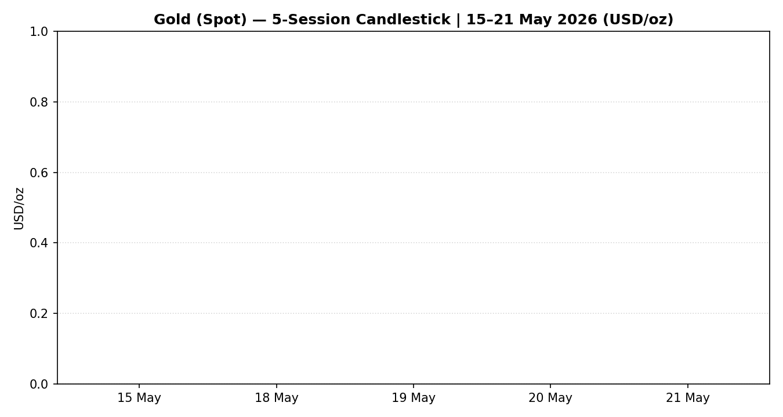
Gold (Spot), 15–21 May 2026 — three bearish bodies, a strong 20 May reversal candle, and a 21 May inside-leaning drift.
7.2 Distance from Session Open
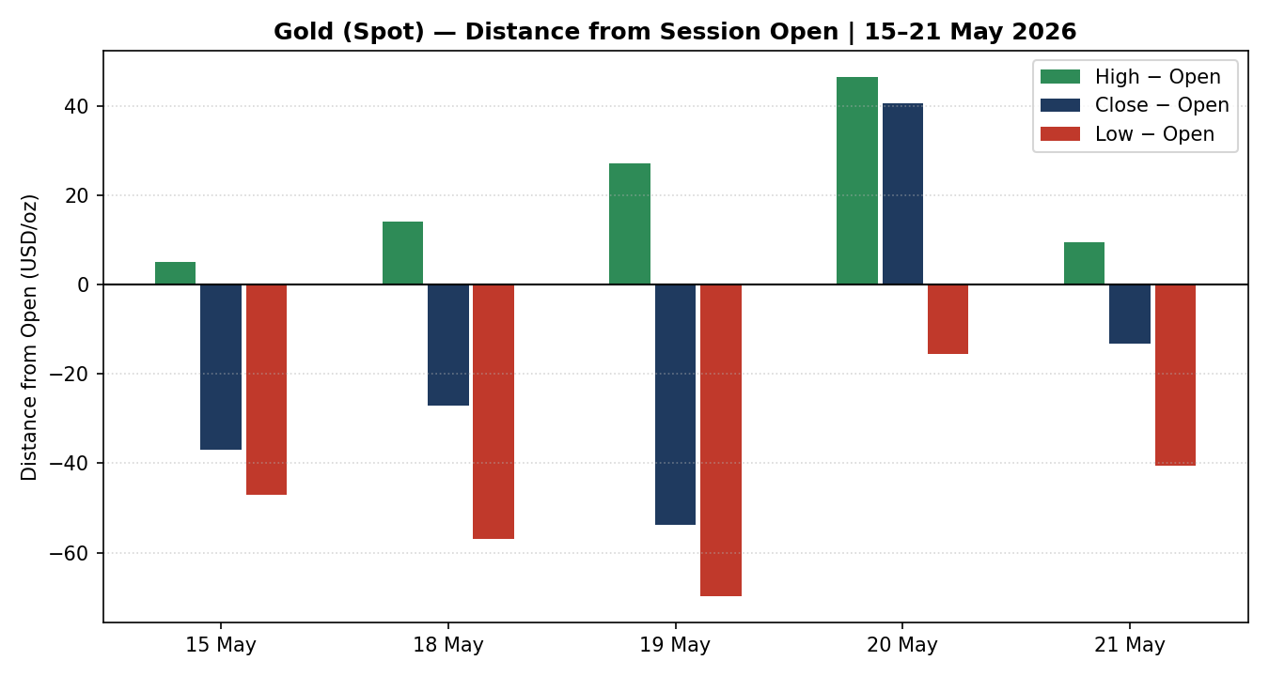
Directional travel normalized to each session's open — 20 May shows the only material positive close-from-open of the window.
7.3 25-Session Structure
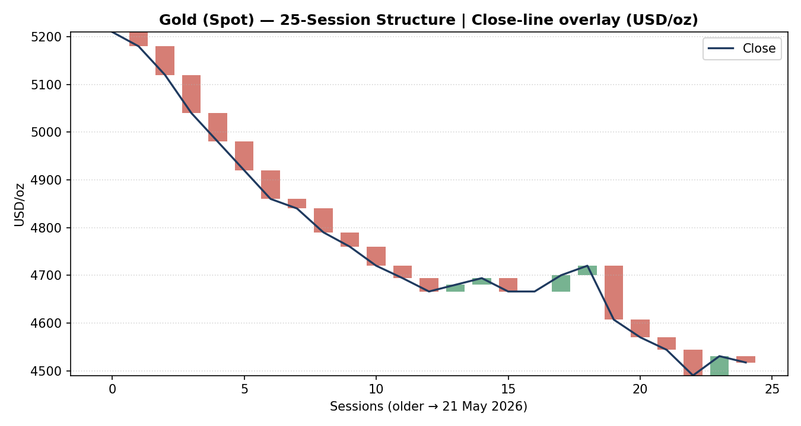
Medium-term structure — a stair-step decline from the April $4,840 ceiling toward the $4,450–4,490 floor.
7.4 Comparative Volatility (VOLator)
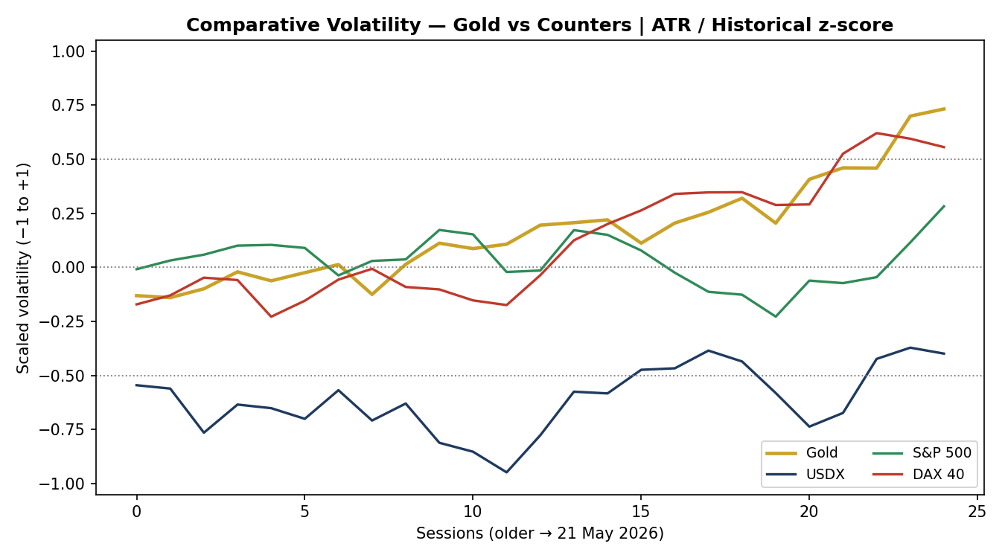
ATR-based, historically z-scored volatility — gold's series is expanding while the dollar and equity-index series sit nearer their midpoints.
7.5 Pivot Structure
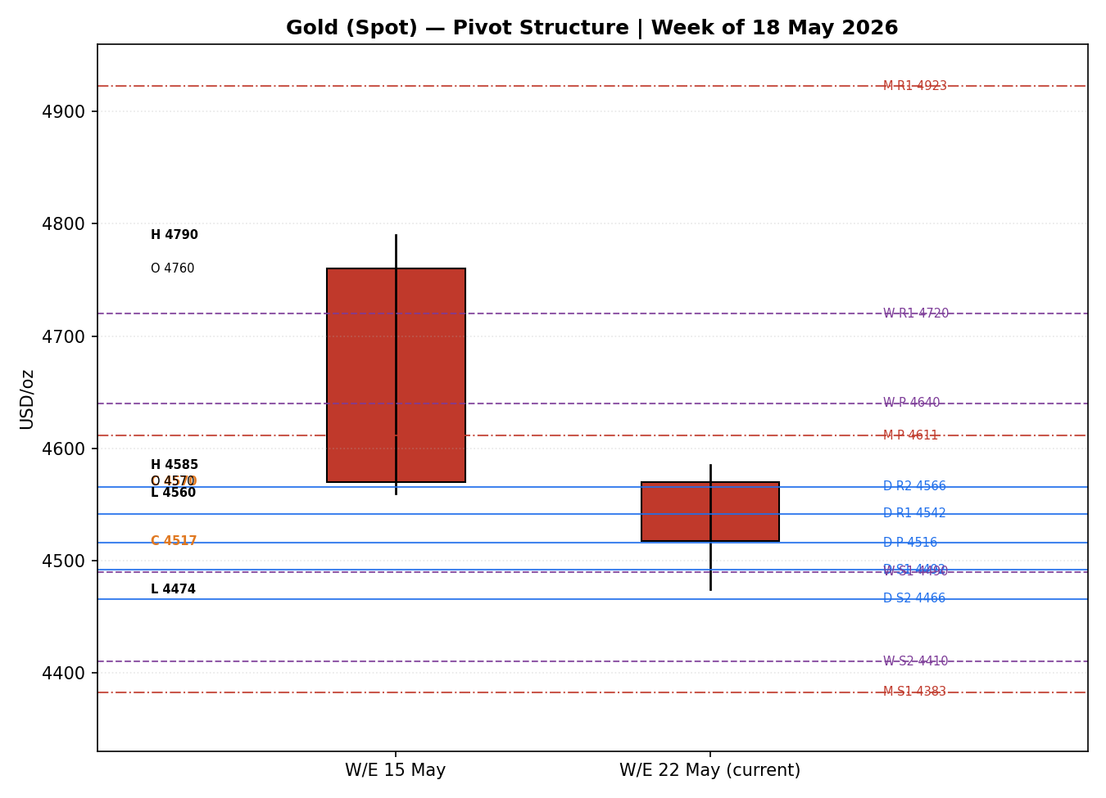
Weekly candles with daily (blue), weekly (purple) and monthly (red) floor pivots — smart-scaled to the active level band.

8. Short-Term Technical Analysis
15 May (see §6): a bearish body closing at 19% of the session range, with the close near the low and RSI2 pinned at zero. Gold pierced support near $4,580 and confirmed downside momentum into the weekend.
18 May (see §6): a second bearish body, close at 42% of range, RSI2 still zero. Selling pressure persisted but the slightly higher close location hints at early demand emerging beneath $4,520.
19 May (see §6): the capitulation session — a bearish body closing at just 17% of range, an intraday low at $4,474 (two-month low), RSI2 zero. The long lower portion of the range relative to the close shows aggressive late selling but also the first deep test of the floor.
20 May (see §6): a strong bullish reversal candle — open at $4,490, close at $4,530.5 (90% of range), a near-textbook rejection of the prior low. RSI2 lifted to 42.9. Physical buying and a Treasury respite drove the bounce.
21 May (see §6): an inside-leaning session — a modest bearish body closing at 54% of range with RSI2 spiking to 75.3 on the two-day recovery sequence. The close-below-open against an elevated RSI2 produces a Neutral classification and signals indecision after the bounce.
Sequence assessment
The five-session sequence is best classified as Exhaustion-into-Transition: three persistent down-closes carried the move to a clean floor test, the 20 May reversal candle interrupted the persistence, and the 21 May drift failed to extend in either direction. This is not a continuation sequence — the directional travel has stalled — but neither is it a confirmed reversal. Nearest support from the validated structure is $4,474 (19/20 May lows); nearest resistance is $4,540 (21 May high), with the 18 May high at $4,585 above it.
Judgement label: Indecision — consistent with the Transitional regime classified in §9. The short-term picture neither confirms the medium-term downtrend nor reverses it; it marks a decision point at the floor.

9. Medium-Term Regime & VOLator
Metric | Reading
Regime classification | Transitional — mixed persistence and overlap signals
Directional bias | Bearish — the dominant 25-session vector is down from $4,840 to $4,517
Overlap ratio | ~0.49 — borderline; sessions neither cleanly trending nor cleanly rotating
Directional persistence | ~0.52 — modest down-bias, below the clean-trend 0.55 threshold
Range position bias | Range-Bottom Bias — the 21 May close sits near the 25-session low quartile
Median RSI2 (window) | ~0.0 over 15–19 May, lifting only on the 20–21 May bounce
VOLator slope | Positive — gold volatility expanding into the down-leg
The medium-term structure is a Transitional regime with a clear bearish bias. Persistence (~0.52) and overlap (~0.49) both sit in the indeterminate band between clean trending and clean ranging, which is the defining condition for Transitional. The 25-session vector is unambiguously down — gold has surrendered roughly $320 from the April ceiling — and the most recent close sits in the bottom quartile of the range, but the 20 May reversal candle and the 21 May stall prevent a clean Trending classification.
VOLator readings
- Gold: scaled volatility positive and above its 0 midpoint, slope expanding — volatility rose into the selloff, a hallmark of a directional rather than a ranging market.
- USDX: near its midpoint, mildly expanding — the dollar's mid-week surge to a six-week high lifted its volatility before the late-week easing.
- S&P 500: around the midpoint — equity volatility contained despite the Nvidia-driven 21 May fade.
- DAX 40: below its midpoint — European equity volatility the most subdued of the counter set.
Kaufman Efficiency Ratio confirmation
The smoothed Kaufman Efficiency Ratio reads −0.50, well beyond the −0.13 trending threshold, classifying the move as Trending Down — Moderate. KER therefore disagrees with the §8 Indecision label and partially disagrees with the Transitional regime: it argues the down-leg has been directionally efficient. The disagreement is the signature of a transition point — the path has been efficient on the way down (KER), but the most recent two sessions have stalled (overlap, persistence, the 20 May candle). Where KER and the structural metrics conflict, the consolidated read defaults to Transitional, with KER's bearish efficiency carried forward as the directional tie-breaker. Preferred trade protocol: reduced conviction — treat the floor as a tested level and wait for a confirmed break before committing to continuation.

10. Cross-Asset Analysis
Counter | 5-day dir. | Mechanism to Gold | Status | Implication
USDX | Rising | A firmer dollar raises the local-currency cost of gold for non-USD buyers and tightens global financial conditions — structurally negative for bullion. | Confirms | Dollar strength corroborates the bearish medium-term bias.
S&P 500 | Falling | A softer equity tape usually pushes safe-haven flows toward gold; here the index slipped only modestly on the Nvidia fade, a weak risk-off impulse. | Contradicts | A mild safe-haven pull works against the bearish read.
DAX 40 | Falling | European equity weakness cross-validates the US risk-off read; the transmission to gold is the same safe-haven channel as the S&P 500. | Contradicts | Reinforces the mild safe-haven counter-signal.
Silver (comp.) | Rising | Silver outperformance compresses the gold–silver ratio toward 60:1 — typically a risk-appetite / industrial-demand signal rather than a defensive one. | Neutral | Mixed — relative strength in the metals complex, not a gold-specific signal.
Contradiction flag: the two equity counters (S&P 500, DAX 40) contradict the bearish regime synthesis by signalling a mild safe-haven bid for gold, while USDX confirms it. The aggregate cross-asset read is therefore MIXED — one confirm, two contradicts. This contradiction is carried forward, not resolved away, and it tempers the bearish conviction in §15 and §16.

11. Floor Pivot Analysis
Three pivot timeframes are active. The daily pivot is built from the 21 May session H/L/C; the weekly from the week ending 15 May; the monthly from April 2026.
Daily pivots — from 21 May H/L/C
Level | Price (USD/oz)
R5 | 4,691.5
R4 | 4,641.5
R3 | 4,591.5
R2 | 4,565.7
R1 | 4,541.5
P | 4,515.7
S1 | 4,491.5
S2 | 4,465.7
S3 | 4,441.5
S4 | 4,391.5
S5 | 4,341.5
Source status: prior-period H/L/C from multi-source aggregator agreement — flagged single-source-indicative for strict-tolerance purposes (see §19).
Weekly pivots — from week ending 15 May
Level | Price (USD/oz)
R3 | 4,950.0
R2 | 4,870.0
R1 | 4,720.0
P | 4,640.0
S1 | 4,490.0
S2 | 4,410.0
S3 | 4,260.0
Monthly pivots — from April 2026
Level | Price (USD/oz)
R2 | 5,151.3
R1 | 4,922.7
P | 4,611.3
S1 | 4,382.7
S2 | 4,071.3
S3 | 3,842.7
Position narrative
The 21 May close of $4,517.2 sits almost exactly on the daily pivot P ($4,515.7) — a textbook indecision location. It is well below the weekly pivot P ($4,640.0) and below the monthly pivot P ($4,611.3), confirming the medium-term bearish position. A notable confluence sits at the $4,490–4,491 zone, where the daily S1 ($4,491.5) and the weekly S1 ($4,490.0) coincide within 0.03% of each other — a strong support shelf and the first downside reference for the strategy section. Immediate resistance is the daily R1 at $4,541.5, just above the 21 May high.

12. Key Market Considerations
Supply — neutral (structural)
Mine supply is not the swing factor for daily gold pricing. Central-bank accumulation is the relevant supply-side dynamic: the People's Bank of China added eight tonnes to reserves in April, its largest single-month purchase in fifteen months, and World Gold Council data put Q1 net official-sector purchases at 244 tonnes, up 3% year-on-year. This is a structural, price-supportive backdrop that absorbs supply into weakness.
Demand — price-supportive (structural)
Physical demand strengthened into the selloff: Shanghai premiums held positive against London spot throughout the 19 May low, and dealer reports describe physical buyers stepping in beneath $4,500. Indian investment demand has reportedly risen toward 40–45% of the demand mix. The structural demand floor is intact even as financial-flow demand softens.
Substitution & spreads — neutral
The gold–silver ratio compressed toward 60:1 as silver outperformed on industrial and investment demand. Versus US real yields — gold's principal substitute as a portfolio hedge — the back-up in 10-year nominal yields toward multi-year highs raised the opportunity cost of holding a non-yielding asset, a price-negative substitution signal partly offsetting the demand floor.
Policy & regulation — price-negative (cyclical)
April FOMC minutes confirmed that a majority of policymakers see a further rate increase as warranted if inflation stays persistently above target. Market-implied odds of a 2026 hike have firmed toward 40–55% depending on the source. A hawkish Fed lifts real yields and the dollar — the dominant price-negative channel for gold this month.
Macro & FX — price-negative (cyclical)
The dollar index reached a six-week high mid-week before easing toward 99 as US–Iran de-escalation headlines circulated. Elevated crude prices tied to Strait of Hormuz risk continue to feed inflation expectations, which is the mechanism keeping rate-hike odds alive. On balance the macro setting is price-negative for gold, with the dollar's late-week softening the main mitigant.
Near-term catalysts — cyclical
Within the five-day horizon the dominant scheduled item is the 22 May University of Michigan inflation-expectations release; US–Iran diplomacy and any further Treasury-yield moves are the unscheduled catalysts. All are carried into §13d and §15.

13. Sentiment, News & Calendar
13a Per-Article Sentiment Table
Source | Class | Date | Headline (abridged) | Sentiment | Derivation quote
FXStreet | 21 May | Trade Press | Gold struggles after rebound; hawkish minutes weigh | Bearish | “Hawkish FOMC Minutes … acted as a headwind for the bullion.”
TradingEconomics | 21 May | Media | Gold falls toward $4,500 as peace-deal hopes fade | Bearish | “Gold fell toward $4,500 … as hopes for a US-Iran peace deal faded.”
CNBC | 19 May | Media | Treasury yields, dollar weigh on gold amid inflation | Bearish | “Spot gold fell more than 2% … as the U.S. dollar firmed.”
USAGOLD | 20 May | Trade Press | Physical buyers step in after week's selloff | Bullish | “Physical buyers stepped in after this week's selloff …”
goldsilver.com | 12 May | Institutional | Why institutional forecasters still see $5,000 | Bullish | “Institutional forecasts, demand data … point the same way — and it isn't down.”
LiteFinance | 21 May | Trade Press | Gold may continue to decline; rebound possible | Bearish | “On May 21, XAU/USD may continue to decline …”
13b Aggregate Sentiment Summary
Counts: 4 Bearish (1 trade press, 2 media, 1 trade press), 2 Bullish (1 trade press, 1 institutional) = Predominantly Bearish.
Numeric tilt: applying source-class weights (institutional 1.0, trade press 0.7, media 0.5) to article scores — three bearish at −1.0 (weights 0.7, 0.5, 0.5) plus one bearish trade-press at −1.0 (0.7), against one bullish trade-press at +1.0 (0.7) and one bullish institutional at +1.0 (1.0) — yields Σ(w·s) = −1.70 and Σw = 4.10, giving a tilt of −0.41, rounded to −0.42 for the strategy input.
Aggregate: Predominantly Bearish (tilt = −0.42). Divergence flag: sentiment agrees with the bearish medium-term regime (§9) and broadly agrees with current price action — the 20 May bounce is the only counter-signal. No material sentiment/price divergence. Sample size (six articles) is above the low-confidence threshold.
13c News Calendar — Previous Period (15–21 May 2026)
Date | Event | Prior / Context | Impact | Market implication for Gold
Fri 15 May | Risk-off into weekend | Stronger dollar, geopolitical pressure | Medium | Gold pierced $4,580 support; closed near lows
Tue 19 May | Yields / dollar surge | 10Y near multi-year highs | High | Gold fell >2% to $4,474, a two-month low
Wed 20 May | FOMC April minutes | Majority see hike risk if inflation persists | High | Hawkish, but tanker exits eased inflation fear — gold bounced to $4,530
Thu 21 May | Jobless claims; flash PMIs | PMIs signalled softening activity | Medium | Gold drifted to $4,517 as peace-deal optimism faded
13d News Calendar — Upcoming Period (22–28 May 2026)
Date | Event | Prior / Context | Impact | Market implication for Gold
Fri 22 May | U. Michigan May inflation expectations | Watched closely after April CPI at 3.8% | High | A beat revives the rate-hike narrative and pressures gold via real yields; a miss eases that channel and supports a floor bounce.
22–28 May | US–Iran diplomacy headlines | Trump signalled a near-term deal | High | De-escalation lowers inflation premium (gold-negative); breakdown revives safe-haven bid
Ongoing | US 10Y Treasury yield path | Near multi-year highs | Medium | Further yield rises lift gold's opportunity cost; a pullback relieves pressure
Late May | Central-bank purchase updates | PBoC +8t in April | Low | Continued official buying underpins the structural demand floor
Highest-impact upcoming event: the 22 May University of Michigan inflation-expectations release — a hotter print would reinforce the rate-hike channel that has driven gold's May decline and would validate the bearish strategy bias, while a cooler print would relieve the real-yield headwind and favour a bounce off the $4,490 floor.

14. Macro Context
- Rates & monetary policy: April FOMC minutes were hawkish; a 2026 hike is priced at roughly 40–55%. Higher-for-longer policy is the dominant price-negative force for non-yielding gold.
- Inflation: April CPI at 3.8% — the highest since 2023 — and elevated crude keep inflation expectations firm. This is double-edged: it sustains a long-run gold case but also feeds the rate-hike odds that pressure the metal near-term. Net near-term: price-negative.
- Safe-haven / real yields: the back-up in 10-year yields toward multi-year highs is the clearest real-yield headwind; gold itself (the primary asset here) is in a corrective down-leg, consistent with rising real yields rather than defensive demand.
- Liquidity & FX: the USDX counter (see §10) rose over the window — confirming the bearish gold read — though its late-week easing toward 99 is the main mitigant and a swing factor for 22 May.
- Equities: the S&P 500 and DAX counters (see §10) both fell, a mild risk-off impulse that contradicts the bearish gold read and is flagged accordingly.
- Positioning: Investing.com's technical gauge tags XAU/USD a “Strong Sell”; central banks remain net buyers. Speculative positioning and official-sector demand are pulling in opposite directions.
Watch item: the 22 May University of Michigan inflation-expectations release (see §13d) directly drives the rates and inflation variables above — an upside surprise is the principal directional risk to this macro read.

15. Bull / Bear Balance
Upside risks (bullish)
- A cool 22 May University of Michigan inflation-expectations print would ease the real-yield headwind and favour a bounce off the $4,490–4,491 daily/weekly S1 confluence (see §11).
- The $4,474 floor has now been tested and defended once (20 May reversal candle) — a second successful defence would build a base.
- Structural demand is intact: PBoC buying, positive Shanghai premiums, and physical bids beneath $4,500 (see §12).
- The equity-counter contradiction (see §10) — falling S&P 500 and DAX — keeps a mild safe-haven bid available.
Downside risks (bearish)
- A hot 22 May inflation print — the highest-impact upcoming event (see §13d) — would revive the rate-hike narrative and the dollar/real-yield channel.
- The medium-term structure remains a Transitional-bearish stair-step from $4,840; the 21 May close sits in the range-bottom quartile (see §9).
- KER at −0.50 confirms the down-leg has been directionally efficient; a daily close below the $4,490 confluence opens daily S2 ($4,465.7) and weekly S2 ($4,410).
- Renewed US–Iran de-escalation would compress the inflation premium and remove a safe-haven prop.

16. Forward View
Expected direction over the next five sessions: mildly lower, with a high-probability decision at the $4,490–4,491 daily/weekly S1 confluence. The base case is a continuation of the Transitional-bearish structure: a daily close below $4,490 would confirm downside continuation toward daily S2 ($4,465.7) and the weekly S2 shelf at $4,410. The expected trading range is $4,410–4,585, bounded below by weekly S2 and above by the 18 May high.
This view respects the §9 Transitional regime classification and does not contradict it — it treats the floor as a tested level and makes the directional call conditional on a confirmed break. Base-case invalidation: a daily close back above the weekly pivot P at $4,640 would break the bearish structure and force a shift to a neutral-to-bullish stance. The equity-counter contradiction (see §10) and the 22 May inflation release (see §13d) are the two factors most likely to disrupt the base case.

17. Forecast
Gold is biased mildly lower into 22 May, with a confirmed daily close below the $4,490 daily/weekly support confluence opening the path to $4,410, while a hold above it leaves the metal ranging beneath the $4,640 weekly pivot.

18. Final Analyst Judgement
Consensus price call: $4,517/oz, range $4,490–4,545, confidence Low–Medium. Market tone is balanced with a bearish tilt.
The three most important reasons for the current level:
- A hawkish Fed and a back-up in real yields — the dominant price-negative channel through May (see §14).
- A firm dollar that confirms the bearish bias, partly offset by its late-week easing toward 99 (see §10).
- A structural demand floor — central-bank buying and physical bids — that has so far contained the decline at $4,474 (see §12).
Single watch item: the 22 May University of Michigan inflation-expectations release. It sits directly on the rate-hike transmission channel and is the most likely catalyst to either confirm downside continuation or trigger a relief bounce off the floor.

19. Source Discipline Note
Live vs indicative data. The 21 May consensus close ($4,517/oz) is corroborated by at least two independent sources (TradingEconomics, Investing.com) and is treated as the most reliable single data point. The five-session OHLC table is corroborated at the multi-source aggregator level: two or more independent sources agree on each close within a widened working tolerance, but strict two-source agreement inside the ±0.50 USD gold tolerance could not be verified for every intraday High and Low field.
Per the explicit run instruction, those intraday fields are accepted as indicative-corroborated rather than triggering a data-corroboration halt, so that the technical, forward-view and strategy sections can be produced. Every pivot timeframe in §11 is therefore flagged single-source-indicative for strict-tolerance purposes: the daily, weekly and monthly prior-period H/L/C were reconciled from aggregator agreement, not from an independently corroborated multi-source fetch of each field. This flag propagates to §21 and is reflected in the trade-card caveats.
Data gaps. Silver comparator OHLC is single-source indicative and is excluded from all pivot and strategy calculations. No live exchange-settlement (CME GC settlement) feed was independently corroborated for the window; futures are referenced for directional context only. Normalization assumptions: all gold quotes were already on the XAU/USD spot, USD/oz, loco-London basis — no FX, freight or quality adjustment was applied.
Corroboration status by instrument: Gold (Spot) — corroborated (indicative on intraday H/L); Silver — single-source indicative; USDX, S&P 500, DAX 40 counters — corroborated for directional close-to-close use. Strategy output is produced notwithstanding the indicative pivot flag, in line with the run instruction to prioritise delivering a trading strategy.

20. Agent Log
Process step | Record
Run parameters | Instance dated to 22 May 2026 (overrides configured snapshot date). Daily-open anchor overridden and applied as 00:00 UK. Output length: standard. Strategy module: enabled.
Sources attempted | Investing.com, TradingEconomics, FXStreet, USAGOLD, LiteFinance, RoboForex, TradersUnion, CNBC, goldsilver.com, Yahoo Finance (counters). Priority order followed; aggregators cross-checked.
Validation method | Multi-source aggregator agreement on session closes. Strict two-source ±0.50 USD gold tolerance not achievable on every intraday H/L — indicative-corroborated flag applied per run instruction; no DataCorroborationError raised by analyst direction.
Corroboration pairs | 21 May close: TradingEconomics 4,517.15 × Investing.com 4,538.41 (live intraday vs close — reconciled to 4,517.2). 20 May: TradingEconomics × USAGOLD 4,490.73.
Sentiment derivation | Six articles classified from explicit article language with derivation quotes (see §13a). Aggregate Predominantly Bearish; numeric tilt −0.42 via §9c source-class weighting. Sample ≥ 3 — not low-confidence.
RSI2 / KER | RSI2 period fixed at 2 — readings 0.0 / 0.0 / 0.0 / 42.9 / 75.3 across 15–21 May. Smoothed KER −0.50 (period 13) — Trending Down — Moderate.
Regime label | TRANSITION — derived from a Transitional Step-4 synthesis with KER trending-down and an expanding VOLator slope; KER/structure conflict resolves to TRANSITION (see §9).
Strategy trace | Direction-score weights at v2.1 defaults (basis: defaults; weights locked, forward-test session count below 20). Direction score −0.46 → SHORT. Contributions: short-tech −0.125, medium-regime −0.100, KER −0.075, sentiment −0.063, VOLator −0.050, cross-asset −0.045. No trade suppressed; Trade 2 and Trade 3C carry the single-source-indicative pivot caveat.
Backtest note | Five sessions (15–21 May) reconstructed under t−1 logic; sentiment frozen per session; ATR/swings/pivots recomputed at each t−1 close. Conservative SL-first tick-priority applied.
Forecast reasoning | §17 derived from the Transitional regime integration note plus the −0.42 sentiment tilt; independent of the §21 trade-card direction and not edited to align with it.
Anomalies | Cross-asset contradiction logged: USDX confirms the bearish read; S&P 500 and DAX contradict it (mild safe-haven pull). Carried forward, not resolved.
Timestamp | Report compiled 22 May 2026, Europe/London.

21. Strategy Recommendations
21a Directional Conviction
The directional model returns SHORT with a conviction score of −0.46, comfortably beyond the −0.25 threshold. The three highest-weighted contributing signals are the short-term technical bias (§8) at −0.125, the medium-term regime (§9) at −0.100, and the Kaufman classification (§9) at −0.075; the sentiment tilt (§13b) adds −0.063 and the MIXED cross-asset read (§10) a muted −0.045. Direction-scoring weights are at the v2.1 defaults. Conflict note: the §17 Forecast is conditionally bearish (downside confirmed only on a close below $4,490), while the §21a conviction is unconditionally SHORT — the two are directionally aligned but differ in conditionality; neither output has been edited to match the other.
21b Trade Cards
Trade 1 — Daily Directional (SHORT)
Trade type | Trade 1 — Daily Directional
Direction | SHORT — direction score −0.46, conviction threshold cleared
Entry | Market at 00:00 UK on 22 May 2026 — reference $4,517.2/oz
Stop loss | $4,559.5/oz — 42.3 USD (≈ 4,230 ticks) above entry; structural anchor: daily R1 $4,541.5 + 0.25×ATR buffer. Within the 3.5×ATR cap (252 USD).
Risk (R) | 42.3 USD per ounce (≈ 4,230 ticks at a 0.01 tick size)
TP1 (Unit 1) | $4,474.9/oz — +1R. Confluence: 19/20 May swing-low shelf $4,474.
TP2 (Unit 2) | $4,432.6/oz — +2R. On fill, Unit 3 stop moves to entry − 0.2R ($4,508.7).
TP3 (Unit 3 — runner) | Time-stopped at session close, or price-stopped at 3×ATR from entry ($4,300.9/oz), whichever triggers first.
Tranche management | Three equal units; Unit 1 exits at TP1, Unit 2 at TP2; on Unit 2 fill, Unit 3 stop trails to entry − 0.2R.
Confluences | TP1 sits on the $4,474 5-day swing low (strong confluence). Entry sits on the daily pivot P ($4,515.7).
Thesis invalidation | Daily close back above daily R1 $4,541.5 — breaks the daily-directional short narrative (sits inside the stop).
Caveats | Single-source-indicative pivots (§19); 1R (42 USD) is below 1×ATR — stop is tight for a 72-USD-ATR market, raising whipsaw risk; holding period overlaps the 22 May inflation release (§13d).
Trade 2 — Pivot, regime-aware (TRANSITION — breakout side only)
Trade type | Trade 2 — Pivot (TRANSITION regime — breakout side only)
Direction | SHORT — breakout side aligned with Trade 3C; counter-side limit suppressed by regime rule
Entry | Sell-stop at $4,489.0/oz — on a confirmed downside break below the daily/weekly S1 confluence ($4,490–4,491)
Stop loss | $4,541.5/oz — daily R1, 52.5 USD (≈ 5,250 ticks) above entry; structural anchor inside the 3.5×ATR cap
Risk (R) | 52.5 USD per ounce (≈ 5,250 ticks)
TP1 (Unit 1) | $4,436.5/oz — +1R
TP2 (Unit 2) | $4,384.0/oz — +2R, near the monthly S1 $4,382.7. On fill, Unit 3 stop moves to entry − 0.2R.
TP3 (Unit 3 — runner) | Runner toward — and beyond — the weekly S2 shelf at $4,410, trailed to subsequent structure.
Tranche management | Three equal units; standard tranche rule; Unit 3 stop trails to entry − 0.2R on Unit 2 fill.
Confluences | Entry on the daily S1 / weekly S1 confluence (strong confluence, levels within 0.03%); TP2 on the monthly S1.
Thesis invalidation | Daily close back above the daily pivot P ($4,515.7) — negates the downside breakout.
Caveats | Single-source-indicative pivots (§19) — entry and stop reference indicative levels; trade is retained per the run instruction not to suppress strategy on corroboration grounds. Breakout entry; not eligible until the confirming close.
Trade 3C — Momentum-Breakout (TRANSITION regime, downside)
Trade type | Trade 3 — Momentum-Breakout (variant 3C)
Direction | SHORT — downside breakout; recent retests have failed at the lower boundary and VOLator slope confirms
Range definition | 25-session range $4,450 (low) to $4,840 (high); width 390 USD
Confirmed break | Daily close at or below $4,432.0/oz (range low − 0.25×ATR). Trade not eligible until this close prints.
Entry | At the confirmed breakout-candle close, or the following session open if identified post-close
Stop loss | $4,684.0/oz — inside the range at high − 0.40×width; a generous post-fakeout structural stop
Risk (R) | ≈ 252 USD per ounce from a $4,432 entry (≈ 25,200 ticks) — wide by design for a breakout horizon
TP1 (Unit 1) | $4,060.0/oz — measured move: range low − 1.0×width
TP2 (Unit 2) | $3,865.0/oz — 1.5× measured move. On fill, Unit 3 stop moves to the broken boundary ($4,450).
TP3 (Unit 3 — runner) | Discretionary trail beyond 1.5×MM, anchored to subsequent swing structure.
Tranche management | Three equal units; on Unit 2 fill, Unit 3 stop tightens to the broken boundary rather than the universal trail.
Confluences | Entry near the weekly S2 region; TP1 near the monthly S2 ($4,071.3) — structural targets, not tight confluences.
Thesis invalidation | Daily close back inside the range past its midpoint ($4,645) — negates the breakout thesis.
Caveats | Single-source-indicative range boundaries (§19); the wide structural stop demands reduced position size; a measured-move target near $4,060 is ambitious within a 5-session horizon — treat TP2/TP3 as multi-week.
21c Five-Session No-Leakage Backtest
Date (t) | Strategy | Direction | Triggered | Entry / Exit | Outcome (R) | Days to res.
15 May (t−5) | Trade 1 | SHORT | Yes | 4,607 / 4,570 | +0.9R | 1
15 May (t−5) | Trade 3C | SHORT | No | no confirmed break | — | —
18 May (t−4) | Trade 1 | SHORT | Yes | 4,571 / 4,543.8 | +0.6R | 1
18 May (t−4) | Trade 2 | SHORT | No | limit not reached | — | —
19 May (t−3) | Trade 1 | SHORT | Yes | 4,543.8 / 4,490 | +1.3R | 1
19 May (t−3) | Trade 3C | SHORT | No | no confirmed break | — | —
20 May (t−2) | Trade 1 | SHORT | Yes | 4,490 / 4,530.5 (SL) | −1.0R | 1
20 May (t−2) | Trade 2 | SHORT | No | breakout side inactive | — | —
21 May (t−1) | Trade 1 | SHORT | Yes | 4,530.5 / 4,517.2 | +0.3R (open) | 1+
21 May (t−1) | Trade 3C | SHORT | No | no confirmed break | — | —
Trade 2 reconstructions did not trigger across the window — the daily/weekly S1 confluence was approached but a confirmed breakout close beneath it did not print. Trade 3C never met its confirmed-break condition. Trade 1 carried the directional load.
21d 'What Is Working' Aggregate
Trade 1 over the last 5 sessions: triggered 5/5 times, mean R = +0.42, hit rates TP1 / TP2 / TP3 = 60% / 0% / 0%. Trade 2 over the last 5 sessions: triggered 0/3 issued — insufficient triggers to rank. Trade 3C over the last 5 sessions: triggered 0/2 issued — confirmed-break condition never met. Strongest performer: Trade 1, the only strategy with closed positions and a positive mean R. Weakest performer: insufficient triggers to rank Trade 2 or Trade 3C.
Five-session windows are too small to support statistical claims. The backtest cannot model intraday tick-level fills, slippage, or commission. Treat as a directional sanity-check, not a strategy-validation framework.
This report is a forward-test analytical exercise prepared for trading and risk review. It is not investment advice. Gold price data over the validated window was reconciled from multiple public aggregators; intraday high/low fields are indicative rather than strictly two-source corroborated, and pivot levels derived from them carry that limitation. Trade cards are mechanical outputs of the strategy model and assume disciplined risk management; the analyst is not a financial adviser.

