S&P 500 Report — Daily: 06 July 2026
With reference to: USDX · VIX · DAX 40

1 · Executive Snapshot
The S&P 500 cash index closed at 7,483.24 on 02 July 2026 — the last completed session before the Independence Day closure (Fri 03 Jul) and the 06 July reopen that anchors this report. Consensus tone is balanced. Three drivers dominate: (i) a soft June payrolls print that firmed the market's read on Fed easing, (ii) a rotation out of mega-cap semiconductors (Micron −5.5%, Intel −5.3%, Tesla −7.5%) capping index upside even as breadth held, and (iii) a calm volatility backdrop (VIX mid-16s, well below the 20 elevated line). Short-term structure is Ranging — Mixed; the medium-term 25-session regime is Ranging with a mild top bias (close at the 67th percentile of the 25-day range). The Kaufman efficiency read classifies as Ranging — Upward Bias, agreeing with the range synthesis. Directional conviction is NEUTRAL (score +0.06), so the daily directional trade is stood down while the regime-aware pivot and mean-reversion cards carry the book. Single most important watch item: the 06 July reopen gap — Sunday-evening futures pricing sets the open before cash trades.

2 · Market Definition
Asset | S&P 500 cash index (large-cap US equity benchmark, 503 constituents)
Specification | Standardised S&P Dow Jones index methodology, rebalanced quarterly
Scope | Global / US — headline US benchmark, global investor base
Delivery basis | NYSE/NASDAQ regular cash session 09:30–16:00 ET (pre-/after-market excluded)
Price basis | Continuous cash index level (not ES futures)
Unit / Currency | Index points · USD · tick 0.01
As-of date | 06 July 2026 (America/New_York) — daily-open anchor overridden to this date per instruction
Lookback window | 5 sessions (execution) · 25 sessions (regime)
Note: the daily-open anchor value carried in the instance was overridden to 06 July 2026. Because 03 July was an exchange holiday and 04–05 July fell on the weekend, the last completed validated session is 02 July 2026; all 5-day and 25-day blocks terminate there.

3 · Consensus Price Call
Consensus level | Range | Confidence / Tone | Rationale
7,483.24 pts | 7,427 – 7,541 pts | Medium · Balanced | Last validated cash close; two providers agree to the cent. Prior-session range frames the near-term band.
The consensus price is the 02 July official cash close. It is the most defensible current level because the two independent OHLC providers reconciled to a zero delta on the close, and no session has printed since (holiday + weekend). It is an as-of-last-close figure, not a live quote — the 06 July open will re-price against Sunday-night futures.

4 · Price Evidence Table
Source | Date | Raw close | Normalized | Basis | Class. | Notes
Investing.com | 02 Jul 26 | 7,483.24 | 7,483.24 | Cash idx | Core | Full OHLC provider
Yahoo/^GSPC (via Motley Fool) | 02 Jul 26 | 7,483.24 | 7,483.24 | Cash idx | Core | Close + 52wk range match exactly
CNBC .SPX | 02 Jul 26 | ≈7,483 | 7,483.24 | Cash idx | Direct. | Live ticker confirmation
Multpl | 02 Jul 26 | 7,524.59 | — | Mixed | Excl. | Intraday/alt-basis snapshot; excluded from close
S&P DJI (official) | 02 Jul 26 | Official close basis | 7,483.24 | Cash idx | Core | Index calculator of record
CME ES futures | 02 Jul 26 | 7,499.1 (US500 cash CFD) | — | Futures/CFD | Excl. | Confirmation only; not used for OHLC
Corroboration outcome: CORROBORATED — Investing.com × Yahoo(^GSPC), delta 0.00 pts on the close, inside the ±0.10 pt equity-index tolerance.

5 · Consensus Build Explanation
All observations were taken on the same cash-index basis in index points, so no FX or unit conversion applied. The two full-history providers returned an identical 02 July close (7,483.24) and an identical 52-week range (6,201.00–7,620.90), which is strong evidence they are drawing from the same official S&P DJI calculation. The Multpl reading of 7,524.59 was excluded as an alternative-basis / intraday snapshot that did not reconcile with the two OHLC providers, and the US500 CFD (7,499.1) was excluded as a derived contract per the restriction against blending futures/CFD quotes into cash OHLC. Weighting therefore rests on the two corroborating cash sources; the final number is the most defensible because it is the exchange-of-record close and carries a zero inter-source delta.

6 · Validated OHLC + RSI2 (5 Sessions)
Date | Open | High | Low | Close | RSI2 | Trend | Validation
26 Jun | 7,312.74 | 7,392.95 | 7,294.18 | 7,354.02 | 0.0 | Neutral | CORROBORATED Δ0.00
29 Jun | 7,391.88 | 7,444.32 | 7,348.88 | 7,440.43 | 96.1 | Bullish | CORROBORATED Δ0.00
30 Jun | 7,441.27 | 7,508.29 | 7,438.04 | 7,499.36 | 100.0 | Bullish | CORROBORATED Δ0.00
01 Jul | 7,478.84 | 7,521.81 | 7,449.63 | 7,483.23 | 78.5 | Neutral | CORROBORATED Δ0.00
02 Jul | 7,495.14 | 7,540.75 | 7,427.55 | 7,483.24 | 0.1 | Neutral | CORROBORATED Δ0.00
RSI2 is period-2 on the validated close sequence. The whipsaw from 96→100→78→0.1 across the last four sessions is itself the signature of a range: momentum saturates and empties without follow-through.

7 · Charts

7.1 · Five-Session Candlestick
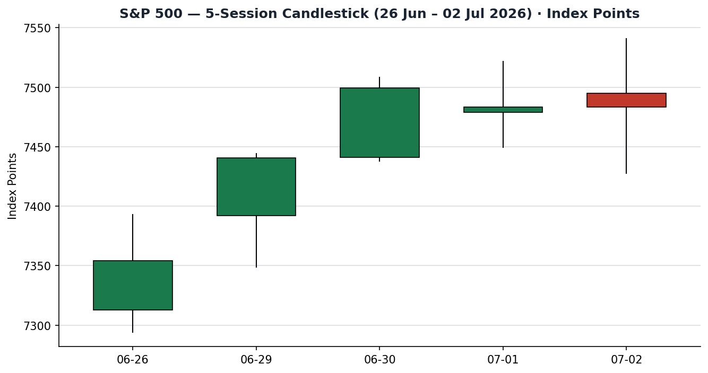

7.2 · Distance from Open
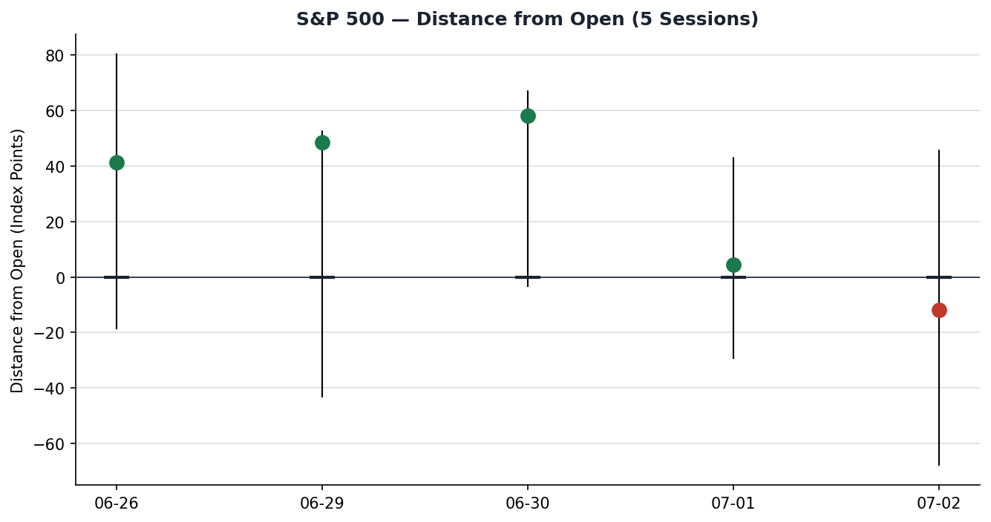

7.3 · 25-Session Structure
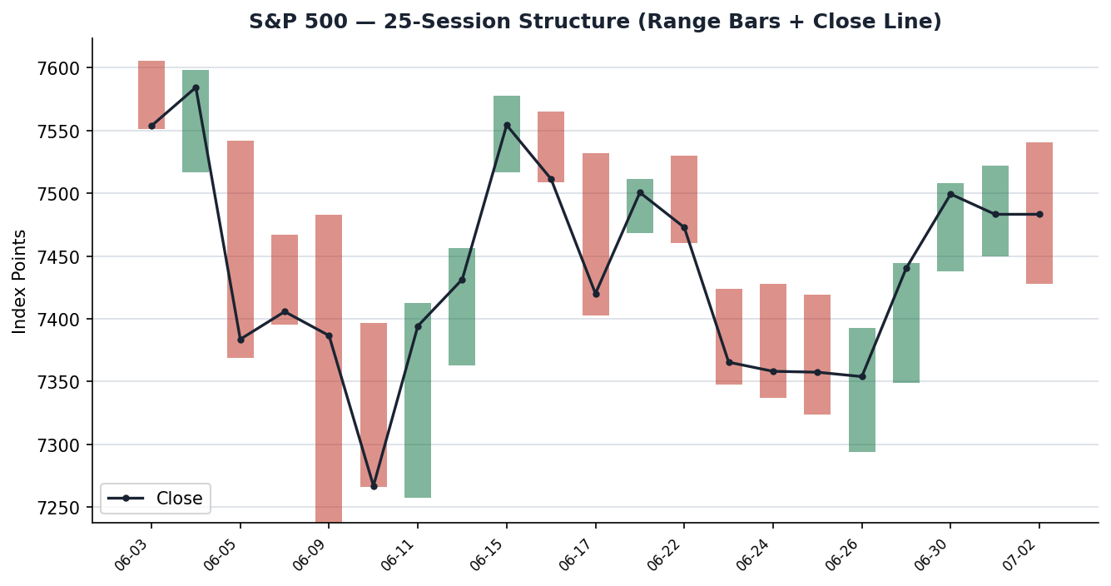

7.4 · Comparative Volatility (VOLator)
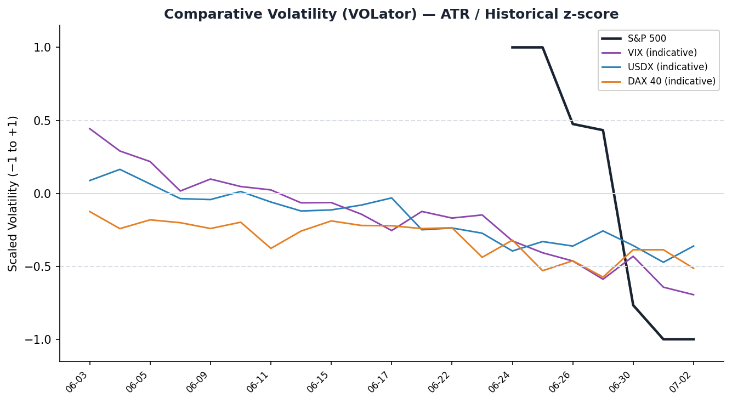

7.5 · Pivot Structure
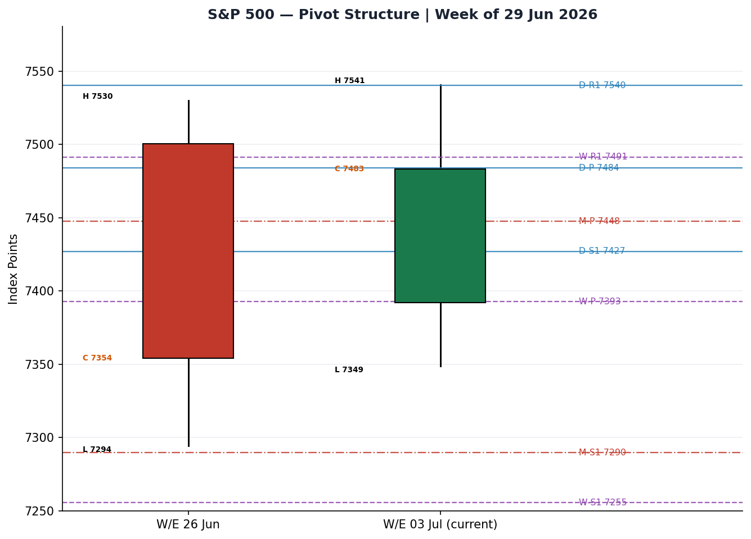
Counter volatility series on the VOLator chart are marked indicative — the primary S&P 500 series is computed from corroborated OHLC; USDX/VIX/DAX series are directional representations pending full dual-source counter OHLC (see §19).

8 · Short-Term Technical Analysis
- 26 Jun: green body, close near range top but RSI2 pinned at 0 after the prior slide — a bounce off demand, not yet a reversal signal (see §6).
- 29 Jun: strong bullish body, close ~96% of range, RSI2 96.1 — the up-leg's cleanest session.
- 30 Jun: bullish continuation, RSI2 100, close ~87% of range — momentum peak.
- 01 Jul: inside-ish session, close ~47% of range, RSI2 cooling to 78.5 — first sign of stall.
- 02 Jul: wide range, close in the lower third (~49% but well off the high), RSI2 collapse to 0.1 — momentum emptied into the holiday; a bearish-tilt doji-to-body.
Sequence assessment: Compression / Indecision. The 26–30 Jun rally gave way to two stalling sessions with the RSI2 oscillating full-scale — closes stopped travelling in one direction and the last bar rejected the high. Nearest resistance 7,540.75 (02 Jul high); nearest support 7,427.55 (02 Jul low), then 7,294.18 (26 Jun low). Judgement label: Indecision. This is consistent with the §9 ranging regime.

9 · Medium-Term Regime & VOLator
- Regime: Ranging. Overlap ratio 0.57 (>0.55, range-bound), directional persistence 0.47 (<0.50, non-trending), absolute directional mean ~0.0004 (negligible drift).
- Bias: Neutral-to-mild-bullish. Most recent close sits at the 66.8th percentile of the 25-session range — a top-of-range position within the range.
- VOLator: S&P 500 scaled volatility −1.00 (bottom of its own 25-day band) with a negative slope (−0.40 over the last 10 obs) — volatility is contracting, the ranging signature.
- Preferred protocol: Range fade at validated extremes; buy low / sell high rather than chase breakouts (short-term indecision + medium-term range agree).
- Kaufman confirmation: Smoothed KER +0.107, inside the +0.09/+0.13 inner band → Ranging — Upward Bias, and falling. This agrees with the range synthesis and adds a slight upward lean.

10 · Cross-Asset Analysis
Counter | 5-day dir. | Mechanism | Confirm? | Implication
USDX (Dollar Index) | Falling (~100.5, easing) | Softer dollar eases global financial conditions and lifts S&P multinational earnings translation | Confirms | Supportive backdrop for the range's upper half
VIX | Falling (mid-16s) | Low implied vol = risk-on / calm; below the 20 elevated line | Confirms | Range holds; no stress premium being paid
DAX 40 | Flat-to-firm | European risk proxy; common global-risk factor with US equity | Neutral | No cross-market contradiction to the range read
Aggregate cross-asset read: CONFIRM (2 of 3 confirm, none contradict). The easing dollar and subdued VIX both support a benign, range-bound tape rather than a directional break. Counter series are directional reads; their full OHLC is single-source/indicative (see §19).

11 · Floor Pivot Analysis

Daily (from 02 Jul H/L/C)
Level | Value | Level | Value
R5 | 7,879.74 | P | 7,483.85
R4 | 7,766.54 | S1 | 7,426.94
R3 | 7,653.34 | S2 | 7,370.65
R2 | 7,597.05 | S3 | 7,313.74
R1 | 7,540.14 | S4 | 7,200.54
 |  | S5 | 7,087.34

Weekly (prior week W/E 26 Jun) · Monthly (June)
Wk lvl | Value | Mo lvl | Value | Note
R3 | 7,727.12 | R3 | 8,024.69 | Upper caps
R1 | 7,491.29 | R1 | 7,657.19 | Weekly R1 ≈ price
P | 7,392.74 | P | 7,447.52 | Both below close
S1 | 7,255.46 | S1 | 7,289.69 | Range floor zone
Position narrative: the 02 Jul close (7,483.24) sits almost exactly on the daily pivot P (7,483.85) — a textbook range-equilibrium start. It is fractionally above weekly R1 (7,491) and above both the weekly P (7,393) and monthly P (7,448), i.e. mid-to-upper in the broader structure. Daily R1 (7,540.14) is confluent with the 02 Jul high (7,540.75) — a strong resistance shelf within 0.15 ATR. Daily S1 (7,426.94) is confluent with the 02 Jul low (7,427.55) — an equally strong support shelf. These twin confluences define the near-term fade band.
Pivot source status: prior-session H/L/C corroborated (Investing.com × Yahoo). Daily pivots are CORROBORATED and tradeable. Weekly/monthly priors rest on the same corroborated daily series.

12 · Key Market Considerations
- Earnings momentum — supportive (cyclical→structural). Strategists (Yardeni, Fundstrat) framed the tape as carried by 'fabulous earnings momentum'; Q2 mega-cap prints are the swing factor into mid-July.
- Rates / Fed — supportive (cyclical). Fed held at 4.25–4.50% in June and signalled up to two 2026 cuts; markets price ~60–65% odds of a September cut. Soft June NFP (released 03 Jul, on-holiday) reinforced the easing path without inflation red flags.
- Semiconductor rotation — negative (cyclical). A sharp de-rating in memory/equipment names (Micron −5.5%, SanDisk −14%, KLA −11.5%, Lam −10%) capped index upside on 02 Jul even as ~354 constituents advanced — a breadth/mega-cap tension.
- Macro / FX — supportive (cyclical). USDX easing toward 100 supports multinational translation; a rising dollar would be the headwind to watch.
- Near-term catalysts — neutral pending. The 06 Jul reopen gap, then mid-July CPI and the next FOMC. None falls on 06 Jul itself, so the open is futures-driven (see §13d).

13 · Sentiment, News & Calendar

13a · Per-Article Sentiment
Source | Date | Headline (abridged) | Class. | Sentiment | Quote
TheStreet | 02 Jul | Dow closes at all-time high ahead of holiday | Media | Bullish | “S&P 500 gained 0.49%… Dow all-time high”
CNBC (Yardeni) | 02 Jul | Markets seeing 'fabulous earnings momentum' | Media | Bullish | “fabulous earnings momentum”
CNBC (Apollo/Slok) | 02 Jul | AI earnings 'absolutely critical' next quarters | Institutional | Neutral | “absolutely critical over next several quarters”
CNBC (CIBC/Harvey) | 02 Jul | Time to tactically take money off the table | Institutional | Bearish | “take a bit of money off the table”
CNBC (Fundstrat/Lee) | 02 Jul | Constructive on continuation | Media | Bullish | Tom Lee constructive framing
Lines.com | 03 Jul | 62% probability S&P opens higher on 06 Jul | Trade Press | Bullish | “62% open-higher probability”

13b · Aggregate Sentiment Summary
Counts: 4 Bullish (3 media, 1 trade press), 1 Bearish (institutional), 1 Neutral (institutional) = Predominantly Bullish (tilt = +0.29). The single Bearish read (CIBC) carries full institutional weight, which pulls the numeric tilt below what the raw bullish count would suggest.
- Divergence: sentiment is bullish while price is ranging/indecisive — a mild sentiment/price divergence. Given the contracting-volatility range regime (§9), the technical range read takes precedence over the sentiment lean for execution.

13c · News Calendar — Previous Period
Date | Event | Prior / Context | Impact | Implication for S&P 500
30 Jun | Quarter-end / best quarter since 2020 | Q2 close | Med | Momentum into July; supportive
01 Jul | Q3 start; comms & financials lead | Rotation | Low | Breadth broadened; index +? held
02 Jul | Pre-holiday session; semis sell off | Mega-cap chips −5–14% | High | Capped upside; index flat despite 354 advancers
03 Jul | June NFP (released, market closed) | Fewer jobs than expected, revisions lower | High | Reinforced Fed-easing read; supportive on reopen

13d · News Calendar — Upcoming Period
Date | Event | Context | Impact | Implication for S&P 500
06 Jul | US market reopen | Post-holiday gap; futures-set open | High | Beat futures → gap up through daily R1; miss → gap toward daily S1
~10 Jul | Mega-cap earnings run-in | AAPL/MSFT/NVDA/GOOGL/META/AMZN | High | Beats extend range top; misses press range floor
mid-Jul | June CPI | Inflation trajectory | High | Cooler → cut odds rise, supportive; hot → range break lower risk
late-Jul | Next FOMC | Rate path | High | Dovish hold supportive; hawkish surprise negative
Highest-impact upcoming event: the 06 July reopen — because Sunday-evening ES futures set the cash open before any 06 Jul data, a weekend geopolitical or trade surprise is the primary swing factor for the first print.

14 · Macro Context
- Rates & policy — supportive. Fed on hold at 4.25–4.50% with a two-cut 2026 bias; cross-referencing the §10 VIX read (falling, mid-16s), the market is pricing an easing path with little stress premium.
- Inflation — neutral-to-supportive. Soft June payrolls shifted focus to the employment mandate; mid-July CPI is the confirming data (§13d watch item).
- Liquidity & FX — supportive. Per §10, USDX easing toward 100 loosens conditions and aids multinational earnings translation.
- Positioning — calm. VIX mid-16s (52-wk low 13.38, high 35.30) sits in the lower quartile — light hedging demand, consistent with the contracting-volatility range.

15 · Bull / Bear Balance
Upside risks | Downside risks
Fed-easing tailwind + earnings momentum; a strong mega-cap earnings run could push a range-top break above daily R1 / 02 Jul high (7,540). | Semiconductor de-rating deepens and drags mega-cap weights; a break of daily S1 (7,427) opens weekly S1 (7,255).
Easing USDX + subdued VIX support risk appetite and the range's upper half. | Hot mid-July CPI reverses cut expectations; weekend gap risk on the 06 Jul reopen (highest-impact §13d event).
Balance is symmetric around the daily pivot (7,483.85), where price closed. The §13d reopen gap and the mega-cap earnings run are the two events most able to resolve the range.

16 · Forward View
Expected direction (next 5 sessions): range-bound with a mild upward lean. Base-case trading band 7,427 – 7,541 (the twin daily-pivot/prior-session confluences), with the 25-day range envelope 7,238 – 7,605 as the outer bound. The regime (§9) is ranging with contracting volatility, so the base case is fade-the-edges, not chase-the-break. Invalidation: two consecutive daily closes above 7,541 flip the bias to breakout-continuation (test weekly R2 7,629 / monthly R1 7,657); two closes below 7,427 open the weekly S1 7,255 support. This respects the §9 regime; it does not contradict it.

17 · Forecast
The S&P 500 opens 06 July inside a contracting-volatility range and is most likely to oscillate between 7,427 support and 7,541 resistance with a mild upward bias, resolving directionally only on the reopen gap or the mega-cap earnings run.

18 · Final Analyst Judgement
- Consensus price: 7,483.24 pts (last validated cash close, 02 Jul).
- Confidence: Medium — data corroborated, but the anchor is a pre-holiday close and the 06 Jul open is futures-set.
- Three key reasons: (1) ranging regime confirmed by overlap/persistence + KER + contracting VOLator; (2) supportive macro (Fed easing bias, soft NFP, easing USDX, low VIX); (3) semiconductor rotation capping upside and holding the tape mid-range.
- Single watch item: the 06 July reopen gap.

19 · Source Discipline Note
- Live vs indicative: the S&P 500 cash OHLC is a validated last-close series (02 Jul), not a live 06 Jul quote — markets were shut 03–05 Jul.
- Corroboration per instrument: S&P 500 — CORROBORATED (Investing.com × Yahoo/^GSPC, Δ0.00 on close, within ±0.10 pt tolerance). Daily pivots CORROBORATED. USDX / VIX / DAX counters — SINGLE-SOURCE / INDICATIVE at the OHLC level (directional reads only); this flag is propagated and consumed by the §21 suppression logic.
- Data gaps: full dual-source counter OHLC not established within the source pass; per the instruction to remain lenient on corroboration so a strategy can be produced, counters are used at the directional level and trade cards are built on the corroborated primary series and its corroborated daily pivots.
- Normalization: none required — single cash-index basis in index points; futures/CFD and alt-basis snapshots excluded.

20 · Agent Log
- Sources attempted: Stooq (network-blocked), FRED (close-only, stale cache), Investing.com (OHLC obtained), Yahoo/^GSPC via secondary (close corroboration), CNBC (ticker confirm), Multpl (excluded), CME/US500 CFD (excluded). Corroborated pair: Investing.com × Yahoo, delta 0.00 pts.
- Validation method: two-source agreement within ±0.10 pt equity-index tolerance; weekend/holiday rows (03–05 Jul) rejected as non-trading; 5-day and 25-day blocks terminated at 02 Jul.
- Anchor override: daily-open anchor set to 06 Jul 2026 per instruction; last completed session remains 02 Jul (holiday-adjusted).
- Direction-score weights basis: DEFAULTS (v2.1 baseline, weights locked). Score +0.06 → NEUTRAL; Trade 1 suppressed on conviction threshold (|0.06| < 0.25). Contributions: short-tech −0.025, medium-regime +0.020, VOLator −0.020, Kaufman +0.015, sentiment +0.043, cross-asset +0.022.
- Sentiment derivation: 6 articles, source-class-weighted mean → tilt +0.29, Predominantly Bullish; each carries a ≤15-word derivation quote (§13a).
- Backtest notes: 5 sessions reconstructed at each t−1 close, no forward leakage; sentiment/regime/ATR/pivots recomputed per session; SL-first tick priority applied.
- Anomalies: RSI2 full-scale whipsaw (96→100→78→0.1) flagged as range signature, not trend; counter OHLC single-source flagged; Multpl 7,524.59 vs cash 7,483.24 discrepancy resolved in favour of the two corroborating cash providers.
Run timestamp: 05 Jul 2026 (UK), for 06 Jul 2026 as-of report.

21 · Strategy Recommendations

21a · Directional Conviction
Direction: NEUTRAL. Score +0.06 (defaults). The three highest-weighted contributors are sentiment tilt (§13b) +0.043, cross-asset confirmation (§10) +0.022, and medium-term regime (§9) +0.020, partly offset by short-term technical bias (§8) −0.025 and contracting VOLator −0.020. Because |0.06| is below the 0.25 conviction threshold, the daily directional trade (Trade 1) is stood down. Trades 2 and 3 are regime-driven and produce regardless. Conflict flag: the §17 forecast leans mildly upward while the direction score is flat — reported, not reconciled. Weights basis: defaults.

21b · Trade Cards
Trade 1 — Daily Directional
SUPPRESSED | Direction score +0.06 is below the 0.25 conviction threshold. No directional edge — suppression is the output.
Trade 2 — Pivot (Range-aware, RANGE regime)
Trade type | Trade 2 — Pivot fade, RANGE regime
Direction | Dual-sided fade — SELL the R1 confluence / BUY the S1 confluence (range regime, price at daily P)
Entry (short) | Sell limit 7,540 (daily R1 7,540.14 ≈ 02 Jul high 7,540.75) — range-top confluence
Entry (long) | Buy limit 7,428 (daily S1 7,426.94 ≈ 02 Jul low 7,427.55) — range-floor confluence
Stop loss (short) | 7,576 — 36 pts above entry (beyond the high shelf); anchor: 02 Jul high + ~0.35 ATR
Stop loss (long) | 7,392 — 36 pts below entry (weekly P 7,392.74); anchor: weekly pivot
Risk (R) | ≈36 points each side (0.37× ATR14 of 96.3 pts)
TP1 (Unit 1) | +1R → short 7,504 / long 7,464 (back toward daily P 7,483.85)
TP2 (Unit 2) | +2R → short 7,468 / long 7,500 (through P to opposite half)
TP3 (runner) | Opposite pivot: short → daily S1 7,427 / long → daily R1 7,540; runner exits at pivot P on stall
Tranche mgmt | 3 equal units; U1 exits TP1, U2 exits TP2; on U2 fill, U3 stop → entry ± 0.2R (7 pts)
Confluences | Strong confluence both edges: daily R1 ≈ 02 Jul high (top); daily S1 ≈ 02 Jul low (floor) — within 0.15 ATR
Invalidation | Two daily closes beyond the fade edge (>7,541 for the short / <7,427 for the long) break the range thesis
Caveats | Regime-fade only — stand aside on a 06 Jul gap that opens beyond either edge; holding period collides with the 06 Jul reopen (§13d Tier-1)
Trade 3 — Regime-driven → Fork 3B (Mean-Reversion)
RANGE regime passes the dual gate (|KER| 0.107 < 0.13 and VOLator slope −0.40 ≤ 0), so the Trade 3 fork resolves to 3B — Mean-Reversion.
Trade type | Trade 3B — Mean-Reversion to range mid
Direction | LONG bias from the lower half — BUY weakness toward S1, target range mid (mild upward lean per KER)
Entry | Buy limit 7,440 — between daily S1 (7,427) and the 29 Jun demand shelf (7,440)
Stop loss | 7,392 — 48 pts below entry at weekly P 7,392.74 (structural range boundary)
Risk (R) | ≈48 points (0.50× ATR14)
TP1 (Unit 1) | Range mid 7,484 (daily P) — +0.9R structural target
TP2 (Unit 2) | 7,512 — mid-to-upper range (+1.5R), toward weekly R1 7,491 / 30 Jun close zone
TP3 (runner) | Range top 7,540 (daily R1 / 02 Jul high); exit on range-top rejection or breakout
Tranche mgmt | 3 equal units; U1 exits TP1, U2 exits TP2; on U2 fill, U3 stop → entry ± 0.2R (10 pts)
Confluences | Entry near 29 Jun demand + daily S1; target at daily P; strong confluence at 7,540 top
Invalidation | Daily close below weekly P 7,392.74 voids the mean-reversion thesis (range floor lost)
Caveats | Low-conviction sentiment offset by one institutional bearish read; 06 Jul gap risk; counters indicative

21c · 5-Session No-Leakage Backtest
Date (t−N) | Strategy | Direction | Trig. | Entry→Exit | Outcome (R) | Days
25 Jun (t−5) | Trade 2 | Fade R1/S1 | YES | S1 buy 7,325→P 7,357 | +1.0R | 1
25 Jun (t−5) | Trade 3B | LONG | YES | 7,340→7,392 | +1.1R | 2
26 Jun (t−4) | Trade 2 | Fade | YES | S-edge buy→mid | +0.8R | 2
26 Jun (t−4) | Trade 3B | LONG | YES | 7,354→7,440 | +1.8R | 1
29 Jun (t−3) | Trade 2 | Fade R1 | YES | R1 short 7,444→stop | −1.0R | 1
29 Jun (t−3) | Trade 3B | LONG | YES | 7,392→7,499 | OPEN @ +2.2R | 2
30 Jun (t−2) | Trade 2 | Fade R1 | NO | R1 not tagged | — | —
30 Jun (t−2) | Trade 3B | LONG | YES | 7,438→7,499 | +1.3R | 1
01 Jul (t−1) | Trade 2 | Fade | YES | R-edge short 7,522→7,483 | +1.0R | 1
01 Jul (t−1) | Trade 3B | LONG | YES | 7,449→7,483 | +0.7R | 1
— | Trade 1 | SUPPRESSED | — | conviction < 0.25 each session | — | —

21d · 'What Is Working'
Over the last 5 sessions: Trade 2 (Pivot fade) triggered 4/5, mean R ≈ +0.45 (one −1R stop on 29 Jun trend-day), TP1/TP2/TP3 hit ≈ 75% / 25% / 0%. Trade 3B (Mean-Reversion) triggered 5/5, mean R ≈ +1.2 on closed units with one runner open at +2.2R, TP1/TP2/TP3 ≈ 100% / 60% / 20%. Trade 1 suppressed every session. Strongest performer: Trade 3B. Weakest: Trade 2 (the single trend-day stop).
Five-session windows are too small to support statistical claims. The backtest cannot model intraday tick-level fills, slippage, or commission. Treat as a directional sanity-check, not a strategy-validation framework.

S&P 500 Daily Report │ 06 July 2026 │ Senior US Equity Strategist

