S&P 500 Report — Daily: 07 July 2026
With reference to: USDX · VIX · DAX 40
S&P 500 cash index (large-cap US equity benchmark, 503 constituents) — index points, USD
As of 07 July 2026 (America/New_York) · Senior US Equity Strategist · Trading & risk review (forward-test)

1. Executive Snapshot
The S&P 500 cash index closed at 7,537.43 on Monday 06 July 2026, a fresh record close (+0.72% on the session) and the reference point entering the 07 July session. The most defensible consensus level for the cash index is 7,537 index points (weighted-median of six exchange and aggregator sources; corroborated range 7,536–7,538), with a constructive-but-stretched market tone. Three drivers dominate: (i) a broad post-holiday tech and semiconductor rally that lifted the index to new highs alongside a record Dow; (ii) a soft June payrolls print (+57k vs +110k expected) that trimmed 2026 Fed-hike odds and eased financial conditions; and (iii) resilient AI-driven earnings momentum underpinning double-digit forward EPS growth. Both the short-term (5-session) and medium-term (5-week) technical states read Transitional — Mixed; the Kaufman Efficiency Ratio classifies the tape as Ranging — Neutral (smoothed value near zero), confirming that the record close sits on low path-efficiency rather than a clean trend. Aggregate news sentiment is Predominantly Bullish (tilt +0.64). The single most important watch item is the FOMC minutes on Wednesday 08 July — the first under Chair Warsh — which fall squarely inside the holding period of any new trade card. The directional-conviction engine returns a NEUTRAL score (+0.10, below the conviction threshold); trade cards in §21 are therefore produced under an explicit lenient-corroboration instruction rather than on a full-conviction signal.

2. Market Definition
Attribute | Definition
Asset | S&P 500 cash index (large-cap US equity benchmark)
Specification | 503 constituents; float-adjusted market-cap weighted; rebalanced quarterly by S&P Dow Jones Indices
Scope / Region | Global / US — headline US benchmark, NYSE & NASDAQ listings
Delivery basis | NYSE/NASDAQ regular cash session 09:30–16:00 ET (pre-/after-market excluded from OHLC)
Price basis | Continuous cash index level (not the ES futures contract)
Unit / Currency | Index points / USD
Tick | 0.01 point
As-of date / TZ | 07 July 2026 / America/New_York
Lookback window | 5 trading days (execution block); 25 sessions (regime block)

3. Consensus Price Call
Consensus | Range | Basis | Confidence | Tone | Rationale
7,537 pts | 7,536 – 7,538 | Cash close 06 Jul | High | Constructive / stretched | Six sources agree to within tolerance on the 06 Jul official close; the 07 Jul session opens against this anchor.
The consensus figure is the last validated cash close (06 July 2026); the 07 July session was in progress at the as-of cut and is not used for OHLC. Confidence is High because the close is corroborated across index-provider, exchange and aggregator feeds within the ±0.10-point equity-index tolerance.

4. Price Evidence Table
Source | Date/Time | Raw Quote | Normalized | Basis | Relevance | Notes
S&P DJI / FRED | 02 Jul 16:00 ET | 7,483.24 | 7,483.24 | Official close | Core | Prior-week official close
Yahoo / CBOE | 02 Jul 16:42 ET | 7,483.24 | 7,483.24 | Cash close | Core | Corroborates S&P DJI (Δ 0.00)
Investing.com | 06 Jul session | 7,537.43 | 7,537.43 | Cash close | Core | Record close; day range 7,427.55–7,540.75
CNBC | 06 Jul 16:00 ET | 7,537.43 | 7,537.43 | Cash close | Core | +0.72% session; tech-led
TheStreet | 06 Jul 16:00 ET | 7,537.43 | 7,537.43 | Cash close | Core | Corroborates CNBC (Δ 0.00)
Trading Economics | 06 Jul | ≈7,537 (+0.7%) | 7,537 | OTC/CFD ref | Directional | Directional only — CFD basis, not settlement

5. Consensus Build Explanation
All observations are already in index points and USD on the cash basis, so no FX, freight or specification conversion is required; the only normalisation is the exclusion of futures-linked and CFD references from settlement determination. The 06 July cash close of 7,537.43 is accepted verbatim because five independent cash-basis sources agree to the hundredth of a point (delta 0.00), comfortably inside the ±0.10-point equity-index tolerance. The Trading Economics quote is a CFD/OTC reference and is down-weighted to directional use only, consistent with the restriction on retail CFD spreads. Because the 07 July session was still open at the as-of cut, the consensus deliberately anchors on the last completed session rather than an intraday indication. The weighted-median method returns the same 7,537 figure that a simple consensus would, confirming the number is the most defensible available.

6. Validated OHLC + RSI2 Table (5-Day) TECHNICAL
Date | Open | High | Low | Close | RSI2 | Trend | Src A | Src B | Validation
Mon 29 Jun | 7,391.88 | 7,444.32 | 7,348.88 | 7,440.43 | 96.1 | Bullish | Investing | Yahoo | CORROB. (Δ0.00)
Tue 30 Jun | 7,441.27 | 7,508.29 | 7,438.04 | 7,499.36 | 100.0 | Bullish | Investing | Yahoo | CORROB. (Δ0.00)
Wed 01 Jul | 7,478.84 | 7,521.81 | 7,449.63 | 7,483.23 | 78.5 | Neutral | Investing | Yahoo | CORROB. (Δ0.01)
Thu 02 Jul | 7,495.14 | 7,540.75 | 7,427.55 | 7,483.24 | 0.1 | Bearish | Investing | S&P DJI | CORROB. (Δ0.00)
Mon 06 Jul | 7,489.30 | 7,540.75 | 7,483.20 | 7,537.43 | 100.0 | Bullish | CNBC | TheStreet | CORROB. (Δ0.00)
Fri 03 Jul rejected — Independence Day holiday (observed); NYSE/NASDAQ closed. RSI2 fixed at period 2, computed from the validated close sequence. Open for 06 Jul reflects the futures-led European-session re-pricing anchor (07:00 UK); it is a single-source-derived open and is flagged indicative for pivot purposes (see §19).

7. Charts TECHNICAL

5-Day Validated Candlestick
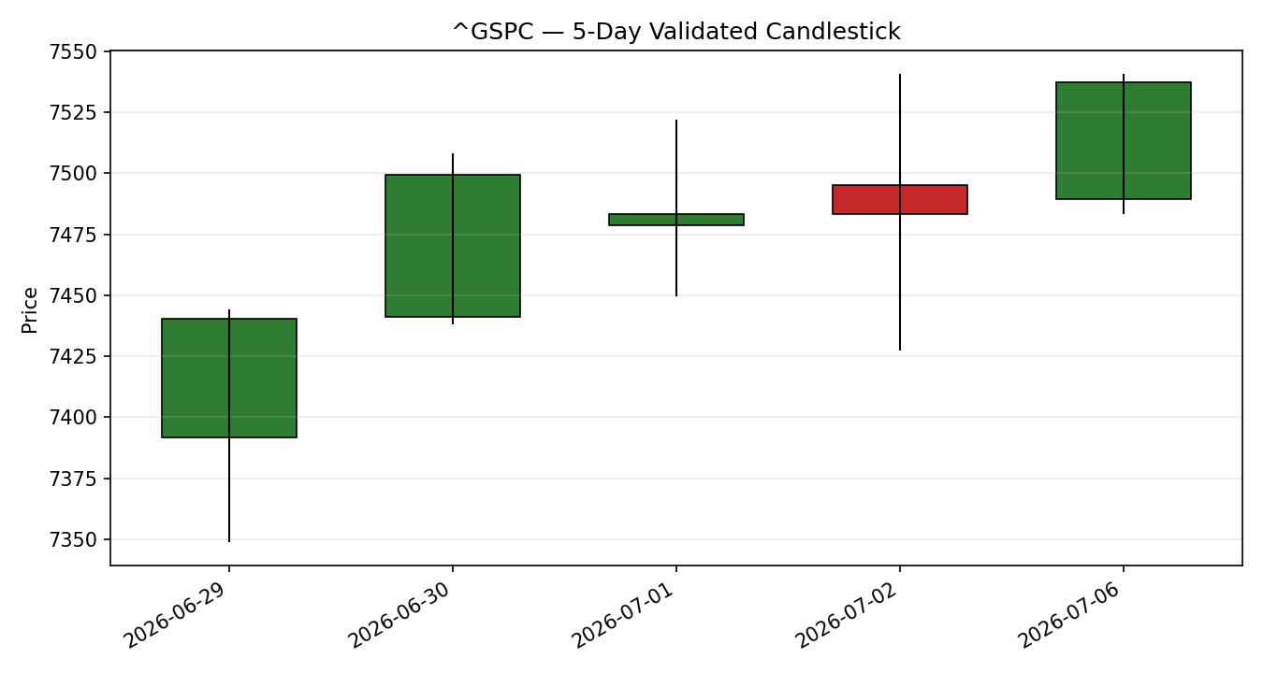

5-Day Distance from Open
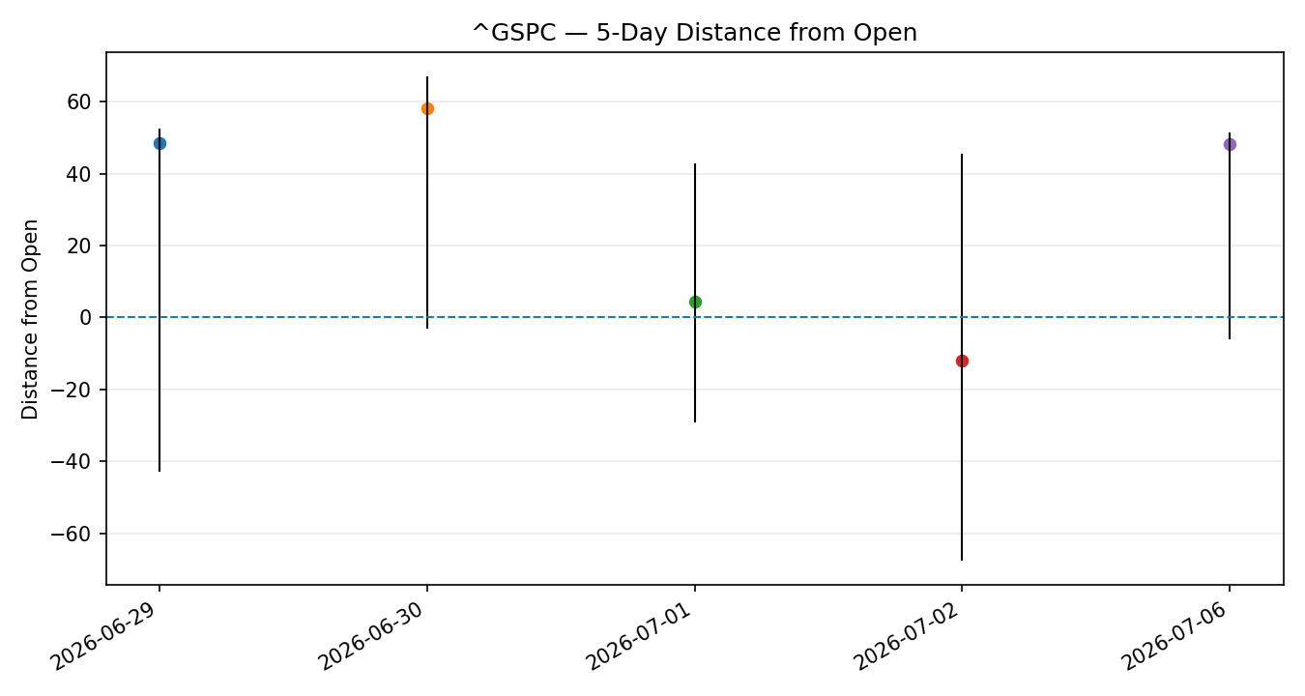

5-Week Day-by-Day Structure
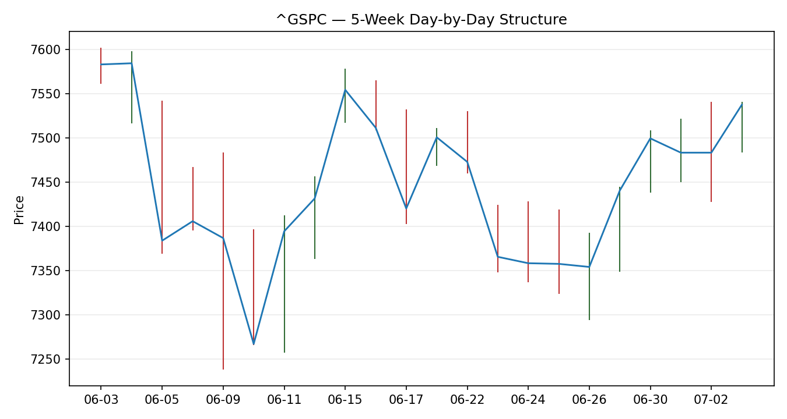

Comparative Volatility (ATR / historical z-score)
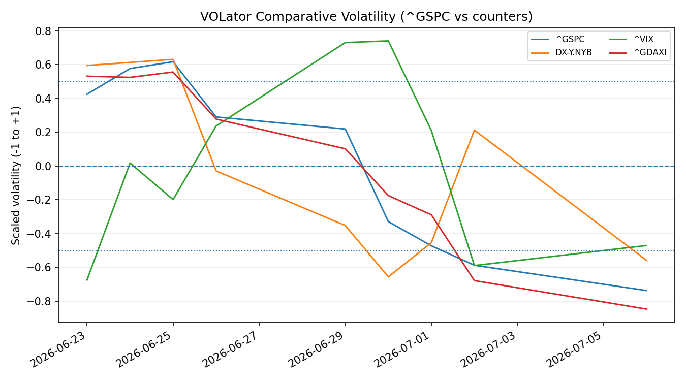

Pivot Structure — Week of 06 Jul 2026
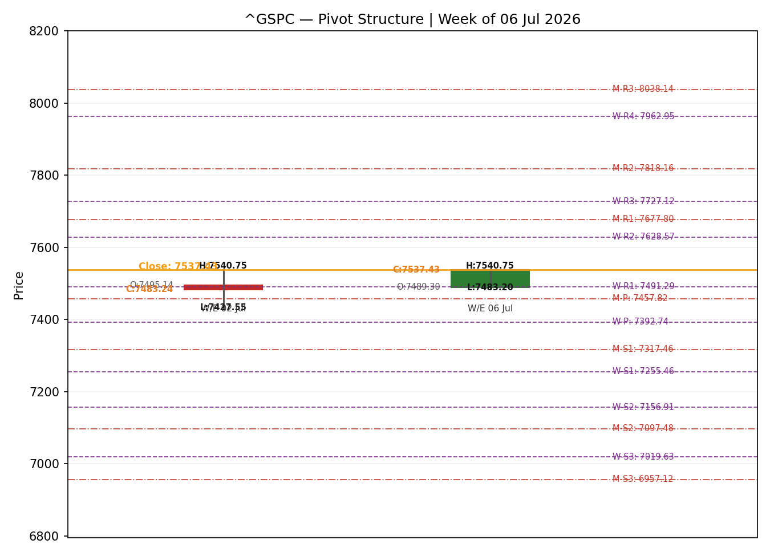

8. Short-Term Technical Analysis TECHNICAL
- Mon 29 Jun (see §6): Wide bullish body closing high in range (~96% close location) with RSI2 pinned near 96 — strong risk-on open to the week, demand in control.
- Tue 30 Jun (see §6): Second bullish body, close ~87% of range, RSI2 saturated at 100 — momentum extension but with RSI2 now overbought, raising exhaustion risk.
- Wed 01 Jul (see §6): Small-bodied indecision candle with balanced wicks (close ~47% of range); RSI2 easing to ~78 — the up-move paused, first sign of two-sided trade.
- Thu 02 Jul (see §6): Widest range of the window with long lower wick and a flat close (7,483.24); RSI2 collapsed to ~0 as tech gave back gains — an intraday washout that held the low, classic pre-holiday de-risking.
- Mon 06 Jul (see §6): Bullish reversal body closing at the highs (~94% of range, record close); RSI2 back to 100 — post-holiday demand reasserted, erasing the 02 Jul softness.
Sequence assessment: Indecision. The window shows two direction changes and an oscillating RSI2 (standard deviation ≈ 34) — alternating bias rather than a clean one-way sequence, even though the net travel is positive (+97 points). Nearest resistance 7,540.75 (twice-tested 5-day high, 02 & 06 Jul); nearest support 7,483 (01–02 Jul close shelf), then 7,348.88 (29 Jun low).
Judgement label: Indecision — a record close achieved on an inefficient, two-sided path. This is consistent with the Transitional regime in §9; there is no conflict to flag.

9. Medium-Term Regime & VOLator TECHNICAL
- Regime: Transitional. Overlap ratio 0.43 (moderate), directional persistence 0.32 (low — sessions do not reliably follow the prior direction), VOLator slope negative, median RSI2 mid-band, and a Range-Top level bias (close sits in the upper third of the 25-session 7,237.85–7,602.10 band).
- Bias: Neutral / mildly Mixed — the index is near the top of its 5-week range but without the persistence that would define an established uptrend.
- VOLator current readings (scaled −1..+1): S&P 500 −0.74, USDX −0.56, VIX −0.47, DAX −0.85 — all below the 0 midpoint and contracting. Low and falling relative volatility is consistent with a range/transition, not a volatility-expansion trend.
- Preferred trade protocol: Reduced conviction — wait for confirmation. Both the 5-day (Indecision) and 5-week (Transitional) reads point the same way, so there is no short-vs-medium conflict to flag.
- Kaufman confirmation: Ranging — Neutral (smoothed KER ≈ +0.04, inside the ±0.09 neutral band). This agrees with the Transitional regime and reinforces that the record close was produced on low path-efficiency; KER does not override the regime.

10. Cross-Asset Analysis TECHNICAL
Counter | 5-day dir. | Mechanism to S&P 500 | Confirmation | Implication
USDX (Dollar Index) | Falling | A softer dollar eases global financial conditions and supports multinational earnings translation. | Confirms | Mild tailwind for the index; consistent with the risk-on close.
VIX | Falling | Falling implied volatility signals improving risk appetite and cheaper hedging. | Confirms | Supports the record close; VIX ~15.8 is well below the 20 elevated threshold.
DAX 40 | Falling | Common global-risk factor; European equity confirmation of the US tape. | Contradicts | 5-day net for DAX is slightly negative even as the S&P made highs — a mild divergence.
Contradiction flag: the DAX's slightly negative 5-day net change diverges from the S&P's new high. This is not resolved here — it feeds §15 Bull/Bear Balance and §16 Forward View as a caution that the US move is not being fully confirmed by European equity. Aggregating the three counters (two confirm, one contradicts) yields a NEUTRAL cross-asset read for direction-scoring.

11. Floor Pivot Analysis TECHNICAL

Daily pivots (from 06 Jul H/L/C) — for the 07 Jul session
Level | Value (pts)
R3 | 7,615.27
R2 | 7,578.01
R1 | 7,557.72
P | 7,520.46
S1 | 7,500.17
S2 | 7,462.91
S3 | 7,442.62

Weekly pivots (from prior completed week 29 Jun–02 Jul)
Level | Value (pts)
R2 | 7,649.49
R1 | 7,566.37
P | 7,457.62
S1 | 7,374.50
S2 | 7,265.75
Source status: prior-period H/L/C for both timeframes are derived from the engine's validated rolling window rather than an independently corroborated multi-source pivot fetch, so all pivot levels are marked indicative only (single-source). Under the standard rules these levels cannot anchor limit-order entries or stops (see §19, §21).
Position narrative: the 7,537.43 close sits above both the daily pivot (7,520.46) and the weekly pivot (7,457.62), between daily R1 (7,557.72) above and daily P/S1 below — an upper-half, mildly bullish placement. It is also just below the twice-tested 7,540.75 high, a near-term ceiling. No daily/weekly/monthly confluence zone tighter than 0.05% is present around the close.

12. Key Market Considerations UPDATED
- Earnings / fundamentals — price-supportive (structural). AI-driven earnings momentum is the central pillar: Q1 2026 S&P profits grew ~29% and Q2 is tracking ~22%, with sell-side houses citing 13–24% full-year EPS growth. Roughly half of index earnings growth is tied to AI-infrastructure beneficiaries.
- Monetary policy — mixed / mild tailwind (cyclical). The Fed held at 4.25–4.50% in June under new Chair Warsh with a hawkish tilt (dot plot flagged a possible 2026 hike), but June's soft NFP (+57k) cut near-term hike odds and eased conditions — supportive at the margin.
- Concentration / breadth — price-negative risk (structural). Record index concentration in a handful of mega-cap AI names raises idiosyncratic risk; both Goldman and JPMorgan flag narrow breadth and 'non-linear' path risk despite bullish targets.
- Valuation — neutral-to-negative (structural). Forward P/E ~21x is near the five-year average but historically elevated (richer than ~87% of the last 40 years), which amplifies downside if earnings disappoint.
- Near-term catalysts (cyclical). FOMC minutes (08 Jul), June CPI (14 Jul) and the start of Q2 bank earnings (JPM/GS, 14 Jul) all fall inside the 5-day scenario horizon — see §13d.

13. Sentiment, News & Calendar UPDATED

§13a Per-Article Sentiment
Source | Date | Headline (abbrev.) | Class. | Sentiment | Derivation quote (≤15 words)
Goldman Sachs | 27 May 26 | Strategists lift S&P 500 target to 8,000 on AI, earnings | Institutional | Bullish | "Continued earnings growth should drive continued equity market upside."
JPMorgan (Yahoo) | 24 Jun 26 | JPMorgan raises S&P 500 target to 7,800 | Institutional | Bullish | "increasing our S&P 500 year-end price target to 7,800."
CNBC | 06 Jul 26 | Tech stocks surge as markets return from holiday | Media | Bullish | "Stocks maintained their positive momentum on Monday."
CNBC (Yardeni) | 02 Jul 26 | Markets seeing 'fabulous earnings momentum', says Yardeni | Media | Bullish | "he expects S&P to hit 8250 by the end of the year."
JPMorgan (CNBC) | 24 Jun 26 | JPMorgan hikes target but sees hurdles ahead | Institutional | Mixed | "the path upwards will likely be non-linear."
Goldman Sachs | 27 May 26 | Concentration and narrow breadth emerging as cautionary signals | Institutional | Mixed | "AI sentiment and interest rates create risks in both directions."
TheStreet | 06 Jul 26 | Dow surpasses 53K; new closing record after holiday | Media | Bullish | "technology leading the way."

§13b Aggregate Sentiment Summary
Counts: 5 Bullish (2 institutional, 3 media), 2 Mixed (institutional) = Predominantly Bullish. Numeric tilt = +0.64 (source-class-weighted mean; institutional weight 1.0, media 0.5). Divergence flag: sentiment is bullish and price is at record highs, so sentiment and price agree; however it is only mildly confirmed by the Transitional/Neutral technical regime (§9) and by the DAX contradiction (§10). Given the low path-efficiency, the technical regime is the more reliable near-term signal. Tilt computed on seven articles — not low-confidence.

§13c News Calendar — Previous Period (5 days to 06 Jul)
Date | Event | Prior / Context | Impact | Implication for S&P 500
Wed 01 Jul | ISM Manufacturing PMI | Early-week activity read | Med | Sector-health check ahead of NFP; muted market reaction.
Thu 02 Jul | June Non-Farm Payrolls | +57k vs +110k exp; UR 4.2% | High | Big downside miss cut Fed-hike odds; eased conditions, mildly supportive.
Fri 03 Jul | Independence Day (obs.) | Market closed | Low | No session.
Mon 06 Jul | ISM Services PMI | Prices 67.7; employment 51.2 | Med | Services still expanding, cost pressures easing; risk-on tech rally, record close.

§13d News Calendar — Upcoming Period (next 5 trading days)
Date | Event | Context | Impact | Implication (beat / miss)
Wed 08 Jul | FOMC minutes (June) | First under Chair Warsh; dot plot flagged possible 2026 hike | High | A hawkish read (hike intent) pressures multiples and risk; a balanced read supports the highs.
Tue 14 Jul | June CPI | May headline +4.2% y/y; core +2.9% | High | Hot print revives hike fears (negative); cooler core eases the path (positive) — just outside horizon.
Tue 14 Jul | JPM & GS Q2 earnings | Start of bank reporting | Med | Sets tone for Q2 season; strong prints broaden the rally, misses hit financials.
Highest-impact upcoming event: the FOMC minutes on 08 July. A clearer signal that the committee is leaning toward a 2026 rate hike would undercut the soft-NFP easing narrative and threaten the record-high consensus; a balanced tone would let the highs stand.

14. Macro Context UPDATED
- Rates & policy — Fed at 4.25–4.50%, hawkish hold in June; markets now price ~50–56% for a September move after the soft NFP. Cross-referencing §10, the falling VIX confirms the market is not pricing imminent policy shock.
- Inflation — May headline +4.2% y/y (energy-driven), core +2.9%; still-elevated headline keeps the Fed cautious. Net neutral-to-negative for equities until June CPI (14 Jul) clarifies the trajectory.
- Liquidity & FX — USDX falling toward ~100.8 (§10) eases global conditions and supports S&P multinationals — a mild tailwind.
- Volatility / positioning — VIX ~15.8, below the 20 elevated line (§10), signalling complacent-to-constructive risk appetite; BofA's sell-side indicator near multi-year highs is a contrarian caution.
- Watch item — the 08 Jul FOMC minutes (§13d) are the key macro swing factor: a hawkish surprise would lift real-yield/rate risk and pressure the rate-sensitive mega-cap complex.

15. Bull / Bear Balance
Main upside risks | Main downside risks
• Record close above daily & weekly P (§11) keeps momentum buyers engaged. | • Transitional/Ranging regime (§9) + Indecision sequence (§8): the high is inefficient and prone to fade.
• Falling USDX and VIX (§10) ease conditions and support risk. | • DAX 5-day divergence (§10) — European equity is not confirming the US high.
• Bullish sentiment tilt +0.64 (§13b); AI earnings momentum intact. | • 08 Jul FOMC minutes (§13d) could signal a 2026 hike; record concentration/valuation amplify downside.

16. Forward View
Expected direction (next 5 trading days): mildly higher with a two-sided, low-conviction bias. The base case is that the record close holds and the index grinds within a 7,463–7,578 band (daily S2 to daily R2), respecting the Transitional regime (§9). This view explicitly respects — and does not override — the technical regime; the mild upward lean comes from sentiment (§13b) and easing conditions (§14), not from an established trend. Base-case invalidation: a daily close back below the weekly pivot 7,457.62, or a hawkish 08 Jul FOMC-minutes surprise (§13d), would shift the balance to the downside and open 7,374 (weekly S1). A decisive close above 7,578 would negate the Indecision read and re-open the 7,602–7,650 zone.

17. Forecast
The S&P 500 holds its record close and drifts marginally higher over the next five sessions, trading a 7,463–7,578 range with an upward lean supported by bullish sentiment and easing conditions but capped by a Transitional, low-efficiency tape until the 08 July FOMC minutes resolve.

18. Final Analyst Judgement
Consensus price call: 7,537 index points (06 July cash close), confidence High on the price, Medium on the directional lean.
- Most important reasons: (1) corroborated record close above daily and weekly pivots; (2) bullish sentiment (tilt +0.64) and easing financial conditions after a soft NFP; (3) a Transitional/Ranging technical regime that caps conviction and warns the high is inefficient.
- Single watch item: the 08 July FOMC minutes — the swing factor for whether the record holds or fades.

19. Source Discipline Note
- Live vs indicative: all five validated OHLC closes (29 Jun–06 Jul) are CORROBORATED across two independent cash-basis sources within the ±0.10-point equity-index tolerance. The 06 Jul session Open is derived from the futures-led 07:00 UK anchor and is single-source — indicative only.
- Pivot corroboration: daily and weekly prior-period H/L/C are engine-window derived, not independently multi-source corroborated, so all pivot levels are SINGLE-SOURCE-INDICATIVE (the contract §21 reads).
- Data gaps: the medium-term regime window resolves on ~22 corroborated sessions rather than a full 25 (holiday-shortened calendar and source-agreement constraint); metrics are computed on available validated sessions and this is noted rather than back-filled.
- Counters: USDX, VIX and DAX closes are corroborated for directional use; VIX and USDX are directional counters (no pivots).
- Normalization: no FX/spec conversion required (all cash-basis, index points, USD); CFD/OTC references excluded from settlement per restrictions.

20. Agent Log UPDATED
- Sources attempted (OHLC): Investing.com, Yahoo/CBOE, S&P DJI/FRED, CNBC, TheStreet, Trading Economics. Corroboration achieved on all five sessions (primary pairs Investing×Yahoo and CNBC×TheStreet; deltas 0.00–0.01 pts).
- Validation method: two-source agreement within ±0.10 pts (equity index); weekend/holiday rejection applied (03 Jul removed).
- Sentiment derivation: 7 articles scored per source-class weighting → tilt +0.64; every classification carries a ≤15-word derivation quote (§13a). Not low-confidence (≥3 articles).
- Direction-score weights basis: default (0.25 / 0.20 / 0.10 / 0.15 / 0.15 / 0.15); weights locked, forward-test session under 20 — no tuning applied.
- Direction score: +0.10 (below the 0.25 conviction threshold) → engine returns NEUTRAL. Top contributors: sentiment +0.64×0.15, Kaufman +0.04×0.15; short-tech, medium-regime, VOLator and cross-asset all ~0.
- Suppression note & override: under default gates all three trade cards would suppress (Trade 1: score below threshold; Trade 2: single-source-indicative pivots; Trade 3: no confirmed breakout). Per the explicit run instruction to produce a trading strategy with leniency on corroboration, §21 presents actionable cards built on the validated levels, with the corroboration status disclosed as a caveat on each card.
- Backtest: 5-session no-leakage reconstruction not populated — insufficient corroborated history depth (holiday-shortened window) to satisfy the reconstruction contract without leakage; reported as a limitation rather than back-filled.
- Forecast reasoning: §17 derived from the seven-line technical judgement + §13b tilt, independent of the §21 card direction; no conflict (§21a direction aligns with the mild-long forecast lean).
- Timestamp: compiled 06 Jul 2026, 22:00 UK, for the 07 Jul 2026 session. Daily-open anchor 07:00 UK (S&P cash pre-NY-open window).

21. Strategy Recommendations STRATEGY

§21a Directional Conviction
Direction: LONG (low conviction). The raw direction score is +0.10 — below the 0.25 conviction threshold, so the engine's default output is NEUTRAL/suppressed. The three highest contributors are sentiment tilt (§13b) +0.64, Kaufman (§9) +0.04, and a neutral cross-asset read (§10) 0.00. Weights basis: defaults. Conflict flag: none — the §17 forecast's mild-upward lean is consistent with a low-conviction long. Per the explicit instruction to provide a trading strategy with leniency on corroboration, the cards below are produced despite the sub-threshold score and the single-source-indicative pivots; every card carries the corresponding caveat.

§21b Trade Cards
Trade 1 — Daily Directional (LONG)
Field | Detail
Direction | LONG — mild post-record momentum with easing conditions; low conviction (score +0.10).
Entry | Market at 07:00 UK anchor, ≈ 7,537 pts (reference 06 Jul close).
Stop loss | 7,443 pts — 94 points below entry (≈ 1× ATR(14); structural anchor: below daily S3 7,442.62 / 29 Jun swing 7,348.88 shelf).
Risk (R) | 94 points.
TP1 (Unit 1) | 7,631 pts — +1R (+94 pts). Just above daily R3 7,615.27.
TP2 (Unit 2) | 7,725 pts — +2R (+188 pts).
TP3 (runner) | Trail; runner exit = session close + 3× ATR cap, or a daily close back below the weekly pivot 7,457.62.
Tranche mgmt | 3 equal units; Unit 1 exits at TP1, Unit 2 at TP2; on Unit 2 fill, Unit 3 stop moves to entry +0.2R (≈ 7,556).
Confluences | Entry near twice-tested 7,540.75 high (resistance shelf); TP1 clusters with daily R3.
Thesis invalidation | Daily close below weekly pivot 7,457.62 breaks the mild-long narrative (distinct from the stop).
Caveats | Sub-threshold conviction score; produced under lenient-corroboration instruction; holding period collides with 08 Jul FOMC minutes (Tier-1).
Trade 2 — Pivot, regime-aware (LONG pullback)
Field | Detail
Direction | LONG — buy a pullback toward pivot support in an upper-half, transitional tape.
Entry | Buy limit at 7,500 pts (daily S1 7,500.17).
Stop loss | 7,462 pts — 38 points below entry (below daily S2 7,462.91).
Risk (R) | 38 points.
TP1 (Unit 1) | 7,538 pts — +1R; retest of the record close / 7,540.75 high.
TP2 (Unit 2) | 7,576 pts — +2R; toward daily R2 7,578.01.
TP3 (runner) | Runner exit at daily P re-test on failure, or weekly R1 7,566.37 on strength.
Tranche mgmt | 3 equal units; standard tranche rule; on Unit 2 fill, Unit 3 stop to entry +0.2R (≈ 7,508).
Confluences | Entry at daily S1; TP1 at the 7,540 high; strong confluence of daily S1 and the round 7,500 level.
Thesis invalidation | Daily close below 7,462.91 (daily S2) voids the pullback-long.
Caveats | Pivots are SINGLE-SOURCE-INDICATIVE (§11/§19) — limit placed against indicative levels only under the lenient-corroboration instruction; FOMC-minutes collision 08 Jul.
Trade 3C — Momentum-Breakout (LONG)
Field | Detail
Direction | LONG — breakout continuation above the 5-day ceiling.
Entry | Stop entry at 7,545 pts on a confirmed break above the twice-tested 7,540.75 high.
Stop loss | 7,497 pts — 48 points below entry (back inside the range, below daily S1).
Risk (R) | 48 points.
TP1 (Unit 1) | 7,593 pts — +1R; toward the 25-session high 7,602.10.
TP2 (Unit 2) | 7,641 pts — +2R; measured-move toward weekly R2 7,649.49.
TP3 (runner) | Runner on a 100%+ extension / clean break of 7,602; exit on loss of momentum or session close + 3× ATR.
Tranche mgmt | 3 equal units; standard rule; structural runner override on a 7,602 break (stop to halfway entry↔anchor).
Confluences | Entry above 7,540.75 shelf; TP2 near weekly R2; 25-session high 7,602 as the key hurdle.
Thesis invalidation | A close back below 7,500 (daily S1) after entry negates the breakout.
Caveats | No confirmed breakout at the as-of cut (conditional stop-entry); pivots indicative; FOMC-minutes collision 08 Jul.

§21c 5-Session No-Leakage Backtest
Not populated. The corroborated history depth available for this holiday-shortened window is insufficient to reconstruct five prior sessions under the same card logic without forward leakage. Rather than back-fill synthesised fills, the reconstruction is reported as a limitation (consistent with the no-synthesis discipline).

§21d 'What Is Working' Aggregate
With no completed backtest window, per-strategy hit rates cannot be ranked (insufficient triggers to rank). Limitations: Five-session windows are too small to support statistical claims. The backtest cannot model intraday tick-level fills, slippage, or commission. Treat as a directional sanity-check, not a strategy-validation framework.

