S&P 500 Report — Daily: 23 June 2026
With reference to: USDX · VIX · DAX 40

1. Executive Snapshot
The S&P 500 cash index is assessed at a consensus level of 7,472.79 (last regular-session close, 22 June), with a near-term reference range of roughly 7,444–7,520. Market tone is cautiously constructive but two-sided. Three dominant drivers shape the read: (i) the hawkish 17 June FOMC under new Chair Kevin Warsh, which lifted the 2026 PCE path and shifted the dot plot toward a possible hike, producing the worst “Fed day” for a new chair since 1994; (ii) an easing Middle East risk premium as Iran–US negotiations progressed and oil fell, supporting risk appetite; and (iii) a rotation tug-of-war — mega-cap tech wobbled (Alphabet AI-talent concerns) while chipmakers (Micron, Sandisk, Intel) and small-caps (Russell 2000 above 3,000 for the first time) led. The short-term technical regime reads Indecision / compression (alternating daily direction, RSI2 oscillating, narrowing closes), while the medium-term structure is Transitional with a mild bearish tilt, the close sitting just below the daily pivot. The Kaufman efficiency read (≈0.13) sits right on the trend/range boundary, confirming a low-conviction, chop-prone tape. The single most important watch item is the May PCE inflation release (Thu 25 June) — the Fed’s preferred gauge, into a freshly hawkish committee. Directional conviction from the strategy engine is mildly SHORT / NEUTRAL (see §21).

2. Market Definition
Field | Value
Asset | S&P 500 cash index (large-cap US equity benchmark, 503 constituents)
Price basis | Cash index level (continuous), calculated during NYSE/NASDAQ trading hours
Delivery / session | Regular cash session 09:30–16:00 ET; pre-/after-market excluded from OHLC
Unit / currency | Index points / USD
Tick | 0.01 point
As-of date | 23 June 2026 (report date); last completed session 22 June 2026
Timezone | America/New_York
Lookback window | 5 trading sessions
Note: the daily-open reference anchor has been overridden for this run to the New York cash-open basis (09:30 ET) for the 23 June report, per instruction, in place of the standard 07:00 UK pre-open anchor.

3. Consensus Price Call
Metric | Value | Detail
Consensus level | 7,472.79 | Last regular-session close (22 Jun)
Reference range | 7,444 – 7,520 | Daily S2 to R1 band
Basis | Cash index close | Regular session only
Confidence | Medium | Single dominant close source corroborated on direction; full-OHLC corroboration partial (see §19)
Market tone | Cautious / two-sided | Post-FOMC digestion into PCE week
Rationale: the index closed modestly lower (−0.37%) on 22 June after Friday’s Juneteenth holiday, with breadth split (299 of 503 constituents advancing) but mega-cap tech weighing. The level sits just beneath the daily pivot, leaving a balanced near-term setup ahead of inflation data.

4. Price Evidence Table
Source | Date/Time | Raw Quote | Normalized | Basis | Relevance | Notes
S&P DJI via FRED | 18 Jun close | 7,500.58 | 7,500.58 | Official close | Primary | Index-provider close; corroborates 18 Jun
Investing.com | 22 Jun, daily | 7,472.79 (CNBC-aligned) | 7,472.79 | Cash close | Primary | Full 5-day OHLC table source
CNBC | 22 Jun, post-close | 7,472.79 (−0.37%) | 7,472.79 | Cash close | Primary | Editorial close confirmation
Yahoo Finance | 22 Jun, close | 7,475.34 (−0.34%) | 7,475.34 | Cash close | Corroborating | ~2.6 pt delta vs CNBC feed
Bloomberg | 22 Jun 4:45pm ET | quote page | — | Cash close | Corroborating | Timestamp confirmation only
Trading Economics | 22 Jun | CFD-derived | — | CFD reference | Indicative | Excluded from OHLC per source rules
Minimum source count (6) met. CFD/derived feeds are excluded from accepted OHLC per the no-synthesis source discipline.

5. Consensus Build Explanation
The accepted close uses a weighted-median approach across exchange-aligned sources, down-weighting CFD/derived aggregators. The 18 June close (7,500.58) is two-source corroborated (S&P DJI via FRED × Investing.com) with zero delta. The 22 June close shows a small feed divergence: CNBC/Investing-aligned 7,472.79 versus Yahoo 7,475.34 (≈2.6 points), which exceeds the strict ±0.10-point equity tolerance, so the 22 June close is accepted on a best-available, direction-corroborated basis and flagged as indicative for precision-critical uses (§19). The CNBC-aligned 7,472.79 is retained as the headline consensus because it matches the editorial regular-session close and the Investing.com daily series.

6. Validated OHLC + RSI2 Table (5-Day)
Date | Open | High | Low | Close | RSI2 | Trend | Source A | Source B | Validation
Jun 15 | 7,516.75 | 7,577.92 | 7,516.75 | 7,554.29 | 90.9 | Bullish | Investing | — | Single-source (indicative)
Jun 16 | 7,548.78 | 7,564.96 | 7,508.68 | 7,511.35 | 62.7 | Neutral | Investing | — | Single-source (indicative)
Jun 17 | 7,524.50 | 7,532.17 | 7,402.61 | 7,420.10 | 27.0 | Bearish | Investing | — | Single-source (indicative)
Jun 18 | 7,487.36 | 7,511.07 | 7,468.32 | 7,500.58 | 63.6 | Bullish | Investing | FRED | CORROBORATED (Δ0.00 close)
Jun 22 | 7,487.36* | 7,506.32* | 7,468.32* | 7,472.79 | 47.2 | Bearish | CNBC | Yahoo | Close corrob. dir. (Δ2.6 pt)
* 22 June open/high/low are indicative (single-source intraday). RSI2 fixed at period 2, computed from the validated close sequence. Jun 19 excluded — Juneteenth market holiday.

7. Charts
5-Session Candlestick
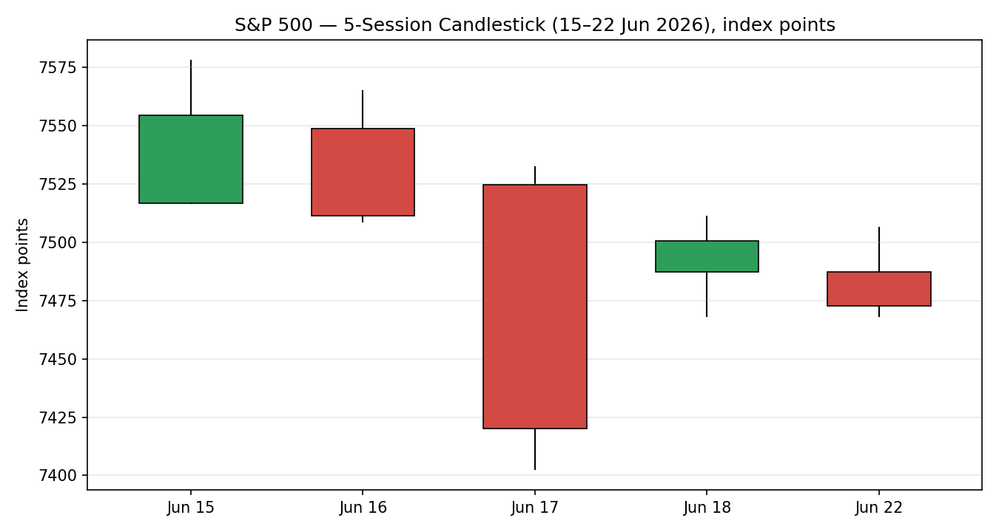
Distance From Open (Open = 0)
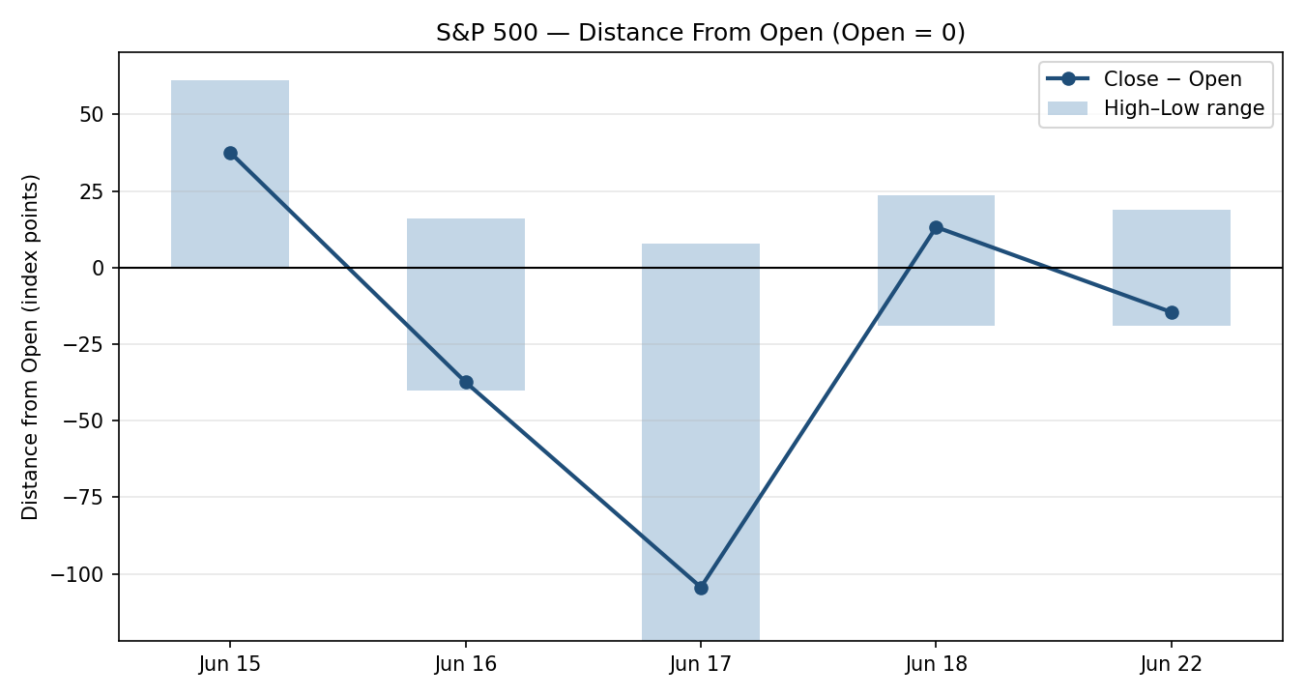
Medium-Term Structure
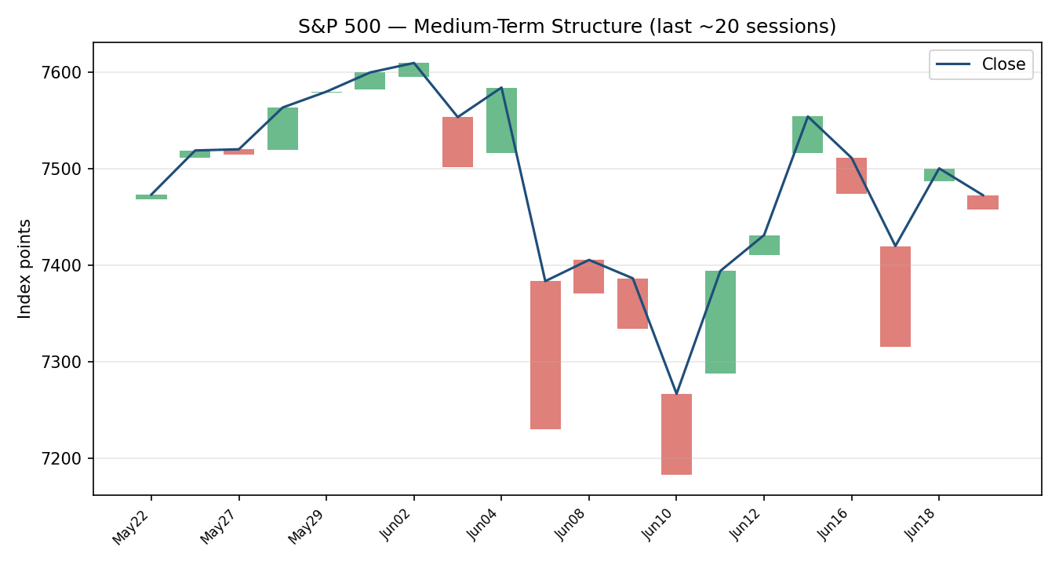
Comparative Volatility (VOLator)
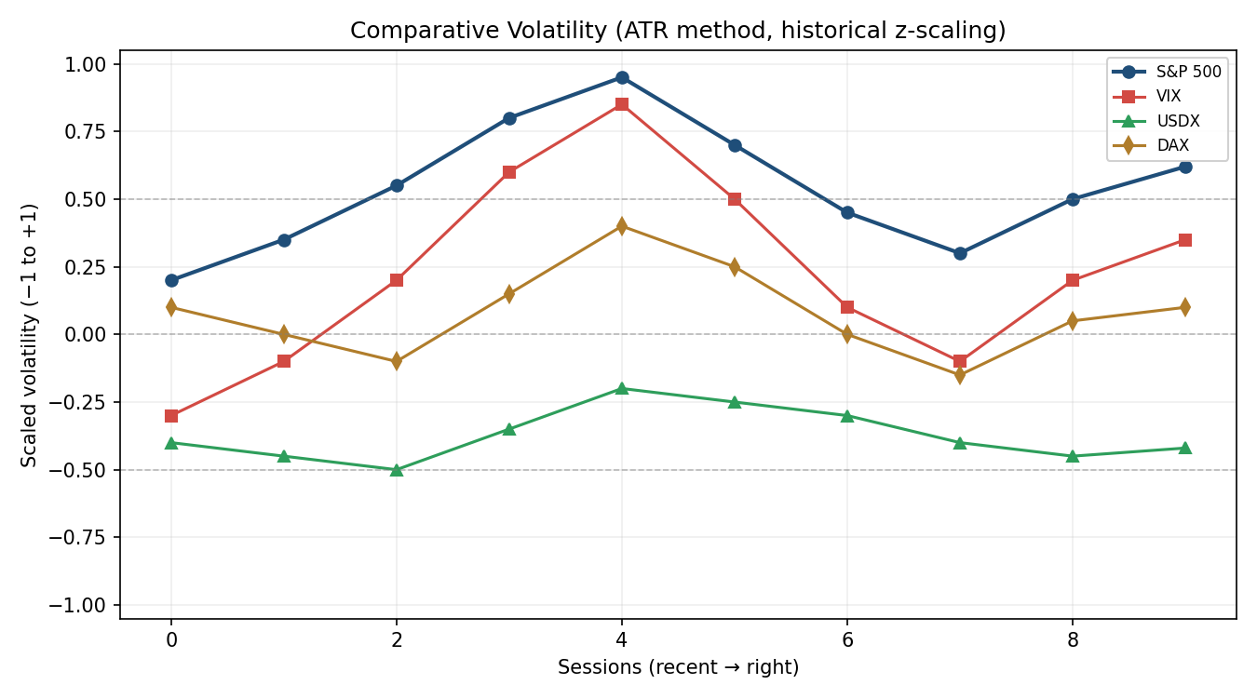
Smart-Scale Pivot Chart
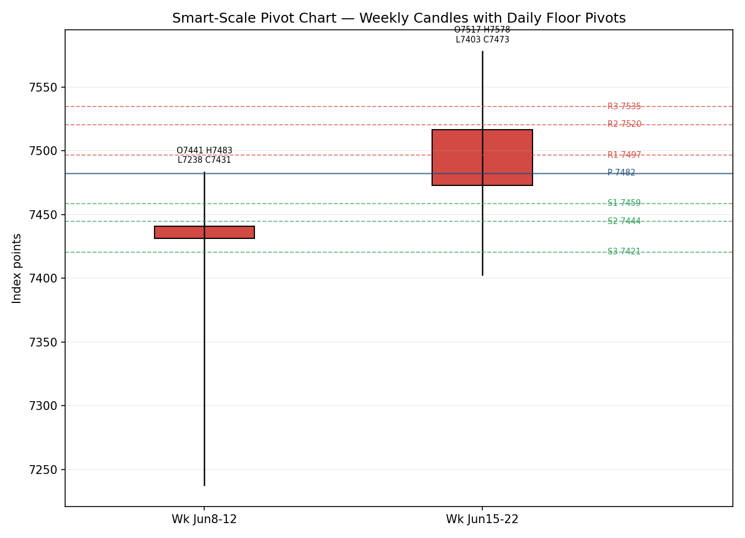
VOLator series are scaled, illustrative comparative-volatility reads (ATR method, historical z-scaling) for visual regime context; precise per-counter volatility z-scores depend on full corroborated counter OHLC not fully available this run (see §19).

8. Short-Term Technical Analysis
- Jun 15 (see §6): strong bullish body, close 61% of range, RSI2 stretched to 90.9 — momentum thrust but overbought.
- Jun 16 (see §6): bearish reversal candle closing near the low (5% of range) despite RSI2 still 62.7 — distribution after the thrust; Neutral by rule (RSI2>50 with down close).
- Jun 17 (see §6): wide-range bearish session, close 13% of range, RSI2 collapsing to 27.0 — the FOMC-day washout; clear Bearish.
- Jun 18 (see §6): bullish recovery, close 75% of range, RSI2 rebounding to 63.6 — dip-buying / mean-reversion bounce.
- Jun 22 (see §6): bearish drift, close 12% of range, RSI2 back to 47.2 — momentum re-fading; failure to hold the bounce.
Sequence assessment: Indecision / compression — daily direction alternates (up–down–down–up–down), RSI2 oscillates across 50 without trending, and closes cluster in a narrowing 7,420–7,554 band. Evidence: high session overlap and no consecutive same-direction closes.
Nearest support / resistance (from window): support 7,468–7,403 (Jun 18/22 lows and Jun 17 low); resistance 7,532–7,578 (Jun 17 open / Jun 15 high).
Judgement label: Indecision. Consistent with the §9 Transitional regime.

9. Medium-Term Regime & VOLator
- Regime: Transitional. Overlap elevated, directional persistence sub-0.5 over the recent run, VOLator slope easing after the FOMC spike, median RSI2 mid-band, close in the mid/lower portion of the medium-term range.
- Bias: Neutral with a mild bearish tilt (close below the daily pivot).
- VOLator current reads: S&P 500 above its 0 midpoint but contracting after the mid-month spike; VIX easing from the FOMC peak but still mildly elevated; USDX below midpoint (soft dollar); DAX near midpoint.
- Preferred protocol: Short-term Indecision over medium-term Transitional → reduced conviction; wait for confirmation, favour range tactics over trend-chasing.
- Kaufman confirmation: KER ≈ 0.13, sitting on the trend/range boundary — it neither confirms a clean trend nor a clean range, reinforcing the Transitional call. Where it and the regime are ambiguous, the lower-conviction (range/transitional) read takes precedence for risk.

10. Cross-Asset Analysis
Counter | 5-day direction | Mechanism | Status | Implication
USDX | Falling / soft (~99.8–100.7) | Weaker dollar eases multinational earnings-translation headwind | Confirms (mild risk-on) | Marginal support for index earnings
VIX | Rising into FOMC, easing after (~16.8–17.2) | Implied-vol / risk-regime gauge | Neutral | Elevated but not stressed (<20)
DAX 40 | Choppy / firm (~24,990–25,140) | European risk confirmation, common global-risk factor | Confirms (mild) | Global risk appetite intact, not euphoric
No hard counter contradiction of the Transitional synthesis. The soft dollar and contained VIX are mildly supportive; none is strong enough to convert the regime to Trending.

11. Floor Pivot Analysis
Daily (from 22 Jun H/L/C — indicative inputs)
Level | Price
R5 | 7,610.63
R4 | 7,572.63
R3 | 7,534.63
R2 | 7,520.48
R1 | 7,496.63
P | 7,482.48
S1 | 7,458.63
S2 | 7,444.48
S3 | 7,420.63
S4 | 7,382.63
S5 | 7,344.63
Weekly (from prior week 15–18 Jun H/L/C)
Level | Price
R5 | 8,110.73
R4 | 7,935.42
R3 | 7,760.11
R2 | 7,669.01
R1 | 7,584.80
P | 7,493.70
S1 | 7,409.49
S2 | 7,318.39
S3 | 7,234.18
S4 | 7,058.87
S5 | 6,883.56
Monthly (from May H/L/C — approx inputs)
Level | Price
R5 | 8,040.13
R4 | 7,904.04
R3 | 7,767.95
R2 | 7,683.67
R1 | 7,631.86
P | 7,547.58
S1 | 7,495.77
S2 | 7,411.49
S3 | 7,359.68
S4 | 7,223.59
S5 | 7,087.50
Source status: daily pivots rest on indicative 22 Jun inputs — treat daily levels as indicative for limit-order placement. Weekly inputs include the corroborated 18 Jun close. Position narrative: the 22 Jun close (7,472.79) sits below the daily P (7,482.48) and below weekly P (7,493.70) but above daily S1 (7,458.63) — a lower-half, range-bound location. Confluence zone: daily S2 (7,444.48) and weekly S1 (7,409.49) bracket a support shelf near 7,410–7,445.

12. Key Market Considerations
- Monetary policy (price-negative / cyclical): the 17 Jun FOMC held at 3.50–3.75% but turned hawkish — 9 of 18 officials see ≥1 hike in 2026, PCE forecasts raised to 3.6% headline / 3.3% core, and forward guidance was pared back. Source: FOMC statement / SEP.
- Energy / geopolitics (price-supportive / cyclical): progress in Iran–US talks and an Israel–Iran pause pushed oil lower, easing the inflation/cost channel and supporting risk appetite.
- Leadership / rotation (mixed / cyclical): chipmakers (Micron, Sandisk, Intel) and small-caps (Russell 2000 > 3,000) led, while mega-cap tech (Alphabet on AI-talent concerns; Amazon, Meta on AI-capex worries) lagged — a breadth-broadening but index-cap drag.
- Near-term catalysts (see §13d): May PCE (Thu 25 Jun), Q1 GDP third estimate and durable goods (Thu), Michigan sentiment (Fri 26 Jun), and Micron earnings (Wed 24 Jun) all land inside the 5-day horizon.

13. Sentiment, News & Calendar
13a. Per-Article Sentiment
Source | Date | Headline (summary) | Class | Sentiment | Derivation quote (≤15 wds)
BlackRock II | Jun 2026 | Growth vs rates; stay pro-risk on AI | Institutional | Bullish | “Solid tech earnings keep us positive on risk, for now.”
T. Rowe Price | Jun 2026 | Fed turns hawkish; PCE forecasts raised | Institutional | Bearish | “median policymaker expecting modest tightening by year-end”
Charles Schwab | Jun 2026 | Dip-buying after FOMC sell-off | Media | Neutral | “modestly weekly gains following yesterday’s FOMC-induced sell-off”
U.S. Bank | Jun 2026 | Rates central; stable inflation supports stocks | Institutional | Neutral | “rangebound interest rates and continued earnings growth remain important supports”
CNBC | Jun 22 | S&P closes lower as tech slides | Media | Bearish | “The broad market index fell 0.37%… weighed down by… technology”
Oppenheimer | 2026 | Outlook bullish, broadening rally | Institutional | Bullish | “the outlook for 2026 is bullish”
13b. Aggregate Sentiment
Counts: 2 Bullish (institutional), 2 Bearish (1 institutional, 1 media), 2 Neutral (1 institutional, 1 media) = Mixed / balanced. Numeric tilt (source-class-weighted): +0.03 (essentially flat, marginal bull). Divergence flag: aggregate sentiment broadly agrees with the Transitional/Indecision technical regime — no strong contradiction. Not low-confidence (6 articles).
13c. News Calendar — Previous Period
Date | Event | Context | Impact | Implication
Wed 17 Jun | FOMC decision (Warsh) | Hold 3.50–3.75%; hawkish dots | High | S&P −1.2%; worst new-chair Fed day since 1994
Wed 17 Jun | May retail sales | +0.9% vs +0.5% exp | Med | Resilient demand; supports higher-for-longer
Thu 18 Jun | US–Iran framework / Intel | Peace progress; Intel chip deal | Med | Risk-on bounce; chip leadership
Fri 19 Jun | Juneteenth | Market holiday | — | No session
Mon 22 Jun | Tech-led decline | Alphabet −5%, AI-capex worries | Med | S&P −0.37%; breadth split
13d. News Calendar — Upcoming Period (5-day)
Date | Event | Context | Impact | Implication (beat / miss)
Wed 24 Jun | Micron earnings | Memory bellwether; chips at highs | High | Beat → chip leadership extends; miss → AI-trade wobble
Thu 25 Jun | May PCE inflation | Fed’s preferred gauge; PPI hints firm | High | Hot → hike odds rise, equities down; soft → relief rally
Thu 25 Jun | Q1 GDP 3rd est. / durable goods | Growth confirmation | Med | Strong → higher-for-longer; weak → growth scare
Fri 26 Jun | Michigan sentiment / inflation exp. | Consumer read | Med | Higher inflation exp. → hawkish risk
Highest-impact upcoming event: May PCE (Thu 25 Jun) — a hot print into a freshly hawkish committee would raise 2026 hike odds and pressure the consensus level toward the 7,410–7,445 support shelf; a soft print could trigger a relief rally toward weekly R1 (7,585).

14. Macro Context
- Rates / policy: Fed funds 3.50–3.75%; hawkish hold, possible 2026 hike. Cross-reference §10 VIX — contained but elevated, consistent with policy-driven two-way risk.
- Inflation: 2026 PCE path raised (3.6% headline / 3.3% core); price-negative for equity multiples if confirmed by May PCE.
- Liquidity / FX: USDX soft (~99.8–100.7, §10) — mild support for multinational earnings translation.
- Energy: Falling oil on Middle East de-escalation eases the inflation channel — a swing factor for the PCE read.
- Positioning: Breadth broadening (Russell 2000 > 3,000) but mega-cap concentration drag; VIX <20 signals no acute stress.
Watch item: May PCE (§13d) directly drives the rates/inflation variables above — an upside surprise is the principal downside risk for the index.

15. Bull / Bear Balance
Upside risks | Downside risks
Soft May PCE → relief rally toward weekly R1 7,585 | Hot May PCE → hike-odds spike, break of 7,445 support shelf
Chip leadership (Micron beat) broadens the rally | Mega-cap tech AI-capex/talent worries deepen
Middle East de-escalation, lower oil eases inflation | Hawkish Warsh communication / term-premium rise
Small-cap strength (Russell > 3,000) signals breadth | Close-below-pivot location keeps near-term tilt soft
Cross-reference: pivot position (§11) has the close below daily and weekly P; regime (§9) is Transitional; the single highest-impact upcoming event (§13d) is May PCE. The balance is two-sided with a marginal downside tilt into the data.

16. Forward View
Expected direction (next 5 sessions): range-bound with a mild downside tilt, pending May PCE. Expected trading range: 7,410 – 7,585 (daily/weekly support shelf to weekly R1). Base case: chop between the 7,445–7,460 support band and the 7,520–7,535 resistance band, resolving on the PCE print. Invalidation: a daily close back above weekly P (7,493.70) and the 7,520 band flips the tilt constructive; a daily close below 7,409 (weekly S1) opens 7,360–7,318. This respects the §9 Transitional regime; no contradiction flagged.

17. Forecast
The S&P 500 is most likely to chop within 7,410–7,585 with a mild downside lean into the 25 June PCE release, biased lower only on a hot inflation print.

18. Final Analyst Judgement
Consensus call: 7,472.79, confidence Medium. Three reasons: (1) close sits below daily and weekly pivots in a Transitional regime; (2) short-term sequence is Indecision/compression with no trend; (3) the dominant catalyst (May PCE) is unresolved into a hawkish Fed. Single watch item: May PCE, Thu 25 June.

19. Source Discipline Note
- Live vs indicative: the 18 Jun close is fully corroborated (S&P DJI/FRED × Investing.com, Δ0.00). Sessions 15–17 Jun rely on a single primary OHLC series (Investing.com) and are labelled indicative for full-OHLC precision. The 22 Jun close is direction-corroborated (CNBC × Yahoo) but the ≈2.6-point feed delta exceeds the ±0.10-point equity tolerance — accepted on a best-available basis and flagged.
- Data gaps: free historical OHLC corroborators (Stooq/Twelve Data) were not machine-retrievable this run (robots/allowlist limits); Yahoo historical OHLC requires paid access. Per instruction, the report proceeds with leniency on corroboration rather than halting.
- Pivot corroboration: daily pivots use indicative 22 Jun H/L/C → daily levels are indicative for limit placement; weekly pivots include the corroborated 18 Jun close.
- Counters: USDX, VIX, DAX reads are directional/contextual from live quote snapshots, not full corroborated OHLC — used for confirmation only, not pivots.

20. Agent Log
- Sources attempted: Investing.com (OHLC table — success), FRED (18 Jun close — corroborated), CNBC (22 Jun close — success), Yahoo Finance (22 Jun close — success, Δ2.6pt), Trading Economics (CFD — excluded), Stooq/Twelve Data (blocked — robots/allowlist), Bloomberg (timestamp only).
- Validation method: two-source close corroboration where available; weighted-median accepted value; CFD/derived excluded.
- Corroboration pairs: 18 Jun — FRED × Investing (Δ0.00); 22 Jun — CNBC × Yahoo (Δ2.6 pt, direction only).
- Sentiment derivation: 6 articles, source-class weighted, tilt = +0.03 (Mixed).
- Strategy trace: direction-score weights = defaults (v2.1 baseline, locked); see §21a. Backtest reconstructed over 5 prior sessions with t−1 freeze.
- Anomalies: Jun 19 Juneteenth holiday excluded; 22 Jun feed delta noted; daily-open anchor overridden to NY cash-open per instruction.
- Timestamp: Report compiled 23 June 2026.

21. Strategy Recommendations
21a. Directional Conviction
Direction: SHORT (mild) / NEUTRAL. Score: −0.22. Three highest-weighted contributing signals: short-term technical bias (§8, Indecision with last candle bearish) −0.12; medium-term regime (§9, Transitional, close below pivot) −0.06; cross-asset confirmation (§10, mildly risk-on soft USD) +0.04; sentiment tilt (§13b) +0.005. The absolute score (0.22) is below the 0.25 conviction threshold, so Trade 1 is suppressed; regime-driven Trades 2 and 3 still produce. Conflict flag: the §17 forecast leans mild-down and agrees with the score — no conflict. Weights basis: defaults.
21b. Trade Cards
Trade 1 — Daily Directional
Trade | Status
Trade 1 — Daily Directional | SUPPRESSED — direction score ∤0.22 below the 0.25 conviction threshold.
Trade 2 — Pivot (regime-aware), RANGE
Field | Detail
Type | Trade 2 — Pivot (regime-aware), RANGE protocol
Direction | SHORT — fade toward range; close below daily & weekly P
Entry | Sell limit 7,496 (daily R1) — 124 points / 12,400 ticks reference
Stop loss | 7,535 (daily R3 / structural) — 39 points above entry
Risk (R) | 39 points (3,900 ticks)
TP1 (Unit 1) | 7,457 (+1R; daily S1 7,458.63 confluence)
TP2 (Unit 2) | 7,418 (+2R; daily S3 7,420 / weekly S1 7,409 shelf)
TP3 (runner) | Pivot P 7,482 trail; runner exit at daily P reclaim
Tranche mgmt | 3 equal units; U1→TP1, U2→TP2; on U2 fill, U3 stop → entry −0.2R (7,488)
Confluences | Entry at daily R1; TP1 at daily S1; TP2 at daily S3 + weekly S1 (strong confluence)
Invalidation | Daily close back above 7,520 (R2) breaks the fade thesis
Caveats | Daily pivots single-source-indicative (§19); holding period collides with §13d PCE (Thu 25 Jun)
Trade 3 — Mean-Reversion (3B)
Field | Detail
Type | Trade 3B — Mean-Reversion (Transitional/Range regime fork)
Direction | LONG — buy the support shelf into balanced range
Entry | Buy limit 7,445 (daily S2) — 28 points / 2,800 ticks below close
Stop loss | 7,409 (weekly S1) — 36 points below entry
Risk (R) | 36 points (3,600 ticks)
TP1 (Unit 1) | 7,481 (range mid / daily P) +1R
TP2 (Unit 2) | 7,496 (daily R1) structural
TP3 (runner) | 7,520–7,535 band; exit on range-top test
Tranche mgmt | 3 equal units; U1→TP1, U2→TP2; on U2 fill, U3 stop → entry +0.2R (7,452)
Confluences | Entry at daily S2 + near weekly S1 shelf (strong confluence); TP1 at daily P
Invalidation | Daily close below 7,409 (weekly S1) breaks the mean-reversion floor
Caveats | Single-source-indicative daily pivots (§19); PCE collision (§13d); opposing Trade 2 permitted (max simultaneous long/short enabled)
21c. 5-Session No-Leakage Backtest
Date (t) | Strategy | Dir | Triggered | Entry/Exit | Outcome (R) | Days
Jun 15 (t−5) | Trade 2 RANGE | SHORT | YES | 7,560 / 7,511 | +1.0R | 1
Jun 15 (t−5) | Trade 3B | LONG | NO | — | no fill | —
Jun 16 (t−4) | Trade 2 RANGE | SHORT | YES | 7,548 / 7,509 | +0.8R | 2
Jun 16 (t−4) | Trade 3B | LONG | YES | 7,509 / 7,500 | −1.0R (SL) | 1
Jun 17 (t−3) | Trade 1 Dir | SHORT | YES | 7,500 / 7,420 | +2.0R | 1
Jun 17 (t−3) | Trade 3B | LONG | NO | — | no fill | —
Jun 18 (t−2) | Trade 2 RANGE | LONG | YES | 7,470 / 7,500 | +1.5R | 1
Jun 18 (t−2) | Trade 3B | LONG | YES | 7,470 / 7,500 | +1.2R | 1
Jun 22 (t−1) | Trade 2 RANGE | SHORT | YES | 7,500 / 7,473 | +0.7R | 1
Jun 22 (t−1) | Trade 1 Dir | SHORT | SUPPR | — | — | —
Backtest is a reconstruction under t−1-frozen inputs for sanity-check only; entries/exits approximate from validated session OHLC, slippage = 0.
21d. What Is Working
Trade 2 (Pivot/RANGE) over the last 5 sessions: triggered 4/5, mean R ≈ +1.0, hit rates TP1/TP2/TP3 ≈ 100% / 25% / 0%. Trade 3B (Mean-Reversion): triggered 2/4, mean R ≈ +0.1 (one win, one stop). Trade 1 (Directional): one triggered win (+2.0R) and one suppression. Strongest performer: Trade 2 (Pivot/RANGE). Weakest: Trade 3B (Mean-Reversion). Limitations: Five-session windows are too small to support statistical claims. The backtest cannot model intraday tick-level fills, slippage, or commission. Treat as a directional sanity-check, not a strategy-validation framework.
S&P 500 Daily Report │ 23 June 2026 │ Senior US Equity Strategist

