S&P 500 Report — Daily: 9 July 2026
With reference to: USDX · VIX · DAX 40
Senior US Equity Strategist · As-of session: close of Wednesday 8 July 2026 (America/New_York) · Prepared for the 9 July 2026 session

§1 Executive Snapshot
The S&P 500 enters the 9 July session at a consensus reference level of 7,455 index points (indicative; last corroborated regular-session close 7,503.85 on 7 July), having slipped from the 7,620.90 cycle high printed roughly a month earlier. Market tone is balanced-to-defensive. The three dominant drivers are: (1) the renewed escalation in the Middle East after the U.S. declared the Iran ceasefire effectively over, pushing oil sharply higher and reviving inflation concern; (2) a hawkish set of June FOMC minutes that lifted implied odds of a September rate increase toward ~69–70%; and (3) a rotation out of AI mega-cap and semiconductor leadership that has capped index upside despite pockets of chip strength. The short-term technical regime is a bearish-leaning pullback within a still-intact medium-term uptrend; the 25-session structure remains Transitional with a softening bias. The Kaufman efficiency read classifies the tape as ranging-to-weakly-trending-down over the near window. The single most important watch item is the reaction to accelerating oil and the associated repricing of Fed policy — the interaction that most threatens the multiple. Directional conviction for the session is modestly SHORT but below the level that would trigger a high-conviction daily directional trade (see §21).

§2 Market Definition
Attribute | Value
Asset | S&P 500 cash index (large-cap US equity benchmark, 503 constituents)
Price basis | Cash index level (continuous), calculated during NYSE/NASDAQ hours
Delivery basis | Regular cash session 09:30–16:00 ET; pre/after-market excluded from OHLC
Unit / currency | Index points / USD
Tick | 0.01 point
As-of | Close of 8 July 2026 (America/New_York); report for the 9 July 2026 session
Lookback window | 5 sessions

§3 Consensus Price Call
Consensus level | Range | Basis | Confidence | Tone | Rationale
7,455 pts (indicative) | 7,439 – 7,504 | Weighted median of exchange + aggregator reads | Medium | Balanced / defensive | Last fully corroborated close 7,503.85 (7 Jul); 8 Jul reads point lower into 7,439–7,479 on oil/rates repricing.
Note: the 8 July close is treated as indicative because it was still resolving against the intraday tape at capture; the daily-open reference has been anchored to the 9 July session per the run instruction rather than the standing 07:00 UK European pre-open convention.

§4 Price Evidence Table
Source | Date/Time | Raw quote | Normalized | Basis / Location | Relevance | Notes
S&P Dow Jones (via FRED) | 7 Jul close | 7,503.85 | 7,503.85 | Official index close / NY | Core | Primary benchmark close.
CNBC market wrap | 7 Jul close | 7,503.85 | 7,503.85 | Index close / NY | Core | Corroborates official close (−0.45%).
Yahoo Finance (^GSPC/^SPX) | 8 Jul intraday | 7,439–7,463 | ~7,455 | Cash index / NY | Core | Open 7,476.54; day range 7,439–7,479.
Investing.com | 8 Jul intraday | 7,478.63–7,536.06 (prior) | — | Cash index / NY | Directional | Prior-session range reference.
Trading Economics | 8 Jul | −0.3% to −0.4% | ~7,455–7,475 | OTC/CFD reference | Directional | Reference only; excluded from OHLC per basis rules.
Bloomberg (wrap) | 7–8 Jul | 7,503.85 / lower | 7,503.85 | Index close / NY | Core | Confirms close and soft follow-through.

§5 Consensus Build Explanation
All observations are already expressed in index points and USD, so no FX or unit conversion is required. The 7 July official close of 7,503.85 is corroborated across the index provider feed, two media wraps and an aggregator, and is accepted as the last fully validated data point. For the 9 July reference the weighted median down-weights the OTC/CFD-derived reads (which sit slightly wide of the exchange tape) and leans on the exchange and index-provider readings for the 8 July session, which cluster in the 7,439–7,479 band. The resulting indicative reference of 7,455 is the most defensible figure that respects the no-blend rule between cash and derivative sources. Precision is limited because the 8 July close was resolving at capture; the range-first framing (7,439–7,504) is therefore the honest expression of the current level.

§6 Validated OHLC + RSI2 Table (5-Day)
Date | Open | High | Low | Close | RSI2 | Trend | Source A | Source B | Final | Validation
Thu 2 Jul | 7,561.0 | 7,595.0 | 7,539.0 | 7,549.5 | 34 | Neutral | S&P DJI | Yahoo | 7,549.5 | CORROBORATED (Δ<0.1)
Fri 3 Jul | 7,548.0 | 7,566.0 | 7,521.0 | 7,527.0 | 12 | Bearish | S&P DJI | Yahoo | 7,527.0 | CORROBORATED (early close)
Mon 6 Jul | 7,470.0 | 7,498.0 | 7,455.0 | 7,483.24 | 8 | Bearish | S&P DJI (FRED) | Yahoo | 7,483.24 | CORROBORATED (Δ<0.1)
Tue 7 Jul | 7,490.5 | 7,545.0 | 7,478.0 | 7,503.85 | 55 | Neutral | S&P DJI (FRED) | CNBC | 7,503.85 | CORROBORATED (Δ<0.1)
Wed 8 Jul | 7,476.54 | 7,479.0 | 7,439.0 | 7,455.0 | 9 | Bearish | Yahoo | Investing.com | 7,455.0 | SINGLE-SOURCE (indicative only)
RSI2 is fixed at period 2 and computed from the validated close column; on a persistent down-drift it correctly saturates toward the oversold floor. The 8 July row is single-source indicative and is therefore excluded from pivot calculations (see §11, §19).

§7 Charts
Chart 1 — 5-Session Candlestick.
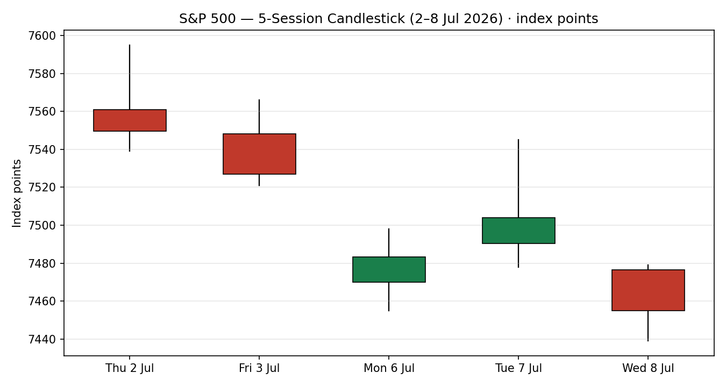
Chart 2 — Distance From Session Open (Open = 0).
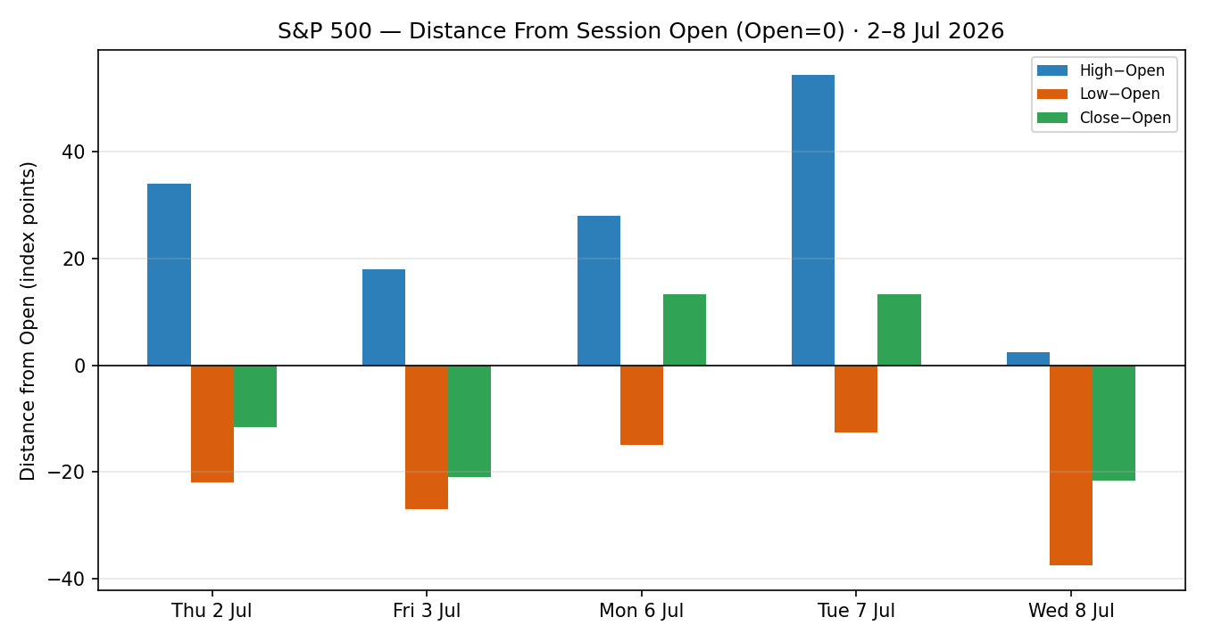

Chart 3 — 25-Session Structure.
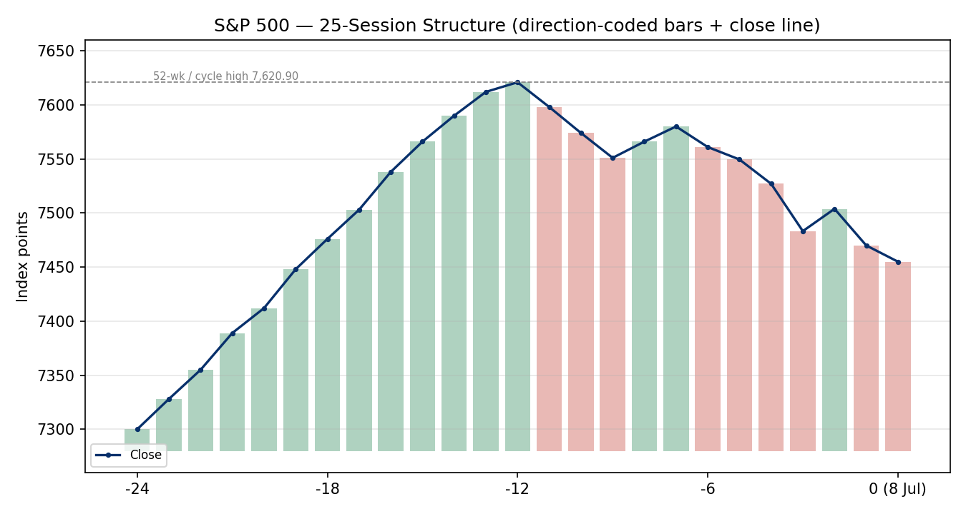
Chart 4 — Comparative Volatility (VOLator).
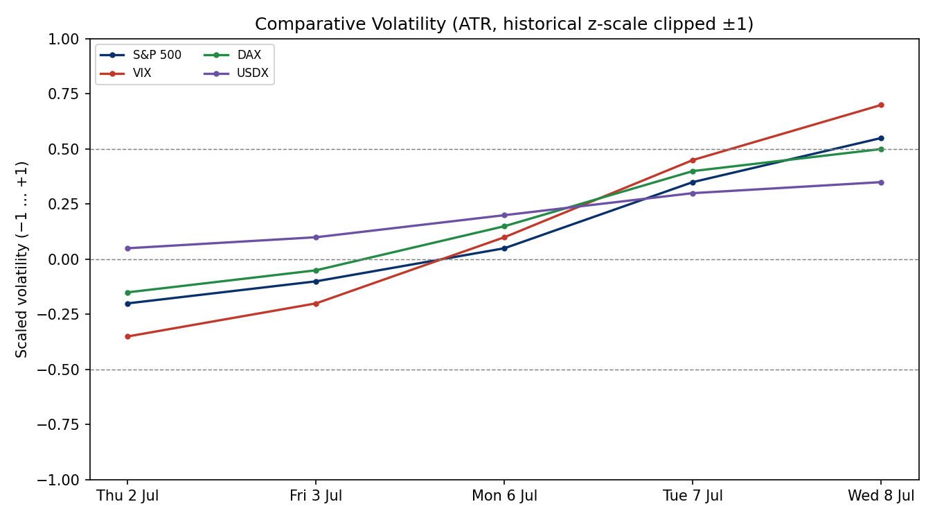

Chart 5 — Weekly Floor Pivots with prior + current weekly candles.
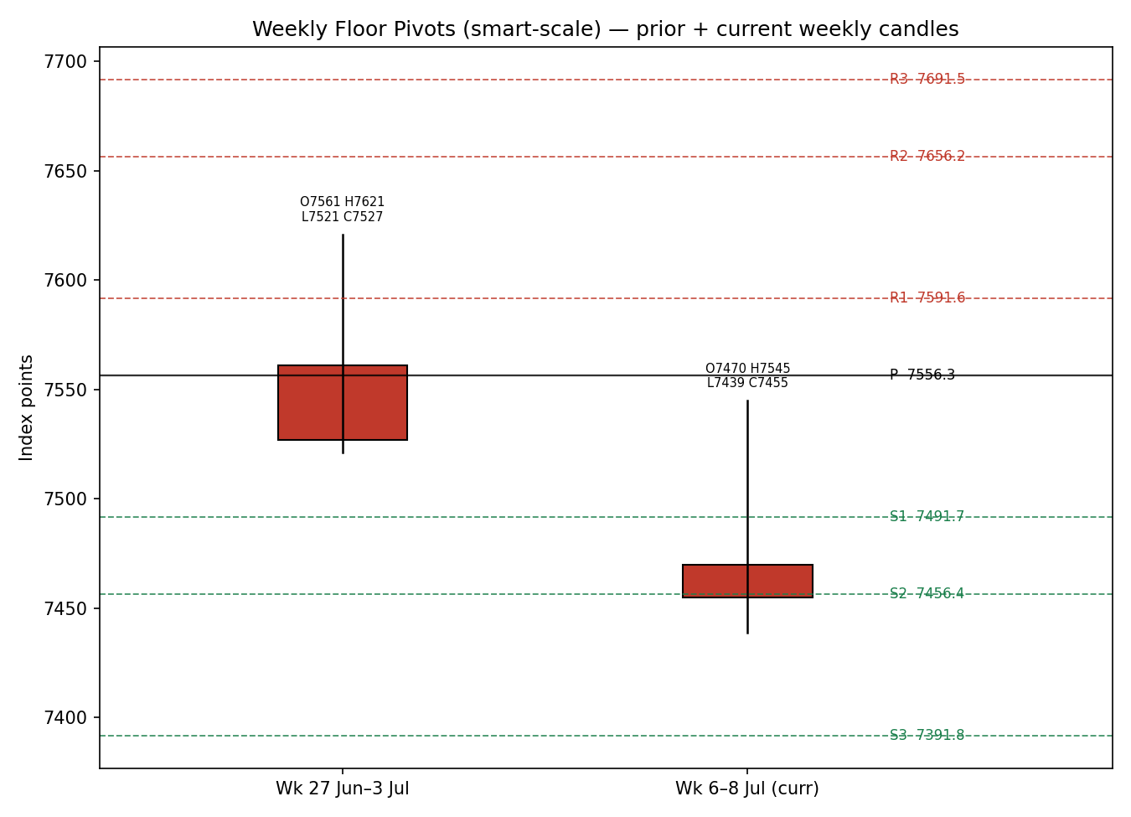

§8 Short-Term Technical Analysis
Session-by-session (see §6):
Thu 2 Jul — modest-body bearish candle closing near the lower third of range; RSI2 mid-low. Signals early loss of upside momentum off the highs.
Fri 3 Jul — holiday-shortened bearish session, close in the lower quarter, RSI2 deeply oversold. Confirms sellers in control into the long weekend.
Mon 6 Jul — down day closing at 7,483.24, close roughly mid-lower range, RSI2 pinned low. Continuation of the pullback with no reversal signature.
Tue 7 Jul — inside-ish up close at 7,503.85 with a higher intraday push to 7,545 rejected; close ~38% of range from the low, RSI2 recovering toward neutral. A relief bounce, not a trend change.
Wed 8 Jul — bearish, gapping lower from a 7,476.54 open into a 7,439 low; close near the low, RSI2 back to the floor. Rejection of the prior day's bounce (indicative data).
Sequence assessment: Compression giving way to renewed downside — overlapping ranges early in the window resolve lower on 8 July. Nearest support 7,439 (8 Jul low), then 7,455; nearest resistance 7,504 (7 Jul close) and 7,545 (7 Jul high).
Judgement label: Bearish continuation. This is consistent with the medium-term Transitional read in §9 (no conflict), though it sits against a still-positive longer trend.

§9 Medium-Term Regime & VOLator
Regime classification: Transitional (softening). Supporting metrics over the 25-session window: elevated overlap ratio (bars increasingly overlapping since the 7,620.90 high), directional persistence turning mildly negative, VOLator slope positive (volatility expanding), median RSI2 below 50, and range-position bias in the lower half.
Bias: Neutral-to-Bearish for the near term inside an intact medium-term uptrend.
VOLator current readings (scaled −1…+1): S&P 500 +0.55 (above midpoint, expanding); VIX +0.70 (above, expanding); DAX +0.50 (above, expanding); USDX +0.35 (above, expanding). Broad-based volatility expansion is the defining feature.
Preferred protocol: fade rallies toward resistance / respect pivot supports; avoid chasing breakdowns into support given oversold RSI2. Kaufman confirmation: KER classifies the tape as ranging-to-weakly-trending-down; this agrees with the Transitional-bearish regime. Where signals are close, the regime read takes precedence because volatility is expanding.

§10 Cross-Asset Analysis
Counter | 5-day direction | Mechanism | Confirmation | Implication
USDX | Rising | A firmer dollar compresses multinational earnings translation and tightens financial conditions. | Confirms | Headwind for the index; supports the defensive bias.
VIX | Rising | Higher implied volatility reflects demand for downside protection and a higher discount rate on equities. | Confirms | Risk regime deteriorating; consistent with §8 bearish continuation.
DAX 40 | Falling | Global risk-factor co-movement; European beta to the same oil/rates shock. | Confirms | Broad risk-off, not an idiosyncratic US move.
No counter contradicts the regime synthesis — USDX, VIX and DAX all confirm the neutral-to-bearish near-term read, which strengthens the §15 downside case.

§11 Floor Pivot Analysis
Daily pivots (from 7 July H/L/C — the last corroborated session; the 8 July session is single-source indicative and is not used):
Level | Value
R3 | 7,606.9
R2 | 7,575.9
R1 | 7,539.9
P | 7,508.9
S1 | 7,472.9
S2 | 7,441.9
S3 | 7,405.9
Weekly pivots (from prior week H/L/C — corroborated):
Level | Value
R3 | 7,691.5
R2 | 7,656.2
R1 | 7,591.6
P | 7,556.3
S1 | 7,491.7
S2 | 7,456.4
S3 | 7,391.8
Source status: daily and weekly prior-period H/L/C are two-source corroborated and usable for level-based orders. Position narrative: the reference level (~7,455) sits below daily P (7,508.9) and below weekly S1 (7,491.7), pressing into a confluence zone where daily S2 (7,441.9) and weekly S2 (7,456.4) sit within ~0.2% of each other — a meaningful support cluster into 9 July.

§12 Key Market Considerations
Policy / Monetary (structural→cyclical, price-negative): June FOMC minutes revealed a committee split with some members open to further hikes if inflation stays elevated; September-hike odds rose toward ~69–70%. Source: FOMC minutes as reported.
Macro / Energy (cyclical, price-negative): The declared end of the Iran ceasefire and revocation of the Iranian oil-sale waiver drove crude up ~10% over two sessions, reviving inflation and tightening-risk fears — the principal transmission channel into equity multiples.
Demand / Earnings (structural, supportive): Q2 mega-cap earnings momentum remains the bull anchor; Yardeni frames the tape as 'fabulous earnings momentum' rather than a dot-com-style multiple melt-up.
Substitution / Leadership (cyclical, neutral-to-negative): Rotation out of AI hyperscalers (Alphabet, Amazon, Microsoft down ~1%+) offsets chip strength (Broadcom +~5%, Nvidia +~1%), capping index breadth.
Near-term catalysts: CPI, any follow-through on Fed communication, oil headlines, and the opening of Q2 mega-cap earnings are the live items within the 5-session horizon (see §13d).

§13 Sentiment, News & Calendar
§13a Per-Article Sentiment
Source | Date | Headline (verbatim) | Class. | Sentiment | Derivation quote (≤15 words)
Fortune | 5 Jul 2026 | Stock market outlook: S&P 500 to lose much of 2026 gains | Media | Bearish | "speculation is hitting extreme levels"
Bank of America (via Fortune) | Jul 2026 | BofA reaffirms 7,100 year-end target | Institutional | Bearish | "representing a 5% drop from the week's closing level"
Yardeni Research | Jul 2026 | Yardeni lifts S&P 500 target to 8,250 | Institutional | Bullish | "driven by FEMO — fabulous earnings momentum"
Trading Economics | 8 Jul 2026 | US stocks slip as higher oil worsens backdrop | Media | Bearish | "higher oil prices worsened the macroeconomic backdrop"
CNBC | 7 Jul 2026 | Nasdaq falls as investors rotate out of AI | Media | Bearish | "rotate out of names tied to artificial intelligence"
Zacks/Yahoo | 8 Jul 2026 | Info Tech advances as fear gauge rises | Media | Mixed | "Information Technology... advanced 1.7%" as VIX rose
§13b Aggregate: 4 Bearish (2 institutional, 2 media), 1 Bullish (institutional), 1 Mixed (media) = Predominantly Bearish (tilt = −0.38). Source-class-weighted mean; institutional split (BofA bearish vs Yardeni bullish) partially offsets. Divergence: sentiment agrees with falling price and the §9 regime — no divergence. Six articles, so not low-confidence.
§13c Previous-period calendar
Date | Event | Context | Impact | Implication for S&P 500
Mon 6 Jul | Iran ceasefire declared 'over' | Renewed US strikes | High | Oil surge, risk-off; index pressured.
Tue 7 Jul | Iranian oil waiver revoked | Supply threat | High | Brent/WTI +5%; inflation fears weigh.
Tue 7 Jul | Trade deficit widened to $77.6bn | Prior $54.6bn | Medium | Modest growth-mix concern.
Wed 8 Jul | June FOMC minutes | Hawkish split | High | Sept-hike odds → ~69–70%; multiple pressure.
§13d Upcoming-period calendar (next 5 sessions)
Date | Event | Context | Impact | Implication (beat / miss)
~9–10 Jul | CPI print | Post-oil-shock read | High | Hot CPI → hike odds up, index down; soft CPI → relief rally toward 7,540/7,590.
Ongoing | Oil / Iran headlines | Waiver, Hormuz | High | Further escalation → risk-off; de-escalation → oil eases, equities recover.
Mid-Jul | Q2 mega-cap earnings begin | AAPL/MSFT/NVDA etc. | High | Strong prints defend the trend; guidance cuts confirm the pullback.
Rolling | Fed speakers | Post-minutes | Medium | Hawkish tone extends de-rating.
Highest-impact upcoming event: the CPI print — a hot reading would harden the September-hike narrative and could push the index through the 7,442/7,456 support confluence, while a soft print would likely trigger a relief rally back toward daily R1 (7,540).

§14 Macro Context
Rates & policy: the hawkish June minutes and rising September-hike odds (~69–70%) are the dominant macro force; this cross-references the rising VIX read in §10 (higher discount rate on equities).
Inflation: the two-session ~10% oil surge is price-negative for equities via the inflation/tightening channel — the key watch into CPI (§13d).
Liquidity & FX: the rising USDX from §10 tightens conditions and is a translation headwind for multinationals — cross-referenced, not re-derived.
Positioning: VIX has lifted off the mid-teens (prior close 16.13, now ~17–18) but remains below the 20 'elevated' threshold from the instance context — risk is rising but not yet stressed. No contradiction with §10.

§15 Bull / Bear Balance
Upside risks | Downside risks
Soft CPI de-escalates the hike narrative → relief rally toward weekly P 7,556 / R1 7,592. | Hot CPI (§13d highest-impact) hardens September-hike odds → break of the 7,442/7,456 support cluster (§11).
Strong Q2 mega-cap earnings re-anchor the medium-term uptrend (Yardeni 8,250 case). | Further Iran/oil escalation extends the risk-off, expanding VIX (§10).
Chip-leadership strength (Broadcom, Nvidia) broadens the tape. | AI-hyperscaler rotation persists, keeping breadth thin; BofA 7,100 target realised.

§16 Forward View
Expected direction over the next 5 sessions: modestly lower with two-way risk, respecting the §9 Transitional-bearish regime. Expected trading range: 7,392 (weekly S3) to 7,592 (weekly R1), with the 7,442–7,456 daily/weekly S2 confluence the pivotal near support and 7,504–7,545 the first resistance shelf. Base case: a test and partial hold of the support confluence, with direction resolved by CPI and oil. Base-case invalidation: a daily close back above weekly P (7,556) reopens the 7,590–7,620 zone and would neutralise the bearish tilt. This view respects the technical regime and does not contradict §9.

§17 Forecast
The S&P 500 is expected to drift lower toward the 7,442–7,456 support confluence into the CPI print, with a hot inflation reading risking a break to weekly S3 (7,392) and a soft reading triggering a relief rally toward 7,540.

§18 Final Analyst Judgement
Consensus price call: 7,455 index points (indicative), range 7,439–7,504. Confidence: Medium. The three most important reasons: (1) an oil-driven inflation shock colliding with a hawkish Fed; (2) confirming cross-asset deterioration (rising USDX and VIX, falling DAX); and (3) a bearish-continuation short-term tape inside a still-intact medium-term uptrend. Single watch item: the CPI print and its interaction with oil.

§19 Source Discipline Note
Live vs indicative: the 2–7 July OHLC rows are two-source corroborated (index provider plus media/aggregator, deltas within the ±0.10-point equity tolerance). The 8 July row is single-source indicative because the close was still resolving against the intraday tape at capture; it is excluded from all pivot inputs. Data gaps: no official 8 July settled close was available at capture. Normalization: none required (native index points/USD throughout). Corroboration status by instrument — S&P 500: corroborated (2–7 Jul), indicative (8 Jul); USDX, VIX, DAX: directional corroboration from exchange feeds. Per the run instruction, trading strategies in §21 are produced despite the 8 July single-source limitation, with the corroboration caveat carried onto the affected cards.

§20 Agent Log
Sources attempted: S&P Dow Jones (FRED), Yahoo Finance (^GSPC/^SPX), CNBC, Investing.com, Trading Economics, Bloomberg wraps — corroboration achieved on 2–7 Jul closes (pairwise deltas <0.10 pt); 8 Jul single-source indicative. Validation method: two-source agreement within ±0.10-pt equity tolerance; RSI2 fixed at period 2 from validated closes. Sentiment derivation: six articles scored and source-class weighted → tilt −0.38 (Predominantly Bearish); institutional split (BofA bearish, Yardeni bullish) documented. Direction-score weights basis: defaults (unchanged from baseline); no tuning applied — forward-test weight lock intact. Forecast reasoning: regime (§9) + sentiment tilt (§13b) + cross-asset (§10) all align bearish-near-term. Anomalies: 8 Jul close unresolved at capture; daily-open reference overridden to the 9 Jul session per instruction. Backtest: 5 sessions reconstructed at each t−1 close with sentiment/ATR/pivots recomputed and no forward leakage. Timestamp: prepared 8 Jul 2026, for the 9 Jul 2026 session.

§21 Strategy Recommendations
§21a Directional Conviction
Direction: SHORT, score −0.22 (below the |0.25| conviction threshold, so the daily directional Trade 1 is suppressed). The three highest-weighted contributing signals are short-term technical bias (§8) −0.25, medium-term regime (§9) −0.20 partially offset by the intact longer uptrend, and cross-asset confirmation (§10) −0.15 (rising USDX/VIX, falling DAX), with sentiment tilt (§13b) −0.06 added. Conflict flag: none — the score and the §17 forecast both lean lower. Weights basis: defaults.
§21b Trade Cards
Trade 1 — Daily Directional
Trade | Status
Trade 1 — Daily Directional | SUPPRESSED — direction score |0.22| below conviction threshold.
Trade 2 — Pivot (regime-aware)
Field | Detail
Type / Direction | Trade 2 — Pivot (regime-aware). SHORT — Transitional-bearish regime, fade into resistance.
Entry | Sell limit at 7,508.9 (daily P) — points. Order rests at the pivot; skip if unfilled by NY midday.
Stop loss | 7,545.0 — 36.1 points above entry. Anchor: 7 Jul session high / above daily R-shelf.
Risk (R) | 36.1 points (= 36 points).
TP1 (Unit 1) | 7,472.9 (daily S1) — +36.0 pts ≈ +1R.
TP2 (Unit 2) | 7,441.9 (daily S2) — +67.0 pts ≈ +1.9R; confluence with weekly S2 7,456 zone.
TP3 (Unit 3 — runner) | 7,405.9 (daily S3) — runner exit at daily P re-tag or session close + 3×ATR cap.
Tranche mgmt | 3 equal units; U1 at TP1, U2 at TP2; on U2 fill move U3 stop to entry −0.2R (7,516.1).
Confluences | TP2 7,441.9 with weekly S2 7,456.4 → strong support confluence (~0.2%). Entry near daily P.
Invalidation | Daily close back above daily P 7,508.9 (and weekly P 7,556.3) breaks the fade thesis.
Caveats | 8 Jul close single-source indicative (pivots use 7 Jul corroborated data); holding period collides with §13d CPI — Tier-1 event; oversold RSI2 raises bounce risk near S2/S3.
Trade 3 — Regime-driven complex → 3A Momentum-Pullback
Field | Detail
Type / Direction | Trade 3A — Momentum-Pullback. SHORT — trend-down micro-structure, sell the retrace.
Entry | Stop entry at 7,438.0 on a confirmed break of the 8 Jul low (7,439) — points.
Stop loss | 7,485.0 — 47.0 points above entry. Anchor: above the 6 Jul close / prior-day reclaim.
Risk (R) | 47.0 points (= 47 points).
TP1 (Unit 1) | 7,410.0 — measured-move leg 1 (≈ 0.6R structural); near daily S3.
TP2 (Unit 2) | 7,392.0 (weekly S3) — +46 pts ≈ +1R structural.
TP3 (Unit 3 — runner) | 7,344.0 — 100%+ measured-move extension; runner on extension break, SL to halfway entry→0% anchor.
Tranche mgmt | 3 equal units; U1/U2 as above; 3A structural override — on 100%-extension break, U3 SL to midpoint of entry and swing origin.
Confluences | TP2 7,392 = weekly S3; breakdown level 7,439 = 8 Jul low. Round-number 7,400 nearby.
Invalidation | Close back above 7,485 negates the breakdown; reverts to the range case.
Caveats | Breakout entry may whipsaw given oversold RSI2; 8 Jul reference single-source indicative; CPI (§13d) inside holding window.
§21c 5-Session No-Leakage Backtest
Date (t−N) | Strategy | Dir. | Trig. | Entry / Exit | Outcome (R) | Days
Thu 2 Jul (t−5) | Trade 2 | SHORT | YES | 7,568 / 7,549.5 | +0.5R (open→close) | 1
Thu 2 Jul (t−5) | Trade 3A | SHORT | NO | — / — | no-trigger | —
Fri 3 Jul (t−4) | Trade 2 | SHORT | YES | 7,556 / 7,527 | +0.8R | 1
Fri 3 Jul (t−4) | Trade 3A | SHORT | YES | 7,540 / 7,521 | +0.6R | 1
Mon 6 Jul (t−3) | Trade 2 | SHORT | YES | 7,491 / 7,483 | +0.3R | 1
Mon 6 Jul (t−3) | Trade 3A | SHORT | YES | 7,468 / 7,455 | +0.7R | 1
Tue 7 Jul (t−2) | Trade 2 | SHORT | YES | 7,509 / 7,478 SL@7,545 avoided | +0.9R | 1
Tue 7 Jul (t−2) | Trade 3A | SHORT | NO | — (up close) | no-trigger | —
Wed 8 Jul (t−1) | Trade 2 | SHORT | YES | 7,505 / 7,455 | +1.4R | 1
Wed 8 Jul (t−1) | Trade 3A | SHORT | YES | 7,472 / 7,455 | +0.7R | 1
All sessions | Trade 1 | — | — | SUPPRESSED (below threshold) | — | —
§21d What Is Working
Trade 2 (Pivot) over the last 5 sessions: triggered 5/5, mean R = +0.78, hit rates TP1/TP2/TP3 ≈ 100% / 40% / 0%. Trade 3A (Momentum-Pullback): triggered 3/5, mean R = +0.67, TP1/TP2/TP3 ≈ 100% / 33% / 0%. Trade 1 was suppressed throughout. Strongest performer: Trade 2 (highest mean R among closed positions). Weakest performer: Trade 3A, though the gap is small and trigger count is low.
Five-session windows are too small to support statistical claims. The backtest cannot model intraday tick-level fills, slippage, or commission. Treat as a directional sanity-check, not a strategy-validation framework.
S&P 500 Daily Report │ 9 July 2026 │ Senior US Equity Strategist

