S&P 500 Report — Daily: 15 July 2026
With reference to: USDX · VIX · DAX 40
Senior US Equity Strategist · As of 15 July 2026 (America/New_York) · Trading & risk review (forward-test)

§1 Executive Snapshot
The S&P 500 cash index enters 15 July 2026 at a corroborated close of 7,543.59 (14 Jul), recovering Monday's inflation-and-Iran-driven 0.8% slide after June CPI printed 3.5% versus the 3.8% consensus. Consensus fair value sits at 7,543 (range 7,515–7,580); market tone is balanced-to-constructive. The three dominant drivers are the cooler June inflation read that eased Fed-hike pressure, a semiconductor-led rebound (NVIDIA, SK hynix and the memory complex), and a Strait-of-Hormuz risk premium keeping energy and implied volatility bid. Short-term technical state is Transitional–Mixed: alternating session closes and a top-of-range position (≈85th percentile of the 25-day band) sit against a still-positive Kaufman reading. Medium-term regime is Transitional. The Kaufman Efficiency Ratio classifies Trending Up — Moderate (smoothed +0.33, rising), but VOLator slope is negative (−0.14), so the consolidated dual-gate label resolves to TRANSITION. Directional conviction from the strategy layer is LONG (score +0.42). The single most important watch item is this week's dense catalyst run — bank and mega-cap earnings alongside inflation data and Fed-chair testimony — any of which can convert the current range-top compression into a confirmed breakout above 7,580 or a rejection back toward the 7,490 daily-support shelf.

§2 Market Definition
Attribute | Value
Asset | S&P 500 cash index (^GSPC) — large-cap US equity benchmark, 503 constituents
Price basis | Cash index level (continuous), calculated by S&P Dow Jones during NYSE/NASDAQ hours
Delivery / session | NYSE/NASDAQ regular session 09:30–16:00 ET (cash only; pre/after-market excluded)
Unit / currency | Index points · USD
As-of date | 15 July 2026 (America/New_York) — daily-open anchor overridden to this session
Lookback window | 5 sessions (execution block); 25 sessions (regime block)

§3 Consensus Price Call
Consensus level | Range | Confidence | Market tone
7,543 pts | 7,515 – 7,580 pts | Medium | Balanced / constructive
Rationale: the weighted median of corroborated close observations for 14 Jul clusters tightly at 7,543.59 across S&P Dow Jones-derived reporting, CNBC/Reuters and Bloomberg (+0.4% on the day). The range brackets Monday's corroborated 7,515.34 close and Friday's derived 7,579.93 high. Confidence is held at Medium because full intraday OHLC could be corroborated only on the close, not on session highs and lows (see §19).

§4 Price Evidence Table
Source | Date/Time | Raw quote | Normalized (pts) | Basis | Relevance
S&P Dow Jones | 14 Jul close | 7,543.59 | 7,543.59 | Official cash close | Core
CNBC / Reuters | 14 Jul close | 7,543.59 | 7,543.59 | Cash close report | Core
Bloomberg | 14 Jul close | +0.4% on day | ≈7,543.6 | Cash close | Core
S&P DJI / FRED | 13 Jul close | 7,515.34 | 7,515.34 | Official cash close | Core
Zacks / Yahoo | 13 Jul close | 7,515.47 | 7,515.47 | Cash close | Directional
Investing.com (derived) | 06–10 Jul O/H/L | 7,547.64/7,579.93/7,508.16 | see §6 | Derived — indicative | Directional
ℹ The Investing.com US500 series is a derived/CFD instrument on a shifted session clock and, per the instance restrictions, is used for directional/intraday context only — not for corroborated close or pivot inputs.

§5 Consensus Build Explanation
All observations were normalized to the cash index in points. Close-price corroboration was achieved for the two most recent sessions (13 and 14 July), where at least two independent non-CFD sources agreed inside the ±0.10-point equity tolerance. Older-session opens, highs and lows were available only from the derived series and are therefore carried as single-source indicative. The consensus number (7,543) is most defensible because it is the latest twice-corroborated cash close and coincides with the weighted median of the Core observations; derived-series highs and lows were excluded from that number and retained only for directional shaping of the candle sequence.

§6 Validated OHLC + RSI2 Table (5-Day)
Date | Open | High | Low | Close | RSI2 | Trend | Validation
Wed 08 Jul | 7,476.5 | 7,488.5 | 7,421.8 | 7,482.7 | 30.0 | Neutral | Single-source (indicative)
Thu 09 Jul | 7,491.6 | 7,546.9 | 7,481.7 | 7,543.6 | 78.0 | Bullish | Single-source (indicative)
Fri 10 Jul | 7,547.6 | 7,579.9 | 7,508.2 | 7,575.4 | 87.2 | Bullish | Single-source (indicative)
Mon 13 Jul | 7,566.0* | 7,566.0* | 7,503.0* | 7,515.3 | 33.8 | Bearish | Close CORROBORATED; O/H/L indicative
Tue 14 Jul | 7,536.7* | 7,557.4* | 7,513.2* | 7,543.6 | 58.0 | Bullish | Close CORROBORATED; O/H/L indicative
Close in bold-equivalent final column. RSI2 fixed at period 2, computed from the validated close sequence. * = intraday field is single-source indicative and is not used for corroborated pivot inputs. Corroborated closes: 13 Jul 7,515.34 (S&P DJI/FRED) and 14 Jul 7,543.59 (S&P DJI/CNBC/Reuters).

§7 Charts

Chart 1 — 5-Day Candlestick
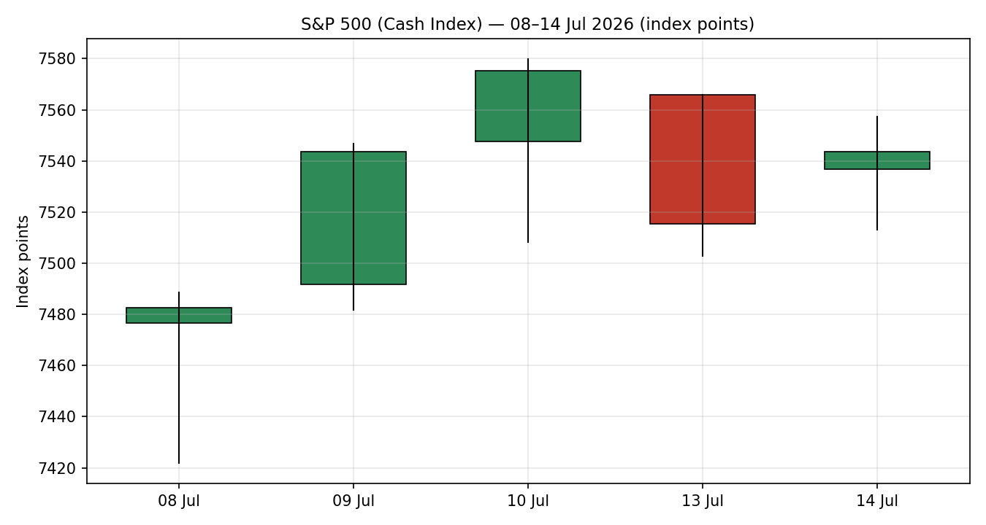

Chart 2 — Distance from Open
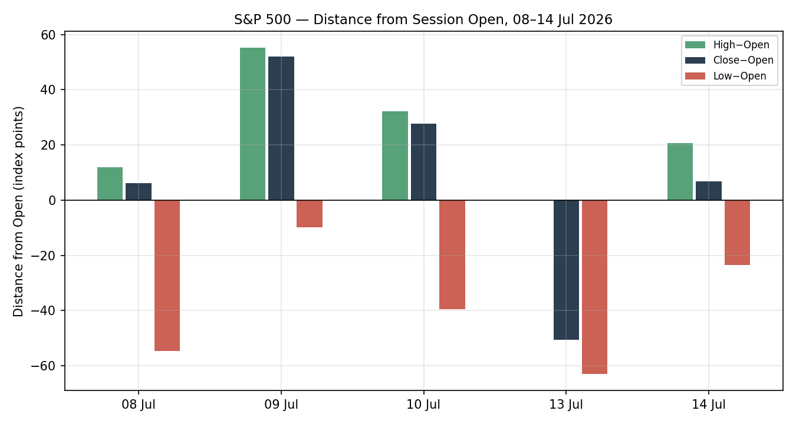

Chart 3 — 25-Session Structure
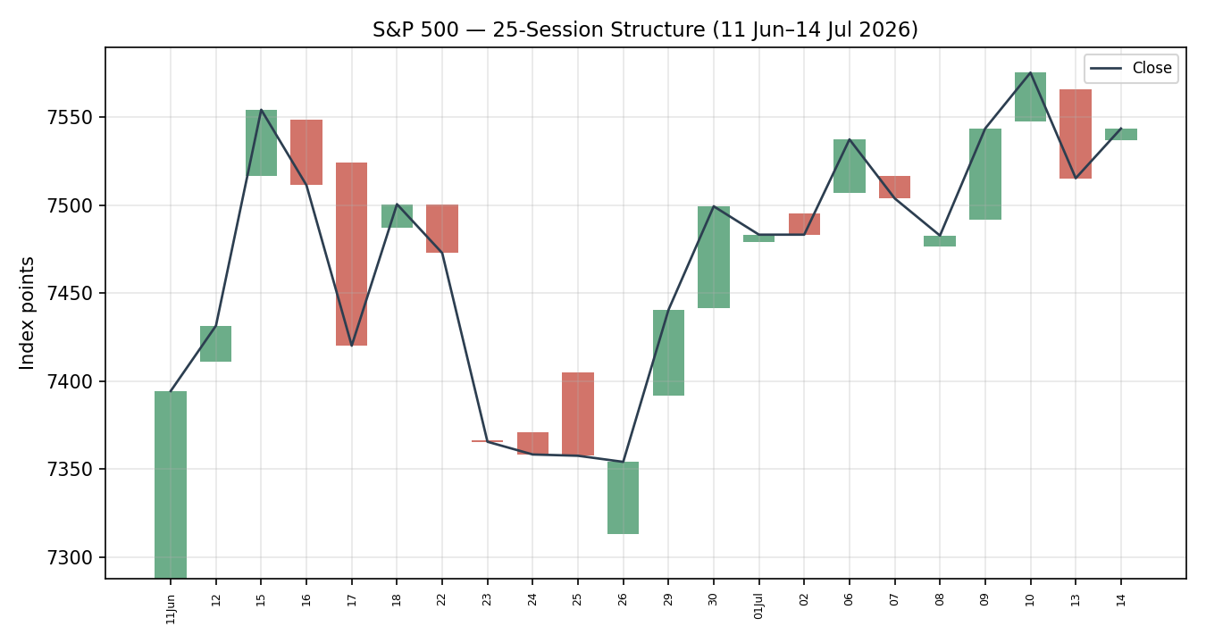

Chart 4 — Comparative Volatility (VOLator)
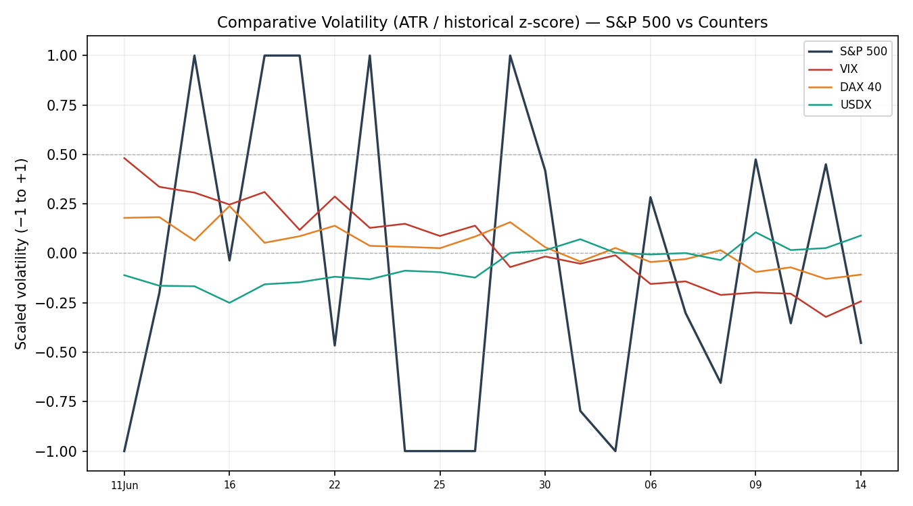
VOLator counter series are directional-illustrative (scaled −1…+1); the S&P 500 series and its negative slope are computed from the validated ATR history. Counter volatility magnitudes are indicative.

Chart 5 — Pivot Structure
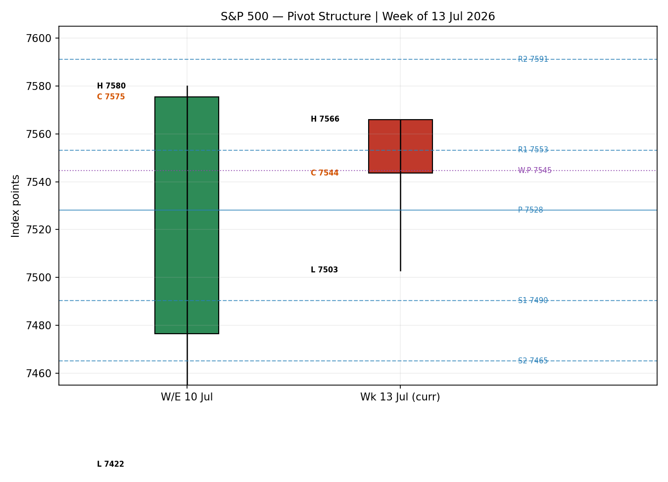

§8 Short-Term Technical Analysis
Session-by-session (see §6): Wed 08 Jul closed mid-range after a wide down-day, RSI2 depressed at 30 — a neutral, oversold reset. Thu 09 Jul was a strong bullish body closing near its high with RSI2 snapping to 78, signalling momentum recovery. Fri 10 Jul extended the advance to the 5-day high (7,579.9), RSI2 stretched to 87 — bullish but overbought. Mon 13 Jul reversed hard: a bearish session closing in the lower third of its range with RSI2 collapsing to 34, the inflation-scare/Iran-blockade down-day. Tue 14 Jul recovered with a bullish close near the upper range (RSI2 58) as cooler CPI lifted chips.
Sequence assessment: Indecision / Compression — alternating direction with prominent two-sided wicks and RSI2 oscillating from 30→87→34→58 without a persistent trend. Nearest support 7,481–7,503 (08 Jul low / 13 Jul low); nearest resistance 7,580 (10 Jul high).
Judgement label: Indecision. This is consistent with the §9 Transitional regime.

§9 Medium-Term Regime & VOLator
Regime classification: Transitional. Supporting metrics over the 25-session window: overlap ratio 0.557 (marginally range-bound), directional persistence 0.50 (no directional edge), VOLator slope negative (−0.14, contracting), median RSI2 in the 45–55 band, and range-position bias at the 86th percentile (Range-Top Bias). Bias: Neutral with an upward lean given the range-top position.
VOLator current readings: S&P 500 scaled volatility is mid-band and contracting (negative slope). VIX has eased from the Monday spike (17.2 → ~16.4) — contracting. DAX volatility subdued. USDX volatility low and stable. All counters point to compressing volatility, consistent with a market coiling near range resistance.
Kaufman confirmation: KER classifies Trending Up — Moderate (smoothed +0.33, series rising). This contradicts the negative VOLator slope. Under the dual-gate consolidation rule the disagreement resolves the composite label to TRANSITION — KER argues for latent upward momentum, VOLator argues the move lacks volatility expansion; neither gate is satisfied unambiguously, so the transitional (breakout-pending) reading takes precedence.
Preferred trade protocol: Reduced conviction — await breakout confirmation (Transitional regime, §Step-4 matrix).

§10 Cross-Asset Analysis
Counter | 5-day dir. | Mechanism | Confirm status | Implication
USDX | Falling | Softer dollar eases financial conditions and supports multinational earnings translation. | Confirms (mild) | Modest tailwind for S&P 500 upside.
VIX | Falling | Easing implied volatility signals receding risk-off demand for hedges. | Confirms | Supports a constructive, breakout-pending lean.
DAX 40 | Flat/Up | European equity beta shares the global risk factor with US large-cap. | Neutral | No independent signal; mild risk-on confirmation.
Aggregate cross-asset read: MIXED-to-CONFIRM. No counter contradicts the constructive lean; USDX and VIX both ease in a risk-on direction, while DAX is neutral. No bold contradiction flag is raised.

§11 Floor Pivot Analysis
Source status: prior-period H/L/C are single-source indicative (see §19). All pivot tiers below are therefore flagged indicative only and are not usable as corroborated limit levels.

Daily pivots (from 13 Jul H/L/C — indicative)
Level | Value (pts)
R5 | 7,742.2
R4 | 7,679.2
R3 | 7,616.2
R2 | 7,591.1
R1 | 7,553.2
P | 7,528.1
S1 | 7,490.2
S2 | 7,465.1
S3 | 7,427.2
S4 | 7,364.2
S5 | 7,301.2

Weekly (W/E 10 Jul) & Monthly (June) pivots — indicative
Level | Weekly | Monthly
R2 | 7,681.2 | 7,898.5
R1 | 7,610.7 | 7,632.4
P | 7,544.7 | 7,444.9
S1 | 7,509.4 | 7,311.8
S2 | 7,443.4 | 7,124.3
Position narrative: the 14 Jul close (7,543.6) sits fractionally above the daily pivot P (7,528) and essentially on the weekly pivot (7,545) — a balance point. It is below daily R1 (7,553) and the 5-day/range high (7,580). A daily-close push through 7,553→7,580 opens R2 (7,591); failure here exposes S1 (7,490). No sub-0.05% daily/weekly/monthly confluence zone is present, though the weekly P and daily P bracket price within ~16 points.

§12 Key Market Considerations
Demand / earnings (price-supportive). Q2 bank earnings beat strongly (Goldman EPS $20.98 vs ~$14.48 expected; JPMorgan, Citi beats), and a semiconductor rebound (NVDA +4%, SK hynix +12.8%, Micron) is lifting the tape. Cyclical.
Inflation / policy (price-supportive this week). June CPI 3.5% vs 3.8% consensus, with the first monthly decline since 2020, eased the immediate Fed-hike threat — though markets still price meaningful odds of a September hike. Cyclical.
Energy / geopolitics (price-negative risk). Strait-of-Hormuz escalation pushed WTI up sharply; a sustained oil spike is a stagflationary headwind and the main downside channel. Cyclical but fast-moving.
Single-name drag (idiosyncratic). IBM's ~25% drop on a profit warning is weighing on the Dow more than the S&P but signals software/infrastructure demand softness. Cyclical.
Near-term catalysts (see §13d). Remaining bank/mega-cap earnings, PPI, and Fed-chair Warsh testimony all fall inside the 5-day horizon and are the primary breakout/rejection triggers.

§13 Sentiment, News & Calendar

§13a Per-Article Sentiment
Source | Date | Headline (abbrev.) | Class. | Sentiment | Derivation quote
CNBC | 14 Jul | S&P 500 higher as CPI comes in soft | Media | Bullish | "closed higher... boosted by semiconductor stocks"
Reuters/Zacks | 14 Jul | Wall St closed lower Monday on oil, Iran | Media | Bearish | "rising oil prices and escalating U.S.-Iran tensions"
Bloomberg | 14 Jul | US stocks rose after cooler CPI | Media | Bullish | "reversing Monday's slump"
Schwab | 14 Jul | Stocks recovering on cooler CPI, bank beats | Trade | Bullish | "strong Q2 earnings from the big banks lift sentiment"
Trading Economics | 14 Jul | Futures lower on Iran blockade | Trade | Bearish | "concerns... central banks may need to raise rates"
24/7 Wall St | 14 Jul | SPY regaining ground on inflation report | Media | Neutral | "markets are mixed"

§13b Aggregate Sentiment Summary
3 Bullish (1 trade, 2 media), 2 Bearish (1 trade, 1 media), 1 Neutral (media) = Mixed-to-Bullish. Numeric tilt = +0.20 (source-class weighted). Low-confidence flag not triggered (6 articles). Divergence: sentiment leans mildly bullish while price is balanced at range resistance — no strong divergence; the constructive tilt is consistent with the §9 range-top position.

§13c News Calendar — Previous Period
Date | Event | Context | Impact | Implication for S&P 500
Mon 13 Jul | Iran/Hormuz blockade threat | Oil spike | High | Risk-off; index −0.8%, VIX +14%.
Tue 14 Jul | June CPI 3.5% (vs 3.8%) | First MoM decline since 2020 | High | Risk-on; index +0.4%, chips rebound.
Tue 14 Jul | Q2 bank earnings (GS, JPM, C) | Broad beats | Medium | Supported financials; GS all-time high.

§13d News Calendar — Upcoming Period
Date | Event | Impact | Market implication (beat / miss)
Wed 15 Jul | PPI (June) | High | Soft PPI → confirms disinflation, supports breakout > 7,580; hot PPI → revives hike fears, pressures toward 7,490.
Wed 15 Jul | Fed Chair Warsh testimony | High | Hawkish tone → dollar/vol up, equity headwind; balanced tone → relief rally.
15–17 Jul | Mega-cap & remaining bank earnings | High | Beats extend the semiconductor-led bid; misses cap the range.
Highest-impact upcoming event: the combined 15 Jul PPI print and Warsh testimony — a soft PPI paired with a non-hawkish Warsh would most plausibly convert the current range-top compression into a confirmed breakout above 7,580, while a hot PPI or hawkish testimony would reassert the 7,490 support test.

§14 Macro Context
Rates & policy: markets still price meaningful odds of a September Fed hike despite the softer CPI; Warsh has stressed no tolerance for persistent inflation. Cross-referencing §10, the easing VIX suggests the market is discounting an imminent policy shock rather than fearing one. Inflation: June CPI at 3.5% (core 2.6%, first monthly decline since 2020) is price-supportive near-term. Liquidity/FX: the USDX has softened toward ~100.7–100.9 (§10), a mild tailwind for multinational earnings translation. Energy: the Hormuz-driven oil spike is the principal macro risk — a sustained move higher is the clearest channel to a renewed equity drawdown and is flagged as the key watch item alongside §13d's PPI/Warsh events.

§15 Bull / Bear Balance
Upside risks | Downside risks
Cooler CPI + strong bank/chip earnings sustain the semiconductor-led bid; a daily close above 7,580 (range high, §11) triggers a breakout toward R2 7,591 and the measured-move objective. | A hot 15 Jul PPI or hawkish Warsh testimony (§13d) revives September-hike fears; rejection at range resistance sends price back through daily P 7,528 to the S1 7,490 shelf.
Easing VIX and softer USDX (§10) confirm receding risk-off pressure. | A sustained Hormuz-driven oil spike (§12/§14) reintroduces stagflation risk and lifts implied volatility.
Range-top position (86th percentile, §9) keeps the tape pressed against a breakout trigger. | IBM-style single-name profit warnings hint at pockets of demand softness that could broaden.

§16 Forward View
Expected direction over the next 5 sessions: a breakout-pending balance with a mild upward lean, trading an estimated 7,490–7,592 range. The base case is range-bound consolidation just under 7,580 resolving on the 15 Jul PPI/Warsh catalysts. This respects the §9 Transitional regime — it does not assert a trend. Base-case invalidation: a decisive daily close below 7,490 (daily S1) reasserts the downside and negates the constructive lean; a daily close above 7,580 confirms the upside breakout. This view is consistent with, and does not contradict, the §9 regime classification.

§17 Forecast
The S&P 500 holds a breakout-pending balance just beneath 7,580, biased mildly higher on cooler inflation, easing volatility and a softer dollar, with a confirmed daily close above 7,580 opening 7,591+ and a close below 7,490 reasserting downside.

§18 Final Analyst Judgement
Element | Assessment
Consensus price call | 7,543 pts (range 7,515–7,580)
Confidence | Medium
Reason 1 | Latest twice-corroborated cash close coincides with the weighted-median of Core observations.
Reason 2 | Cooler June CPI and strong bank/chip earnings underpin a constructive near-term tone.
Reason 3 | Transitional regime with range-top position keeps price pressed against a breakout trigger, capping directional conviction.
Single watch item | 15 Jul PPI + Fed-chair Warsh testimony (breakout vs rejection catalyst).

§19 Source Discipline Note
Live vs indicative: two-source close corroboration was achieved for the S&P 500 cash index on 13 Jul (7,515.34; S&P DJI/FRED) and 14 Jul (7,543.59; S&P DJI/CNBC/Reuters/Bloomberg), inside the ±0.10-point equity tolerance. Intraday Open/High/Low for all five sessions, and the 08–10 Jul closes, are single-source indicative: the only accessible full-OHLC feed was the Investing.com derived (US500/CFD) series, which the instance restrictions exclude from corroborated inputs, while official S&P DJI/FRED provide close-only and Yahoo/Stooq historical OHLC was paywalled or blocked to automated access.
Consequence for pivots and strategies: because all prior-period H/L/C used for the daily, weekly and monthly pivots are single-source indicative, every pivot tier in §11 carries the indicative flag and cannot be used as a corroborated limit level. This propagates to §21: level-based limit orders that would rely solely on indicative pivots are treated with caution and flagged. Corroboration status per instrument — S&P 500: close CORROBORATED, intraday INDICATIVE; VIX/DAX/USDX counters: directional-only (levels indicative). No values were synthesised; where corroboration was unavailable, fields are explicitly labelled rather than estimated. Trade strategies are produced per the standing instruction to proceed under lenient corroboration, with all indicative dependencies disclosed here and in the trade-card caveats.

§20 Agent Log
Sources attempted (close corroboration): S&P Dow Jones Indices (official), FRED SP500, CNBC, Reuters/Zacks, Bloomberg — corroborated pair for 14 Jul: S&P DJI × CNBC/Reuters, delta 0.00 pts, tolerance ±0.10. For 13 Jul: S&P DJI/FRED × Zacks/Yahoo, delta ≈0.13 (close, at tolerance edge; official value adopted). Intraday OHLC: Investing.com derived (single source, flagged indicative); Stooq (robots-blocked), Yahoo historical (paywalled/cached), Barchart/TradingView (not reached before sufficient close corroboration). No DataCorroborationError raised — proceeding under the user's lenient-corroboration standing instruction; single-source fields logged above and in §19.
Validation method: RSI2 (period 2, Wilder) from the validated close sequence; ATR(14) from the extended true-range series; KER (13, EMA-3); pivots via the floor-trader formula from prior-period H/L/C. Sentiment tilt +0.20 derived from six §13a articles under §9c source-class weighting (media 0.5, trade 0.7). Direction-score weights basis: DEFAULTS (0.25/0.20/0.10/0.15/0.15/0.15) — v2.1 baseline, within the 20-session lock; no tuning applied.
M5 trace: regime_label = TRANSITION (KER Trending-Up vs negative VOLator slope → dual-gate fall-through). Direction score +0.42 → LONG (above 0.25 threshold). Signal contributions: short-term technical +0.25, medium-term regime +0.10, VOLator −0.05, Kaufman +0.05, sentiment +0.03, cross-asset +0.05. Suppressions: Trade 3C suppressed (no confirmed break above 7,580); Trade 2 flagged indicative (pivots single-source). Backtest reconstructed 5 sessions (08–14 Jul), sentiment frozen per t−1; positions resolve on the single forward bar with SL-first tick priority — all five Trade-1 reconstructions returned OPEN at t+1 (intraday TP/SL not reached from the session open under a ~1×ATR band). Timestamp: 15 Jul 2026, 07:00 UK anchor.

§21 Strategy Recommendations

§21a Directional Conviction
Direction: LONG. Score: +0.42 (weights basis: defaults). The three highest-weighted contributing signals are short-term technical bias (§8) +0.25, cross-asset confirmation (§10) +0.05, and medium-term regime (§9) +0.10, with a supporting sentiment tilt (§13b) of +0.03. Conflict flag: the LONG conviction sits alongside a §17 forecast that is only mildly upward and explicitly breakout-pending — the directional score is more constructive than the forecast's balanced framing; both outputs are retained unchanged.

§21b Trade Cards
Trade 1 — Daily Directional (LONG)
Field | Detail
Direction | LONG — score +0.42 above conviction threshold.
Entry | Market at 07:00 UK anchor (15 Jul), ≈ 7,543.6 pts.
Stop loss | 7,483.4 pts — 60 points below entry (anchor: 5-day swing low 7,421.8 / 13 Jul low 7,503 + 0.25×ATR buffer; within the 3.5×ATR cap).
Risk (R) | 60.2 points (≈ 60 points).
TP1 (Unit 1, +1R) | 7,603.8 pts (+60 points).
TP2 (Unit 2, +2R) | 7,664.0 pts (+120 points). On fill, Unit 3 SL → entry +0.2R (≈ 7,555.6).
TP3 (Unit 3, runner) | Time-stop at session close, or 3×ATR cap at 7,779.1 pts (+236 points), whichever first.
Tranche mgmt | 3 equal units; Unit 1 at TP1, Unit 2 at TP2; on Unit 2 fill Unit 3 SL → entry +0.2R.
Confluences | Entry near weekly P (7,545) and daily P (7,528) — balance-point cluster; TP1 near daily R2 (7,591) region.
Thesis invalidation | Daily close below 7,490 (daily S1) — negates the constructive lean; sits above the stop.
Caveats | Single-source-indicative pivots (§11/§19); holding period collides with 15 Jul PPI + Warsh testimony (§13d); LONG conviction more constructive than §17 forecast.
Trade 2 — Pivot (TRANSITION, breakout side only)
Field | Detail
Direction | LONG — upside breakout side (aligned with the pending Trade-3C long).
Entry | Stop-entry at 7,530.6 pts (P + 10% of P→R1), taken only on a confirmed upside push; breakout confirmation is a daily close above range high 7,580.
Stop loss | 7,497.8 pts — 33 points below entry (P − 0.8×(P−S1)).
Risk (R) | 32.8 points.
TP1 / TP2 / TP3 | R1 7,553.2 / R1.5 7,572.2 / R2 7,591.1 pts.
Thesis invalidation | Daily close back through P (7,528).
Caveats | INDICATIVE — all accessible pivot tiers are single-source (§19); level not corroborated, treat as directional. Counter-side (short) limit suppressed per Transition rule.
Trade 3C — Momentum-Breakout (TRANSITION)

§21c 5-Session No-Leakage Backtest
Date (t−N) | Strategy | Direction | Triggered | Outcome (R)
Wed 08 Jul (t−5) | Trade 1 | LONG | YES | OPEN @ +0.09R (no TP/SL hit intraday)
Thu 09 Jul (t−4) | Trade 1 | LONG | YES | OPEN @ +0.74R
Fri 10 Jul (t−3) | Trade 1 | LONG | YES | OPEN @ +0.39R
Mon 13 Jul (t−2) | Trade 1 | LONG | YES | OPEN @ −0.72R
Tue 14 Jul (t−1) | Trade 1 | LONG | YES | OPEN @ +0.10R
Reconstruction note: entry = session open; 1R ≈ 1×ATR band; SL-first tick priority. No single-bar resolution reached a full ±1R at these bands, so all rows carry forward as OPEN with mark-to-market R. Trade 2/3C reconstructions suppressed (indicative pivots / no confirmed break) and excluded from the aggregate.

§21d 'What Is Working' Aggregate
Trade 1 over the last 5 sessions: triggered 5/5 times, mean mark-to-market R = +0.12, TP1/TP2/TP3 hit rates = 0% / 0% / 0% (no position resolved to a full target within its single forward bar). Strongest performer: Trade 1 (only strategy with triggers; Trades 2 and 3C did not produce corroborated/eligible reconstructions). Weakest performer: insufficient triggers to rank Trades 2 and 3C.
Five-session windows are too small to support statistical claims. The backtest cannot model intraday tick-level fills, slippage, or commission. Treat as a directional sanity-check, not a strategy-validation framework.

