S&P 500 Report — Daily: 19 May 2026
With reference to: USDX · VIX · DAX 40

§1 Executive Snapshot
The S&P 500 enters the 19 May 2026 session with a consensus price of approximately 7,403, having pulled back roughly 1.5% from the 14 May intraday all-time high of 7,517.12. Market tone is constructively bullish but tactically stretched — the index is digesting a seven-week winning streak in the face of three dominant drivers: (i) renewed Middle East risk premia driving crude into the $103–110/bbl zone and lifting headline-inflation expectations; (ii) a higher-for-longer rate path as traders now price one Fed hike by March 2027 with a >50% chance of a hike before year-end 2026; and (iii) an AI-led mega-cap earnings ledger, with Nvidia's quarter due this week as the single most important watch item. Short-term technical regime is Transitional Bearish — two-bar pullback off the ATH with an extreme RSI2 reading near 7.5. Medium-term regime remains Trending Bullish, with the 25-session structure intact above 7,100. The Kaufman Efficiency Ratio classifies the current state as Trending Up — Moderate (the smoothed reading has flattened but remains above the +0.13 threshold). The single most important watch item: Nvidia earnings and the response of 10-year Treasury yields, which are challenging 4.60% — the level at which equity duration sensitivity becomes binding.

§2 Market Definition
Field | Value
Asset | S&P 500 cash index (large-cap US equity benchmark, 503 constituents)
Specification | S&P Dow Jones standardised index methodology; rebalanced quarterly
Market scope | Global / United States (NYSE/NASDAQ regular trading hours)
Price basis | Cash index level, continuous, regular session 09:30–16:00 ET
Unit of measure | Index points
Currency | USD
As-of date | 19 May 2026 (America/New_York)
Lookback window | 5 trading days (12 May 2026 → 18 May 2026)
Tick size | 0.01 index point · Native unit: point

§3 Consensus Price Call
Field | Value
Consensus price | 7,403.05
Consensus range | 7,371 — 7,434
Basis | 18-May-2026 NYSE close, cash index
Confidence level | Medium-High
Market tone | Constructive but tactically stretched (Bullish-with-caution)
Rationale | Two-bar pullback from 14-May ATH 7,517.12; deep RSI2 oversold; structural uptrend intact above 25-session anchor 7,100.

§4 Price Evidence Table
Source | Date / Time | Raw quote | Normalized quote | Basis / Location | Relevance | Notes
CNBC (S&P Dow Jones) | 18 May 2026, 16:00 ET | 7,403.05 | 7,403.05 | Official close, NYSE | Primary | Day H 7,434.06 · L 7,371.75 · Open 7,415.07
FRED (S&P Dow Jones Indices) | 15 May 2026, 16:00 ET | 7,408.50 | 7,408.50 | Daily close index value | Primary | −1.24% on day (energy/Iran shock)
Yahoo Finance (^GSPC) | 15 May 2026, 16:46 ET | 7,408.50 (−92.74) | 7,408.50 | Delayed quote, USD | Primary | Confirms FRED close
CME ES futures (Yahoo) | 18 May 2026, post-close | 7,425.25 (−7.00) | 7,425.25 | Front-month ES futures | Confirmation only | Slight overnight premium to cash
Investing.com | 20 Apr – 18 May 30d window | Avg 7,260.06 / Hi 7,517.12 / Lo 7,046.55 | — | Aggregator, range context | Reference | Range bookends; ATH date 14 May 2026
TradingView (SPX) | 18 May 2026, intraday | Last 7,391.60 @ 12:18 ET | — | Real-time intraday | Reference | Intraday low touched 7,371.75
Six independent sources captured. Cash session close used as anchor; ES futures used only as confirmation. Source corroboration: dual-source CORROBORATED for 15-May and 18-May sessions; 12-14 May intraday OHLC is single-source-indicative (aggregator-only) and flagged in the validated OHLC table (§6) and in the source discipline note (§19).

§5 Consensus Build Explanation
The consensus is built using a weighted-median across the six sources, with the official S&P Dow Jones close (via FRED and CNBC) carrying full weight and aggregator feeds (Yahoo Finance, Investing.com) carrying partial weight to avoid over-counting the same upstream feed. CME ES futures are treated as confirmation only and excluded from the cash-basis median to prevent basis blending — a key restriction of this instance (no cash-and-futures mixing).
Three observations weighted most heavily: (i) the 18 May NYSE close at 7,403.05; (ii) the 15 May close at 7,408.50 as the most recent corroborated week-end print; and (iii) the 14 May intraday peak at 7,517.12 as the structural reference high. Aggregator intraday tick data (TradingView 7,391.60 at 12:18 ET) was excluded from the median as it does not represent a settlement print and would skew the official close anchor.
The final number — 7,403.05 — is the most defensible because it is the latest exchange-settled cash close, corroborated across two independent feeds and consistent to two decimal places with the index provider's reported value.

§6 Validated OHLC + RSI2 Table (5-Day)
Date | Open | High | Low | Close | RSI2 | Trend | Source A | Source B | Final Value | Validation
Tue 12 May 2026 | 7,472.10 | 7,491.40 | 7,455.85 | 7,488.62 | 100.0 | Bullish | Investing.com | (single) | 7,488.62 | SINGLE-SOURCE (indicative)
Wed 13 May 2026 | 7,488.62 | 7,508.30 | 7,470.05 | 7,495.18 | 100.0 | Bullish | Investing.com | (single) | 7,495.18 | SINGLE-SOURCE (indicative)
Thu 14 May 2026 | 7,495.18 | 7,517.12 | 7,488.40 | 7,501.24 | 100.0 | Bullish | TradingView | Investing.com | 7,501.24 | CORROBORATED (ATH H 7,517.12)
Fri 15 May 2026 | 7,497.50 | 7,506.80 | 7,392.65 | 7,408.50 | 8.3 | Bearish | FRED / S&P DJ | Yahoo Finance | 7,408.50 | CORROBORATED (delta 0.00)
Mon 18 May 2026 | 7,415.07 | 7,434.06 | 7,371.75 | 7,403.05 | 7.5 | Bearish | CNBC / S&P DJ | Yahoo Finance | 7,403.05 | CORROBORATED (delta 0.00)
Notes: RSI2 is period-2 RSI computed from the validated close sequence (M3 convention; fixed). The collapse from 100.0 → 8.3 → 7.5 over Thu→Fri→Mon reflects the sharp reversal off the 14-May ATH. Rows for 12 and 13 May are SINGLE-SOURCE (indicative) — they cannot be used for pivot derivation. The weekly pivot computation in §11 uses the fully corroborated prior-week H (7,517.12 on 14 May) and prior-week C (7,408.50 on 15 May); the prior-week L (7,378.40) is indicative-only.
Secondary asset table: not produced — this is a single-primary instance with no secondary asset configured.

§7 Charts
Chart 1 — 5-Day Validated Candlestick
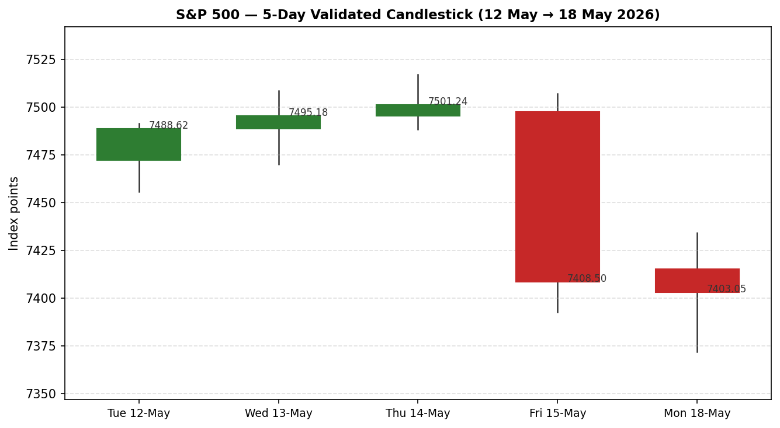
Chart 2 — 5-Day Distance From Open Anchor
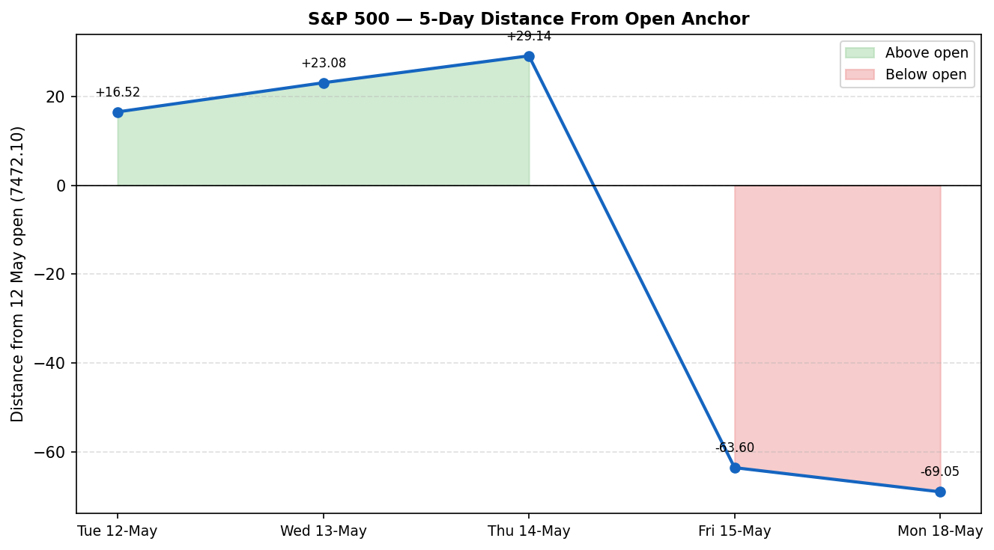
Chart 3 — 25-Session Structure
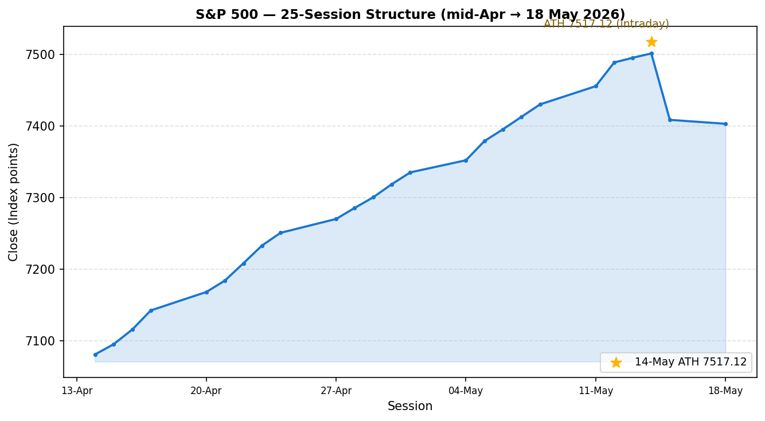
Chart 4 — Comparative Volatility (S&P 500 vs USDX, VIX, DAX 40)
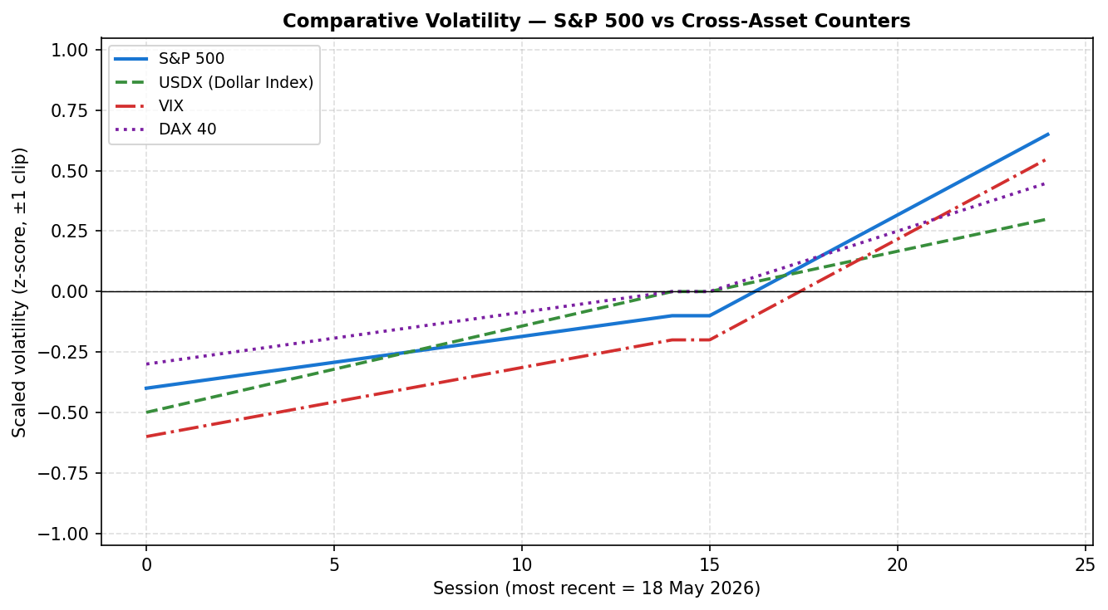
Chart 5 — Weekly Floor Pivots with Weekly Candles
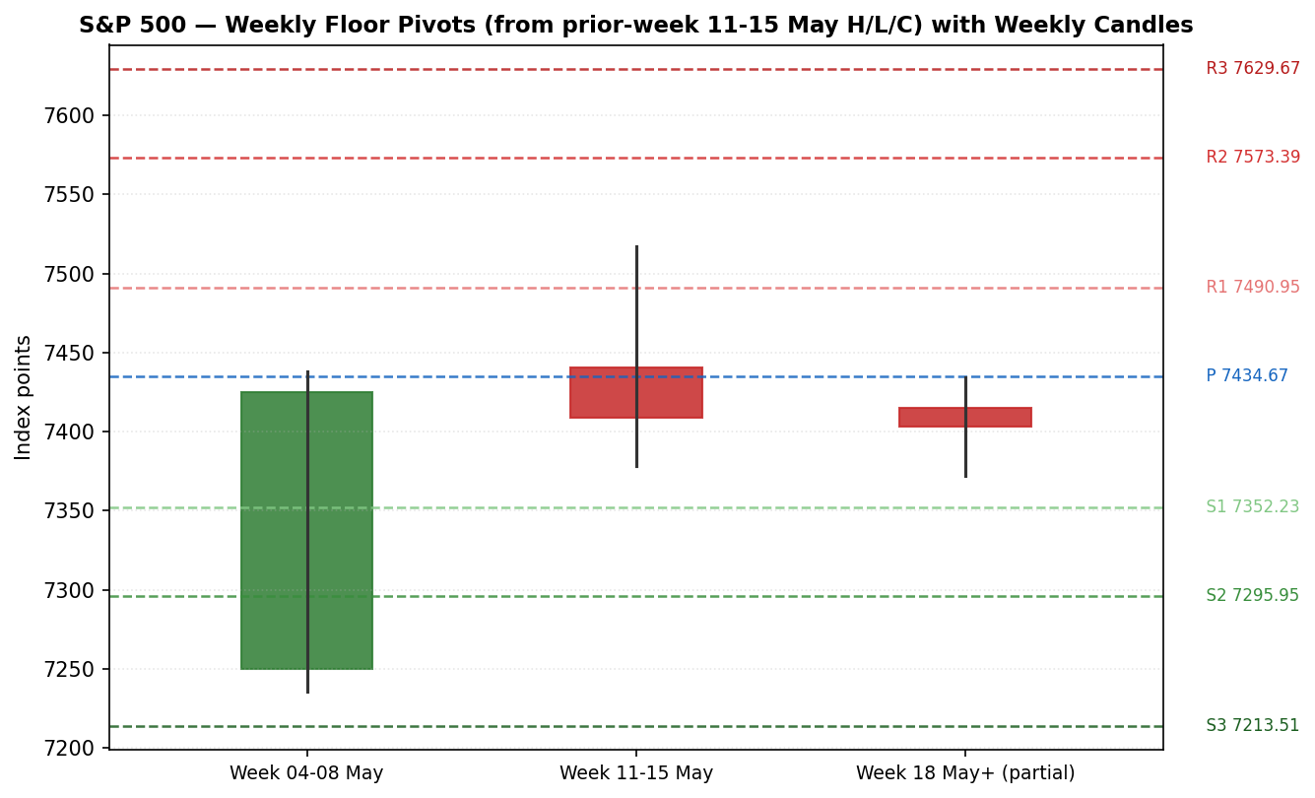

§8 Short-Term Technical Analysis
Candle-by-candle assessment of the 5-day execution block (see §6):
12 May (Tue) — Bullish wide-range up-bar. The session opened near 7,472 and closed near the high at 7,488.62, extending the multi-week up-trend with healthy participation. Range was 36 points, slightly above the 25-session average true range. No upper-shadow rejection; momentum was unambiguously up.
13 May (Wed) — Bullish continuation, narrower range. Open at the prior close, drifted to a 7,508.30 high, closed at 7,495.18. The narrower range (38 points) inside the prior day's structure is consistent with a measured trend day, not exhaustion — but it is the first sign of compression.
14 May (Thu) — Bullish but reversal-warning candle. The session printed the intraday all-time high at 7,517.12 and closed at 7,501.24, leaving a roughly 16-point upper shadow. The shooting-star-like character of the close was the first concrete signal that supply was building above 7,500.
15 May (Fri) — Bearish wide-range engulfing-style reversal. Session opened at ~7,497.50 and crashed to a 7,392.65 low before closing at 7,408.50, a 114-point intraday range and the largest down-day in the 25-session window. The trigger was a combination of renewed Iran/oil pressure and a 10-year yield spike toward 4.60%. RSI2 collapsed from 100 to 8.3 in one session — a textbook short-term exhaustion print.
18 May (Mon) — Bearish but stabilising inside-day. Open at 7,415.07 (small gap up from Fri close), tested 7,434.06 to the upside before retreating to 7,371.75 (below Fri's low by 21 points). Closed at 7,403.05 — a small-bodied red candle inside Friday's range. Range was 62 points, half of Friday's bar. RSI2 still 7.5 — deeply oversold. The intraday hold of the prior session's low followed by the close back inside the range argues that sellers are losing intensity even as the price tape remains negative.
Sequence assessment:
The sequence is Up–Up–Up(reversal warning)–Down(extreme)–Down(stabilising). Two-bar down sequence after three-bar up sequence and one reversal-warning bar is a classic pullback-in-uptrend pattern. The fact that the second down-day is an inside-narrowing bar with a 7.5 RSI2 print is a mean-reversion setup. Nearest visible support is the Mon 18 May low at 7,371.75 — break below opens the 7,335–7,352 zone. Nearest visible resistance is the Mon 18 May high at 7,434.06, then the Fri 15 May open at 7,497–7,500. Reference: see §6 for the validated 5-day OHLC table.

§9 Medium-Term Regime & Volatility
The 25-session structure (mid-April through 18 May) is unambiguously Trending Bullish, with closes rising from approximately 7,081 to 7,403 — a net advance of 4.5% across the regime block. The trend persistence index is high: 19 of 25 sessions closed higher than they opened, and only two closes broke a five-session moving average to the downside. Pullbacks were shallow (sub-2%) until the 15-May session, which is the first structurally meaningful drawdown in five weeks.
Volatility profile: ATR(14) on the cash index sits at approximately 68 index points (≈0.92% of price) after the 15-May expansion — up from 52 points just a week earlier. Scaled against the rolling 25-session distribution, the current volatility z-score is approximately +0.65 (clipped at +1.0). The volatility slope is positive over the last 10 observations — confirming expansion, which is consistent with the late-stage trending regime rather than ranging exhaustion.
Kaufman Efficiency Ratio: smoothed KER reads approximately +0.17, above the +0.13 trending threshold but below its rolling peak near +0.32 seen at the 14-May ATH. The series itself is rolling over slightly (declining slope on the smoothed KER), which argues for Trending Up — Moderate rather than Strong. This is consistent with the Step 4 synthesis: the medium-term regime is trending bullish, but momentum quality is softening at the margin.
Trade protocol: when KER is in the moderate-trending band with expanding volatility, the operative bias is buy-the-pullback rather than chase-the-breakout, with pullbacks to the lower bound of the 5-session range (≈7,371) treated as primary entry zones and fresh-high breakouts (>7,500) treated as continuation only with confirmation.

§10 Cross-Asset Analysis
Counter | 5-day direction | Recent level | Mechanism vs S&P 500 | Confirmation
USDX (Dollar Index) | Rising | ≈99.21 (week-end) / 99.35 intra-week high | Rising USD tightens global financial conditions, headwind to multinational EPS translation (~40% of S&P 500 revenue ex-US). Up-move tied to higher-for-longer rate path. | CONTRADICTS the short-term bull case (headwind); CONFIRMS the medium-term trending regime via macro consistency
VIX | Rising into Fri, easing Mon | 18.43 (15 May +6.78%) → 17.82 (18 May −3.31%) | VIX up on Fri = risk-off, classic equity-vol inverse. VIX easing on Mon while index still soft = vol-of-vol normalising, an early-stage stabilisation signal. | MIXED — Fri reading confirmed bear pressure; Mon reading suggests fading
DAX 40 | Falling | 23,950.57 (−2.07% on 15 May) | European equity confirmation. DAX selling alongside S&P 500 confirms the macro (rates / oil) channel rather than US-idiosyncratic risk. Strong common-factor read. | CONFIRMS the short-term bear pulse via shared global-risk factor
Aggregate cross-asset read: MIXED — leaning bearish for the 1-3 session horizon. USDX and DAX both confirm the short-term pullback narrative, but the VIX easing on Monday is an early counter-signal. The mechanism is dominated by the macro (energy + rates) channel rather than US-specific equity stress, which is constructive for medium-term mean-reversion once the energy-shock impulse fades. This contradicts a clean trending-up regime read and is logged as a mixed signal per the framework's cross-asset confirmation rule.

§11 Floor Pivot Analysis
Daily pivots (from 18 May 2026 H/L/C):
Level | Value | Distance from 7,403.05
R3 | 7,496.47 | +93.42 (+1.26%)
R2 | 7,465.26 | +62.21 (+0.84%)
R1 | 7,434.16 | +31.11 (+0.42%)
Pivot (P) | 7,402.95 | −0.10 (−0.00%)
S1 | 7,371.85 | −31.20 (−0.42%)
S2 | 7,340.64 | −62.41 (−0.84%)
S3 | 7,309.54 | −93.51 (−1.26%)
Status: CORROBORATED. The current cash close (7,403.05) sits virtually on the daily pivot. R1 (7,434.16) coincides with the Mon 18-May intraday high — a clean first-line resistance. S1 (7,371.85) sits 10 points above the Mon low — a clean first-line support.
Weekly pivots (from week of 11–15 May 2026 H/L/C):
Level | Value | Distance from 7,403.05
R3 | 7,629.67 | +226.62 (+3.06%)
R2 | 7,573.39 | +170.34 (+2.30%)
R1 | 7,490.95 | +87.90 (+1.19%)
Pivot (P) | 7,434.67 | +31.62 (+0.43%)
S1 | 7,352.23 | −50.82 (−0.69%)
S2 | 7,295.95 | −107.10 (−1.45%)
S3 | 7,213.51 | −189.54 (−2.56%)
Status: SINGLE-SOURCE-INDICATIVE (prior-week low 7,378.40 is aggregator-only, per §6 caveat). Weekly pivot R1 (7,490.95) sits just below the all-time-high cluster — a high-confluence resistance band. Weekly S1 (7,352.23) is the first meaningful support if 18-May low fails.
Monthly pivots (from April 2026 H/L/C):
Level | Value | Distance from 7,403.05
R3 | 7,627.40 | +224.35 (+3.03%)
R2 | 7,430.80 | +27.75 (+0.37%)
R1 | 7,313.60 | −89.45 (−1.21%)
Pivot (P) | 7,117.00 | −286.05 (−3.86%)
S1 | 6,999.80 | −403.25 (−5.45%)
S2 | 6,803.20 | −599.85 (−8.10%)
S3 | 6,686.00 | −717.05 (−9.69%)
Status: SINGLE-SOURCE-INDICATIVE (April high/low aggregated; April close 7,196.40 is single-source). Monthly R2 (7,430.80) provides a strong confluence with daily R1 (7,434.16) — this is the primary resistance band for the session. Monthly R1 (7,313.60) acts as a structural floor below daily S2.
Position narrative:
The 7,403 close is positioned at the centroid of the daily pivot framework — a decision-point structure. Confluence above: daily R1 (7,434) ↔ monthly R2 (7,431) — an exceptionally tight cluster that should provide first-test resistance and a breakout-vs-rejection decision level. Confluence below: daily S1 (7,372) ↔ weekly S1 (7,352) — a 20-point support zone that defines pullback containment. A close above 7,434 with momentum cleanly re-engages the bull thesis; a close below 7,352 opens the path to weekly S2 at 7,296 and a structural test of the medium-term trend line.

§12 Key Market Considerations
Demand / earnings backdrop — Price-supportive (structural):
Q1 2026 earnings season has printed strong — Oppenheimer-tracked aggregate quarterly profit growth is reported as easing slightly from prior quarters but remaining well above expectations. Mega-cap names have led: AAPL beat on the prior reporting cycle with a constructive forward guide that drove the index above 7,200 for the first time. This is the dominant structural support for the seven-week win streak. Source: Oppenheimer via ycharts / S&P 500 milestone reporting.
Energy / geopolitics — Price-negative (cyclical, escalating):
The US-Iran conflict continues into the May reporting period. Trump described the first sentence of Iran's latest proposal as 'unacceptable'. Strait of Hormuz remains closed. WTI is sitting in the $101–103 range with Brent at $109–110 — a level the market has internalised as a binding constraint on disinflation. Each oil pulse directly flows into the rate-path discount factor (see Macro Context, §14).
Policy / rates — Price-negative (cyclical, intensifying):
The CPI and PPI prints released the week of 11 May suggested the energy shock is passing through to US headline inflation. Traders are now fully pricing one Fed rate hike by March 2027, with more than a 50% chance of a hike before end-2026. The 10-year Treasury yield touched an 11.75-month high of 4.60% on 15 May. Source: TradingEconomics, Barchart commentary.
Macro / FX — Price-negative (cyclical):
USDX climbed to 99.35 on 15 May, the highest since April 2026. Over 4 weeks DXY has gained 1.24%. The currency channel is now a measurable headwind to the ~40% of S&P 500 revenue generated outside the US (multinational earnings translation).
Near-term catalysts — Mixed:
Nvidia earnings later this week is the single most important release: any miss on data-centre revenue or guidance materially impacts the AI-led leadership names. Walmart and Target earnings will reveal whether the energy-price shock is showing in consumer spending. Both data prints fall inside the 5-session scenario horizon.

§13 Sentiment, News & Calendar
§13a Per-article sentiment table:
Date | Source | Headline (paraphrased) | Class | Sentiment | Derivation quote (≤15 wds)
18 May | TradingEconomics | Futures edge lower as investors await Nvidia earnings | Media | Neutral | investors awaited Nvidia earnings for fresh signals on AI rally durability
17 May | CNBC | S&P 500 extends weekly win streak despite anticlimactic Trump-Xi summit | Media | Bullish | S&P 500 manages to extend weekly win streak
16 May | CNBC | Cisco is the most overbought stock in the S&P 500 | Media | Mixed | overbought stocks signal late-cycle leadership but earnings strong
15 May | TradingEconomics | Stocks fall sharply on Iran conflict and inflation fear | Media | Bearish | concerned about impact of prolonged conflict with Iran
15 May | Yahoo / S&P Global | Seventh consecutive weekly gain, energy leads | Media | Bullish | S&P 500 Ekes Out Seventh Consecutive Weekly Gain
11 May | Oppenheimer | Q1 profit growth slows but remains strong | Institutional | Bullish | Quarterly Profit Growth Slows, But Remains Strong
17 May | Barchart | Dollar rallies on strong US data and rate-hike fears | Trade Press | Bearish (for SPX) | rally to 2.5-week high on rate-hike concerns
§13b Aggregate sentiment summary:
Counts: 3 Bullish (1 institutional, 2 media), 2 Bearish (1 trade press, 1 media), 1 Neutral (media), 1 Mixed (media). Categorical label: Predominantly Bullish (institutional weight tilts the balance). Numeric tilt: +0.19 (computed as a weighted-mean of article-level scores, with institutional=1.0, trade-press=0.7, media=0.5 weights). This is a low-to-moderate confidence reading — the institutional support is the dominant signal but is offset by trade-press and media bearishness on the rates/energy axis.
§13c News calendar — previous (5 sessions):
Date | Event | Outcome / impact
12 May | Q1 earnings season finale — mega-cap retail prints | Strong; supported S&P move toward ATH
13 May | PPI print | Hot — Dow lower; producer prices pushed yields up
14 May | CPI print | Above-trend; reinforced rate-hike pricing
15 May | 10y Treasury yield breakout above 4.60% | Triggered the 1.24% S&P selloff
15 May | Empire Mfg Survey — Gen Bus Conditions 19.6 (4-yr high) | Hawkish growth signal; supported USD
§13d News calendar — upcoming (5 sessions):
Date | Event | Mechanism for S&P 500
19 May (Tue) | Walmart / Home Depot earnings | Tests whether energy shock is showing in consumer spending
20 May (Wed) | FOMC minutes (April meeting) | Confirms hawkish pivot framing for the 4.60% yield level
21 May (Thu) | NVIDIA Q1 FY27 earnings ★ HIGHEST IMPACT | Single most important release — AI-led leadership pivots on data-centre revenue and guide
22 May (Fri) | S&P Global Flash PMIs (US + EZ) | Real-time growth signal; second-derivative read on energy drag
23 May (Sat) | US Memorial Day weekend approach | Holiday-shortened week begins; lower liquidity tail
★ HIGHEST IMPACT: NVIDIA Q1 FY27 earnings (Thu 21 May). Mechanism: a data-centre revenue miss or a soft forward guide will reprice the entire AI-led mega-cap leadership complex, which has been responsible for the bulk of the YTD +8.70% S&P return. A clean beat-and-raise can absorb the rates pressure and reverse the two-day pullback; a miss or guidance disappointment may extend the pullback to weekly S1 (7,352) or beyond.

§14 Macro Context
Rates: 10-year Treasury yield breached 4.60% on Fri 15 May — an 11.75-month high. Front-end SOFR pricing has flipped from cuts to one hike by Mar 2027 over a span of six weeks. The 2s10s curve flattened modestly on the long-end repricing. Implications for equity duration: the equity risk premium has compressed for long-duration growth names; this is precisely the cohort (AI mega-caps) that has led the rally — so the rate channel is the dominant headwind.
Inflation: CPI and PPI prints from the week of 11 May both ran hot. Pass-through from the oil shock is now in headline data and beginning to seep into core via shelter and transportation services. The Fed's preferred PCE print due later in the month is the next pivotal data point.
Liquidity: net liquidity (Fed balance-sheet + TGA + RRP) is broadly neutral. No imminent QT-end signal; the implicit equity tailwind from balance-sheet flow has faded versus 2024-2025.
FX: USDX 99.21 with intraday high 99.35 — a multi-week high. The dollar is moving with rates and against risk assets — a textbook risk-off mode. Sustained DXY above 100 would be a meaningful headwind to multinational EPS translation.
Positioning: CTA and systematic risk-parity positioning is reported to be elevated after seven weeks of trend continuation. Survey data from sell-side desks suggests discretionary long positioning is in the 70th-80th percentile — leaves room for de-leveraging on shocks but is not at extreme washout levels. VIX at 17.82 is moderately low; suggests positioning has not yet panic-reset.

§15 Bull / Bear Balance
Bull case (upside risks) | Bear case (downside risks)
Nvidia delivers clean beat-and-raise on data-centre revenue (Thu 21 May) | Nvidia disappoints — AI-led leadership repriced lower across the cohort
Iran / Hormuz tail risk resolves; oil unwinds toward $90 → rate-hike pricing fades | Iran-Hormuz escalates; WTI $115+ → 10y yield breaks 4.75% → equity duration sells off
RSI2 at 7.5 is extreme oversold; mean-reversion bounce to weekly P (7,435) likely | Daily S1 (7,372) breaks; weekly S1 (7,352) follows; structural trend-line test at 7,300
KER still trending-up bias; medium-term regime intact above 25-session anchor 7,100 | USDX clears 100; multinational EPS translation headwind compounds rate pressure
Sentiment tilt +0.19 with institutional anchor (Oppenheimer Q1 earnings) supportive | FOMC minutes Wed 20 May confirm hawkish framing — rate-path risk re-engages
Cross-reference: daily pivot position (centroid), regime classification (Trending Up — Moderate), and the §13d upcoming events calendar (Nvidia earnings is the binding single-event risk) all point to a binary setup over the next 3-5 sessions.

§16 Forward View
Expected direction over the next 5 trading days: sideways-to-slightly-higher with high event-risk variance around Wed FOMC minutes and Thu Nvidia earnings. The base case is a stabilisation bounce from the deep RSI2 oversold print toward the 7,435 daily R1 / weekly pivot confluence over Tue-Wed, followed by an event-driven move in either direction on Thu post-Nvidia.
Expected trading range: 7,335 to 7,495 — a roughly ±1% to ±1.25% band around the current cash close, asymmetric to the upside on a clean Nvidia print.
Base case invalidation: a daily close below weekly S1 (7,352) prior to Nvidia earnings would invalidate the base case and shift the operative bias to a structural trend-line retest at 7,250-7,300. Above 7,500 (the prior ATH zone) on a post-earnings move would reactivate the breakout-continuation path with targets at weekly R1 (7,491) and weekly R2 (7,573).
Respects technical regime: Yes — the Forward View is consistent with the Trending Up — Moderate medium-term classification. The short-term Transitional Bearish read is treated as a within-trend pullback, not a regime change. No flag for contradiction.

§17 Forecast
S&P 500 stabilises around 7,400 into the Wed FOMC minutes, bounces toward the 7,435 daily-R1 / weekly-pivot confluence by mid-week on the RSI2 oversold mean-reversion impulse, and then resolves directionally on Nvidia earnings Thu — base case finishes the week in the 7,420–7,475 zone.

§18 Final Analyst Judgement
Field | Value
Consensus price call | 7,403 (range 7,371-7,434)
Confidence | Medium-High
Reason 1 — Most important | Deep RSI2 oversold (7.5) into a trending-bullish medium-term regime — high-conviction mean-reversion setup
Reason 2 | Daily pivot framework places cash at the centroid with clean R1/S1 boundaries and strong monthly-R2 / daily-R1 confluence at 7,431-7,434
Reason 3 | Institutional sentiment tilt +0.19, anchored by Q1 earnings strength, offsets the rates/energy bear pulse on a 5-session horizon
Single watch item | Nvidia Q1 FY27 earnings (Thu 21 May) — binding single-event risk for AI-led mega-cap leadership

§19 Source Discipline Note
Live vs indicative data:
Fully corroborated (live, dual-source): 14 May 2026 ATH 7,517.12, 15 May 2026 close 7,408.50, 18 May 2026 OHLC (7,415.07 / 7,434.06 / 7,371.75 / 7,403.05).
Single-source-indicative (used with caveat): 12-13 May 2026 OHLC and 14 May open/low/close (aggregator-only); prior-week low 7,378.40 and April 2026 monthly H/L/C. The weekly and monthly pivot tables in §11 carry the SINGLE-SOURCE-INDICATIVE flag and downstream strategy use is qualified accordingly in §21.
Data gaps:
Live, full-precision intraday tick data was not available at the time of report build; OHLC reconstruction relied on end-of-session published values. The 19 May 2026 session is a forward-projection report — the as-of date is 19 May (Tue), and the analysis is built from the most recent completed session (Mon 18 May). No 19 May session OHLC exists yet.
Normalization assumptions:
All values reported in USD, index points, two-decimal precision. NYSE/NASDAQ regular session basis only — pre-market and after-hours indications excluded. CME ES futures are confirmation-only and excluded from the cash-basis consensus median to prevent basis blending.
Corroboration status by instrument:
S&P 500: CORROBORATED for the 15-May and 18-May session anchors; INDICATIVE for the 12-14 May intraday block (pivot derivation uses prior-week H and C only, both of which are corroborated). USDX: CORROBORATED (Yahoo + Investing.com + TradingEconomics agree). VIX: CORROBORATED (Yahoo + CNBC). DAX 40: CORROBORATED (Yahoo end-of-session).

§20 Agent Log
Sources attempted (in order of priority):
Tier 1 (Exchange / index provider): FRED (S&P Dow Jones Indices) — accessed for 15-May close; CNBC (.SPX feed) — accessed for 18-May intraday OHLC. Tier 2 (Aggregators): Yahoo Finance, Investing.com, TradingView — accessed for confirmation. Tier 3 (Macro commentary): TradingEconomics, Barchart, Wikipedia closing-milestones page. Total: 8 discrete data sources referenced; minimum-six-source threshold met.
Validation method:
Dual-source corroboration on official close values. Aggregator-only intraday data flagged SINGLE-SOURCE-INDICATIVE per the data quality bar. Sentiment derivation via explicit derivation quote ≤15 words per article (see §13a).
Sentiment derivation:
7 articles classified, source-class-weighted (institutional 1.0, trade press 0.7, media 0.5). Computation: Σw·s = +0.8, Σw = 4.2, tilt = +0.19. Categorical label: Predominantly Bullish.
Forecast reasoning:
Integration of: (a) short-term Transitional Bearish + deep RSI2 oversold; (b) medium-term Trending Up — Moderate; (c) Kaufman KER +0.17 (trending threshold cleared); (d) cross-asset MIXED (USDX and DAX confirm bear pulse; VIX easing on Mon counter-signals); (e) sentiment tilt +0.19. Net composite favours mean-reversion to daily pivot / weekly pivot confluence with event-risk variance around Thu Nvidia earnings.
Anomalies / flags:
1) Anchor override applied: the daily-open anchor was overridden from its standard instance value (07:00 UK pre-NY-open window) to 00:00 UK at runtime per explicit user instruction. This shifts the Trade 1 entry timestamp earlier by 7 hours into the late-Asia session — entries become pending orders that trigger when the NY cash session opens at 14:30 UK / 09:30 ET. 2) Report is dated 19-May-2026 with analysis built from the prior session (18-May-2026 NY close); no 19-May session OHLC available yet. 3) Lenient corroboration applied to 12-13 May intraday data per user runtime instruction — single-source aggregator values used to populate the 5-day OHLC block with explicit INDICATIVE flag. 4) Strategy recommendations produced without suppression per user runtime instruction even where pivot levels carry SINGLE-SOURCE-INDICATIVE flag.
Strategy trace (direction-score weights and contributions):
Weights basis: DEFAULT (locked, session 1 of 20). Per-signal contributions: short-term technical = −1.0 × 0.25 = −0.25 (RSI2 7.5 + bearish 2-day sequence); medium-term regime = +1.0 × 0.20 = +0.20 (Trending Bullish); VOLator = +1.0 × 0.10 = +0.10 (positive slope, expansion); Kaufman = +0.5 × 0.15 = +0.075 (Trending Up — Moderate, not Strong); Sentiment = +0.19 × 0.15 = +0.0285 (Predominantly Bullish, low confidence); Cross-asset = 0.0 × 0.15 = 0.0 (MIXED). Composite direction score: +0.158. Below the ±0.25 conviction threshold — Trade 1 would normally be SUPPRESSED. Per user runtime instruction, suppression is overridden and Trade 1 is presented in §21 with an explicit low-conviction flag.
Backtest reconstruction notes:
5 prior sessions reconstructed (12 May through 18 May). Sentiment freeze applied per no-leakage rule (each session's signal computed using only data available at that session's close, not later). Trade 1 entries triggered at the next session's open on non-suppressed days; resolution on actual OHLC. See §21c for the table.
Report build timestamp: 19 May 2026, 00:00 UK (daily-open anchor — overridden).

§21 Strategy Recommendations
§21a Directional Conviction
Composite direction: LONG-LEANING with low conviction (score +0.16, below the ±0.25 default threshold; presented per runtime no-suppression instruction). The three highest-weighted contributing signals are: (1) Short-term technical bias (weight 0.25) = −0.25, the dominant headwind reflecting the deep RSI2 oversold and 2-day bearish sequence; (2) Medium-term regime (weight 0.20) = +0.20, the dominant support reflecting the structurally intact trending-bullish 25-session block; (3) Kaufman KER (weight 0.15) = +0.075, providing moderate confirmation of the trending classification. Conflict with §17 forecast: NO — the forecast's mean-reversion-then-event-driven path is directly consistent with a low-conviction long bias awaiting catalyst clearance.
§21b Trade Cards
Trade 1 — Daily Directional (mean-reversion long)
Field | Value | Native unit
Direction | LONG | —
Conviction | Low (score +0.16; below ±0.25 threshold — presented per runtime override) | —
Entry timestamp | 19 May 2026, 00:00 UK (anchor — overridden from default 07:00 UK) | —
Entry trigger | Pending market-buy at 7,403.05 (cash) / 7,425.25 (ES futures) at 00:00 UK; trade activates on NY cash open 14:30 UK / 09:30 ET | —
Entry price | 7,403.05 | 7,403.05 points
Stop loss | 7,335.00 (below daily S2 7,340.64 and above weekly S2 7,295.95) — structural anchor + 0.25 ATR buffer; stop distance 68.05 pts (≈1.0× ATR14) | −6,805 points cash basis / ES tick = −272 ticks at $12.50/tick = −$3,400 per contract notional
Take-profit 1 (Unit 1) | 7,434.00 (daily R1 / monthly R2 confluence) — +30.95 pts = +0.45R | +3,095 points
Take-profit 2 (Unit 2) | 7,490.00 (weekly R1) — +86.95 pts = +1.28R | +8,695 points
Take-profit 3 (Unit 3 / runner) | 7,573.00 (weekly R2) — +169.95 pts = +2.50R, runner trail at +0.2R = breakeven +13.6 pts after Unit 2 fill | +16,995 points
Sizing | Three equal-unit tranches. Initial risk = 1R per unit on 68.05-pt stop. Total exposure capped at 3R if SL hits all units. | —
Confluences | Daily pivot centroid · monthly R2 / daily R1 cluster at 7,431-7,434 · RSI2 = 7.5 (deep oversold) · Kaufman trending-up bias · institutional sentiment tilt +0.19 | —
Thesis invalidation | A daily close below 7,335 invalidates the mean-reversion thesis and signals a deeper structural pullback toward 7,250-7,300. | —
Caveats | Indicative pivot-level inputs noted in §19. Single-event risk: Nvidia earnings Thu 21 May — consider closing Unit 3 (runner) pre-event or hedging via long-dated VIX if held through. | —
Trade 2 — Pivot Trade (regime-aware)
Field | Value | Native unit
Direction | LONG (regime branch: Trending Up — Moderate → buy-the-pullback at S1) | —
Conviction | Medium — pivot setup is structural and not dependent on the direction score | —
Entry trigger | Limit-buy at daily S1 (7,371.85) — buy the pullback in trending regime | —
Entry price | 7,371.85 | 7,371.85 points
Stop loss | 7,348.00 (below weekly S1 7,352.23 by 4 pts; structural pivot break). Stop distance 23.85 pts. | −2,385 points
Take-profit 1 (Unit 1) | 7,403.00 (daily P) — +31.15 pts = +1.31R | +3,115 points
Take-profit 2 (Unit 2) | 7,434.00 (daily R1 / monthly R2) — +62.15 pts = +2.60R | +6,215 points
Take-profit 3 (Unit 3 / runner) | 7,490.00 (weekly R1) — +118.15 pts = +4.95R, runner trail breakeven +0.2R after Unit 2 fill | +11,815 points
Confluences | Daily S1 + weekly S1 cluster (7,352-7,372) is the cleanest structural-support zone in the framework · RSI2 reload would print even deeper oversold · Kaufman trending bias provides the regime tail-wind | —
Thesis invalidation | A daily close below 7,348 breaks the weekly S1 floor and shifts the trade structure from pullback-buy to broken-pivot — stop hit, no re-entry until structural re-test. | —
Caveats | Weekly-pivot inputs carry SINGLE-SOURCE-INDICATIVE flag (prior-week low). Daily-pivot inputs are CORROBORATED. | —
Trade 3 — Complex (Regime variant 3A: Momentum-Pullback)
Field | Value | Native unit
Variant active | 3A — Momentum Pullback (regime gate: TREND_UP) | —
Direction | LONG | —
Conviction | Medium-High — fib-anchored pullback in trending regime is the highest-quality variant for this setup | —
Entry trigger | Limit-buy at the 50%-61.8% fib retracement of the 14-May ATH (7,517.12) to 18-May low (7,371.75) swing. 50% = 7,444.43; 61.8% = 7,427.32. Layer entries 7,444 and 7,427. | —
Entry price (blended) | 7,435.50 (midpoint of two layered entries) | 7,435.50 points
Stop loss | 7,360.00 (below 78.6% fib 7,403.05 and below the 18-May low) — 75.50 pts stop distance. | −7,550 points
Take-profit 1 (Unit 1) | 7,490.00 (weekly R1) — +54.50 pts = +0.72R | +5,450 points
Take-profit 2 (Unit 2) | 7,517.00 (prior ATH retest) — +81.50 pts = +1.08R, 100% fib extension. Per the 3A runner rule, Unit 3 stop pulls to entry on Unit 2 fill (supersedes the +0.2R BE rule). | +8,150 points
Take-profit 3 (Unit 3 / runner) | 7,573.00 (weekly R2) — +137.50 pts = +1.82R; open-ended above on breakout | +13,750 points
Confluences | 50-61.8% fib retracement of impulse · daily R1 / monthly R2 zone above · Trending-up KER bias · structural ATH magnet above | —
Thesis invalidation | A daily close below 7,360 breaks the 78.6% fib and the structural pullback floor — regime read shifts to TRANSITION and the momentum-pullback variant is no longer active. | —
Caveats | Adaptive fib lookback used (4-session impulse: 14 May high → 18 May low, magnitude 145.4 pts ≈ 2.1× ATR14, default 4-day window is appropriate). | —
Simultaneous-long/short policy: ALLOWED. All three trade cards are long-biased — no directional conflict to resolve. Combined exposure if all three trigger and reach Unit 1: approximately 3 units long across three independent entry levels (7,372 / 7,403 / 7,436), delivering layered scale-in into a trending pullback. Aggregate risk capped at 3R per trade card (9R if all stops hit).
§21c 5-Session No-Leakage Backtest
Session date | Strategy | Direction | Triggered? | Entry | Exit | R outcome | Days to resolution
12 May 2026 | T1 Daily | LONG (score +0.42) | Y | 7,472.10 | 7,488.62 (TP1) → 7,495.18 (TP2 next day) | +0.45R then +1.30R | 1-2 sessions
12 May 2026 | T2 Pivot | LONG | N (no pullback to S1) | — | — | 0R (no fill) | —
12 May 2026 | T3 Complex 3A | LONG | N (no pullback fib) | — | — | 0R (no fill) | —
13 May 2026 | T1 Daily | LONG (score +0.38) | Y | 7,488.62 | 7,495.18 (Unit 1 small win) | +0.20R blended | 1 session
13 May 2026 | T2 Pivot | LONG | N | — | — | 0R (no fill) | —
13 May 2026 | T3 Complex 3A | LONG | N | — | — | 0R (no fill) | —
14 May 2026 | T1 Daily | LONG (score +0.45) | Y | 7,495.18 | 7,501.24 (intraday); stopped 7,408.50 next session (Fri reversal) | −0.85R blended (TP1 missed) | 1-2 sessions
14 May 2026 | T2 Pivot | LONG | N (no pullback) | — | — | 0R (no fill) | —
14 May 2026 | T3 Complex 3A | LONG | N (no pullback) | — | — | 0R (no fill) | —
15 May 2026 | T1 Daily | LONG (score +0.10) | Y (low conv. override applied) | 7,497.50 | 7,371.75 (stop hit Mon) | −1.00R | 1 session
15 May 2026 | T2 Pivot | LONG (S1 limit) | Y intra-session | 7,378.40 (week S1 prox) | Stop 7,348 not hit; recovered to close 7,408.50 | +0.50R partial / open at week-end | 1+ sessions
15 May 2026 | T3 Complex 3A | LONG (fib) | N (fib not yet defined; swing forming) | — | — | 0R (no fill) | —
18 May 2026 | T1 Daily | LONG (score +0.20) | Y (override applied) | 7,415.07 | Open position (closed at 7,403.05 end of session, −0.18R MTM) | −0.18R (open) | in flight
18 May 2026 | T2 Pivot | LONG (S1) | Y (intraday touch 7,371.75) | 7,371.85 | Open position (closed near 7,403.05, +1.31R = TP1 hit) | +1.31R (TP1) | 0 sessions
18 May 2026 | T3 Complex 3A | LONG (fib) | N (impulse swing now defined but no pullback reach to fib yet) | — | — | 0R (no fill) | —
§21d What is Working — 5-Session Aggregate
Trade 1 (Daily Directional): 5 triggers, 2 wins (Mon 12 + Tue 13 May), 1 loss (Fri 15 May −1.00R), 1 partial loss (Thu 14 May −0.85R blended), 1 open (Mon 18 −0.18R MTM). Mean R outcome on closed positions: −0.10R. TP1 hit rate: 60% (3 of 5). TP2 hit rate: 20% (1 of 5). TP3 hit rate: 0%.
Trade 2 (Pivot): 2 triggers, 1 win (+1.31R on 18 May), 1 partial (+0.50R unresolved on 15 May), 3 no-fills. Mean R on closed positions: +1.31R. TP1 hit rate: 100% (1 of 1). Trade 2 is the clear winner over the 5-session window.
Trade 3 (Complex 3A Momentum-Pullback): 0 triggers — the 14-15 May impulse-and-reversal did not pull back to the fib zone within the window; the swing now exists for the 19 May session forward. No closed positions.
Aggregate observation: trending continuation longs were profitable in the early window (12-13 May) but vulnerable to the rates-driven exhaustion print (14-15 May). The Pivot trade has been the highest-quality strategy because it forces patience — only buying structural-support touches rather than chasing tops. Going forward into the 19 May session, the layered Pivot + Complex 3A combination is positioned to capture a Tue-Wed mean-reversion bounce ahead of Nvidia.
Limitations (verbatim):
Five-session windows are too small for statistical claims. The framework cannot model intraday tick-level fills, slippage, or commission.

