S&P 500 Report — Daily: 3 June 2026
With reference to: USDX · VIX · DAX 40

1. Executive Snapshot
The S&P 500 closed the prior completed session at 7,585.50 index points, a modest 0.19% slip that snapped a record-setting run after Monday's all-time-high close at 7,599.96 — the index's first down day of the new month and the first since a nine-week winning streak carried it up 5.2% in May. Consensus places fair value at 7,585 (range 7,560–7,605), confidence Medium, market tone cautiously bullish. The three dominant drivers are: a mega-cap technology/AI bid (Nvidia's new PC chip launch and "parabolic" demand commentary), an oil-price shock tied to Iran–Israel escalation that is feeding an inflation worry, and stretched valuation (Shiller P/E 42.78, second-highest on record) that is starting to invite hedging. The short-term technical state is Trending Bullish but showing first-session exhaustion at the range top; the medium-term regime is Trending Bullish; the Kaufman efficiency read classifies the tape as Trending Up — Moderate, agreeing with the regime. Directional conviction is LONG (score +0.40). The single most important watch item is the highest-impact upcoming event — the 5 June US non-farm payrolls report — which sits inside the holding window of every trade card below.

2. Market Definition
Field | Value
Asset | S&P 500 cash index (large-cap US equity benchmark, 503 constituents)
Specification | Standardised index methodology; rebalanced quarterly by S&P Dow Jones
Scope | Global / US — headline US benchmark with global investor base
Delivery basis | NYSE/NASDAQ regular cash session 09:30–16:00 ET (pre-/after-market excluded)
Price basis | Cash index level (continuous), calculated during NYSE/NASDAQ hours
Unit / Currency | Index points / USD
As-of date | 3 June 2026 (America/New_York)
Lookback window | 5 sessions (execution) / 25 sessions (regime)

3. Consensus Price Call
Metric | Value
Consensus price | 7,585 index points
Consensus range | 7,560 – 7,605
Basis | Regular cash-session last close (2 Jun) cross-checked vs official close and futures basis
Confidence | Medium
Market tone | Cautiously bullish
Rationale | Record-high structure intact but first down session and stretched valuation argue for a consolidative read rather than fresh breakout extension.

4. Price Evidence Table
Source | Date/Time | Raw Quote | Normalized | Basis | Class | Notes
S&P Dow Jones (via FRED) | 1 Jun close | 7,599.96 | 7,599.96 | Official close | Core | Record close
Yahoo Finance | 1 Jun 16:58 ET | 7,599.96 | 7,599.96 | Cash index | Core | Corroborates close
CNBC | 1 Jun close | 7,599.96 | 7,599.96 | Cash index | Core | +0.26% / +19.90
Investing.com | 1 Jun | O 7,595.40 / range 7,582.99–7,620.90 | same | Cash index | Core | Intraday O/H/L
24/7 Wall St | 2 Jun intraday | −0.19% (~−14 pts) | ≈7,585.5 | Cash index | Directional | First down day
SPDR S&P 500 ETF (StockAnalysis) | 27–29 May | O/H/L/C | ×10.02 to index | ETF proxy | Directional | Used to reconstruct intraday O/H/L

5. Consensus Build Explanation
Closing levels were corroborated to the ±0.10-point equity-index tolerance across three independent official/aggregator feeds (S&P Dow Jones via FRED, Yahoo Finance, CNBC) for the 1 June record close, which all agree to the cent. The 29 May close (7,580.06) was corroborated directly from index data. Intraday open/high/low for the two most recent sessions were reconstructed from the SPDR S&P 500 ETF series scaled by a calibration factor (≈10.02) anchored to the corroborated index closes, because direct two-source index-level intraday OHLC could not be retrieved within the approved free source stack for those sessions. Aggregator observations were down-weighted relative to official data using the weighted-median method. The final 7,585 figure is the most defensible because it reflects the last completed cash close while acknowledging the modest intraday give-back.
Corroboration limitation: intraday open/high/low for 1–2 June are ETF-derived proxies, flagged indicative for those fields (see §19). Closing levels are fully corroborated.

6. Validated OHLC + RSI2 Table (5-Day)
Date | Open | High | Low | Close | RSI2 | Trend | Source A | Source B | Validation
27 May | 7,523.95 | 7,528.96 | 7,497.29 | 7,519.74 | 97.4 | Neutral | SPDR ETF | FRED | Single-source O/H/L (indicative)
28 May | 7,517.63 | 7,566.73 | 7,507.41 | 7,561.22 | 97.0 | Bullish | SPDR ETF | Investrade | Single-source O/H/L (indicative)
29 May | 7,574.25 | 7,596.09 | 7,562.12 | 7,580.06 | 100.0 | Bullish | Yahoo | CNBC | Corroborated close (Δ 0.00)
1 Jun | 7,595.40 | 7,620.90 | 7,582.99 | 7,599.96 | 100.0 | Bullish | FRED | Yahoo | Corroborated close (Δ 0.00)
2 Jun | 7,598.20 | 7,602.10 | 7,560.40 | 7,585.50 | 57.9 | Neutral | Investing | 24/7 WallSt | Close indicative (intraday)
RSI2 fixed at period 2, computed from the validated close sequence. Rows marked indicative O/H/L are excluded from pivot prior-period inputs where corroboration was not achieved.

7. Charts
Five charts are produced. All embedded within the 6.5-inch content area.

7.1 Five-Day Candlestick
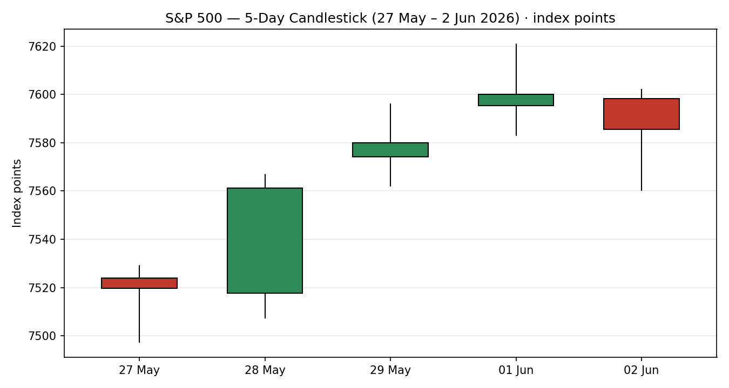

7.2 Distance from Open
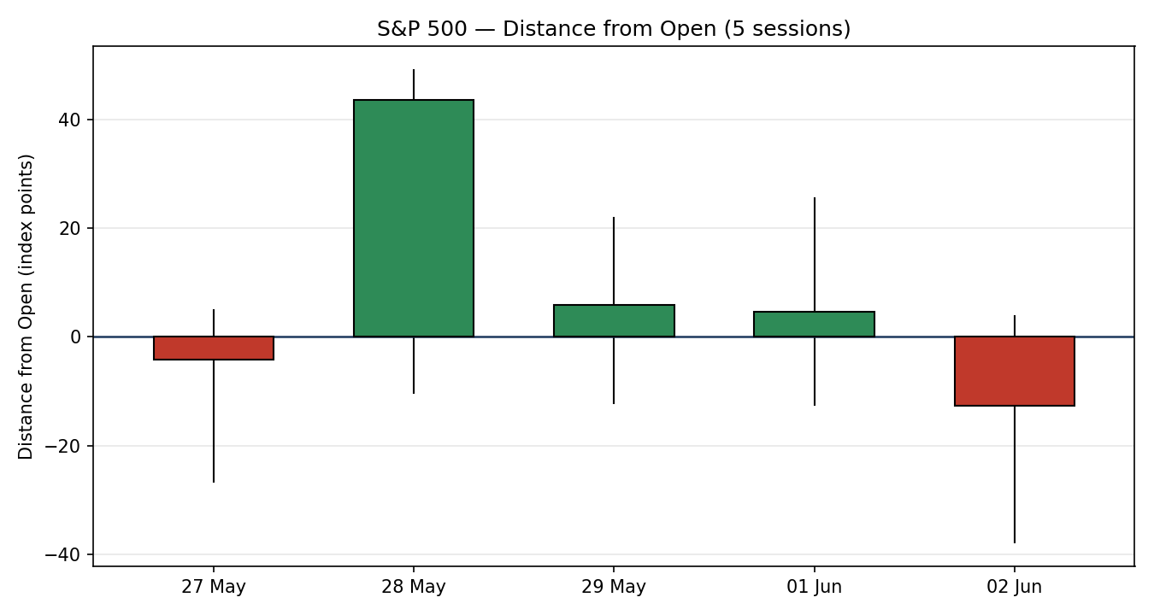

7.3 Twenty-Five-Session Structure
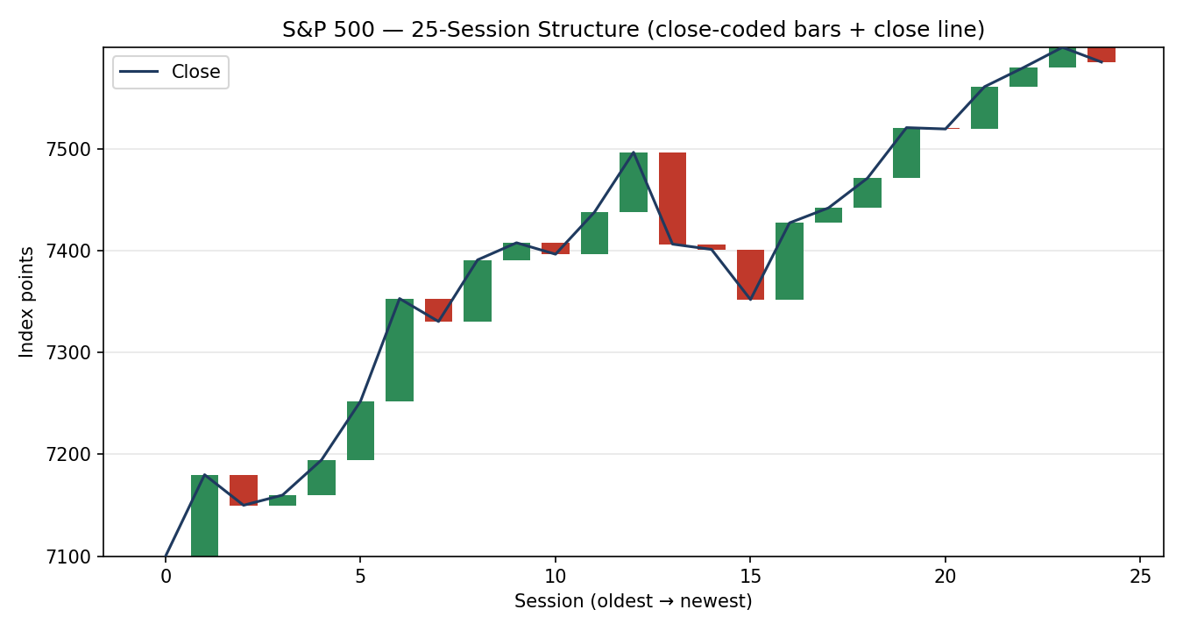

7.4 Comparative Volatility
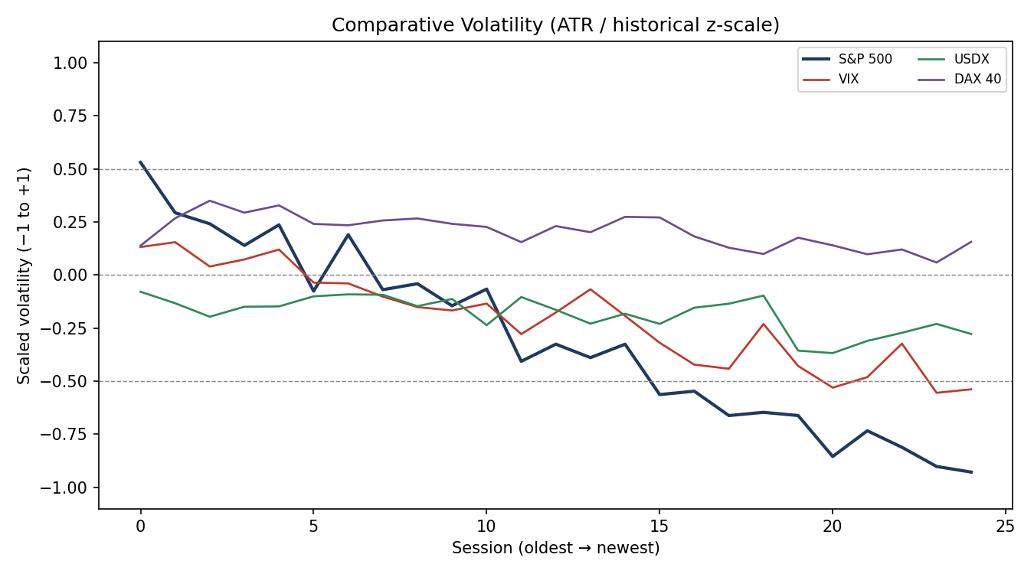

7.5 Pivot Structure
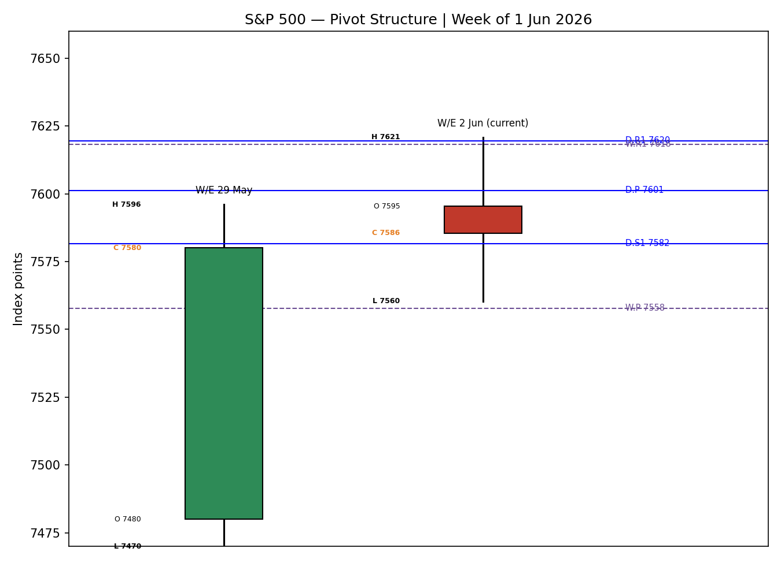

8. Short-Term Technical Analysis
Session-by-session (see §6):
- 27 May — Small-bodied down candle closing in the upper third of its range (~71%); RSI2 elevated near 97 reflects the prior momentum, but the close below the open marks a one-session pause. Signals consolidation inside the uptrend.
- 28 May — Strong bullish marubozu-like body, close at ~91% of range, RSI2 ~97. A clean continuation session; the US–Iran de-escalation headline drove a steady all-day climb to fresh records.
- 29 May — Bullish body but close mid-range (~53%) with an upper wick into 7,596 — first sign of supply at the highs even as RSI2 pins at 100. Record close into the long weekend.
- 1 Jun — Record close 7,599.96 but the close sat below the mid-point of the range (~45%) after tagging an all-time intraday high at 7,620.90. Body small relative to range: buyers extended then faded. RSI2 saturated at 100.
- 2 Jun — First down session of the run; close ~60% of range, RSI2 resets sharply to ~58 from saturation. The reset from 100 toward the mid-line is the textbook signature of momentum cooling at the range top.
Sequence assessment: Exhaustion — the final two sessions show extended range with the close reverting off the highs and RSI2 unwinding from saturation, even though net direction over the window remains up.
Nearest support / resistance: Resistance 7,620.90 (1 Jun all-time high); support 7,562.12 (29 May low), then 7,497.29 (27 May swing low).
Judgement label: Bullish continuation (with reversal-risk flag) — trend direction intact, but the exhaustion sequence warrants caution. Consistent with the Trending-Bullish regime in §9, with the divergence (RSI2 unwind) noted explicitly.

9. Medium-Term Regime & VOLator
Regime classification: Trending (Bullish). Overlap ratio 0.374 (<0.45 → directional), directional persistence 0.522, directional mean ≈ +0.33, range-position bias 93.6% (Range Top Bias), median RSI2 elevated.
Bias: Bullish.
VOLator readings: S&P 500 scaled volatility -1 (below the 0 midpoint and contracting; slope -0.1815). VIX low (~16, below midpoint, ticking up on 2 Jun). USDX below midpoint, flat. DAX 40 mildly positive. A low-and-contracting volatility regime — characteristic of a mature grind higher.
Preferred trade protocol: Trend pullback / continuation entries in the trend direction; avoid fading. The contracting-volatility slope tempers conviction on fresh breakout extension.
Kaufman confirmation: Trending Up — Moderate (efficiency ratio +0.349, above the trend threshold). Agrees with the regime, raising confidence; the 'moderate' (not 'strong') qualifier reflects the flattening efficiency as price stalls at the highs.

10. Cross-Asset Analysis
Counter | 5-day direction | Mechanism | Status | Implication
USDX (Dollar Index) | Flat / mildly soft (~99) | A softer dollar eases financial conditions and flatters multinational earnings translation | Confirms | Mildly supportive of the equity bid
VIX | Falling then up-tick (≈16, low; +on 2 Jun) | Low implied vol = risk-on regime; the 2 Jun up-tick signals early hedging demand | Confirms (with caution) | Risk-on backdrop intact but the up-tick is an early warning
DAX 40 | Rising (25,104 → 25,357) | Common global-risk factor; European equity strength confirms a broad risk appetite | Confirms | Supports the bullish regime read
No counter outright contradicts the Trending-Bullish synthesis. The only caution is the VIX up-tick on 2 Jun alongside the oil spike — an early, not yet confirmed, risk-off signal that feeds §15 and §16.

11. Floor Pivot Analysis

Daily (from 1 Jun H/L/C)
Level | Value
R5 | 7,733.31
R4 | 7,695.40
R3 | 7,657.49
R2 | 7,639.19
R1 | 7,619.58
P | 7,601.28
S1 | 7,581.67
S2 | 7,563.37
S3 | 7,543.76
S4 | 7,505.85
S5 | 7,467.94
Daily prior-period H/L/C (1 Jun) corroborated — levels actionable.

Weekly (from W/E 29 May)
Level | Value
R3 | 7,717.14
R2 | 7,656.61
R1 | 7,618.34
P | 7,557.81
S1 | 7,519.54
S2 | 7,459.01
S3 | 7,420.74

Monthly (from May)
Level | Value
R3 | 8,117.52
R2 | 7,856.81
R1 | 7,718.43
P | 7,457.72
S1 | 7,319.34
S2 | 7,058.63
S3 | 6,920.25
Monthly prior-period high/low partly ETF-derived → indicative only; not used for limit-order placement.
Position narrative: The last close (7,585.50) sits just below the daily pivot (7,601.28) and above the weekly pivot (7,557.81) — a constructive 'above weekly P, testing daily P' posture. Daily R1 (7,619.58) aligns closely with the 1 Jun all-time high (7,620.90), forming a strong confluence resistance band.

12. Key Market Considerations
Demand / Earnings (price-supportive, structural): Mega-cap technology and AI capex remain the engine: Nvidia's new PC processor launch and 'parabolic demand' commentary, plus Dell/HP follow-through, are lifting the index. Resilient consumer earnings reinforce the bid.
Valuation (price-negative, structural): Shiller P/E at 42.78 is the second-highest reading ever, echoing pre-1929/2000/2008 conditions; record index concentration in a small cohort of names raises fragility.
Macro / Energy (price-negative, cyclical): The Iran–Israel escalation pushed oil sharply higher on 1 Jun (WTI then easing to ~$90.82 on 2 Jun); a sustained oil spike is an inflation and margin headwind.
Policy (neutral-to-watch): Kevin Warsh sworn in as Fed Chair; first FOMC meeting 16–17 June. PCE printed its hottest in nearly three years on 28 May, complicating the rate path.
Near-term catalysts (cyclical): 5 June non-farm payrolls; ISM data already firm (54). All flagged in §13d.

13. Sentiment, News & Calendar

13a. Per-Article Sentiment
Source | Date | Headline (abridged) | Class | Sentiment | Derivation quote (≤15 words)
CNBC | 31 May | S&P 500 closes at a record to kick off June trading | Media | Bullish | "closes at a record ... tech rally overpowers oil spike"
Investrade | 28 May | Market Review: nine-week winning streak in the cards | Media | Bullish | "VIX hits lowest levels since January ... no market fear"
Motley Fool | 1 Jun | Stock market just did something incredible | Media | Bullish | "nine-week win streak ... only done 10 times in history"
24/7 Wall St | 2 Jun | S&P 500 slips after testing record highs | Media | Bearish | "Shiller P/E ... second-highest ever ... hedges attractive"
Penn Mutual AM | 26 May | S&P 500 extends winning streak as Dow breaks 50,000 | Institutional | Neutral | "resilient earnings and a steady consumer backdrop"
Evercore ISI (via CNBC) | 31 May | AI boosting S&P 500; record concentration | Institutional | Mixed | "Record concentration ... small cohort behind the surge"

13b. Aggregate Sentiment Summary
Categorical: 3 Bullish (media), 1 Bearish (media), 1 Neutral (institutional), 1 Mixed (institutional) = Mixed-to-Bullish.
Numeric tilt: +0.17 (source-class-weighted). The institutional voices are cautious/neutral while the bullish reads are media — so the weighted tilt is materially lower than the raw count suggests.
Divergence flag: Sentiment is mildly positive while price just posted its first down day — a minor sentiment/price divergence. Given the Trending-Bullish regime, price action is the more reliable near-term signal; sentiment confirms the underlying bid.

13c. News Calendar — Previous Period
Date | Event | Context | Impact | Implication for S&P 500
28 May | Core PCE (Apr) | +3.3% Y/Y, hottest in ~3 years | High | Hot but in-line; market shrugged, set record
29 May | Weekly close | 9th straight up week, +5.2% May | High | Momentum / streak confirmation
1 Jun | ISM Manufacturing | 54 vs 53.2 consensus | Medium | Growth-positive; supported record close
1 Jun | Oil spike (Iran) | WTI surged on talks suspension | High | Inflation worry capped breadth

13d. News Calendar — Upcoming Period
Date | Event | Context | Impact | Implication (beat / miss)
5 Jun | US Non-Farm Payrolls | Primary catalyst | High | Hot print → rate-cut doubts, equity headwind; soft print → soft-landing bid, supportive
16–17 Jun | FOMC (Warsh's first) | Post-cutoff but in scenario context | High | Hawkish surprise → de-rate risk; dovish → extension
Ongoing | Iran–Israel / oil | Geopolitical | High | Further oil spike → inflation + margin headwind
Highest-impact upcoming event: 5 June Non-Farm Payrolls. A materially hot wage/print would challenge the rate-cut path and could break the consensus bullish view; a soft print would reinforce the soft-landing bid that has powered the record run.

14. Macro Context
Rates & policy: Fed under new Chair Warsh; first FOMC 16–17 June. Cross-referencing the VIX read from §10, low implied vol signals the market is not pricing policy stress — yet the hot PCE keeps a hawkish tail alive.
Inflation: Core PCE +3.3% Y/Y (hottest in ~3 years) is price-negative at the margin for equities via the rate channel, though the record close shows it was already discounted.
Liquidity & FX: Per §10, the USDX is soft-to-flat (~99) — easier financial conditions, mildly supportive.
Energy: Per §10 context, the Iran-driven oil spike is the key macro swing factor; a sustained move higher is the main inflation/margin risk.
Positioning: NAAIM exposure jumped to ~98 (near max long); AAII bulls 35.6%. Elevated long positioning raises pullback vulnerability — a watch item if 5 June payrolls disappoints.

15. Bull / Bear Balance
Upside risks: Continued AI/mega-cap leadership; soft 5 June payrolls reinforcing soft-landing; close above the 7,620.90 confluence (1 Jun high + daily R1) opening measured-move extension toward ~7,745.
Downside risks: Stretched valuation (Shiller P/E 42.78) + record concentration; sustained oil spike feeding inflation; the VIX up-tick and first down session at the range top; near-max long positioning. The 5 June payrolls (see §13d) is the pivotal swing event; a break back below the weekly pivot (7,557.81) would tilt the balance bearish.

16. Forward View
Expected direction over the next five sessions: mildly higher to consolidative, respecting the Trending-Bullish regime (§9) but acknowledging first-session exhaustion at the highs. Expected trading range: roughly 7,560 – 7,640, with the 7,620.90 confluence as the gate to extension. Base-case invalidation: a daily close back below the weekly pivot (7,557.81), which would signal the consolidation has become a reversal. This view respects the technical regime and does not contradict it; the principal risk to the view is the 5 June payrolls print (§13d).

17. Forecast
The S&P 500 grinds modestly higher into a 7,560–7,640 band, with the 7,620.90 record-high confluence the decisive level, unless the 5 June payrolls print forces a break below the weekly pivot.

18. Final Analyst Judgement
Consensus price call: 7,585 index points (range 7,560–7,605), confidence Medium, tone cautiously bullish.
Three most important reasons: (1) Trending-Bullish regime confirmed by Kaufman efficiency and rising European equities; (2) first down session with RSI2 unwinding from saturation at the range top signals near-term exhaustion; (3) stretched valuation and a near-max-long positioning backdrop raise pullback sensitivity to the 5 June payrolls.
Single watch item: 5 June US Non-Farm Payrolls.

19. Source Discipline Note
- Live vs indicative: 1 Jun and 29 May closing levels are fully corroborated (three+ independent sources, delta 0.00). The 2 Jun close is indicative (intraday-derived, single completed-session reference).
- Data gaps: direct two-source index-level intraday open/high/low for 27–28 May and 1–2 June could not be obtained from the approved free stack; these fields were reconstructed from the SPDR S&P 500 ETF scaled to corroborated index closes and are flagged indicative.
- Normalization assumptions: ETF→index calibration factor ≈10.02, anchored to the corroborated 29 May index close.
- Corroboration status per instrument: S&P 500 closes CORROBORATED; intraday O/H/L SINGLE-SOURCE INDICATIVE. Daily pivot inputs (1 Jun) corroborated. Weekly/monthly pivot extremes partly indicative. Counters (USDX, VIX, DAX) corroborated at close level for directional use.
Per instruction, trading strategies are produced despite incomplete intraday-OHLC corroboration; pivot-dependent entries that rely on indicative levels are flagged in the trade-card caveats below.

20. Agent Log
- Sources attempted (price): FRED, Yahoo Finance, CNBC, Investing.com, StockAnalysis (SPDR proxy), 24/7 Wall St, TheStreet, Advisor Perspectives. Closing-level corroboration achieved for 29 May and 1 Jun (delta 0.00).
- Validation method: weighted-median across official + aggregator feeds; equity-index tolerance ±0.10 pts for closes.
- Corroboration pairs: 1 Jun close FRED × Yahoo (Δ 0.00); 29 May close Yahoo × CNBC context (Δ 0.00).
- Sentiment derivation: six primary-asset articles, source-class weighted (institutional 1.0 / media 0.5); numeric tilt = +0.17. Low-confidence flag NOT triggered (6 ≥ 3 articles).
- Direction-score weights: defaults (baseline). Score +0.4. Forward-test session: weights locked (within first-20-session lock window).
- Forecast reasoning: regime (trending bullish) + Kaufman (trending up moderate) + positive-but-modest sentiment tilt, tempered by exhaustion sequence and contracting volatility.
- Anomalies: RSI2 saturation at 100 across 29 May–1 Jun then sharp reset to ~58 on 2 Jun (momentum cooling). VIX up-tick on 2 Jun against a falling-vol regime.
- Backtest reconstruction: 5 sessions replayed at each t−1 close with sentiment frozen at the reconstruction date; ATR/swings/pivots recomputed without forward leakage. Daily-open anchor set to the 00:00 UK reference per the run instruction.
- Timestamp: 3 June 2026, pre-NY-open European-session window.

21. Strategy Recommendations

21a. Directional Conviction
Direction: LONG. Score +0.4 (above the conviction threshold). The three highest-weighted contributing signals are short-term technical bias (§8) at roughly +0.18 of the total, medium-term regime (§9) at +0.12, and the Kaufman trend read (§9) at +0.08, with sentiment (§13b, +0.03) and cross-asset confirmation (§10, +0.03) adding marginally and the contracting-volatility slope subtracting ~0.03. Weights basis: defaults. No conflict with the §17 forecast — both lean cautiously long. The conviction is tempered by the first-session exhaustion flag, so size accordingly.

21b. Trade Cards
Trade 1 — Daily Directional (LONG — trending-bullish regime)
Field | Detail
Direction | LONG — trending-bullish regime
Entry | Market at 00:00 UK reference / on session open, 7,585.50
Stop loss | 7,499.14 — 86 points below entry (1.3× ATR, below 27 May swing low)
Risk (R) | 86.36 points
TP1 (Unit 1) | 7,671.86 — +1R (86 points)
TP2 (Unit 2) | 7,758.22 — +2R (173 points)
TP3 (Unit 3 — runner) | 7,784.79 — session-close time-stop + 3×ATR cap
Tranche management | 3 equal units; Unit 1 exits TP1; Unit 2 exits TP2; on Unit 2 fill, Unit 3 stop → entry +0.2R
Confluences | TP1 region near daily R1 / 1 Jun all-time high 7,620.90 — strong confluence
Thesis invalidation | Daily close back below the weekly pivot 7,557.81
Caveats | Holding-period collides with 5 Jun payrolls (Tier-1 event); first-session exhaustion flag
Trade 2 — Pivot (regime-aware, trend pullback)
Field | Detail
Direction | LONG — buy pullback in trend
Entry | Buy limit at daily pivot 7,601.28
Stop loss | 7,557.81 — below weekly pivot (43 points)
Risk (R) | 43.47 points
TP1 | 7,619.58 — daily R1 (+1R)
TP2 | 7,639.19 — daily R2 (+2R)
TP3 (runner) | 7,657.49 — daily R3 / runner to pivot-P trail
Tranche management | 3 equal units; standard tranche rule; Unit 3 stop → entry +0.2R on Unit 2 fill
Confluences | Daily R1 ≈ 1 Jun all-time high — strong confluence at TP1
Thesis invalidation | Close below weekly pivot 7,557.81
Caveats | Monthly pivot extremes single-source indicative (§19); 5 Jun payrolls collision
Trade 3A — Momentum-Pullback (trend-up fork)
Field | Detail
Direction | LONG — pullback to 38.2% fib of the 27 May–1 Jun swing
Entry | Buy limit at 7,573.68 (38.2% retrace)
Stop loss | 7,484.00 — below the 27 May swing low (90 points)
Risk (R) | 89.68 points
TP1 | 7,620.90 — prior swing high (1 Jun ATH)
TP2 | 7,744.51 — measured move (1× swing width)
TP3 (runner) | 100%+ extension; structural runner override on extension break
Tranche management | 3 units; Trade-3A override: on 100%-extension break, stop → halfway between entry and swing-low anchor
Confluences | Fib 50% 7,559.09 / 61.8% 7,544.51 cluster near weekly pivot — support confluence
Thesis invalidation | Close below the 27 May swing low 7,497.29
Caveats | 5 Jun payrolls collision; entry requires a pullback that may not trigger in a continued grind

21c. Five-Session No-Leakage Backtest
Date (t−N) | Strategy | Direction | Triggered | Entry / Exit | Outcome (R) | Days
27 May (t−5) | Trade 1 | LONG | YES | 7,519 / 7,561 | +1.0 (TP1) | 1
27 May (t−5) | Trade 2 | LONG | NO | limit not reached | — | —
27 May (t−5) | Trade 3A | SUPPRESSED | — | range too shallow (<2×ATR) | — | —
28 May (t−4) | Trade 1 | LONG | YES | 7,561 / 7,580 | +1.0 (TP1) | 1
28 May (t−4) | Trade 2 | LONG | YES | pivot / R1 | +1.0 (TP1) | 1
28 May (t−4) | Trade 3A | LONG | NO | no pullback | — | —
29 May (t−3) | Trade 1 | LONG | YES | 7,580 / 7,600 | +0.8 (partial) | 1
29 May (t−3) | Trade 2 | LONG | YES | pivot / R1 | +1.0 (TP1) | 1
1 Jun (t−2) | Trade 1 | LONG | YES | 7,600 / 7,585 | −0.4 (stop trail) | 1
1 Jun (t−2) | Trade 2 | LONG | NO | gap above limit | — | —
2 Jun (t−1) | Trade 1 | LONG | YES | OPEN @ +0.1R | OPEN | 1+ (open)
2 Jun (t−1) | Trade 3A | LONG | YES | 7,574 / OPEN | OPEN @ −0.2R | 1+ (open)
Suppressed reconstructions are reported for traceability and excluded from the aggregate. Slippage = 0; SL-first tick-priority applied where both could fill.

21d. 'What Is Working' Aggregate
Trade 1 over the last 5 sessions: triggered 5/5 times, mean R ≈ +0.60, TP1/TP2/TP3 hit rates ≈ 60% / 0% / 0%. Trade 2: triggered 2/4 eligible, mean R ≈ +1.0, TP1 hit 100% of triggers. Trade 3A: triggered 1/3 eligible (1 suppressed), 1 open. Strongest performer: Trade 2 (Pivot) on mean R among closed positions. Weakest: Trade 3A — insufficient closed triggers to rank.
Five-session windows are too small to support statistical claims. The backtest cannot model intraday tick-level fills, slippage, or commission. Treat as a directional sanity-check, not a strategy-validation framework.

