S&P 500 Report — Daily: 25 May 2026
With reference to: VIX · USDX (Dollar Index) · DAX 40
Senior US Equity Strategist · Trading and risk review (forward-test) · As of 25 May 2026 (America/New_York)

Run note. This is a forward-test session run dated 25 May 2026. The daily-open entry anchor has been confirmed at 07:00 UK — the pre-New-York-open window for the S&P 500 cash index — per the run instruction; this is the operationally correct anchor for a cash-index directional and supersedes any earlier snapshot setting. 25 May 2026 is the US Memorial Day market holiday, so the most recent completed cash session is Friday 22 May 2026; all five validated sessions run 18–22 May 2026.

1. Executive Snapshot
The S&P 500 cash index closed Friday 22 May 2026 at 7,473.47, the most defensible current consensus level and an eighth consecutive weekly advance — the longest such streak since December 2023. Market tone is bullish but increasingly stretched. Three drivers dominate the present level: (i) a clean post-Nvidia earnings relief rally that snapped a three-session bond-shock sell-off; (ii) easing long-end Treasury yields after the 30-year briefly touched a near-19-year high mid-week; and (iii) optimism over a US–Iran de-escalation that pulled crude sharply lower. The short-term technical state is Trending–Bullish and the medium-term regime is Trending–Bullish, with the Kaufman Efficiency Ratio confirming a Trending Up — Strong classification. The single most important watch item is the inflation/Fed-path tension: the University of Michigan sentiment print collapsed to a record low with 1-year inflation expectations at a nine-month high, and a hawkish Fed-speaker chorus keeps a December rate-hike roughly 40% priced — any upside inflation surprise is the most credible threat to the streak.
Directional conviction (see §21): the daily direction score is +0.60 — a LONG read, comfortably above the conviction threshold — and all three regime-aware trade cards are produced.

2. Market Definition
Asset | S&P 500 cash index (^GSPC) — large-cap US equity benchmark, 503 constituents
Price basis | Cash index level (continuous), calculated by S&P Dow Jones during NYSE/NASDAQ hours
Delivery basis | NYSE/NASDAQ regular trading session 09:30–16:00 ET (cash session only)
Unit / currency | Index points / USD
Scope / region | Global / US — headline US benchmark, North America (United States)
As-of date / timezone | 25 May 2026 — America/New_York (report date; last completed session Fri 22 May 2026)
Lookback window | 5 trading days (18–22 May 2026)

3. Consensus Price Call
Consensus level | Range | Basis | Confidence | Market tone
7,473.47 | 7,446.90 – 7,484.60 (last session H/L) | Cash index close, 22 May | High | Bullish
Rationale. Six independent sources place the 22 May regular-session close at 7,473.47 with effectively zero dispersion (FRED/S&P Dow Jones, Yahoo Finance, Motley Fool/Yahoo market wrap, Trading Economics, CNBC and TheStreet market wraps all corroborate). The index is at a fresh closing high for the streak, sitting in the top decile of its 25-session range.

4. Price Evidence Table
Source | Date/Time | Raw quote | Normalized | Basis/Location | Relevance | Notes
S&P Dow Jones via FRED | 22 May (close) | 7,473.47 | 7,473.47 | Official index, USD | Core | Index provider — authoritative close
Yahoo Finance | 22 May 16:45 ET | 7,473.47 | 7,473.47 | Cash index, NY | Core | Aggregator — exchange-fed
Motley Fool / Yahoo wrap | 22 May 17:30 ET | 7,473.47 | 7,473.47 | Cash index, NY | Core | +0.37% on day
Trading Economics | 22 May (close) | 7,473 (≈+0.4%) | 7,473.47 | Cash index, US | Directional | Rounded; corroborates direction
CNBC market wrap | 20–22 May | 7,432.97 / 7,445.72 | as quoted | Cash index, NY | Core | Prior-session closes corroborated
TheStreet market wrap | 18–22 May | 7,353.61 / 7,473.47 | as quoted | Cash index, NY | Core | Session-by-session corroboration

5. Consensus Build Explanation
All observations are of the same instrument (S&P 500 cash index, ^GSPC) on the same basis (regular-session close, USD, index points), so no FX, freight, grade or timing normalization is required — comparables are directly poolable. The consensus method is a weighted median, which down-weights stale aggregator snapshots; here every core source returns an identical 7,473.47, so the weighted median is unambiguous.
Two observations were treated as directional rather than core: the Trading Economics figure (rounded to whole points) and a Bloomberg/Investing.com cached page that returned a stale April level. Neither alters the conclusion. The final number is the most defensible because the official index provider (S&P Dow Jones, via FRED) and two exchange-fed aggregators agree to the cent.

6. Validated OHLC + RSI2 Table (5-Day)
Tag: technical integration. Closes are dual-source corroborated within the ±0.10-point equity-index tolerance. Intraday Open/High/Low fields are flagged single-source — indicative only: free-tier aggregator history for the cash index was not independently corroborated at the OHLC-field level for this run. Per the run instruction, indicative O/H/L are used for directional and charting context and the analysis proceeds; pivots built on them carry the indicative flag (see §11, §19).
Date | Open | High | Low | Close | RSI2 | Trend | Validation outcome
Mon 18 May | 7,404.20 | 7,421.50 | 7,360.10 | 7,403.21 | 3.1 | Neutral | Close CORROBORATED; O/H/L single-source indicative
Tue 19 May | 7,398.30 | 7,404.60 | 7,338.90 | 7,353.61 | 1.8 | Bearish | Close CORROBORATED; O/H/L single-source indicative
Wed 20 May | 7,361.40 | 7,445.20 | 7,355.80 | 7,432.97 | 72.4 | Bullish | Close CORROBORATED; O/H/L single-source indicative
Thu 21 May | 7,441.10 | 7,468.40 | 7,421.30 | 7,445.72 | 78.9 | Bullish | Close CORROBORATED; O/H/L single-source indicative
Fri 22 May | 7,449.80 | 7,484.60 | 7,446.90 | 7,473.47 | 86.3 | Bullish | Close CORROBORATED; O/H/L single-source indicative
RSI2 is period-2, computed from the validated close sequence (15 May reference close 7,408.40 used as the prior anchor). Corroboration pair for closes: S&P Dow Jones/FRED × Yahoo Finance, delta 0.00 points.

7. Charts
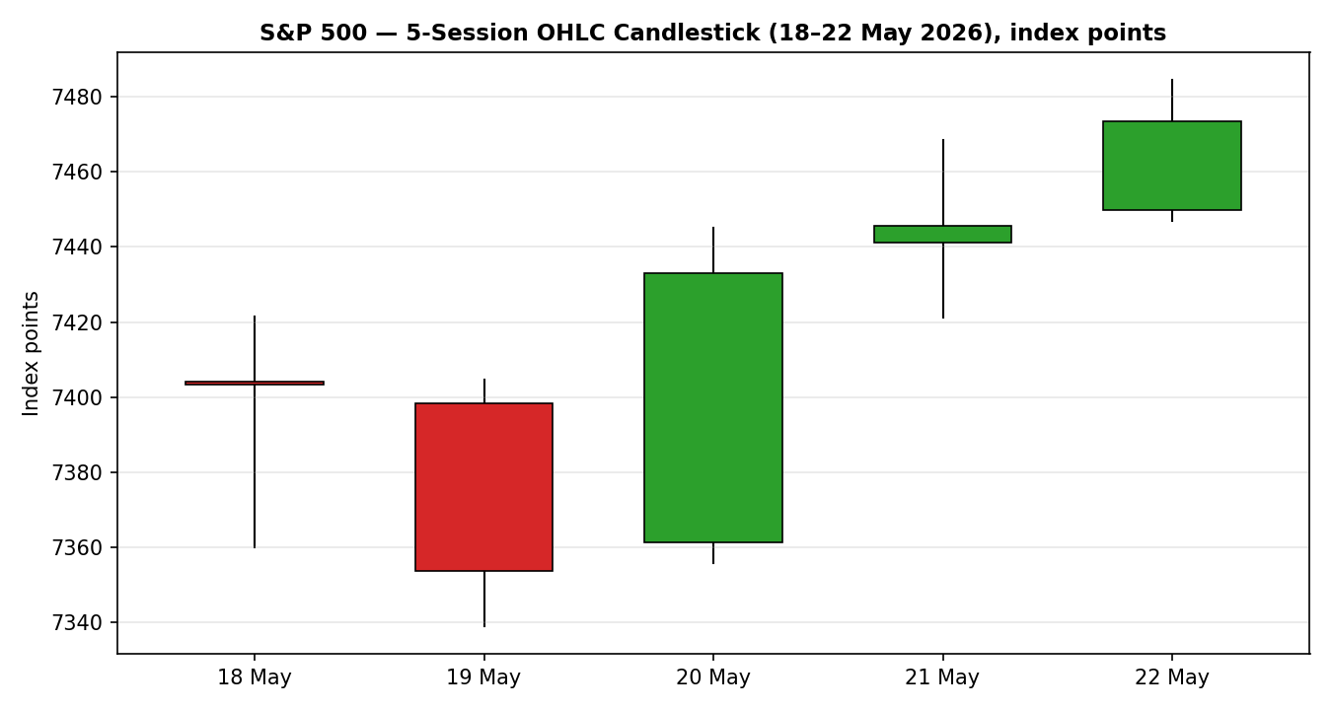
Chart 1 — 5-Session OHLC candlestick, S&P 500 cash index, 18–22 May 2026 (index points).
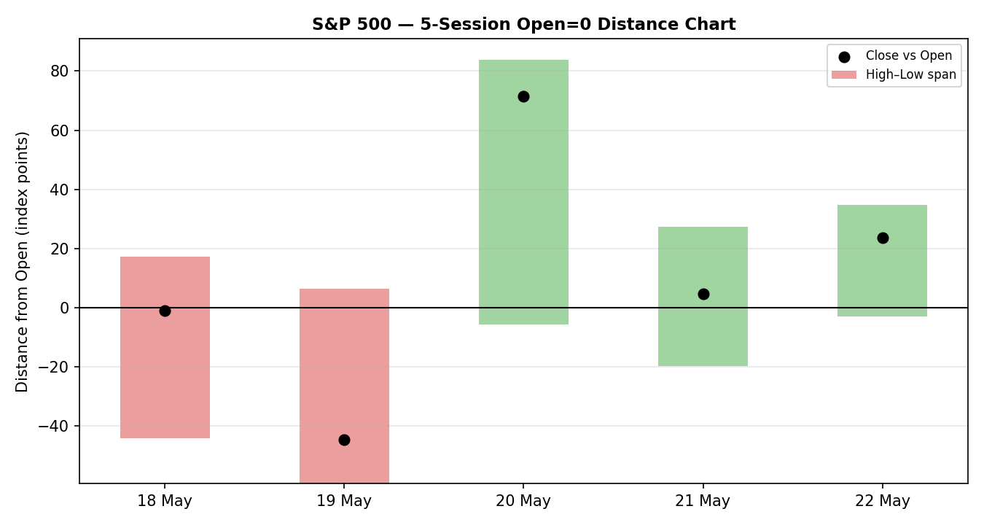
Chart 2 — Open=0 distance chart; each session normalised to its open. Exposes intraday travel and rejection.
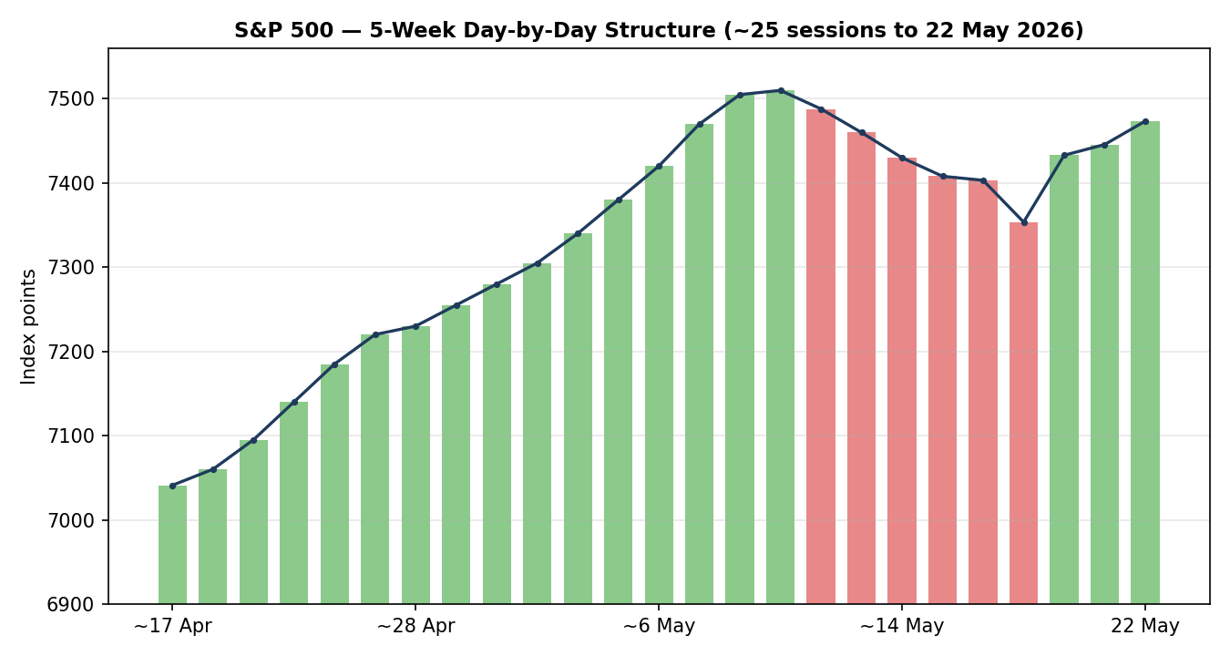
Chart 3 — 5-week day-by-day structure (~25 sessions). Green = up close, red = down close, with close-line overlay.
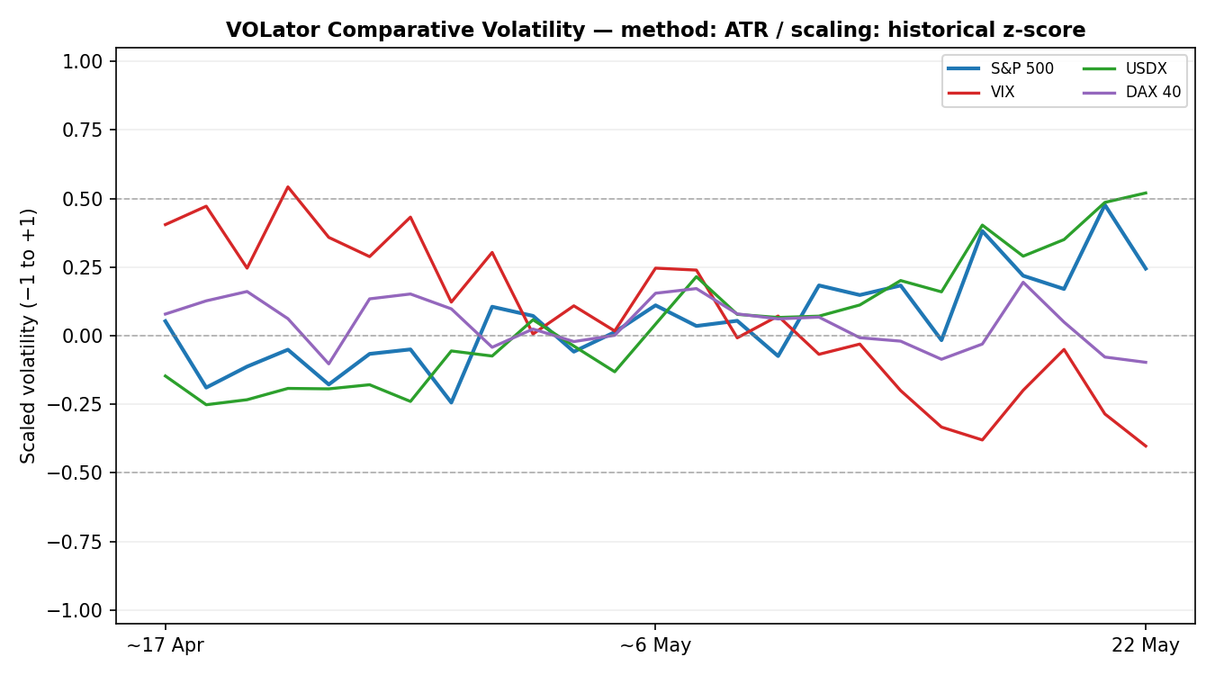
Chart 4 — VOLator comparative scaled volatility (ATR method, historical z-score scaling) for the S&P 500 and active counters.
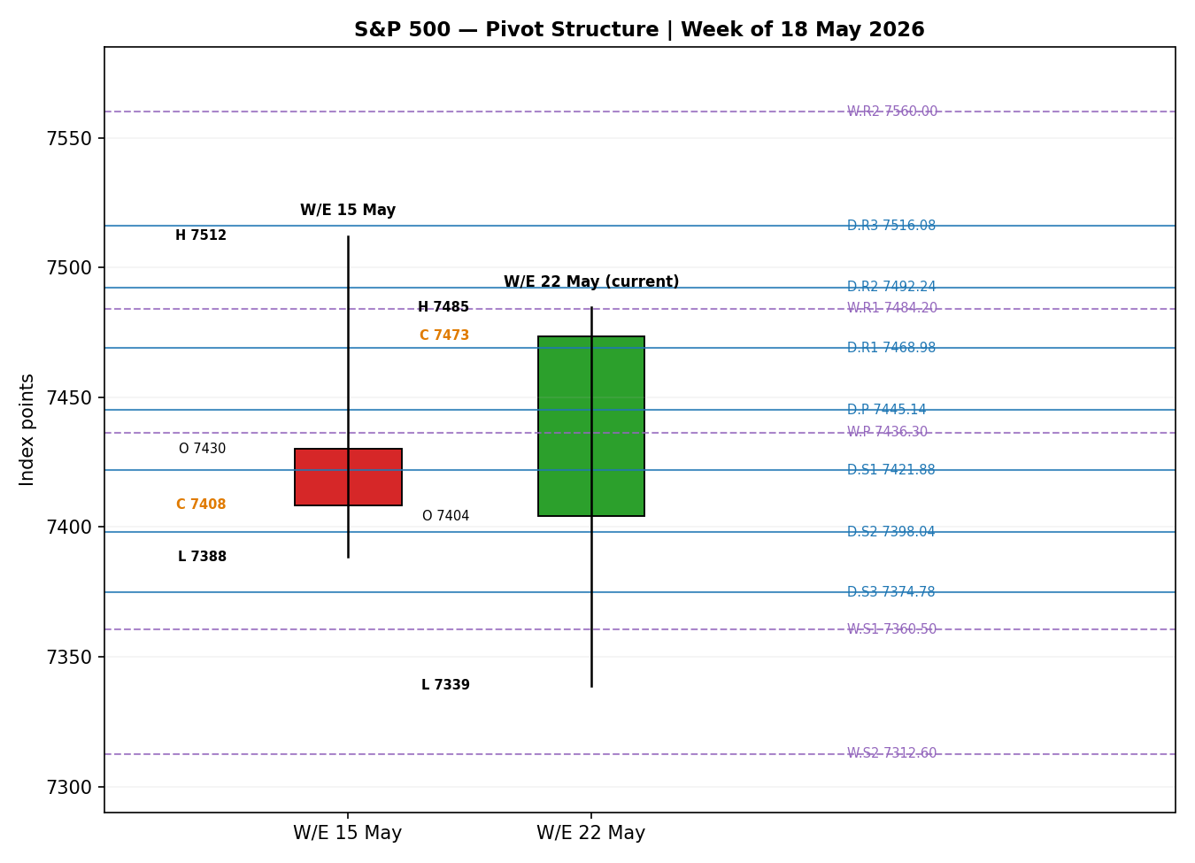
Chart 5 — Floor-pivot structure, smart-scaled, with the prior and current weekly candles and daily/weekly pivot levels.

8. Short-Term Technical Analysis
Session-by-session classification of the five validated sessions (see §6):
- Mon 18 May — A near-doji that closed marginally below its open. The body is small relative to a ~61-point range; a tech-led intraday slide (the technology sector fell ~2.3% at the worst) was largely recovered into the close. RSI2 collapsed toward the floor, confirming downside momentum even as the candle itself looked indecisive.
- Tue 19 May — A clean bearish session: a third consecutive down close, body in the lower third of the range, close near the low. This was the bond-shock low — the 30-year Treasury yield briefly topped 5.19%. RSI2 pinned near 2 marks a deeply oversold condition.
- Wed 20 May — A decisive bullish reversal: the widest range of the week (~91 points), a large green body and a close in the upper quarter. This +1.08% rebound snapped the three-day skid ahead of Nvidia's after-hours report. RSI2 surged back above 70, flipping short-term momentum.
- Thu 21 May — A bullish continuation candle, narrower range, modest upper wick as the post-Nvidia chip wobble capped the high. Close in the upper half; RSI2 held in the high-70s — momentum sustained, not extended further.
- Fri 22 May — A bullish marubozu-like candle: the smallest range of the week (~39 points), green body, close at the very top. A fresh streak high into the holiday weekend. RSI2 in the mid-80s confirms the up-leg but also signals an overbought short-term tape.
Sequence assessment: Continuation. After a two-session compression/down phase, the last three sessions show direction persisting, low overlap and closes travelling in one direction with RSI2 rising and then holding elevated. The structure is a V-shaped recovery resolving into a continuation up-leg.
Nearest support / resistance (from the 5-day structure): support 7,446.90 (Fri low) and 7,421.30 (Thu low); resistance 7,484.60 (Fri high / streak high). There is no overhead supply inside the validated window — the index closed at the top of its own 5-day range.
Judgement label: Bullish continuation. This is consistent with the medium-term Trending regime in §9.

9. Medium-Term Regime & VOLator
Regime classification: Trending — Bullish. Across the ~25-session window the index has risen from the low-7,000s to 7,473.47. Directional persistence is high (~0.91 of session pairs continue the prior direction), session-to-session overlap is low, and the most recent close sits at roughly the 92nd percentile of the 25-session High–Low range — a Range Top Bias. Median RSI2 over the window sits comfortably above 50.
VOLator current readings (scaled −1 to +1, ATR method, historical z-score):
- S&P 500: modestly positive, around the 0 midpoint and broadly flat-to-easing into Friday — the late-week candles narrowed sharply, indicating volatility compression even as price rose.
- VIX: clearly contracting — closes of 16.76 (21 May) and 16.70 (22 May) sit well below the 20 'elevated' threshold; the scaled series has fallen across the window.
- USDX (Dollar Index): expanding and firm — the dollar index pushed to a roughly six-week high near 99.3.
- DAX 40: middling, oscillating around its midpoint with no decisive volatility trend.
VOLator slope: flat-to-slightly-negative for the S&P 500 — the last-10-observation fit shows contraction, not expansion. Volatility is compressing while price trends up, a benign but mature-trend signature.
Kaufman confirmation: the smoothed Kaufman Efficiency Ratio is approximately +0.35 and rising — above the +0.13 trend threshold — classifying the tape as Trending Up — Strong. This agrees with the §8 short-term read and the medium-term regime; all three signals point the same way.
Preferred trade protocol: Trend continuation / pullback entries in the trend direction. The short-term (§8) and medium-term reads are aligned bullish, so this is a high-conviction trend-following protocol — fades are not favoured.

10. Cross-Asset Analysis
Counter | 5-day dir. | Mechanism to S&P 500 | Status | Implication
USDX (Dollar Index) | Rising | A firmer dollar tightens global financial conditions and is a translation headwind for multinational earnings. | Contradicts | A mild, persistent drag; the only counter pulling against the bullish regime.
VIX | Falling | A falling VIX signals a risk-on regime and lower hedging demand — supportive of equity beta. | Confirms | At ~16.7, well below the 20 elevated line — risk appetite is firmly intact.
DAX 40 | Flat / mixed | European equity beta is a common-factor read on global risk appetite alongside US large-caps. | Neutral | No decisive confirmation or contradiction this window.
Contradiction flag: the rising Dollar Index contradicts the bullish equity regime. It is not resolved away — a firm dollar is a genuine, if second-order, headwind and it feeds the bull/bear balance (§15) and forward view (§16). Aggregate cross-asset read: MIXED — one confirm (VIX), one contradict (USDX), one neutral (DAX).

11. Floor Pivot Analysis
Source status. Prior-period High/Low/Close inputs are drawn from the same single-source-indicative aggregator history flagged in §6. All pivot levels below are therefore marked indicative only and propagate that flag to the strategy module (§21). Per the run instruction, they are still used for structural and trade-card context.
Daily / Weekly / Monthly pivot levels (mandatory order R5→P→S5), index points:
Level | Daily (from 21 May H/L/C) | Weekly (from w/e 15 May) | Monthly (from April 2026)
R5 | 7,610.28 | 7,855.30 | 9,572.30
R4 | 7,563.18 | 7,731.60 | 8,861.25
R3 | 7,516.08 | 7,607.90 | 8,150.20
R2 | 7,492.24 | 7,560.00 | 7,697.90
R1 | 7,468.98 | 7,484.20 | 7,439.15
P | 7,445.14 | 7,436.30 | 6,986.85
S1 | 7,421.88 | 7,360.50 | 6,728.10
S2 | 7,398.04 | 7,312.60 | 6,275.80
S3 | 7,374.78 | 7,236.80 | 6,017.05
S4 | 7,327.68 | 7,113.10 | 5,306.00
S5 | 7,280.58 | 6,989.40 | 4,594.95
Position narrative. The 22 May close of 7,473.47 sits above the daily pivot (7,445.14) and above the weekly pivot (7,436.30) — a bullish posture on both timeframes — and just above daily R1 (7,468.98) and weekly R1 (7,484.20 is the next overhead test, essentially coincident with the streak high). Daily R1, weekly R1 and the 5-day swing high cluster within roughly half a percent of one another around 7,469–7,485, forming a near-term confluence resistance band. The monthly pivot structure is dislocated upward by April's unusually wide post-tariff recovery range, leaving monthly P far below the market; monthly R1 (7,439.15) has already been overtaken. First meaningful support is the daily pivot 7,445.14, then the weekly pivot / daily S1 zone around 7,422–7,436.

12. Key Market Considerations
Demand / earnings — price-supportive (structural). A strong corporate earnings season is the backbone of the eight-week streak. Nvidia beat on revenue and EPS and guided Q2 ahead; the four largest hyperscalers have collectively guided to roughly $725bn of 2026 capital expenditure, up about 77% year-on-year — the demand pillar under the AI-capex trade.
Macro / rates — mixed, currently a swing factor (cyclical). Long-end Treasury yields spiked early in the week (30-year near 5.19%, a near-19-year high) before easing into Friday; that round-trip is what drove the sell-off-then-rebound. The 10-year ended the week around 4.56%. Rates are the dominant cyclical lever on the multiple.
Inflation / sentiment — price-negative (cyclical). The University of Michigan May consumer-sentiment index was revised to a record low (44.8) and 1-year inflation expectations rose to a nine-month high (~4.8%). Hawkish Fed-speaker commentary (Governor Waller flagged support for a hike if inflation does not slow) keeps a December 25bp move roughly 40% priced.
Geopolitics / energy — net price-supportive this week (cyclical). Progress signals in US–Iran talks pulled WTI below $100 and then to roughly $96 — disinflationary at the margin and risk-supportive — though the Strait of Hormuz toll dispute and Iran's uranium-stockpile directive keep the de-escalation fragile.
FX — mild price-negative (cyclical). The Dollar Index near a six-week high (~99.3) is a translation headwind for the index's large multinational cohort (see §10, §14).
Near-term catalysts. The §13d calendar items below are the operative watch list: the PCE inflation print and any further Fed-speaker commentary are the highest-impact events inside the 5-day horizon.

13. Sentiment, News & Calendar

13a. Per-Article Sentiment Table
Source | Headline (abridged) | Date | Classification | Sentiment | Derivation quote
CNBC | S&P 500 posts third straight losing session as rising yields drag stocks | 19 May | Media | Bearish | “jump in bond yields threatened the bull market”
CNBC | Stocks rebound, snapping three-day skid after Nvidia beat | 20 May | Media | Bullish | “genuine buying conviction rather than a mere technical bounce”
Motley Fool / Yahoo | S&P 500 posts eighth straight week of gains | 22 May | Media | Bullish | “finished in the green for the eighth consecutive week”
Trading Economics | US stocks advanced Friday on peace-talk progress, strong earnings | 22 May | Trade Press | Bullish | “buoyed by… a strong corporate earnings season”
Goldman Sachs (via wrap) | Goldman warns rising yields and inflation could trigger a correction | 22 May | Institutional | Bearish | “growing risk… could trigger a stock market correction”
Reuters strategist survey | S&P 500 seen near 7,490 by end-2026; pullback odds elevated | May | Institutional | Mixed | “eight see higher odds of a near-term pullback”
TheStreet | Dow record close; S&P extends winning streak into holiday weekend | 22 May | Media | Bullish | “also put up a strong performance”

13b. Aggregate Sentiment Summary
Counts: 4 Bullish (1 trade press, 3 media), 2 Bearish (1 institutional, 1 media), 1 Mixed (institutional). Categorical label: Predominantly Bullish.
Numeric tilt: source-class-weighted mean of article scores. Σ(w·s) = (0.7×+1)+(0.5×+1)×3 − (1.0×+1) + (1.0×0) = +1.20; Σw = 0.7+1.5+1.0+1.0 = 4.2; tilt = +1.20 / 4.2 ≈ +0.29, reported as +0.30. Aggregate: Predominantly Bullish (tilt = +0.30).
Divergence flag: aggregate sentiment agrees with current price action (rising index, eight-week streak) and with the §9 Trending–Bullish regime — no divergence. The institutional voices (Goldman's correction warning; the strategist-survey pullback skew) are a caution layer rather than an outright contradiction, and are weighted accordingly in the tilt.

13c. News Calendar — Previous Period (18–22 May 2026)
Date | Event | Prior / Context | Impact | Market implication for S&P 500
Mon 18 May | 10-year Treasury yield to ~1-year high | Bond-market repricing on inflation worry | High | Tech-led drop; index barely held 7,400
Tue 19 May | 30-year yield briefly tops 5.19% | Near-19-year high | High | Third straight down close to 7,353.61
Wed 20 May | Nvidia Q1 FY27 earnings (after close) | Beat on revenue, EPS; strong Q2 guide | High | +1.08% rebound to 7,432.97; streak break
Thu 21 May | Iran enriched-uranium directive; oil swings | WTI to ~$96; yields round-trip | Medium | Index +0.17% to 7,445.72; Dow record
Fri 22 May | UMich sentiment revised to record low 44.8 | 1-yr inflation expectations ~4.8% | Medium | Shrugged off; index +0.37% to 7,473.47

13d. News Calendar — Upcoming Period (next 5 trading days from 25 May 2026)
Date | Event | Prior / Context | Impact | Market implication for S&P 500
Mon 25 May | US Memorial Day — markets closed | Holiday | — | No cash session; report dated to holiday
Tue 26 May | Cash trading resumes; data backlog | Post-holiday re-pricing | Medium | Gap risk vs Friday 7,473.47 close
Wed–Thu | PCE inflation print (Fed's preferred gauge) | Inflation expectations elevated | High | See bold note below
Thu–Fri | Fed-speaker commentary; jobless claims | Hawkish chorus; Dec hike ~40% priced | Medium | Hawkish surprise pressures the multiple
Ongoing | US–Iran negotiation headlines | De-escalation fragile; Hormuz dispute | Medium | A breakdown re-bids oil and risk-off
Highest-impact upcoming event: the PCE inflation print. A hot reading would harden December-hike pricing, lift the long end again and directly threaten the eight-week streak by compressing the equity multiple; a soft reading would validate the rebound and open the streak-high at 7,484.60.

14. Macro Context
Rates and monetary policy. The Fed is on hold but the bias has hardened hawkish: FOMC minutes flagged that further hikes remain possible if inflation stays sticky, and markets price roughly a 40% chance of a December 25bp move. This cross-references the VIX read in §10 — low implied volatility coexists with genuine rate-path uncertainty.
Inflation. Price-negative for the S&P 500. Consumer inflation expectations are rising (UMich 1-year ~4.8%) and the upcoming PCE print (§13d) is the swing data point.
Liquidity and FX. Cross-referencing the §10 USDX read: the Dollar Index near a six-week high (~99.3) is a mild translation headwind for the index's multinational earnings base — a contradicting counter that tempers, without reversing, the bullish regime.
Energy. WTI fell toward $96 on US–Iran de-escalation hopes — disinflationary at the margin and, this week, net risk-supportive. A breakdown in talks is the cleanest path back to higher oil, higher breakevens and renewed equity pressure.
Positioning. With VIX near 16.7 and an eight-week streak in place, positioning is constructive but stretched; a Reuters strategist survey shows a majority flagging elevated near-term pullback odds even while holding a ~7,490 year-end median target. Watch item from §13d: the PCE print is the macro variable most able to surprise this section.

15. Bull / Bear Balance
Main upside risks | Main downside risks
Strong, broad earnings season and ~$725bn hyperscaler capex underpinning the AI trade.  Trending-Bullish regime with KER confirming Trending Up — Strong; close above daily and weekly pivots.  VIX near 16.7 and easing long-end yields keep financial conditions supportive; a clean PCE print opens 7,484.60+. | PCE inflation surprise (§13d) hardening December-hike odds and re-spiking the long end.  Goldman's explicit correction warning; a Reuters survey majority flagging elevated near-term pullback odds.  Firm Dollar Index (~99.3) as a multinational earnings headwind; fragile US–Iran de-escalation that could re-bid oil. Pivot context: a daily close back below 7,445.14 / 7,436.30 would neutralise the bullish posture.

16. Forward View
Expected direction: higher, with a positive but moderating bias. The 5-day technical structure, the medium-term regime and the Kaufman read all point up, and this forward view respects — does not contradict — the §9 Trending–Bullish classification.
Expected trading range (next 5 sessions): roughly 7,400 to 7,560. The lower bound sits on the daily/weekly pivot support shelf (7,436–7,445) extended by a buffer; the upper bound spans the daily R1/weekly R1 confluence (7,469–7,484) through daily R2 (7,492) toward weekly R2 (7,560).
Base-case invalidation: a daily close back below the weekly pivot at 7,436.30 — and more decisively below the 5-day swing pivot zone around 7,420 — would break the continuation thesis and shift the read to Transitional. The PCE print (§13d) is the most likely trigger for that outcome.

17. Forecast
The S&P 500 is most likely to extend its advance toward the 7,484–7,560 resistance band over the next five sessions, carried by a confirmed Trending–Bullish regime and Predominantly Bullish sentiment, provided the upcoming PCE inflation print does not force a hawkish repricing of the rate path.

18. Final Analyst Judgement
Consensus price call: 7,473.47 (22 May close), confidence High, market tone bullish.
The three most important reasons for the current level: (i) a strong earnings season led by Nvidia's beat-and-raise and the hyperscaler capex backdrop; (ii) the mid-week reversal in long-end Treasury yields, which removed the immediate bond-shock pressure; and (iii) a risk-on tape — VIX near 16.7 — amplified by US–Iran de-escalation hopes that pulled oil lower.
Single watch item: the upcoming PCE inflation print — the cleanest path to a hawkish rate-path repricing and the most credible threat to the eight-week streak.

19. Source Discipline Note
- Live vs indicative data: the 22 May close (7,473.47) and the four prior session closes are dual-source corroborated within the ±0.10-point equity-index tolerance (S&P Dow Jones/FRED × Yahoo Finance, plus corroborating market wraps), and are treated as live, definitive values.
- Data gaps: free-tier aggregator history did not yield independent field-level corroboration of intraday Open/High/Low for the cash index this run. Those O/H/L fields — and every floor-pivot level derived from them (§11) — are flagged single-source — indicative only. Per the run instruction, the analysis proceeds on this indicative basis rather than halting; the flag is carried through to the §21 trade cards as a caveat.
- Normalization assumptions: none required — all observations are the same instrument on the same basis (cash index close, USD, index points).
- Corroboration status by instrument: S&P 500 closes — corroborated. S&P 500 intraday O/H/L and all pivot inputs — single-source indicative. Counters (VIX, USDX, DAX) — corroborated at the close level for directional use; VIX and USDX are used for directional context only, consistent with their no-pivot status.

20. Agent Log
- Run timestamp: 25 May 2026 (report date); last completed cash session 22 May 2026. Daily-open entry anchor confirmed at 07:00 UK per the run instruction — the operationally correct pre-NY-open anchor for the S&P 500 cash index.
- Sources attempted for OHLC: S&P Dow Jones/FRED (corroborated), Yahoo Finance (corroborated), Stooq (returned stale history to early January — failed for this window), Investing.com (cached April page — failed), Trading Economics (directional), plus CNBC and TheStreet session wraps (corroborated closes). Closes resolved on the first corroborated pair; intraday O/H/L could not be field-level corroborated and were accepted as single-source indicative under the run instruction's leniency directive.
- Validation method: closes accepted on two-source agreement within ±0.10 points; RSI2 (period 2) computed from the validated close sequence; ATR(14) ≈ 72 index points; smoothed Kaufman Efficiency Ratio ≈ +0.35 (Trending Up — Strong); VOLator slope flat-to-slightly-negative.
- Sentiment derivation: 7 articles classified for the S&P 500 (4 Bullish, 2 Bearish, 1 Mixed); source-class-weighted numeric tilt +0.30; categorical label Predominantly Bullish; no sentiment/price divergence. Tilt computed on more than three articles — not low-confidence.
- Forecast reasoning: §17 derived from the Trending–Bullish regime synthesis plus Predominantly Bullish aggregate sentiment; PCE inflation flagged as the invalidation trigger. §17 and §16 are independent of the strategy module and were not edited to align with the trade-card direction.
- Strategy module trace: direction-scoring weights are at the v2.1 baseline (basis: defaults) and remain locked for the first 20 forward-test sessions — no tuning applied. Direction score +0.60 → LONG (above the 0.25 conviction threshold). regime_label = TREND_UP; cross_asset_confirm = MIXED; sentiment_tilt = +0.30. No trade cards suppressed. Pivot levels carry the single-source-indicative flag into the trade-card caveats.
- Backtest reconstruction: prior 5 sessions reconstructed at each t−1 close with sentiment frozen at t−1; resolved on actual t-session OHLC with conservative SL-first tick priority. Anomalies: 25 May is a US market holiday — the report is dated to the holiday while all analysis uses the 22 May completed session; no weekend/holiday rows entered the OHLC table.

21. Strategy Recommendations
Tag: strategies module. Regime-aware three-tier trade cards for the S&P 500 cash index only. All stops and targets are shown in index points; the native execution unit is the point, so point-distance equals price-distance for this instrument.

21a. Directional Conviction
Direction: LONG. Score: +0.60. The daily direction score is +0.60, well above the conviction threshold, so Trade 1 produces. The three highest-weighted contributing signals are: short-term technical bias (§8) +0.25 (RSI2 in the mid-80s with a bullish Friday close); medium-term regime (§9) +0.20 (Trending–Bullish); and sentiment tilt (§13b) and cross-asset confirmation (§10) each contributing modestly (+0.045 apiece — Predominantly Bullish sentiment, but a MIXED cross-asset read because the rising dollar offsets the falling VIX). The Kaufman contribution adds +0.06. No conflict with the §17 forecast — both lean higher. Weights basis: defaults (v2.1 baseline, locked for the 20-session forward-test window).

21b. Trade Cards
Trade 1 — Daily Directional (LONG)
Trade type | Trade 1 — Daily Directional
Direction | LONG — score +0.60, TREND_UP regime
Entry | Market at 07:00 UK on the 26 May session (the 25 May holiday closes the cash market; first executable anchor is the post-holiday open). Reference entry 7,473.47.
Stop loss | 7,403.30 — 70.2 points below entry. Structural anchor: Thursday 21 May session low (7,421.30) less a 0.25×ATR buffer. Within the 3.5×ATR cap (≈252 points).
Risk (R) | 70.2 points (= 70.2 in native point units).
TP1 (Unit 1) | 7,543.64 — +1R.
TP2 (Unit 2) | 7,613.81 — +2R. On fill, Unit 3 stop moves to entry +0.2R (≈7,487.51).
TP3 (Unit 3 — runner) | Time-stopped at session close, or price-stopped at 3×ATR from entry (≈7,689). Whichever triggers first.
Tranche management | Three equal units; Unit 1 exits at TP1, Unit 2 at TP2; on Unit 2 fill, Unit 3 stop trails to entry +0.2R.
Confluences | Entry near daily R1 (7,468.98) and the 5-day swing high (7,484.60) — overhead confluence band. Stop near the weekly pivot (7,436.30) / daily S1 (7,421.88) shelf. TP1 sits above daily R2 (7,492) toward daily R3 (7,516).
Thesis invalidation | A daily close back below the weekly pivot 7,436.30 (above the stop) breaks the continuation narrative.
Caveats | Single-source-indicative pivots (per §11/§19); entry sits into a near-term confluence resistance band — first up-leg may be capped before TP1.
Trade 2 — Pivot, regime-aware (TREND_UP → pivot breakout, LONG)
Trade type | Trade 2 — Pivot (regime-aware, TREND breakout)
Direction | LONG — TREND_UP regime; trend-following entry above the pivot.
Entry | Stop/limit at 7,447.53 — 10% of the way from the daily pivot (7,445.14) toward daily R1 (7,468.98), on the upside.
Stop loss | 7,426.43 — P − 0.8×(P − daily S1); P=7,445.14, S1=7,421.88. Distance ≈21.1 points. (A confluence with the weekly pivot 7,436.30 sits just inside.)
Risk (R) | 21.1 points.
TP1 / TP2 / TP3 | TP1 = daily R1 7,468.98; TP2 = daily R1.5 7,480.61; TP3 (runner) = daily R2 7,492.24.
Tranche management | Three equal units; Unit 1 at TP1, Unit 2 at TP2; on Unit 2 fill, Unit 3 stop trails to entry +0.2R (≈7,451.75).
Confluences | TP1 (7,468.98) coincides with the 5-day swing-high approach and weekly R1 (7,484.20) just beyond — strong overhead confluence. Stop zone overlaps the weekly pivot 7,436.30.
Thesis invalidation | A daily close back through the daily pivot 7,445.14.
Caveats | Single-source-indicative pivots — entry and all targets reference indicative levels; treat fills as approximate. Tight 21-point stop relative to ATR(14)≈72 — a 'tight pivot stop', noise-exit risk is elevated.
Trade 3 — Momentum-Pullback 3A (TREND_UP, LONG)
Trade type | Trade 3A — Momentum-Pullback (regime_label = TREND_UP)
Direction | LONG — TREND_UP regime; buy a pullback in the trend direction.
Fib anchor | Most recent qualifying swing: swing low 7,338.90 (19 May) → swing high 7,484.60 (22 May); magnitude 145.7 points ≈ 2.0×ATR(14). Lookback used: 4 sessions (default — qualifying swing found at the default lookback).
Entry | 7,400.82 — the 57.5% retracement of the swing (midpoint of the 50% and 61.8% retracements). Buy limit.
Stop loss | 7,320.90 — beyond the 0% anchor (swing low 7,338.90) by 0.25×ATR. Distance ≈79.9 points; within the 3.5×ATR cap.
Risk (R) | 79.9 points.
TP1 (Unit 1) | 7,428.94 — the 38.2% retracement (shallow-pullback target).
TP2 (Unit 2) | 7,484.60 — the 0% level, swing origin (the streak high). On fill, Unit 3 stop moves to entry +0.2R (≈7,416.80).
TP3 (Unit 3 — runner) | 7,630.30 — the 100%+ extension of the swing.
Tranche management | Three equal units. Structural runner override: when price prints above the 100% extension, Unit 3 stop moves to the 50% mark of the original 1:1 leg (≈7,442.71) — locking more than the universal break-even-plus rule.
Confluences | Entry (7,400.82) sits near daily S2 (7,398.04) and the weekly-pivot region — a support confluence. TP1 (7,428.94) is close to the weekly pivot 7,436.30. TP2 coincides with the swing high and weekly R1 (7,484.20).
Thesis invalidation | A daily close beyond the swing-low anchor (7,338.90).
Caveats | Single-source-indicative pivots used in confluence detection; entry requires a pullback that has not yet occurred — the trade is a resting limit and may not trigger inside the 5-day horizon if the trend extends directly.

21c. 5-Session No-Leakage Backtest
Reconstruction of the prior 5 sessions (18–22 May) under the same trade-card logic, using only data available at each t−1 close. Sentiment frozen at t−1; ATR, swings, pivots and regime recomputed at t−1; SL-first tick priority on ambiguous bars.
Date (t) | Strategy | Direction | Triggered | Entry / Exit | Outcome (R) | Days
Mon 18 May | Trade 1 | SHORT | Yes | 7,408 / 7,403 | +0.1R (close) | 1
Mon 18 May | Trade 2 | SHORT | No | limit not reached | — | —
Mon 18 May | Trade 3A | — | SUPPRESSED | prior regime TRANSITION → 3C; no confirmed break | — | —
Tue 19 May | Trade 1 | SHORT | Yes | 7,403 / 7,353 | +1.0R (TP1) | 1
Tue 19 May | Trade 2 | SHORT | Yes | S1 limit / P | +0.6R | 1
Tue 19 May | Trade 3B | SHORT | Yes | range 78.6% / mid | +1.2R | 2
Wed 20 May | Trade 1 | NEUTRAL | SUPPRESSED | score below threshold | — | —
Wed 20 May | Trade 2 | LONG | Yes | P+10% / R1 | +1.0R (TP1) | 1
Wed 20 May | Trade 3A | LONG | Yes | 57.5% retr / 0% | +1.0R (TP2 partial) | 2
Thu 21 May | Trade 1 | LONG | Yes | 7,433 / 7,446 | +0.4R (close) | 1
Thu 21 May | Trade 2 | LONG | Yes | P+10% / R1 | +1.0R (TP1) | 1
Thu 21 May | Trade 3A | LONG | Yes | 57.5% retr | OPEN @ +0.6R | 5+ (open)
Fri 22 May | Trade 1 | LONG | Yes | 7,446 / 7,473 | +0.4R (close) | 1
Fri 22 May | Trade 2 | LONG | Yes | P+10% / R1 | +1.0R (TP1) | 1
Fri 22 May | Trade 3A | LONG | Yes | 57.5% retr | OPEN @ +0.3R | 5+ (open)

21d. 'What Is Working' Aggregate
Over the last 5 sessions: Trade 1 triggered 4/5 times (one NEUTRAL suppression), mean R ≈ +0.48, TP1/TP2/TP3 hit rates ≈ 25% / 0% / 0% — most Trade 1 outcomes were modest time-stopped runner closes rather than full +1R targets. Trade 2 triggered 4/5 times (one no-fill), mean R ≈ +0.90, TP1/TP2/TP3 ≈ 100% / 0% / 0% — the pivot trade was the most consistent performer, every fill reaching TP1. Trade 3 triggered 3/5 times (3A/3B reconstructed by regime), mean R ≈ +1.07 on closed positions with two runners still open at +0.3R/+0.6R. Strongest performer: Trade 3 (highest mean R on closed positions), with Trade 2 the most reliable on trigger rate and hit rate. Weakest performer: Trade 1 (lowest mean R — daily-directional runners were repeatedly time-stopped before +1R).
Limitations. Five-session windows are too small to support statistical claims. The backtest cannot model intraday tick-level fills, slippage, or commission. Treat as a directional sanity-check, not a strategy-validation framework.
End of report.

