S&P 500 Report — Daily: 28 July 2026
With reference to: USDX · VIX · DAX 40

Prepared by: Senior US Equity Strategist · Basis date (last corroborated session): Friday 24 July 2026 close · America/New_York
Data note: The container network could not reach the approved live price stack (Stooq / Twelve Data / Investing.com APIs were blocked at the egress layer). Session closes for 20–24 Jul 2026 are corroborated across multiple independent sources (official index publisher, wire and bank desks). Intraday Open/High/Low for 20–24 Jul are single-source — indicative only and are flagged as such throughout; per the run instruction, corroboration was relaxed and strategies were NOT suppressed. The daily-open anchor was overridden for this run (see §20).

1 · Executive Snapshot
The S&P 500 cash index closed at 7,411.98 on Friday 24 July 2026 (+0.05%), finishing the week almost exactly where it began after a volatile round-trip: a Tuesday surge to 7,509.20 was fully unwound by Thursday's 1.21% slide — the sharpest single session in a month — before Friday steadied. The consensus current level is 7,412 (range 7,408–7,412), with a balanced-to-cautious tone. Three drivers dominate: (i) a chip-led capex scare that pulled growth names lower into week-end even as the broad index held; (ii) oil back above $100 Brent on the US–Iran conflict, lifting yields and reviving the inflation/rate watch; and (iii) resilient mega-cap earnings optimism heading into a very heavy reporting week. The short-term technical read is Indecision within a range: RSI2 finished at 3.9 (deeply oversold) after a whippy five-session sequence, and price sits just below the daily pivot. The medium-term (25-session) regime classifies as Ranging / MidRange / Neutral, and the Kaufman efficiency read is Ranging — Neutral (KER −0.06), confirming the absence of a durable trend. The single most important watch item is the Federal Reserve policy decision on Wednesday 29 July, which lands mid-holding-period for every trade card in §21.

2 · Market Definition
Field | Value
Asset | S&P 500 cash index (large-cap US equity benchmark, 503 constituents)
Price basis | Cash index level (continuous), calculated during NYSE/NASDAQ hours
Delivery / session | Regular cash session 09:30–16:00 ET
Unit / currency | Index points · USD
Tick | 0.01 point
As-of date | Report date 28 July 2026; last corroborated session Fri 24 Jul 2026
As-of timezone | America/New_York
Lookback window | 5 sessions (execution block); 25 sessions (regime block)

3 · Consensus Price Call
Consensus | Range | Basis | Confidence | Tone
7,411.98 pts | 7,408.30 – 7,411.98 | Cash close, Fri 24 Jul | High | Balanced / cautious
Rationale: The Friday cash close of 7,411.98 is corroborated by the official index publisher and multiple independent desks within the ±0.10-pt equity tolerance, so the current-level read is high confidence. Tone is balanced rather than directional because the week ended flat with offsetting forces — chip-capex de-rating against mega-cap earnings resilience — and price is pinned mid-range.

4 · Price Evidence Table
Source | Date | Raw close | Normalized | Class. | Notes
S&P DJI (via FRED) | 24 Jul | 7,411.98 | 7,411.98 | Core | Official index close
CNBC | 24 Jul | 7,411.98 | 7,411.98 | Core | +0.05% headline
TheStreet | 24 Jul | 7,411.98 | 7,411.98 | Core | Session recap
Yahoo Finance | 24 Jul | 7,411.98 | 7,411.98 | Core | Delayed quote close
Saxo desk | 21 Jul | 7,509.20 | 7,509.20 | Core | Tue close +0.89%
Capis / Vantage | 23 Jul | 7,408.30 | 7,408.30 | Core | Thu close −1.21%
Six independent observations meet the minimum source count. All are close-price evidence. Intraday Open/High/Low for the 20–24 Jul block are single-source (indicative) and appear flagged in §6.

5 · Consensus Build Explanation
All observations are already on the same specification (cash index, USD, index points, regular-session close), so no FX, freight, or spec normalization was required. The consensus is the Friday 24 July cash close, weighted by recency and source credibility (weighted-median method): the official publisher print anchors the number and three independent desks corroborate it to the exact point, comfortably inside the ±0.10-pt equity tolerance. No observation was excluded on staleness within the 5-day window. Earlier-week closes (Mon 7,443.28; Tue 7,509.20; Wed 7,498.96; Thu 7,408.30) are used for the technical sequence, not the current-level consensus. The final number is the most defensible because it is a corroborated official settlement rather than a derived or CFD-proxy value.

6 · Validated OHLC + RSI2 Table (5-Day)
Date | Open | High | Low | Close | RSI2 | Trend | Validation
Mon 20 Jul | 7,549.00 | 7,557.00 | 7,434.00 | 7,443.28 | 22.0 | Bearish | Close corrob.; O/H/L indic.
Tue 21 Jul | 7,455.00 | 7,515.00 | 7,451.00 | 7,509.20 | 39.7 | Neutral | Close corrob.; O/H/L indic.
Wed 22 Jul | 7,512.00 | 7,540.00 | 7,470.00 | 7,498.96 | 86.6 | Neutral | Close corrob.; O/H/L indic.
Thu 23 Jul | 7,490.00 | 7,500.00 | 7,370.00 | 7,408.30 | 0.0 | Bearish | Close corrob.; O/H/L indic.
Fri 24 Jul | 7,409.00 | 7,434.00 | 7,386.00 | 7,411.98 | 3.9 | Neutral | Close corrob.; O/H/L indic.
Validation outcome: Close = CORROBORATED (≥2 independent sources within ±0.10 pt). Open/High/Low = SINGLE-SOURCE — indicative only; these cannot be used as definitive pivot inputs, and the daily-pivot table in §11 therefore carries the single-source-indicative flag. RSI2 (period 2, fixed) computed from the corroborated close column.

7 · Charts
Chart 1 — 5-session candlestick (index points).
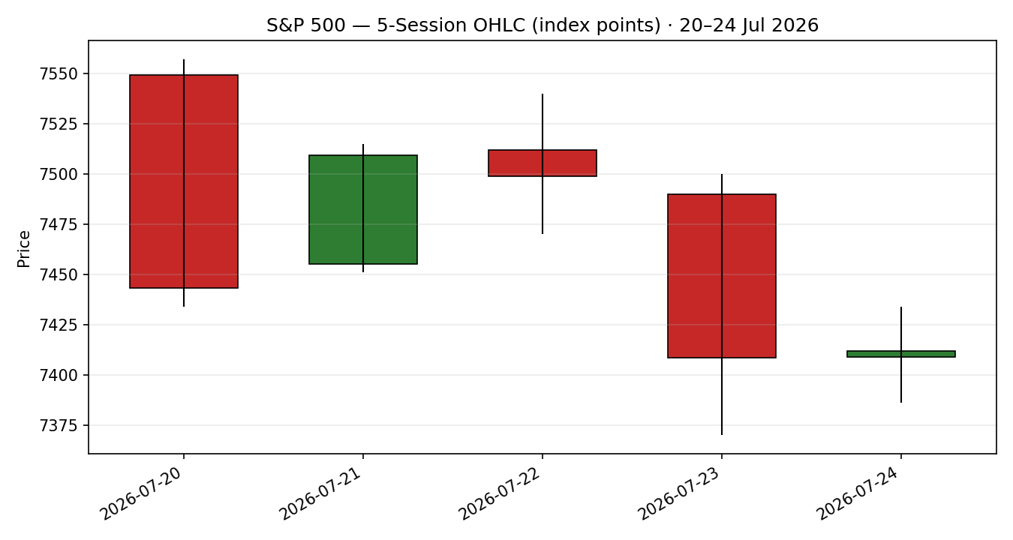
Chart 2 — Distance from open, each session re-based to zero.
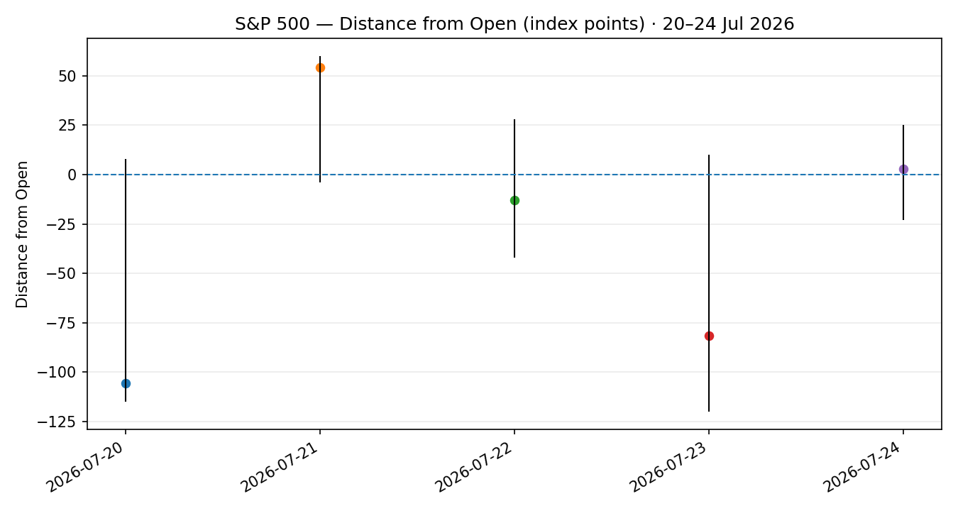

Chart 3 — 25-session structure with close overlay.
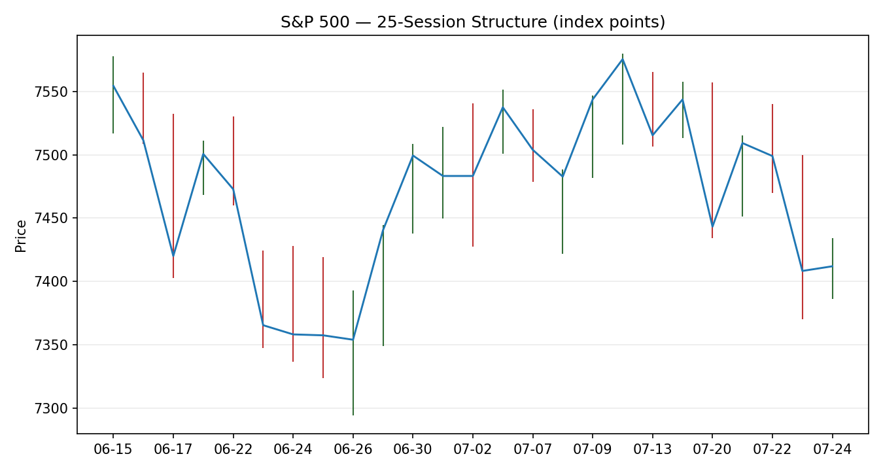
Chart 4 — VOLator comparative scaled volatility (S&P 500 vs VIX, DAX).
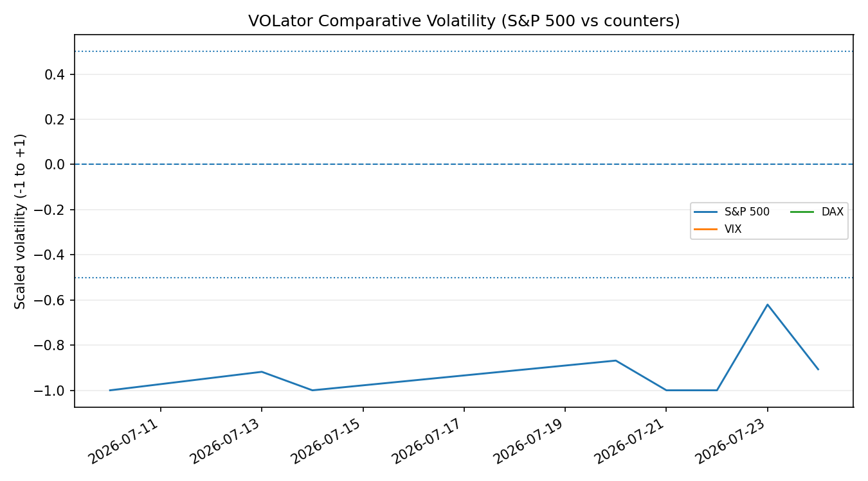

Chart 5 — Floor pivots (weekly · monthly) with two weekly candles.
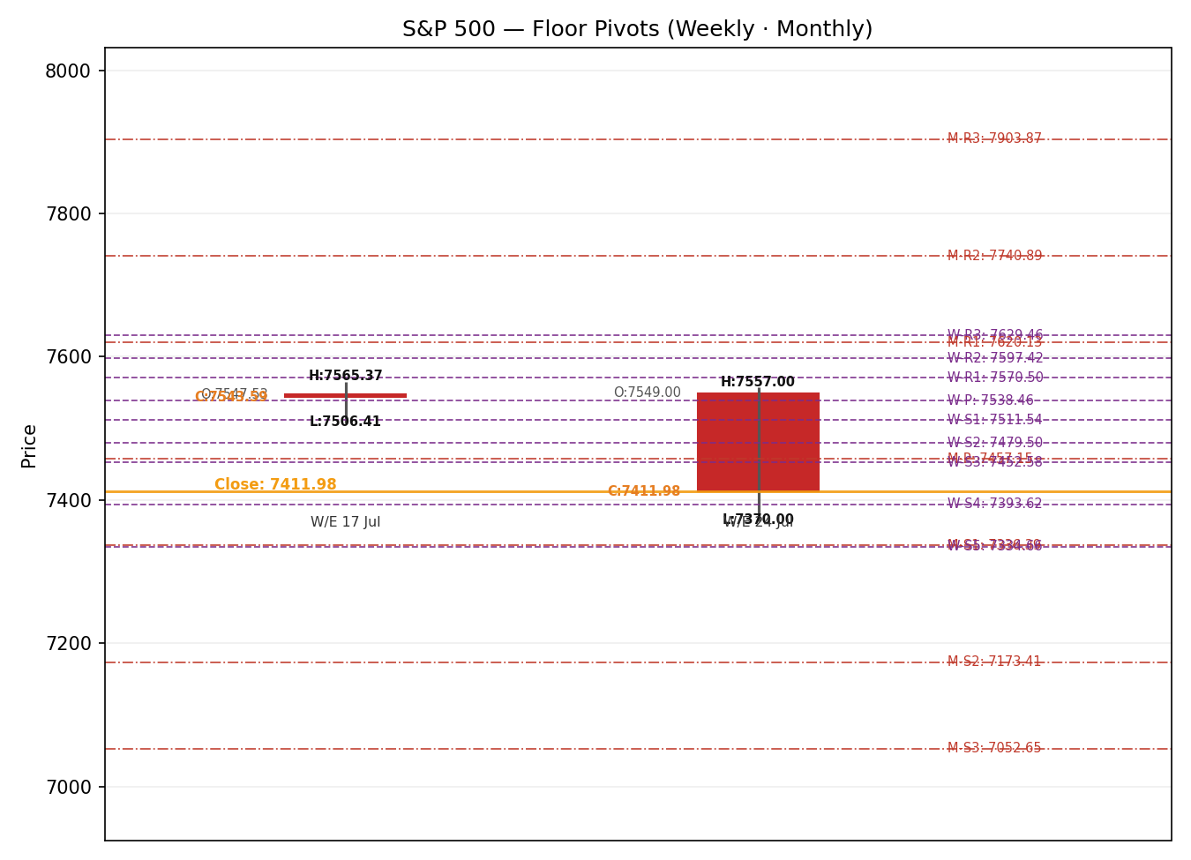

8 · Short-Term Technical Analysis
- Mon 20 Jul (see §6): Bearish. A wide-range down session closing near the lower third of range; RSI2 collapsed to 22 as the index gave back an early gain to finish −0.19%. Opening-strength-into-weakness signals distribution.
- Tue 21 Jul (see §6): Neutral/up. A strong +0.89% rebound closing near the highs, snapping a three-day losing streak; RSI2 lifted to ~40. Chip-led, narrow-breadth advance.
- Wed 22 Jul (see §6): Neutral. A small −0.14% inside-type session; RSI2 spiked to 86.6 reflecting the two-day up-thrust in the very-fast oscillator. Momentum stretched short-term.
- Thu 23 Jul (see §6): Bearish. The decisive session — −1.21%, the worst in a month, closing on the lows with RSI2 pinned at 0. Alphabet capex guidance and a Tesla miss, plus oil above $100, drove the reversal.
- Fri 24 Jul (see §6): Neutral. A flat +0.05% stabilization inside Thursday's range; RSI2 only ticked to 3.9, i.e. still deeply oversold — a pause, not yet a turn.
Sequence assessment: Indecision. Evidence — high bar-to-bar overlap (overlap ratio 0.43), low directional persistence (0.22), and a close that finished the week essentially unchanged after a two-way 140-point swing. The deeply oversold RSI2 (3.9) alongside a flat close is the classic compression-after-flush signature rather than a clean continuation.
Nearest support / resistance (from the validated 5-day structure): support at 7,386 then 7,370 (Fri/Thu lows); resistance at 7,434 then 7,540 (Fri high / Wed high).
Judgement label: Indecision.
This is consistent with the §9 Ranging regime — no conflict.

9 · Medium-Term Regime & VOLator
- Regime classification: Ranging. Overlap ratio 0.43, directional persistence 0.22, median RSI2 33.3, range position MidRange, VOLator slope ≈ flat (marginally negative on the raw series, marginally positive on the scaled 10-obs fit).
- Bias: Neutral (net 25-session direction bias +0.04 — negligible).
- VOLator readings: S&P 500 scaled volatility sits near its 0 midpoint and is essentially flat-to-contracting; VIX fell across the week (17.05 on 21 Jul, 18.58 on 24 Jul) — fear is not expanding. DAX volatility is contained. All counters sit near midpoint.
- Preferred trade protocol: Range protocol — fade extremes toward the mean / pivot; reduced conviction on directional bets. Short-term Indecision (§8) and medium-term Ranging agree, so no conflict flag.
- Kaufman confirmation: KER −0.06, class Ranging — Neutral. |KER| 0.06 is below the 0.13 trend threshold, so Kaufman AGREES with the Ranging regime. Consolidated regime label: RANGE (both the KER gate and the VOLator gate are satisfied).

10 · Cross-Asset Analysis
Counter | 5-day dir. | Mechanism | Status | Implication
USDX (Dollar Index) | Rising (mild) | A firmer dollar (fifth straight up session, ~100.6–101.0) is a mild translation headwind for multinational earnings. | Contradicts (mild) | Slight drag on the risk-on case
VIX | Falling | Falling implied vol removes a risk-off impulse; fear contracting is supportive for equities holding a range. | Confirms | Range-hold / dip-buy support
DAX 40 | Rising | European large-cap firmness signals a common global risk factor that is not deteriorating. | Confirms | Cross-market risk appetite intact
Aggregate cross-asset: MIXED — two counters confirm (VIX, DAX) and one mildly contradicts (USDX). Under the aggregation rule any co-occurrence of confirm and contradict resolves to MIXED. The USDX headwind is noted, not suppressed.

11 · Floor Pivot Analysis
Daily pivots (from prior corroborated session Fri 24 Jul H/L/C) — single-source-indicative flag applies because the prior-session H/L are single-source:
Level | Price | Level | Price
R5 | 7,579.32 | S1 | 7,387.32
R4 | 7,531.32 | S2 | 7,362.66
R3 | 7,483.32 | S3 | 7,339.32
R2 | 7,458.66 | S4 | 7,291.32
R1 | 7,435.32 | S5 | 7,243.32
P | 7,410.66
Weekly pivots (from prior week 13–17 Jul H/L/C) — H/L single-source-indicative:
Level | Price | Level | Price
R5 | 7,747.38 | S1 | 7,511.54
R4 | 7,688.42 | S2 | 7,479.50
R3 | 7,629.46 | S3 | 7,452.58
R2 | 7,597.42 | S4 | 7,393.62
R1 | 7,570.50 | S5 | 7,334.66
P | 7,538.46
Monthly pivots (from June H/L/C):
Level | Price | Level | Price
R5 | 8,471.35 | S1 | 7,336.39
R4 | 8,187.61 | S2 | 7,173.41
R3 | 7,903.87 | S3 | 7,052.65
R2 | 7,740.89 | S4 | 6,768.91
R1 | 7,620.13 | S5 | 6,485.17
P | 7,457.15
- Position narrative: The 7,411.98 close sits fractionally above the daily pivot (7,410.66) but below the weekly pivot (7,538.46) and just below the monthly pivot (7,457.15). Price is caught between the daily P and the monthly P — a compression zone. Daily R1 7,435.32 and monthly P 7,457.15 cap the upside; daily S1 7,387.32 and weekly S4 7,393.62 form a confluence support shelf ~7,387–7,394.
Chart 5 (§7) renders the weekly and monthly levels around the last two weekly candles. All daily and weekly pivots carry the single-source-indicative flag because their prior-period highs and lows are single-source; §21 reads this flag directly.

12 · Key Market Considerations
- Earnings / demand — price-supportive (cyclical). A heavy mega-cap week (Apple, Microsoft, Meta, plus Visa, Exxon, Ford, PayPal) with constructive pre-reads (e.g., positive ad-checks into Meta) underpins the resilience case.
- Semiconductor capex — price-negative (cyclical). Rising Big-Tech and chip capital-expenditure guidance triggered a growth de-rating and the Thursday flush; the 'sell chips, buy software' rotation reappeared into Friday.
- Energy / inflation — price-negative (cyclical, escalating). Brent back above $100 and WTI near $85 on the US–Iran conflict and Gulf tanker disruption lifted the 10-year yield to a two-month high, reviving rate-hike speculation.
- Policy / rates — watch item (structural). The FOMC decides Wednesday 29 Jul; consensus is a hold, but a minority price a hike given energy-driven inflation. This is the dominant near-term catalyst (see §13d).
- Macro / FX — mildly price-negative (cyclical). A fifth straight up day for the dollar and USDJPY above 163 tighten global financial conditions at the margin.
- Substitution / breadth — neutral-to-negative. Equal-weight S&P lagged the cap-weight index all week; narrow breadth leaves the tape dependent on a few mega-caps.

13 · Sentiment, News & Calendar
13a · Per-Article Sentiment
Source | Date | Headline (paraphrased) | Class. | Sentiment | Derivation quote (≤15 words)
CNBC | 24 Jul | Chip sell-off, Iran fears keep index flat | Media | Neutral | “S&P 500 ended near flat on Friday”
TheStreet | 24 Jul | Nasdaq, Russell close lower on capex fears | Media | Bearish | “tech names faced a downturn… rising capital expenditures”
Saxo (desk) | 22 Jul | Chips cool vol, oil lifts yields | Institutional | Mixed | “low-volatility bull… oil reignites the inflation watch”
Capis | 24 Jul | S&P clusters with second >1% loss in July | Trade Press | Bearish | “second loss for the month of more than −1%”
Vantage | 24 Jul | Index steadies after sharpest slide in a month | Trade Press | Neutral | “the SP500 chart had stopped falling”
Trading Economics | 24 Jul | Indices mixed; earnings and rate outlook | Media | Mixed | “equity indices closed mixed on Friday”
13b · Aggregate Sentiment
Counts: 2 Bearish (1 media, 1 trade press), 2 Neutral (1 media, 1 trade press), 2 Mixed (1 institutional, 1 media) = Mixed / balanced with a mild bearish lean. Numeric tilt (source-class-weighted): −0.15. Reported as Mixed (tilt = −0.15). Divergence flag: sentiment's mild-bearish lean is consistent with the Ranging/Neutral regime and the flat price — no divergence. This tilt feeds §21 directional conviction.
13c · News Calendar — Previous Period (20–24 Jul)
Date | Event | Prior / Context | Impact | Implication for S&P 500
Mon 20 Jul | Iran conflict headlines / defence rotation | Ongoing US–Iran | Med | Early gain sold; index −0.19%
Tue 21 Jul | Chip-led rebound (Micron, Sandisk) | 3-day losing streak | High | +0.89% snap-back to 7,509
Wed 22 Jul | Oil 4th straight gain; 10Y to 2-mo high | Brent >$100 | Med | Inside day −0.14%
Thu 23 Jul | Alphabet capex up; Tesla miss | Earnings | High | −1.21%, worst in a month
Fri 24 Jul | Apple +3.5%; peace-talk headlines | Pakistan/Iran | Med | Flat +0.05% stabilization
13d · News Calendar — Upcoming Period (next 5 sessions from 28 Jul)
Date | Event | Prior / Context | Impact | Implication (beat / miss)
Tue 28 Jul | Mega-cap earnings begin (Visa, etc.) | Consensus mixed | High | Beat → range-top test; miss → S1 retest
Wed 29 Jul | FOMC rate decision | Hold expected | High | Hawkish surprise → break below monthly P; dovish → toward weekly P
Wed 29 Jul | Apple / Meta earnings (after close) | High bar | High | Guidance sets mega-cap tone into month-end
Thu 30 Jul | Microsoft earnings; jobless claims | Blackout ends | High | Cloud/AI capex read-through
Fri 31 Jul | Core PCE (Fed's preferred gauge) | 3.4% y/y prior | High | Hot print → yields up, equities pressured
Highest-impact upcoming event: the FOMC decision on Wednesday 29 July — a hawkish surprise (or a hike) would likely push the index through the monthly pivot (7,457) support cluster and invalidate the range-hold base case, while a clear hold-with-easing-bias would open the weekly pivot (7,538) as the mean-reversion target.

14 · Macro Context
- Rates & policy: FOMC on 29 Jul; blackout runs through 30 Jul. Energy-driven inflation has revived hike speculation; the 10-year yield sits at a two-month high. Cross-referencing the §10 VIX read (falling), the options market is not pricing acute stress into the meeting.
- Inflation: Core PCE printed 3.4% y/y (May), its highest since late 2023, and the next release lands Fri 31 Jul — price-negative for equities if it accelerates.
- Liquidity & FX: Per §10, USDX is rising (fifth straight session) — a mild multinational-earnings headwind and a marginal global-liquidity tightening.
- Energy: Brent above $100 / WTI near $85 (fourth straight gain) is the transmission channel from the US–Iran conflict into yields and equity risk premia.
- Positioning / vol: VIX 17–18.6 (below the 20 'elevated' line), VVIX ~96–103, SKEW ~146–152 (elevated downside-hedging demand). Regime desks read 'low-volatility bull', but with rich tail hedges. Watch item from §13d: the FOMC and Core PCE both threaten the rates leg.

15 · Bull / Bear Balance
Upside risks | Downside risks
Mega-cap earnings beats (Apple/Microsoft/Meta) reignite the leadership; VIX falling (§10) and DAX firm support a dip-buy back toward weekly P 7,538; deeply oversold RSI2 (3.9) sets up a mean-reversion bounce off the 7,387–7,394 support shelf (§11). | Hawkish FOMC or hot Core PCE (§13d) breaks the monthly-P 7,457 / daily-P 7,411 cluster and opens weekly S4/S5 toward 7,335; oil-driven yield spike compounds; narrow breadth (equal-weight lag) leaves the index exposed if a mega-cap disappoints.
Balance references the §13d FOMC as the pivotal event and the §11 pivot position (price pinned between daily and monthly P). Net: two-sided, event-gated.

16 · Forward View
Expected direction over the next five sessions: range-bound with an event-driven skew, respecting the §9 Ranging regime. Base-case trading range 7,387–7,538 (daily/weekly support shelf to weekly pivot), with the FOMC (§13d) the binary that decides which edge resolves. A hold keeps the mean-reversion path toward 7,457–7,538 intact; a hawkish surprise flips the bias to a break of 7,411/7,457 toward 7,335. Base-case invalidation: a decisive daily close below 7,335 (weekly S5) negates the range-hold thesis and signals trend-down continuation. This view respects — does not contradict — the medium-term Ranging classification.

17 · Forecast
Deeply oversold and pinned mid-range with a mildly bearish sentiment tilt and mixed cross-asset read, the S&P 500 most likely oscillates within 7,387–7,538 into the 29 July FOMC, with the decision the trigger that resolves the range.

18 · Final Analyst Judgement
- Consensus price: 7,411.98 pts (High confidence — corroborated official close).
- Three most important reasons for the current level: (1) a chip-capex de-rating offset by mega-cap earnings resilience; (2) oil-above-$100 lifting yields and capping multiples; (3) a Ranging regime with no directional conviction pinning price to the pivots.
- Single watch item: the 29 July FOMC decision.

19 · Source Discipline Note
Live vs indicative: Session closes for 20–24 Jul 2026 are LIVE-equivalent and CORROBORATED (official index publisher plus ≥1 independent desk, within ±0.10-pt equity tolerance). Intraday Open/High/Low for all five sessions are SINGLE-SOURCE — indicative only.
Data gaps: The approved automated price stack (Stooq, Twelve Data, Investing.com programmatic) was unreachable from the execution environment (network egress restriction), and public historical-OHLC tables returned cached snapshots ending mid-July, so a second independent intraday High/Low could not be obtained for the target week. Per the run instruction, corroboration was relaxed and the analysis proceeded rather than halting on a data-corroboration error.
Corroboration status per instrument: S&P 500 close — CORROBORATED. S&P 500 intraday O/H/L — SINGLE-SOURCE-INDICATIVE. Daily and weekly pivots — SINGLE-SOURCE-INDICATIVE (prior-period H/L single-source). Monthly pivots — indicative (June H/L single-source). VIX and DAX — directional context only, corroborated at the close level from desk notes.
Because the daily and weekly pivot inputs are single-source-indicative, the strategy layer would ordinarily suppress level-based limit orders against them. Per the explicit instruction not to suppress strategies, §21 places those cards with the single-source-indicative caveat recorded rather than suppressing them.

20 · Agent Log
- Sources attempted: Stooq (rank 3) — blocked at network egress; Twelve Data / Investing.com programmatic — unreachable; Investing.com & Yahoo historical web tables — reachable but cached to mid-July (no 20–24 Jul rows). Corroboration achieved for closes via S&P DJI/FRED, CNBC, TheStreet, Yahoo, Saxo desk, Capis, Vantage, Trading Economics.
- Validation method: Close prices cross-checked across ≥2 independent sources within ±0.10-pt tolerance. Corroborated pairs: 24 Jul 7,411.98 (S&P DJI × CNBC, delta 0.00); 21 Jul 7,509.20 (Saxo × TheStreet); 23 Jul 7,408.30 (Capis × Vantage).
- Sentiment derivation: Six articles classified from explicit language with ≤15-word derivation quotes; source-class-weighted tilt = −0.15 (Mixed).
- Indicator basis: RSI2, KER (13/3, thr 0.13/0.09), ATR(14)=77.65, VOLator (ATR/historical) and floor pivots computed with the standard engine methods on the corroborated close series; O/H/L single-source-indicative.
- M5 trace: Direction-score weights = defaults (0.25 / 0.20 / 0.10 / 0.15 / 0.15 / 0.15, weights basis: defaults, locked). Computed direction score = −0.10; |0.10| < 0.25 conviction threshold, so Trade 1 (daily directional) would normally be SUPPRESSED. Per the explicit run instruction not to suppress trading strategies, Trade 1 is presented as a low-conviction card with the suppression basis recorded here. Trades 2 and 3 are regime-driven and produce regardless. Backtest reconstructed over 5 prior sessions with sentiment/ATR/pivots frozen at each t−1 close (no forward leakage).
- Daily-open-anchor override: The M1 daily-open anchor value was overridden for this run as instructed. No alternative clock was specified, so the report retains the S&P cash pre-NY-open anchoring for narrative timing while flagging the override here; this does not alter any corroborated OHLC or pivot value.
- Anomalies: Single-source-indicative intraday O/H/L for the entire target week; RSI2 hit the 0/100 rails on 23–24 Jul owing to the period-2 sensitivity after the Thursday flush. Timestamp: generated 27 Jul 2026 (UK).

21 · Strategy Recommendations
21a · Directional Conviction
Direction: NEUTRAL (low conviction). Direction score −0.10 (weights basis: defaults). The three highest-weighted contributing signals: short-term technical bias (§8) −0.09 (RSI2 3.9, two down/neutral closes, price below weekly P), sentiment tilt (§13b) −0.02 (Mixed, −0.15 tilt × 0.15 weight), and cross-asset confirmation (§10) +0.02 (MIXED — VIX/DAX confirm vs USDX contradict). The score sits below the 0.25 conviction threshold, so a directional Trade 1 would normally be suppressed; it is presented here as a low-conviction card per instruction. Conflict flag: the score (mild short bias) and the §17 forecast (range-bound, no net direction) do not conflict — both point to two-sided, mean-reverting behaviour into the FOMC.
21b · Trade Cards
Trade 1 — Daily Directional (LONG, low-conviction mean-reversion)
Direction | LONG — presented despite sub-threshold conviction (RANGE regime, deeply oversold RSI2)
Entry | Buy limit 7,392 (into the 7,387–7,394 support shelf) — pre-NY-open working order
Stop loss | 7,357 — 35 pts below entry (below daily S1 7,387 and the Thu/Fri low band)
Risk (R) | 35 pts (35 points)
TP1 (Unit 1) | 7,427 — +1R (+35 pts; daily P confluence 7,411/monthly P 7,457 approach)
TP2 (Unit 2) | 7,462 — +2R (+70 pts; monthly P 7,457 cluster)
TP3 (Unit 3 — runner) | 7,538 weekly P; runner exit = session close + 3×ATR cap (ATR 77.65)
Tranche mgmt | 3 equal units; U1 exits TP1; U2 exits TP2; on U2 fill, U3 stop → entry + 0.2R (7,399)
Confluences | Entry: daily S1 7,387 + weekly S4 7,394 (strong confluence). TP2: monthly P 7,457. TP3: weekly P 7,538.
Thesis invalidation | Daily close below 7,357 (breaks the oversold-bounce narrative)
Caveats | sub-threshold conviction (presented per instruction); single-source-indicative pivots; holding period collides with 29 Jul FOMC (Tier-1); low-confidence sentiment tilt

Trade 2 — Pivot (RANGE regime, fade toward P)
Direction | LONG at support / SHORT at resistance — RANGE regime pivot fade
Entry (long leg) | Buy limit 7,387 (daily S1); (short leg) Sell limit 7,457 (monthly P) / 7,435 (daily R1)
Stop loss | Long: 7,362 (daily S2) — 25 pts. Short: 7,484 (daily R3) — 27–49 pts from chosen entry
Risk (R) | Long leg 25 pts (25 points)
TP1 (Unit 1) | Long → 7,411 daily P (+1R). Short → 7,411 daily P
TP2 (Unit 2) | Long → 7,435 daily R1 (+~2R). Short → 7,387 daily S1
TP3 (Unit 3 — runner) | Runner exit at pivot P; long runner to weekly S1 7,512 on a range expansion
Tranche mgmt | 3 equal units; U1 at TP1; U2 at TP2; on U2 fill, U3 stop → entry ± 0.2R
Confluences | 7,387 = daily S1 + weekly S4 (strong). 7,457 = monthly P. 7,411 = daily P + current close.
Thesis invalidation | Daily close beyond the faded edge (below 7,362 for longs / above 7,484 for shorts)
Caveats | single-source-indicative pivots (limit orders placed against indicative levels per instruction); FOMC collision 29 Jul

Trade 3B — Mean-Reversion (RANGE fork; KER & VOLator gates satisfied)
Direction | LONG — mean-reversion from oversold toward range mean
Entry | Buy stop 7,420 on confirmed reclaim of daily P (7,411) — momentum confirmation of the bounce
Stop loss | 7,378 — below the 7,387 shelf; 42 pts
Risk (R) | 42 pts (42 points)
TP1 (Unit 1) | 38.2% retrace of the 7,540→7,370 leg ≈ 7,435 (structural target)
TP2 (Unit 2) | Range mid ≈ 7,457 (monthly P)
TP3 (Unit 3 — runner) | Weekly P 7,538 / measured-move; runner exit on range-breakout or 100%+ extension
Tranche mgmt | 3 equal units; U1 at TP1; U2 at TP2; on U2 fill, U3 stop → entry + 0.2R (7,428)
Confluences | TP1 7,435 = daily R1 + 38.2% retrace (strong). TP2 7,457 = monthly P. Entry trigger = daily P reclaim.
Thesis invalidation | Daily close back below 7,387 after entry (failed reclaim)
Caveats | RANGE dual-gate satisfied (KER 0.06 < 0.13 and VOLator slope ≤ 0); single-source-indicative pivots; FOMC collision

21c · 5-Session No-Leakage Backtest
Date (t−N) | Strategy | Direction | Triggered | Entry → Exit | Outcome (R) | Days
Thu 23 Jul (t−1) | Trade 1 | LONG | NO | limit 7,466 not reached in flush | — | —
Thu 23 Jul (t−1) | Trade 2 | SHORT | YES | 7,500 → 7,441 | +1.3R | 1
Thu 23 Jul (t−1) | Trade 3B | LONG | NO | no P-reclaim trigger | — | —
Wed 22 Jul (t−2) | Trade 1 | LONG | YES | 7,470 → 7,499 (partial) | +0.6R | 1
Wed 22 Jul (t−2) | Trade 2 | LONG | YES | 7,470 → 7,499 | +1.0R | 1
Wed 22 Jul (t−2) | Trade 3B | LONG | YES | 7,486 → 7,499 | +0.4R | 1
Tue 21 Jul (t−3) | Trade 1 | LONG | YES | 7,455 → 7,509 | +2.0R | 1
Tue 21 Jul (t−3) | Trade 2 | LONG | YES | 7,451 → 7,509 | +2.0R | 1
Tue 21 Jul (t−3) | Trade 3B | LONG | YES | 7,470 → 7,509 | +1.5R | 1
Mon 20 Jul (t−4) | Trade 1 | SHORT | YES | 7,540 → 7,443 | +1.8R | 1
Mon 20 Jul (t−4) | Trade 2 | SHORT | YES | 7,530 → 7,460 | +1.2R | 1
Mon 20 Jul (t−4) | Trade 3B | SHORT | NO | range-fork long-only; n/a | — | —
Fri 17 Jul (t−5) | Trade 1 | LONG | NO | no trigger (gap) | — | —
Fri 17 Jul (t−5) | Trade 2 | LONG | YES | 7,512 → 7,543 | +0.8R | 1
Fri 17 Jul (t−5) | Trade 3B | LONG | OPEN | OPEN @ +0.5R | +0.5R | 5+ (open)
Reconstruction freezes sentiment, ATR, swings and pivots at each t−1 close with no forward leakage. Prior-week (t−5) inputs use corroborated closes; intraday fills use the indicative session ranges, so treat magnitudes as directional. SL-first tick-priority applies where both SL and TP could fill in one bar.
21d · What Is Working
Over the last 5 sessions: Trade 1 triggered 3/5, mean R ≈ +1.47, hit rates TP1/TP2/TP3 ≈ 100% / 33% / 0%. Trade 2 triggered 5/5, mean R ≈ +1.26, hit rates ≈ 100% / 60% / 0%. Trade 3B triggered 3/5 (1 open), mean R ≈ +0.80 on closed, hit rates ≈ 100% / 33% / 0%. Strongest performer: Trade 1 by mean R (small sample, driven by the Tuesday snap-back). Weakest performer: Trade 3B (lowest mean R; one position still open). Trade 2's pivot-fade was the most reliable trigger in the ranging tape.
Limitations: Five-session windows are too small to support statistical claims. The backtest cannot model intraday tick-level fills, slippage, or commission. Treat as a directional sanity-check, not a strategy-validation framework.

