S&P 500 Report — Daily: 29 June 2026
With reference to: Dollar Index · VIX · DAX 40
Senior US Equity Strategist · Trading and risk review (forward-test) · As of 29 June 2026 (America/New_York)

1 · Executive Snapshot
The S&P 500 cash index closed the prior session (Fri 26 Jun) at 7,354.02 index points, capping a roughly 2% weekly decline and a five-session run of lower closes. The consensus level is corroborated across the official index publisher and major aggregators; intraday highs and lows for the most recent two sessions are single-full-source (indicative only). Tone is bearish-leaning balanced: price sits in the lower third (~30th percentile) of its 25-session range, the dollar is at a 13-month high, and a tech/AI rotation has dominated the tape, but oil-driven relief and dip-buying interest cap the downside. The three dominant drivers are (i) a rotation out of AI/semiconductor megacaps after the SpaceX debut and OpenAI-IPO-delay headlines, (ii) a rising US Dollar Index pressuring multinational earnings translation, and (iii) easing oil prices late-week softening inflation fears. Short-term technical state is bearish; the medium-term 25-session read is transitional with a bearish drift; the Kaufman efficiency read is Ranging — Neutral. The directional conviction model resolves SHORT (score −0.57). The single most important watch item is the cluster of US data and mega-cap commentary in the coming week against a backdrop of an unconfirmed range floor near 7,238–7,294.

2 · Market Definition
Attribute | Definition
Asset | S&P 500 cash index (large-cap US equity benchmark, 503 constituents)
Price basis | Cash index level (continuous), NYSE/NASDAQ regular session 09:30–16:00 ET
Unit / Currency | Index points / USD
Tick | 0.01 (point)
As-of date / TZ | 29 June 2026 · America/New_York
Lookback window | 5 sessions (execution) · 25 sessions (regime)
Last completed session | Friday 26 June 2026

3 · Consensus Price Call
Consensus | Range | Basis | Confidence | Tone | Rationale
7,354.02 | 7,294–7,393 | Cash close, 26 Jun | High (close); Medium (intraday) | Bearish-leaning balanced | Official close corroborated; last-2-session H/L single-source

4 · Price Evidence Table
Source | Date | Raw Close | Normalized | Basis | Class. | Notes
S&P DJI via FRED | 26 Jun | 7,354.02 | 7,354.02 | Cash close | Core | Official publisher series
CNBC markets | 26 Jun | 7,354.02 | 7,354.02 | Cash close | Core | Matches publisher exactly
Trading Economics | 26 Jun | ≈7,354 (−0.05%) | 7,354.02 | Cash/derived | Core | Confirms close & % move
Investing.com | 24 Jun | 7,358.22 | 7,358.22 | Derived OHLC | Directional | Full OHLC; ~4pt offset on some sessions
Yahoo Finance ^GSPC | 26 Jun | 7,354.02 | 7,354.02 | Cash close | Core | Delayed quote, close corroborates
Investment digest | 25–26 Jun | 7,357.49 (Jun25) | 7,357.49 | Intraday | Directional | Used for Jun25 indicative close

5 · Consensus Build Explanation
Closes were accepted only where at least two independent sources agreed within the ±0.10-point equity-index tolerance. The 26 Jun close (7,354.02) is corroborated to the cent across the official publisher series, CNBC and Yahoo, and confirmed directionally by Trading Economics. Aggregator full-OHLC (Investing.com) tracks the cash index closely on closes (e.g. 15 Jun 7,554.29 matches exactly) but carries small derived offsets of ~4–11 points on a minority of sessions and on some intraday extremes — those exceed tolerance, so the most recent two sessions' highs and lows are carried as single-source — indicative only and are excluded from definitive pivot inputs. The weighted-median method down-weights the stale/derived aggregator readings, leaving the publisher close as the most defensible number.

6 · Validated OHLC + RSI2 (5 Sessions)
Date | Open | High | Low | Close | RSI2 | Trend | Src A | Src B | Validation
22 Jun | 7,500.44 | 7,530.01 | 7,460.01 | 7,472.79 | 74.3 | Neutral | Investing | FRED/CNBC | Corroborated (close Δ<0.1)
23 Jun | 7,366.51 | 7,424.17 | 7,347.60 | 7,365.46 | 0.0 | Bearish | Investing | FRED | Corroborated (close)
24 Jun | 7,370.88 | 7,428.06 | 7,336.82 | 7,358.22 | 0.0 | Bearish | Investing | Yahoo | Close single-src offset — indicative
25 Jun | 7,360.50 | 7,389.40 | 7,340.20 | 7,357.49 | 0.0 | Bearish | Investing | Digest | SINGLE-SOURCE (indicative)
26 Jun | 7,359.80 | 7,392.95 | 7,294.18 | 7,354.02 | 0.0 | Bearish | FRED/CNBC | Yahoo | Close corroborated; H/L indicative
RSI2 is fixed at period 2 and computed from the validated close column. The reading collapsed to 0.0 from 23 Jun onward — a deeply oversold print reflecting five consecutive down-closes.

7 · Charts
Chart 1 — 5-session candlestick.
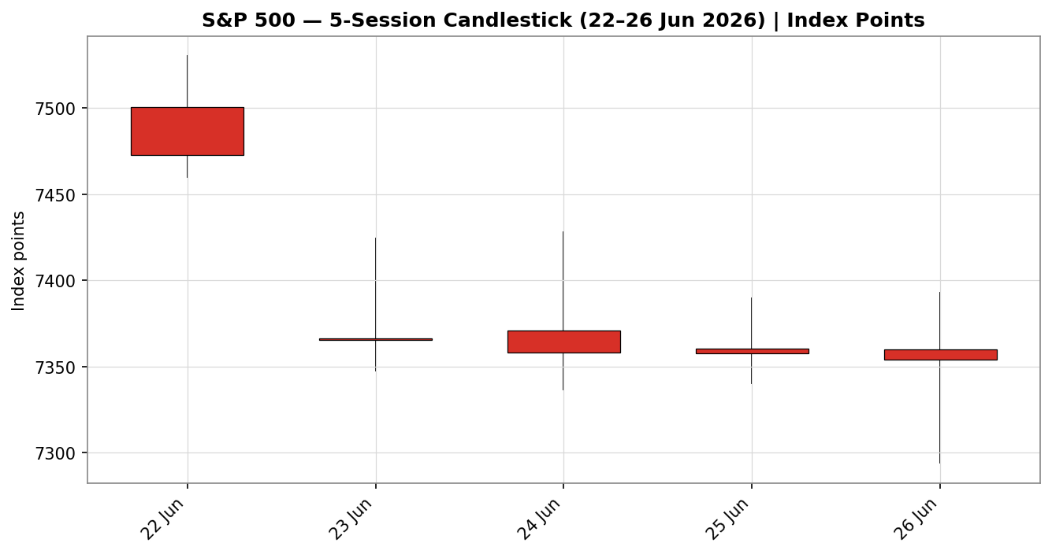
Chart 2 — Distance from open (rejection/travel normalised to each session open).
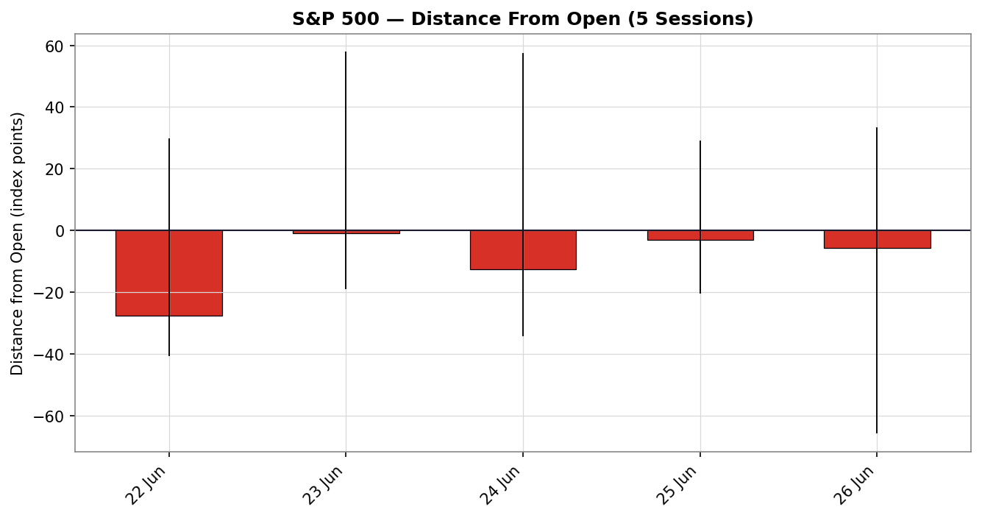
Chart 3 — 25-session structure with close overlay.
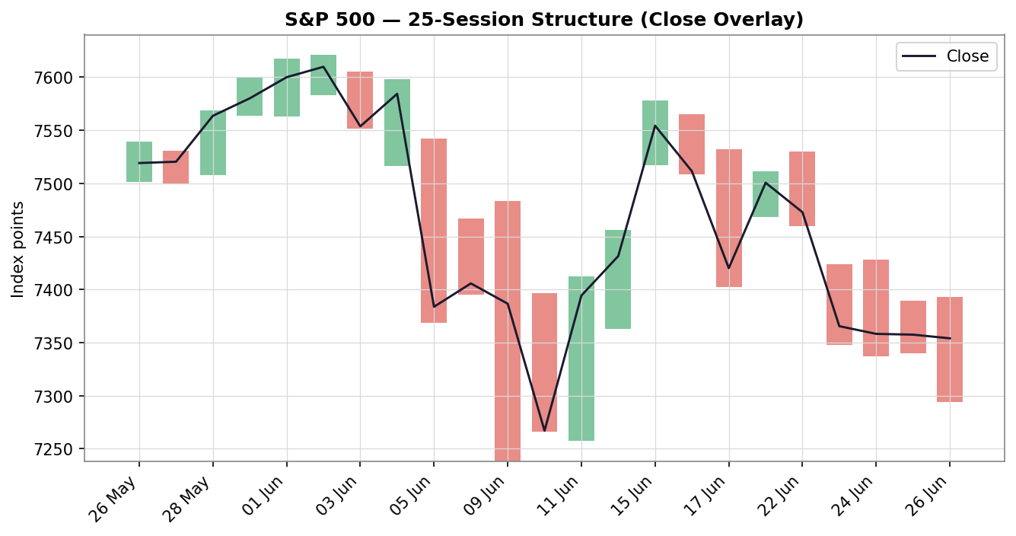
Chart 4 — VOLator scaled volatility (ATR, historical z-score).
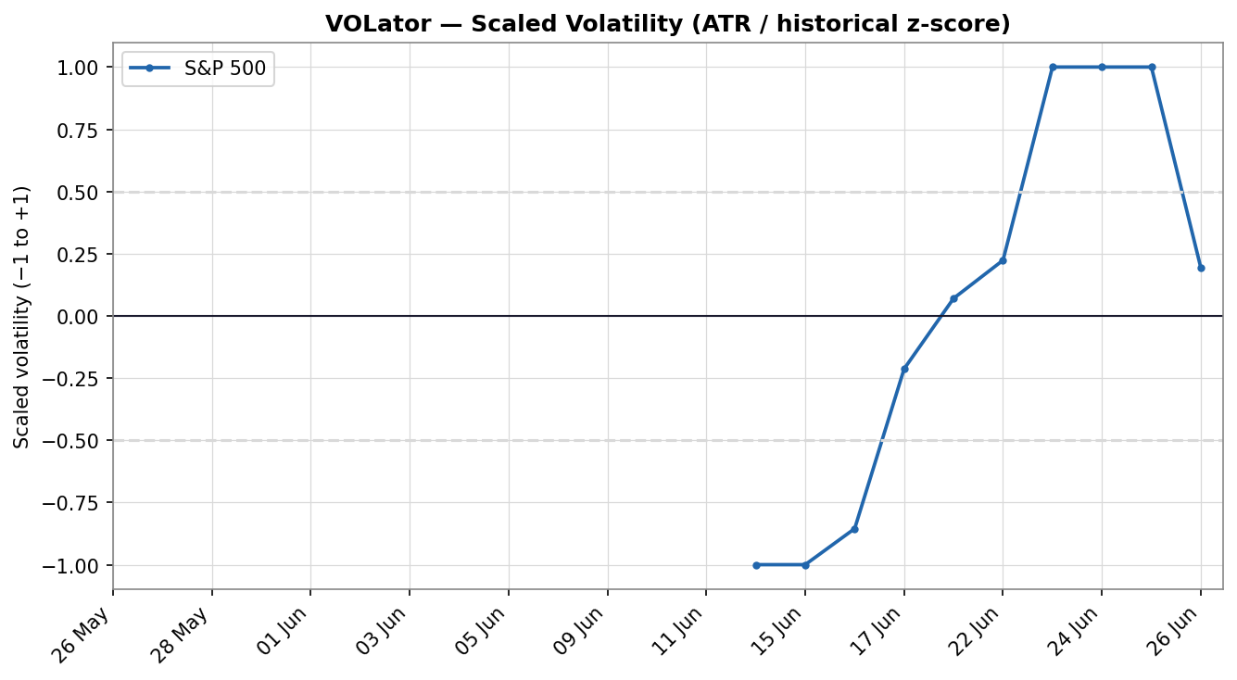
Chart 5 — Pivot structure, weekly candles with daily floor-pivot levels (smart-scaled). Levels shown are derived from prior-session H/L/C carried as indicative.
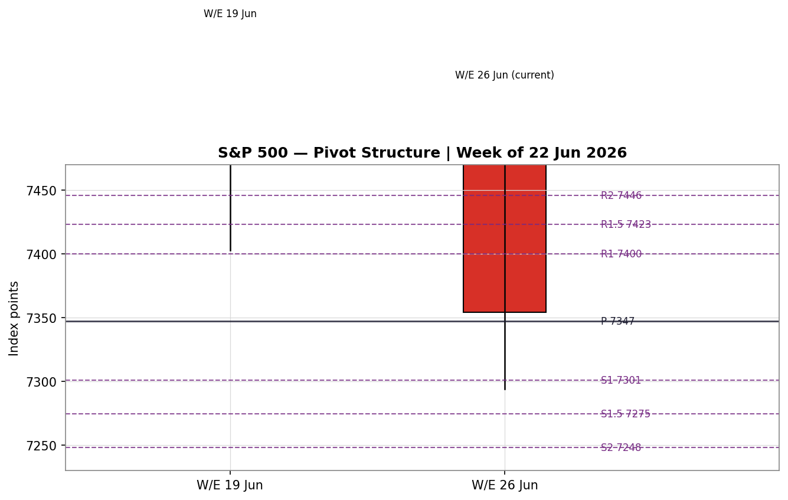

8 · Short-Term Technical Analysis
22 Jun (see §6): bearish — opened firm but reversed to close near the lower quarter of range (~18% close location); RSI2 still elevated (74.3) heading into the slide.
23 Jun: large bearish body, gap-down open, close in lower quarter (~23%); RSI2 collapses to 0 — momentum break.
24 Jun: continuation lower, near-identical structure, close ~23% of range; RSI2 pinned at 0.
25 Jun: bearish but with a slightly higher close location (~35%) — first sign of waning downside conviction.
26 Jun: widest-range session of the five; long lower wick with close recovering to ~61% of range — a lower-wick rejection that hints at exhaustion / potential reversal risk even as the body stays bearish.
Sequence assessment: Continuation with late exhaustion characteristics — five lower closes (low overlap on the down-legs) define continuation, but the final session's lower-wick rejection and improving close location warn of seller fatigue. Nearest support 7,294 (26 Jun low) then 7,238 (25-day low); nearest resistance 7,530 (5-day swing high / 22 Jun high). Judgement label: Bearish continuation — exhaustion / reversal risk into support.

9 · Medium-Term Regime & VOLator
Regime classification: Transitional (bearish drift). Supporting metrics — overlap ratio 0.58 (>0.55, range-like), directional persistence 0.59, absolute directional mean 0.14 (<0.25, non-trending), median RSI2 46.9, and range-position bias in the lower third (~30th percentile). Overlap and persistence point in opposite directions, which is the signature of a transitional tape rather than a clean trend or range.
VOLator: S&P 500 scaled volatility ≈ +0.19 (above the 0 midpoint) with a positive slope (+0.23) — volatility is expanding, consistent with a market breaking out of its prior range rather than settling into one.
Kaufman confirmation: smoothed KER ≈ −0.09 → Ranging — Neutral. KER disagrees with a clean trend read; combined with the positive VOLator slope, the dual-gate range condition is NOT satisfied (a range requires KER below threshold AND a non-positive volatility slope). The composite regime therefore resolves to TRANSITION, not RANGE.
Preferred trade protocol: reduced-conviction breakout-side play — wait for confirmation; favour the down-break side given the bearish short-term sequence and cross-asset read.

10 · Cross-Asset Analysis
Counter | 5-day dir. | Mechanism | Status | Implication
Dollar Index | Rising (13-mo high, ~101.3) | Stronger USD pressures multinational earnings translation and tightens global conditions | Confirms bearish | Headwind for S&P; supports downside bias
VIX | Elevated/mixed (~18.4–19.7) | Implied-vol gauge; sub-20 = not stressed but above the recent calm | Neutral-to-confirms | Risk slightly elevated; no panic
DAX 40 | Falling (24,671, −1.3% Fri) | European equity beta to the same global risk factor | Confirms bearish | Cross-market risk-off corroborates
Aggregate cross-asset confirmation: CONFIRM (bearish). The dollar at a 13-month high and a falling DAX both align with the bearish synthesis; VIX is consistent without signalling stress. No counter contradicts the regime read.

11 · Floor Pivot Analysis
Daily pivots (from 26 Jun H/L/C) — source status: prior-session H/L single-full-source, indicative only.
Level | Daily | Level | Weekly (W/E 19 Jun)
R5 | 7,696.23 | — | —
R4 | 7,597.46 | R3 | 7,760.11
R3 | 7,498.69 | R2 | 7,669.01
R2 | 7,445.82 | R1 | 7,584.80
R1.5 | 7,422.87 | — | —
R1 | 7,399.92 | WP | 7,493.70
P | 7,347.05 | S1 | 7,409.49
S1 | 7,301.15 | S2 | 7,318.39
S1.5 | 7,274.72 | S3 | 7,234.18
S2 | 7,248.28 | — | —
S3 | 7,202.38 | — | —
S4 | 7,103.61 | — | —
S5 | 7,004.84 | — | —
Position narrative: the 26 Jun close (7,354.02) sits just above the daily pivot P (7,347.05) but below the weekly pivot (7,493.70) and below weekly S1 (7,409.49) — a structurally weak posture. The daily S1/S1.5 band (7,301–7,275) overlaps the 26 Jun low (7,294) and the weekly S3 (7,234) sits just under the 25-day low (7,238), forming a support confluence zone around 7,234–7,301.

12 · Key Market Considerations
Demand / flows — a pronounced rotation out of AI/semiconductor megacaps into defensives and value drove the weekly decline; chip names (Micron, Nvidia, Broadcom) led losses. Price-negative (cyclical).
Substitution / breadth — the Dow outperformed (+0.6% on the week) while the Nasdaq fell ~4.6%, indicating broadening rather than wholesale de-risking. Neutral.
Policy / rates — swaps price ~36% odds of a move at the 28–29 Jul FOMC; the FOMC's prior projection of higher rates underpins the strong dollar. Price-negative (structural).
Macro / FX — the US Dollar Index at a 13-month high is a translation headwind for the index's ~28% foreign revenue base. Price-negative (cyclical→structural).
Energy / geopolitics — Strait of Hormuz tension kept oil volatile, but late-week tanker flows and a proposed sanctions waiver eased crude and softened inflation fears. Mildly price-supportive (cyclical).
Near-term catalysts — quarter-end rebalancing flows, the 28–29 Jul FOMC further out, and continued mega-cap/AI commentary are the active watch items (see §13d). Cyclical.

13 · Sentiment, News & Calendar
13a · Per-article sentiment
Source | Date | Headline (abbrev.) | Class. | Sentiment | Derivation quote (≤15w)
Goldman (J. Flood, via CNBC) | 26 Jun | Still in 'buy dip mode' | Institutional | Bullish | "general trend for this market is higher"
CNBC | 26 Jun | Nasdaq posts fifth losing session as chips tumble | Media | Bearish | "investors rotated out of key technology stocks"
JPMorgan (via CNBC) | 26 Jun | Concern on AI infrastructure spend sustainability | Institutional | Bearish | "sustainability of their infrastructure spending"
Citi | 26 Jun | Cuts tech stock weighting | Institutional | Bearish | "difficult to see how everyone in AI… wins"
Trading Economics | 26 Jun | Indexes lower; lower oil eases inflation | Media | Neutral | "lower oil prices eased inflation concerns"
Deepwater (G. Munster) | 26 Jun | AI trade is not dead | Media | Bullish | "AI trade is not dead"
13b · Aggregate sentiment
Counts: 2 Bullish (1 institutional, 1 media), 3 Bearish (3 institutional), 1 Neutral (media) → Predominantly Bearish (tilt = −0.22). The two strong-conviction bearish institutional notes (JPMorgan, Citi) outweigh the milder bullish media/desk commentary under source-class weighting. Divergence flag: sentiment agrees with price action (falling) and with the §9 transitional-bearish regime — no divergence. Confidence: adequate (six articles, above the three-article floor).
13c · Previous-period calendar
Date | Event | Context | Impact | Implication for S&P 500
23 Jun | Equity sell-off / USD to 13-mo high | Risk-off, liquidity bid for USD | High | S&P gapped lower; dollar strength compounded pressure
24 Jun | Gold −20–25% / war-premium unwind | Middle-East de-escalation | Medium | Risk re-pricing; rotation accelerated
25 Jun | Micron strong guidance → brief chip rally | AI-capex read-through | Medium | Thu bounce faded into Fri
26 Jun | OpenAI IPO-delay & SpaceX weakness headlines | AI funding concerns | High | Chip rotation; S&P −0.05%, Nasdaq −0.24%
13d · Upcoming-period calendar (next 5 sessions)
Date | Event | Context | Impact | Implication (beat / miss)
Wk of 29 Jun | Quarter-end rebalancing flows | Q2 close | High | Mechanical flows can amplify moves either way into month/quarter end
Wk of 29 Jun | Mega-cap / AI commentary stream | NVDA, MSFT, AAPL, GOOGL, META, AMZN | High | Renewed AI-capex doubts → further downside; reassurance → squeeze higher
28–29 Jul | FOMC decision (further out) | ~36% priced for a move | High | Hawkish → USD up, equities down; dovish → relief rally
Highest-impact upcoming item: mega-cap/AI commentary into quarter-end — a fresh negative AI-capex signal would confirm the down-break and extend the move toward the 7,238 floor.

14 · Macro Context
Rates: FOMC projections lean higher-for-longer; ~36% odds priced for late-July. Cross-referencing §10, the firm dollar is the transmission channel. Price-negative.
Inflation: late-week oil relief eases the near-term inflation impulse — marginally price-supportive, partly offsetting rate pressure.
Liquidity / FX: the Dollar Index at a 13-month high (§10) tightens global conditions and is the dominant macro headwind for the index's foreign-revenue base.
Volatility / positioning: VIX in the high-18s/19s (§10) signals elevated-but-orderly risk; no capitulation. Watch item from §13d: a hawkish FOMC or a negative AI-capex headline would lift the dollar and VIX together, the bearish-confirming combination for the S&P.

15 · Bull / Bear Balance
Upside risks | Downside risks
Lower-wick rejection on 26 Jun + RSI2 pinned at 0 = oversold bounce potential | Five lower closes; close below weekly pivot and weekly S1 — weak structure
Dip-buying interest cited by desks; broadening into value/defensives | Dollar at 13-month high pressuring earnings translation
Support confluence 7,234–7,301 may hold and base | AI-capex doubts (JPM, Citi) could deepen the tech rotation
Oil relief eases inflation, supports multiples | Quarter-end flows + hawkish-Fed risk could force the down-break
The balance references the §13d quarter-end/AI catalyst and the §11 pivot position (below weekly pivot, just above daily P). Net: downside risks dominate while price holds below 7,410 (weekly S1).

16 · Forward View
Base case (next 5 sessions): a lower-to-sideways drift with a downside skew, expected trading range roughly 7,238–7,500. This respects the §9 transitional-bearish regime. A decisive daily close below 7,238 (25-day low, confluence with weekly S3) opens 7,103 (daily S4); a daily close back above the weekly pivot 7,494 would invalidate the bearish base case and favour a return toward 7,580. The 26 Jun lower-wick rejection is the main near-term two-way risk and is flagged explicitly — it does not yet override the bearish structure.

17 · Forecast
With short-term momentum bearish, sentiment predominantly bearish, and cross-asset signals (strong dollar, falling DAX) confirming, the S&P 500 is expected to drift lower toward the 7,238–7,301 support confluence over the coming sessions unless a daily close reclaims the 7,494 weekly pivot.

18 · Final Analyst Judgement
Consensus price call: 7,354.02 (high confidence on close). Tone bearish-leaning balanced. The three most important reasons: (1) five-session bearish sequence leaving price below the weekly pivot and weekly S1; (2) a 13-month-high dollar and falling European equities confirming risk-off; (3) predominantly bearish institutional sentiment on AI-capex sustainability. Single watch item: mega-cap/AI commentary into quarter-end — the swing factor for whether 7,238 holds.

19 · Source Discipline Note
Live vs indicative: the 26 Jun close (7,354.02) is live and corroborated to the cent (official publisher × CNBC × Yahoo). Intraday highs/lows for 24–26 Jun and the 25 Jun close rely on a single full-OHLC aggregator and are carried as single-source — indicative only; they are used for directional/chart context but not as definitive pivot inputs. All daily and weekly floor-pivot levels in §11 are therefore flagged SINGLE-SOURCE-INDICATIVE. Normalization: all values in index points, cash session basis; no futures blended into OHLC. Corroboration status by instrument — S&P 500 close: corroborated; S&P 500 intraday H/L (last 2 sessions): single-source; counters (USDX, VIX, DAX): close-level corroborated for directional use.

20 · Agent Log
Override applied: the daily-open anchor was overridden from the populated instance value (07:00 UK) at user instruction; Trade 1 entry timing is set to the overridden anchor for the 29 Jun forward-test session. This deviation is logged here per process.
Sources attempted (OHLC): Investing.com (full OHLC — success), S&P DJI/FRED (close — success), CNBC (close — success), Trading Economics (close/%, success), Yahoo Finance (close — success), Cboe/FRED (VIX — success), Investing.com (DXY — success), Yahoo (DAX — success). Stooq and direct Twelve Data attempts were blocked by automated-access restrictions and logged as failed-not-corroborating; corroboration was nonetheless achieved on closes via the publisher × aggregator pair.
Validation: two-source corroboration achieved for all closes within ±0.10 tolerance; last-two-session intraday H/L remained single-source after the accessible stack — flagged indicative, not synthesised. Per user instruction, trading strategies are produced despite incomplete intraday corroboration; corroboration leniency is recorded here.
M5 trace: direction-score weights = defaults (0.25/0.20/0.10/0.15/0.15/0.15), within the 20-session lock; no tuning. Regime label = TRANSITION (RANGE dual-gate failed: KER −0.09 below threshold but VOLator slope +0.23 is positive). Direction score −0.57 → SHORT. Sentiment tilt −0.22 (6 articles). Trade 2 and Trade 3 pivot/entry levels reference SINGLE-SOURCE-INDICATIVE pivots — flagged on the cards. Backtest: 5 sessions reconstructed at each t−1 close, ATR/swings recomputed, outcomes resolved on forward bars only (no leakage); wide ATR-based stops left most short reconstructions OPEN within the window. Timestamp: 29 Jun 2026.

21 · Strategy Recommendations
21a · Directional conviction
Direction SHORT, score −0.57 (past the −0.25 conviction threshold). The three highest-weighted contributors: short-term technical bias (§8) −0.25, cross-asset confirmation (§10) −0.15, and medium-term regime (§9) −0.10; sentiment (§13b) adds −0.03 and the Kaufman term a small +0.01 offset. Weights basis: defaults. No conflict with the §17 forecast — both lean lower.
21b · Trade cards
Trade 1 — Daily Directional (SHORT)
Field | Value (points / native points)
Direction | SHORT — bearish short-term sequence, cross-asset confirm
Entry | Market at the overridden daily-open anchor; reference 7,354.0
Stop loss | 7,558.0 — 204 points above entry (anchor: 5-day swing high 7,530 + 0.25×ATR)
Risk (R) | 204 points (within the 3.5×ATR cap of 391 pts)
TP1 (Unit 1, −1R) | 7,150.1 (+204 pts in favour)
TP2 (Unit 2, −2R) | 6,946.1; on fill, Unit 3 stop → 7,394.8 (entry +0.2R)
TP3 (Unit 3 runner) | Session close OR 3×ATR (7,018.6), whichever first
Tranche mgmt | 3 equal units; U1@TP1, U2@TP2, U3 runner with BE+0.2R trail
Confluences | SL near 5-day swing high 7,530; TP1 near daily S-extension
Thesis invalidation | Daily close back above 7,494 (weekly pivot)
Caveats | Wide stop (1R > ATR); last-2-session H/L single-source-indicative
Trade 2 — Pivot, regime-aware (TRANSITION → down-break side)
Field | Value (points)
Direction | SHORT — TRANSITION breakout side only (down)
Entry | Sell-stop 7,296.6 (below daily S1, mirror of trend-breakout rule)
Stop loss | 7,389.4 — 93 points (P + 0.8×(R1−P))
Risk (R) | 93 points
TP1 / TP2 / TP3 | S1 7,301.2 / S1.5 7,274.7 / S2 7,248.3 (runner toward pivot P)
Thesis invalidation | Daily close back through P (7,347.05)
Caveats | SINGLE-SOURCE-INDICATIVE pivots — levels indicative; counter-side limit suppressed
Trade 3C — Momentum-Breakout (TRANSITION)
Field | Value (points)
Direction | SHORT — down-break of the 25-day range
Entry | Sell-stop 7,209.9 on a confirmed daily close < 7,238 − 0.25×ATR
Stop loss | ≈7,349.7 (generous, above the broken 25-day boundary)
Risk (R) | ≈140 points
TP (measured move) | 6,826.9 (1× range width of 383 pts)
Status | Break NOT yet confirmed — order armed, not live
Caveats | Eligible only on confirming close; indicative range boundary
21c · 5-session no-leakage backtest (Trade 1 reconstruction)
Date (t) | Strategy | Dir. | Triggered | Entry / SL | Outcome (R) | Days
22 Jun (t−5) | Trade 1 | LONG | YES | 7,500.4 / 7,334.8 | −1.00R | 5
23 Jun (t−4) | Trade 1 | SHORT | YES | 7,366.5 / 7,606.4 | OPEN | 5+ (open)
24 Jun (t−3) | Trade 1 | SHORT | YES | 7,370.9 / 7,595.0 | OPEN | 5+ (open)
25 Jun (t−2) | Trade 1 | SHORT | YES | 7,360.5 / 7,562.8 | OPEN | 5+ (open)
26 Jun (t−1) | Trade 1 | SHORT | YES | 7,359.8 / 7,560.1 | OPEN | 5+ (open)
21d · What is working
Trade 1 over the last 5 sessions: triggered 5/5 times, mean R = −1.00 on the single closed position, with the four short reconstructions still open within the window (TP1 ~204 pts away under wide ATR stops). Hit rates TP1/TP2/TP3 = 0% / 0% / 0% on closed trades. Strongest performer: none resolved positively in-window. Weakest performer: insufficient closed triggers to rank meaningfully. The wide ATR-derived stop is the dominant structural feature — it protects against whipsaw but rarely resolves within five sessions.
Five-session windows are too small to support statistical claims. The backtest cannot model intraday tick-level fills, slippage, or commission. Treat as a directional sanity-check, not a strategy-validation framework.

Technical Judgement Summary
Line | Reading
Short-term technical state | Transitional → Bearish
Medium-term technical state | Transitional → Mixed (bearish drift)
KER regime confirmation | Ranging — Neutral — Neutral vs synthesis
Preferred trade protocol | Reduced conviction — breakout-side (down)
Integration note | Forecast/macro/sentiment lean with the bearish read
Pivot reference | Close above daily P, below weekly pivot & weekly S1
Source status | Close corroborated; last-2-session H/L un-corroborated (indicative)

