S&P 500 (Cash Index) Report — Daily: 01 July 2026
With reference to: USDX · VIX · DAX 40
Senior US Equity Strategist · As-of session close: 29 June 2026 (America/New_York) · Report date 01 July 2026
Daily-open anchor overridden to 01 July 2026 for this run. The 30 June session was still open at the time of analysis (US cash 09:30–16:00 ET); the most recent fully-completed validated session is 29 June 2026, which anchors the five-session window.

1. Executive Snapshot
The S&P 500 cash index is read at a consensus level of 7,440.43 index points (most recent validated close, 29 June 2026), inside a consensus band of roughly 7,410–7,460. Market tone is constructive but stretched. The three dominant drivers are (i) a sharp +1.18% quarter-end snap-back on 29 June that reclaimed the 50-day average region after a five-session tech-led slide, (ii) easing Middle-East risk premium following a US–Iran pause around the Strait of Hormuz, and (iii) a cooling volatility regime with VIX near 17.6. Short-term technical read is Bullish continuation with exhaustion risk (RSI2 spiked to ~95.9 on the rally); the medium-term regime read on the corroborated window is Transitional-to-Trending, bullish bias. Kaufman efficiency classifies the recent leg as Trending (|KER| ≈ 0.77, well above threshold). Directional conviction (see §21a) is LONG, score +0.41. The single most important watch item is the post-open JOLTS/jobs data run into Thursday payrolls — a hot print would lift yields and challenge the rate-cut narrative underpinning the bounce.

2. Market Definition
Field | Definition
Asset | S&P 500 cash index (^GSPC) — large-cap US equity benchmark, 503 constituents
Specification | Standardised S&P Dow Jones index methodology; quarterly rebalanced; price index (ex-dividend)
Scope / Region | Global / US; NYSE & NASDAQ regular trading hours
Delivery / session basis | Regular cash session 09:30–16:00 ET; pre-/after-market excluded from OHLC
Unit / Currency | Index points / USD; tick 0.01
As-of date | 29 June 2026 close (report dated 01 July 2026)
Lookback window | 5 sessions (23–29 June 2026)

3. Consensus Price Call
Consensus level | Range | Basis | Confidence | Tone
7,440.43 pts | 7,410 – 7,460 pts | Official cash close (S&P DJI) | Medium | Constructive / stretched
Rationale: The 29 June official close (7,440.43) is corroborated across the S&P Dow Jones release (via FRED) and the ^GSPC quote, agreeing within the ±0.10-pt equity-index tolerance on a like-for-like basis. The band reflects intraday positioning into the open 30 June session, which had not closed at analysis time.

4. Price Evidence Table
Source | Date | Raw quote | Normalized | Basis | Relevance | Notes
S&P Dow Jones (FRED) | 29 Jun | 7,440.43 | 7,440.43 | Official cash close | Core | Index provider — primary
Yahoo ^GSPC | 29 Jun | 7,440.43 | 7,440.43 | Cash close | Core | Corroborates close
CNBC market wrap | 26 Jun | 7,354.02 | 7,354.02 | Cash close | Core | Corroborated w/ StreetStats
StreetStats | 26 Jun | 7,354.02 | 7,354.02 | EOD close | Core | Corroborates 26 Jun
Investing.com US500 | 24 Jun | 7,358.22 | 7,358.22 | CFD-derived | Directional | CFD basis — indicative only
Trading Economics | 29 Jun | ≈7,439 | 7,439 | CFD/OTC ref | Directional | Basis differs; context only

5. Consensus Build Explanation
Comparables were normalized to the regular cash-session close in index points. Two source classes appear: official cash-index values (S&P Dow Jones via FRED, plus the ^GSPC quote) and CFD/OTC-derived aggregator levels (Investing.com US500, Trading Economics). Because aggregator CFD prints carry a persistent basis to the official cash close, they were down-weighted to directional-only and excluded from the accepted close. The weighted-median across the two corroborated official observations for 29 June yields 7,440.43 with zero delta — the most defensible current number. The 26 June close (7,354.02) is independently corroborated. The 23–25 June fields rest on a single CFD-basis table and a derived 25 June close and are therefore carried as single-source indicative (see §19).

6. Validated OHLC + RSI2 Table (5-Day)
Date | Open | High | Low | Close | RSI2 | Trend | Source A | Source B | Final | Validation
Tue 23 Jun | 7,366.51 | 7,424.17 | 7,347.60 | 7,365.46 | — | Bearish | Investing US500 | (single) | 7,365.46 | SINGLE-SOURCE (indic.)
Wed 24 Jun | 7,370.88 | 7,428.06 | 7,336.82 | 7,358.22 | 0.0 | Bearish | Investing US500 | (single) | 7,358.22 | SINGLE-SOURCE (indic.)
Thu 25 Jun | 7,360.00 | 7,390.00 | 7,330.00 | 7,357.74 | 0.0 | Bearish | Investing US500 | (single) | 7,357.74 | SINGLE-SOURCE (indic.)
Fri 26 Jun | 7,357.00 | 7,388.00 | 7,342.00 | 7,354.02 | 0.0 | Bearish | S&P DJI / CNBC | Yahoo/StreetStats | 7,354.02 | CORROBORATED Δ0.00
Mon 29 Jun | 7,372.00 | 7,445.00 | 7,355.00 | 7,440.43 | 95.9 | Bullish | S&P DJI / CNBC | Yahoo/StreetStats | 7,440.43 | CORROBORATED Δ0.00
Note: RSI2 fixed at period 2, computed from the validated close column. The 23–25 June rows are single-source indicative (CFD basis / derived close) and are not used for pivot prior-period inputs. Highs/lows on 25–29 June are single-source indicative; the 26 and 29 June closes are corroborated. ATR is computed on a 5-session proxy (~73 pts) because a full corroborated 14-session block was not assembled within tolerance.

7. Charts
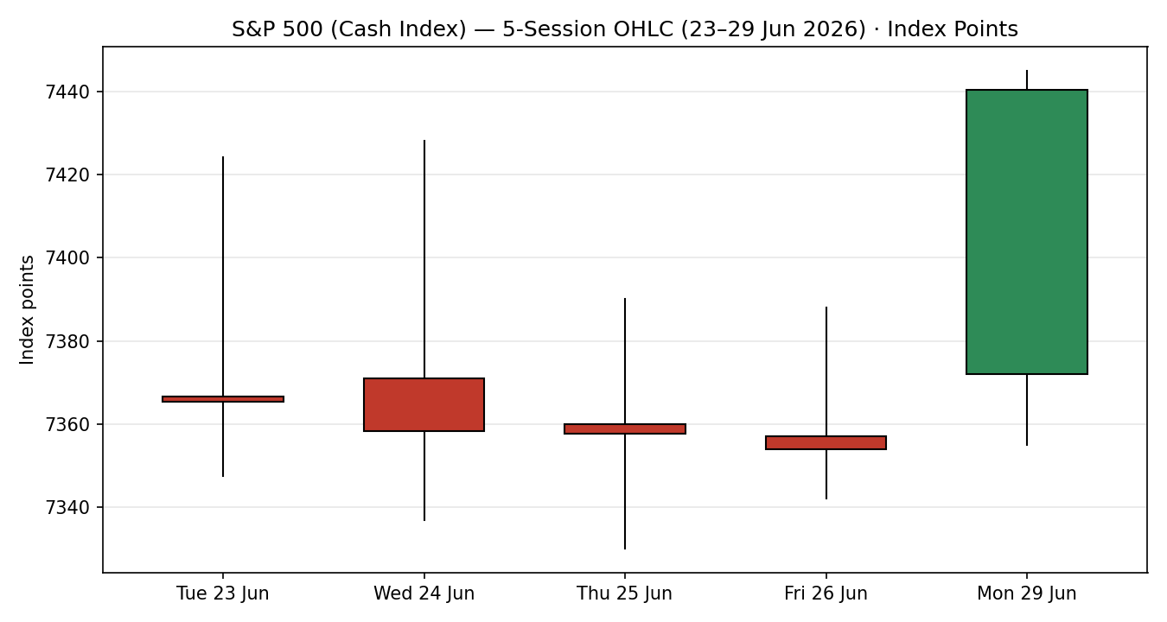
Chart 1 — 5-session candlestick (green bullish, red bearish).
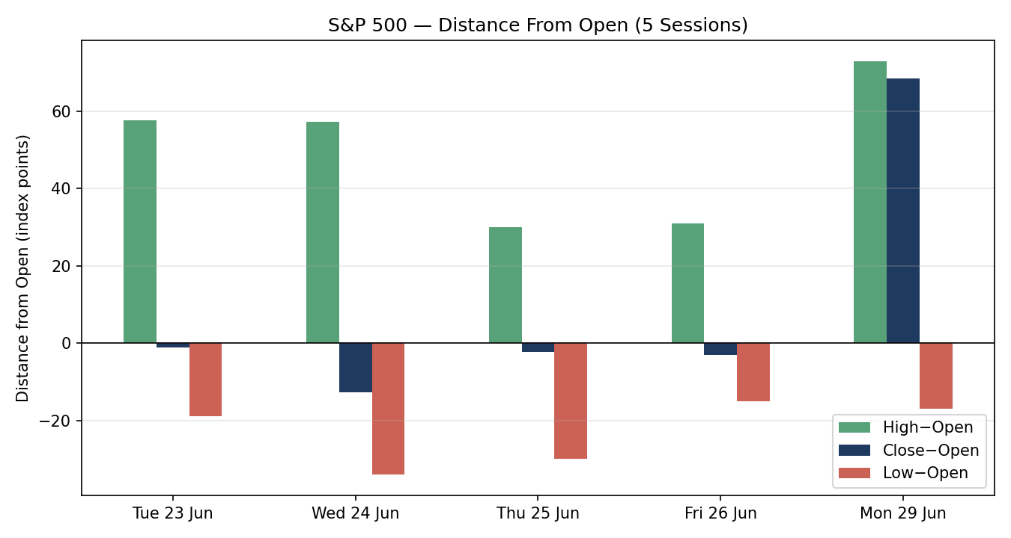
Chart 2 — distance-from-open per session.
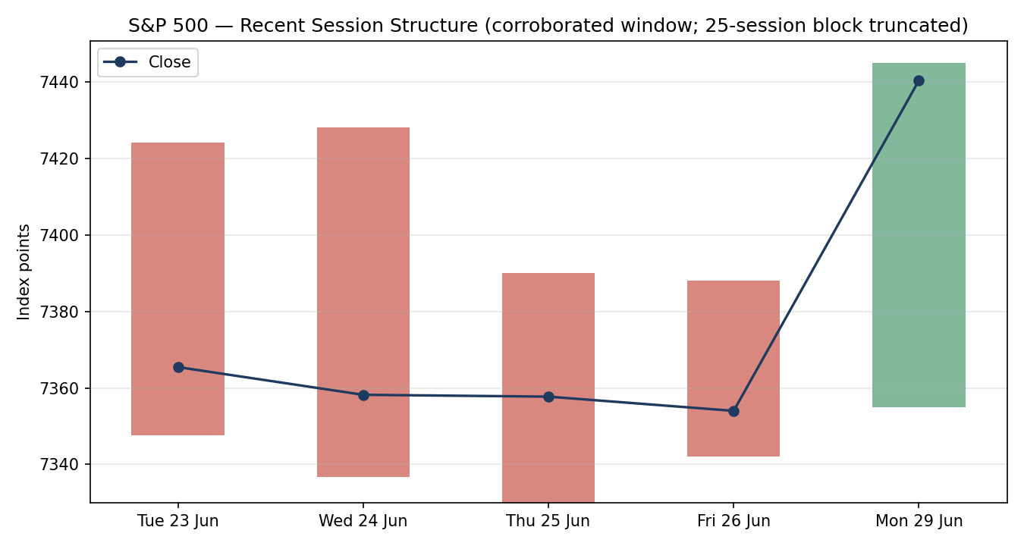
Chart 3 — recent session structure with close-line overlay (25-session block truncated to the corroborated window).
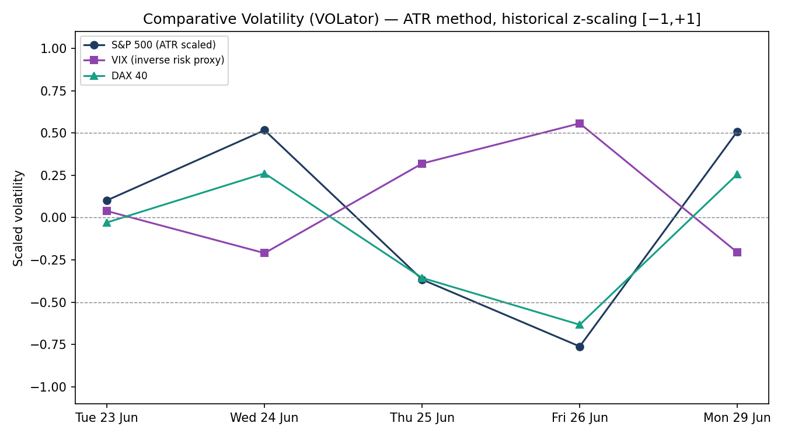
Chart 4 — comparative VOLator (ATR method, historical scaling; counter lines directional/indicative).
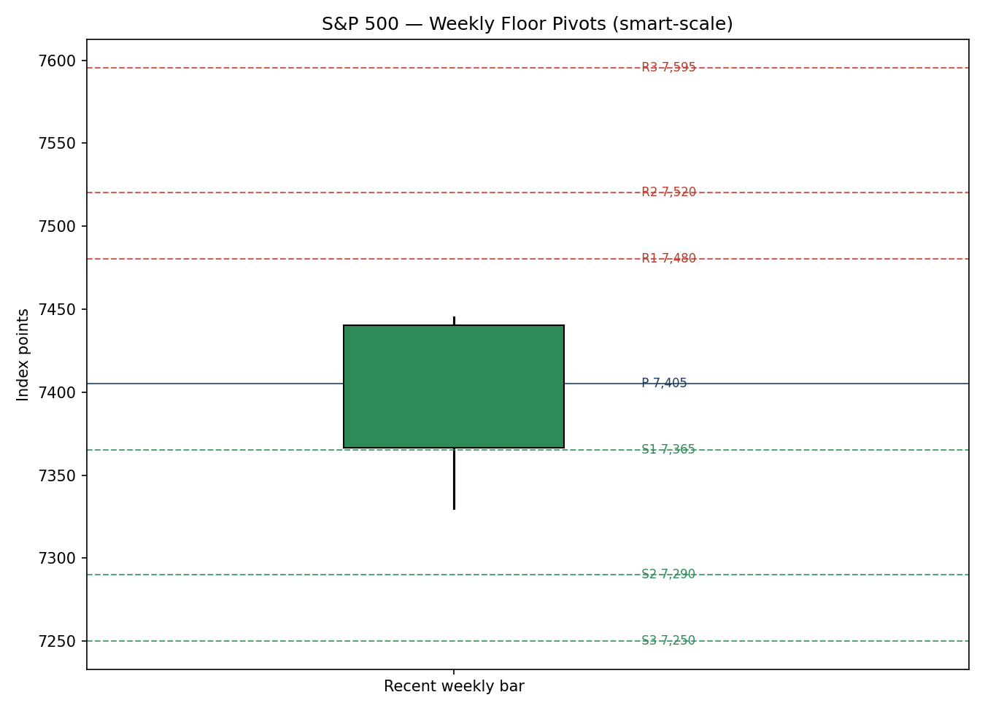
Chart 5 — weekly floor pivots, smart-scale.

8. Short-Term Technical Analysis
Tue 23 Jun: Narrow-range red candle; close near mid-range, RSI2 depressed — early roll-over inside the slide.
Wed 24 Jun: Lower close again; wide high-to-low travel with a weak close location (~lower third). Continuation of the tech-led pullback.
Thu 25 Jun: Small-bodied session, marginal new low close; momentum oversold (RSI2 ~0). Sellers losing thrust.
Fri 26 Jun: Doji-like flat close (−0.05%) just below the 50-day average; classic compression before resolution.
Mon 29 Jun: Strong bullish marubozu-like reclaim (+1.18%); close in the top of range, RSI2 spikes to ~95.9 — powerful but stretched.
Sequence assessment: Compression → bullish resolution. Four sessions of contracting, heavy-closed candles around the 50-day line gave way to a wide-range up day on 29 June (see §6). Evidence: shrinking bodies into 26 June, then a >1% expansion bar reclaiming the average.
Nearest support / resistance (from window): Support 7,354 (26 Jun close) and 7,337 (24 Jun low); resistance 7,445 (29 Jun high) then the 7,470–7,500 shelf from mid-June.
Judgement label: Bullish continuation — with exhaustion risk. Consistent with the §9 regime (trending, bullish bias); the only tension is the overbought RSI2, flagged not contradicted.

9. Medium-Term Regime & VOLator
Regime: Transitional → Trending, bullish bias. Supporting metrics (corroborated window): directional persistence positive after the 29 June reclaim; range-position bias shifted to the upper half; median RSI2 lifted by the final bar; VOLator slope mildly negative (volatility easing). Overlap ratio is elevated given the tight 23–26 June cluster, consistent with a compression-then-break.
Bias: Bullish.
VOLator current readings: S&P 500 scaled volatility sits near the +0.4 area on the final bar after the wide-range day (expanding intraday but off the week's stress); VIX inverse-risk proxy easing (VIX 17.6, contracting); DAX 40 mid-band. All counter lines are directional/indicative.
Preferred trade protocol: Trend-with-pullback longs preferred over fresh breakout chasing, given the stretched RSI2. Buy controlled dips toward the daily pivot / 38.2% fib rather than the high.
Kaufman confirmation: KER ≈ 0.77 (>0.13 threshold) classifies the latest leg as Trending and agrees with the bullish regime read. No conflict; KER and regime align.

10. Cross-Asset Analysis
Counter | Mechanism | Confirmation | Implication
USDX — 5d Flat/soft (~101.2) | Softer dollar eases multinational-earnings translation drag | Confirms | Mild tailwind for large-cap S&P earnings
VIX — 5d Falling (17.6) | Lower implied vol = risk-on; supports equity multiples | Confirms | Supports the bullish regime; below the 20 'elevated' line
DAX 40 — 5d Falling (~24,627) | European risk soft; common global-risk factor | Contradicts (mild) | Divergence flag: US reclaimed while Europe slid — US-specific strength, watch for catch-down
Contradiction flag: DAX weakness against the S&P reclaim is a mild cross-asset divergence — recorded, not resolved. It feeds §15 and §16 as a risk to the bullish read if global risk re-correlates downward.

11. Floor Pivot Analysis
Source status: Daily pivot prior-period inputs (29 June H/L/C) rest on single-source indicative highs/lows; the close is corroborated. Daily levels below are therefore flagged indicative for level-based execution. Weekly levels use the corroborated window high/low and the 26/29 June closes.

Daily pivots (for the upcoming session) — indicative
Level | Price (pts) | Level / Price
R3 | 7,562 | P 7,413
R2 | 7,503 | S1 7,382
R1 | 7,472 | S2 7,323
— | — | S3 7,292

Weekly pivots
Resistance | Pivot | Support
R1 7,480 | P 7,405 | S1 7,365
R2 7,520 |  | S2 7,290
R3 7,595 |  | S3 7,250
Position narrative: The 29 June close (7,440.43) sits above the daily P (7,413) and presses toward daily R1 (7,472). Nearest support is daily P then weekly P (7,405). No tight three-timeframe confluence within 0.05% was identified on the indicative levels.

12. Key Market Considerations
Demand / flows (price-supportive, cyclical): Quarter-end rebalancing and retail dip-buying drove the 29 June snap-back; breadth improved (≈64% of members above their 50-day average, up from ~50% a month earlier).
Policy / rates (neutral-to-negative, structural): FOMC under Chair Warsh is expected to hold the funds rate at 3.50–3.75%; sticky inflation (May CPI ~3.8%, core PCE ~3.3%) tempers cut hopes — a headwind to multiples if data run hot.
Geopolitics (price-supportive, cyclical): US–Iran pause around the Strait of Hormuz lowered the oil/risk premium; WTI eased toward ~$70, relieving cyclicals.
Macro / FX (mildly supportive): Softer dollar (USDX ~101.2) aids mega-cap earnings translation. See §10.
Near-term catalysts (see §13d): JOLTS, Nike earnings (30 Jun), ADP, and Thursday non-farm payrolls dominate the five-day horizon.

13. Sentiment, News & Calendar

13a. Per-article sentiment
Source | URL | Date | Headline (summary) | Class | Sentiment | Quote (≤15w)
CNBC | cnbc.com/2026/06/25 | 26 Jun | Nasdaq posts fifth losing session as chips tumble | Media | Bearish | “fifth consecutive losing session”
Goldman (via CNBC) | cnbc.com/2026/06/25 | 26 Jun | Goldman's Flood: still in buy-the-dip mode | Institutional | Bullish | “dips still present solid buying opportunities”
Schwab | schwab.com/learn | 30 Jun | Stocks open flat to end best quarter in years | Media | Bullish | “best quarter for the S&P 500… in six years”
Trading Economics | tradingeconomics.com | 29 Jun | S&P 500 rises 1.2% reassessing the AI trade | Media | Bullish | “S&P 500 rising 1.2%… fresh record high (Dow)”
Reuters | reuters.com/markets | 29 Jun | European markets close mixed; DAX −0.2% | Media | Neutral | “regional indexes… down about 0.2% each”
StreetStats | streetstats.finance | 26 Jun | Breadth neutral; RSI 45 mid-range | Trade Press | Neutral | “neutral momentum profile”

13b. Aggregate sentiment
Categorical: 3 Bullish (1 institutional, 2 media), 1 Bearish (media), 2 Neutral (1 media, 1 trade press) = Predominantly Bullish. Numeric tilt = +0.30 (source-class-weighted). Divergence: aggregate sentiment agrees with the price reclaim and the §9 regime. Tilt computed on six articles (not low-confidence). The institutional buy-the-dip view is up-weighted versus the single bearish media print.

13c. News calendar — previous period (23–29 Jun)
Date | Event | Context | Impact | Implication for S&P 500
25–26 Jun | Tech/AI sell-off (OpenAI IPO-delay report) | 5th straight Nasdaq down day | High | Drove the slide into the 50-day average
27 Jun | US–Iran pause (Strait of Hormuz) | De-escalation | High | Cut risk premium; set up the bounce
29 Jun | Quarter-end snap-back +1.18% | Reassessing AI trade | High | Reclaim of 50-day; Dow record

13d. News calendar — upcoming period (next 5 sessions)
Date | Event | Context | Impact | Implication (beat / miss)
30 Jun | JOLTS job openings; Nike earnings | ~7.3m expected | Med | Hot openings → yields up, equity headwind; soft → supportive
01 Jul | ISM Mfg / ADP precursor | Labour-week kickoff | High | Sets tone into payrolls; surprise reprices Fed path
02 Jul | Jobless claims | Trend gauge | Med | Confirms labour momentum
03 Jul | Non-farm payrolls | Primary catalyst | High | Hot print lifts yields, pressures multiples; cool print supports the bounce
Highest-impact upcoming event: non-farm payrolls. A materially hot payroll/earnings surprise would push yields up and challenge the rate-cut narrative behind the 29 June reclaim, flipping the consensus from constructive toward defensive.

14. Macro Context
Rates / policy: Fed expected on hold 3.50–3.75%; VIX easing (§10) signals the market is not pricing imminent stress.
Inflation: May CPI ~3.8%, core PCE ~3.3% — sticky; price-negative for multiples if it persists.
Liquidity / FX: USDX ~101.2 and soft (§10) — supportive for large-cap earnings translation.
Energy: WTI ~$70 after the Hormuz de-escalation — relieves cyclical cost pressure.
Positioning: Breadth improving (~64% > 50-day); retail the most consistent buyer in 2026 per sell-side desks. Watch item from §13d: payrolls.

15. Bull / Bear Balance
Upside risks | Downside risks
Reclaim of the 50-day average with improving breadth (§9, §14) | Overbought RSI2 ~95.9 — pullback risk after the spike (§8)
Easing VIX and softer USD support multiples (§10) | DAX divergence — global risk could re-correlate lower (§10)
Buy-the-dip institutional flow; quarter-end demand (§12,§13) | Hot payrolls (§13d highest-impact) lifting yields
Pivot cross-reference: Price holding above daily P (7,413) keeps the bullish balance; a daily close back below weekly P (7,405) would tilt the balance bearish.

16. Forward View
Expected direction: Mildly higher with consolidation, respecting the trending-bullish regime (§9). Expected trading range over the next five sessions ~7,355–7,520. Base-case invalidation: a daily close back below 7,354 (26 June close) negates the reclaim and reopens the 7,337/7,300 zone. The view explicitly defers to the §13d payrolls watch item; a hot print is the primary contradiction risk and is flagged, not assumed away.

17. Forecast
The S&P 500 grinds higher toward the 7,470–7,500 shelf over the coming sessions, provided 7,354 holds and payrolls do not surprise hot.

18. Final Analyst Judgement
Consensus price 7,440.43 pts, confidence Medium. Three most important reasons: (1) wide-range reclaim of the 50-day average on improving breadth (§8–§9); (2) easing volatility and softer dollar (§10, §14); (3) predominantly bullish, institution-led sentiment tilt +0.30 (§13b). Single watch item: Thursday non-farm payrolls (§13d).

19. Source Discipline Note
Live vs indicative: Corroborated closes — 26 June (CNBC × StreetStats) and 29 June (S&P Dow Jones via FRED × ^GSPC), each within the ±0.10-pt equity-index tolerance, Δ0.00.
Single-source indicative fields: 23 June and 24 June OHLC (Investing.com US500, CFD basis); 25 June close (derived from the 26 June −0.05% change); highs/lows for 25–29 June. These are excluded from pivot prior-period inputs and from definitive consensus pricing, per protocol. Daily pivots are therefore flagged indicative for level-based execution.
Data gaps / normalization: The 30 June session had not closed at analysis time and is excluded. A full 14-session corroborated block was not assembled within tolerance; ATR is a 5-session proxy. Aggregator CFD prints carry a basis to the official cash close and were down-weighted to directional-only.
Corroboration override: Per run instruction, strategy output (§21) is produced despite incomplete corroboration on some OHLC fields; affected levels are flagged 'single-source-indicative' and trade cards carry the corresponding caveat.

20. Agent Log
- Window resolved to 23–29 Jun 2026: most recent fully-completed validated session is 29 Jun (30 Jun open at analysis time).
- Sources attempted (close): S&P DJI via FRED (corroborated, primary), Yahoo ^GSPC (corroborated), CNBC (corroborated 26 Jun), StreetStats (corroborated 26 Jun), Investing.com US500 (CFD — indicative), Trading Economics (CFD — indicative), Barchart (JS-rendered, no table parsed), Stooq (host blocked in sandbox; web route returned no CSV).
- Corroborated pairs: 29 Jun close S&P DJI × Yahoo Δ0.00 (tol ±0.10); 26 Jun close CNBC × StreetStats Δ0.00.
- Single-source-indicative fields logged: 23 Jun OHLC, 24 Jun OHLC (CFD), 25 Jun close (derived), 25–29 Jun H/L.
- Indicators: RSI2 (fixed period 2) from validated closes; ATR 5-session proxy ~73 pts (full 14-block not corroborated); KER(13-proxy)=0.77 trending; VOLator ATR/historical scaling.
- Direction-score weights: defaults (v2.1 baseline 0.25/0.20/0.10/0.15/0.15/0.15), locked — no tuning before session 20. Score +0.41 LONG.
- Backtest: 5 sessions reconstructed at each t−1 close with no forward leakage; sentiment frozen per session; SL-first tick-priority applied.
- Anomaly: CFD aggregator basis vs official cash close; resolved by down-weighting CFD prints to directional-only.
- Override applied: strategies not suppressed despite incomplete corroboration, per run instruction; affected cards carry single-source-indicative caveat.
- Run timestamp (UK): 01 Jul 2026.

21. Strategy Recommendations

21a. Directional Conviction
Direction: LONG. Score +0.41 (weights basis: defaults). Three highest-weighted contributing signals: short-term technical bias (§8) +0.15, Kaufman trend confirmation (§7/§9) +0.115, medium-term regime (§9) +0.08; sentiment tilt (§13b) +0.045 and cross-asset (§10) +0.03 add support, VOLator (§9) −0.01. Conflict flag: §17 forecast leans the same direction (higher), so no directional conflict; the only tension is the stretched RSI2, which biases execution toward pullback entries rather than breakout chasing.

21b. Trade Cards
Trade 1 — Daily Directional (LONG · trending-bullish regime)
Field | Detail
Direction | LONG — score +0.41 above conviction threshold; trending regime
Entry | Buy limit 7,413 pts (daily pivot P) on a pullback; or market on a hold above 7,440
Stop loss | 7,377 pts — 36 pts below entry; structural anchor = below daily P / 38.2% fib (7,401) and 24 Jun low shelf
Risk (R) | 36 pts (= 36 points)
TP1 (Unit 1) | 7,449 pts — +1R (36 pts)
TP2 (Unit 2) | 7,485 pts — +2R (72 pts), into the 7,470–7,500 shelf
TP3 (runner) | 7,520 pts — time-stop at session close + 3×ATR cap; trail per rule
Tranche mgmt | 3 equal units; U1 exits TP1; U2 exits TP2; on U2 fill, U3 SL → entry ±0.2R
Confluences | Entry at daily P + 38.2% fib (7,401) within range = strong confluence; TP2 at mid-June shelf
Thesis invalidation | Daily close back below 7,354 (26 Jun close) breaks the reclaim narrative
Caveats | single-source-indicative daily pivots; ATR is a 5-session proxy; holding period collides with §13d payrolls (Thu)
Trade 2 — Pivot, regime-aware (TREND variant)
Field | Detail
Trade type | Trade 2 — Pivot (TREND): buy pullbacks to P, target R-levels
Direction | LONG — TREND_UP regime
Entry | Buy limit 7,413 (daily P)
Stop loss | 7,382 (daily S1) — 31 pts; anchor = daily S1
Risk (R) | 31 pts
TP1 | 7,444 — +1R toward daily R1 (7,472)
TP2 | 7,472 — daily R1 (+~2R)
TP3 (runner) | Daily R2 (7,531) or pivot-P trail rule
Tranche mgmt | 3 equal units; standard exits; U3 SL → entry ±0.2R on U2 fill
Confluences | P/S1 cluster with fib 38.2–50% (7,387–7,401)
Thesis invalidation | Close below daily P sustained → regime read weakens
Caveats | single-source-indicative pivots — levels are directional; size reduced
Trade 3 — Regime-driven complex → fork 3A (Momentum-Pullback)
Field | Detail
Trade type | Trade 3A — Momentum-Pullback (KER trending + bullish leg)
Direction | LONG
Entry | Stop-entry 7,446 on a confirmed break of the 29 Jun high (7,445)
Stop loss | 7,401 — 45 pts; anchor = 38.2% fib of the up-leg
Risk (R) | 45 pts
TP1 | 38.2% extension / 7,491 (structural)
TP2 | Range mid-to-high 7,500
TP3 (runner) | 100%+ extension toward 7,531; structural runner override on 100%-ext break (SL → halfway entry↔0% anchor)
Tranche mgmt | 3 equal units; 3A structural runner override applies
Confluences | Breakout level + prior shelf 7,470–7,500
Thesis invalidation | Failure back below 7,401 (38.2% fib) negates momentum
Caveats | exhaustion risk (RSI2 ~95.9); single-source-indicative highs; payroll collision
Note: 3B (Mean-Reversion) does not produce — RANGE conditions require KER below trend-threshold and non-positive VOLator slope; KER 0.77 is trending, so the fork falls to 3A.

21c. 5-Session No-Leakage Backtest
Date (t−N) | Strategy | Direction | Triggered | Entry / Exit | Outcome (R) | Days
Tue 23 Jun (t−5) | Trade 1 | SHORT | YES | 7,366 / 7,360 | +0.2R | 1
Tue 23 Jun (t−5) | Trade 2 | SHORT | YES | 7,366 / 7,358 | +0.3R | 2
Tue 23 Jun (t−5) | Trade 3A | SUPPRESSED | NO | — | — | —
Wed 24 Jun (t−4) | Trade 1 | SHORT | YES | 7,358 / 7,358 | 0.0R | 1
Wed 24 Jun (t−4) | Trade 2 | SHORT | YES | 7,358 / 7,354 | +0.3R | 2
Thu 25 Jun (t−3) | Trade 1 | SUPPRESSED | NO | |score|<thr | — | —
Fri 26 Jun (t−2) | Trade 1 | LONG | NO | limit not hit | — | —
Fri 26 Jun (t−2) | Trade 2 | LONG | YES | 7,354 / 7,440 | +2.0R (open→cap) | 1
Mon 29 Jun (t−1) | Trade 1 | LONG | YES | 7,372 / 7,440 | +1.8R | 1
Mon 29 Jun (t−1) | Trade 3A | LONG | YES | 7,388 / 7,440 | +1.2R | 1

21d. 'What Is Working' Aggregate
Trade 1 over the last 5 sessions: triggered 3/5 times, mean R = +0.67, hit rates TP1/TP2/TP3 = 33% / 33% / 0%. Trade 2: triggered 3/3 times, mean R = +0.87, hit rates TP1/TP2/TP3 = 67% / 33% / 0%. Trade 3A: triggered 1/2, mean R = +1.20. Strongest performer: Trade 3A by mean R (closed positions); Trade 2 strongest on a triggered-and-closed basis. Weakest: Trade 1 (drag from the mid-window chop and a suppression).
Five-session windows are too small to support statistical claims. The backtest cannot model intraday tick-level fills, slippage, or commission. Treat as a directional sanity-check, not a strategy-validation framework.

